Detail of Amendments to City Plan 2014 - City west neighbourhood plan

Part B: Major Amendment v9.00/2018

It is hereby certified that this is a true and correct copy of Brisbane City Plan 2014 Major Amendment v9.00/2018 made, in accordance with the Planning Act 2016, by the
Council of the Brisbane City.

Marcus Mulholland
A/Manager, City Planning and Economic Development
City Planning and Sustainability
Part 1 Amendment of Part 1 (About the planning scheme)

1.1 Amendment of section 1.2 (Planning scheme components)
- Section 1.2 Planning scheme components, Table 1.2.2—Neighbourhood plans precincts and sub-precincts–
insert before Clayfield—Wooloowin district neighbourhood plan:
‘
City west neighbourhood plan | NPP-001: Victoria Barracks renewal  NPP-002: Caxton Street  NPP-003: Normanby renewal
’.
- Section 1.2 Planning scheme components, Table 1.2.2—Neighbourhood plans precincts and sub-precincts
‘
Latrobe and Given Terraces neighbourhood plan | NPP-001: Centres  NPP-002: Residential  NPP-003: Mixed use  NPP-004: Park
’–
omit, insert:
‘
Latrobe and Given Terraces neighbourhood plan | NPP-001: Centres  NPP-002: Residential  NPP-003: Mixed use
’.
- Section 1.2 Planning scheme components, Table 1.2.2—Neighbourhood plans precincts and sub-precincts
‘
Petrie Terrace and Spring Hill neighbourhood plan | NPP-001: Detached house  NPP-002: Low-rise residential  NPP-002a: Low-rise residential 1  NPP-002b: Low-rise residential 2  NPP-002c: Low-rise residential 3  NPP-002d: Low-rise residential 4  NPP-003: High-rise residential  NPP-004: Low-rise commercial  NPP-004a: Low-rise commercial 1  NPP-004b: Low-rise commercial 2  NPP-004c: Low-rise commercial 3  NPP-004d: Low-rise commercial 4  NPP-004e: Low-rise commercial 5  NPP-005: High-rise commercial  NPP-005a: High-rise commercial 1  NPP-005b: High-rise commercial 2  NPP-005c: High-rise commercial 3  NPP-005d: High-rise commercial 4  NPP-006: Police barracks  NPP-006a: Police barracks a  NPP-006b: Police barracks b  NPP-006c: Police barracks c  NPP-006d: Police barracks d
’–
omit.
- Section 1.2 Planning scheme components, Table 1.2.2—Neighbourhood plans and precincts and sub-precincts–
insert before Taringa neighbourhood plan:
‘
Spring Hill neighbourhood plan | NPP-001: Detached house  NPP-002: Low-rise residential  NPP-002a: Low-rise residential 1  NPP-002b: Low-rise residential 2  NPP-002c: Low-rise residential 3  NPP-003: High-rise residential  NPP-004: Low-rise commercial  NPP-004a: Low-rise commercial 1  NPP-004b: Low-rise commercial 2  NPP-005: High-rise commercial  NPP-005a: High-rise commercial 1  NPP-005b: High-rise commercial 2  NPP-005c: High-rise commercial 3  NPP-005d: High-rise commercial 4
’.

Part 2 Amendment of Part 5 (Tables of assessment)

2.1 Amendment of section 5.9 (Categories of development and assessment—Neighbourhood plans)
- Section 5.9 Categories of development and assessment—Neighbourhood plans, Table 5.9.1—Neighbourhood plan categories of development and assessment changes–
insert before Clayfield—Wooloowin district neighbourhood plan:
‘
City west neighbourhood plan | Change | Change | Change | No change
’.
- Section 5.9 Categories of development and assessment—Neighbourhood plans, Table 5.9.1—Neighbourhood plan categories of development and assessment changes
‘
Petrie Terrace and Spring Hill neighbourhood plan | Change | No change | No change | No change
’–
omit.
- Section 5.9 Categories of development and assessment—Neighbourhood plans, Table 5.9.1—Neighbourhood plan categories of development and assessment changes–
insert before Taringa neighbourhood plan:
‘
Spring Hill neighbourhood plan | Change | No change | No change | No change
’.
- Section 5.9 Categories of development and assessment—Neighbourhood plans–
insert before Table 5.9.18.A—Clayfield—Wooloowin district neighbourhood plan: material change of use:
‘

Table 5.9.78.A—City west neighbourhood plan: material change of use
Use | Categories of development and assessment | Assessment benchmarks
If in the neighbourhood plan area
MCU, if assessable development where not listed in this table | No change | City west neighbourhood plan code
If in the Victoria Barracks renewal precinct (NPP-001)
Centre activities (activity group) where not caretaker's accommodation | Assessable development—Impact assessment
 | If involving a new premises or an existing premises with an increase in gross floor area | The planning scheme, including:  City west neighbourhood plan code  Centre or mixed use code  Mixed use zone code  Prescribed secondary code
Garden centre | Assessable development—Impact assessment
Garden centre | If involving a new premises or an existing premises with an increase in gross floor area | The planning scheme, including:  City west neighbourhood plan code  Centre or mixed use code  Mixed use zone code  Prescribed secondary code
Hardware and trade supplies | Assessable development—Impact assessment
Hardware and trade supplies | If involving a new premises or an existing premises with an increase in gross floor area | The planning scheme, including:  City west neighbourhood plan code  Centre or mixed use code  Mixed use zone code  Prescribed secondary code
Multiple dwelling | Assessable development—Impact assessment
Multiple dwelling | - | The planning scheme, including:  City west neighbourhood plan code  Centre or mixed use code  Mixed use zone code  Multiple dwelling code  Prescribed secondary code
Residential care facility | Assessable development—Impact assessment
Residential care facility | - | The planning scheme, including:  City west neighbourhood plan code  Centre or mixed use code  Residential care facility code  Mixed use zone code  Prescribed secondary code
Retirement facility | Assessable development—Impact assessment
Retirement facility | - | The planning scheme, including:  City west neighbourhood plan code  Centre or mixed use code  Mixed use zone code  Prescribed secondary code
Rooming accommodation | Assessable development—Code assessment
Rooming accommodation | If involving a new premises or an existing premises with an increase in gross floor area | The planning scheme, including:  City west neighbourhood plan code  Centre or mixed use code  Rooming accommodation code—section B outcomes only  Mixed use zone code  Prescribed secondary code
Showroom | Assessable development—Impact assessment
Showroom | If involving a new premises or an existing premises with an increase in gross floor area | The planning scheme, including:  City west neighbourhood plan code  Centre or mixed use code  Mixed use zone code  Prescribed secondary code

Table 5.9.78.B—City west neighbourhood plan: reconfiguring a lot
Development | Categories of development and assessment | Assessment benchmarks
ROL, if assessable development | No change | City west neighbourhood plan code
If in the Victoria Barracks renewal precinct (NPP-001)
ROL | Assessable development—Impact assessment
ROL | - | The planning scheme, including:  City west neighbourhood plan code  Subdivision code  Mixed use zone code  Prescribed secondary code
Table 5.9.78.C—City West neighbourhood plan: building work
Development | Categories of development and assessment | Assessment benchmarks
Building work, if assessable development where not listed in this table | No change | City west neighbourhood plan code
Building work for an extension to a dwelling house where in the Mixed use zone | Accepted development, subject to compliance with identified requirements
 | If not on a small lot, where complying with all acceptable outcomes in the Dwelling house code | Not applicable
 | If on a small lot, where complying with all acceptable outcomes in the Dwelling house (small lot) code | Not applicable
 | Assessable development—Code assessment
 | If not on a small lot, where not complying with all acceptable outcomes in the Dwelling house code | Dwelling house code
 | If on a small lot, where not complying with all acceptable outcomes in the Dwelling house (small lot) code | Dwelling house (small lot) code

Table 5.9.78.D—City west neighbourhood plan: operational work
Development | Categories of development and assessment | Assessment benchmarks
Operational work, if assessable development | No change | City west neighbourhood plan code
’.
- Section 5.9 Categories of development and assessment—Neighbourhood plans
‘
Table 5.9.54.A—Petrie Terrace and Spring Hill neighbourhood plan: material change of use
Use | Categories of development and assessment | Assessment benchmarks
If in the neighbourhood plan area
MCU, if assessable development where not listed in this table | No change | Petrie Terrace and Spring Hill neighbourhood plan code
If in the Detached house precinct (NPP-001), where in the Character residential zone
Educational establishment | Assessable development—Code assessment
Educational establishment | If on a site identified as SA4 on Figure a or Figure b in the Petrie Terrace and Spring Hill neighbourhood plan code | Petrie Terrace and Spring Hill neighbourhood plan code  Community facilities code  Prescribed secondary code
If in the Low-rise residential precinct (NPP-002), where in the Up to 3 storey zone precinct of the Low-medium density residential zone
Educational establishment | Assessable development—Code assessment
Educational establishment | If on a site identified as SA4 or SA20 on Figure a or Figure b in the Petrie Terrace and Spring Hill neighbourhood plan code | Petrie Terrace and Spring Hill neighbourhood plan code  Community facilities code  Prescribed secondary code
Emergency services | Assessable development—Code assessment
Emergency services | If on a site identified as SA13 on Figure a or Figure b in the Petrie Terrace and Spring Hill neighbourhood plan code | Petrie Terrace and Spring Hill neighbourhood plan code  Community facilities code  Prescribed secondary code
Office | Assessable development—Code assessment
Office | If on a site identified as SA16 or SA19 on Figure a or Figure b in the Petrie Terrace and Spring Hill neighbourhood plan code | Petrie Terrace and Spring Hill neighbourhood plan code  Centre or mixed use code  Prescribed secondary code
If in the High-rise residential precinct (NPP-003), where in the High density residential zone
Office | Assessable development—Code assessment
Office | If on a site identified as SA9 on Figure a or Figure b in the Petrie Terrace and Spring Hill neighbourhood plan code | Petrie Terrace and Spring Hill neighbourhood plan code  Centre or mixed use code  Prescribed secondary code
Shop | Assessable development—Code assessment
Shop | If on a site identified as SA9 on Figure a or Figure b in the Petrie Terrace and Spring Hill neighbourhood plan code | Petrie Terrace and Spring Hill neighbourhood plan code  Centre or mixed use code  Prescribed secondary code

Table 5.9.54.B—Petrie Terrace and Spring Hill neighbourhood plan: reconfigure a lot
Development | Categories of development and assessment | Assessment benchmarks
ROL, if assessable development | No change | Petrie Terrace and Spring Hill neighbourhood plan code

Table 5.9.54.C—Petrie Terrace and Spring Hill neighbourhood plan: building work
Development | Categories of development and assessment | Assessment benchmarks
Building work, if assessable development | No change | Petrie Terrace and Spring Hill neighbourhood plan code

Table 5.9.54.D—Petrie Terrace and Spring Hill neighbourhood plan: operational work
Development | Categories of development and assessment | Assessment benchmarks
Operational work, if assessable development | No change | Petrie Terrace and Spring Hill neighbourhood plan code
’–
omit.
- Section 5.9 Categories of development and assessment—Neighbourhood plans–
insert before Table 5.9.74.A—Taringa neighbourhood plan: material change of use:
‘

Table 5.9.54.A—Spring Hill neighbourhood plan: material change of use
Use | Categories of development and assessment | Assessment benchmarks
If in the neighbourhood plan area
MCU, if assessable development where not listed in this table | No change | Spring Hill neighbourhood plan code
If in the Detached house precinct (NPP-001), where in the Character residential zone
Educational establishment | Assessable development—Code assessment
Educational establishment | If on a site identified as SA4 on Figure a in the Spring Hill neighbourhood plan code | Spring Hill neighbourhood plan code  Community facilities code  Prescribed secondary code
If in the Low-rise residential precinct (NPP-002), where in the Up to 3 storey zone precinct of the Low-medium density residential zone
Educational establishment | Assessable development—Code assessment
Educational establishment | If on a site identified as SA4 or SA20 on Figure a in the Spring Hill neighbourhood plan code | Spring Hill neighbourhood plan code  Community facilities code  Prescribed secondary code
Emergency services | Assessable development—Code assessment
Emergency services | If on a site identified as SA13 on Figure a in the Spring Hill neighbourhood plan code | Spring Hill neighbourhood plan code  Community facilities code  Prescribed secondary code
Office | Assessable development—Code assessment
Office | If on a site identified as SA16 or SA19 on Figure a in the Spring Hill neighbourhood plan code | Spring Hill neighbourhood plan code  Centre or mixed use code  Prescribed secondary code
If in the High-rise residential precinct (NPP-003), where in the High density residential zone
Office | Assessable development—Code assessment
Office | If on a site identified as SA9 on Figure a in the Spring Hill neighbourhood plan code | Spring Hill neighbourhood plan code  Centre or mixed use code  Prescribed secondary code
Shop | Assessable development—Code assessment
Shop | If on a site identified as SA9 on Figure a in the Spring Hill neighbourhood plan code | Spring Hill neighbourhood plan code  Centre or mixed use code  Prescribed secondary code

Table 5.9.54.B—Spring Hill neighbourhood plan: reconfigure a lot
Development | Categories of development and assessment | Assessment benchmarks
ROL, if assessable development | No change | Spring Hill neighbourhood plan code

Table 5.9.54.C—Spring Hill neighbourhood plan: building work
Development | Categories of development and assessment | Assessment benchmarks
Building work, if assessable development | No change | Spring Hill neighbourhood plan code

Table 5.9.54.D—Spring Hill neighbourhood plan: operational work
Development | Categories of development and assessment | Assessment benchmarks
Operational work, if assessable development | No change | Spring Hill neighbourhood plan code
’.

2.2 Amendment of section 5.10 (Categories of development and assessment—Overlays)
- Section 5.10 Categories of development and assessment—Overlays, Table 5.10.16—Pre-1911 building overlay
‘
Building work
Building work for removal, demolition, or demolition of a part of, a pre-1911 building, if in the Emerging community zone, Low density residential zone, Low–medium density residential zone, Character residential zone, Environmental management zone, Rural zone or Community facilities zone | Assessable development—Code assessment
 | -  Note—If the development is impact assessable in the zone or neighbourhood plan, then the category of assessment is not lowered to code assessment. | Pre-1911 building overlay code
’–
omit, insert:
‘
Building work
Building work for removal, demolition, or demolition of a part of, a pre-1911 building, if in the Emerging community zone, Low density residential zone,  Low–medium density residential zone, Character residential zone, Environmental management zone, Rural zone or Community facilities zone or where located within the City west neighbourhood plan area | Assessable development—Code assessment
 | -  Note—If the development is impact assessable in the zone or neighbourhood plan, then the category of assessment is not lowered to code assessment. | Pre-1911 building overlay code
’.

Part 3 Amendment of Part 7 (Neighbourhood plans)

3.1 Amendment of section 7.1 (Preliminary)
- Section 7.1 Preliminary, Table 7.1.1—Neighbourhood plan codes–
insert before Darra—Oxley district neighbourhood plan:
‘
7.2.3.9 | City west neighbourhood plan | NPM-003.9
’.
- Section 7.1 Preliminary, Table 7.1.1 Neighbourhood plan codes
‘
7.2.16.1 | Petrie Terrace and Spring Hill neighbourhood plan | NPM-016.1
’–
omit, insert:
‘
7.2.16.1 | Intentionally blank
’.
- Section 7.1 Preliminary, Table 7.1.1 Neighbourhood plan codes–
insert before Taringa neighbourhood plan:
‘
7.2.19.5 | Spring Hill neighbourhood plan | NPM-019.5
’.

3.2 Amendment of section 7.2 (City west neighbourhood plan code)
- Section 7.2 neighbourhood plan codes, 7.2.3.9 City west neighbourhood plan–
insert before Clayfield—Wooloowin district neighbourhood plan code:
‘

7.2.3.9 City west neighbourhood plan code

7.2.3.9.1 Application
- This code applies to assessing a material change of use, reconfiguring a lot, operational work or building work in the City west neighbourhood plan area if:
- assessable development where this code is an applicable code identified in the assessment benchmarks column of a table of assessment for the neighbourhood plan (section 5.9); or
- impact assessable development.
- Land in the City west neighbourhood plan area is identified on the NPM-003.9 City west neighbourhood plan map and includes the following precincts:
- Victoria Barracks renewal precinct (City west neighbourhood plan/NPP-001);
- Caxton Street precinct (City west neighbourhood plan/NPP-002);
- Normanby renewal precinct (City west neighbourhood plan/NPP-003).
- When using this code, reference should be made to section 1.5, section 5.3.2 and section 5.3.3.
Note—The following purpose, overall outcomes, performance outcomes and acceptable outcomes comprise the assessment benchmarks of this code.
Note—This neighbourhood plan includes a table of assessment with variations to categories of development and assessment. Refer to Table 5.9.78.A, Table 5.9.78.B, Table 5.9.78.C and Table 5.9.78.D.
Note—The preparation of an urban context report in accordance with Table 7.2.3.9.3.B will assist in demonstrating achievement of performance outcomes in this neighbourhood plan.
Editor’s note—Council’s New World City Design Guide – Buildings that Breathe document sets out the vision, design elements and best practice case studies to guide new development. Development is actively encouraged to incorporate these design elements and embrace the city’s subtropical climate.

7.2.3.9.2 Purpose
- The purpose of the City west neighbourhood plan code is to provide finer grained planning at a local level for the City west neighbourhood plan area.
- The purpose of the City west neighbourhood plan code will be achieved through overall outcomes including overall outcomes for each precinct of the neighbourhood plan area.
- The overall outcomes for the neighbourhood plan area are:
- City west is a diverse inner city neighbourhood with low-rise traditional character housing supported by key activity streets, high amenity public spaces, major entertainment destinations and historic renewal precincts.
- Development in City west reflects and complements the area’s unique historical and architectural character, cultural heritage values and importance as one of the earliest suburbs settled in Brisbane. The area is characterised by the 1867 Victoria Barracks and large areas comprising buildings constructed in 1946 or earlier, federation era or earlier buildings and heritage places on small allotments within a network of narrow streets and laneways. These buildings, places and areas make a significant contribution to Brisbane’s heritage and character and are retained.
- Development protects and reinforces City west’s extensive heritage and traditional character through the retention, conservation and reuse of heritage places, commercial character buildings, pre-1911 buildings and buildings constructed in 1946 or earlier. As one of the city’s oldest residential suburbs, Petrie Terrace retains a high concentration of pre-1911 buildings as well as character houses. These historic buildings are protected from demolition or removal, except where they are not capable of structural repair. New development is sensitively integrated in character areas or adjoining heritage places and federation era or earlier buildings.
- Development is of a height, scale and form which is consistent with the existing amenity, character and community expectations and is commensurate with infrastructure expectations.
- Development supports an inclusive and diverse community and provides a range of meeting and gathering places for locals and visitors.
- Development enhances the public realm and pedestrian and cycle connections.
- The Victoria Barracks renewal precinct (City west neighbourhood plan/NPP-001) overall outcomes are:
- Victoria Barracks is a precinct of high cultural heritage significance that will be revitalised as a vibrant, mixed use destination for locals and visitors, which will provide continued public access throughout the precinct, including within and around heritage buildings and open spaces.
- The precinct’s unique history will be celebrated and promoted through the retention, conservation and adaptive reuse of heritage buildings for a mix of community, commercial, retail and residential uses that facilitate public access and enjoyment of these buildings.
- Development accords with a master plan to ensure the cohesive and strategic renewal of the precinct.
- Development sensitively integrates with heritage buildings and landscapes through a predominately low-rise building height and sensitive building form that maintains the prominence of existing heritage buildings, spaces and site elements. Limited mid-rise development is permissible in discrete locations in the precinct.
- Development contributes to the amenity and legibility of the overall pedestrian and cycle network by providing publicly accessible landscaped connections through the site and to surrounding destinations including The Barracks, Roma Street Parkland and Hardgrave Park. These opportunities will be investigated and delivered through a joint stakeholder and government partnership.
- Development protects and enhances culturally significant open spaces including the Parade Grounds, 19th Century Grass Tennis Court, Petrie Terrace Wall, significant retaining walls and mature trees throughout the precinct, and provides public access to these features.
- Development optimises public access through and around the precinct and ensures that spaces between buildings and along street frontages are embellished with high quality landscaping.
- Development is designed to minimise the impact of car parking areas and vehicle access points within the public realm.
- The Caxton Street precinct (City west neighbourhood plan/NPP-002) overall outcomes are:
- The Caxton Street precinct is a key entertainment destination adjacent to Suncorp Stadium that is characterised by small-scale, ground level, active frontage uses including food and drink outlet uses such as cafes and restaurants and hotel uses such as bars.
- The Caxton Street precinct also supports a mix of office, shop and short-term accommodation uses.
- Development maintains the traditional low-rise character of the streetscape and provides fine grain active frontages to the street.
- Development retains, conserves and adaptively reuses heritage buildings, commercial character buildings and pre-1911 buildings for non-residential uses that contribute to the vibrancy of the streetscape.
- Development height and building form sensitively transitions to adjoining and nearby lower intensity residential uses.
- Development provides streetscape improvements that enhance pedestrian amenity and the quality and vibrancy of the public realm.
- Development activates existing laneways and provides casual surveillance of these spaces.
- The Normanby renewal precinct (City west neighbourhood plan/NPP-003) overall outcomes are:
- This precinct is a mixed use hub with cross-site pedestrian connections, activated streetscapes and publicly accessible spaces.
- Development protects and integrates with the historic Normanby Hotel site by providing a permeable public realm and adequate separation between buildings to protect views and privacy.
- Development is designed at a scale and form that minimises building bulk and considers the topographical feature of the site.
- Development provides a significant publicly accessible space that is activated by ground floor uses to create a safe and comfortable public environment.

7.2.3.9.3 Performance outcomes and acceptable outcomes

Table 7.2.3.9.3.A—Performance outcomes and acceptable outcomes
Performance outcomes | Acceptable outcomes
General
PO1  Development is designed to respond to its site context and setting and exhibits outstanding architectural merit.  Development is of a height, scale and form that achieves the intended outcome for the precinct, improves the amenity of the neighbourhood plan area, contributes to a cohesive streetscape and built form character and is:  - consistent with anticipated density and assumed infrastructure demand;  - aligned to community expectations about the number of storeys to be built;  - proportionate and commensurate with the utility of the site area and frontage width;  - designed to avoid significant adverse amenity impact to adjoining development and public spaces;  - sited to enable existing and future buildings to be well separated from each other and to avoid affecting the potential development of an adjoining site.  Note—Development that exceeds the intended number of storeys or building height can place disproportionate pressure on the transport network, public space or community facilities in particular.  Note—Development that is over-scaled for its site can result in an undesirable dominance of vehicle access, parking and manoeuvring areas that significantly reduce streetscape character and amenity. | AO1  Development complies with the number of storeys in Table 7.2.3.9.3.C.  Note—Neighbourhood plans will mostly specify the maximum number of storeys where zone outcomes have been varied in relation to building height. Some neighbourhood plans may also specify the height in metres. Development must comply with both parameters where maximum number of storeys and height in metres are specified.  Note—The preparation of an urban context report in accordance with Table 7.2.3.9.3.B will assist in demonstrating achievement of performance outcomes in this neighbourhood plan code.  Note—Council’s Independent Design Advisory Panel may be invited to provide advice on development, to facilitate high quality development, in accordance with the provisions of the Independent design advisory panel planning scheme policy.  Editor’s note—Council’s New World City Design Guide - Buildings that Breathe document sets out the vision, design elements and best practice case studies to provide guidance on how to achieve subtropical design outcomes in the Caxton Street precinct, Victoria Barracks renewal precinct and Normanby renewal precinct.
PO2  Development on a site that requires a building height transition as shown on  Figure a is set back from the front, side and rear boundaries so as to not create an overbearing appearance on adjoining properties, surrounding residential areas and heritage places or significantly impact occupant privacy and amenity. | AO2  Development on a site that requires a building height transition as shown on Figure a, and where above the second storey, is:  - set back a minimum of 3m from the front and side boundaries;  - set back a minimum of 6m from the rear boundary.
If in the Mixed use zone
PO3  Development:  - retains and adaptively reuses commercial character buildings and pre-1911 buildings for non-residential activities;  - ensures new buildings or additions to existing buildings are compatible and in character with the built form, architecture and scale of the area. | AO3  Development involving non-residential activities on the site of commercial character buildings and pre-1911 buildings maintains the traditional building form by:  - retaining the commercial character building or pre-1911 building;  - siting infill development to the rear of the existing building;  - providing external elements such as verandahs, eaves, overhangs and balustrades that reflect those elements of the commercial character building or pre-1911 building;  - using traditional materials, including roof materials, similar to the materials used in the commercial character building or pre-1911 building;  - preserving the scale, grain and spacing between buildings when viewed from the street;  - retaining or providing subtropical plantings within the front setback area.
If in the Victoria Barracks renewal precinct (NPP-001)
PO4  Development has, and is undertaken in accordance with, a master plan that:  - retains and conserves heritage buildings and historically and culturally significant spaces and site elements, including spaces and elements such as the Parade Ground, the Petrie Terrace Wall, retaining walls, the 19th Century Grass Tennis Court and the many mature trees throughout the precinct;  - facilitates adaptive reuse of heritage buildings for appropriate uses that promote public access and enjoyment;  - adheres to best practice heritage conservation consistent with the Burra Charter 2013 that conserves, respects and retains the built, landscape and archaeological significance of the place;  - limits the maximum total site cover of new buildings to 16% of the precinct’s site area;  - restricts new buildings of up to 6 storeys to the southern corner of the precinct adjoining the railway line, and locates only low-rise buildings in other parts of the precinct of a scale and height commensurate with the existing heritage buildings;  - provides a minimum 35% of the precinct’s site area as publicly accessible space, including, but not limited to, the plazas indicated on Figure a and Blackall Street;  - contributes to a high quality public realm with a strong pedestrian focus through subtropical landscaping, streetscape improvements and passive surveillance within and adjoining the precinct;  - provides a mix of community, commercial, retail and residential uses that creates a vibrant precinct that generates activity throughout the day and evening;  - includes predominantly active uses on the ground storeys of buildings, along pedestrian connections and fronting open spaces to ensure passive surveillance;  - provides pedestrian and cyclist access within and through the site that connects with arcades, plazas and other public spaces, and that provides access between the precinct and Petrie Terrace, The Barracks, Hardgrave Park and Roma Street Parkland;  - provides vehicular access and circulation that supports the precinct’s revitalisation, while prioritising pedestrian and cyclist access and connections.  Note—For the purposes of this performance outcome, the total site cover of all non-heritage buildings in the precinct is no more than 16%. | AO4  No acceptable outcome is prescribed.
If in the Normanby renewal precinct (NPP-003)
PO5  Development provides useable, publicly accessible open spaces that have generous subtropical plantings and are supported by active uses and passive surveillance. | AO5  Development:  - provides a minimum of 30% of the site area as publicly accessible open space;  - ensures that a minimum of 10% of publicly accessible open space contains subtropical plantings;  - is oriented to overlook public spaces, with doors, windows and balconies that allow activity, visual connection and surveillance opportunities.
PO6  Development is of a scale and design that minimises building bulk and minimises overshadowing of the Normanby Hotel. | AO6  Development above the podium is set back a minimum of 8m from the Normanby Hotel.
PO7  Development:  - provides adequate separation between buildings to allow for light penetration, air circulation, views, vistas and privacy;  - exhibits human scale and does not dominate the site. | AO7  Development above the podium:  - has a minimum building separation of 12m between towers;  - occupies less than 30% of the site area.  Note—For the purposes of this acceptable outcome, 30% site area above the podium applies to the cumulative total of all towers on the site.

Table 7.2.3.9.3.B—Urban context report
Content | Scope (and format)
Site characteristics | Demonstrate how the site’s constraints and attributes have been considered in the design of the development.
Cityscape and built form | Demonstrate how the development:  - provides a site-responsive built form taking into account site characteristics and form of surrounding development, including relationship with other buildings in terms of setbacks, privacy, light and air;  - provides a contextually responsive built form taking into account site location within City west;  - impacts on broader views across the cityscape and of the city skyline;  - exhibits outstanding architectural merit.
Streetscape | Demonstrate how the development impacts on and contributes to the streetscape and street functioning, in terms of:  - street building height, setbacks and design;  - ground level activation, including proportion of glazing and openings;  - awning heights and continuity;  - footpath width, continuity and design.
Heritage, landmarks, natural assets, views and vistas | Demonstrate how the development:  - respects the streetscape and public realm context and setting of nearby heritage buildings and places, landmarks and natural assets;  - maintains or creates views and vistas from public vantage points, including heritage places, landmarks and natural assets, and across public realm.
Public realm, connections, attractors and movement network | Demonstrate how the development:  - respects, enhances, expands and/or connects to adjoining and nearby public realm;  - maintains and enhances pedestrian permeability, including to major attractors and the wider movement network.
Subtropical climate | Demonstrate how the development design incorporates orientation, shading, outdoor spaces, natural ventilation, landscaping and articulation to reduce heat loading, protect from weather, optimise natural light and support outdoor lifestyles.

Editor’s note––The Urban context report provides a formal means for developers, architects and designers to clearly articulate how the development successfully responds to the site, its context and climate. This report should comprise of plans, diagrams, perspectives, 3D modelling (including use of the Virtual Brisbane 3D model to test development options) and supporting design rationales to demonstrate how the proposal achieves the outcomes of the Neighbourhood plan code.
Editor’s note––Council’s New World City Design Guide – Buildings that Breathe document sets out the vision, design elements and best practice case studies to guide new development. Development is actively encouraged to incorporate these design elements and embrace the city’s subtropical climate.

Table 7.2.3.9.3.C—–Maximum building height in storeys
 | Development of a site less than 500m² | Development of a site 500m² or greater but less than 1000m² | Development of a site 1000m² or greater but less than 5000m² | Development of a site 5000m² or greater
If in the Victoria Barracks renewal precinct (City west neighbourhood plan/NPP-001)
Where in the Mixed use zone | 3 |  | 6
If in the Caxton Street precinct (City west neighbourhood plan/NPP-002)
Where in the District centre zone | 3 |  | 5
If in the Normanby renewal precinct (City west neighbourhood plan/NPP-003)
Where in the Mixed use zone | 3 |  | 8 | 12
If on a site that is not in the Victoria Barracks renewal precinct, Caxton Street precinct or Normanby renewal precinct
Where in the Mixed use zone | 2 | 3

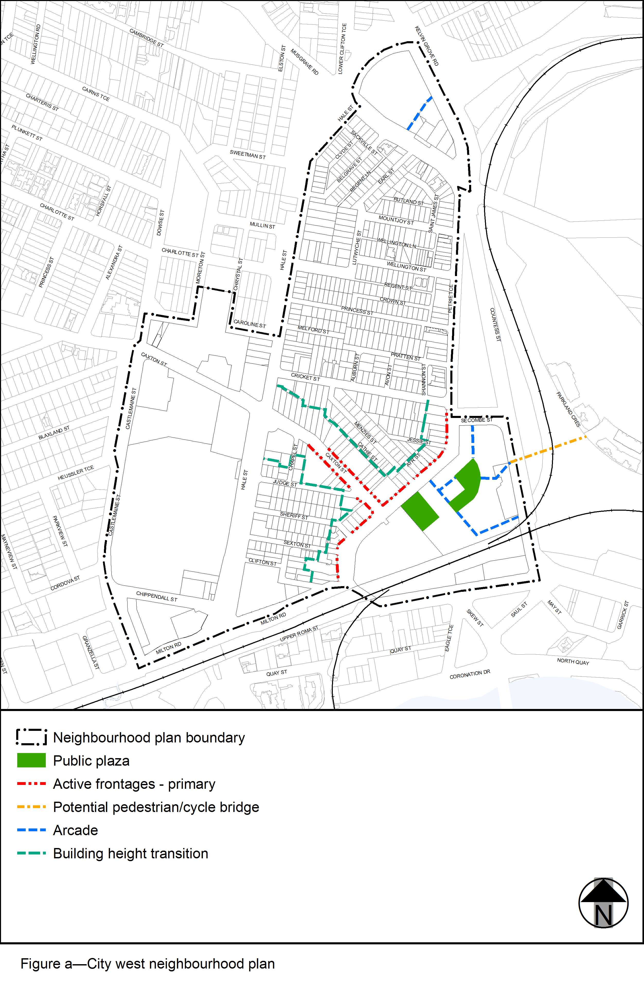View the high resolution of Figure a—City west neighbourhood plan (PDF file size is 428Kb)
’.

3.3 Amendment of section 7.2.12.2 (Latrobe and Given Terraces neighbourhood plan code)
- Section 7.2 Neighbourhood plan codes, 7.2.12.2 Latrobe and Given Terraces neighbourhood plan code, 7.2.12.2.1 Application, (2)
‘
(d) Park precinct (Latrobe and Given Terraces neighbourhood plan/NPP-004).
’ –
omit.
- Section 7.2 Neighbourhood plans, 7.2.12.2 Latrobe and Given Terraces neighbourhood plan code, 7.2.12.2.2 Purpose
‘
- Park precinct (Latrobe and Given Terraces neighbourhood plan/NPP-004) overall outcomes are:
- The small pocket parks of Trammies Corner and Ithaca Memorial Park are retained for passive recreation purposes, and Neal Macrossan Playground for passive and limited active recreation purposes.
- Further development does not occur within Trammies Corner and Ithaca Memorial Park.
- Uses other than recreational purposes do not occur in Neal Macrossan Playground, and any use does not result in the loss of recreation facilities such as Ithaca Pool.
’ –
omit.
- Section 7.2 Neighbourhood plans, 7.2.12.2 Latrobe and Given Terraces neighbourhood plan code, Figure c—Latrobe and Given Terraces Special areas
‘

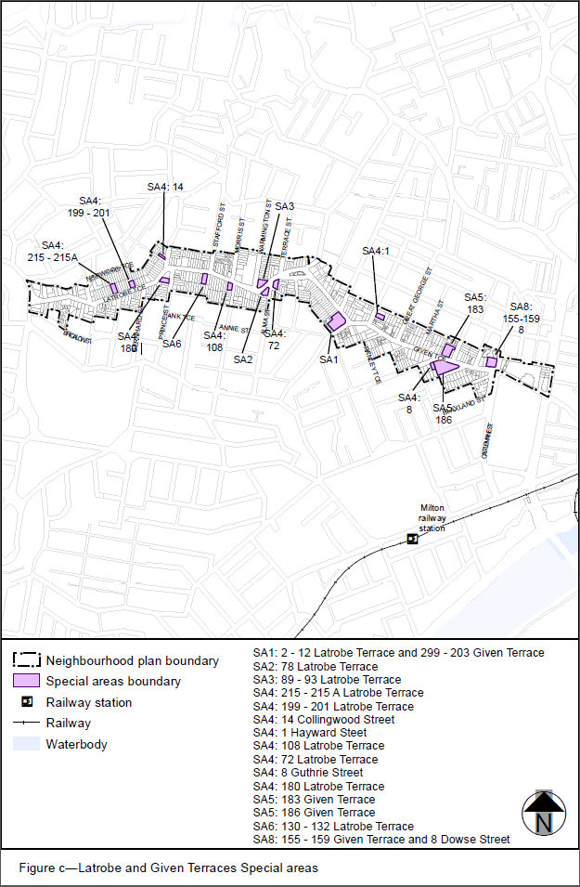
’–
omit, insert:
‘
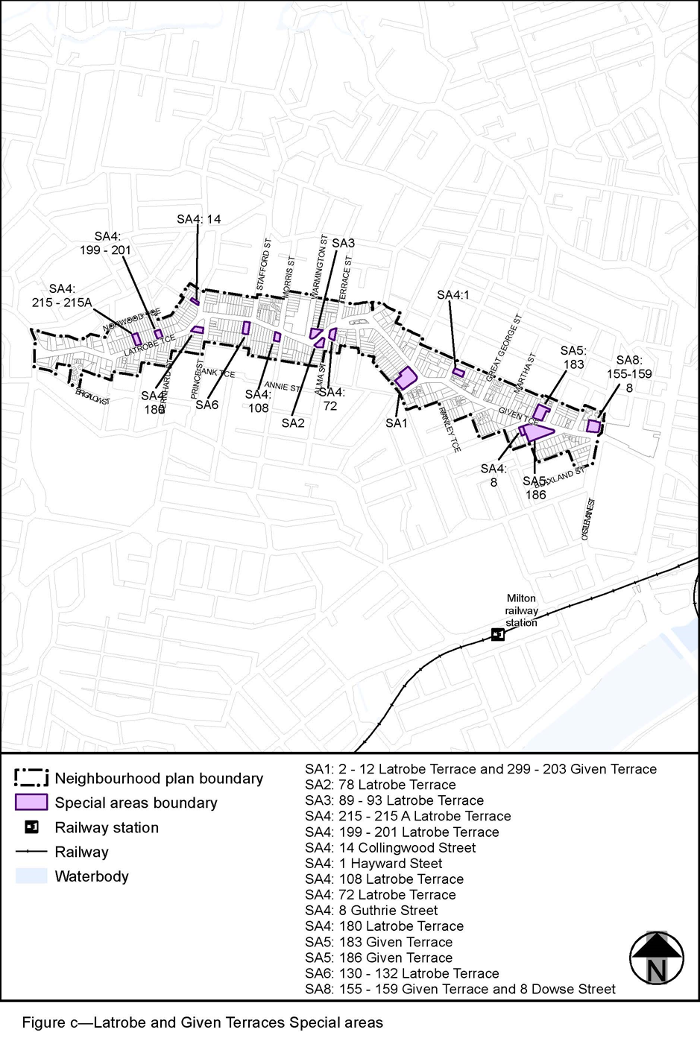’.

3.4 Amendment of section 7.2.16.1 (Petrie Terrace and Spring Hill neighbourhood plan code)
- Section 7.2 Neighbourhood plan codes, 7.2.16.1 Petrie Terrace and Spring Hill neighbourhood plan code
‘

7.2.16.1 Petrie Terrace and Spring Hill neighbourhood plan code

7.2.16.1.1 Application
- This code applies to assessing a material change of use, reconfiguring a lot, operational work or building work in the Petrie Terrace and Spring Hill neighbourhood plan area if:
- assessable development where this code is an applicable code identified in the assessment benchmarks column of a table of assessment for a neighbourhood plan (section 5.9); or
- impact assessable development.
- Land within the Petrie Terrace and Spring Hill neighbourhood plan area is identified on the NPM-016.1 Petrie Terrace and Spring Hill neighbourhood plan map and includes the following precincts:
- Detached house precinct (Petrie Terrace and Spring Hill neighbourhood plan/NPP-001);
- Low-rise residential precinct (Petrie Terrace and Spring Hill neighbourhood plan/NPP-002):
- Low-rise residential 1 sub-precinct (Petrie Terrace and Spring Hill neighbourhood plan/NPP-002a);
- Low-rise residential 2 sub-precinct (Petrie Terrace and Spring Hill neighbourhood plan/NPP-002b);
- Low-rise residential 3 sub-precinct (Petrie Terrace and Spring Hill neighbourhood plan/NPP-002c);
- Low-rise residential 4 sub-precinct (Petrie Terrace and Spring Hill neighbourhood plan/NPP-002d).
- High-rise residential precinct (Petrie Terrace and Spring Hill neighbourhood plan/NPP-003);
- Low-rise commercial precinct (Petrie Terrace and Spring Hill neighbourhood plan/NPP-004):
- Low-rise commercial 1 sub-precinct (Petrie Terrace and Spring Hill neighbourhood plan/NPP-004a);
- Low-rise commercial 2 sub-precinct (Petrie Terrace and Spring Hill neighbourhood plan/NPP-004b);
- Low-rise commercial 3 sub-precinct (Petrie Terrace and Spring Hill neighbourhood plan/NPP-004c);
- Low-rise commercial 4 sub-precinct (Petrie Terrace and Spring Hill neighbourhood plan/NPP-004d);
- Low-rise commercial 5 sub-precinct (Petrie Terrace and Spring Hill neighbourhood plan/NPP-004e).
- High-rise commercial precinct (Petrie Terrace and Spring Hill neighbourhood plan/NPP-005):
- High-rise commercial 1 sub-precinct (Petrie Terrace and Spring Hill neighbourhood plan/NPP-005a);
- High-rise commercial 2 sub-precinct (Petrie Terrace and Spring Hill neighbourhood plan/NPP-005b);
- High-rise commercial 3 sub-precinct (Petrie Terrace and Spring Hill neighbourhood plan/NPP-005c);
- High-rise commercial 4 sub-precinct (Petrie Terrace and Spring Hill neighbourhood plan/NPP-005d).
- Police barracks precinct (Petrie Terrace and Spring Hill neighbourhood plan/NPP-006):
- Police barracks a sub-precinct (Petrie Terrace and Spring Hill neighbourhood plan/NPP-006a);
- Police barracks b sub-precinct (Petrie Terrace and Spring Hill neighbourhood plan/NPP-006b);
- Police barracks c sub-precinct (Petrie Terrace and Spring Hill neighbourhood plan/NPP-006c);
- Police barracks d sub-precinct (Petrie Terrace and Spring Hill neighbourhood plan/NPP-006d).
- When using this code, reference should be made to section 1.5, section 5.3.2 and section 5.3.3.
Note—The following purpose, overall outcomes, performance outcomes and acceptable outcomes comprise the assessment benchmarks of this code.
Note—This neighbourhood plan includes a table of assessment with variations to categories of development and assessment. Refer to Table 5.9.54.A, Table 5.9.54.B, Table 5.9.54.C and Table 5.9.54.D.

7.2.16.1.2 Purpose
- The purpose of the Petrie Terrace and Spring Hill neighbourhood plan code is to provide finer grained planning at a local level for the Petrie Terrace and Spring Hill neighbourhood plan area.
- The purpose of the Petrie Terrace and Spring Hill neighbourhood plan code will be achieved through overall outcomes including overall outcomes for each precinct of the neighbourhood plan area.
- The overall outcomes for the neighbourhood plan area are:
- The neighbourhood plan protects the character of the built environment by restricting the demolition of buildings that have either character or heritage significance. Petrie Terrace and Spring Hill were two of the first parts of the city to be settled and as such, contain some of the oldest buildings and traditional character streetscape in the city. Traditional modest residential dwellings erected on small allotments are the hallmark of Petrie Terrace and Spring Hill. These buildings and areas make a significant contribution to Brisbane’s heritage and character and are to be retained.
- Any new development is to be sympathetic to the scale and character of the original urban development pattern and siting of existing buildings. Development in the identified heritage protection precincts is to retain and reinforce the original character of buildings predominating during the period 1850 to 1920. Proposals in other precincts, subject to building design and character requirements, are to retain and improve upon the existing character by incorporating the main identifiable features, materials and detailing of buildings that predominated during the period from 1850 to 1935.
- The high level of inner-city residential amenity prevalent in Petrie Terrace and Spring Hill is not to be reduced through commercial expansion, increase in non-local traffic movements, City Centre commuter parking overspill and general deterioration of housing stock.
- Traditional character is to be protected from unsympathetic proposals in order to attract people to live within walking distance of the City Centre by improving the amenity and attractiveness of the neighbourhood plan area and encouraging an upgrading of traditional housing stock.
- Higher density residential and commercial development is to be contained to those areas identified as suitable for such uses. The expansion of commercial uses in the neighbourhood plan area outside the City Centre, or other areas well served by both bus and rail, is discouraged in order to reduce impacts on residential areas and the traffic network.
- Population increase and housing choice is encouraged through providing a range of dwelling types across the residential precincts. Residential and mixed-use development is encouraged in the commercial precincts by allowing residential floor space to be provided in addition to that permitted for commercial use and by creating environments in the commercial areas conducive to residential amenity.
- Detached house precinct (Petrie Terrace and Spring Hill neighbourhood plan/NPP-001) overall outcomes are:
- The precinct is intended as a heritage and character protection precinct that preserves the area’s unified streetscapes featuring traditional built form character and buildings of similar age and generally high integrity. It comprises residential areas featuring cohesive and homogenous character, suffering little from the intrusion of other forms of development and relatively isolated from the effects of traffic and non-residential development. These areas are unsuitable for higher intensity residential development and are buffered from the highest intensity residential and commercial areas by a ring of less-intensive uses. As such, residential development in the precinct is intended to be in the form of detached houses strongly reflecting the typical Petrie Terrace and Spring Hill character predominating during the period 1850 to 1935. Existing traditional character buildings are to be retained wherever possible in preference to new buildings.
- Any new development within the precinct, including the erection of new houses, restoration, rehabilitation, repairs, alteration or additional, is to be carried out in a style and using materials consistent with the traditional character of the precinct.
- The neighbourhood plan requirements recognise the practical difficulties of rebuilding on the existing small sites located in areas with narrow and closely spaced roads and sloping terrain. As such, there are no minimum site area requirements for detached houses. The erection of the same type of houses that were originally built, subject to compliance with the requirements of this code, is encouraged. However, the subdivision of existing allotments is not considered to be appropriate.
- The following uses are considered consistent with the outcomes sought for the precinct:
- theatre if in special area 21 identified in Figure b;
- parking station in special area 14 identified in Figure b if the car parking structure is no greater than 6.2m in overall height and the upper deck is no greater than 5.2m in height, with a side boundary clearance of 1.5m and perimeter screening of 1m height.
- Low-rise residential precinct (Petrie Terrace and Spring Hill neighbourhood plan/NPP-002) overall outcomes are:
- There are four sub-precincts within the Low-rise residential precinct providing for a variety of building intensities and housing types. The precinct comprises a band of more-intensive residential buildings, generally following the ridgelines of Gregory Terrace and Petrie Terrace and major roads, such as Boundary Street, that buffer areas of detached housing from the commercial precincts. The precinct is intended to retain the traditional urban form and built character and to accommodate multiple dwellings and dwelling houses. Multiple dwellings and dwelling houses are to be compatible with the traditional character of detached housing predominating during the period 1850 to 1935 by incorporating and/or reflecting the main building design and character elements of these older dwellings. New development is to incorporate any existing traditional character building with the new building and any extensions or alterations to be designed so that they are sympathetic to the style of the existing building.
- Development in the Low-rise residential 1 sub-precinct (Petrie Terrace and Spring Hill neighbourhood plan/NPP-002a):
- provides for relatively low-rise medium intensity residential development in the form of townhouses or duplexes. Located in the residential hearts of Petrie Terrace and Spring Hill, the sub-precinct provides a transition from the style and intensity of development occurring in the Detached house precinct (Petrie Terrace and Spring Hill neighbourhood plan/NPP-001) to the style and intensity occurring in the surrounding precincts that are allocated to higher intensity residential and non-residential uses.
- Development in the Low-rise residential 2 sub-precinct (Petrie Terrace and Spring Hill neighbourhood plan NPP-002b):
- is suited to ‘walk up’ housing and is generally suited to higher density residential uses due to its visual amenity, proximity to parkland, its elevated location, the size of existing allotments and its proximity to the City Centre.
- Development in the Low-rise residential 3 sub-precinct (Petrie Terrace and Spring Hill neighbourhood plan/NPP-002c):
- is suited to ‘walk up’ housing. However, the sub-precinct acts as a buffer between the Detached house precinct (Petrie Terrace and Spring Hill neighbourhood plan/NPP-001) and the commercial precincts. Many of the sites have a frontage to a road with a high volume of traffic and thus are unsuited to development of a type or intensity likely to generate a substantial volume of vehicular movements.
- Development in the Low-rise residential 4 sub-precinct (Petrie Terrace and Spring Hill neighbourhood plan/NPP-002d):
- does not encourage high-intensity residential or non-residential uses, but does support the highest feasible intensities for ‘walk-up’ housing. The appearance of buildings is to be sympathetic with buildings in the adjacent Detached house precinct (Petrie Terrace and Spring Hill neighbourhood plan/NPP-001).
- The following uses are considered consistent with the outcomes sought for the precinct:
- parking station in special area 3 identified in Figure a if ancillary parking for adjoining development not within the Low-rise residential sub-precincts;
- club if in special area 5, special area 6, special area 10, special area 13 and special area 20 identified in Figure a;
- place of worship;
- health care service if in special area 7 identified in Figure a;
- office if in the Low-rise residential sub-precincts on a site fronting Boundary Street;
- telecommunications facility where a broadcasting station or television station if in the Low-rise residential sub-precinct on a site fronting Boundary Street;
- veterinary service if in the Low-rise residential sub-precincts on a site fronting Boundary Street.
- High-rise residential precinct (Petrie Terrace and Spring Hill neighbourhood plan/NPP-003) overall outcomes are:
- The precinct comprises allotments which are generally larger, road capacities which are greater, services which are readily augmented if necessary and where the amenity, character or available views encourage such uses. Generally, high-rise apartments are to be concentrated in the southern and western residential parts of Spring Hill following the ridgelines along Leichhardt Street and Wickham Terrace.
- The precinct is particularly suited to high-rise housing, partly because of its relative closeness to the City Centre, and partly because of its topographic advantages, with ridges along the main roads and most of the remaining land sloping to the north or north-east.
- Considering the diverse range of existing residential and non-residential uses, and proximity of this precinct to the commercial precincts to the east, it is intended that the precinct develops for a wide range of residential uses. As it is intended that there should be a variety of residential types, and as it is desirable to allow the opportunity to develop the small sites in the precinct, it is also possible to erect low-rise apartments, attached houses or detached houses in accordance with the provisions applicable in the Low-rise residential precinct (Petrie Terrace and Spring Hill neighbourhood plan/NPP-002).
- The following uses are considered consistent with the outcomes sought for the precinct:
- theatre if in special area 21 identified in Figure b;
- indoor sport and recreation if in special area 6 or special area 20 identified in Figure a;
- centre activities activity group if in special area 2 or special area 22 identified in Figure a;
- hospital, office and health care service if in special area 8 identified in Figure a;
- food and drink outlet if in special area 9 identified in Figure a.
- Low-rise commercial precinct (Petrie Terrace and Spring Hill neighbourhood plan/NPP-004) overall outcomes are:
- The precinct is divided into five sub-precincts. Many of the provisions applicable to the precinct are similar to those applying in the Low-rise residential precinct (Petrie Terrace and Spring Hill neighbourhood plan/NPP-002). In both precincts, development is facilitated on small sites and is to be compatible with the traditional Spring Hill and Petrie Terrace character. It is intended that development in most of the sub-precincts in the precinct is built close to or on the alignment and that most of the available space in front of and around the buildings be landscaped.
- Development with large setbacks allocated particularly close to car parking is not encouraged as this would be detrimental to the character of the precinct.
- Preferred non-residential uses are those that are not likely to attract a significant number of business trips or cause non-local traffic impacts in the residential precincts.
- Development in the Low-rise commercial 1 sub-precinct (Petrie Terrace and Spring Hill neighbourhood plan/NPP-004a):
- is set back from the road alignment and exhibit a residential character. The sub-precinct maintains a residential character, but complements the role of neighbouring commercial precincts and provides a transition between commercial and residential areas. Mixed use development allowing people to both live and work on the same site is encouraged.
- Development in the Low-rise commercial 2 sub-precinct (Petrie Terrace and Spring Hill neighbourhood plan/NPP-004b):
- is set back from the road alignment and complements existing and proposed development in neighbouring residential areas with respect to scale, bulk and other design features.
- Development in the Low-rise commercial 3 sub-precinct (Petrie Terrace and Spring Hill neighbourhood plan/NPP-004c):
- complements the role of the Low-rise commercial 4 sub-precinct (Petrie Terrace and Spring Hill neighbourhood plan/NPP-004d), while recognising the nature and function of prior buildings and existing uses. Development may be built to the alignment where appropriate in the streetscape. New buildings should incorporate sufficient car parking facilities to meet parking needs on site and residual areas should be landscaped. Mixed use development is also consistent with the outcomes sought.
- Development in the Low-rise commercial 4 sub-precinct (Petrie Terrace and Spring Hill neighbourhood plan/NPP-004d):
- provides for a heritage and character protection precinct that preserves the commercial building types, including commercial character buildings, and streetscapes that predominated in the precinct during the period from 1850 to 1920. Any new development within the precinct, including the erection of buildings, restoration, rehabilitation, repairs, alteration or additions, is to be carried out in a style and using materials consistent with the traditional character of the precinct. In order to maintain continuity of facades along Caxton Street, building up to the alignment of Caxton Street is required. The provision of continuous pedestrian shelter, where appropriate in the streetscape, is also considered essential to the retention of character. The provision of off-street parking is essential as this precinct borders residential areas already experiencing significant impacts from commercial uses in the area.
- Development in the Low-rise commercial 5 sub-precinct (Petrie Terrace and Spring Hill neighbourhood plan/NPP-004e):
- recognises the existence of buildings erected for non-residential purposes which have continued to be used in this way. Any new buildings in this precinct should complement existing and proposed buildings in the
Low-rise commercial 4 sub-precinct with respect to scale, bulk and design features. New development should be set back from the road alignment. Any development that would attract vehicle-based shopping trips is considered inappropriate.
- High-rise commercial precinct (Petrie Terrace and Spring Hill neighbourhood plan/NPP-005) overall outcomes are:
- The four sub-precincts in this precinct can be considered as four bands of building intensity stepping out and down from the City Centre. These bands allow a gradation of intensity, height and uses, with the highest being closest to the City Centre, and the lowest merging with the Low-rise residential precinct (Petrie Terrace and Spring Hill neighbourhood plan/NPP-002) north of Boundary Street.
- Residential and mixed use development is encouraged through enabling gross floor area in excess of the maximum permitted for non-residential uses. However, the permitted intensity of residential buildings reduces between successive precincts in a similar manner to that of non-residential buildings. The type of activities envisioned within the various precincts also varies with distance from the City Centre.
- The requirements for commercial use in the precinct are more detailed because of the concern to create an environment conducive to residential uses. Awnings are to be provided to shelter pedestrians from the impacts of sun and rain. It is intended that proposals further enhance the precinct’s character through the introduction of landscaping of setback areas, provision of garden plants and the establishment of street trees. Proposals providing mid-block public pedestrian connections between roads such as Leichhardt Street, Astor Terrace and Wickham Terrace are consistent with the outcomes sought.
- The environment for the first 2 or 3 storeys is essentially of a commercial character in the form of a podium extended to the boundaries, except where front setbacks are required. Tower construction is intended above the podium, providing open space at the upper levels, and where residential uses are proposed, providing opportunities for outdoor living areas on roof decks. The location and shape of towers is to be carefully designed to minimise impacts of loss of light, air and outlook to buildings in the vicinity.
- Development in the High-rise commercial 1 sub-precinct (Petrie Terrace and Spring Hill neighbourhood plan/NPP-005a):
- is suited to the highest intensity of both residential and non-residential uses within the Petrie Terrace and Spring Hill neighbourhood plan area because of its close proximity to the City Centre, Central Station, bus routes, parking facilities and accessibility to major traffic arteries. Centre activities providing commercial, technical and professional services for the activities in the City Centre are considered most appropriate. However, specialist medical functions contribute substantially to the character of the sub-precinct and their continued concentration is encouraged. Residential opportunities are provided by the form of high-rise multiple dwellings and short-term accommodation.
- The High-rise commercial 2 sub-precinct (Petrie Terrace and Spring Hill neighbourhood plan/NPP-005b) is well beyond the average walking distances from the main bus routes and centres of activity in the City Centre and is only just within such distance from Central Station. In addition, the topography is not encouraging for pedestrians. For these reasons the maximum commercial plot ratio in this precinct is roughly one-third less than that in High-rise commercial 1 sub-precinct (Petrie Terrace and Spring Hill neighbourhood plan/NPP-005a). Development in this sub-precinct:
- encourages residential and non-residential activities similar to those in the High-rise commercial 1 sub-precinct (Petrie Terrace and Spring Hill neighbourhood plan/NPP-005a). Uses associated with medical and other professional and technical services are also catered for.
- The High-rise commercial 3 sub-precinct (Petrie Terrace and Spring Hill neighbourhood plan/NPP-005c) is remote from the City Centre and the main public transport routes and, as such, the majority of employees could be expected to commute by car. In addition to increasing congestion on the arterial street system, large-scale uses would increase the demand for day-time parking and have adverse impact on the residential precincts of Spring Hill. Consequently the plot ratio for commercial uses has been matched to that of equivalent areas outside the Petrie Terrace and Spring Hill neighbourhood plan. Development in this sub-precinct:
- has a distinctive character despite many of its possible uses being the same as High-rise commercial 1 sub-precinct (Petrie Terrace and Spring Hill neighbourhood plan/NPP-005a) and High-rise commercial 2 sub-precinct (Petrie Terrace and Spring Hill neighbourhood plan/NPP-005b). Non-residential uses considered most acceptable are those encountered in the transitional areas at the fringe of the City Centre.
- The High-rise commercial 4 sub-precinct (Petrie Terrace and Spring Hill neighbourhood plan/NPP-005d) has been matched to that of equivalent areas outside the Petrie Terrace and Spring Hill neighbourhood plan due to its distance from public transport and the City Centre and has the same character of land use as found in High-rise commercial 3 sub-precinct (Petrie Terrace and Spring Hill neighbourhood plan/NPP-005c). Development in this sub-precinct:
- has a range of activities provided for where no detriment would be likely to the amenity of existing or future residential uses or development.
- The following uses are considered consistent with the outcomes sought for the precinct:
- outdoor sales and low impact industry if vehicle sales, repair and servicing where in the High-rise commercial 3 sub-precinct (Petrie Terrace and Spring Hill neighbourhood plan/NPP-005c) or High-rise commercial 4 sub-precinct (Petrie Terrace and Spring Hill neighbourhood plan/NPP-005d);
- hospital if in the High-rise commercial 3 sub-precinct (Petrie Terrace and Spring Hill neighbourhood plan/NPP-005c) or High-rise commercial 4 sub-precinct (Petrie Terrace and Spring Hill neighbourhood plan/NPP-005d).
- Police Barracks precinct (Petrie Terrace and Spring Hill neighbourhood plan/NPP-006) overall outcomes are:
- New development within this precinct integrates with the existing significant buildings. Any development is to be carried out in a manner that does not prejudice the retention and appearance of the existing buildings, including the Police Barracks buildings, and be of a scale that will complement and be consistent with the architectural building forms and style of those buildings. New development is also to be cognisant of the landmark qualities of the precinct and the impact on the city skyline that any new building work may have.
- The precinct has four sub-precincts, each of which combine with a table of assessment and assessment benchmarks to ensure an appropriate nature and intensity of use is achieved for each sub-precinct.
- For development in a special area identified in Figure a or Figure b:
- A special area is a number of existing sites that do not comply with the outcomes sought for the precinct in which the site is located. However, where the use is generally well established and accepted by the community, it has been included as a special area to provide for the continuation of the use. Reasonable intensification and expansion of the use is possible provided it is located within the defined boundaries of the special area.
- Other special areas have been created to provide for the inclusion of alternative purposes or consideration of slightly higher residential intensities, where a particular planning problem has been identified and the potential exists to rectify it by applying more flexible planning provisions.
- It is intended that all development in special areas complies with the provision of this code pertaining to the precinct and sub-precinct if applicable in which the site is located. However, where the functions and other intrinsic characteristics of the particular purposes or any special circumstances of the special area make such compliance unreasonable, variation is possible provided the development exhibits the built form character intended for the precinct. If for some reason an existing use ceases, the site concerned should be developed under the other provisions of this code that apply in the precinct, and sub-precinct if applicable, in which it is located. However, where lawfully erected existing buildings are demolished, they may be rebuilt provided the new development does not contravene this code to any greater extent.

7.2.16.1.3 Performance outcomes and acceptable outcomes

Table 7.2.16.1.3.A—Performance outcomes and acceptable outcomes
Performance outcomes |  |  | Acceptable outcomes
General – number of storeys and building height
PO1  Development is of a height, scale and form that achieves the intended outcome for the precinct, improves the amenity of the neighbourhood plan area, contributes to a cohesive streetscape and built form character and is:  - consistent with anticipated density and assumed infrastructure demand;  - aligned to community expectations about the number of storeys to be built;  - proportionate to and commensurate with the utility of the site area and frontage width;  - designed to avoid significant and undue adverse amenity impact to adjoining development;  - sited to enable existing and future buildings to be well separated from each other and to avoid affecting the potential development of adjoining sites.  Note—Development that exceeds the intended number of storeys or building height can place disproportionate pressure on the transport network, public space or community facilities in particular.  Note—Development that is over-scaled for its site can result in an undesirable dominance of vehicle access, parking and manoeuvring areas that significantly reduce streetscape character and amenity. |  |  | AO1  Development complies with the number of storeys and building height in Table 7.2.16.1.3.B.  Note—Neighbourhood plans will mostly specify the maximum number of storeys where zone outcomes have been varied in relation to building height. Some neighbourhood plans may also specify the height in metres. Development must comply with both parameters where maximum number of storeys and height in metres are specified.
PO2  Development of buildings in the Detached house precinct (Petrie Terrace and Spring Hill neighbourhood plan/NPP-001), Low-rise residential precinct (Petrie Terrace and Spring Hill neighbourhood plan/NPP-002) and Low-rise commercial precinct (Petrie Terrace and Spring Hill neighbourhood plan/NPP-004) are of a compatible scale and design and contribute positively to the amenity and desired traditional character of the precincts. |  |  |  | AO2  Building height does not exceed the eaves height specified in Table 7.2.16.1.3.B except for a pitched roof that may extend to the specified ridge height, if:  - the roof pitch does not commence above the specified ridge height;  - no part of the roof exceeds a maximum pitch of 45^{ο}.  Note—An additional attic storey built into the roof space is appropriate provided the building maintains the appearance of having the number of storeys indicated in Table 7.2.16.1.3.B.  Note—For detail in calculating compliance and other exceptions refer to Figure d.
PO3  Development of podiums in the High-rise commercial precinct (Petrie Terrace and Spring Hill neighbourhood plan/NPP-005) is appropriate in height to the precinct’s function and context, and is consistent with the scale and design of nearby buildings. |  |  |  | AO3  Development of podiums does not exceed the height specified in Table 7.2.16.1.3.B.  Note—Guidance on how to apply these building forms is provided in Figure r.  Note—Additional podium height may be appropriate where the building form provides a consistent streetscape, does not result in enclosure or obstruction of outlook for nearby properties taking into account the nature of current and future buildings in the vicinity of the site.
General – site access and car parking
PO4  Development provides vehicle access and parking that is designed and located to ensure convenient and safe parking and vehicular access that does not detract from the aesthetics or amenity of the area. |  |  | AO4.1  Development for a dwelling house:  - provides a minimum of 1 car parking space;  - where the area of the site is less than 200m2 and it would be impracticable to require a car parking space, does not require on-site car parking.
AO4.2
Development in the High-rise commercial 1 sub-precinct (Petrie Terrace and Spring Hill neighbourhood plan/NPP-005a) provides:
- not more than 1 car parking space per 125m2 of gross floor area for non-residential development of the non-residential part of a development in a mixed use development;
- not fewer than 1 car parking space per dwelling unit and not more than 1.5 spaces per dwelling for residential development or the residential part of a mixed use development.
AO4.3
Development provides no more than 20 car parking spaces for non-residential activities in the High-rise commercial precinct (Petrie Terrace and Spring Hill neighbourhood plan/NPP-005), where alternative access is not possible and the site has a frontage of less than 40m to the following roads:
- Boundary Street;
- Leichhardt Street;
- Little Edward Street;
- Turbot Street;
- Upper Edward Street;
- Wharf Street;
- Wickham Street.
AO4.4
Development of an office where located in the Low-rise residential precinct (Petrie Terrace and Spring Hill neighbourhood plan/NPP-002) provides no more than 10% more car parking spaces than required under the Transport, access, parking and servicing code.
AO4.5
Development that cannot reasonably provide access from some other road frontage or alternative location does not provide vehicle access within 9m of an intersection with any of the following roads:
- Boundary Street;
- Brunswick Street;
- Caxton Street;
- Gregory Terrace;
- Hale Street;
- Leichhardt Street;
- Little Edward Street;
- Milton Road;
- Musgrave Road;
- Petrie Terrace;
- St Pauls Terrace;
- Turbot Street;
- Upper Edward Street;
- Water Street;
- Wharf Street;
- Wickham Terrace.
AO4.6
Development that cannot reasonably provide access from some other road frontage or alternative location does not provide vehicle access from a road:
- less than 7m wide on which traffic normally travels in two directions;
- less than 5m wide on which traffic normally travels in one direction.
AO4.7
Development for any activity except for a dwelling house or non-residential use requiring no more than 3 car parking spaces provides on-site manoeuvring for all types of vehicles where vehicle access is to the following roads:
- Boundary Street;
- Brunswick Street;
- Caxton Street;
- Gregory Terrace;
- Hale Street;
- Leichhardt Street;
- Little Edward Street;
- Milton Road;
- Musgrave Road;
- Petrie Terrace;
- St Pauls Terrace;
- Turbot Street;
- Upper Edward Street;
- Water Street;
- Wharf Street;
- Wickham Terrace.
General – residential amenity
PO5  Development provides dwelling houses with private outdoor living areas sufficient to meet residents’ needs and consistent with the intended character of the Detached house precinct (Petrie Terrace and Spring Hill neighbourhood plan/NPP-001) and Low-rise residential precinct (Petrie Terrace and Spring Hill neighbourhood plan/NPP-002). |  |  | AO5  Development provides a dwelling house with a minimum private outdoor living area of:  - 60m² with a 4.5m minimum horizontal dimension; or  - 30m² with a 4.5m minimum horizontal dimension, if the site has an area of less than 200m² or the shape or topography of the site constrains provision of additional outdoor living area.
PO6  Development activity creates a high level of amenity and does not reduce the amenity of adjacent uses or detract from the intended character of the precinct and neighbourhood plan area. |  |  | AO6.1  Development for residential or mixed residential/non-residential uses in the Detached house precinct (Petrie Terrace and Spring Hill neighbourhood plan/NPP-001) and Low-rise residential precinct (Petrie Terrace and Spring Hill neighbourhood plan/NPP-002):  - orientates the windows of the habitable rooms towards the front and rear boundary of the site, other for a corner site;  - orientates the windows of habitable rooms to avoid privacy conflicts if outdoor living areas are located adjacent to side boundaries or development is located on a corner lot.
AO6.2
Development for residential or mixed residential and non-residential uses in the High-rise commercial precinct (Petrie Terrace and Spring Hill neighbourhood plan/NPP-005) provide dwellings with an outlook space 10m by 10m in dimension abutting the main window of a living room, if:
- the sill of that window is located on one side of that space;
- no structure other than a fence, mast or similar, or part of a balcony of the relevant unit, intrudes upon that space;
- that space is contained within the boundaries of the site of the building containing that unit and includes the road abutting it to the centre line of the road.
PO7  Development of separate structures not used for human habitation that form part of a use are designed and sited to preserve the amenity of adjacent uses and are compatible with the building/s they serve. |  |  | AO7.1  Development of an ancillary building in all precincts is designed and located to be sympathetic to the building/s that it serves and located so as not to detract from the building/s on the site as a whole.
AO7.2
Development of an ancillary building in the Detached house precinct (Petrie Terrace and Spring Hill neighbourhood plan/NPP-001), Low-rise residential precinct (Petrie Terrace and Spring Hill neighbourhood plan/NPP-002) and Low-rise commercial precinct (Petrie Terrace and Spring Hill neighbourhood plan/NPP-004):
- does not exceed 2.4m in maximum height, except for a roof that may extend to a maximum of 3.6m in height at the ridge of the roof;
- may extend to a side boundary provided the height above ground level at the boundary is limited to 2m where the building length along the relevant boundary is greater than 6m;
- increases in height within a 45º angle to the horizontal, as the setback increases from a side or rear boundary;
- are compatible with the building types that predominated from 1850 to 1935.
Refer to Figure c.
If in a residential precinct – gross floor area
PO8  Development building size and bulk are of a density consistent with the nature of the locality and retain an appropriate residential scale and relationship with other buildings. |  |  | AO8.1  Development has a maximum gross floor area of 60% of the site area in the Low-rise residential 1 sub-precinct
AO8.2
Development has a maximum gross floor area in the Low-rise residential 2 sub-precinct (Petrie Terrace and Spring Hill neighbourhood plan/NPP-002b), Low-rise residential 3 sub-precinct (Petrie Terrace and Spring Hill neighbourhood plan/NPP-002c) and Low-rise residential 4 sub-precinct (Petrie Terrace and Spring Hill neighbourhood plan/NPP-002d) as follows:
 |  |  | Site area |  |  |  |  | Gross floor area
 |  |  | less than 1,200m² |  |  |  |  | 100% of the site area
 |  |  | 1,200m² to 3,000m² |  |  |  |  | 1,220m² + 140% of the site area (site area minus 1,200m²)
 |  |  | greater than 3,000m² |  |  |  |  | 125% of the site area
AO8.3
Development has a maximum gross floor area in the High-rise residential precinct (Petrie Terrace and Spring Hill neighbourhood plan/NPP-003) of:
 |  |  | Site area |  |  |  |  | Gross floor area
 |  |  | less than 1,000m² |  |  |  |  | 60% of the site area
 |  |  | 1,000m² to 1,200m² |  |  |  |  | 600m² + 120% of the site area (site area minus 1,000m²)
 |  |  | over 1,200m² to 1,500m² |  |  |  |  | 140% of the site area minus 460m²
 |  |  | over 1,500m² to 3,500m² |  |  |  |  | 2,120m² + 200% of the site area (site area minus 1,500m²)
 |  |  | greater than 3,500m² |  |  |  |  | 175% of the site area
AO8.4
Development in the Low-rise residential 3 sub-precinct has a gross floor area for that part of the building used for non-residential purposes no greater than 50% of the maximum allowable gross floor area for the site.
If in a residential precinct – site cover
PO9  Development provides buildings that are of a scale and design generally compatible with those of nearby buildings and contribute positively to the amenity and character of the local area. |  |  | AO9.1  Development has a maximum site cover in the Low-rise residential precinct (Petrie Terrace and Spring Hill neighbourhood plan/NPP-002) of:  - 50% of the area of the site; or  - 60% of the area of the site if ancillary buildings associated with recreational uses is provided for residential development.
AO9.2
Development has a maximum site cover in the High-rise residential precinct (Petrie Terrace and Spring Hill neighbourhood plan/NPP-003) of:
- 30% for the first 2 storeys above ground level;
- 20% for the third storey above ground level and above.
If in a residential precinct – street frontage setbacks
PO10  The building setbacks complement the setbacks prevailing in the street. |  |  |  | AO10.1  Development provides a minimum building setback of 6m from the road alignment to all alignments in the High-rise residential precinct (Petrie Terrace and Spring Hill neighbourhood plan/NPP-003) and to the following road frontages in all other residential precincts:  - Boundary Street;  - Brunswick Street;  - Caxton Street;  - Gregory Terrace;  - Hale Street;  - Milton Road;  - Musgrave Road;  - Petrie Terrace;  - St Pauls Terrace;  - Water Street;  - Wickham Terrace.
AO10.2
Development provides a minimum building setback of 4m to all other road frontages in the Detached house precinct (Petrie Terrace and Spring Hill neighbourhood plan/NPP-001) and Low-rise residential precinct (Petrie Terrace and Spring Hill neighbourhood plan/NPP-002).
AO10.3
Development of open verandahs, balconies, carports and ancillary buildings may extend up to 2m into the building setback, and bay windows by not more than 0.75m in the Detached house precinct (Petrie Terrace and Spring Hill neighbourhood plan/NPP-001) and Low-rise residential precinct (Petrie Terrace and Spring Hill neighbourhood plan/NPP-002).
AO10.4
Development of buildings fronting Water Street in the Low-rise residential 3 sub-precinct (Petrie Terrace and Spring Hill neighbourhood plan/NPP-002c) may extend to the front alignment.
If in a residential precinct – side and rear setbacks
PO11  Development of buildings is well separated to allow for natural light penetration, air circulation, outlook and privacy. |  |  |  | AO11.1  Development provides minimum boundary clearances as follows:
 |  |  |  | Precinct/sub-precinct |  |  |  |  | Side setbacks
 |  |  |  | Detached house precinct (Petrie Terrace and Spring Hill neighbourhood plan/NPP-001) |  |  |  |  | 1.5m
 |  |  |  | Low-rise residential 1 sub-precinct (Petrie Terrace and Spring Hill neighbourhood plan/NPP-002a)  Low-rise residential 2 sub-precinct (Petrie Terrace and Spring Hill neighbourhood plan/NPP-002b)  Low-rise residential 3 sub-precinct (Petrie Terrace and Spring Hill neighbourhood plan/NPP-002c)  Low-rise residential 4 sub-precinct (Petrie Terrace and Spring Hill neighbourhood plan/NPP-002d) |  |  |  |  | 10m or 6m in a screened situation  Note—A screened situation is provided in the Detached house precinct and the  Low-rise residential precinct, where the following is provided along the relevant boundary:  - a maximum 6.8m building height to eaves;  - a 1.8m high fixed privacy screen or fence;  - densely planted screening vegetation able to achieve 6m in height.
 |  |  |  | High-rise residential precinct (Petrie Terrace and Spring Hill neighbourhood plan/NPP-003) |  |  |  |  | 50% of the building height or 3m, whichever is greater
 |  |  |  | Precinct/sub-precinct |  |  |  |  | Rear setback
 |  |  |  | Detached house precinct (Petrie Terrace and Spring Hill neighbourhood plan/NPP-001);  Low-rise residential 1 sub-precinct (Petrie Terrace and Spring Hill neighbourhood plan/NPP-002a);  Low-rise residential 2 sub-precinct (Petrie Terrace and Spring Hill neighbourhood plan/NPP-002b);  Low-rise residential 3 sub-precinct (Petrie Terrace and Spring Hill neighbourhood plan/NPP-002c);  Low-rise residential 4 sub-precinct (Petrie Terrace and Spring Hill neighbourhood plan/NPP-002d) |  |  |  |  | 10m or 6m in a screened situation  Note—A screened situation is provided in the Detached house precinct and the Low-rise residential precinct, where the following is provided along the relevant boundary:  - a maximum 6.8m building height to eaves;  - a 1.8m high fixed privacy screen or fence;  - densely planted screening vegetation able to achieve 6m in height.
 |  |  |  | High-rise residential precinct (Petrie Terrace and Spring Hill neighbourhood plan/NPP-003) |  |  |  |  | 50% of the building height or 6m, whichever setback is greater
AO11.2
Development provides a minimum 1.5m side boundary clearance for part of a building located within 20m of a road frontage in the Low-rise residential precinct (Petrie Terrace and Spring Hill neighbourhood plan/NPP-002) provided total building length is not greater than 15m of which no more than 10m exceeds a building eaves height of 6.8m.
AO11.3
Development provides a minimum 3m side boundary clearance for part of a building located more than 20m from a road frontage in the Low-rise residential precinct (Petrie Terrace and Spring Hill neighbourhood plan/NPP-002), if:
- total building length is not greater than 15m of which no more than 10m exceeds a building eaves height of 6.8m;
- a screened situation is provided for a distance of 10m between this part of the building and any other part of the building setback less than 6m from a side boundary.
AO11.4
Development may have open verandahs, balconies and external stairs that extend 1.25m inside the minimum side and rear boundary setbacks in the Low-rise residential precinct (Petrie Terrace and Spring Hill neighbourhood plan/NPP-002) and the rear boundary setback in the Detached house precinct (Petrie Terrace and Spring Hill neighbourhood plan/NPP-001, as specified in AO11.1. Other exceptions, where a minimum 1.5m setback is possible, are as follows:
- a minimum side boundary setback to eaves of 1.2m;
- a minimum side boundary setback to window or sun hoods of 0.75m.
Note—For detail in calculating compliance in the Low-rise residential precinct, refer to Figure e.
AO11.5
Development involving part of a building in the Detached house precinct (Petrie Terrace and Spring Hill neighbourhood plan/NPP-001) may extend to a side boundary, if:
- that part of the building is limited to 10m in length, with the exception of any extensions or alterations to an existing building as at 13 June 1997 that maintain the existing boundary setback or a greater setback;
- the building is less than 20m in total length along the relevant boundary;
- that part of the building is not closer than 2m to any habitable room window of a dwelling on an adjoining site.
Note—-Advice is to be provided by adjoining landowners that they have no objection to side boundary clearances less than that specified in AO11.1 in relation to an extension or addition to an existing building.
AO11.6
Development involving part of a building in the Detached house precinct (Petrie Terrace and Spring Hill neighbourhood plan/NPP-001) may provide a minimum 3m rear boundary clearance if the site is so small or shallow, or the topography such that development would otherwise be rendered impractical or unsatisfactory.
AO11.7
Development involving part of a building located within 20m of a road frontage in the Low-rise residential precinct (Petrie Terrace and Spring Hill neighbourhood plan/NPP-002) may extend to a side boundary if:
- total building length is not greater than 15m of which no more than 10m exceeds a building eaves height of 6.8m;
- the building is not closer than 2m to the habitable room windows of an adjacent dwelling;
- the building incorporates privacy screening to all windows and openings along the relevant boundary.
AO11.8
Development involving part of a building located within 20m of a road frontage in the Low-rise residential precinct (Petrie Terrace and Spring Hill neighbourhood plan/NPP-002) may extend beyond 20m from the road frontage, if:
- the building setback to a side boundary is 1.5m;
- total building length provided at this setback does not exceed a range of 16.5m to 18m;
- building length provided at this setback does not exceed a range of 11m to 12m where the building height exceeds 6.8m.
AO11.9
Development involving part of a building located more than 20m from a road frontage in the Low-rise residential precinct (Petrie Terrace and Spring Hill neighbourhood plan/NPP-002) may provide a 1.5m side boundary setback, if:
- total building length is not greater than 5m, of which no more than 10m exceeds a building eaves height of 6.8m;
- a screened situation is provided for a distance of 10m between this part of the building and any other part of the building setback less than 6m from a side boundary.
If in the Detached house precinct (Petrie Terrace and Spring Hill neighbourhood plan/NPP-001) – building design and character
PO12  Development ensures new buildings or additions to existing buildings:  - are compatible and in character with the building types that predominated during the period 1850 to 1920;  - are not replicas, but rather incorporate such basic design features, materials and detailing that give them an external appearance of being in the same design idiom. |  |  |  |  | AO12.1  Development of a building, or extensions to existing buildings, incorporates an orthogonal plan form with outside walls aligned to correspond with those of buildings on adjoining sites in accordance with Figure f.
AO12.2
Development has a roof design that:
- comprises a dominant, symmetrical and steeply pitched portion;
- may also feature steeply pitched gables and hips, with or without secondary lean-to sections;
- is consistent with roof types illustrated in Figure g and Figure h;
- avoids those roof types depicted in Figure i;
- is constructed from corrugated sheet metal of a compatible profile;
- incorporates ridges, valleys, barges and fascias together with roof drainage compatible with the details depicted in Figure j.
AO12.3
Development has external walls that are sheeted in wide-profile weatherboards, chamfer boards or similar lightweight materials. Brick and masonry construction is only acceptable if:
- it is rendered and painted;
- lightweight sheeting, being weatherboards, chamfer boards or similar, is also incorporated in the external wall detailing;
- the building does not include other features alien to the building types which predominated from 1850 to 1920.
AO12.4
Development ensures that windows and doors contained in any external wall of a building that is visible from the street or other public place are compatible with the design and type detailed in Figure k. The design and placement of windows and doors in visible external walls:
- emphasises openings that are of vertical proportions;
- includes a higher ratio of wall area to window or door;
- is of a style and construction and incorporates materials sympathetic with the building types that predominated between 1859 and 1920.
Note—Windows and doors of timber construction are preferred. However, powder-coated aluminium windows may be acceptable where they are consistent with other window and door requirements.
AO12.5
Development ensures that:
- buildings incorporate an open verandah that overlooks the road frontage of the site and extends across the front elevation, except where a projecting bay of the building prevents this, of a style compatible with the designs depicted in Figure l;
- if the verandah is above the ground, it is timber framed and decked, with the area underneath open except for the provision of timber battens, screen curtains or valances between stumps or posts;
- the verandah incorporates the following:
- balustrades of timber or steel rail with infill of either timber framing, dowelling or decorative metal, with any timber latticework or louvres located above the balustrade railing;
- any steps or stairways to verandahs are to be timber framed, decked and balustraded in a like manner to the verandah;
- post supports are constructed from timber, with other lightweight supports such as metal posts being acceptable if they are designed and detailed to reflect the scale and form of timber;
- if it is proposed to enclose an existing verandah or construct a new building without open verandahs:
- the enclosed area is detailed as if it could serve as a verandah in keeping with the manner suggested in Figure m;
- balustrading, louvers and latticework is retained to form part of the enclosure and the external materials are lightweight and distinct from the remainder of the building.

AO12.6
Development ensures any fencing along a road frontage is between 0.75m and 1.5m in height and constructed in open style similar to timber pickets and complementary to the type detailed in Figure n.
AO12.7
Development ensures all buildings, ancillary buildings and fences are painted in a colour scheme compatible with the schemes that predominated from 1850 to 1920.
Note—Minor variations from the character requirement are possible where it is demonstrated that the variation is reasonable and would not substantially detract from the intent of the design requirements. Major variations are possible where it is an extension or addition to a prior building and the style and character of the building is such that it would be unreasonable to require compliance with the design requirements.
If in the Detached house precinct (NPP-001) – more than one building on a site
PO13  Buildings are of a scale and design generally compatible with those of nearby buildings and contribute positively to the amenity and character of the neighbourhood plan area. |  |  |  |  | AO13  Development in the Detached house precinct (Petrie Terrace and Spring Hill neighbourhood plan/NPP-001) if comprising more than 1 building (other than ancillary buildings), locates such buildings in respect of each other and considers each building under this code as if it was independently sited.
If in the Low-rise residential precinct (NPP-002) – building design and character
PO14  Development ensures:  - buildings are of a scale and design generally compatible with those of nearby buildings and contribute positively to the amenity and character of the neighbourhood plan area;  - new buildings or additions to existing buildings are compatible and in character with the building types that predominated during the period 1850 to 1935;  - new buildings and extensions to existing buildings are not replicas, but rather incorporate such basic design features, materials and detailing that give them an external appearance of being in the same design idiom. |  |  |  |  | AO14.1  Development of a building is designed to appear as a series of blocks, each of a size and scale similar to that of a detached house, and which feature:  - separation by vertical recesses and projections in the exterior walls;  - articulation through steps in the plane of the exterior walls and roof;  - external walls and roof lines articulated in a manner similar to detached character houses, such as the addition of lightweight details.
AO14.2
Development of a building does not exceed 30m in length, unless the external walls of the building are designed to incorporate significant recesses and projections and the roof geometry provides significant variety, to prevent the appearance of inappropriate building form, disproportionate bulk and excessive facade length. For one example of how to reduce building bulk, refer to Figure o.
AO14.3
Development has building roofs that:
- incorporate steeply pitched gables and hips either with or without secondary lean-to sections. Their design is consistent with roof types illustrated in Figure g and Figure h but not those depicted in Figure i;
- are constructed from corrugated sheet metal of a compatible profile and incorporate ridges, valleys, barges and fascias together with roof drainage compatible with the details depicted in Figure j.
AO14.4
Development has external walls sheeted in wide-profile weatherboards, chamfer boards or other lightweight materials. Brick and masonry aspects of construction is rendered and painted.
AO14.5
Development:
- of a building incorporates an open verandah that overlooks the road frontage of the site and extends across the front elevation, and is of a style compatible with those that predominated between 1850 and 1935 except where a projecting bay of the building prevents this;
- if it is proposed to enclose an existing verandah or construct a new building without open verandahs, has the enclosed area detailed as if it could serve as a verandah in keeping with the manner suggested in Figure o.
AO14.6
Development ensures:
- windows and doors contained in any external wall of a building that are visible from the street or other public place are compatible with the design and type detailed in Figure k;
- design and placement of windows and doors in visible external walls:
- emphasises openings that are of vertical proportions;
- includes a higher ratio of wall area to window or door;
- is of a style and construction and incorporates materials sympathetic with the building types that predominated between 1850 and 1935.
If in the Low-rise residential precinct (NPP-002) – building separation distances
PO15  Development ensures residential and mixed use buildings within a site are designed to be well separated from each other to allow for natural light penetration, air circulation, outlook and privacy. |  |  |  |  | AO15.1  Development of residential and mixed use buildings has the following separation distances between windows:
 |  |  |  |  | Situation between windows |  |  |  |  | Separation distance
 |  |  |  |  | Facing situation |  |  |  |  | 16m
 |  |  |  |  | Screened facing situation |  |  |  |  | 10m
 |  |  |  |  | Other |  |  |  |  | 3m
AO15.2
Development of residential and mixed use buildings has the following separation distances between windows and blank walls:
 |  |  |  |  | Main window |  | Blank wall length |  |  |  |  | Separation distance
 |  |  |  |  | Living room |  | greater than 12m |  |  |  |  | 10m
 |  |  |  |  | Living room |  | less than 12m |  |  |  |  | 6m
 |  |  |  |  | Other habitable room |  | greater than 12m |  |  |  |  | 10m
 |  |  |  |  | Other habitable room |  | less than 12m |  |  |  |  | 3m
 |  |  |  |  | Note—A facing situation occurs when the relevant windows and walls are within sightlines extending out at a 30º horizontal angle from the vertical edge of a window. A screened situation is provided where a fixed privacy screen or fence is erected across the window sightlines in conjunction with densely planted screening vegetation able to grow to 6m in height.
If in the High-rise residential precinct (NPP-003) – site requirements
PO16  Development uses sites large enough to accommodate a building form of an appropriate size and bulk. |  | AO16.1  Development of all existing lots within the precinct may be for the purpose of dwelling house irrespective of site area.
AO16.2
Development of building sites in the precinct have a minimum site area of 1,500m² and a minimum frontage length of 40m.
Note—To provide a variety of residential types and opportunities to develop small sites, development on sites having a lesser area and frontage is acceptable provided such development is consistent with the intent and requirements of the Low-rise residential precinct (Petrie Terrace and Spring Hill neighbourhood plan/NPP-002) and Low-rise residential 4 sub-precinct (Petrie Terrace and Spring Hill neighbourhood plan/NPP-002d).
If in a commercial precinct – site requirements
PO17  Development ensures that building size and bulk are consistent with the density and nature of the neighbourhood plan area. | AO17.1  Development has a gross floor area that complies with the following:
 | Gross floor area for non-residential purposes
 | Sub-precinct |  |  |  |  |  |  |  |  |  | Gross floor area
 | High-rise commercial 1 sub-precinct (Petrie Terrace and Spring Hill neighbourhood plan/NPP-005a) |  |  |  |  |  |  |  |  |  | 350% of the site area
 | High-rise commercial 2 sub-precinct (Petrie Terrace and Spring Hill neighbourhood plan/NPP-005b) |  |  |  |  |  |  |  |  |  | 175% of the site area
 | High-rise commercial 3 sub-precinct (Petrie Terrace and Spring Hill neighbourhood plan/NPP-005c);  High-rise commercial 4 sub-precinct (Petrie Terrace and Spring Hill neighbourhood plan/NPP-005d) |  |  |  |  |  |  |  |  |  | 150% of the site area
 | Low-rise commercial 1 sub-precinct (Petrie Terrace and Spring Hill neighbourhood plan/NPP-004a),  Low-rise commercial 3 sub-precinct (Petrie Terrace and Spring Hill neighbourhood plan/NPP-004c) |  |  |  |  |  |  |  |  |  | 125% of the site area
 | Low-rise commercial 2 sub-precinct (Petrie Terrace and Spring Hill neighbourhood plan/NPP-004b)  Low-rise commercial 4 sub-precinct (Petrie Terrace and Spring Hill neighbourhood plan/NPP-004d)  Low-rise commercial 5 sub-precinct (Petrie Terrace and Spring Hill neighbourhood plan/NPP-004e) |  |  |  |  |  |  |  |  |  | 100% of the site area
 | Gross floor area for residential or mixed residential and non-residential purposes
 | Sub-precinct |  |  |  |  |  |  |  |  |  | Gross floor area
 | High-rise commercial 1 sub-precinct (Petrie Terrace and Spring Hill neighbourhood plan/NPP-005a) |  |  |  |  |  |  |  |  |  | 500% of the site area
 | High-rise commercial 2 sub-precinct (Petrie Terrace and Spring Hill neighbourhood plan/NPP-005b) |  |  |  |  |  |  |  |  |  | 300% of the site area
 | High-rise commercial 3 sub-precinct (Petrie Terrace and Spring Hill neighbourhood plan/NPP-005c)  High-rise commercial 4 sub-precinct (Petrie Terrace and Spring Hill neighbourhood plan/NPP-005d) |  |  |  |  |  |  |  |  |  | 250% of the site area
 | Low-rise commercial 1 sub-precinct (Petrie Terrace and Spring Hill neighbourhood plan/NPP-004a)  Low-rise commercial 3 sub-precinct (Petrie Terrace and Spring Hill neighbourhood plan/NPP-004c) |  |  |  |  |  |  |  |  |  | 150% of the site area
 | Low-rise commercial 2 sub-precinct (Petrie Terrace and Spring Hill neighbourhood plan/NPP-004b);  Low-rise commercial 4 sub-precinct (Petrie Terrace and Spring Hill neighbourhood plan/NPP-004d)  Low-rise commercial 5 sub-precinct (Petrie Terrace and Spring Hill neighbourhood plan/NPP-004e) |  |  |  |  |  |  |  |  |  | 120% of the site area
Note—Development for mixed residential and non-residential uses ensures the gross floor area of the non-residential component does not exceed the amount specified in AO17.1.
Note—Where the site is in more than 1 precinct, the maximum gross floor area shall be calculated for each site and then summed.
AO17.2
Development promotes the provision of publicly accessible landscaped pedestrian-scale spaces and pedestrian links through sites in the High-rise commercial 1 sub-precinct (Petrie Terrace and Spring Hill neighbourhood plan/NPP-005a) and High-rise commercial 2 sub-precinct (Petrie Terrace and Spring Hill neighbourhood plan/NPP-005b) by granting a gross floor area bonus up to 25% of the site area, provided the facilities comply with the acceptable outcomes in the Centre or mixed use code.
If in a commercial precinct – street frontage setbacks
PO18  Development of buildings enhances the character of traditional streetscapes and maintains a sense of open space and pedestrian scale in public and pedestrian areas. | AO18.1  Development below the maximum podium height in the High-rise commercial 1 sub-precinct (Petrie Terrace and Spring Hill neighbourhood plan/NPP-005a) and High-rise commercial 2 sub-precinct (Petrie Terrace and Spring Hill neighbourhood plan/NPP-005b) has buildings built to the alignment with the exception of buildings fronting the following roads, which require a minimum 3m setback:  - Astor Terrace;  - Bowen Street;  - Leichhardt Street;  - Turbot Street;  - Upper Edward Street (not including the eastern side);  - Wharf Street (not including the western side between Astor Terrace and Leichhardt Street);  - Wickham Terrace.
AO18.2
Development above the maximum podium height in the High-rise commercial 1 sub-precinct (Petrie Terrace and Spring Hill neighbourhood plan/NPP-005a) and High-rise commercial 2 sub-precinct, has buildings that are set back a minimum of 6m to roads referred to in AO18.1 and a minimum 3m to all other roads.
AO18.3
Development above and below the maximum podium height in the High-rise commercial 3 sub-precinct and High-rise commercial 4 sub-precinct provide a minimum building setback of 6m.
AO18.4
Development for structures that may extend closer than the minimum building setback to a road frontage in the High-rise commercial precinct are:
- eaves, awnings, screens or similar providing privacy or shelter and extending not more than 1.2m through a building line;
- columns extending not more than 0.6m through a building line;
- an awning for pedestrian shelter along the road frontage.
AO18.5
Development provides a minimum building setback to the following road frontages in the Low-rise commercial precinct:
 | Minimum setback |  |  |  |  | Road frontages
 | Nil |  |  |  |  | Caxton Street and Boundary Street (between Bradley Street and Fortescue Street)
 | 6m |  |  |  |  | Ayr Street, Boundary Street, Cathie Street, Sackville Street, St Pauls Terrace, Turbot Street, Water Street and Weetman Street
 | 4m |  |  |  |  | All other frontages
AO18.6
Development in the Low-rise commercial precinct allows open verandahs, balconies, carports and ancillary buildings to extend up to 2m into the building setback and bay windows not more than 0.75m, into the building setback.
Note—Awnings required by the neighbourhood plan to provide pedestrian shelter along the frontage of premises are excluded from building line requirements.
If in a commercial precinct – boundary clearance to residential precincts
PO19  Development of commercial buildings is well separated from adjoining residential sites to allow for natural light penetration, air circulation, outlook and privacy. | AO19.1  Development provides a minimum boundary clearance to residential precincts of:
 | Precinct |  |  |  |  |  | Side and rear boundary clearance
 | Low-rise commercial precinct (Petrie Terrace and Spring Hill neighbourhood plan/NPP-004) |  |  |  |  |  | 10m, or 6m in a screened situation
 | High-rise commercial precinct (Petrie Terrace and Spring Hill neighbourhood plan/NPP-005) |  |  |  |  |  | 50% of the building height or 6m, whichever setback is the greater
Note—A screened situation is provided in the Low-rise commercial precincts where the following is provided along the relevant boundary:
- a maximum 8.8m building height to eaves;
- a 1.8m high fixed privacy screen or fence;
- densely planted screening vegetation able to achieve 6m in height.
Note—In the High-rise commercial precinct, non-habitable areas not exceeding 1.5m height above ground level may provide a lesser setback where appropriate.
AO19.2
Development:
- of open verandahs, balconies and external stairs in the Low-rise commercial precinct (Petrie Terrace and Spring Hill neighbourhood plan/NPP-004) may extend 1.25m inside the minimum side and rear boundary clearances specified in AO19.1;
- ensures other exceptions, where minimum 1.5m setbacks are possible, are as follows:
- a minimum side boundary setback to eaves of 1.2m;
- a minimum side boundary setback to window or sun hoods of 0.75m.
AO19.3
Development may provide a minimum 1.5m side boundary clearance for part of a building located within 20m of a road frontage in the Low-rise commercial precinct (Petrie Terrace and Spring Hill neighbourhood plan/NPP-004) abutting a residential precinct, if the total building length is not greater than 15m of which no more than 10m exceeds a building eaves height of 8.8m.
AO19.4
Development may provide a minimum 3m side boundary clearance for part of a building located more than 20m from a road frontage in the Low-rise commercial precinct (Petrie Terrace and Spring Hill neighbourhood plan/NPP-004) abutting a residential precinct, if:
- total building length is not greater than 15m of which no more than 10m exceeds a building eaves height of 8.8m;
- a screened situation is provided for a distance of 10m between this part of the building and any other part of the building set back less than 6m from a side boundary.
Note—For detail in calculating compliance in the Low-rise commercial precinct (Petrie Terrace and Spring Hill neighbourhood plan/NPP-004) abutting a residential precinct, refer to Figure e.
AO19.5
Development of part of a building located within 20m of a road frontage in the Low-rise commercial precinct (Petrie Terrace and Spring Hill neighbourhood plan/NPP-004) abutting a residential precinct may extend to a side boundary if:
- total building length is not greater than 15m of which no more than 10m exceeds a building eaves height of 8.8m;
- the building is not closer than 2m to the habitable room windows of an adjacent dwelling;
- the building incorporates privacy screening to all windows and openings along the relevant boundary.
AO19.6
Development of part of a building located within 20m of a road frontage in the Low-rise commercial precinct (Petrie Terrace and Spring Hill neighbourhood plan/NPP-004) abutting a residential precinct may exceed the maximum building length and extend beyond 20m from the road frontage, if:
- the building setback to a side boundary is 1.5m;
- total building length provided at this setback does not exceed a range of 16.5m to 18m;
- building length provided at this setback does not exceed a range of 11m to 12m where the building height exceeds 8.8m.
AO19.7
Development of part of a building located more than 20m from a road frontage in the Low-rise commercial precinct (Petrie Terrace and Spring Hill neighbourhood plan/NPP-004) abutting a residential precinct may provide a minimum 1.5m side boundary setback, if:
- total building length is not greater than 15m, of which no more than 10m exceeds a building eaves height of 8.8m;
- a screened situation is provided for a distance of 10m between this part of the building and any other part of the building set back less than 6m from a side boundary.
If in a commercial precinct – awnings and pedestrian walkways
PO20  Development ensures that pedestrian footpaths provide protection from rain and sun and:  - are continuous and compatible with existing pedestrian shelter;  - allow for street trees and other landscaping;  - are visually compatible with the principal building on the site and walkway structures on other sites in the immediate vicinity of the site. | AO20.1  Development proposals that include the non-residential uses and are located in the Low-rise commercial 2 sub-precinct (Petrie Terrace and Spring Hill neighbourhood plan/NPP-004b), Low-rise commercial 3 sub-precinct (Petrie Terrace and Spring Hill neighbourhood plan/NPP-004c), Low-rise commercial 4 sub-precinct (Petrie Terrace and Spring Hill neighbourhood plan/NPP-004d), High-rise commercial 1 sub-precinct (Petrie Terrace and Spring Hill neighbourhood plan/NPP-005a) and High-rise commercial 2 sub-precinct (Petrie Terrace and Spring Hill neighbourhood plan/NPP-005b) provide a continuous pedestrian awning and a paved walkway (if a setback below podium is required) along the following frontages:
 | Precinct |  |  |  |  |  | Road frontage
 | High-rise commercial 1 sub-precinct (Petrie Terrace and Spring Hill neighbourhood plan/NPP-005a) |  |  |  |  |  | Astor Terrace, Turbot Street, Upper Edward Street, Wharf Street and Wickham Terrace
 | High-rise commercial 2 sub-precinct (Petrie Terrace and Spring Hill neighbourhood plan/NPP-005b) |  |  |  |  |  | Leichhardt Street, Upper Edward Street and Wharf Street
 | Low-rise commercial 2 sub-precinct (Petrie Terrace and Spring Hill neighbourhood plan/NPP-004b)  Low-rise commercial 3 sub-precinct (Petrie Terrace and Spring Hill neighbourhood plan/NPP-004c)  Low-rise commercial 4 sub-precinct (Petrie Terrace and Spring Hill neighbourhood plan/NPP-004d) |  |  |  |  |  | Boundary Street, Caxton Street and Petrie Terrace
 | Note—It is the responsibility of the property owner to maintain and periodically refurbish these facilities.
AO20.2
Development provides paved walkways that are constructed so that the levels along the length of the paving correspond as far as practicable with the adjoining footpath to avoid steps and other sudden changes in gradient.
AO20.3
Development provides paved walkways and pedestrian awnings that are constructed in visually attractive and durable materials. Awnings are visually compatible with the building on the site.
AO20.4
Development of awnings in the Low-rise commercial 4 sub-precinct (Petrie Terrace and Spring Hill neighbourhood plan/NPP-004d) are roofed with corrugated iron of traditional profile, incorporate traditional roof drainage detailing, and are supported on timber posts. For details of appropriate awnings, refer to Figure p.
If in the Low-rise commercial precinct (NPP-004) – building design and character
PO21  Development of new buildings or additions to existing buildings:  - is compatible and in character with the building types that predominated during the period 1850 to 1920 in the Low-rise commercial 4 sub-precinct (Petrie Terrace and Spring Hill neighbourhood plan/NPP-004d) and building types predominating between 1850 to 1935 in the other sub-precincts;  - does not comprise replicas, but rather incorporates such basic design features, materials and detailing that give them an external appearance of being in the same design idiom.  Note—Minor variations from the character requirements are possible where the variation is reasonable and would not substantially detract from the intent of the building design requirements.  Note—Major variations are possible where it is an extension or addition to a prior building and the style and character of the building are such that it would be unreasonable to require compliance with the building design and character provisions. | AO21.1  Development in the Low-rise commercial 4 sub-precinct (Petrie Terrace and Spring Hill neighbourhood plan/NPP-004d) of any new building or addition to an existing building is compatible and in character with the building types that predominated during the period 1850 to 1920 as depicted in Figure p.
AO21.2
Development in the Low-rise commercial 4 sub-precinct (Petrie Terrace and Spring Hill neighbourhood plan/NPP-004d) of a single-storey building features a parapet above awning level as depicted in Figure p. Two-storey buildings are articulated with features that produce recesses and projections in the wall plane, such as cornices, pilasters and keystones, and have an open-roofed verandah at the second level that:
- overlooks the Caxton Street frontage of the site;
- extends along the Caxton Street elevation;
- has balustrades with infill of timber framing, dowelling or decorative metal;
- may provide timber louvres or lattice that is located above the balustrade;
- is compatible with the examples in Figure p.
AO21.3
Development ensures building roofs:
- in the Low-rise commercial 4 sub-precinct (Petrie Terrace and Spring Hill neighbourhood plan/NPP-004d) are steeply pitched and constructed from corrugated steel or shingles and are finished with roof drainage detailing appropriate for such building types;
- in the Low-rise commercial 1 sub-precinct (Petrie Terrace and Spring Hill neighbourhood plan/NPP-004a), Low-rise commercial 2 sub-precinct (Petrie Terrace and Spring Hill neighbourhood plan/NPP-004b), Low-rise commercial 3 sub-precinct (Petrie Terrace and Spring Hill neighbourhood plan/NPP-004c) and Low-rise commercial 5 sub-precinct (Petrie Terrace and Spring Hill neighbourhood plan/NPP-004e) incorporate steeply pitched gables and hips, with or without secondary lean-to sections.
AO21.4
Development ensures external walls in the Low-rise commercial 4 sub-precinct (Petrie Terrace and Spring Hill neighbourhood plan/NPP-004d) are sheeted in wide-profile weatherboards, chamfer boards or other lightweight materials. Brick and masonry construction is only acceptable where:
- it is rendered and painted;
- lightweight sheeting, being weatherboards, chamfer boards or similar, is also incorporated in the external wall detailing;
- the building does not include other features alien to the building types that predominated from 1850 to 1920.
AO21.5
Development of buildings in the Low-rise commercial 1 sub-precinct (Petrie Terrace and Spring Hill neighbourhood plan/NPP-004a), Low-rise commercial 2 sub-precinct (Petrie Terrace and Spring Hill neighbourhood plan/NPP-004b), Low-rise commercial 3 sub-precinct (Petrie Terrace and Spring Hill neighbourhood plan/NPP-004c) and Low-rise commercial 5 sub-precinct (Petrie Terrace and Spring Hill neighbourhood plan/NPP-004e) incorporates an open verandah that overlooks the road frontage of the site and extends across the front elevations of a style compatible with those that predominated between 1850 and 1935, except where a projecting bay of the building prevents this. For details of verandah design refer to Figure p.
AO21.6
Development of buildings in the Low-rise commercial 4 sub-precinct (Petrie Terrace and Spring Hill neighbourhood plan/NPP-004d) has windows and doors that are contained in any external wall of a building that is visible from the street or other public place, compatible with the design and type detailed in Figure k and Figure q. The design and placement of windows and doors in visible external walls:
- emphasises openings that are of vertical proportions;
- includes a higher ratio of wall area to window or door;
- is of a style and construction and incorporates materials sympathetic with the building types which predominated from 1850 to 1935.
AO21.7
Development in the Low-rise commercial 1 sub-precinct (Petrie Terrace and Spring Hill neighbourhood plan/NPP-004a), Low-rise commercial 2 sub-precinct (Petrie Terrace and Spring Hill neighbourhood plan/NPP-004b), Low-rise commercial 3 sub-precinct (Petrie Terrace and Spring Hill neighbourhood plan/NPP-004c) and Low-rise commercial 5 sub-precinct (Petrie Terrace and Spring Hill neighbourhood plan/NPP-004e) has the windows and doors contained in any external wall of a building above ground storey that is visible from the street or other public place compatible with the design and type detailed in Figure k.
If in the Low-rise commercial precinct (NPP-004) – site cover
PO22  Development of buildings is of a scale and design generally compatible with those of nearby buildings and contributes positively to the amenity and character of the local area. | AO22  Development has a site cover that is a maximum of:  - 50% in the case of development for residential purposes exclusively; or  - 75% otherwise.
If in the High-rise commercial precinct (NPP-005) – site cover above podium height
PO23  Development ensures that site cover above maximum podium height allows for narrow buildings to ensure that building bulk is appropriate, that views are available between towers and that adequate light and air reaches the building and nearby buildings. | AO23.1  Development has a site cover above maximum podium height of no more than 30%.
AO23.2
Development has no provisions for maximum site cover that apply above maximum podium height for buildings that are solely for non-residential purposes, provided the tower component is no higher than 8m above maximum podium height, and does not extend above a 45º angle, measured from the horizontal around the boundaries of the site at maximum podium height.
Note—Guidance on how to calculate site cover is provided in Figure r.
If in the High-rise commercial precinct (NPP-005) – side and rear setbacks above podium height
PO24  Development ensures buildings are well separated from each other to:  - allow light penetration, air circulation and outlook;  - ensure windows are not built out by adjoining buildings;  - avoid unsightly expanses of blank walls that result from high-rise buildings built to a boundary with the exception of where abutting a future building. | AO24  Development provides a minimum side and rear boundary clearance above maximum podium height of 6m. Boundary clearance may be reduced to 3m where erecting a blank wall is proposed.  Note—Boundary clearance requirements do not apply to eaves, awnings, screen or similar providing privacy or shelter and extending not more than 1.2m into a boundary clearance and columns extending not more than 0.6m into a boundary clearance.
If in the High-rise commercial precinct (NPP-005) – landscaping
PO25  Development provides street trees and landscaping that contribute to the character and amenity of public places. | AO25  Development of the part of a site within 3m of any of the following roads is landscaped:  - Astor Terrace;  - Bowen Street:  - Leichhardt Street;  - Turbot Street;  - Upper Edward Street (not including the eastern side);  - Wharf Street (not including the western side between Astor Terrace and Leichhardt Street);  - Wickham Terrace.
If in the Police Barracks precinct (NPP-006)
PO26  Development is carried out in a manner that does not prejudice the retention and appearance of the existing heritage places including the Police Barracks building and any new proposal complements the architectural style of existing heritage buildings. | AO26.1  Development in the Police barracks a sub-precinct (Petrie Terrace and Spring Hill neighbourhood plan/NPP-006a) ensures:  - the existing Police Barracks building is retained;  - the maximum gross floor area of any new building is 1,850m²;  - access ways and vehicle servicing are provided within the adjoining sub-precincts.
AO26.2
Development in the Police barracks b sub-precinct (Petrie Terrace and Spring Hill neighbourhood plan/NPP-006b) ensures:
- the existing building is retained;
- gross floor area including the existing building is 1,080m².
AO26.3
Development in the Police barracks c sub-precinct (Petrie Terrace and Spring Hill neighbourhood plan/NPP-006c) ensures:
- the maximum gross floor area of any new building is 13,210m²;
- access ways and vehicle servicing are provided within the adjoining sub-precincts.
AO26.4
Development in the Police barracks d sub-precinct (Petrie Terrace and Spring Hill neighbourhood plan/NPP-006d) ensures:
- the existing building is retained;
- the maximum gross floor area including the existing building is 360m².

Table 7.2.16.1.3.B—Maximum building height
Development | Number of storeys | Eaves height (m) | Ridge height (m) | Podium height (m)
If in the Detached house precinct (Petrie Terrace and Spring Hill neighbourhood plan/NPP-001)
Any development in this precinct | 2 | 6.8 | 11 | Not specified
If in the Low-rise residential 1 sub-precinct (Petrie Terrace and Spring Hill neighbourhood plan/NPP-002a)
Any development in this precinct | 2 | 6.8 | 11 | Not specified
If in the Low-rise residential 2 sub-precinct (Petrie Terrace and Spring Hill neighbourhood plan/NPP-002b)
Any development in this precinct | 3 | 9.7 | 13.9 | Not specified
If in the Low-rise residential 3 sub-precinct (Petrie Terrace and Spring Hill neighbourhood plan/NPP-002c)
Any development in this precinct | 3 | 9.7 | 13.9 | Not specified
If in the Low-rise residential 4 sub-precinct (Petrie Terrace and Spring Hill neighbourhood plan/NPP-002d)
Any development in this precinct | 3 | 9.7 | 13.9 | Not specified
If in the High-rise residential precinct (Petrie Terrace and Spring Hill neighbourhood plan/NPP-003)
Any development in this precinct | 10 | 30 | 34.2 | Not specified
If in the Low-rise commercial 1 sub-precinct (Petrie Terrace and Spring Hill neighbourhood plan/NPP-004a)
Any development in this precinct | 3 | 11.9 | 16.3 | Not specified
If in the Low-rise commercial 2 sub-precinct (Petrie Terrace and Spring Hill neighbourhood plan/NPP-004b)
Any development in this precinct | 2 | 9.7 | 13.9 | Not specified
If in the Low-rise commercial 3 sub-precinct (Petrie Terrace and Spring Hill neighbourhood plan/NPP-004c)
Any development in this precinct | 3 | 11.9 | 16.3 | Not specified
If in the Low-rise commercial 4 sub-precinct (Petrie Terrace and Spring Hill neighbourhood plan/NPP-004d)
Any development in this precinct | 2 | 9.7 | 13.9 | Not specified
If in the Low-rise commercial 5 sub-precinct (Petrie Terrace and Spring Hill neighbourhood plan/NPP-004e)
Any development in this precinct | 2 | 9.7 | 13.9 | Not specified
If in the High-rise commercial 1 sub-precinct (Petrie Terrace and Spring Hill neighbourhood plan/NPP-005a)
Any development in this precinct | 10 | Not specified | Not specified | 12
If in the High-rise commercial 2 sub-precinct (Petrie Terrace and Spring Hill neighbourhood plan/NPP-005b)
Any development in this precinct | 10 | Not specified | Not specified | 12
If in the High-rise commercial 3 sub-precinct (Petrie Terrace and Spring Hill neighbourhood plan/NPP-005c)
Any development in this precinct | 10 | Not specified | Not specified | 8
If in the High-rise commercial 4 sub-precinct (Petrie Terrace and Spring Hill neighbourhood plan/NPP-005d)
Any development in this precinct | 7 | Not specified | Not specified | 8
If in the Police barracks a sub-precinct (Petrie Terrace and Spring Hill neighbourhood plan/NPP-006a)
Any development in this precinct | Not specified | Not specified | 9 | Not specified
If in the Police barracks b sub-precinct (Petrie Terrace and Spring Hill neighbourhood plan/NPP-006b)
Any development in this precinct | As existing | As existing | As existing | Not specified
If in the Police barracks c sub-precinct (Petrie Terrace and Spring Hill neighbourhood plan/NPP-006c)
Any development in this precinct | 5 | Not specified | 17.5 | Not specified
If in the Police barracks d sub-precinct (Petrie Terrace and Spring Hill neighbourhood plan/NPP-006d)
Any development in this precinct | As existing | As existing | As existing | Not specified
Note—Eaves height may exceed the maximum indicated in Figure d if a gable, a parapet, a dormer window or for part of the external wall where no greater than 20% of the external wall length.
Note—The ridge height is the apex of the roof at any point. Eaves height is measured at the outermost projection to the top side of the eaves.
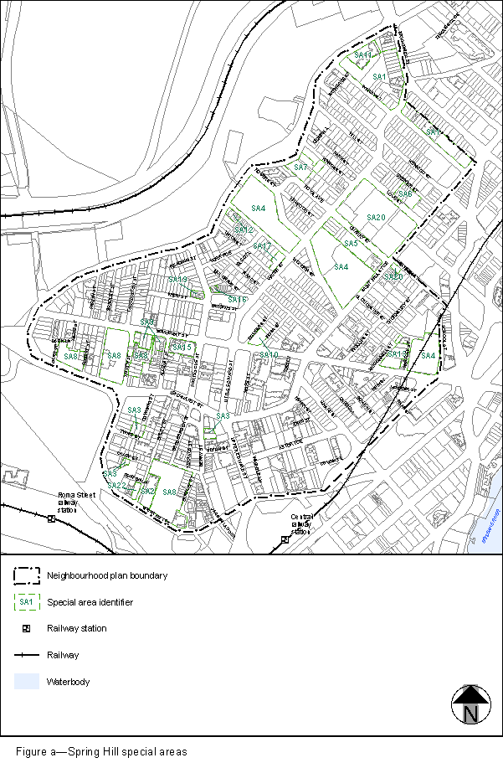
View the high resolution of Figure a–Spring Hill special areas (PDF file size is 428Kb)

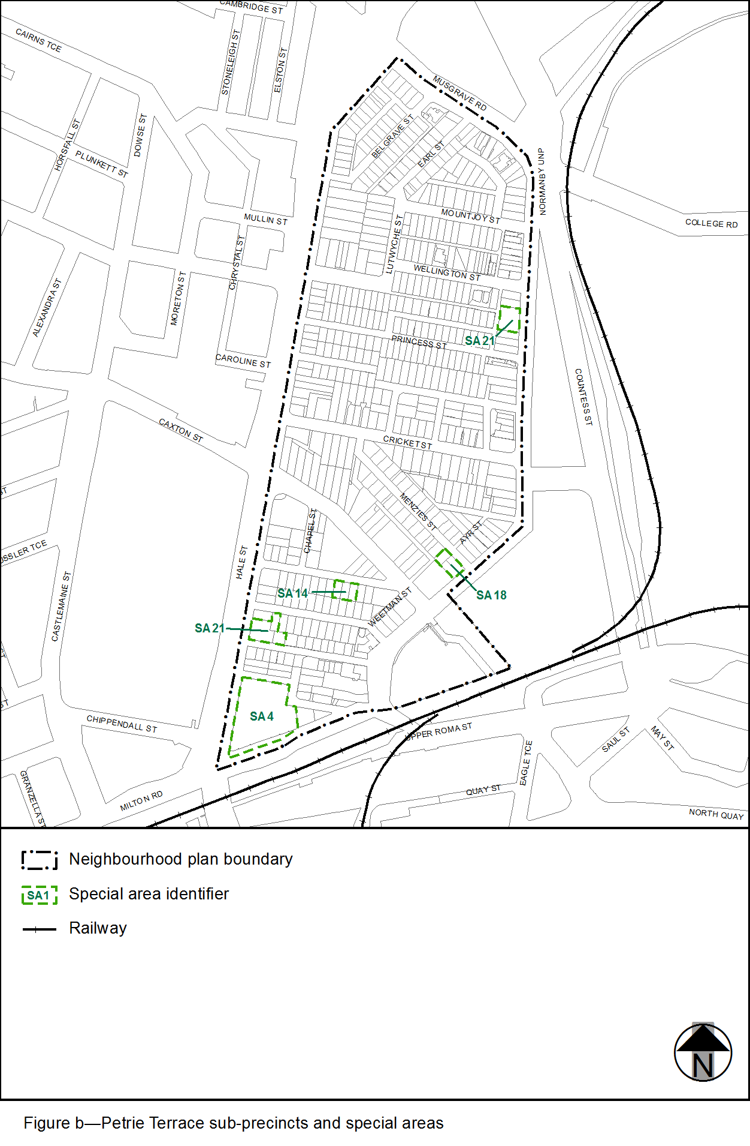
View the high resolution of Figure b–Petrie Terrace sub-precincts and special areas (PDF file size is 134Kb)

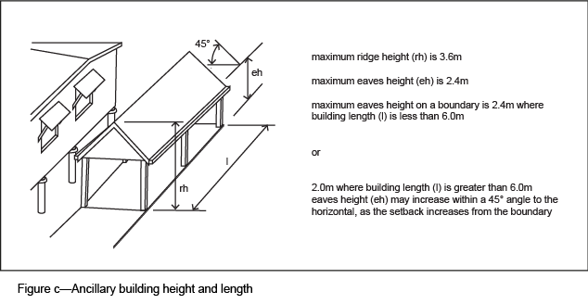

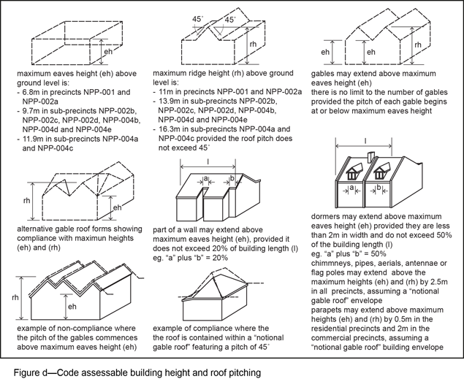
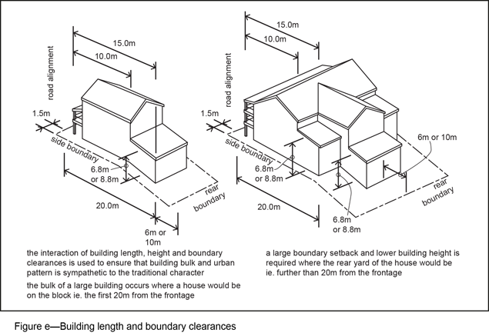

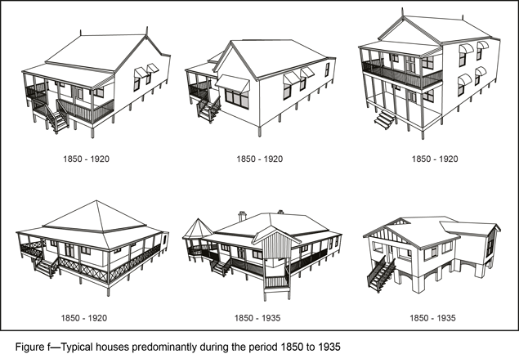
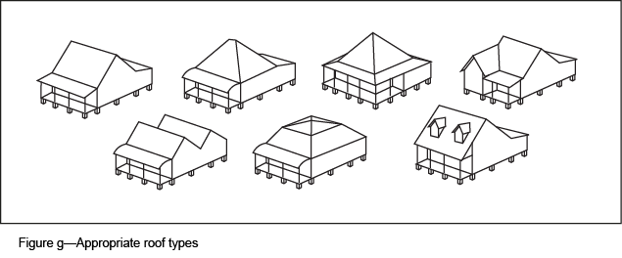

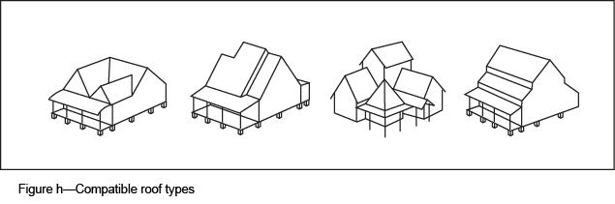

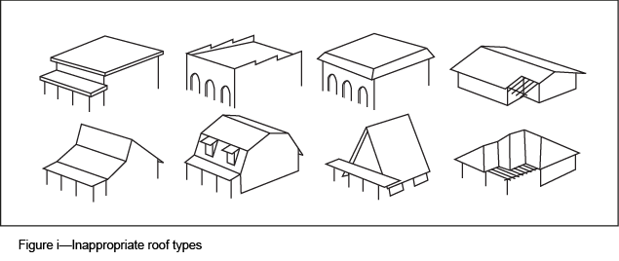
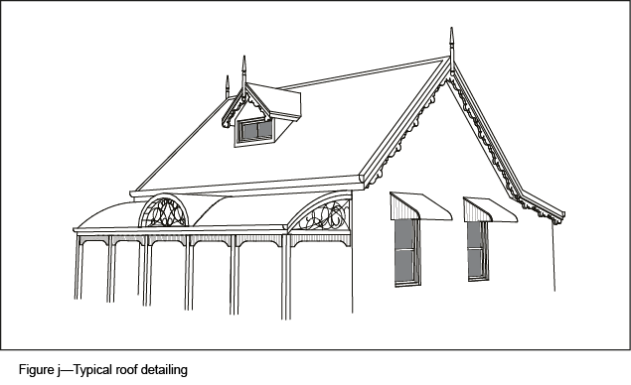

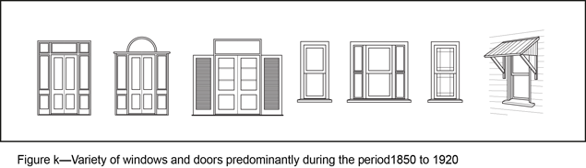

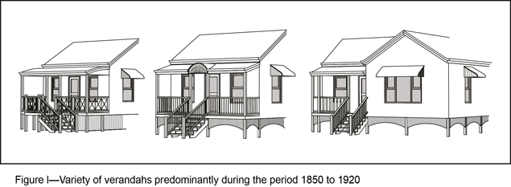
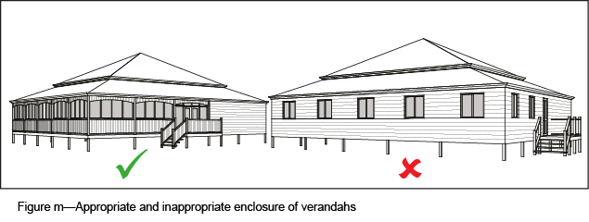

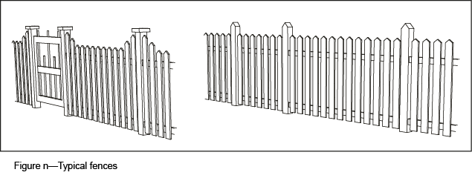

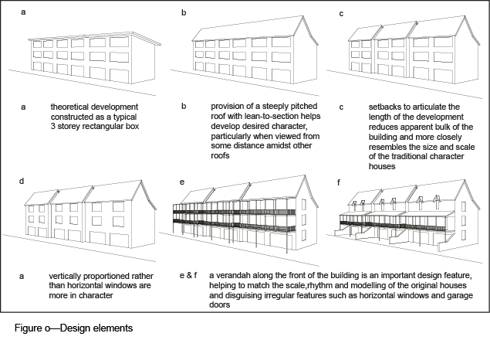
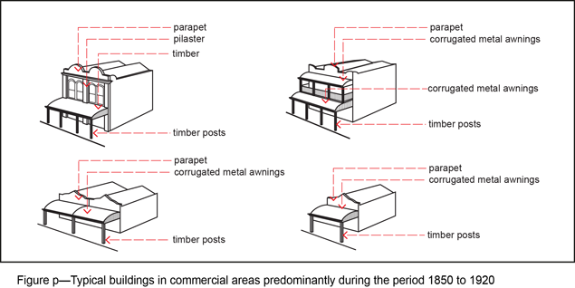
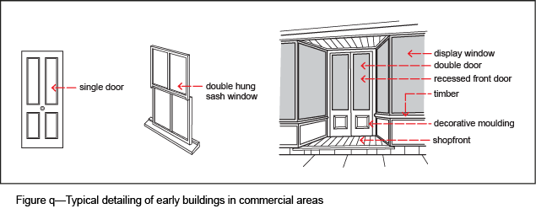
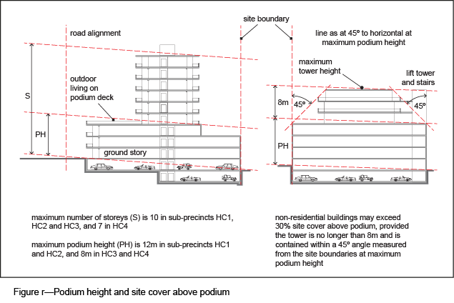
’–
omit.

3.5 Amendment of section 7.2.19.5 (Spring Hill neighbourhood plan code)
- Section 7.2 Neighbourhood plan codes–
insert before 7.2.20.1 Taringa neighbourhood plan code:
‘

7.2.19.5 Spring Hill neighbourhood plan code

7.2.19.5.1 Application
- This code applies to assessing a material change of use, reconfiguring a lot, operational work or building work in the Spring Hill neighbourhood plan area if:
- assessable development where this code is an applicable code identified in the assessment benchmarks column of a table of assessment for a neighbourhood plan (section 5.9); or
- impact assessable development.
- Land within the Spring Hill neighbourhood plan area is identified on the NPM-019.5 Spring Hill neighbourhood plan map and includes the following precincts:
- Detached house precinct (Spring Hill neighbourhood plan/NPP-001);
- Low-rise residential precinct (Spring Hill neighbourhood plan/NPP-002):
- Low-rise residential 1 sub-precinct (Spring Hill neighbourhood plan/NPP-002a);
- Low-rise residential 2 sub-precinct (Spring Hill neighbourhood plan/NPP-002b);
- Low-rise residential 3 sub-precinct (Spring Hill neighbourhood plan/NPP-002c);
- High-rise residential precinct (Spring Hill neighbourhood plan/NPP-003);
- Low-rise commercial precinct (Spring Hill neighbourhood plan/NPP-004):
- Low-rise commercial 1 sub-precinct (Spring Hill neighbourhood plan/NPP-004a);
- Low-rise commercial 2 sub-precinct (Spring Hill neighbourhood plan/NPP-004b);
- High-rise commercial precinct (Spring Hill neighbourhood plan/NPP-005):
- High-rise commercial 1 sub-precinct (Spring Hill neighbourhood plan/NPP-005a);
- High-rise commercial 2 sub-precinct (Spring Hill neighbourhood plan/NPP-005b);
- High-rise commercial 3 sub-precinct (Spring Hill neighbourhood plan/NPP-005c);
- High-rise commercial 4 sub-precinct (Spring Hill neighbourhood plan/NPP-005d).
- When using this code, reference should be made to section 1.5, section 5.3.2 and section 5.3.3.
Note—The following purpose, overall outcomes, performance outcomes and acceptable outcomes comprise the assessment benchmarks of this code.
Note—This neighbourhood plan includes a table of assessment with variations to categories of development and assessment. Refer to Table 5.9.54.A, Table 5.9.54.B, Table 5.9.54.C and Table 5.9.54.D.

7.2.19.5.2 Purpose
- The purpose of the Spring Hill neighbourhood plan code is to provide finer grained planning at a local level for the Spring Hill neighbourhood plan area.
- The purpose of the Spring Hill neighbourhood plan code will be achieved through overall outcomes including overall outcomes for each precinct of the neighbourhood plan area.
- The overall outcomes for the neighbourhood plan area are:
- The neighbourhood plan protects the character of the built environment by restricting the demolition of buildings that have either character or heritage significance. Spring Hill was one of the first parts of the city to be settled and as such, contain some of the oldest buildings and traditional character streetscape in the city. Traditional modest residential dwellings erected on small allotments are the hallmark of Spring Hill. These buildings and areas make a significant contribution to Brisbane’s heritage and character and are to be retained.
- Any new development is to be sympathetic to the scale and character of the original urban development pattern and siting of existing buildings. Development in the identified heritage protection precincts is to retain and reinforce the original character of buildings predominating during the period 1850 to 1920. Proposals in other precincts, subject to building design and character requirements, are to retain and improve upon the existing character by incorporating the main identifiable features, materials and detailing of buildings that predominated during the period from 1850 to 1935.
- The high level of inner city residential amenity prevalent in Spring Hill is not to be reduced through commercial expansion, increase in non-local traffic movements, City Centre commuter parking overspill and general deterioration of housing stock.
- Traditional character is to be protected from unsympathetic proposals in order to attract people to live within walking distance of the City Centre by improving the amenity and attractiveness of the neighbourhood plan area and encouraging an upgrading of traditional housing stock.
- Higher density residential and commercial development is to be contained to those areas identified as suitable for such uses. The expansion of commercial uses in the neighbourhood plan area outside the City Centre, or other areas well served by both bus and rail, is discouraged in order to reduce impacts on residential areas and the traffic network.
- Population increase and housing choice is encouraged through providing a range of dwelling types across the residential precincts. Residential and mixed-use development is encouraged in the commercial precincts by allowing residential floor space to be provided in addition to that permitted for commercial use and by creating environments in the commercial areas conducive to residential amenity.
- Detached house precinct (Spring Hill neighbourhood plan/NPP-001) overall outcomes are:
- The precinct is intended as a heritage and character protection precinct that preserves the area’s unified streetscapes featuring traditional built form character and buildings of similar age and generally high integrity. It comprises residential areas featuring cohesive and homogenous character, suffering little from the intrusion of other forms of development and relatively isolated from the effects of traffic and non-residential development. These areas are unsuitable for higher intensity residential development and are buffered from the highest intensity residential and commercial areas by a ring of less-intensive uses. As such, residential development in the precinct is intended to be in the form of detached houses strongly reflecting the typical Spring Hill character predominating during the period 1850 to 1935. Existing traditional character buildings are to be retained wherever possible in preference to new buildings.
- Any new development within the precinct, including the erection of new houses, restoration, rehabilitation, repairs, alteration or additional, is to be carried out in a style and using materials consistent with the traditional character of the precinct.
- The neighbourhood plan requirements recognise the practical difficulties of rebuilding on the existing small sites located in areas with narrow and closely spaced roads and sloping terrain. As such, there are no minimum site area requirements for detached houses. The erection of the same type of houses that were originally built, subject to compliance with the requirements of this code, is encouraged. However, the subdivision of existing allotments is not considered to be appropriate.
- Low-rise residential precinct (Spring Hill neighbourhood plan/NPP-002) overall outcomes are:
- There are 3 sub-precincts within the Low-rise residential precinct providing for a variety of building intensities and housing types. The precinct comprises a band of more-intensive residential buildings, generally following the ridgelines of Gregory Terrace and major roads, such as Boundary Street, that buffer areas of detached housing from the commercial precincts. The precinct is intended to retain the traditional urban form and built character and to accommodate multiple dwellings and dwelling houses. Multiple dwellings and dwelling houses are to be compatible with the traditional character of detached housing predominating during the period 1850 to 1935 by incorporating and/or reflecting the main building design and character elements of these older dwellings. New development is to incorporate any existing traditional character building with the new building and any extensions or alterations to be designed so that they are sympathetic to the style of the existing building.
- Development in the Low-rise residential 1 sub-precinct (Spring Hill neighbourhood plan/NPP-002a):
- provides for relatively low-rise medium intensity residential development in the form of townhouses or duplexes. Located in the residential heart of Spring Hill, the sub-precinct provides a transition from the style and intensity of development occurring in the Detached house precinct (Spring Hill neighbourhood plan/NPP-001) to the style and intensity occurring in the surrounding precincts that are allocated to higher intensity residential and non-residential uses.
- Development in the Low-rise residential 2 sub-precinct (Spring Hill neighbourhood plan NPP-002b):
- is suited to ‘walk up’ housing and is generally suited to higher density residential uses due to its visual amenity, proximity to parkland, its elevated location, the size of existing allotments and its proximity to the City Centre.
- Development in the Low-rise residential 3 sub-precinct (Spring Hill neighbourhood plan/NPP-002c):
- is suited to ‘walk up’ housing. However, the sub-precinct acts as a buffer between the Detached house precinct (Spring Hill neighbourhood plan/NPP-001) and the commercial precincts. Many of the sites have a frontage to a road with a high volume of traffic and thus are unsuited to development of a type or intensity likely to generate a substantial volume of vehicular movements.
- The following uses are considered consistent with the outcomes sought for the precinct:
- parking station in Special area 3 identified in Figure a if ancillary parking for adjoining development not within the Low-rise residential sub-precincts;
- club if in Special area 5, Special area 6, Special area 10, Special area 13 and Special area 20 identified in Figure a;
- place of worship;
- health care service if in Special area 7 identified in Figure a;
- office if in the Low-rise residential sub-precincts on a site fronting Boundary Street;
- telecommunications facility where a broadcasting station or television station if in the Low-rise residential sub-precinct on a site fronting Boundary Street;
- veterinary service if in the Low-rise residential sub-precincts on a site fronting Boundary Street.
- High-rise residential precinct (Spring Hill neighbourhood plan/NPP-003) overall outcomes are:
- The precinct comprises allotments which are generally larger, road capacities which are greater, services which are readily augmented if necessary and where the amenity, character or available views encourage such uses. Generally, high-rise apartments are to be concentrated in the southern and western residential parts of Spring Hill following the ridgelines along Leichhardt Street and Wickham Terrace.
- The precinct is particularly suited to high-rise housing, partly because of its relative closeness to the City Centre, and partly because of its topographic advantages, with ridges along the main roads and most of the remaining land sloping to the north or north-east.
- Considering the diverse range of existing residential and non-residential uses, and proximity of this precinct to the commercial precincts to the east, it is intended that the precinct develops for a wide range of residential uses. As it is intended that there should be a variety of residential types, and as it is desirable to allow the opportunity to develop the small sites in the precinct, it is also possible to erect low-rise apartments, attached houses or detached houses in accordance with the provisions applicable in the Low-rise residential precinct (Spring Hill neighbourhood plan/NPP-002).
- The following uses are considered consistent with the outcomes sought for the precinct:
- indoor sport and recreation if in Special area 6 or Special area 20 identified in Figure a;
- centre activities activity group if in Special area 2 or Special area 22 identified in Figure a;
- hospital, office and health care service if in Special area 8 identified in Figure a;
- food and drink outlet if in Special area 9 identified in Figure a.
- Low-rise commercial precinct (Spring Hill neighbourhood plan/NPP-004) overall outcomes are:
- The precinct is divided into 2 sub-precincts. Many of the provisions applicable to the precinct are similar to those applying in the Low-rise residential precinct (Spring Hill neighbourhood plan/NPP-002). In both precincts, development is facilitated on small sites and is to be compatible with the traditional Spring Hill character. It is intended that development in most of the sub-precincts in the precinct is built close to or on the alignment and that most of the available space in front of and around the buildings be landscaped.
- Development with large setbacks allocated particularly close to car parking is not encouraged as this would be detrimental to the character of the precinct.
- Preferred non-residential uses are those that are not likely to attract a significant number of business trips or cause non-local traffic impacts in the residential precincts.
- Development in the Low-rise commercial 1 sub-precinct (Spring Hill neighbourhood plan/NPP-004a):
- is set back from the road alignment and exhibit a residential character. The sub-precinct maintains a residential character, but complements the role of neighbouring commercial precincts and provides a transition between commercial and residential areas. Mixed use development allowing people to both live and work on the same site is encouraged.
- Development in the Low-rise commercial 2 sub-precinct (Spring Hill neighbourhood plan/NPP-004b):
- is set back from the road alignment and complements existing and proposed development in neighbouring residential areas with respect to scale, bulk and other design features.
- High-rise commercial precinct (Spring Hill neighbourhood plan/NPP-005) overall outcomes are:
- The 4 sub-precincts in this precinct can be considered as 4 bands of building intensity stepping out and down from the City Centre. These bands allow a gradation of intensity, height and uses, with the highest being closest to the City Centre, and the lowest merging with the Low-rise residential precinct (Spring Hill neighbourhood plan/NPP-002) north of Boundary Street.
- Residential and mixed use development is encouraged through enabling gross floor area in excess of the maximum permitted for non-residential uses. However, the permitted intensity of residential buildings reduces between successive precincts in a similar manner to that of non-residential buildings. The type of activities envisioned within the various precincts also varies with distance from the City Centre.
- The requirements for commercial use in the precinct are more detailed because of the concern to create an environment conducive to residential uses. Awnings are to be provided to shelter pedestrians from the impacts of sun and rain. It is intended that proposals further enhance the precinct’s character through the introduction of landscaping of setback areas, provision of garden plants and the establishment of street trees. Proposals providing mid-block public pedestrian connections between roads such as Leichhardt Street, Astor Terrace and Wickham Terrace are consistent with the outcomes sought.
- The environment for the first 2 or 3 storeys is essentially of a commercial character in the form of a podium extended to the boundaries, except where front setbacks are required. Tower construction is intended above the podium, providing open space at the upper levels, and where residential uses are proposed, providing opportunities for outdoor living areas on roof decks. The location and shape of towers is to be carefully designed to minimise impacts of loss of light, air and outlook to buildings in the vicinity.
- Development in the High-rise commercial 1 sub-precinct (Spring Hill neighbourhood plan/NPP-005a):
- is suited to the highest intensity of both residential and non-residential uses within the Spring Hill neighbourhood plan area because of its close proximity to the City Centre, Central Station, bus routes, parking facilities and accessibility to major traffic arteries. Centre activities providing commercial, technical and professional services for the activities in the City Centre are considered most appropriate. However, specialist medical functions contribute substantially to the character of the sub-precinct and their continued concentration is encouraged. Residential opportunities are provided by the form of high-rise multiple dwellings and short-term accommodation.
- The High-rise commercial 2 sub-precinct (Spring Hill neighbourhood plan/NPP-005b) is well beyond the average walking distances from the main bus routes and centres of activity in the City Centre and is only just within such distance from Central Station. In addition, the topography is not encouraging for pedestrians. For these reasons the maximum commercial plot ratio in this precinct is roughly one-third less than that in High-rise commercial 1 sub-precinct (Spring Hill neighbourhood plan/NPP-005a). Development in this sub-precinct:
- encourages residential and non-residential activities similar to those in the High-rise commercial 1 sub-precinct (Spring Hill neighbourhood plan/NPP-005a). Uses associated with medical and other professional and technical services are also catered for.
- The High-rise commercial 3 sub-precinct (Spring Hill neighbourhood plan/NPP-005c) is remote from the City Centre and the main public transport routes and, as such, the majority of employees could be expected to commute by car. In addition to increasing congestion on the arterial street system, large-scale uses would increase the demand for day-time parking and have adverse impact on the residential precincts of Spring Hill. Consequently the plot ratio for commercial uses has been matched to that of equivalent areas outside the Spring Hill neighbourhood plan. Development in this sub-precinct:
- has a distinctive character despite many of its possible uses being the same as High-rise commercial 1 sub-precinct (Spring Hill neighbourhood plan/NPP-005a) and High-rise commercial 2 sub-precinct (Spring Hill neighbourhood plan/NPP-005b). Non-residential uses considered most acceptable are those encountered in the transitional areas at the fringe of the City Centre.
- The High-rise commercial 4 sub-precinct (Spring Hill neighbourhood plan/NPP-005d) has been matched to that of equivalent areas outside the Spring Hill neighbourhood plan due to its distance from public transport and the City Centre and has the same character of land use as found in High-rise commercial 3 sub-precinct (Spring Hill neighbourhood plan/NPP-005c). Development in this sub-precinct:
- has a range of activities provided for where no detriment would be likely to the amenity of existing or future residential uses or development.
- The following uses are considered consistent with the outcomes sought for the precinct:
- outdoor sales and low impact industry if vehicle sales, repair and servicing where in the High-rise commercial 3 sub-precinct (Spring Hill neighbourhood plan/NPP-005c) or High-rise commercial 4 sub-precinct (Spring Hill neighbourhood plan/NPP-005d);
- hospital if in the High-rise commercial 3 sub-precinct (Spring Hill neighbourhood plan/NPP-005c) or High-rise commercial 4 sub-precinct (Spring Hill neighbourhood plan/NPP-005d).
- For development in a special area identified in Figure a:
- A special area is a number of existing sites that do not comply with the outcomes sought for the precinct in which the site is located. However, where the use is generally well established and accepted by the community, it has been included as a special area to provide for the continuation of the use. Reasonable intensification and expansion of the use is possible provided it is located within the defined boundaries of the special area.
- Other special areas have been created to provide for the inclusion of alternative purposes or consideration of slightly higher residential intensities, where a particular planning problem has been identified and the potential exists to rectify it by applying more flexible planning provisions.
- It is intended that all development in special areas complies with the provision of this code pertaining to the precinct and sub-precinct if applicable in which the site is located. However, where the functions and other intrinsic characteristics of the particular purpose or any special circumstances of the special area make such compliance unreasonable, variation is possible provided the development exhibits the built form character intended for the precinct. If for some reason an existing use ceases, the site concerned should be developed under the other provisions of this code that apply in the precinct, and sub-precinct if applicable, in which it is located. However, where lawfully erected existing buildings are demolished, they may be rebuilt provided the new development does not contravene this code to any greater extent.

7.2.19.5.3 Performance outcomes and acceptable outcomes

Table 7.2.19.5.3.A—Performance outcomes and acceptable outcomes
Performance outcomes | Acceptable outcomes
General—number of storeys and building height
PO1  Development is of a height, scale and form that achieves the intended outcome for the precinct, improves the amenity of the neighbourhood plan area, contributes to a cohesive streetscape and built form character and is:  - consistent with anticipated density and assumed infrastructure demand;  - aligned to community expectations about the number of storeys to be built;  - proportionate to and commensurate with the utility of the site area and frontage width;  - designed to avoid significant and undue adverse amenity impact to adjoining development;  - sited to enable existing and future buildings to be well separated from each other and to avoid affecting the potential development of adjoining sites.  Note—Development that exceeds the intended number of storeys or building height can place disproportionate pressure on the transport network, public space or community facilities in particular.  Note—Development that is over-scaled for its site can result in an undesirable dominance of vehicle access, parking and manoeuvring areas that significantly reduce streetscape character and amenity. | AO1  Development complies with the number of storeys and building height in Table 7.2.19.5.3.B.  Note—Neighbourhood plans will mostly specify the maximum number of storeys where zone outcomes have been varied in relation to building height. Some neighbourhood plans may also specify the height in metres. Development must comply with both parameters where maximum number of storeys and height in metres are specified.
PO2  Development of buildings in the Detached house precinct (Spring Hill neighbourhood plan/NPP-001), Low-rise residential precinct (Spring Hill neighbourhood plan/NPP-002) and Low-rise commercial precinct (Spring Hill neighbourhood plan/NPP-004) are of a compatible scale and design and contribute positively to the amenity and desired traditional character of the precincts. |  | AO2  Building height does not exceed the eaves height specified in Table 7.2.19.5.3.B except for a pitched roof that may extend to the specified ridge height, if:  - the roof pitch does not commence above the specified ridge height;  - no part of the roof exceeds a maximum pitch of 45□.  Note—An additional attic storey built into the roof space is appropriate provided the building maintains the appearance of having the number of storeys indicated in Table 7.2.19.5.3.B.  Note—For detail in calculating compliance and other exceptions refer to Figure c.
PO3  Development of podiums in the High-rise commercial precinct (Spring Hill neighbourhood plan/NPP-005) is appropriate in height to the precinct’s function and context, and is consistent with the scale and design of nearby buildings. |  | AO3  Development of podiums does not exceed the height specified in Table 7.2.19.5.3.B.  Note—Guidance on how to apply these building forms is provided in Figure q.  Note—Additional podium height may be appropriate where the building form provides a consistent streetscape, does not result in enclosure or obstruction of outlook for nearby properties taking into account the nature of current and future buildings in the vicinity of the site.
General—site access and car parking
PO4  Development provides vehicle access and parking that is designed and located to ensure convenient and safe parking and vehicular access that does not detract from the aesthetics or amenity of the area. | AO4.1  Development for a dwelling house:  - provides a minimum of 1 car parking space;  - where the area of the site is less than 200m2 and it would be impracticable to require a car parking space, does not require onsite car parking.
AO4.2
Development in the High-rise commercial 1
sub-precinct (Spring Hill neighbourhood plan/NPP-005a) provides:
- not more than 1 car parking space per 125m² of gross floor area for non-residential development of the non-residential part of a development in a mixed use development;
- not fewer than 1 car parking space per dwelling unit and not more than 1.5 spaces per dwelling for residential development or the residential part of a mixed use development.
AO4.3
Development provides no more than 20 car parking spaces for non-residential activities in the High-rise commercial precinct (Spring Hill neighbourhood plan/NPP-005), where alternative access is not possible and the site has a frontage of less than 40m to the following roads:
- Boundary Street;
- Leichhardt Street;
- Little Edward Street;
- Turbot Street;
- Upper Edward Street;
- Wharf Street;
- Wickham Street.
AO4.4
Development of an office where located in the Low-rise residential precinct (Spring Hill neighbourhood plan/NPP-002) provides no more than 10% more car parking spaces than required under the Transport, access, parking and servicing code.
AO4.5
Development that cannot reasonably provide access from some other road frontage or alternative location does not provide vehicle access within 9m of an intersection with any of the following roads:
- Boundary Street;
- Brunswick Street;
- Gregory Terrace;
- Leichhardt Street;
- Little Edward Street;
- St Pauls Terrace;
- Turbot Street;
- Upper Edward Street;
- Water Street;
- Wharf Street;
- Wickham Terrace.
AO4.6
Development that cannot reasonably provide access from some other road frontage or alternative location does not provide vehicle access from a road:
- less than 7m wide on which traffic normally travels in 2 directions;
- less than 5m wide on which traffic normally travels in 1 direction.
AO4.7
Development for any activity except for a dwelling house or non-residential use requiring no more than 3 car parking spaces provides onsite manoeuvring for all types of vehicles where vehicle access is to the following roads:
- Boundary Street;
- Brunswick Street;
- Gregory Terrace;
- Leichhardt Street;
- Little Edward Street;
- St Pauls Terrace;
- Turbot Street;
- Upper Edward Street;
- Water Street;
- Wharf Street;
- Wickham Terrace.
General—residential amenity
PO5  Development provides dwelling houses with private outdoor living areas sufficient to meet residents’ needs and consistent with the intended character of the Detached house precinct (Spring Hill neighbourhood plan/NPP-001) and Low-rise residential precinct (Spring Hill neighbourhood plan/NPP-002). | AO5  Development provides a dwelling house with a minimum private outdoor living area of:  - 60m² with a 4.5m minimum horizontal dimension; or  - 30m² with a 4.5m minimum horizontal dimension, if the site has an area of less than 200m² or the shape or topography of the site constrains provision of additional outdoor living area.
PO6  Development activity creates a high level of amenity and does not reduce the amenity of adjacent uses or detract from the intended character of the precinct and neighbourhood plan area. | AO6.1  Development for residential or mixed residential/non-residential uses in the Detached house precinct (Spring Hill neighbourhood plan/NPP-001) and Low-rise residential precinct (Spring Hill neighbourhood plan/NPP-002):  - orientates the windows of the habitable rooms towards the front and rear boundary of the site, other for a corner site;  - orientates the windows of habitable rooms to avoid privacy conflicts if outdoor living areas are located adjacent to side boundaries or development is located on a corner lot.
AO6.2
Development for residential or mixed residential and non-residential uses in the High-rise commercial precinct (Spring Hill neighbourhood plan/NPP-005) provide dwellings with an outlook space 10m by 10m in dimension abutting the main window of a living room, if:
- the sill of that window is located on 1 side of that space;
- no structure other than a fence, mast or similar, or part of a balcony of the relevant unit, intrudes upon that space;
- that space is contained within the boundaries of the site of the building containing that unit and includes the road abutting it to the centre line of the road.
PO7  Development of separate structures not used for human habitation that form part of a use are designed and sited to preserve the amenity of adjacent uses and are compatible with the building/s they serve. | AO7.1  Development of an ancillary building in all precincts is designed and located to be sympathetic to the building/s that it serves and located so as not to detract from the building/s on the site as a whole.
AO7.2
Development of an ancillary building in the Detached house precinct (Spring Hill neighbourhood plan/NPP-001), Low-rise residential precinct (Spring Hill neighbourhood plan/NPP-002) and Low-rise commercial precinct (Spring Hill neighbourhood plan/NPP-004):
- does not exceed 2.4m in maximum height, except for a roof that may extend to a maximum of 3.6m in height at the ridge of the roof;
- may extend to a side boundary provided the height above ground level at the boundary is limited to 2m where the building length along the relevant boundary is greater than 6m;
- increases in height within a 45º angle to the horizontal, as the setback increases from a side or rear boundary;
- are compatible with the building types that predominated from 1850 to 1935.
Refer to Figure b.
If in a residential precinct—gross floor area
PO8  Development building size and bulk are of a density consistent with the nature of the locality and retain an appropriate residential scale and relationship with other buildings. | AO8.1  Development has a maximum gross floor area of 60% of the site area in the Low-rise residential 1 sub-precinct.
AO8.2
Development has a maximum gross floor area in the Low-rise residential 2 sub-precinct (Spring Hill neighbourhood plan/NPP-002b) and Low-rise residential 3 sub-precinct (Spring Hill neighbourhood plan/NPP-002c) as follows:
 | Site area |  |  |  |  |  |  | Gross floor area
 | less than 1,200m2 |  |  |  |  |  |  | 100% of the site area
 | 1,200m2 to 3,000m2 |  |  |  |  |  |  | 1,220m2 + 140% of the site area (site area minus 1,200m2)
 | greater than 3,000m2 |  |  |  |  |  |  | 125% of the site area
AO8.3
Development has a maximum gross floor area in the High-rise residential precinct (Spring Hill neighbourhood plan/NPP-003) of:
 | Site area |  |  |  |  |  |  | Gross floor area
 | less than 1,000m2 |  |  |  |  |  |  | 60% of the site area
 | 1,000m2 to 1,200m2 |  |  |  |  |  |  | 600m2 + 120% of the site area (site area minus 1,000m2)
 | over 1,200m2 to 1,500m2 |  |  |  |  |  |  | 140% of the site area minus 460m2
 | over 1,500m2 to 3,500m2 |  |  |  |  |  |  | 2,120m2 + 200% of the site area (site area minus 1,500m2)
 | greater than 3,500m2 |  |  |  |  |  |  | 175% of the site area
AO8.4
Development in the Low-rise residential 3 sub-precinct has a gross floor area for that part of the building used for non-residential purposes no greater than 50% of the maximum allowable gross floor area for the site.
If in a residential precinct—site cover
PO9  Development provides buildings that are of a scale and design generally compatible with those of nearby buildings and contribute positively to the amenity and character of the local area. | AO9.1  Development has a maximum site cover in the Low-rise residential precinct (Spring Hill neighbourhood plan/NPP-002) of:  - 50% of the area of the site; or  - 60% of the area of the site if ancillary buildings associated with recreational uses is provided for residential development.
AO9.2
Development has a maximum site cover in the High-rise residential precinct (Spring Hill neighbourhood plan/NPP-003) of:
- 30% for the first 2 storeys above ground level;
- 20% for the third storey above ground level and above.
If in a residential precinct—street frontage setbacks
PO10  The building setbacks complement the setbacks prevailing in the street. |  |  | AO10.1  Development provides a minimum building setback of 6m from the road alignment to all alignments in the High-rise residential precinct (Spring Hill neighbourhood plan/NPP-003) and to the following road frontages in all other residential precincts:  - Boundary Street;  - Brunswick Street;  - Gregory Terrace;  - St Pauls Terrace;  - Water Street;  - Wickham Terrace.
AO10.2
Development provides a minimum building setback of 4m to all other road frontages in the Detached house precinct (Spring Hill neighbourhood plan/NPP-001) and Low-rise residential precinct (Spring Hill neighbourhood plan/NPP-002).
AO10.3
Development of open verandahs, balconies, carports and ancillary buildings may extend up to 2m into the building setback, and bay windows by not more than 0.75m in the Detached house precinct (Spring Hill neighbourhood plan/NPP-001) and Low-rise residential precinct (Spring Hill neighbourhood plan/NPP-002).
AO10.4
Development of buildings fronting Water Street in the Low-rise residential 3 sub-precinct (Spring Hill neighbourhood plan/NPP-002c) may extend to the front alignment.
If in a residential precinct—side and rear setbacks
PO11  Development of buildings is well separated to allow for natural light penetration, air circulation, outlook and privacy. |  |  | AO11.1  Development provides minimum boundary clearances as follows:
 |  |  | Precinct/  sub-precinct |  |  |  |  |  | Side setbacks
 |  |  | Detached house precinct (Spring Hill neighbourhood plan/NPP-001) |  |  |  |  |  | 1.5m
 |  |  | Low-rise residential 1 sub-precinct (Spring Hill neighbourhood plan/NPP-002a)  Low-rise residential 2 sub-precinct (Spring Hill neighbourhood plan/NPP-002b)  Low-rise residential 3 sub-precinct (Spring Hill neighbourhood plan/NPP-002c) |  |  |  |  |  | 10m, or 6m in a screened situation  Note—A screened situation is provided in the Detached house precinct and the Low-rise residential precinct, where the following is provided along the relevant boundary:  - a maximum 6.8m building height to eaves;  - a 1.8m high fixed privacy screen or fence;  - densely planted screening vegetation able to achieve 6m in height.
 |  |  | High-rise residential precinct (Spring Hill neighbourhood plan/NPP-003) |  |  |  |  |  | 50% of the building height or 3m, whichever is greater
 |  |  | Precinct/  sub-precinct |  |  |  |  |  | Rear setback
 |  |  | Detached house precinct (Spring Hill neighbourhood plan/NPP-001)  Low-rise residential 1 sub-precinct (Spring Hill neighbourhood plan/NPP-002a)  Low-rise residential 2 sub-precinct (Spring Hill neighbourhood plan/NPP-002b)  Low-rise residential 3 sub-precinct (Spring Hill neighbourhood plan/NPP-002c) |  |  |  |  |  | 10m, or 6m in a screened situation  Note—A screened situation is provided in the Detached house precinct and the Low-rise residential precinct, where the following is provided along the relevant boundary:  - a maximum 6.8m building height to eaves;  - a 1.8m high fixed privacy screen or fence;  - densely planted screening vegetation able to achieve 6m in height.
 |  |  | High-rise residential precinct (Spring Hill neighbourhood plan/NPP-003) |  |  |  |  |  | 50% of the building height or 6m, whichever setback is greater
AO11.2
Development provides a minimum 1.5m side boundary clearance for part of a building located within 20m of a road frontage in the Low-rise residential precinct (Spring Hill neighbourhood plan/NPP-002) provided total building length is not greater than 15m of which no more than 10m exceeds a building eaves height of 6.8m.
AO11.3
Development provides a minimum 3m side boundary clearance for part of a building located more than 20m from a road frontage in the Low-rise residential precinct (Spring Hill neighbourhood plan/NPP-002), if:
- total building length is not greater than 15m of which no more than 10m exceeds a building eaves height of 6.8m;
- a screened situation is provided for a distance of 10m between this part of the building and any other part of the building setback less than 6m from a side boundary.
AO11.4
Development may have open verandahs, balconies and external stairs that extend 1.25m inside the minimum side and rear boundary setbacks in the Low-rise residential precinct (Spring Hill neighbourhood plan/NPP-002) and the rear boundary setback in the Detached house precinct (Spring Hill neighbourhood plan/NPP-001), as specified in AO11.1. Other exceptions, where a minimum 1.5m setback is possible, are as follows:
- a minimum side boundary setback to eaves of 1.2m;
- a minimum side boundary setback to window or sun hoods of 0.75m.
Note—For detail in calculating compliance in the Low-rise residential precinct, refer to Figure d.
AO11.5
Development involving part of a building in the Detached house precinct (Spring Hill neighbourhood plan/NPP-001) may extend to a side boundary, if:
- that part of the building is limited to 10m in length, with the exception of any extensions or alterations to an existing building as at 13 June 1997 that maintain the existing boundary setback or a greater setback;
- the building is less than 20m in total length along the relevant boundary;
- that part of the building is not closer than 2m to any habitable room window of a dwelling on an adjoining site.
Note—-Advice is to be provided by adjoining landowners that they have no objection to side boundary clearances less than that specified in AO11.1 in relation to an extension or addition to an existing building.
AO11.6
Development involving part of a building in the Detached house precinct (Spring Hill neighbourhood plan/NPP-001) may provide a minimum 3m rear boundary clearance if the site is so small or shallow, or the topography such that development would otherwise be rendered impractical or unsatisfactory.
AO11.7
Development involving part of a building located within 20m of a road frontage in the Low-rise residential precinct (Spring Hill neighbourhood plan/NPP-002) may extend to a side boundary if:
- total building length is not greater than 15m of which no more than 10m exceeds a building eaves height of 6.8m;
- the building is not closer than 2m to the habitable room windows of an adjacent dwelling;
- the building incorporates privacy screening to all windows and openings along the relevant boundary.
AO11.8
Development involving part of a building located within 20m of a road frontage in the Low-rise residential precinct (Spring Hill neighbourhood plan/NPP-002) may extend beyond 20m from the road frontage, if:
- the building setback to a side boundary is 1.5m;
- total building length provided at this setback does not exceed a range of 16.5m to 18m;
- building length provided at this setback does not exceed a range of 11m to 12m where the building height exceeds 6.8m.
AO11.9
Development involving part of a building located more than 20m from a road frontage in the Low-rise residential precinct (Spring Hill neighbourhood plan/NPP-002) may provide a 1.5m side boundary setback, if:
- total building length is not greater than 5m, of which no more than 10m exceeds a building eaves height of 6.8m;
- a screened situation is provided for a distance of 10m between this part of the building and any other part of the building setback less than 6m from a side boundary.
If in the Detached house precinct (Spring Hill neighbourhood plan/NPP-001)—building design and character
PO12  Development ensures new buildings or additions to existing buildings:  - are compatible and in character with the building types that predominated during the period 1850 to 1920;  - are not replicas, but rather incorporate such basic design features, materials and detailing that give them an external appearance of being in the same design idiom. |  |  |  | AO12.1  Development of a building, or extensions to existing buildings, incorporates an orthogonal plan form with outside walls aligned to correspond with those of buildings on adjoining sites in accordance with Figure e.
AO12.2
Development has a roof design that:
- comprises a dominant, symmetrical and steeply pitched portion;
- may also feature steeply pitched gables and hips, with or without secondary lean-to sections;
- is consistent with roof types illustrated in Figure f and Figure g;
- avoids those roof types depicted in Figure h;
- is constructed from corrugated sheet metal of a compatible profile;
- incorporates ridges, valleys, barges and fascias together with roof drainage compatible with the details depicted in Figure i.
AO12.3
Development has external walls that are sheeted in wide-profile weatherboards, chamfer boards or similar lightweight materials. Brick and masonry construction is only acceptable if:
- it is rendered and painted;
- lightweight sheeting, being weatherboards, chamfer boards or similar, is also incorporated in the external wall detailing;
- the building does not include other features alien to the building types which predominated from 1850 to 1920.
AO12.4
Development ensures that windows and doors contained in any external wall of a building that is visible from the street or other public place are compatible with the design and type detailed in Figure j. The design and placement of windows and doors in visible external walls:
- emphasises openings that are of vertical proportions;
- includes a higher ratio of wall area to window or door;
- is of a style and construction and incorporates materials sympathetic with the building types that predominated between 1859 and 1920.
Note—Windows and doors of timber construction are preferred. However, powder-coated aluminium windows may be acceptable where they are consistent with other window and door requirements.
AO12.5
Development ensures that:
- buildings incorporate an open verandah that overlooks the road frontage of the site and extends across the front elevation, except where a projecting bay of the building prevents this, of a style compatible with the designs depicted in Figure k;
- if the verandah is above the ground, it is timber framed and decked, with the area underneath open except for the provision of timber battens, screen curtains or valances between stumps or posts;
- the verandah incorporates the following:
- balustrades of timber or steel rail with infill of either timber framing, dowelling or decorative metal, with any timber latticework or louvres located above the balustrade railing;
- any steps or stairways to verandahs are to be timber framed, decked and balustraded in a like manner to the verandah;
- post supports are constructed from timber, with other lightweight supports such as metal posts being acceptable if they are designed and detailed to reflect the scale and form of timber;
- if it is proposed to enclose an existing verandah or construct a new building without open verandahs;
- the enclosed area is detailed as if it could serve as a verandah in keeping with the manner suggested in Figure l;
- balustrading, louvers and latticework is retained to form part of the enclosure and the external materials are lightweight and distinct from the remainder of the building.
AO12.6
Development ensures any fencing along a road frontage is between 0.75m and 1.5m in height and constructed in open style similar to timber pickets and complementary to the type detailed in Figure m.
AO12.7
Development ensures all buildings, ancillary buildings and fences are painted in a colour scheme compatible with the schemes that predominated from 1850 to 1920.
Note—Minor variations from the character requirement are possible where it is demonstrated that the variation is reasonable and would not substantially detract from the intent of the design requirements. Major variations are possible where it is an extension or addition to a prior building and the style and character of the building is such that it would be unreasonable to require compliance with the design requirements.
If in the Detached house precinct (NPP-001)—more than one building on a site
PO13  Buildings are of a scale and design generally compatible with those of nearby buildings and contribute positively to the amenity and character of the neighbourhood plan area. |  |  |  | AO13  Development in the Detached house precinct (Spring Hill neighbourhood plan/NPP-001) if comprising more than 1 building (other than ancillary buildings), locates such buildings in respect of each other and considers each building under this code as if it was independently sited.
If in the Low-rise residential precinct (NPP-002)—building design and character
PO14  Development ensures:  - buildings are of a scale and design generally compatible with those of nearby buildings and contribute positively to the amenity and character of the neighbourhood plan area;  - new buildings or additions to existing buildings are compatible and in character with the building types that predominated during the period 1850 to 1935;  - new buildings and extensions to existing buildings are not replicas, but rather incorporate such basic design features, materials and detailing that give them an external appearance of being in the same design idiom. |  |  |  | AO14.1  Development of a building is designed to appear as a series of blocks, each of a size and scale similar to that of a detached house, and which feature:  - separation by vertical recesses and projections in the exterior walls;  - articulation through steps in the plane of the exterior walls and roof;  - external walls and roof lines articulated in a manner similar to detached character houses, such as the addition of lightweight details.
AO14.2
Development of a building does not exceed 30m in length, unless the external walls of the building are designed to incorporate significant recesses and projections and the roof geometry provides significant variety, to prevent the appearance of inappropriate building form, disproportionate bulk and excessive facade length. For one example of how to reduce building bulk, refer to Figure n.
AO14.3
Development has building roofs that:
- incorporate steeply pitched gables and hips either with or without secondary lean-to sections. Their design is consistent with roof types illustrated in Figure f and Figure g but not those depicted in Figure h;
- are constructed from corrugated sheet metal of a compatible profile and incorporate ridges, valleys, barges and fascias together with roof drainage compatible with the details depicted in Figure i.
AO14.4
Development has external walls sheeted in wide-profile weatherboards, chamfer boards or other lightweight materials. Brick and masonry aspects of construction is rendered and painted.
AO14.5
Development:
- of a building incorporates an open verandah that overlooks the road frontage of the site and extends across the front elevation, and is of a style compatible with those that predominated between 1850 and 1935 except where a projecting bay of the building prevents this;
- if it is proposed to enclose an existing verandah or construct a new building without open verandahs, has the enclosed area detailed as if it could serve as a verandah in keeping with the manner suggested in Figure n.
AO14.6
Development ensures:
- windows and doors contained in any external wall of a building that are visible from the street or other public place are compatible with the design and type detailed in Figure j;
- design and placement of windows and doors in visible external walls:
- emphasises openings that are of vertical proportions;
- includes a higher ratio of wall area to window or door;
- is of a style and construction and incorporates materials sympathetic with the building types that predominated between 1850 and 1935.
If in the Low-rise residential precinct (NPP-002)—building separation distances
PO15  Development ensures residential and mixed use buildings within a site are designed to be well separated from each other to allow for natural light penetration, air circulation, outlook and privacy. |  |  |  | AO15.1  Development of residential and mixed use buildings has the following separation distances between windows:
 |  |  |  | Situation between windows |  |  |  |  |  | Separation distance
 |  |  |  | Facing situation |  |  |  |  |  | 16m
 |  |  |  | Screened facing situation |  |  |  |  |  | 10m
 |  |  |  | Other |  |  |  |  |  | 3m
AO15.2
Development of residential and mixed use buildings has the following separation distances between windows and blank walls:
 |  |  |  | Main window |  |  | Blank wall length |  |  |  |  | Separation distance
 |  |  |  | Living room |  |  | greater than 12m |  |  |  |  | 10m
 |  |  |  | Living room |  |  | less than 12m |  |  |  |  | 6m
 |  |  |  | Other habitable room |  |  | greater than 12m |  |  |  |  | 10m
 |  |  |  | Other habitable room |  |  | less than 12m |  |  |  |  | 3m
 |  |  |  | Note—A facing situation occurs when the relevant windows and walls are within sightlines extending out at a 30º horizontal angle from the vertical edge of a window. A screened situation is provided where a fixed privacy screen or fence is erected across the window sightlines in conjunction with densely planted screening vegetation able to grow to 6m in height.
If in the High-rise residential precinct (NPP-003)—site requirements
PO16  Development uses sites large enough to accommodate a building form of an appropriate size and bulk. |  |  |  | AO16.1  Development of all existing lots within the precinct may be for the purpose of dwelling house irrespective of site area.
AO16.2
Development of building sites in the precinct have a minimum site area of 1,500m2 and a minimum frontage length of 40m.
Note—To provide a variety of residential types and opportunities to develop small sites, development on sites having a lesser area and frontage is acceptable provided such development is consistent with the intent and requirements of the Low-rise residential precinct (Spring Hill neighbourhood plan/NPP-002).
If in a commercial precinct—site requirements
PO17  Development ensures that building size and bulk are consistent with the density and nature of the neighbourhood plan area. |  |  |  | AO17.1  Development has a gross floor area that complies with the following:
 |  |  |  | Gross floor area for non-residential purposes
 |  |  |  | Sub-precinct |  |  |  |  |  |  | Gross floor area
 |  |  |  | High-rise commercial 1 sub-precinct (Spring Hill neighbourhood plan/NPP-005a) |  |  |  |  |  |  | 350% of the site area
 |  |  |  | High-rise commercial 2 sub-precinct (Spring Hill neighbourhood plan/NPP-005b) |  |  |  |  |  |  | 175% of the site area
 |  |  |  | High-rise commercial 3 sub-precinct (Spring Hill neighbourhood plan/NPP-005c)  High-rise commercial 4 sub-precinct (Spring Hill neighbourhood plan/NPP-005d) |  |  |  |  |  |  | 150% of the site area
 |  |  |  | Low-rise commercial 1 sub-precinct (Spring Hill neighbourhood plan/NPP-004a) |  |  |  |  |  |  | 125% of the site area
 |  |  |  | Low-rise commercial 2 sub-precinct (Spring Hill neighbourhood plan/NPP-004b) |  |  |  |  |  |  | 100% of the site area
 |  |  |  | Gross floor area for residential or mixed residential and non-residential purposes
 |  |  |  | Sub-precinct |  |  |  |  |  |  | Gross floor area
 |  |  |  | High-rise commercial 1 sub-precinct (Spring Hill neighbourhood plan/NPP-005a) |  |  |  |  |  |  | 500% of the site area
 |  |  |  | High-rise commercial 2  sub-precinct (Spring Hill neighbourhood plan/  NPP-005b) |  |  |  |  |  |  | 300% of the site area
 |  |  |  | High-rise commercial 3  sub-precinct (Spring Hill neighbourhood plan/  NPP-005c)  High-rise commercial 4  sub-precinct (Spring Hill neighbourhood plan/  NPP-005d) |  |  |  |  |  |  | 250% of the site area
 |  |  |  | Low-rise commercial 1  sub-precinct (Spring Hill neighbourhood plan/  NPP-004a) |  |  |  |  |  |  | 150% of the site area
 |  |  |  | Low-rise commercial 2  sub-precinct (Spring Hill neighbourhood plan/  NPP-004b) |  |  |  |  |  |  | 120% of the site area
Note—Development for mixed residential and non-residential uses ensures the gross floor area of the non-residential component does not exceed the amount specified in AO17.1.
Note—Where the site is in more than 1 precinct, the maximum gross floor area shall be calculated for each site and then summed.
AO17.2
Development promotes the provision of publicly accessible landscaped pedestrian-scale spaces and pedestrian links through sites in the High-rise commercial 1 sub-precinct (Spring Hill neighbourhood plan/NPP-005a) and High-rise commercial 2 sub-precinct (Spring Hill neighbourhood plan/NPP-005b) by granting a gross floor area bonus up to 25% of the site area, provided the facilities comply with the acceptable outcomes in the Centre or mixed use code.
If in a commercial precinct—street frontage setbacks
PO18  Development of buildings enhances the character of traditional streetscapes and maintains a sense of open space and pedestrian scale in public and pedestrian areas. |  |  |  | AO18.1  Development below the maximum podium height in the High-rise commercial 1 sub-precinct (Spring Hill neighbourhood plan/NPP-005a) and High-rise commercial 2 sub-precinct (Spring Hill neighbourhood plan/NPP-005b) has buildings built to the alignment with the exception of buildings fronting the following roads, which require a minimum 3m setback:  - Astor Terrace;  - Bowen Street;  - Leichhardt Street;  - Turbot Street;  - Upper Edward Street (not including the eastern side);  - Wharf Street (not including the western side between Astor Terrace and Leichhardt Street);  - Wickham Terrace.
AO18.2
Development above the maximum podium height in the High-rise commercial 1 sub-precinct (Spring Hill neighbourhood plan/NPP-005a) and High-rise commercial 2 sub-precinct, has buildings that are set back a minimum of 6m to roads referred to in AO18.1 and a minimum 3m to all other roads.
AO18.3
Development above and below the maximum podium height in the High-rise commercial 3
sub-precinct and High-rise commercial 4 sub-precinct provide a minimum building setback of 6m.
AO18.4
Development for structures that may extend closer than the minimum building setback to a road frontage in the High-rise commercial precinct are:
- eaves, awnings, screens or similar providing privacy or shelter and extending not more than 1.2m through a building line;
- columns extending not more than 0.6m through a building line;
- an awning for pedestrian shelter along the road frontage.
AO18.5
Development provides a minimum building setback to the following road frontages in the Low-rise commercial precinct:
 |  |  |  | Minimum setback | Road frontages
 |  |  |  | Nil | Boundary Street (between Bradley Street and Fortescue Street)
 |  |  |  | 6m | Boundary Street, St Pauls Terrace, Turbot Street and Water Street
 |  |  |  | 4m | All other frontages
AO18.6
Development in the Low-rise commercial precinct allows open verandahs, balconies, carports and ancillary buildings to extend up to 2m into the building setback and bay windows not more than 0.75m, into the building setback.
Note—Awnings required by the neighbourhood plan to provide pedestrian shelter along the frontage of premises are excluded from building line requirements.
If in a commercial precinct—boundary clearance to residential precincts
PO19  Development of commercial buildings is well separated from adjoining residential sites to allow for natural light penetration, air circulation, outlook and privacy. |  |  |  | AO19.1  Development provides a minimum boundary clearance to residential precincts of:
 |  |  |  | Precinct |  | Side and rear boundary clearance
 |  |  |  | Low-rise commercial precinct (Spring Hill neighbourhood plan/NPP-004) |  | 10m, or 6m in a screened situation
 |  |  |  | High-rise commercial precinct (Spring Hill neighbourhood plan/NPP-005) |  | 50% of the building height or 6m, whichever setback is the greater
Note—A screened situation is provided in the Low-rise commercial precincts where the following is provided along the relevant boundary:
- a maximum 8.8m building height to eaves;
- a 1.8m high fixed privacy screen or fence;
- densely planted screening vegetation able to achieve 6m in height.
Note—In the High-rise commercial precinct, non-habitable areas not exceeding 1.5m height above ground level may provide a lesser setback where appropriate.
AO19.2
Development:
- of open verandahs, balconies and external stairs in the Low-rise commercial precinct (Spring Hill neighbourhood plan/NPP-004) may extend 1.25m inside the minimum side and rear boundary clearances specified in AO19.1;
- ensures other exceptions, where minimum 1.5m setbacks are possible, are as follows:
- a minimum side boundary setback to eaves of 1.2m;
- a minimum side boundary setback to window or sun hoods of 0.75m.
AO19.3
Development may provide a minimum 1.5m side boundary clearance for part of a building located within 20m of a road frontage in the Low-rise commercial precinct (Spring Hill neighbourhood plan/NPP-004) abutting a residential precinct, if the total building length is not greater than 15m of which no more than 10m exceeds a building eaves height of 8.8m.
AO19.4
Development may provide a minimum 3m side boundary clearance for part of a building located more than 20m from a road frontage in the Low-rise commercial precinct (Spring Hill neighbourhood plan/NPP-004) abutting a residential precinct, if:
- total building length is not greater than 15m of which no more than 10m exceeds a building eaves height of 8.8m;
- a screened situation is provided for a distance of 10m between this part of the building and any other part of the building set back less than 6m from a side boundary.
Note—For detail in calculating compliance in the Low-rise commercial precinct (Spring Hill neighbourhood plan/NPP-004) abutting a residential precinct, refer to Figure d.
AO19.5
Development of part of a building located within 20m of a road frontage in the Low-rise commercial precinct (Spring Hill neighbourhood plan/NPP-004) abutting a residential precinct may extend to a side boundary if:
- total building length is not greater than 15m of which no more than 10m exceeds a building eaves height of 8.8m;
- the building is not closer than 2m to the habitable room windows of an adjacent dwelling;
- the building incorporates privacy screening to all windows and openings along the relevant boundary.
AO19.6
Development of part of a building located within 20m of a road frontage in the Low-rise commercial precinct (Spring Hill neighbourhood plan/NPP-004) abutting a residential precinct may exceed the maximum building length and extend beyond 20m from the road frontage, if:
- the building setback to a side boundary is 1.5m;
- total building length provided at this setback does not exceed a range of 16.5m to 18m;
- building length provided at this setback does not exceed a range of 11m to 12m where the building height exceeds 8.8m.
AO19.7
Development of part of a building located more than 20m from a road frontage in the Low-rise commercial precinct (Spring Hill neighbourhood plan/NPP-004) abutting a residential precinct may provide a minimum 1.5m side boundary setback, if:
- total building length is not greater than 15m, of which no more than 10m exceeds a building eaves height of 8.8m;
- a screened situation is provided for a distance of 10m between this part of the building and any other part of the building set back less than 6m from a side boundary.
If in a commercial precinct—awnings and pedestrian walkways
PO20  Development ensures that pedestrian footpaths provide protection from rain and sun and:  - are continuous and compatible with existing pedestrian shelter;  - allow for street trees and other landscaping;  - are visually compatible with the principal building on the site and walkway structures on other sites in the immediate vicinity of the site. |  |  |  | AO20.1  Development proposals that include the non-residential uses and are located in the Low-rise commercial 2 sub-precinct (Spring Hill neighbourhood plan/NPP-004b), High-rise commercial 1 sub-precinct (Spring Hill neighbourhood plan/NPP-005a) and High-rise commercial 2 sub-precinct (Spring Hill neighbourhood plan/NPP-005b) provide a continuous pedestrian awning and a paved walkway (if a setback below podium is required) along the following frontages:
 |  |  |  | Precinct |  |  | Road frontage
 |  |  |  | High-rise commercial 1 sub-precinct (Spring Hill neighbourhood plan/NPP-005a) |  |  | Astor Terrace, Turbot Street, Upper Edward Street, Wharf Street and Wickham Terrace
 |  |  |  | High-rise commercial 2 sub-precinct (Spring Hill neighbourhood plan/NPP-005b) |  |  | Leichhardt Street, Upper Edward Street and Wharf Street
 |  |  |  | Low-rise commercial 2 sub-precinct (Spring Hill neighbourhood plan/NPP-004b) |  |  | Boundary Street
 |  |  |  | Note—It is the responsibility of the property owner to maintain and periodically refurbish these facilities.
AO20.2
Development provides paved walkways that are constructed so that the levels along the length of the paving correspond as far as practicable with the adjoining footpath to avoid steps and other sudden changes in gradient.
AO20.3
Development provides paved walkways and pedestrian awnings that are constructed in visually attractive and durable materials. Awnings are visually compatible with the building on the site.
If in the Low-rise commercial precinct (NPP-004)—building design and character
PO21  Development of new buildings or additions to existing buildings:  - is compatible and in character with the building types predominating between 1850 to 1935;  - does not comprise replicas, but rather incorporates such basic design features, materials and detailing that give them an external appearance of being in the same design idiom.  Note—Minor variations from the character requirements are possible where the variation is reasonable and would not substantially detract from the intent of the building design requirements.  Note—Major variations are possible where it is an extension or addition to a prior building and the style and character of the building are such that it would be unreasonable to require compliance with the building design and character provisions. |  |  |  | AO21.1  Development ensures building roofs in the Low-rise commercial 1 sub-precinct (Spring Hill neighbourhood plan/NPP-004a) and Low-rise commercial 2 sub-precinct (Spring Hill neighbourhood plan/NPP-004b) incorporate steeply pitched gables and hips, with or without secondary lean-to sections.
AO21.2
Development of buildings in the Low-rise commercial 1 sub-precinct (Spring Hill neighbourhood plan/NPP-004a) and Low-rise commercial 2 sub-precinct (Spring Hill neighbourhood plan/NPP-004b) incorporates an open verandah that overlooks the road frontage of the site and extends across the front elevations of a style compatible with those that predominated between 1850 and 1935, except where a projecting bay of the building prevents this. For details of verandah design refer to Figure o.
AO21.3
Development in the Low-rise commercial 1 sub-precinct (Spring Hill neighbourhood plan/NPP-004a) and Low-rise commercial 2 sub-precinct (Spring Hill neighbourhood plan/NPP-004b) has the windows and doors contained in any external wall of a building above ground storey that is visible from the street or other public place compatible with the design and type detailed in Figure j.
If in the Low-rise commercial precinct (NPP-004)—site cover
PO22  Development of buildings is of a scale and design generally compatible with those of nearby buildings and contributes positively to the amenity and character of the local area. |  |  |  | AO22  Development has a site cover that is a maximum of:  - 50% in the case of development for residential purposes exclusively; or  - 75% otherwise.
If in the High-rise commercial precinct (NPP-005)—site cover above podium height
PO23  Development ensures that site cover above maximum podium height allows for narrow buildings to ensure that building bulk is appropriate, that views are available between towers and that adequate light and air reaches the building and nearby buildings. |  |  |  | AO23.1  Development has a site cover above maximum podium height of no more than 30%.
AO23.2
Development has no provisions for maximum site cover that apply above maximum podium height for buildings that are solely for non-residential purposes, provided the tower component is no higher than 8m above maximum podium height, and does not extend above a 45º angle, measured from the horizontal around the boundaries of the site at maximum podium height.
Note—Guidance on how to calculate site cover is provided in Figure q.
If in the High-rise commercial precinct (NPP-005)—side and rear setbacks above podium height
PO24  Development ensures buildings are well separated from each other to:  - allow light penetration, air circulation and outlook;  - ensure windows are not built out by adjoining buildings;  - avoid unsightly expanses of blank walls that result from high-rise buildings built to a boundary with the exception of where abutting a future building. |  |  |  | AO24  Development provides a minimum side and rear boundary clearance above maximum podium height of 6m. Boundary clearance may be reduced to 3m where erecting a blank wall is proposed.  Note—Boundary clearance requirements do not apply to eaves, awnings, screen or similar providing privacy or shelter and extending not more than 1.2m into a boundary clearance and columns extending not more than 0.6m into a boundary clearance.
If in the High-rise commercial precinct (NPP-005)—landscaping
PO25  Development provides street trees and landscaping that contribute to the character and amenity of public places. |  |  |  | AO25  Development of the part of a site within 3m of any of the following roads is landscaped:  - Astor Terrace;  - Bowen Street:  - Leichhardt Street;  - Turbot Street;  - Upper Edward Street (not including the eastern side);  - Wharf Street (not including the western side between Astor Terrace and Leichhardt Street);  - Wickham Terrace.

Table 7.2.19.5.3.B—Maximum building height
Development | Number of storeys | Eaves height (m) | Ridge height (m) | Podium height (m)
If in the Detached house precinct (Spring Hill neighbourhood plan/NPP-001)
Any development in this precinct | 2 | 6.8 | 11 | Not specified
If in the Low-rise residential 1 sub-precinct (Spring Hill neighbourhood plan/NPP-002a)
Any development in this precinct | 2 | 6.8 | 11 | Not specified
If in the Low-rise residential 2 sub-precinct (Spring Hill neighbourhood plan/NPP-002b)
Any development in this precinct | 3 | 9.7 | 13.9 | Not specified
If in the Low-rise residential 3 sub-precinct (Spring Hill neighbourhood plan/NPP-002c)
Any development in this precinct | 3 | 9.7 | 13.9 | Not specified
If in the High-rise residential precinct (Spring Hill neighbourhood plan/NPP-003)
Any development in this precinct | 10 | 30 | 34.2 | Not specified
If in the Low-rise commercial 1 sub-precinct (Spring Hill neighbourhood plan/NPP-004a)
Any development in this precinct | 3 | 11.9 | 16.3 | Not specified
If in the Low-rise commercial 2 sub-precinct (Spring Hill neighbourhood plan/NPP-004b)
Any development in this precinct | 2 | 9.7 | 13.9 | Not specified
If in the High-rise commercial 1 sub-precinct (Spring Hill neighbourhood plan/NPP-005a)
Any development in this precinct | 10 | Not specified | Not specified | 12
If in the High-rise commercial 2 sub-precinct (Spring Hill neighbourhood plan/NPP-005b)
Any development in this precinct | 10 | Not specified | Not specified | 12
If in the High-rise commercial 3 sub-precinct (Spring Hill neighbourhood plan/NPP-005c)
Any development in this precinct | 10 | Not specified | Not specified | 8
If in the High-rise commercial 4 sub-precinct (Spring Hill neighbourhood plan/NPP-005d)
Any development in this precinct | 7 | Not specified | Not specified | 8
Note—Eaves height may exceed the maximum indicated in Figure c if a gable, a parapet, a dormer window or for part of the external wall where no greater than 20% of the external wall length.
Note—The ridge height is the apex of the roof at any point. Eaves height is measured at the outermost projection to the top side of the eaves.
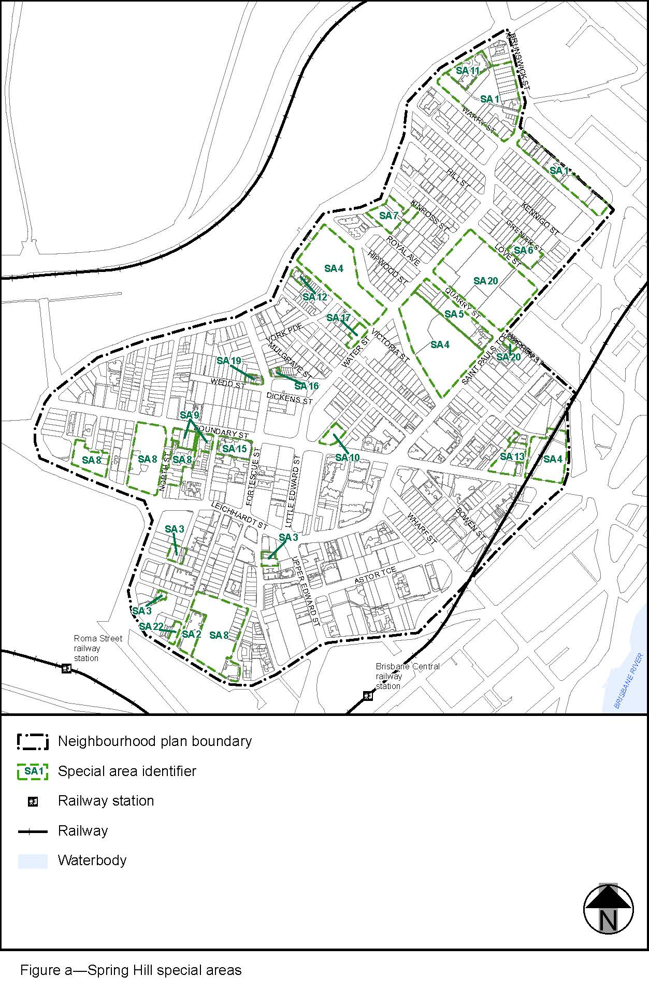

View the high resolution of Figure a–Spring Hill Special areas (PDF file size is 428Kb)

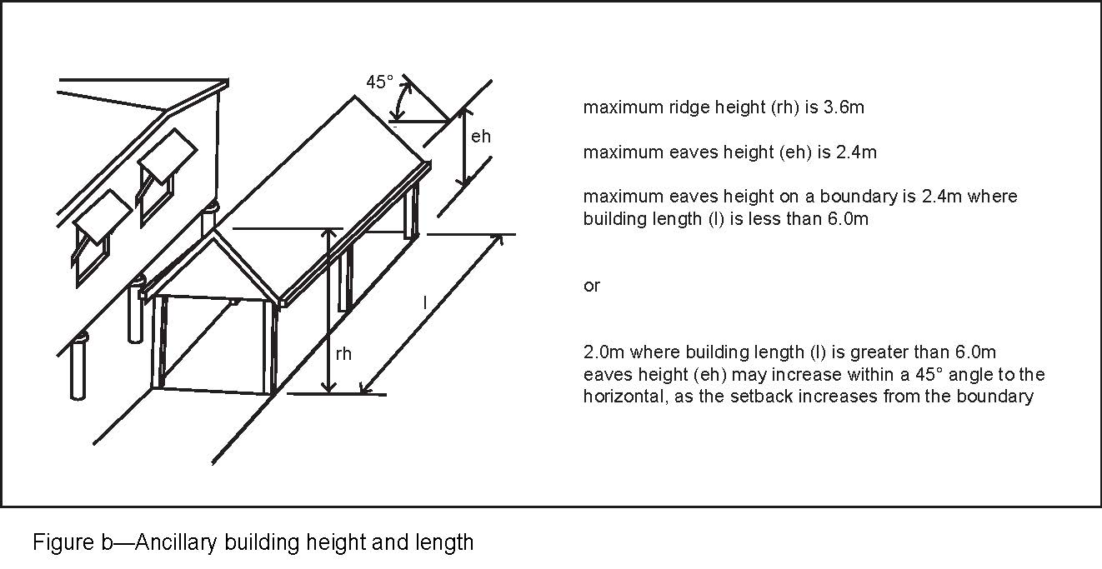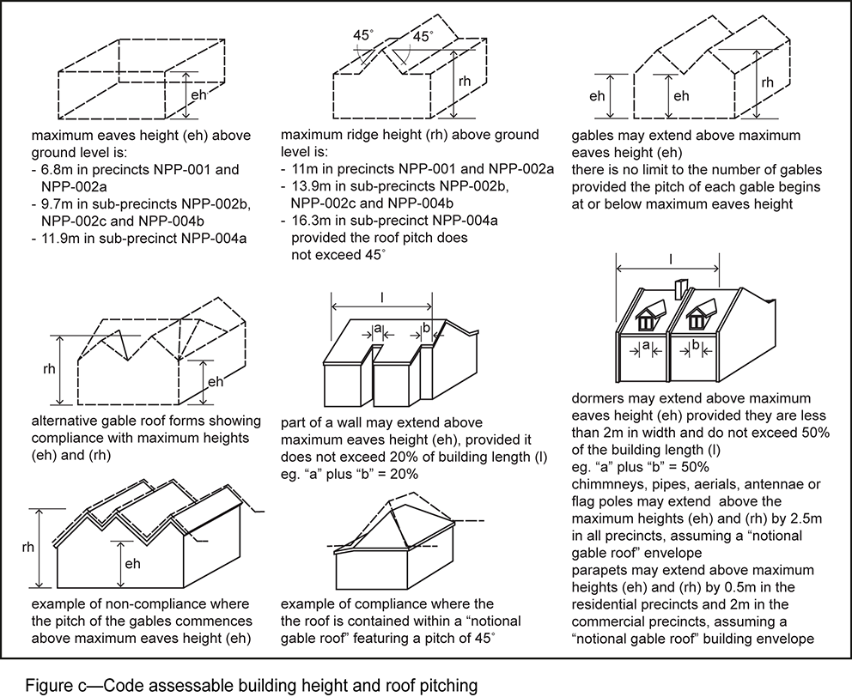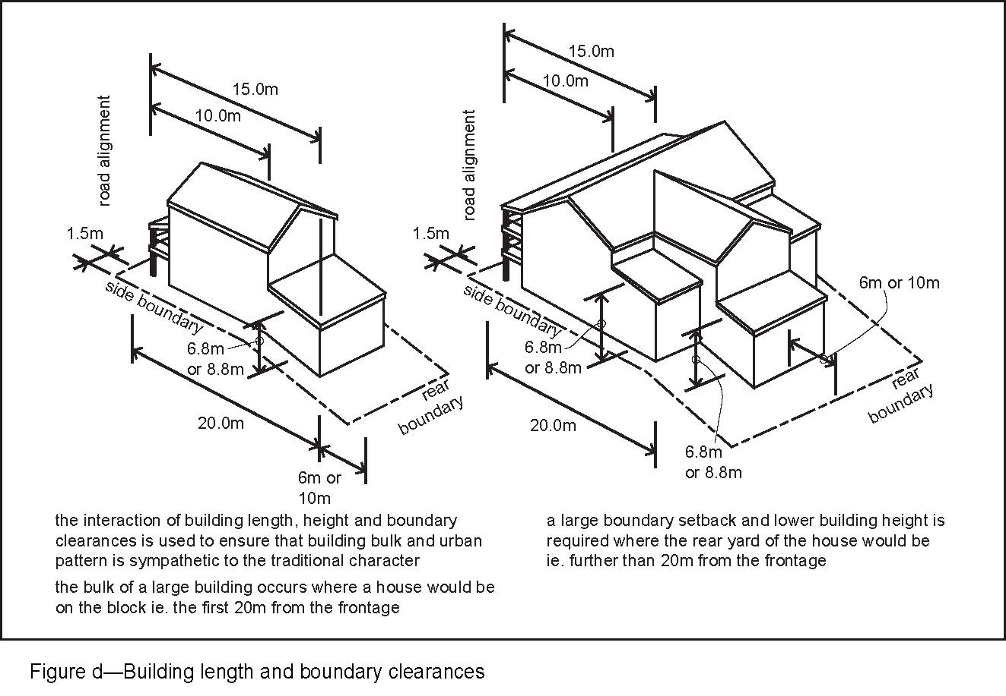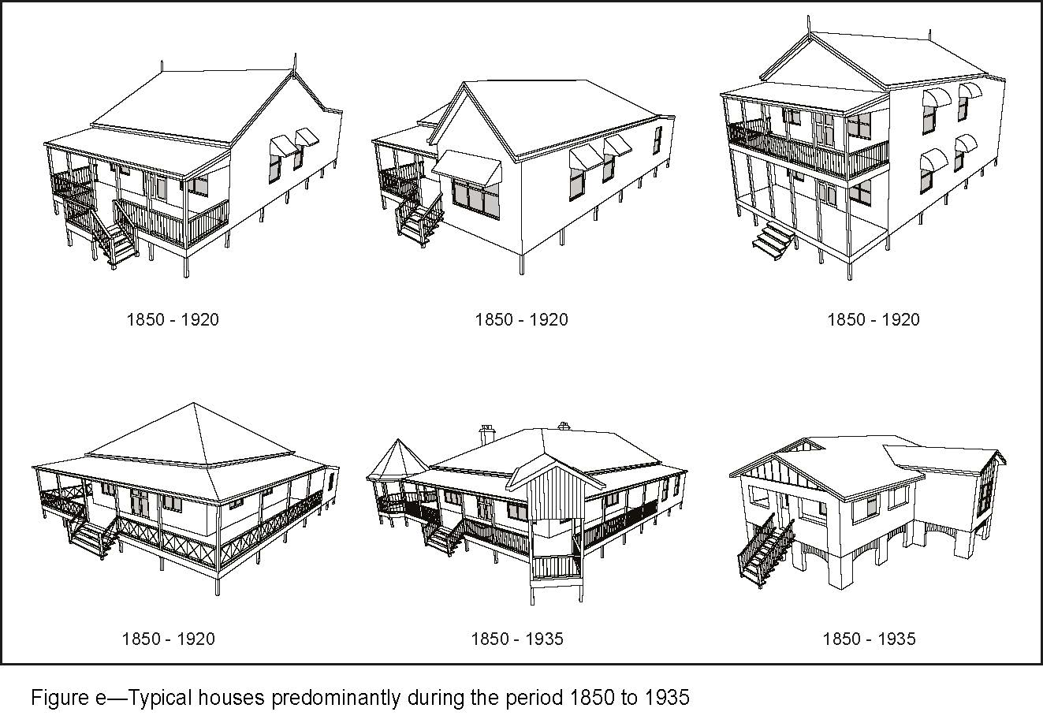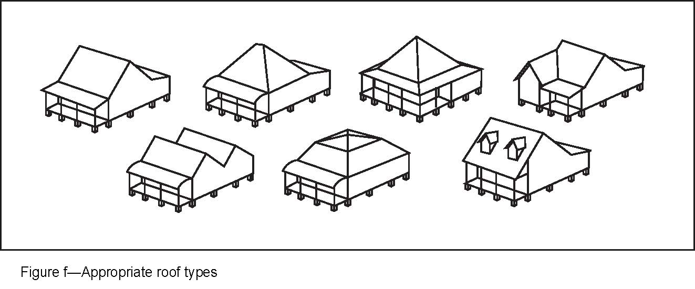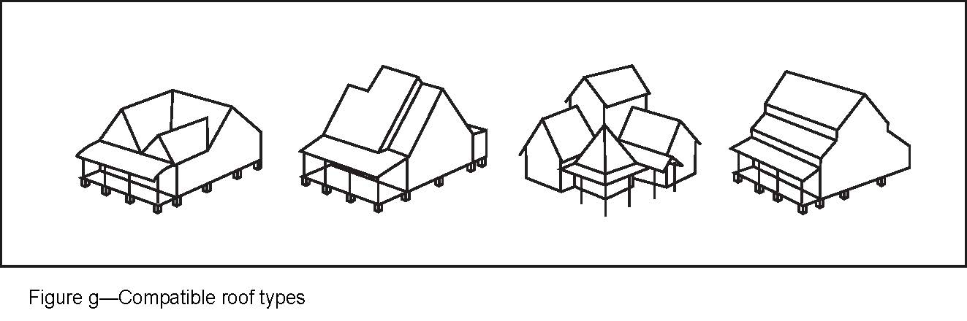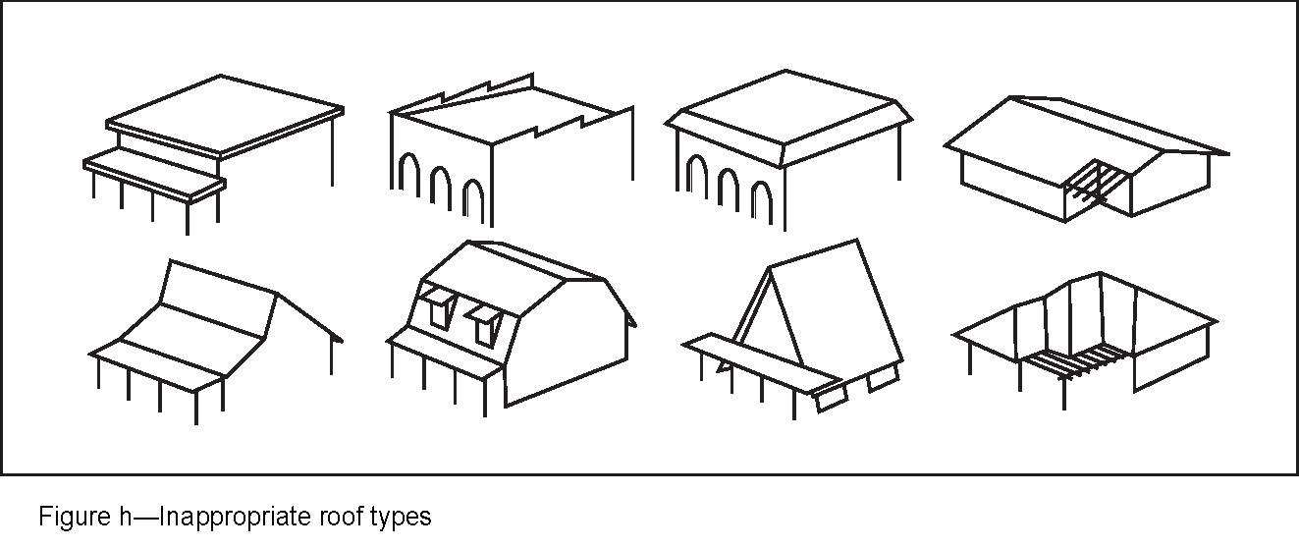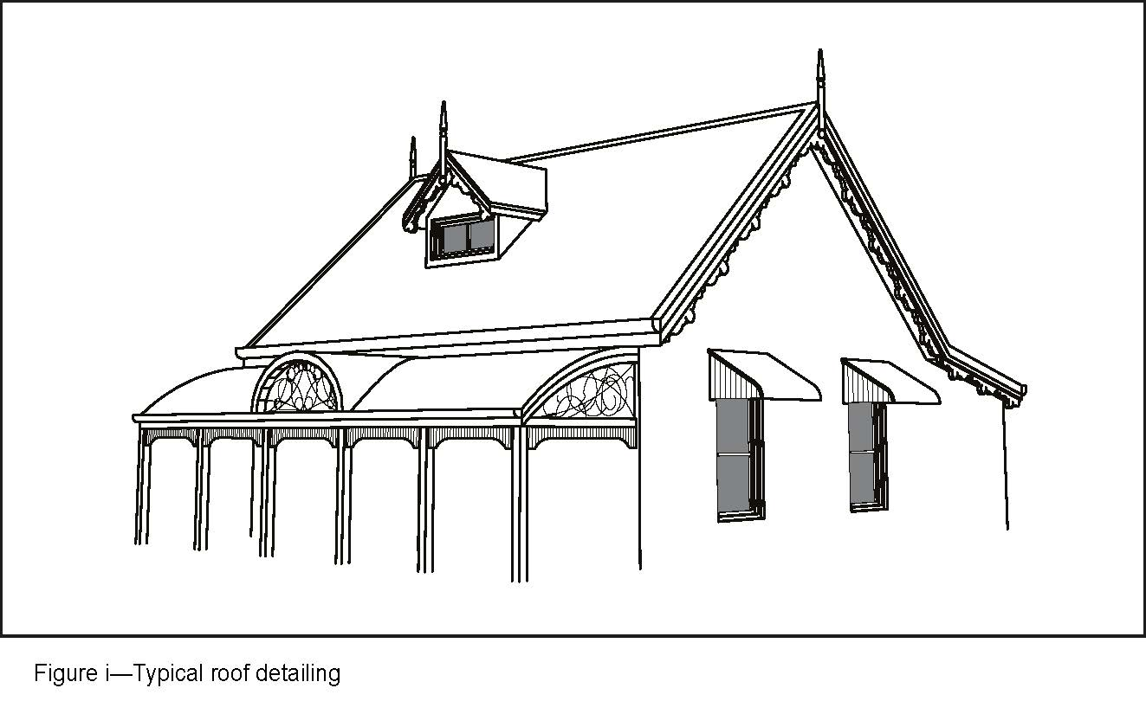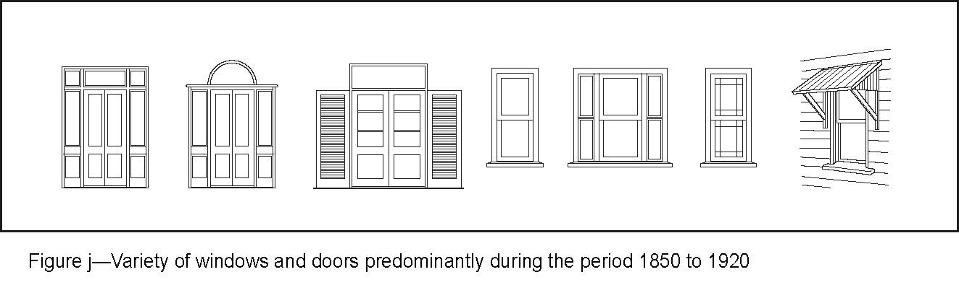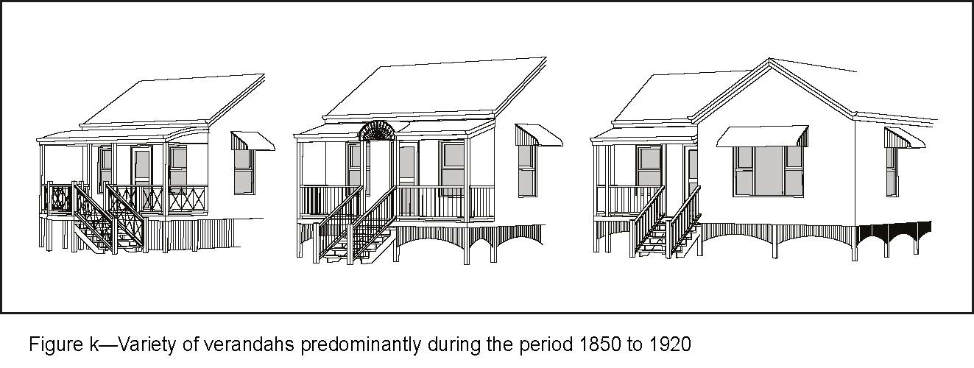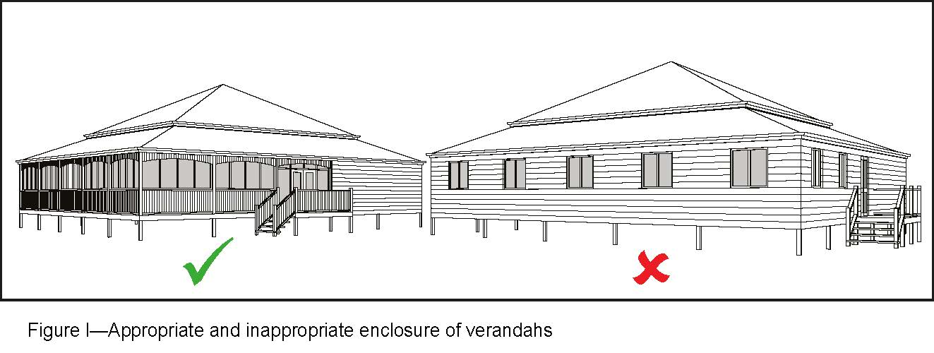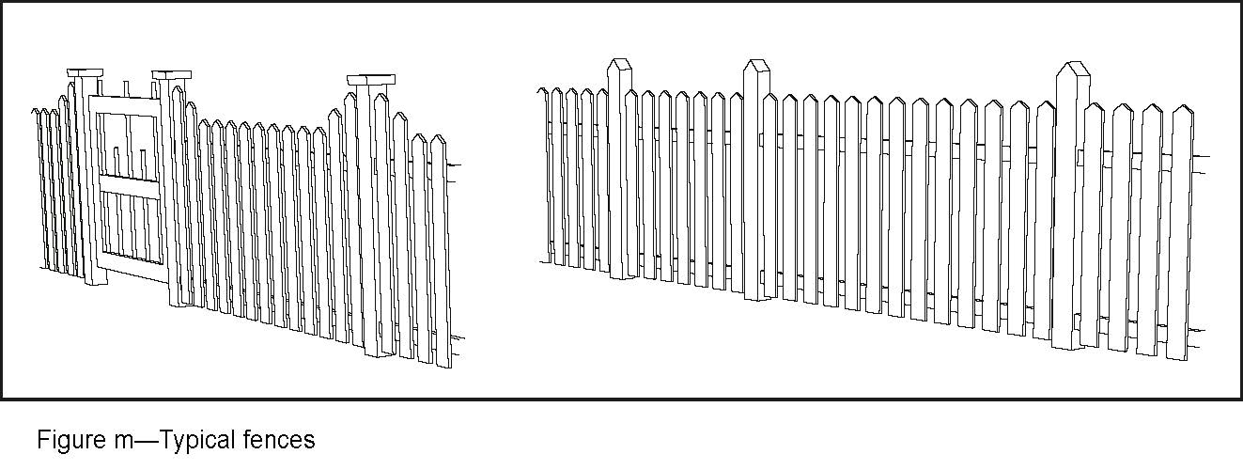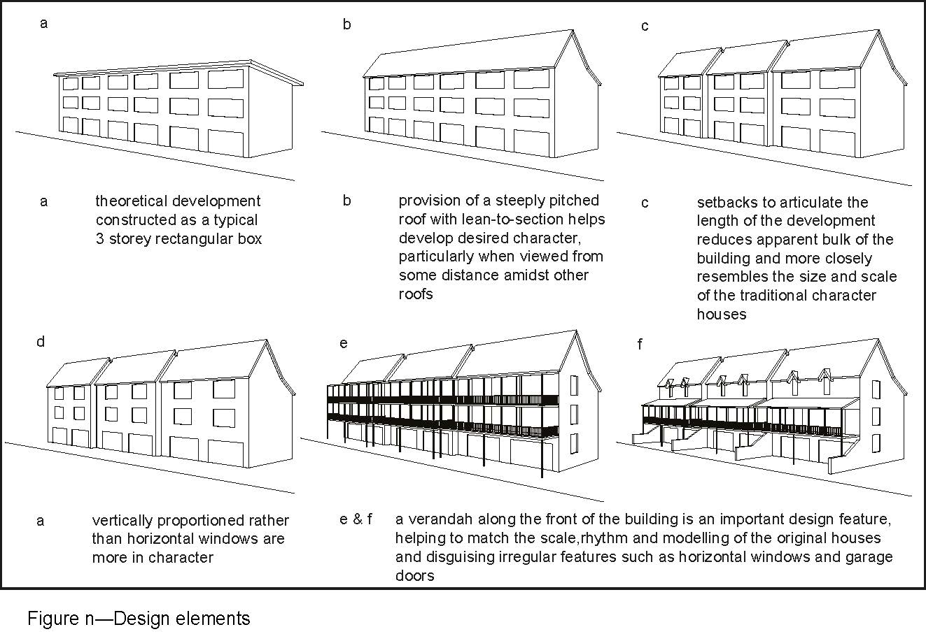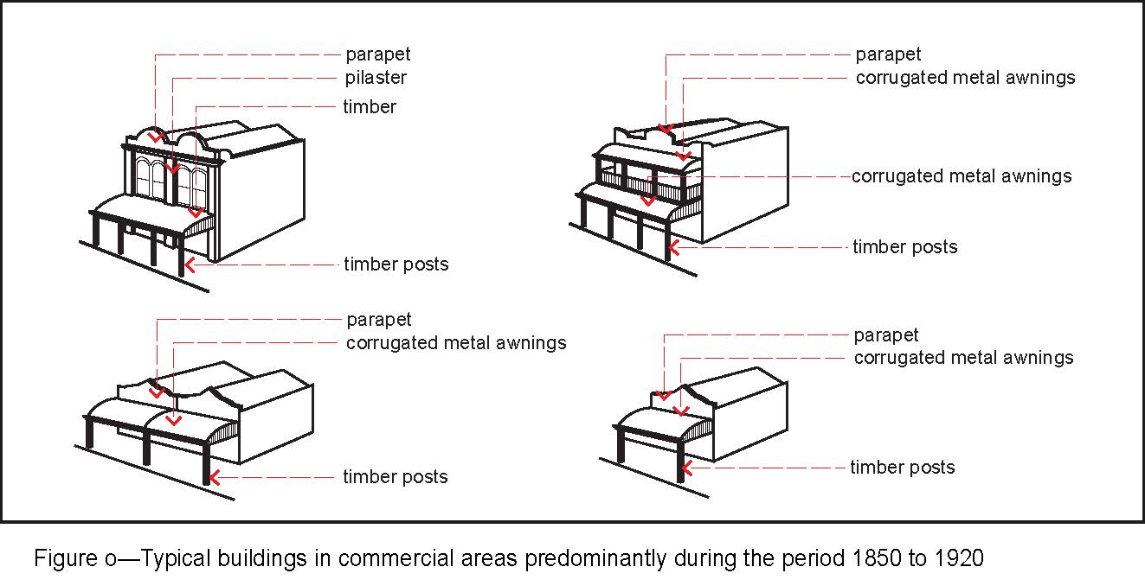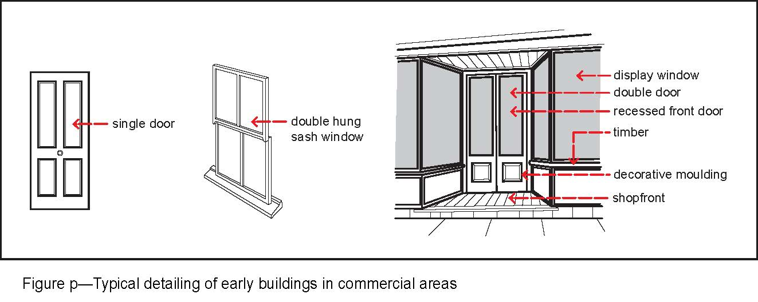
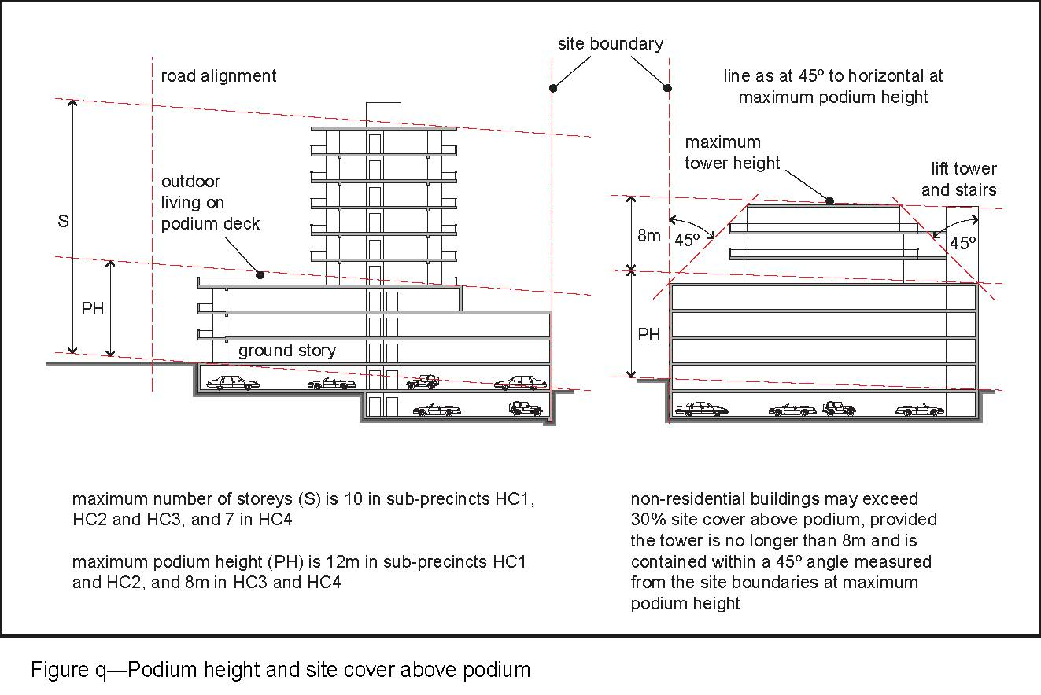

’.
Part 4 Amendment of Part 8 (Overlays)

4.1 Amendment to section 8.2.16 (Pre-1911 building overlay code)
- Section 8.2.16 Pre-1911 building overlay code, Table 8.2.16.3—Performance outcomes and acceptable outcomes
‘
Performance outcomes | Acceptable outcomes
If involving removal or demolition in the Emerging community zone, Low density residential zone, Low–medium density residential zone, Character residential zone, Environmental management zone, Rural zone or Community facilities zone
PO1  The building must not be capable of structural repair. | AO1  The building is demonstrated by an engineering report prepared by a Registered Professional Engineer Queensland to be structurally unsound and not reasonably capable of being made structurally sound.  Note—For the purpose of this code, comparative analysis of an existing dwelling constructed in 1911 or earlier against the current timber framing standards is not considered to demonstrate that a building is 'structurally unsound'.
If involving demolition of a part of a building in the Emerging community zone, Low density residential zone, Low–medium density residential zone, Character residential zone, Environmental management zone, Rural zone or Community facilities zone
PO2  The building does not lose an integral component such as roof shape and pitch or verandahs that contributes to its traditional building character. | AO2  The part of the building constructed prior to 1911 is retained.
’–
omit, insert:
‘
Performance outcomes | Acceptable outcomes
If involving removal or demolition in the Emerging community zone, Low density residential zone, Low-medium density residential zone, Character residential zone, Environmental management zone, Rural zone or Community facilities zone or where located within the City west neighbourhood plan area
PO1  The building must not be capable of structural repair. | AO1  The building is demonstrated by an engineering report prepared by a Registered Professional Engineer Queensland to be structurally unsound and not reasonably capable of being made structurally sound.  Note—For the purpose of this code, comparative analysis of an existing dwelling constructed in 1911 or earlier against the current timber framing standards is not considered to demonstrate that a building is 'structurally unsound'.
If involving demolition of a part of a building in the Emerging community zone, Low density residential zone, Low-medium density residential zone, Character residential zone, Environmental management zone, Rural zone or Community facilities zone or where located within the City west neighbourhood plan area
PO2  The building does not lose an integral component such as roof shape and pitch or verandahs that contributes to its traditional building character. | AO2  The part of the building constructed prior to 1911 is retained.
’.

4.2 Amendment to section 8.2.19 (Significant landscape tree overlay code)
- Section 8.2.19 Significant landscape tree overlay code, Table 8.2.19.3.C—Significant landscape trees in specific locations–
insert before Murrarie:
‘
’.
Milton
9 x Ficus benjamina weeping fig | 124 and 140 Caxton Street | L581 RP227070  L357 SP161706
- Section 8.2.19 Significant landscape tree overlay code, Table 8.2.19.3.C—Significant landscape trees in specific locations–
insert before Red Hill:
‘
’.
Petrie Terrace
Delonix regia Poinciana | 14 Clifton Street | L2 RP10648
Delonix regia Poinciana | 71 Hale Street | L1 RP10654
Ceiba pentandra Kapok tree and other mixed native and exotic species of historical and cultural significance | 83 Petrie Terrace | L329 RP145429 L343 RP145429

4.3 Amendment to section 8.2.21 (Traditional building character (demolition) overlay code)
- Section 8.2.21 Traditional building character (demolition) overlay code, Table 8.2.21.3—Performance outcomes and acceptable outcomes
‘
Performance outcomes | Acceptable outcomes
Section A—Partial demolition of a building constructed in 1946 or earlier
General
PO1  Development involving partial demolition of traditional elements, detailing and materials constructed in 1946 or earlier does not diminish traditional building form and roof styles, where:  - forward of the highest and rearmost ridge of the roof; or  - on the side elevation of the building where on a corner lot.  Note—Where demolition results in the loss of integral components, assessment against Section B of this code is also required. | AO1.1  Development ensures that the building does not lose integral components such as feature roof forms and side verandahs.
AO1.2
Development involving partial demolition does not result in a narrow building which has a width-to-height proportion out of character with the residential buildings constructed in 1946 or earlier in the street within the Traditional building character overlay.
Additional performance outcomes and acceptable outcomes if a pre-1911 building
PO2  Development ensures that the building does not lose integral components such as roof shape and pitch or verandahs that contribute to its traditional building character. | AO2  Development retains the parts of the building constructed prior to 1911.
Additional performance outcomes and acceptable outcomes if in the Sherwood—Graceville district neighbourhood plan area where not in the Westside character precinct
PO3  Development ensures that:  - significant elements that contribute to the character of buildings constructed in 1946 or earlier are retained if they can be seen from the primary street frontage;  - the proposed partial demolition does not affect the view of the original structure from the street.  Note—Elements include roof form, external walls, building core, verandahs, external openings and decorative detailing. | AO3.1  Development retains the building in its original form, proportions and external components, including:  - the front walls and the roof form and side walls beyond, at least as far back as the ridge of the rearmost gable in a gable roof house or the primary ridge for a hipped roof house;  - original doors and windows and their size, proportions and materials;  - side and front verandahs including balustrading and decorative details.
AO3.2
Development retains the front door to the house as the main entrance in its original location and proportion.
Note—The extent of any partial demolition is to be identified in plan and elevation drawings.
Additional performance outcomes and acceptable outcomes if in the Bulimba district neighbourhood plan area
PO4  Development involving partial demolition or refurbishment of a residential building constructed in 1946 or earlier as part of refurbishment or extension work does not diminish the traditional building character elements of the building. | AO4  Development complies with an engineering report prepared by a Registered Professional Engineer Queensland which certifies that all works proposed whether permanent or temporary will ensure the structural adequacy of the building at all phases of building work.  Note—The extent of any partial demolition is to be identified in plan and elevation drawings.
Section B—Demolition or removal of a building constructed in 1946 or earlier
General performance outcomes and acceptable outcomes if not in the Latrobe and Given Terraces neighbourhood plan area
PO5  Development involves a building which:  - does not represent traditional building character; or  - is not capable of structural repair; or  - does not contribute to the traditional building character of that part of the street within the Traditional building character overlay. | AO5  Development involves a building which:  - has been substantially altered or does not have the appearance of being constructed in 1946 or earlier; or  - an engineering report prepared by a Registered Professional Engineer Queensland which certifies that the building is structurally unsound and not reasonably capable of being made structurally sound; or  - if demolished will not result in the loss of traditional building character; or  - is in a section of the street within the Traditional building character overlay that has no traditional character.  Note— For the purpose of this code, comparative analysis of an existing dwelling constructed in 1946 or earlier against the current timber framing standards is not considered to demonstrate 'structurally unsound'.
Additional performance outcomes and acceptable outcomes if a pre-1911 building
PO6  Development involves a building which is not capable of structural repair. | AO6  Development involves a building which a Registered Professional Engineer Queensland certifies is structurally unsound and not reasonably capable of being made structurally sound.  Note— For the purpose of this code, comparative analysis of an existing dwelling constructed in 1946 or earlier against the current timber framing standards is not considered to demonstrate 'structurally unsound'.
Additional performance outcomes and acceptable outcomes if in the Local character significance sub-category
PO7  Development involves a building which:  - does not represent traditional building character; or  - is not capable of structural repair; or  - is not a building constructed in 1946 or earlier. | AO7.1  Development involves a building which has been substantially and irreversibly altered or does not have the appearance of being constructed in 1946 or earlier.
AO7.2
Development involves a building which:
- has an appearance that cannot practically be reinstated to that of a building constructed pre-1911 or in 1946 or earlier; or
Note—In making a determination as to whether the appearance of a building constructed in 1946 or earlier can be reinstated, Council will require information to be submitted with any development application addressing the practicalities of a development:
- opening up enclosed front and/or side verandahs;
- removing enclosures under the front section of the building;
- removing fibro, stucco or metal cladding to underlying weatherboards or chamferboards;
- replacing aluminium windows with timber windows;
- reinstating verandah elements.
- an engineering report prepared by a Registered Professional Engineer Queensland certifies is structurally unsound and not reasonably capable of being made structurally sound; or
- is located in the Hawthorne centre precinct of the Bulimba district neighbourhood plan and is not a character non-residential building.
Additional performance outcomes and acceptable outcomes if in the Latrobe and Given Terraces neighbourhood plan area
PO8  Development involves a building which is not capable of being structurally repaired. | AO8  Development involves a building which a Registered Professional Engineer Queensland certifies is structurally unsound and not reasonably capable of being made structurally sound.  Note—For the purpose of this code, comparative analysis of an existing dwelling constructed in 1946 or earlier against the current timber framing standards is not considered to demonstrate 'structurally unsound'.
Section C—Repositioning or raising a building or structure (not including any building work to enclose underneath a building) if any part of the building or structure was substantially constructed for residential purposes in 1946 or earlier
PO9  Development involving the repositioning of a residential building or structure that straddles more than one lot, onto one small lot:  - does not detract from:  - the traditional setting of the dwelling houses constructed in 1946 or earlier nearby in the street within the Traditional building character overlay;  - the traditional scale of the components of the street within the Traditional building overlay;  - does not impact on the amenity or privacy of adjoining residents;  - provides adequate open space, screening and noise attenuation from the street. | AO9  Development involving the repositioning of a residential building or structure constructed in 1946 or earlier on a small lot results in setbacks that comply with the building envelope requirements of the Dwelling house (small lot) code, other than where AO10.2 in this code varies the front building setback.  Editor's note—Where not on a small lot, repositioning must not result in an unlawful structure regulated by the Building Act 1975.
PO10  Development ensures that the siting and orientation of a residential building on a lot:  - is complementary to the traditional setting of a dwelling house constructed in 1946 or earlier nearby in the street;  - does not diminish the streetscape character components of the original street to which the building was orientated within the Traditional building character overlay;  - does not result in a the building being isolated from a streetscape within the Traditional building character overlay or a streetscape that exhibits traditional character. | AO10.1  Development involving a residential building remains orientated to face its existing street frontage in a manner consistent with a dwelling house constructed in 1946 or earlier on adjoining lots.
AO10.2
Development retains the residential building within 20% of the front setback of a neighbouring dwelling house constructed in 1946 or earlier.
PO11  Development involving raising a building constructed in 1946 or earlier is consistent with and complements the predominant traditional scale, proportion and setting of residential buildings constructed in 1946 or earlier nearby in the street. Refer to Figure a. | AO11  Development involving raising a dwelling house constructed in 1946 or earlier results in a building height that does not exceed:  - the building height requirements contained in any relevant neighbourhood plan; or  - 9.5m otherwise.
’–
omit, insert:
‘
Performance outcomes | Acceptable outcomes
Section A—Partial demolition of a building constructed in 1946 or earlier
General
PO1  Development involving partial demolition of traditional elements, detailing and materials constructed in 1946 or earlier does not diminish traditional building form and roof styles, where:  - forward of the highest and rearmost ridge of the roof; or  - on the side elevation of the building where on a corner lot.  Note—Where demolition results in the loss of integral components, assessment against Section B of this code is also required. | AO1.1  Development ensures that the building does not lose integral components such as feature roof forms and side verandahs.
AO1.2
Development involving partial demolition does not result in a narrow building which has a width-to-height proportion out of character with the residential buildings constructed in 1946 or earlier in the street within the Traditional building character overlay.
Additional performance outcomes and acceptable outcomes if a pre-1911 building
PO2  Development ensures that the building does not lose integral components such as roof shape and pitch or verandahs that contribute to its traditional building character. | AO2  Development retains the parts of the building constructed prior to 1911.
Additional performance outcomes and acceptable outcomes if in the City west neighbourhood plan area or in the Sherwood—Graceville district neighbourhood plan area where not in the Westside character precinct
PO3  Development ensures that:  - significant elements that contribute to the character of buildings constructed in 1946 or earlier are retained if they can be seen from the primary street frontage;  - the proposed partial demolition does not affect the view of the original structure from the street.  Note—Elements include roof form, external walls, building core, verandahs, external openings and decorative detailing. | AO3.1  Development retains the building in its original form, proportions and external components, including:  - the front walls and the roof form and side walls beyond, at least as far back as the ridge of the rearmost gable in a gable roof house or the primary ridge for a hipped roof house;  - original doors and windows and their size, proportions and materials;  - side and front verandahs including balustrading and decorative details.
AO3.2
Development retains the front door to the house as the main entrance in its original location and proportion.
Note—The extent of any partial demolition is to be identified in plan and elevation drawings.
Additional performance outcomes and acceptable outcomes if in the Bulimba district neighbourhood plan area
PO4  Development involving partial demolition or refurbishment of a residential building constructed in 1946 or earlier as part of refurbishment or extension work does not diminish the traditional building character elements of the building. | AO4  Development complies with an engineering report prepared by a Registered Professional Engineer Queensland which certifies that all works proposed whether permanent or temporary will ensure the structural adequacy of the building at all phases of building work.  Note—The extent of any partial demolition is to be identified in plan and elevation drawings.
Section B—Demolition or removal of a building constructed in 1946 or earlier
General performance outcomes and acceptable outcomes if not in the Latrobe and Given Terraces neighbourhood plan area or the City west neighbourhood plan area
PO5  Development involves a building which:  - does not represent traditional building character; or  - is not capable of structural repair; or  - does not contribute to the traditional building character of that part of the street within the Traditional building character overlay. | AO5  Development involves a building which:  - has been substantially altered or does not have the appearance of being constructed in 1946 or earlier; or  - an engineering report prepared by a Registered Professional Engineer Queensland which certifies that the building is structurally unsound and not reasonably capable of being made structurally sound; or  - if demolished will not result in the loss of traditional building character; or  - is in a section of the street within the Traditional building character overlay that has no traditional character.  Note—For the purpose of this code, comparative analysis of an existing dwelling constructed in 1946 or earlier against the current timber framing standards is not considered to demonstrate 'structurally unsound'.
Additional performance outcomes and acceptable outcomes if a pre-1911 building
PO6  Development involves a building which is not capable of structural repair. | AO6  Development involves a building which a Registered Professional Engineer Queensland certifies is structurally unsound and not reasonably capable of being made structurally sound.  Note—For the purpose of this code, comparative analysis of an existing dwelling constructed in 1946 or earlier against the current timber framing standards is not considered to demonstrate 'structurally unsound'.
Additional performance outcomes and acceptable outcomes if in the Local character significance sub-category
PO7  Development involves a building which:  - does not represent traditional building character; or  - is not capable of structural repair; or  - is not a building constructed in 1946 or earlier. | AO7.1  Development involves a building which has been substantially and irreversibly altered or does not have the appearance of being constructed in 1946 or earlier.
AO7.2
Development involves a building which:
- has an appearance that cannot practically be reinstated to that of a building constructed pre-1911 or in 1946 or earlier; or
Note—In making a determination as to whether the appearance of a building constructed in 1946 or earlier can be reinstated, Council will require information to be submitted with any development application addressing the practicalities of a development:
- opening up enclosed front and/or side verandahs;
- removing enclosures under the front section of the building;
- removing fibro, stucco or metal cladding to underlying weatherboards or chamferboards;
- replacing aluminium windows with timber windows;
- reinstating verandah elements.
- an engineering report prepared by a Registered Professional Engineer Queensland certifies is structurally unsound and not reasonably capable of being made structurally sound; or
- is located in the Hawthorne centre precinct of the Bulimba district neighbourhood plan and is not a character non-residential building.
Additional performance outcomes and acceptable outcomes if in the Latrobe and Given Terraces neighbourhood plan area or the City west neighbourhood plan area
PO8  Development involves a building which is not capable of being structurally repaired. | AO8  Development involves a building which a Registered Professional Engineer Queensland certifies is structurally unsound and not reasonably capable of being made structurally sound.  Note— For the purpose of this code, comparative analysis of an existing dwelling constructed in 1946 or earlier against the current timber framing standards is not considered to demonstrate 'structurally unsound'.
Section C—Repositioning or raising a building or structure (not including any building work to enclose underneath a building) if any part of the building or structure was substantially constructed for residential purposes in 1946 or earlier
PO9  Development involving the repositioning of a residential building or structure that straddles more than one lot, onto one small lot:  - does not detract from:  - the traditional setting of the dwelling houses constructed in 1946 or earlier nearby in the street within the Traditional building character overlay;  - the traditional scale of the components of the street within the Traditional building overlay;  - does not impact on the amenity or privacy of adjoining residents;  - provides adequate open space, screening and noise attenuation from the street. | AO9  Development involving the repositioning of a residential building or structure constructed in 1946 or earlier on a small lot results in setbacks that comply with the building envelope requirements of the Dwelling house (small lot) code, other than where AO10.2 in this code varies the front building setback.  Editor's note—Where not on a small lot, repositioning must not result in an unlawful structure regulated by the Building Act 1975.
PO10  Development ensures that the siting and orientation of a residential building on a lot:  - is complementary to the traditional setting of a dwelling house constructed in 1946 or earlier nearby in the street;  - does not diminish the streetscape character components of the original street to which the building was orientated within the Traditional building character overlay;  - does not result in a building being isolated from a streetscape within the Traditional building character overlay or a streetscape that exhibits traditional character. | AO10.1  Development involving a residential building remains orientated to face its existing street frontage in a manner consistent with a dwelling house constructed in 1946 or earlier on adjoining lots.
AO10.2
Development retains the residential building within 20% of the front setback of a neighbouring dwelling house constructed in 1946 or earlier.
PO11  Development involving raising a building constructed in 1946 or earlier is consistent with and complements the predominant traditional scale, proportion and setting of residential buildings constructed in 1946 or earlier nearby in the street. Refer to Figure a. | AO11  Development involving raising a dwelling house constructed in 1946 or earlier results in a building height that does not exceed:  - the building height requirements contained in any relevant neighbourhood plan; or  - 9.5m otherwise.
’.

Part 5 Amendment of Schedule 2 (Mapping)

5.1 Amendment to Schedule 2.2 (Zone maps)
- Schedule 2 Mapping, SC2.2 Zone Maps, ZM-001 (Tile 28)
‘
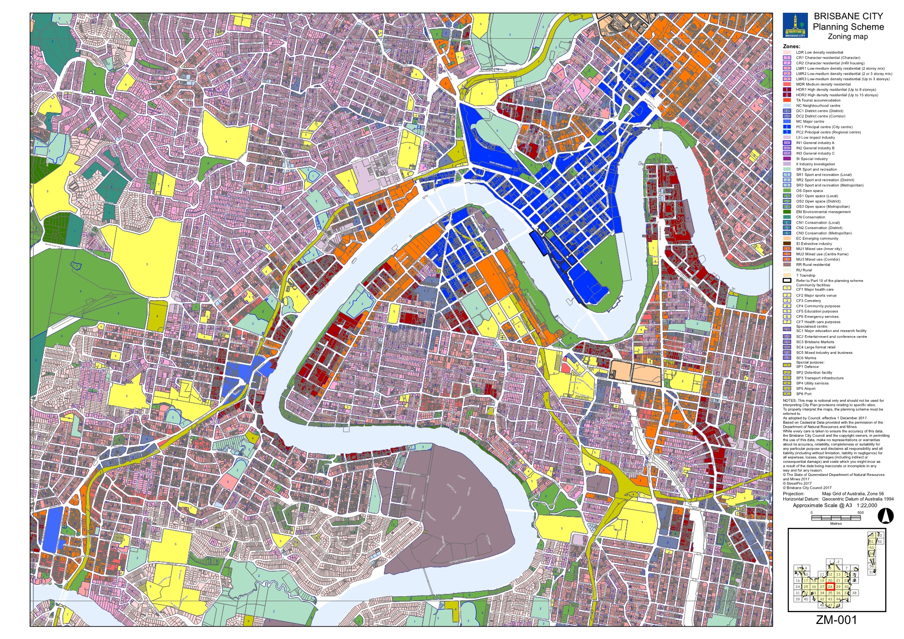
’–
omit, insert: SC2.2 Zone Maps, ZM-001 (Tile 28)–refer to Supplement 1a.
See Supplement 2.1 Zone map for Listing of Properties Affected by Mapping Changes.

5.2 Amendment to Table SC2.2.1 (Zone maps)
- Schedule 2 Mapping, SC2.2 Zone Maps, Table SC2.2.1—Zone Maps–
insert after Gazettal date, 1 December 2017:
‘
Not applicable | ZM-001 | Zoning map  Map tile 28 | 16 February 2018
’.

5.3 Amendment to Schedule 2.3 (Neighbourhood plan maps)
- Schedule 2 Mapping, SC2.3 Neighbourhood plan maps, NPM-003.9 City west neighbourhood plan map–
insert: NPM-003.9 City west neighbourhood plan map–refer to Supplement 1b.

- Schedule 2 Mapping, SC2.3 Neighbourhood plan maps, NPM-009.2 Ithaca district neighbourhood plan map
‘
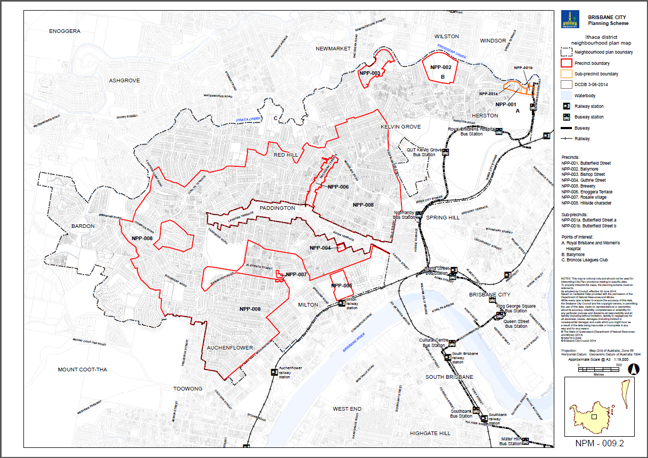
’–
omit, insert: NPM-009.2 Ithaca district neighbourhood plan map–refer to Supplement 1c.

- Schedule 2 Mapping, SC2.3 Neighbourhood plan maps, NPM-012.2 Latrobe and Given Terraces neighbourhood plan map
‘
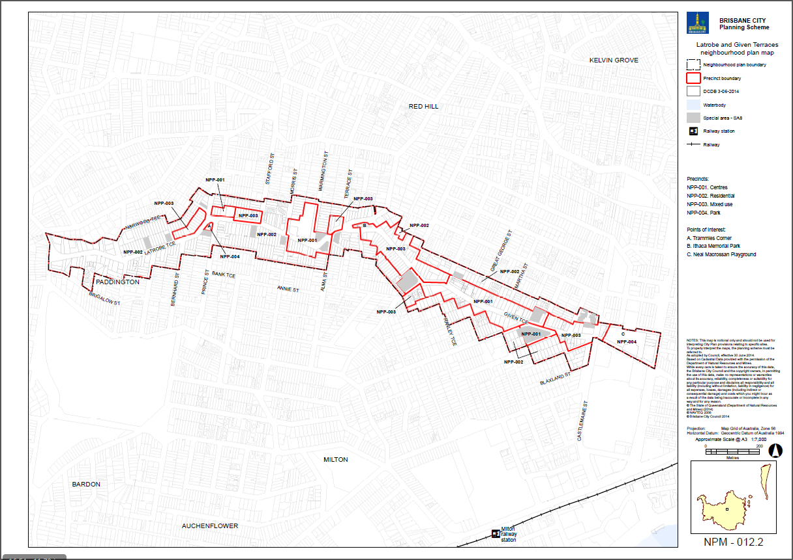
’–
omit, insert: NPM-012.2 Latrobe and Given Terraces neighbourhood plan map–refer to Supplement 1d.

- Schedule 2 Mapping, SC2.3 Neighbourhood plan maps, NPM-016.1 Petrie Terrace and Spring Hill neighbourhood plan map
‘
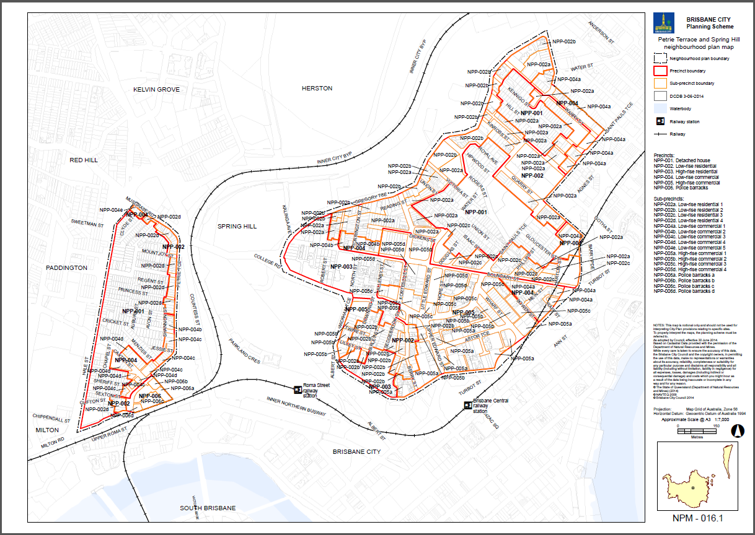
’–
omit.

- Schedule 2 Mapping, SC2.3 Neighbourhood plan maps, NPM-019.5 Spring Hill neighbourhood plan map–
insert: NPM-019.5 Spring Hill neighbourhood plan map–refer to Supplement 1e.

5.4 Amendment to Table SC2.3.1 (Neighbourhood plan maps)
- Schedule 2 Mapping, SC2.3 Neighbourhood plan maps, Table SC2.3.1—Neighbourhood plan maps–
insert before Darra—Oxley district neighbourhood plan map:
‘
NPM-003.9 | City west neighbourhood plan map | 16 February 2018
’.
- Schedule 2 Mapping, SC2.3 Neighbourhood plan maps, Table SC2.3.1—Neighbourhood plan maps
‘
NPM-016.1 | Petrie Terrace and Spring Hill neighbourhood plan map | 30 June 2014
’–
omit, insert:
‘
Intentionally left blank
’.
- Schedule 2 Mapping, SC2.3 Neighbourhood plan maps, Table SC2.3.1—Neighbourhood plan maps–
insert before Taringa neighbourhood plan map:
‘
NPM-019.5 | Spring Hill neighbourhood plan map | 16 February 2018
’.

5.5 Amendment of Schedule 2.4 (Overlay maps)
- Schedule 2 Mapping, SC2.4 Overlay maps, OM-003.2 Commercial character building overlay map (Tile 28)
‘
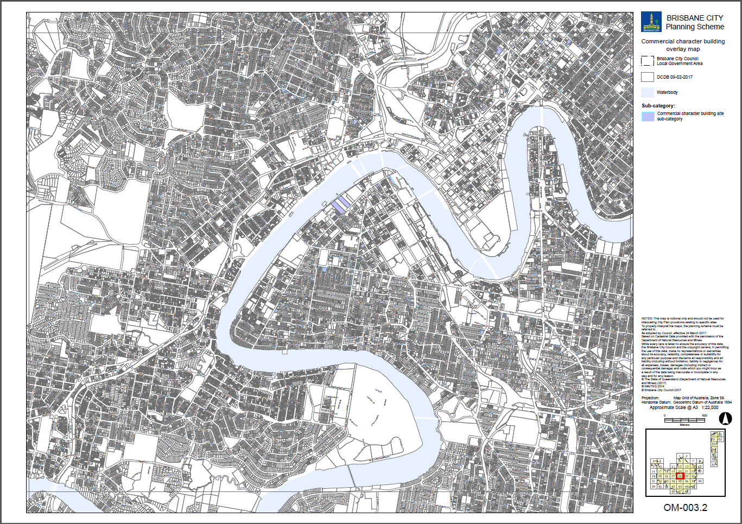
’–
omit, insert: OM-003.2 Commercial character building overlay map (Tile 28)–refer to Supplement 1f.
See Supplement 2.2 Overlay maps for Listing of Properties Affected by Mapping Changes.

- Schedule 2 Mapping, SC2.4 Overlay maps, OM-004.1 Dwelling house character overlay map (Tile 28)
‘
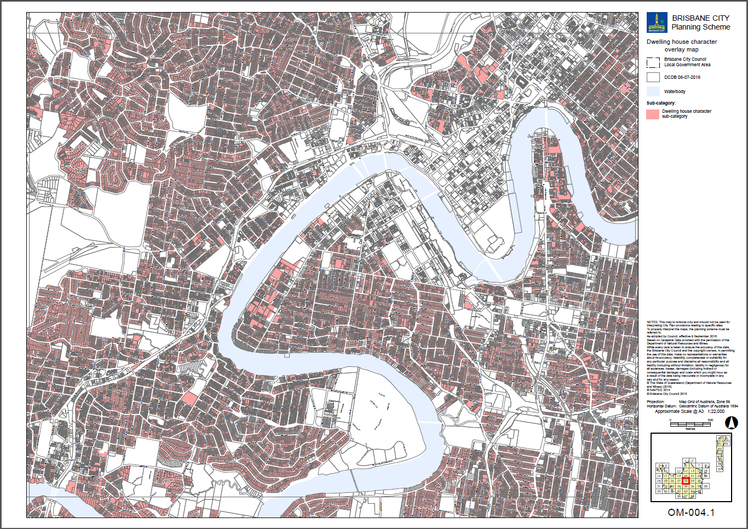
’–
omit, insert: OM-004.1 Dwelling house character overlay map (Tile 28)–refer to Supplement 1g.
See Supplement 2.2 Overlay maps for Listing of Properties Affected by Mapping Changes.

- Schedule 2 Mapping, SC2.4 Overlay maps, OM-008.1 Heritage overlay map (Tile 28)
‘
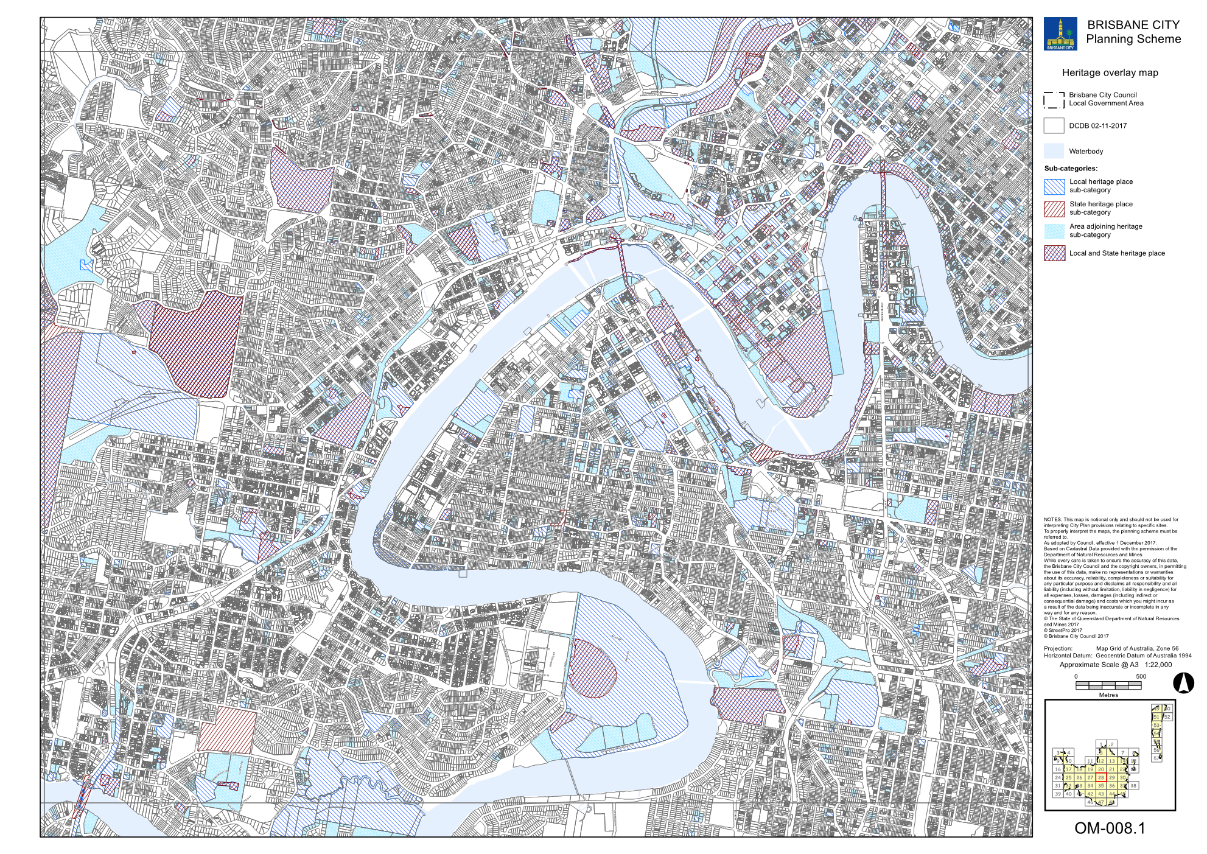
’–
omit, insert OM-008.1 Heritage overlay map (Tile 28)–refer to Supplement 1h.
See Supplement 2.2 Overlay maps for Listing of Properties Affected by Mapping Changes.

- Schedule 2 Mapping, SC2.4 Overlay maps, OM-016.2 Pre-1911 building overlay map (Tile 28)
‘
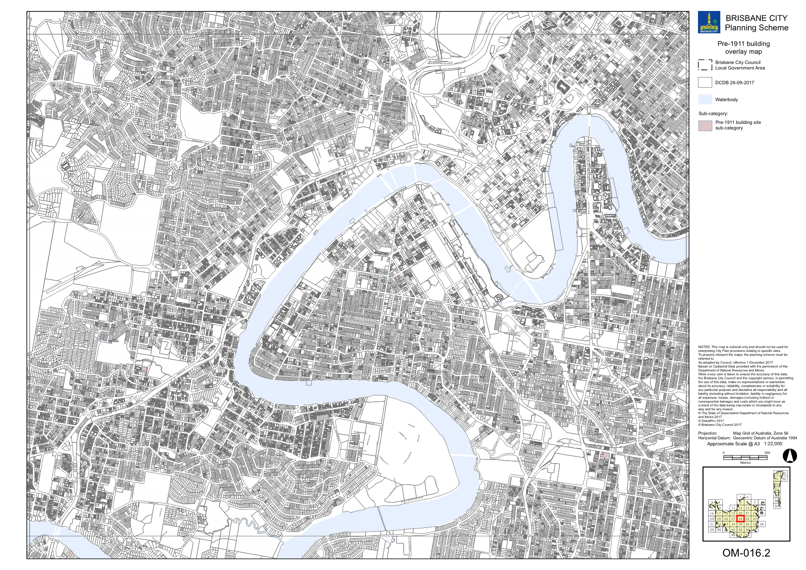
’–
omit, insert: OM-016.2 Pre-1911 building overlay map (Tile 28)–refer to Supplement 1i.
See Supplement 2.2 Overlay maps for Listing of Properties Affected by Mapping Changes.
- Schedule 2 Mapping, SC2.4 Overlay maps, OM-019.1 Significant landscape tree overlay map (Tile 28)
‘
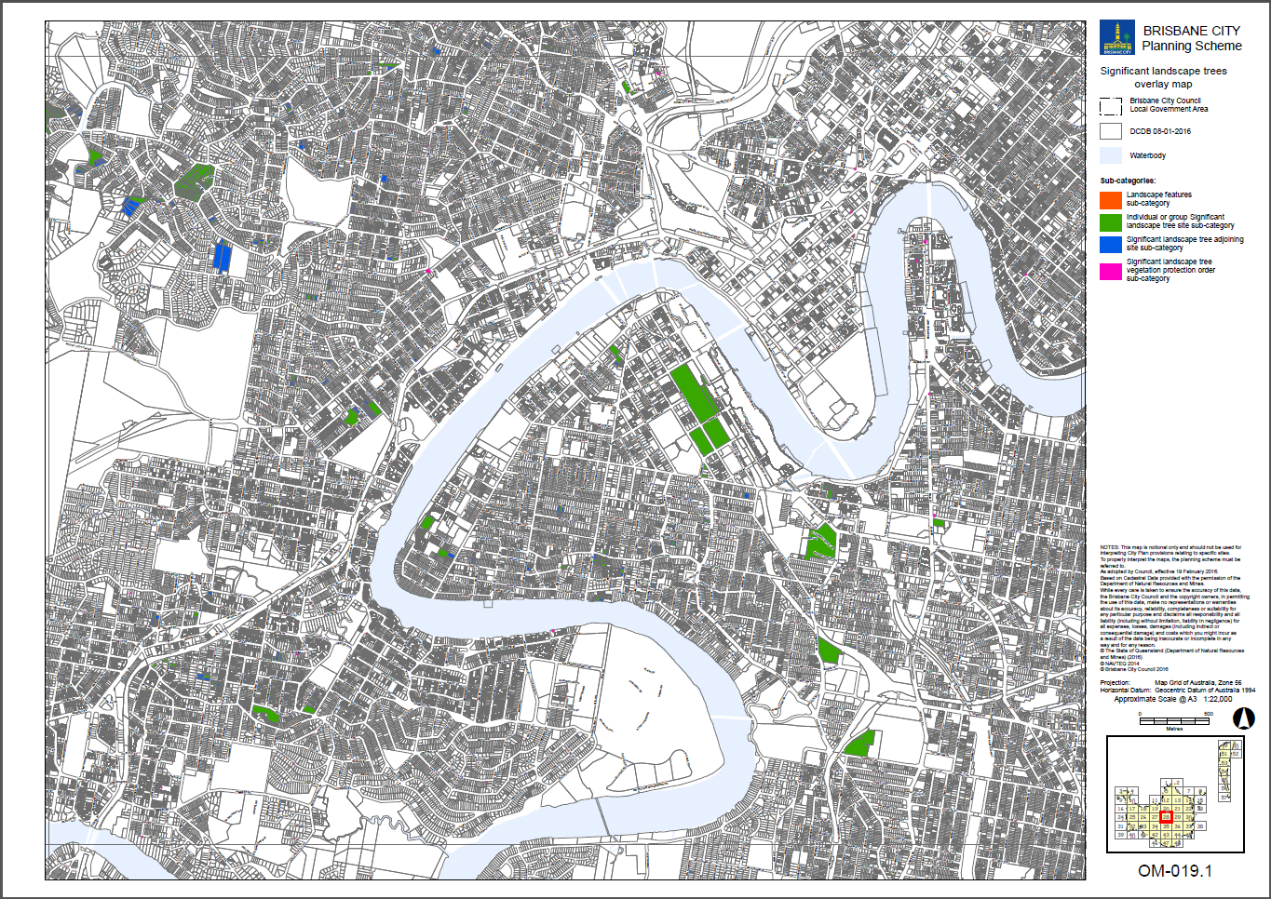
’–
omit, insert: OM-019.1 Significant landscape tree overlay map (Tile 28)–refer to Supplement 1j.
Refer to Supplement 2.2 Overlay maps for Listing of Properties Affected by Mapping Changes.

- Schedule 2 Mapping, SC2.4 Overlay maps, OM-019.2 Streetscape hierarchy overlay map (Tile 28)
‘
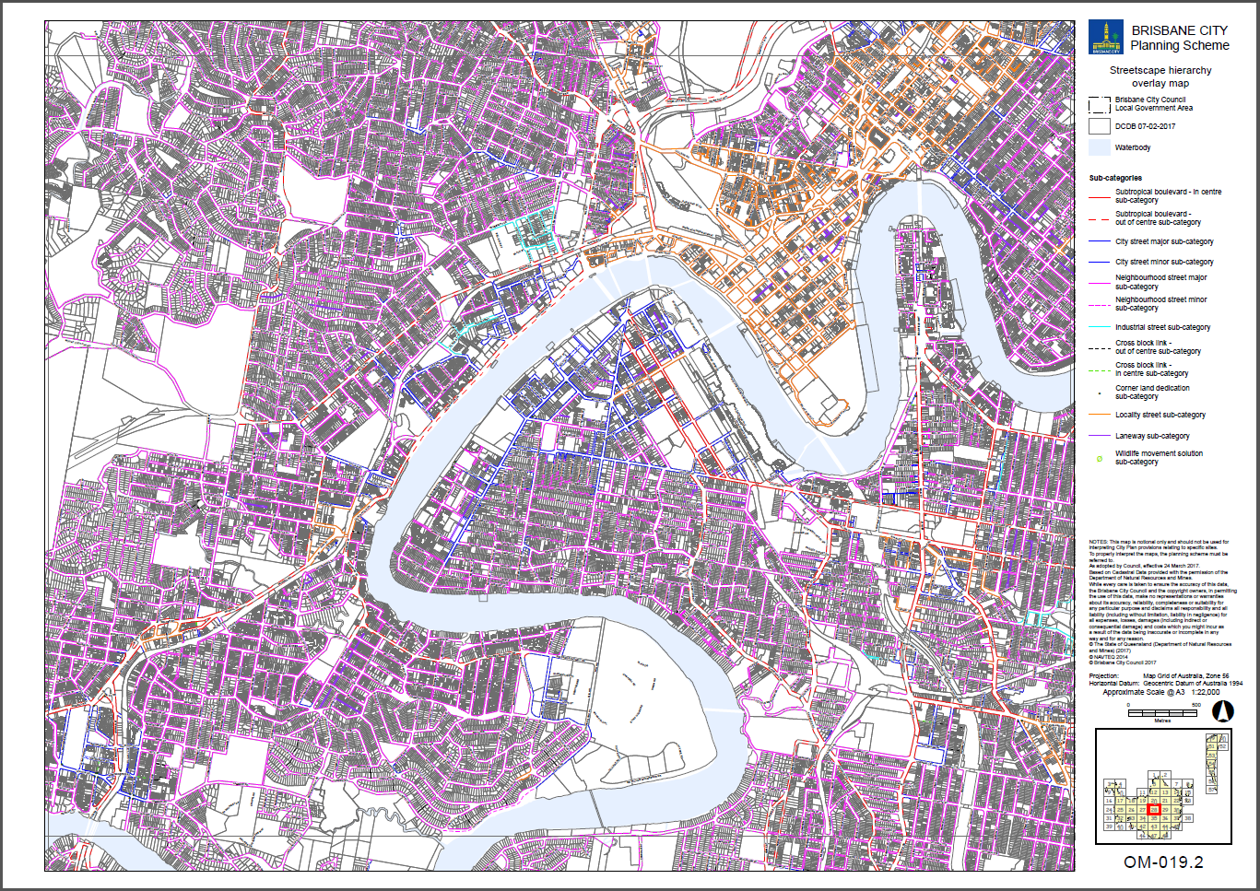
’–
omit, insert: OM-019.2 Streetscape hierarchy overlay map (Tile 28)–refer to Supplement 1k.
- Schedule 2 Mapping, SC2.4 Overlay maps, OM-020.1 Traditional building character overlay map (Tile 28)
‘
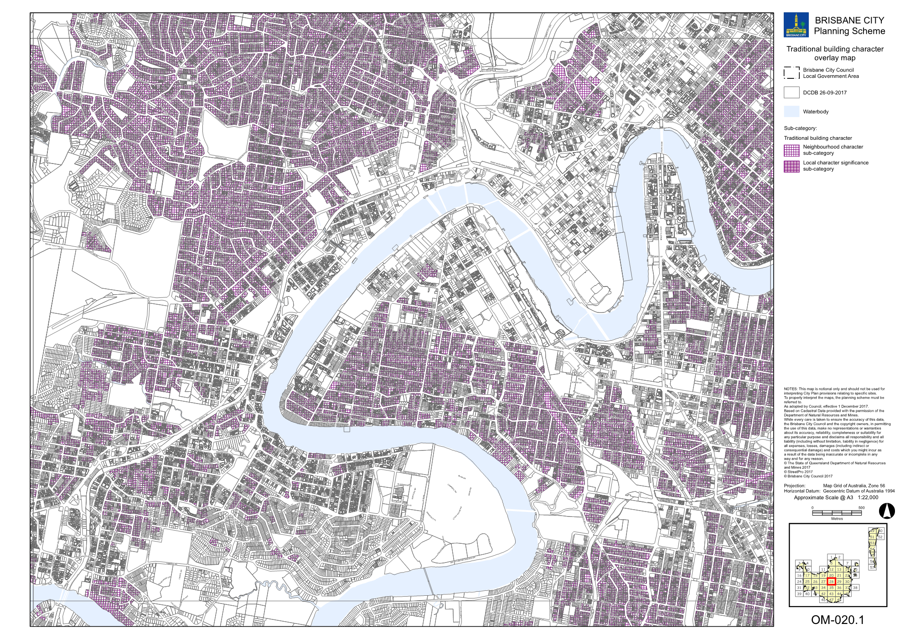
’–
omit, insert: OM-020.1 Traditional building character overlay map (Tile 28)–refer to Supplement 1l.
Refer to Supplement 2.2 Overlay maps for Listing of Properties Affected by Mapping Changes.

5.6 Amendment of Table SC2.4.1 (Overlay maps)
- Schedule 2 Mapping, SC2.4 Overlay maps, Table SC2.4.1—Overlay maps–
insert before OM-003.3, Critical infrastructure and movement overlay map, 30 June 2014:
‘
OM-003.2 | Commercial character building overlay map  Map tile 28 | 16 February 2018
’.
- Schedule 2 Mapping, SC2.4 Overlay maps, Table SC2.4.1—Overlay maps–
insert before OM-005.1, Extractive resources overlay map (all tiles, other than where specified below), 30 June 2014:
‘
OM-004.1 | Dwelling house character overlay map  Map tile 28 | 16 February 2018
’.
- Schedule 2 Mapping, SC2.4 Overlay maps, Table SC2.4.1—Overlay maps–
insert before OM-009.1, Industrial amenity overlay map (all tiles, other than where specified below, 30 June 2014:
‘
OM-008.1 | Heritage overlay map  Map tile 28 | 16 February 2018
’.
- Schedule 2 Mapping, SC2.4 Overlay maps, Table SC2.4.1—Overlay maps–
insert before Q, intentionally left blank:
‘
OM-016.2 | Pre-1911 building overlay map  Map tile 28 | 16 February 2018
’.
- Schedule 2 Mapping, SC2.4 Overlay maps, Table SC2.4.1—Overlay maps–
insert before OM-019.2, Streetscape hierarchy overlay map (all tiles, other than where specified below), 30 June 2014:
‘
OM-019.1 | Significant landscape tree overlay map  Map tile 28 | 16 February 2018
’.
- Schedule 2 Mapping, SC2.4 Overlay maps, Table SC2.4.1—Overlay maps–
insert before OM-020.1, Traditional building character overlay map (all tiles, other than where specified below), 30 June 2014:
‘
OM-019.2 | Streetscape hierarchy overlay map  Map tile 28 | 16 February 2018
’.
- Schedule 2 Mapping, SC2.4 Overlay maps, Table SC2.4.1—Overlay maps–
insert before OM-020.2, Transport air quality corridor overlay map (all tiles, other than where specified below), 30 June 2014:
‘
OM-020.1 | Traditional building character overlay  Map tile 28 | 16 February 2018
’.

Part 6 Amendment of Schedule 6 (Planning scheme policies)

6.1 Amendment to Schedule 6.16 (Infrastructure design planning scheme policy)
- Schedule 6 Planning scheme policies (PSP), SC6.16 Infrastructure design planning scheme policy, Chapter 5 Streetscape locality advice, Table 5.1.2—Locality streets within Neighbourhood plan areas and other locations–
insert before 5.3.4, Intentionally left blank – as no Neighbourhood plans beginning with ‘D’:
‘
5.3.3.2 | City west
’.
- Schedule 6 Planning scheme policies (PSP), SC6.16 Infrastructure design planning scheme policy, Chapter 5 Streetscape locality advice, Section 5.3 Neighbourhood pans and other locations, 5.3.3.2 City west–
insert before 5.3.6.1 Fortitude Valley:
‘

5.3.3.2 City west

5.3.3.2.1 Location and extent
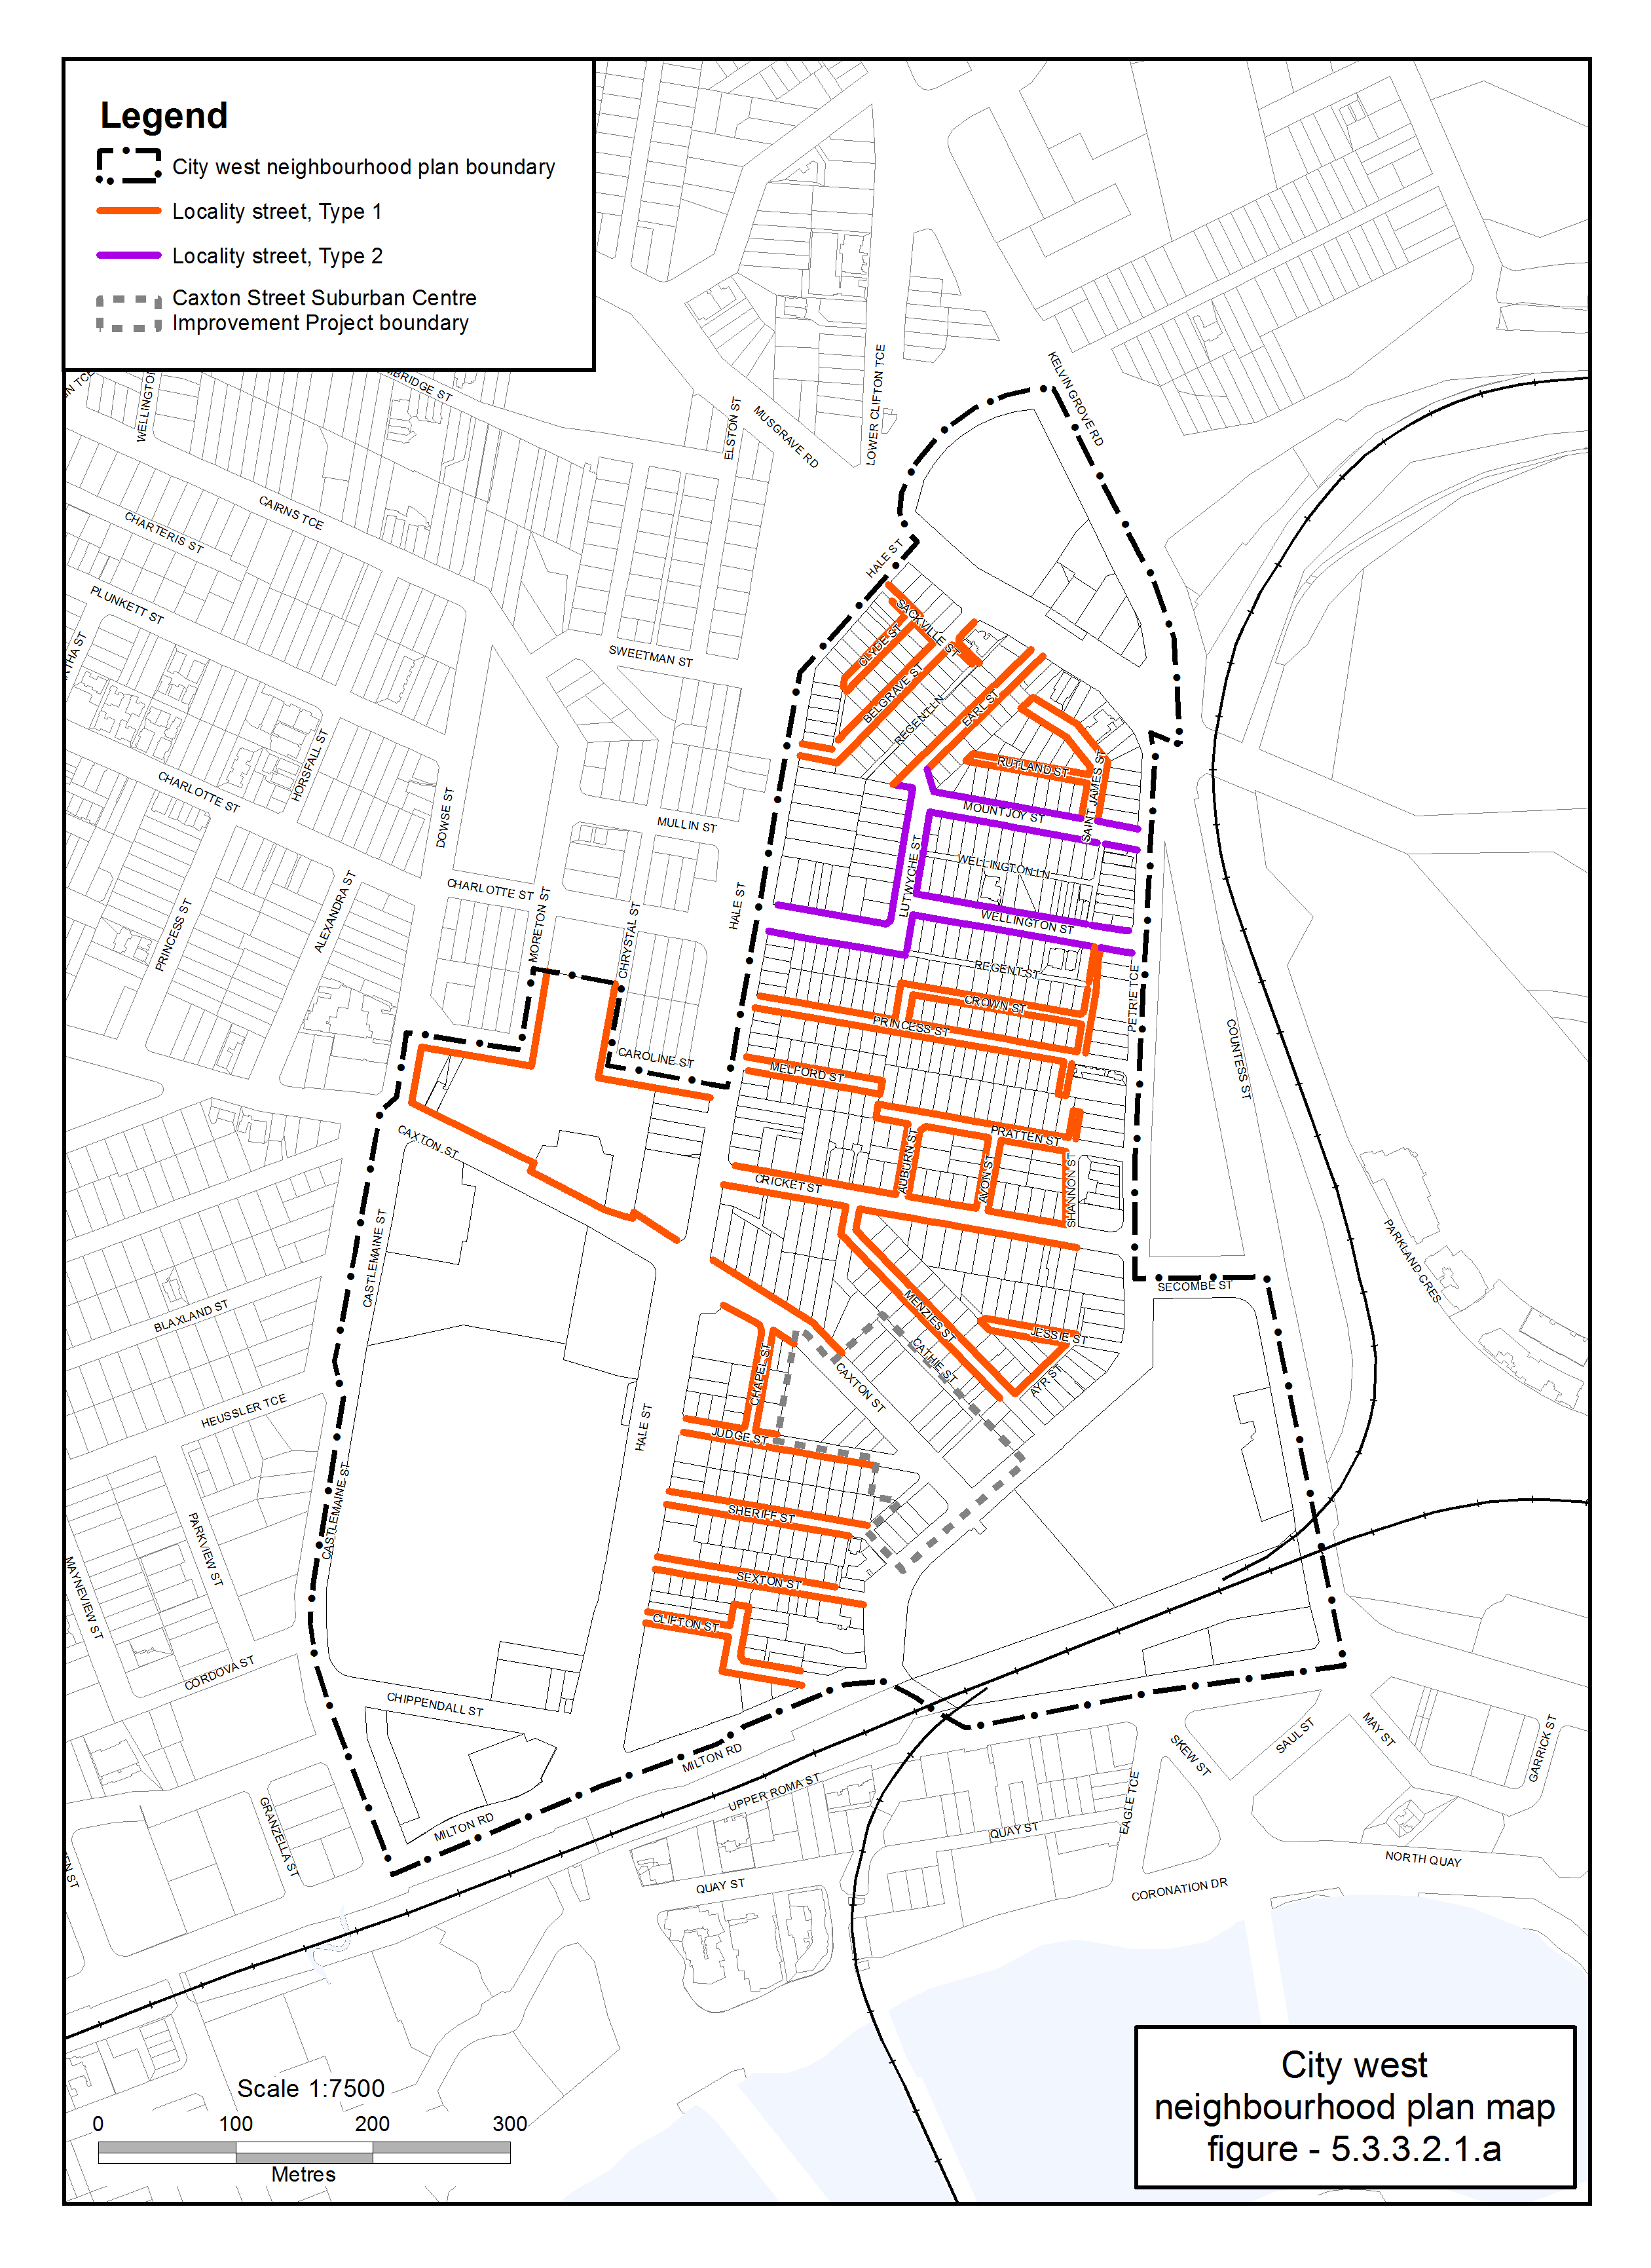

Figure 5.3.3.2.1.a—City west Locality Streetscape extent

- The Locality Streets in the City west neighbourhood plan area are indicated on the City west Locality Streetscape Extent map in Figure 5.3.3.2.1.a.
- All streetscape works occurring within the Locality Streets indicated in Figure 5.3.3.2.1.a, must comply with the character specified in this document.
- Streetscapes outside these areas may be developed in keeping with this character, at the discretion of the developer and subject to Council approval.

5.3.3.2.2 Standard footway elements and materials
- These locality guidelines are to be read in conjunction with Chapter 3 – Road corridor design of the Infrastructure design planning scheme policy.
- Footway upgrades are to include new surfacing, new or reinstated kerb and channel, driveways, pedestrian kerb crossings, tactile markers, roof water drainage line connections, service pit lids, street trees, garden beds, furniture and pedestrian lighting applicable to the streetscape type.
- The scope, layout and detail of the footway upgrades are to be agreed on a site by site basis through the development assessment process.

5.3.3.2.3 Streetscape hierarchy

5.3.3.2.3.1 Streetscape types overview
- The locality streets within the City west neighbourhood plan area are exceptions to the standard streetscape hierarchy.
- The streetscape type and specifications for locality streets in this area are outlined in Table 5.3.3.2.3.1A and shown in Figure 5.3.3.2.1.a.

Table 5.3.3.2.3.1A—Streetscape type and specifications
Component | Locality Streets Type 1 in City west neighbourhood plan area
Verge width | Retain existing width
Description | Full width pavement
Unobstructed pavement | Refer to Table 5.3.3.2.3.1B
Paving materials | Full width asphalt:  - Type: BCC Type 1 asphalt;  - Width: 25mm thick.
Tactile markers | Type: Concrete tactile paver  Supplier: Chelmstone, Urbanstone or approved equivalent  Colour: CCS ‘Pewter’
Driveways | Broom finished concrete
Furniture | No furniture
Trees | Street trees planted in asphalt footpaths are to be planted in garden beds or tree grates and are permitted in accordance with the footway width requirements set out in Table 5.3.3.2.3.1B.  Streets trees include:  - a mix of tree species laid out in an informal manner with clusters of trees;  - medium and small crown trees to be planted at minimum 2m spacing, if within garden beds, or minimum 6m spacing outside of garden beds;  - large crown feature trees to be planted at minimum 10m centres.  Distance:  - all tree centrelines are 750mm from the nominal face of the kerb and a minimum of 600mm from the edges of the pavement.  Layout:  - a mix of species, in a single row at the rear of kerb;  - to be planted as singles and in pairs or clusters.
Garden beds | Garden beds are permitted subject to the footway width requirements set out in Table 5.3.3.2.3.1B.  A garden bed located adjacent to the kerb has a:  - 1.5m minimum spacing between garden beds;  - maximum length of 10m;  - layout and length to accommodate car parking and other kerbside allocation.

Component | Locality Streets Type 2 in the City west neighbourhood plan area
Verge width | As existing verge width
Description | 1.2m wide concrete footpath in turf
Unobstructed pavement | Refer to Table 5.3.3.2.3.1B
Paving materials | Broom finished concrete
Tactile markers | Type: Concrete tactile paver  Supplier: Chelmstone, Urbanstone or approved equivalent  Colour: CCS ‘Voodoo’
Driveways | Broom finished concrete
Furniture | No furniture
Trees | Street trees planted in asphalt footpaths are to be planted in garden beds or tree grates and are permitted in accordance with the footway width requirements set out in Table 5.3.3.2.3.1B.  Streets trees include:  - a mix of tree species laid out in an informal manner with clusters of trees;  - medium and small crown trees to be planted at minimum 2m spacing, if within garden beds, or minimum 6m spacing outside of garden beds;  - large crown feature trees to be planted at minimum 10m centres.  Distance:  - all tree centrelines are 750mm from the nominal face of the kerb and a minimum of 600mm from the edges of the pavement.  Layout:  - a mix of species, in a single row at the rear of kerb;  - to be planted as singles and in pairs or clusters.
Garden beds | Garden beds are permitted subject to the footway width requirements set out in Table 5.3.3.2.3.1B.  A garden bed located adjacent to the kerb has a:  - 1.5m minimum spacing between garden beds;  - maximum length of 10m;  - layout and length to accommodate car parking and other kerbside allocation.

Table 5.3.3.2.3.1B—Footway width exceptions
Existing verge widths (from nominal face of kerb) | Garden bed width | Street trees | Unobstructed pavement width
Less than 2.1m | No garden beds | No | Full width
2.1m - 2.49m | 750mm - 1.15m | No | 1.2m
2.5m - 3.14m | 1.15m | Yes | 1.2m - 1.8m
3.15m - 3.74m | 1.2m | Yes | 1.8m - 2.4m
3.75m | 1.2m | Yes | 2.4m

5.3.3.2.4 Planting

5.3.3.2.4.1 Street trees
- Street trees are permitted and SC6.24 Planting species planning scheme policy in Schedule 6 Planning scheme policies sets out the approved street tree species for use on the various streets within the City west area.
- Each street has a minimum of two approved street tree species to encourage variety and diversity within the precinct.
- Where 2 or more street trees are required on the same development frontage, a mixture of the appropriate species as listed in SC6.24 is required.

5.3.3.2.4.2 Garden beds
- Garden beds are permitted as identified in Table 5.3.3.2.3.1B.
- Shrub and groundcover species are to be selected from SC6.24 Planting species planning scheme policy in Schedule 6 Planning scheme policies.
’.

Part 7 Amendment of Appendix 2 (Table of amendments)

7.1 Amendment to Appendix 2 (Table of amendments)
- Appendix 2 Table of Amendments, Table AP2.1—Table of amendments–
insert after v08.00/2017:
‘
5 December 2017 (adoption) and 16 February 2018 (effective) | v09.00/2018 | Major | Major amendment to planning scheme (2.3A.4 of MAALPI).  Refer to Amendment v09.00/2018 for further detail.
’.

Supplement 1a to 1l—A3 Map Tiles
Supplement 1a to 1l are located as separate documents in Attachment C folder.
Supplement 2—Listing of Properties Affected by Mapping Changes
Properties listed in the tables below include all dwellings contained within a property address such as multiple dwelling units.

SC2.1 Zone map
Supplement 1 Reference | Map Number | Map Title | House Number | Street Name | Street Description | Suburb | Property Description
REMOVE FROM OPEN SPACE (OS1 – LOCAL ZONE PRECINCT) AND INCLUDE IN COMMUNITY FACILITIES (CF4 – COMMUNITY PURPOSES ZONE PRECINCT)
1a | ZM-001 (Tile 28) | Zoning map | 14 | CAROLINE | STREET | PADDINGTON | RESERVE.1037 - L.571 SL.811593 PAR NTH BRISBANE
REMOVE FROM COMMUNITY FACILITIES (CF2 – MAJOR SPORTS VENUE ZONE PRECINCT) AND INCLUDE IN MIXED USE (MU2 – CENTRE FRAME ZONE PRECINCT)
1a | ZM-001 (Tile 28) | Zoning map | 150 | CAXTON | STREET | MILTON | L.356 SP.161706 PAR NTH BRISBANE
REMOVE FROM SPECIAL PURPOSE (SP1 – DEFENCE ZONE PRECINCT) AND INCLUDE IN MIXED USE (MU2 - CENTRE FRAME ZONE PRECINCT)
1a | ZM-001 (Tile 28) | Zoning map | 83 | PETRIE | TERRACE | PETRIE TERRACE | L.329 343 RP.145429 PAR NTH BRISBANE
REMOVE FROM CHARACTER RESIDENTIAL (CR2 – INFILL ZONE PRECINCT) AND INCLUDE IN COMMUNITY FACILITIES (CF5 – EDUCATION PURPOSES ZONE PRECINCT)
1a | ZM-001 (Tile 28) | Zoning map | 1 | HALE | STREET | PETRIE TERRACE | L.7 SP.225981 PAR NTH BRISBANE
REMOVE FROM CHARACTER RESIDENTIAL (CR2 – INFILL ZONE PRECINCT) AND INCLUDE IN CHARACTER RESIDENTIAL (CR1 – CHARACTER ZONE PRECINCT)
1a | ZM-001 (Tile 28) | Zoning map | 18 | MENZIES | STREET | PETRIE TERRACE | L.28 RP.10666 PAR NTH BRISBANE
1a | ZM-001 (Tile 28) | Zoning map | 15 | AVON | STREET | PETRIE TERRACE | L.19 RP.10678 PAR NTH BRISBANE
1a | ZM-001 (Tile 28) | Zoning map | 17 | AVON | STREET | PETRIE TERRACE | L.18 RP.10678 PAR NTH BRISBANE
1a | ZM-001 (Tile 28) | Zoning map | 20 | AVON | STREET | PETRIE TERRACE | L.16 RP.10678 PAR NTH BRISBANE
1a | ZM-001 (Tile 28) | Zoning map | 11 | BELGRAVE | STREET | PETRIE TERRACE | L.123 RP.10688 PAR NTH BRISBANE
1a | ZM-001 (Tile 28) | Zoning map | 15 | BELGRAVE | STREET | PETRIE TERRACE | L.122 RP.10688 PAR NTH BRISBANE
1a | ZM-001 (Tile 28) | Zoning map | 28 | BELGRAVE | STREET | PETRIE TERRACE | L.90 RP.10688 PAR NTH BRISBANE
1a | ZM-001 (Tile 28) | Zoning map | 52 | BELGRAVE | STREET | PETRIE TERRACE | L.97 RP.10688 PAR NTH BRISBANE
1a | ZM-001 (Tile 28) | Zoning map | 10 | CHAPEL | STREET | PETRIE TERRACE | L.12 RP.10655 PAR NTH BRISBANE
1a | ZM-001 (Tile 28) | Zoning map | 34 | CRICKET | STREET | PETRIE TERRACE | L.6 RP.10677 PAR NTH BRISBANE
1a | ZM-001 (Tile 28) | Zoning map | 60 | CRICKET | STREET | PETRIE TERRACE | L.10 RP.10677 PAR NTH BRISBANE
1a | ZM-001 (Tile 28) | Zoning map | 77 | CRICKET | STREET | PETRIE TERRACE | L.1/6 GTP.2776 PAR NTH BRISBANE
1a | ZM-001 (Tile 28) | Zoning map | 17 | CROWN | STREET | PETRIE TERRACE | L.12 RP.10681 PAR NTH BRISBANE
1a | ZM-001 (Tile 28) | Zoning map | 19 | CROWN | STREET | PETRIE TERRACE | L.13 RP.10681 PAR NTH BRISBANE
1a | ZM-001 (Tile 28) | Zoning map | 35 | CROWN | STREET | PETRIE TERRACE | L.16 RP.10682 PAR NTH BRISBANE
1a | ZM-001 (Tile 28) | Zoning map | 47 | CROWN | STREET | PETRIE TERRACE | L.20 RP.10682 PAR NTH BRISBANE
1a | ZM-001 (Tile 28) | Zoning map | 11 | EARL | STREET | PETRIE TERRACE | L.1 RP.10692 PAR NTH BRISBANE
1a | ZM-001 (Tile 28) | Zoning map | 26 | EARL | STREET | PETRIE TERRACE | L.8 RP.10691 PAR NTH BRISBANE
1a | ZM-001 (Tile 28) | Zoning map | 30 | EARL | STREET | PETRIE TERRACE | L.3 RP.40591 PAR NTH BRISBANE
1a | ZM-001 (Tile 28) | Zoning map | 279 | HALE | STREET | PETRIE TERRACE | L.102 RP.10688 PAR NTH BRISBANE
1a | ZM-001 (Tile 28) | Zoning map | 287 | HALE | STREET | PETRIE TERRACE | L.104 RP.10688 PAR NTH BRISBANE
1a | ZM-001 (Tile 28) | Zoning map | 45 | JESSIE | STREET | PETRIE TERRACE | L.10 RP.10673 PAR NTH BRISBANE
1a | ZM-001 (Tile 28) | Zoning map | 47 | JESSIE | STREET | PETRIE TERRACE | L.11 RP.98493 PAR NTH BRISBANE
1a | ZM-001 (Tile 28) | Zoning map | 35 | JUDGE | STREET | PETRIE TERRACE | L.4 RP.817568 PAR NTH BRISBANE
1a | ZM-001 (Tile 28) | Zoning map | 48 | JUDGE | STREET | PETRIE TERRACE | L.10 RP.10654 PAR NTH BRISBANE
1a | ZM-001 (Tile 28) | Zoning map | 11 | MELFORD | STREET | PETRIE TERRACE | L.12 RP.10683 PAR NTH BRISBANE
1a | ZM-001 (Tile 28) | Zoning map | 19 | MELFORD | STREET | PETRIE TERRACE | L.14 RP.10683 PAR NTH BRISBANE
1a | ZM-001 (Tile 28) | Zoning map | 30 | MENZIES | STREET | PETRIE TERRACE | L.26 RP.10666 PAR NTH BRISBANE
1a | ZM-001 (Tile 28) | Zoning map | 58 | MENZIES | STREET | PETRIE TERRACE | L.21 RP.10666 PAR NTH BRISBANE
1a | ZM-001 (Tile 28) | Zoning map | 79 | MENZIES | STREET | PETRIE TERRACE | L.2 RP.10666 PAR NTH BRISBANE
1a | ZM-001 (Tile 28) | Zoning map | 50 | MOUNTJOY | STREET | PETRIE TERRACE | L.49 RP.10688 PAR NTH BRISBANE
1a | ZM-001 (Tile 28) | Zoning map | 27 | PRATTEN | STREET | PETRIE TERRACE | L.6 RP.10680 PAR NTH BRISBANE
1a | ZM-001 (Tile 28) | Zoning map | 39 | PRATTEN | STREET | PETRIE TERRACE | L.9 RP.10680 PAR NTH BRISBANE
1a | ZM-001 (Tile 28) | Zoning map | 55 | PRATTEN | STREET | PETRIE TERRACE | L.13 RP.10680 PAR NTH BRISBANE
1a | ZM-001 (Tile 28) | Zoning map | 19 | PRINCESS | STREET | PETRIE TERRACE | L.36 RP.10681 PAR NTH BRISBANE
1a | ZM-001 (Tile 28) | Zoning map | 60 | PRINCESS | STREET | PETRIE TERRACE | L.48 RP.10681 PAR NTH BRISBANE
1a | ZM-001 (Tile 28) | Zoning map | 47 | SEXTON | STREET | PETRIE TERRACE | L.11 RP.10652 PAR NTH BRISBANE
1a | ZM-001 (Tile 28) | Zoning map | 4 | SHANNON | STREET | PETRIE TERRACE | L.27 RP.10678 PAR NTH BRISBANE
1a | ZM-001 (Tile 28) | Zoning map | 17 | SHERIFF | STREET | PETRIE TERRACE | L.1 RP.809888 PAR NTH BRISBANE
1a | ZM-001 (Tile 28) | Zoning map | 39 | SHERIFF | STREET | PETRIE TERRACE | L.26 RP.10654 PAR NTH BRISBANE
1a | ZM-001 (Tile 28) | Zoning map | 40 | SHERIFF | STREET | PETRIE TERRACE | L.37 RP.10654 PAR NTH BRISBANE
1a | ZM-001 (Tile 28) | Zoning map | 44 | SHERIFF | STREET | PETRIE TERRACE | L.36 RP.10654 PAR NTH BRISBANE
1a | ZM-001 (Tile 28) | Zoning map | 30 | WELLINGTON | STREET | PETRIE TERRACE | L.8 RP.10688 PAR NTH BRISBANE
1a | ZM-001 (Tile 28) | Zoning map | 54 | WELLINGTON | STREET | PETRIE TERRACE | L.14 RP.10688 PAR NTH BRISBANE
1a | ZM-001 (Tile 28) | Zoning map | 59 | WELLINGTON | STREET | PETRIE TERRACE | L.21 RP.10688 PAR NTH BRISBANE
1a | ZM-001 (Tile 28) | Zoning map | 47 | CLIFTON | STREET | PETRIE TERRACE | L.9/10 RP.10644 PAR NTH BRISBANE
1a | ZM-001 (Tile 28) | Zoning map | 50 | PRINCESS | STREET | PETRIE TERRACE | L.45/46 RP.10681 PAR NTH BRISBANE
1a | ZM-001 (Tile 28) | Zoning map | 22 | ST JAMES | STREET | PETRIE TERRACE | L.81/82 RP.10688 PAR NTH BRISBANE
1a | ZM-001 (Tile 28) | Zoning map | 45 | EARL | STREET | PETRIE TERRACE | L.17 RP.10691 PAR NTH BRISBANE
1a | ZM-001 (Tile 28) | Zoning map | 21 | CLIFTON | STREET | PETRIE TERRACE | L.4 RP.883935 PAR NTH BRISBANE
1a | ZM-001 (Tile 28) | Zoning map | 48 | SEXTON | STREET | PETRIE TERRACE | L.1 SP.124380 PAR NTH BRISBANE
1a | ZM-001 (Tile 28) | Zoning map | 52 | SEXTON | STREET | PETRIE TERRACE | L.3 SP.124380 PAR NTH BRISBANE
1a | ZM-001 (Tile 28) | Zoning map | 35 | PRINCESS | STREET | PETRIE TERRACE | L.31/32 SP.118199 PAR NTH BRISBANE
1a | ZM-001 (Tile 28) | Zoning map | 47 | EARL | STREET | PETRIE TERRACE | L.16 RP.10691 PAR NTH BRISBANE
1a | ZM-001 (Tile 28) | Zoning map | 5 | CROWN | STREET | PETRIE TERRACE | L.8 SP.244098 PAR NTH BRISBANE
1a | ZM-001 (Tile 28) | Zoning map | 11A | CLYDE | STREET | PETRIE TERRACE | L.109 RP.10688 PAR NTH BRISBANE
1a | ZM-001 (Tile 28) | Zoning map | 12 | AVON | STREET | PETRIE TERRACE | L.14 RP.10678 PAR NTH BRISBANE
1a | ZM-001 (Tile 28) | Zoning map | 21 | AVON | STREET | PETRIE TERRACE | L.17 RP.10678 PAR NTH BRISBANE
1a | ZM-001 (Tile 28) | Zoning map | 12 | BELGRAVE | STREET | PETRIE TERRACE | L.87 RP.10688 PAR NTH BRISBANE
1a | ZM-001 (Tile 28) | Zoning map | 56 | BELGRAVE | STREET | PETRIE TERRACE | L.98 RP.10688 PAR NTH BRISBANE
1a | ZM-001 (Tile 28) | Zoning map | 19 | CRICKET | STREET | PETRIE TERRACE | L.23 RP.10678 PAR NTH BRISBANE
1a | ZM-001 (Tile 28) | Zoning map | 27 | CRICKET | STREET | PETRIE TERRACE | L.22 RP.10678 PAR NTH BRISBANE
1a | ZM-001 (Tile 28) | Zoning map | 38 | CRICKET | STREET | PETRIE TERRACE | L.7 RP.10677 PAR NTH BRISBANE
1a | ZM-001 (Tile 28) | Zoning map | 85 | CRICKET | STREET | PETRIE TERRACE | L.15 RP.10662 PAR NTH BRISBANE
1a | ZM-001 (Tile 28) | Zoning map | 99 | CRICKET | STREET | PETRIE TERRACE | L.2 RP.851842 PAR NTH BRISBANE
1a | ZM-001 (Tile 28) | Zoning map | 21 | CROWN | STREET | PETRIE TERRACE | L.14 RP.10681 PAR NTH BRISBANE
1a | ZM-001 (Tile 28) | Zoning map | 43 | CROWN | STREET | PETRIE TERRACE | L.18 RP.10682 PAR NTH BRISBANE
1a | ZM-001 (Tile 28) | Zoning map | 179 | HALE | STREET | PETRIE TERRACE | L.2 RP.10661 PAR NTH BRISBANE
1a | ZM-001 (Tile 28) | Zoning map | 183 | HALE | STREET | PETRIE TERRACE | L.11 RP.10683 PAR NTH BRISBANE
1a | ZM-001 (Tile 28) | Zoning map | 19 | CLYDE | STREET | PETRIE TERRACE | L.105 RP.10688 PAR NTH BRISBANE
1a | ZM-001 (Tile 28) | Zoning map | 21 | JESSIE | STREET | PETRIE TERRACE | L.5 RP.10673 PAR NTH BRISBANE
1a | ZM-001 (Tile 28) | Zoning map | 29 | JESSIE | STREET | PETRIE TERRACE | L.7 RP.10673 PAR NTH BRISBANE
1a | ZM-001 (Tile 28) | Zoning map | 37 | JESSIE | STREET | PETRIE TERRACE | L.8 RP.10673 PAR NTH BRISBANE
1a | ZM-001 (Tile 28) | Zoning map | 44 | JUDGE | STREET | PETRIE TERRACE | L.11 RP.10654 PAR NTH BRISBANE
1a | ZM-001 (Tile 28) | Zoning map | 52 | JUDGE | STREET | PETRIE TERRACE | L.9 RP.10654 PAR NTH BRISBANE
1a | ZM-001 (Tile 28) | Zoning map | 22 | LUTWYCHE | STREET | PETRIE TERRACE | L.6 RP.10684 PAR NTH BRISBANE
1a | ZM-001 (Tile 28) | Zoning map | 21 | MENZIES | STREET | PETRIE TERRACE | L.2 RP.10668 PAR NTH BRISBANE
1a | ZM-001 (Tile 28) | Zoning map | 42 | MENZIES | STREET | PETRIE TERRACE | L.24 RP.10666 PAR NTH BRISBANE
1a | ZM-001 (Tile 28) | Zoning map | 44 | MENZIES | STREET | PETRIE TERRACE | L.23 RP.10666 PAR NTH BRISBANE
1a | ZM-001 (Tile 28) | Zoning map | 78 | MENZIES | STREET | PETRIE TERRACE | L.17 RP.10666 PAR NTH BRISBANE
1a | ZM-001 (Tile 28) | Zoning map | 24 | MOUNTJOY | STREET | PETRIE TERRACE | L.42 RP.10688 PAR NTH BRISBANE
1a | ZM-001 (Tile 28) | Zoning map | 33 | MOUNTJOY | STREET | PETRIE TERRACE | L.3 RP.58238 PAR NTH BRISBANE
1a | ZM-001 (Tile 28) | Zoning map | 37 | MOUNTJOY | STREET | PETRIE TERRACE | L.56 RP.10688 PAR NTH BRISBANE
1a | ZM-001 (Tile 28) | Zoning map | 46 | MOUNTJOY | STREET | PETRIE TERRACE | L.48 RP.10688 PAR NTH BRISBANE
1a | ZM-001 (Tile 28) | Zoning map | 67 | PRATTEN | STREET | PETRIE TERRACE | L.16 RP.10680 PAR NTH BRISBANE
1a | ZM-001 (Tile 28) | Zoning map | 74 | PRINCESS | STREET | PETRIE TERRACE | L.35 RP.10683 PAR NTH BRISBANE
1a | ZM-001 (Tile 28) | Zoning map | 84 | PRINCESS | STREET | PETRIE TERRACE | L.34 RP.10683 PAR NTH BRISBANE
1a | ZM-001 (Tile 28) | Zoning map | 24 | REGENT | STREET | PETRIE TERRACE | L.48 RP.10683 PAR NTH BRISBANE
1a | ZM-001 (Tile 28) | Zoning map | 23 | RUTLAND | STREET | PETRIE TERRACE | L.83 RP.10688 PAR NTH BRISBANE
1a | ZM-001 (Tile 28) | Zoning map | 24 | SHERIFF | STREET | PETRIE TERRACE | L.41 RP.10654 PAR NTH BRISBANE
1a | ZM-001 (Tile 28) | Zoning map | 28 | SHERIFF | STREET | PETRIE TERRACE | L.40 RP.10654 PAR NTH BRISBANE
1a | ZM-001 (Tile 28) | Zoning map | 36 | SHERIFF | STREET | PETRIE TERRACE | L.38 RP.10654 PAR NTH BRISBANE
1a | ZM-001 (Tile 28) | Zoning map | 47 | SHERIFF | STREET | PETRIE TERRACE | L.24 RP.10654 PAR NTH BRISBANE
1a | ZM-001 (Tile 28) | Zoning map | 15 | WELLINGTON | STREET | PETRIE TERRACE | L.1/2 BUP.106618 PAR NTH BRISBANE
1a | ZM-001 (Tile 28) | Zoning map | 65 | CRICKET | STREET | PETRIE TERRACE | L.1/2 RP.10678 PAR NTH BRISBANE
1a | ZM-001 (Tile 28) | Zoning map | 20 | MENZIES | STREET | PETRIE TERRACE | L.1/2 RP.10669 PAR NTH BRISBANE
1a | ZM-001 (Tile 28) | Zoning map | 26 | PRINCESS | STREET | PETRIE TERRACE | L.38/39 RP.10681 PAR NTH BRISBANE
1a | ZM-001 (Tile 28) | Zoning map | 53 | PRINCESS | STREET | PETRIE TERRACE | L.28 RP.10681 PAR NTH BRISBANE
1a | ZM-001 (Tile 28) | Zoning map | 99 | PRINCESS | STREET | PETRIE TERRACE | L.43 RP.10683 PAR NTH BRISBANE
1a | ZM-001 (Tile 28) | Zoning map | 54 | SEXTON | STREET | PETRIE TERRACE | L.4 SP.226324 PAR NTH BRISBANE
1a | ZM-001 (Tile 28) | Zoning map | 100 | PRINCESS | STREET | PETRIE TERRACE | L.2 SP.275949 PAR NTH BRISBANE
1a | ZM-001 (Tile 28) | Zoning map | 20 | BELGRAVE | STREET | PETRIE TERRACE | L.88 RP.10688 PAR NTH BRISBANE
1a | ZM-001 (Tile 28) | Zoning map | 24 | BELGRAVE | STREET | PETRIE TERRACE | L.89 RP.10688 PAR NTH BRISBANE
1a | ZM-001 (Tile 28) | Zoning map | 32 | BELGRAVE | STREET | PETRIE TERRACE | L.91 RP.10688 PAR NTH BRISBANE
1a | ZM-001 (Tile 28) | Zoning map | 44 | BELGRAVE | STREET | PETRIE TERRACE | L.95 RP.10688 PAR NTH BRISBANE
1a | ZM-001 (Tile 28) | Zoning map | 60 | BELGRAVE | STREET | PETRIE TERRACE | L.99 RP.10688 PAR NTH BRISBANE
1a | ZM-001 (Tile 28) | Zoning map | 15 | CHAPEL | STREET | PETRIE TERRACE | L.2 RP.904242 PAR NTH BRISBANE
1a | ZM-001 (Tile 28) | Zoning map | 35 | CLIFTON | STREET | PETRIE TERRACE | L.35 RP.863010 PAR NTH BRISBANE
1a | ZM-001 (Tile 28) | Zoning map | 9 | CLYDE | STREET | PETRIE TERRACE | L.111 RP.10688 PAR NTH BRISBANE
1a | ZM-001 (Tile 28) | Zoning map | 81 | CRICKET | STREET | PETRIE TERRACE | L.14 RP.10662 PAR NTH BRISBANE
1a | ZM-001 (Tile 28) | Zoning map | 106 | CRICKET | STREET | PETRIE TERRACE | L.7 RP.10661 PAR NTH BRISBANE
1a | ZM-001 (Tile 28) | Zoning map | 13 | CROWN | STREET | PETRIE TERRACE | L.11 RP.10681 PAR NTH BRISBANE
1a | ZM-001 (Tile 28) | Zoning map | 18 | EARL | STREET | PETRIE TERRACE | L.6 RP.10691 PAR NTH BRISBANE
1a | ZM-001 (Tile 28) | Zoning map | 35 | EARL | STREET | PETRIE TERRACE | L.20 RP.10691 PAR NTH BRISBANE
1a | ZM-001 (Tile 28) | Zoning map | 79 | HALE | STREET | PETRIE TERRACE | L.4 RP.10654 PAR NTH BRISBANE
1a | ZM-001 (Tile 28) | Zoning map | 221 | HALE | STREET | PETRIE TERRACE | L.1 RP.10683 PAR NTH BRISBANE
1a | ZM-001 (Tile 28) | Zoning map | 241 | HALE | STREET | PETRIE TERRACE | L.5 RP.10686 PAR NTH BRISBANE
1a | ZM-001 (Tile 28) | Zoning map | 26 | MELFORD | STREET | PETRIE TERRACE | L.23 RP.10683 PAR NTH BRISBANE
1a | ZM-001 (Tile 28) | Zoning map | 25 | MENZIES | STREET | PETRIE TERRACE | L.1 RP.10668 PAR NTH BRISBANE
1a | ZM-001 (Tile 28) | Zoning map | 43 | MENZIES | STREET | PETRIE TERRACE | L.8 RP.10666 PAR NTH BRISBANE
1a | ZM-001 (Tile 28) | Zoning map | 64 | MENZIES | STREET | PETRIE TERRACE | L.20 RP.10666 PAR NTH BRISBANE
1a | ZM-001 (Tile 28) | Zoning map | 67 | MENZIES | STREET | PETRIE TERRACE | L.4 RP.10666 PAR NTH BRISBANE
1a | ZM-001 (Tile 28) | Zoning map | 17 | MOUNTJOY | STREET | PETRIE TERRACE | L.62 RP.10688 PAR NTH BRISBANE
1a | ZM-001 (Tile 28) | Zoning map | 40 | MOUNTJOY | STREET | PETRIE TERRACE | L.46 RP.10688 PAR NTH BRISBANE
1a | ZM-001 (Tile 28) | Zoning map | 43 | PRATTEN | STREET | PETRIE TERRACE | L.10 RP.10680 PAR NTH BRISBANE
1a | ZM-001 (Tile 28) | Zoning map | 63 | PRATTEN | STREET | PETRIE TERRACE | L.15 RP.10680 PAR NTH BRISBANE
1a | ZM-001 (Tile 28) | Zoning map | 15 | PRINCESS | STREET | PETRIE TERRACE | L.37 RP.10681 PAR NTH BRISBANE
1a | ZM-001 (Tile 28) | Zoning map | 55 | PRINCESS | STREET | PETRIE TERRACE | L.27 RP.10681 PAR NTH BRISBANE
1a | ZM-001 (Tile 28) | Zoning map | 77 | PRINCESS | STREET | PETRIE TERRACE | L.37 RP.10683 PAR NTH BRISBANE
1a | ZM-001 (Tile 28) | Zoning map | 35 | SHERIFF | STREET | PETRIE TERRACE | L.27 RP.10654 PAR NTH BRISBANE
1a | ZM-001 (Tile 28) | Zoning map | 48 | SHERIFF | STREET | PETRIE TERRACE | L.35 RP.10654 PAR NTH BRISBANE
1a | ZM-001 (Tile 28) | Zoning map | 56 | SHERIFF | STREET | PETRIE TERRACE | L.33 RP.10654 PAR NTH BRISBANE
1a | ZM-001 (Tile 28) | Zoning map | 14 | WELLINGTON | STREET | PETRIE TERRACE | L.4 RP.10688 PAR NTH BRISBANE
1a | ZM-001 (Tile 28) | Zoning map | 67 | WELLINGTON | STREET | PETRIE TERRACE | L.19 RP.10688 PAR NTH BRISBANE
1a | ZM-001 (Tile 28) | Zoning map | 7 | CLYDE | STREET | PETRIE TERRACE | L.112 RP.10688 & L.2 RP.10694 PAR NTH BRISBANE
1a | ZM-001 (Tile 28) | Zoning map | 35 | MELFORD | STREET | PETRIE TERRACE | L.18/19 RP.10683 PAR NTH BRISBANE
1a | ZM-001 (Tile 28) | Zoning map | 27 | PRINCESS | STREET | PETRIE TERRACE | L.33/34 RP.10681 PAR NTH BRISBANE
1a | ZM-001 (Tile 28) | Zoning map | 39 | JUDGE | STREET | PETRIE TERRACE | L.2 RP.817568 PAR NTH BRISBANE
1a | ZM-001 (Tile 28) | Zoning map | 10 | MOUNTJOY | STREET | PETRIE TERRACE | L.1 SP.182756 PAR NTH BRISBANE
1a | ZM-001 (Tile 28) | Zoning map | 56 | SEXTON | STREET | PETRIE TERRACE | L.5 SP.226324 PAR NTH BRISBANE
1a | ZM-001 (Tile 28) | Zoning map | 98 | PRINCESS | STREET | PETRIE TERRACE | L.3 SP.275949 PAR NTH BRISBANE
1a | ZM-001 (Tile 28) | Zoning map | 38 | BELGRAVE | STREET | PETRIE TERRACE | L.93 RP.10688 PAR NTH BRISBANE
1a | ZM-001 (Tile 28) | Zoning map | 40 | BELGRAVE | STREET | PETRIE TERRACE | L.94 RP.10688 PAR NTH BRISBANE
1a | ZM-001 (Tile 28) | Zoning map | 14 | CLIFTON | STREET | PETRIE TERRACE | L.2 RP.10648 PAR NTH BRISBANE
1a | ZM-001 (Tile 28) | Zoning map | 28 | CRICKET | STREET | PETRIE TERRACE | L.5 RP.10677 PAR NTH BRISBANE
1a | ZM-001 (Tile 28) | Zoning map | 39 | CRICKET | STREET | PETRIE TERRACE | L.13 RP.10678 PAR NTH BRISBANE
1a | ZM-001 (Tile 28) | Zoning map | 56 | CRICKET | STREET | PETRIE TERRACE | L.9 RP.10677 PAR NTH BRISBANE
1a | ZM-001 (Tile 28) | Zoning map | 76 | CRICKET | STREET | PETRIE TERRACE | L.13 RP.10677 PAR NTH BRISBANE
1a | ZM-001 (Tile 28) | Zoning map | 92 | CRICKET | STREET | PETRIE TERRACE | L.9 RP.10662 PAR NTH BRISBANE
1a | ZM-001 (Tile 28) | Zoning map | 96 | CRICKET | STREET | PETRIE TERRACE | L.8 RP.10662 PAR NTH BRISBANE
1a | ZM-001 (Tile 28) | Zoning map | 14 | EARL | STREET | PETRIE TERRACE | L.5 RP.10691 PAR NTH BRISBANE
1a | ZM-001 (Tile 28) | Zoning map | 31 | EARL | STREET | PETRIE TERRACE | L.21 RP.10691 PAR NTH BRISBANE
1a | ZM-001 (Tile 28) | Zoning map | 39 | EARL | STREET | PETRIE TERRACE | L.19 RP.10691 PAR NTH BRISBANE
1a | ZM-001 (Tile 28) | Zoning map | 40 | EARL | STREET | PETRIE TERRACE | L.12 RP.10691 PAR NTH BRISBANE
1a | ZM-001 (Tile 28) | Zoning map | 69 | HALE | STREET | PETRIE TERRACE | L.51 RP.131767 PAR NTH BRISBANE
1a | ZM-001 (Tile 28) | Zoning map | 273 | HALE | STREET | PETRIE TERRACE | L.100 RP.10688 PAR NTH BRISBANE
1a | ZM-001 (Tile 28) | Zoning map | 25 | JESSIE | STREET | PETRIE TERRACE | L.6 RP.10673 PAR NTH BRISBANE
1a | ZM-001 (Tile 28) | Zoning map | 41 | JESSIE | STREET | PETRIE TERRACE | L.9 RP.10673 PAR NTH BRISBANE
1a | ZM-001 (Tile 28) | Zoning map | 10 | MELFORD | STREET | PETRIE TERRACE | L.27 RP.10683 PAR NTH BRISBANE
1a | ZM-001 (Tile 28) | Zoning map | 27 | MELFORD | STREET | PETRIE TERRACE | L.16 RP.10683 PAR NTH BRISBANE
1a | ZM-001 (Tile 28) | Zoning map | 31 | MELFORD | STREET | PETRIE TERRACE | L.17 RP.10683 PAR NTH BRISBANE
1a | ZM-001 (Tile 28) | Zoning map | 32 | MELFORD | STREET | PETRIE TERRACE | L.21 RP.10683 PAR NTH BRISBANE
1a | ZM-001 (Tile 28) | Zoning map | 17 | MENZIES | STREET | PETRIE TERRACE | L.4 RP.813851 PAR NTH BRISBANE
1a | ZM-001 (Tile 28) | Zoning map | 52 | MENZIES | STREET | PETRIE TERRACE | L.22 RP.10666 PAR NTH BRISBANE
1a | ZM-001 (Tile 28) | Zoning map | 53 | MOUNTJOY | STREET | PETRIE TERRACE | L.1 RP.43165 PAR NTH BRISBANE
1a | ZM-001 (Tile 28) | Zoning map | 71 | PRATTEN | STREET | PETRIE TERRACE | L.17 RP.10680 PAR NTH BRISBANE
1a | ZM-001 (Tile 28) | Zoning map | 79 | PRINCESS | STREET | PETRIE TERRACE | L.38 RP.10683 PAR NTH BRISBANE
1a | ZM-001 (Tile 28) | Zoning map | 91 | PRINCESS | STREET | PETRIE TERRACE | L.40 RP.10683 PAR NTH BRISBANE
1a | ZM-001 (Tile 28) | Zoning map | 8 | REGENT | STREET | PETRIE TERRACE | L.54 RP.10683 PAR NTH BRISBANE
1a | ZM-001 (Tile 28) | Zoning map | 31 | RUTLAND | STREET | PETRIE TERRACE | L.84 RP.10688 PAR NTH BRISBANE
1a | ZM-001 (Tile 28) | Zoning map | 19 | SHERIFF | STREET | PETRIE TERRACE | L.31 RP.10654 PAR NTH BRISBANE
1a | ZM-001 (Tile 28) | Zoning map | 34 | WELLINGTON | STREET | PETRIE TERRACE | L.9 RP.10688 PAR NTH BRISBANE
1a | ZM-001 (Tile 28) | Zoning map | 50 | WELLINGTON | STREET | PETRIE TERRACE | L.13 RP.10688 PAR NTH BRISBANE
1a | ZM-001 (Tile 28) | Zoning map | 55 | WELLINGTON | STREET | PETRIE TERRACE | L.22 RP.10688 PAR NTH BRISBANE
1a | ZM-001 (Tile 28) | Zoning map | 66 | WELLINGTON | STREET | PETRIE TERRACE | L.17 RP.10688 PAR NTH BRISBANE
1a | ZM-001 (Tile 28) | Zoning map | 70 | WELLINGTON | STREET | PETRIE TERRACE | L.18 RP.10688 PAR NTH BRISBANE
1a | ZM-001 (Tile 28) | Zoning map | 51 | CROWN | STREET | PETRIE TERRACE | L.21/22 RP.10681 PAR NTH BRISBANE
1a | ZM-001 (Tile 28) | Zoning map | 42 | EARL | STREET | PETRIE TERRACE | L.1 RP.59502 & L.13 RP.10691 PAR NTH BRISBANE
1a | ZM-001 (Tile 28) | Zoning map | 215 | HALE | STREET | PETRIE TERRACE | L.3/4 RP.10683 PAR NTH BRISBANE
1a | ZM-001 (Tile 28) | Zoning map | 25 | MOUNTJOY | STREET | PETRIE TERRACE | L.60/61 RP.10688 PAR NTH BRISBANE
1a | ZM-001 (Tile 28) | Zoning map | 103 | PRINCESS | STREET | PETRIE TERRACE | L.44/45 RP.10683 PAR NTH BRISBANE
1a | ZM-001 (Tile 28) | Zoning map | 37 | JUDGE | STREET | PETRIE TERRACE | L.3 RP.817568 PAR NTH BRISBANE
1a | ZM-001 (Tile 28) | Zoning map | 29 | SEXTON | STREET | PETRIE TERRACE | L.2 RP.908542 PAR NTH BRISBANE
1a | ZM-001 (Tile 28) | Zoning map | 64 | MOUNTJOY | STREET | PETRIE TERRACE | L.1 SP.111166 PAR NTH BRISBANE
1a | ZM-001 (Tile 28) | Zoning map | 39 | BELGRAVE | STREET | PETRIE TERRACE | L.115 RP.10688 PAR NTH BRISBANE
1a | ZM-001 (Tile 28) | Zoning map | 13 | SEXTON | STREET | PETRIE TERRACE | L.5 SP.128766 PAR NTH BRISBANE
1a | ZM-001 (Tile 28) | Zoning map | 16 | AVON | STREET | PETRIE TERRACE | L.15 RP.10678 PAR NTH BRISBANE
1a | ZM-001 (Tile 28) | Zoning map | 19 | BELGRAVE | STREET | PETRIE TERRACE | L.121 RP.10688 PAR NTH BRISBANE
1a | ZM-001 (Tile 28) | Zoning map | 27 | BELGRAVE | STREET | PETRIE TERRACE | L.119 RP.10688 PAR NTH BRISBANE
1a | ZM-001 (Tile 28) | Zoning map | 51 | CRICKET | STREET | PETRIE TERRACE | L.10 RP.10678 PAR NTH BRISBANE
1a | ZM-001 (Tile 28) | Zoning map | 66 | CRICKET | STREET | PETRIE TERRACE | L.11 RP.10677 PAR NTH BRISBANE
1a | ZM-001 (Tile 28) | Zoning map | 93 | CRICKET | STREET | PETRIE TERRACE | L.6 RP.10661 PAR NTH BRISBANE
1a | ZM-001 (Tile 28) | Zoning map | 97 | CRICKET | STREET | PETRIE TERRACE | L.5 RP.10661 PAR NTH BRISBANE
1a | ZM-001 (Tile 28) | Zoning map | 9 | CROWN | STREET | PETRIE TERRACE | L.10 RP.10681 PAR NTH BRISBANE
1a | ZM-001 (Tile 28) | Zoning map | 23 | CROWN | STREET | PETRIE TERRACE | L.15 RP.10681 PAR NTH BRISBANE
1a | ZM-001 (Tile 28) | Zoning map | 29 | EARL | STREET | PETRIE TERRACE | L.22 RP.10691 PAR NTH BRISBANE
1a | ZM-001 (Tile 28) | Zoning map | 181 | HALE | STREET | PETRIE TERRACE | L.1 RP.10661 PAR NTH BRISBANE
1a | ZM-001 (Tile 28) | Zoning map | 261 | HALE | STREET | PETRIE TERRACE | L.8 RP.10686 PAR NTH BRISBANE
1a | ZM-001 (Tile 28) | Zoning map | 36 | JUDGE | STREET | PETRIE TERRACE | L.13 RP.10654 PAR NTH BRISBANE
1a | ZM-001 (Tile 28) | Zoning map | 60 | JUDGE | STREET | PETRIE TERRACE | L.7 RP.10654 PAR NTH BRISBANE
1a | ZM-001 (Tile 28) | Zoning map | 18 | LUTWYCHE | STREET | PETRIE TERRACE | L.5 RP.10684 PAR NTH BRISBANE
1a | ZM-001 (Tile 28) | Zoning map | 26 | LUTWYCHE | STREET | PETRIE TERRACE | L.7 RP.10684 PAR NTH BRISBANE
1a | ZM-001 (Tile 28) | Zoning map | 14 | MELFORD | STREET | PETRIE TERRACE | L.26 RP.10683 PAR NTH BRISBANE
1a | ZM-001 (Tile 28) | Zoning map | 23 | MELFORD | STREET | PETRIE TERRACE | L.15 RP.10683 PAR NTH BRISBANE
1a | ZM-001 (Tile 28) | Zoning map | 34 | MELFORD | STREET | PETRIE TERRACE | L.20 RP.10683 PAR NTH BRISBANE
1a | ZM-001 (Tile 28) | Zoning map | 31 | MENZIES | STREET | PETRIE TERRACE | L.10 RP.10666 PAR NTH BRISBANE
1a | ZM-001 (Tile 28) | Zoning map | 40 | MENZIES | STREET | PETRIE TERRACE | L.25 RP.10666 PAR NTH BRISBANE
1a | ZM-001 (Tile 28) | Zoning map | 55 | MENZIES | STREET | PETRIE TERRACE | L.6 RP.10666 PAR NTH BRISBANE
1a | ZM-001 (Tile 28) | Zoning map | 70 | MENZIES | STREET | PETRIE TERRACE | L.19 RP.10666 PAR NTH BRISBANE
1a | ZM-001 (Tile 28) | Zoning map | 31 | PRATTEN | STREET | PETRIE TERRACE | L.7 RP.10680 PAR NTH BRISBANE
1a | ZM-001 (Tile 28) | Zoning map | 35 | PRATTEN | STREET | PETRIE TERRACE | L.8 RP.10680 PAR NTH BRISBANE
1a | ZM-001 (Tile 28) | Zoning map | 47 | PRATTEN | STREET | PETRIE TERRACE | L.1 RP.158069 PAR NTH BRISBANE
1a | ZM-001 (Tile 28) | Zoning map | 42 | PRINCESS | STREET | PETRIE TERRACE | L.44 RP.10681 PAR NTH BRISBANE
1a | ZM-001 (Tile 28) | Zoning map | 56 | PRINCESS | STREET | PETRIE TERRACE | L.47 RP.10681 PAR NTH BRISBANE
1a | ZM-001 (Tile 28) | Zoning map | 75 | PRINCESS | STREET | PETRIE TERRACE | L.36 RP.10683 PAR NTH BRISBANE
1a | ZM-001 (Tile 28) | Zoning map | 6 | REGENT | STREET | PETRIE TERRACE | L.55 RP.10683 PAR NTH BRISBANE
1a | ZM-001 (Tile 28) | Zoning map | 15 | REGENT | STREET | PETRIE TERRACE | L.5 RP.10685 PAR NTH BRISBANE
1a | ZM-001 (Tile 28) | Zoning map | 36 | SEXTON | STREET | PETRIE TERRACE | L.2 RP.806360 PAR NTH BRISBANE
1a | ZM-001 (Tile 28) | Zoning map | 39 | SEXTON | STREET | PETRIE TERRACE | L.2 RP.10652 PAR NTH BRISBANE
1a | ZM-001 (Tile 28) | Zoning map | 16 | SHERIFF | STREET | PETRIE TERRACE | L.43 RP.10654 PAR NTH BRISBANE
1a | ZM-001 (Tile 28) | Zoning map | 32 | SHERIFF | STREET | PETRIE TERRACE | L.39 RP.10654 PAR NTH BRISBANE
1a | ZM-001 (Tile 28) | Zoning map | 43 | SHERIFF | STREET | PETRIE TERRACE | L.25 RP.10654 PAR NTH BRISBANE
1a | ZM-001 (Tile 28) | Zoning map | 42 | WELLINGTON | STREET | PETRIE TERRACE | L.11 RP.10688 PAR NTH BRISBANE
1a | ZM-001 (Tile 28) | Zoning map | 58 | WELLINGTON | STREET | PETRIE TERRACE | L.15 RP.10688 PAR NTH BRISBANE
1a | ZM-001 (Tile 28) | Zoning map | 219 | HALE | STREET | PETRIE TERRACE | L.2 46 RP.10683 PAR NTH BRISBANE
1a | ZM-001 (Tile 28) | Zoning map | 27 | SEXTON | STREET | PETRIE TERRACE | L.3 RP.908542 PAR NTH BRISBANE
1a | ZM-001 (Tile 28) | Zoning map | 56 | MOUNTJOY | STREET | PETRIE TERRACE | L.50 RP.10688 PAR NTH BRISBANE
1a | ZM-001 (Tile 28) | Zoning map | 17 | CRICKET | STREET | PETRIE TERRACE | L.24 RP.10678 PAR NTH BRISBANE
1a | ZM-001 (Tile 28) | Zoning map | 62 | JUDGE | STREET | PETRIE TERRACE | L.6 SP.155292 PAR NTH BRISBANE
1a | ZM-001 (Tile 28) | Zoning map | 49 | EARL | STREET | PETRIE TERRACE | L.15 RP.10691 PAR NTH BRISBANE
1a | ZM-001 (Tile 28) | Zoning map | 12 | AUBURN | STREET | PETRIE TERRACE | L.3 RP.10678 PAR NTH BRISBANE
1a | ZM-001 (Tile 28) | Zoning map | 15 | AUBURN | STREET | PETRIE TERRACE | L.8 RP.74933 PAR NTH BRISBANE
1a | ZM-001 (Tile 28) | Zoning map | 50 | BELGRAVE | STREET | PETRIE TERRACE | L.96 RP.10688 PAR NTH BRISBANE
1a | ZM-001 (Tile 28) | Zoning map | 8 | CLIFTON | STREET | PETRIE TERRACE | L.2 RP.10649 PAR NTH BRISBANE
1a | ZM-001 (Tile 28) | Zoning map | 19 | CLIFTON | STREET | PETRIE TERRACE | L.3 RP.883935 PAR NTH BRISBANE
1a | ZM-001 (Tile 28) | Zoning map | 25 | CLIFTON | STREET | PETRIE TERRACE | L.2 RP.883935 PAR NTH BRISBANE
1a | ZM-001 (Tile 28) | Zoning map | 23 | CLYDE | STREET | PETRIE TERRACE | L.103 RP.10688 PAR NTH BRISBANE
1a | ZM-001 (Tile 28) | Zoning map | 24 | CRICKET | STREET | PETRIE TERRACE | L.2 RP.889955 PAR NTH BRISBANE
1a | ZM-001 (Tile 28) | Zoning map | 43 | CRICKET | STREET | PETRIE TERRACE | L.12 RP.10678 PAR NTH BRISBANE
1a | ZM-001 (Tile 28) | Zoning map | 104 | CRICKET | STREET | PETRIE TERRACE | L.6 RP.10662 PAR NTH BRISBANE
1a | ZM-001 (Tile 28) | Zoning map | 23 | EARL | STREET | PETRIE TERRACE | L.23 RP.10691 PAR NTH BRISBANE
1a | ZM-001 (Tile 28) | Zoning map | 71 | HALE | STREET | PETRIE TERRACE | L.1 RP.10654 PAR NTH BRISBANE
1a | ZM-001 (Tile 28) | Zoning map | 75 | HALE | STREET | PETRIE TERRACE | L.3 RP.10654 PAR NTH BRISBANE
1a | ZM-001 (Tile 28) | Zoning map | 225 | HALE | STREET | PETRIE TERRACE | L.1 RP.10686 PAR NTH BRISBANE
1a | ZM-001 (Tile 28) | Zoning map | 247 | HALE | STREET | PETRIE TERRACE | L.6 RP.10686 PAR NTH BRISBANE
1a | ZM-001 (Tile 28) | Zoning map | 251 | HALE | STREET | PETRIE TERRACE | L.7 RP.10686 PAR NTH BRISBANE
1a | ZM-001 (Tile 28) | Zoning map | 20 | JUDGE | STREET | PETRIE TERRACE | L.17 RP.10654 PAR NTH BRISBANE
1a | ZM-001 (Tile 28) | Zoning map | 40 | JUDGE | STREET | PETRIE TERRACE | L.12 RP.10654 PAR NTH BRISBANE
1a | ZM-001 (Tile 28) | Zoning map | 8 | LUTWYCHE | STREET | PETRIE TERRACE | L.2 RP.886474 PAR NTH BRISBANE
1a | ZM-001 (Tile 28) | Zoning map | 36 | LUTWYCHE | STREET | PETRIE TERRACE | L.9 RP.10684 PAR NTH BRISBANE
1a | ZM-001 (Tile 28) | Zoning map | 40 | LUTWYCHE | STREET | PETRIE TERRACE | L.10 RP.10684 PAR NTH BRISBANE
1a | ZM-001 (Tile 28) | Zoning map | 15 | MELFORD | STREET | PETRIE TERRACE | L.13 RP.10683 PAR NTH BRISBANE
1a | ZM-001 (Tile 28) | Zoning map | 49 | MENZIES | STREET | PETRIE TERRACE | L.7 RP.10666 PAR NTH BRISBANE
1a | ZM-001 (Tile 28) | Zoning map | 88 | MENZIES | STREET | PETRIE TERRACE | L.3 RP.10664 PAR NTH BRISBANE
1a | ZM-001 (Tile 28) | Zoning map | 29 | MOUNTJOY | STREET | PETRIE TERRACE | L.4 RP.58238 PAR NTH BRISBANE
1a | ZM-001 (Tile 28) | Zoning map | 43 | MOUNTJOY | STREET | PETRIE TERRACE | L.55 RP.10688 PAR NTH BRISBANE
1a | ZM-001 (Tile 28) | Zoning map | 14 | PRATTEN | STREET | PETRIE TERRACE | L.28 RP.10678 PAR NTH BRISBANE
1a | ZM-001 (Tile 28) | Zoning map | 51 | PRATTEN | STREET | PETRIE TERRACE | L.2 RP.158069 PAR NTH BRISBANE
1a | ZM-001 (Tile 28) | Zoning map | 60 | PRATTEN | STREET | PETRIE TERRACE | L.1 RP.10679 PAR NTH BRISBANE
1a | ZM-001 (Tile 28) | Zoning map | 59 | PRINCESS | STREET | PETRIE TERRACE | L.26 RP.10681 PAR NTH BRISBANE
1a | ZM-001 (Tile 28) | Zoning map | 63 | PRINCESS | STREET | PETRIE TERRACE | L.25 RP.10681 PAR NTH BRISBANE
1a | ZM-001 (Tile 28) | Zoning map | 10 | REGENT | STREET | PETRIE TERRACE | L.53 RP.10683 PAR NTH BRISBANE
1a | ZM-001 (Tile 28) | Zoning map | 17 | REGENT | STREET | PETRIE TERRACE | L.4 RP.10686 PAR NTH BRISBANE
1a | ZM-001 (Tile 28) | Zoning map | 18 | REGENT | STREET | PETRIE TERRACE | L.51 RP.10683 PAR NTH BRISBANE
1a | ZM-001 (Tile 28) | Zoning map | 9 | SEXTON | STREET | PETRIE TERRACE | L.3 RP.10653 PAR NTH BRISBANE
1a | ZM-001 (Tile 28) | Zoning map | 30 | SEXTON | STREET | PETRIE TERRACE | L.1 RP.806360 PAR NTH BRISBANE
1a | ZM-001 (Tile 28) | Zoning map | 20 | SHERIFF | STREET | PETRIE TERRACE | L.42 RP.10654 PAR NTH BRISBANE
1a | ZM-001 (Tile 28) | Zoning map | 31 | SHERIFF | STREET | PETRIE TERRACE | L.28 RP.10654 PAR NTH BRISBANE
1a | ZM-001 (Tile 28) | Zoning map | 52 | SHERIFF | STREET | PETRIE TERRACE | L.34 RP.10654 PAR NTH BRISBANE
1a | ZM-001 (Tile 28) | Zoning map | 36 | ST JAMES | STREET | PETRIE TERRACE | L.78 RP.10688 PAR NTH BRISBANE
1a | ZM-001 (Tile 28) | Zoning map | 40 | ST JAMES | STREET | PETRIE TERRACE | L.77 RP.10688 PAR NTH BRISBANE
1a | ZM-001 (Tile 28) | Zoning map | 6 | WEETMAN | STREET | PETRIE TERRACE | L.2 RP.809888 PAR NTH BRISBANE
1a | ZM-001 (Tile 28) | Zoning map | 43 | WELLINGTON | STREET | PETRIE TERRACE | L.26 RP.10688 PAR NTH BRISBANE
1a | ZM-001 (Tile 28) | Zoning map | 46 | WELLINGTON | STREET | PETRIE TERRACE | L.12 RP.10688 PAR NTH BRISBANE
1a | ZM-001 (Tile 28) | Zoning map | 63 | WELLINGTON | STREET | PETRIE TERRACE | L.20 RP.10688 PAR NTH BRISBANE
1a | ZM-001 (Tile 28) | Zoning map | 22 | REGENT | STREET | PETRIE TERRACE | L.49/50 RP.10683 PAR NTH BRISBANE
1a | ZM-001 (Tile 28) | Zoning map | 51 | SHERIFF | STREET | PETRIE TERRACE | L.21/22 RP.10654 PAR NTH BRISBANE
1a | ZM-001 (Tile 28) | Zoning map | 35 | WELLINGTON | STREET | PETRIE TERRACE | L.1/2 RP.67124 PAR NTH BRISBANE
1a | ZM-001 (Tile 28) | Zoning map | 41 | EARL | STREET | PETRIE TERRACE | L.18 RP.10691 PAR NTH BRISBANE
1a | ZM-001 (Tile 28) | Zoning map | 31 | CLIFTON | STREET | PETRIE TERRACE | L.1 RP.883935 PAR NTH BRISBANE
1a | ZM-001 (Tile 28) | Zoning map | 60 | MOUNTJOY | STREET | PETRIE TERRACE | L.51 RP.10688 PAR NTH BRISBANE
1a | ZM-001 (Tile 28) | Zoning map | 11 | SEXTON | STREET | PETRIE TERRACE | L.6 SP.128766 PAR NTH BRISBANE
1a | ZM-001 (Tile 28) | Zoning map | 97 | PRINCESS | STREET | PETRIE TERRACE | L.42 RP.10683 PAR NTH BRISBANE
1a | ZM-001 (Tile 28) | Zoning map | 20A | REGENT | LANE | PETRIE TERRACE | L.129 RP.10688 PAR NTH BRISBANE  LINK RESERVE
1a | ZM-001 (Tile 28) | Zoning map | 104 | PRINCESS | STREET | PETRIE TERRACE | L.1 SP.275949 PAR NTH BRISBANE
1a | ZM-001 (Tile 28) | Zoning map | 31 | BELGRAVE | STREET | PETRIE TERRACE | L.118 RP.10688 PAR NTH BRISBANE
1a | ZM-001 (Tile 28) | Zoning map | 36 | BELGRAVE | STREET | PETRIE TERRACE | L.92 RP.10688 PAR NTH BRISBANE
1a | ZM-001 (Tile 28) | Zoning map | 6 | CHAPEL | STREET | PETRIE TERRACE | L.11 RP.10655 PAR NTH BRISBANE
1a | ZM-001 (Tile 28) | Zoning map | 41 | CLIFTON | STREET | PETRIE TERRACE | L.3 RP.10644 PAR NTH BRISBANE
1a | ZM-001 (Tile 28) | Zoning map | 45 | CLIFTON | STREET | PETRIE TERRACE | L.4 RP.10644 PAR NTH BRISBANE
1a | ZM-001 (Tile 28) | Zoning map | 16 | CRICKET | STREET | PETRIE TERRACE | L.3 RP.10677 PAR NTH BRISBANE
1a | ZM-001 (Tile 28) | Zoning map | 22 | CRICKET | STREET | PETRIE TERRACE | L.1 RP.889955 PAR NTH BRISBANE
1a | ZM-001 (Tile 28) | Zoning map | 42 | CRICKET | STREET | PETRIE TERRACE | L.8 RP.10677 PAR NTH BRISBANE
1a | ZM-001 (Tile 28) | Zoning map | 47 | CRICKET | STREET | PETRIE TERRACE | L.11 RP.10678 PAR NTH BRISBANE
1a | ZM-001 (Tile 28) | Zoning map | 72 | CRICKET | STREET | PETRIE TERRACE | L.12 RP.10677 PAR NTH BRISBANE
1a | ZM-001 (Tile 28) | Zoning map | 88 | CRICKET | STREET | PETRIE TERRACE | L.2 RP.10667 PAR NTH BRISBANE
1a | ZM-001 (Tile 28) | Zoning map | 100 | CRICKET | STREET | PETRIE TERRACE | L.7 RP.10662 PAR NTH BRISBANE
1a | ZM-001 (Tile 28) | Zoning map | 37 | CROWN | STREET | PETRIE TERRACE | L.17 RP.10682 PAR NTH BRISBANE
1a | ZM-001 (Tile 28) | Zoning map | 22 | EARL | STREET | PETRIE TERRACE | L.7 RP.10691 PAR NTH BRISBANE
1a | ZM-001 (Tile 28) | Zoning map | 34 | EARL | STREET | PETRIE TERRACE | L.4 RP.40591 PAR NTH BRISBANE
1a | ZM-001 (Tile 28) | Zoning map | 105 | HALE | STREET | PETRIE TERRACE | L.1 RP.817568 PAR NTH BRISBANE
1a | ZM-001 (Tile 28) | Zoning map | 177 | HALE | STREET | PETRIE TERRACE | L.3 RP.10661 PAR NTH BRISBANE
1a | ZM-001 (Tile 28) | Zoning map | 203 | HALE | STREET | PETRIE TERRACE | L.6 RP.10683 PAR NTH BRISBANE
1a | ZM-001 (Tile 28) | Zoning map | 107 | PRINCESS | STREET | PETRIE TERRACE | L.5 RP.10683 PAR NTH BRISBANE
1a | ZM-001 (Tile 28) | Zoning map | 56 | JUDGE | STREET | PETRIE TERRACE | L.8 RP.10654 PAR NTH BRISBANE
1a | ZM-001 (Tile 28) | Zoning map | 10 | LUTWYCHE | STREET | PETRIE TERRACE | L.1 RP.886474 PAR NTH BRISBANE
1a | ZM-001 (Tile 28) | Zoning map | 18 | MELFORD | STREET | PETRIE TERRACE | L.25 RP.10683 PAR NTH BRISBANE
1a | ZM-001 (Tile 28) | Zoning map | 22 | MELFORD | STREET | PETRIE TERRACE | L.24 RP.10683 PAR NTH BRISBANE
1a | ZM-001 (Tile 28) | Zoning map | 30 | MELFORD | STREET | PETRIE TERRACE | L.22 RP.10683 PAR NTH BRISBANE
1a | ZM-001 (Tile 28) | Zoning map | 19 | MENZIES | STREET | PETRIE TERRACE | L.3 RP.813851 PAR NTH BRISBANE
1a | ZM-001 (Tile 28) | Zoning map | 49 | JESSIE | STREET | PETRIE TERRACE | L.12 RP.10673 PAR NTH BRISBANE
1a | ZM-001 (Tile 28) | Zoning map | 61 | MENZIES | STREET | PETRIE TERRACE | L.5 RP.10666 PAR NTH BRISBANE
1a | ZM-001 (Tile 28) | Zoning map | 73 | MENZIES | STREET | PETRIE TERRACE | L.3 RP.10666 PAR NTH BRISBANE
1a | ZM-001 (Tile 28) | Zoning map | 13 | MOUNTJOY | STREET | PETRIE TERRACE | L.63 RP.10688 PAR NTH BRISBANE
1a | ZM-001 (Tile 28) | Zoning map | 54 | PRATTEN | STREET | PETRIE TERRACE | L.2 RP.10679 PAR NTH BRISBANE
1a | ZM-001 (Tile 28) | Zoning map | 23 | PRINCESS | STREET | PETRIE TERRACE | L.35 RP.10681 PAR NTH BRISBANE
1a | ZM-001 (Tile 28) | Zoning map | 28 | PRINCESS | STREET | PETRIE TERRACE | L.40 RP.10681 PAR NTH BRISBANE
1a | ZM-001 (Tile 28) | Zoning map | 36 | PRINCESS | STREET | PETRIE TERRACE | L.42 RP.10681 PAR NTH BRISBANE
1a | ZM-001 (Tile 28) | Zoning map | 40 | PRINCESS | STREET | PETRIE TERRACE | L.43 RP.10681 PAR NTH BRISBANE
1a | ZM-001 (Tile 28) | Zoning map | 43 | PRINCESS | STREET | PETRIE TERRACE | L.30 RP.10681 PAR NTH BRISBANE
1a | ZM-001 (Tile 28) | Zoning map | 69 | PRINCESS | STREET | PETRIE TERRACE | L.24 RP.10681 PAR NTH BRISBANE
1a | ZM-001 (Tile 28) | Zoning map | 88 | PRINCESS | STREET | PETRIE TERRACE | L.33 RP.10683 PAR NTH BRISBANE
1a | ZM-001 (Tile 28) | Zoning map | 14 | REGENT | STREET | PETRIE TERRACE | L.52 RP.10683 PAR NTH BRISBANE
1a | ZM-001 (Tile 28) | Zoning map | 38 | WELLINGTON | STREET | PETRIE TERRACE | L.10 RP.10688 PAR NTH BRISBANE
1a | ZM-001 (Tile 28) | Zoning map | 51 | WELLINGTON | STREET | PETRIE TERRACE | L.23 RP.10688 PAR NTH BRISBANE
1a | ZM-001 (Tile 28) | Zoning map | 5 | CLYDE | STREET | PETRIE TERRACE | L.114 RP.10688 & L.1 RP.10694 PAR NTH BRISBANE
1a | ZM-001 (Tile 28) | Zoning map | 68 | PRINCESS | STREET | PETRIE TERRACE | L.50/51 RP.10681 PAR NTH BRISBANE
1a | ZM-001 (Tile 28) | Zoning map | 32 | ST JAMES | STREET | PETRIE TERRACE | L.79/80 RP.10688 PAR NTH BRISBANE
1a | ZM-001 (Tile 28) | Zoning map | 51 | PRINCESS | STREET | PETRIE TERRACE | L.29 RP.10681 PAR NTH BRISBANE
1a | ZM-001 (Tile 28) | Zoning map | 31 | SEXTON | STREET | PETRIE TERRACE | L.1 RP.908542 PAR NTH BRISBANE
1a | ZM-001 (Tile 28) | Zoning map | 37 | BELGRAVE | STREET | PETRIE TERRACE | L.116 RP.10688 PAR NTH BRISBANE
1a | ZM-001 (Tile 28) | Zoning map | 15 | SEXTON | STREET | PETRIE TERRACE | L.4 SP.128766 PAR NTH BRISBANE
1a | ZM-001 (Tile 28) | Zoning map | 20 | MOUNTJOY | STREET | PETRIE TERRACE | L.41 SP.147985 PAR NTH BRISBANE
1a | ZM-001 (Tile 28) | Zoning map | 15 | CRICKET | STREET | PETRIE TERRACE | L.25 RP.10678 PAR NTH BRISBANE
1a | ZM-001 (Tile 28) | Zoning map | 58 | SEXTON | STREET | PETRIE TERRACE | L.6 SP.226324 PAR NTH BRISBANE
1a | ZM-001 (Tile 28) | Zoning map | 19 | AUBURN | STREET | PETRIE TERRACE | L.1 RP.74933 PAR NTH BRISBANE
1a | ZM-001 (Tile 28) | Zoning map | 23 | BELGRAVE | STREET | PETRIE TERRACE | L.120 RP.10688 PAR NTH BRISBANE
1a | ZM-001 (Tile 28) | Zoning map | 35 | BELGRAVE | STREET | PETRIE TERRACE | L.117 RP.10688 PAR NTH BRISBANE
1a | ZM-001 (Tile 28) | Zoning map | 11 | CHAPEL | STREET | PETRIE TERRACE | L.1 RP.904242 PAR NTH BRISBANE
1a | ZM-001 (Tile 28) | Zoning map | 39 | CLIFTON | STREET | PETRIE TERRACE | L.1 RP.10647 PAR NTH BRISBANE
1a | ZM-001 (Tile 28) | Zoning map | 13 | CLYDE | STREET | PETRIE TERRACE | L.108 RP.10688 PAR NTH BRISBANE
1a | ZM-001 (Tile 28) | Zoning map | 31 | CRICKET | STREET | PETRIE TERRACE | L.21 RP.10678 PAR NTH BRISBANE
1a | ZM-001 (Tile 28) | Zoning map | 35 | CRICKET | STREET | PETRIE TERRACE | L.20 RP.10678 PAR NTH BRISBANE
1a | ZM-001 (Tile 28) | Zoning map | 53 | CRICKET | STREET | PETRIE TERRACE | L.9 RP.10678 PAR NTH BRISBANE
1a | ZM-001 (Tile 28) | Zoning map | 161 | HALE | STREET | PETRIE TERRACE | L.1 RP.851842 PAR NTH BRISBANE
1a | ZM-001 (Tile 28) | Zoning map | 187 | HALE | STREET | PETRIE TERRACE | L.10 RP.10683 PAR NTH BRISBANE
1a | ZM-001 (Tile 28) | Zoning map | 191 | HALE | STREET | PETRIE TERRACE | L.9 RP.10683 PAR NTH BRISBANE
1a | ZM-001 (Tile 28) | Zoning map | 195 | HALE | STREET | PETRIE TERRACE | L.8 RP.10683 PAR NTH BRISBANE
1a | ZM-001 (Tile 28) | Zoning map | 199 | HALE | STREET | PETRIE TERRACE | L.7 RP.10683 PAR NTH BRISBANE
1a | ZM-001 (Tile 28) | Zoning map | 269 | HALE | STREET | PETRIE TERRACE | L.9 RP.10686 PAR NTH BRISBANE
1a | ZM-001 (Tile 28) | Zoning map | 14 | JUDGE | STREET | PETRIE TERRACE | L.18 RP.10654 PAR NTH BRISBANE
1a | ZM-001 (Tile 28) | Zoning map | 14 | LUTWYCHE | STREET | PETRIE TERRACE | L.4 RP.10684 PAR NTH BRISBANE
1a | ZM-001 (Tile 28) | Zoning map | 30 | LUTWYCHE | STREET | PETRIE TERRACE | L.8 RP.10684 PAR NTH BRISBANE
1a | ZM-001 (Tile 28) | Zoning map | 37 | MENZIES | STREET | PETRIE TERRACE | L.9 RP.10666 PAR NTH BRISBANE
1a | ZM-001 (Tile 28) | Zoning map | 74 | MENZIES | STREET | PETRIE TERRACE | L.18 RP.10666 PAR NTH BRISBANE
1a | ZM-001 (Tile 28) | Zoning map | 28 | MOUNTJOY | STREET | PETRIE TERRACE | L.1 RP.118603 PAR NTH BRISBANE
1a | ZM-001 (Tile 28) | Zoning map | 36 | MOUNTJOY | STREET | PETRIE TERRACE | L.45 RP.10688 PAR NTH BRISBANE
1a | ZM-001 (Tile 28) | Zoning map | 44 | MOUNTJOY | STREET | PETRIE TERRACE | L.47 RP.10688 PAR NTH BRISBANE
1a | ZM-001 (Tile 28) | Zoning map | 47 | MOUNTJOY | STREET | PETRIE TERRACE | L.2 RP.43165 PAR NTH BRISBANE
1a | ZM-001 (Tile 28) | Zoning map | 19 | PRATTEN | STREET | PETRIE TERRACE | L.4 RP.10680 PAR NTH BRISBANE
1a | ZM-001 (Tile 28) | Zoning map | 23 | PRATTEN | STREET | PETRIE TERRACE | L.5 RP.10680 PAR NTH BRISBANE
1a | ZM-001 (Tile 28) | Zoning map | 59 | PRATTEN | STREET | PETRIE TERRACE | L.14 RP.10680 PAR NTH BRISBANE
1a | ZM-001 (Tile 28) | Zoning map | 32 | PRINCESS | STREET | PETRIE TERRACE | L.41 RP.10681 PAR NTH BRISBANE
1a | ZM-001 (Tile 28) | Zoning map | 64 | PRINCESS | STREET | PETRIE TERRACE | L.49 RP.10681 PAR NTH BRISBANE
1a | ZM-001 (Tile 28) | Zoning map | 87 | PRINCESS | STREET | PETRIE TERRACE | L.39 RP.10683 PAR NTH BRISBANE
1a | ZM-001 (Tile 28) | Zoning map | 92 | PRINCESS | STREET | PETRIE TERRACE | L.32 RP.10683 PAR NTH BRISBANE
1a | ZM-001 (Tile 28) | Zoning map | 95 | PRINCESS | STREET | PETRIE TERRACE | L.41 RP.10683 PAR NTH BRISBANE
1a | ZM-001 (Tile 28) | Zoning map | 25 | REGENT | STREET | PETRIE TERRACE | L.1/2 GTP.1670 PAR NTH BRISBANE
1a | ZM-001 (Tile 28) | Zoning map | 29 | REGENT | STREET | PETRIE TERRACE | L.2 RP.10686 PAR NTH BRISBANE
1a | ZM-001 (Tile 28) | Zoning map | 34 | REGENT | STREET | PETRIE TERRACE | L.47 RP.10683 PAR NTH BRISBANE
1a | ZM-001 (Tile 28) | Zoning map | 23 | SHERIFF | STREET | PETRIE TERRACE | L.30 RP.10654 PAR NTH BRISBANE
1a | ZM-001 (Tile 28) | Zoning map | 27 | SHERIFF | STREET | PETRIE TERRACE | L.29 RP.10654 PAR NTH BRISBANE
1a | ZM-001 (Tile 28) | Zoning map | 49 | SHERIFF | STREET | PETRIE TERRACE | L.23 RP.10654 PAR NTH BRISBANE
1a | ZM-001 (Tile 28) | Zoning map | 18 | WELLINGTON | STREET | PETRIE TERRACE | L.1/9 BUP.6107 PAR NTH BRISBANE
1a | ZM-001 (Tile 28) | Zoning map | 27 | WELLINGTON | STREET | PETRIE TERRACE | L.29 RP.10688 PAR NTH BRISBANE
1a | ZM-001 (Tile 28) | Zoning map | 47 | WELLINGTON | STREET | PETRIE TERRACE | L.1/2 BUP.12819 PAR NTH BRISBANE
1a | ZM-001 (Tile 28) | Zoning map | 62 | WELLINGTON | STREET | PETRIE TERRACE | L.16 RP.10688 PAR NTH BRISBANE
1a | ZM-001 (Tile 28) | Zoning map | 15 | EARL | STREET | PETRIE TERRACE | L.24/25 RP.10691 PAR NTH BRISBANE
1a | ZM-001 (Tile 28) | Zoning map | 295 | HALE | STREET | PETRIE TERRACE | L.106/107 RP.10688 PAR NTH BRISBANE
1a | ZM-001 (Tile 28) | Zoning map | 70 | PRINCESS | STREET | PETRIE TERRACE | L.52/53 RP.10681 PAR NTH BRISBANE
1a | ZM-001 (Tile 28) | Zoning map | 25 | LUTWYCHE | STREET | PETRIE TERRACE | L.2 SP.111166 PAR NTH BRISBANE
1a | ZM-001 (Tile 28) | Zoning map | 50 | SEXTON | STREET | PETRIE TERRACE | L.2 SP.124380 PAR NTH BRISBANE
1a | ZM-001 (Tile 28) | Zoning map | 16 | MOUNTJOY | STREET | PETRIE TERRACE | L.40 RP.10688 PAR NTH BRISBANE
1a | ZM-001 (Tile 28) | Zoning map | 2 | SHANNON | STREET | PETRIE TERRACE | L.26 RP.10678 PAR NTH BRISBANE
1a | ZM-001 (Tile 28) | Zoning map | 7 | CROWN | STREET | PETRIE TERRACE | L.9 RP.10681 PAR NTH BRISBANE
1a | ZM-001 (Tile 28) | Zoning map | 11 | CLYDE | STREET | PETRIE TERRACE | L.110 RP.10688 PAR NTH BRISBANE
REMOVE FROM CHARACTER RESIDENTIAL (CR2 – INFILL ZONE PRECINCT) AND INCLUDE IN MIXED USE (MU2 – CENTRE FRAME ZONE PRECINCT)
1a | ZM-001 (Tile 28) | Zoning map | 59 | CAXTON | STREET | PETRIE TERRACE | L.2 RP.10664 PAR NTH BRISBANE
1a | ZM-001 (Tile 28) | Zoning map | 65 | CAXTON | STREET | PETRIE TERRACE | L.2/3 RP.10662 PAR NTH BRISBANE
1a | ZM-001 (Tile 28) | Zoning map | 101 | CAXTON | STREET | PETRIE TERRACE | L.10 RP.10661 PAR NTH BRISBANE
1a | ZM-001 (Tile 28) | Zoning map | 57 | CAXTON | STREET | PETRIE TERRACE | L.1 RP.10664 PAR NTH BRISBANE
1a | ZM-001 (Tile 28) | Zoning map | 111 | HALE | STREET | PETRIE TERRACE | L.5 RP.10655 PAR NTH BRISBANE
1a | ZM-001 (Tile 28) | Zoning map | 7 | CHAPEL | STREET | PETRIE TERRACE | L.24 SP.167463 PAR NTH BRISBANE
1a | ZM-001 (Tile 28) | Zoning map | 151 | CAXTON | STREET | PADDINGTON | L.601 SL.11086 PAR NTH BRISBANE
1a | ZM-001 (Tile 28) | Zoning map | 9 | CHAPEL | STREET | PETRIE TERRACE | L.9 RP.10655 PAR NTH BRISBANE
1a | ZM-001 (Tile 28) | Zoning map | 149 | CAXTON | STREET | PADDINGTON | L.1/3 BUP.106597 PAR NTH BRISBANE
1a | ZM-001 (Tile 28) | Zoning map | 93 | CAXTON | STREET | PETRIE TERRACE | L.12 RP.10661 PAR NTH BRISBANE
1a | ZM-001 (Tile 28) | Zoning map | 68 | CAXTON | STREET | PETRIE TERRACE | L.10 SP.107370 PAR NTH BRISBANE
1a | ZM-001 (Tile 28) | Zoning map | 77 | CAXTON | STREET | PETRIE TERRACE | L.4 RP.10662 PAR NTH BRISBANE
1a | ZM-001 (Tile 28) | Zoning map | 83 | CAXTON | STREET | PETRIE TERRACE | L.5 RP.10662 PAR NTH BRISBANE
1a | ZM-001 (Tile 28) | Zoning map | 89 | CAXTON | STREET | PETRIE TERRACE | L.13 RP.10661 PAR NTH BRISBANE
1a | ZM-001 (Tile 28) | Zoning map | 105 | CAXTON | STREET | PETRIE TERRACE | L.9 RP.10661 PAR NTH BRISBANE
1a | ZM-001 (Tile 28) | Zoning map | 97 | CAXTON | STREET | PETRIE TERRACE | L.11 RP.10661 PAR NTH BRISBANE
1a | ZM-001 (Tile 28) | Zoning map | 66 | CAXTON | STREET | PETRIE TERRACE | L.100 SP.107370 PAR NTH BRISBANE
REMOVE FROM DISTRICT CENRE (DC1 – DISTRICT ZONE PRECINCT) AND INCLUDE IN MIXED USE (MU2 – CENTRE FRAME ZONE PRECINCT)
1a | ZM-001 (Tile 28) | Zoning map | 4 | PETRIE | TERRACE | PETRIE TERRACE | L.1 RP.48462 PAR NTH BRISBANE
1a | ZM-001 (Tile 28) | Zoning map | 24 | MUSGRAVE | RD | PETRIE TERRACE | L.1 19 RP.93285 PAR NTH BRISBANE
1a | ZM-001 (Tile 28) | Zoning map | 3 | CLIFTON | STREET | PETRIE TERRACE | L.1 RP.10646 PAR NTH BRISBANE
1a | ZM-001 (Tile 28) | Zoning map | 162 | PETRIE | TERRACE | PETRIE TERRACE | L.1/4 BUP.9298 PAR NTH BRISBANE
1a | ZM-001 (Tile 28) | Zoning map | 146 | PETRIE | TERRACE | PETRIE TERRACE | L.1 RP.96689 PAR NTH BRISBANE
REMOVE FROM LOW-MEDIUM DENSITY RESIDENTIAL (LMR3 – UP TO 3 STOREYS ZONE PRECINT) AND INCLUDE IN MIXED USE (MU2 – CENTRE FRAME ZONE PRECINCT)
1a | ZM-001 (Tile 28) | Zoning map | 11 | ST JAMES | STREET | PETRIE TERRACE | L.1&7 RP.82811 PAR NTH BRISBANE
1a | ZM-001 (Tile 28) | Zoning map | 228 | PETRIE | TERRACE | PETRIE TERRACE | L.2 SP.113050 PAR NTH BRISBANE 1/5
1a | ZM-001 (Tile 28) | Zoning map | 1 | WELLINGTON | STREET | PETRIE TERRACE | L.4 SP.145664 PAR NTH BRISBANE 1/5
1a | ZM-001 (Tile 28) | Zoning map | 242 | PETRIE | TERRACE | PETRIE TERRACE | L.2 SP.143847 PAR NTH BRISBANE
1a | ZM-001 (Tile 28) | Zoning map | 216 | PETRIE | TERRACE | PETRIE TERRACE | L.2 RP.895199 PAR NTH BRISBANE
1a | ZM-001 (Tile 28) | Zoning map | 230 | PETRIE | TERRACE | PETRIE TERRACE | L.1 SP.113050 PAR NTH BRISBANE 1/5
1a | ZM-001 (Tile 28) | Zoning map | 226 | PETRIE | TERRACE | PETRIE TERRACE | L.3 SP.113050 PAR NTH BRISBANE 1/5
1a | ZM-001 (Tile 28) | Zoning map | 194 | PETRIE | TERRACE | PETRIE TERRACE | L.4/5 RP.10681 PAR NTH BRISBANE
1a | ZM-001 (Tile 28) | Zoning map | 186 | PETRIE | TERRACE | PETRIE TERRACE | L.1/14 BUP.13412 PAR NTH BRISBANE
1a | ZM-001 (Tile 28) | Zoning map | 210 | PETRIE | TERRACE | PETRIE TERRACE | L.1 RP.125109 PAR NTH BRISBANE
1a | ZM-001 (Tile 28) | Zoning map | 260 | PETRIE | TERRACE | PETRIE TERRACE | L.3 RP.190798 PAR NTH BRISBANE
1a | ZM-001 (Tile 28) | Zoning map | 244 | PETRIE | TERRACE | PETRIE TERRACE | L.3 SP.143847 PAR NTH BRISBANE
1a | ZM-001 (Tile 28) | Zoning map | 190 | PETRIE | TERRACE | PETRIE TERRACE | L.3 RP.10681 PAR NTH BRISBANE
1a | ZM-001 (Tile 28) | Zoning map | 8 | PETRIE | TERRACE | PETRIE TERRACE | L.2/5 BUP.103655 & L.6/12 BUP.104697 PAR NTH BRISBANE
1a | ZM-001 (Tile 28) | Zoning map | 276 | PETRIE | TERRACE | PETRIE TERRACE | L.67 RP.10688 & L.1 RP.10689 PAR NTH BRISBANE
1a | ZM-001 (Tile 28) | Zoning map | 246 | PETRIE | TERRACE | PETRIE TERRACE | L.5/6 SP.157357 PAR NTH BRISBANE
1a | ZM-001 (Tile 28) | Zoning map | 226 | PETRIE | TERRACE | PETRIE TERRACE | L.1/3 SP.113050 & L.4/5 SP.145664 PAR NTH BRISBANE
1a | ZM-001 (Tile 28) | Zoning map | 176 | PETRIE | TERRACE | PETRIE TERRACE | L.1 RP.10680 PAR NTH BRISBANE
1a | ZM-001 (Tile 28) | Zoning map | 222 | PETRIE | TERRACE | PETRIE TERRACE | L.3 RP.10688 PAR NTH BRISBANE
1a | ZM-001 (Tile 28) | Zoning map | 256 | PETRIE | TERRACE | PETRIE TERRACE | L.2 RP.190798 PAR NTH BRISBANE  FLORENCE HOUSE
1a | ZM-001 (Tile 28) | Zoning map | 11 | WELLINGTON | STREET | PETRIE TERRACE | L.5 SP.145664 PAR NTH BRISBANE 1/5
REMOVE FROM MIXED USE (MU3 – CORRIDOR ZONE PRECINCT) AND INCLUDE IN MIXED USE (MU2 – CENTRE FRAME PRECINCT)
1a | ZM-001 (Tile 28) | Zoning map | 26 | KELVIN GROVE | RD | RED HILL | L.2 RP.10719 & L.2/4 SP.144606 & RL.06/220791 & RL.06/221786 PAR NTH BRISBANE  (RL - 06/220791 (L.1 AP.9896) & 06/221786 (L.1 AP11406)  NORMANBY HOTEL
1a | ZM-001 (Tile 28) | Zoning map | 25 | MUSGRAVE | RD | RED HILL | L.1 RP.805875 PAR NTH BRISBANE
1a | ZM-001 (Tile 28) | Zoning map | 10A | KELVIN GROVE | RD | RED HILL | L.1 SP.144606 PAR NTH BRISBANE
1a | ZM-001 (Tile 28) | Zoning map | 17 | MUSGRAVE | RD | RED HILL | L.2 RP.41990 & L.2 RP.41991 PAR NTH BRISBANE

SC2.2 Overlay maps
Supplement 1 Reference | Map Number | Map Title | House Number | Street Name | Street Description | Suburb | Property Description
INCLUDE WITHIN COMMERICAL CHARACTER BUILDING OVERLAY
1f | OM-003.2 (Tile 28) | Commercial character building overlay map | 25 | MUSGRAVE | RD | RED HILL | L.1 RP.805875 PAR NTH BRISBANE
1f | OM-003.2 (Tile 28) | Commercial character building overlay map | 122 | PETRIE | TERRACE | PETRIE TERRACE | L.2 RP.10670 & L.1 RP.10672 PAR NTH BRISBANE
REMOVE FROM COMMERICAL CHARACTER BUILDING OVERLAY
1f | OM-003.2 (Tile 28) | Commercial character building overlay map | 14 | MUSGRAVE | RD | PETRIE TERRACE | L.2 RP.10692 PAR NTH BRISBANE
REMOVE FROM DWELLING HOUSE CHARACTER OVERLAY
1g | OM-004.1 (Tile 28) | Dwelling house character overlay map | 186 | PETRIE | TERRACE | PETRIE TERRACE | L.8 BUP.13412 PAR NTH BRISBANE 1/14
1g | OM-004.1 (Tile 28) | Dwelling house character overlay map | 228 | PETRIE | TERRACE | PETRIE TERRACE | L.2 SP.113050 PAR NTH BRISBANE 1/5
1g | OM-004.1 (Tile 28) | Dwelling house character overlay map | 1 | WELLINGTON | STREET | PETRIE TERRACE | L.4 SP.145664 PAR NTH BRISBANE 1/5
1g | OM-004.1 (Tile 28) | Dwelling house character overlay map | 59 | CAXTON | STREET | PETRIE TERRACE | L.2 RP.10664 PAR NTH BRISBANE
1g | OM-004.1 (Tile 28) | Dwelling house character overlay map | 65 | CAXTON | STREET | PETRIE TERRACE | L.2/3 RP.10662 PAR NTH BRISBANE
1g | OM-004.1 (Tile 28) | Dwelling house character overlay map | 11 | ST JAMES | STREET | PETRIE TERRACE | L.1&7 RP.82811 PAR NTH BRISBANE
1g | OM-004.1 (Tile 28) | Dwelling house character overlay map | 242 | PETRIE | TERRACE | PETRIE TERRACE | L.2 SP.143847 PAR NTH BRISBANE
1g | OM-004.1 (Tile 28) | Dwelling house character overlay map | 101 | CAXTON | STREET | PETRIE TERRACE | L.10 RP.10661 PAR NTH BRISBANE
1g | OM-004.1 (Tile 28) | Dwelling house character overlay map | 230 | PETRIE | TERRACE | PETRIE TERRACE | L.1 SP.113050 PAR NTH BRISBANE 1/5
1g | OM-004.1 (Tile 28) | Dwelling house character overlay map | 246 | PETRIE | TERRACE | PETRIE TERRACE | L.5 SP.157357 PAR NTH BRISBANE 1/2
1g | OM-004.1 (Tile 28) | Dwelling house character overlay map | 7 | CHAPEL | STREET | PETRIE TERRACE | L.24 SP.167463 PAR NTH BRISBANE
1g | OM-004.1 (Tile 28) | Dwelling house character overlay map | 57 | CAXTON | STREET | PETRIE TERRACE | L.1 RP.10664 PAR NTH BRISBANE
1g | OM-004.1 (Tile 28) | Dwelling house character overlay map | 111 | HALE | STREET | PETRIE TERRACE | L.5 RP.10655 PAR NTH BRISBANE
1g | OM-004.1 (Tile 28) | Dwelling house character overlay map | 216 | PETRIE | TERRACE | PETRIE TERRACE | L.2 RP.895199 PAR NTH BRISBANE
1g | OM-004.1 (Tile 28) | Dwelling house character overlay map | 149 | CAXTON | STREET | PADDINGTON | L.3 BUP.106597 PAR NTH BRISBANE 1/3
1g | OM-004.1 (Tile 28) | Dwelling house character overlay map | 226 | PETRIE | TERRACE | PETRIE TERRACE | L.3 SP.113050 PAR NTH BRISBANE 1/5
1g | OM-004.1 (Tile 28) | Dwelling house character overlay map | 194 | PETRIE | TERRACE | PETRIE TERRACE | L.4/5 RP.10681 PAR NTH BRISBANE
1g | OM-004.1 (Tile 28) | Dwelling house character overlay map | 151 | CAXTON | STREET | PADDINGTON | L.601 SL.11086 PAR NTH BRISBANE
1g | OM-004.1 (Tile 28) | Dwelling house character overlay map | 9 | CHAPEL | STREET | PETRIE TERRACE | L.9 RP.10655 PAR NTH BRISBANE
1g | OM-004.1 (Tile 28) | Dwelling house character overlay map | 244 | PETRIE | TERRACE | PETRIE TERRACE | L.3 SP.143847 PAR NTH BRISBANE
1g | OM-004.1 (Tile 28) | Dwelling house character overlay map | 190 | PETRIE | TERRACE | PETRIE TERRACE | L.3 RP.10681 PAR NTH BRISBANE
1g | OM-004.1 (Tile 28) | Dwelling house character overlay map | 210 | PETRIE | TERRACE | PETRIE TERRACE | L.1 RP.125109 PAR NTH BRISBANE
1g | OM-004.1 (Tile 28) | Dwelling house character overlay map | 260 | PETRIE | TERRACE | PETRIE TERRACE | L.3 RP.190798 PAR NTH BRISBANE
1g | OM-004.1 (Tile 28) | Dwelling house character overlay map | 3 | MORETON | STREET | PADDINGTON | L.2 BUP.106597 PAR NTH BRISBANE 1/3
1g | OM-004.1 (Tile 28) | Dwelling house character overlay map | 68 | CAXTON | STREET | PETRIE TERRACE | L.10 SP.107370 PAR NTH BRISBANE
1g | OM-004.1 (Tile 28) | Dwelling house character overlay map | 11 | WELLINGTON | STREET | PETRIE TERRACE | L.5 SP.145664 PAR NTH BRISBANE 1/5
1g | OM-004.1 (Tile 28) | Dwelling house character overlay map | 246 | PETRIE | TERRACE | PETRIE TERRACE | L.6 SP.157357 PAR NTH BRISBANE 1/2
1g | OM-004.1 (Tile 28) | Dwelling house character overlay map | 93 | CAXTON | STREET | PETRIE TERRACE | L.12 RP.10661 PAR NTH BRISBANE
1g | OM-004.1 (Tile 28) | Dwelling house character overlay map | 182 | PETRIE | TERRACE | PETRIE TERRACE | L.1 RP.10681 PAR NTH BRISBANE
1g | OM-004.1 (Tile 28) | Dwelling house character overlay map | 172 | PETRIE | TERRACE | PETRIE TERRACE | L.2/3 RP.10680 PAR NTH BRISBANE
1g | OM-004.1 (Tile 28) | Dwelling house character overlay map | 226 | PETRIE | TERRACE | PETRIE TERRACE | L.1/3 SP.113050 & L.4/5 SP.145664 PAR NTH BRISBANE
1g | OM-004.1 (Tile 28) | Dwelling house character overlay map | 77 | CAXTON | STREET | PETRIE TERRACE | L.4 RP.10662 PAR NTH BRISBANE
1g | OM-004.1 (Tile 28) | Dwelling house character overlay map | 83 | CAXTON | STREET | PETRIE TERRACE | L.5 RP.10662 PAR NTH BRISBANE
1g | OM-004.1 (Tile 28) | Dwelling house character overlay map | 89 | CAXTON | STREET | PETRIE TERRACE | L.13 RP.10661 PAR NTH BRISBANE
1g | OM-004.1 (Tile 28) | Dwelling house character overlay map | 105 | CAXTON | STREET | PETRIE TERRACE | L.9 RP.10661 PAR NTH BRISBANE
1g | OM-004.1 (Tile 28) | Dwelling house character overlay map | 66 | CAXTON | STREET | PETRIE TERRACE | L.100 SP.107370 PAR NTH BRISBANE
1g | OM-004.1 (Tile 28) | Dwelling house character overlay map | 246 | PETRIE | TERRACE | PETRIE TERRACE | L.5/6 SP.157357 PAR NTH BRISBANE
1g | OM-004.1 (Tile 28) | Dwelling house character overlay map | 97 | CAXTON | STREET | PETRIE TERRACE | L.11 RP.10661 PAR NTH BRISBANE
1g | OM-004.1 (Tile 28) | Dwelling house character overlay map | 176 | PETRIE | TERRACE | PETRIE TERRACE | L.1 RP.10680 PAR NTH BRISBANE
1g | OM-004.1 (Tile 28) | Dwelling house character overlay map | 222 | PETRIE | TERRACE | PETRIE TERRACE | L.3 RP.10688 PAR NTH BRISBANE
1g | OM-004.1 (Tile 28) | Dwelling house character overlay map | 256 | PETRIE | TERRACE | PETRIE TERRACE | L.2 RP.190798 PAR NTH BRISBANE  FLORENCE HOUSE
1g | OM-004.1 (Tile 28) | Dwelling house character overlay map | 276 | PETRIE | TERRACE | PETRIE TERRACE | L.67 RP.10688 & L.1 RP.10689 PAR NTH BRISBANE
INCLUDE IN HERITAGE OVERLAY
1h | OM-008.1 (Tile 28) | Heritage overlay map | 15 | ST JAMES | STREET | PETRIE TERRACE | L.1/6 BUP.101434 PAR NTH BRISBANE
INCLUDE IN PRE-1911 OVERLAY
1i | OM-016.2 (Tile 28) | Pre-1911 building overlay map | 77 | CAXTON | STREET | PETRIE TERRACE | L.4 RP.10662 PAR NTH BRISBANE
1i | OM-016.2 (Tile 28) | Pre-1911 building overlay map | 93 | CAXTON | STREET | PETRIE TERRACE | L.12 RP.10661 PAR NTH BRISBANE
1i | OM-016.2 (Tile 28) | Pre-1911 building overlay map | 97 | CAXTON | STREET | PETRIE TERRACE | L.11 RP.10661 PAR NTH BRISBANE
1i | OM-016.2 (Tile 28) | Pre-1911 building overlay map | 210 | PETRIE | TERRACE | PETRIE TERRACE | L.1 RP.125109 PAR NTH BRISBANE
1i | OM-016.2 (Tile 28) | Pre-1911 building overlay map | 89 | CAXTON | STREET | PETRIE TERRACE | L.13 RP.10661 PAR NTH BRISBANE
1i | OM-016.2 (Tile 28) | Pre-1911 building overlay map | 83 | CAXTON | STREET | PETRIE TERRACE | L.5 RP.10662 PAR NTH BRISBANE
1i | OM-016.2 (Tile 28) | Pre-1911 building overlay map | 222 | PETRIE | TERRACE | PETRIE TERRACE | L.3 RP.10688 PAR NTH BRISBANE
1i | OM-016.2 (Tile 28) | Pre-1911 building overlay map | 66 | CAXTON | STREET | PETRIE TERRACE | L.100 SP.107370 PAR NTH BRISBANE
1i | OM-016.2 (Tile 28) | Pre-1911 building overlay map | 101 | CAXTON | STREET | PETRIE TERRACE | L.10 RP.10661 PAR NTH BRISBANE
1i | OM-016.2 (Tile 28) | Pre-1911 building overlay map | 68 | CAXTON | STREET | PETRIE TERRACE | L.10 SP.107370 PAR NTH BRISBANE
INCLUDE WITHIN SIGNIFICANT LANDSCAPE TREE OVERLAY
1j | OM-019.1 (Tile 28) | Significant landscape tree overlay map | 14 | CLIFTON | STREET | PETRIE TERRACE | L.2 RP.10648 PAR NTH BRISBANE
1j | OM-019.1 (Tile 28) | Significant landscape tree overlay map | 1 | HALE | STREET | PETRIE TERRACE | L.7 SP.225981 PAR NTH BRISBANE
1j | OM-019.1 (Tile 28) | Significant landscape tree overlay map | 83 | PETRIE | TERRACE | PETRIE TERRACE | L.329 343 RP.145429 PAR NTH BRISBANE
1j | OM-019.1 (Tile 28) | Significant landscape tree overlay map | 40 | CASTLEMAINE | STREET | MILTON | L.581 RP.227070 & L.354 RP.898660 & L.41 RP.904552 & L.471 SP.144611 & L.42 SP.161089 & L.357 SP.161706 PAR NTH BRISBANE  SUNCORP STADIUM
1j | OM-019.1 (Tile 28) | Significant landscape tree overlay map | 71 | HALE | STREET | PETRIE TERRACE | L.1 RP.10654 PAR NTH BRISBANE
REMOVE FROM TRADITIONAL BUILDING CHARACTER OVERLAY
1l | OM-020.1 (Tile 28) | Traditional building character overlay map | 77 | CAXTON | STREET | PETRIE TERRACE | L.4 RP.10662 PAR NTH BRISBANE
1l | OM-020.1 (Tile 28) | Traditional building character overlay map | 93 | CAXTON | STREET | PETRIE TERRACE | L.12 RP.10661 PAR NTH BRISBANE
1l | OM-020.1 (Tile 28) | Traditional building character overlay map | 260 | PETRIE | TERRACE | PETRIE TERRACE | L.3 RP.190798 PAR NTH BRISBANE
1l | OM-020.1 (Tile 28) | Traditional building character overlay map | 65 | CAXTON | STREET | PETRIE TERRACE | L.2/3 RP.10662 PAR NTH BRISBANE
1l | OM-020.1 (Tile 28) | Traditional building character overlay map | 7 | CHAPEL | STREET | PETRIE TERRACE | L.24 SP.167463 PAR NTH BRISBANE
1l | OM-020.1 (Tile 28) | Traditional building character overlay map | 97 | CAXTON | STREET | PETRIE TERRACE | L.11 RP.10661 PAR NTH BRISBANE
1l | OM-020.1 (Tile 28) | Traditional building character overlay map | 210 | PETRIE | TERRACE | PETRIE TERRACE | L.1 RP.125109 PAR NTH BRISBANE
1l | OM-020.1 (Tile 28) | Traditional building character overlay map | 11 | ST JAMES | STREET | PETRIE TERRACE | L.1&7 RP.82811 PAR NTH BRISBANE
1l | OM-020.1 (Tile 28) | Traditional building character overlay map | 11 | WELLINGTON | STREET | PETRIE TERRACE | L.5 SP.145664 PAR NTH BRISBANE 1/5
1l | OM-020.1 (Tile 28) | Traditional building character overlay map | 89 | CAXTON | STREET | PETRIE TERRACE | L.13 RP.10661 PAR NTH BRISBANE
1l | OM-020.1 (Tile 28) | Traditional building character overlay map | 111 | HALE | STREET | PETRIE TERRACE | L.5 RP.10655 PAR NTH BRISBANE
1l | OM-020.1 (Tile 28) | Traditional building character overlay map | 59 | CAXTON | STREET | PETRIE TERRACE | L.2 RP.10664 PAR NTH BRISBANE
1l | OM-020.1 (Tile 28) | Traditional building character overlay map | 83 | CAXTON | STREET | PETRIE TERRACE | L.5 RP.10662 PAR NTH BRISBANE
1l | OM-020.1 (Tile 28) | Traditional building character overlay map | 186 | PETRIE | TERRACE | PETRIE TERRACE | L.1/14 BUP.13412 PAR NTH BRISBANE
1l | OM-020.1 (Tile 28) | Traditional building character overlay map | 57 | CAXTON | STREET | PETRIE TERRACE | L.1 RP.10664 PAR NTH BRISBANE
1l | OM-020.1 (Tile 28) | Traditional building character overlay map | 105 | CAXTON | STREET | PETRIE TERRACE | L.9 RP.10661 PAR NTH BRISBANE
1l | OM-020.1 (Tile 28) | Traditional building character overlay map | 182 | PETRIE | TERRACE | PETRIE TERRACE | L.1 RP.10681 PAR NTH BRISBANE
1l | OM-020.1 (Tile 28) | Traditional building character overlay map | 222 | PETRIE | TERRACE | PETRIE TERRACE | L.3 RP.10688 PAR NTH BRISBANE
1l | OM-020.1 (Tile 28) | Traditional building character overlay map | 9 | CHAPEL | STREET | PETRIE TERRACE | L.9 RP.10655 PAR NTH BRISBANE
1l | OM-020.1 (Tile 28) | Traditional building character overlay map | 66 | CAXTON | STREET | PETRIE TERRACE | L.100 SP.107370 PAR NTH BRISBANE
1l | OM-020.1 (Tile 28) | Traditional building character overlay map | 101 | CAXTON | STREET | PETRIE TERRACE | L.10 RP.10661 PAR NTH BRISBANE
1l | OM-020.1 (Tile 28) | Traditional building character overlay map | 176 | PETRIE | TERRACE | PETRIE TERRACE | L.1 RP.10680 PAR NTH BRISBANE
1l | OM-020.1 (Tile 28) | Traditional building character overlay map | 68 | CAXTON | STREET | PETRIE TERRACE | L.10 SP.107370 PAR NTH BRISBANE



