7.2.4.1 Darra—Oxley district neighbourhood plan code

7.2.4.1.1 Application
- This code applies to assessing a material change of use, reconfiguring a lot, operational work or building work in the Darra—Oxley district neighbourhood plan area if:
- assessable development where this code is an applicable code identified in the assessment benchmarks column of a table of assessment for a neighbourhood plan (section 5.9); or
- impact assessable development.
- Land in the Darra—Oxley district neighbourhood plan area is identified on the NPM-004.1 Darra—Oxley district neighbourhood plan map and includes the following precincts:
- Darra centre precinct (Darra—Oxley district neighbourhood plan/NPP-001):
- Darra suburban centre sub-precinct (Darra—Oxley district neighbourhood plan/NPP-001a);
- Darra residential sub-precinct (Darra—Oxley district neighbourhood plan/NPP-001b);
- Darra mixed light industry and business sub-precinct (Darra—Oxley district neighbourhood plan/NPP-001c);
- Darra industrial sub-precinct (Darra—Oxley district neighbourhood plan/NPP-001d).
- Oxley centre precinct (Darra—Oxley district neighbourhood plan/NPP-002):
- Oxley suburban centre sub-precinct (Darra—Oxley district neighbourhood plan/NPP-002a);
- Oxley residential sub-precinct (Darra—Oxley district neighbourhood plan/NPP-002b).
- Brickworks precinct (Darra—Oxley district neighbourhood plan/NPP-003);
- Portal Street precinct (Darra—Oxley district neighbourhood plan/NPP-004);
- Ipswich Motorway precinct (Darra—Oxley district neighbourhood plan/NPP-005):
- Ipswich Motorway mixed light industry and business sub-precinct (Darra—Oxley district neighbourhood plan/NPP-005a);
- Douglas Street light industry sub-precinct (Darra—Oxley district neighbourhood plan/NPP-005b);
- Douglas Street residential sub-precinct (Darra—Oxley district neighbourhood plan/NPP-005c).
- When using this code, reference should be made to section 1.5, section 5.3.2 and section 5.3.3.
Note—The following purpose, overall outcomes, performance outcomes and acceptable outcomes comprise the assessment benchmarks of this code.
Note—This neighbourhood plan includes a table of assessment with variations to categories of development and assessment. Refer to Table 5.9.19.A, Table 5.9.19.B, Table 5.9.19.C and Table 5.9.19.D.

7.2.4.1.2 Purpose
- The purpose of the Darra—Oxley district neighbourhood plan code is to provide finer grained planning at a local level for the Darra—Oxley district neighbourhood plan area.
- The purpose of the Darra—Oxley district neighbourhood plan code will be achieved through overall outcomes including overall outcomes for each precinct of the neighbourhood plan area.
- The overall outcomes for the neighbourhood plan area are:
- Development in the Darra and Oxley centres results in the growth of business, services and residential choice on well-located, high-frequency public transport corridors.
- Development results in building form, design and landscaping and streetscape amenity that contribute to these centres becoming active destinations within their communities.
- Development achieves housing choice in residential areas within walking distance to the suburban centres and high-frequency public transport.
- Development protects strategically important industrial areas from encroachment of sensitive land uses.
- Development of industry areas are supported by well-located business and services in defined locations adjoining established industrial areas.
- Development of industry within defined separation distances manages emissions and risks that may impact on sensitive land uses.
- Development within the Archerfield Airport Australian Noise Exposure Forecast and airport operations area is sited and designed to ensure the safety and efficiency of the current and future operational capacity of the airport and minimise the impact of aircraft noise.
- Development is of a height, scale and form which is consistent with the amenity and character, community expectations and infrastructure assumptions intended for the relevant precinct, sub-precinct or site and is only developed at a greater height, scale and form where there is both a community need and an economic need for the development.
- Darra centre precinct (Darra—Oxley district neighbourhood plan/NPP-001) overall outcomes are:
- Development capitalises on its highly accessible location at the junction of rail transport infrastructure (Brisbane to Ipswich and Springfield) to support a range of residential and retail uses and services.
- Development in the Darra suburban centre sub-precinct (Darra—Oxley district neighbourhood plan/NPP-001a):
- will result in high-quality designed buildings with a mix of district scale centre activity uses such as shops, food and drink outlets that will promote pedestrian activity at street level, while supporting centre activity and multiple dwellings uses at upper levels;
- will achieve vehicle entrances, servicing and parking that are designed and located to minimise vehicle entry points, facilitate safe pedestrian and cycle movement, and support active frontages;
- will include quality landscaping (including deep planting) and amenity improvements that ensure a safe and attractive pedestrian environment.
- Development in the Darra residential sub-precinct (Darra—Oxley district neighbourhood plan/NPP-001b):
- results in a range of housing types including dwelling houses and multiple dwellings;
- achieves good building design and avoids overlooking and overshadowing of adjoining low density residential development and uses for education purposes, including the Darra State School and the Darra-Jindalee Catholic School;
- provides safe pedestrian and cycle access, particularly along Killarney Avenue and King Edward Avenue, to the Darra suburban centre and public transport facilities;
- for sensitive land uses must demonstrate that there is no impact from surrounding industry emissions;
- does not constrain the ability of established industry to operate.
- Development in the Darra mixed light industry and business sub-precinct (Darra—Oxley district neighbourhood plan/NPP-001c):
- achieves a mix of low impact industry and office uses. Short-term accommodation and multiple dwellings are not consistent with the outcomes sought in this sub-precinct due to nearby industry;
- for industrial purposes manages the impact of emissions on existing and future residents in neighbouring residential areas;
- does not compromise the continued operation of the Cementco Bowls Club as a sport and recreation facility;
- achieves pedestrian connectivity linkages, especially along Station Avenue, Queensland Road and Shamrock Street to provide connections from the Darra railway station to surrounding residential and employment areas.
- Development in the Darra industrial sub-precinct (Darra—Oxley district neighbourhood plan/NPP-001d):
- results in low impact industry and medium impact industry;
- maintains the viability of low impact industry and medium impact industry uses associated with logistics activity on large lots. The reconfiguration of large industrial lots is not consistent with the outcomes sought;
- that includes centre activities, high impact industry and special industry is not consistent with the outcomes sought in this sub-precinct.
- Oxley centre precinct (Darra—Oxley district neighbourhood plan/NPP-002) overall outcomes are:
- Development in the Oxley centre precinct capitalises on its proximity to high- frequency public transport infrastructure, provides services to the local community and increases housing choice.
- Development in the Oxley suburban centre sub-precinct (Darra—Oxley district neighbourhood plan/NPP-002a):
- achieves a range of uses including multiple dwellings and centre activities (commercial, retail, entertainment and community uses) for local residents, workers and commuters;
- provides pedestrian amenity by quality building design, landscaping (including deep planting) and streetscape details that create safe pedestrian environments;
- provides active frontages encouraging pedestrian and cycle activity while commercial and residential uses are supported at upper levels;
- provides vehicle entrances, service areas and parking areas that are located to minimise vehicle entry points, facilitate safe pedestrian and cycle movement and support active frontages.
- Development in the Oxley residential sub-precinct (Darra—Oxley district neighbourhood plan/NPP-002b):
- achieves housing choice within proximity to the Oxley railway station including multiple dwellings at low–medium density;
- avoids overlooking and overshadowing of neighbouring low density residential areas;
- adjoining Cawonga Park results in an active pedestrian frontage to Cawonga Park;
- ensures safe pedestrian and cycle access to the Oxley suburban centre and public transport facilities.
- Brickworks precinct (Darra—Oxley district neighbourhood plan/NPP-003) overall outcomes are:
- Development maintains an extractive industry site including existing high impact industry uses with access limited to Harcourt Road only.
- Development of existing high impact industry will mitigate potential amenity impacts on surrounding sensitive land uses in terms of noise, air quality, hours of operation, storage of dangerous goods, building design and site operations. Development of other types of high impact industry are not consistent with the outcomes sought in this precinct.
- Low impact industry and medium impact industry that is compatible with the surrounding sensitive land uses is consistent with the outcomes sought.
- Development will achieve connectivity improvements by providing an internal local road network with connections to Harcourt Road and Dowding Street, including active transport network improvements.
- Development will protect, restore and consolidate habitat and biodiversity areas and enhance connectivity to other significant natural assets through wildlife movement solutions.
- Portal Street precinct (Darra—Oxley district neighbourhood plan/NPP-004) overall outcomes are:
- The Portal Street precinct contains established sensitive land uses (such as residential uses) that are located within the defined separation areas (500m) to high impact industries, including operations in the Brickworks precinct (Darra—Oxley district neighbourhood plan/NPP-003) and industries located south of the Ipswich Motorway. While this does not prohibit development, intensification of residential uses must not constrain the ability of established industry to operate.
- Future redevelopment of the Brickworks precinct (Darra—Oxley district neighbourhood plan/NPP-003) for low impact industry and medium impact industry will allow this precinct to develop to its full potential.
- Ipswich Motorway precinct (Darra—Oxley district neighbourhood plan/NPP-005) overall outcomes are:
- Development manages the interface between potential industrial impacts and existing and future neighbouring residential areas and other surrounding sensitive land uses. Medium impact industry, high impact industry and special industry are not consistent with the outcomes sought.
- For development in the Ipswich Motorway mixed light industry and business sub-precinct (Darra—Oxley district neighbourhood plan/NPP-005a):
- mixed low impact industry and office uses are supported where safe access to the regional transport network is achieved;
- multiple dwellings are not consistent with the outcomes sought, however short-term accommodation is consistent.
- For development in the Douglas Street light industry sub-precinct (Darra—Oxley district neighbourhood plan/NPP-005b):
- low impact industry is supported where access to the regional transport network is achieved and industry emissions on adjoining areas are managed to Council standards.
- Development in the Douglas Street residential sub-precinct (Darra—Oxley district neighbourhood plan/NPP-005c):
- achieves a range of housing types and lot sizes supported by improved pedestrian and cycle connections;
- is located outside of habitat areas and ecological corridors.

7.2.4.1.3 Performance outcomes and acceptable outcomes

Table 7.2.4.1.3.A—Performance outcomes and acceptable outcomes
Performance outcomes | Acceptable outcomes
General
PO1  Development is of a height, scale and form that achieves the intended outcome for the precinct, improves the amenity of the neighbourhood plan area, contributes to a cohesive streetscape and built form character and is:  - consistent with the anticipated density and assumed infrastructure demand;  - aligned to community expectations about the number of storeys to be built;  - proportionate to and commensurate with the utility of the site area and frontage width;  - designed to avoid a significant and undue adverse amenity impact to adjoining development;  - sited to enable existing and future buildings to be well separated from each other and to avoid affecting the potential development of adjoining sites.  Note—Development that exceeds the intended number of storeys or building height can place disproportionate pressure on the transport network, public space or community facilities in particular.  Note—Development that is over-scaled for its site can result in an undesirable dominance of vehicle access, parking and manoeuvring areas that significantly reduce streetscape character and amenity. | AO1  Development complies with the number of storeys, building height and gross floor area in Table 7.2.4.1.3.B.  Note—Neighbourhood plans will mostly specify the maximum number of storeys where zone outcomes have been varied in relation to building height. Some neighbourhood plans may also specify the height in metres. Development must comply with both parameters where maximum number of storeys and height in metres is specified.
PO2  Development creates an integrated and continuous pedestrian and cyclist network that facilitates logical and direct access to activity centres, public transport facilities and public open spaces. | AO2  Development provides pedestrian and bicycle paths as shown in Figure a and Figure b.
PO3  Development supports the creation of a road network that efficiently provides for the movement of vehicles. | AO3  Development provides road infrastructure in accordance with Council standards, as shown in Figure a, Figure b and Figure c.
If in the Darra centre precinct (Darra—Oxley district neighbourhood plan/NPP-001), where in the Darra mixed light industry and business sub-precinct (Darra—Oxley district neighbourhood plan/NPP-001c)
PO4  Development of the sport and recreation facility shown in Figure a does not exceed the scale of adjacent development. | AO4.1  Development complies with the number of storeys, building height and gross floor area in Table 7.2.4.1.3.B.
AO4.2
Development other than a sport and recreation activity (such as function facility or office) is ancillary in size to the sport and recreation club floor area.
If in the Darra centre precinct (Darra—Oxley district neighbourhood plan/NPP-001), where in the Darra suburban centre sub-precinct (Darra—Oxley district neighbourhood plan/NPP-001a) or the Darra residential sub-precinct (Darra—Oxley district neighbourhood plan/NPP-001b), or if in the Oxley centre precinct (Darra—Oxley district neighbourhood plan/NPP-002), where in the Oxley suburban centre sub-precinct (Darra—Oxley district neighbourhood plan/NPP-002a) or the Oxley residential sub-precinct (Darra—Oxley district neighbourhood plan/NPP-002b)
PO5  Development boundary setbacks that:  - create a consistent and cohesive streetscape;  - enable existing and future buildings to be well separated from each other to allow light penetration, air circulation, privacy and ensure windows are not built out by adjoining buildings. | AO5  Development complies with the boundary setbacks in Table 7.2.4.1.3.C.
PO6  Development promotes activation of streets and parks in Darra and Oxley centres through responsive building design, site layout and a mix of uses. | AO6  Development provides an active frontage as identified in Figure a and Figure b.
PO7  Development protects the amenity of adjoining educational facilities by:  - minimising impacts, including excess overshadowing, overlooking and visual dominance;  - providing an appropriate interface by stepping down in height and scale at site boundaries;  - maintaining adequate levels of natural ventilation and light penetration to neighbouring habitable rooms, balconies and private open space;  - providing landscape buffers and screens. | AO7  Development that adjoins the boundary of the educational facility as shown in Figure a:  - complies with the number of storeys and building height in Table 7.2.4.1.3.B;  - provides landscaping along a common boundary in accordance with an approved landscape plan.

Table 7.2.4.1.3.B—Maximum building height and gross floor area
Development | Site area | Maximum building height (storeys(m)) | Gross floor area
If in the Darra centre precinct (Darra—Oxley district neighbourhood plan/NPP-001), where in the Darra suburban centre sub-precinct (Darra—Oxley district neighbourhood plan/NPP-001a), or if in the Oxley centre precinct (Darra—Oxley district neighbourhood plan/NPP-002), where in the Oxley suburban centre sub-precinct (Darra—Oxley district neighbourhood plan/NPP-002a)
Any development in these precincts | Less than 800m2 | 3 (9.5m) | 125% of the site area
 | 800m2 or greater but less than 1,200m2 | 4 | 150% of the site area
 | 1,200m2 or greater but less than 1,600m2 | 5 | 200% of the site area
 | 1,600m2 or greater | 5 | 225% of the site area
If in the Darra centre precinct (Darra—Oxley district neighbourhood plan/NPP-001), where in the Darra mixed light industry and business sub-precinct (Darra—Oxley district neighbourhood plan/NPP-001c)
Development of a site in the sport and recreation area (refer to Figure a) | Not specified | 3 (9.5m) | 35% of the site area
If adjoining the boundary of the educational facility as shown in Figure a
Development within 10m from the common boundary (refer to Figure d) | Not specified | 2 | Not specified
Development within 10m to 20m from the common boundary (refer to Figure d) | Not specified | 3 | Not specified

Table 7.2.4.1.3.C—Minimum building setbacks
Development | Level | Minimum setbacks
 |  | Front | Side | Rear
If in the Darra centre precinct (Darra—Oxley district neighbourhood plan/NPP-001), where in the Darra suburban centre sub-precinct (Darra—Oxley district neighbourhood plan/NPP-001a), or if in the Oxley centre precinct (Darra—Oxley district neighbourhood plan/NPP-002), where in the Oxley suburban centre sub-precinct (Darra—Oxley district neighbourhood plan/NPP-002a)
Development for a commercial use above ground floor level | Ground level | 3m | 0m | 6m
 | Level 2 | 0m | 0m | 6m
 | Levels 3–5 | 5m | 3m | 6m
Development for a residential use above ground floor level | Ground level | 3m | 0m | 6m
 | Level 2 | 5m | 3m | 6m
 | Levels 3–5 | 5m | 3m | 6m

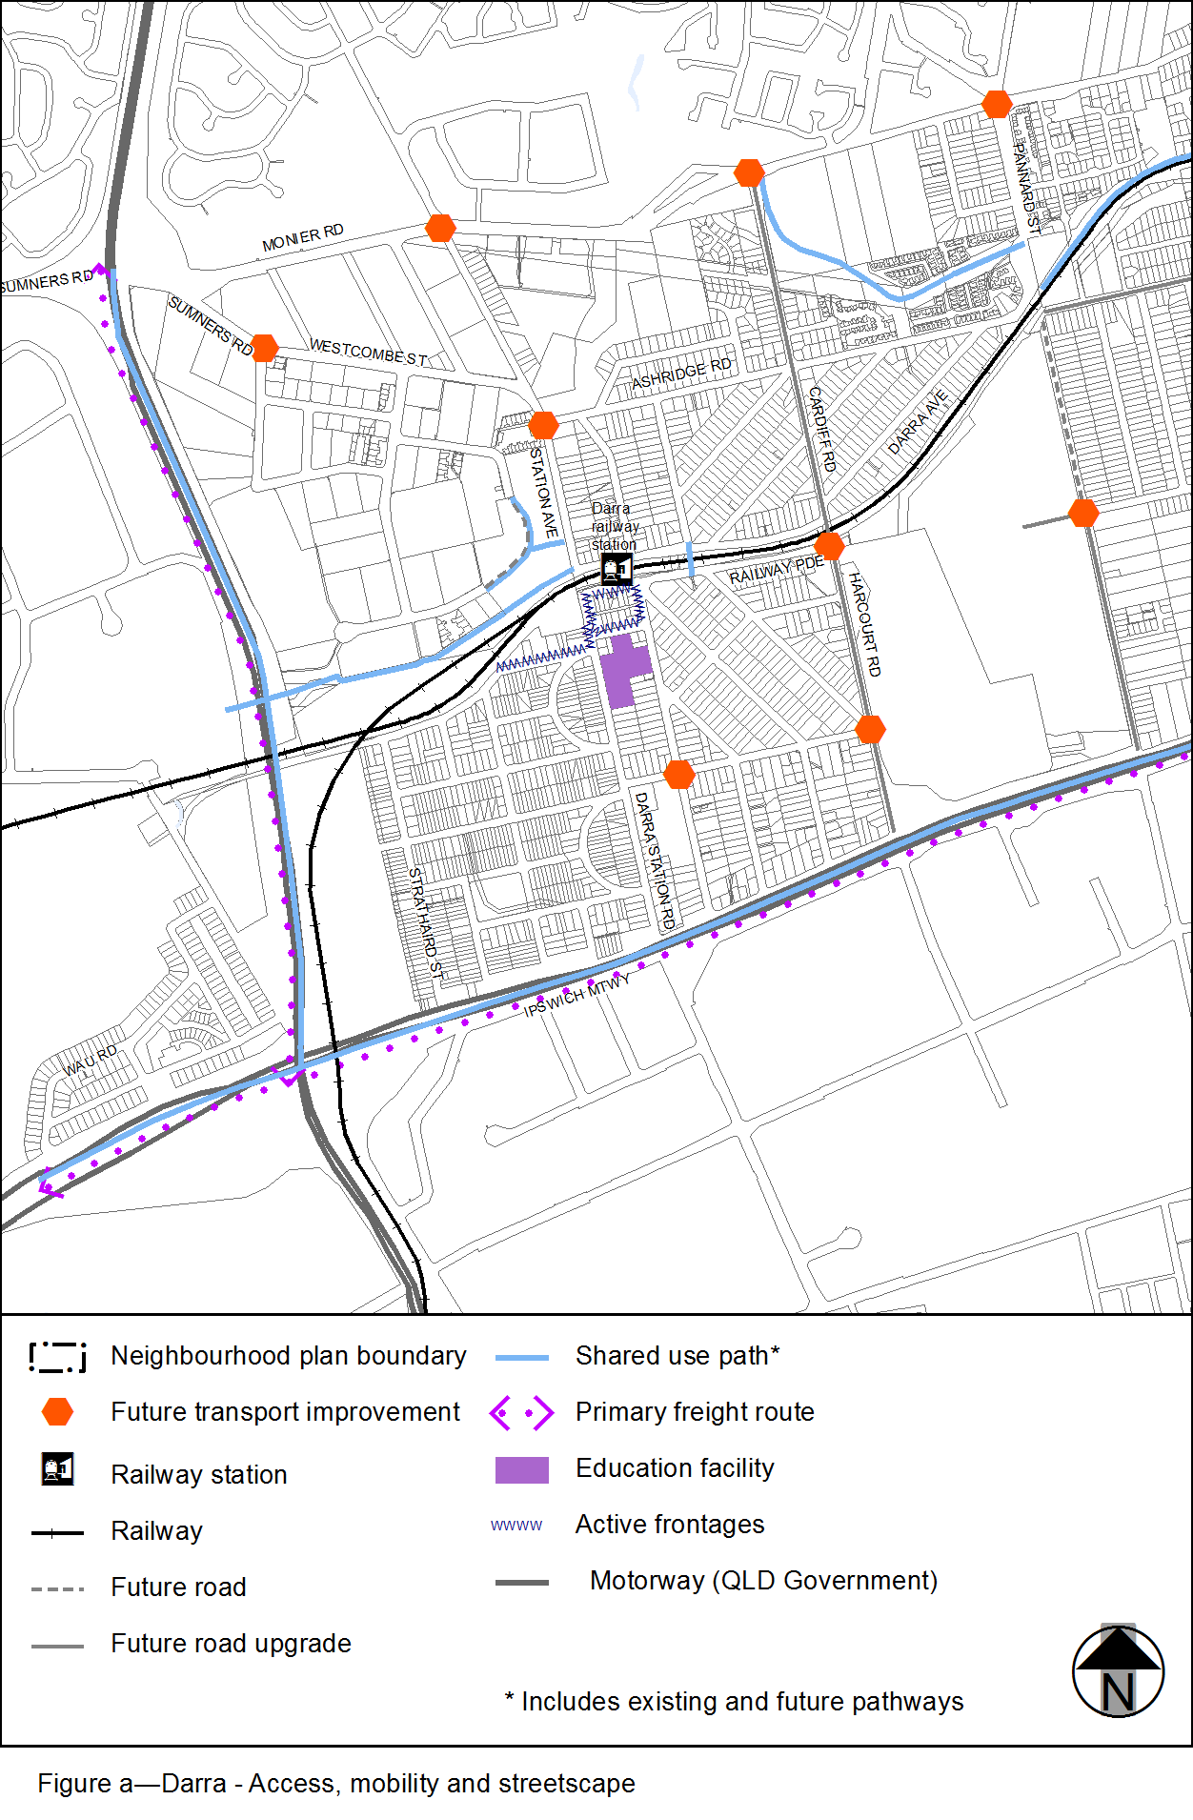
View the high resolution of Figure a–Darra – Access, mobility and streetscape (PDF file size is 213Kb)
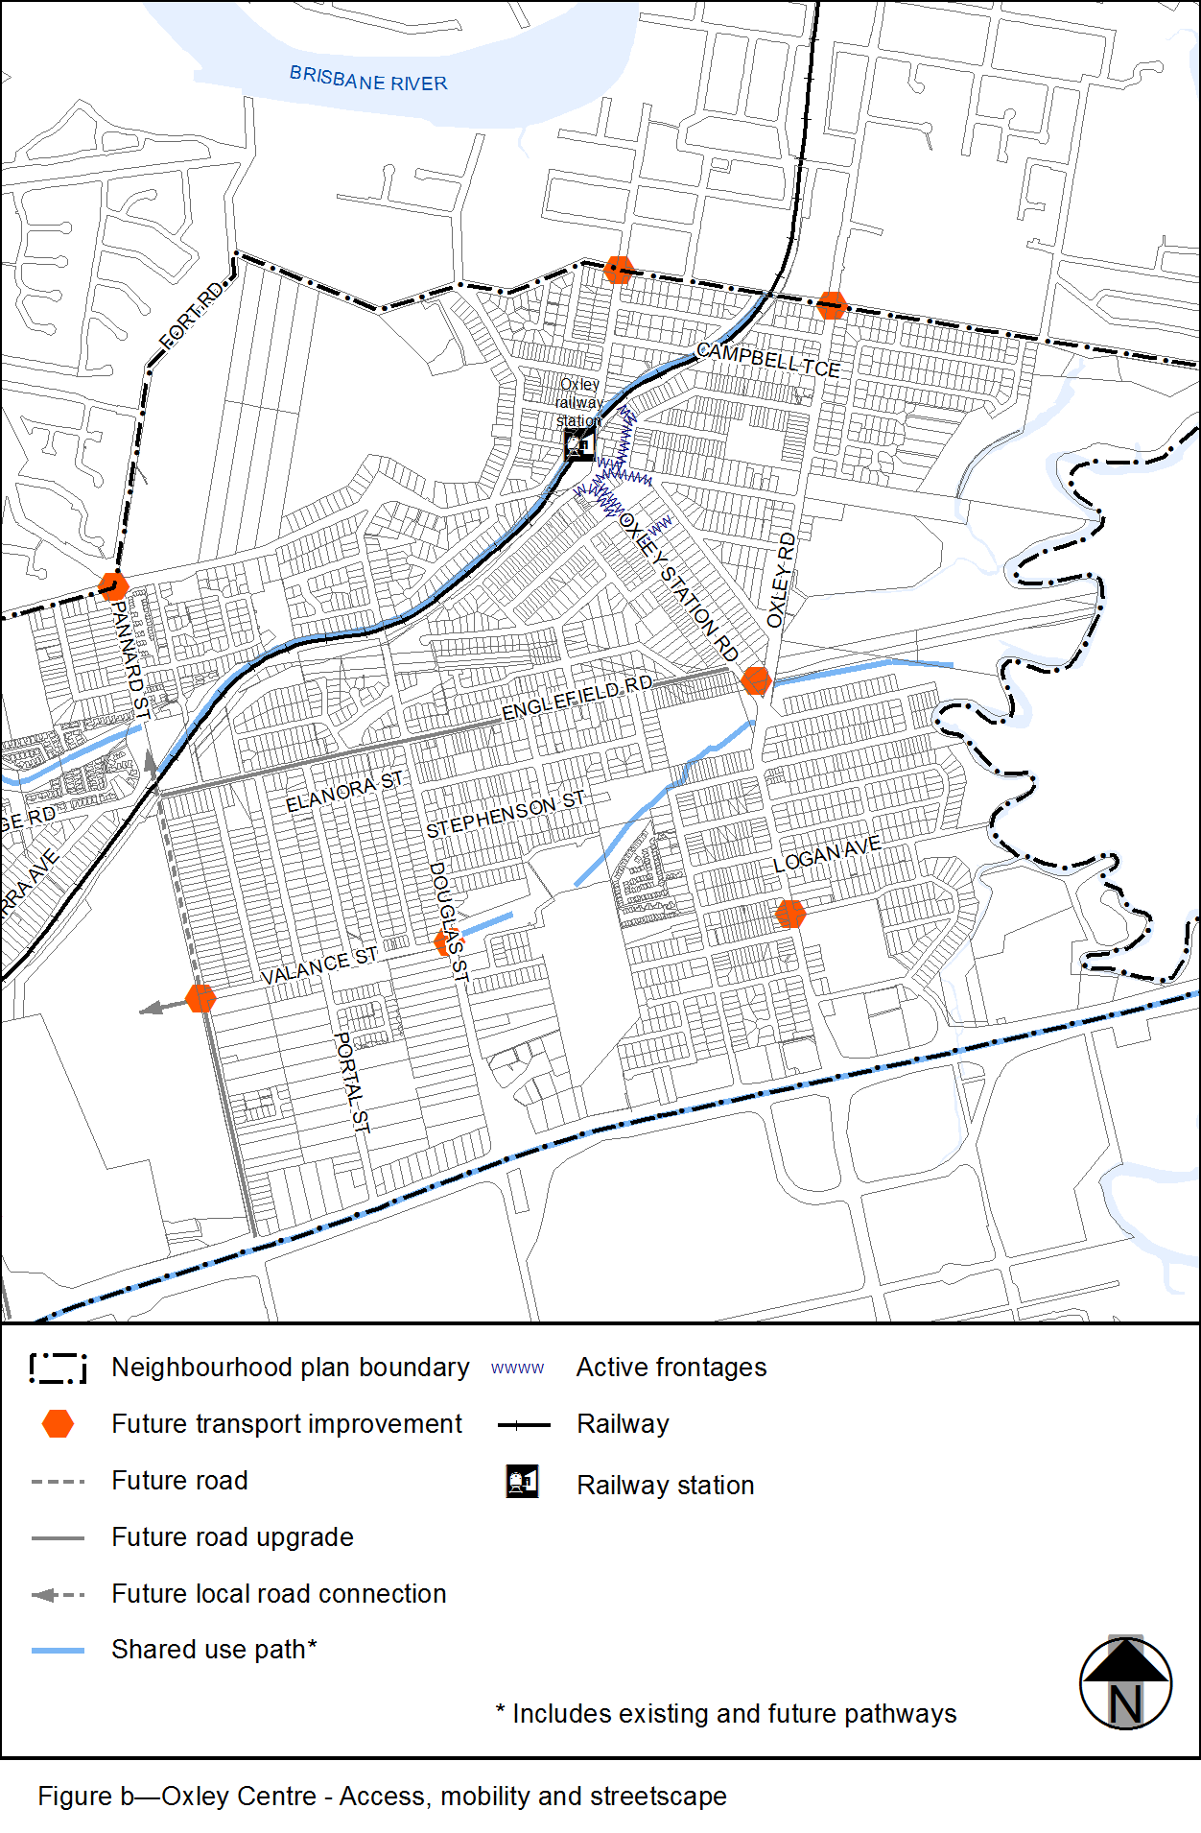
View the high resolution of Figure b–Oxley Centre – Access, mobility and streetscape (PDF file size is 242Kb)
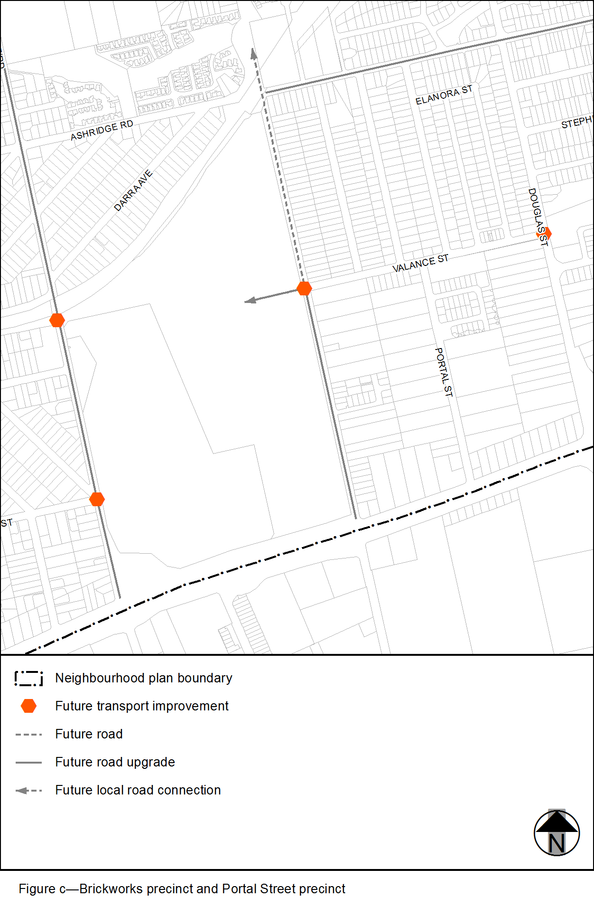
View the high resolution of Figure c–Brickworks precinct and Portal Street precinct (PDF file size is 116Kb)
