7.2.6.1 Ferny Grove—Upper Kedron neighbourhood plan code

7.2.6.1.1 Application
- This code applies to assessing a material change of use, reconfiguring a lot, operational work or building work in the Ferny Grove—Upper Kedron neighbourhood plan area if:
- assessable development where this code is an applicable code identified in the assessment benchmarks column of a table of assessment for a neighbourhood plan (section 5.9); or
- impact assessable development.
- Land in Ferny Grove—Upper Kedron neighbourhood plan is identified on the NPM-006.1 Ferny Grove—Upper Kedron neighbourhood plan map.
- When using this code, reference should be made to section 1.5, section 5.3.2 and section 5.3.3.
Note—The following purpose, overall outcomes, performance outcomes and acceptable outcomes comprise the assessment benchmarks of this code.
Note—This neighbourhood plan includes a table of assessment. Refer to Table 5.9.25.A, Table 5.9.25.B, Table 5.9.25.C and Table 5.9.25.D.

7.2.6.1.2 Purpose
- The purpose of the Ferny Grove—Upper Kedron neighbourhood plan code is to provide finer grained planning at a local level for the Ferny Grove—Upper Kedron neighbourhood plan.
- The purpose of the Ferny Grove—Upper Kedron neighbourhood plan code will be achieved through overall outcomes.
- The overall outcomes for the neighbourhood plan area are:
- Development creates functional and integrated communities.
- Land subject to development constraints, character or environmental values indicated in a figure in this neighbourhood plan code or shown on an overlay map is protected from inappropriate development in order to maintain its character, natural and ecological significance.
- Development of land south of Levitt Road, generally above the 95m contour line, minimises visual impacts in conjunction with revegetation.
- Open space, parks and recreational facilities meet the needs of the community and are located in accessible locations that are well connected within the neighbourhood plan area.
- Both indoor and outdoor sports are accommodated at the proposed district sports park.
- The quarry site is stabilised and rehabilitated upon completion of quarrying activities and recreation activities are located on the site when quarrying operations have ceased.
- Neighbourhood centres identified in the neighbourhood plan serve the retail, commercial, community and service needs of the local community.
- Centre activities do not expand outside of these identified sites and other land already included in a zone in the Centre zones category.
- Development of the Ferny Grove railway station and surrounding suburban centre is to be in accordance with an approved centre concept plan. The centre concept plan must address the issue of car parking at Ferny Grove station while making it an integrated transport and business hub.
- Development in a potential development area addresses the location of the land, availability of services, environmental constraints, amenity, and existing patterns of development, to ensure an integrated development outcome.
- Residential development in a potential development area identified in Figure a or Figure b provides for a mix of housing types, styles and densities, in particular:
- the very low density residential — dwelling houses area as shown in Figure a contains dwelling houses up to 5 dwellings per hectare to ensure minimal disturbance to areas of environmental and scenic value;
- the low density residential — dwelling houses area as shown in Figure a contains predominantly dwelling houses at a yield of 12 dwellings per hectare;
- the low density residential — dwelling houses and multiple dwellings area as shown in Figure a contains a mix of dwelling houses and multiple dwellings at a yield of 16 dwellings per hectare;
- the low density residential – multiple dwellings area as shown in Figure a contains predominantly multiple dwellings at a yield of 25 dwellings per hectare.
- Development of the sites listed below is contingent on providing infrastructure and access from adjoining lands, in particular:
- 320 Levitt Road (Lot 1, RP 162875) is not developed until access is provided from Canvey Road via 232 Canvey Rd (Lot 1, RP 20577);
- 221 McGinn Road (Lot 2, RP 164168) is not developed until 205, 189 and 173 McGinn Road (Lot 1, RP 164167, Lot 2, RP 164167 and Lot 1, RP 210657) have been developed and provide access;
- land west of Ross Road is not developed until the land east of Ross Road provides water supply and sewerage connections. Only under these circumstances will development in this area be assessed against the Emerging community zone provisions; and
- land at 171, 173 and 179 Upper Kedron Road (Lots 1 and 2, RP 185509 and Lot 1, RP 82882) must enable access to 24 Persimmon Street (Lot 43, RP 167933);
- very low density residential development south of Cedar Creek is accessed through the potential development area to the north and not from Mt Nebo Road, Brompton Road or the unconstructed part of Ross Road;
- the Samford Valley sub-arterial corridor has been identified to preserve an option for a future transport connection between Samford Valley and Brisbane.
- Development does not prejudice the future transport corridor investigation area, identified in Brisbane City Council’s Transport Plan for Brisbane 2002–2016 to the west of the neighbourhood plan area.
Editor’s note—The word ‘State’ was removed from this future transport corridor investigation route by direction of the Minister for Local Government Planning and Sport given under Section 866(2)(b) of Chapter 10 of the Sustainable Planning Act 2009.
- Walking and cycling routes provide safe and legible connections between residential areas and key destinations including centres, community facilities, major parks and conservation reserves and public transport nodes.
- Development is of a height, scale and form which is consistent with the amenity and character, community expectations and infrastructure assumptions intended for the relevant precinct, sub-precinct or site and is only developed at a greater height, scale and form where there is both a community need and an economic need for the development.

7.2.6.1.3 Performance outcomes and acceptable outcomes

Table 7.2.6.1.3.A—Performance outcomes and acceptable outcomes
Performance outcomes | Acceptable outcomes
General
PO1  Development is of a height, scale and form that achieves the intended outcome for the precinct, improves the amenity of the neighbourhood plan area, contributes to a cohesive streetscape and built form character and is:  - consistent with the anticipated density and assumed infrastructure demand;  - aligned to community expectations about the number of storeys to be built;  - proportionate to and commensurate with the utility of the site area and frontage width;  - designed to avoid a significant and undue adverse amenity impact to adjoining development;  - sited to enable existing and future buildings to be well separated from each other and to avoid affecting the development potential of an adjoining site.  Note—Development that exceeds the intended number of storeys or building height can place disproportionate pressure on the transport network, public space or community facilities in particular.  Note—Development that is over-scaled for its site can result in an undesirable dominance of vehicle access, parking and manoeuvring areas that significantly reduce streetscape character and amenity. | AO1  Development complies with the number of storeys and building height in Table 7.2.6.1.3.B  Note—Neighbourhood plans will mostly specify maximum number of storeys where zone outcomes have been varied in relation to building height. Some neighbourhood plans may also specify height in metres. Development must comply with both parameters where maximum number of storeys and height in metres are specified.
If involving reconfiguring a lot with landscape features south of Levitt Road
PO2  Development:  - has a subdivision pattern designed to protect and promote views of the hills of Brisbane Forest Park and reduce the visual impact of new development;  - must be effectively screened with local vegetation. | AO2  Development has a development footprint plan and is located a minimum of 15m vertically below any ridgeline.
If involving a neighbourhood centre on the site indicated at Canvey Road in Figure a and Figure b
PO3  Development of a Neighbourhood centre must be of a suitable scale to serve the local catchment. | AO3.1  Development involving centre activities does not exceed 2000m2 gross floor area (not including any childcare centre).
AO3.2
Development provides a 2,000m2 site area for uses to be accommodated in the Community facilities zone.
PO4  Development has a building design and location which addresses and connects to Cedar Creek and Canvey Road. | AO4.1  Development has safe and direct pedestrian access from the Neighbourhood centre to Canvey Road and Cedar Creek in accordance with Figure c.
AO4.2
Development provides active frontages to Canvey Road and Cedar Creek from buildings on the eastern and southern sides of the site, in accordance with Figure c.
PO5  Development provides vehicle access with connection to adjoining properties and maximises exposure to Cedar Creek. | AO5  Development has vehicular access via Canvey Road in the form of an esplanade road along Cedar Creek that provides access to the site to the west in accordance with Figure c.

Table 7.2.6.1.3.B—Maximum building height
Development | Building height (number of storeys)
If in the area identified as neighbourhood centre in Figure a and Figure b
Development of a site located on Canvey Road | 2

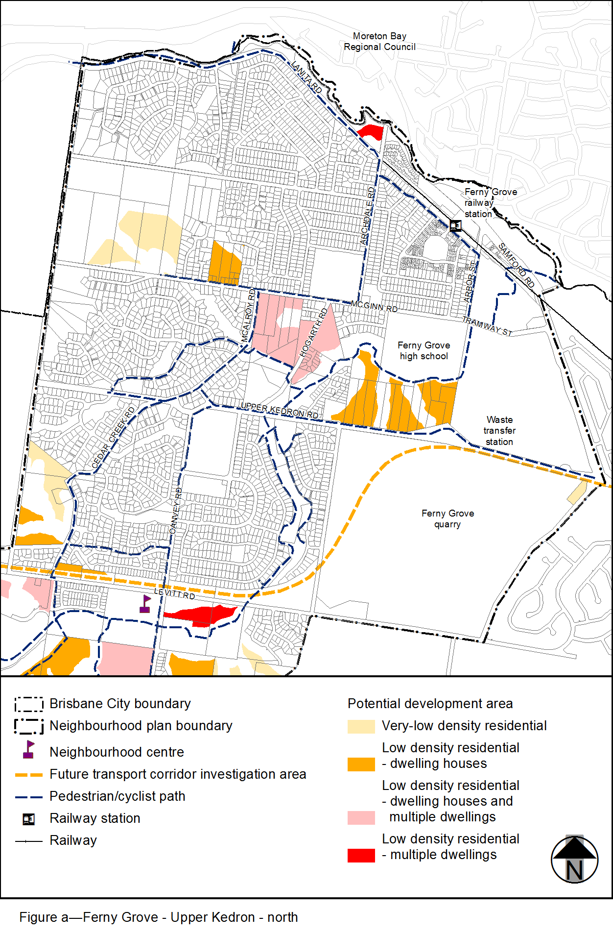
View the high resolution of Figure a–Ferny Grove – Upper Kedron – north (PDF file size is 294Kb)
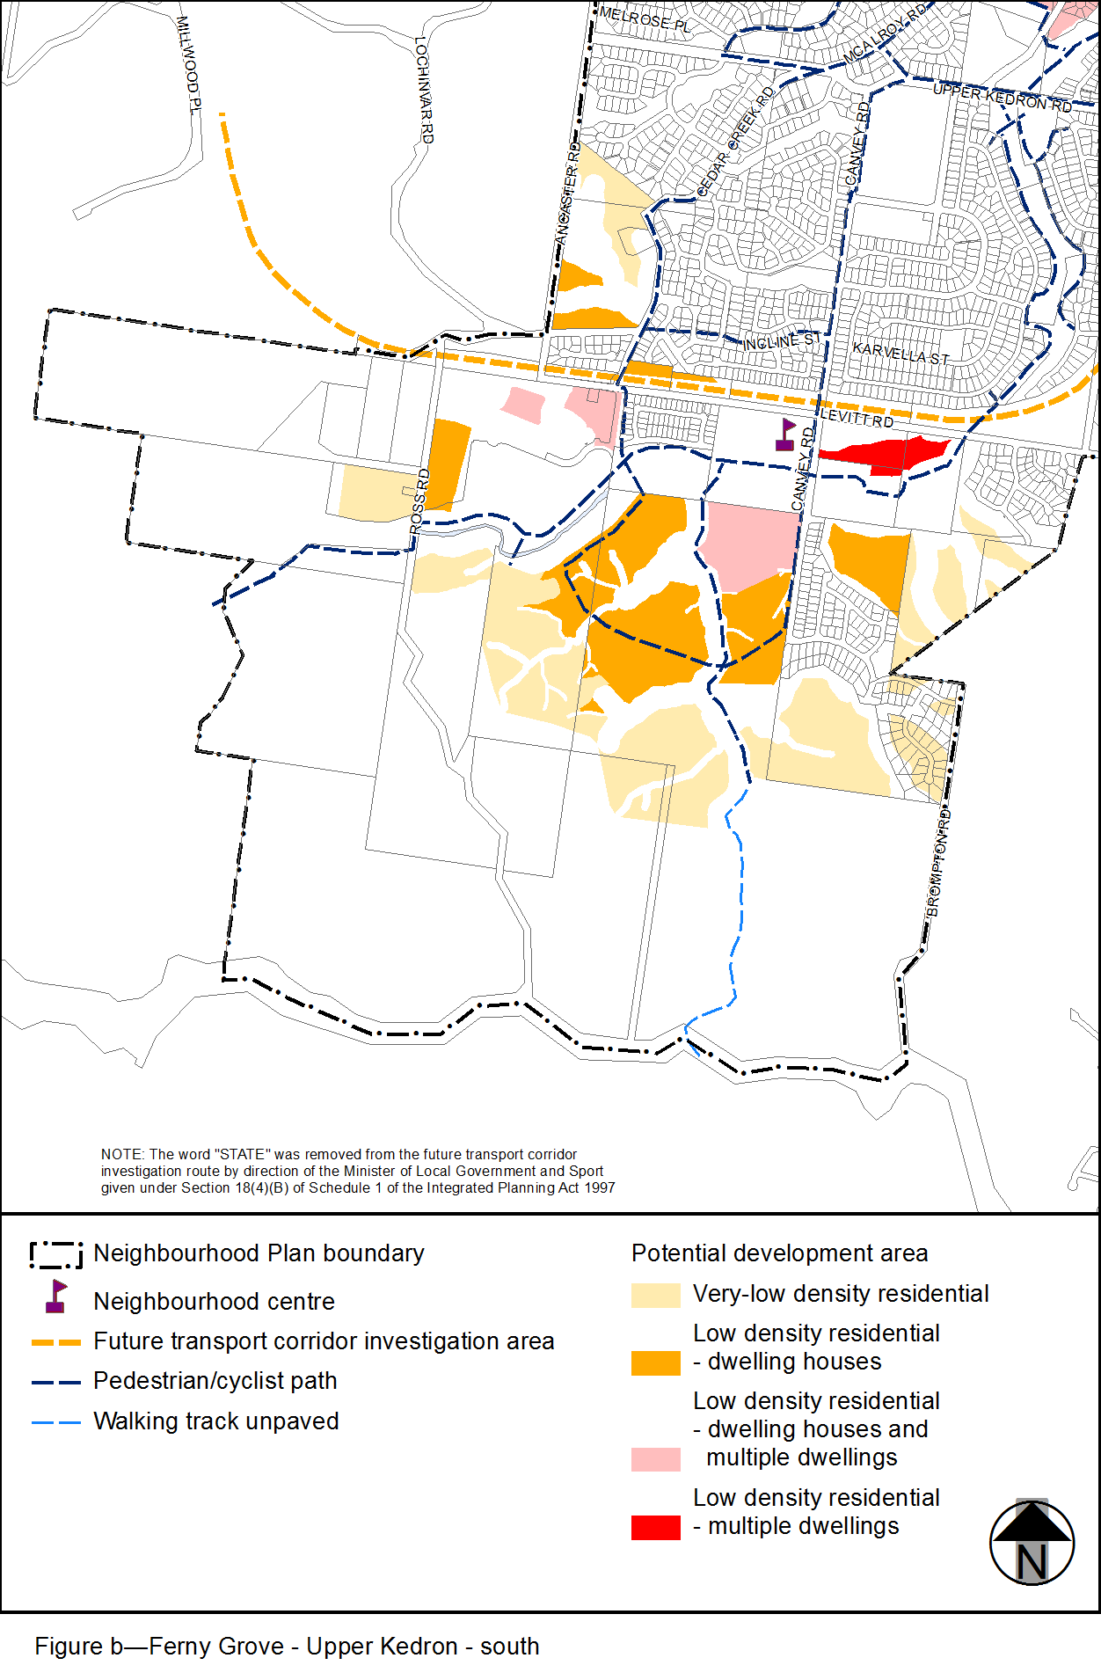
View the high resolution of Figure b–Ferny Grove – Upper Kedron – south (PDF file size is 158Kb)
