7.2.12.2 Latrobe and Given Terraces neighbourhood plan code

7.2.12.2.1 Application
- This code applies to assessing a material change of use, reconfiguring a lot, operational work or building work in the Latrobe and Given Terraces neighbourhood plan area if:
- assessable development where this code is an applicable code identified in the assessment benchmarks column of a table of assessment for a neighbourhood plan (section 5.9); or
- impact assessable development.
- Land in the Latrobe and Given Terraces neighbourhood plan area is identified on the NPM-012.2 Latrobe and Given Terraces neighbourhood plan map and includes the following precincts:
- Centres precinct (Latrobe and Given Terraces neighbourhood plan/NPP-001);
- Residential precinct (Latrobe and Given Terraces neighbourhood plan/NPP-002);
- Mixed use precinct (Latrobe and Given Terraces neighbourhood plan/NPP-003).
- When using this code, reference should be made to section 1.5, section 5.3.2 and section 5.3.3.
Note—The following purpose, overall outcomes, performance outcomes and acceptable outcomes comprise the assessment benchmarks of this code.
Note—This neighbourhood plan includes a table of assessment with variations to categories of development and assessment. Refer to Table 5.9.37.A, Table 5.9.37.B, Table 5.9.37.C and Table 5.9.37.D.
Note—Latrobe and Given Terrace locality (The Terraces) is a hillside character area. Hillside character areas are steeper residential areas containing traditional character housing and significant ridgelines. Hillside character is derived from the relationship of buildings to their physical setting. Traditional character housing built following an historic subdivision pattern and located on well-treed hillsides results in a unique character of important visual significance in the local context.

7.2.12.2.2 Purpose
- The purpose of the Latrobe and Given Terraces neighbourhood plan code is to provide finer grained planning at a local level for the Latrobe and Given Terraces neighbourhood plan area.
- The purpose of the Latrobe and Given Terraces neighbourhood plan code will be achieved through overall outcomes including overall outcomes for each precinct of the neighbourhood plan area.
- The overall outcomes for the neighbourhood plan area are:
- Development is sited and designed to contribute to a high-quality visual landscape and respect and enhance the area’s ‘timber and tin’ hillside character by using quality contemporary subtropical architecture respectful of its setting but not replicative in its design.
- Hillside character is retained and enhanced through sympathetic development that minimises visual impact within its visual catchment.
- Structurally sound traditional character buildings are retained whether they are located in isolation or within character streetscapes.
- Development is of a height, scale and form which is consistent with the amenity and character, community expectations and infrastructure assumptions intended for the relevant precinct, sub-precinct or site and is only developed at a greater height, scale and form where there is both a community need and an economic need for the development.
- Latrobe and Given Terrace continues to perform a multipurpose transport role, catering for pedestrians, cyclists and through traffic, while also providing for on-street parking, servicing and vehicular access to adjoining properties within a streetscape environment improved by complementary street furniture, paving and planting.
- Development minimises intrusion of non-residential traffic into residential side streets. However the provision of on-site car parking associated with low traffic generating, non-residential uses is balanced against site constraints such as steep slope, vegetation and traditional character buildings and provision of hardstand and manoeuvring areas does not compromise ‘timber and tin’ hillside character.
- Centres precinct (Latrobe and Given Terraces neighbourhood plan/NPP-001) overall outcomes are:
- The precinct is the primary focus for non-residential uses accommodated within low rise development that respect the ‘timber and tin’ hillside character.
- Mixed use development is encouraged, with most development incorporating a residential component.
- Non-residential development is designed to avoid impacts to the Residential precinct (Latrobe and Given Terraces neighbourhood plan/NPP-002) and the Mixed use precinct (Latrobe and Given Terraces neighbourhood plan/NPP-003).
- Non-residential uses are oriented to either Latrobe Terrace or Given Terrace and create a vibrant streetscape that supports social interaction and high levels of pedestrian amenity by locating shops, food and drink outlets and other active uses at street level, with other uses generally located above or below street level.
- Limited low impact industry and service industry uses are possible in the precinct to facilitate the production of arts and crafts and other goods produced substantially by hand.
- Development of Special areas 1, 2 and 3 (as shown in Figure c) is encouraged where buildings of traditional character or heritage significance are retained, corners are provided with strong architectural landmark definition and non-residential uses are designed to address, embellish and activate the Terraces.
- Development of the following uses is consistent with the outcomes sought:
- bar, hotel or nightclub entertainment facility where located in Special area 5 (as shown in Figure c) and if non-residential gross floor area is no greater than 80% of the site area and site cover is no greater than 75%;
- intensification of a bar, hotel or nightclub entertainment facility within special area 5 is only appropriate where residential impacts can be managed. This can be demonstrated by a social and health impact assessment report prepared in accordance with the Social and health impact assessment planning scheme policy, and Consultation planning scheme policy, demonstrating that the proposal:
- does not result in adverse community impact;
- does not detrimentally affect the amenity of adjacent and nearby residential areas;
- safeguards personal and property security for users of the centre and occupants of nearby residential areas.
- Development for the following uses is not considered consistent with the outcomes sought:
- bar, hotel or nightclub entertainment facility in any location other than special area 5.
- Residential precinct (Latrobe and Given Terraces neighbourhood plan/NPP-002) overall outcomes are:
- The precinct is the main location for residential uses, accommodated primarily within traditional character houses.
- Low rise infill development does not result in the demolition of traditional character buildings, protects residential amenity and respects the ‘timber and tin’ hillside character.
- Non-residential uses do not expand beyond the boundaries of the special areas within the precinct.
- Special area 4 continues to be used for shop, office, food and drink outlet, low impact industry and service industry which are considered low-impact, smaller scale, non-residential activities.
- Special area 4 is comprised of a handful of traditional character buildings adaptively used for non-residential purposes that complement the activities of the Centres precinct (Latrobe and Given Terraces neighbourhood plan/NPP-001) and the Mixed use precinct (Latrobe and Given Terraces neighbourhood plan/NPP-003).
- Special area 6 continues to be used for community uses.
- Development of the following uses is not considered consistent with the outcomes sought:
- any expansion of non-residential uses beyond the Centres precinct (Latrobe and Given Terraces neighbourhood plan/NPP-001) and the Mixed use precinct Latrobe and Given Terraces neighbourhood plan/NPP-003) and special areas 4 and 6 into the Residential precinct (Latrobe and Given Terraces neighbourhood plan/NPP-002). This would constitute an incremental extension of a centre within a catchment already sufficiently serviced by such activities and at transport infrastructure capacity.
- Mixed use precinct (Latrobe and Given Terraces neighbourhood plan/NPP-003) overall outcomes are:
- The precinct provides a unique low rise environment of residential and low intensity non-residential uses such as shop, office, food and drink outlet, low impact industry and service industry accommodated within small-scale tenancies that maintain the domestic appearance of traditional character houses.
- Development provides a combination of residential and non-residential uses.
- Non-residential development does not erode residential character and amenity and is designed to avoid impacts to the Residential precinct (Latrobe and Given Terraces neighbourhood plan/NPP-002).
- Non-residential uses are oriented to either Latrobe or Given Terrace.
- Development for the following uses is not considered consistent with the outcomes sought:
- development incorporating Centre activities of a type or scale other than the identified low-impact, smaller scale, non-residential activities for this precinct. These uses are located in Centres precinct (Latrobe and Given Terraces neighbourhood plan/NPP-001).

7.2.12.2.3 Performance outcomes and acceptable outcomes

Table 7.2.12.2.3.A—Performance outcomes and acceptable outcomes
Performance outcomes | Acceptable outcomes
General
PO1  Development is of a height, scale and form that achieves the intended outcome for the precinct, improves the amenity of the neighbourhood plan area, contributes to a cohesive streetscape and built form character and is:  - consistent with anticipated density and assumed infrastructure demand;  - aligned to community expectations about the number of storeys to be built;  - proportionate to and commensurate with the utility of the site area and frontage width;  - designed to avoid a significant and undue adverse amenity impact to adjoining development;  - sited to enable existing and future buildings to be well separated from each other and to avoid affecting the development potential of an adjoining site.  Note—Development that exceeds the intended number of storeys or building height can place disproportionate pressure on the transport network, public space or community facilities in particular.  Note—Development that is over-scaled for its site can result in an undesirable dominance of vehicle access, parking and manoeuvring areas that significantly reduce streetscape character and amenity. | AO1  Development complies with the number of storeys and building height in Table 7.2.12.2.3.B.  Note—Neighbourhood plans will mostly specify maximum number of storeys where zone outcomes have been varied in relation to building height. Some neighbourhood plans may also specify height in metres. Development must comply with both parameters where maximum number of storeys and height in metres are specified.
PO2  Development:  - is designed, sited and landscaped to minimise the impact of incompatible building bulk;  - Maintains and enhances the traditional character and built form of ‘The Terraces’:  - in terms of bulk form and scale, heights of eaves, elevational treatment, and construction materials;  - through the use of quality contemporary architecture respectful of its setting;  - If along a ridgeline does not dominate the skyline and is designed and sited to contribute to a consistent rhythm and sense of scale along the ridgeline when viewed from the visual catchment. | AO2  Development incorporates:  - orthogonal plan forms with outside walls aligned to those on adjoining allotments or within the development;  - pitched roofs sheeted in metal profiles;  - heights of eaves reflecting the pattern of their existing heights along undulating ridgelines, horizontally across hillsides and vertically down hillsides;  - external wall treatments incorporating lightweight sheeting;  - elevations articulated with modulating elements such as verandahs and decks.
PO3  Development which provides car parking with low traffic-generating uses is at a rate that does not:  - result in an unacceptable impact on the values of a heritage place, commercial character building, or traditional character building;  - adversely affect the topography of steep sites or backyard vegetation;  - compromise the safety and movement of vehicles or pedestrians;  - adversely affect the amenity of adjacent residential properties or streetscape of ‘The Terraces’.  Note—Food and drink outlets and similar uses generating high patronage levels are not considered to be low traffic generating uses and are not subject to variation of car parking requirements. | AO3  No acceptable outcome prescribed.
PO4  Development designs and locates parking and vehicular access to ensure convenient and safe parking is provided and residential amenity is preserved via no increase in the use of residential streets for non-residential parking and minimal intrusion of non-residential traffic into these streets. | AO4.1  Development ensures that access driveways do not provide or enable the creation of mid-block vehicular access between Latrobe or Given Terrace and any parallel residential streets.
AO4.2
Development provides a setback to unenclosed vehicular access, parking and manoeuvring areas of:
- 3m from any boundary to adjoining properties in the Residential precinct (Latrobe and Given Terraces neighbourhood plan/NPP-002), where in the Centres precinct (Latrobe and Given Terraces neighbourhood plan/NPP-001);
- 3m from the rear boundary where in any other precinct;
- the setback is planted to provide a dense landscape screen capable of achieving a canopy width of 6m high by 6m wide.
PO5  Development is designed and sited to avoid impacts on residential amenity and to provide backyard vegetation consistent with the hillside character. | AO5.1  Development locates non-residential uses on that part of the site closest to Latrobe Terrace or Given Terrace and orients them away from side or rear boundaries to the Residential precinct (Latrobe and Given Terraces neighbourhood plan/NPP-002).
AO5.2
Development provides a dense landscape screen capable of achieving a canopy width of 6m high by 6m wide along the rear boundary and along any boundary to the Residential precinct (Latrobe and Given Terraces neighbourhood plan/NPP-002), where in the Centres precinct (Latrobe and Given Terraces neighbourhood plan/NPP-001).
PO6  Development minimises impacts to existing significant vegetation and provides replacement vegetation on the site of advanced size and maturity where significant vegetation is removed. | AO6.1  Development designs and sites buildings or other structures, driveways and hardstand areas to maximise the retention of trees featuring a trunk diameter width of 250mm or greater measured at 1m above ground level.
AO6.2
Development that results in the removal of trees replaces these trees with vegetation identified in the Planting species planning scheme policy of 100L minimum stock size planted in sufficient quantity to achieve a total canopy area of 50% of the removed vegetation when mature.
PO7  Development including buildings or other structures, driveways and hardstand areas, are designed and sited to minimise cut and fill disturbance on the site and to soften its visual impact. | AO7  Development incorporates:  - foundation systems that minimise disturbance to the landscape, such as post and pier type foundations;  - slab-on-ground foundations only on those parts of a site with gradients less than 1 in 8 and where cut and fill is minimal;  - benching, cut and fill, or construction of retaining walls of a minor nature only, with fill not exceeding 1m, where the height of any retaining wall and fence not exceeding 2m is designed or screened by landscaping so as to not be noticeable after construction is completed;  - driveways and hardstand areas only on those parts of a site with gradients less than 1 in 4.
Building height, scale and proportions
PO8  Development for residential purposes is of a height, scale and proportion compatible with traditional character houses when viewed from the visual catchment. | AO8.1  Development ensures that large buildings appear as a series of separate blocks, each of a size and scale similar to that of a traditional character house, using either physical separation and/or:  - significant recesses and projections of the exterior wall plane;  - articulation through steps in the horizontal plane of the roof;  - roof geometry incorporating significant variety such as pitched roofs of a minimum 27.5-degree pitch;  - elevational and roof treatment using a variety of materials, colours and finishes compatible with traditional character houses to achieve the appearance of separate blocks.
AO8.2
Development only has building heights exceeding the prescribed building height in Table 7.2.12.2.3.B where:
- use of traditional character elements or site-responsive construction methods has resulted in non-compliance with the prescribed building height in Table 7.2.12.2.3.B;
- any additional building height or storeys are incorporated into a building form appearing to comply with the prescribed building height in Table 7.2.12.2.3.B; for example where 2 storey development is prescribed, any third storey is incorporated into a roofspace area.
Note—Site-responsive construction methods, such as posts or piers minimise the amount of alteration to site topography. Traditional character elements are pitched roofs of a minimum 27.5º degree pitch.
AO8.3
Development only has a site cover exceeding the prescribed site cover for the relevant precinct where the development is designed to reduce building bulk in accordance with AO16.1.
AO8.4
Development incorporates eaves of a height that reflect the predominant development pattern and form of development in the area:
- along undulating ridgelines;
- horizontally across hillsides;
- vertically down hillsides.
AO8.5
Development limits the length of a uniform elevational treatment above ground level without variation, articulation or openings to no more than 10m.
PO9  Development is designed, sited and landscaped to minimise the impact of incompatible building bulk. | AO9  No acceptable outcome is prescribed.
PO10  Development along a ridgeline does not dominate the skyline and is designed and sited to contribute to a consistent rhythm and sense of scale along the ridgeline when viewed from the visual catchment. | AO10  No acceptable outcome is prescribed.
Landscape character, physical setting and topography
If in a special area
Note—Development in the special areas is also assessed against the performance outcomes and acceptable outcomes of the relevant precinct.
PO11  Development in special areas 1, 2 or 3:  - is consistent with buildings in the locality and as planned for the special area;  - addresses and responds to the site’s prominent corner location;  - provides for an improved streetscape and pedestrian environment;  - maintains the amenity of adjoining residential development. | AO11  Development provides:  - landmark definition of the corner and forms a strong visual bond with the streetscape;  - non-residential uses that address and activate the Latrobe and Given Terrace frontages;  - buildings built to the alignment along the Latrobe and Given Terrace frontages with pedestrian awning/shelter;  - street trees, furniture, lighting, footpath and kerb treatments in accordance with the Infrastructure design planning scheme policy.
PO12  Development in Special area 1 protects adjoining residential amenity and provides additional off-street car parking opportunities for the general community. | AO12.1  Development:  - locates residential uses at the rear of the site adjoining the Residential precinct (Latrobe and Given Terraces neighbourhood plan/NPP-002);  - is designed to respond to the site contours;  - does not gain vehicular access from Mort Street.
AO12.2
Development has a maximum gross floor area up to 20% greater than specified in AO16.1 below, and accrued at the rate of an additional 30m² for each additional car parking space that is provided in excess of the minimum applicable rate specified in the Transport, access, parking and servicing code.
PO13  Development in Special area 2 provides an area of public open space that reflects the desired character of ‘The Terraces’ and enables views of the site’s south eastern vista overlooking Paddington and beyond to the City Centre.  Editor's note—Examples of public open space that reflect the desired character of ‘The Terraces’ include the ‘Genoa Lounge’ at the intersection of Wilden Street and Latrobe Terrace and ‘Trammies Corner’ at the intersection of Prince Street and Latrobe Terrace. | AO13  Development provides an area of dedicated public open space that is:  - located at the Latrobe Terrace and Alma Street intersection on the site’s corner;  - embellished with improvements such as planting, landscaping, artwork and street furniture that encourages passive recreational use of the space;  - distinguishable as public open space, rather than private open space comprising part of the development;  - accessible at-grade from Latrobe Terrace.
PO14  Development in Special area 3 protects adjoining residential amenity. | AO14  Development may only provide a built to northern boundary wall where the wall:  - does not exceed 3m in height;  - does not contain any openings or windows;  - is rendered and painted in a colour scheme that does not detract from the residential amenity of adjoining sites.
PO15  Development for community facilities in special area 6 respects the residential nature of the precinct and protects residential amenity. | AO15  Development maintains significant on-site vegetation.
If in the Centres precinct (Latrobe and Given Terraces neighbourhood pan/NPP-001)
PO16  Development ensures that the scale and bulk of buildings is consistent with buildings in the locality and as planned for the precinct or special area in the neighbourhood plan. | AO16.1  Development has a maximum gross floor area of:  - non-residential – 80% of the site area;  - residential – area of the site;  - mixed residential/non-residential where a minimum of 20% of the total gross floor area is used for residential purposes – area of the site.
AO16.2
Development has a maximum site cover of 75% of the site area.
PO17  Development has building setbacks that maintain and enhance the character, streetscape and amenity of the locality and are as planned for the precinct or special area in the neighbourhood plan. | AO17  Development has minimum side and rear setbacks that are:  - 6m, or 12m where gradient is greater than 1 in 8, if adjacent to the Residential precinct (Latrobe and Given Terraces neighbourhood plan/NPP-002);  - nil for all other side boundaries;  - Refer to Figure a.
PO18  Development has a front setback that appears consistent with those in the streetscape and:  - provides for pedestrian awnings, roof overhangs or other measures to improve the pedestrian environment;  - retains significant viewsheds or vistas to heritage places;  - accommodates landscaping or other streetscape improvements. | AO18  Development of buildings are built:  - to the front alignment; or  - within 20% of the average front setback of adjoining buildings in the Mixed use precinct (Latrobe and Given Terraces neighbourhood plan/NPP-003) or the Residential precinct (Latrobe and Given Terraces neighbourhood plan/NPP-002) fronting the same street for that part of the frontage greater than 20m from the property alignment to Latrobe Terrace or Given Terrace where a corner site. Refer to Figure a.
If in the Residential precinct (Latrobe and Given Terraces neighbourhood plan/NPP-002) or Mixed use precinct (Latrobe and Given Terraces neighbourhood plan/NPP-003)
PO19  Development:  - has a height, scale and proportion compatible with traditional character houses;  - is designed and sited to retain and reinforce the predominant development pattern and form of:  - separate allotments, whether or not the site area exceeds predominant lot sizes in the area, or the site is an amalgamation of allotments;  - buildings of a traditional character house scale uniformly spaced and consistently stepped across well-treed hillsides viewed from the visual catchment.  - incorporates a design and scale of elevation and building form that considers the views of the building from surrounding areas and the impact of the proposal on properties to the rear of the development. | AO19.1  Development reflects the predominant pattern and form of development in the area in the building envelope size and siting.
AO19.2
Development of buildings are designed to appear as a series of separate blocks, each of a size and scale similar to that of a traditional character house, using either physical separation or:
- significant recesses and projections of the exterior wall plane;
- articulation through steps in the horizontal plane of the roof;
- roof geometry incorporating significant variety degree, such as pitched roofs or a minimum 27.5 degree pitch;
- elevational and roof treatment using a variety of materials, colours and finishes, compatible with traditional character houses;
- no uniform elevational treatment above ground level without variations, articulation or openings, of more than 10m in length.
PO20  Development:  - is designed and sited to retain or reinforce the landscape character and physical setting of the locality and to break up building bulk;  - incorporates buildings that are to appear to be uniformly sited on well-treed hillsides and consistently spaced along major ridgelines. | AO20.1  Development provides communal open space and ground storey private open space required for multiple dwellings at a minimum dimension of 5m.
AO20.2
Development has a minimum boundary setback of:
- 6m from the rear boundary;
- 12m to the rear boundary on sites steeper than 1 in 8 gradient (long axis from the front boundary to rear boundary of the site);
- 6m to any adjoining site’s front or rear boundary in the case of rear allotments.
Note—In the case of corner lots, the rear boundary is that boundary which abuts other rear boundaries.
If in the Mixed use precinct (Latrobe and Given Terraces neighbourhood plan/NPP-003) or in Special area 4
PO21  Development of buildings has a scale and bulk consistent with buildings in the locality and as planned for the precinct or special area in the neighbourhood plan. | AO21.1  Development has a maximum gross floor area of:  - non-residential – 40% of the site area;  - residential – 50% of the site area;  - mixed residential / non-residential where a minimum of 20% of the total gross floor area is used for residential purposes – 50% of the site area.
AO21.2
Development has a maximum site cover of 60%.
PO22  Development has building setbacks that maintain and enhance the character, streetscape and amenity of the locality and as planned for the precinct or special area in the neighbourhood plan. | AO22.1  Development has minimum side boundary setback that complies with:  - Table 7.2.12.2.3.C;  - Figure b
AO22.2
Development has front setbacks excluding eaves, awnings, stairs and garages that are within 20% of the average front setback of adjoining buildings in the Mixed use precinct (Latrobe and Given Terrace neighbourhood plan/NPP-003) or Residential precinct (Latrobe and Given Terrace neighbourhood plan/NPP-002) fronting the same street.
If in the Mixed use precinct (Latrobe and Given Terrace neighbourhood plan/NPP-003) or in Special area 4 and incorporating a multiple dwelling
PO23  Development of buildings have a size and bulk consistent with the low density nature of the locality, and lot size is sufficient to cater for landscaping, outdoor living area and screening needs. | AO23.1  Development has a minimum site area of 400m².
AO23.2
Development has a minimum frontage of 10m.
AO23.3
Development does not provide more than 1 dwelling per 300m² of site area.
If in the Mixed use precinct (Latrobe and Given Terraces neighbourhood plan/NPP-003) or in Special area 4 and incorporating a non-residential component
PO24  Development of non-residential activities maintains the residential appearance of traditional character houses. | AO24  Development in traditional character houses maintains a residential appearance through:  - retaining traditional character elements such as open front verandahs and projecting gables;  - limiting front fences to 1.3m in height and side and rear fences to 1.8m in height;  - providing front fencing of an ‘open picket’ type of a light open appearance when viewed from the street;  - retaining garden beds and planting within the front setback area.
PO25  Development involving non-residential activities are of a low intensity, contained within small-scale tenancies that:  - are consistent with the low density residential nature of the locality;  - are respectful of the residential character, building bulk and small scale of traditional character buildings;  - do not adversely impact upon surrounding residential amenity. | AO25.1  Development of single tenancies have a maximum size of:  - 80m² gross floor area where office or shop at ground level;  - 150m² gross floor area where office at any level other than ground level;  - 100m² gross floor area where service industry;  - 30 seat capacity where food and drink outlet (where not a drive-through facility).
AO25.2
Non-residential activities are accommodated within the existing street level floor area of traditional character buildings.

Table 7.2.12.2.3.B—Maximum building height
Development | Building height  (number of storeys) | Building height (m)
Any development | 2 | 9.5

Table 7.2.12.2.3.C—Side boundary setbacks in the Mixed use precinct (Latrobe and Given Terrace neighbourhood plan/NPP-003) and Special area 4
Frontage width of allotment | Minimum side boundary clearance
 | Building height  4.5m or less | Building height  4.51–7.5m | Building height  over 7.5m
Over 15m | 1.5m | 2m | 2m plus 0.5m for every 3m (or part of 3m) above 7.5m
14.501–15m | 1.425m | 1.9m
14.001–14.5m | 1.35m | 1.8m
13.501–14m | 1.275m | 1.7m
13.001–13.5m | 1.2m | 1.6m
12.501–13m | 1.125m | 1.5m
12.001–12.5m | 1.05m | 1.4m
11.501–12m | 0.975m | 1.3m
11.001–11.5m | 0.9m | 1.2m
10.501–11m | 0.825m | 1.1m
10.5m or less | 0.75m | 1m

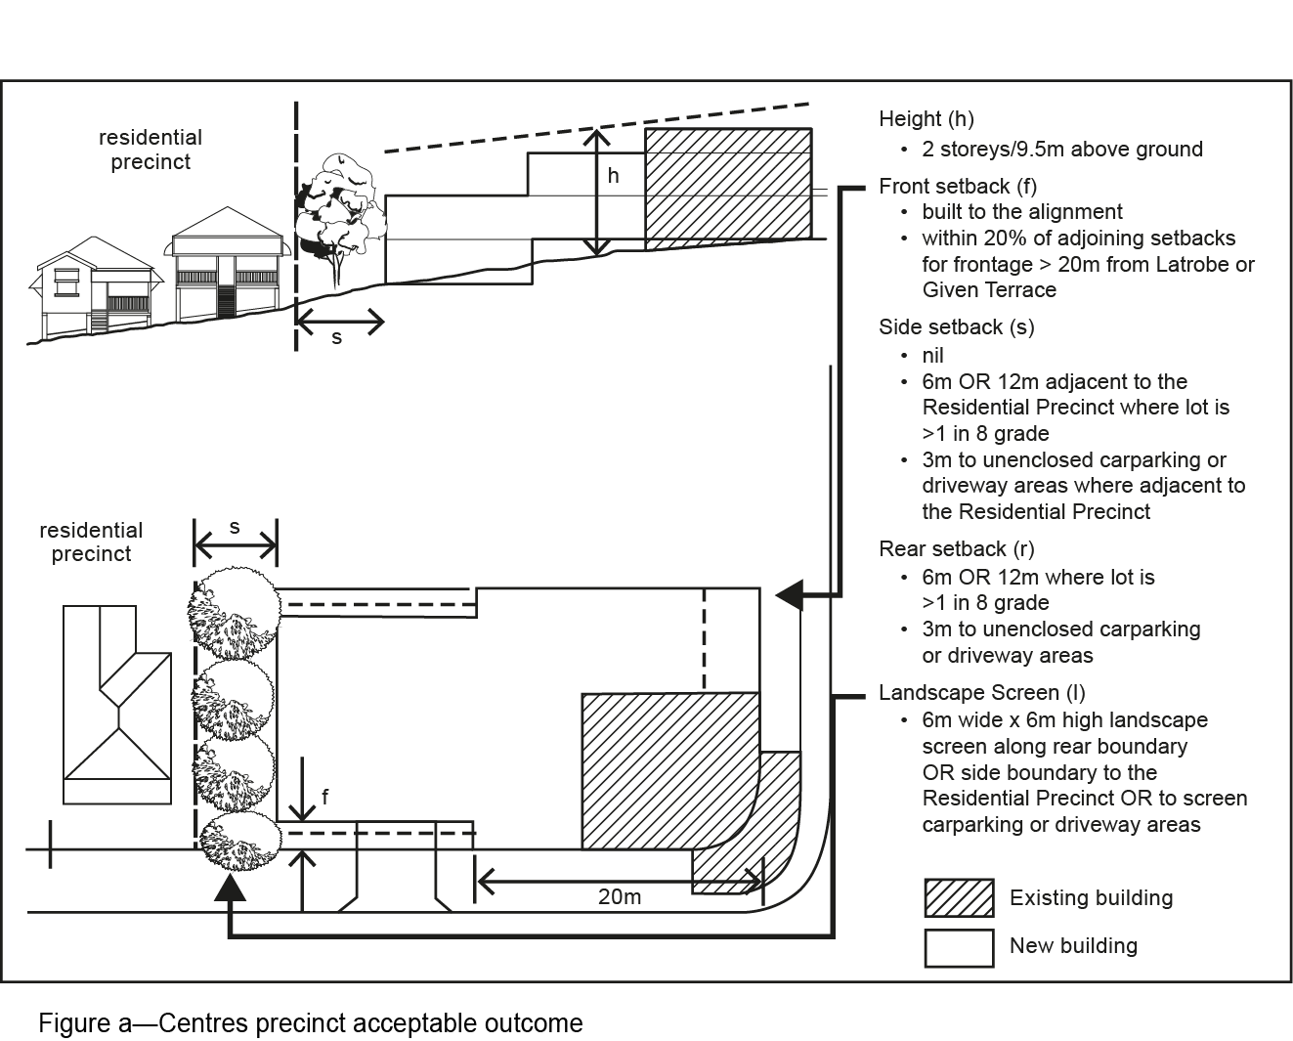
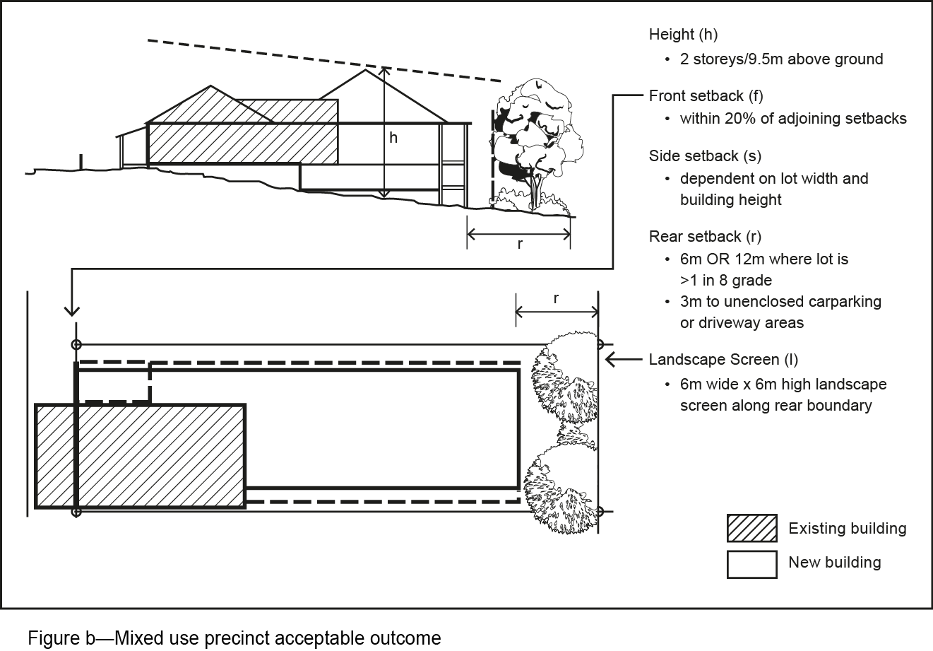
f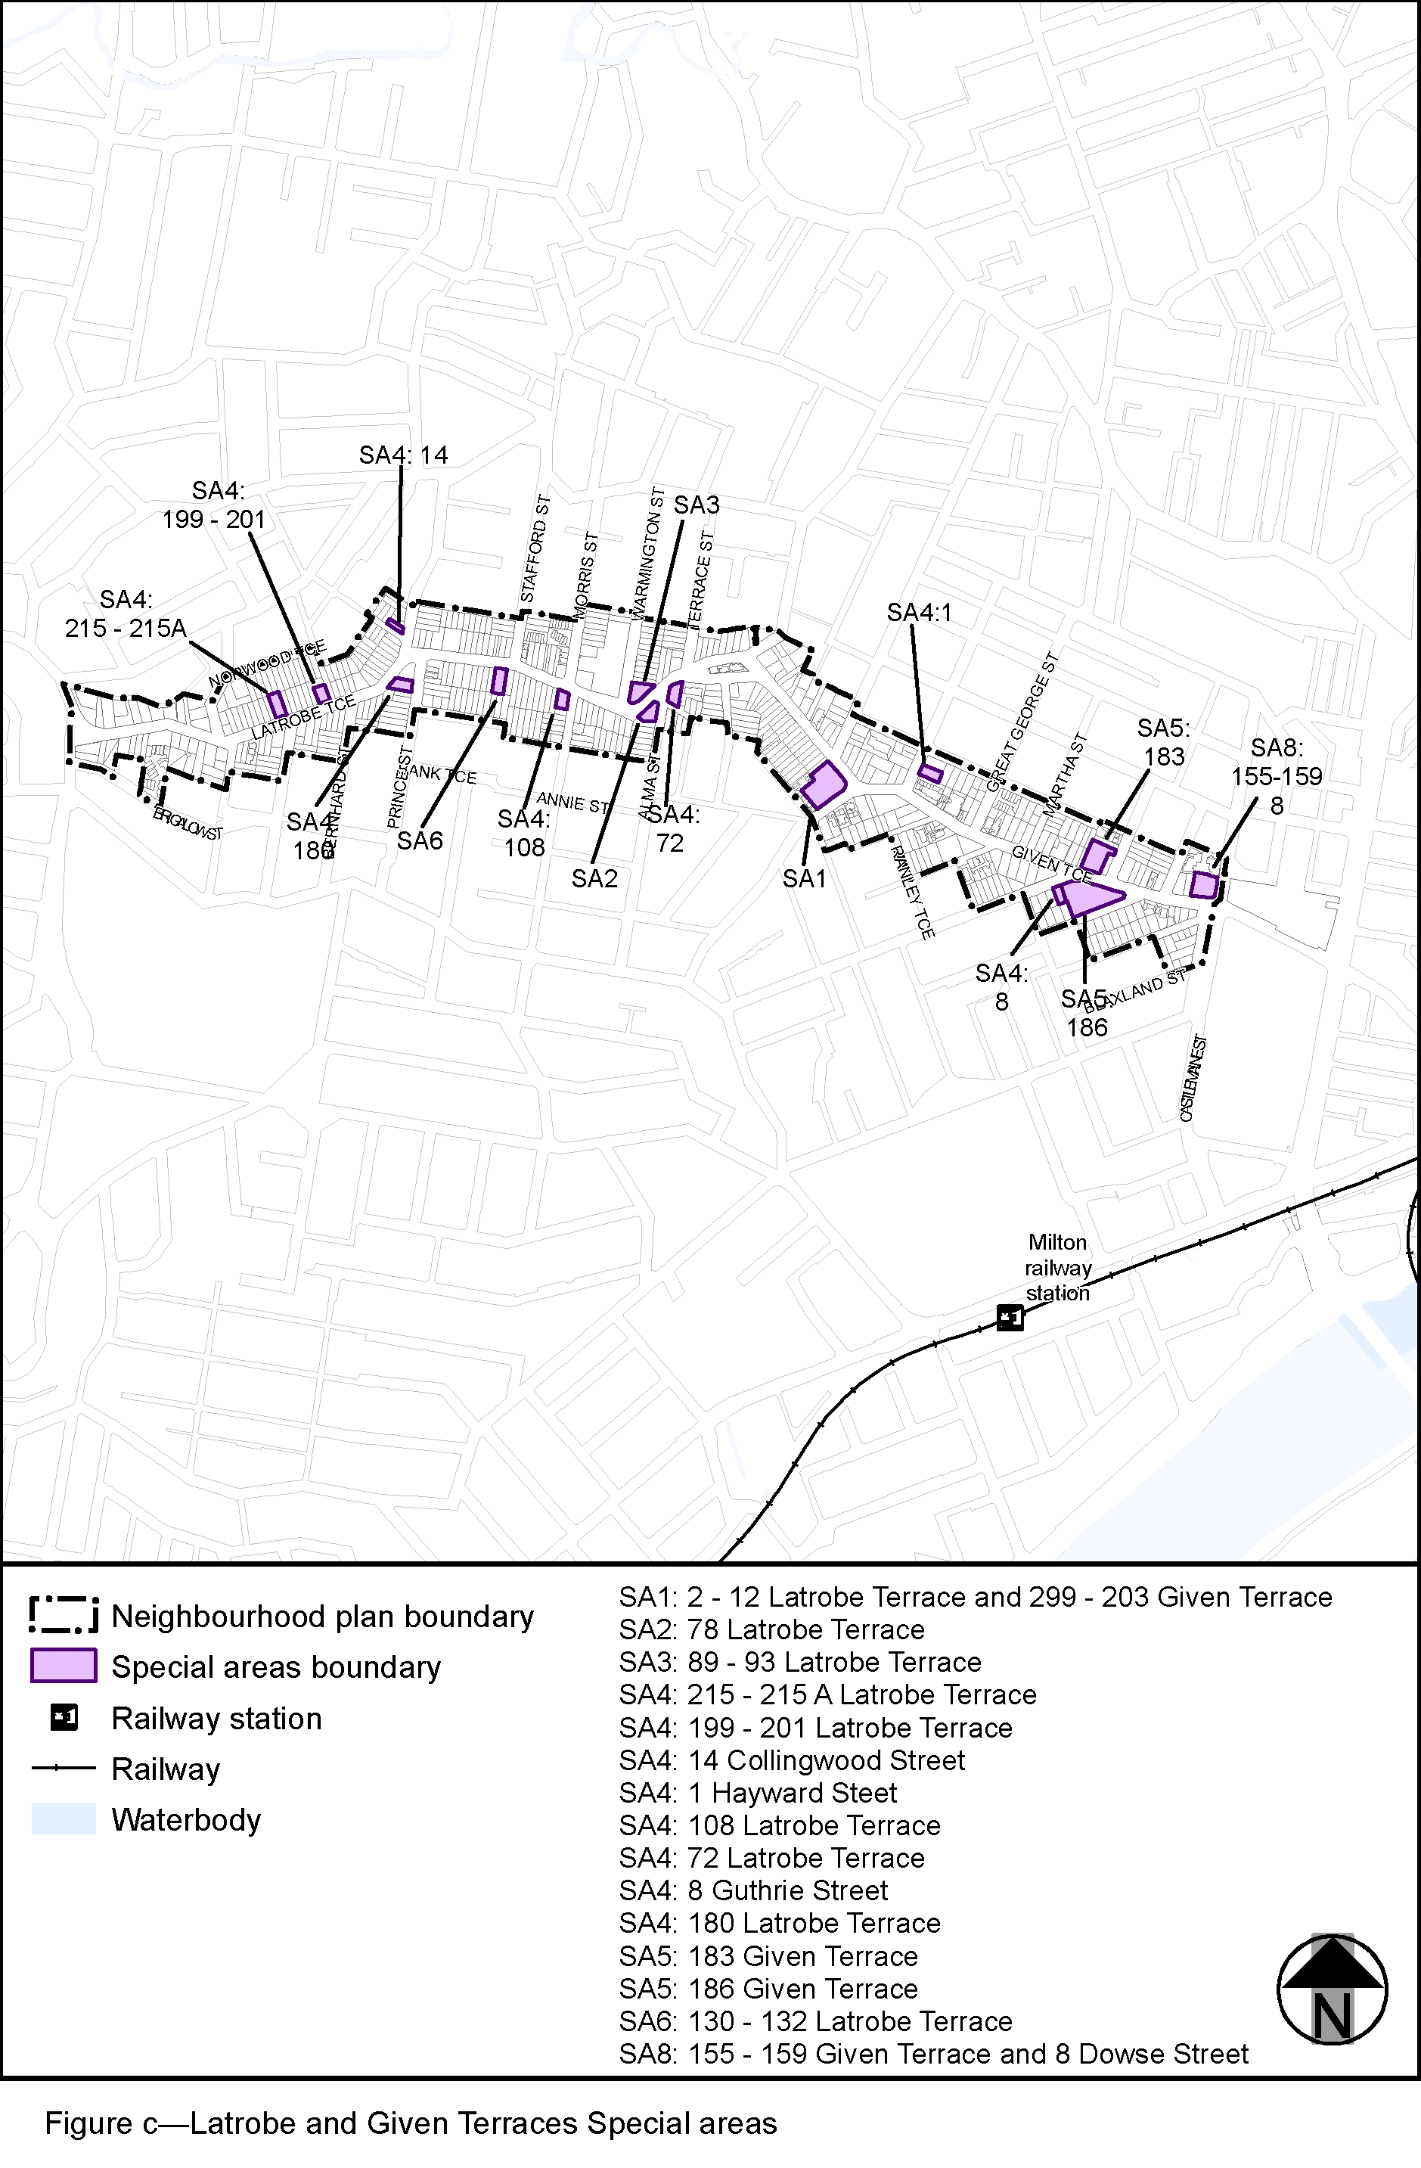

View the high resolution of Figure c–Latrobe and Given Terraces Special areas (PDF file size is 337Kb)

