SC6.19 Management of hazardous chemicals in flood affected areas planning scheme policy

Contents
1 Introduction
1.1 Relationship to planning scheme
1.2 Purpose
1.3 Terminology

2 Chemical hazards flood risk report requirements

3 Calculation of buoyancy forces

4 Acceptable measures
4.1 General
4.2 Underground tanks
4.3 Above-ground fuel or chemical storage tanks
4.4 Pipework
4.5 Package stores

1 Introduction

1.1 Relationship to planning scheme
This planning scheme policy:
- provides information the Council may request for a development application;
- provides guidance or advice about satisfying an assessment benchmark which identifies this planning scheme policy as providing that guidance or advice;
- states a standard for the following assessment benchmarks identified in the table.
Column 1 –  Section or table in the code | Column 2 –  Assessment benchmark reference | Column 3 –  Standard in the planning scheme policy
Coastal hazard overlay code
Table 8.2.6.3.A | PO8 | Section 2
Table 8.2.6.3.A | AO8.2 | Section 2
Flood overlay code
Table 8.2.11.3.H | PO16 | Sections 3 and 4
Table 8.2.11.3.H | AO16 | Sections 3 and 4

1.2 Purpose
This planning scheme policy provides information required for a development application, guidance and advice for satisfying assessment benchmarks and standards for:
- the preparation of a chemical hazards flood risk report;
- the acceptable measures that may be used in a development to mitigate hazardous chemical risks in a flood affected area or a coastal hazard area.

1.3 Terminology
In this planning scheme policy unless the context or subject matter otherwise indicates or requires, a term has the following meaning:

hazard: a situation or an intrinsic property with the potential to cause harm to people, property or the environment

risk: the likelihood of harm occurring from a hazard

2 Chemical hazards flood risk report requirements
- A chemical hazards flood risk report is to identify all the risks associated with the storage and handling of hazardous chemicals in a flood-affected area.
- The report is to identify the mitigation measures that will be required to mitigate the identified risks.
- A chemical hazards flood risk report is to:
- describe the hazardous chemicals to be stored and handled on the site, including the volume and nature of the chemicals;
- describe the method of storage and handling of the hazardous chemicals, including underground tanks, above ground tanks and package stores;
- include a site plan to scale showing the location of the hazardous chemical storage and handling;
- describe the flood event risks relevant to the site and development;
- describe the risks associated with storing and handling hazardous chemicals on the site in flood events;
- describe the risk assessment methodology;
- document the flood impact model use, flood event scenarios modelled and sources and reliability of data if flood impact modelling is used;
- list all assumptions associated with the risk assessment and modelling;
- include calculations of buoyancy forces on underground tanks;
- include risk assessment results;
- describe the measures proposed to address each identified risk including by drawings to scale, and to mitigate the impacts on the environment and public health and safety in a flood;
- provide justification and certification for alternative measures, if the acceptable measures in section 4 of this planning scheme policy are not applied.

3 Calculation of buoyancy forces
The following formulas and table are to be used for calculating buoyancy forces on tanks.
Formula 1—calculation of buoyancy forces exerted on a tank (tank buoyancy):

Fb = Vt x γ x FS

Where:
- Fb is the buoyancy force exerted on the tank (newtons)
- Vt is the volume of the tank (m3)
- γ is the specific weight of floodwater surrounding the tank (9800 newtons/m3 for freshwater)
- FS is a factor of safety to be applied to the computation (typically 1.3 for tanks).

Formula 2—Calculation of net buoyancy:

Net buoyancy (newtons) = tank buoyancy Fb (newtons) – tank weight (newtons) – equivalent flood weight of soil acting as a counterweight(s) over tank (newtons) (see Table 1).

Table 1—Effective equivalent fluid weight of soil(s)
Soil type  (as defined by Table A1 AS 1726-1993 Geotechnical site investigations) | Equivalent fluid  weight of moist soil  (newtons) | Equivalent fluid  weight of submerged  soil and water  (newtons)
Clean sand and gravel:  GW, GP, SW, SP 30 75 | 4709.4292 | 11773.573
Dirty sand and gravel of restricted  permeability:  GM, GM-GP, SM, SM-SP | 5494.3308 | 12087.5356
Stiff residual silts and clays, silty  file sands, clayey sands and gravels:  CL, ML, CH, MH, SM, SC, GC | 7064.1438 | 12872.4372
Very soft to soft clay, silty clay,  organic silt and clay:  CL, ML, OL, CH, MH, OH | 15698.0908 | 16639.9786
Medium to stiff clay deposited in  chunks and protected from  infiltration: CL, CH | 18837.7168 | 22291.2956

Formula 3—Calculation of the number of hold-down straps required:

Number of hold-down straps required = net buoyancy / allowable working load of each strap

Formula 4—Calculation of the volume of concrete (Vc) necessary to resist buoyancy:

Vc = (net buoyancy / density of concrete) x FS

4 Acceptable measures

4.1 General
- This section outlines the acceptable measures to be used to mitigate the risks of storing and handling hazardous chemicals in flood-prone areas.
- The measures proposed for the development will require certification by a Registered Professional Engineer Queensland.

4.2 Underground tanks
The following measures can be used to protect underground tanks for hazardous chemicals against the forces of buoyancy:
- Increase the burial depth and the amount of pavement above the underground tank. The extra weight of the additional soil backfill and pavement may be enough to keep the tank from floating or moving from its original position.
- Anchor the tank to a concrete slab to counteract the expected buoyancy forces.
- Install concrete anchors, such as deadmen, on opposite sides of the tank, with hold-down straps attached extending to the slab (see Figure a). The buoyancy forces exerted on the tank are to be calculated in accordance with section 3 and the anchors and hold down straps should be implemented accordingly.
- Alternative options for anchoring of underground tanks with concrete counterweights are provided in Figure b and Figure c.
- If installing a concrete collar above the tank refer to Figure d.
Note— In all cases, the tank manufacturer’s recommendations are to be observed.
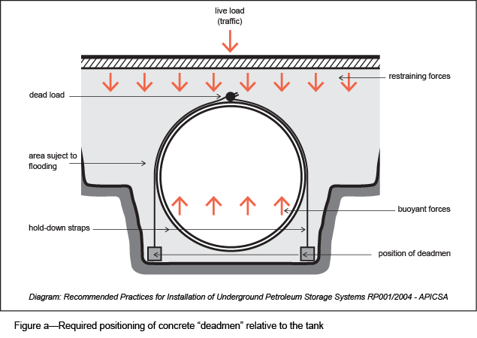
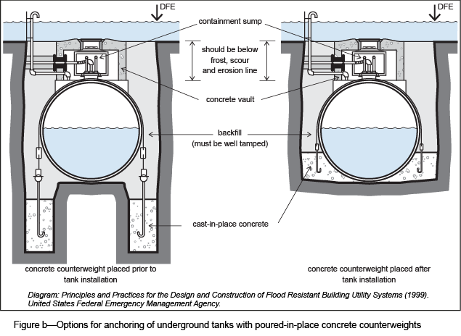
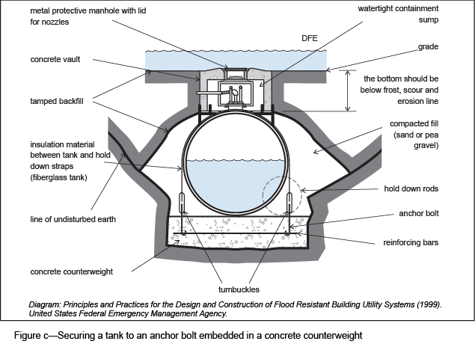
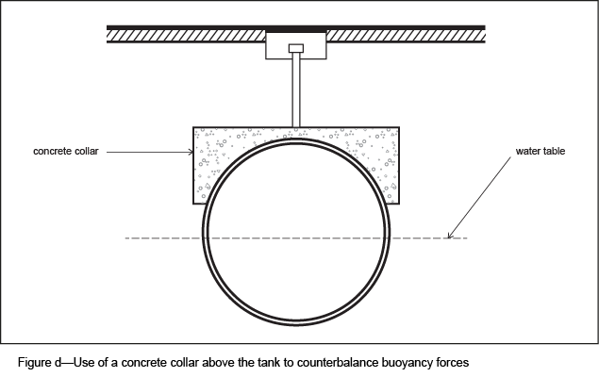
Note—Counteracting buoyancy forces may also be achieved by installing a concrete collar above the tank. The concrete collar together with the weight of the tank, the weight of overbearing soil and surface coverings shall be calculated to counteract the buoyancy forces exerted by the tank.

4.3 Above-ground fuel or chemical storage tanks
The following measures are acceptable to be used to secure above-ground fuel or chemical tanks against flotation and lateral movement:
- The vertical tank is to be located so that the top of the tank extends above the maximum expected flood level by at least 30% of the allowable storage capacity.
- If in a location that is not subject to velocity flows, horizontal tanks are secured to a concrete slab installed in the ground using suitable materials (see Figure e). Alternatively, tanks may be secured to concrete counterweights located on opposite sides of the tank using straps or tie downs.
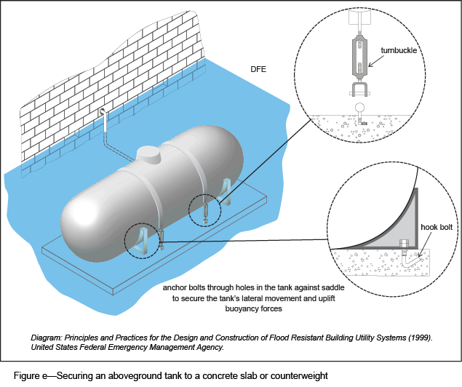
- Above-ground tanks can be elevated above the defined flood event on a platform designed to provide adequate protection against the force of the floodwaters and associated debris in a velocity flow area (see Figure f).
- Posts and columns are designed to have deep concrete footings embedded below expected erosion and scour lines. The required depth of the footing will be dependent on the geology and identified hazards at the site. The piles, posts or columns are to be cross-braced to withstand all expected forces such as velocity flow, wave action, wind and earthquakes. Cross-bracing should be parallel to the direction of flow to allow for free flow of debris.
- The tank is to be anchored to the platform using straps capable of restraining the tank against strong winds and other forces. Straps are to be constructed on non-corrosive material to prevent rusting.
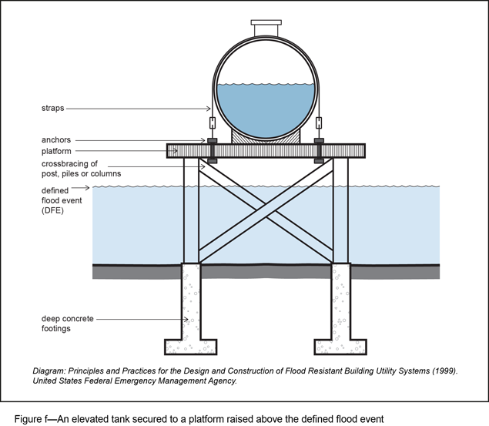
- Vaulted tanks (including vent pipes) used for fuel or chemical storage:
- are to be made of a primary steel tank coated with a layer of lightweight concrete which may then be contained within a secondary steel tank;
- are secured, including by way of bolting to the concrete slab, to a concrete slab and have secure beams welded to the secondary or outer tank to the concrete slab;
- locate fuel piping below the expected flood level on the downstream side of the tank which is either securely strapped to the tank or contained in a secondary protective shaft includes the vent pipe from the vault tank which extends above the expected flood level.
- If inundation of floodwater is modelled to be of low velocity, elevation of the tank may be achieved by using compacted fill to raise the level of the ground above the expected defined flood event (refer to Figure g).
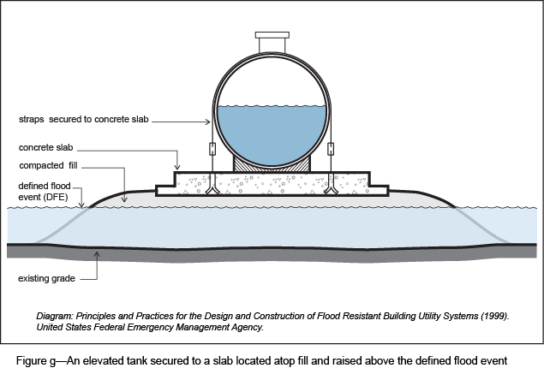
- Vertical and horizontal tanks are protected from identified debris impact and velocity flow by:
- protective walls which:
- are higher than the expected flood level;
- absorb the bulk impacts of debris and floodwater velocity flow;
- include drainage holes at the base of the walls; or
- concrete guard posts which are constructed at equal distances apart to surround the tank to protect it from debris.

4.4 Pipework
This section identifies the acceptable measures that can be used to mitigate flood damage to pipework associated with fuel or chemical tanks and mitigate the risk of release of hazardous chemicals to the environment during a flood:
- Pipework is to be located above the defined flood event where possible. If not possible to elevate the whole length of a pipeline above the defined flood event, the pipe should be protected by:
- strapping it to the downstream side of a vertical support structure, such as structural support for the tank or wall of a building;
- burying it well below the expected scour and erosion line.
- Alternatively, vertical above-ground fuel lines can be provided with a protective utility shaft. The protective shafts can be made of concrete, metal or rigid plastic pipe and they are to extend above the expected flood level. Ideally, these protective shafts should be watertight, however if this is not possible, drainage holes should be provided at the base of the shaft. The flexibility of the fuel lines are not to be compromised by the use of a protective shaft.
- Pipework is to be designed to penetrate buildings, tanks and associated equipment at points above the defined flood event.
- Vent pipes are to be terminated above expected flood levels. Floodwaters entering through a vent pipe will potentially settle at the bottom of the tank, pushing hazardous chemicals out in to the surrounding environment.
- During a flood, uneven settlement of a tank can occur due to soil saturation. Such movement can cause rigid, metallic pipe connections of fuel lines to potentially break off. Providing adequate flexibility for pipework reduces the likelihood of them rupturing and releasing a chemical into the environment. Any protective secondary containment is to permit this flexibility of the fuel lines whilst preventing the entry of floodwaters into the tank.
- Fuel dispensers, chemical pumps and associated equipment are to be located above the expected flood level. This may be achieved by elevating equipment to an accessible deck or platform above the expected flood level.
- Automatic shut-off valves are to be installed on all product pipework to prevent contamination where pipework breaks or disconnects from a tank during a flood event.

4.5 Package stores
This section identifies the acceptable measures that can be used to mitigate flood impacts on package stores and mitigate the risk of release of hazardous chemicals to the environment during a flood:
- All packages, drums, IBCs, and ISO containers of hazardous chemicals are to be contained within protective buildings or structures designed to withstand all forces expected to be experienced by relevant flood modelling. Containers of hazardous chemicals are not to be stored outside of approved flood-proofed buildings.
- The goal of flood-resistant construction for package stores is for buildings and structures to resist flotation, collapse, permanent lateral movement or other structural damage that may cause a release of contaminants during a flood event. Flood-resistant designs for package stores are able to withstand flood loads over a period of decades, and exhibit the following characteristics:
- any flood damage is to be minor and easily repairable;
- the building foundation is to remain intact and fully functional following a design flood;
- any breakaway enclosure below the defined flood event is to be designed to break free without causing damage to the elevated building, the foundation, building access structures or utility systems;
- the building envelope is to remain intact;
- hazardous chemicals contained in packages and drums are adequately protected from the ingress of floodwaters and impact of flood-borne debris;
- all hazardous chemicals are to be contained within the building during and after a flood event;
- utility connections remain intact or are easily restorable after a design flood;
- the building is to be accessible and useable after a design flood.
Note—Active flood proofing, sometimes known as contingent (partial) or emergency (temporary) flood proofing, requiring human intervention to implement actions to protect a package store and its contents from flooding is not to be used.
- The design of a flood-resistant package store includes:
- the lowest floor, including basement, to be elevated to or above the design flood elevation; or
- the building and its utility systems to be:
- watertight below the design flood elevation that is dry flood-proofed with walls substantially impermeable and with structural components having the capability of resisting hydrostatic and hydrodynamic loads and effects of buoyancy;
- supported on a foundation that is designed and constructed to resist all anticipated flood loads, in combination with other anticipated loads;
- constructed with flood damage resistant materials below the design flood elevation;
- elevated on piles or columns (minimise the use of shear walls below the defined flood event, wherever possible) if in areas subject to extreme interval flood loads, to keep the area below the defined flood event free of obstructions that could transfer flood loads to the elevated building, and use breakaway construction for any non-structural building elements;
- so that the use of shear walls below the defined flood event is minimised.
Note—Examples of dry flood-proofing methods include:
- waterproof sealants and coatings on walls and floors;
- permanently installed, automatic flood shields and doors;
- installing backflow prevention valves and sump pumps.

