SC6.30 Traditional building character planning scheme policy

Contents
1 Introduction
1.1 Relationship to planning scheme
1.2 Purpose

2 Traditional character and traditional building character
2.1 Introduction
2.2 Traditional building form and roof styles
2.3 Traditional elements, detailing and materials
2.4 Traditional scale
2.5 Traditional setting

1 Introduction

1.1 Relationship to planning scheme
The planning scheme policy provides guidance or advice about satisfying an assessment benchmark which identifies this planning scheme policy as providing that guidance or advice.

1.2 Purpose
This planning scheme policy provides guidance on the elements that comprise traditional character and traditional building character identified in the Traditional building character (demolition) overlay code and Traditional building character (design) overlay code.

2 Traditional character and traditional building character

2.1 Introduction
- The traditional character of areas and the traditional building character of buildings, within the Traditional building character overlay, is a combination of one or more of the following elements:
- traditional building form and roof styles;
- traditional elements, detailing and materials;
- traditional scale;
- traditional setting.
- The component elements of traditional character or traditional building character vary in the context of demolition or new development including extensions.

2.2 Traditional building form and roof styles
- The predominant traditional building character of dwelling houses constructed in 1946 or earlier, often referred to generically as the Queensland vernacular, usually comprises:
- a core with attached or integrated verandahs raised above the ground on timber supports which are now often replaced with concrete or steel stumps or steel beams;
- enclosed areas under the dwelling house that generally maintain the street appearance of lightweight supports to upper floors and reflect the layout of upper floor entrance and verandahs;
- roof forms of medium pitched pyramids, hips or gables (refer to Figure a).
- Building form can detract from the character of the street if it conflicts with:
- the relationship between floor and ground levels;
- the traditional concept of lightweight verandahs attached to solid core;
- the established pattern of roof shape and pitch.
- Other traditional building character forms exhibit overseas architectural influences on Brisbane’s residential design. These forms occurred primarily during the inter-war period and are often influenced by but not limited to art deco, Spanish mission, Californian bungalow and Georgian.

2.3 Traditional elements, detailing and materials
- The traditional character of the older suburbs is influenced by elements such as eaves, sunhoods, verandahs, lattice screens, balustrades and batten panels that cast shadows and provide three-dimensional effects. These lightweight external elements:
- reduce building bulk;
- form a transition with the external landscape;
- make an appropriate response to the local climatic conditions of strong sun and high rainfall.
- The traditional character of a street can be diminished by styles that do not incorporate shade-forming elements and that present a flat facade to the street. These styles also have poor environmental qualities.
- Traditional character is also derived from the relatively limited range of materials available at the time of construction. This provided a unifying theme of painted timber walls and corrugated steel and terracotta tile roofing.
- Whilst ‘timber and tin’ are the predominant materials of the older suburbs, the presence of other distinctive traditional building character forms, such as Spanish mission, and the variety of materials highlights the overseas influence on residential design in Brisbane and is an integral part of the traditional building character. These styles usually incorporate face brick or rendered walls on the exterior and have a base material of fibro, masonry or concrete with a tile or tin roof.

2.4 Traditional scale
- The traditional scale of a street was first established by its subdivision pattern of 16, 24 or 32 perch lots, with 10m, 15m or 20m frontages respectively. This pattern was reinforced by the traditional building form of a single-level dwelling house elevated on stumps. This created a reasonably uniform scale, accentuated by consistent stepping of the levels of adjoining dwelling houses in Brisbane’s hilly suburbs, and by uniform spacing between dwelling houses in the flatter suburbs.
- The traditional scale of a street can be diminished if buildings are introduced that:
- significantly exceed the surrounding building height; or
- present large unarticulated facades to the street; or
- interrupt the rhythm of stepping roof lines in a sloping street.
- Scale can also be affected by introducing buildings or lots that are significantly smaller than the prevailing size of dwelling houses and subdivision pattern. Two narrow buildings can be combined with a common boundary to give a single building form under a unified roof consistent with the traditional setting and scale of dwelling houses constructed in 1946 or earlier in the street (refer to Figure b).

2.5 Traditional setting
- The traditional setting of dwelling houses in the older suburbs is a fairly uniform building line, with individual front gardens punctuated by a pedestrian path and single width driveway.
- The setting of new buildings can detract from the character of a street if orientation or setbacks conflict with traditional settings or if garages dominate.
- Setbacks, particularly to existing or proposed side boundaries, complying with the relevant residential codes are consistent with the character of older suburbs.
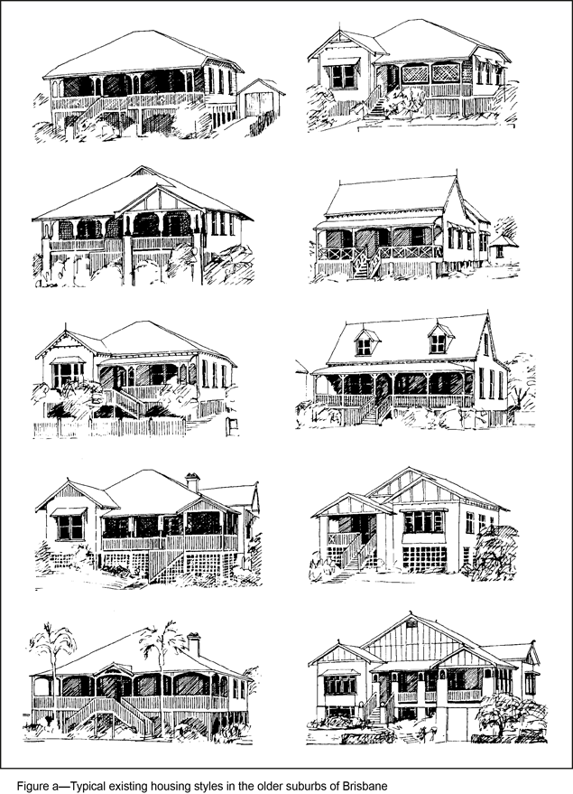
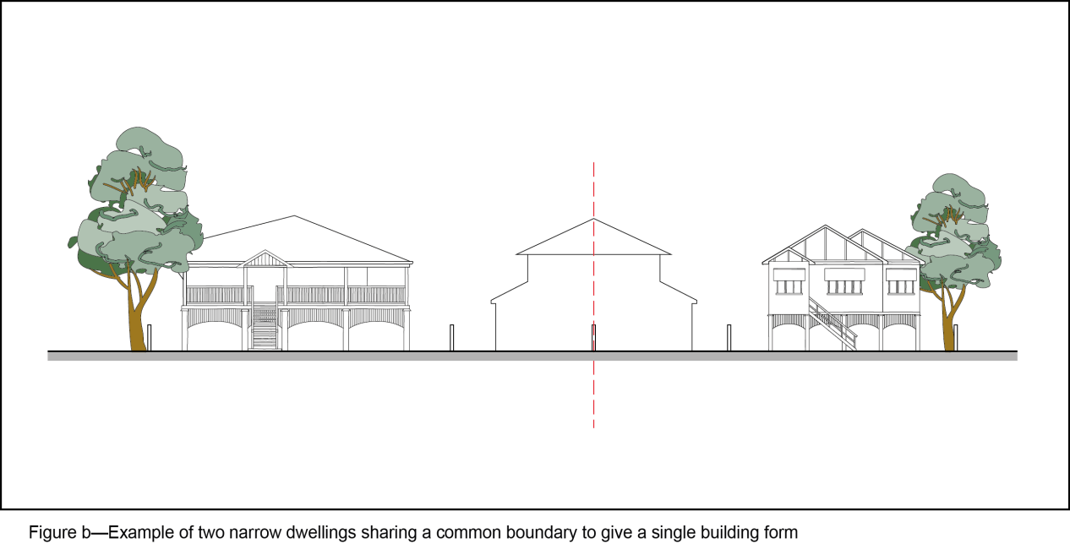
Editor's note—Figures are examples only and display one way the built form outcomes sought by the Traditional building character (demolition) overlay code and Traditional building character (design) overlay code might be realised, in order to provide assistance to applicants in determining whether the building style of their proposed development achieves the desired outcomes.

