7.2.3.4 Carindale centre neighbourhood plan code

7.2.3.4.1 Application
- This code applies to assessing a material change of use, reconfiguring a lot, operational work or building work in the Carindale centre neighbourhood plan area if:
- assessable development where this code is an applicable code identified in the assessment benchmarks column of a table of assessment for a neighbourhood plan (section 5.9); or
- impact assessable development.
- Land in the Carindale centre neighbourhood plan area is identified on the NPM-003.4 Carindale centre neighbourhood plan map and includes the following precincts:
- Centre core precinct (Carindale centre neighbourhood plan/NPP-001);
- Centre fringe precinct (Carindale centre neighbourhood plan/NPP-002);
- Centre residential precinct (Carindale centre neighbourhood plan/NPP-003).
- When using this code, reference should be made to section 1.5, section 5.3.2 and section 5.3.3.
Note—The following purpose, overall outcomes, performance outcomes and acceptable outcomes comprise the assessment benchmarks of this code.
Note—This neighbourhood plan includes a table of assessment. Refer to Table 5.9.14.A, Table 5.9.14.B, Table 5.9.14.C and Table 5.9.14.D.

7.2.3.4.2 Purpose
- The purpose of the Carindale centre neighbourhood plan code is to provide finer grained planning at a local level for the Carindale centre neighbourhood plan area.
- The purpose of the Carindale centre neighbourhood plan code will be achieved through overall outcomes including overall outcomes of each precinct of the neighbourhood plan area.
- The overall outcomes for the neighbourhood plan area are:
- Carindale is the Major Centre serving the eastern sector of Brisbane.
- The centre contains a range of functions that complement one another and combine to create an integrated mixed use centre, with strong retail, office, residential, community and entertainment uses, and high-quality public transport services.
- Community and after hours uses ensure the centre is active in the evenings and on weekends. These activities are focused on the plaza.
- The centre is the focus for high-quality public transport services in the eastern part of the city.
- Development is of a height, scale and form which is consistent with the amenity and character, community expectations and infrastructure assumptions intended for the relevant precinct, sub-precinct or site and is only developed at a greater height, scale and form where there is both a community need and an economic need for the development.
- Development is consistent with community expectations and infrastructure assumptions.
- Centre core precinct (Carindale centre neighbourhood plan/NPP-001) overall outcomes are:
- The precinct is an integrated shopping facility supporting a full range of centre activities and focused on the Carindale Shopping Centre.
- All development is in accordance with an approved structure plan.
- The plaza at the northern end of the precinct:
- is surrounded by uses with active building frontages;
- is the focus for community and after-hours activities, including food and drink outlets with outdoor dining;
- has uses fronting the plaza which are capable of operating independently of the main shopping complex.
- Centre fringe (Carindale centre neighbourhood plan/NPP-002) overall outcomes are:
- The precinct primarily contains a range of businesses, offices and personal services in purpose-built commercial buildings which also accommodates retail activities that cannot locate within the Carindale Shopping Centre.
- All development is in accordance with the approved structure plan.
- Buildings are well articulated, are buffered by quality landscaping, add visual interest to and enhance the appearance of the centre, and are of compatible design so to appear as part of an integrated business park.
- Centre residential (Carindale centre neighbourhood plan/NPP-003) overall outcomes are:
- The precinct is developed for medium density residential uses and takes advantage of its location close to various centre activities and public transport facilities.

7.2.3.4.3 Performance outcomes and acceptable outcomes

Table 7.2.3.4.3.A—Performance outcomes and acceptable outcomes
Performance outcomes | Acceptable outcomes
General
PO1  Development is of a height, scale and form that achieves the intended outcome for the precinct, improves the amenity of the neighbourhood plan area, contributes to a cohesive streetscape and built form character and is:  - consistent with the anticipated density and assumed infrastructure demand;  - aligned to community expectations about the number of storeys to be built;  - proportionate to and commensurate with the utility of the site area and frontage width;  - designed not to cause significant and undue adverse amenity impact to adjoining development;  - sited to enable existing and future buildings to be well separated from each other and to not prejudice the development of an adjoining site.  Note—Development that exceeds the intended number of storeys or building height can place disproportionate pressure on the transport network, public space or community facilities in particular.  Note—Development that is over-scaled for its site can result in an undesirable dominance of vehicle access, parking and manoeuvring areas that significantly reduce streetscape character and amenity. | AO1  Development complies with the number of storeys and building height in Table 7.2.3.4.3.B.  Note—Neighbourhood plans will mostly specify maximum number of storeys where zone outcomes have been varied in relation to building height. Some neighbourhood plans may also specify height in metres. Development must comply with both parameters where maximum number of storeys and height in metres are specified.
PO2  Development provides safe, convenient and fully accessible pedestrian links:  - throughout the neighbourhood plan area, particularly between the plaza, cinemas and public transport interchanges including the future busway station;  - with residential development immediately north of the centre also established. | AO2  Development provides walking and cycling links that are available at all times and do not rely on access to the shopping centre.
If in the Centre core precinct (Carindale centre neighbourhood plan/NPP-001)
PO3  Development size and bulk is consistent with the highly urban character of the core area of a Major Centre. | AO3  Development has a maximum gross floor area of 250% of the site area.
PO4  Development enhances integration of the centre, reinforces its identity and desired character and assists with visitor orientation and direction. | AO4.1  Development provides extensive landscaping and detailed architectural treatments that soften the multistorey car park and blank facades that dominate the built form of the precinct.
AO4.2
Development adjacent to the centre’s major intersections and community spaces includes gateway features such as entry statements or site markers. Refer to Figure a.
AO4.3
Development for the plaza and other public spaces incorporates public art.
PO5  Development ensures car parking areas do not undermine the character and visual attraction of the centre and do not dominate the streetscape or diminish the quality of spaces between buildings. | AO5  Development conceals car parking within basements or the building structure.
If in the Centre fringe precinct (Carindale centre neighbourhood plan/NPP-002)
PO6  Development size and bulk is consistent with the highly urban character of a Major Centre. | AO6  Development has a maximum gross floor area of 200% of the site area.
PO7  Development enhances integration of the centre, reinforces its identity and desired character and facilitates quality landscaping and pedestrian forecourts. | AO7.1  Development has a minimum building setback from the property alignment of 6m.
AO7.2
Development adjacent to the centre’s major intersections and community spaces includes gateway features such as entry statements or site markers as indicated in Figure a
AO7.3
Development incorporates building forecourts that are publicly accessible and that feature quality landscaping.
PO8  Development is designed to provide opportunities for casual surveillance of the Bulimba Creek recreation corridor and creates a strong interface with Creek Road and Old Cleveland Road. | AO8  Development addresses Creek Road, Old Cleveland Road and Bulimba Creek.
PO9  Development ensures that pedestrian areas are designed to reinforce the character of the centre, promote pedestrian and cycle use and facilitate safe pedestrian movement between the Centre fringe precinct and the plaza. | AO9  Development allows for pedestrian crossings on Millennium Boulevard.
PO10  Development does not impact on the operation of the major road network. | AO10  Development is accessed by vehicles via the existing internal road network. No new direct vehicle access is provided from Creek Road or Old Cleveland Road in the areas indicated in Figure a.
PO11  Development ensures that car parking areas do not undermine the character and visual attraction of the centre and do not dominate the streetscape or diminish the quality of spaces between buildings. | AO11  Development conceals car parking within basements or the building structure.

Table 7.2.3.4.3.B—Maximum building height
Development | Circumstance | Building height (number of storeys) | Building height (m) | Eaves height (m)
If in the Centre core precinct (Carindale centre neighbourhood plan/NPP-001)
Any development in this precinct |  | 10 | Not specified | Not specified
If in the Centre fringe precinct (Carindale centre neighbourhood plan/NPP-002)
Any development in this precinct |  | 8 | Not specified | Not specified
If in the Centre residential precinct (Carindale centre neighbourhood plan/NPP-003)
Any development in this precinct |  | 3 | Not specified | 9.5

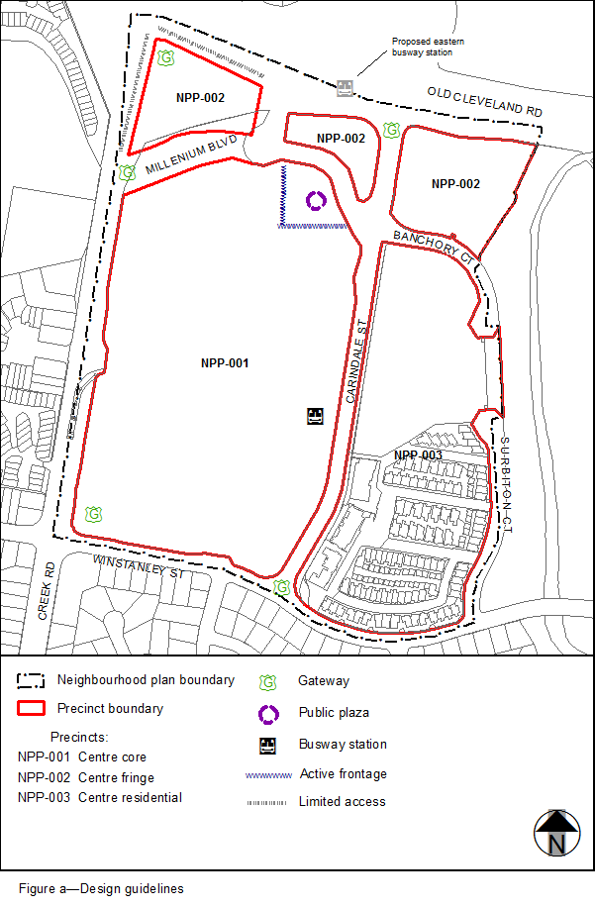
View the high resolution of Figure a–Design guidelines (PDF file size is 119Kb)

