7.2.5.2 Eastern corridor neighbourhood plan code

7.2.5.2.1 Application
- This code applies to assessing a material change of use, reconfiguring a lot, operational work or building work in the Eastern corridor neighbourhood plan area if:
- assessable development where this code is an applicable code identified in the assessment benchmarks column of a table of assessment for neighbourhood plan (section 5.9); or
- impact assessable development.
- Land in the Eastern corridor neighbourhood plan area is identified on the NPM-005.2 Eastern corridor neighbourhood plan map and includes the following precincts:
- Buranda precinct (Eastern corridor neighbourhood plan/NPP-001):
- Buranda core sub-precinct (Eastern corridor neighbourhood plan/NPP-001a);
- Buranda corridor sub-precinct (Eastern corridor neighbourhood plan/NPP-001b);
- Buranda residential sub-precinct (Eastern corridor neighbourhood plan/NPP-001c).
- Buranda Station precinct (Eastern corridor neighbourhood plan/NPP-002):
- Buranda Station core sub-precinct (Eastern corridor neighbourhood plan/NPP-002a);
- Buranda Station corridor sub-precinct (Eastern corridor neighbourhood plan/NPP-002b).
- Stones Corner precinct (Eastern corridor neighbourhood plan/NPP-003):
- Stones Corner core sub-precinct (Eastern corridor neighbourhood plan/NPP-003a);
- Stones Corner corridor sub-precinct (Eastern corridor neighbourhood plan/NPP-003b);
- Stones Corner residential sub-precinct (Eastern corridor neighbourhood plan/NPP-003c).
- Langlands Park precinct (Eastern corridor neighbourhood plan/NPP-004):
- Langlands Park corridor sub-precinct (Eastern corridor neighbourhood plan/NPP-004a);
- Langlands Park residential sub-precinct (Eastern corridor neighbourhood plan/NPP-004b).
- Coorparoo precinct (Eastern corridor neighbourhood plan/NPP-005):
- Coorparoo core sub-precinct (Eastern corridor neighbourhood plan/NPP-005a);
- Coorparoo corridor sub-precinct (Eastern corridor neighbourhood plan/NPP-005b);
- Coorparoo residential sub-precinct (Eastern corridor neighbourhood plan/NPP-005c).
- Bennetts Road precinct (Eastern corridor neighbourhood plan/NPP-006):
- Bennetts Road corridor sub-precinct (Eastern corridor neighbourhood plan/NPP-006a);
- Bennetts Road residential sub-precinct (Eastern corridor neighbourhood plan/NPP-006b).
- Annerley precinct (Eastern corridor neighbourhood plan/NPP-007):
- Annerley corridor sub-precinct (Eastern corridor neighbourhood plan/NPP-007a):
- Annerley residential sub-precinct (Eastern corridor neighbourhood plan/NPP-007b).
- When using this code, reference should be made to section 1.5, section 5.3.2 and section 5.3.3.
Note—The following purpose, overall outcomes, performance outcomes and acceptable outcomes comprise the assessment benchmarks of this code.
Note—This neighbourhood plan includes a table of assessment with variations to categories of development and assessment. Refer to Table 5.9.22.A, Table 5.9.22.B, Table 5.9.22.C, and Table 5.9.22.D.

7.2.5.2.2 Purpose
- The purpose of the Eastern corridor neighbourhood plan code is to provide finer grained planning at a local level for the Eastern corridor neighbourhood plan area.
- The purpose of the Eastern corridor neighbourhood plan code will be achieved through overall outcomes including overall outcomes for each precinct of the neighbourhood plan area.
- The outcomes for the neighbourhood plan area are:
- Each centre showcases the principles of high-quality urban design and forms a focus for transit-oriented communities, catering to residents’ and workers’ daily needs within a distance that can be easily walked or cycled to and from high-quality public transport.
- The centres of Buranda, Buranda Station, Stones Corner, Coorparoo, Bennetts Road and Annerley:
- maintain a unique role and identity to ensure they do not compete with the function of each other;
- provide an intensity of development, urban form and mix of uses appropriate for the role and identity of each centre;
- Langlands Park precinct allows for non-residential development but is not considered a centre.
- Intensive development is contained within the precincts, to maintain the low scale of surrounding areas:
- core sub-precincts have the greatest development intensity and focus for retail uses (active frontage – primary are the commercial and community heart of each intensively developed core sub-precinct and the focus area for retailing and other pedestrian-oriented activities);
- corridor sub-precincts provide for a lesser intensity of development that complements the primacy of the cores;
- residential sub-precincts accommodate the population that supports each transit-oriented community.
- Development both functionally and visually integrates the busway and railway stations with surrounding areas. Appropriate location of uses and building design enhances busway and railway station legibility and activates entry points and the immediate environs. Development does not adversely affect the structural integrity or ongoing operation and maintenance of major transport infrastructure.
- Streets are designed as subtropical, shady pedestrian places. Where provided, parking, servicing and vehicle entrances are designed and located in a way that creates an enjoyable and safe pedestrian environment. Development maintains a human scale to the street and promotes activation of the street through appropriate location of uses and building design.
- Development encourages walking, cycling and public transport as attractive options for daily travel to reach employment, shopping, recreation, education and entertainment destinations from residences. Development improves pedestrian and cycle connections to these key destinations and provides facilities that support walking and cycling. A range of arcades facilitate pedestrian and cyclist movement within and between precincts creating strong connections within and along the corridor.
- The history and character of the area is protected. The design of new development respects and complements the established architectural character of the area.
- A choice of different housing types, sizes and costs are provided to suit a range of lifestyle and household types. Adaptable housing and affordable housing is encouraged and actively supported to cater to the needs of existing and future residents.
- Open space is a key asset in the Eastern corridor, supporting a healthy lifestyle and community interaction. Development contributes to the creation of new public spaces and improves existing public spaces, ensuring casual surveillance, providing new pedestrian connections and where possible, integration with and direct access to open space. A system of green space areas, urban plazas and streets provide numerous and varied opportunities for social interaction.
- Development is of a height, scale and form which is consistent with the amenity and character, community expectations and infrastructure assumptions intended for the relevant precinct, sub-precinct or site and is only developed at a greater height, scale and form where there is both a community need and an economic need for the development.
- Buranda precinct (Eastern corridor neighbourhood plan/NPP-001) overall outcomes are:
- This precinct is revitalised, capitalising upon its proximity to the Princess Alexandra Hospital and the Eastern Busway.
- Non-residential uses front onto Ipswich Road and O’Keefe Street, creating a highly active frontage to these busy roads. An improved streetscape along these roads with widened footpaths and boulevard planting creates a strong landscape image and attractive routes for pedestrians and cyclists.
- Development supports a high level of accessibility for pedestrians and cyclists, with an arcade improving pedestrian permeability within the precinct and allowing better connections between the Princess Alexandra Hospital, the rail and busway stations and surrounding residential and employment areas.
- Development provides a public park of approximately 4,800m2 between Wolseley Street and Carl Street which, along with the active frontage – primary focus at the intersection of Tottenham Street and Wolseley Street, creates a hub for social interaction.
- Development in the Buranda core sub-precinct (Eastern corridor neighbourhood plan/NPP-001a):
- ensures that a mix of predominantly non-residential uses with a strong focus on medical related services is consistent with the outcomes sought;
- includes offices and some higher density residential development and active uses at the ground storey;
- retail activities are focused on the Centro Buranda site supporting the active frontage – primary role of Tottenham Street.
- Development in the Buranda corridor sub-precinct (Eastern corridor neighbourhood plan/NPP-001b):
- is predominantly non-residential development where it frames O’Keefe Street and Ipswich Road;
- is of a lesser scale than the Buranda core sub-precinct.
- Development in the Buranda residential sub-precinct (Eastern corridor neighbourhood plan/NPP-001c):
- encourages high density housing within easy walking distance of the busway stations. Short-term accommodation is supported and actively encouraged;
- encourages continued activation of Cornwall Street through small-scale office and food and drink outlet uses at ground storey fronting Cornwall Street.
- Buranda Station precinct (Eastern corridor neighbourhood plan/NPP-002) overall outcomes are:
- Development within this precinct capitalises upon its strategic location immediately adjacent to and enhancing 2 key public transport stations.
- The precinct is a high-quality mixed use centre with a focus on commercial office space and residential accommodation with a small retail component. Community facilities are also provided in this precinct.
- Built form addresses Logan Road and O’Keefe Street respectively with active frontages and an excellent pedestrian environment.
- Buildings are internally located and sleeved by medium-rise buildings.
- High-quality, at-grade, publicly accessible pedestrian connections are provided both through the site between O’Keefe Street, Logan Road, the busway station and the railway station as well as to the nearby Buranda precinct and Stones Corner precinct.
- Development in the Buranda Station core sub-precinct (Eastern corridor neighbourhood plan/NPP-002a):
- offers one of Brisbane’s foremost transit oriented development opportunities. The frequency, convenience and connectivity of services are outstanding and provide the platform for the creation of an exceptional living, workplace and lifestyle hub. The scale and intensity of development in this sub-precinct capitalises on the opportunity to establish an exemplar mixed use transit oriented development;
- provides public pedestrian connections through the site to link the busway and railway stations with the surrounding street network;
- addresses O’Keefe Street at a lower scale, with active uses at ground level, contributing to the creation of a lively subtropical boulevard;
- ensures that a landmark building is developed on the corner of Logan Road and O’Keefe Street, providing an entry statement of architectural excellence that emphasises the congruence of these 2 major subtropical boulevards. The prominence of this corner is supported with the planting of a significant landscape tree.
- Development in the Buranda Station corridor sub-precinct (Eastern corridor neighbourhood plan/NPP-002b):
- is of a lesser scale with active uses at ground level along the Logan Road subtropical boulevard;
- ensures that pedestrian connections to the Buranda Station core sub-precinct are created;
- addresses flooding impacts with appropriate building design and infrastructure.
- Stones Corner precinct (Eastern corridor neighbourhood plan/NPP-003) overall outcomes are:
- The precinct is revitalised as an urban village while retaining its unique character and history.
- A continuous and fine-grain built form with active frontages defines the precinct’s key public streets.
- Logan Road and Old Cleveland Road continue as the active frontage – primary retail focus of the precinct.
- Buildings at landmark intersections and significant corner sites create tangible markers defining the points of arrival and transition between precincts and improve the legibility of the area.
- Arcades are provided to improve pedestrian permeability to the active frontage – primary and the busway station.
- The precinct contains a number of non-residential character buildings located on small sites with little or no on-site parking and servicing to facilitate adaptive building re-use and support economic revitalisation, one site at the intersection of Cornwall Street and Montague Street is considered suitable for a fully concealed commercial car park. The location is well away from the busway station to encourage active travel modes for everyday trips.
- Development in the Stones Corner core sub-precinct (Eastern corridor neighbourhood plan/NPP-003a):
- ensures that building design and active ground-storey uses along Logan and Old Cleveland roads contribute to the creation of a vibrant active frontage – primary with active uses at ground level;
- along the active frontage – primary maintains and reinforces the traditional fine-grain urban form and low-scale commercial building facades to the street.
- Development in the Stones Corner corridor sub-precinct (Eastern corridor neighbourhood plan/NPP-003b):
- locates retail and food and drink outlet uses around the busway station and plaza;
- for mixed use development with non-residential uses on lower levels fronts onto Logan Road, Old Cleveland Road and Montague Street.
- Development in the Stones Corner residential sub-precinct (Eastern corridor neighbourhood plan/NPP-003c):
- for high density development which is primarily residential with some opportunity for small-scale office uses at the ground storey occurs along Cleveland Street, Gladys Street, Beata Street, Edith Street and Laura Street;
- uses building design and layout to create a defining edge to Hanlon Park and Norman Creek;
- ensures that a residential interface activates and promotes casual surveillance of the park.
- Langlands Park precinct (Eastern corridor neighbourhood plan/NPP-004) overall outcomes are:
- This precinct is a hub for sport and recreation and related activities.
- Pedestrian connectivity to Langlands Park from surrounding areas including Old Cleveland Road and the busway station is improved.
- This precinct is particularly impacted by overland flow and creek flooding. Development must effectively manage these constraints.
- Development in the Langlands Park corridor sub-precinct (Eastern corridor neighbourhood plan/NPP-004a):
- ensures that a mix of commercial and residential uses support the primary role of Langlands Park as a sport and recreation node rather than a retail centre;
- is sited within a substantial landscape setting with generous front and side setbacks, acknowledging how the character of this sub-precinct is different from other corridor precincts;
- is designed to facilitate overland flow and sited above areas of ponding while maintaining an attractive frontage to Old Cleveland Road;
- ensures that the built form focuses on creating a welcoming pedestrian environment with visual and physical connections from Old Cleveland Road to the busway station and to adjacent sport and recreation facilities.
- Development in the Langlands Park residential sub-precinct (Eastern corridor neighbourhood plan/ NPP-004b):
- accommodates high density residential living adjacent to Langlands Park and the busway station.
- Coorparoo precinct (Eastern corridor neighbourhood plan/NPP-005) overall outcomes are:
- Coorparoo Centre is an intense mixed use centre with a focus on office space concentrated around the busway station.
- Shops and food and drink outlets, predominantly at ground level, contribute to an active and integrated centre. A permanent market focused on selling locally produced food and products is encouraged. This type of specialty retailing is particularly attractive to residents, visitors and tourists and provides a unique point of difference for the Coorparoo Centre and distinctive anchoring land use for active frontage retail trade.
- Development improves the visibility and integration of the parks within the precinct and provides them with wide, safe pedestrian connections, active frontages and casual surveillance.
- The precinct provides a range of urban open space experiences, accommodates pedestrian and cycle linkages and is an interface between development and the natural environment of the Norman Creek catchment.
- Development adjoining Coorparoo Creek Park and in particular the development interface will be of a high standard. Bath Street Park is a discrete open space area serving the recreation needs of residents and employees.
- This precinct is particularly impacted by overland flow and creek flooding and development must effectively manage these constraints.
- For development in the Coorparoo core sub-precinct (Eastern corridor neighbourhood plan/NPP-005a):
- intensive redevelopment is focused around the busway station;
- towers are located and proportioned to maximise solar access and breezes;
- Holdsworth Street and Harries Road form the key axis for street life in the precinct;
- outdoor dining and retail activities are encouraged to activate these streets.
- For development in the Coorparoo corridor sub-precinct (Eastern corridor neighbourhood plan/NPP-005b):
- mixed use development activates Old Cleveland Road, with non-residential uses at ground level that encourage a high level of pedestrian activity and less intensive non-residential or residential uses located above.
- For development in the Coorparoo residential sub-precinct (Eastern corridor neighbourhood plan/NPP-005c):
- high density residential development supports the creation of a strong pedestrian-oriented corridor connecting the busway and railway stations.
- Bennetts Road precinct (Eastern corridor neighbourhood plan/NPP-006) overall outcomes are:
- This precinct accommodates additional residential development, with a small amount of convenience retail and businesses providing a neighbourhood hub.
- Development provides additional pedestrian connections between the Bowies Flat Park and Wembley Park and building design and layout promotes casual surveillance of parkland.
- For development in Bennetts Road corridor sub-precinct (Eastern corridor neighbourhood plan/NPP-006a):
- development accommodates active uses at the ground level;
- non-residential uses are of a small scale catering for local residents within a walking catchment.
- For development in the Bennetts Road residential sub-precinct (Eastern corridor neighbourhood plan/NPP-006b):
- residential development encourages surveillance and activation of the Bowies Flat Park and Biran Street Park, with balconies and living areas orientated towards the park and low, transparent fences adjacent to parkland and walkways.
- Annerley precinct (Eastern corridor neighbourhood plan/NPP-007) overall outcomes are:
- The precinct transitions from the greater scale and intensity of development to the north in the Buranda precinct (Eastern corridor neighbourhood plan/NPP-002) and generally accommodates low–medium scale residential development and medium- scale centre and mixed use development where fronting Ipswich Road.
- Development in the Annerley corridor sub-precinct (Eastern corridor neighbourhood plan/NPP-007a):
- accommodates active uses at ground level and are orientated to the street frontages to Cornwall Street, Ipswich Road and Juliette Street;
- above ground level is a mix of commercial, community and residential uses with non-residential uses accommodated in podium levels;
- is of a scale and form consistent with the outcomes of the District centre zone unless varied in this code.
- Development in the Annerley residential sub-precinct (Eastern corridor neighbourhood plan/NPP-007b);
- is residential in character;
- is of a scale and form consistent with the Low–medium density residential zone;
- reflects traditional building character outcomes in the area in the vicinity of Juliette Street.

7.2.5.2.3 Performance outcomes and acceptable outcomes

Table 7.2.5.2.3.A—Performance outcomes and acceptable outcomes
Performance outcomes | Acceptable outcomes
Transport infrastructure
PO1  Development that adjoins major transport infrastructure or with a frontage to a subtropical boulevard, city street, neighbourhood street or locality street:  - activates the edges of busway or railway stations and the immediate environs and creates vibrant and attractive street environments;  - enables casual surveillance of streets and public spaces, busway and railway station platforms;  - facilitates safe, logical and direct pedestrian and cyclist access to busway and railway station entry points;  - maintains views of the passenger areas of busway and railway stations, including platforms and entry points, from streets and public spaces;  - screens servicing and utility areas from view of the passenger areas of busway and railway stations;  - designs and sites buildings to mitigate busway interface issues. | AO1  No acceptable outcome is prescribed.  Note—Major transport infrastructure is an existing or proposed railway or busway station.
PO2  Development on the site of or adjacent to, major transport infrastructure maintains the physical prominence of the station plaza or entry.  Note—Major transport infrastructure is an existing or proposed railway or busway station. | AO2  No acceptable outcome is prescribed.
PO3  Development that adjoins major transport infrastructure:  - provides sufficient on-site servicing and utilities to contain adverse impacts;  - preserves the structural integrity and ongoing operation and maintenance of transport infrastructure.  Note—Major transport infrastructure is an existing or proposed railway or busway station. | AO3  No acceptable outcome is prescribed.
General built form
PO4  Development is of a height, scale and form that achieves the intended outcome for the precinct, improves the amenity of the neighbourhood plan area, contributes to a cohesive streetscape and built form character and is:  - consistent with the anticipated density and assumed infrastructure demand;  - aligned with community expectations about the number of storeys to be built;  - proportionate to and commensurate with the utility of the site area and frontage width;  - designed so as to not cause a significant and undue adverse amenity impact to adjoining development;  - sited to enable existing and future buildings to be well separated from each other and to avoid affecting the potential development of an adjoining site.  Note—Development that exceeds the intended number of storeys or building height can place disproportionate pressure on the transport network, public space or community facilities in particular.  Note—Development that is over-scaled for its site can result in an undesirable dominance of vehicle access, parking and manoeuvring areas that significantly reduce streetscape character and amenity. | AO4  Development complies with the number of storeys and building height in Table 7.2.5.2.3.B.  Note—Neighbourhood plans will mostly specify a maximum number of storeys where zone outcomes have been varied in relation to building height. Some neighbourhood plans may also specify height in metres. Development must comply with both parameters where maximum number of storeys and height in metres are specified.
PO5  Development provides design, bulk and setbacks to ensure the building:  - creates a consistent and cohesive streetscape;  - enables existing and future buildings to be well separated from each other to allow light penetration, air circulation, privacy and ensure windows are not built out by adjoining buildings;  - does not prejudice the development of adjoining sites;  - does not dominate the street or other pedestrian spaces;  - results in sensitive massing and articulation that ensures the building does not dominate the street or other pedestrian spaces. | AO5.1  Development complies with front, side and rear setbacks specified in Table 7.2.5.2.3.C.  Note—Front setbacks differ in the Stones Corner precinct (Eastern corridor neighbourhood plan/NPP-003) depending on location. Refer to AO31.2.
AO5.2
Development is designed to give the appearance of narrow individual facades not exceeding 30m in width.
Note—Building facades for levels 1–8 are articulated where greater than 30m in length to provide interesting, human scale medium-rise streetscapes. Tower elements at levels 9 and above are limited in width as their physical bulk and impacts are more difficult to mitigate through design measures.
Note—Overall building length in the Langlands Park precinct (Eastern corridor neighbourhood plan/NPP-004) and Bennetts Road precinct (Eastern corridor neighbourhood plan/NPP-006) is limited in accordance with AO34.2 and AO45.2.
AO5.3
Development is designed so that the maximum horizontal dimension of any tower is 30m.
Note—A tower is considered to be that part of the building at level 9 and above.
Note—Maximum horizontal dimensions differ in the Stones Corner precinct (Eastern corridor neighbourhood plan/NPP-003) in accordance with AO30.4.
AO5.4
Development is designed so that there is a minimum setback of 10m between towers, either within a site or between towers on separate sites.
AO5.5
Development has a maximum site cover of 60% if in a residential sub-precinct.
PO6  Development provides a transition to surrounding residential areas and does not create an overbearing appearance or significantly impact on the privacy and amenity of adjoining residences. | AO6.1  Development where adjoining a zone in the Residential zones category not located in a precinct:  - has a building height of no more than 2 storeys within 10m from the common property boundary;  - has a building height of no more than 4 storeys within 10m to 20m from that same boundary;  - is set back a minimum of 3m from the common side and rear boundaries.
AO6.2
Development where across a minor road from a zone in the Residential zones category not located in a precinct:
- has a building height of no more than 4 storeys within 10m from the property boundary to that street;
- has a heavily landscaped front setback.
Core and corridor transit oriented land use
PO7  Development:  - ensures that the Buranda precinct (Eastern corridor neighbourhood plan/NPP-001), Buranda Station precinct (Eastern corridor neighbourhood plan/NPP-002), Stones Corner precinct (Eastern corridor neighbourhood plan/NPP-003), Coorparoo core sub-precinct (Eastern corridor neighbourhood plan/NPP-005a) and Coorparoo corridor sub-precinct (Eastern corridor neighbourhood plan/NPP-005b) contain land uses that both attract and generate trips by public transport;  - provides a mix of uses that supports the intent for the sub-precinct and the function of the neighbourhood plan area as a network of transit oriented communities, each with its unique role and function;  - limits individual shop tenancy sizes to restrict retailing that encourages car-based trips.  Note—Car-based retailing and in particular, large or full-line supermarkets, bulky goods retailing, hardware and discount department stores are undesirable. | AO7.1  Development for individual shop tenancies are a maximum of 1,500m² in size except where on:  - Lot 4 RP 158152;  - Lot 1 RP121119;  - Lot 2 RP131792.
AO7.2
Development of 1 individual shop tenancy with a gross floor area greater than 1,500m² is permitted within the Coorparoo core sub-precinct (Eastern corridor neighbourhood plan/NPP-005a) on the site indicated in Figure c to accommodate a market.
Note—A permanent indoor market is particular to the Coorparoo Junction site and adds to the creation of a unique precinct character and retail experience.
AO7.3
Development does not result in the combined gross floor area of shops in the Buranda Station precinct (Eastern corridor neighbourhood plan/NPP-002) exceeding 10,000m2.
Note—Ground storey non-residential uses in the Langlands Park corridor sub-precinct (Eastern corridor neighbourhood plan/NPP-004a) and Bennetts Road corridor sub-precinct (Eastern corridor neighbourhood plan/NPP-006a) are encouraged but not required.
AO7.4
Development provides:
- a mix of both non-residential and residential uses;
- non-residential uses at the ground storey activate the street or other adjacent public spaces and arcades.
Significant corner and landmark sites
PO8  Development on a landmark site indicated in Figure a, Figure b, Figure c and Figure d provides a prominent visual reference and contribution to the city’s public realm by:  - exhibiting subtropical architectural excellence through design, treatment and articulation;  - defining the site and its setting through building form, expression, silhouette, scale, materials and landscaping;  - reinforcing a sense of arrival to the neighbourhood plan area, precinct or sub-precinct through marking a node, an intersection or major connection point in the city;  - respecting the prominence of any adjoining or nearby heritage places or local landmarks;  - where a land dedication is required:  - accommodating a deep-planted large feature tree within the dedication area;  - providing a developable envelope that acknowledges and respects the presence of the large feature tree canopy;  - accommodating high levels of pedestrian movement and enhancing the pedestrian experience. | AO8  No acceptable outcome is prescribed.
PO9  Development on a significant corner site provides a prominent visual reference and contribution to the public realm by:  - accommodating high levels of pedestrian movement at the corner and enhancing the pedestrian experience;  - emphasising the corner setting through building form, expression, silhouette, scale, materials and landscaping;  - reinforcing a sense of arrival to the neighbourhood plan area, precinct or sub-precinct through marking a node, an intersection or connection point in the neighbourhood;  - respecting the prominence of any adjoining or nearby heritage places, traditional character buildings or local landmarks;  - where a land dedication is required:  - accommodating a deep-planted large feature tree within the dedication area;  - providing a developable envelope that acknowledges and respects the presence of the large feature tree canopy. | AO9.1  Development provides a 5m x 5m inverted corner land dedication in the significant corner site locations indicated in Figure b and Figure c.  Note—This is a locally specific outcome complementing the requirements of the neighbourhood plan section of either the Multiple dwelling code or the Centre or mixed use code.
AO9.2
Development on a significant corner site is designed such that the building, excluding awnings but including the basement, is kept outside of the corner land dedication area.
AO9.3
Development includes deep-planted feature trees, seating and public art in the corner land dedication area in accordance with specifications in the road corridor design and public art sections of the Infrastructure design planning scheme policy.
AO9.4
Development includes significant landscaping and street furniture to enhance the public pedestrian experience.
AO9.5
Development includes ground storey uses that facilitate a high degree of pedestrian activity such as shops and food and drink outlets on both frontages.
Note—AO9.1 to AO9.3 do not apply to development on significant corner sites that are a heritage place or character non-residential building built to the front property boundary.
General streetscape and activation
PO10  Development provides buildings that exhibit a fine-grain building rhythm and architectural interest with variations in horizontal and vertical profile and a human scale to the street. | AO10  Development is designed so that lower storeys incorporate:  - awnings and sun-protection devices;  - balconies orientated to the street;  - operable elements within the facade;  - elements of a finer scale than the main structural framing;  - display windows, showcases or public art.
PO11  Development provides protection from rain and sun for footpaths and pathways on key pedestrian routes that is:  - continuous and compatible with existing awnings;  - designed to incorporate adequate space for street trees and other landscaping;  - visually safe and amenable. | AO11.1  Development in a core sub-precinct and corridor sub-precinct provides awnings:  - over the footpath of streets;  - where buildings face arcades.
AO11.2
Development in a residential sub-precinct includes awnings at entries to residential buildings.
Note—Key pedestrian routes are generally boulevards, streets and arcades.
PO12  Development is designed to promote a strong interaction with, and legibility from, public spaces including streets, parks and the passenger areas of busway and railway stations. | AO12.1  Development has clearly identifiable entries from the adjoining streets or public spaces.
AO12.2
Development includes individual entries for each ground storey dwelling facing a public street, arcade or park.
AO12.3
Development incorporates expansive decks, balconies and verandahs which:
- have a minimum dimension of 3m;
- are directly accessible from living spaces;
- are orientated to directly overlook public spaces.
Active frontages and casual surveillance
PO13  Development fronting an active frontage – primary actively contributes to the role of the street as the focus for the commercial and community life of the precinct, by providing:  - intensive activation of the ground storey with uses that encourage the greatest degree of pedestrian activity and interaction such as shops, restaurants and cafes;  - highly articulated facades that feature a very high proportion of openings and windows;  - strong integration between the footpath and the adjoining street level or public space to seamlessly integrate indoor and outdoor spaces;  - building design that creates a human scale to the street;  - a safe, enjoyable and continuous pedestrian environment without obstruction or interruption from vehicular crossovers and manoeuvring. | AO13.1  Development on a site indicated as an active frontage – primary in Figure a, Figure b, Figure c, Figure d or Figure e:  - is designed for and fully occupied by retail or other highly active uses at ground level;  - provides awnings for the full street frontage;  - provides lighting to publicly accessible areas;  - provides a continuous built form to the street;  - provides at least 1 pedestrian entrance or exit for every 10m of building frontage;  - provides a minimum of 50% transparent external wall materials up to a height of 2.5m above the footpath level;  - has a minimum ground-storey floor-to-ceiling height of 4m.  Note—In the Stones Corner precinct (Eastern corridor neighbourhood plan/NPP-003), preservation of heritage places and non-residential building character is a paramount outcome. As such, achievement of built form outcomes such as 50% facade transparency or 4m floor-to-ceiling heights may not be possible or desirable when involving existing building fabric.
AO13.2
Development on an active frontage – primary does not include:
- vehicular crossovers or driveways;
- at-grade or otherwise visible car parking;
- service vehicle access across the footpath.
Note—Vehicular access is to be provided from an alternative street frontage or by a shared access arrangement. Access from the active frontage – primary must only be provided where it is demonstrated that the function of an arterial road would be compromised or that shared access is not feasible. This access point is to be designed and sited to preserve pedestrian amenity and reinforce the desired active frontage – primary character.
AO13.3
Development on an active frontage – primary provides a footpath with a minimum width of 5m.
Note—Footpath is to be entirely within public ownership. Land dedication may be required to provide the minimum footpath width.
Note—In the Stones Corner precinct (Eastern corridor neighbourhood plan/NPP-003), a consistent streetscape character and continuity of building setbacks is paramount. As such, achievement of a 5m footpath width may not be possible or desirable in many parts of the active frontage – primary.
PO14  Development with an active frontage assists in creating a safe, interesting and attractive street or public space, by providing:  - activation at the ground floor with uses that encourage a high degree of pedestrian activity and casual interaction such as offices, community uses and services;  - articulated facades with a high proportion of transparent openings and windows to enable casual surveillance of the street;  - ground treatments encouraging an indoor/outdoor relationship;  - a minimal number of vehicular entry points to ensure pedestrian safety and continuity of movement. | AO14  Development on a site indicated as an active frontage in Figure a, Figure b, Figure c, Figure d and Figure e:  - is designed for and fully occupied by non-residential centre activities generating a high level of pedestrian activity at ground level;  - provides a continuous built form to the street and does not include on-site parking at the frontage;  - provides at least 1 pedestrian entrance or exit for every 20m of building frontage;  - provides a minimum of 30% transparent external wall materials up to a height of 2.5m above footpath level;  - has a minimum ground-storey floor-to-ceiling height of 4m.
PO15  Development with a casual surveillance interface contributes to the safety, quality and character of adjacent or nearby public space, by providing:  - living and working spaces that are directly accessible to and can overlook the adjacent or nearby public spaces;  - balconies and outdoor living areas that enable casual surveillance;  - low and visually permeable fencing and landscaping. | AO15  Development on a site indicated as an interface with casual surveillance in Figure a, Figure b, Figure c, Figure d and Figure e is designed so that:  - ground storey residential uses or centre activities are located directly adjoining and accessible to these streets, arcades or spaces;  - balconies, living areas, entries and windows overlook these streets, arcades or spaces;  - fences adjoining public space are a maximum 1.5m high with a minimum of 50% visual permeability.  Note—Public spaces include streets, arcades, parks and the passenger areas of busway and railway stations.
Connectivity and pedestrian movement
PO16  Development supports the patronage of street crossings. | AO16  Development is designed to align entrances and foyers with existing or proposed pedestrian crossings.
PO17  Development creates an integrated and continuous pedestrian and cyclist network that facilitates logical and direct access to activity centres, public transport facilities and public open spaces. | AO17  Development provides an arcade as indicated in Figure a, Figure b, Figure c, Figure d and Figure e.  Note—Arcades are shown in the general location in which they are needed and may be varied at the Council’s discretion.
PO18  Development ensures that an arcade identified in Figure a, Figure b, Figure c, Figure d and Figure e:  - is designed to reflect the function, width and scale of the arcade;  - has a design, site layout and ground- storey treatment that promotes activation and surveillance of the arcade;  - allows appropriate public access for the type of link. | AO18.1  Development is designed so that an arcade is:  - provided at-grade with the street;  - is a minimum width of 4m;  - designed for and fronted by active pedestrian-oriented tenancies.  Note—An arcade may be through a building.
AO18.2
Development does not:
- locate bin collection and parking areas adjacent to an arcade;
- provide for service vehicle access through an arcade.

Car parking, access and servicing
PO19  Development ensures:  - vehicle entrances, servicing and car parking and the pedestrian environment are located to minimise disruption and reduce visual impact on building frontages, the street environment and significant public spaces such as Coorparoo Creek Park;  - pedestrian movement, comfort and safety is maximised in areas of high pedestrian usage, by reducing pedestrian and vehicular conflict;  - driveway crossovers are sized, sited and designed to maintain the integrity, quality and primacy of footpaths. | AO19.1  Development:  - locates car parking areas underground; or  - where it is demonstrated that car parking cannot be located underground, car parking is located in areas behind the building, within the podium, or fully concealed behind active uses and not discernible from street frontages.  Note—The location of infrastructure such as tunnels, flooding or overland flow are the only reasons that car parking should not be located in a basement.
AO19.2
Development does not gain vehicular access from a primary street frontage where alternative access is available and where new service lanes can be created.
AO19.3
Development has only 1 vehicle access point to each site.
AO19.4
Development uses shared vehicle access points where possible, and new vehicle access points are not located within 30m of another.
AO19.5
Development is accessed from vehicle entrances that are not wider than 5.5m and not higher than 3.5m.
Sustainability
PO20  Development for residential purposes is provided with floor-to-ceiling heights that facilitate natural ventilation, provide improved amenity and allow adequate clearance for ceiling fans. | AO20  Development has a minimum floor-to-ceiling height of 2.6m for a residential dwelling.
If in the Buranda precinct (Eastern corridor neighbourhood plan/NPP-001)
PO21  Development caters for the recreation needs of local residents by providing a new park located centrally within the Buranda precinct (Eastern corridor neighbourhood plan/NPP-001) that is:  - at least 4,800m2 in area;  - regularly shaped;  - highly visible from surrounding streets;  - provided with at least 2 street frontages. | AO21  Development provides a park where a future park is indicated in Figure a.
PO22  Development complements and contributes positively to the landscape amenity of the new park, and its scale and bulk does not visually dominate or overshadow the park. | AO22  Development is a maximum of 4 storeys within 10m of the park.
PO23  Development servicing does not compromise the function of Ipswich Road or O’Keefe Street. | AO23  Development:  - does not include a service vehicle entry onto O’Keefe Street or Ipswich Road;  - provides a service laneway on the southern boundary of the Buranda corridor sub-precinct (Eastern corridor neighbourhood plan/NPP-001b), connecting Wolseley Street and Carl Street as indicated in Figure a.
If in the Buranda Station precinct (Eastern corridor neighbourhood plan/NPP-002)
PO24  Development provides retail activities that:  - are limited in size and function;  - provide for convenience shopping only;  - do not encourage patronage via private vehicles from persons living or working outside the Eastern corridor neighbourhood plan area. | AO24  Development does not result in the combined gross floor area of shops in the Buranda Station precinct (Eastern corridor neighbourhood plan/NPP-002) exceeding 10,000m2.
PO25  Development contributes to the management of local traffic movement including intersection upgrades and new pedestrian crossings. | AO25  No acceptable outcome is prescribed
If in the Buranda Station precinct (Eastern corridor neighbourhood plan/NPP-002), where in the Buranda Station core sub-precinct (Eastern corridor neighbourhood plan/NPP-002a)
PO26  Development provides:  - a balance of residential and non-residential uses;  - a significant component of non-residential centre activities with a commercial focus to maximise transit oriented development outcomes. | AO26  Development has the following residential and non-residential uses:  - a maximum of 60% of the floor space for non-residential centre activities per site;  - a maximum of 60% of the floor space for residential uses per site.  Note—Centre activities in the form of office uses are consistent with the outcomes sought as these broaden the economic base of the centre and generate destination trips by transit. Restrictions on the amount and nature of any retail floor space component of non-residential centre activities still apply.
PO27  Development ensures:  - tall buildings are located centrally within the sub-precinct to minimise overshadowing, reinforce desired corridor building scale and reduce visual impact to surrounding established residential areas;  - tower forms are well articulated to visually reduce their perceived bulk and scale. | AO27  No acceptable outcome is prescribed.  Note—Building height and setback requirements set out in A28.1 and A28.2 are also applicable and buildings higher than prescribed in these acceptable outcomes are to be set back 20m from the street frontage to ensure a consistent corridor building scale on Logan Road and O’Keefe Street.
PO28  Development:  - presents a consistent medium- to high-rise corridor building scale along O’Keefe Street;  - presents a consistent low- to medium-rise corridor building scale along Logan Road;  - provides a transition to the lower scale residential areas south of O’Keefe Street and north-east of Logan Road. | AO28.1  Development has a maximum building height of 12 storeys where within 20m of the property boundary to O’Keefe Street.
AO28.2
Development has a maximum building height of 8 storeys where within 20m of the property boundary to Logan Road.
Note—The Buranda Station core sub-precinct (Eastern corridor neighbourhood plan/NPP-002a) is also a landmark site. As such, maximum building height is 14 storeys in the area where the 2 setback requirements intersect at the corner of Logan Road and O’Keefe Street. However, taller buildings must be located internally within the site and be set back 20m from the site frontages.
PO29  Development provides a new contemporary plaza/forecourt area to create an attractive and central public space for commuters and pedestrians working and living in the area. | AO29  Development incorporates a publicly accessible plaza/forecourt of at least 2,000m2 in the location indicated in Figure d.  Note—The plaza/forecourt area is to be publicly accessible but privately owned and managed.
If in the Stones Corner precinct (Eastern corridor neighbourhood plan/NPP-003)
PO30  Development:  - protects and complements the traditional character of the active frontage – primary;  - contributes to a fine-grain urban form and maintains a low-scale awning with parapet facade to the street, similar to traditional buildings in the street;  - is designed to create strong visual interest and is complementary to the level of detail and articulation of the existing streetscape;  - creates a pedestrian environment uninterrupted by vehicular crossovers on the active frontage (primary). | AO30.1  Development retains and re-uses character non-residential buildings.
AO30.2
Development has a maximum building height of:
- 2 storeys within 6m of Logan Road and Old Cleveland Road as indicated in Figure h;
- 2 storeys within 10m of 329–427 Logan Road as indicated in Figure g.
AO30.3
Development fronting the active frontage – primary:
- is clearly expressed as individual shop fronts of 7m to 10m in width consistent with traditional widths in the street;
- incorporates a continuous awning and parapet as indicated in Figure f and Figure g;
- has building facades that are articulated through frequent recesses and projections and elements of a finer scale than the main structural framing of the building;
- is built to the front alignment of Logan Road and Old Cleveland Road.
AO30.4
Development has a maximum length of 20m in any direction above the podium in accordance with Figure f.
PO31  Development for offices in Cleveland Street is for small-scale spaces that activate the street while maintaining the residential feel of the precinct. | AO31.1  Development occupied by commercial premises in Cleveland Street is built to the front boundary.
AO31.2
Development above the ground storey is set back 4m to 6m from the front boundary in accordance with Figure i.
PO32  Development form:  - is stepped back from Stoneham Street to maintain a low-scale appearance at street level;  - contributes to improving pedestrian comfort and safety. | AO32.1  Development is built to the front boundary on Stoneham Street. Refer to Figure j.
AO32.2
Development is designed to recess entries to a depth of 2m for a width of at least 5m of the site frontage to provide shelter for pedestrians.
AO32.3
Development has a maximum building height of 2 storeys within 6m of Stoneham Street.
AO32.4
Development provides lighting in publicly accessible areas.
Note—Refer to the Crime prevention through environmental design planning scheme policy.
PO33  Development for a parking station is sized, designed and sited to:  - avoid significant adverse impact to the road network;  - make a positive contribution to the accessibility and economic vitality of the precinct;  - provide an activated and attractive interface to the streetscape, the public realm and adjacent development. | AO33  Development for a parking station is provided only on the site identified in Figure b, and is:  - located below ground level; or  - completely sleeved by centre activities and/or multiple dwellings at all levels on all sides;  - screened from view from the public realm and any adjoining residential uses (including any hard-stand and manoeuvring areas).  Note—The centre activities and/or multiple dwellings are to be sleeved at a minimum depth of 10m along the street frontages with parking spaces within the parking station located behind the building fabric.
If in the Langlands Park precinct (Eastern corridor neighbourhood plan/NPP-004), where in the Langlands Park corridor sub-precinct (Eastern corridor neighbourhood plan/NPP-004a)
PO34  Development bulk and scale is limited to create a strong landscape setting provided through deep planting in wide front and side setbacks, low site cover and restrictions on building length. | AO34.1  Development has a maximum site cover of 60%.
AO34.2
Development has a maximum overall building length of 30m.
AO34.3
Development has a 3m wide deep-planted landscape setback for at least 80% of the site frontage.
PO35  Development conceals car parking structures and areas from view through their location and design and the use of extensive landscaped areas to create an attractive landscaped facade to the street. | AO35  Development screens car parking from view from the street by:  - a dense landscape buffer;  - building design and architectural screening.
PO36  Development:  - preserves the arterial road function of Old Cleveland Road;  - minimises opportunities for vehicular, cyclist and pedestrian conflict;  - reduces the total numbers of vehicle crossovers. | AO36  Development where vehicular access is only possible from Old Cleveland Road:  - provides only 1 access point is provided;  - provides an on-site vehicle turn-a-round is provided;  - has a minimum frontage width of 20m; or  - provides vehicular access via an adjoining site fronting Old Cleveland Road; or  - provides shared access to all adjoining sites fronting Old Cleveland Road.
PO37  Development:  - accommodates floodwaters and ponding through the design and siting of buildings, where on land affected by creek, river or overland flow;  - does not adversely affect flood behaviour over adjacent or nearby development. | AO37.1  Development has a minimum lot size of 2,000m².
AO37.2
Development on the south side of Old Cleveland Road:
- provides for overland flow paths linking Ellis Street to Old Cleveland Road;
- ensures flow paths are free of any permanent obstructions to floodwaters;
- provides landscaping capable of withstanding floodwaters and ponding.
AO37.3
Development on the south side of Old Cleveland Road with an existing surface level at or lower than 4.5m AHD provides the following:
- a minimum of 60% of the site is permeable at ground level;
- a minimum 900mm clearance from ground level to the underside of slab;
- free-draining undercroft areas;
- ponding for floodwaters under any structures.
Note—Permeable ground levels can be achieved by providing elevated structures for vehicle parking, habitable and non-habitable areas.
If in the Coorparoo precinct (Eastern corridor neighbourhood plan/NPP-005)
PO38  Development reinforces the role of the active frontage – primary and ensures that the intersection of Harries Road and Holdsworth Street is:  - the focus for street life in the precinct;  - designed to seamlessly integrate indoor activities with outdoor street life;  - provided with spacious street corners suitable for outdoor dining and other street activities;  - sheltered by prominent and substantial trees sited on the 4 corners. | AO38.1  Development on the Holdsworth Street and Harries Road active frontage – primary has a minimum setback of 3m at the ground level.
AO38.2
Development integrates the ground-level setback with the public footpath to facilitate pedestrian movement.
AO38.3
Development is designed so that height changes between the footpath and the ground storey do not exceed 0.6m.
Note—Commercial tenancies should be level with the footpath in the active frontage – primary. Changes between the footpath and ground-floor level are only acceptable where required to achieve flood immunity. The actual height difference should be limited to a maximum of 0.6m and the perceived difference mitigated through building design and materials.
AO38.4
Development at the intersection of Harries Road and Holdsworth Street provides deep-planted feature trees on the 4 corners.
Note—Significant corner site requirements set out in AO9.1 to AO9.5 also apply to sites at the intersection of Harries Road and Holdsworth Street.
PO39  Development provides a land dedication to the Council as indicated in Figure c for park purposes in accordance with the Infrastructure design planning scheme policy and in accordance with a Council park master plan. | AO39  No acceptable outcome is prescribed.
PO40  Development activates and encourages casual surveillance of Coorparoo Creek Park. | AO40.1  Development is built to the alignment of the park in the locations indicated as active frontages in Figure c
AO40.2
Development is designed for and fully occupied by non-residential centre activities at ground storey in the locations indicated as active frontages in Figure c.
Note—Active frontage requirements set out in AO13.1 also apply to these sites.
AO40.3
Development integrates the ground-level setback with the public footpath to facilitate pedestrian movement.
AO40.4
Development is designed so that height changes between the footpath and the ground storey do not exceed 0.6m in accordance with Figure k.
Note—Changes between the footpath and ground storey are only acceptable where required to achieve flood immunity. The actual height difference should be limited to a maximum of 0.6m and the perceived difference mitigated through building design and materials.
AO40.5
Development is designed to enable and encourage overlooking in the locations indicated as casual surveillance in Figure c.
Note—Casual surveillance requirements set out in AO15 also apply to these sites.
AO40.6
Development incorporates a pedestrian access thoroughfare, building entries and direct access to the park along the eastern boundary of the park.
Note—The pedestrian thoroughfare is publicly accessible but privately owned and managed. It may be combined with vehicular access to development.
PO41  Development:  - of Lot 2 RP69511 improves the accessibility and safety of the pedestrian connection between the Coorparoo Creek park and the Coorparoo Creek waterway corridor to the north;  - is located and designed to improve the visual connection between the established waterway corridor to the north and the open space to the south. | AO41.1  Development dedicates the land indicated in Figure c to the Council to widen the existing connection to a minimum width of 6m.
AO41.2
Development ensures that fences bordering the connection have:
- a maximum height of 1.2m;
- a minimum of 50% transparency.
PO42  Development:  - promotes activation and casual surveillance of the Bath Street park;  - is of a scale that is not overbearing and allows ample solar access for the Bath Street park;  - allows for unencumbered deep planting within the Bath Street park;  - allows arcades to the Bath Street park to be widened and fronted by uses that promote pedestrian activity and casual surveillance such as restaurants with outdoor dining. | AO42.1  Development is designed so that living areas and balconies are orientated to overlook the Bath Street park.
AO42.2
Development has a maximum building height of 4 storeys within 10m of the Bath Street park.
AO42.3
Development is designed so that basements do not encroach within the Bath Street park area.
PO43  Development:  - of the electrical substation site:  - minimises visual impact of substation infrastructure;  - provides attractive street frontages;  - improves the prominence and visual surveillance of the Bath Street park and pathways leading to it;  - facilitates the efficient and economical long-term mixed use development of the site consistent with the desired core sub-precinct outcomes;  - for electrical supply purposes provides:  - new electrical infrastructure that is designed and sited to maximise the mixed use development potential of the site;  - substation infrastructure that is enclosed within attractive built structures set back from the Holdsworth Street frontage;  - widening of the path connecting Holdsworth Street to Bath Street Park coupled with an enlarged path entrance way at the Holdsworth Street entry;  - landscaping on the street frontages and interface to Bath Street Park;  - for mixed uses provides:  - an active frontage on the Holdsworth Street frontage;  - attractive elevations to the Bath Street park and pathways leading to it. | AO43  No acceptable outcome is prescribed.
If in the Coorparoo precinct (Eastern Corridor neighbourhood plan/NPP-005), where in the Coorparoo core sub-precinct (Eastern corridor neighbourhood plan/NPP-005a)
PO44  Development provides a significant component of non-residential centre activities with a commercial focus to maximise transit oriented development outcomes. | AO44  Development is constituted of a minimum 20% of the gross floor area for non-residential centre activities for each site.  Note—Centre activities in the form of commercial or office uses are consistent with the outcomes sought as these broaden the economic base of the centre and generate destination trips by transit. Restrictions on the amount and nature of any retail floor space component of non-residential centre activities still apply.
If in the Bennetts Road precinct (Eastern corridor neighbourhood plan/NPP-006)
PO45  Development bulk and scale is limited to create a strong landscape setting and ensure compatibility with the scale and bulk of surrounding residential areas. | AO45.1  Development has a maximum site cover of 60%.
AO45.2
Development has a maximum overall building length of 30m.
AO45.3
Development has a 3m deep-planted landscape buffer for at least 80% of the site frontage.
PO46  Development promotes activation and casual surveillance of the Bowie Flats Park and Biran Street Park. | AO46.1  Development is designed so that living areas and balconies are oriented to overlook the park.
AO46.2
Development which has fences that border pedestrian paths or park are:
- a maximum height of 1.2m;
- a minimum of 50% transparency.
AO46.3
Development is designed so that:
- the combined height of fences and retaining walls bordering pedestrian paths or park does not exceed 1.8m;
- any fence component is a minimum of 50% transparent.

Table 7.2.5.2.3.B—Maximum building height
Development | Building height (number of storeys)
Site area | Less than 800m² | 800m² or greater but less than 1,200m² | 1,200m² or greater but less than 2,500m² | 2,500m² or greater | Any other case
Site frontage | 20m or less site frontage | 20m site frontage | 30m site frontage
If in the Buranda precinct (Eastern corridor neighbourhood plan/NPP-001)
Development of a site in the Buranda core sub-precinct (Eastern corridor neighbourhood plan/NPP-001a) | 3 storeys | 6 storeys | 12 storeys | 15 storeys | 3 storeys
Development of a site in the Buranda corridor sub-precinct (Eastern corridor neighbourhood plan/NPP-001b) | Not specified | 6 storeys | 8 storeys | 12 storeys | Not specified
Development of a site in the Buranda residential sub-precinct (Eastern corridor neighbourhood plan/NPP-001c) | 12 storeys | 12 storeys | 12 storeys | 12 storeys | 12 storeys
If in the Buranda Station precinct (Eastern corridor neighbourhood plan/NPP-002)
Development of a site in the Buranda Station core sub-precinct (Eastern corridor neighbourhood plan/NPP-002a) | 3 storeys | 6 storeys | 12 storeys | 25 storeys | 3 storeys
Development of a site in the Buranda Station corridor sub-precinct (Eastern corridor neighbourhood plan/NPP-002b) | Not specified | 6 storeys | 8 storeys | 8 storeys | Not specified
If in the Stones Corner precinct (Eastern corridor neighbourhood plan/NPP-003)
Development of a site in the Stones Corner core sub-precinct (Eastern corridor neighbourhood plan/NPP-003a) | 3 storeys | 6 storeys | 8 storeys | 12 storeys | 3 storeys
Development of a site in the Stones Corner corridor sub-precinct (Eastern corridor neighbourhood plan/NPP-003b) | Not specified | 6 storeys | 6 storeys | 8 storeys | Not specified
Development of a site in the Stones Corner residential sub-precinct (Eastern corridor neighbourhood plan/NPP-003c) | 6 storeys | 6 storeys | 8 storeys | 8 storeys | 6 storeys
If in the Langlands Park precinct (Eastern corridor neighbourhood plan/NPP-004)
Development of a site in the Langlands corridor sub-precinct (Eastern corridor neighbourhood plan/NPP-004a) | Not specified | 4 storeys | 6 storeys | 6 storeys | Not specified
Development of a site in the Langlands residential sub-precinct (Eastern corridor neighbourhood plan/NPP-004b) | 6 storeys | 6 storeys | 6 storeys | 6 storeys | 6 storeys
If in the Coorparoo precinct (Eastern corridor neighbourhood plan/NPP-005)
Development of a site in the Coorparoo core sub-precinct (Eastern corridor neighbourhood plan/NPP-005a) | Not specified | 6 storeys | 12 storeys | 15 storeys | Not specified
Development of a site in the Coorparoo corridor sub-precinct (Eastern corridor neighbourhood plan/NPP-005b) | Not specified | 6 storeys | 8 storeys | 8 storeys | Not specified
Development of a site in the Coorparoo residential sub-precinct (Eastern corridor neighbourhood plan/NPP-005c) | 12 storeys | 12 storeys | 12 storeys | 12 storeys | 12 storeys
If in the Bennetts Road precinct (Eastern corridor neighbourhood plan/NPP-006)
Development of a site in the Bennetts Road corridor sub-precinct (Eastern corridor neighbourhood plan/NPP-006a) | Not specified | 4 storeys | 6 storeys | 6 storeys | Not specified
Development of a site in the Bennetts Road residential sub-precinct (Eastern corridor neighbourhood plan/NPP-006b) | 6 storeys | 6 storeys | 6 storeys | 6 storeys | 6 storeys
If in the Annerley precinct (Eastern corridor neighbourhood plan/NPP-007)
Development of a site in the Annerley corridor sub-precinct (Eastern corridor neighbourhood plan/NPP-007a) | Not specified | Not specified | 7 storeys | 7 storeys | Not specified
Development of a site in the Annerley residential sub-precinct (Eastern corridor neighbourhood plan/NPP-007b) | Not specified | Not specified | Not specified | Not specified | Not specified
Note—Separate setback and building height requirements apply to sites that adjoin or are located opposite sites outside a precinct in accordance with AO6.1 and AO6.2.
Note—Buildings on landmark sites are permitted up to an additional 2 storeys where P08 is met.
Note—Buildings on significant corner sites are permitted up to an additional storey where P09 is met.

Table 7.2.5.2.3.C—Minimum building setbacks
Level | Front setback | Side setback | Rear setback
If in the Buranda precinct (Eastern corridor neighbourhood plan/NPP-001), where in the Buranda core sub-precinct (Eastern corridor neighbourhood plan/NPP-001a) or the Buranda corridor sub-precinct (Eastern corridor neighbourhood plan/NPP-001b), or if in the Buranda Station precinct (Eastern corridor neighbourhood plan/NPP-002), where in the Buranda Station core sub-precinct (Eastern corridor neighbourhood plan/NPP-002a) or the Buranda Station corridor sub-precinct (Eastern corridor neighbourhood plan/NPP-002b), or if in the Coorparoo precinct (Eastern corridor neighbourhood plan/NPP-005), where in the Coorparoo core sub-precinct (Eastern corridor neighbourhood plan/NPP-005a) or the Coorparoo corridor sub-precinct (Eastern corridor neighbourhood plan/NPP-005b)
Ground | 3m | 0m – building wall for non-habitable rooms, eaves, awnings where non-residential  3m – building wall for non-habitable rooms, eaves, awnings where residential  5m – building wall for habitable rooms, balconies | Refer to Centre or mixed use code
Podium:  levels 2 to 8 | 0m for non-residential  3m for residential
Tower:  level 9 and above | 5m | 5m
If in the Stones Corner precinct (Eastern corridor neighbourhood plan/NPP-003), where in the Stones Corner core sub-precinct (Eastern corridor neighbourhood plan/NPP-003a) or the Stones Corner corridor sub-precinct (Eastern corridor neighbourhood plan/NPP-003b)
Ground | Refer to P030 to P033 | 0m – building wall for non-habitable rooms, eaves, awnings where non-residential  3m – building wall for non-habitable rooms, eaves, awnings where residential  5m – building wall for habitable rooms, balconies | Refer to Centre or mixed use code
Podium:
levels 2 to 8
Tower:  level 9 and above |  | 5m
If in the Langlands Park precinct (Eastern corridor neighbourhood plan/NPP-004), where in the Langlands Park corridor sub-precinct (Eastern corridor neighbourhood plan/NPP-004a), or if in the Bennetts Road precinct (Eastern corridor neighbourhood plan/NPP-006), where in the Bennetts Road corridor sub-precinct (Eastern corridor neighbourhood plan/NPP-006a)
Development of all levels | 3m | 3m – building wall for non-habitable rooms, eaves, awnings  5m – building wall for habitable rooms, balconies | Refer to Centre or mixed use code
If in the Buranda precinct (Eastern corridor neighbourhood plan/NPP-001), where in the Buranda residential sub-precinct (Eastern corridor neighbourhood plan/NPP-001c), or if in the Coorparoo precinct (Eastern corridor neighbourhood plan/NPP-005), where in the Coorparoo residential sub-precinct (Eastern corridor neighbourhood plan/NPP-005c)
Ground | 3m – balconies, eaves, awnings  5m – building wall | 3m – building wall for non-habitable rooms, eaves, awnings  5m – building wall for habitable rooms, balconies | 10m
Podium:
levels 2 to 8
Tower:  level 9 and above |  | 5m
If in the Stones Corner precinct (Eastern corridor neighbourhood plan/NPP-003), where in the Stones Corner residential sub-precinct (Eastern corridor neighbourhood plan/NPP-003c), or if in the Langlands Park precinct (Eastern corridor neighbourhood plan/NPP-004), where in the Langlands Park residential sub-precinct (Eastern corridor neighbourhood plan/NPP-004b), or if in the Bennetts Road precinct (Eastern corridor neighbourhood plan/NPP-006), where in the Bennetts Road residential sub-precinct (Eastern corridor neighbourhood plan/NPP-006b)
Development of all levels | 3m – balconies, eaves, awnings  5m – building wall | 3m – building wall for non-habitable rooms, eaves, awnings  5m – building wall for habitable rooms, balconies | Refer to Multiple dwelling code
Note—Separate setback and building height requirements apply to sites that adjoin or are located opposite sites outside a precinct in accordance with AO6.1 and AO6.2.
Note—Requirements for built to boundary walls in residential sub-precincts are set out in the relevant use code.
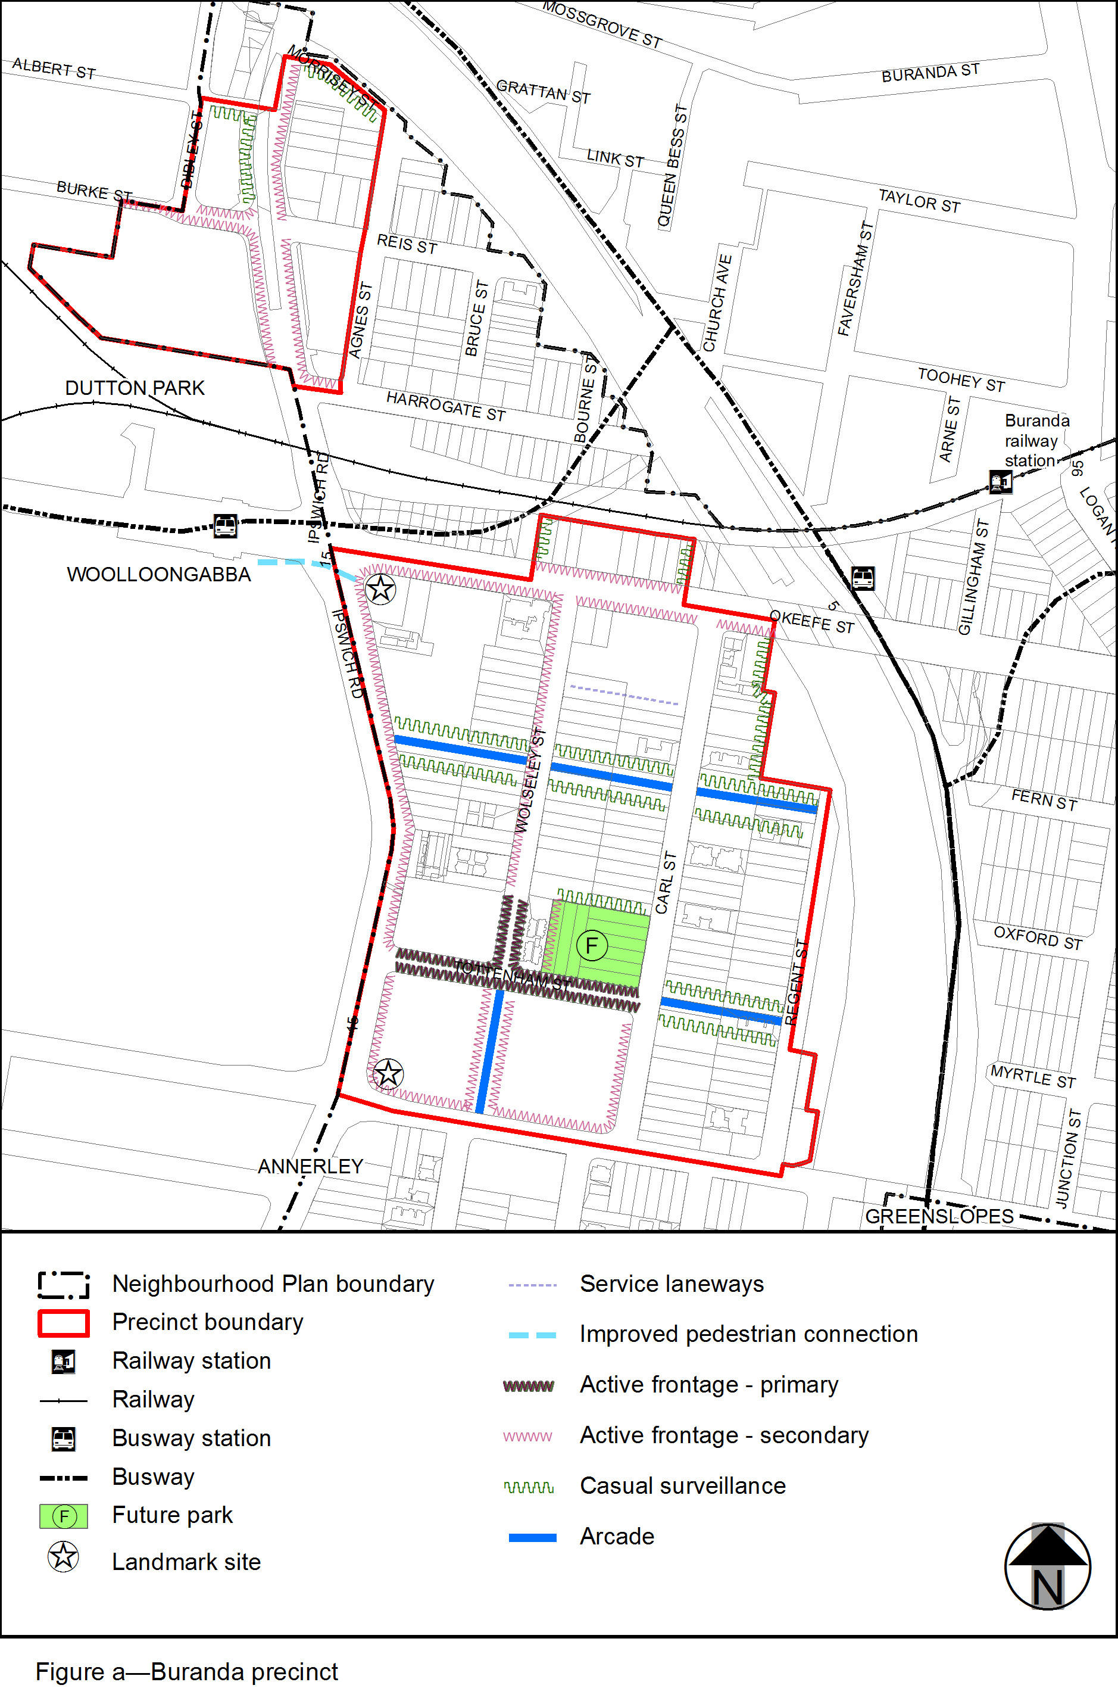
View the high resolution of Figure a–Buranda precinct (PDF file size is 167Kb)
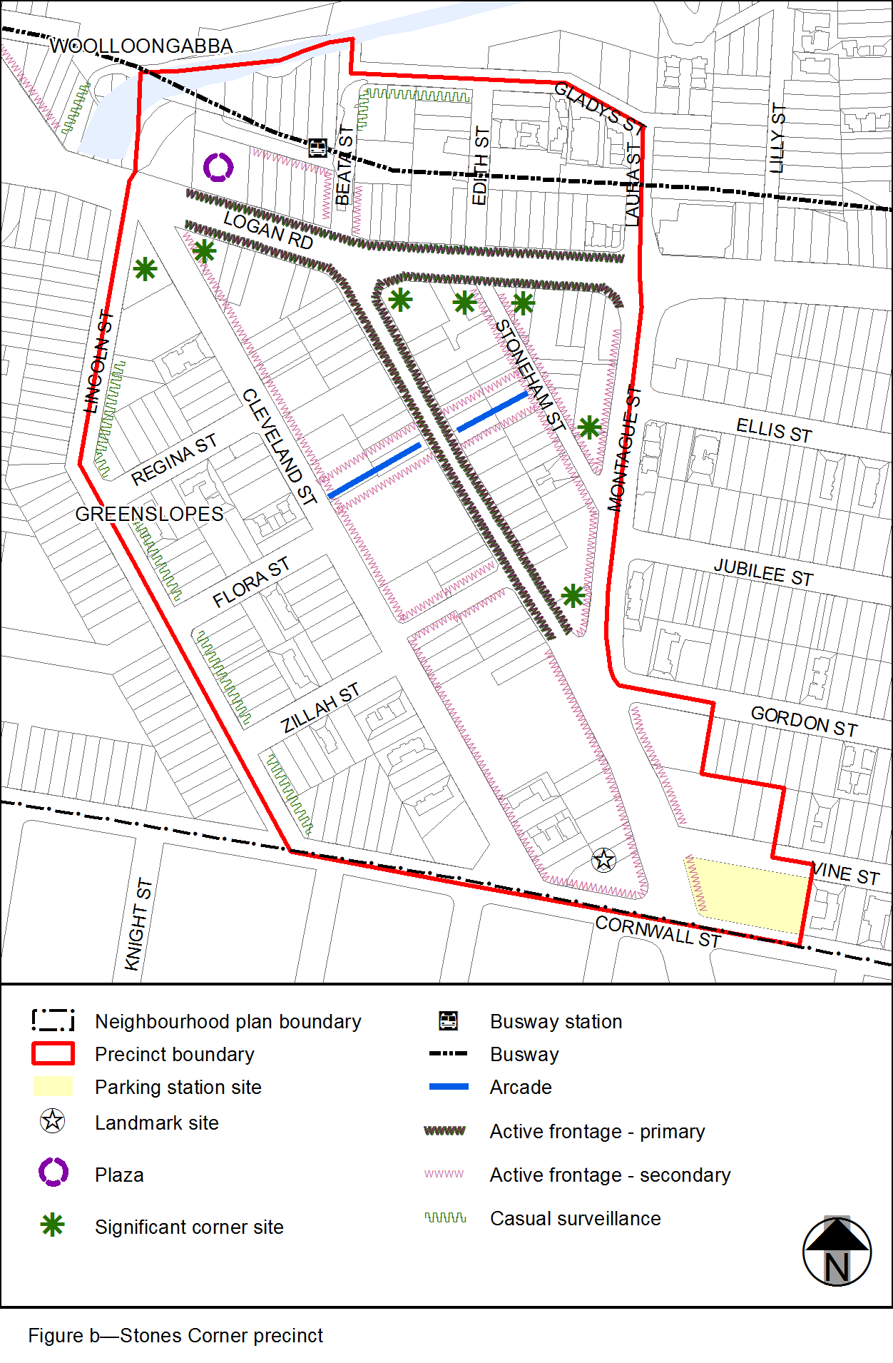
View the high resolution of Figure b–Stone Corner precinct (PDF file size is 120Kb)
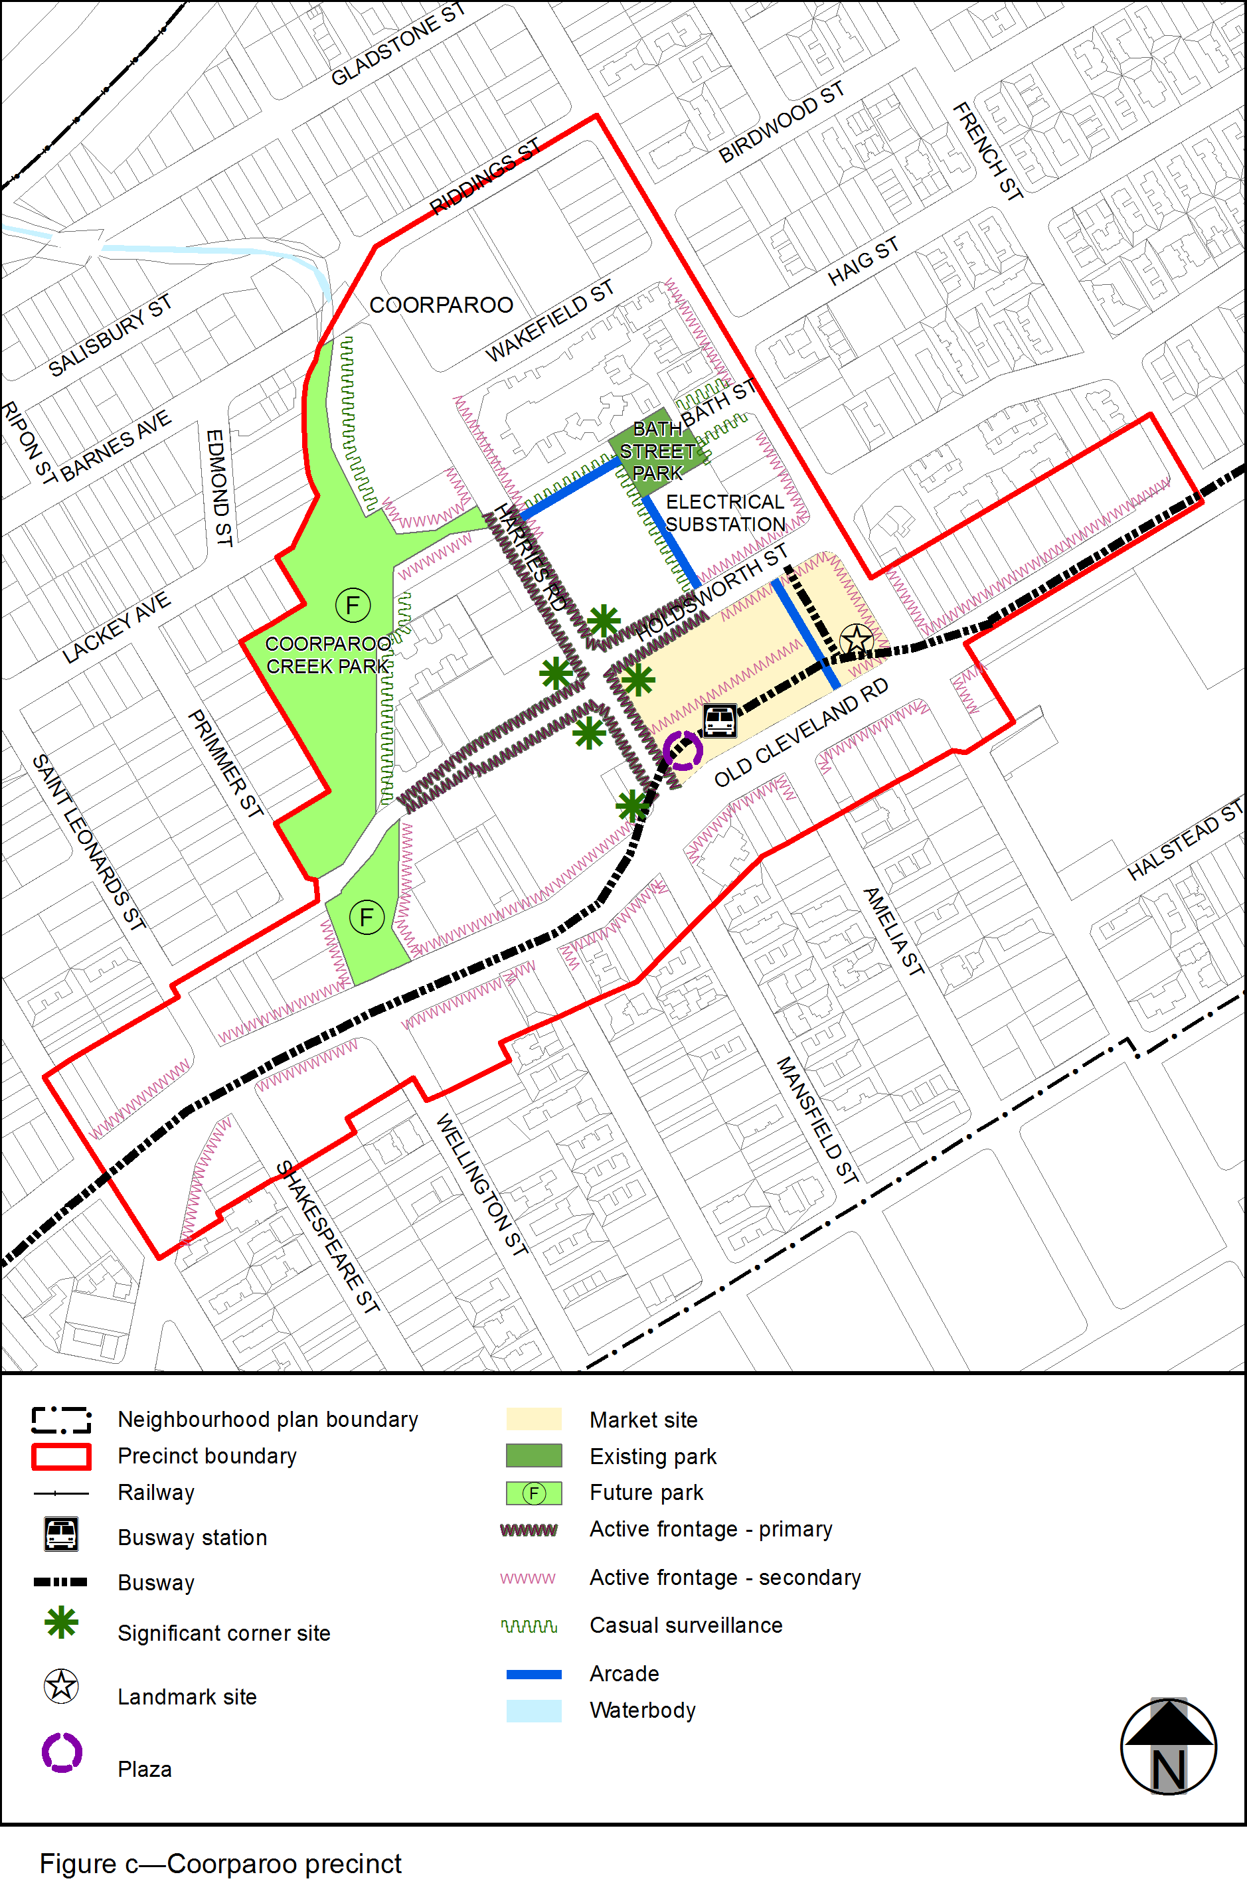
View the high resolution of Figure c–Coorparoo precinct (PDF file size is 233Kb)
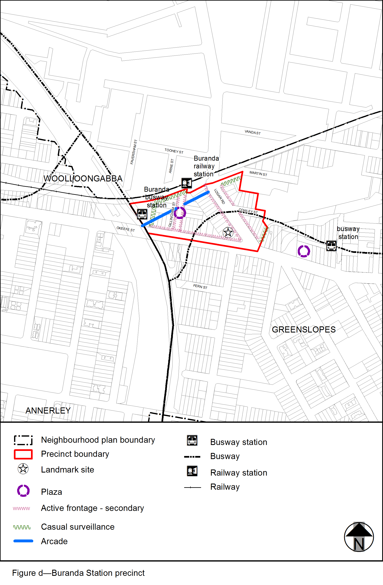
View the high resolution of Figure d–Buranda Station precinct (PDF file size is 131Kb)
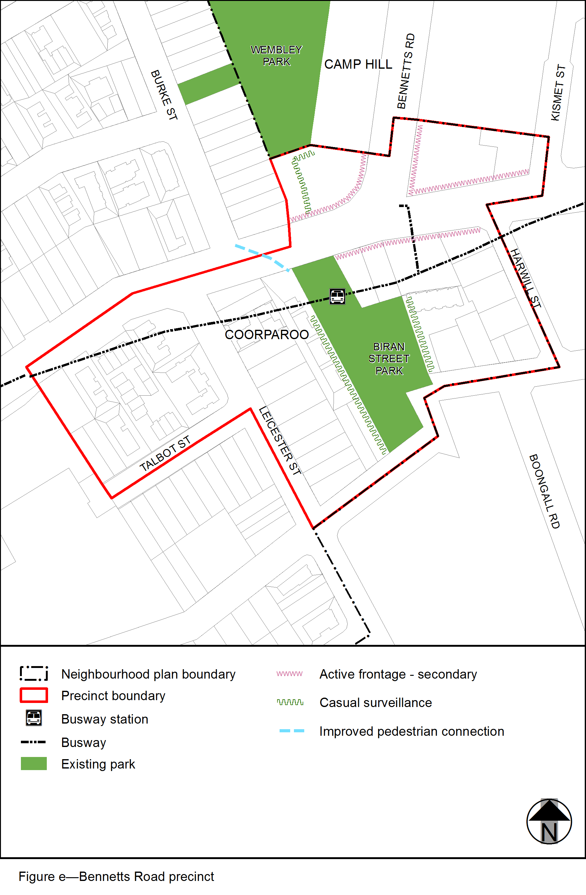
View the high resolution of Figure e–Bennetts Road precinct (PDF file size is 125Kb)
