7.2.8.1 Holland Park—Tarragindi district neighbourhood plan code

7.2.8.1.1 Application
- This code applies to assessing a material change of use, reconfiguring a lot, operational work or building work in the Holland Park—Tarragindi district neighbourhood plan area if:
- assessable development where this code is an applicable code identified in the assessment benchmarks column of a table of assessment for a neighbourhood plan (section 5.9); or
- impact assessable development.
- Land in the Holland Park—Tarragindi district neighbourhood plan area is identified on the NPM-008.1 Holland Park—Tarragindi district neighbourhood plan map and includes the following precincts:
- Parkland precinct ( Holland Park—Tarragindi district neighbourhood plan/NPP-001);
- Greenslopes Busway Station precinct (Holland Park—Tarragindi district neighbourhood plan/NPP-002):
- Energex depot sub-precinct (Holland Park—Tarragindi district neighbourhood plan/NPP-002a);
- Stephens Mountain sub-precinct (Holland Park—Tarragindi district neighbourhood plan/NPP-002b);
- Nicholson Street sub-precinct (Holland Park—Tarragindi district neighbourhood plan/NPP-002c);
- Greenslopes Hospital sub-precinct (Holland Park—Tarragindi district neighbourhood plan/NPP-002d).
- Greenslopes Mall district centre precinct (Holland Park—Tarragindi district neighbourhood plan/NPP-003);
- Greenslopes central neighbourhood centre precinct (Holland Park—Tarragindi district neighbourhood plan/NPP-004);
- Holland Park central district centre precinct (Holland Park—Tarragindi district neighbourhood plan/NPP-005);
- Kuring-gai Avenue neighbourhood centre precinct (Holland Park—Tarragindi district neighbourhood plan/NPP-006);
- Reservoir parkland precinct (Holland Park—Tarragindi district neighbourhood plan/NPP-007);
- Hillside character precinct (Holland Park—Tarragindi district neighbourhood plan/NPP-008).
- When using this code, reference should be made to section 1.5, section 5.3.2 and section 5.3.3.
Note—The following purpose, overall outcomes, performance outcomes and acceptable outcomes comprise the assessment benchmarks of this code.
Note—This neighbourhood plan includes a table of assessment. Refer to Table 5.9.29.A, Table 5.9.29.B, Table 5.9.29.C and Table 5.9.29.D.
Note—Hillside character areas are steeper residential areas containing traditional character housing and significant ridgelines. Hillside character is derived from the relationship of buildings to their physical setting. Traditional character housing built following an historic subdivision pattern and located on well-treed hillsides results in a unique character of important visual significance in the local context. Hillside character is retained and enhanced through sympathetic development that minimises visual impact within its visual catchment.

7.2.8.1.2 Purpose
- The purpose of the Holland Park—Tarragindi district neighbourhood plan code is to provide finer grained planning at a local level for the Holland Park—Tarragindi district neighbourhood plan area.
- The purpose of the Holland Park—Tarragindi district neighbourhood plan code will be achieved through overall outcomes including overall outcomes for each precinct for the neighbourhood plan area.
- The overall outcomes for the Holland Park—Tarragindi district neighbourhood plan area are:
- A mix of housing densities and types serves the needs of the community, especially the neighbourhood plan area’s young adult and elderly populations. Identified character housing is retained with higher density housing encouraged in proximity to major employment nodes and public transport.
- Sandy, Ekibin and Norman creeks are protected and enhanced for their ecological and recreational values.
- The landscape and ecological values of Stephens Mountain, Wellers Hill reservoir and Tarragindi Hill reservoir are retained and enhanced.
- The Greenslopes Private Hospital will continue to be the major employment node for the neighbourhood plan area. Development respects the setting of the hospital within a predominantly residential locality and maximises pedestrian and cyclist accessibility between the hospital and the Greenslopes Busway Station.
- Public transport use is facilitated by upgrading pedestrian and cyclist access from employment nodes, centres and residential precincts to the Greenslopes and Holland Park Busway Stations. Relaxation of parking requirements in the vicinity of the Busway Stations is inconsistent with outcomes sought due to potential commuter parking conflicts.
- Significant views and vistas are protected. Development proposed in visually prominent locations such as major ridgelines and hill tops is designed to achieve minimal visual impact. Development forms that require cut and fill and disturbance of vegetation are avoided.
- Development is of a height, scale and form which is consistent with the amenity and character, community expectations and infrastructure assumptions intended for the relevant precinct, sub-precinct or site and is only developed at a greater height, scale and form where there is both a community need and an economic need for the development.
- Parkland precinct (Holland Park—Tarragindi district neighbourhood plan/NPP-001) overall outcomes are:
- This precinct indicates a site that is regarded as suitable for acquisition by the Council for parkland.
- The site is part of a waterway corridor and links existing parkland on the western and eastern side of Birdwood Road.
- Most of the site falls under the Flood Regulation Line and therefore is regarded as unsuitable for development.
- Greenslopes Busway Station precinct (Holland Park—Tarragindi district neighbourhood plan/NPP-002) overall outcomes are:
- This precinct provides a range of housing types and other land uses including parks and community facilities in close proximity to the Greenslopes Busway Station.
- Any non-residential and multiple dwelling development in this precinct contributes to the upgrading of the pedestrian environment, including provision of footpaths, street trees and other improvements to the accessibility of the Busway Station.
- Development is designed to retain the landscape and ecological values of Stephens Mountain.
- Development may be required to contribute towards improvements to the intersection of Ridge Street and Barnsdale Place.
- The Energex depot sub-precinct (Holland Park—Tarragindi district neighbourhood plan/NPP-002a) is occupied by Energex and is used for community purposes. Development in this sub-precinct:
- if this site were to redevelop, an appropriate use would be higher density residential development that increases dwelling densities and provides active uses adjacent to the Greenslopes busway station;
- is to be in accordance with any future approved structure plan.
- Stephens Mountain sub-precinct (Holland Park—Tarragindi district neighbourhood plan/NPP-002b) mostly comprises remnant bushland featuring ecological and landscape values which is used for park, providing opportunities for passive recreation activities. Development in this sub-precinct:
- if it were to redevelop in the part comprising disturbed former quarry land of limited ecological or landscape value, an appropriate use would be higher density residential development that increases dwelling densities and provides active uses adjacent to the Greenslopes busway station;
- is to be in accordance with future approved structure plan.
- Development in the Nicholson Street sub-precinct (Holland Park—Tarragindi district neighbourhood plan/NPP-002c):
- provides for a range of housing types at low to low–medium density in close proximity to the Greenslopes Busway Station.
- The Greenslopes Hospital sub-precinct (Holland Park—Tarragindi district neighbourhood plan/NPP-002d) encompasses the Greenslopes Private Hospital which is located in a predominantly residential locality. Development in this sub-precinct:
- should minimise adverse impacts to residential amenity and address residential building bulk and scale;
- does not support expansion of hospital functions and associated medical activities into the surrounding residential locality;
- residential activities supporting the functions of the hospital may be appropriate in this locality;
- complements and enhances the site’s highly visually prominent position in its immediate residential setting and in its broader setting as viewed from the Pacific Motorway and surrounds;
- provides for:
- retention of vegetation and habitat and provision of a landscape buffer adjoining Stephens Mountain;
- landscaping which contributes to the setting and backdrop of Stephens Mountain;
- land and work for future park to improve access to the Greenslopes Busway Station and passive recreation opportunities;
- building bulk and scale which is sympathetic to the residential locality, particularly on the perimeter of the site;
- high-quality urban design particularly for those buildings that are highly visible from surrounding suburbs and major transport thoroughfares such as the Pacific Motorway and busway;
- active street frontages, particularly to Nicholson Street such as associated medical activities and where possible, hospital functions that address and are accessible for pedestrians from the street frontage and incorporate a range of design techniques and other measures encouraging surveillance of Nicholson Street to improve pedestrian and cyclist safety.
- Greenslopes Mall district centre precinct (Holland Park—Tarragindi district neighbourhood plan/NPP-003) overall outcomes are:
- This precinct is an integrated facility accommodating a range of uses expected in a district centre.
- Development provides for improvements to the visual amenity along Logan Road, Plimsoll Street and Sackville Street frontages, shade for pedestrians, improvements to legibility and active frontages.
- Greenslopes central neighbourhood centre precinct (Holland Park—Tarragindi district neighbourhood plan/NPP-004) overall outcomes are:
- Retail and commercial services are consolidated within this centre.
- Pedestrian activity is encouraged via active street frontages and an enhanced streetscape.
- Holland Park central district centre precinct (Holland Park—Tarragindi district neighbourhood plan/NPP-005) overall outcomes are:
- This precinct accommodates a range of activities expected in a district centre.
- The built form and character of the precinct as a traditional suburban strip shopping centre is maintained.
- Significant views that add to the identity and unique character of the centre as a gateway to the Brisbane Valley are maintained.
- Kuring-gai Avenue neighbourhood centre precinct (Holland Park—Tarragindi district neighbourhood plan/NPP-006) overall outcomes are:
- This precinct provides convenience functions supporting the surrounding residential locality and the Holland Park Busway Station.
- The built form and character of the precinct as a traditional suburban strip shopping centre is maintained.
- Development provides and incorporates upgraded walking paths, street trees and improvements to connections between the centre and footpaths leading to the busway station.
- Reservoir parkland precinct (Holland Park—Tarragindi district neighbourhood plan/NPP-007) overall outcomes are:
- This precinct contains Wellers Hill reservoir and Tarragindi Hill reservoir which perform two important functions as a water storage and supply facility and as a park with bushland, scenic landscape and passive recreation values.
- Development complements the natural values of the site and avoids impacting surrounding residential amenity or the utility installation function of the reservoirs.
- Hillside character precinct (Holland Park—Tarragindi district neighbourhood plan/NPP-008) overall outcomes are:
- Hillside character is maintained, retained and enhanced through sympathetic development that minimises visual impact within its visual catchment.
- Development along major ridgelines in the precinct contributes to a consistent rhythm and sense of scale along the ridgeline when viewed from the surrounding visual catchment.
- Residential development in particular provides for:
- the appearance of traditional character houses uniformly spaced and stepped across well-treed hillsides;
- compatible building height, bulk and proportions.
- construction methods, such as posts or piers, that minimise the amount of alteration to site topography;
- alteration to site topography.

7.2.8.1.3 Performance outcomes and acceptable outcomes

Table 7.2.8.1.3.A—Performance outcomes and acceptable outcomes
Performance outcomes | Acceptable outcomes
General
PO1  Development is of a height, scale and form that achieves the intended outcome for the precinct, improves the amenity of the neighbourhood plan area, contributes to a cohesive streetscape and built form character and is:  - consistent with the anticipated density and assumed infrastructure demand;  - aligned to community expectations about the number of storeys to be built;  - proportionate to and commensurate with the utility of the site area and frontage width;  - designed to avoid a significant and undue adverse amenity impact to adjoining development;  - sited to enable existing and future buildings to be well-separated from each other and to avoid affecting the potential development of an adjoining site.  Note—Development that exceeds the intended number of storeys or building height can place disproportionate pressure on the transport network, public space or community facilities in particular.  Note—Development that is over-scaled for its site can result in an undesirable dominance of vehicle access, parking and manoeuvring areas that significantly reduce streetscape character and amenity. |  | AO1  Development complies with the number of storeys and building height in Table 7.2.8.1.3.B.  Note—Neighbourhood plans will mostly specify a maximum number of storeys where zone outcomes have been varied in relation to building height. Some neighbourhood plans may also specify height in metres. Development must comply with both parameters where maximum number of storeys and height in metres are specified.
If in the Greenslopes Busway Station precinct (Holland Park—Tarragindi district neighbourhood plan/NPP-002)
PO2  Development:  - complements and enhances the existing residential and landscape character of the locality;  - if in the Stephens Mountain sub-precinct (Holland Park—Tarragindi district neighbourhood plan/NPP-002b), complements and enhances the site’s visually prominent position in the locality and its vegetated character;  - if in the Greenslopes Hospital sub-precinct (Holland Park—Tarragindi district neighbourhood plan/NPP-002d), complements and enhances the landscape and ecological character of the locality and retains existing significant vegetation adjacent to Stephens Mountain;  - retains significant vegetation and provides sufficient areas between buildings for the provision of trees and landscaping that uses locally occurring native species, in accordance with the Planting species planning scheme policy. |  | AO2  No acceptable outcome is prescribed.
If in the Greenslopes Busway Station precinct (Holland Park—Tarragindi district neighbourhood plan/NPP-002), where in the Energex depot sub-precinct (Holland Park—Tarragindi district neighbourhood plan/NPP-002a)
PO3  Development fronting Barnsdale Place must complement and reinforce the role of the road as the major pedestrian and vehicular access point to the Greenslopes Busway Station. |  | AO3.1  Development minimises vehicular crossovers to Barnsdale Place.
AO3.2
Development incorporates people-oriented activity areas (such as internal and external living areas) overlooking Barnsdale Place and the rear of the site overlooking Stephens Mountain and other measures to encourage surveillance and improve pedestrian safety within the areas.
PO4  Development complements and enhances the highly visually prominent position of the adjoining Stephens Mountain. |  | AO4  Development ensures building height, scale and roof form is designed to retain views from the north and west to the bushland part of Stephens Mountain.
If in the Greenslopes Busway Station precinct (Holland Park—Tarragindi district neighbourhood plan/NPP-002), where in the Stephens Mountain sub-precinct (Holland Park—Tarragindi district neighbourhood plan/NPP-002b)
PO5  Development contributes to pedestrian safety and amenity in the locality, including access from the sub-precinct to the Greenslopes Busway Station. |  | AO5  Development:  - incorporates internal and external living areas overlooking the walking and cycling path on the southern side of the site and the rear of the site overlooking Stephens Mountain and other measures to encourage surveillance and improve pedestrian safety within these areas;  - ensures any acoustic treatments, such as walls and landscape mounds, between development and the Pacific Motorway are located on the southern side of the shared walking and cycling path to ensure direct access and the ability to overlook from the development to pathway.
PO6  Development complements and enhances the site’s highly visually prominent position in its locality and its vegetated character. |  | AO6  Development:  - retains significant vegetation and provides sufficient areas between buildings for the provision of trees and landscaping which incorporates locally occurring native species, in accordance with the Planting species planning scheme policy;  - ensures building heights and roof forms are designed to retain views from the south and east to the top of the cliff face of Stephens Mountain;  - retains views from the south and east to the bushland parts of Stephens Mountain.
If in the Greenslopes Busway Station precinct (Holland Park—Tarragindi district neighbourhood plan/NPP-002), where in the Greenslopes Hospital sub-precinct (Holland Park—Tarragindi district neighbourhood plan/NPP-002d)
PO7  Development complements and enhances the landscape and ecological character of the locality and retains existing significant vegetation adjacent to Stephens Mountain. |  | AO7.1  Development provides sufficient areas between buildings for trees capable of reducing apparent building bulk and scale.
AO7.2
Development provides a landscaped 6m setback to all road frontages that:
- incorporates existing vegetation;
- does not include structures such as car parking, servicing areas, mechanical exhausts and plant balconies and patios;
- includes covered walkways and other pedestrian shelters required for the functioning of the pedestrian network throughout the site in accordance with Figure a.
AO7.3
Development along the western boundary of the site (adjoining Stephens Mountain):
- retains existing vegetation;
- incorporates a landscaped buffer not less than 20m wide at any point, in accordance with Figure a with no future development (including hard-stand and vehicle manoeuvring areas and excavation and filling) occurring within this buffer.
AO7.4
Development provides for the dedication of Lots 134 and 135 on RP46047 along the Stephens Mountain boundary for park, in lieu of a monetary contribution for a future park.
PO8  Development complements and enhances the visual amenity of the adjoining Stephens Mountain. |  | AO8  Development ensures building heights, scale and roof forms are designed to retain views from the north and west to the bushland part of Stephens Mountain.
If in the Greenslopes Mall district centre precinct (Holland Park—Tarragindi district neighbourhood plan/NPP-003)
PO9  Development contributes positively to the urban amenity and character of this precinct, in particular:  - actively contributes to the improvements of visual amenity in Lottie Street;  - activates the Logan Road frontage;  - improves streetscape amenity, legibility and safety within this precinct. |  | AO9  Development of any future extensions to, or redevelopment of, the existing Greenslopes mall facility incorporates the following:  - streetscape frontages that are articulated with colour, texture and architectural features to conceal unsightly exposure of utilities/building hardware and relieve existing blank facades;  - landscaping that is used to provide pedestrian shade and as a screening device at streetscape level to assist in improvements to visual amenity;  - a vegetation buffer that is provided to improve the amenity of Lottie Street residences in accordance with Figure b;  - enhanced legibility particularly in relation to the streetscape, entry statements and mall identity;  - retailing and commercial activities that are located on and accessible from street frontages, particularly Logan Road, as a means of activating otherwise blank facades in accordance with Figure b;  - activity that contributes to the improvement of visual amenity in Lottie Street;  - if adjoining Lottie Street, extends for 30m from the street frontage and provides a 6m vegetated setback along the Lottie Street frontage in accordance with Figure b.
If in the Greenslopes central neighbourhood centre precinct (Holland Park—Tarragindi district neighbourhood plan/NPP-004)
PO10  Development maintains and enhances the position of the centre as a place along a major vehicular route with views to the City Centre. |  | AO10.1  Development setbacks maintain views from Logan Road to the City Centre.
AO10.2
Development:
- enhances the system of vehicular access in the centre by on-site links in accordance with Figure c;
- vehicular access, circulation areas and parking areas is coordinated or designed to allow for future integration;
- direct access ensures the capability for shared access is not prejudiced by the design.
AO10.3
Development enhances the centre with street tree planting as indicated in Figure c.
AO10.4
Development incorporates a landscape buffer a minimum of 5m wide along street frontages perpendicular to Logan Road that is not to be occupied by service zones or areas for refuse bins.
PO11  Development minimises visual impacts to the surrounding locality. |  | AO11  Development that incorporates a vegetation buffer a minimum of 5m wide along rear and side boundaries where adjoining residential sites to provide a landscape screen capable of achieving a height of 10m to 12m at maturity is not to be occupied by refuse bins or other back-of- house activities in order to maintain visual privacy to residences.
If in the Holland Park central district centre precinct (Holland Park—Tarragindi district neighbourhood plan/NPP-005)
PO12  Development maintains and enhances the position of the centre as a place along a major vehicular route with views to the D’Aguilar Ranges. |  | AO12  Development maintains views from Logan Road to the D’Aguilar Ranges as shown in Figure d.
PO13  Development enhances the role of the centre as a community place, by:  - incorporating landscape features and seating nodes;  - upgrading footpath and visual connections with its surrounding neighbourhood;  - coordinating on-site vehicular movement and parking. |  | AO13.1  Development for the redevelopment of Lot 11 on RP146764 and Lot 2 on RP56059 (the Holland Park Hotel) incorporates a landscape setback to the Logan Road frontage. The setback maximises views from Logan Road to the D’Aguilar Ranges, in accordance with Figure d.
AO13.2
Development enhances the system of vehicular access in the centre by locating on-site linkages within blocks at the rear of sites. Vehicular access, circulation areas and parking areas are coordinated by development or designed to allow for future integration.
AO13.3
Development enhances the Holland Park centre by street tree planting where shown in Figure d.
AO13.4
Development on the northern side of Logan Road allows for visual connections between the street and the surrounding residential areas and beyond, such as:
- for residential uses, for example shop-top housing, a minimum 3m wide visually open corridor;
- for non-residential development, maximising a visual connection using glazing in the rear wall of the buildings.
PO14  Development minimises visual impacts to the surrounding residential area. |  | AO14.1  Development that incorporates a vegetation buffer a minimum of 5m wide along rear and side boundaries where adjoining a residential site, provides a landscape screen capable of achieving a height of 10m to 12m at maturity that is not occupied by refuse bins or other back of house activities to maintain visual privacy to residences.
AO14.2
Development is set back a minimum of 3m to street frontages perpendicular to Logan Road that are not occupied by service areas or refuse bins.
If in the Kuring-gai Avenue neighbourhood centre precinct (Holland Park—Tarragindi district neighbourhood plan/NPP-006)
PO15  Development improves pedestrian facilities and streetscape amenity. |  | AO15.1  Development enhances the Kuring-gai Avenue Convenience Centre by street tree planting and landscaping in accordance with Figure e.
AO15.2
Development provides active street frontages to increase pedestrian activity in the centre in accordance with Figure e.
AO15.3
Development on Lot 21 on RP65585 is set back to retain views from Marshall Road to the centre in accordance with Figure e.
PO16  Development minimises impacts to the surrounding residential area. |  | AO16  Development that incorporates a vegetation buffer a minimum of 5m wide along rear and side boundaries where adjoining a residential site, provides a landscape screen capable of achieving a height of 10m to 12m at maturity that is not occupied by refuse bins or other back-of- house activities, to maintain visual privacy to residences.
If in the Hillside Character precinct (Holland Park—Tarragindi district neighbourhood plan/NPP-008)
Development pattern and form
PO17  Development for residential uses is:  - compatible with traditional character house scale;  - designed and sited to retain and reinforce the predominant development pattern and form of:  - separate allotments, whether or not the site area exceeds predominant lot sizes in the area or the site is an amalgamation of allotments;  - buildings of a traditional character house scale uniformly spaced and consistently stepped across well-treed hillsides when viewed from the visual catchment. |  | AO17.1  Development ensures the building footprint, boundary setbacks and siting in relation to adjoining development reflect the predominant development pattern and form of development in the area.
AO17.2
Development ensures buildings feature orthogonal plan forms with outside walls aligned with those on adjoining allotments or within the development.
Building height, scale and proportions
PO18  Development for residential uses achieves height, scale and proportions that are compatible with traditional character houses when viewed from the visual catchment. |  | AO18.1  Development of large buildings is designed to appear as a series of separate blocks, each of a size and scale similar to that of a traditional character house, using:  - physical separation;  - significant recesses and projections of the exterior wall plane;  - articulation through steps in the horizontal plane of the roof;  - roof geometry incorporating significant variety such as pitched roofs of a minimum 27.5 degree pitch;  - elevational and roof treatment in a variety of materials, colours and finishes compatible with traditional character houses to achieve the appearance of separate blocks.
AO18.2
Development only excludes building heights in Table 7.2.8.1.3.B where:
- using traditional character elements or site-responsive construction methods has resulted in non-compliance with the maximum building height;
- any additional building height or storeys are incorporated into a building form appearing to comply with maximum building height such as through additional storeys being incorporated into a roof-space area.
Note—Site–responsive construction methods, such as posts or piers, minimise the amount of alteration to site topography. Traditional character elements are pitched roofs of a minimum 27.5 degree pitch.
AO18.3
Development only exceeds the site cover prescribed acceptable outcome where the development is designed to reduce building bulk in accordance with AO18.1.
AO18.4
Development ensures the height of eaves reflects the predominant pattern and form of the area:
- along undulating ridgelines;
- horizontally across hillsides;
- vertically down hillsides.
AO18.5
Development ensures the length of an elevation treatment above ground level without variation, articulation or openings is no more than 10m.
PO19  Development is designed, sited and landscaped to minimise the impact of incompatible building bulk. |  | AO19  No acceptable outcome is prescribed.
PO20  Development along ridgelines does not dominate the skyline and is designed and sited to contribute to a consistent rhythm and sense of scale along the ridgeline when viewed from the visual catchment. |  | AO20  No acceptable outcome is prescribed.
Landscape character, physical setting and topography
PO21  Development minimises impacts on existing significant vegetation and provides replacement vegetation on the site of an advanced size and maturity where significant vegetation is removed. |  | AO21.1  Development of buildings, structures, driveways and hard-stand areas are designed and sited to maximise the retention of vegetation on the site.
AO21.2
Significant vegetation removed as a result of the development is replaced with vegetation of advanced size and maturity that contributes to the special character of the area.
Note—Trees featuring a trunk diameter width of 250mm or greater measured at 1m above ground level are considered significant vegetation. Advanced size and maturity is vegetation of 100L minimum stock size planted in sufficient quantity to achieve a total canopy area of 50% of the removed vegetation when mature.
PO22  Development for residential purposes must be designed to retain or reinforce the landscape character and physical setting of the locality and designed and situated to break up building bulk such that development appears:  - as a collection of separate buildings uniformly sited on well-treed hillsides; or  - separate buildings consistently spaced along major ridgelines. |  | AO22.1  Development provides communal open space and ground-storey private open space for residential development at a minimum dimension of 5m.
AO22.2
Development provides boundary setbacks that are a minimum of:
- 6m to the rear boundary;
- 12m to the rear boundary on sites steeper than 1 in 8 gradient (long axis from the front boundary to rear boundary of the site);
- 6m to any adjoining site’s front or rear boundary in the case of rear allotments;
- car parking and manoeuvring areas are located at least 3m from rear boundaries;
- the setback is planted to provide a dense landscape screen.
Note—In the case of corner lots, the rear boundary is that boundary which abuts other rear boundaries.
PO23  Development, including buildings or other structures, driveways and hard-stand areas, must be designed and sited to minimise cut and fill disturbance on the site. |  | AO23.1  Development incorporates:  - foundation systems of a type that minimise disturbance to the landscape, such as post and pier type foundations;  - slab-on-ground foundations only on those parts of a site with gradients less than 1 in 8 and where no cut and fill is required or cut and fill is minimal;  - benching, cut and fill, or construction of retaining walls of a minor nature only and designed so as not to be noticeable after construction has been completed;  - driveways and hard-stand areas only on those parts of a site with gradients less than 1 in 4.  Note—Cut and fill is considered to be of a minor nature where fill does not exceed 1m or the combined height of any retaining wall and fence does not exceed 2m.
AO23.2
Development sets back retaining walls from any boundary and are stepped or terraced and landscaped to soften visual impact.

Table 7.2.8.1.3.B—Maximum building height
Development | Building height  (number of storeys) | Building height (m)
If in the Greenslopes Busway Station precinct (Holland Park—Tarragindi district neighbourhood plan/NPP-002), where in the Greenslopes Hospital sub-precinct (Holland Park—Tarragindi district neighbourhood plan/NPP-002d)
Development of a site within 40m of Denman Street and Newdegate Street | 3 | 12
Development of a site in Denman Street where north of the administration building | 2 | 9.5
Development of a site within 20m of Nicholson Street | 3 | 12
Development of a site in all other areas of the Greenslopes Hospital site or in accordance with an approved structure plan | 5 | Not specified
If in the Greenslopes Mall district centre precinct (Holland Park—Tarragindi district neighbourhood plan/NPP-003)
Development adjoining Lottie Street extending for a distance of 30m from the street frontage | 2 | 9.5
Notes—
- Development heights in Greenslopes Hospital precinct (NPP-002d) are shown in Figure a.
- The maximum of 3 storeys and 12m on Denman Street is only permitted where development is not north of the administration building.
- The maximum of 5 storeys and 20m in all other areas of the Greenslopes Hospital site or in accordance with a structure plan is only permitted where the development is not for plant and equipment buildings. Any development to house plant and equipment is to be designed in accordance with the relevant codes.
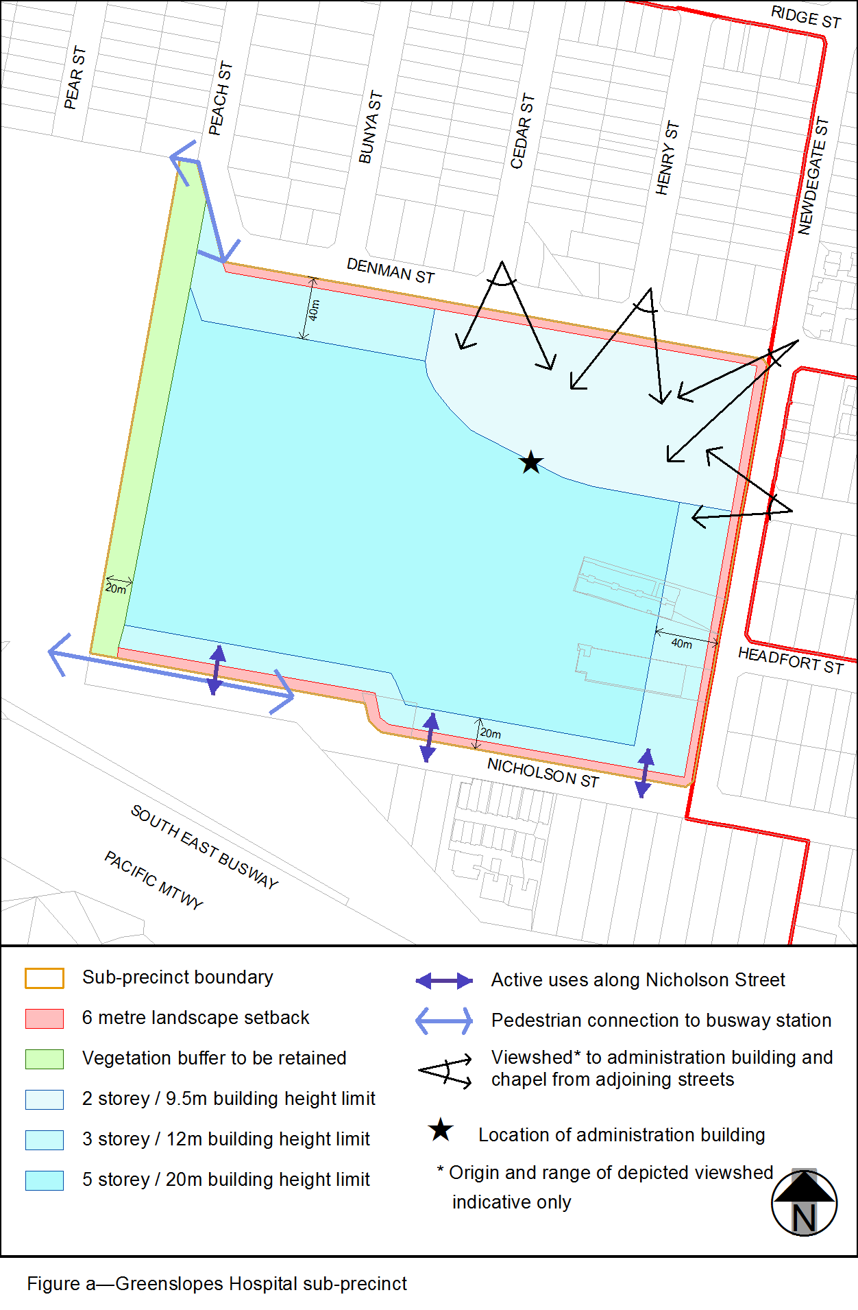
View the high resolution of Figure a–Greenslopes Hospital sub-precinct (PDF file size is 83Kb)
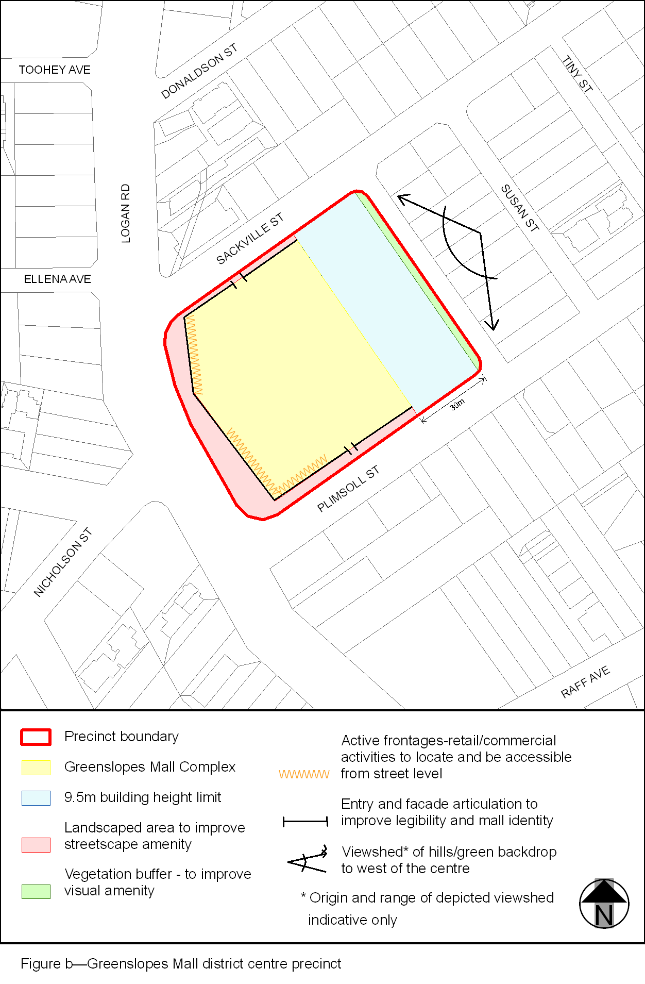
View the high resolution of Figure b–Greenslopes Mall district centre precinct (PDF file size is 77Kb)
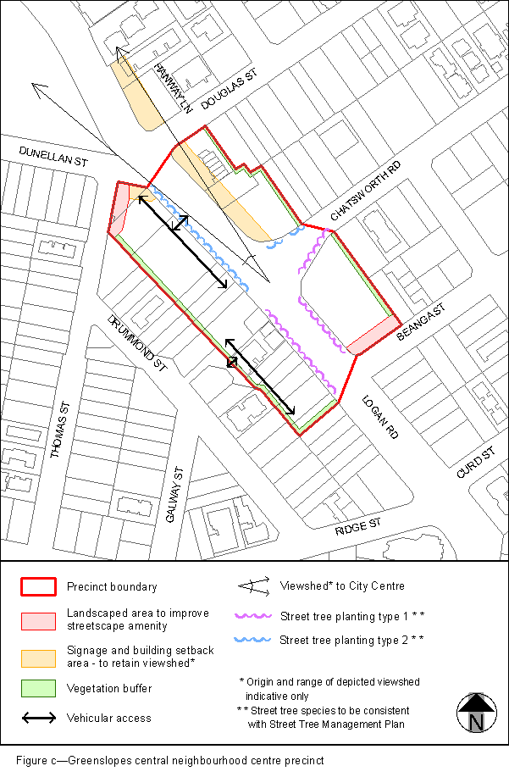
View the high resolution of Figure c–Greenslopes central neighbourhood centre precinct (PDF file size is 89Kb)
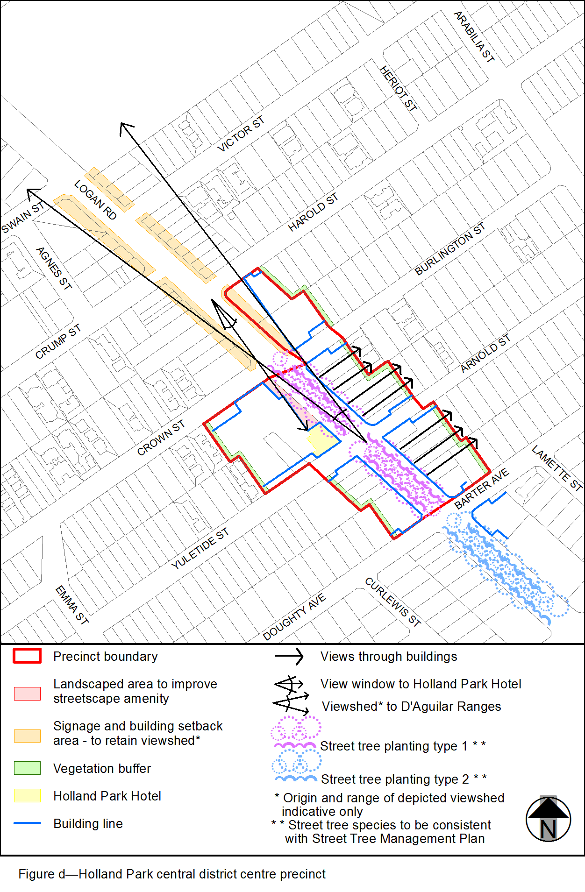
View the high resolution of Figure d–Holland Park central district centre precinct (PDF file size is 93Kb)
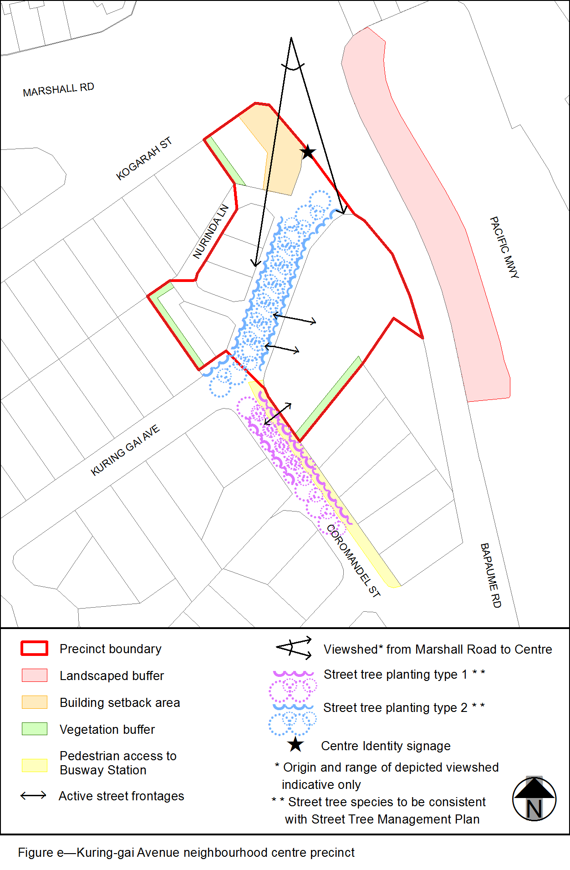
View the high resolution of Figure e–Kuring-gai Avenue neighbourhood centre precinct (PDF file size is 71Kb)
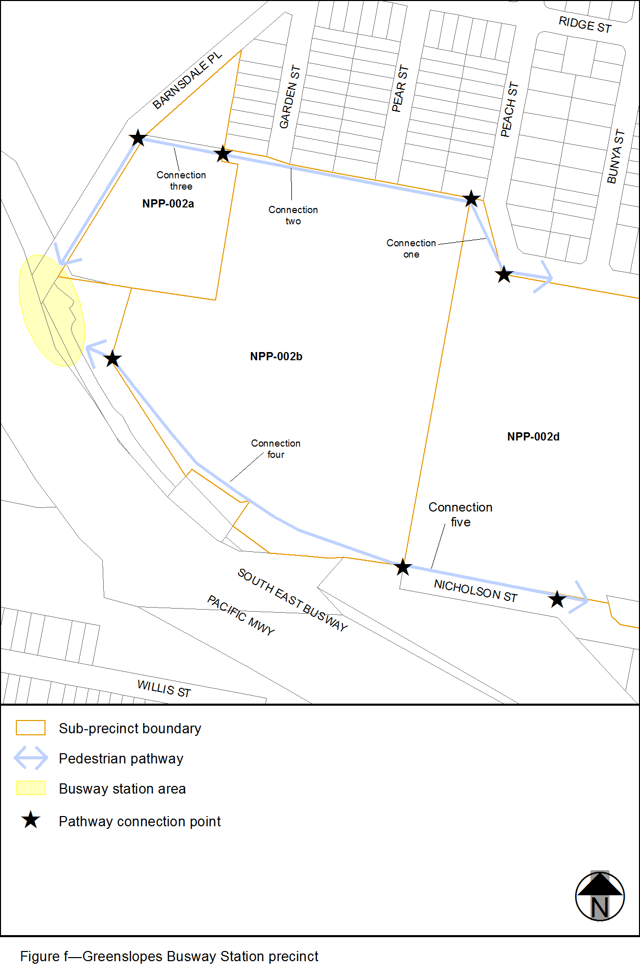
View the high resolution of Figure f–Greenslopes Busway Station precinct (PDF file size is 103Kb)

