7.2.13.1 McDowall—Bridgeman Downs neighbourhood plan code

7.2.13.1.1 Application
- This code applies to assessing a material change of use, reconfiguring a lot, operational work or building work in the McDowall—Bridgeman Downs neighbourhood plan area if:
- assessable development where this code is an applicable code identified in the assessment benchmarks column of a table of assessment for a neighbourhood plan (section 5.9); or
- impact assessable development.
- Land in the McDowall—Bridgeman Downs neighbourhood plan area is identified on the NPM-013.1 McDowall—Bridgeman Downs neighbourhood plan map.
- When using this code, reference should be made to section 1.5, section 5.3.2 and section 5.3.3.
Note—The following purpose, overall outcomes, performance outcomes and acceptable outcomes comprise the assessment benchmarks of this code.
Note—This neighbourhood plan includes a table of assessment. Refer to Table 5.9.40.A, Table 5.9.40.B, Table 5.9.40.C and Table 5.9.40.D.

7.2.13.1.2 Purpose
- The purpose of the McDowall—Bridgeman Downs neighbourhood plan code is to provide finer grained planning at a local level for the McDowall—Bridgeman Downs area.
- The purpose of the McDowall—Bridgeman Downs neighbourhood plan code will be achieved through overall outcomes.
- The overall outcomes for the neighbourhood plan area are:
- Development creates functional and integrated communities.
- Land subject to development constraints, character or environmental values specified in Figure a or Figure b or shown on an overlay map is protected from inappropriate development in order to maintain its character, natural and ecological significance.
- Open space, parks and recreational facilities meet the needs of the community and are located in accessible locations that are well connected within the neighbourhood plan area.
- Residential development provides for a mix of housing types, styles and densities.
Note—Development in a potential development area specified in Figure a or Figure b addresses the location of the land, availability of services, environmental constraints, amenity, and existing patterns of development to ensure an integrated development outcome.
Note—Densities and yields for residential development are to be calculated excluding parts of the site that are not within a potential development area. These include areas with development constraints or character or environmental values identified in overlay maps. Yields and maximum gross floor area for multiple dwellings and dual occupancy are to be calculated across the potential development area including all access ways and roads respectively.
- Land in the Emerging community zone in a potential development area in the northern portion of the neighbourhood plan area:
- includes a mix of larger lot sizes, retains existing vegetation and minimises development in vegetated or other scenically important areas;
- has a built form no greater than 2 storeys in height;
- locates higher density development in the cleared parts of this area and comprises clusters of development surrounded by a high proportion of landscaping and open space.
- Neighbourhood centres identified in the neighbourhood plan serve the retail, commercial, community and service needs of the local community. Centre activities do not expand outside the sites specified in Figure a and other land already included in a zone in the centre zones category.

7.2.13.1.3 Performance outcomes and acceptable outcomes

Table 7.2.13.1.3—Performance outcomes and acceptable outcomes
Performance outcomes | Acceptable outcomes
No performance outcomes are prescribed. | No acceptable outcomes are prescribed.

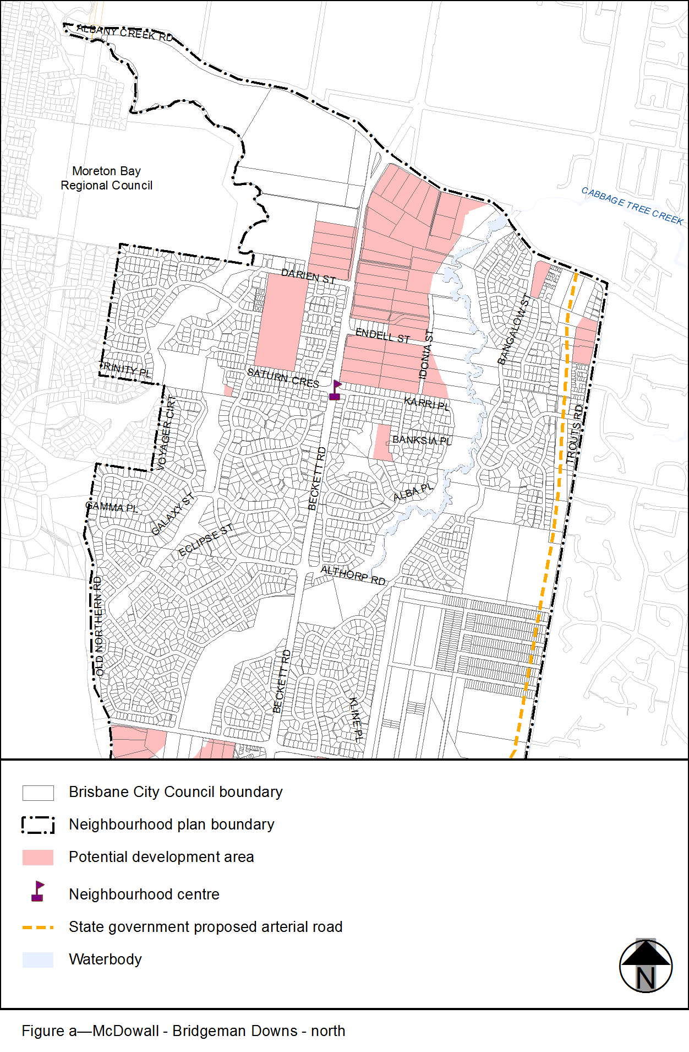
View the high resolution of Figure a–McDowall – Bridgeman Downs (PDF file size is 271Kb)
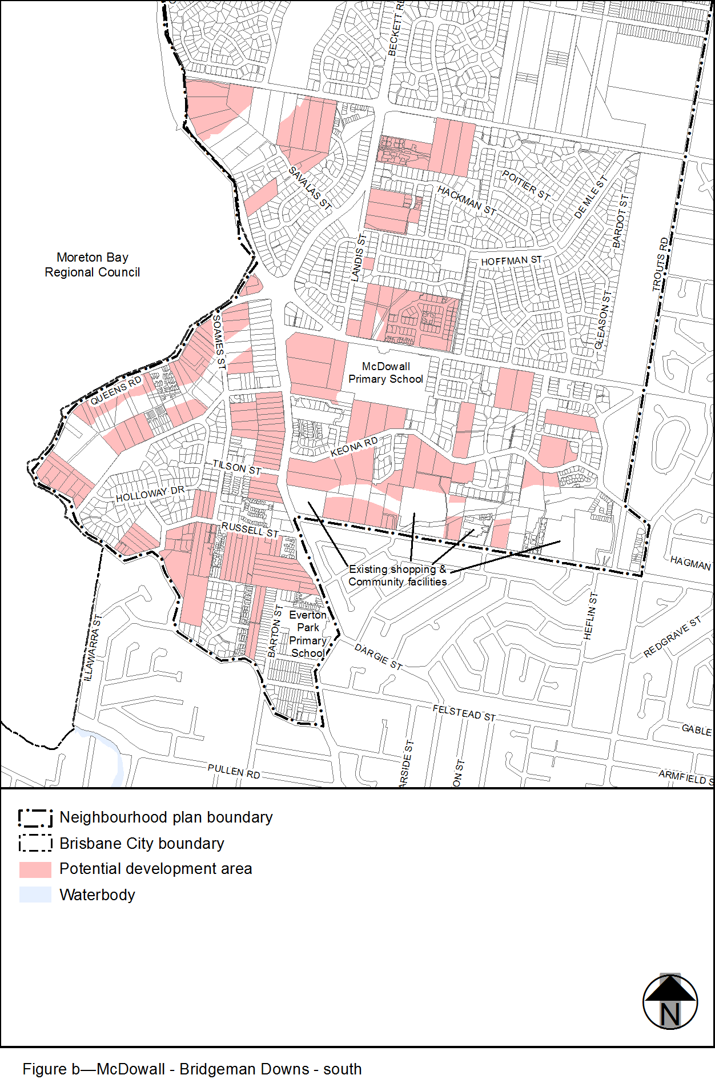
View the high resolution of Figure b–McDowall – Bridgeman Downs – south (PDF file size is 255Kb)

