5.3.1.1 Albion

5.3.1.1.1 Location and extent

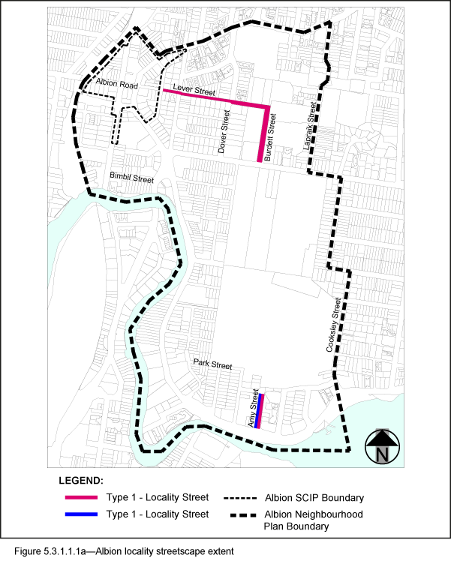
- The Locality Streets in the Albion neighbourhood plan area are indicated on the Streetscape hierarchy overlay map and in Figure 5.3.1.1.1a.
- All streetscape works occurring within the Locality Streets indicated in Figure 5.3.1.1.1a, must comply with the character specified in this document.
- Streetscapes outside these areas may be developed in keeping with this character, at the discretion of the developer and subject to Council approval.

5.3.1.1.2 Standard footway elements and materials
- These locality guidelines are to be read in conjunction with Chapter 3 – Road corridor design of the Infrastructure design planning scheme policy.
- Footway upgrades are to include new surfacing, new or reinstated kerb and channel, driveways, pedestrian kerb crossings, tactile markers, roof water drainage line connections, service pit lids, street trees, garden beds, furniture and pedestrian lighting applicable to the streetscape type.
- The scope, layout and detail of the footway upgrades are to be agreed on a site by site basis through the development assessment process.

5.3.1.1.3 Streetscape hierarchy

5.3.1.1.3.1 Streetscape types overview
- The locality streets within the Albion neighbourhood plan area are exceptions to the standard streetscape hierarchy.
- The streetscape type and specifications for locality streets in this area are outlined in Table 5.3.1.1.3.1A and shown in Figure 5.3.1.1.1a.
- If the total footway width is narrower than 3.75m, the turf strip or garden beds with street trees and pedestrian paths shall comply with the dimensions outlined in Table 5.3.1.1.3.1B and Table 5.3.1.1.3.1C.

Table 5.3.1.1.3.1A – Streetscape type and specifications
Specifications | Type 1 | Type 2
Verge width | Existing width (as per Table 5.3.1.1.3.1B) | Existing width (as per Table 5.3.1.1.3.1C)
Pavement width | As per Table 5.3.1.1.3.1B. | Full width
Unobstructed Pavement Width | As per Table 5.3.1.1.3.1B. | As per Table 5.3.1.1.3.1C
Paving materials | Broom Finished: Standard Portland Grey concrete. | Exposed Aggregate Concrete: Standard Portland Grey 'Victoria Falls' (90% ‘Blue Heeler’ 10% ‘Winter Brown’) by Hanson (code 10043620), Boral or approved equivalent
Tactile paving  (consistent with BSD-5218) | Concrete tactile paver by Chelmstone, Urbanstone or approved equivalent.  Colour: CCS ‘Voodoo’ | Concrete tactile paver by Chelmstone, Urbanstone or approved equivalent.  Colour: CCS ‘Voodoo’
Driveways | Broom finished Portland Grey concrete. | Exposed aggregate to match footway
Street Trees (refer to section 5.3.1.1.5.2) | Refer to Table 5.3.1.1.3.1B  Street trees:  (a) All trees minimum of 750mm from nominal face of kerb.  (b) Distance between trees and edges of pavement varies depending on turf width in accordance with Table 5.3.1.1.3.1B.  Trees planted in: Mulched tree planting area in turf.  Tree planting beds – minimum widths:  (a) 1.2m where turf width permits;  (b) Equal to turf width where less than 1.2m. | Refer to Table 5.3.1.1.3.1C  Street trees:  (a) All trees minimum of 750mm from nominal face of kerb and 600mm from edges of garden beds on all other sides.  Trees planted in: Garden beds or tree grates. Garden bed minimum widths are as per Table 5.3.1.1.3.1C
Garden Beds (refer to section 5.3.1.1.5.1) | No garden beds | Garden beds are required where identified in Table 5.3.1.1.3.1C. Garden bed minimum widths: Refer to Table 5.3.1.1.3.1C.
Turf strips | As per Table 5.3.1.1.3.1B. | No turf strips
Furniture (refer to section 5.3.1.1.4) | No furniture. | As per Table 5.3.1.1.3.1C

Table 5.3.1.1.3.1B —Streetscape width exceptions (Type 1)
Verge widths (from nominal face of kerb) | Unobstructed pavement width | Turf strip adjacent kerb – minimum width | Turf strip at rear of verge | Street trees | Distance between tree and edge of pavement
Less than 2.1m | Full width | No turf | None | No | N/A
2.1m – 2.49m | 1.2m | 750mm – 1.14m | None | No | N/A
2.50m - 3.14m | 1.2m | 1.15m – 1.79m | None | Yes | 550mm – 1.19m
3.15m - 3.74m | 1.8m | 1.2m – 1.69m | None | Yes | 600mm – 1.09m
3.75m | 1.8m | 1.3m | 0.5m | Yes | 600mm

Table 5.3.1.1.3.1C —Streetscape width exceptions (Type 2)
Verge widths (from nominal face of kerb) | Garden bed minimum width | Street trees | Unobstructed pavement width | Furniture
Less than 2.1m | No garden beds | No | Full width | No
2.1m – 2.49m | 750mm – 1.15m | No | 1.2m | No
2.50m – 3.14m | 1.15m | Yes | 1.2m – 1.8m | Yes
3.15m – 3.74m | 1.2m | Yes | 1.8m – 2.4m | Yes
3.75m | 1.2m | Yes | 2.4m | Yes
Note—Dimensions are indicative only. Footway layout will be assessed on a site by site basis at the discretion of Council’s Development Assessment Officer.

5.3.1.1.3.2 Albion Suburban Centre Improvement Project
Any works required to footways within the Albion Suburban Centre Improvement Project (SCIP) area, as shown on Figure 5.3.1.1.1a, is to be in accordance with section 5.2.1.2 Albion of the Infrastructure design planning scheme policy.

5.3.1.1.4 Furniture
- Refer to section 3.7.6 Design standards for street furniture of the Infrastructure design planning scheme policy for standard furniture elements and specifications.
- All furniture is to be located outside of the unobstructed pavement area.
- Furniture elements and layout requirements are to be agreed on a site by site basis through the development assessment process.

5.3.1.1.5 Planting

5.3.1.1.5.1 Garden beds
- Garden beds are permitted as identified in Table 5.3.1.1.3.1A.
- Shrub and groundcover species are to be selected from Table 5.3.1.1.5A.
- Garden beds are located adjacent to the kerb and include:
- 1.5m minimum spacing between garden beds;
- maximum length of 10m;
- layout and length to accommodate car parking and other kerbside allocation.

5.3.1.1.5.2 Street trees
- Street trees are permitted as identified in Table 5.3.1.1.3.1A.
- Street trees are to be a mix of tree species laid out in an informal manner with clusters of trees;
- Medium and small crown trees to be planted at minimum 6m centres
- Large crown feature trees to be planted at minimum 10m centres.
- Street trees planted in a single row at the rear of kerb. Trees are to be planted as singles and in pairs or clusters.
- Table 5.3.1.1.5B sets out the approved street tree species for use on the various streets within the Albion area.
- Each street has a minimum of two approved street tree species to encourage variety and diversity within the precinct.
- Where two or more street trees are required on the same development frontage, a mixture of the appropriate species as listed in Table 5.3.1.1.5B is required.

Table 5.3.1.1.5A—Shrubs and groundcover species
Shrub and groundcover species | Common name
Liriope ‘Evergreen Giant’ | Liriope
Liriope ‘Stripey White’ | Variegated Liriope
Trachelospermum jasminoides ‘Tricolour’ | Variegated Star Jasmine

Table 5.3.1.1.5B—Street trees
Street | Tree species
Lever Street | Buckinghamia celsissima  Cupaniopsis anacardioides  Harpullia pendula  Lophostemon confertus
Burdett Street | Cupaniopsis anacardioides  Tabebuia argentea  Waterhousia floribunda  Peltophorum pterocarpum
Amy Street | Cupaniopsis anacardioides  Tabebuia rosea  Flindersia schottiana  Harpullia pendula

