5.3.3.1 City Centre

5.3.3.1.1 Location and extent
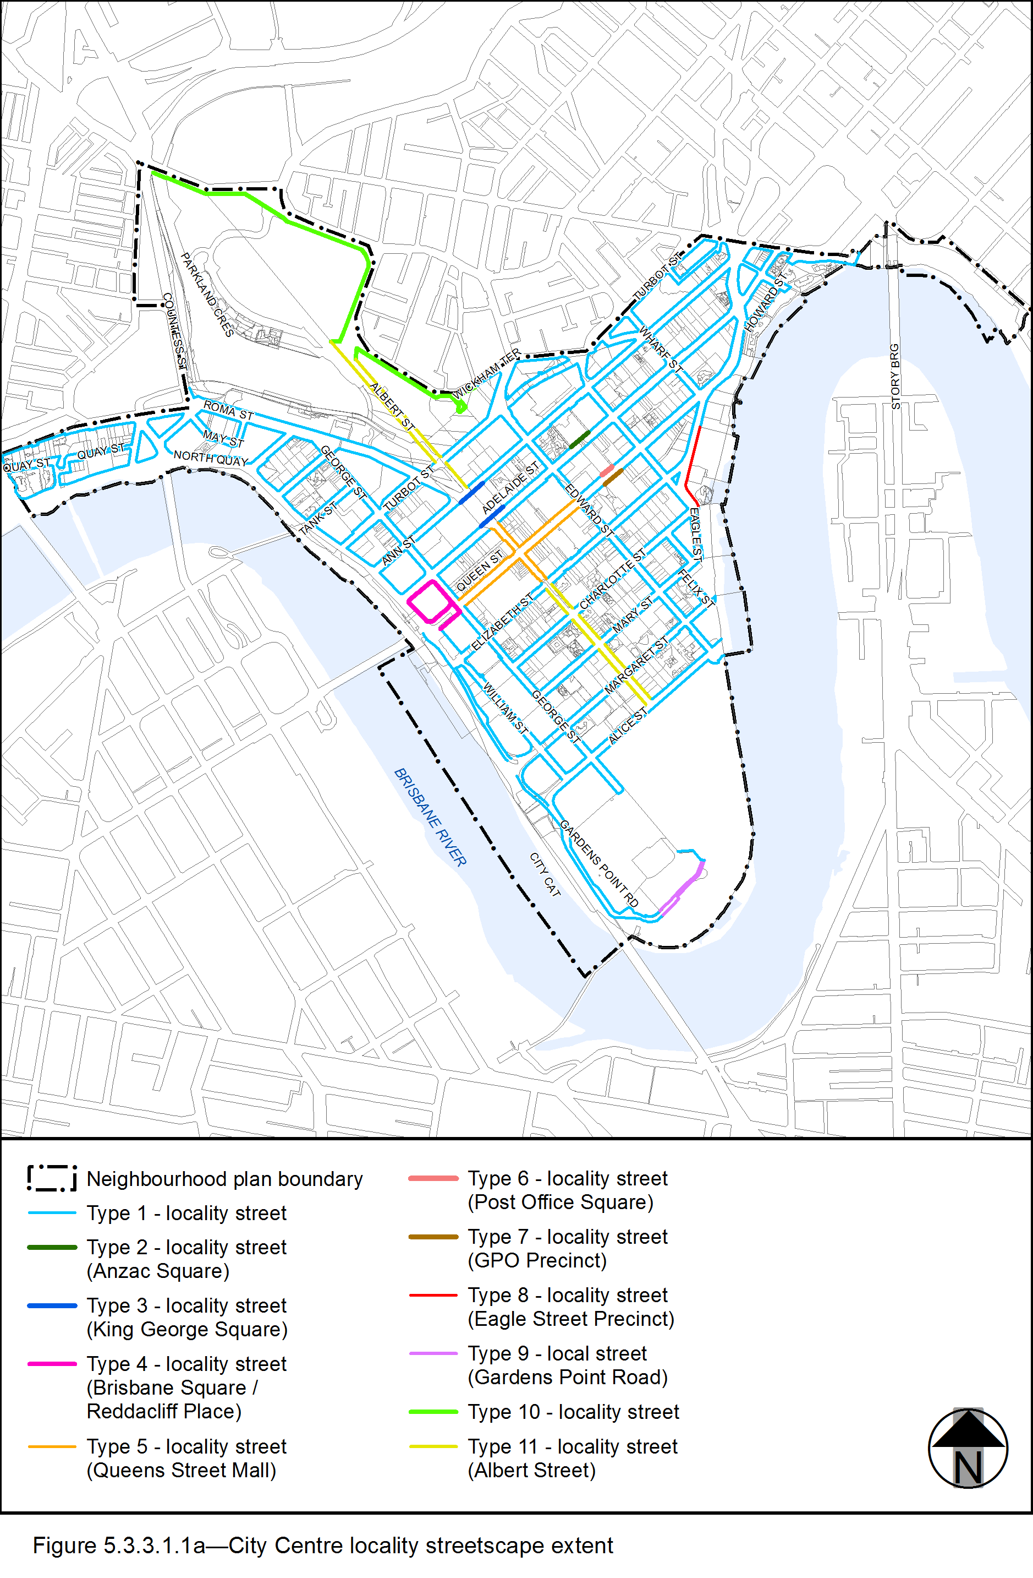
- The Locality Streets in the City Centre Neighbourhood Plan area are indicated on the Streetscape hierarchy overlay map and on Figure 5.3.3.1.1a.
- All streetscape works occurring within the Locality Streets indicated in Figure 5.3.3.1.1a, must comply with the character specified in this document.
- Streetscapes outside these areas may be developed in keeping with this character, at the discretion of the developer and subject to Council approval.

5.3.3.1.2 Standard footway elements and materials
- These locality guidelines are to be read in conjunction with Chapter 3 – Road corridor design of the Infrastructure design planning scheme policy.
- Footway upgrades are to include new surfacing, new or reinstated kerb and channel, driveways, pedestrian kerb crossings, tactile markers, roof water drainage line connections, service pit lids, street trees, garden beds, furniture and pedestrian lighting applicable to the streetscape type.
- The scope, layout and detail of the footway upgrades are to be agreed on a site by site basis through the development assessment process.

5.3.3.1.3 Streetscape hierarchy

5.3.3.1.3.1 Streetscape types overview
- The locality streets within the City Centre Neighbourhood Plan area are exceptions to the standard streetscape hierarchy.
- The streetscape type and specifications for locality streets in this area are shown in Figure 5.3.3.1.1a and outlined in this document.

5.3.3.1.3.2 Type 1 - Locality streetscape specifications
The streetscape specifications for Type 1 Locality Street are outlined in Table 5.3.3.1.3.2A.

Table 5.3.3.1.3.2A – Streetscape type and specifications
Component | Type 1 - Design specifications
Verge width | 5m
Pavement width | Full width pavement
Unobstructed pavement | 2.4m
Paving materials | Type: Honed coloured concrete with sawcut pattern.  Supplier: Hanson Racona (code 10040798), Boral or approved equivalent.  Colour: CCS ‘Liquorice’ 90% ‘Blue Heeler’ + 10% ‘Winter Brown’
Tactile markers  (consistent with BSD-5218) | Type: Concrete tactile pavers  Supplier: ‘Chelmstone’, ‘Urbanstone’ or approved equivalent  Colour: CCS 'Voodoo'
Driveways | Honed coloured concrete to match footway
Furniture | All furniture is to be located outside of the unobstructed pavement area.  Furniture elements and layout requirements are to be agreed on a site by site basis through the development assessment process.  Refer to 3.7.6 Design standards for street furniture for standard furniture elements and specifications.
Trees | Refer to 5.3.3.1.4 Planting.
Garden beds | No garden beds.

5.3.3.1.3.3 Type 2 - Locality streetscape specifications (Anzac Square)
The streetscape specifications for Type 2 Locality Street are outlined in Table 5.3.3.1.3.3A and shown in Figure 5.3.3.1.3.3a.

Table 5.3.3.1.3.3A – Streetscape type and specifications
Component | Type 2 - Design specifications
Verge width | 5m
Pavement width | Full width pavement
Unobstructed pavement | 2.4m
Paving materials - Body | Match existing.  Supplier: Boral or approved equivalent  Material: ‘Stylestone’ concrete flag paver  Colour: ‘Tan’ (003)  Size: 400mm x 400mm  Finish: honed
Band and highlight panel | Match existing.  Supplier: Boral or approved equivalent  Material: ‘Stylestone’ concrete flag paver  Colour: ‘Silver’ (015)  Size: 400mm x 400mm  Finish: honed
Tactile markers  (consistent with BSD-5218) | Type: Concrete tactile pavers  Supplier: ‘Chelmstone’, ‘Urbanstone’ or approved equivalent  Colour: CCS 'Voodoo'
Driveways | Honed coloured concrete to match footway
Furniture | All furniture is to be located outside of the unobstructed pavement area.  Furniture elements and layout requirements are to be agreed on a site by site basis through the development assessment process.  Refer to 3.7.6 Design standards for street furniture for standard furniture elements and specifications.
Trees | Refer to 5.3.3.1.4 Planting.
Garden beds | None.

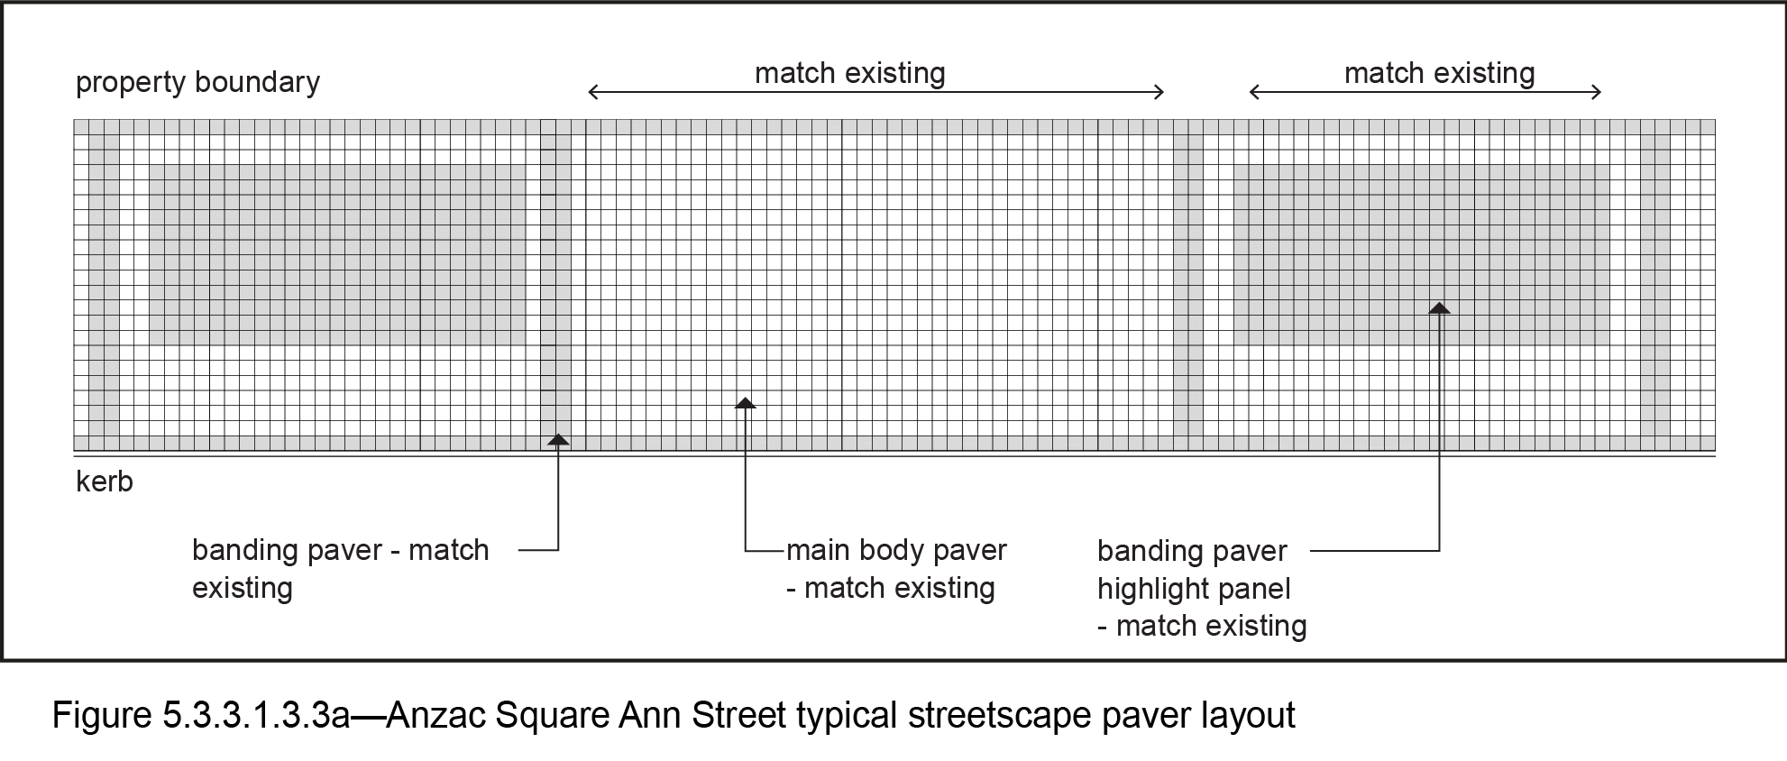

5.3.3.1.3.4 Type 3 - Locality streetscape specifications (King George Square)
The streetscape specifications for Type 3 Locality Street are outlined in Table 5.3.3.1.3.4A and shown in Figure 5.3.3.1.3.4a and Figure 5.3.3.1.3.4b.

Table 5.3.3.1.3.4A – Streetscape type and specifications
Component | Type 3 - Design specifications
Verge width | As existing
Pavement width | Full width pavement
Unobstructed pavement | 2.4m
Paving Type P2 | Match existing.  Material: 205mm x (200,400, 600, 800)mm ‘Oyster Pearl” granite paver, flamed finish.  Highlight Pavers:  - P12: 205mm x (200, 400, 600, 800)mm ‘Rous Ridge’ basalt paver, bright etched finish;  - P13: 205mm x (200, 400, 600, 800)mm ‘Misty Cloud’ paver, flamed finish.
Paving type P3 | Match existing.  Main Paver Material: 415mm x (200, 400, 500, 600, 700,800, 900, 1000)mm ‘Oyster Pearl” granite paver, flamed finish  Highlight Pavers: (P12) 415mm x 1000mm ‘Rous Ridge’ basalt paver, bright etched finish.
Paving type P4 | Match existing.  Main Paver Material: 615mm x 1000mm ‘Oyster Pearl” granite paver, flamed finish.  Highlight Pavers:  - P12: 205mm x 500mm ‘Rous Ridge’ basalt paver, bright etched finish;  - P13: 205mm x1m ‘Misty Cloud’ paver, flamed finish;  - P4: 404mm x 1m‘ Oyster Pearl” granite paver, flamed finish.
Paving type P5/P6 | Match existing.  Paver Material: 620mm x 1.520m typical ‘Rous Ridge’ basalt paver, bright etched finish.
Paving type P7 | Match existing.  Paver Material: 400mm x 1m typical ‘Rous Ridge’ basalt paver, bright etched finish.
Paving type P10 | Match existing.
Paving type P14 | Match existing.  Paver Material: 100mm x (195, 400, 600)mm ‘Rous Ridge’ basalt paver, bright etched finish.
Paving type P15 | Match existing.  Main Paver Material: 100mm x (195, 400, 600)mm ‘Oyster Pearl’ paver, flamed finish.  Highlight Pavers:  - P12: 100mm x 400mm ‘Rous Ridge’ basalt paver, bright etched finish;  - P13: 100mm x 600mm ‘Misty Cloud’ paver, flamed finish.
Paving type P17 | Match existing.  Paver Material: 100mm x 300mm ‘Rous Ridge’ basalt paver, bright etched finish.
Tactile markers  (consistent with BSD-5218) | Match existing.
Driveways | Honed coloured concrete to match footway
Furniture | All furniture is to be located outside of the unobstructed pavement area.  Furniture elements and layout requirements are to be agreed on a site by site basis through the development assessment process.  Refer to 3.7.6 Design standards for street furniture for standard furniture elements and specifications.
Trees | Refer to 5.3.3.1.4 Planting.
Garden beds | None.

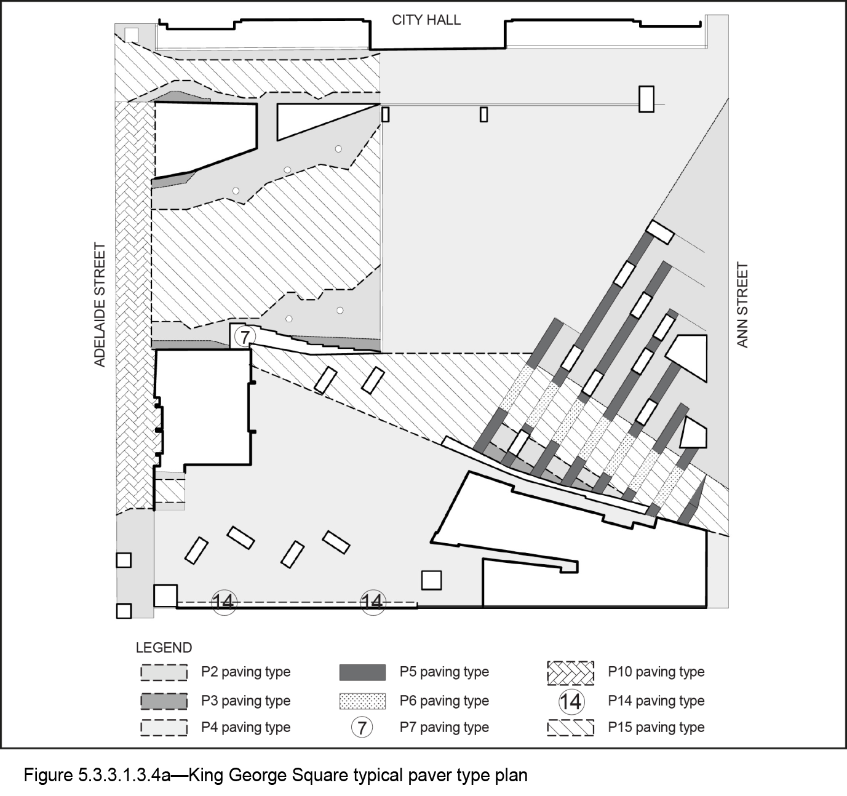
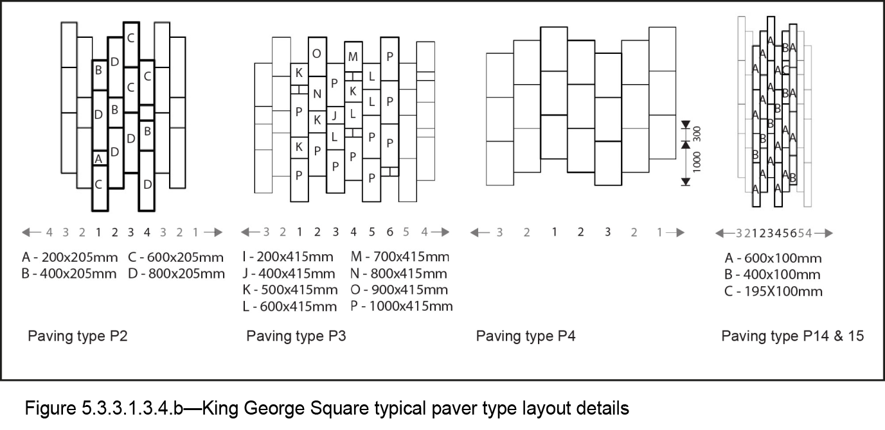

5.3.3.1.3.5 Type 4 - Locality streetscape specifications (Brisbane Square and Reddacliff Place)
The streetscape specifications for Type 4 Locality Street are outlined in Table 5.3.3.1.3.5A and shown in Figure 5.3.3.1.3.5a.

Table 5.3.3.1.3.5A – Streetscape type and specifications
Component | Type 4 - Design specifications
Verge width | 5m
Pavement width | Full width pavement
Unobstructed pavement | 2.4m
Paving Material – Body | Main paving type (SN02) - Match existing.  Material: (595x295), (595x197), (295x295), (295x197)mm Sindoor Brown granite paver, exfoliated finish
Highlight Panel | Highlight paving ‘piano keys’ (SN04) - Match existing.  Material: (595x295), (595x197), (295x295), (295x197)mm Indian Black granite, exfoliated finish
Tactile markers  (consistent with BSD-5218) | Tactiles to match existing - match Indian Black exfoliated granite paver
Driveways | Match existing.  Material: Type SN02 - (595x295), (595x197), (295x295), (295x197) mm Sindoor brown granite paver, exfoliated finish  Type SN04 (595x295), (595x197), (295x295), (295x197) mm Indian Black granite, exfoliated finish
Furniture | All furniture is to be located outside of the unobstructed pavement area.  Furniture elements and layout requirements are to be agreed on a site by site basis through the development assessment process.  Refer to 3.7.6 Design standards for street furniture for standard furniture elements and specifications.
Trees | Refer to 5.3.3.1.4 Planting.
Garden beds | None.

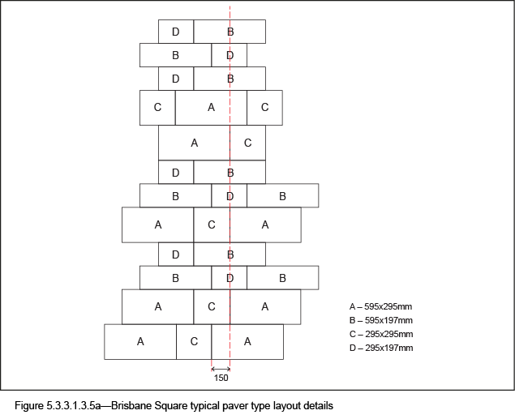

5.3.3.1.3.6 Type 5 - Locality streetscape specifications (Queen Street Mall)
The streetscape specifications for Type 5 Locality Street are outlined in Table 5.3.3.1.3.6A and shown in Figure 5.3.3.1.3.6a.

Table 5.3.3.1.3.6A – Streetscape type and specifications
Component | Type 5 - Design specifications
Verge width | As existing
Pavement width | Full width pavement
Unobstructed pavement | 2.4m
Queen Street - Main Body Paver | Supplier and processing: Australian Granites Pty Ltd; J Wagner & Sons or approved equivalent  Material: Granite  Colour: ‘Midnight Rose’  Size: (597x297x50), (297x297x50)mm  Finish: exfoliated
Queen Street - Band Contrast Paver | Randomly spread at a 1:20 ratio.  Supplier and processing: Australian Granites Pty Ltd; J Wagner & Sons or approved equivalent  Material: Granite  Colour: ‘Adelaide Black’  Size: 297mm x 297mm x 55mm  Finish: exfoliated
Queen Street ‘Procession Way’ pavers | Supplier and processing: Australian Granites Pty Ltd; J Wagner & Sons or approved equivalent  Material: Granite  Colour: ‘Midnight Rose’  Size:  - Main paver 297mm x 297mm x 50mm  - Central Lateral Line 297mm x 97mm x 50mm  Finish: exfoliated
Albert Street - Paving type main body paver | Material: Granite  Colour: Sindoor Brown  Size: (597x297x50)mm, (297x297,50)mm  Finish: exfoliated  Layout: to match Queen Street area of the mall
Albert Street - Vehicle movement areas and cross overs | Match existing Queen Street ‘Procession Way’ paving type  Layout: to match Queen Street area of the mall
Tactile markers  (consistent with BSD-5218) | Supplier: Boral  Material: Concrete ‘Stylestone’ or approved equivalent  Colour: Charcoal Black  Size: 300mm x 300mm x 55mm
Driveways | Honed coloured concrete to match footway.
Furniture | All furniture is to be located outside of the unobstructed pavement area.  Furniture elements and layout requirements are to be agreed on a site by site basis through the development assessment process.  Refer to 3.7.6 Design standards for street furniture for standard furniture elements and specifications.
Trees | Refer to 5.3.3.1.4 Planting.
Garden beds | None.

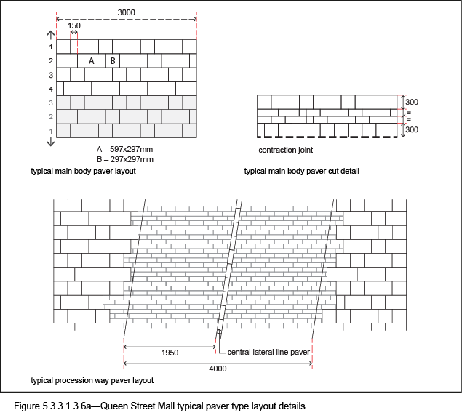

5.3.3.1.3.7 Type 6 - Locality streetscape specifications (Post Office Square)
The streetscape specifications for Type 6 Locality Street are outlined in Table 5.3.3.1.3.7A and shown in Figure 5.3.3.1.3.7a.

Table 5.3.3.1.3.7A – Streetscape type and specifications
Component | Type 6 - Design specifications
Verge width | As existing
Pavement width | Full width pavement
Unobstructed pavement | 2.4m
Main body  paving type (PT1) | Match existing.  Supplier: The Tile Factory or approved equivalent  Material: Granite paver  Code: HG6013  Size: 895mm x 595mm x 30 mm  Finish: exfoliated
Banding  paver type (PT2) | Match existing.  Supplier: The Tile Factory or approved equivalent  Material: Granite paver  Code: HG6007  Size: 695mm x 395mm x 30 mm  Finish: exfoliated
Diagonal detail  paver type (PT3) | Match existing.  Supplier: The Tile Factory or approved equivalent  Material: Granite paver  Code: HG6016  Size: 295mm x 595mm x 30 mm  Finish: exfoliated  Finish: honed
Banding paver type (PT4) | Match existing.  Supplier: Boral or approved equivalent  Material: concrete paver  Colour: Boral ‘grey’  Size: 400mm x 400 mm  Finish: honed
Infill panel paver type (PT5) | Match existing.  Supplier: Boral or approved equivalent  Material: concrete paver  Colour: Boral ‘ivory’  Size: 400mm x 400 mm
Tactile markers  (consistent with BSD-5218) | Type: Concrete tactile pavers  Supplier: ‘Chelmstone’, ‘Urbanstone’ or approved equivalent  Colour: CCS ‘Voodoo'
Driveways | Honed coloured concrete to match footway.
Furniture | All furniture is to be located outside of the unobstructed pavement area.  Furniture elements and layout requirements are to be agreed on a site by site basis through the development assessment process.  Refer to 3.7.6 Design standards for street furniture for standard furniture elements and specifications.
Trees | Refer to 5.3.3.1.4 Planting.
Garden beds | None.

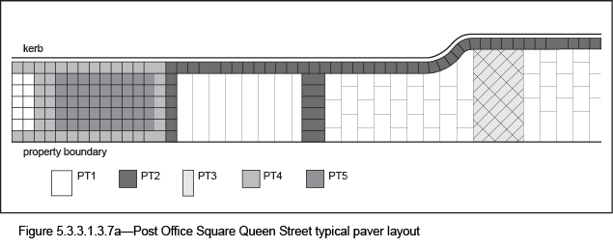

5.3.3.1.3.8 Type 7 - Locality streetscape specifications (GPO Precinct)
The streetscape specifications for Type 7 Locality Street are outlined in Table 5.3.3.1.3.8A and shown in Figure 5.3.3.1.3.8a.

Table 5.3.3.1.3.8A – Streetscape type and specifications
Component | Type 7 - Design specifications
Verge width | As existing
Pavement width | Full width pavement
Unobstructed pavement | 2.4m
Main body paving type (PT1) | Match existing.  Supplier: The Tile Factory or approved equivalent  Material: Granite paver  Code: HG6013  Size: 895mm x 595mm x 30 mm  Finish: exfoliated
Banding paver type (PT2) | Match existing.  Supplier: The Tile Factory or approved equivalent  Material: Granite paver  Code: HG6007  Size: 695mm x 395mm 30 mm  Finish: exfoliated
Tree square detail paver type (PT4) | Match existing.  Supplier: The Tile Factory or approved equivalent  Material: Granite paver  Code: HG6052  Size: 585mm x 585mm x 30mm  Finish: Honed – light sand blast
Corner detail paver – tree pit (PT6) | Match existing.  Supplier: The Tile Factory or approved equivalent  Material: Granite paver  Code: HG332  Size: 585mm x 585mm x 30mm  Finish: Honed – light sand blast
Pedestrian ramp tactiles (PT8) | Match existing.  Supplier: The Tile Factory or approved equivalent  Material: Granite paver  Code: HG6007  Size: 395mm x 395mm x 30 mm  Finish: exfoliated
Diagonal detail paver type (PT3) | Match existing  Supplier: The Tile Factory or approved equivalent  Material: Granite paver  Code: HG6016  Size: 295mm x 595mm x 30 mm  Finish: exfoliated
Corner detail paver (PT5) | Match existing.  Supplier: The Tile Factory or approved equivalent  Material: Granite paver  Code: HG332  Size: 585mm x 585mm x 30mm  Finish: Honed – light sand blast
Banding manor apartment/ Suncorp Metway (PT7) | Match existing.  Supplier: The Tile Factory or approved equivalent  Material: Granite paver  Code: HG6013  Size: 395mm x 395mm x 30 mm  Finish: exfoliated
Tactile markers  (consistent with BSD-5218) | Type: Concrete tactile pavers  Supplier: ‘Chelmstone’, ‘Urbanstone’ or approved equivalent  Colour: CCS ‘Voodoo'
Driveways | Honed coloured concrete to match footway.
Furniture | All furniture is to be located outside of the unobstructed pavement area.  Furniture elements and layout requirements are to be agreed on a site by site basis through the development assessment process.  Refer to 3.7.6 Design standards for street furniture for standard furniture elements and specifications.
Trees | Refer to 5.3.3.1.4 Planting.
Garden beds | None.

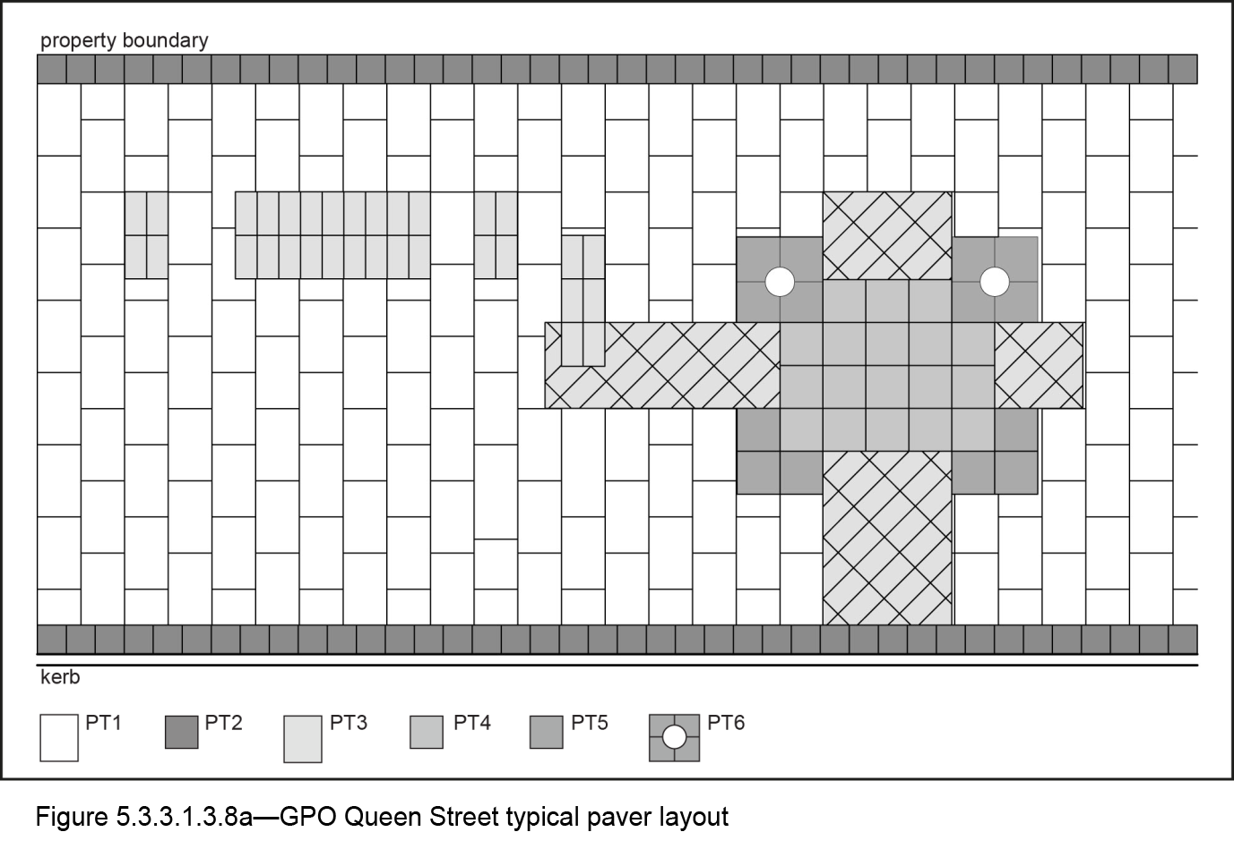

5.3.3.1.3.9 Type 8 - Locality streetscape specifications (Eagle Street Precinct)
The streetscape specifications for Type 8 Locality Street are outlined in Table 5.3.3.1.3.9A and shown in Figure 5.3.3.1.3.9a.

Table 5.3.3.1.3.9A – Streetscape type and specifications
Component | Type 8 - Design specifications
Verge width | 5m
Pavement width | Full width pavement
Unobstructed pavement | 2.4m
Pedestrian pavement | Match existing.  Supplier: Tilecorp or approved equivalent  Material: Italian Porphyry  Size & Finish: match existing
Pedestrian pavement highlight band | Match existing.  Supplier: Tilecorp or approved equivalent  Material: Travertine banding  Size & Finish:  match existing
Pedestrian pavement highlight band | Match existing.  Supplier: Tilecorp or approved equivalent  Material: Italian Porphyry banding  Size & Finish:  match existing
Tactile markers  (consistent with BSD-5218) | Type: Concrete tactile paver  Supplier: Chelmstone, Urbanstone or approved equivalent  Colour: CCS ‘Pewter’
Driveways | Honed coloured concrete to match footway.
Furniture | All furniture is to be located outside of the unobstructed pavement area.  Furniture elements and layout requirements are to be agreed on a site by site basis through the development assessment process.  Refer to 3.7.6 Design standards for street furniture for standard furniture elements and specifications.
Trees | Refer to 5.3.3.1.4 Planting.
Garden beds | None.

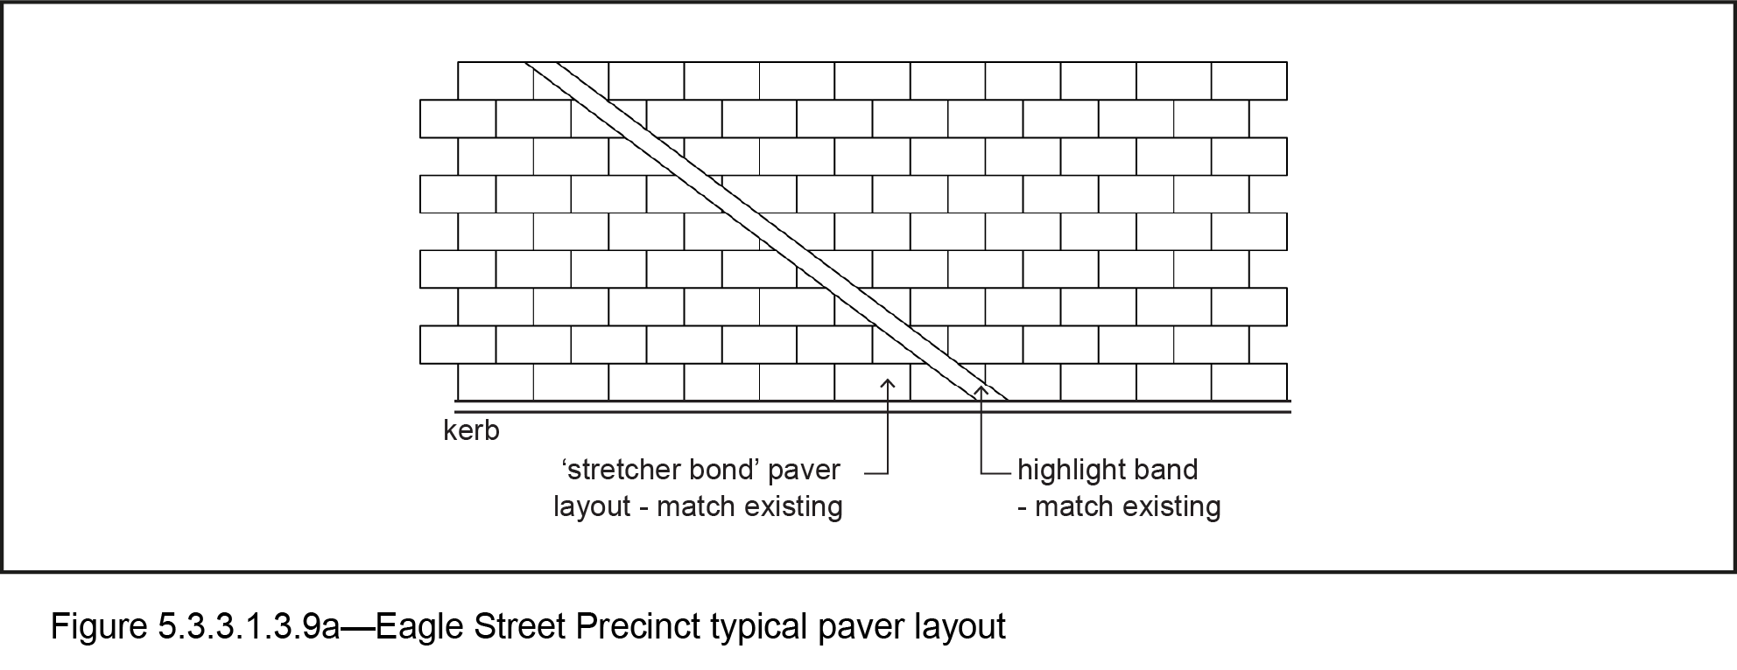

5.3.3.1.3.10 Type 9 - Locality streetscape specifications (Gardens Point Road)
The streetscape specifications for Type 9 Locality Street are outlined in Table 5.3.3.1.3.10A and shown in Figure 5.3.3.1.3.10a.

Table 5.3.3.1.3.10A – Streetscape type and specifications
Component | Type 9 - Design specifications
Verge width | As existing
Pavement width | Full width pavement
Unobstructed pavement | 2.4m
Honed saw cut concrete (PT1) | Match existing.  Supplier: Hanson (Racona - code 10040798) or approved equivalent  Material: Concrete  Style: Kolormasta  Colour: Concrete Colour Systems ‘liquorice’ or approved equivalent  Aggregate: 90% ‘Blue Heeler’/ 10% ‘Winter Brown’  Finish: Honed, saw cut pattern
Granite pavers fixed on concrete slab (PT2) | Match existing.  Supplier: Urbanstone or approved equivalent  Material: 600x400x40mm Granite Pavers  Colour: Juperana (colour of pavers to be approved )  Finish: Exfoliated and sealed - Crommelin Stain Repel  Layout Pattern:  Stretcher bond – set out to match existing
Broom finished concrete (PT3) | Match existing.  Portland grey concrete  Finish: Broom finish
Porous paving (PT4) | Match existing.  Supplier: Stoneset  Material: 70mm Porous Paving – 6mm crushed rock  Colour: to match existing or approved equivalent
Tactile markers  (consistent with BSD-5218) | Type: Concrete paver 300 x 300mm  Supplier: ‘Chelmstone’, ‘Urbanstone’ or approved equivalent  Colour: CCS 'Voodoo'
Driveways | Honed coloured concrete to match footway.
Furniture | All furniture is to be located outside of the unobstructed pavement area.  Furniture elements and layout requirements are to be agreed on a site by site basis through the development assessment process.  Refer to 3.7.6 Design standards for street furniture for standard furniture elements and specifications.
Trees | Refer to 5.3.3.1.4 Planting.
Garden beds | None.

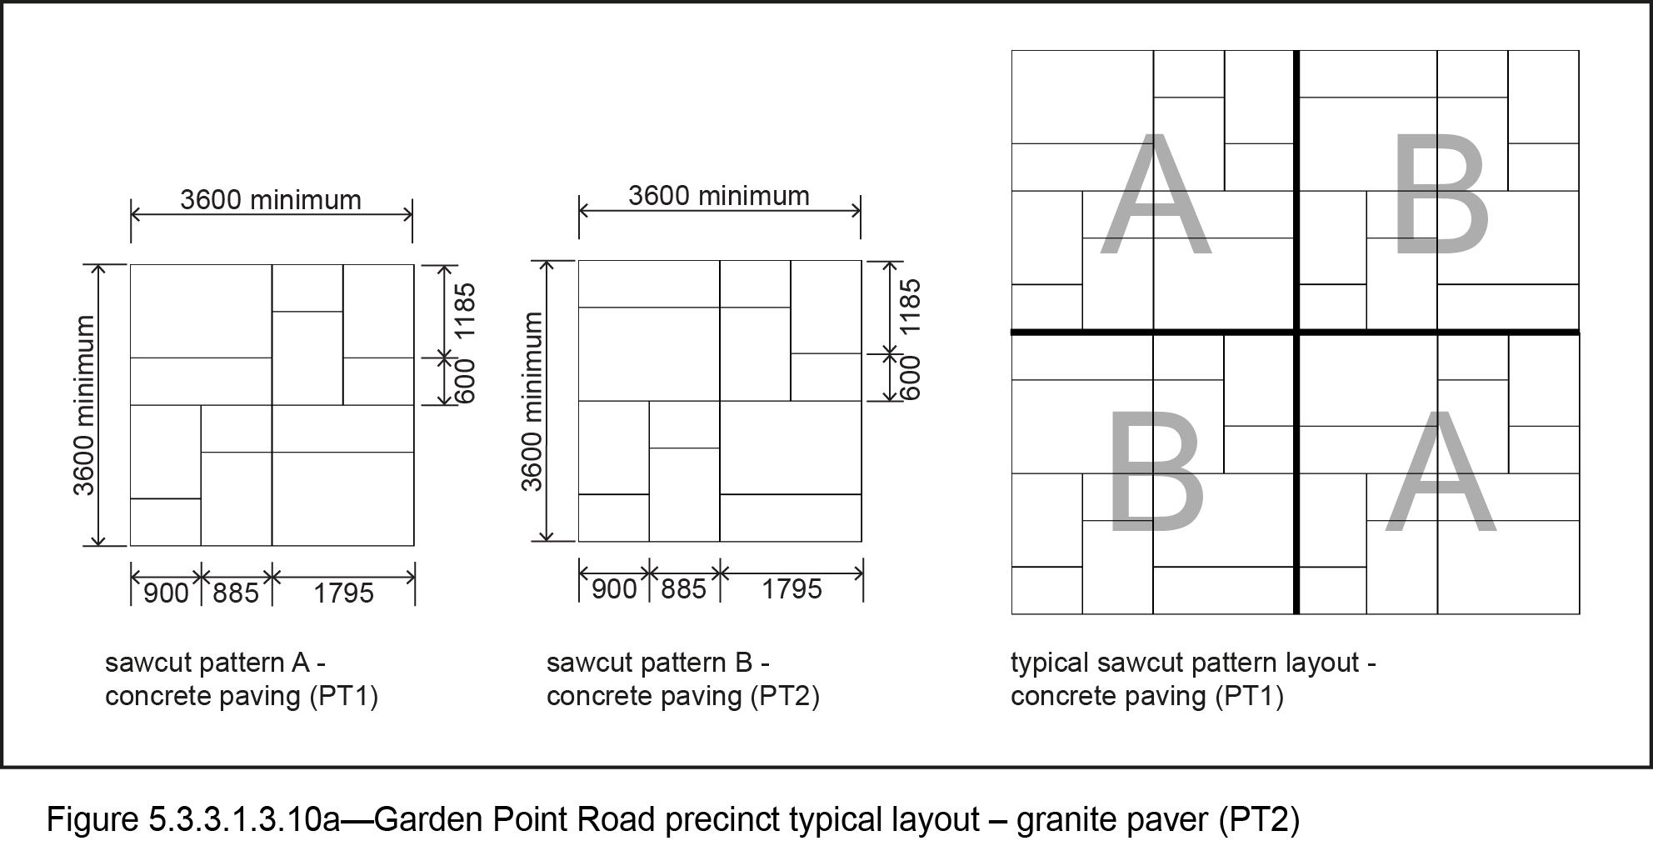

5.3.3.1.3.11 Type 10 - Locality streetscape specifications (Park edge)
The streetscape specifications for Type 10 Locality Street are outlined in Table 5.3.3.1.3.11A.

Table 5.3.3.1.3.11A – Streetscape type and specifications
Component | Type 10 - Design specifications
Verge width | As existing
Pavement width | Full width pavement
Unobstructed pavement | 2.4m
Paving materials | Type: Honed coloured concrete with sawcut pattern.  Supplier: Hanson (code 10050284), Boral or approved equivalent.  Colour: CCS ‘Liquorice’ 90% ‘Blue Heeler’ + 10% ‘Winter Brown’
Tactile markers  (consistent with BSD-5218) | Type: Concrete tactile pavers  Supplier: Chelmstone, Urbanstone or approved equivalent  Colour: CCS ‘Voodoo’
Driveways | Honed coloured concrete to match footway
Furniture | All furniture is to be located outside of the unobstructed pavement area.  Furniture elements and layout requirements are to be agreed on a site by site basis through the development assessment process.  Refer to 3.7.6 Design standards for street furniture for standard furniture elements and specifications.
Trees | Refer to 5.3.3.1.4 Planting.
Garden beds | Garden beds – minimum widths: 1.6m.  A garden bed located adjacent to the kerb has a:  - 1.5m minimum spacing between garden beds;  - Maximum length of 10m;  - Layout and length to accommodate car parking and other kerbside allocation.

5.3.3.1.3.12 Type 11 - Locality streetscape specifications (Albert Street)
The streetscape specifications for Type 11 Locality Street are outlined in Table 5.3.3.1.3.12A.

Table 5.3.3.1.3.12A – Streetscape type and specifications
Component | Type 11 - Design specifications
Verge width | 5m
Pavement width | Full width pavement
Unobstructed pavement | 2.4m
Paving materials | Type: Honed coloured concrete with sawcut pattern.  Supplier: Hanson (code 10050284), Boral or approved equivalent.  Colour: CCS ‘Liquorice’ 90% ‘Blue Heeler’ + 10% ‘Winter Brown’
Tactile markers  (consistent with BSD-5218) | Type: Concrete tactile pavers  Supplier: Chelmstone, Urbanstone or approved equivalent  Colour: CCS ‘Voodoo’
Driveways | Honed coloured concrete to match footway
Furniture | All furniture is to be located outside of the unobstructed pavement area.  Furniture elements and layout requirements are to be agreed on a site by site basis through the development assessment process.  Refer to 3.7.6 Design standards for street furniture for standard furniture elements and specifications.
Trees | Refer to 5.3.3.1.4 Planting
Garden beds | Garden beds – minimum widths: 1.6m.  A garden bed located adjacent to the kerb has a:  - 1.5m minimum spacing between garden beds;  - Maximum length of 10m;  - Layout and length to accommodate car parking and other kerbside allocation and footpath dining provision.

5.3.3.1.4 Planting
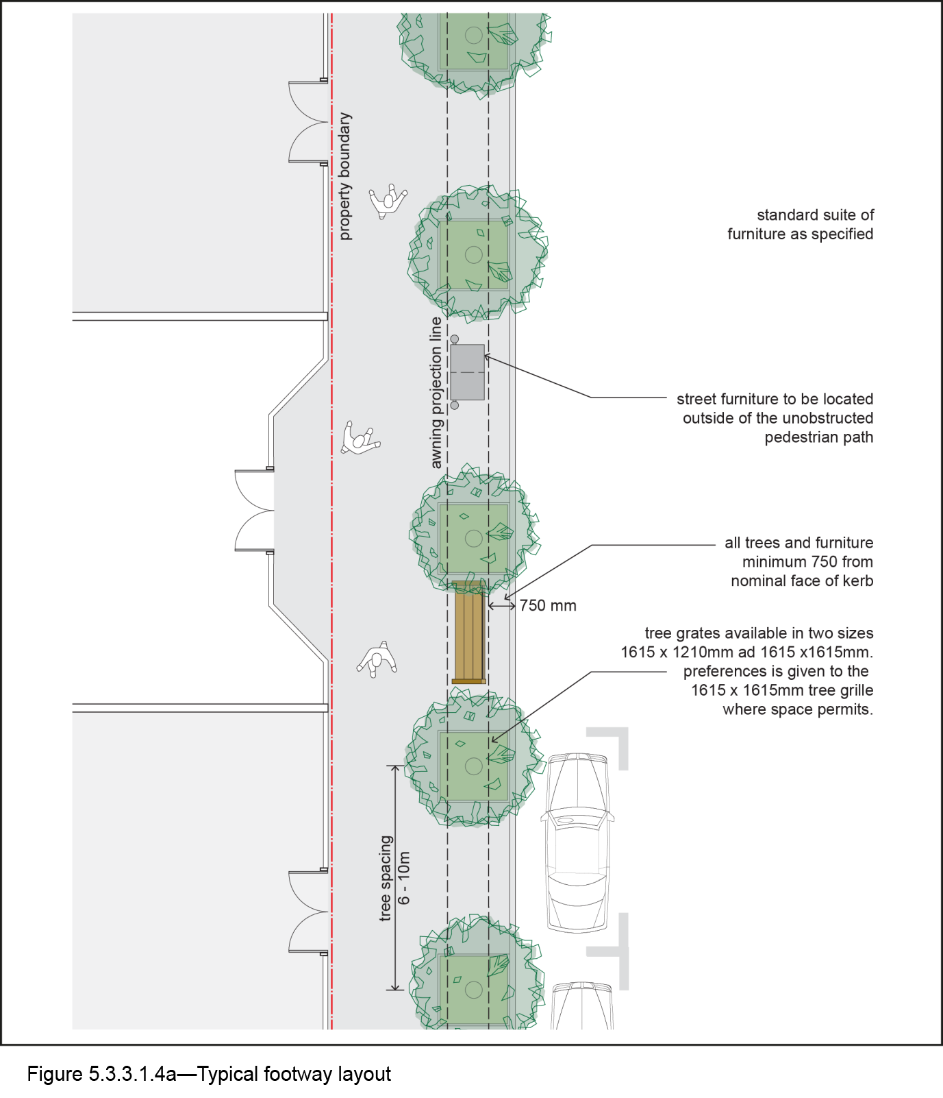

5.3.3.1.4.1 Street trees
- Street trees are permitted in all streets within the City Centre as determined on a site-by-site basis.
- Table 5.3.3.1.4.3A sets out the approved street tree species for use on the various streets within the City Centre.
- Street trees are to be planted with 1.6m x 1.6m tree grates where footway width permits.
- Elsewhere, 1.615m long x 1.21m tree grates are to be used, as per Figure 5.3.3.1.4a.
- The layout of street trees is as follows:
- a mix of species, in a single row at the rear of kerb;
- to be planted as singles and in pairs or clusters.
- Trees are planted in garden beds or tree grates.
- All tree centrelines are 750mm from the nominal face of the kerb and a minimum of 600mm from the edges of the pavement.
- Streets in the City Centre include:
- a mix of tree species laid out in an informal manner with clusters of trees;
- medium and small crown trees to be planted at minimum 2m spacing, if within garden beds, or minimum 6m spacing outside of garden beds;
- large crown feature trees to be planted at minimum 10m centres.

5.3.3.1.4.2 Traffic islands
- There are a number of locations in the City Centre where there are large traffic islands populated by very well-established trees – including figs and jacarandas.
- Table 5.3.3.1.4.3B provides a list of street tree species for traffic islands.

5.3.3.1.4.3 Garden beds
The high volume of pedestrian traffic makes the application of garden beds unsuitable for most parts of the City Centre, with the exception of Albert Street and Wickham Terrace, where garden beds are supported.
- Shrub and groundcover species are to be selected from Table 5.3.3.1.4C.
.

Table 5.3.3.1.4.3A—Street trees
Street | Street trees
Adelaide Street – between Boundary and Queen Streets | Waterhousia floribunda
Adelaide Street – between Queen and Edward Streets | Flindersia brayleyana
Adelaide Street – between Edward Street and North Quay | Caesalpinea ferrea
Albert Street – between Alice and Elizabeth Streets | Colvillea racemosa  Flindersia australis  Flindersia brayleana  Grevillea baileyana Hymenosporum flavum
Albert Street – between Elizabeth and Adelaide Streets | Waterhousia floribunda
Alice Street roundabout junction with Edward Street | Jacaranda mimosifolia
Alice Street – western side, between Edward and George Streets  Note: Overhanging mature figs along the edge of the City Botanic Gardens preclude planting on the eastern side of the street. | Agathis robusta
Alice Street – between George and William Streets | Agathis robusta
Ann Street | Flindersia australis
Charlotte Street – between George and Edward Streets | Flindersia australis
Charlotte Street – between Edward and Eagle Streets | Harpullia pendula
Creek Street – between Charlotte and Elizabeth Streets | Agathis robusta & Bauhinia variegata
Creek Street – between Elizabeth and Adelaide Streets | Flindersia brayleyana & Bauhinia variegata
Creek Street – between Adelaide and Ann Streets | Bauhinia variegata
Eagle Street | Agathis robusta
Edward Street – between Turbot Street and Wickham Terrace | Tabebuia impetiginosa
Edward Street – between Turbot and Ann Streets | Bauhinia variegata & Tabebuia impetiginosa
Edward Street – between Ann and Adelaide Streets | Bauhinia variegata
Edward Street – between Adelaide and Mary Streets | Waterhousia floribunda
Edward Street – between Mary and Margaret Streets | Harpullia pendula & Bauhinia variegata
Edward Street – between Margaret and Alice Streets | Harpullia pendula
Elizabeth Street – between Creek and George Streets | Harpullia pendula
Elizabeth Street – between George and William Streets | Syagrus romanzoffiana
Felix Street | Harpullia pendula
Garrick Street | Agathis robusta
George Street – between Roma and Alice Streets | Flindersia australis  Podocarpus elatus  Syagrus romanzoffiana  Waterhousia floribunda
Herschel Street | Jacaranda mimosifolia
Howard Street | Harpullia pendula
Makerston Street | Agathis robusta
Margaret Street – between North Quay and Edward Street | Harpullia pendula
Margaret Street – between Edward and Felix Streets | Agathis robusta
Market Street | Elaeocarpus obovatus  Xanthostemon chrysanthus
Mary Street – between Eagle and Edward Streets | Harpullia pendula
Mary Street – between Edward and George Streets | Harpullia pendula  Elaeocarpus obovatus
May Street | Agathis robusta
North Quay – northern side | Araucaria cunninghamii
North Quay – southern side | Elaeocarpus obovatus
Queen Street – between Boundary and Adelaide Streets | Flindersia australia Waterhousia floribunda
Queen Street – between Wharf and Creek Streets | Agathis robusta
Queen Street –between Creek and Edward Streets | Agathis robusta  Harpullia pendula  Livingstonia australis
Queen Street – between George Street and North Quay | Waterhousia floribunda
Roma Street Boulevard | Araucaria cunninghamii  Ficus spp.
Saul Street | Araucaria cunninghamii
Tank Street | Podocarpus elatus
Turbot Street – between Wharf and Raff Streets | Flindersia schottiana & Tabebuia impetiginosa
Turbot Street – between Edward and Albert Streets | Agathis robusta
Turbot Street –between Albert Street and North Quay | Flindersia schottiana
Upper Albert Street | Colvillea racemosa  Flindersia australis  Flindersia brayleana  Grevillea baileyana  Hymenosporum flavum
Wickham Terrace – northern side between Edward and Turbot Streets | Harpullia pendula
Wickham Terrace – northern side between Edward and Albert Streets | Flindersia australis  Agathis robusta  Ficus benjamina  Araucaria cunninghamii
Wickham Terrace – between Albert and Leichhardt Streets | Araucaria cunninghamii  Agathis robusta  Ficus benjamina  Elaeocarpus eumundi  Flindersia schottiana  Colvillea racemosa
Wickham Terrace – between Leichhardt Street and Gregory Terrace | Flindersia schottiana  Ficus microcarpa var. Hillii  Colvillea racemosa
Wharf Street – between Turbot and Ann Streets | Agathis robusta
Wharf Street – between Ann and Queen Streets | Flindersia Australis  Flindersia brayleyana
William Street between Alice and Queen Streets | Syagrus romanzoffiana  Bauhinia variegata
Queen’s Gardens Park – George, Elizabeth and William Street frontages | Syagrus romanzoffiana

Table 5.3.3.1.4.3B—Traffic island street trees
Street Intersection | Street Trees
Creek, Elizabeth and Eagle Streets | Ficus virens and Ficus benghalensis
North Quay and Skew Streets | Ficus sp. and Jacaranda mimosifolia
Queen and Eagle Streets | Ficus benjamina
Skew and Saul Streets | Ficus sp. and Jacaranda mimosifolia

Table 5.3.3.1.4.3C—Shrub and groundcover species
Shrub and groundcover species | Common name
Dianella sp. | Dianella
Liriope ‘Evergreen Giant’ | Liriope
Liriope ‘Stripey White’ | Variegated Liriope
Trachelospermum jasminoides ‘Tricolour’ | Variegated Star Jasmine

