5.2.19.1 Sandgate

5.2.19.1.1 Location and extent
The location and extent of the Locality streets in the Sandgate Suburban Centre Improvement Project (SCIP) are identified in Figure 5.2.19.1.1a and in the Streetscape hierarchy overlay map.
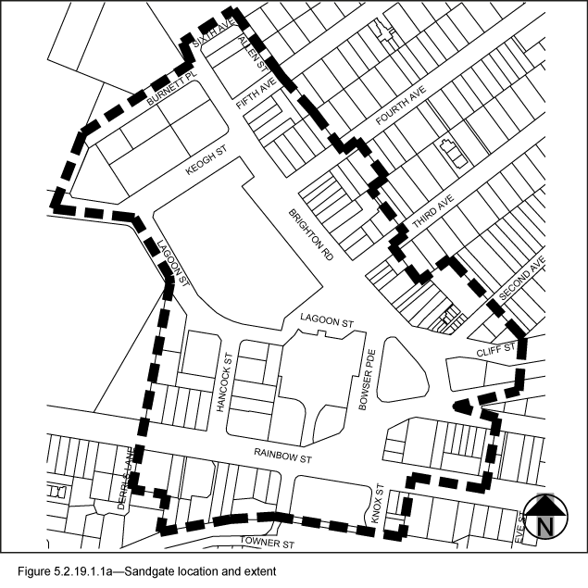

5.2.19.1.2 Locality street specifications
- The design specifications for footway surfacing for the Locality streets in the Sandgate SCIP are identified in Table 5.2.19.1.2.A.
- These locality guidelines are to be read in conjunction with Chapter 3 – Road corridor design of the Infrastructure design planning scheme policy.
- Footway upgrades are to include new surfacing, new or reinstated kerb and channel, driveways, pedestrian kerb crossings, tactile markers, roof water drainage line connections, service pit lids, street trees, garden beds, furniture and pedestrian lighting applicable to the streetscape type.
- The scope, layout and detail of the footway upgrades are to be agreed on a site by site basis through the development assessment process.

Table 5.2.19.1.2.A— Sandgate SCIP Locality streetscape type and specifications
Component | Design specifications
Verge width | As existing
Description | Full width pavement
Unobstructed pavement width | 2.4m
Paving materials | Type: Exposed aggregate concrete  Supplier: Hanson or approved equivalent  Colour: ‘Country Gold’
Tactile markers  (consistent with BSD-5218) | Type: Concrete paver  Supplier: Chelmstone, Urbanstone or approved equivalent  Colour: CCS 'Voodoo'
Driveways | To match adjacent footpath finish.
Furniture | All furniture is to be located outside of the unobstructed pavement area.  Paint colour and finish:  (a) For tree grates - Interpon D1000 Sable Bass Texture GN297A, or approved equivalent.  (b) For all other furniture - Dulux ‘Metropolis Storm Pearl’ (88471) in 'Satin' finish, or approved equivalent.  Refer to 3.7.6 Design standards for street furniture.
Trees | All tree centrelines are 750mm from the nominal face of the kerb and a minimum of 600mm from the edges of the pavement.  Streets trees include:  - a mix of tree species laid out in an informal manner with clusters of trees;  - medium and small crown trees to be planted at minimum 2m spacing, if within garden beds, or minimum 6m spacing outside of garden beds;  - large crown feature trees to be planted at minimum 10m centres.  Layout:  - a mix of species, in a single row at the rear of kerb;  - to be planted as singles and in pairs or clusters.  Planting: Trees are planted in garden beds or tree grates (1.6m x 1.2m minimum).
Garden beds | A garden bed located adjacent to the kerb has a:  - 1.5m minimum spacing between garden beds;  - maximum length of 10m;  - layout and length to accommodate car parking and other kerbside allocation.  Garden bed minimum width: 1.2m

5.2.19.1.3 Preferred plant species
The preferred plant species for the Locality streets in Sandgate are stated in Table 5.2.19.1.3.A.

Table 5.2.19.1.3.A—Plant species
Trees | Shrubs and groundcovers
Cupaniopsis anacardioides  Delonix regia  Ficus benjamina  Jacaranda mimosifolia  Waterhousia floribunda | Abelia grandiflora – dwarf  Cuphea hyssopifolia – mauve  Dianella caerulea  Dietes bicolour  Erigeron karvinskianus  Helichrysum aplexans  Helichrysum ramossissimum  Liriope ‘Evergreen Giant’  Liriope muscari  Ophiopogon japonicus  Pittosporum ‘Miss Muffett’  Rondeletia amoena  Serissa foetida

