7.2.14.2 Newstead and Teneriffe waterfront neighbourhood plan code

7.2.14.2.1 Application
- This code applies to assessing a material change of use, reconfiguring a lot, operational work or building work in the Newstead and Teneriffe waterfront neighbourhood plan area if:
- assessable development where this code is an applicable code identified in the assessment benchmarks column of a table of assessment for a neighbourhood plan (section 5.9); or
- impact assessable development.
- Land in the Newstead and Teneriffe waterfront neighbourhood plan area is identified on the NPM-014.2 Newstead and Teneriffe waterfront neighbourhood plan map and includes the following precincts:
- Waterfront precinct (Newstead and Teneriffe waterfront neighbourhood plan/NPP-001);
- Commercial Road precinct (Newstead and Teneriffe waterfront neighbourhood plan/NPP-002):
- Heritage sub-precinct (Newstead and Teneriffe waterfront neighbourhood plan/NPP-002a);
- Riverside sub-precinct (Newstead and Teneriffe waterfront neighbourhood plan/NPP-002b).
- Riverpark precinct (Newstead and Teneriffe waterfront neighbourhood plan/NPP-003);
- When using this code, reference should be made to section 1.5, section 5.3.2 and section 5.3.3.
Note—The following purpose, overall outcomes, performance outcomes and acceptable outcomes comprise the assessment benchmarks of this code.
Note—This neighbourhood plan includes a table of assessment with variations to categories of development and assessment. Refer to Table 5.9.51.A, Table 5.9.51.B, Table 5.9.51.C and Table 5.9.51.D.

7.2.14.2.2 Purpose
- The purpose of the Newstead and Teneriffe waterfront neighbourhood plan code is to provide finer grained planning at a local level for the Newstead and Teneriffe waterfront neighbourhood plan area.
- The purpose of the Newstead and Teneriffe waterfront neighbourhood plan code will be achieved through overall outcomes including overall outcomes for each precinct of the neighbourhood plan area.
- Overall outcomes for the neighbourhood plan area are:
- Newstead and Teneriffe waterfront continues its transition from a former industrial area to a compatible mix of residential, commercial, and recreational activities.
- Development is of a height, scale and form which is consistent with the amenity and character, community expectations and infrastructure assumptions intended for the relevant precinct, sub-precinct or site and is only developed at a greater height, scale and form where there is both a community need and an economic need for the development.
- Buildings are designed to present an attractive frontage that enhances the streetscape and other public spaces.
- Existing public open spaces (including Powerhouse Park) are retained, and new major public open space facilities are established in the Riverpark precinct (Newstead and Teneriffe waterfront neighbourhood plan/NPP-003).
- Development contributes to streetscape works that enhance the character and amenity of the street.
- Historical features such as the former woolstores and gasworks are conserved and re-used.
- Views to the City Centre from Kingsford Smith Drive are retained. These views are considered an important arrival statement for the city.
- New development assists in providing community facilities to meet the needs of the growing local community.
- A range of housing types and sizes are provided, including affordable housing, to meet the diverse needs of the future population.
- Waterfront precinct (Newstead and Teneriffe waterfront neighbourhood plan/NPP-001) overall outcomes are:
- This precinct primarily accommodates mid-rise multiple dwellings and detached residential dwellings, along with small shops, offices, and, food and drink outlets at ground level.
- Any non-residential components of a development are of a small scale and local nature that is compatible with the area’s residential character and amenity.
- Building scale, height and design maintains the dominance of former woolstores and sugar refinery buildings and transitions down to nearby low density and character residential areas in order to preserve the amenity of those areas.
- Commercial Road precinct (Newstead and Teneriffe waterfront neighbourhood plan/NPP-002) overall outcomes are:
- This precinct is to be transformed into a medium to high density urban community.
- Development takes advantage of improved public transport in the area, including the CityGlider bus service and CityCat ferry terminal.
- Residential and commercial uses are encouraged throughout the precinct, with a focus on commercial uses along Commercial Road and Longland Street. Retail development is of a small scale and does not contain large shops.
- New built form will reflect the existing building character of the area through a built to side boundary podium other than in the Riverside sub-precinct (Newstead and Teneriffe waterfront neighbourhood plan/NPP-002b) and a clearly defined and set back tower element.
- Building height is highest on large sites along Longland Street, Commercial Road and Skyring Terrace. Smaller and narrower sites accommodate correspondingly shorter buildings, while taller towers adopt a more slender form minimising the appearance of building bulk.
- Developments within the defined view corridor preserve views of the City Centre from Kingsford Smith Drive.
- Development incorporates a rear setback area that contributes to the precinct’s open space and is used as a vegetated recreational area for building residents or workers.
- On Stratton Street, Kyabra Street, Doggett Street and Masters Street, deep planting is established within the front setback to shade pedestrians.
- A network of pedestrian links facilitates safe and efficient movement of pedestrians through the precinct and to the river.
- Development in the Heritage sub-precinct (Newstead and Teneriffe waterfront neighbourhood plan/NPP-002a):
- contributes towards creating strong visual and architectural links with the Waterfront precinct (Newstead and Teneriffe waterfront neighbourhood plan/NPP-001);
- complements the prevailing built to front and side boundary character of the area including the former woolstores and other heritage buildings, and forms a transition zone between the character area in the northern part of the Waterfront precinct (Newstead and Teneriffe waterfront neighbourhood plan/NPP-001) and the higher density built form of the Commercial Road precinct (Newstead and Teneriffe waterfront neighbourhood plan/NPP-002);
- achieves a scale and design of development that maintains the visual dominance of the former woolstores' built form.
- For development in the Riverside sub-precinct (Newstead and Teneriffe waterfront neighbourhood plan/NPP-002b):
- the two major industrial facilities (being an electricity substation and sub-transmission tower and a sand-mining transport operation) may continue in their present form, but in the event of the relocation of either facility, redevelopment is intended to take the form of a high-quality predominantly residential development that addresses the significant river frontage;
- retail and restaurant uses are provided on the lower levels to activate and survey Skyring Terrace, Commercial Road and the river;
- outdoor dining that addresses the Riverwalk is encouraged;
- any commercial activities will be subordinate to the primary residential use of the site and be contained within the podium levels;
- a podium element at a height that is complementary to the nearby former woolstore buildings is incorporated, with a tower above. The tower is set well back from the river to reflect the predominant low- to mid-rise riverside built form in Newstead and Teneriffe;
- tower heights form a transition between the taller buildings of the Commercial Road precinct (Newstead and Teneriffe waterfront neighbourhood plan/NPP-002) and Riverpark precinct (Newstead and Teneriffe waterfront neighbourhood plan/NPP-003) and the shorter buildings of the Waterfront precinct (Newstead and Teneriffe waterfront neighbourhood plan/NPP-001);
- a break in the buildings facilitates views and breezes from Helen Street to the river;
- any proposal while the electricity substation, sub-transmission tower or powerlines remain operational demonstrates that residents/workers will not be subject to unacceptable health and safety impacts arising from the electricity infrastructure;
- building design should be informed by the ongoing visual prominence of the sub-transmission tower.
- Riverpark precinct (Newstead and Teneriffe waterfront neighbourhood plan/NPP-003) overall outcomes are:
- The precinct is an integrated community of residential, shopping, business and employment activities located around a large parkland area.
- The precinct will provide a substantial amount of residential and commercial floor space that is proportionate to the precinct’s city fringe location and level of access to public transport.
- Buildings are located to maintain an open, parkland setting.
- The precinct will have a varied built form that includes mid- and high-rise buildings that are designed to minimise the appearance of building bulk and incorporate active frontages.
- Building heights are subordinate to the Valley heart precinct (Fortitude Valley neighbourhood plan/NPP-002) and do not compromise aircraft safety or the operational airspace of the Brisbane Airport.
- Buildings along the river complement the low- to mid-rise character of this reach of the river.
- Buildings within the defined view corridor preserve views of the City Centre from Kingsford Smith Drive.
- The western part of the precinct is developed as a mixed use destination providing a gateway into the parkland area and Fortitude Valley. A district shopping centre including a supermarket may be established in the vicinity of Longland Street.
- It is intended that residential uses dominate towards the riverfront, with active uses at ground level throughout the precinct.
- Buildings on the periphery of the precinct present active frontages to surrounding streets and facilitate safe and convenient pedestrian access to and from adjoining precincts.
- Buildings are designed and sited to retain the Gasometer as a focal point for the area and visual reminder of the site’s history, and preserve significant views through the precinct and to the river.
- A large parkland area will be established between Skyring Terrace and the river, as well as a major public space in and around the Gasometer.

7.2.14.2.3 Performance outcomes and acceptable outcomes

Table 7.2.14.2.3.A—Performance outcomes and acceptable outcomes
Performance outcomes | Acceptable outcomes
General
PO1  Development is of a height, scale and form that achieves the intended outcome for the precinct, improves the amenity of the neighbourhood plan area, contributes to a cohesive streetscape and built form character and is:  - consistent with anticipated density and assumed infrastructure demand;  - aligned to community expectations about the number of storeys to be built;  - proportionate to and commensurate with the utility of the site area and frontage width;  - designed to avoid significant and undue adverse amenity impact to adjoining development;  - sited to enable existing and future buildings to be well separated from each other and avoid affecting the potential development of adjoining sites.  Note—Development that exceeds the intended number of storeys or building height can place disproportionate pressure on the transport network, public space or community facilities in particular.  Note—Development that is over-scaled for its site can result in an undesirable dominance of vehicle access, parking and manoeuvring areas that significantly reduce streetscape character and amenity. | AO1  Development complies with the number of storeys and building heights in Table 7.2.14.2.3.B.  Note—Neighbourhood plans will mostly specify a maximum number of storeys where zone outcomes have been varied in relation to building height. Some neighbourhood plans may also specify height in metres. Development must comply with both parameters where maximum number of storeys and height in metres are specified.
PO2  Development located on the river, contributes to the provision of a continuous riverside bikeway/walkway (Riverwalk) linking Newstead Park with New Farm Park which:  - is fully accessible by the public and provides a variety of opportunities for recreation and rest in a pleasant environment;  - provides links to the adjoining riverfront properties and street network;  - establishes a high degree of pedestrian amenity though tree planting, furniture, lighting, balustrades, pavement treatment and public art. | AO2.1  Development on premises adjoining  the river provides:  - a fully publicly accessible Riverwalk that is dedicated to the Council and has a minimum unobstructed pavement width of 4.5m and a minimum overall corridor width of 6m as indicated in Figure f;  - tree planting, furniture, lighting, balustrading, pavement treatment and public art within the Riverwalk area in accordance with the specifications in the Public riverside facilities section of the Infrastructure design planning scheme policy;  - connections between the Riverwalk and the adjoining riverfront properties and street network.
AO2.2
Development provides a landscaped seating node in the location identified in Figure a, designed in accordance with the specifications in the Public riverside facilities section of the Infrastructure design planning scheme policy.
PO3  Development on Breakfast Creek Road and Commercial Road west of Helen Street provides:  - a widened public footpath that caters for a high volume of pedestrian traffic  - a double row of street tree planting on Breakfast Creek Road. | AO3  Development on Breakfast Creek Road and Commercial Road west of Helen Street dedicates a linear land contribution to the Council sufficient to provide a 5m wide public footpath along these streets.
PO4  Development contributes to an integrated pedestrian network that facilitates the safe and efficient movement of pedestrians through the precinct and to the river. | AO4  Development provides arcades:  - on development sites that include land within the indicative locations for arcades as shown in Figure a where the development site spans the 2 streets to be connected;  - between Skyring Terrace and the river in the locations identified in Figure a.
PO5  Development conserves and re-uses historical features (including the former woolstores and gasworks) for a range of activities. | AO5  No acceptable outcome is prescribed.
If in the Waterfront precinct (Newstead and Teneriffe waterfront neighbourhood plan/NPP-001)
PO6  Development scale and design:  - is consistent with the intended height, bulk and character of the relevant precinct as indicated in Figure b;  - does not result in a density that would place disproportionate pressure on transport infrastructure, public space or community facilities;  - where located in the Waterfront precinct (Newstead and Teneriffe waterfront neighbourhood plan/NPP-001) maintains the former woolstores and sugar refinery buildings as the dominant built form elements, and transitions down to nearby low density and character residential areas. | AO6  Development ensures that a building’s gross floor area does not exceed 125% of the site area in the Waterfront precinct (Newstead and Teneriffe waterfront neighbourhood plan/NPP-001).
PO7  Development of multiple dwellings:  - is located on sites of sufficient area to achieve a coherent building and site layout that results in a pleasant, attractive and manageable living environment that does not impact on the amenity of adjoining properties;  - incorporates a landscaped buffer from the road alignment that is compatible with that of nearby multiple dwellings and ensures that buildings are not of an overbearing scale to pedestrians. | AO7.1  Development of a multiple dwelling has a minimum site area of 1,200m2.
AO7.2
Development of a multiple dwelling is set back a minimum of 3m from the road alignment and contains deep planting within this buffer.
If in the Waterfront precinct (Newstead and Teneriffe waterfront neighbourhood plan/NPP-001)
PO8  Development of a non-residential component is:  - of a small scale;  - located only on the ground storey of buildings;  - compatible with the overall residential character intended for the precinct and does not unreasonably reduce residential amenity;  - of a local nature that serves the needs of residents or users of the Riverwalk and does not attract significant vehicular traffic into the precinct. | AO8  No acceptable outcome is prescribed.
If in the Commercial Road precinct (Newstead and Teneriffe waterfront neighbourhood plan/NPP-002)
PO9  Development scale, height and design:  - is proportionate to the area and frontage of the site, and the intent of any sub-precinct in which development is proposed;  - minimises amenity impacts on other properties and public areas in terms of access to sunlight, daylight and breezes;  - enables existing and future buildings to be appropriately separated from each other to allow light penetration, air circulation, privacy and to ensure windows are not built out by adjoining buildings;  - complements the existing precinct character of low- to mid-rise bulky buildings through incorporating a low-level podium and a clearly defined and set-back tower element. Tall buildings adopt a more slender tower form that minimises the appearance of building bulk of the tower;  - if located within the view corridor to the CBD identified in Figure d, preserves views of the City Centre from Kingsford Smith Drive;  - if located within the Heritage sub-precinct (Newstead and Teneriffe waterfront neighbourhood plan/NPP-002a) complements the built-to-front-boundary character of the area, while preserving a large rear setback to allow light penetration and air circulation though the precinct. Buildings incorporate a podium height consistent with the prevailing height of the former woolstore buildings. Any tower is of a small size, and has large setbacks to all boundaries so as to maintain the visual dominance of the former woolstores' built form;  - if located within the Riverside sub-precinct (Newstead and Teneriffe waterfront neighbourhood plan/NPP-002b) incorporates a podium height consistent with the prevailing height of the former woolstore buildings, and incorporates a tower element that is well separated from the river so as to complement the area’s predominant low- to mid-rise riverside built form. Tower heights form a transition between the taller buildings of the Commercial Road precinct (Newstead and Teneriffe waterfront neighbourhood plan/NPP-002) and Riverpark precinct (Newstead and Teneriffe waterfront neighbourhood plan/NPP-003) and the shorter buildings of the Waterfront precinct (Newstead and Teneriffe waterfront neighbourhood plan/NPP-001).  Note—Maximum gross floor area provisions do not apply within the Commercial road precinct (Newstead and Teneriffe waterfront neighbourhood plan/NPP-002). | AO9.1  Development podium height complies with Table 7.2.14.2.3.B.
AO9.2
Development does not exceed 55m AHD where located within the view corridor to the CBD as shown in Figure d.
AO9.3
Development provides building setbacks in accordance with Table 7.2.14.2.3.C in the Commercial Road precinct (Newstead and Teneriffe waterfront neighbourhood plan/NPP-002).
AO9.4
Development where for a building over 10 storeys, towers have a maximum horizontal dimension of 40m and a maximum site cover of 40%.
AO9.5
Development where for a building up to
10 storeys tall, towers have a maximum horizontal dimension of 50m.
Note—Figure c illustrates the intended building height and setbacks in the Heritage sub-precinct (Newstead and Teneriffe waterfront neighbourhood plan/NPP-002a).

PO10  Development has a ground storeythat:  - presents an attractive frontage that is orientated to the street and the Riverwalk;  - reinforces a safe and attractive pedestrian environment by contributing to passive surveillance of the street and the Riverwalk. | AO10.1  Development of the ground storey, where fronting Longland Street, Commercial Road, Skyring Terrace or the river, includes a mix of retail, food and drink outlet and entertainment activities.
AO10.2
Development of buildings ensures that each ground storey dwelling unit has direct access to the street.
PO11  Development incorporates a vegetated area to provide for the recreational needs of residents and/or workers. | AO11  Development includes a vegetated recreational area in the rear setback area.
PO12  Development of a retail component is of a small scale and does not contain large shops. | AO12  No acceptable outcome is prescribed.
PO13  Development located in the Riverside sub-precinct (Newstead and Teneriffe waterfront neighbourhood plan/NPP-002b) is primarily residential, with any commercial uses limited to the podium levels and subordinate in scale to the residential uses. | AO13  No acceptable outcome is prescribed.
PO14  Development establishes deep planting areas within the building setback to Stratton Street, Kyabra Street, Doggett Street and Masters Street that reduces the appearance of building bulk and enhances the streetscape environment for pedestrians. | AO14  Development ensures that all building elements (including basement parking) are set back a minimum of 3m from the Stratton Street, Kyabra Street, Doggett Street and Masters Street frontages and establishes in-ground deep planting that contributes to footpath shading within this area.  Note—Figure e illustrates the intended streetscape and setbacks.
PO15  Development ensures that the design of development on sites between Wyatt Street and Wyandra Street maximises pedestrian and vehicular safety and amenity and reinforces Wyandra Street as an attractive streetscape. | AO15  Development on sites with a dual frontage to Wyatt Street and Wyandra Street has vehicular access only from Wyatt Street and provides pedestrian entries from both streets.
PO16  Development in the Riverside precinct (Newstead and Teneriffe waterfront neighbourhood plan/NPP-002b) incorporates a significant break in the buildings to facilitate breezes and views to the river along the Helen Street alignment. | AO16  Development in the Riverside precinct (Newstead and Teneriffe waterfront neighbourhood plan/NPP-002b) does not intrude into the 20m wide view and breeze corridor identified in Figure d.
PO17  Development where located in the Riverside sub-precinct (Newstead and Teneriffe waterfront neighbourhood plan/NPP-002b) demonstrates that residents and workers will not be subject to unacceptable health and safety impacts arising from the electricity substation, sub-transmission tower or powerlines, in accordance with the principle of prudent avoidance. | AO17  No acceptable outcome is prescribed.
If in the Riverpark precinct (Newstead and Teneriffe waterfront neighbourhood plan/NPP-003)
PO18  Development:  - contributes to the precinct achieving a density that accommodates significant residential and commercial floor space that is proportionate to the precinct’s city fringe location and level of access to public transport;  - is proportionate to the area of the site;  - located within the view corridor to the CBD identified in Figure d preserves views of the City Centre from Kingsford Smith Drive;  - does not compromise aircraft safety or the operational airspace of the Brisbane Airport;  - contributes to a varied built form that includes mid- and high-rise buildings;  - where adjacent to the river, adopts a built form that complements the area’s low- to mid-rise riverside character;  - maintains an open, parkland setting. | AO18.1  Development ensures that a building has a maximum gross floor area of 450% of the site area.
AO18.2
Development does not extend into the area identified as publicly owned public open space in Figure d.
PO19  Development:  - has a predominantly residential focus in the vicinity of the river and the large parkland area, and a mixed use function elsewhere;  - only provides retail uses at a scale that services local and district needs. | AO19  No acceptable outcome is prescribed.
PO20  Development:  - retains the Gasometer, and designs and sites buildings such that the Gasometer remains as a primary way-finding tool throughout the precinct;  - preserves views of the Gasometer from Breakfast Creek Road;  - preserves views from Waterloo Street and Skyring Terrace through to the river. | AO20  No acceptable outcome is prescribed.
PO21  Development:  - minimises the appearance of building bulk through a built form that consists of multiple discrete buildings and avoids lengthy unarticulated facades;  - enables existing and future buildings to be appropriately separated from each other to allow light penetration, air circulation, privacy and to ensure windows are not built out by adjoining buildings;  - minimises amenity impacts on other properties and public areas in terms of access to sunlight, daylight and breezes. | AO21.1  Development of buildings provides a minimum setback of 10m to all boundaries for all storeys above the 4th storey.
AO21.2
Development for buildings over 10 storeys has a maximum horizontal dimension of 50m for all storeys above the fourth storey.
PO22  Development:  - contributes to an attractive streetscape through the incorporation of active frontages to the ground level of buildings;  - contributes to passive surveillance and visual amenity by incorporating windows and balconies to upper floor facades;  - incorporates breaks in buildings to provide for a high level of visual and pedestrian permeability from adjoining areas, including the Commercial Road precinct;  - incorporates variations in materials and building form. | AO22  No acceptable outcome is prescribed.
PO23  Development provides:  - a large public open space (parkland) between Skyring Terrace and the river;  - a major public open space in and around the Gasometer. | AO23.1  Development establishes public open space in the area identified as publicly owned public open space in Figure d, and this area is dedicated to the Council.
AO23.2
Development of the area identified as privately owned public open space in Figure d is retained in private ownership, but provides fully publicly accessible open space. Only park-related structures are established above ground in this area, however private basement parking is permitted underground.
AO23.3
Development establishes a major public open space in and around the Gasometer.

Table 7.2.14.2.3.B—Maximum building and podium height
Development | Location | Primary street frontage | Maximum podium height(1) | Maximum building height (number of storeys) | Maximum building height (m)(1)
If in the Commercial Road precinct (Newstead and Teneriffe waterfront neighbourhood plan/NPP-002)
Development of a site less than 800m2 | All areas | Not specified | Not specified | 3 | Not specified
Development of a site 800m2 or greater but less than 1,200m2 | All areas | 20m or greater | 3 storeys | 6 | Not specified
Development of a site 1,200m2 or greater but less than 2,500m2 | All other areas | 30m or greater | 3 storeys | 8 | Not specified
 | Where building is located within 50m of Longland Street or Commercial Road |  |  | 10 | Not specified
Development of a site 2,500m2 or greater | All other areas | 30m or greater | 3 storeys | 8 | Not specified
 | Where building is located within 50m of Longland Street or Commercial Road |  | 4 storeys | 15 | Not specified
Development of a site in the Heritage sub-precinct (Newstead and Teneriffe waterfront neighbourhood plan/NPP-002a) less than 800m2 | All areas | Not specified | Not specified | 3 | Not specified
Development of a site in the Heritage sub-precinct (Newstead and Teneriffe waterfront neighbourhood plan/NPP-002a) 800m2 or greater but less than 1,200m2 | All areas | 20m or greater | Not specified | Not specified | 19 AHD(3)
Development of a site in the Heritage sub-precinct (Newstead and Teneriffe waterfront neighbourhood plan/NPP-002a) 1,200m2 or greater | All areas | 30m or greater | 19m AHD(2) | 8 | Not specified
Development of a site in the Riverside sub-precinct (Newstead and Teneriffe waterfront neighbourhood plan/NPP-002b) | All other areas | Not specified | 19m AHD(2) | 8 | Not specified
 | Where building is located north-west of the view and breeze corridor shown in Figure d. |  |  | 15
If in the Waterfront precinct (Newstead and Teneriffe waterfront neighbourhood plan/NPP-001)
Development of a site in all other areas | As shown in Figure b | Not specified | Not specified | 3 | See Figure b
Development of a site of any size | Area A in Figure b |  |  | Not specified | (4)
Development of a site less than 2,500m2 | Area B in Figure b |  |  | 4 | See Figure b
Development of a site 2,500m2 or greater | Area B in Figure b |  |  | 6
If in the Riverpark precinct (Newstead and Teneriffe waterfront neighbourhood plan/NPP-003)
Development of a site less than 2,500m2 | Not specified | Not specified | Not specified | 8 | (5)
Development of a site 2,500m2 or greater but less than 4,000m2 |  |  |  | 15
Development of a site greater than 4,000m2 |  |  |  | 25
Development of a site of any size | Where located within 50m of the Brisbane River |  |  | 8
Note—
(1) The site must meet both the site area and primary street frontage criteria to achieve the relevant maximum podium and overall building heights. Where the site area and primary street frontage criteria provide for different building height, the lesser of the heights applies.
(2) As measured at the highest point of the podium roof (including any parapet).
(3) As measured at the highest point of the building.
(4) Building height does not exceed the uppermost sill level of the adjacent former woolstore buildings.
(5) Buildings do not in any case exceed 55m AHD where located within the view corridor to the CBD identified in Figure d. Buildings do not in any case exceed 95m AHD, as structures above this height may present an obstacle for aircraft using Brisbane Airport.

Table 7.2.14.2.3.C—Minimum building setbacks in the Commercial Road precinct
Development | Building component | Minimum front setback | Minimum side setback |  | Minimum rear setback
If in the Commercial Road precinct (Newstead and Teneriffe waterfront neighbourhood plan/NPP-002)
Any development in this precinct | Podium | 3m; or 0m on Longland Street, Wyanda Street and Commercial Road(1) | 0m |  | 5m; or 10m where for residential uses with windows of habitable rooms or balconies oriented to the rear boundary
 | Tower (for buildings that are no more than 10 storeys tall) | 6m | 5m; or 10m where for residential uses with windows of habitable rooms or balconies orientated to that boundary
 | Tower (for buildings that are over 10 storeys tall) | 10m
If in the Heritage sub-precinct (Newstead and Teneriffe waterfront neighbourhood plan/NPP-002a) | Podium | 0m |  | 8m
 | Tower | 8m |  | 13m
If in the Riverside sub-precinct (Newstead and Teneriffe waterfront neighbourhood plan/NPP-002b) | Podium | 3m from the ultimate Skyring Terrace and Commercial Road boundaries.  6m from any land-based non-street boundary(2) and Riverwalk (refer to Figure f)
 | Tower | 10m from the ultimate Skyring Terrace and Commercial Road boundaries and any land-based non-street boundary(2).  20m from Riverwalk (refer to Figure f)
Note—
(1) The setback to Commercial Road is from the ultimate boundary following any road widening required to achieve PO3/AO3.
(2) Development is set back further from the boundary to the electricity substation or sub-transmission tower where necessary to demonstrate compliance with PO18.
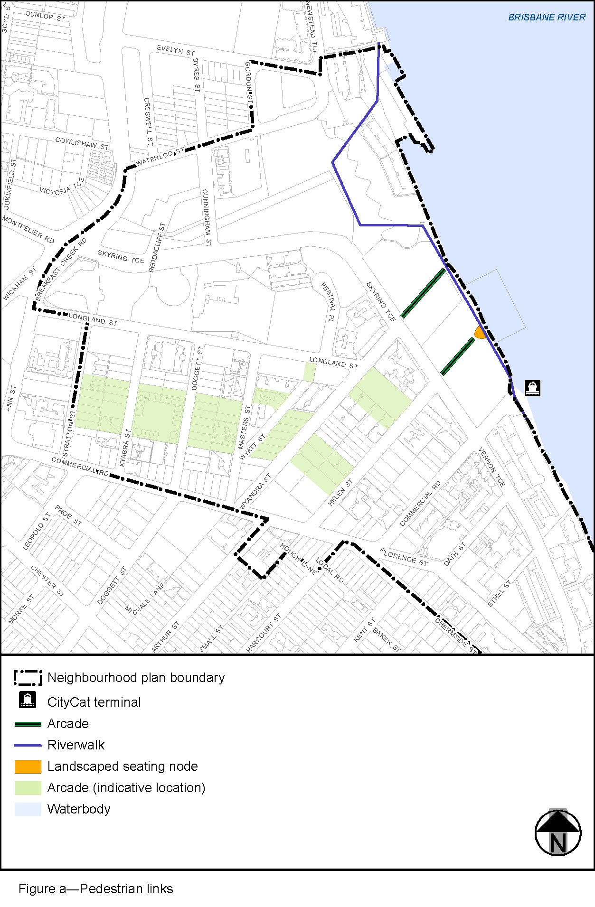
View the high resolution of Figure a–Pedestrian links (PDF file size is 257Kb)
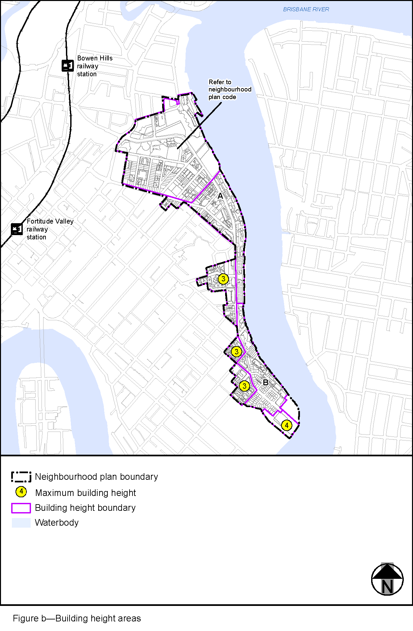
View the high resolution of Figure b–Building height areas (PDF file size is 1947Kb)
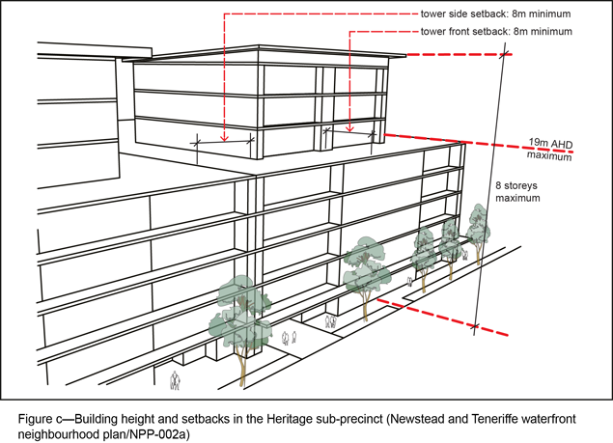
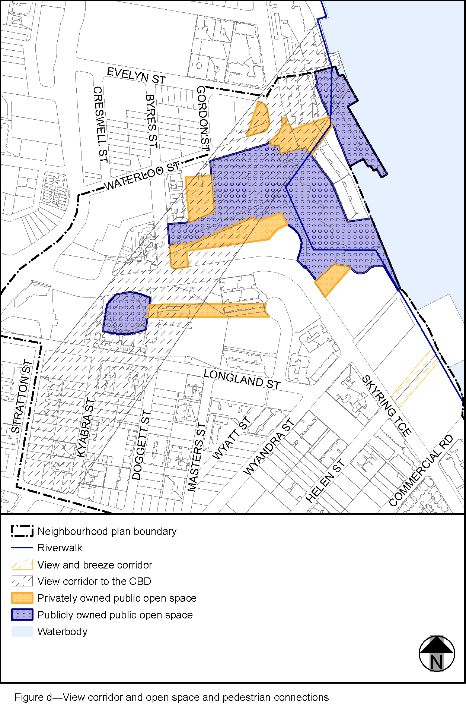
View the high resolution of Figure d—View corridor and open space and pedestrian connections (PDF file size is 334Kb)
