7.2.20.3 Toowong—Auchenflower neighbourhood plan code

7.2.20.3.1 Application
- This code applies to assessing a material change of use, reconfiguring a lot, operational work or building work in the Toowong—Auchenflower neighbourhood plan area if:
- assessable development where this code is an applicable code identified in the assessment benchmarks column of a table of assessment for a neighbourhood plan (section 5.9); or
- impact assessable development.
- Land in the Toowong—Auchenflower neighbourhood plan area is identified on the NPM-020.3 Toowong—Auchenflower neighbourhood plan map and includes the following precincts:
- Toowong centre precinct (Toowong—Auchenflower neighbourhood plan/NPP-001):
- Toowong centre a sub-precinct (Toowong—Auchenflower neighbourhood plan/NPP-001a);
- Toowong centre b sub-precinct (Toowong—Auchenflower neighbourhood plan/NPP-001b);
- Toowong centre c sub-precinct (Toowong—Auchenflower neighbourhood plan/NPP-001c).
- Toowong residential precinct (Toowong—Auchenflower neighbourhood plan/NPP-002);
- Memorial Park precinct (Toowong—Auchenflower neighbourhood plan/NPP-003);
- Regatta riverside precinct (Toowong—Auchenflower neighbourhood plan/NPP-004):
- Regatta riverside a sub-precinct (Toowong—Auchenflower neighbourhood plan/NPP-004a).
- Auchenflower heart precinct (Toowong—Auchenflower neighbourhood plan/NPP-005):
- Auchenflower heart a sub-precinct (Toowong—Auchenflower neighbourhood plan/NPP-005a);
- Auchenflower heart b sub-precinct (Toowong—Auchenflower neighbourhood plan/NPP-005b);
- Auchenflower heart c sub-precinct (Toowong—Auchenflower neighbourhood plan/NPP-005c).
- Dunmore residential precinct (Toowong—Auchenflower neighbourhood plan/NPP-006).
- When using this code, reference should be made to section 1.5, section 5.3.2 and section 5.3.3.
Note—The following purpose, overall outcomes, performance outcomes and acceptable outcomes comprise the assessment benchmarks of this code.
Note—This neighbourhood plan includes a table of assessment with variations to categories of development and assessment. Refer to Table 5.9.65.A, Table 5.9.65.B, Table 5.9.65.C and Table 5.9.65.D.

7.2.20.3.2 Purpose
- The purpose of the Toowong—Auchenflower neighbourhood plan code is to provide finer grained planning at a local level for the Toowong—Auchenflower neighbourhood plan area.
- The purpose of the Toowong—Auchenflower neighbourhood plan code will be achieved through overall outcomes including overall outcomes for each precinct of the neighbourhood plan area.
- The overall outcomes for the neighbourhood plan area are:
- Toowong and Auchenflower play an important role in inner western Brisbane by providing a mix of offices, shops and residences in a high-quality urban environment.
- Renewal is focused in the 2 transit-oriented centres in the Toowong centre precinct (Toowong—Auchenflower neighbourhood plan/NPP-001) and Auchenflower heart precinct (Toowong—Auchenflower neighbourhood plan/NPP-005), where the greatest mixture of land uses are contained.
- The 2 centres of Toowong and Auchenflower each have a distinct role and identity, with an intensity of development, urban form and mix of uses appropriate for that centre.
- The 2 centres provide a range of knowledge and medical-based employment opportunities and capitalise on their strong economic ties to Milton and St Lucia.
- Outside the Toowong centre precinct (Toowong—Auchenflower neighbourhood plan/NPP-001) and Auchenflower heart precinct (Toowong—Auchenflower neighbourhood plan/NPP-005), a mixture of new and established residential areas are supported by a network of public spaces and community facilities.
- Higher density development is located in areas with high amenity, close to major open space or the Brisbane River, or in centres and around major public transport to promote a legible centre structure and support transit oriented development.
- Lower density development is located predominantly to the west of the railway line in constrained or less-accessible areas, providing a transition to existing lower density areas and the Character residential zone.
- Development is of a height, scale and form which is consistent with the amenity and character, community expectations and infrastructure assumptions intended for the relevant precinct, sub-precinct or site and is only developed at a greater height, scale and form where there is both a community need and an economic need for the development.
- A mixture of dwelling types is encouraged, to cater for the broad lifestyle and household needs of the community, particularly key workers, students and short-term visitors.
- Adaptable housing and affordable housing is encouraged to cater to the needs of existing and future residents.
- New development along the river’s edge on the former ABC site improves public river access and provides appropriate building design using setbacks, bulk and separation and the provision of public open space.
- The heritage value of Middenbury House is protected and enhanced, through the retention, refurbishment and re-use of this building.
- Development achieves a height and density that makes efficient use of land, but does not overburden local transport, infrastructure, public space or community facilities.
- Development enhances the public realm and pedestrian and cycle movement with a network of parks, arcades and plazas (e.g. predominantly hard-surfaced open space used by the general public).
- Development encourages walking, cycling and public transport as attractive options for daily travel for residents, employees and visitors, and improves pedestrian/cycle connections to key destinations.
- Development contributes to the creation of new public spaces and improves existing public spaces, ensuring casual surveillance, providing new pedestrian connections and where possible, integrating with and providing direct access to open space.
- The Brisbane River has a renewed focus within the neighbourhood plan area, and residents, employees and visitors are provided with easy access to active and passive recreational opportunities that make the most of this important natural asset.
- Important views and vistas to the Brisbane River and Mt Coot-tha, as identified in Figure b are retained from Sylvan Road, Toowong Memorial Park and Middenbury House.
- Structure planning of catalyst sites identified in Figure a addresses the unique characteristics of these sites ensuring that development integrates with surrounding land, creates an attractive public realm and urban environment, provides public space and retains and re-uses on-site heritage structures.
- Sherwood Road functions as an active frontage–primary function, where ground-storey retail and commercial activities occur during the day and night.
- Sherwood Road forms an important east–west connection to the river and is enhanced by a high-quality streetscape and new public space that act as a focal point for pedestrian-oriented activities.
- Development addressing Sherwood Road is of a larger scale that reflects its central location, while creating a pleasant pedestrian environment.
- Streets function as pedestrian places; development maintains a human-scale at the street level and promotes activation of the street through appropriate location of uses and building design.
- Toowong centre precinct (Toowong—Auchenflower neighbourhood plan/NPP-001) overall outcomes are:
- The precinct is the social and economic heart of Toowong and has a vital role as the Major Centre for inner western Brisbane.
- The precinct contains a range of knowledge-based employment opportunities and takes full advantage of its strong economic ties to the CBD and surrounding suburbs of Auchenflower, St Lucia and Indooroopilly, while complementing the role of these centres.
- The precinct contains the greatest intensity and mix of land uses in the neighbourhood plan area, providing a focal point for retail, commercial and social activities. A variety of residential uses also exists in the centre and takes advantage of the area’s proximity to public transport and the amenity provided by new public open space and the Brisbane River.
- Sherwood Road serves an active frontage–primary function, where the majority of retail, community and lifestyle uses are located. Sherwood Road accommodates the tallest buildings in the precinct, to improve legibility and reinforce the primacy of this centre and its role as a transit-oriented centre.
- High Street is the focus for non-residential development, accommodating a mixture of retail and commercial development at ground level and providing a high-quality pedestrian experience.
- An urban common at the intersection of High Street and Sherwood Road provides a distinctive and recognisable social hub for Toowong. Development fronting the urban common provides ground-level activation and high-quality design. Activation of Toowong Village frontages and terrace areas with retail, outdoor dining and after-hours uses is particularly encouraged. The urban common also provides a public forecourt to the Toowong railway station.
- Development in this precinct extends to and engages with the river, while providing public spaces that are linked to the remainder of the precinct by high-quality streets and pedestrian connections.
- Development on sites adjoining the Brisbane River ensures the public access to the river, and buildings adjoining riverfront public spaces include a lively blend of retail, commercial, residential and community uses.
- Public transport is easily accessible and is the preferred method of travelling to and from the Toowong centre. Development promotes pedestrian movement to and from public transport and centres.
- A new pedestrian connection supported by active building frontages is created between Sherwood Road and High Street as identified in Figure b. Improved pedestrian connections are also provided between Sherwood Road and Lissner Street, and Jephson Street and High Street.
- Toowong residential precinct (Toowong—Auchenflower neighbourhood plan/NPP-002) overall outcomes are:
- This precinct forms the primary residential catchment to the Toowong centre, and contains medium to high-density residential uses that are suited to the diverse Toowong community.
- Buildings in the Toowong residential precinct are well designed and act as a transition from the high-intensity development in the Toowong centre, to the lower scale residential uses immediately to the south and west.
- Memorial Park precinct (Toowong—Auchenflower neighbourhood plan/NPP-003) overall outcomes are:
- The focal point for this precinct is Toowong Memorial Park, which provides active and passive recreational opportunities for residents, workers and visitors. Future expansion of sporting facilities in Toowong Memorial Park is encouraged, to provide for the needs of the growing population.
- Well-designed medium density housing is orientated toward and activates the park. Some non-residential uses are supported at the ground level of new buildings along Sylvan Road.
- Future residential development may occur on the site of the Holy Spirit Church on Harriett Street at a scale commensurate with buildings on adjoining land in Ridley Street.
- Streets and pedestrian walkways within the precinct provide high-quality linkages between the park, other open spaces, the Toowong centre and surrounding residential areas to the north, east and west. An easily accessible pedestrian path within Toowong Memorial Park connects to the Toowong and Auchenflower centres, and park embellishments provide greater activation and increase the use of this space.
- Regatta riverside precinct (Toowong—Auchenflower neighbourhood plan/NPP-004) overall outcomes are:
- The precinct is situated between the Toowong and Auchenflower railway stations and has Brisbane River frontage. The northern portion of the precinct contains high-density residential buildings that maintain view corridors to the river and include active street frontages. Non-residential uses are located to the south of Sylvan Road.
- Development in the precinct takes advantage of the amenity provided by the Brisbane River, Moorlands Park and its convenient access to public transport and the Bicentennial Bikeway.
- The Regatta Hotel is a key landmark in this precinct, and a major historical and entertainment venue in the neighbourhood plan area.
- The precinct also provides important pedestrian and cycle linkages between the Auchenflower heart precinct and Toowong centre precincts.
- Auchenflower heart precinct (Toowong—Auchenflower neighbourhood plan/NPP-005) overall outcomes are:
- The precinct includes a mixture of health, residential, retail and commercial uses.
- A new centre with a neighbourhood and employment function is provided around the Auchenflower railway station and along Ridley Street, which is supported by improved street environments on Ridley Street, Chasely Street and Lang Parade. The existing centre on Milton Road between Ridley Street and Grimes Street has more of a commercial focus, with people-oriented uses being concentrated along Ridley Street and around the Auchenflower railway station.
- The new centre is established primarily as a key health and education cluster and is a focus for public life. Uses in this centre also include short-term accommodation, cafes, restaurants, convenience retail and commercial opportunities that activate the street and service the local community and Wesley Hospital workers and visitors.
- The greatest intensity in building height and density in this precinct is on land adjoining or opposite the railway line, to reinforce the primacy of the centre and maximise public transport opportunities for residents, workers and visitors.
- In this precinct there is an opportunity to provide a new pedestrian, cyclist and potentially bus connection across the railway line adjacent to the Auchenflower railway station. Upgrades could allow for improved access to public plazas.
- The Wesley Hospital continues to be the major employment generator for Auchenflower. Future medical activities are appropriate in the adjoining centre.
- New development at the Wesley Hospital results in an improved frontage to Auchenflower station, Moorlands Park, Land Street and Coronation Drive, along with improved pedestrian and cycle access, safety and amenity.
- Dunmore residential precinct (Toowong—Auchenflower neighbourhood plan/NPP-006) overall outcomes are:
- The precinct is a diverse residential environment. Some ground-level non-residential uses are supported along Lang Parade to activate Dunmore Park and complement commercial uses to the north and in the Auchenflower centre.
- High-density residential uses are concentrated on the eastern side of the railway line to take advantage of the amenity provided by the Brisbane River, and the proximity to high-frequency public transport.
- Residential uses west of the railway line are of a lower density to reflect the character values of the area, and remain consistent with the surrounding built form along Aldridge Street, Hobbs Street and Challinor Street.

7.2.20.3.3 Performance outcomes and acceptable outcomes

Table 7.2.20.3.3.A—Performance outcomes and acceptable outcomes
Performance outcomes | Acceptable outcomes
General
Built form – Overall
PO1  Development is of a height, scale and form that achieves the intended outcome for the precinct, improves the amenity of the neighbourhood plan area, contributes to a cohesive streetscape and built form character and:  - is consistent with the anticipated density and assumed infrastructure demand;  - is aligned to community expectations about the number of storeys to be built;  - is proportionate to and commensurate with the utility of the site area and frontage width;  - is designed to avoid a significant and undue adverse amenity impact on adjoining development;  - is sited to enable existing and future buildings to be well separated from each other and to avoid affecting the development of an adjoining site;  - retains the significant views of Mt Coot-tha or the Brisbane River.  Note—Development that exceeds the intended number of storeys or building height can place disproportionate pressure on the transport network, public space or community facilities in particular.  Note—Development that is over-scaled for its site can result in an undesirable dominance of vehicle access, parking and manoeuvring areas that significantly reduce streetscape character and amenity. | AO1.1  Development complies with the number of storeys, building height and minimum site frontage in Table 7.2.20.3.3.B.  Note—Neighbourhood plans will mostly specify maximum number of storeys where zone outcomes have been varied in relation to building height. Some neighbourhood plans may also specify height in metres. Development must comply with both parameters where maximum number of storeys and height in metres are specified.
AO1.2
Development has building setbacks which are in accordance with Table 7.2.20.3.3.C.
AO1.3
Development has a maximum horizontal dimension of 40m for any tower.
AO1.4
Development has a maximum tower site cover of 50%.
AO1.5
Development has a maximum podium height of:
- 4 storeys in centres;
- 3 storeys in residential areas.
AO1.6
Development has building siting, configuration and design which retains the significant views of Mt Coot-tha or the Brisbane River as identified in Figure b.
If in a zone in the centre zones category or the Mixed use zone
PO2  Development:  - actively contributes to a vibrant and safe streetscape;  - provides a highly active frontage with a high proportion of openings and windows that support their functioning as streets with:  - high levels of on-street activity;  - pedestrian movement and strong integration between the footpath and adjoining ground level spaces;  - seamless integration between indoor and outdoor spaces; a building design that results in sensitive massing and articulation that creates a human scale;  - creates a safe and enjoyable pedestrian environment to minimise the interruption of vehicular crossovers and entries. | AO2.1  Development includes:  - balconies, living areas, entries and windows that overlook streets, arcades or spaces as illustrated in Figure c;  - building facade articulation including:  - frequent openings and small foyers at ground level;  - windows and doors that open into activities;  - display windows or showcases;  - rich architectural detailing;  - sun-protection devices.  - ground-storey pedestrian entries that are clearly visible from the public realm;  - a vertical mix of land uses;  - lighting of publicly accessible areas.
AO2.2
Development fronting Sherwood Road is occupied for a minimum of 75% of the ground-storey frontage by tenancies that are suitable for shops or other highly active uses.
AO2.3
Development that fronts a street with secondary activation or an indicative location for an arcade as indicated in Figure b is occupied for a minimum of 40% of the ground-storey frontage by tenancies that are suitable for shops or other highly active uses or units that are directly accessible from the street.
PO3  Development in centre precincts provides a balanced mix of residential and non-residential uses and includes a significant component of non-residential centre activities to maximise transit-oriented development outcomes. | AO3  Development has a maximum of 80% of the floor space of individual buildings occupied by residential uses.
PO4  Development of buildings' ground and podium levels exhibit a fine-grain building rhythm and architectural interest with variations in horizontal and vertical profile. | AO4  Development at ground and podium levels of buildings incorporate:  - balconies orientated to the street;  - distinctive elements within the facade;  - elements of a finer scale than the main structural framing.
If in a residential area
PO5  Development:  - makes a positive contribution to the local area and addresses the issues of noise, privacy, height, orientation, views, shade and security through high-quality design;  - actively contributes to the streetscape and provides a high level of amenity for both residents and pedestrians. | AO5.1  Development has a building form and facade that addresses the street and provides balconies overlooking the street, in accordance with Figure d.
AO5.2
Development for residential buildings delivers direct entry from the street to ground-level units.
AO5.3
Development has ground-storey pedestrian entries that are clearly visible from the street.
Landmark sites
PO6  Development on a landmark site provides a prominent visual reference and contribution to the city’s public realm by:  - exhibiting subtropical architectural excellence through design, treatment and articulation;  - defining the site and its setting through building form, expression, silhouette, scale, materials and landscaping;  - reinforcing a sense of arrival to the neighbourhood plan area, precinct or sub-precinct by marking a node, an intersection or major connection point in the city;  - respecting the prominence of any adjoining or nearby heritage places or local landmarks;  - incorporating public art that is integrated with the development’s design response to the public realm. | AO6  No acceptable outcome prescribed.  Note—This is a locally specific outcome complementing the requirements of the neighbourhood plan section of either the Multiple dwelling code or Centre or mixed use code.
Transport, car parking, access and servicing
PO7  Development provides vehicle entrances, servicing and car parking which are designed and located to provide:  - a seamless integration into the development;  - passive surveillance so as not to dominate the street environment;  - pedestrian movement, comfort and safety in areas of high-pedestrian usage by reducing pedestrian and vehicular conflict. | AO7.1  Development provides underground car parking.
AO7.2
Development has vehicular access which is not provided from a principal frontage where alternative access can be provided.
AO7.3
Development has 1 vehicle access point to each site.
AO7.4
Development in a centre provides vehicle access points which are not located within 30m of another and shared vehicle access points are used where possible, particularly for buildings fronting Sherwood Road.
AO7.5
Development in a residential area has vehicle entrances which are no wider than 5.5m and no higher than 3.5m.
AO7.6
Development provides driveway crossovers which maintain the integrity, quality and primacy of footpaths.
If in the Toowong centre precinct (Toowong—Auchenflower neighbourhood plan/NPP-001)
PO8  Development provides additional open space (in the form of an urban common) centrally within the Toowong centre precinct to provide for a dedicated urban space for public activities. | AO8.1  Development provides a park (urban common) as shown in Figure b.
AO8.2
Development provides direct access from the urban common to the Toowong railway station.
AO8.3
Development involving the redevelopment of the Toowong Village frontages and terrace areas includes retail, outdoor dining and after-hours uses that provide direct interaction with the urban common.
PO9  Development creates an integrated and continuous pedestrian and cyclist network that facilitates logical and direct access to activity centres, public transport facilities and public open spaces and arcades have a strong street presence that signifies that they are publicly accessible. | AO9.1  Development retains the existing informal arcade between Sherwood Road and Lissner Street, as indicated in Figure b.
AO9.2
Development provides new arcades on development sites that include land within the indicative location for arcades (as indicated in Figure b, where the development site spans the streets to be connected.
AO9.3
Development involving an arcade ensures the design of the arcade:
- creates a 24-hour publicly accessible space with equitable access;
- provides lighting, shelter and furniture, including informal seating areas;
- has a minimum corridor width of 6m, including a minimum unobstructed pavement width of 3m that is suitable for pedestrians and cyclists;
- is bounded by active uses with ground levels that address the space and provide opportunities for social interaction.
PO10  Development on the Woolworths site as shown in Figure a:  - creates a high-quality, high-density mixed use development in the heart of the centre;  - establishes a continuous public realm at the ground level including a public plaza and arcades that provide optimal pedestrian legibility, permeability and activation and are clearly identifiable from the street;  - reinforces Sherwood Road as the active frontage – primary of the Toowong centre where pedestrian movement is a priority;  - contributes to an active and vibrant place that adds to the fine-grain character of the active frontage – primary;  - provides vehicular access to the site that is efficient and does not dominate the street.  Note—A structure plan prepared in accordance with the Structure planning planning scheme policy can assist in demonstrating achievement of this outcome. | AO10  Development on the Woolworths site, shown in Figure a, has a structure plan which demonstrates:  - location of taller buildings on the Sherwood Road or High Street frontage, with building height stepping down towards Jephson Street;  - provision of a privately provided publicly accessible plaza space on High Street with a minimum area of 1,500m2;  - provision of arcades to connect High Street and Sherwood Road;  - inclusion of active uses on the ground levels of buildings fronting public spaces, Sherwood Road and High Street;  - vehicular access to and movement through the site in a manner that does not dominate the Sherwood Road and High Street frontages and allows for free pedestrian flow;  - provision of a bus stop and layover on the High Street frontage;  - the ability to integrate with future development on adjoining sites to the south and west.
PO11  Development on the former ABC site as shown in Figure a:  - enhances the pedestrian experience with high-quality building design, streetscape and waterfront amenities providing a direct and tangible linkage between Toowong and the river;  - provides a new public space with supportive uses to encourage activity on and occupation of the river’s edge;  - maintains the natural quality of the waterfront experience for access by the general public;  - reflects the local culture and heritage of Middenbury House;  - provides an arcade between Coronation Drive and Archer Street.  Note—A structure plan prepared in accordance with the Structure planning planning scheme policy can assist in demonstrating achievement of this outcome. | AO11  Development on the former ABC site shown in Figure a has a structure plan which demonstrates:  - provision of a riverside open space area a minimum of 3,000m2 and with a minimum Brisbane River frontage of 40m;  - retention and re-use of Middenbury House and retention of the heritage-listed trees on Coronation Drive;  - retention of views to the Brisbane River as indicated in Figure b;  - public access to the entire Brisbane River frontage for a minimum width of 12m;  - provision of an arcade to connect to Coronation Drive at Booth Street from Archer Street;  - activation of the ground storeys of buildings fronting public spaces;  - provision of vehicular access to the site that is shared with pedestrian spaces;  - provision of a maximum of 1 vehicular access to the site from Coronation Drive;  - extension of the Bicentennial Bikeway through the site to connect with Archer Street.
If in the Auchenflower heart precinct (Toowong—Auchenflower neighbourhood plan/NPP-005)
PO12  Development on the Wesley Hospital site as shown in Figure a:  - focuses taller buildings adjacent to Auchenflower station and on the corner of Coronation Drive and Chasely Street;  - is orientated toward the railway station, Chasely Street and Moorlands Park;  - provides for pedestrian and cycle movement between Auchenflower Station and Moorlands Park. | AO12  Development on the Wesley Hospital site shown in Figure a has a structure plan which demonstrates:  - the location of signature buildings on the corners of Chasely Street and Lang Parade and Coronation Drive and Chasely Street;  - orientation of buildings towards Chasely Street, Coronation Drive, Auchenflower Station, Moorlands Park and the Auchenflower centre;  - additional pedestrian access points from Chasely Street, Auchenflower Station and Coronation Drive;  - pedestrian and cycle links through the site between Auchenflower Station and Moorlands Park.
If in the Dunmore residential precinct (Toowong—Auchenflower neighbourhood plan/NPP-006)
PO13  Development has retail activities that provide for a local and convenience service function and do not encourage patronage via private vehicles from persons living or working outside the precinct. | AO13  Development has floor space for non-residential uses on each individual site that does not exceed 250m2.

Table 7.2.20.3.3.B—Maximum building height
Development | Minimum site frontage | Building height  (number of storeys)
Development of a site less than 1,000m2 or if not meeting a minimum site frontage specified in this table | Not specified | 3
If in the Toowong centre precinct (Toowong—Auchenflower neighbourhood plan/NPP-001), where in the Toowong centre a sub-precinct (Toowong—Auchenflower neighbourhood plan/NPP-001a) and fronting Sherwood Road
Development of a site 1,000m2 or greater but less than 1,200m2 | 20m | 5
Development of a site 1,200m2 or greater but less than 1,500m2 | 27m | 12
Development of a site 1,500m2 or greater | 36m | 25
If in the Toowong centre a sub-precinct (Toowong—Auchenflower neighbourhood plan/NPP-001a), where not fronting Sherwood Road or if in the Toowong centre precinct (Toowong—Auchenflower neighbourhood plan/NPP-001), where in the Toowong centre b sub-precinct (Toowong—Auchenflower neighbourhood plan/NPP-001b)
Development of a site 1,000m2 or greater but less than 1,200m2 | 20m | 5
Development of a site greater than 1,200m2 or greater but less than 1,500m2 | 27m | 12
Development of a site 1,500m2 or greater | 36m | 20
If in the Toowong centre precinct (Toowong—Auchenflower neighbourhood plan/NPP-001), where in the Toowong centre c sub-precinct (Toowong—Auchenflower neighbourhood plan/NPP-001c) or if in the Auchenflower heart precinct (Toowong—Auchenflower neighbourhood plan/NPP-005), where in the Auchenflower heart a sub-precinct (Toowong—Auchenflower neighbourhood plan/NPP-005a)
Development of a site 1,000m2 or greater but less than 1,200m2 | 20m | 5
Development of a site 1,200m2 or greater but less than 1,500m2 | 27m | 8
Development of a site 1,500m2 or greater where in sub-precinct NPP-005a | 36m | 12
Development of a site 1,500m2 where in sub-precinct NPP-001c | 36m | 15
If in the Auchenflower heart precinct (Toowong—Auchenflower neighbourhood plan/NPP-005), where in the Auchenflower heart b sub-precinct (Toowong—Auchenflower neighbourhood plan/NPP-005b)
Development of a site 1,000m2 or greater but less than 1,200m2 | 20m | 4
Development of a site 1,200m2 or greater | 27m | 6
If in the Auchenflower heart precinct (Toowong—Auchenflower neighbourhood plan/NPP-005), where in the Auchenflower heart c sub-precinct (Toowong—Auchenflower neighbourhood plan/NPP-005c)
Development of a site of any size | Not specified | 10
If in the Regatta riverside precinct (Toowong—Auchenflower neighbourhood plan/NPP-004), where in the Regatta riverside a sub-precinct (Toowong—Auchenflower neighbourhood plan/NPP-004a)
Development of a site 1,000m2 or greater but less than 1,200m2 | 20 | 5
Development of a site 1,200m2 or greater but less than 1,500m2 | 27 | 8
Development of a site 1,500m2 or greater | 36 | 10
If in the Low–medium density residential zone
Development of a site of any size | Not specified | 3
If in the Medium density residential zone
Development of a site where less than 1,000m2 | Not specified | 3
Development of a site 1,000m2 or greater and where on Bennett Street, Bayliss Street or McIlwraith Street | 20m | 5
Development of a site 1,000m2 or greater in all other Medium density residential zones | 27m | 8
If in the High density residential zone
Development of a site less than 1,000m2 | Not specified | 3
Development of a site 1,000m2 or greater but less than 1,200m2 | 20m | 5
Development of a site 1,000m2 or greater where on Ridley Street or Milton Road | 27m | 8
Development of a site 1,200m2 or greater but less than 1,500m2 | 27m | 8
Development of a site 1,500m2 or greater in all other High density residential zones | 36m | 10
Development of a site 1,500m2 or greater where on Coronation Drive, Benson Street or Glen Road | 36m | 15
Note—Minimum site frontage is not a trigger for category of development or category of assessment.

Table 7.2.20.3.3.C—Minimum building setbacks(1)
Development | Level | Minimum front setback⁽2⁾ | Minimum side setback | Minimum rear setback
If in a zone in the Centre zones category
Any development in the zone | Up to 8 storeys | 0m | 3m for non-residential  3m for residential (5m if windows of habitable rooms are orientated towards the boundary) | 8m for non-residential  10m for residential
 | Podium | 0m | 0m (5m if the windows of habitable rooms are orientated towards the boundary) | 3m for non-residential  8m for residential
 | Tower | 5m | 5m (8m if the windows of habitable rooms are orientated towards the boundary)  10m where adjoining a Low–medium density residential zone | 10m
If in a zone in the residential zones category
Any development in the zone | Up to 8 storeys | 3m | 3m (5m if the windows of habitable rooms are orientated towards the boundary) | 10m
 | Podium | 0m for non-residential  3m for residential | 3m (5m if the windows of habitable rooms are orientated towards the boundary) | 8m
 | Tower | 5m | 5m (8m if the windows of habitable rooms are orientated towards the boundary)  10m where adjoining a Medium density residential zone | 10m
Note—
(1)Setbacks on catalyst sites as identified in Figure a are to be determined through a structure planning process.
(2)In addition to any footpath widening.
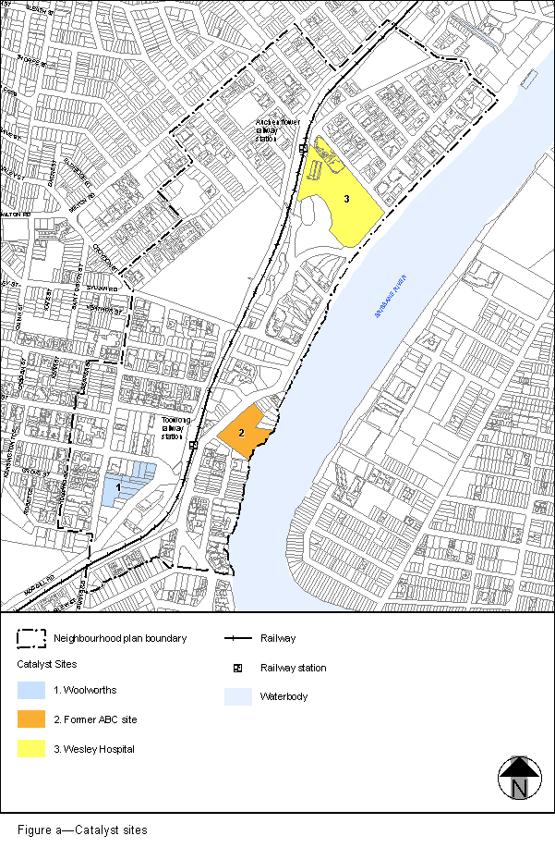
View the high resolution of Figure a–Catalyst sites (PDF file size is 393Kb)
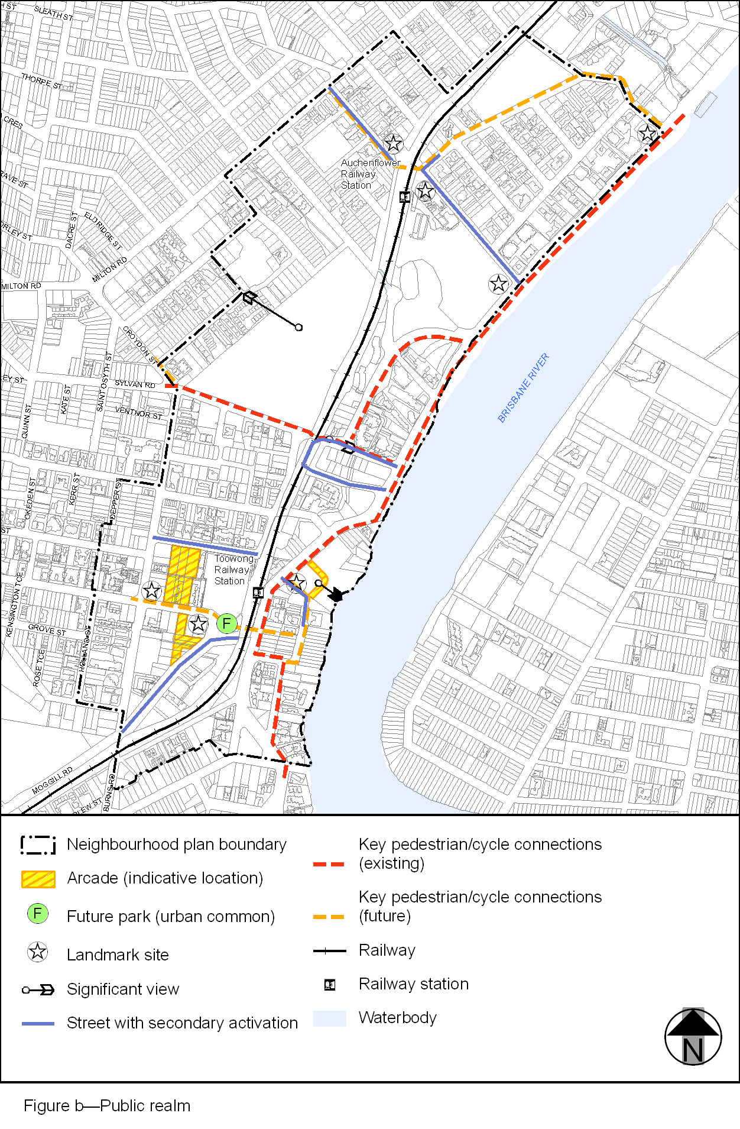
View the high resolution of Figure b–Public realm (PDF file size is 377Kb)
