7.2.4.3 Dutton Park—Fairfield neighbourhood plan code

7.2.4.3.1 Application
- This code applies to assessing a material change of use, reconfiguring a lot, operational work or building work in the Dutton Park—Fairfield neighbourhood plan area if:
- assessable development where this code is an applicable code identified in the assessment benchmarks column of a table of assessment for neighbourhood plan (section 5.9); or
- impact assessable development.
- Land in the Dutton Park—Fairfield neighbourhood plan area is identified on the NPM-004.3 Dutton Park-Fairfield neighbourhood plan map and includes the following precincts:
- Mater Hill precinct (Dutton Park—Fairfield neighbourhood plan/NPP-001);
- Health sub-precinct (Dutton Park—Fairfield neighbourhood plan/NPP-001a);
- Stanley Street and Annerley Road sub-precinct (Dutton Park—Fairfield neighbourhood plan/NPP-001b);
- Annerley Road sub-precinct (Dutton Park—Fairfield neighbourhood plan/NPP-001c);
- Education sub-precinct (Dutton Park—Fairfield neighbourhood plan/NPP-001d).
- Boggo Road Urban Village precinct (Dutton Park—Fairfield neighbourhood plan/NPP-002);
- Boggo Road Urban Village north sub-precinct (Dutton Park—Fairfield neighbourhood plan/NPP-002a);
- Boggo Road Urban Village north sub-precinct (Dutton Park—Fairfield neighbourhood plan/NPP-002b).
- When using this code, reference should be made to section 1.5, section 5.3.2 and section 5.3.3.

Note—The following purpose, overall outcomes, performance outcomes and acceptable outcomes comprise the assessment benchmarks of this code.
Note—This neighbourhood plan includes a table of assessment with variations to categories of development and assessment. Refer to Table 5.9.80.A, Table 5.9.80.B, Table 5.9.80.C and Table 5.9.80.D.
Editor’s note—Part of the neighbourhood plan area is covered by the Woolloongabba priority development area which Economic Development Queensland is responsible for planning under the Economic Development Act 2012.
Editor's note—Part of the neighbourhood plan area is covered by the Yeronga Priority Development Area which Economic Development Queensland is responsible for planning under the Economic Development Act 2012.

7.2.4.3.2 Purpose
- The purpose of the Dutton Park—Fairfield neighbourhood plan code is to provide finer grained planning at a local level for the Dutton Park—Fairfield neighbourhood plan area.
- The purpose of the Dutton Park-Fairfield neighbourhood plan code will be achieved through overall outcomes including overall outcomes for each precinct of the neighbourhood plan area.
- The overall outcomes for the neighbourhood plan area are:
- Development of the Princess Alexandra, Mater and Lady Cilento Children’s hospitals facilitates the growth of specialised health and knowledge facilities to create integrated health and knowledge precincts, supported by a mix of ancillary uses, with dedicated public transport infrastructure.
- Development preserves heritage places, and heritage buildings are retained conserved and re-used.
- Development minimises impacts on areas of traditional building character in the Character zone precinct of the Character residential zone and in the Infill housing zone precinct of the Character residential zone by providing transitions in building height.
- Development achieves a high quality built form and public realm that supports the creation of walkable catchments to public transport and pedestrian and cyclist networks through the provision of streetscape treatments, plazas and arcades.
- Development in the Mixed use zone along Annerley Road and in the Neighbourhood centre zone near Dutton Park Railway Station activates street frontages and supports accessibility to centre activities via building design that emphasises shelter, shade, legible paths and crossing points.
- Development on Annerley Road, and other arterial roads, creates subtropical, shady pedestrian boulevards including corner land dedications at key intersections.
- Development provides for the potential integration of Gair Park with development fronting Maldon Street including maintaining access for pedestrians and cyclists through the park.
- Development does not adversely affect the structural integrity, ongoing operation and maintenance of major transport infrastructure.
- Development is located and designed to enhance the accessibility and integration of existing and future public transport passenger facilities.
- The Mater Hill precinct (Dutton Park—Fairfield neighbourhood plan/NPP-001) outcomes are:
- Development supports the growth of specialised and regionally significant health services, health research and education within an established character residential suburb. Heritage buildings are retained and repurposed to maintain a strong identity for this centre.
- The Health sub-precinct (Dutton Park—Fairfield neighbourhood plan/NPP-001a) overall outcomes are:
- Growth of a regionally significant health services, research and education centre is consistent with an endorsed master plan.
- Provides for the expansion of regionally significant health and knowledge uses by support for building heights up to 20 storeys.
- Ensures that a range of complementary uses are co-located with major health care activities including technical institutes, residential care facilities, food and drink outlets and shops.
- Provides high density short-term accommodation for health services and research workers and visitors.
- Integrates development with high frequency public transport infrastructure and develops strong active transport linkages to minimise private transport demands.
- Minimises operational and service noise from the Mater Hospital and Lady Cilento Children’s Hospital to residential property fronting Clarence Street.
- The Stanley Street and Annerley Road sub-precinct (Dutton Park—Fairfield neighbourhood plan/NPP-001b) overall outcomes are:
- Accommodates a mix of non-residential uses which support the Mater and Lady Cilento Children’s Hospitals including health care services, conference facilities, offices, short-term accommodation, food and drink outlets, bars and does not provide for multiple dwellings, rooming accommodation, residential care or retirement facilities.
- Creates a vibrant day and night pedestrian precinct destination in the mixed use area south of Stanley Street including an arcade immediately behind heritage listed buildings, a plaza space next to the Princess Theatre on Annerley Road and public art in prominent locations.
- Retains and reuses heritage buildings on Stanley Street and Annerley Road by ensuring that uses located in Stanley Street activate the street and the arcade.
- Enhances pedestrian amenity and connectivity between Trinity Lane and Annerley Road by providing active tenancies along the arcade and pedestrian access from Annerley Road to Merton Road and from Merton Road to Trinity Lane.
- Manages interface between new development and character residential areas by providing transitions in building heights between development in the Mixed use zone and the Character residential zone, particularly in the Stanley Street and Annerley Road sub-precinct (b) where maximum building heights are reduced.
- Consolidates access and service arrangements by locating a service lane from Merton Road to Catherine Street in the mixed use area adjacent to the character residential area.
- The Annerley Road sub-precinct (Dutton Park—Fairfield neighbourhood plan/NPP-001c) overall outcomes are:
- Supports the development, up to 10 storeys, of an active sub-precinct near the Mater Hospital, comprising a mix of non-residential ancillary uses, including health care services, conference facilities, offices, short-term accommodation, food and drink outlets.
- Manages the interface between new development and character residential areas by providing transitions in building heights between development in the Mixed use zone and the Character residential zone.
- The Education sub-precinct (Dutton Park—Fairfield neighbourhood plan/NPP-001d) overall outcomes are:
- Provides for the continued operation of preparatory, primary and secondary education facilities within inner city Brisbane, which adjoin a specialised health and knowledge centre.
- Ensures the protection, conservation and reuse of heritage listed buildings including Somerville House and the South Brisbane Municipal Chambers.
- Ensures that development is consistent with an endorsed master plan which manages the interface between the Education sub-precinct NPP-001d and the Health sub-precinct NPP-001a.
- Manages the interface between character residential areas and education purposes along the Stephens Road frontage by:
- maintaining a residential scale up to 3 storeys where facing residential zoned areas with traditional building character.
- managing traffic demands on-site to minimise on-street vehicle activity.
- Facilitates a high degree of pedestrian access to the high frequency public transport infrastructure and supports active transport linkages to minimise private transport demands.
- The Boggo Road Urban Village precinct (Dutton Park—Fairfield neighbourhood plan/NPP-002) overall outcomes are:
- Facilitates the development of the Boggo Road Urban Village as a centre for research in eco-sciences within a vibrant inner-city mixed use precinct.
- Achieves a mix of medium to high density residential, research facility and office uses including providing for a new, small-scale supermarket and retail centre.
- Ensures the protection, conservation and reuse of heritage listed gaol buildings for community facility (e.g. museum), market, shop, food and drink outlet, hotel, function facility and educational establishment uses.
- Provides a highly active pedestrian link through the centre of the Boggo Road Urban Village lined by active frontage uses.
- Manages adverse amenity impacts of the railway and busway through the design and placement of appropriate uses.
- Provides pedestrian and cyclist connections from the Boggo Road busway station to surrounding residential and employment areas.

7.2.4.3.3 Performance outcomes and acceptable outcomes

Table 7.2.4.3.3.A–Performance outcomes and acceptable outcomes
Performance outcomes | Acceptable outcomes
Building height
PO1  Development is of a height, scale and form that achieves the intended outcome for the precinct, improves the amenity of the neighbourhood plan area, contributes to a cohesive streetscape and built form character and is:  - consistent with the anticipated density and assumed infrastructure demand;  aligned with community expectations about the number of storeys to be built;  - proportionate to and commensurate with the utility of the site area and frontage width;  - designed so as to not cause a significant and undue adverse amenity impact to adjoining development;  - sited to enable existing and future buildings to be well separated from each other and to avoid affecting the potential development of an adjoining site.  Note—Development that exceeds the intended number of storeys or building height can place disproportionate pressure on the transport network, public space or community facilities in particular.  Note—Development that is over-scaled for its site can result in an undesirable dominance of vehicle access, parking and manoeuvring areas that significantly reduce streetscape character and amenity. | AO1  Development complies with the number of storeys in Table 7.2.4.3.3.B.  Note—Neighbourhood plans will mostly specify a maximum number of storeys where zone outcomes have been varied in relation to building height. Some neighbourhood plans may also specify height in metres. Development must comply with both parameters where maximum number of storeys and height in metres are specified.
If in the Mater Hill precinct (NPP-001), where in the Health sub-precinct (NPP-001a)
PO2  Development has, and is undertaken in accordance with, a Master Plan that:  - provides a mix of health services, education and research uses;  - demonstrates that the scale and design of new buildings will respect and respond to the cultural significance of the heritage buildings and spaces;  - preserves heritage buildings through the retention, conservation and adaptive reuse of heritage buildings and spaces;  - activates the ground storey of buildings fronting pedestrian connections and open spaces, where compatible with health services operations, to ensure passive surveillance of these spaces;  - provides a high quality public realm with a strong pedestrian focus through subtropical landscaping, streetscape improvements and passive surveillance;  - provides high quality pedestrian and cyclist access within the sub-precinct that connects with high frequency public transport infrastructure and promotes reduction in private transport demands;  - provides vehicular access and circulation to the site compatible with health services operations;  - demonstrates that acceptable air quality and hazard risk outcomes can be achieved where located within 100m of any on-site coal fired boiler emission stack. | AO2  No acceptable outcome is prescribed.
If in the Mater Hill precinct (NPP-001), where in the Stanley Street and Annerley Road sub-precinct (NPP-001b)
PO3  Development creates an arcade that:  - provides public access and connection from Annerley Road to Trinity Lane to facilitate direct, convenient, comfortable and safe access;  - has a strong street presence and clear entry from Annerley Road;  - has an active frontage and use including activating heritage buildings facing Stanley Street. | AO3  Development provides an arcade which:  - is located at the rear (i.e. along the rear wall) of the heritage listed buildings on Stanley Street as indicated in Figures a and b;  - is uncovered in area a as indicated in  Figure b;  - provides pedestrian access from Annerley Road to Trinity Lane during the hours of operation of the use;  - provides a buffer to heritage building wall and footing elements;  - activates heritage buildings by enabling pedestrian access from the rear.
PO4  Development respects, retains and adaptively reuses heritage buildings as indicated in Figure b. | AO4  Development ensures that:  - the scale and design of new buildings respects and responds to the cultural significance of heritage buildings and spaces;  - heritage buildings and spaces are conserved and adaptively reused;  - the ground storey of buildings fronting Stanley Street, arcades and open spaces are activated to ensure passive surveillance.
PO5  Development creates an informal meeting place for workers, visitors and local residents by providing a new plaza within the Stanley Street and Annerley Road sub-precinct. | AO5  Development provides a plaza where indicated in Figure a that:  - is at least 10m wide for the length of the Princess Theatre;  - is regularly shaped;  - is highly visible from Annerley Road;  - complements and provides a positive interface to the Princess Theatre.
PO6  Development ensures that access for all vehicles including for site servicing minimises disruption and reduces visual impact on building frontages, pedestrian circulation areas, plazas and arcades. | AO6.1  Development provides a shared service lane along the eastern boundary of the Stanley Street and Annerley Road sub-precinct which provides access from Merton Road and Catherine Street, where indicated in Figure a.
AO6.2
Development does not gain access from Annerley Road unless no alternative access point can be provided.
PO7  Development ensures that the front boundary setbacks relate to the existing setback patterns of heritage buildings along Annerley Road. | AO7  Development for a podium has a front setback of 0m to the front property boundary along  Annerley Road between Stanley and Catherine Streets.
PO8  Development for a new premises adjacent to or in the vicinity of a heritage place maintains and enhances the heritage place and its surrounds. | AO8  Development provides a podium height which aligns with parapet levels of adjacent heritage buildings.
PO9  Development provides a transition to surrounding residential areas and does not create an overbearing appearance or significantly impact on the privacy and amenity of adjoining residences by:  - stepping down in height and scale;  - minimising impacts including those from overlooking and visual dominance;  - maintaining adequate levels of natural ventilation and light penetration to a habitable room, balcony and private open space. | AO9.1  Development where sharing a common boundary with premises in the Low-medium density residential zone or Character residential zone:  - has a building height of no more than one storey higher than the maximum allowable height of the adjoining property within 10m from the common property boundary;  - all structures, except adjoining boundary fences, are set back a minimum of 4m from the common boundary;  - an acoustic and visual screen fence of 2m height is provided on the common boundary.
AO9.1
Development where located fronting a minor road that is opposite premises in the Low–medium density residential zone or Character residential zone:
- has a building height of no more than
4 storeys within 10m from the front boundary;
- has a heavily landscaped front setback;
- buildings are provided with modulation and articulation with variations in the wall and roof plan every 10m.
If in the Mater Hill precinct (NPP-001), where in the Education sub-precinct (NPP-001d)
PO10  Development has, and is undertaken in accordance with, a Master Plan that:  - provides a mix of preparatory, primary and secondary education uses;  - demonstrates that the scale and design of new buildings will respect and respond to the cultural significance of the heritage buildings and spaces;  - ensures that heritage buildings and spaces are conserved and adaptively reused;  - ensures building heights step down to neighbouring residential areas;  - provides a high quality public realm and internal access circulation with a strong pedestrian focus through subtropical landscaping, streetscape improvements and passive surveillance;  - provides high quality pedestrian and cyclist access that connects with high frequency public transport infrastructure and promotes reduction in private transport demands;  - provides vehicular access and circulation to the site compatible with education operations. | AO10  No acceptable outcome is prescribed.
If in the Boggo Road Urban Village precinct (NPP-002)
PO11  Development along the village centre link, between Boggo Road and Peter Doherty Drive, provides an active and highly accessible link to the Boggo Road Busway Station. | AO11  Development adjoining the village centre link between Boggo Road and Peter Doherty Street, provides:  - continuous active uses, such as shops and food and drink outlets, at street level, including access and orientation to the street;  - a shop (supermarket) or shop tenancy component of a shopping centre not exceeding 1,500m² in gross floor area;  - legible and convenient pedestrian access through the centre of the precinct to the Boggo Road Busway Station and the precinct’s proposed future public passenger transport facility.
PO12  Development provides a transition to adjoining residential and education purpose areas and does not create an overbearing appearance or significantly impact on the privacy and amenity of adjoining residences or the operation of the education purposes by:  - stepping down in height and scale;  - minimising impacts including those from overlooking and visual dominance;  - maintaining adequate levels of natural ventilation and light penetration to a habitable room, balcony and private open space. | AO12  Development in the Boggo Road Urban Village south sub-precinct where adjoining the Character residential zone provides a rear setback of:  - 10m where for the first 2 storeys or 7m AHD;  - 15m where exceeding 2 storeys in building height.

Table 7.2.4.3.3.B–Maximum building height in storeys
 | Building height (number of storeys)
Site area | 800m to less than 1,2000m² | 1,200m² to less than 2,500m² | 2,500m² or greater
Site frontage | 20m | 20m to 30m | 30m
If in the Health sub-precinct (Dutton Park—Fairfield neighbourhood plan/NPP-001a)
Development of a site in the Community facilities major health care zone precinct | 20 storeys
Development of a site in the High density residential (up to 15 storeys) zone precinct | 20 storeys
Development of a site in the Mixed use (Inner city) zone precinct | 20 storeys
If in the Stanley Street and Annerley Road sub precinct area a shown on Figure a (Dutton Park—Fairfield neighbourhood plan/NPP-001b)
Development of a site in the Mixed use (Inner city) zone precinct | 6 storeys | 12 storeys | 15 storeys
If in the Stanley Street and Annerley Road sub precinct area b shown on Figure a
(Dutton Park-Fairfield neighbourhood plan/NPP-001b)
Development of a site in the Mixed use (Inner city) zone precinct | 5 storeys | 8 storeys
If in the Annerley Road sub precinct (Dutton Park—Fairfield neighbourhood plan/NPP-001c)
Development of a site in the Mixed use (Corridor) zone precinct | 5 storeys | 8 storeys | 10 storeys
If in the Mixed-use zone and not in a precinct of the Dutton Park—Fairfield neighbourhood plan/NPP-001
Development of a site in the Mixed use (Corridor) zone precinct | 5 storeys | 8 storeys
If in the Education sub-precinct (Dutton Park—Fairfield neighbourhood plan/NPP-001d)
Development of a site fronting  Stephens Road | 3 storeys (within 20m of Stephens Road alignment)
Development of a site fronting  Graham Street or adjoining health  sub-precinct NPP-001a | 10 storeys (where not conflicting with Stephens Road building height specification)
If in the Boggo Road Urban Village precinct (Dutton Park—Fairfield neighbourhood
plan/NPP-002)
Development of a site in the Specialised centre (Major education and research facility) zone precinct | 8 storeys
If in the Boggo Road Urban Village north sub-precinct (Dutton Park—Fairfield neighbourhood plan/NPP-002a)
Development of a site in the Mixed use Corridor zone precinct | 12 storeys
If in the Boggo Road Urban Village south sub-precinct (Dutton Park—Fairfield neighbourhood plan/NPP-002b)
Development of a site in the Mixed use Corridor zone precinct | 5 storeys
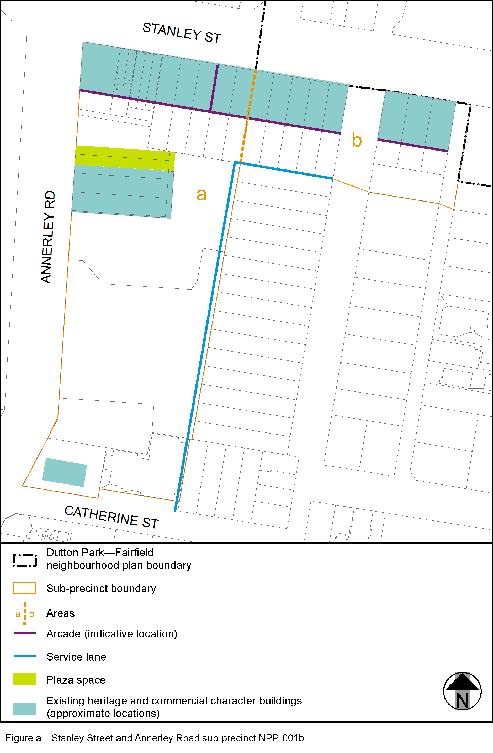

View the high resolution of Figure a–Stanley Street and Annerley Road sub-precicnt NPP-001b (PDF file size is 108Kb)
