7.2.9.1 Indooroopilly centre neighbourhood plan code

7.2.9.1.1 Application
- This code applies to assessing a material change of use, reconfiguring a lot, operational work or building work in the Indooroopilly centre neighbourhood plan area if:
- accepted development subject to compliance with identified requirements, where acceptable outcomes AO16, AO17.1, AO17.2, AO17.3, AO18 and AO19 of this code are identified requirements in a table of assessment for a neighbourhood plan (section 5.9); or
- assessable development where this code is an applicable code identified in the assessment benchmarks column of a table of assessment for a neighbourhood plan (section 5.9); or
- impact assessable development.
- Land in the Indooroopilly centre neighbourhood plan area is identified on the NPM-009.1 Indooroopilly centre neighbourhood plan map and includes the following precincts:
- Multi-purpose centre precinct (Indooroopilly centre neighbourhood plan/NPP-001):
- High Street sub-precinct (Indooroopilly centre neighbourhood plan/NPP-001a);
- Moggill Road north sub-precinct (Indooroopilly centre neighbourhood plan/NPP-001b);
- Indooroopilly shopping centre mixed use sub-precinct (Indooroopilly centre neighbourhood plan/NPP-001c);
- Witton Barracks precinct (Indooroopilly centre neighbourhood plan/NPP-002);
- Special context area precinct (Indooroopilly centre neighbourhood plan/NPP-003):
- Jackson Street special context area sub-precinct (Indooroopilly centre neighbourhood plan/NPP-003a);
- Moggill Road west special context area sub-precinct (Indooroopilly centre neighbourhood plan/NPP-003b).
- When using this code, reference should be made to section 1.5, section 5.3.2 and section 5.3.3.
Note—The following purpose, overall outcomes, performance outcomes and acceptable outcomes comprise the assessment benchmarks of this code.
Note—This neighbourhood plan includes a table of assessment with variations to categories of development and assessment. Refer to Table 5.9.30.A, Table 5.9.30.B, Table 5.9.30.C and Table 5.9.30.D.

7.2.9.1.2 Purpose
- The purpose of the Indooroopilly centre neighbourhood plan code is to provide finer grained planning at a local level for the Indooroopilly centre neighbourhood plan area.
- The purpose of the Indooroopilly centre neighbourhood plan code will be achieved through overall outcomes including overall outcomes for each precinct of the neighbourhood plan area.
- The overall outcomes for the Indooroopilly centre neighbourhood plan area are:
- Indooroopilly centre develops as a centre and will build on the strength of its existing retail, commercial and community sectors to become the principal location for these activities in western Brisbane.
- Development creates a diverse, integrated, mixed use centre hosting retail and commercial office uses, higher density dwellings and a range of community and recreational facilities that are concentrated around existing and future public transport nodes to encourage greater use of public transport services and attract further investment in new public transport facilities in and serving Indooroopilly centre.
- Development is of a height, scale and design that is consistent with the intended height, bulk and character of the relevant precinct and does not result in a density that would place disproportionate pressure on transport infrastructure, public space or community facilities.
- Open space, including Keating Park and the former Witton Barracks, is an integral part of the local active transport network and offers a variety of accessible and comfortable community meeting places and recreational spaces.
- New houses and other development in areas with strong traditional architectural character of buildings built in 1946 or before, complement traditional streetscape characteristics and in specified residential areas along highly trafficked roads, the introduction of appropriate new uses is encouraged, where this leads to the preservation of heritage or character buildings.
- A range of community facilities and services is supported within the neighbourhood plan area that caters for residents, employees and visitors. New development assists in the provision of community spaces to meet the needs of the growing local community. Community facilities are encouraged to co-locate with public and private open space.
- Higher density development requires larger sites that will be achieved through lot amalgamation.
- Development is of a height, scale and form, including expansive podium and tower element, which does not adversely compromise air quality and is consistent with the amenity, character, community expectations and infrastructure assumptions intended for the precinct.
- Multi-purpose centre precinct (Indooroopilly Centre neighbourhood plan/NPP-001) overall outcomes are:
- Higher density mixed use development is concentrated in the heart of Indooroopilly between the railway line, Moggill Road, Musgrave Road and Station Road. The Indooroopilly Railway Station and bus interchange will promote high levels of public transport patronage and reinforce the precinct as a Major Centre to be developed using the principles of transit oriented development and sustainability. It is anticipated that a new bus interchange will be established in this precinct.
- The southern side of Moggill Road emerges as a key employment area, meeting the needs of a range of commercial activities that benefit from proximity and exposure to an arterial road. Mixed use development results in the formation of commercial activities located on the ground storey, with offices located on the upper floors. In order to protect future residents from the impacts of traffic noise, and to maintain supply of valuable and scarce employment land the neighbourhood plan area, new residential development along the southern side of Moggill Road is not consistent with the outcomes sought for this precinct.
- Redevelopment of the ‘Westpoint Autos’ site on Moggill Road, being Lot 1 on SP104846, Lot 22 on RP23680, Lot 23 on RP23680 and Lot 24 on RP23680, integrates with its predominantly residential surrounds. Buildings, including parking structures, are set back from site frontages and do not visually dominate. Redevelopment and intensification of land on the northern side of Moggill Road is not consistent with the outcomes sought for this precinct. Future possible road upgrades and widening of Moggill Road is an outcome that is consistent with this precinct.
- The land use mix and building design of mixed use development elsewhere in the precinct supports the creation of vibrant, interesting and active ground-storey shopping streets, with high density residential uses above.
- Existing vehicular accesses along Moggill Road, Station Road and Coonan Street are consolidated and new public or private accesses to these roads are not provided. Commercial servicing for properties on these roads occurs principally from rear lanes wherever possible.
- Development will require the upgrade of the existing substation to a bulk supply substation.
- Development in the High Street sub-precinct (Indooroopilly centre neighbourhood plan/NPP-001a):
- ensures that Station Road and Lambert Road develop as western Brisbane’s premier retail, entertainment and outdoor dining destination and complement the Indooroopilly Shopping Centre. It capitalises on its role as a primary pedestrian connection between the rail station and bus interchange and the high pedestrian volumes using the street;
- establishes a comfortable, safe and convenient east–west pedestrian linkage between the Indooroopilly Shopping Centre, the rail station and Lambert Road through footway widening and streetscape improvements;
- adjoining the sub-precinct promotes the economic revitalisation of businesses located along Station Road and Lambert Road through the creation of a vibrant and active streetscape;
- provides streetscape and public domain treatments with a unique sense of place. This may be achieved by drawing from the Aboriginal name for Indooroopilly, ‘Yindurupilly’, one meaning of which is ‘gully of running water’. Development results in:
- a building’s bulk and scale that sensitively responds to changes in terrain and slope;
- new public outdoor dining spaces that take advantage of the steep slope of Station Road;
- shaded, cool pedestrian environments and wide shopfront awnings;
- generous tree planting and landscaping with the predominant use of indigenous tree and plant species;
- footways that cater to the needs of users with a range of mobility requirements.
- Development in the Moggill Road north sub-precinct (Indooroopilly centre neighbourhood plan/NPP-001b):
- transforms it to create a distinctive entry to the Indooroopilly centre through redevelopment and strategic transport infrastructure;
- comprises a mix of employment uses, with retail and commercial activities on ground storey and offices above. Residential development is not supported due to the amenity impacts associated with existing and proposed transport infrastructure;
- transforms the junction of Coonan Street and Moggill Road in accordance with Figure a. The long-term future widening of Moggill Road will also trigger land dedication as part of any redevelopment in this sub-precinct. Land that is no longer required for road purposes is to be consolidated for future non-residential development as shown in Figure b.
- Development in the Indooroopilly shopping centre mixed use sub-precinct (Indooroopilly centre neighbourhood plan/NPP-001c):
- ensures the efficient operation of the Indooroopilly shopping centre and encourages mixed use redevelopment of the Indooroopilly shopping centre site through provision of new residential uses;
- for significant expansion or redevelopment of the Indooroopilly shopping centre site is to:
- reduce the relative size and scale of the external walls and facades;
- break through the edges of the existing ‘big box’ so it activates the centre;
- improve pedestrian accessibility into and through the sub-precinct;
- ensure the amenity of neighbouring residential properties is high;
- minimise the impacts of traffic, including service vehicles;
- screen in servicing and utility areas.
- orientates towards, and sensitively integrates with Keating Park and complements its role and function as local open space and a community gathering area;
- encourages publicly accessible open space at the rooftop level of the Indooroopilly shopping centre as a way of supplementing open space resources at street level;
- at the northern end of the Indooroopilly shopping centre takes into account the higher level of pedestrian connectivity needed to this area.
- Witton Barracks precinct (Indooroopilly centre neighbourhood plan/NPP-002) overall outcomes are:
- Should redevelopment occur at the Witton Barracks, the preferred future use of the site and existing buildings is public open space, community facilities, retail and commercial activity.
- The heritage-listed buildings on site are retained and adaptively re-used for small-scale retail and commercial activities where it preserves the buildings and accords with the historic characteristics of the site.
- Any new development supports and contributes to the formation of pedestrian and cycle links along the Brisbane River and retention of views from public areas to the Brisbane River, Walter Taylor Bridge and Mt Coot-tha.
- Development also provides land for future transport infrastructure located along the western boundary of the site.
- Special context area precinct (Indooroopilly centre neighbourhood plan/NPP-003) overall outcomes are:
- Development in the Jackson Street special context area sub-precinct (Indooroopilly centre neighbourhood plan/NPP-003a):
- retains the cluster of high-quality houses built in 1946 or before and heritage buildings contained in this residential area;
- ensures that new building works and modifications to existing buildings are sympathetic to the traditional characteristics of the building and nearby buildings.
- Moggill Road west special context area sub-precinct (Indooroopilly centre neighbourhood plan/NPP-003b) contains a cluster of houses built in 1946 or before located along Moggill Road. Its arterial road function and noise levels significantly impact on residential amenity. Development in this sub-precinct:
- supports adaptive re-use by non-residential uses to maintain the existing character buildings and address noise issues;
- prefers low-intensity non-residential uses to protect the amenity of surrounding residential area and ensures no additional vehicle accesses to Moggill Road are provided;
- has the following uses consistent with the outcomes sought for the precinct where involving a new premises or increase in gross floor area:
- club, community use, health care service, office, shop and veterinary service if in the Low density residential zone;
- low impact industry and service industry if no greater than 100m2 gross floor area where in the Low density residential zone;
- service industry if no greater than 100m2 gross floor area where in the Mixed use zone.
- ensures that buildings continue to present a residential appearance and character to the street, regardless of use.

7.2.9.1.3 Performance outcomes and acceptable outcomes

Table 7.2.9.1.3.A—Performance outcomes and acceptable outcomes
Performance outcomes | Acceptable outcomes
General
PO1  Development is of a height, scale and form that achieves the intended outcome for the precinct, improves the amenity of the neighbourhood plan area, contributes to a cohesive streetscape and built form character and is:  - consistent with the anticipated density and assumed infrastructure demand;  - aligned with community expectations about the number of storeys to be built;  - proportionate to and commensurate with the utility of the site area and frontage width;  - designed to avoid a significant and undue adverse amenity impact to adjoining development;  - sited to enable existing and future buildings to be well separated from each other and to avoid affecting the potential development of an adjoining site.  Note—Development that exceeds the intended number of storeys or building height can place disproportionate pressure on the transport network, public space or community facilities in particular.  Note—Development that is over-scaled for its site can result in an undesirable dominance of vehicle access, parking and manoeuvring areas that significantly reduce streetscape character and amenity. | AO1  Development complies with:  - the number of storeys and building height in Table 7.2.9.1.3.B;  - the maximum gross floor area in Table 7.2.9.1.3.C;  - the boundary setbacks in Table 7.2.9.1.3.D.  Note—Neighbourhood plans will mostly specify a maximum number of storeys where zone outcomes have been varied in relation to building height. Some neighbourhood plans may also specify height in metres. Development must comply with both parameters where maximum number of storeys and height in metres are specified.  Note—Where development is located in a street that is subject to a road widening requirement, the new property alignment, after the proposed widening, is regarded as the street front property boundary.
PO2  Development provides long term infrastructure for the parks network to meet the recreational needs of residents and workers. | AO2.1  Development provides land for a new park in the location specified as Future park in Figure b and the Local government infrastructure plan.
AO2.2
Development protects land for the provision of park in the general location specified in Figure b annotation 'A' and in accordance with the Long term infrastructure plans.
PO2A  Development provides long term infrastructure for the land for community facilities network to meet the recreational needs of residents and workers. | AO2A  Development protects land for community facilities in the general location specified in Figure b in accordance with the Long term infrastructure plans.
PO3  Development provides land to support the creation of a road network that:  - efficiently provides for the movement of traffic, including required road widening and new roads;  - provides comfortable pedestrian environments;  - meets the needs of a range of users, including persons with mobility impairments;  - positively contributes to landscaped, shaded, subtropical streetscapes in the neighbourhood plan area. | AO3  Development dedicates land to Council for road widening and new roads in accordance with Figure a and Figure f.
PO4  Development ensures:  - vehicle entrances, servicing and parking are designed and located to minimise disruption to building frontages, pedestrian environment and to reduce the visual impact on the street environment;  - pedestrian movement, comfort and safety is maximised in areas of high pedestrian usage by reducing pedestrian and vehicular conflict;  - driveway crossovers maintain the integrity, quality and primacy of footpaths. | AO4.1  Development provides a maximum of  2 vehicle access points to each site and shared vehicular access is used where possible.
AO4.2
Development does not provide vehicular access from a primary frontage where an alternative access is available by a side street or rear service lane.
AO4.3
Development provides rear service lanes to adjoining properties from the nearest public road to enable vehicular access and servicing as indicated in Figure b.
Note—It may be necessary to provide a number of lanes within a city block to service all properties.
Note—Rear service lane locations are indicative and should be read as specifying intent to achieve alternative access and servicing to adjoining sites.
AO4.4
Development creates easements over rear service lanes benefiting all parties to the easement, including adjoining owners and the Council, in perpetuity if the Council determines that these are to serve more than 1 individual development or property.
PO5  Development ensures the scale, width, design and tenure of an arcade to reflect its function and location. | AO5  Development provides an arcade as indicated in Figure b.  Note—Arcades are shown in the general location in which they are needed.
PO6  Development within or adjacent to the rail corridor ensures the safety, amenity and preservation of the integrity of the rail corridor without operational restrictions. | AO6  No acceptable outcome is prescribed
If in the Multi-purpose centre precinct (Indooroopilly centre neighbourhood plan/NPP-001)
PO7  Development includes a mix of commercial and residential uses that provide the level of activity needed to support the role and function of each sub-precinct and street in the centre. | AO7  Development on land fronting the following streets achieves the specified land use mixes:  - Moggill Road and Coonan Street – non-residential (shop and office) activities;  - Station Road and Lambert Road – non-residential (shop, food and drink outlet being a cafe or a restaurant, office) on the ground storey and podium levels and residential above podium level;  - all other streets – residential activities.
PO8  Development provides a built form typology that facilitates the preferred land uses and reinforces the character of the street. | AO8  Development provides a built form:  - fronting Coonan Street, Moggill Road, Station Road and Lambert Road, that incorporates a podium and tower typology in accordance with Figure d;  - fronting any other street, that incorporates a podium sleeve and tower typology as specified in Figure e.
PO9  Development includes a podium and tower that:  - facilitates increased residential and non-residential uses;  - avoids the creation of a ‘canyon’ of buildings along streets;  - minimises the visual impacts of tall buildings from street level;  - minimises the impacts on adjoining buildings;  - positively contributes to an attractive landscaped urban character in the centre;  - allows air flow between buildings and views through the site. | AO9.1  Development with a podium typology and tower complies with the minimum setbacks in Table 7.2.9.1.3.D.
AO9.2
Development ensures if a commercial podium is proposed and residential uses exist on an adjoining site at the ground or first storey, the maximum height of the podium is 2 storeys at that side boundary.
AO9.3
Development ensures that the podiums of a building are:
- built to the side boundary for a minimum distance of 10m from the front property boundary, except if:
- there is a requirement for the provision of an overland flow path; or
- the site adjoins the boundary of a property outside the precinct;
- if (a)(i) or (ii) apply, no part of the development is less than 2m from the boundary with the adjoining property.
AO9.4
Development ensures that a building with towers above a podium has the towers separated by a distance of at least 12m.
Note—This is only applicable where there is more than 1 tower within a site.
AO9.5
Development ensures that a building incorporating a podium design includes landscape areas at roof top level.
AO9.6
Development which locates car parking within podiums ensures parking is sleeved by active uses so it is not visible from any street.
AO9.7
Development ensures that the podium levels of a building have minimum floor-to-floor height of 4m.
AO9.8
Development has podium and tower roof space designed for use as communal open space that is directly accessible from tenancies or units, remains unenclosed and screens and soundproofs utility areas.
AO9.9
Development of residential, commercial or mixed use multi-storey buildings including balconies:
- are a maximum length of 30m in any direction;
- extend for no more than 75% of the width of the property;
- on a large site comprise more than 1 tower to reduce bulk and towers are separated by at least 12m.
AO9.10
Development on a corner site may involve buildings built to the street boundary above podium level for a distance of up to 15m from the corner.
AO9.11
Development ensures that a building provides at least 1 pedestrian entrance for every 15m of building frontage.
PO10  Development of a building includes a podium sleeve and tower typology to:  - facilitate an increased residential population;  - limit the bulk of taller building elements;  - present a lower scale at street level;  - minimise the amenity impacts on other properties and public open space in terms of access to sunlight, daylight and breezes;  - enable existing and future building. | AO10.1  Development comprises a podium sleeve and tower typology in accordance with Figure e.
AO10.2
Development of a building includes a
4-storey podium sleeve fronting the street that, in accordance with Figure e:
- is set back a minimum of 4m from the front boundary;
- has a maximum depth of 10m;
- is set back a minimum of 2m to side boundaries, with screening to any windows facing the side boundary;
- incorporates balconies, living areas or other active uses orientated to the street.
AO10.3
Development of a building including a tower element above 4 storeys is set back a minimum of:
- 5m from the side boundaries;
- 10m from the rear boundary;
- 7m from the front boundary.
Note—Refer to Figure e.
AO10.4
Development of a building:
- provides a maximum horizontal dimension for any tower of 30m on any 1 side or 75% the width of the site;
- on a large site comprises more than 1 tower to reduce bulk and towers are separated by at least 12m.
AO10.5
Development designs buildings to ensure that the outlook from dwelling units is to the front and rear of the block to minimise the potential for direct interfacing or overlooking.
If in the Multi-purpose centre precinct (Indooroopilly centre neighbourhood plan/NPP-001), where in or fronting the High Street sub-precinct (Indooroopilly centre neighbourhood plan/NPP-001a)
PO11  Development in the sub-precinct supports the formation of a high-quality public domain along Station Road and Lambert Road. In particular, development:  - creates a distinctive streetscape character reflecting the need to provide attractive, cool, interesting pedestrian amenity;  - provides continuous shade by generous awnings and mature tree planting;  - provides outdoor dining areas that promote the vibrancy and amenity of the streetscape. | AO11  No acceptable outcome is prescribed.
If in the Multi-purpose centre precinct (Indooroopilly centre neighbourhood plan/NPP-001), where in the Moggill Road north sub-precinct (Indooroopilly centre neighbourhood plan/NPP-001b)
PO12  Development within the sub-precinct does not prevent or negatively impact on the need to provide:  - transport infrastructure;  - public transport;  - public open space. | AO12  Development for non-residential (shop, office and commercial) purposes specifies:  - location and sequencing of major transport infrastructure;  - road network, site access and servicing;  - land use and built form.  Note—Compliance can be achieved by preparing a structure plan. The relevant provisions of this neighbourhood plan are to inform the development of the structure plan.
If in the Multi-purpose centre precinct (Indooroopilly centre neighbourhood plan/NPP-001), where in the Indooroopilly shopping centre mixed use sub-precinct (Indooroopilly centre neighbourhood plan/NPP001c)
PO13  Development or expansion of the Indooroopilly Shopping Centre achieves the following:  - diversified land uses, including shops, offices and accommodation activities;  - building bulk and scale is reduced through the use of podium and tower building typology elements;  - podium elements are built to the street frontage;  - podium wall planes are articulated by providing recesses and projections and by using a range of materials, including glass, that avoid creating featureless or overbearing building facades;  - tower heights are varied in response to the topography of the site and ensure a dynamic roof plane that adds to the appearance of the townscape;  - tower elements are set back a minimum of 10m from the street frontage to reduce the visual dominance of the building in the streetscape;  - individual tower elements have a maximum building footprint of 1,200m2;  - tower elements are separated by a minimum of 12m to minimise amenity impacts;  - active street frontages are achieved along Station Road, Stamford Road and Musgrave Road by providing tenancies that are orientated to the street and accommodate centre activities;  - visible and connected pedestrian entries separated from driveways are provided along Station Road, Stamford Road and Musgrave Road;  - pedestrian movement is facilitated between the sub-precinct and any bus interchange area;  - significant trees are provided at the corners of the site;  - car parking areas located at ground level or above ground do not directly front the street and are sleeved with centre activity land uses to enhance the vibrancy of the centre and ensure safe streets;  - permanent new structures and buildings are not located within the future road upgrade/widening corridor shown in Figure a and Figure f;  - development takes into account the possible future bus interchange in the general location indicated in Figure b. | AO13  No acceptable outcome is prescribed.  Note—The relevant provisions of this code are to inform a supporting structure plan prepared in accordance with the Structure planning planning scheme policy.
PO14  Development of a new residential use provides space for a community use facility that meets the needs of the population. | AO14.1  Development provides a district community use facility of a minimum size of 500m² that is integrated into the development and is accessible to the public at all times.
AO14.2
Development:
- dedicates the community use for exclusive use to the Council; or
- privately owns and manages the community use and leases it to the Council.
AO14.3
Development of a community use facility incorporates a layout that includes a range of large flexible rooms for a community hall, neighbourhood activity centre and community hub activities and meeting rooms.
Note—This requirement does not apply where such a community facility has already been provided.
If in the Witton Barracks precinct (Indooroopilly centre neighbourhood plan/NPP-002)
PO15  Development:  - supports an integrated, high-quality district park and small-scale commercial and community use;  - maintains the landscape qualities on the site;  - allows public footpaths and cycleway connections through the site and along the Brisbane River;  - preserves the major transport infrastructure corridor on site and ensures impact on the recreational and amenity values of the land is minimised;  - maintains locally significant views and vistas to the Brisbane River, Walter Taylor Bridge and Mt Coot-tha;  - maintains and adaptively re-uses the heritage buildings on site;  - limits the impact of any new development on the heritage qualities and low-density character of the area to the east of the rail line.  Note—A structure plan prepared in accordance with the Structure planning planning scheme policy can assist in demonstrating achievement of this outcome. | AO15  No acceptable outcome is prescribed.
If in the Special context area precinct (Indooroopilly centre neighbourhood plan/NPP-003), where in the Jackson Street special context area sub-precinct (Indooroopilly centre neighbourhood plan/NPP-003a)
PO16  Development of a building reflects the rhythm, setting and building line of nearby buildings built in 1946 or before in the street to the east of the railway. | AO16  Development ensures that a building, excluding eaves, awnings, stairs and garage, is set back from any road alignment to be within 20% of the average front setback of the nearest building built in 1946 or before fronting the same street in accordance with Figure g.  Note—Where a development is located in a street that is subject to a road widening requirement, the alignment of the proposed widening is regarded as the street-front property boundary.
PO17  Development ensures car parking structures and areas do not dominate the appearance and setting of a dwelling house when viewed from the street. | AO17.1  Development ensures car parking structures are not located between the front facade of the building and the street and have a maximum total width of 6m.
AO17.2
Development of any garage or carport is:
- situated under or to the side or rear of the building:
- set back for the full depth of all open or enclosed verandahs on the upper level, in line with the original external wall;
- set back a minimum of 1m from the upper level of the front exterior wall where there is no verandah;
- to the rear of the dwelling house.
Note—Refer to Figure h.
AO17.3
Development provides a driveway crossover that is a maximum width of 3.5m.
PO18  Development ensures fences visible from the street are low and semi-transparent, and complement traditional fencing styles in the area. | AO18  Development ensures that front and return side fences forward of the main building complement the traditional character of the streetscape and:  - have a maximum height of 1.2m;  - be at least 20% transparent.  Note—Refer to Figure i and Figure j.
PO19  Development of a new building, car parks or driveway is located to allow for retention and long-term viability of significant on-site vegetation. | AO19  Development does not remove significant vegetation.
If in the Special context area precinct (Indooroopilly centre neighbourhood plan/NPP-003), where in the Moggill Road west special context area sub-precinct (Indooroopilly centre neighbourhood plan/NPP-003b)
PO20  Development of a building for non-residential use:  - maintains the residential appearance of traditional character houses;  - comprises low-intensity land uses that are consistent with the low density residential nature of the locality and do not result in adverse amenity impacts;  - is contained within small-scale tenancies that do not require significant extension of the existing buildings;  - is respectful of the residential character, building bulk and small scale of traditional character buildings;  - maintains a fine-grain, permeable ground-floor frontage. | AO20.1  Development of a non-residential use in a traditional character house maintains a residential appearance by:  - retaining traditional character elements, such as open front verandas and projecting gables;  - providing signage that is discreet in appearance and not illuminated;  - limiting front fences to 1.2m in height;  - providing front fencing of a traditional semi-transparent type;  - retaining garden beds and planting within the front setback area.
AO20.2
Development accommodates for non-residential uses within the existing ground storey area of traditional character buildings.
AO20.3
Development retains or refurbishes original shopfronts using materials sensitive to the period of the building.

Table 7.2.9.1.3.B—Maximum building height
Development | Building height  (number of storeys) | Building height (m)
If in an area identified as A in Figure c
Development of a site 800m2 or greater but less than 1,200m2 | Not specified | Not specified
Development of a site 1,200m2 or greater but less than 2,500m2 | Not specified | Not specified
Development of a site 2,500m2 or greater but less than 4,000m2 | 20 | Not specified
Development of a site 4,000m2 or greater | 20 | Not specified
If in an area identified as B or B* in Figure c
Development of a site 800m2 or greater but less than 1,200m2 | 6 | Not specified
Development of a site 1,200m2 or greater but less than 2,500m2 | 12 | Not specified
Development of a site 2,500m2 or greater but less than 4,000m2 | 15 | Not specified
Development of a site 4,000m2 or greater | 20 | Not specified
If in an area identified as C or C* in Figure c
Development of a site 800m2 or greater but less than 1,200m2 | 6 | Not specified
Development of a site 1,200m2 or greater but less than 2,500m2 | 8 | Not specified
Development of a site 2,500m2 or greater but less than 4,000m2 | 10 | Not specified
Development of a site 4,000m2 or greater | 15 | Not specified
If in an area identified as D in Figure c
Development of a site less than 1,200m2 | 5 | Not specified
Development of a site 1,200m2 or greater but less than 2,500m2 | 5 | Not specified
Development of a site 2,500m2 or greater but less than 4,000m2 | 5 | Not specified
Development of a site 4,000m2 or greater | Not specified | Not specified
If in an area identified as E in Figure c
Any development | 5 | Not specified
If in an area identified as F in Figure c
Any development | 4 | Not specified
Note—Heights allowed on sites specified as B* in Figure c where complying with the minimum lot size.
Note—Heights allowed on sites specified as C* in Figure c where complying with the minimum lot size.

Table 7.2.9.1.3.C— Maximum gross floor area
Development | Gross floor area
If in an area identified as A in Figure c
Development of a site 800m² or greater but less than 1,200m² | Not specified
Development of a site 1,200m² or greater but less than 2,500m² | Not specified
Development of a site 2,500m² or greater but less than 4,000m² | 450% of the area of the site
Development of a site 4,000m² or greater | 450% of the area of the site
If in an area identified as B or B* in Figure c
Development of a site 800m² or greater but less than 1,200m² | 250% of the area of the site
Development of a site 1,200m² or greater but less than 2,500m² | 300% of the area of the site
Development of a site 2,500m² or greater but less than 4,000m² | 450% of the area of the site
Development of a site 4,000m² or greater | 500% of the area of the site
If in an area identified as C or C* in Figure c
Development of a site 800m2 or greater but less than 1,200m² | 250% of the area of the site
Development of a site 1,200m² or greater but less than 2,500m² | 250% of the area of the site
Development of a site 2,500m² or greater but less than 4,000m² | 300% of the area of the site
Development of a site 4,000m² or greater | 300% of the area of the site
If in an area identified as D in Figure c
Development of a site 800m² or greater but less than 1,200m² | 150% of the area of the site
Development of a site 1,200m² or greater but less than 2,500m² | 150% of the area of the site
Development of a site 2,500m² or greater but less than 4,000m² | 200% of the area of the site
Development of a site 4,000m² or greater | Not specified
If in an area identified as E in Figure c
Any development | 150% of the area of the site for all lot sizes
If in an area identified as F in Figure c
Any development | 150% of the area of the site for all lot sizes
Note—Gross floor area allowed on sites specified as B* in Figure c where complying with the minimum lot size.
Note—Gross floor area allowed on sites specified as C* in Figure c where complying with the minimum lot size.

Table 7.2.9.1.3.D—Minimum building setbacks
Development | Storey
 | Ground–2nd floor |  |  | 3rd–4th floor |  |  | 5th floor and above
 | Front (m) | Side (m) | Rear (m) | Front (m) | Side (m) | Rear (m) | Front (m) | Side (m) | Rear (m)
Development of a site in the Major centre zone or the Mixed use zone fronting Moggill Road, Coonan Street, Lambert Road and Station Road using podium and tower typology | 3 | 0 | 6 | 0 | 0 | 6 | 3 | 3 | 9
Development of a site in the Major centre zone or the Mixed use zone fronting all other streets and podium sleeve and tower typology | 4 | 2 | Not specified | 4 | 2 | Not specified | 7 | 5 | 10
If in the Special context area precinct (Indooroopilly centre neighbourhood plan/NPP-003), where in the Jackson Street special context area sub-precinct (Indooroopilly centre neighbourhood plan/NPP-003a) or Moggill Road west special context area sub-precinct (Indooroopilly centre neighbourhood plan/NPP-003b)
Any development in these sub-precincts | Refer to PO16 and AO16, PO17 and AO17.1-AO17.3, PO18 and AO18, PO19 and AO19, PO20 and AO20.1-AO20.3 of this neighbourhood plan.
Note—Where development is located in a street that is subject to a road widening requirement, the alignment of the proposed widening is regarded as the street front property boundary.
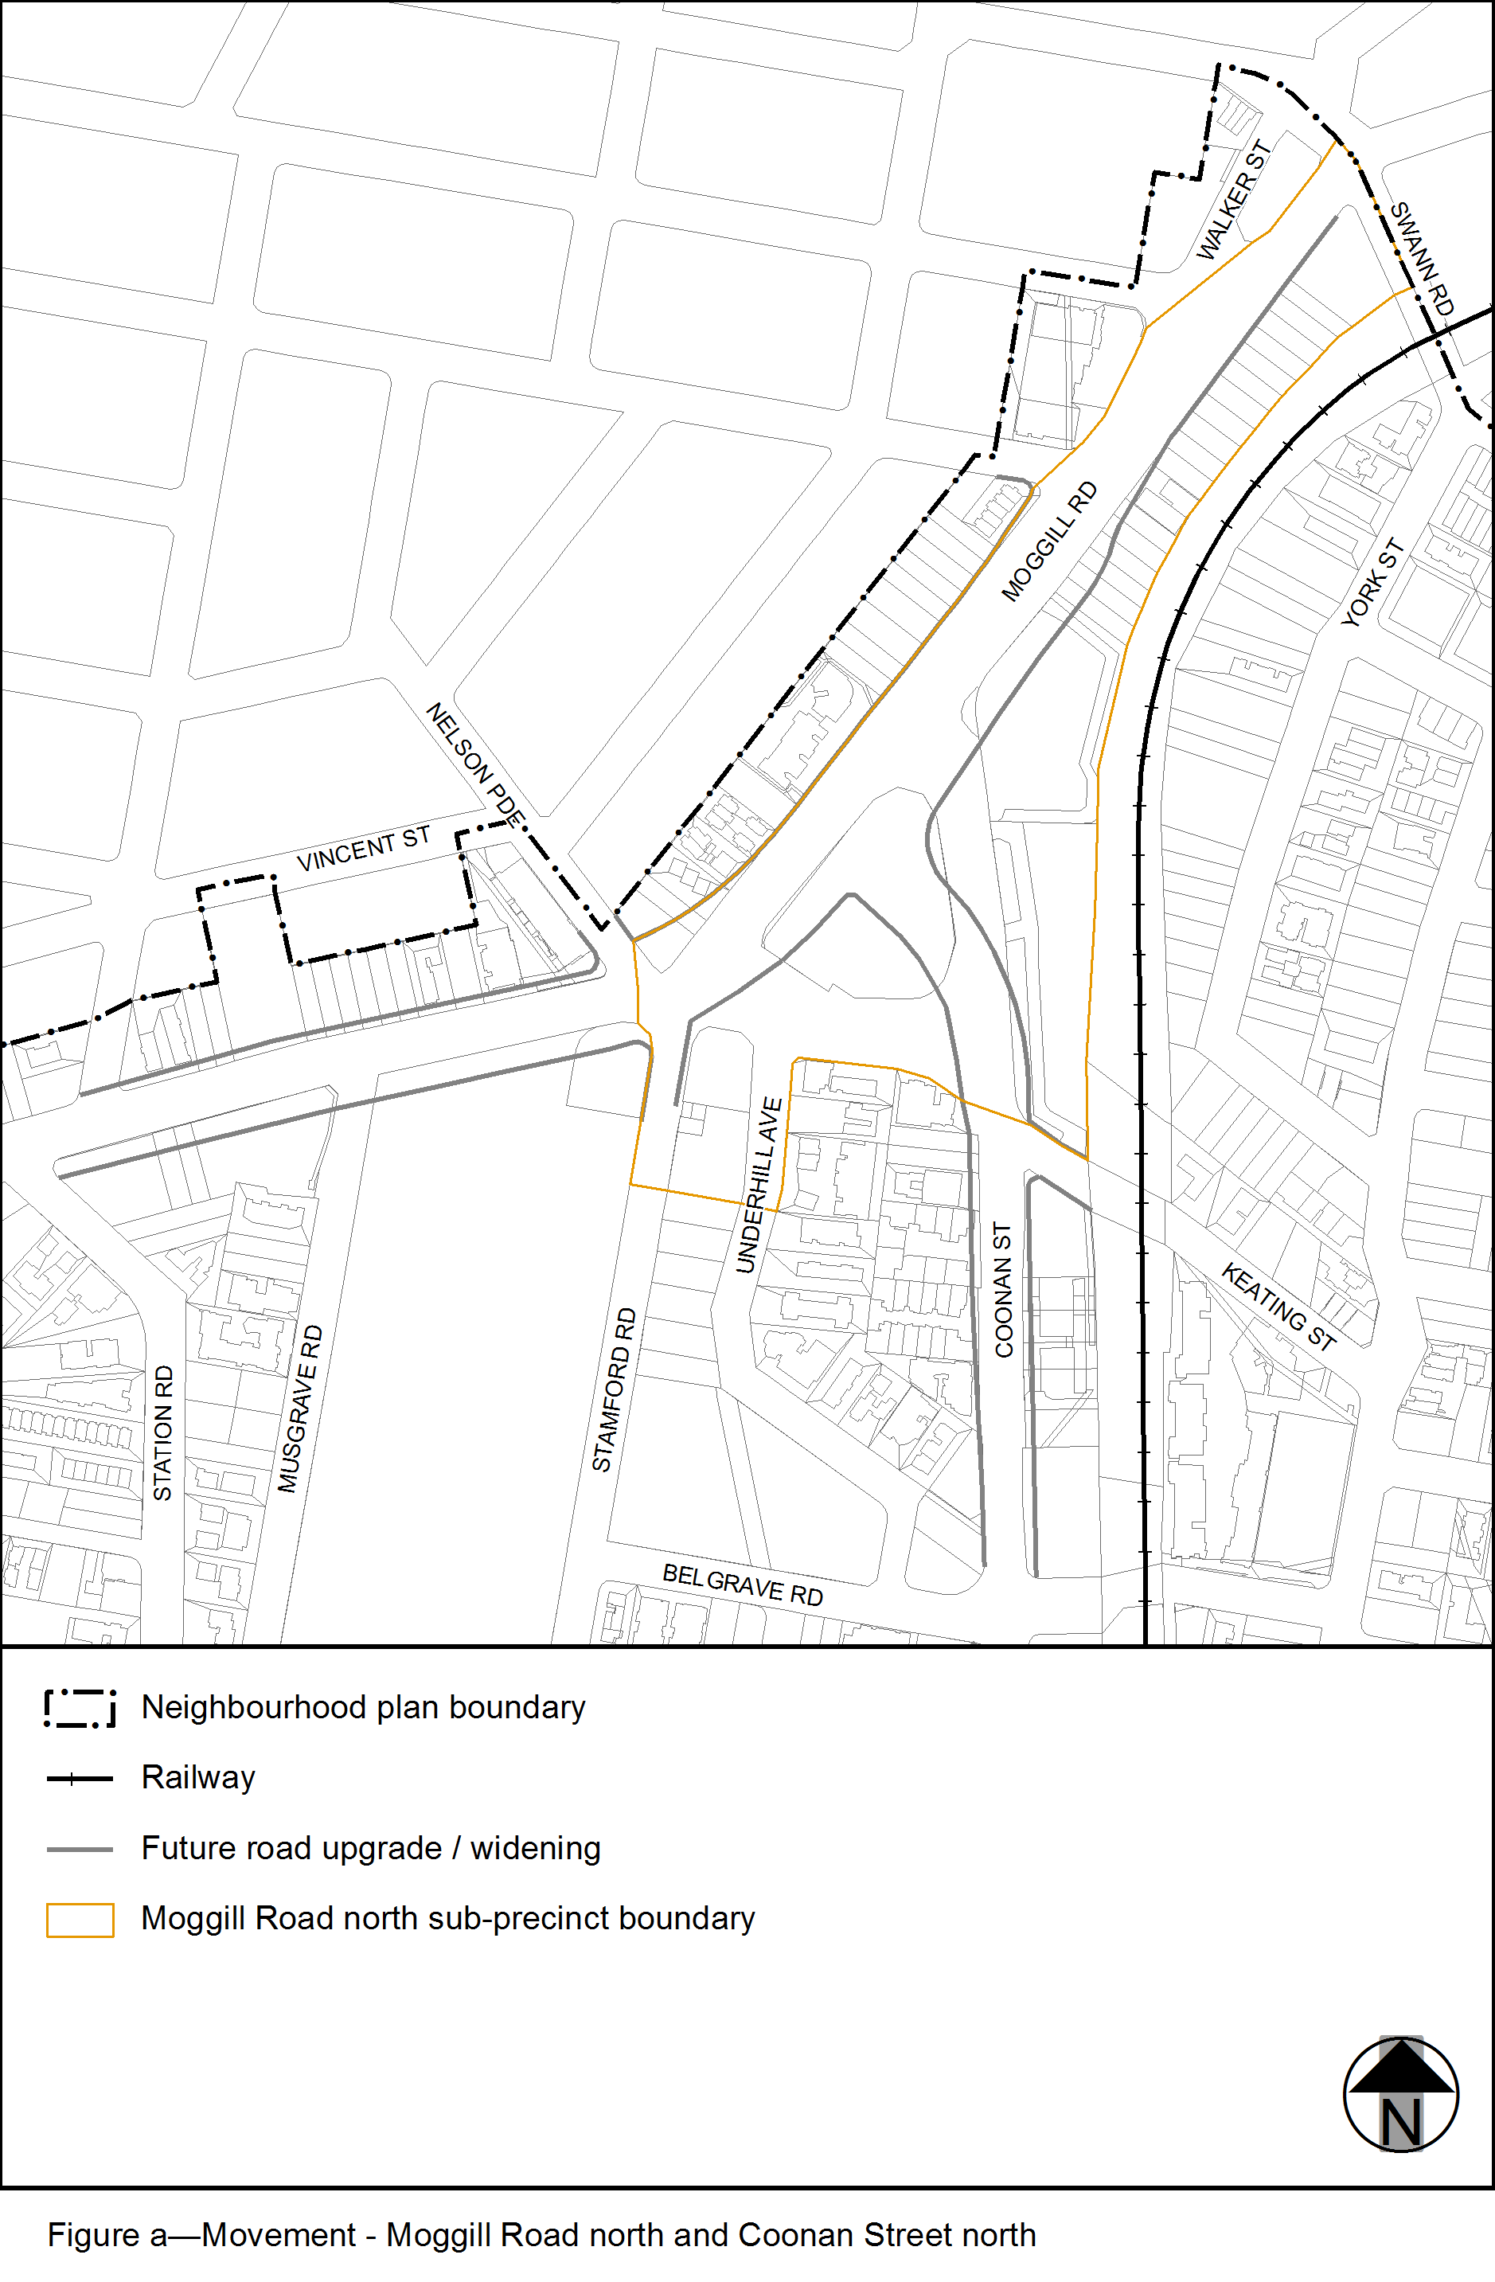
View the high resolution of Figure a–Movement – Moggill Road north and Coonan Street north (PDF file size is 281Kb)

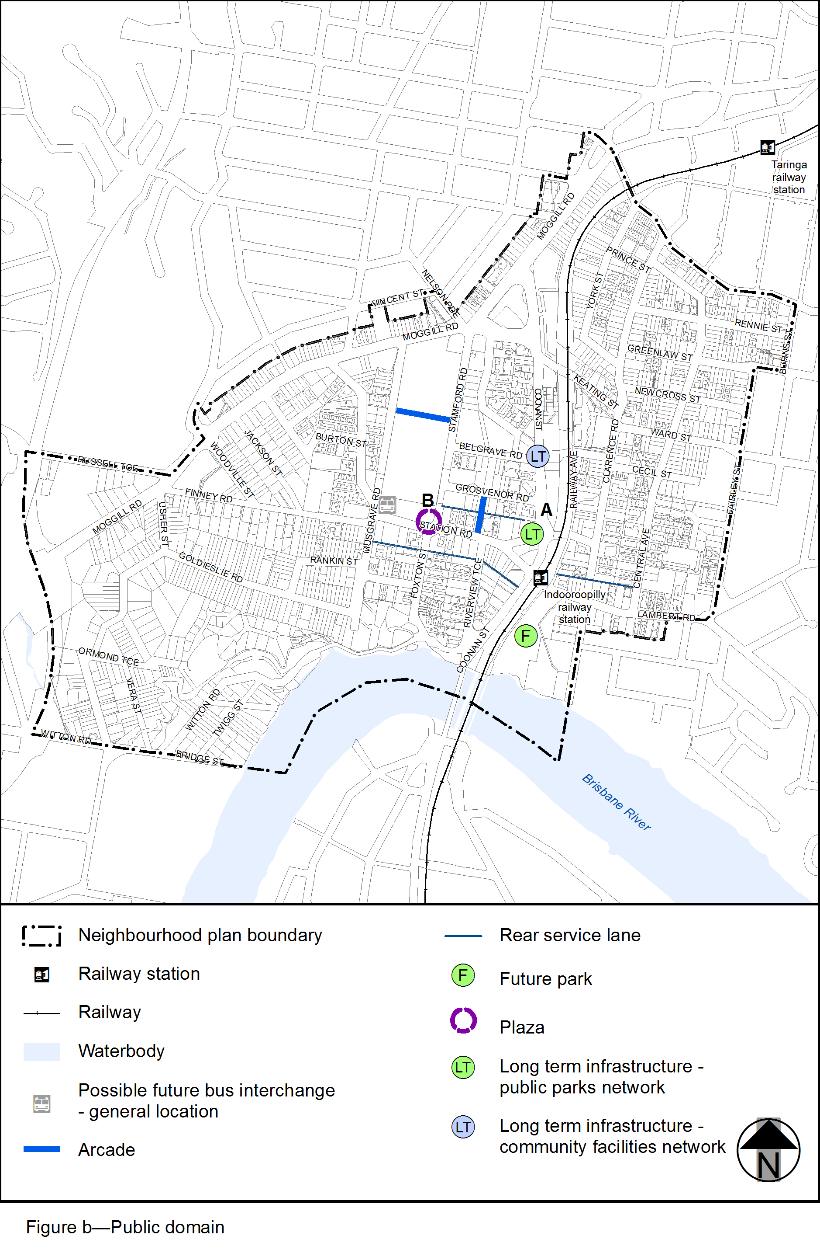View the high resolution of Figure b–Public domain (PDF file size is 662Kb)
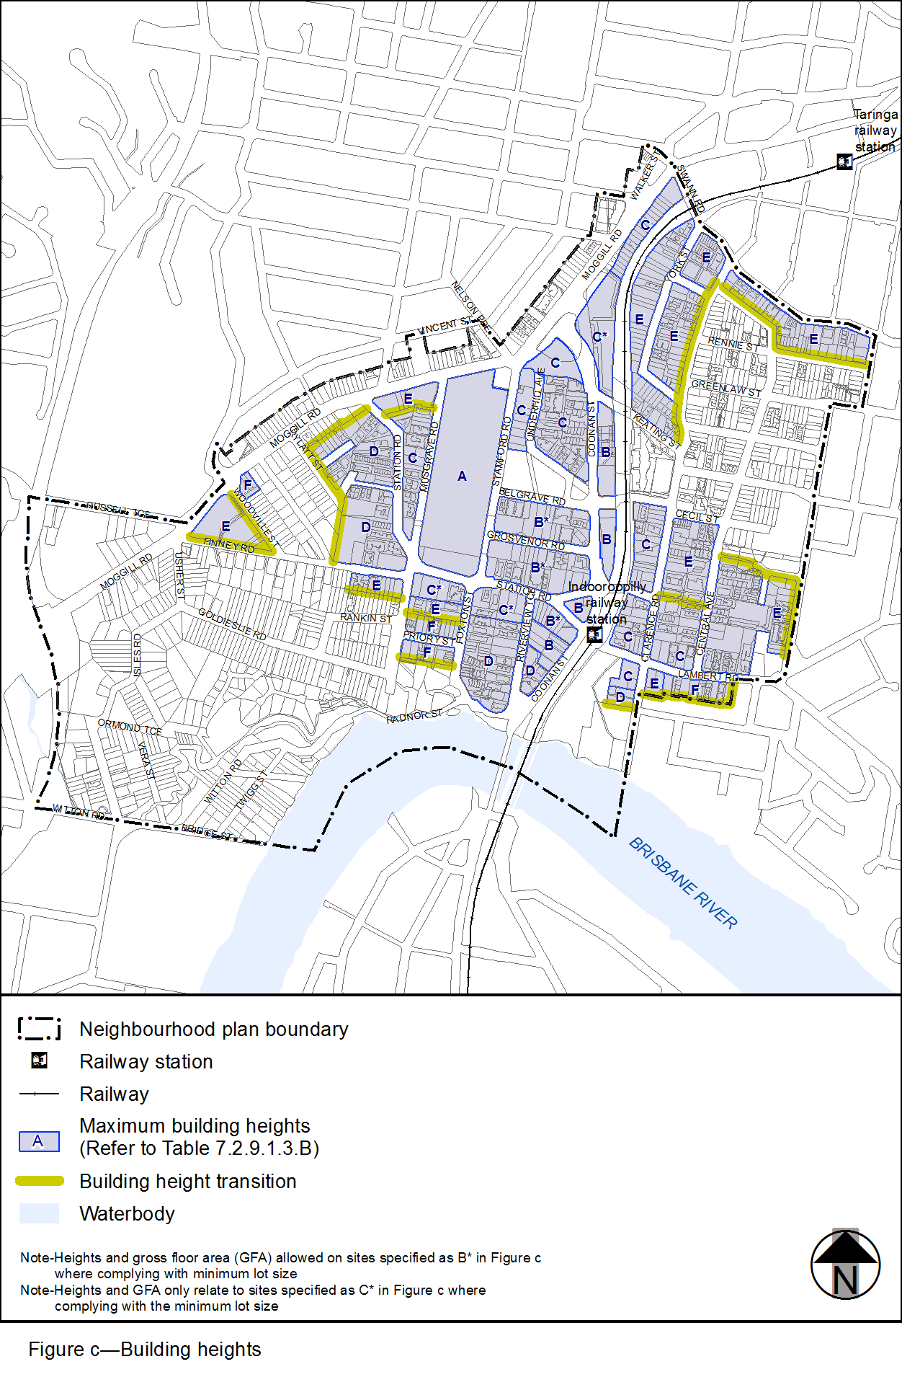
View the high resolution of Figure c–Building heights (PDF file size is 367Kb)
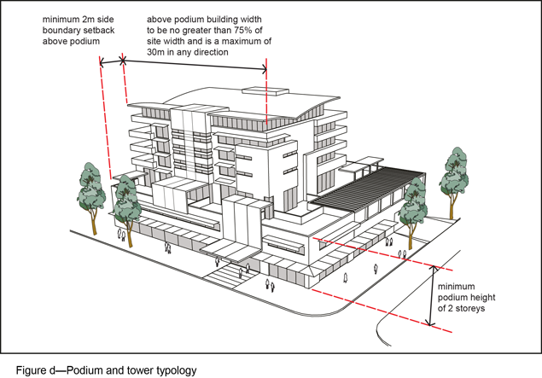
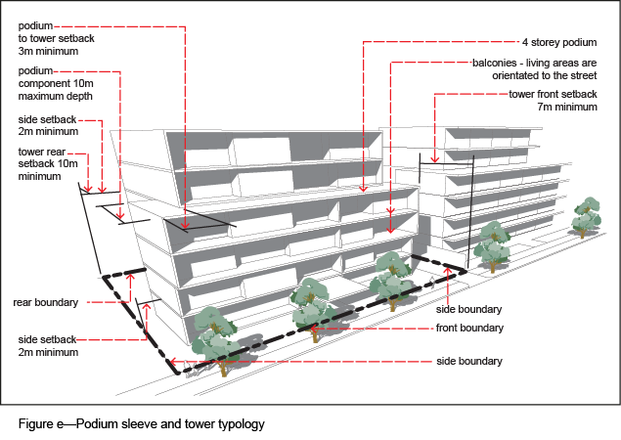
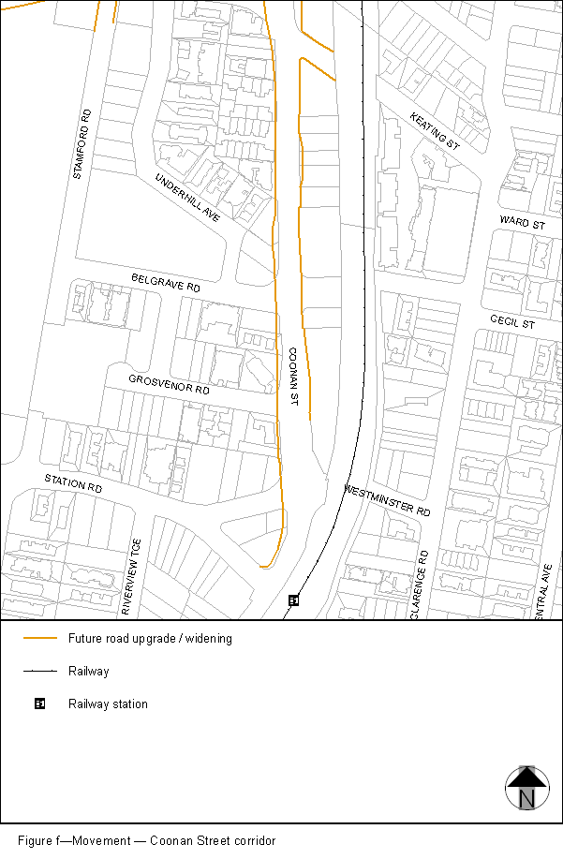
View the high resolution of Figure f–Movement – Coonan Street corridor (PDF file size is 155Kb)
