7.2.19.5 Spring Hill neighbourhood plan code

7.2.19.5.1 Application
- This code applies to assessing a material change of use, reconfiguring a lot, operational work or building work in the Spring Hill neighbourhood plan area if:
- assessable development where this code is an applicable code identified in the assessment benchmarks column of a table of assessment for a neighbourhood plan (section 5.9); or
- impact assessable development.
- Land within the Spring Hill neighbourhood plan area is identified on the NPM-019.5 Spring Hill neighbourhood plan map and includes the following precincts:
- City Centre expansion precinct (Spring Hill neighbourhood plan/NPP-001);
- Spring Hill mixed use precinct (Spring Hill neighbourhood plan/NPP-002):
- Spring Hill mixed use a sub-precinct (Spring Hill neighbourhood plan/NPP-002a);
- Spring Hill mixed use b sub-precinct (Spring Hill neighbourhood plan/NPP-002b).
- Boundary Street heart precinct (Spring Hill neighbourhood plan/NPP-003);
- Spring Hill east precinct (Spring Hill neighbourhood plan/NPP-004).
- When using this code, reference should be made to section 1.5, section 5.3.2 and section 5.3.3.
Note—The following purpose, overall outcomes, performance outcomes and acceptable outcomes comprise the assessment benchmarks of this code.
Note—This neighbourhood plan includes a table of assessment with variations to categories of development and assessment. Refer to Table 5.9.54.A, Table 5.9.54.B, Table 5.9.54.C and Table 5.9.54.D.
Editor’s note—The preparation of an Urban context report in accordance with Table 7.2.19.5.3.B will assist in demonstrating how the proposal achieves the outcomes of this neighbourhood plan.
Note—Council’s Independent Design Advisory Panel may be invited to provide advice on development, to facilitate high quality development, in accordance with the provisions of the Independent design advisory panel planning scheme policy.
Editor’s note—The New World City Design Guide - Buildings that Breathe sets out the vision, design elements and best practice case studies to guide new development. Development is actively encouraged to incorporate these design elements and embrace the city’s subtropical climate.
Note—The ‘street building’ comprises all levels of a building below which a set back tower commences. Refer to Figure c for guidance.
Note—Where located in the Principal centre zone, District centre zone, or Mixed use zone, the building height transitions provisions as identified in the Multiple dwelling code and/or the Centre or mixed use code do not apply within this neighbourhood plan area.

7.2.19.5.2 Purpose
- The purpose of the Spring Hill neighbourhood plan code is to provide finer grained planning at a local level for the Spring Hill neighbourhood plan area.
- The purpose of the Spring Hill neighbourhood plan code will be achieved through overall outcomes including overall outcomes for each precinct of the neighbourhood plan area.
- The overall outcomes for the neighbourhood plan area are:
- Spring Hill is a diverse neighbourhood, with higher density mixed use activities bordering the CBD and along major streets, bounding pockets of small-scale, fine-grain residential dwellings.
- Spring Hill supports an inclusive community and provides a range of housing options for a diverse mix of people, jobs in a variety of sectors, a range of community services and a choice of meeting and gathering places.
- Development in Spring Hill reflects the unique character of the neighbourhood and its importance as one of the earliest suburbs settled in Brisbane. This is characterised by large areas of traditional residential dwellings built before 1885 on small allotments within a network of narrow streets and laneways. These buildings and areas make a significant contribution to Brisbane’s heritage and character and are retained.
- Development protects and reinforces Spring Hill’s extensive heritage and character through the retention, conservation and re-use of heritage places and character buildings.
- Development provides a sensitive design response to character dwellings, heritage places, and commercial character buildings that respects the visual integrity of these buildings, and the positive contribution that they make to the character and built form of Spring Hill.
- Development reinforces the diverse architecture and urban form that sets Spring Hill apart from other parts of Brisbane and is responsive to each site’s specific shape, size, topography, context and setting.
- Development is designed to take advantage of Brisbane’s subtropical climate and delivers high quality, subtropical architecture. Buildings, the public realm and landscaped spaces are designed to be open, engaging and green, with shaded spaces and opportunities to interact with the street, and contribute to Brisbane’s identity and lifestyle.
- Development provides new and enhanced arcades and streetscape treatments in accordance with Figure a to improve the quality and quantity of public spaces in the neighbourhood plan area and enhance recreational opportunities. Improved footpaths and active frontages enhance street amenity and reinforce pedestrian movement.
- Development in the Principal centre zone, District centre zone, Mixed use zone or Community facilities zone provides slender towers that are sited and designed to maintain the openness of street vistas with adequate spacing between buildings to allow for light penetration, air circulation, views and vistas, and privacy, particularly for residential towers.
- Development in the District centre zone, Mixed use zone or Community facilities zone is set back from, and provides a highly landscaped design response to, adjoining sites in the Character residential zone or Low-medium density residential zone to minimise privacy and amenity impacts on residents.
- Development in the Community facilities zone provides physical and visual connections that contribute to the amenity and legibility of the overall pedestrian network. Development integrates with surrounding uses through an articulated and responsive built form, including a strong interface with the public domain at street frontages and welcoming front entrances.
- Development in the Low-medium density residential zone provides a mix of residential options in close proximity to the city centre (CBD), including Dual occupancy, Dwelling house, and Multiple dwelling uses.
- Development in the Character residential zone protects traditional housing stock.
- The City Centre expansion precinct (Spring Hill neighbourhood plan/NPP-001) overall outcomes are:
- The City Centre expansion precinct contains a mix of commercial, retail, residential, community and recreational uses, providing a transition in height between the CBD and development in the Boundary Street heart precinct and Spring Hill mixed use precinct.
- The Principal centre zone develops as a strong economic centre for Spring Hill, encouraging investment and employment in the area and leveraging off its proximity to the CBD and existing major health care and education institutions in the neighbourhood plan area. The Principal centre zone accommodates the highest densities and most diverse range of uses at a scale that is subordinate to the CBD.
- Development facilitates improvements to existing, and the creation of additional, pedestrian connections from Wickham Terrace and Leichhardt Street to Astor Terrace to improve permeability throughout Spring Hill. The key wayfinding spines of Little Edward, Upper Edward, Leichhardt and Wharf Streets are enhanced.
- Astor Terrace is recognised as a weekday, evening and weekend meeting place. Through development, Astor Terrace becomes a key destination for entertainment activities, comprising live music and entertainment venues, and for small ground level active uses including cafes, restaurants and bars.
- The Spring Hill mixed use precinct (Spring Hill neighbourhood plan/NPP-002) overall outcomes are:
- Development is of a height and scale that is subordinate to development in the City Centre expansion precinct.
- Development in the Mixed use zone or Community facilities zone is set back from, and provides a highly landscaped design response to adjoining sites in the Character residential zone or Low-medium density residential zone to minimise privacy and amenity impacts on residents.
- Development in the Mixed use zone provides a range of built form outcomes which include commercial, residential and creative uses that support the City Centre expansion precinct.
- Development in the Character residential zone maintains the low-rise character of 1 and 2 storey dwellings, while encouraging the reuse of character housing for non-residential activities that maintain the domestic appearance of traditional character houses.
- The Boundary Street heart precinct (Spring Hill neighbourhood plan/NPP-003) overall outcomes are:
- Development in the District centre zone reinforces Boundary Street as the ‘heart’ of Spring Hill through support for a mix of uses and as a location for higher-order services.
- Development is of a height and scale that is subordinate to development in the City Centre expansion precinct.
- Development in the District centre zone or Mixed use zone is set back from, and provides a highly landscaped design response to adjoining sites in the Character residential zone or Low-medium density residential zone to minimise privacy and amenity impacts on residents.
- Development in the Mixed use zone supports existing community facilities in the area through the promotion of complementary uses, including Health care service and Short-term accommodation.
- Development promotes Boundary Street as a pedestrian friendly street through a combination of ground level activation, high quality street building and streetscape design, and welcoming front entrances.
- Spring Hill east precinct (Spring Hill neighbourhood plan/NPP-004) overall outcomes are:
- Development maintains a mix of small-scale residential, higher density mixed use, and community (education) facilities land uses in the precinct.
- Development in the Mixed use zone is set back from, and provides a highly landscaped design response to adjoining sites in the Character residential zone or Low-medium density residential zone to minimise privacy and amenity impacts on residents.
- The Neighbourhood centre zoned land on Water Street maintains a local activity centre function providing a variety of uses and activities that service local residents. No further expansion of commercial activities into residential areas occurs.
- Development in the Mixed use zone provides a transition between the lower density residential portions of Spring Hill to the higher density city frame areas of Bowen Hills and Fortitude Valley. Development is of a higher intensity along St Pauls Terrace, to provide a height transition to the Principal centre zoned land on the opposite side of the road.
- Development in the Low-medium density residential zone along Gregory Terrace forms an urban residential edge to Victoria Park opposite.
- Bedford Playground Park continues to be a central public open space for residents of Spring Hill, offering a range of local and district level informal recreation experiences. Complementary community uses continue to operate from existing community buildings in the park.

7.2.19.5.3 Performance outcomes and acceptable outcomes

Table 7.2.19.5.3.A—Performance outcomes and acceptable outcomes
Performance outcomes | Acceptable outcomes
If in the Principal centre zone, District centre zone, Mixed use zone, or Community facilities zone
PO1  Development is of a height, scale and form that achieves the intended outcome for the precinct, improves the amenity of the neighbourhood plan area, contributes to a cohesive streetscape and built form character and is:  - consistent with anticipated density and assumed infrastructure demand;  - aligned to community expectations about the number of storeys to be built;  - proportionate and commensurate with the utility of the site area and frontage width;  - designed to avoid significant and undue adverse amenity impact to adjoining development;  - sited to enable existing and future buildings to be well separated from each other and to avoid affecting the potential development of an adjoining site.  Note—Development that exceeds the intended number of storeys or building height can place disproportionate pressure on the transport network, public space or community facilities in particular.  Note—Development that is over-scaled for its site can result in an undesirable dominance of vehicle access, parking and manoeuvring areas that significantly reduce streetscape character and amenity. | AO1  Development complies with the number of storeys in Table 7.2.19.5.3.C—Maximum building height and maximum tower site cover.  Note—Neighbourhood plans will mostly specify the maximum number of storeys where zone outcomes have been varied in relation to building height. Some neighbourhood plans may also specify the height in metres. Development must comply with both parameters where maximum number of storeys and height in metres are specified.
PO2  Development is designed to respond to its site context and setting and exhibits outstanding architectural merit. | AO2  No acceptable outcome is prescribed.
PO3  Development is of a scale and form that contributes to a cohesive streetscape and built form character, and:  - does not cause significant and undue adverse amenity impacts to adjoining properties, or prejudice their development;  - is sited and designed to enable existing and future buildings to be well separated from each other to allow for light penetration, air circulation between buildings, and the preservation of views, vistas and resident privacy;  - protects the amenity of properties located in the Character residential zone or Low medium density residential zone;  - respects the existing built form of properties identified in the Heritage overlay, Pre-1911 building overlay, and the Commercial character building overlay. | AO3.1  Development ensures setbacks are in accordance with Table 7.2.19.5.3.D—Boundary setback requirements.
AO3.2
Development has a maximum tower site cover in accordance with Table 7.2.19.5.3.C—Maximum building height and maximum tower site cover.
PO4  Development in the Principal centre zone, or District centre zone, or Mixed use zone incorporates a street building with a façade treatment that is designed to:  - address and activate the street and any adjacent publicly accessible space with a high level of permeability, landscaping, shade and shelter;  - contribute to an attractive streetscape;  - create a smooth transition from indoors to outdoors;  - respond to the subtropical climate by opening up to the elements while providing shade and comfort. | AO4.1  Development in the Principal centre zone, or District centre zone, or Mixed use zone includes a building form that incorporates a street building.  Refer to Figure c for guidance.
AO4.2
Development has a maximum street building height in accordance with the following:
- if in the Principal centre zone, no greater than 3 storeys; or
- if in the District centre zone or Mixed use zone, no greater than 2 storeys.
AO4.3
Development of a street building incorporates:
- balconies, openings and louvres to create a high degree of permeability that allow building occupants to overlook the street and any adjacent publicly accessible space;
- outdoor spaces that allow building occupants to access open air;
- vertical landscaping, shade structures, and articulation that provide shade and shelter for pedestrians on the street and the building.
Refer to Figure c for guidance.
PO5  Development exhibits best practice subtropical design and presents a highly landscaped environment, including:  - landscaping and outdoor spaces that make the most of Brisbane’s subtropical climate, while mitigating heat;  - landscaped subtropical spaces and water features on ground levels, roofs, balconies, terraces, and edges of buildings. | AO5  Development provides landscaped outdoor spaces equivalent to a minimum 30% of the site area.  Note—Outdoor space does not include spaces where more than 70% of the perimeter is enclosed, or balconies that are less than 12m².
PO6  Development exhibits best-practice climate responsive design, including orientation, to mitigate heat and reduce the need for mechanical heating, cooling and lighting. | AO6  No acceptable outcome is prescribed.
PO7  Development provides a landscape buffer within the setback area of a special boundary identified on Figure b to facilitate:  - visual privacy to and between sites;  - visual amenity;  - shading and occupant amenity;  - appropriate transition to adjoining character housing. | AO7  No acceptable outcome is prescribed.
Additional criteria if in the Major health care zone precinct of the Community facilities zone
PO8  Development of the lower 2 storeys of the building:  - exhibits a human-scale, having regard to the characteristics of surrounding development;  - supports a comfortable and attractive pedestrian environment. | AO8  No acceptable outcome is prescribed.
PO9  Development provides arcades to create an integrated and continuous pedestrian network that facilitates movement within and through large sites and along key thoroughfares. | AO9  Development provides arcades running from street to street within the locations indicated in Figure a that:  - provides pedestrian access during hours of operation of the use;  - integrates with adjoining buildings;  - links established pedestrian networks, parking and public transport facilities;  - is finished with high quality materials considering public safety;  - is provided at-grade with an adjoining public area and connects safely without any lip or step;  - incorporates crime prevention through environmental design principles to maximise safety;  - has signage at each end identifying the connection provided.  Note—Crime prevention principles can be found in the Crime prevention through environmental design planning scheme policy.

Table 7.2.19.5.3.B—Urban context report
Content | Scope (and format)
Site characteristics | Demonstrate how the site’s constraints and attributes have been considered in the design of the development.
Cityscape and built form | Demonstrate how the development:  - provides a site-responsive built form taking into account site characteristics and form of surrounding development, including relationship with other buildings in terms of setbacks, privacy, light and air;  - provides a contextually responsive built form taking into account site location within Spring Hill;  - impacts on broader views across the cityscape and of the city skyline;  - exhibits outstanding architectural merit.
Streetscape | Demonstrate how the development impacts on and contributes to the streetscape and street functioning, in terms of:  - street building height, setbacks and design;  - ground level activation, including proportion of glazing and openings;  - awning heights and continuity;  - footpath width, continuity and design.
Heritage, landmarks, natural assets, views and vistas | Demonstrate how the development:  - respects the streetscape and public realm context and setting of nearby heritage buildings and places, landmarks and natural assets;  - maintains or creates views and vistas from public vantage points to heritage places, landmarks and natural assets, and across public realm.
Public realm, connections, attractors and movement network | Demonstrate how the development:  - respects, enhances, expands and/or connects to adjoining and nearby public realm;  - maintains and enhances pedestrian permeability, including major attractors and the wider movement network.
Subtropical climate | Demonstrate how the development design incorporates orientation, shading, outdoor spaces, natural ventilation, landscaping and articulation to reduce heat loading, protect from weather, optimise natural light and support outdoor lifestyles.
Editor’s note—The Urban context report provides a formal means for developers, architects and designers to clearly articulate how the development successfully responds to the site, its context and climate. This report should comprise plans, diagrams, perspectives, 3D modelling (including use of the Virtual Brisbane 3D model to test development options) and supporting design rationales to demonstrate how the proposal achieves the outcomes of this neighbourhood plan.
Editor’s note—The New World City Design Guide - Buildings that Breathe sets out the vision, design elements and best practice case studies to guide new development. Development is actively encouraged to incorporate these design elements and embrace the city’s subtropical climate.

Table 7.2.19.5.3.C—Maximum building height and maximum tower site cover
 | Development of a site less than 800m² or with a site frontage of less than 20m | Development of a site 800m² or greater but less than 1,000m² | Development of a site 1,000m² or greater but less than 1,800m² | Development of a site 1,800m² or greater
Maximum building height (storeys)
If in the City Centre expansion precinct (Spring Hill neighbourhood plan/NPP-001)
Where in the Principal centre zone | 3 | 15 | 25 | 30
If in the Spring Hill mixed use precinct (Spring Hill neighbourhood plan/NPP-002)
Where in the Mixed use zone and in sub-precinct a | 3 | 8 | 15 | 20
Where in the Mixed use zone and in sub-precinct b | 3 | 8 | 10 | 15
Where in the Community facilities zone (Major health care zone precinct) | 20
Where in the Community facilities zone (Education purposes zone precinct) | 10
If in the Boundary Street heart precinct (Spring Hill neighbourhood plan/NPP-003)
Where in the District centre zone or the Mixed use zone | 3 | 5 | 10 | 15
Where in the Community facilities zone (Major health care zone precinct) | 15
Where in the Community facilities zone (Education purposes zone precinct) | 10
If in the Spring Hill east precinct (Spring Hill neighbourhood plan/NPP-004)
Where in the Mixed use zone and with a primary frontage to Saint Pauls Terrace | 3 | 8 | 15 | 20
Where in the Mixed use zone otherwise | 3 | 8 | 10 | 15
Where in the Community facilities zone (Education purposes zone precinct) | 5
Maximum tower site cover (%)
If in the Principal centre zone, or the District centre zone, or the Mixed use zone | Not applicable | Not applicable | Not applicable | 60%
Note—Maximum building height includes the ground storey and all street building and tower storeys above ground level.
Note—Tower site cover (TSC) is:
- the combined average area of the 5 largest storeys of each building (being the full area of any storey located wholly or partially above the maximum street building height identified in AO4.2) as a portion of the original site area;
- calculated as the area bounded by the outside of the external wall, including balconies but excluding projections.

Table 7.2.19.5.3.D—Boundary setback requirements
Element | Minimum boundary setback (metres)
 | Front | Side and rear | Where identified as a special boundary on Figure b
Street building | 0 | 0 | 3
Tower | 3 to balcony  6 to wall | 6 | 9
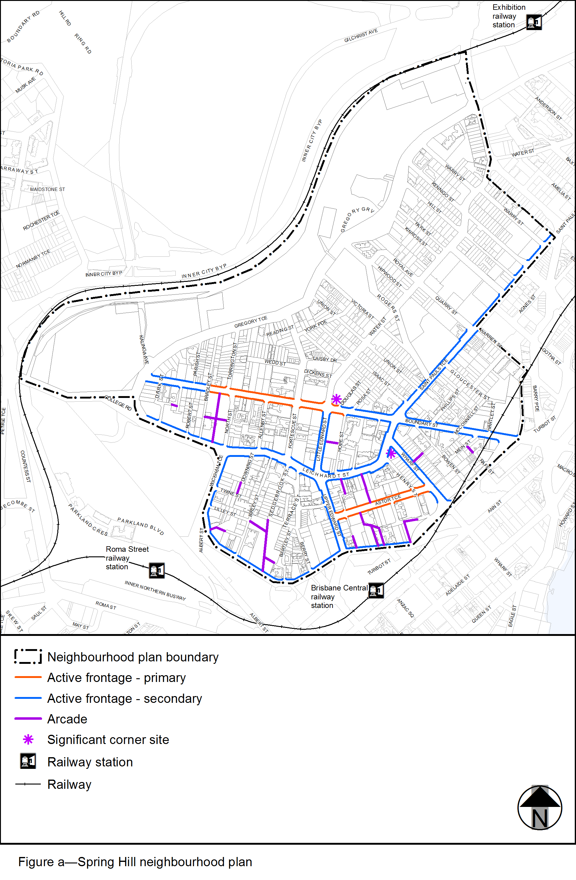

View the high resolution of Figure a–Spring Hill neighbourhood plan (PDF file size is 476Kb)
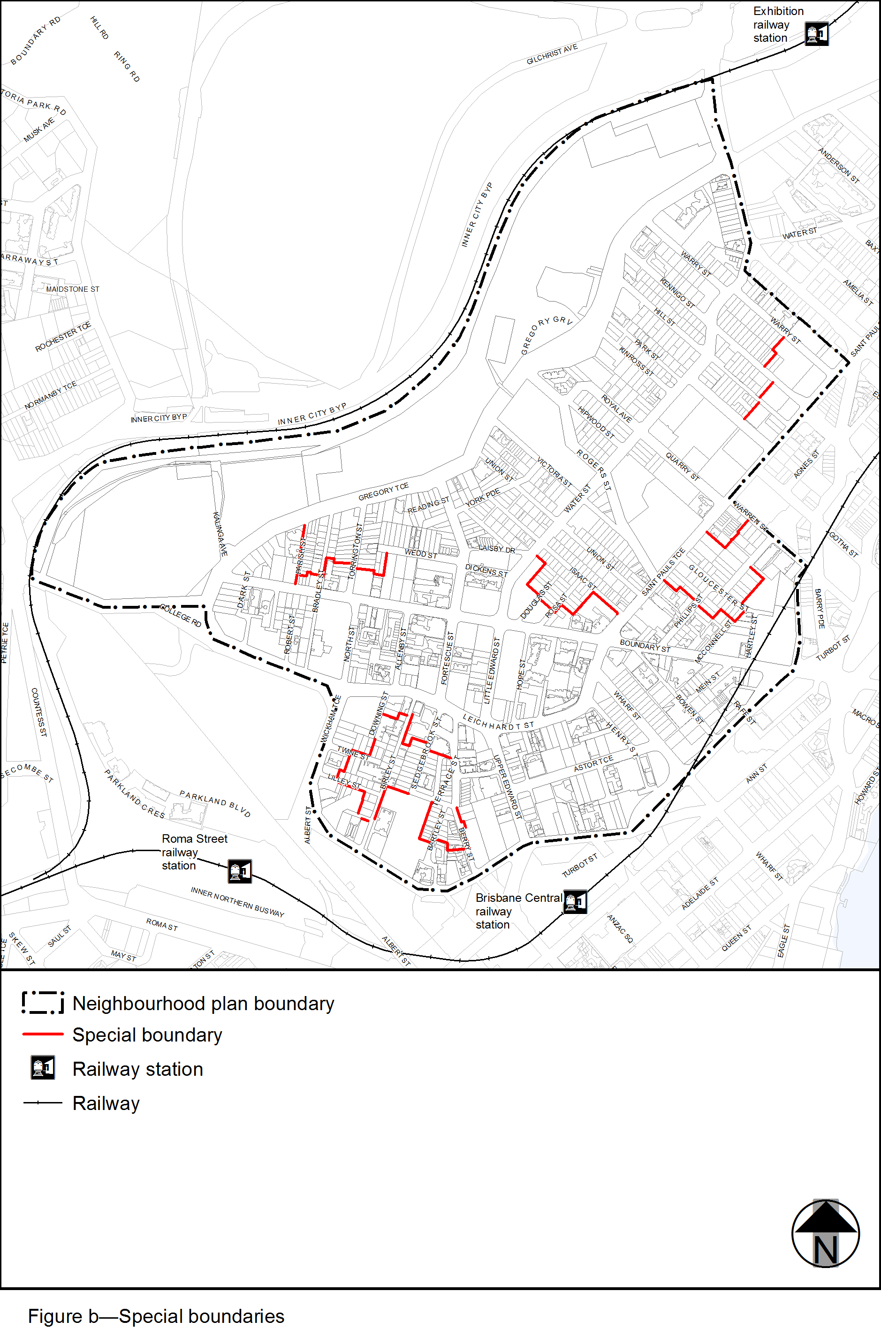

View the high resolution of Figure b–Special boundaries (PDF file size is 471Kb)
