7.2.23.1 Wakerley neighbourhood plan code

7.2.23.1.1 Application
- This code applies to assessing a material change of use, reconfiguring a lot, operational work or building work in the Wakerley neighbourhood plan area if:
- assessable development where this code is an applicable code identified in the assessment benchmarks column of a table of assessment for a neighbourhood plan (section 5.9); or
- impact assessable development.
- Land in the Wakerley neighbourhood plan area is identified on the NPM-0023.1 Wakerley neighbourhood plan map and includes the following precincts:
- Residential development precinct (Wakerley neighbourhood plan/NPP-001):
- Residential a sub-precinct (Wakerley neighbourhood plan/NPP-001a);
- Residential b sub-precinct (Wakerley neighbourhood plan/NPP-001b);
- Residential c sub-precinct (Wakerley neighbourhood plan/NPP-001c).
- Industrial development precinct (Wakerley neighbourhood plan/NPP-002).
- When using this code, reference should be made to section 1.5, section 5.3.2 and section 5.3.3.
Note—The following purpose, overall outcomes, performance outcomes and acceptable outcomes comprise the assessment benchmarks of this code.
Note—This neighbourhood plan includes a table of assessment with variations to categories of development and assessment. Refer to Table 5.9.67.A, Table 5.9.67.B, Table 5.9.67.C and Table 5.9.67.D.

7.2.23.1.2 Purpose
- The purpose of the Wakerley neighbourhood plan code is to provide finer grained planning at a local level for the Wakerley area neighbourhood plan area.
- The purpose of the Wakerley neighbourhood plan code will be achieved through overall outcomes including overall outcomes for each precinct of the neighbourhood plan area.
- The overall outcomes for the neighbourhood plan area are:
- Development creates functional and integrated communities.
- Land subject to development constraints, character or environmental values indicated in a figure in this neighbourhood plan code or shown on an overlay map are protected from inappropriate development in order to maintain its character, and natural and ecological significance.
- Open space, parks and recreational facilities meet the needs of the community and are located in accessible locations that are well connected within the neighbourhood plan area.
- Development in a potential development area addresses the location of the land, availability of services, environmental constraints, amenity, and existing patterns of development, to ensure an integrated development outcome.
- Non-residential uses not consistent with the outcomes sought in residential potential development areas include, bar, club, community care centre, educational establishment, food and drink outlet, health care service, hotel, hospital, indoor sport and recreation, relocatable home park or service station.
- Neighbourhood centres identified in the neighbourhood plan serve the retail, commercial, community and service needs of the local community. Centre activities do not expand outside of these identified sites and other land already included in a zone in the centre zones category.
Note—Where reference is made to koala food trees throughout this neighbourhood plan, the following are recommended: forest red gum (Eucalyptus tereticornis), scribbly gum (Eucalyptus racemosa), grey iron bark (Eucalyptus siderphloia), tallowwood (Eucalyptus microcorys), or other local native canopy trees.
- Residential development precinct (Wakerley neighbourhood plan/NPP-001) overall outcomes are:
- The precinct provides for a mix of housing types, styles and densities, in particular, where indicated in Figure a:
- Very low density residential: comprises dwelling houses up to 5 dwellings per hectare to ensure minimal disturbance to areas of environmental and scenic value;
- Low density residential – area 1: comprises dwelling houses up to 10 dwellings per hectare;
- Low density residential – area 2: comprises dwelling houses up to 15 dwellings per hectare where small lots and are a minimum of 400m2 and located close to centres and public transport routes;
- Low density residential – multiple dwellings: contains a mix of small lot dwelling houses, dual occupancy and multiple dwellings up to 25 dwellings per hectare;
- reconfiguring a lot in the Emerging community zone that results in a lot less than 5ha has regard for environmental values of the site and significant vegetation.
Note—Densities and yields are to be calculated excluding parts of the site that are not within a potential development area. These include areas with development constraints or character or environmental values identified in overlay maps. Yields and maximum gross floor area for multiple dwellings and dual occupancy are to be calculated across the potential development area including all access ways and roads respectively.
- Development in the Residential a sub-precinct (Wakerley neighbourhood plan/NPP-001a):
- provides for very low and low density residential development due its valuable landscape features.
- Development in the Residential b sub-precinct (Wakerley neighbourhood plan/NPP-001b):
- provides for very low density residential development due to its valuable landscape features.
- Development in the Residential c sub-precinct (Wakerley neighbourhood plan/NPP-001c):
- provides for very low density and low density residential development.
- Industrial development precinct (Wakerley neighbourhood plan/NPP-002) overall outcomes are:
- Development addresses the land use intent as indicated in Figure a.
- Shared access is provided to the industry area on Ingleston Road. Industrial development fronting New Cleveland Road is designed to create attractive streetscapes incorporating extensive landscaping and coordinated signage.
- Development adjacent to the tributary of Bulimba Creek traversing the eastern part of the industry area and flowing north into the Numgubbah Swamp comprises low impact industry or service uses that are compatible with the environmental values of the corridor and with nearby residential land. This corridor is progressively rehabilitated.

7.2.23.1.3 Performance outcomes and acceptable outcomes

Table 7.2.23.1.3—Performance outcomes and acceptable outcomes
Performance outcomes | Acceptable outcomes
PO1  Development provides an acceptable sewerage system that is not a temporary pump station to service new development. | AO1  Development provides a gravity sewerage system to new development in the area identified in Figure a.
PO2  Development does not result in stormwater flow that has adverse impacts upstream, downstream on habitats or adjacent properties. | AO2  Development with impermeable areas including dwelling houses, secondary buildings, vehicular access and all paved areas, does not exceed the following percentage of the site area for potential development areas and centres:  - Very low density residential: 20%;  - Low density residential – area 1: 50%;  - Low density residential – area 2: 70%;  - Low density residential – multiple dwellings: 75%;  - neighbourhood centres, low impact industry and medium impact industry: 90%.
PO3  Development in residential areas and for public parkland is adequately protected from industrial development to ameliorate the impact of industry noise and air pollution and facilitate wildlife movement between nearby parklands and corridors. | AO3.1  Development, if reconfiguring a lot for residential purposes north of New Cleveland Road where abutting the Industrial development precinct (Wakerley neighbourhood plan/NPP-002), incorporates a noise and air pollution buffer 70m wide as identified in Figure a, with a minimum 20m of the width comprising existing native vegetation or is revegetated using a layered structure of native species, including koala food species.
AO3.2
Development of parkland north of New Cleveland Road where abutting the Industrial development precinct (Wakerley neighbourhood plan/NPP-002):
- is a minimum of 70m wide;
- is accessible from an adjacent public street for a minimum of 50% of the length of its eastern boundary;
- comprises existing native vegetation or is revegetated using a layered structure of native species, including koala food species for a minimum width of 20m from the boundary with the low impact industry or medium impact industry potential development area.
PO4  Development in residential areas and public parkland is appropriately buffered from major traffic routes to improve amenity and facilitate wildlife movement between nearby parklands and corridors. | AO4.1  Development involving reconfiguring a lot for residential development incorporates a landscaped buffer/fauna link a minimum of 20m wide along the boundary with the road corridor where indicated in Figure a, and the buffer/fauna link comprises existing native vegetation or is revegetated using a layered structure of native species, including koala food species.
AO4.2
Development for parkland abutting the Tilley Road extension and the Manly Road intersection with the Tilley Road extension:
- is a minimum of 40m wide;
- is accessible from an adjacent public street;
- comprises existing native vegetation or is revegetated using a layered structure of native species, including koala food species for a minimum width of 20m from the boundary to Manly Road or the Tilley Road extension.
AO4.3
Development on any street abutting the Tilley Road extension includes a verge abutting the road corridor with a minimum width of 20m, and comprises existing native vegetation or is revegetated using native trees, including koala food species.
If in the very low density residential potential development area
PO5  Development for residential purposes is designed to retain and enhance significant natural environmental values, including wildlife habitat and movement functions and existing native vegetation, minimise impacts on habitat values and landscape character and protect ecological corridors and waterway corridors. | AO5.1  Development has a minimum street frontage for all new lots of 40m.
AO5.2
Development has a development footprint plan of a size and location that:
- ensures a minimum of 70% of the site, or 85% of the site where in the Residential a sub-precinct (Wakerley neighbourhood plan/NPP-001a), is retained in its natural state to protect existing native vegetation or is revegetated using local native plant species including at least 50% koala food species planted at maximum 2m centres;
- is no more than 15% of the site area for sites in the Residential a sub-precinct (Wakerley neighbourhood plan/NPP-001a);
- minimises loss or fragmentation of existing native vegetation;
- is close to the lot boundary that has street access.

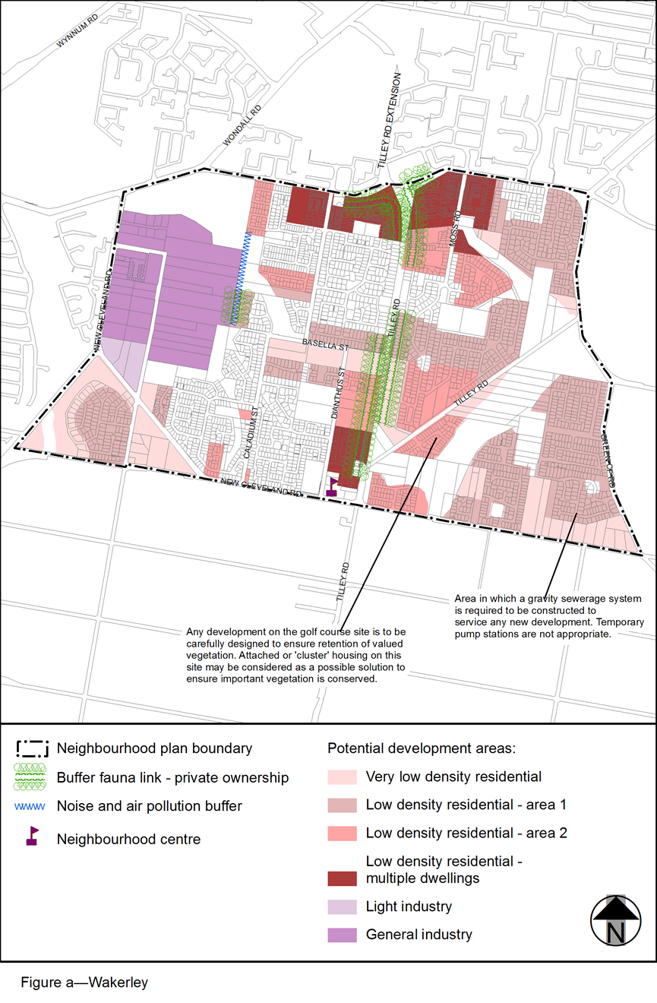
View the high resolution of Figure a–Wakerley (PDF file size is 339Kb)

