7.2.3.2 Capalaba West neighbourhood plan code

7.2.3.2.1 Application
- This code applies to assessing a material change of use, reconfiguring a lot, operational work or building work in the Capalaba West neighbourhood plan area if:
- assessable development where this code is an applicable code identified in the assessment benchmarks column of a table of assessment for a neighbourhood plan (section 5.9); or
- impact assessable development.
- Land in the Capalaba West neighbourhood plan area is identified on the NPM-003.2 Capalaba West neighbourhood plan map.
- When using this code, reference should be made to section 1.5, section 5.3.2 and section 5.3.3.
Note—The following purpose, overall outcomes, performance outcomes and acceptable outcomes comprise the assessment benchmarks of this code.
Note—This neighbourhood plan includes a table of assessment. Refer to Table 5.9.12.A, Table 5.9.12.B, Table 5.9.12.C and Table 5.9.12.D.

7.2.3.2.2 Purpose
- The purpose of the Capalaba West neighbourhood plan code is to provide finer grained planning at a local level for the Capalaba West neighbourhood plan area.
- The purpose of the Capalaba West neighbourhood plan code will be achieved through the following overall outcomes:
- Capalaba West remains a semi-rural centre, with compatible land uses supporting its semi-rural, broad hectare character.
- Development is limited in range, scale and form to reflect this character.
- A variety of small-scale commercial uses create an integrated centre for this area.
- Uses consistent with this outcome include agricultural supplies store, community uses, emergency services, garden centre (nursery and plant sales), indoor sport and recreation, low impact industry (where not exceeding 100m2 gross floor area), office, food and drink outlet (restaurant), shop, utility installation and veterinary service.
- The establishment of any land use is to complement rather than compete with those facilities provided in the nearby Capalaba Centre.
- Retail warehousing and fast-food outlets are located in the Capalaba Centre rather than Capalaba West.
- Development is of a scale and form which recognises that while reticulated water is available, sewerage is not and that connection to the City’s sewerage system is unlikely to be provided in the foreseeable future.
- Residential amenity in the surrounding area is protected through measures including landscaping and fencing.
- The function of Old Cleveland Road and Mt Gravatt-Capalaba Road as arterial roads is protected:
- by the provision of shared vehicular access arrangements;
- from development with high traffic generating potential.
- Development is of a height, scale and form that achieves the relevant intended outcome indicated in Table 7.2.3.2.3.B, and is consistent with community expectations and infrastructure assumptions.

7.2.3.2.3 Performance outcomes and acceptable outcomes

Table 7.2.3.2.3.A—Performance outcomes and acceptable outcomes
Performance outcomes | Acceptable outcomes
If for non-residential development
PO1  Development is of a height, scale and form that achieves the intended outcome for the precinct, improves the amenity of the neighbourhood plan area, contributes to a cohesive streetscape and built form character and is:  - consistent with anticipated density and assumed infrastructure demand;  - aligned to community expectations about the number of storeys to be built;  - proportionate to and commensurate with the utility of the site area and frontage width;  - designed not to cause a significant and undue adverse amenity impact to adjoining development;  - sited to enable existing and future buildings to be well separated from each other and to not prejudice the development of an adjoining site.  Note—Development that exceeds the intended number of storeys or building height can place disproportionate pressure on the transport network, public space or community facilities in particular.  Note—Development that is over-scaled for its site can result in an undesirable dominance of vehicle access, parking and manoeuvring areas that significantly reduce streetscape character and amenity. | AO1  Development complies with the number of storeys and building height in Table 7.2.3.2.3.B.  Note—Neighbourhood plans will mostly specify a maximum number of storeys where zone outcomes have been varied in relation to building height. Some neighbourhood plans may also specify height in metres. Development must comply with both parameters where maximum number of storeys and height in metres are specified.
PO2  Development of new buildings has a height, bulk and design compatible with the predominantly semi-rural character of the Capalaba West neighbourhood plan area. | AO2.1  Development of non-residential uses has a gross floor area that does not exceed 200m2 or 10% of the site area, whichever is less.
AO2.2
Development of buildings does not incorporate reflective glass panelling or curtain walls, but does incorporate the following elements:
- a pitched or gabled metal roof;
- external timber or masonry walls
- a front verandah where not an outbuilding;
- a subdued external colour scheme.
PO3  Development maximises building elevation to Old Cleveland Road. | AO3  Development positions the building in the location shown in Figure a and addresses Old Cleveland Road.
PO4  Development ensures:  - buildings are set back to prevent impacts on residential amenity in areas adjoining the neighbourhood plan;  - sufficient area for on-site activities that support a site’s function including car parking, landscaping and waste disposal. | AO4  Development ensures that buildings are set back at least:  - 20m from the rear boundary;  - 3m from the front boundary along the southern side of Old Cleveland Road and 4m from the front boundary along the northern side of Old Cleveland Road, as shown in Figure a;  - 3m from the side boundaries, where the site is used as a home-based business, or 6m from the side boundaries for any other non-residential use.
PO5  Development must integrate buildings to provide pedestrian movement between sites. | AO5.1  Development provides a minimum 3m setback along the entire frontage of each site with a continuous footpath along each side of Old Cleveland Road.
AO5.2
Development constructs a continuous pedestrian awning along the entire length of the front boundary setback, providing shelter on the footpath consistent with the single storey commercial buildings as shown in Figure a.
PO6  Development provides adequate and well-designed on-site parking and servicing to discourage kerbside parking on Old Cleveland Road, and must ultimately provide an access system alternative to the continued use of Old Cleveland Road. | AO6.1  Development provides car parking and servicing areas as shown in Figure a and easements are provided over this land to the adjoining premises for access and parking.
AO6.2
Development ensures that as sites are redeveloped to comply with Figure a and access is provided from Mt Gravatt-Capalaba Road, Caradoc Street, Camrose Street or Tinchborne Street, access driveways to Old Cleveland Road are progressively closed.
PO7  Development provides a high standard of landscaping resulting in:  - a defined edge to the neighbourhood plan area that is compatible with the adjacent semi-rural character of Capalaba West;  - appropriate visual screening between adjacent sites and a consistent landscape treatment;  - the area having the appearance of a woodland when viewed from a distance. | AO7.1  Development provides landscaping along the entire frontage of each site that is:  - at least 3m wide;  - planted at an average of 3m centres with Melaleuca quinquenervia and lawn.
AO7.2
Development provides a landscaped area along the side boundary of the site that is planted and maintained with advanced trees at a maximum of 3m apart.
AO7.3
Development provides a landscaped area 10m wide along the rear boundary of the site that is planted and maintained with advanced trees at a maximum of 3m apart.
PO8  Development must adequately buffer the impacts of any activity in the neighbourhood plan area to adjoining premises. | AO8.1  Development provides and maintains a 2m acoustic fence along those boundaries and frontages shown in Figure a with:  - no opening gates;  - no pedestrian or vehicular access provided to the rear allotments which have frontages to Mt Gravatt-Capalaba Road or Remington Street, Tinchborne Street, Caradoc Street or Camrose Street.
AO8.2
Development provides fences to:
- match the materials, form of construction and height of the fence on the adjoining premises; or
- match fences within the neighbourhood plan area where no fence exists on the adjoining premises.
PO9  Development provides adequate vehicle parking on site to minimise off-site impacts for the following uses:  - outdoor sales where a boat sales yard;  - home-based business. | AO9  Development provides on-site car parking for the specified uses at the following rate:  - outdoor sales where a boat sales yard – 2 car spaces plus 2 car spaces per 5 employees;  - home-based business – 1 car space per 30m2 of gross floor area.
PO10  Development ensures that reconfiguring a lot must only occur in a way that preserves the character of the Capalaba West neighbourhood plan area. | AO10  Development has a minimum site area of 4,000m2.

Table 7.2.3.2.3.B—Maximum building height
Development | Building height (number of storeys)
Development of a non-residential use. | 1  Note—2 storeys where the second level is used for residential purposes.

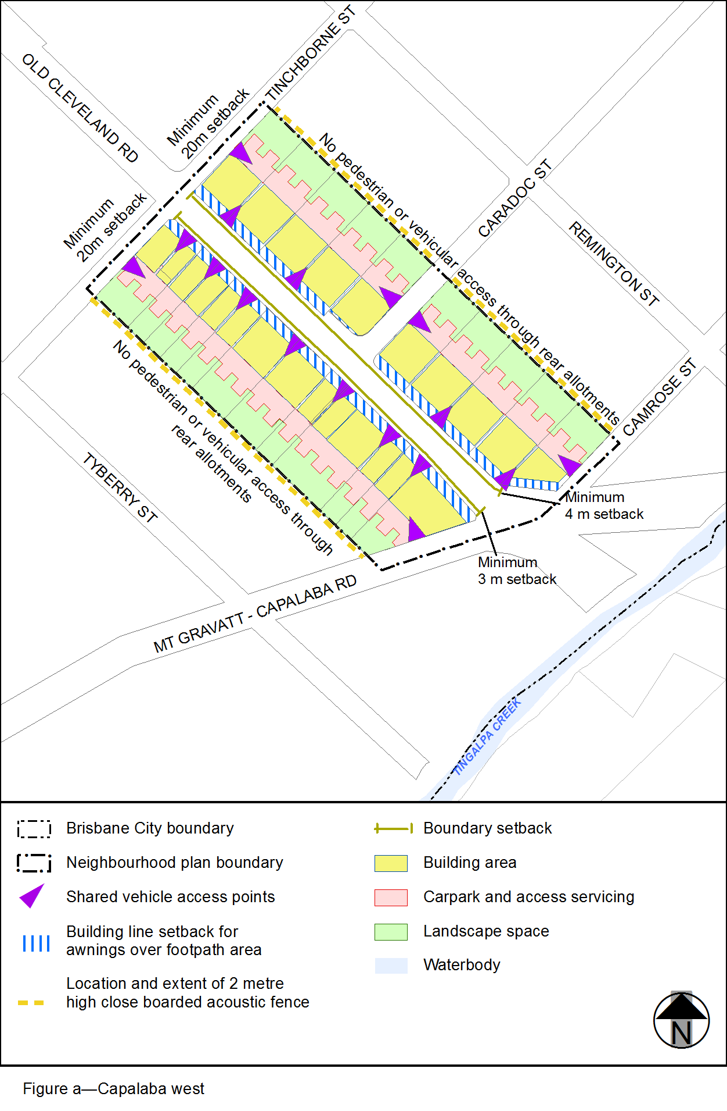
View the high resolution of Figure a–Capalaba west (PDF file size is 106Kb)

