7.2.4.2 Doolandella neighbourhood plan code

7.2.4.2.1 Application
- This code applies to assessing a material change of use, reconfiguring a lot, operational work or building work in the Doolandella neighbourhood plan area if:
- assessable development where this code is an applicable code identified in the assessment benchmarks column of a table of assessment for a neighbourhood plan (section 5.9); or
- impact assessable development.
- Land in the Doolandella neighbourhood plan area is identified on the NPM-004.2 Doolandella neighbourhood plan map.
- When using this code, reference should be made to section 1.5, section 5.3.2 and section 5.3.3.
Note—The following purpose, overall outcomes, performance outcomes and acceptable outcomes comprise the assessment benchmarks of this code.
Note—This neighbourhood plan includes a table of assessment with variations to categories of development and assessment. Refer to Table 5.9.20.A, Table 5.9.20.B, Table 5.9.20.C and Table 5.9.20.D.

7.2.4.2.2 Purpose
- The purpose of the Doolandella neighbourhood plan code is to provide finer grained planning at a local level for the Doolandella neighbourhood plan area.
- The purpose of the Doolandella neighbourhood plan code will be achieved through overall outcomes.
- The overall outcomes for the neighbourhood plan area are:
- Development creates functional and integrated communities.
- Land subject to development constraints, character or environmental values indicated in a figure in this neighbourhood plan code or shown on an overlay map is protected from inappropriate development in order to maintain its character, natural and ecological significance.
- Open space, parks and recreational facilities meet the needs of the community and are located in accessible locations that are well connected within the neighbourhood plan area.
- The existing caravan park identified in Figure a remains a provider of affordable housing and tourist accommodation in the local area.
- Development in a potential development area addresses the location of the land, availability of services, environmental constraints, amenity, and existing patterns of development to ensure an integrated development outcome.
- Residential development provides for a mix of housing types, styles and densities, in particular:
- Very low density residential areas as shown in Figure a and Figure b — comprise dwelling houses at a yield of 5 dwellings per hectare, to ensure minimal disturbance to areas of environmental and scenic value;
- Low density residential — dwelling houses areas as shown in Figure a and Figure b comprise predominantly dwelling houses at a yield of 12 dwellings per hectare;
- Low density residential — dwelling houses and multiple dwellings areas as shown in Figure a and Figure b comprise a mix of dwelling houses and multiple dwellings at a yield of 16 dwellings per hectare, with multiple dwellings located adjoining the esplanade road to facilitate surveillance of the adjoining public spaces;
- Low density residential — multiple dwellings areas as shown in Figure a and Figure b comprise predominantly multiple dwellings at a yield of 25 dwellings per hectare.
Note—Densities and yields are to be calculated excluding parts of the site that are not within a potential development area. These include areas with development constraints or character or environmental values identified in overlay maps. Yields and maximum gross floor area for multiple dwellings and dual occupancy are to be calculated across the potential development area including all access ways and roads respectively.
- Land east of Blunder Road is developed in accordance with:
- the intent of the Rural zone;
- the Emerging community zone only where land is dedicated in public ownership for habitat areas and ecological corridors as identified in Figure a and Figure b.
- Development south of Cloverdale Road in a potential development area minimises fragmentation of habitat areas and ecological corridors.
- Neighbourhood centres identified in the neighbourhood plan serve the retail, commercial, community and service needs of the local community and centre activities do not expand outside of these identified sites and other land already included in a zone in the Centre zones category.
- Walking and cycling routes provide safe and legible connections between residential areas and key destinations including centres, community facilities, major parks, conservation reserves and public transport nodes.

7.2.4.2.3 Performance outcomes and acceptable outcomes

Table 7.2.4.2.3—Performance outcomes and acceptable outcomes
Performance outcomes | Acceptable outcomes
If for reconfiguring a lot
PO1  Development ensures that stormwater on roads is managed to aid filtration and detention of stormwater. | AO1  Development ensures that all roads except Blunder Road are designed in accordance with water-sensitive road design principles.
PO2  Development facilitates safe vehicular, pedestrian and cyclist connectivity and casual surveillance of all roads. | AO2  Development:  - continues the interconnected road pattern established in Forest Lake in its subdivision design;  - facilitates pedestrian/cyclist movement and surveillance by designing cul-de-sacs which remain open in accordance with Figure c.
If for development east of Blunder Road unless in accordance with the Rural zone code
PO3  Development must protect biodiversity and landscape values and provide access along the public corridor. | AO3  Development that includes land within the habitat areas and ecological corridor (public ownership) as identified in Figure a and Figure b ensures that:  - the corridor is rehabilitated and stabilised in accordance with an approved rehabilitation plan;  - land is transferred to the Council for public ownership and included in the Conservation zone;  - a road with a shared use (pedestrian and cyclist) path in an adjoining 6m wide verge is constructed within the potential development area as shown in Figure a and Figure b.
If for development adjoining or including the park south of Cloverdale Road
PO4  Development maintains the park to protect and enhance landscape amenity and allow for a range of local recreational activities. | AO4.1  Development retains a natural bushland setting at the high point on Lots 90 and 91 on RP90234 with minimal loss of natural vegetation.
AO4.2
Development provides a shared use (pedestrian and cyclist) path connection to the existing Forest Lake network in accordance with Figure a and Figure b.

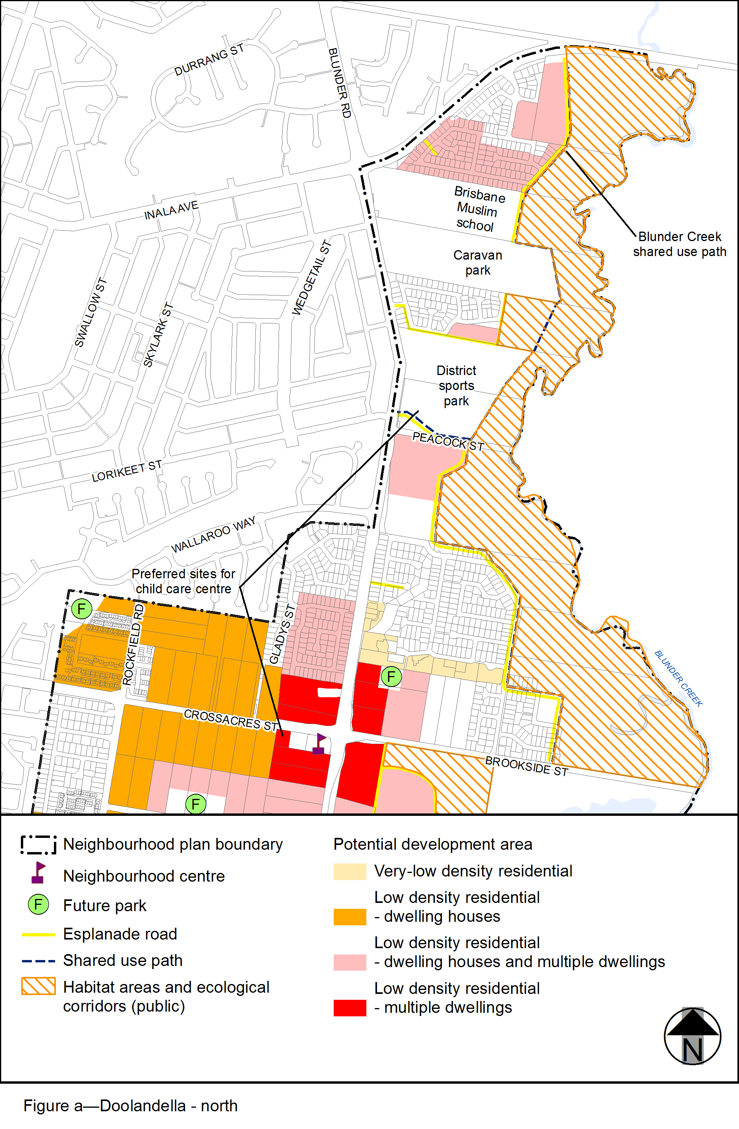
View the high resolution of Figure a–Doolandella - north (PDF file size is 302Kb)
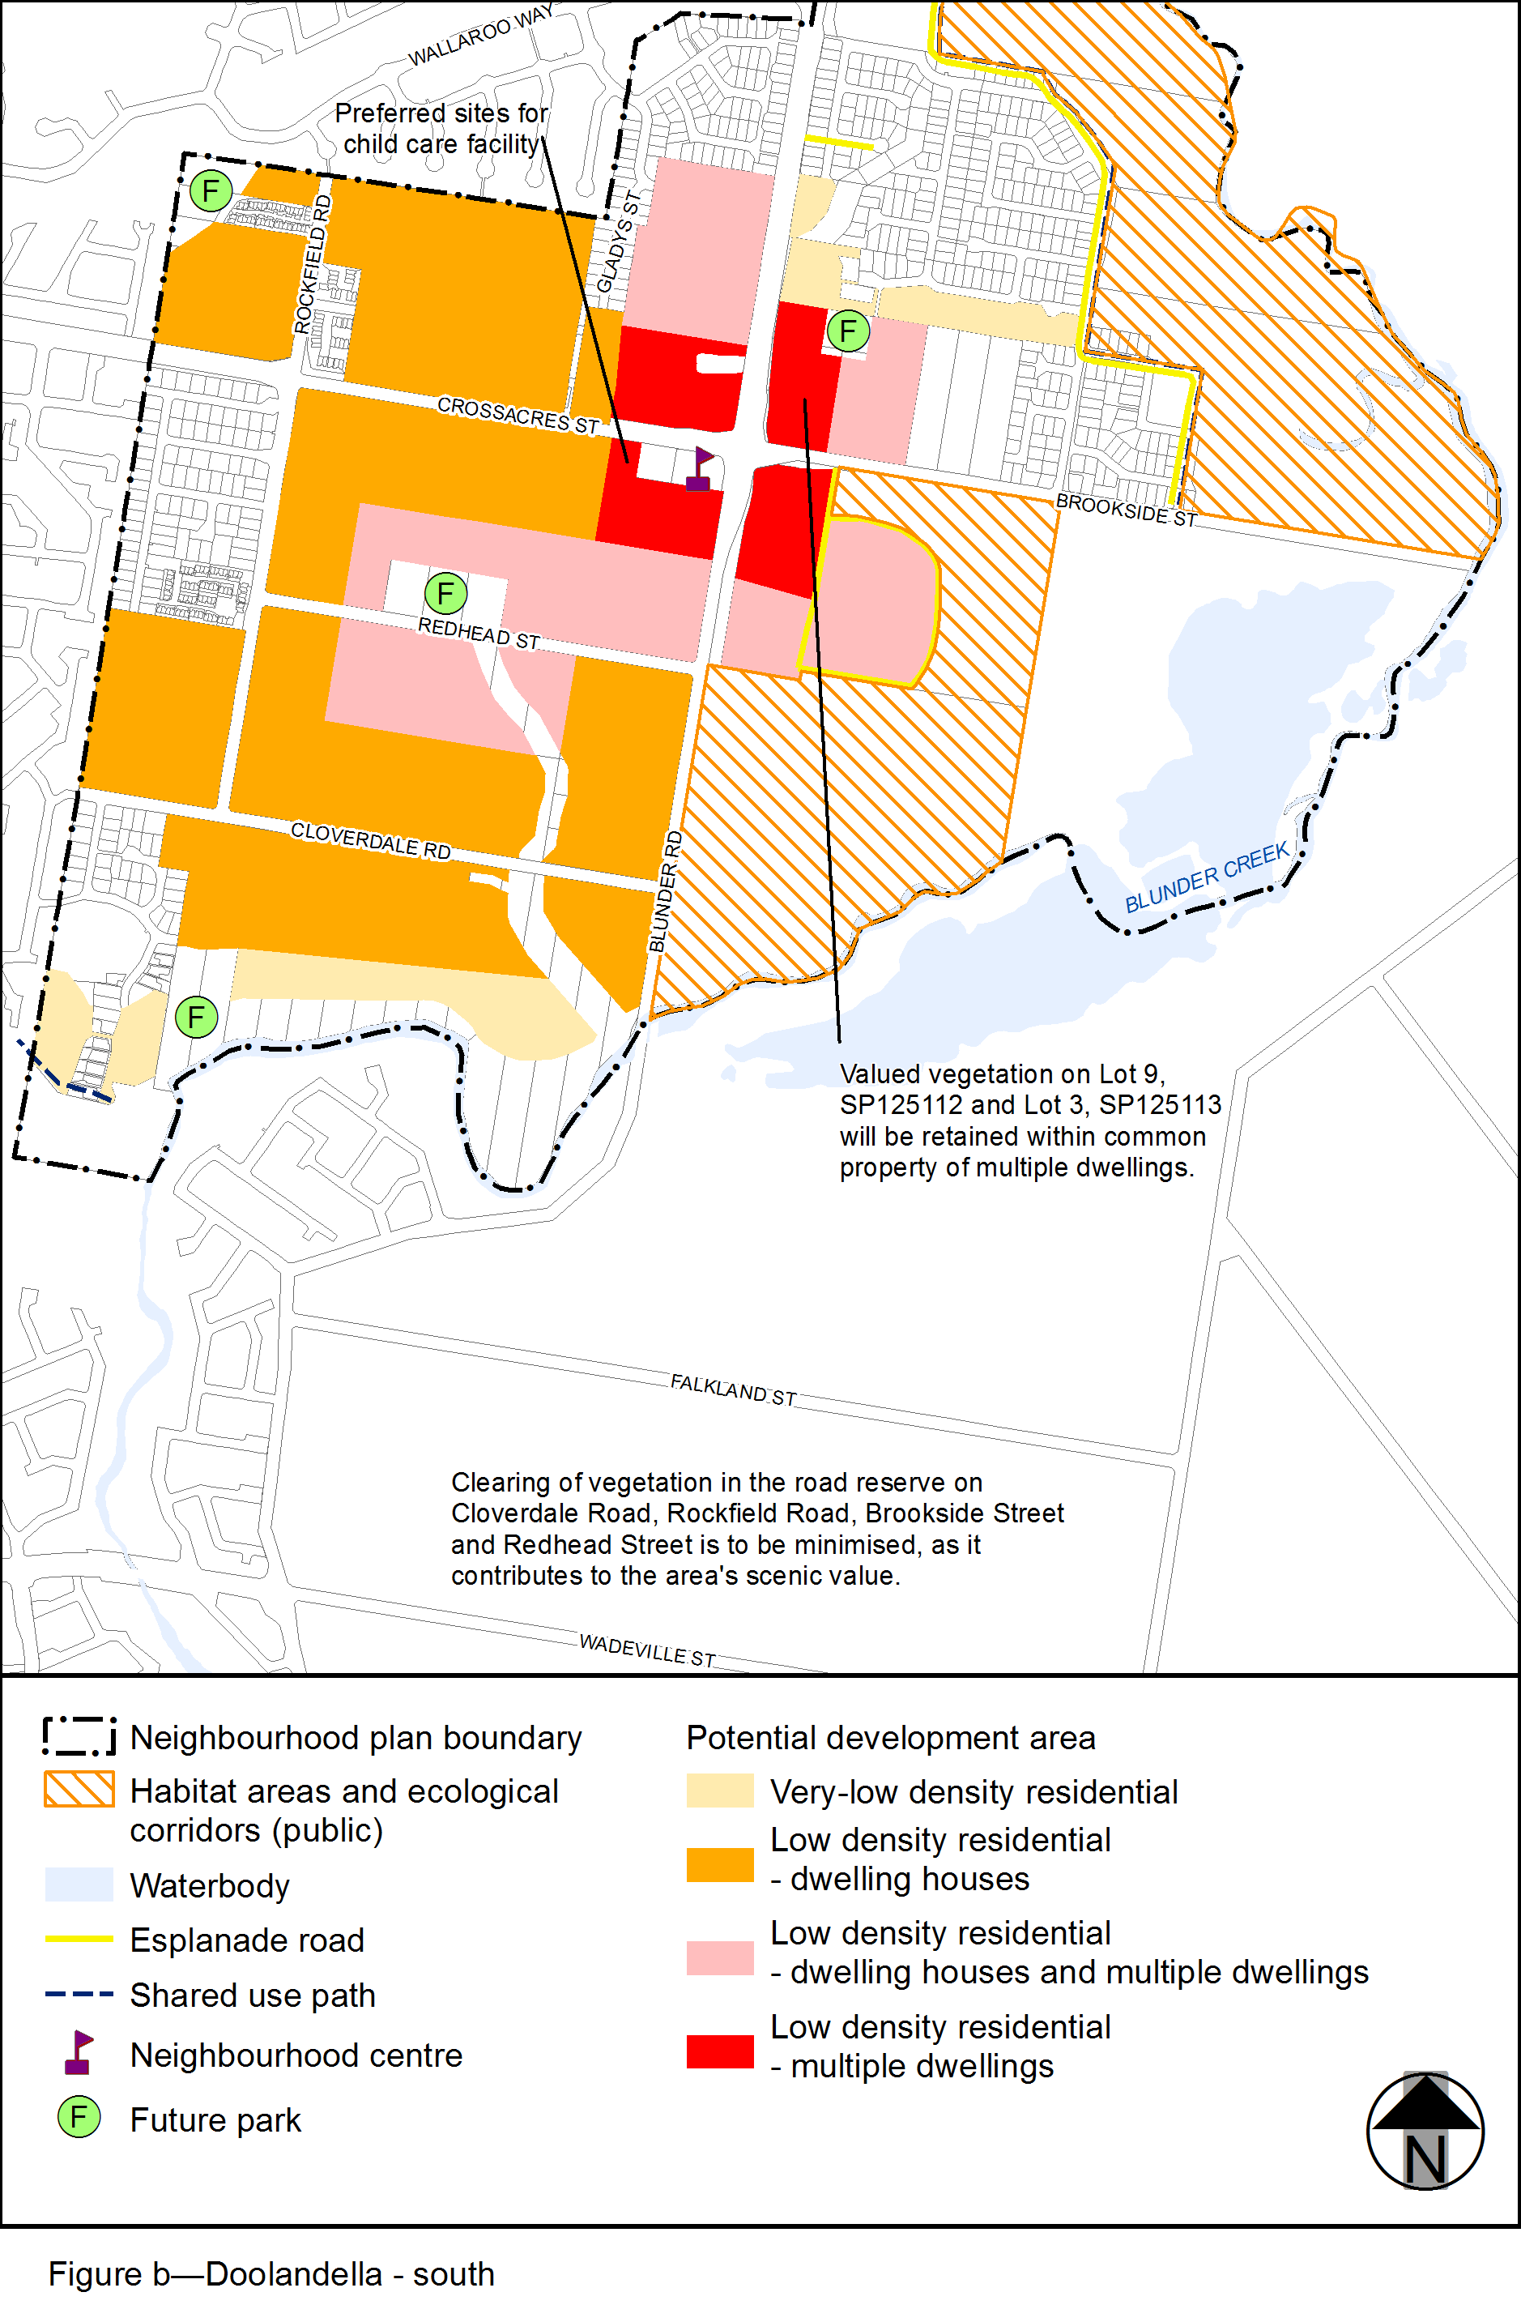
View the high resolution of Figure b–Doolandella - south (PDF file size is 243Kb)
