7.2.6.1 Ferny Grove—Upper Kedron neighbourhood plan code

7.2.6.1.1 Application
- This code applies to assessing a material change of use, reconfiguring a lot, operational work or building work in the Ferny Grove—Upper Kedron neighbourhood plan area if:
- assessable development where this code is an applicable code identified in the assessment benchmarks column of a table of assessment for a neighbourhood plan (section 5.9); or
- impact assessable development.
- Land in Ferny Grove—Upper Kedron neighbourhood plan is identified on the NPM-006.1 Ferny Grove—Upper Kedron neighbourhood plan map and includes the following precincts:
- Cedar Creek south precinct (Ferny Grove—Upper Kedron neighbourhood plan/NPP-001):
- Cedar Creek south centre sub-precinct (Ferny Grove—Upper Kedron neighbourhood plan NPP-001a);
- Cedar Creek south diverse housing sub-precinct (Ferny Grove—Upper Kedron neighbourhood plan NPP-001b);
- Cedar Creek south urban edge sub-precinct (Ferny Grove—Upper Kedron neighbourhood plan NPP-001c);
- When using this code, reference should be made to section 1.5, section 5.3.2 and section 5.3.3.
Note—The following purpose, overall outcomes, performance outcomes and acceptable outcomes comprise the assessment benchmarks of this code.
Note—This neighbourhood plan includes a table of assessment with variations to categories of development and assessment. Refer to Table 5.9.25.A, Table 5.9.25.B, Table 5.9.25.C and Table 5.9.25.D.

7.2.6.1.2 Purpose
- The purpose of the Ferny Grove—Upper Kedron neighbourhood plan code is to provide finer grained planning at a local level to support the vision of the Ferny Grove—Upper Kedron community to create a community-spirited, transit supported village and suburban living area surrounded by natural bushland, where residents can connect at local hubs by a range of accessible transport networks.
- The purpose of the Ferny Grove—Upper Kedron neighbourhood plan code will be achieved through overall outcomes, including overall outcomes for each precinct of the neighbourhood plan area.
- The overall outcomes for the neighbourhood plan area are:
- Development creates functional and integrated communities.
- Land subject to development constraints, character or environmental values indicated in a figure in this neighbourhood plan code or shown on an overlay map is protected from inappropriate development in order to deliver the suburban living character or protect natural and ecological significance.
- Open space, parks and recreational facilities meet the needs of the community and are located in accessible locations that are well connected within the neighbourhood plan area. Open spaces are planned and located to create focal points for community activity and interaction.
- Both indoor and outdoor sports are supported at the proposed district sports park.
- The quarry site is stabilised and rehabilitated upon completion of quarrying activities and recreation activities are located on the site when quarrying operations have ceased.
- The Neighbourhood centre meets the retail, commercial, community and service needs of the local community.
- Centre activities do not expand outside of the identified precinct site and other land already included in a zone in the Centre zones category.
- Development of the Ferny Grove railway station and surrounding district centre creates an integrated public transport and commercial hub, while supporting solutions for car parking, access and connectivity to Samford Road.
- Development provides safe and clear, walking and cycling routes that connect residential areas and key destinations including centres, community facilities, major parks and conservation reserves and public transport nodes.
- Development is of a height, scale and form which is consistent with the amenity, character, community expectations and infrastructure assumptions intended for the relevant precinct, sub-precinct or site and is only developed at a greater height, scale and form where there is both a community need and an economic need for the development.
- Development of the sites listed below is contingent on providing infrastructure and access from adjoining lands, in particular:
- 320 Levitt Road (Lot 1 on RP 162875) is not developed until access is provided from Canvey Road via 232 Canvey Road (Lot 1 on RP 20577);
- 221 McGinn Road (Lot 2 on RP 164168) is not developed until 173, 189 and 205 McGinn Road (Lot 1 on RP 164167, Lot 2 on RP 164167 and Lot 1 on RP 210657) have been developed and provide access;
- land west of Ross Road is not developed until the land east of Ross Road provides water supply and sewerage connections. Only under these circumstances will development in this area be assessed against the Emerging community zone provisions; and
- land at 171, 173 and 179 Upper Kedron Road (Lots 1 and 2 on RP 185509 and Lot 1 on RP 82882) must enable access to 24 Persimmon Street (Lot 43 on RP 167933).
- Residential development in all areas of Ferny Grove—Upper Kedron (excluding Cedar Creek south precinct) identified in Figure a as potential development areas provides for a mix of housing types, styles and densities, in particular:
- the Very low density residential – dwelling houses area as shown in Figure a contains dwelling houses up to a density of 5 dwellings per hectare to ensure minimal disturbance to areas of environmental and scenic value;
- the Low density residential – dwelling houses area as shown in Figure a contains predominantly dwelling houses at a yield of 12 dwellings per hectare;
- the Low density residential – dwelling houses and multiple dwellings area as shown in Figure a contains a mix of dwelling houses and multiple dwellings at a yield of 16 dwellings per hectare;
- the Low density residential – multiple dwellings area as shown in Figure a contains predominantly multiple dwellings at a yield of 25 dwellings per hectare.
- Cedar Creek south precinct (Ferny Grove—Upper Kedron neighbourhood plan/NPP-001) overall outcomes are:
- Development decreases in intensity and scale from the residential and centre uses at the corner of Levitt and Canvey Roads to the ecological corridors framing the southern and western edges as shown in Figures b, c and d to:
- ensure the constraints of slope and natural hazards, including bushfire, landslide and flooding, can be appropriately addressed to manage risk to the community;
- protect and enhance regionally significant ecological values and functions;
- promote ecological resilience to manage the impacts on ecosystems from climate change;
- preserve the visual amenity of major ridgelines as identified on Figure e;
- achieve effective active transport connections within this catchment, including emergency access and active transport access only to Mt Nebo Road.
- Development provides ecological and waterway corridors that create a network of linkages west to east adjoining Mt Nebo Road from D’Aguilar National Park to Keperra Bushland, and south to north from Mt Nebo Road boundary of Enoggera Reservoir to Cedar Creek as shown in Figure b. These corridors:
- contribute to the enhancement of native fauna and flora populations in the precinct and in adjoining ecological areas;
- are rehabilitated to the standards identified in Figure i;
- protect and enhance matters of State and local environmental significance;
- protect and enhance riparian areas to maintain waterway stability.
- Development minimises disturbance to the ground level and slope protecting natural features such as waterways, overland flow paths and vegetation, maintaining existing landform, and minimises visual impact.
- Development provides for a road layout that:
- achieves effective road and public transport connections within this catchment;
- provides for emergency services access and evacuation;
- contributes to bushfire hazard mitigation.
- Development supports ageing in place by offering housing choice to residents by ensuring a range in dwelling sizes and forms are available in the community.
- Development manages frequent flows to minimise scour of waterways and ecological corridors.
- Centre sub-precinct (Ferny Grove—Upper Kedron neighbourhood plan/NPP-001a) overall outcomes are:
- Development of centre activities serves the retail, commercial, community and service needs of the local community, and is outwardly focused, activates adjoining public streets and spaces, and connects with adjoining residential areas.
- Development of Low-medium density residential uses up to 2 storeys are located adjoining the centre to promote walkable compact communities.
- Diverse housing (Ferny Grove—Upper Kedron neighbourhood plan/NPP-001b) sub precinct overall outcomes are:
- Development provides a range of allotment sizes, not exceeding an average of 9 to 12 dwellings per hectare (excluding the land identified as ecological and waterway corridors as shown on Figure b), with lot design and layout achieving a distribution of interspersed smaller lots that are located close to public transport on district road routes.
- Development provides rehabilitated ecological and waterway corridors that contribute to Brisbane’s regional ecological outcomes as shown in Figure b.
- Urban edge sub-precinct Ferny Grove—Upper Kedron neighbourhood plan/NPP-001c) overall outcomes are:
- Development forms the transition from urban to non-urban ecological areas by establishing residential development that responds to site constraints and hazards with minimal disturbance of slope and vegetation.
- Development provides for a range of allotment sizes not exceeding an average of 1 to 3 dwellings per hectare (excluding the land identified as ecological and waterway corridors as shown on Figure b).
- Development forms the transition between residential to non-urban ecological areas and is characterised by:
- responding to the identified ecological and waterway corridors, as well as designing for potential hazards, with minimal earthworks and vegetation removal (Figures b, c, d, e, f, g and h);
- minimising topography changes through the identification and consideration of local site features and constraints;
- maintaining of visual dominance and ecological connectivity of the D’Aguilar National Park to Keperra Bushland ridgeline;
- taking appropriate account of bushfire hazard by providing mitigation responses within the proposed development areas to achieve an acceptable or tolerable level of risk;
- gradating densities to achieve the intent of Figures c and d.

7.2.6.1.3 Performance outcomes and acceptable outcomes

Table 7.2.6.1.3.A—Performance outcomes and acceptable outcomes
Performance outcomes | Acceptable outcomes
General
PO1  Development is of a height, scale and form that achieves the intended outcome for the precinct, improves the amenity of the neighbourhood plan area, contributes to a cohesive streetscape and built form character and:  - is consistent with the anticipated density and assumed infrastructure demand;  - is aligned to community expectations about the number of storeys to be built;  - is proportionate to and commensurate with the utility of the site area and frontage width;  - is designed to avoid a significant and undue adverse amenity impact to adjoining development;  - is sited to enable existing and future buildings to be well separated from each other and to avoid affecting the development potential of an adjoining site;  - roads, lots and buildings are sited and designed to minimise impacts from potential hazards. | AO1  Development complies with the building height (number of storeys) and floor area in Table 7.2.6.1.3.B.  Note—Neighbourhood plans will mostly specify maximum number of storeys where zone outcomes have been varied in relation to building height. Some neighbourhood plans may also specify height in metres. Development must comply with both parameters where maximum number of storeys and height in metres are specified.
If in the Cedar Creek south precinct (Ferny Grove—Upper Kedron neighbourhood plan/NPP 001)
PO2  Development provides a decreasing number of dwellings per hectare from the Cedar Creek south centre sub-precinct (Ferny Grove—Upper Kedron neighbourhood plan NPP-001a) to the interface of D’Aguilar National Park and Conservation zone as shown in Figures b, c and d, where within:  - the Diverse housing sub-precinct (Ferny Grove—Upper Kedron neighbourhood plan NPP-001b);  - the Urban edge sub-precinct (Ferny Grove—Upper Kedron neighbourhood plan NPP 001c). | AO2.1  Where within the Cedar Creek south diverse housing sub-precinct (Ferny Grove—Upper Kedron neighbourhood plan NPP-001b), development complies with the average maximum density and minimum lot size set out in Table 7.2.6.1.3.C.
AO2.2
Where within the Cedar Creek south urban edge sub-precinct (Ferny Grove—Upper Kedron neighbourhood plan NPP-001c), development complies with the average maximum density and minimum lot size set out in Table 7.2.6.1.3.C.
PO3  Development ensures the road and subdivision pattern, lot size and design, and servicing, maintains and enhances ecological features, significant vegetation, ecological and waterway corridors and overland flow paths  Note—Achievement of this outcome must be demonstrated on a structure plan prepared in accordance with the Structure planning planning scheme policy. The structure plan is an essential tool to integrate subdivision layout with all relevant spatial attributes and constraints as addressed in overlays together with the overall outcomes of the Ferny Grove—Upper Kedron neighbourhood plan. | AO3  Development is consistent with a structure plan prepared in accordance with the Structure planning planning scheme policy and which addresses site context and setting by:  - protecting and enhancing state and locally significant flora and fauna;  - identifying and mitigating existing and potential future bushfire hazard;  - identifying appropriate vegetation management regimes;  - providing appropriate services and infrastructure;  - protecting soil stability;  - preserving topography;  - identifying appropriate stormwater and water quality management regimes;  - housing density conforming with overall dwelling densities;  - transport network supporting public transport connectivity.
PO4  Development ensures the stormwater management system and site work enhances the stability of existing waterways and minimises the frequency of stormwater discharge to Cedar Creek and other receiving waterways. | AO4.1  Where within the Diverse housing sub-precinct (Ferny Grove—Upper Kedron neighbourhood plan NPP-001b), development minimises the scour of receiving waterways and Cedar Creek by providing:  - bioretention basins that maximise stormwater retention, frequent flow attenuation and water quality treatment prior to discharge into a receiving waterway;  - stormwater detention systems that mitigate impacts to frequent flow events in Cedar Creek and receiving waterways, including storm events up to the 1-year ARI (63% AEP).
AO4.2
Where within the Urban edge sub-precinct (Ferny Grove—Upper Kedron neighbourhood plan NPP-001c), development provides and integrates streetscape water quality treatments within new roads in accordance with the standards in the Infrastructure design planning scheme policy.
AO4.3
Development designs stormwater outlets into receiving waterways with energy dissipation and rock chutes to the waterway low flow channel in order to minimise scour. Designs are to be in accordance with the standards in the Infrastructure design planning scheme policy.
PO5  Development ensures the regionally significant ecological and waterway corridors in the precinct are protected and enhanced as part of Brisbane’s publicly owned natural areas. | AO5.1  Development ensures the ecological and waterway corridors as shown on Figure b are transferred into public ownership.
AO5.2
Development ensures ecological and waterway corridors are appropriately rehabilitated as identified in Figure i.
AO5.3
Development ensures existing matters of state and local environmental significance are protected and enhanced.
PO6  Development ensures that lot size and layout mitigates adverse impacts to ecological values and the visual amenity through:  - site design that is responsive to topography and land constraints;  - siting larger lots on steeper land;  - minimising impacts from site earthworks including cutting, filling and retaining walls. | AO6.1  Development ensures lot sizes are in compliance with Table 7.2.6.1.3.C.
AO6.2
Development of buildings or other structures incorporates:
- foundation systems that minimise disturbance to the landscape, such as post and pier type foundations;
- slab-on-ground foundations only on those parts of a site with gradients less than 1 in 8 and where cut and fill is minimal;
- benching, cut and fill, or construction of retaining walls of a minor nature only (i.e. fill does not exceed 1m at any point and/or the combined height of any retaining wall and fence does not exceed 2m) and is designed not to be noticeable after construction has been completed;
- driveways and hard stand areas are located only on those parts of a site with gradients less than 1 in 4;
- retaining walls that are set back from any site boundary and are stepped, terraced and landscaped.
PO7  Development ensures the road network facilitates a clear, legible and logical road hierarchy that supports provision of future public transport, emergency service access, resident evacuation and bushfire hazard mitigation. | AO7.1  Development provides a road network with a clear, legible and logical hierarchy that services this catchment for vehicles and future public transport.
AO7.2
Development excludes general traffic access from Mt Nebo Road and exclusively supports emergency services and active transport use only.
AO7.3
Development provides a road network that contributes to bushfire hazard mitigation where appropriate.
AO7.4
Development does not rely on private vehicle access to Mt Nebo Road.
If in the Centre sub-precinct (Ferny Grove—Upper Kedron neighbourhood plan/NPP-001a)
PO8  Development ensures building design orientation and location addresses and connects to all frontages. | AO8.1  Development provides safe and direct access to Levitt Road, Canvey Road and Cedar Creek.
AO8.2
Development provides active frontages to Canvey Road and Cedar Creek.
If in the Diverse housing sub-precinct (Ferny Grove—Upper Kedron neighbourhood plan/NPP-001b)
PO9  Development provides decreasing number of dwellings per hectare as shown in Figures b, c and d. | AO9.1  Development complies with the average maximum density and minimum lot size set out in Table 7.2.6.1.3.C.
AO9.2
Development provides lots of 400m² within 200m of the future public transport corridor.
If in the Urban edge sub-precinct (Ferny Grove—Upper Kedron neighbourhood plan/NPP-001c)
PO10  Development provides decreasing number of dwellings per hectare as shown in Figures b, c and d. | AO10  Development complies with the average maximum density and minimum lot size set out in Table 7.2.6.1.3.C.
PO11  Development ensures that lot size and layout mitigates adverse impacts to ecological values and the visual amenity through:  - site design that is responsive to topography and land constraints;  - siting larger lots on steeper land;  - minimising impacts from site earthworks including cutting, filling and retaining walls. | AO11.1  Development ensures that site earthworks including cutting, filling and retaining walls does not result in cumulative cut and fill responses that exceed 1.5m from boundary to boundary of an allotment (as shown in Figures f, g and h).
AO11.2
Development ensures a development footprint plan is located at least 9.5m below the height of major ridgelines as identified on Figure e.

Table 7.2.6.1.3.B—Maximum building height and floor area
Development | Building height (number of storeys) and floor area
If in neighbourhood centre zone
Development of a centre activity on a site located on the corner of Canvey and Levitt Roads. | 2 storeys and a floor area not exceeding 2,000m² (excluding a childcare centre).

Table 7.2.6.1.3.C—Lot criteria
Reconfiguring a lot | Average maximum density | Minimum lot size
Diverse housing sub-precinct (Ferny Grove—Upper Kedron neighbourhood plan NPP-001b)
Where in the Low density residential zone and not in an ecological or waterway corridor identified on Figure b. | 9-12 dwellings per hectare. | 400m²
Urban edge sub-precinct (Ferny Grove—Upper Kedron neighbourhood plan NPP-001c)
Where in the Low density residential zone and not in an ecological or waterway corridor identified on Figure b. | 1-3 dwellings per hectare. | 3,000m²

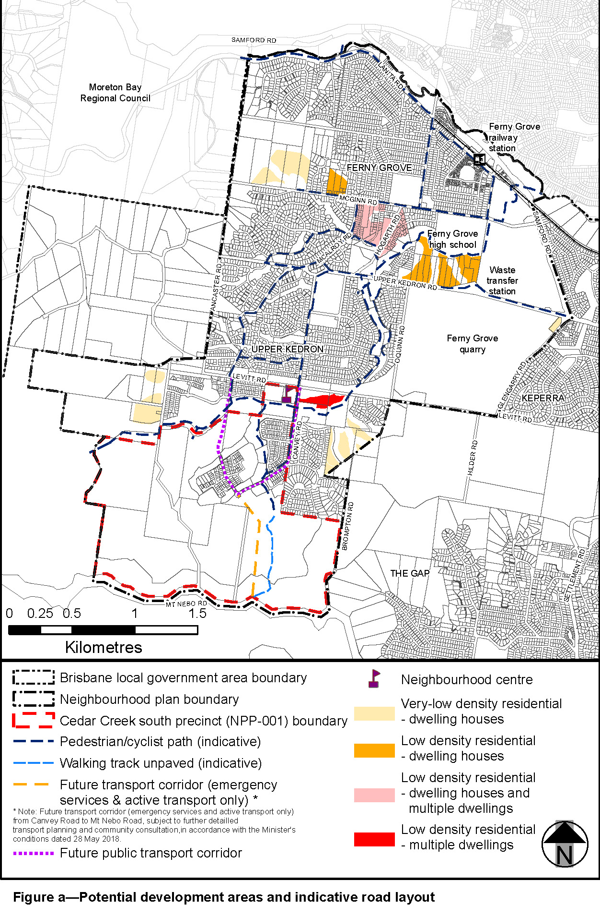
View the high resolution of Figure a–Potential development areas and indicative road layout (PDF file size is 506Kb)
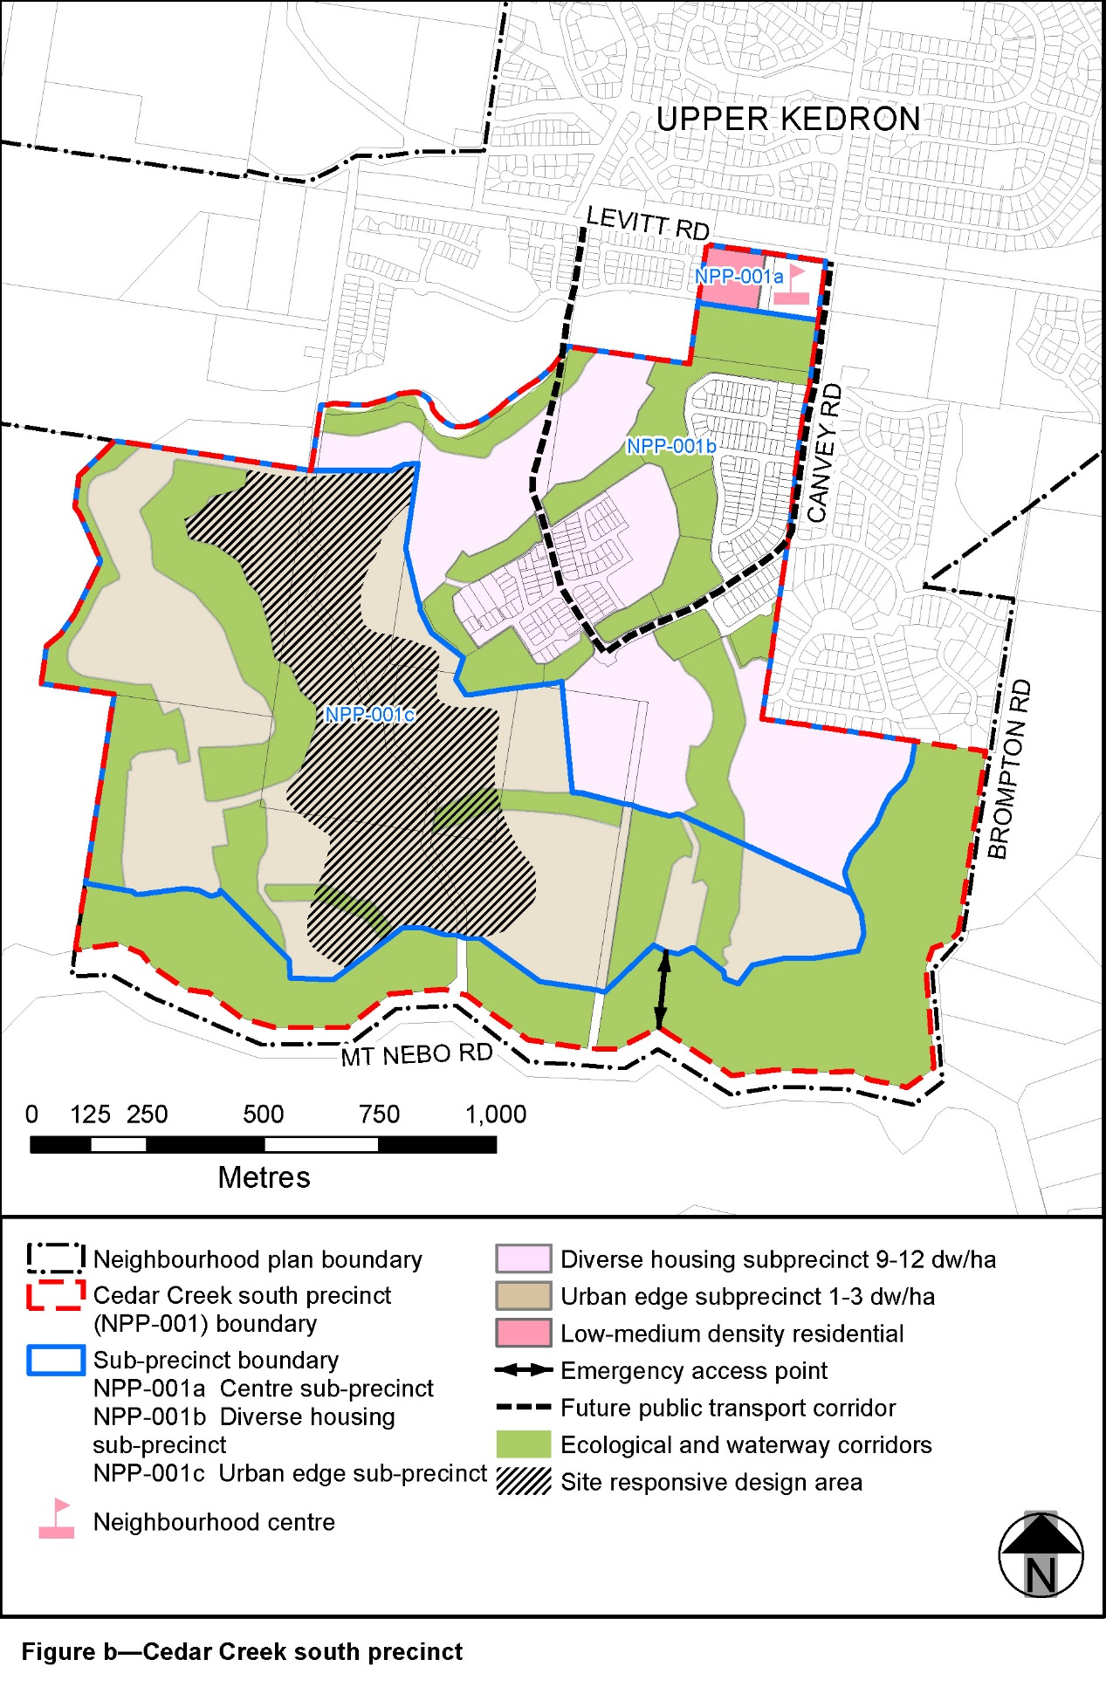
View the high resolution of Figure b–Cedar Creek south precinct (PDF file size is 333Kb)
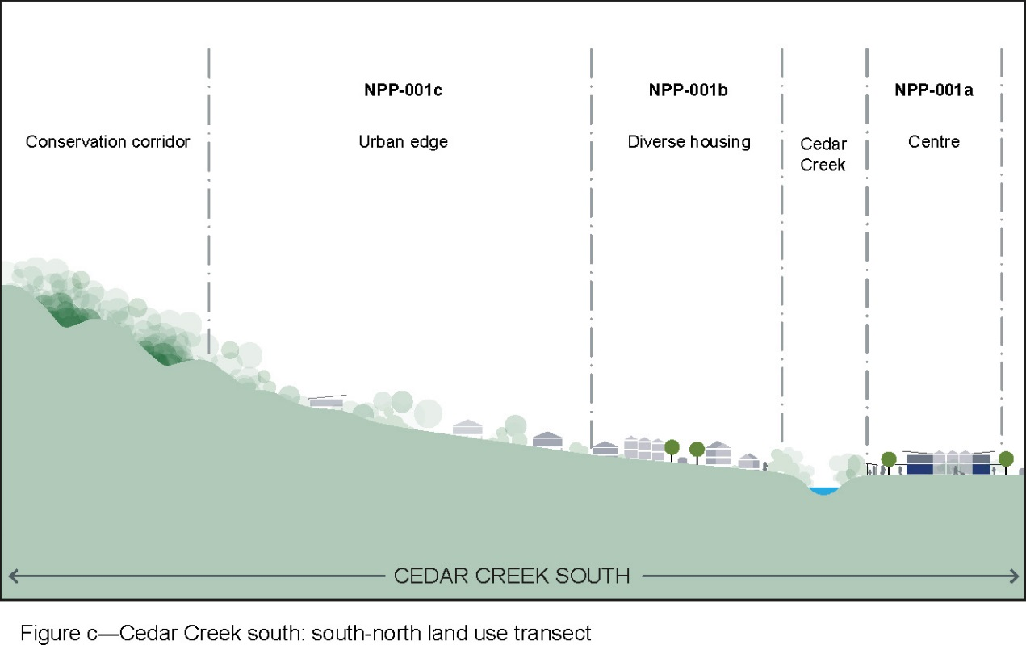

View the high resolution of Figure c–Cedar Creek south: south-north land use transect (PDF file size is 168Kb)

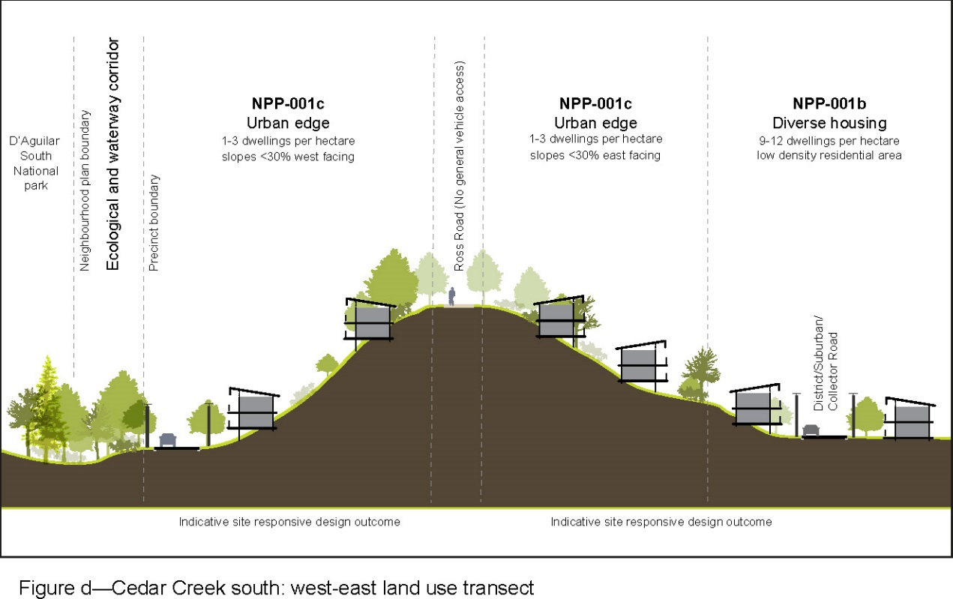

View the high resolution of Figure d–Cedar Creek south: west-east land use transect (PDF file size is 456Kb)
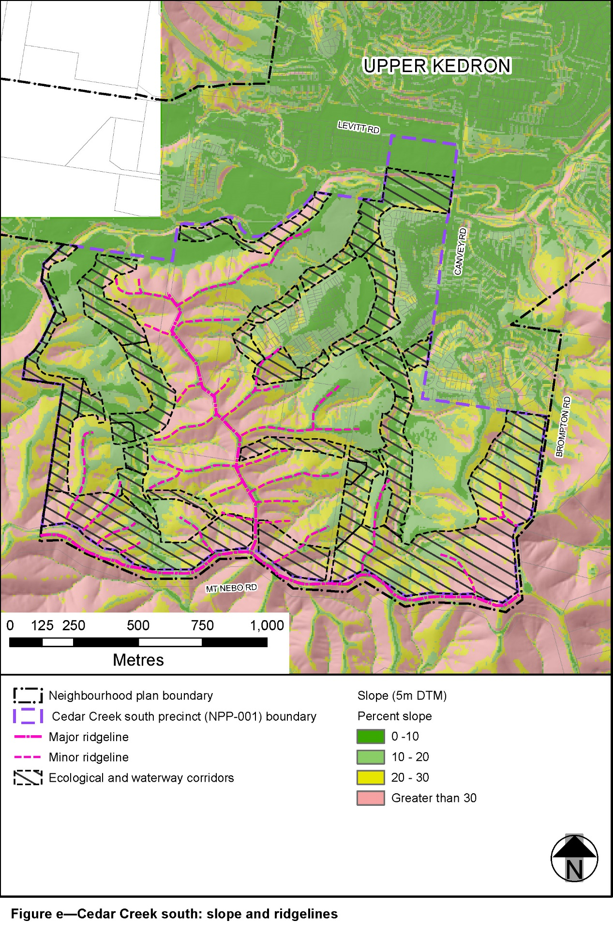
View the high resolution of Figure e–Cedar Creek south: slope and ridgelines (PDF file size is 701Kb)
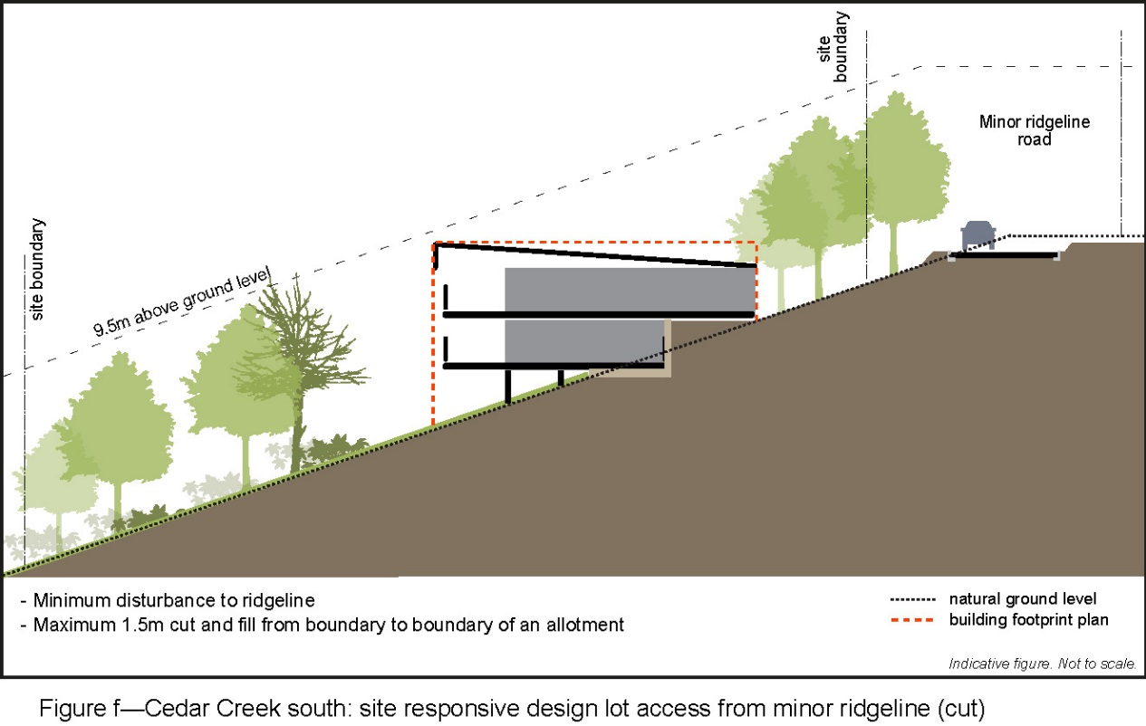

View the high resolution of Figure f–Cedar Creek south: site responsive design lot access from minor ridgeline (cut) (PDF file size is 233Kb)

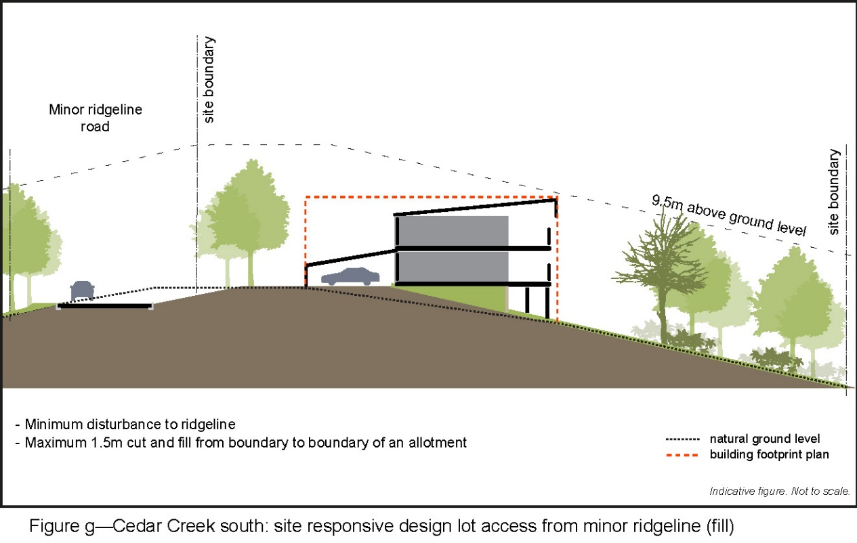

View the high resolution of Figure g–Cedar Creek south: site responsive design lot access from minor ridgeline (fill) (PDF file size is 207Kb)
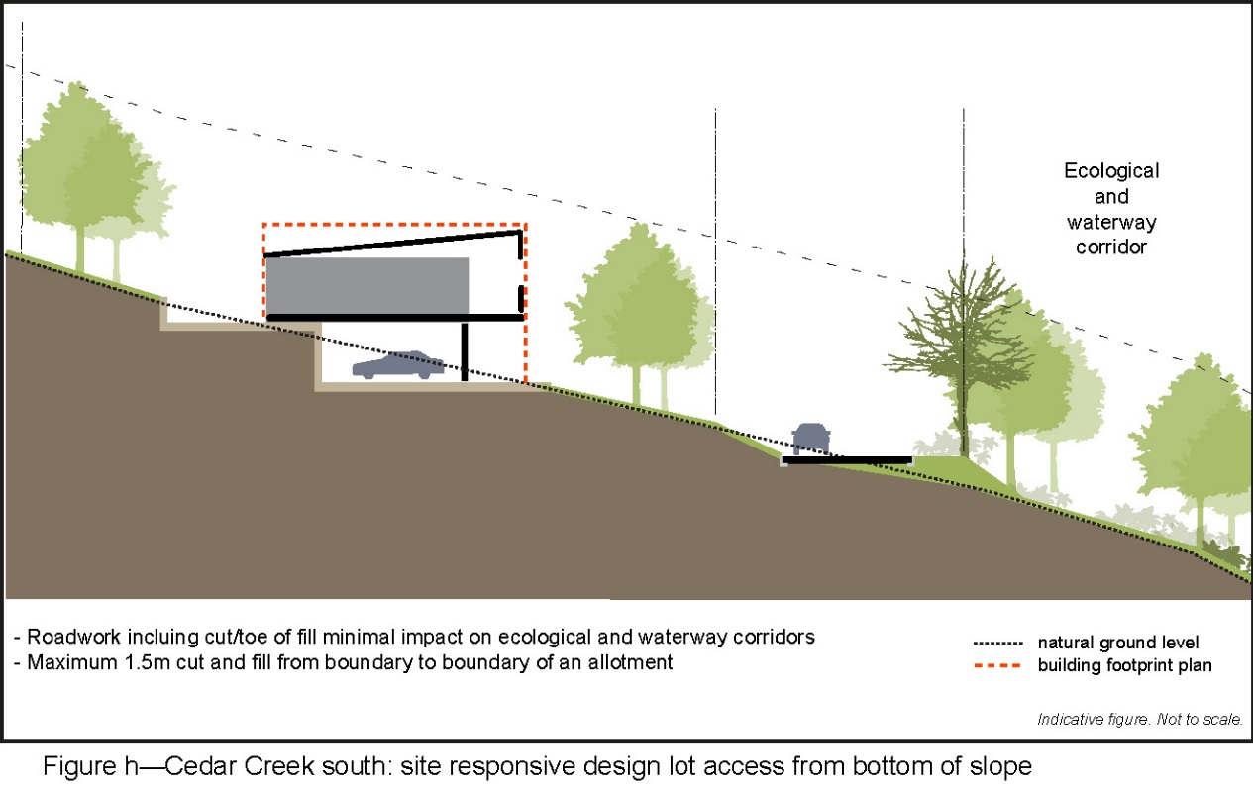

View the high resolution of Figure h–Cedar Creek south: site responsive design lot access from bottom of slope (PDF file size is 199Kb)
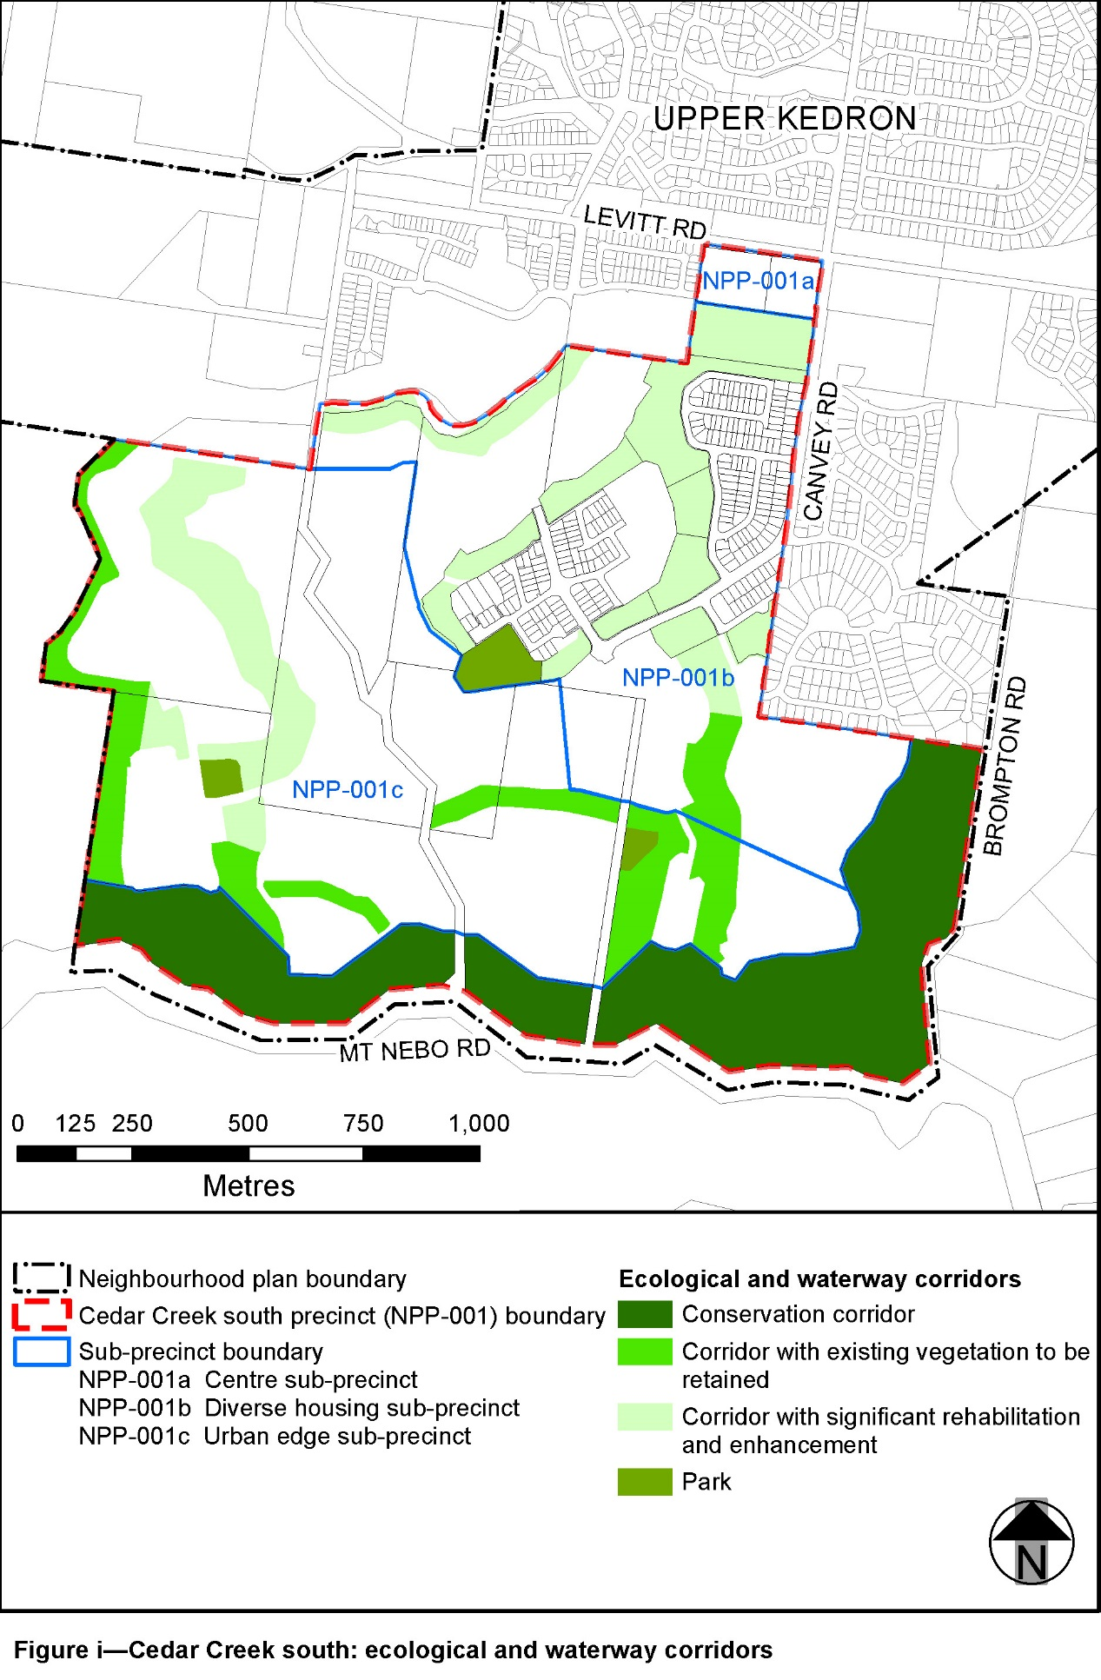

View the high resolution of Figure i–Cedar Creek south: ecological and waterway corridors (PDF file size is 319Kb)

