7.2.11.1 Kangaroo Point peninsula neighbourhood plan code

7.2.11.1.1 Application
- This code applies to assessing a material change of use, reconfiguring a lot, operational work or building work in the Kangaroo Point peninsula neighbourhood plan area if:
- assessable development where this code is an applicable code identified in the assessment benchmarks column of a table of assessment for a neighbourhood plan (section 5.9); or
- impact assessable development.
- Land in the Kangaroo Point peninsula neighbourhood plan area is identified on NPM-011.1 Kangaroo Point peninsula neighbourhood plan map and includes the following precincts:
- Residential precinct (Kangaroo Point peninsula neighbourhood plan/NPP-001);
- Community convenience centre precinct (Kangaroo Point peninsula neighbourhood plan/NPP-002);
- Park precinct (Kangaroo Point peninsula neighbourhood plan/NPP-003);
- Dockside precinct (Kangaroo Point peninsula neighbourhood plan/NPP-004);
- Dockside A sub-precinct (Kangaroo Point peninsula neighbourhood plan/NPP-004a);
- Dockside A1 sub-precinct (Kangaroo Point peninsula neighbourhood plan/NPP-004b);
- Dockside B1 sub-precinct (Kangaroo Point peninsula neighbourhood plan/NPP-004c);
- Dockside B2 sub-precinct (Kangaroo Point peninsula neighbourhood plan/NPP-004d);
- Dockside B3 sub-precinct (Kangaroo Point peninsula neighbourhood plan/NPP-004e);
- Dockside C1 sub-precinct (Kangaroo Point peninsula neighbourhood plan/NPP-004f);
- Dockside C2 sub-precinct (Kangaroo Point peninsula neighbourhood plan/NPP-004g);
- Dockside D1 sub-precinct (Kangaroo Point peninsula neighbourhood plan/NPP-004h);
- Dockside D2 sub-precinct (Kangaroo Point peninsula neighbourhood plan/NPP-004i);
- Dockside E1 sub-precinct (Kangaroo Point peninsula neighbourhood plan/NPP-004j);
- Dockside E2 sub-precinct (Kangaroo Point peninsula neighbourhood plan/NPP-004k);
- Dockside F sub-precinct (Kangaroo Point peninsula neighbourhood plan/NPP-004l);
- Dockside G sub-precinct (Kangaroo Point peninsula neighbourhood plan/NPP-004m);
- Dockside H sub-precinct (Kangaroo Point peninsula neighbourhood plan/NPP-004n);
- Dockside I sub-precinct (Kangaroo Point peninsula neighbourhood plan/NPP-004o).
- When using this code, reference should be made to section 1.5, section 5.3.2 and section 5.3.3.
Note—The following purpose, overall outcomes, performance outcomes and acceptable outcomes comprise the assessment benchmarks of this code.
Note—This neighbourhood plan includes a table of assessment with variations to categories of development and assessment. Refer to Table 5.9.32.A, Table 5.9.32.B, Table 5.9.32.C and Table 5.9.32.D.

7.2.11.1.2 Purpose
- The purpose of the Kangaroo Point peninsula neighbourhood plan code is to provide finer grained planning at a local level for the Kangaroo Point peninsula neighbourhood plan area.
- The purpose of the Kangaroo Point peninsula neighbourhood plan code will be achieved through overall outcomes including overall outcomes for each precinct of the neighbourhood plan area.
- The overall outcomes for the Kangaroo Point peninsula neighbourhood plan area are:
- The Kangaroo Point peninsula neighbourhood plan area is a convenient residential area where higher density living is more prominent than in many other parts of Brisbane;
- Highly accessible walking and cycling routes throughout the neighbourhood plan area link to ferry terminals and to a wider network of walking and cycling routes increasing convenience while reducing residents' dependency on cars. A riverside walking and cycling route from Kangaroo Point Cliffs to Mowbray Park is provided. The locality also incorporates continuous public spaces that are well landscaped, providing comfort and safety;
- Traffic movement avoids dangerous traffic situations and interference with the capacity of the major arterials connecting to the Story Bridge;
- Views to and from the Story Bridge are protected. Buildings are of a height and scale that maintains the dominance of the city centre skyline and the significance of the Story Bridge to the inner-city skyline;
- Views are available to most residents in the neighbourhood plan area;
- Development is of a height, scale and form which is consistent with the amenity and character, community expectations and infrastructure assumptions intended for the relevant precinct, sub-precinct or site and is only developed at a greater height, scale and form where there is both a community need and an economic need for the development;
- While making efficient use of land, development is consistent with community expectations and infrastructure assumptions.
- Residential precinct (Kangaroo Point peninsula neighbourhood plan/NPP-001) overall outcome is:
- This precinct contains high density residential development with a building size and bulk, built form and layout that maintain views to and from the Story Bridge and Brisbane River.
- Community convenience centre precinct (Kangaroo Point peninsula neighbourhood plan/NPP-002) overall outcome is:
- This precinct provides community-focused local convenience services such as food and drink outlets, shops and offices that service the local community and public spaces, such as a plaza in Baildon Street.
- Park precinct (Kangaroo Point peninsula neighbourhood plan/NPP-003) overall outcomes are:
- This precinct is maintained for park purposes;
- Developments such as kiosks, cafes and shore-based services for floating restaurants are located in this precinct, if they:
- enhance public access;
- attract an increased number of visitors;
- do not adversely impact on public facilities and the parkland generally.
- Dockside precinct (Kangaroo Point peninsula neighbourhood plan/NPP-004) overall outcomes are:
- This precinct provides for the continued development of the Dockside area. It contains a mix of residential, retail and tourist uses around large public plaza areas in accordance with Figure a;
- A town centre including retail uses such as a supermarket, a limited number of specialty shops and local services such as health care service and real estate office service the area;
- Supporting development to that nominated for each sub-precinct is only provided if it enhances the amenity of the area;
- Development in the Dockside A sub-precinct (Kangaroo Point peninsula neighbourhood plan/NPP-004a) and Dockside A1 sub-precinct (Kangaroo Point peninsula neighbourhood plan/NPP-004b):
- enhances public pedestrian access and bikeways ensuring high levels of safety and connectivity.
- Development in the Dockside B1 sub-precinct (Kangaroo Point peninsula neighbourhood plan/NPP-004c), Dockside B2 sub-precinct (Kangaroo Point peninsula neighbourhood plan/NPP-004d), Dockside C1 sub-precinct (Kangaroo Point peninsula neighbourhood plan/NPP-004f), Dockside C2 sub-precinct (Kangaroo Point peninsula neighbourhood plan/NPP-004g), Dockside D1 sub-precinct (Kangaroo Point peninsula neighbourhood plan/NPP-004h), Dockside D2 sub-precinct (Kangaroo Point peninsula neighbourhood plan/NPP-004i), Dockside E1 sub-precinct (Kangaroo Point peninsula neighbourhood plan/NPP-004j) and Dockside E2 sub-precinct (Kangaroo Point peninsula neighbourhood plan/NPP-004k):
- ensures residential developments are of a height and scale that complement surrounding uses.
- Development in the Dockside B3 sub-precinct (Kangaroo Point peninsula neighbourhood plan/NPP-004e):
- ensures the sub-precinct remains an open recreation area, with parking access points.
- Development in the Dockside F sub-precinct (Kangaroo Point peninsula neighbourhood plan/NPP-004l):
- ensures the sub-precinct is a low-rise parking area.
- Development in the Dockside G sub-precinct (Kangaroo Point peninsula neighbourhood plan/NPP-004m):
- provides a range of office and recreation facilities.
- Development in the Dockside H sub-precinct (Kangaroo Point peninsula neighbourhood plan/NPP-004n):
- provides local shopping services.
- Development in the Dockside I sub-precinct (Kangaroo Point peninsula neighbourhood plan/NPP-004o):
- ensures the sub-precinct is a landscape area around the dry dock that also provides for boat mooring and pontoons.

7.2.11.1.3 Performance outcomes and acceptable outcomes

Table 7.2.11.1.3.A—Performance outcomes and acceptable outcomes
Performance outcomes | Acceptable outcomes
General
PO1  Development is of a height, scale and form that achieves the intended outcome for the precinct, improves the amenity of the neighbourhood plan area, contributes to a cohesive streetscape and built form character and is:  - is consistent with anticipated density and assumed infrastructure demand;  - is aligned with community expectations about the number of storeys to be built;  - is proportionate to and commensurate with the utility of the site area and frontage width;  - is designed to avoid a significant and undue adverse amenity impact to adjoining development;  - is sited to enable existing and future buildings to be well separated from each other and to avoid affecting the potential development of adjoining sites.  Note—Development that exceeds the intended number of storeys or building height can place disproportionate pressure on the transport network, public space or community facilities in particular.  Note—Development that is over-scaled for its site can result in an undesirable dominance of vehicle access, parking and manoeuvring areas that significantly reduce streetscape character and amenity. | AO1  Development ensures that the number of storeys and building height complies with Table 7.2.11.1.3.B.  Note—Neighbourhood plans will mostly specify a maximum number of storeys where zone outcomes have been varied in relation to building height. Some neighbourhood plans may also specify height in metres. Development must comply with both parameters where maximum number of storeys and height in metres are specified.
PO2  Development occurs on building sites that are large enough to accommodate building form of an appropriate size and bulk. | AO2  Development sites have a minimum area of 800m² and a minimum frontage of 30m.
PO3  Development ensures building size and bulk are consistent with the high density of the locality and retain an appropriate residential scale and relationship with other buildings on the city skyline. | AO3  Development:  - where the site area does not exceed 3,000m², has a maximum gross floor area 140% of the site area minus 460m²;  - where the site area exceeds 3,000m², has a maximum gross floor area 125% of the site area;  - has a gross floor area of non-residential development, or of any part of a composite development used for non-residential purposes, that does not exceed the site area;  - is permitted a bonus gross floor area of 0.25m² for every square metre of the site area where:  - development south of Cairns Street which provides a public pedestrian access way whether or not in the form of a boardwalk in accordance with the relevant acceptable outcomes for riverside public access; or  - development provides the first public pedestrian access way in, or within the general vicinity of, each of the 3 locations indicated in Figure g to connect O’Connell Street, Castlebar Street and Thorn Street to the riverside public access and park. These access ways are at least 4.5m wide and of an alignment, gradient formation and treatment that meet the relevant codes.
PO4  Development provides:  - building forms in keeping with the existing streetscape;  - building articulation and design elements that address street frontages. | AO4.1  Development of an above-ground part of a building or other structure, other than eaves, awnings, screens and similar is not within 6m of a road alignment and is not within 20m of the high water mark of the river.  Note—A single level of basement car parking may be permitted to extend within 15m of the high water mark if suitable mounding and landscaping is provided to completely screen the car parking area.
AO4.2
Development does not build any part of a building of 2 storeys or more above the ground level across or near the 6m building line of the principal frontage of a site including frontage shown as a desirable continuous frontage in Figure g. Refer to Figure d, Figure e and Figure f.
Note—This requirement does not negate requirements for spaces for side boundary clearances, driveways and vistas, or any recesses, divisions or features required to provide interest, variety and desirable scale to satisfy design objectives of the relevant code.
PO5  Development close to the river is designed and located to provide view corridors for existing and prospective development further from the river, and vistas for people moving about the local area. | AO5.1  Development for buildings or landscape structures maintains a minimum of 10m separation between other structures where vista corridors are indicated in Figure g.
AO5.2
Development of buildings and landscape structures only extends up to 1m above ground level within the separation area, or as otherwise required by the topography of the site in accordance with Figure h.
Note—A view analysis may be requested for an application for development on a site that is within 50m of the river, and not affected by the limits on height to retain views from or to the Story Bridge. The view analysis is to show how all views from existing and prospective developments further from the river would be affected by the proposed development, including desirable views that are not necessarily directly towards the river.
PO6  Development ensures building setbacks ameliorate amenity impacts on adjacent buildings and maintain high levels of amenity for proposed dwelling units on a site, buildings on adjoining sites, and the public domain. | AO6  Development does not have any part of a building closer than 10m to a side or rear boundary of a site, except for:  - a blank wall directly facing a side boundary which is set back a minimum of 6m, has a maximum length of 15m and has a minimum separation of 30m to a similar wall on the same side of the site;  - a blank wall directly facing a side boundary which is a maximum height of 9m, set back a minimum of 2m from the boundary, is a maximum length of 15m and within 25m of a frontage;  - an exterior wall or balcony that is a maximum height of 9m is set back a minimum of 6m to a side or rear boundary and is screened from any adjoining building.  Refer to Figure i, Figure j and Figure k.
PO7  Development provides:  - riverfront park and public access along the river from Kangaroo Point Cliffs to Mowbray Park as a recreational facility;  - convenient access to ferry terminals. | AO7  Development along the riverfront provides public access and park along the entire frontage to the river, as follows:  - the minimum width of any pedestrian access and park is:  - 10m north of Cairns Street;  - 4.5m south of Cairns Street;  - a minimum of 75% of any pedestrian access and park north of Cairns Street is 15m or wider.  - the width of the public access and park is measured from the high water mark of the Brisbane River.  Note—A boardwalk constructed in accordance with the structures section of the Infrastructure design planning scheme policy may form a component of the public access and park.
PO8  Development provides convenient and safe parking and vehicular access for residents, visitor, and emergency and service vehicles. | AO8  Development involving properties in the area south of Thornton Street does not create new vehicular access points to Main Street.
If in the Dockside precinct (Kangaroo Point peninsula neighbourhood plan/NPP-004), where in the Dockside A sub-precinct (Kangaroo Point peninsula neighbourhood plan/NPP004a)
PO9  Development maintains public pedestrian access and public safety. | AO9.1  Development maintains unrestricted 24-hour public access to the riverfront area at all times.
AO9.2
Development ensures the riverfront area is lit from dusk to dawn.
AO9.3
Development maintains a 6m wide pedestrian area.
PO10  Development does not restrict public access. | AO10.1  Development does not involve erecting a building or other structure, except for an ornamental garden structure or covered walkway.
AO10.2
Development of a building for a marina or harbour master’s office has a maximum of gross floor area of 20m².
PO11  Development provides for adequate access way connections to and from the Dockside precinct (Kangaroo Point peninsula neighbourhood plan/NPP-004). | AO11  Development ensures access ways connect with any riverside public pedestrian area immediately to the north of the Dockside precinct (Kangaroo Point peninsula neighbourhood plan/NPP-004).
PO12  Development minimises reclamation of the Brisbane River. | AO12  Development involving reclamation of the Brisbane River is not to reclaim an area exceeding 9m in width.
If in the Dockside precinct (Kangaroo Point peninsula neighbourhood plan/NPP-004), where in the Dockside A1 sub-precinct (Kangaroo Point peninsula neighbourhood plan/NPP004b)
PO13  Development maintains a fully open and direct visual link between Cairns Street and Goodwin Street. | AO13  Development does not erect a building or structure other than a covered walkway or ornamental garden structure.
If in the Dockside precinct (Kangaroo Point peninsula neighbourhood plan/NPP-004), where in the Dockside B1 sub-precinct (Kangaroo Point peninsula neighbourhood plan/NPP004c)
PO14  Development ensures residential building design and density is in the form of multiple dwellings. | AO14.1  Development does not exceed a gross floor area of 51,400m².
AO14.2
Development does not contain more than 293 dwelling units.
AO14.3
Development that is above the ground storey is set back a minimum of 6m from a road.
If in the Dockside precinct (Kangaroo Point peninsula neighbourhood plan/NPP-004), where in the Dockside B2 sub-precinct (Kangaroo Point peninsula neighbourhood plan/NPP004d)
PO15  Development ensures residential building design and density is in the form of a dwelling house, dual occupancy or multiple dwellings. | AO15.1  Development does not exceed a gross floor area of 5,600m².
AO15.2
Development does not contain more than 47 dwelling units.
PO16  Development incorporates features that reduce the apparent size and bulk of structures. | AO16  Development does not exceed 30m building length.
If in the Dockside precinct (Kangaroo Point peninsula neighbourhood plan/NPP-004), where in the Dockside B3 sub-precinct (Kangaroo Point peninsula neighbourhood plan/NPP004e)
PO17  Development minimises the impact of vehicle access and parking design on the local area. | AO17.1  Development allows only minor structures to be erected above ground level.
AO17.2
Development ensures openings to car parking areas are screened from the boundaries of the sub-precinct.
AO17.3
Development does not provide vehicle access to Rotherham Street.
AO17.4
Development is set back a minimum of 6m from a road.
If in the Dockside precinct (Kangaroo Point peninsula neighbourhood plan/NPP-004), where in the Dockside C1 sub-precinct (Kangaroo Point peninsula neighbourhood plan/NPP004f)
PO18  Development complements the building design and density of existing development in the sub-precinct. | AO18.1  Development does not exceed a gross floor area of 17,600m².
AO18.2
Development does not contain more than 144 dwelling units, or, where a combination of dwelling units and rooming units is proposed, does not exceed 168 dwelling units and rooming units combined.
If in the Dockside precinct (Kangaroo Point peninsula neighbourhood plan/NPP-004), where in the Dockside C2 sub-precinct (Kangaroo Point peninsula neighbourhood plan/NPP004g)
PO19  Development complements the building design and density of existing development in the sub-precinct. | AO19.1  Development does not exceed a gross floor area of 1,600m².
AO19.2
Development provides parking within the sub-precinct.
AO19.3
Development is set back a minimum of 20m from the edge of any boardwalk structure.
If in the Dockside precinct (Kangaroo Point peninsula neighbourhood plan/NPP-004), where in the Dockside D1 sub-precinct (Kangaroo Point peninsula neighbourhood plan/NPP004h)
PO20  Development complements the building design and density of existing development in the sub-precinct. | AO20.1  Development does not exceed a gross floor area of 7,000m².
AO20.2
Development does not contain more than 48 dwelling units.
AO20.3
Development is set back a minimum of 6m from the edge of the Brisbane River.
If in the Dockside precinct (Kangaroo Point peninsula neighbourhood plan/NPP-004), where in the Dockside D2 sub-precinct (Kangaroo Point peninsula neighbourhood plan/NPP004i)
PO21  Development complements the building design and density of existing development in the sub-precinct. | AO21.1  Development does not exceed a gross floor area of 2,800m².
AO21.2
Development does not contain more than 18 dwelling units.
AO21.3
Development is set back a minimum of 6m from any road.
If in the Dockside precinct (Kangaroo Point peninsula neighbourhood plan/NPP-004), where in the Dockside E1 sub-precinct (Kangaroo Point peninsula neighbourhood plan/NPP004j)
PO22  Development complements the building design and density of existing development in the sub-precinct. | AO22.1  Development does not exceed a gross floor area of 5,420m².
AO22.2
Development does not contain more than 42 dwelling units.
AO22.3
Development extending existing parking facilities along Prospect Street is set back a minimum of 3m from the Prospect Street alignment.
If in the Dockside precinct (Kangaroo Point peninsula neighbourhood plan/NPP-004), where in the Dockside E2 sub-precinct (Kangaroo Point peninsula neighbourhood plan/NPP004k)
PO23  Development complements the building design and density of existing development in the sub-precinct. | AO23  Development does not exceed a gross floor area of 5,830m².
If in the Dockside precinct (Kangaroo Point peninsula neighbourhood plan/NPP-004), where in the Dockside F sub-precinct (Kangaroo Point peninsula neighbourhood plan/NPP004l)
PO24  Development:  - achieves adequate provision for on-site vehicle parking;  - must not detract from the visual amenity of the area;  - for office purposes incorporates suitable landscaping and is constructed to give the external appearance of a residential building. | AO24  Development for proposals located in the Dockside C1 sub-precinct (Kangaroo Point peninsula neighbourhood plan/NPP-004f), Dockside C2 sub-precinct (Kangaroo Point peninsula neighbourhood plan/NPP-004g) and Dockside H sub-precinct (Kangaroo Point peninsula neighbourhood plan/NPP-004n) ensures all parking facilities are available at all times.
If in the Dockside precinct (Kangaroo Point peninsula neighbourhood plan/NPP-004), where in the Dockside G sub-precinct (Kangaroo Point peninsula neighbourhood plan/NPP004m)
PO25  Development design and density is in the form of office, indoor sport and recreation being a squash court and gymnasium and outdoor sport and recreation being a tennis court and swimming pool. | AO25.1  Development does not exceed a gross floor area of 500m².
AO25.2
Development provides parking in Dockside E2 sub-precinct.
If in the Dockside precinct (Kangaroo Point peninsula neighbourhood plan/NPP-004), where in the Dockside H sub-precinct (Kangaroo Point peninsula neighbourhood plan/NPP004n)
PO26  Development ensures local shopping services are provided to predominantly serve the local community. | AO26.1  Development does not exceed a gross floor area of 750m².
AO26.2
Development locates active uses only at ground level.
AO26.3
Development provides parking facilities in Dockside F sub-precinct.
If in the Dockside precinct (Kangaroo Point peninsula neighbourhood plan/NPP-004), where in the Dockside I sub-precinct (Kangaroo Point peninsula neighbourhood plan/NPP004o)
PO27  Development:  - achieves boat mooring, pontoons, viewing platforms and water access in the eastern section, and a landscaped area to enhance visual amenity in the western section of the sub-precinct;  - maintains the remnant dry dock as a substantial feature of any redevelopment of adjacent land. | AO27  No acceptable outcome is prescribed.

Table 7.2.11.1.3.B—Maximum building height(1)
Development | Building height  (number of storeys) | Building height (m)
Development of a site on the western side of Bradfield Highway where south of Bright Street | 10(2) | Not specified
Development of a site on the eastern side of Bradfield Highway where south of Cairns Street | 10(2) | Not specified
Development of a site within 40m of Hamilton Street | Not specified | 12
Development of a site between Bright Street and Scott Street | 10(3) | 11(3)
Development of a site in all other areas | 10 | Not specified
If in the Dockside precinct (Kangaroo Point peninsula neighbourhood plan/NPP-004)
Development of a site in the Dockside B1 sub-precinct (Kangaroo Point peninsula neighbourhood plan/NPP-004c) | 10(4) | 30(4)
Development of a site within 78m of southern boundary of the Dockside B2 sub-precinct (Kangaroo Point peninsula neighbourhood plan/NPP-004d) | 2(4) | 9.5(4)
Development of a site not within 120m of the southern boundary or within 23m of the northern boundary of the Dockside B2 sub-precinct (Kangaroo Point peninsula neighbourhood plan/NPP-004d) | 5(4) | 15(4)
Development of a site in all other areas of the Dockside B2 sub-precinct (Kangaroo Point peninsula neighbourhood plan/NPP-004d) | 4(4) | 12(4)
Development of a site in the Dockside C1 sub-precinct (Kangaroo Point peninsula neighbourhood plan/NPP-004f) | 10(4) | 30(4)
Development of a site in the Dockside C2 sub-precinct (Kangaroo Point peninsula neighbourhood plan/NPP-004g) | 1 | 5
Development of a site in the Dockside D1 sub-precinct (Kangaroo Point peninsula neighbourhood plan/NPP-004h) | 4(4) | 12(4)
Development of a site in the Dockside D2 sub-precinct (Kangaroo Point peninsula neighbourhood plan/NPP-004i) | 3(5) | 9.5(5)
Development of a site in the Dockside E1 sub-precinct (Kangaroo Point peninsula neighbourhood plan/NPP-004j) | 8(4) | 24(4)
Development of a site in the Dockside E2 sub-precinct (Kangaroo Point peninsula neighbourhood plan/NPP-004k) | 6(6) | 18(6)
Development of a site in the Dockside F sub-precinct (Kangaroo Point peninsula neighbourhood plan/NPP-004l) | 3(4) | 9.5(4)
Development of a site in the Dockside G sub-precinct (Kangaroo Point peninsula neighbourhood plan/NPP-004m) | 2 | 9.5
Note—
(1) Where building height is permitted by the general provision, Figure b must be used to identify the maximum building height. The maximum building height is in accordance with Figure b, or 10 storeys above ground level, whichever is lower.
(2) Maximum building height excludes lift towers and other roof plant rooms and a penthouse storey where not exceeding 50% of the average area of typical floors of a tower.
(3) Maximum building height does not exceed 11m above ground level when viewed in an elevation parallel to Main Street at the intersection of the western side of Main Street and the southern side of Bright Street sloping upward from Bright Street at an angle of 11.5 degrees, or 10 storeys, whichever is lower in height. A rooftop service room with a maximum floor area of 15% of the average area or typical floor area of the building may be permitted to extend above the height provided in Figure c, but must not exceed 10 storeys.
(4) For buildings within the Dockside B1 sub-precinct (NPP-004c) Dockside B2 sub-precinct (NPP-004d), Dockside C1 sub-precinct (NPP-004f), Dockside D1 sub-precinct (NPP-004h), Dockside E1 sub-precinct (NPP-004j), Dockside F sub-precinct (NPP-004l), the maximum building height listed in Table 7.2.11.1.3.B is to the underside of the ceiling of any habitable room above ground level.
(5) For buildings within the Dockside D2 sub-precinct (NPP-004i), the maximum building height listed in Table 7.2.11.1.3.B is to the underside of the ceiling of any habitable room above ground level at the Cairns Street alignment.
(6) For buildings within the Dockside E2 sub-precinct (NPP-004k), the maximum building height listed in Table 7.2.11.1.3.B is to the underside of the ceiling of any habitable room above ground level at the Deakin Street alignment.
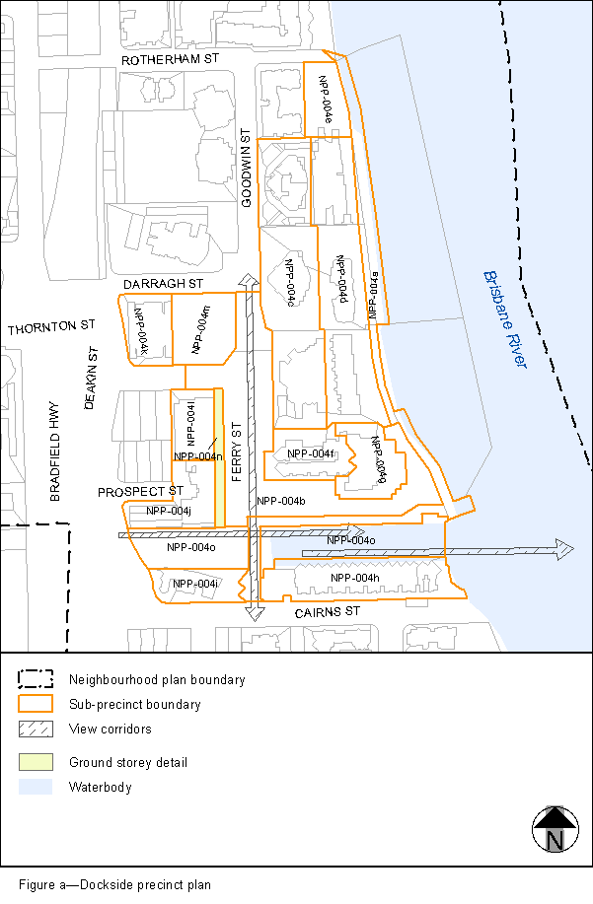
View the high resolution of Figure a–Dockside precinct plan (PDF file size is 286Kb)
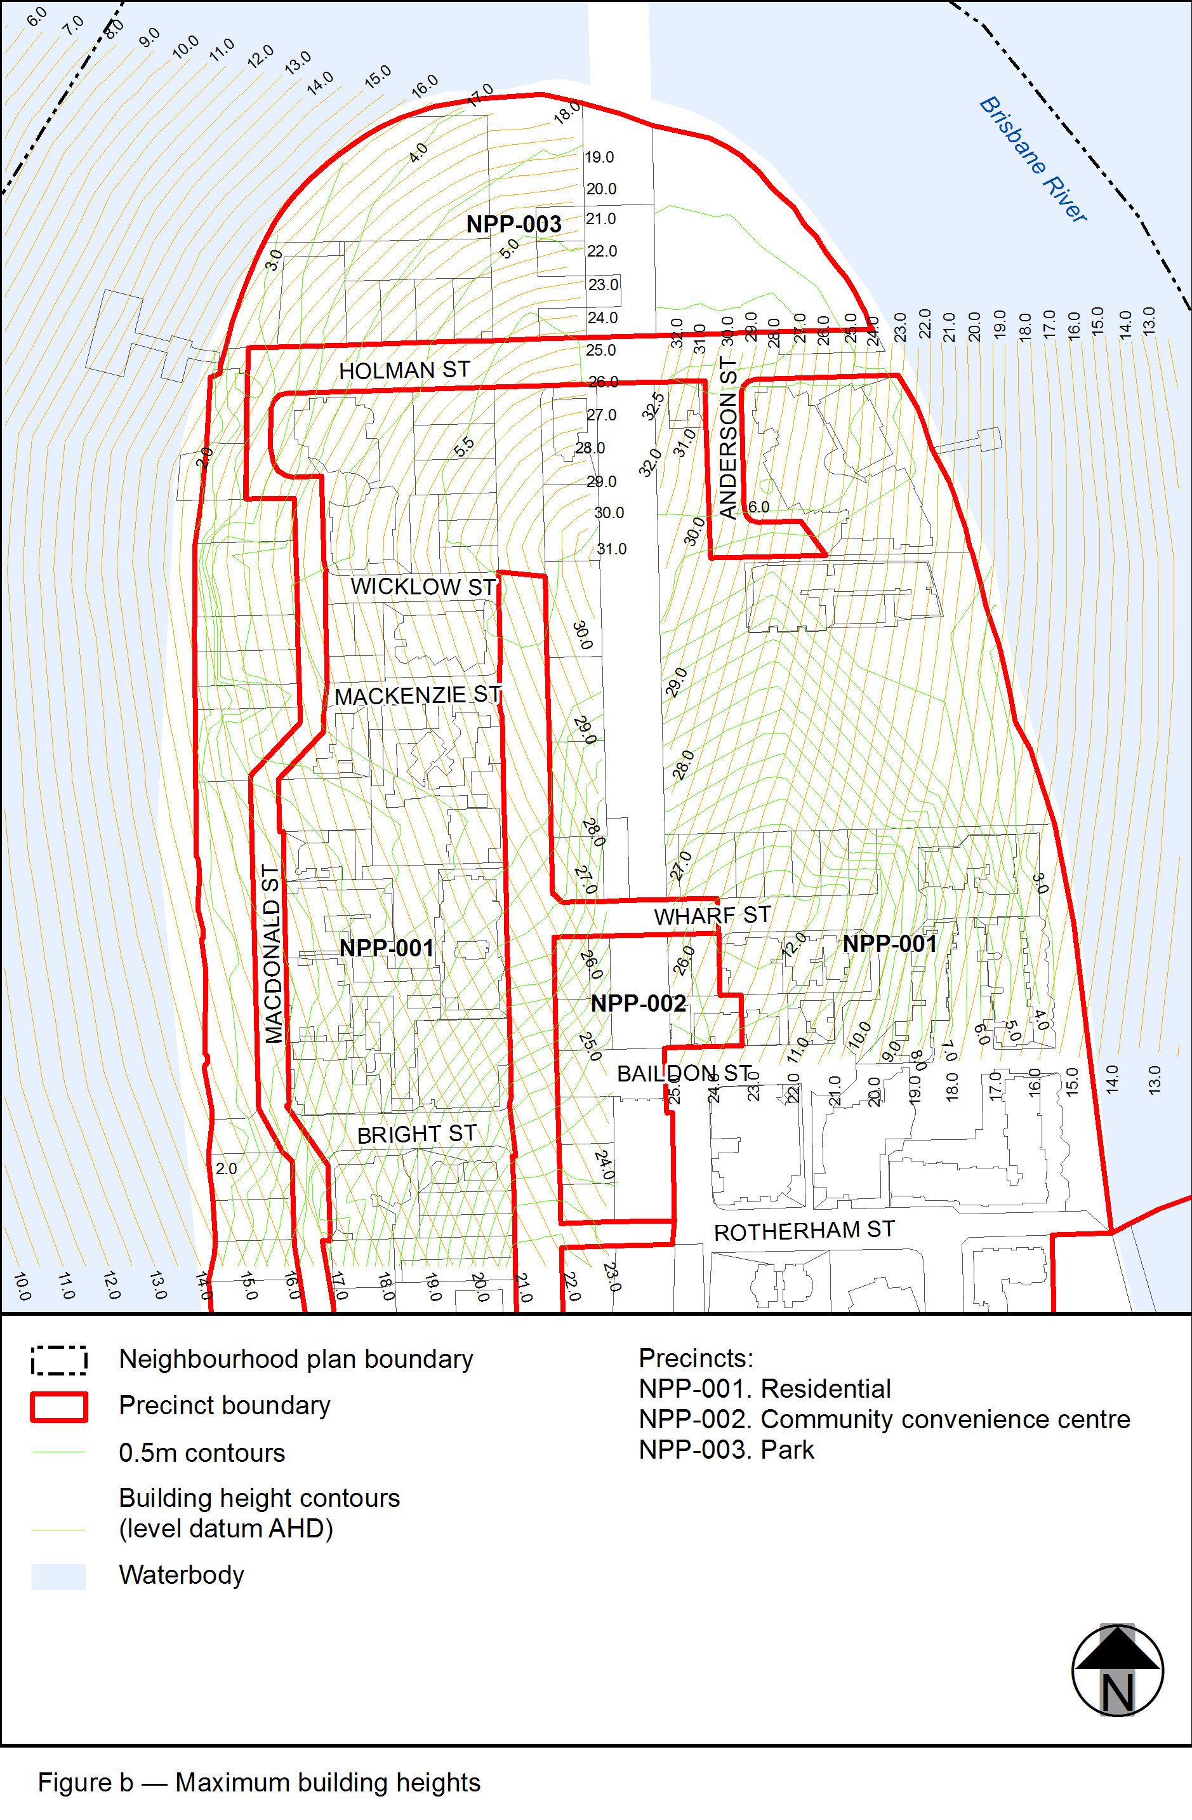
View the high resolution of Figure b–Maximum building heights (PDF file size is 350Kb)
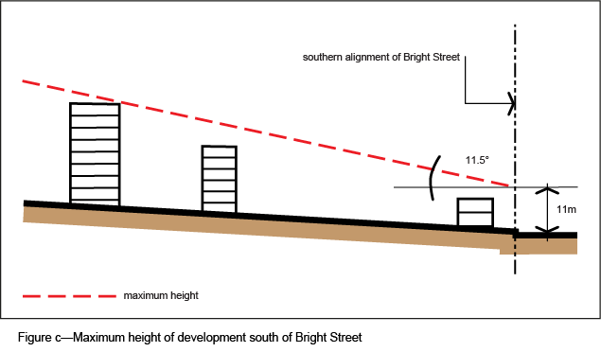
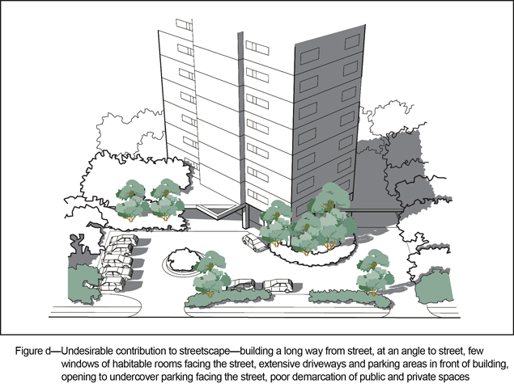
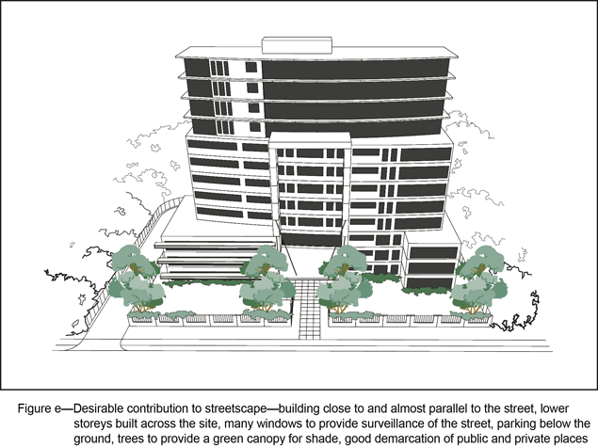
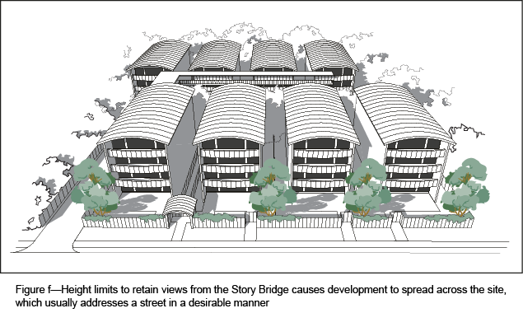
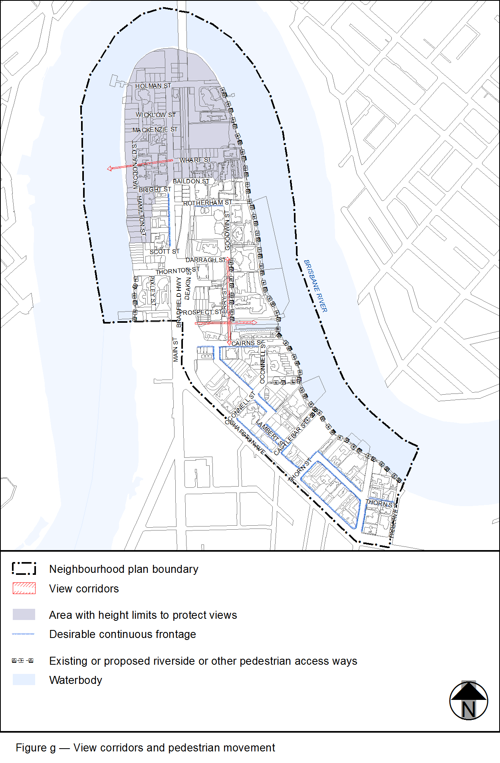
View the high resolution of Figure g–View corridors and pedestrian movement (PDF file size is 338Kb)
