7.2.11.4 Kuraby neighbourhood plan code

7.2.11.4.1 Application
- This code applies to assessing a material change of use, reconfiguring a lot, operational work or building work in the Kuraby neighbourhood plan area if:
- assessable development where this code is an applicable code identified in the assessment benchmarks column of a table of assessment for a neighbourhood plan (section 5.9); or
- impact assessable development.
- Land in the Kuraby neighbourhood plan area is identified on the NPM-011.4 Kuraby neighbourhood plan map.
- When using this code, reference should be made to section 1.5, section 5.3.2 and section 5.3.3.
Note—The following purpose, overall outcomes, performance outcomes and acceptable outcomes comprise the assessment benchmarks of this code.
Note—This neighbourhood plan includes a table of assessment. Refer to Table 5.9.35.A, Table 5.9.35.B, Table 5.9.35.C and Table 5.9.35.D.

7.2.11.4.2 Purpose
- The purpose of the Kuraby neighbourhood plan code is to provide finer grained planning at a local level for the Kuraby neighbourhood plan area.
- The purpose of the Kuraby neighbourhood plan code will be achieved through overall outcomes.
- The overall outcomes for the neighbourhood plan area are:
- Development creates functional and integrated communities;
- Land subject to development constraints, character or environmental values indicated in Figure a or Figure b in this code or shown on an overlay map is protected from inappropriate development in order to maintain its character, natural and ecological significance;
- Open space, parks and recreational facilities meet the needs of the community and are located in accessible locations that are well connected within the neighbourhood plan area;
- Development in a potential development area addresses the location of the land, availability of services, environmental constraints, amenity, and existing patterns of development to ensure an integrated development outcome;
- Residential development provides for a mix of housing types, styles and densities, in particular:
- low density residential – dwelling houses: contains dwelling densities of between 10 and 15 dwellings per hectare;
- low density residential – dwelling houses and multiple dwellings: contains dwelling densities of up to 20 dwellings per hectare where between 400m and 800m of the Kuraby Railway Station or Fruitgrove Railway Station and is designed to ensure compatibility with the form and scale of detached housing;
- low–medium density residential – multiple dwellings: contains dwelling densities of up to 25 dwellings per hectare where within 400m of the Kuraby Railway Station or Fruitgrove Railway Station.
Note—Residential densities and yields are to be calculated excluding parts of the site that are not within a potential development area. These include areas with development constraints or character or environmental values identified in overlay maps. Yields and maximum gross floor area for multiple dwellings and dual occupancy are to be calculated across the potential development area including all access ways and roads respectively.
- Development contiguous to the major electrical easement that passes through the Kuraby district is screened by appropriate planting.

7.2.11.4.3 Performance outcomes and acceptable outcomes

Table 7.2.11.4.3—Performance outcomes and acceptable outcomes
Performance outcomes | Acceptable outcomes
PO1  Development must protect biodiversity and landscape values and provide access along the public corridor. | AO1  Development that includes land within the Habitat areas and ecological corridors (public) as defined on Figure a and Figure b ensure that:  - the land is rehabilitated and stabilised in accordance with an approved rehabilitation plan;  - land is transferred to the Council for public ownership and included in the conservation zone;  - a road with a shared use (pedestrian and cyclist path) in an adjoining 6m wide verge is constructed within the Potential development area.

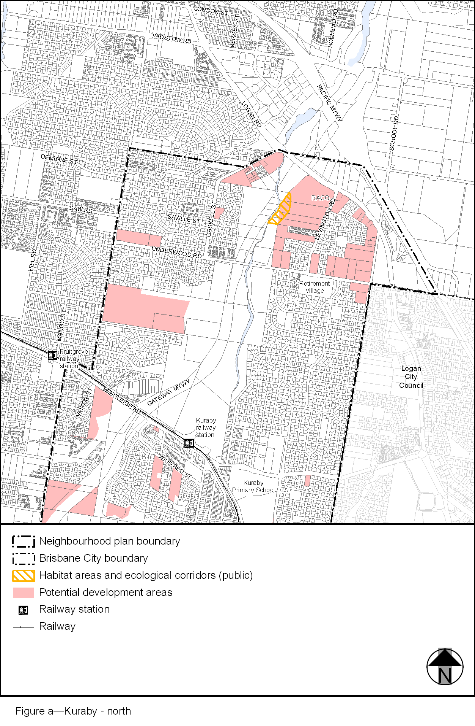
View the high resolution of Figure a–Kuraby – north (PDF file size is 328Kb)
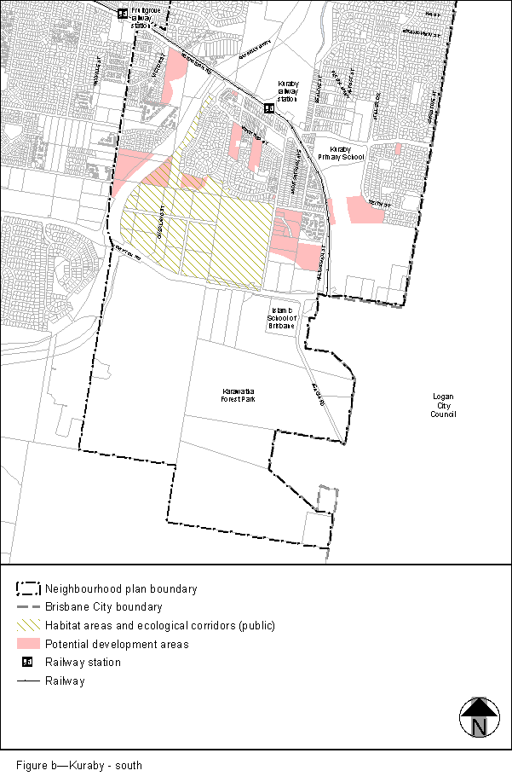
View the high resolution of Figure b–Kuraby – south (PDF file size is 335Kb)

