7.2.13.4 Mitchelton centre neighbourhood plan code

7.2.13.4.1 Application
- This code applies to assessing a material change of use, reconfiguring a lot, operational work or building work in the Mitchelton centre neighbourhood plan area if:
- assessable development where this code is an applicable code identified in the assessment benchmarks column of a table of assessment for a neighbourhood plan (section 5.9); or
- impact assessable development.
- Land in the Mitchelton centre neighbourhood plan area is identified on the NPM-0013.4 Mitchelton centre neighbourhood plan map and includes the following precincts:
- Brookside precinct (Mitchelton centre neighbourhood plan/NPP-001):
- Brookside A sub-precinct (Mitchelton centre neighbourhood plan/NPP-001a);
- Brookside B sub-precinct (Mitchelton centre neighbourhood plan/NPP-001b);
- Brookside C sub-precinct (Mitchelton centre neighbourhood plan/NPP-001c);
- Brookside D sub-precinct (Mitchelton centre neighbourhood plan/NPP-001d);
- Brookside E sub-precinct (Mitchelton centre neighbourhood plan/NPP-001e).
- Fringe residential precinct (Mitchelton centre neighbourhood plan/NPP-002);
- McConaghy Street south precinct (Mitchelton centre neighbourhood plan/NPP-003);
- University Road precinct (Mitchelton centre neighbourhood plan/NPP-004):
- University Road east sub-precinct (Mitchelton centre neighbourhood plan/NPP-004a);
- University Road west sub-precinct (Mitchelton centre neighbourhood plan/NPP-004b).
- Blackwood Street precinct (Mitchelton centre neighbourhood plan/NPP-005):
- Blackwood Street west sub-precinct (Mitchelton centre neighbourhood plan/NPP-005a);
- Blackwood Street east sub-precinct (Mitchelton centre neighbourhood plan/NPP-005b).
- Osborne Road south precinct (Mitchelton centre neighbourhood plan/NPP-006):
- Osborne Road south A sub-precinct (Mitchelton centre neighbourhood plan/NPP-006a);
- Osborne Road south B sub-precinct (Mitchelton centre neighbourhood plan/NPP-006b);
- Osborne Road south C sub-precinct (Mitchelton centre neighbourhood plan/NPP-006c).
- Prospect Road precinct (Mitchelton centre neighbourhood plan/NPP-007);
- Northmore Street precinct (Mitchelton centre neighbourhood plan/NPP-008).
- When using this code, reference should be made to section 1.5, section 5.3.2 and section 5.3.3.
Note—The following purpose, overall outcomes, performance outcomes and acceptable outcomes comprise the assessment benchmarks of this code.
Note—This neighbourhood plan includes a table of assessment with variations to categories of development and assessment. Refer to Table 5.9.43.A, Table 5.9.43.B, Table 5.9.43.C and Table 5.9.43.D.

7.2.13.4.2 Purpose
- The purpose of the Mitchelton centre neighbourhood plan code is to provide finer grained planning at a local level for the Mitchelton centre neighbourhood plan area.
- The purpose of the Mitchelton centre neighbourhood plan code will be achieved through overall outcomes including overall outcomes for each precinct of the neighbourhood plan area.
- The overall outcomes for the neighbourhood plan area are:
- Mitchelton centre develops as a Major Centre and will build on its existing provisions of retail, commercial and education services, and community sectors to become the major location for these activities in the north-western corridor of Brisbane.
- Development creates a diverse, integrated, mix of centre activities hosting shop and office uses, higher density residential dwellings and a range of community and recreational facilities that are concentrated around existing public transport nodes to support greater use of public transport services and attract further investment in new public transport facilities in and serving the Mitchelton centre.
- Development is of a height, scale and form which is consistent with the amenity and character, community expectations and infrastructure assumptions intended for the relevant precinct, sub-precinct or site and is only developed at a greater height, scale and form where there is both a community need and an economic need for the development.
- Higher density development requires larger sites that will be achieved through lot amalgamation.
- New houses and other development in areas with strong representation of buildings built in 1946 or before, complement traditional streetscape characteristics. In specified residential areas along roads with a high volume of traffic, the introduction of appropriate new uses is encouraged, where this leads to the preservation of heritage or character buildings.
- A range of community facilities and services is supported in the neighbourhood plan area that caters to residents, employees and visitors. New development assists in providing community spaces to meet the needs of the growing local community. Community facilities are supported to co-locate with public and private open space.
- Open space, including Kedron Brook, is an integral part of the local active transport network and offers a variety of accessible and comfortable community meeting places and recreational spaces.
- Brookside precinct (Mitchelton centre neighbourhood plan/NPP-001) overall outcomes are:
- Brookside Shopping Centre is supported to expand as the key economic, retail and services activity area for the north-western suburban corridor from Gaythorne to Ferny Grove.
- Higher density mixed use development is concentrated in Mitchelton between Osborne Road, Kedron Brook and the Ferny Grove railway corridor.
- The Brookside bus interchange promotes high levels of public transport patronage and reinforces the precinct as a Major Centre and supports transit oriented development outcomes.
- The land use mix and building design within the sub-precincts supports the creation of vibrant, active public spaces and active ground storey shopping streets with high density residential uses above.
- Brookside precinct will be a primary focus for new development due to the available infrastructure.
- Development integrates active transport and site landscaping with the Kedron Brook open space and waterway corridor.
- For development in the Brookside A sub-precinct (Mitchelton centre neighbourhood plan/NPP-001a):
- Development in the sub-precinct supports high density residential.
- Shops and cafe uses at ground storey level are consistent with the outcomes sought.
- Development that requires new road access to Osborne Road is not consistent with the outcomes sought. Development provides access to the road network via Northmore Street.
- Development in the Brookside B sub-precinct (Mitchelton centre neighbourhood plan/NPP-001b):
- of the existing Brookside Shopping Centre achieves future extension of the centre activity uses. High-density multiple dwellings are consistent with the outcomes sought;
- has a maximum building height of up to 10 storeys, depending on site area;
- supports activation of local streets and internal access routes by siting shops, food and drink outlets and offices at ground storey;
- screens service areas, including loading bays, from activity streets and residential streets;
- supports the provision of open space comprising an urban plaza as identified in Figure a that retains a significant landscape tree.
- Development in the Brookside C sub-precinct (Mitchelton centre neighbourhood plan/NPP-001c):
- supports high-density multiple dwellings with ground and podium level shops and offices that are linked to the Brookside Shopping Centre by road and the active transport network;
- has a built form for residential development that is expressed as individual towers above podiums that promote casual surveillance of the Kedron Brook open space and waterway corridor.
- Development in the Brookside D sub-precinct (Mitchelton centre neighbourhood plan/NPP-001d):
- supports the existing Brookside Shopping Centre and future extension of the shops and office activity uses in a podium level. High-density multiple dwellings are consistent with the outcomes sought as individual towers above podium level;
- transitions building height in response to established residential development fronting Prospect Road.
- Development in the Brookside E sub-precinct (Mitchelton centre neighbourhood plan/NPP-001e):
- supports shops, office activity and community facilities adjacent to the bus interchange;
- for community facilities including library, office space for community services and meeting facilities is consistent with the outcomes sought.
- supports a high-quality public realm that facilitates active transport and ground-level urban open space.
- Fringe residential precinct (Mitchelton centre neighbourhood plan/NPP-002) overall outcomes are:
- Development in the precinct supports multiple dwellings at low–medium density residential development and medium density residential development. Aged-care accommodation is supported due to proximity to a range of centre activity uses and regional public transport stations.
- Development on sites fronting Osborne Street supports 4 storey multiple dwellings where a deep landscape buffer is provided at the common boundary to the Low density residential zone (refer to Figure d(i), Figure d(ii) and Figure i(i)).
- McConaghy Street south precinct (Mitchelton centre neighbourhood plan/NPP-003) overall outcomes are:
- Development in the precinct supports multiple dwellings at medium density.
- Development on a site fronting the Mitchelton railway station supports shop and office activity on ground level to promote street activation.
- Development results in active frontages to adjoining open space and active transport corridor links (refer to Figure e) to the Mitchelton railway station and the Brookside Shopping Centre bus interchange.
- Development on sites adjoining the Osborne Road open-level railway crossing (refer to Figure b) does not restrict the requirements of a grade separated rail crossing. Building height and setbacks to existing Osborne Road frontages will respond to requirements stated by Queensland Government transport agencies.
- University Road precinct (Mitchelton centre neighbourhood plan/NPP-004) overall outcomes are:
- Development in the University Road precinct supports multiple dwellings and limited centre activity uses at low–medium density.
- Development in the University Road east sub-precinct (Mitchelton centre neighbourhood plan/NPP-004a):
- for limited centre activity uses at ground floor level responds to the residential character of University Road west;
- has a minimum site frontage of 40m due to the constraints imposed by the waterway corridor at the rear.
- Development in the University Road west sub-precinct (Mitchelton centre neighbourhood plan/NPP-004b):
- comprises multiple dwellings at low–medium density.
- Blackwood Street precinct (Mitchelton centre neighbourhood plan/NPP-005) overall outcomes are:
- Development comprises a high-street pattern of retail and commercial tenancies supporting an active day and night pedestrian streetscape.
- Development has shop, food and drink outlet, and office uses at ground storey and podium levels. Multiple dwellings are supported in individual towers dependent on site area.
- Development of sites fronting Blackwood Street results in permeable vehicle and active transport networks. Laneways are provided to create shared access ways, allow for vehicle connectivity at the rear of properties and reduce the number of vehicle crossovers to Blackwood Street.
- Development promotes building setbacks at ground level (refer to Figure g) to create a high-quality pedestrian streetscape that supports community use in the centre.
- Development in the Blackwood Street west sub-precinct (Mitchelton centre neighbourhood plan/NPP-005a):
- comprises medium density residential and centre activity uses. An undercroft is required to mitigate flood risk associated with the waterway;
- provides a shared rear access driveway servicing the building fronting Blackwood Street (refer to Figure b, Figure g and Figure i(iii)).
- Development in the Blackwood Street east sub-precinct (Mitchelton centre neighbourhood plan/NPP-005b):
- comprises medium density residential and centre activity uses;
- has a rear boundary setback to buildings consistent with Table 7.2.13.4.3.C. Development has a front boundary setback consistent with Table 7.2.13.4.3.C and provides a high-quality streetscape and high-street retail outcome in Blackwood Street;
- provides a shared rear-access driveway servicing the building fronting Blackwood Street (refer to Figure b, Figure g, Figure i(ii) and Figure i(iii)) with a shared access point at 27 Blackwood Street (Lot 83 RP 18817).
- Osborne Road south precinct (Mitchelton centre neighbourhood plan/NPP-006) overall outcomes are:
- Development comprises a mix of centre activity tenancies and multiple dwellings.
- Development is sited to provide for the elimination of the Osborne Road open-level railway crossing.
- Development provides a shared rear access lane servicing the building fronting Osborne Road as shown in Figure h.
- Development that provides additional vehicle access points to Osborne Road is not consistent with the outcomes sought.
- Development in the Osborne Road south A sub-precinct (Mitchelton centre neighbourhood plan/NPP-006a):
- for mixed use centre activity uses is consistent with the outcomes sought;
- provides an active frontage that links the bus interchange to retail precincts and community facilities;
- uses vehicular access from a rear lane and does not require additional vehicle access points to Osborne Road.
- Development in the Osborne Road south B sub-precinct (Mitchelton centre neighbourhood plan/NPP-006b):
- comprises mixed use centre activity uses and multiple dwellings. Residential development in individual towers above commercial podium levels is consistent with the outcomes sought;
- provides an active frontage to Mitchelton Park that provides observation of public access paths;
- provides a public pedestrian frontage that links the sub-precinct to the Mitchelton railway station, bus interchange and Brookside retail precincts and community facilities;
- provides for the elimination of the Osborne Road open-level railway crossing (refer to Figure b and Figure h).
- Development in the Osborne Road south C sub-precinct (Mitchelton centre neighbourhood plan/NPP-006c):
- comprises mixed use centre activity uses and multiple dwellings. Residential multiple dwelling development in individual towers above commercial ground storeys is consistent with the outcomes sought;
- provides a public pedestrian frontage that links the sub-precinct to the Mitchelton railway station, bus interchange and Blackwood Street retail precincts;
- provides for the elimination of the Osborne Road open-level railway crossing (refer to Figure b and Figure h).
- Prospect Road precinct (Mitchelton centre neighbourhood plan/NPP-007) overall outcomes are:
- Development of medium density residential multiple dwellings is consistent with the outcomes sought.
- Development is sited to provide for pedestrian access to the Gaythorne railway station.
- Development transitions building height where adjoining the Low density residential zone fronting Bellevue Avenue and Prospect Road (refer to Figure a).
- Development is subject to site remediation in relation to previous industrial activity and subsequent on-site waste disposal.
- Development is subject to the reinstatement and remediation of the waterway corridor transecting the site.
- Development provides a public road connection between Prospect Road and Bellevue Avenue.
- Northmore Street precinct (Mitchelton centre neighbourhood plan/NPP-008) overall outcomes are:
- Development of medium density residential multiple dwellings is consistent with the outcomes sought.

7.2.13.4.3 Performance outcomes and acceptable outcomes

Table 7.2.13.4.3.A—Performance outcomes and acceptable outcomes
Performance outcomes | Acceptable outcomes
General
PO1  Development is of a height, scale and form that achieves the intended outcome for the precinct, improves the amenity of the neighbourhood plan area, contributes to a cohesive streetscape and built form character and is:  - consistent with the anticipated density and assumed infrastructure demand;  - aligned to community expectations about the number of storeys to be built;  - proportionate to and commensurate with the utility of the site area and frontage width;  - designed to avoid a significant and undue adverse amenity impact to adjoining development;  - sited to enable existing and future buildings to be well separated from each other and avoid affecting the potential development of an adjoining site.  Note—Development that exceeds the intended number of storeys or building height can place disproportionate pressure on the transport network, public space or community facilities in particular.  Note—Development that is over-scaled for its site can result in an undesirable dominance of vehicle access, parking and manoeuvring areas that significantly reduce streetscape character and amenity. | AO1  Development complies with the number of storeys and building height in Table 7.2.13.4.3.B.  Note—Neighbourhood plans will mostly specify a maximum number of storeys where zone outcomes have been varied in relation to building height. Some neighbourhood plans may also specify height in metres. Development must comply with both parameters where maximum number of storeys and height in metres are specified.
PO2  Development creates a consistent and cohesive streetscape.  Note—Where development is located in a street that is subject to a road widening requirement, the new property alignment, after the proposed widening, is regarded as the street-front property boundary. | AO2  Development complies with the boundary and building setbacks in Table 7.2.13.4.3.C.
PO3  Development results in a mix of centre activities and residential uses that:  - support Mitchelton centre's function as a Major Centre located on a public transport corridor;  - supports the development of Mitchelton centre's growth precincts. | AO3  Development complies with the land use mix specified in Table 7.2.13.4.3.D.
PO4  Development provides new public open space to meet the recreational needs of residents and workers. | AO4.1  Development dedicates to Council a new park in the form of an urban common with a minimum area of 2,000m2 in the location identified in Figure a.
AO4.2
Development provides a new public open space in the form of a public plaza with a minimum area of 1,600m2 in the location identified in Figure a, which is not required to be dedicated to the Council.
PO5  Development provides land to support the creation of a road network that:  - efficiently provides for the movement of traffic, including road widening and new roads;  - provides comfortable pedestrian environments;  - meets the needs of a range of users, including those with mobility impairments;  - positively contributes to landscaped, shared, subtropical streetscapes in the neighbourhood plan area. | AO5  Development provides for road widening and new roads in accordance with Figure b through the dedication of land to Council.
PO6  Development achieves building design, site layout and land use that contributes to the street as a focus of commercial and community life. | AO6  Development along active streets as indicated in Figure a achieves continuous tenancy frontage with minimal breaks for building services and a high degree of visibility between the public realm and tenancies.
PO7  Development that includes a podium achieves building design that:  - avoids the creation of a canyon of buildings along street frontages;  - promotes a fine grain of human scale activity at street level;  - responds to changes in topography and gradients. | AO7  Development ensures:  - podium heights are a maximum of 2 storeys;  - a podium that is built to the side boundary ensures a minimum length of 10m from the front boundary is achieved, except where:  - there is a requirement for the provision of an overland flow path;  - the development adjoins property not included within the District centre zone.  - podiums where adjoining property not included in the District centre zone are set back a minimum of 2m from the boundary with the adjoining property;  - development includes a tower that is no more than 75% of the width of the site or a maximum of 30m in any direction, whichever is the lesser.  Note—Refer to Table 7.2.13.4.3.C.
PO8  Development ensures:  - vehicle entrances, servicing and parking are designed and located to minimise disruption to building frontages, pedestrian environment and to reduce the visual impact of vehicle entrances on the street environment;  - pedestrian movement, comfort and safety is maximised in areas of high pedestrian usage by reducing pedestrian and vehicular conflict;  - driveway crossovers maintain the integrity, quality and primacy of the footpath. | AO8.1  Development of rear service lanes are provided to adjoining properties from the nearest public road to enable vehicular access and servicing as indicated in Figure b.  Note—Neighbourhood plans that specify rear service lanes should be read as specifying an intent to achieve alternative access and servicing to adjoining sites that reinforce precinct outcomes.
AO8.2
Development creates easements over rear service lanes benefiting all parties to the easement, including adjoining landowners and the Council, in perpetuity if Council determines that these easements are to service more than 1 individual development or property.
PO9  Development contributes to the safety and utility of publicly accessible areas. | AO9  Development adjoining McConaghy Street park or Kedron Brook provides for access to the public open space via a communal pathway.
PO10  Development creates an integrated pedestrian and cyclist network that provides direct access to public transport routes, activity centres and public open space. The scale, width, design and tenure of arcades reflect their function and location. | AO10  Development provides arcades and bicycle paths in accordance with Council standards, as shown in Figure b.
If in the Brookside B sub-precinct (Mitchelton centre neighbourhood plan/NPP-001b)
PO11  Development of the Brookside Shopping Centre achieves the following:  - expands the mix of land uses beyond retail to include office and residential;  - includes highly articulated buildings with significant recesses and projections and a range of building materials (including glass) to visually reduce their bulk and scale and sensitively integrate with adjoining residential areas;  - sensitively addresses Kedron Brook, providing transitions in building height and building setbacks maximising opportunities for casual surveillance of the waterway corridor;  - breaks down the edges of the existing ‘big box’ and creates active frontages with multiple building breaks for building articulation and separation, pedestrian and vehicular access along Osborne Road, and arcades to add to the vibrancy of the area;  - maximises pedestrian accessibility to and from the site and pedestrian safety through the site, particularly to any bus interchange, via the introduction of legible arcades with 24-hour access where supported by an ‘active frontage’ as shown in Figure a;  - provides vibrant and safe publicly accessible open spaces in the form of town squares and meeting places integrated with the development;  - provides safe and efficient access for vehicles (including service vehicles) and internal circulation networks that do not detrimentally impact on the surrounding road network;  - takes into account the need for the future elimination of the Osborne Road open-level railway crossing;  - building height transition (where shown in Figure b) by stepping down along the boundary of the precinct, in accordance with Figure a.  Note—A concept plan may be prepared to demonstrate compliance with this performance outcome. | AO11  No acceptable outcome is prescribed.
If in the Brookside E sub-precinct (Mitchelton centre neighbourhood plan/NPP-001e)
PO12  Development of a bus interchange:  - provides a public transport hub with highly accessible connections to shops, community facilities, commercial and professional services and open space within the Brookside centre;  - integrates with the local and regional transport network to improve public transport efficiency along the district roads in the north-western suburbs;  - building and site design transitions public transport passengers from the bus interchange to shops, offices, centre activities and community facilities via an attractive and active ‘street’ environment;  - bus interchange utility and services areas are designed to minimise visual dominance in active streets. | AO12  No acceptable outcome is prescribed.
If in the Fringe residential precinct (Mitchelton centre neighbourhood plan/NPP-002)
PO13  Development on a site greater than 2,400m2 includes landscaping that:  - protects and positively contributes to character, amenity, safety and privacy;  - sensitively manages interfaces to adjoining sites within the Low density residential zone and Character residential zone and road frontages. | AO13  Development includes:  - deep-planting areas within 10m of any boundary that adjoins a ‘Building height transition area’ as shown in Figure a;  - deep-planting areas within 4m of the front property boundary to Osborne Road.
If in the Blackwood Street precinct (Mitchelton centre neighbourhood plan/NPP-005)
PO14  Development in the existing retail and commercial centre along Blackwood Street, between Samford Road and the railway line:  - contributes to a fine-grain urban form;  - creates strong visual interest;  - contributes to a high-quality public domain that supports ongoing regular use as street markets. | AO14  Development fronting Blackwood Street includes:  - clearly expressed individual shop fronts of 10m–15m widths consistent with traditional widths in the street;  - continuous awning and parapet;  - building facades that are articulated through frequent recesses and projections and elements of a finer scale than the main structural framing of the building.
PO15  Development provides service and residential vehicle access from the rear of Blackwood Street that:  - forms a continuous connection, accommodating changes in ground levels on individual sites;  - allows for an alternative access/egress route from buildings fronting Blackwood Street on market days;  - supports the provision of dual access arrangements that allow for emergency vehicular access/egress via Blackwood Street in the event of waterway flooding along the rear boundaries;  - reduces conflicts between pedestrians and service vehicles on Blackwood Street. | AO15.1  No new vehicular accesses are formed to Blackwood Street where alternative access is available.
AO15.2
Vehicular and pedestrian access are provided from a new private laneway running along the rear property boundary of properties fronting Blackwood Street, as shown in Figure g, Figure i(i) and Figure i(iii).
Note—Easements are created over shared vehicular access ways to all adjoining owners and Council easement where Council determines these are to serve more than an individual development and property.
AO15.3
Development provides:
- car parking that is contained to the rear of buildings, in a basement or at ground level where vehicle entry is provided from the rear laneway only;
- vehicle and pedestrian access is provided by means of a raised platform construction;
- finished ground-floor levels that facilitate a continuous shared access for vehicles and pedestrians, in accordance with AO15.2.
AO15.4
Development is sited and designed to achieve the pedestrian and vehicle access laneway shown on the Streetscape hierarchy overlay map.
If in the Blackwood Street west sub-precinct (Mitchelton centre neighbourhood plan/NPP005a)
PO16  Development does not reduce flood conveyance or water quality of waterways. | AO16.1  Development of a rear access lane and at ground storey achieves minimum flood immunity levels by means of a raised platform construction, as shown in Figure g.  Note—Table 7.2.13.4.3.C requires a minimum 20m setback between basement level and the waterway (refer to Figure g).
AO16.2
Development achieves a minimum vertical clearance between natural or reconstructed ground level and the slab or beams of any raised platform construction, in accordance with Council standards.
Note—Compliance with the above acceptable outcomes may be achieved by submission and approval of a hydraulic and hydrology report (as part of a site-based stormwater management plan) identifying potential flooding impacts on upstream, downstream or adjacent properties.
If in the Osborne Road south precinct (Mitchelton centre neighbourhood plan/NPP-006)
PO17  Development is sited and incorporates building design elements so as to not prejudice the elimination of the Osborne Road open level railway crossing. | AO17.1  Development is sited outside the area described as the Osborne Road open-level railway crossing in Figure b.
AO17.2
Development provides for rear access lane whose access point to a public road is outside the area described as the Osborne Road open level railway crossing in Figure b.
AO17.3
Development incorporates a bioretention garden bed of a minimum width of 1200mm–1600mm with water sensitive urban design kerb inlet that provides adequate filtration of water before it enters the watercourse.
AO17.4
Development comprising filling or excavation of more than 100mm does not adversely affect the flow of water in an overland flow path.
If in the Osborne Road south C sub-precinct (Mitchelton centre neighbourhood plan/NPP-006c)
PO18  Development results in a built form that ameliorates the impact of mixed use development on adjacent education facilities. | AO18  Development directly adjoining the school and kindergarten provides:  - a building setback from the common boundary of a minimum of 3m or half the height of the building at that point, whichever is greater;  - landscaping of the common boundary with deep planting of mature trees and understorey plants of a type consistent with the locality and planted at intervals that will ensure a significant level (2m for understorey plants and at least 6m for mature trees) to the school and kindergarten to act as a screen.

Table 7.2.13.4.3.B—Maximum building height and gross floor area
Development | Minimum site area | Minimum frontage | Maximum building height (storeys(m)) | Maximum gross floor area
If in the Brookside precinct (Mitchelton centre neighbourhood plan/NPP-001)
Development of a site in the Brookside sub-precincts A, B or D and any part of the site within 20m of Osborne Road (shown as a ‘Building height transition area’ in Figure a) | Not specified | 40m | 6 (20m) | Not specified
Development of a site in the Brookside sub-precincts A, B or D and any part of the site beyond 20m of Osborne Road (shown as a ‘Building height transition area’ in Figure a) | Not specified | 40m | 10 (35m) | Not specified
Development of a site in the Brookside C sub-precinct (Mitchelton centre neighbourhood plan/NPP-001c) | Not specified | 30m | 10 (35m) | Not specified
Development of a site in the Brookside E sub-precinct (Mitchelton centre neighbourhood plan/NPP-001e) | Not specified | Not specified | 10 (35m) | Not specified
If in the Fringe residential precinct (Mitchelton centre neighbourhood plan/NPP-002)
Development of any part of a site beyond 10m of a boundary to an existing Low density residential zone (shown as a ‘Building height transition area’ in Figure a). Refer to Figure d(i) and Figure d(ii). | 2,400m2(1) | 40m | 4 (14m) | 200% of the site area
If in the McConaghy Street south precinct (Mitchelton centre neighbourhood plan/NPP-003)
Development of a site in the McConaghy Street south precinct (Mitchelton centre neighbourhood plan/NPP-003) | 1,200m2 | 20 | 5 (18m) | 200% of the site area
If in the University Road precinct (Mitchelton centre neighbourhood plan/NPP-004)
Development of a site in the University Road east sub-precinct (Mitchelton centre neighbourhood plan/NPP-004a). Refer to Figure f. | 800m2 | 40m(2) | 3 (11m) | 125% of the site area
Development of a site in the University Road west sub-precinct (Mitchelton centre neighbourhood plan/NPP-004b) | Not specified | Not specified | 3 (11m) | 125% of the site area
If in the Blackwood Street precinct (Mitchelton centre neighbourhood plan/NPP-005)
Development of a site in the Blackwood Street precinct | Up to 1,199m2 | Not specified | 4 (14m) | Not specified
Development of a site in the Blackwood Street precinct | 1,200m2 | 20m | 6 (20m) | Not specified
Development of a site in the Blackwood Street Precinct where site is Lot 1 RP124398 (30 Kedron Avenue, Mitchelton) | 1,200m2 | 20m | 8 (27m) | Not specified
If in the Osborne Road south precinct (Mitchelton centre neighbourhood plan/NPP-006)
Development of a site in the Osborne Road precinct (sub-precincts A, B and C) | Up to 1,199m2 | Not specified | 4 (14m) | Not specified
Development of a site in the Osborne Road south A sub-precinct (Mitchelton centre neighbourhood plan/NPP-006a) | 1,200m2 | 20m | 6 (20m) | Not specified
Development of a site in the Osborne Road south B sub-precinct (Mitchelton centre neighbourhood plan/NPP-006b). Refer to Figure h. | 1,200m2 | 20m | 8 (27m) | Not specified
Development of a site in the Osborne Road south C sub-precinct (Mitchelton centre neighbourhood plan/NPP-006c). Refer to Figure h. | 1,200m2 | 20m | 6 (20m) | Not specified
If in the Prospect Road precinct (Mitchelton centre neighbourhood plan/NPP-007)
Development of a site in the Prospect Road precinct and any part of the site within 20m of Bellevue Avenue or Prospect Road (shown as a ‘Building height transition area’ in Figure a) | Not specified | Not specified | 3 (11m) | 200% of the site area
Development of a site in the Prospect Road Precinct and any part of the site beyond 20m of Bellevue Avenue or Prospect Road (shown as a ‘Building height transition area’ in Figure a) | Not specified | Not specified | 6 (20m) | 200% of the site area
Note—
(1) For lots less than 2,400m2, the neighbourhood plan does not vary the maximum height or gross floor area.
(2) Where the site adjoins land in the waterway corridors overlay.

Table 7.2.13.4.3.C—Minimum building setbacks
Development | Minimum setbacks
Development where more than one tower on site | Between each tower 12m
If in the Brookside precinct (Mitchelton centre neighbourhood plan/NPP-001)
Any development in this precinct | Ground storey | 2nd storey podium | 3rd–6th storey | 7th storey and above
 | Front – 3m to building wall from Osborne Road  Refer to Figure c. | Front – 0m from Osborne Road  Refer to Figure c. | Front – 4m to balcony and 6m to building wall from Osborne Road  Refer to Figure c. | Front – 20m to building wall from Osborne Road  Refer to Figure c.
If in the Fringe residential precinct (Mitchelton centre neighbourhood plan/NPP-002)
Any development in this precinct | Front – 6m  Rear – 6m  Where fronting Osborne Road:  Rear – 10m  Refer to Figure d(i) and Figure d(ii).
If in the McConaghy Street south precinct (Mitchelton centre neighbourhood plan/NPP-003)
Any development in this precinct | Ground storey |  | 2nd storey podium | 3rd storey and above
 | Front – 3m  Rear – 6m  Refer to Figure e. |  | Non-residential uses:  Front – 0m  Residential uses:  Front – 6m to balcony and 9m to building wall  Rear – 6m  Refer to Figure e. | Front – 6m to balcony and 9m to building wall  Rear – 6m  Refer to Figure e.
If in the University Road east sub-precinct (Mitchelton centre neighbourhood plan/NPP-004a)
Development of a site fronting University Road | Front – 4m to balcony, 6m to building wall  Rear – 0m to waterway corridor  Refer to Figure f.
If in the Blackwood Street west sub-precinct (Mitchelton centre neighbourhood plan/NPP-005a)
Any development in this precinct | Basement | Ground storey | 2nd storey podium | 3rd storey and above
 | Front – 0m  Rear – 20m from waterway  Refer to Figure g. | Front – 5m  Side – 0m  Rear – 12m  Refer to Figure g. | Front – 0m  Side – 0m  Residential uses:  Side – 3m  Rear – 12m  Refer to Figure g. | Front – 5m to balcony; and 8m to building wall  Side – 3m  Rear – 8m  Refer to Figure g.
If in the Blackwood Street east sub-precinct (Mitchelton centre neighbourhood plan/NPP-005b)
Any development in this precinct | Basement | Ground storey | 2nd storey podium | 3rd storey and above
 | Front – 0m  Rear – 0m  Refer to Figure g. | Front – 5m  Side – 0m  Rear – 1.6m (1m where on L1 RP 124398 ‘Doyle’s Hardware’ site)  Refer to Figure g. | Front – 0m  Side – 0m  Rear – 1.6m (1m where on L1 RP 124398 ‘Doyle’s Hardware’ site)  Refer to Figure g. | Front – 5m to balcony; and 8m to building wall  Side – 3m  Rear – 1.6m to balcony; and 4.6m to building wall  (where on L1, RP 124398 ‘Doyle’s Hardware’ site, 7m to balcony and 10m to building wall)  Refer to Figure g.
If in the Osborne Road south precinct (Mitchelton centre neighbourhood plan/NPP-006)
Any development in this precinct | Ground storey |  | 2nd storey podium | 3rd storey and above
 | Front – 12m  Rear – 6m  Side – 3m  Refer to Figure h (1) |  | Front – 12m  Rear – 6m to balcony, 9m to building wall  Side – 3m  Refer to Figure h (1) | Front – 6m  Rear – 6m to balcony, 9m to building wall  Side – 6m  Refer to Figure h (1)
Note—Where a development is located in a street that is subject to a road widening requirement, the alignment of the proposed widening is regarded as the street front property boundary
(1) Refer to AO18 of the Mitchelton centre neighbourhood plan code for setback requirements where adjoining school/kindergarten in Osborne Road south C sub-precinct (Mitchelton centre neighbourhood plan/NPP-006c)

Table 7.2.13.4.3.D—Land use mix
Development | Ground floor and podium | Above podium
If in the Brookside A sub-precinct (Mitchelton centre neighbourhood plan/NPP-001a)
Any development in this precinct | Maximum 10% centre activities  Minimum 90% residential | 100% residential
If in the Brookside B sub-precinct (Mitchelton centre neighbourhood plan/NPP-001b) or the Brookside D sub-precinct (Mitchelton centre neighbourhood plan/NPP-001d)
Any development in this precinct | 100% centre activities | 100% residential
If in the Brookside C sub-precinct (Mitchelton centre neighbourhood plan/NPP-001c)
Any development in this precinct | Maximum 20% centre activities  Minimum 80% residential | 100% residential
If in the Brookside E sub-precinct (Mitchelton centre neighbourhood plan/NPP-001e)
Any development in this precinct | Combination of centre activities, park (urban common) and/or community facilities | 100% residential
If in the University Road east sub-precinct (Mitchelton centre neighbourhood plan/NPP-004a)
Any development in this precinct | Maximum 20% centre activity  Minimum 80% residential | 100% residential

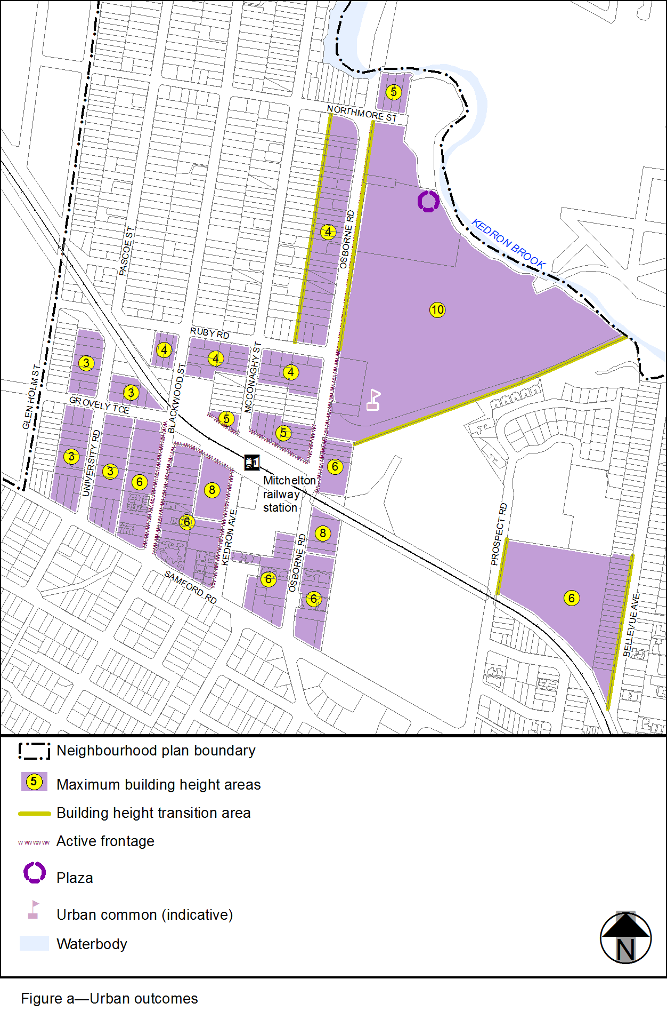
View the high resolution of Figure a–Urban outcomes (PDF file size is 189Kb)
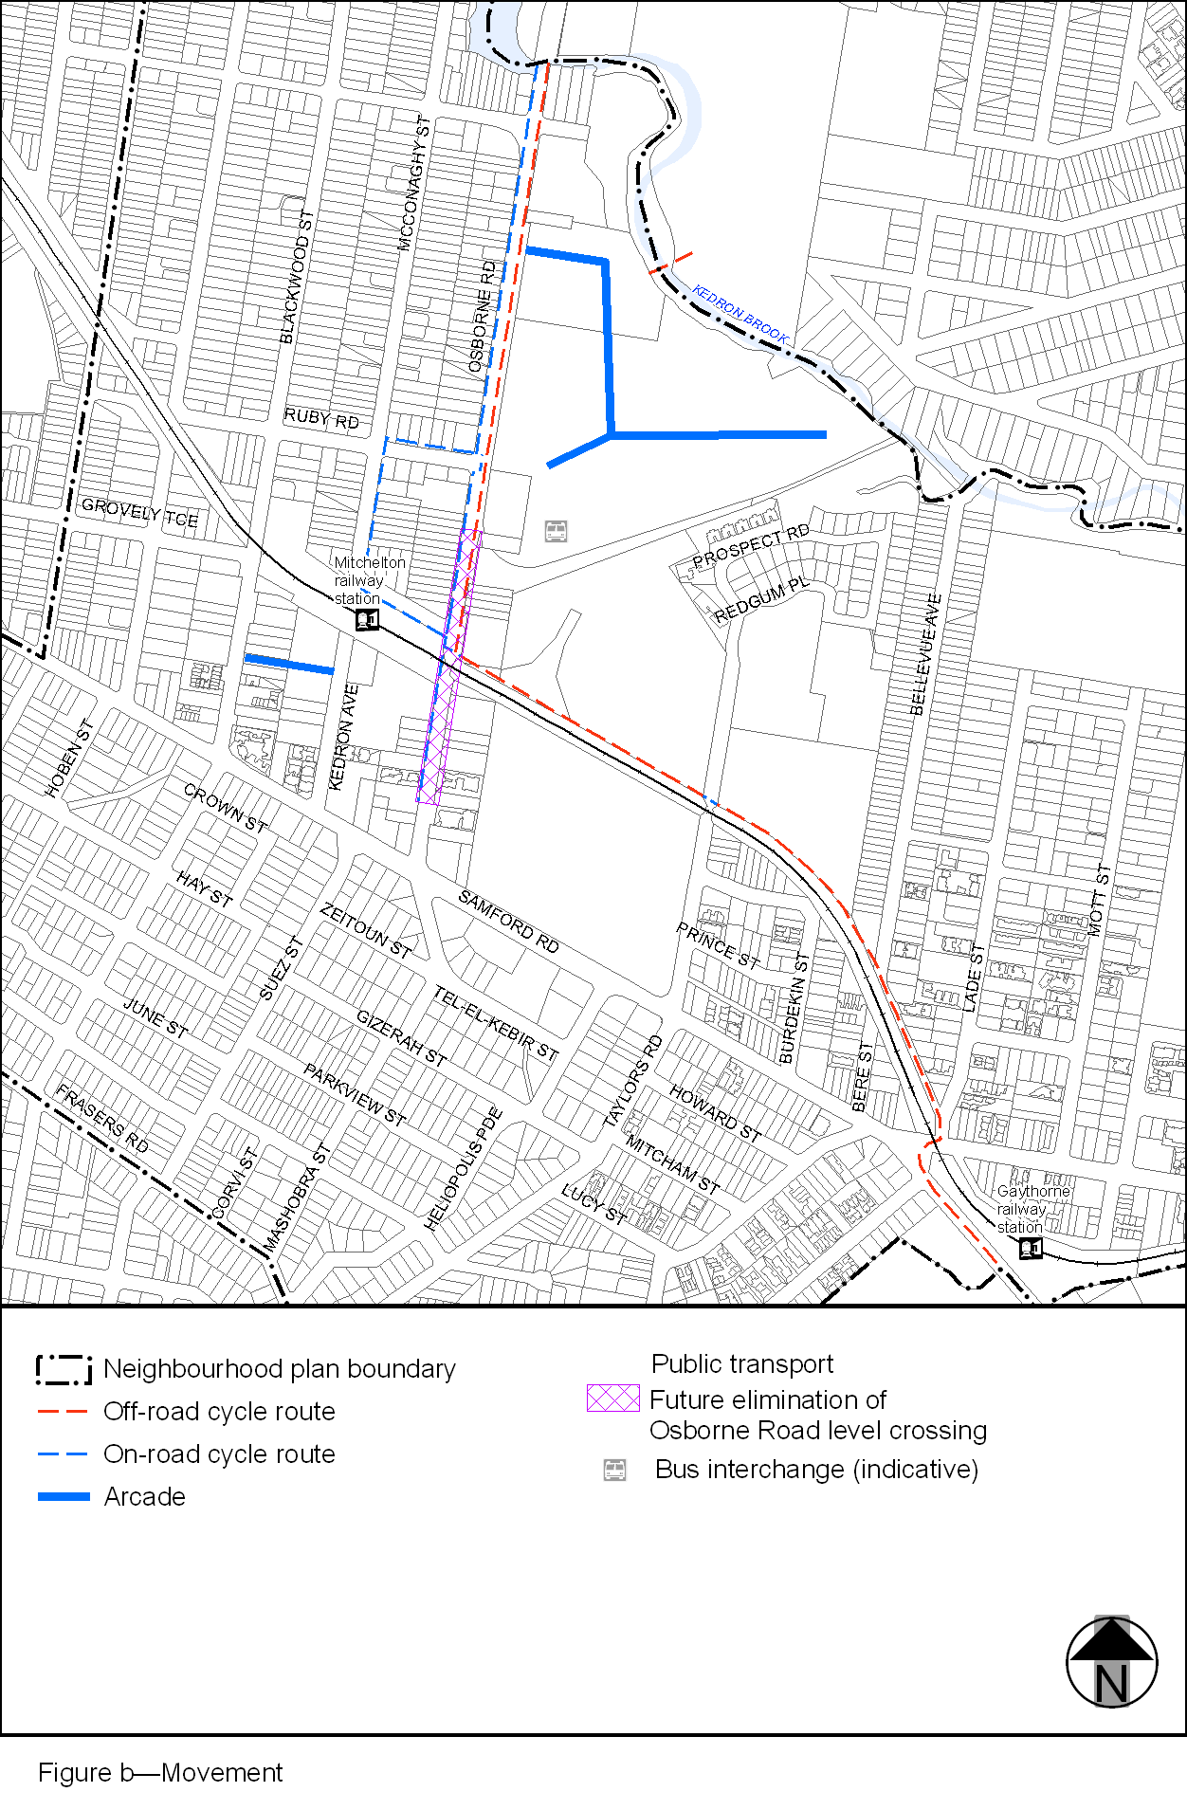
View the high resolution of Figure b–Movement (PDF file size is 239Kb)
