7.2.13.6 Moggill—Bellbowrie district neighbourhood plan code

7.2.13.6.1 Application
- This code applies to assessing a material change of use, reconfiguring a lot, operational work or building work in the Moggill—Bellbowrie district neighbourhood plan area if:
- assessable development where this code is an applicable code identified in the assessment benchmarks column of a table of assessment for a neighbourhood plan (section 5.9); or
- impact assessable development.
- Land within the Moggill—Bellbowrie district neighbourhood plan area is identified on the NPM-013.6 Moggill—Bellbowrie district neighbourhood plan map and includes the following precincts:
- Environmental protection precinct (Moggill—Bellbowrie district neighbourhood plan/NPP-001);
- Established residential precinct (Moggill—Bellbowrie district neighbourhood plan/NPP-002);
- Low density residential precinct (Moggill—Bellbowrie district neighbourhood plan/NPP-003):
- Church and Witty roads sub-precinct (Moggill—Bellbowrie district neighbourhood plan/NPP-003a);
- Priors Pocket Road sub-precinct (Moggill—Bellbowrie district neighbourhood plan/NPP-003b).
- Multi-purpose centres precinct (Moggill—Bellbowrie district neighbourhood plan/NPP-004);
- University of Queensland Pinjarra Hills precinct (Moggill—Bellbowrie district neighbourhood plan/NPP-005).
- When using this code, reference should be made to section 1.5, section 5.3.2 and section 5.3.3.
Note—The following purpose, overall outcomes, performance outcomes and acceptable outcomes comprise the assessment benchmarks of this code.
Note—This neighbourhood plan includes a table of assessment with variations to categories of development and assessment. Refer to Table 5.9.45.A, Table 5.9.45.B, Table 5.9.45.C and Table 5.9.45.D.

7.2.13.6.2 Purpose
- The purpose of the Moggill—Bellbowrie district neighbourhood plan code is to provide finer grained planning at a local level for the Moggill—Bellbowrie district neighbourhood plan area.
- The purpose of the Moggill—Bellbowrie district neighbourhood plan code will be achieved through overall outcomes including overall outcomes for each precinct of the neighbourhood plan area.
- The overall outcomes for the neighbourhood plan area are:
- Development in established residential areas retains the leafy and semi-rural character of the district through:
- minimum lot sizes of 800m2;
- sensitive landscaping.
- Development is limited in areas of high environmental and landscape value.
- Development retains a viable koala population by conserving koala habitat.
- Development in new residential areas (greenfield subdivisions) minimises impacts on the environmental values and scenic amenity of the district through:
- large lot sizes;
- buildings sited beneath ridgelines;
- fauna-friendly fencing.
- Development protects proposed Queensland Government transport corridors, such as the Moggill Pocket Future Transport Corridor.
- Development is of a height, scale and form which is consistent with the amenity and character, community expectations and infrastructure assumptions intended for the relevant precinct, sub-precinct or site and is only developed at a greater height, scale and form where there is both a community need and an economic need for the development.
- Environmental protection precinct (Moggill—Bellbowrie district neighbourhood plan/NPP-001) overall outcomes are:
- Dwellings are clustered using a range of lot sizes and titling options to minimise vegetation clearing and adverse scenic amenity impacts (refer to Figure a);
- For lots partly within the Environmental protection precinct (Moggill—Bellbowrie district neighbourhood plan/NPP-001) and partly in a precinct in which residential development is consistent with the outcomes sought, development occurs on the part of the lot on which residential development is supported.
- Impact assessable uses that may be accommodated include very low density residential development on minimum 1ha lots, if environmental protection outcomes can be achieved.
- Established residential precinct (Moggill—Bellbowrie district neighbourhood plan/NPP-002) overall outcomes are:
- Development retains the open semi-rural character of this precinct by ensuring lot sizes are at least 800m2 and rear lots are not created.
- Low density residential precinct (Moggill—Bellbowrie district neighbourhood plan/NPP-003) overall outcomes are:
- Development provides a range of lot sizes to meet the needs of the growing population while retaining the open character and environmental significance of the area.
- Lots fronting Hawkesbury Road, Church Road, Witty Road, Priors Pocket Road and Livesay Road are at least 1,000m2 to:
- retain substantial mature native vegetation;
- maintain the area’s open semi-rural character;
- allow varied house setbacks;
- reduce potential impacts between rural activities and residential development.
- Lots not fronting Hawkesbury Road, Church Road, Witty Road, Priors Pocket Road and Livesay Road are at least 600m2.
- Development within the low density residential areas (identified on NPM-013.6 Moggill—Bellbowrie neighbourhood plan map) retains valuable koala habitat by clearly separating residential uses from habitat vegetation.
- Multi-purpose centres precinct (Moggill—Bellbowrie district neighbourhood plan/NPP-004) overall outcomes are:
- Development provides the retail and business services required to meet the day-to-day needs of the area's population.
- University of Queensland Pinjarra Hills precinct (Moggill—Bellbowrie district neighbourhood plan NPP-005) overall outcomes are:
- Development supports the University of Queensland Pinjarra Hills campus role as a regionally significant educational facility.

7.2.13.6.3 Performance outcomes and acceptable outcomes

Table 7.2.13.6.3—Performance outcomes and acceptable outcomes
Performance outcomes | Acceptable outcomes
General
PO1  Development provides an integrated movement network that connects with the existing hierarchy. | AO1  Development provides new road, bikeway and footpath infrastructure in accordance with Figure c, Figure d and Figure e.
If in the Environmental protection precinct (Moggill—Bellbowrie district neighbourhood plan/NPP-001)
PO2  Development:  - is located and designed to maintain the function of waterways and to preserve areas of habitat and biodiversity vegetation;  - manages bushfire by providing safe access from each lot to a public road to facilitate emergency evacuation. | AO2  Development ensures that each lot:  - is at least 10,000m2;  - has a development footprint with a maximum area of 800m2 and that is located outside the waterway corridor and areas of habitat and biodiversity vegetation indicated on the figures in this neighbourhood plan.  Note—Figure b illustrates subdivision options in the Environmental protection precinct (Moggill—Bellbowrie district neighbourhood plan NPP-001).
If in the Established residential precinct (Moggill—Bellbowrie district neighbourhood plan/NPP002)
PO3  Development retains the open semi-rural character of the area by maintaining large lot sizes and providing sufficient frontage for buildings to address the street. | AO3.1  Development ensures lot size is at least 800m2.
AO3.2
Development does not create rear lots.
If in the Low density residential precinct (Moggill—Bellbowrie district neighbourhood plan/NPP003)
PO4  Development:  - retains the open semi-rural character of the area by maintaining large lot sizes with a variety of building setbacks to major roads;  - incorporates setback widths that may vary in response to site characteristics such as slope, native vegetation and landscape character values. | AO4.1  Development ensures that each lot with a frontage to Hawkesbury Road, Church Road, Witty Road, Priors Pocket Road and Livesay Road:  - is a minimum of 1,000m2;  - incorporates shared vehicular access/driveways;  - has a nominated development footprint with a maximum area of 600m2;  - includes a development footprint set back from the road frontage by an average of 10m and a minimum of 6m.  Note—Refer to Figure a.
AO4.2
Development of a lot not fronting the roads specified in AO4.1 is a minimum of 600m2.
Note—Lots do not require a development footprint to be nominated.
If in the Church and Witty roads sub-precinct (Moggill—Bellbowrie district neighbourhood plan/NPP003a) or the Priors Pocket Road sub-precinct (Moggill Bellbowrie district neighbourhood plan/NPP-003b)
PO5  Development ensures that the semi-rural streetscape character and landscape amenity of the area is maintained and enhanced. | AO5.1  Development retains mature native vegetation in a 10m corridor adjacent to Hawkesbury Road, Church Road, Witty Road, Priors Pocket Road and Livesay Road  Note—Refer to Figure a.
AO5.2
Development ensures that a landscape concept plan is prepared which details the landscaping treatment along the road frontages specified in A06.1, including at least the following:
- tree planting at irregular spacing;
- grouping and clumping of trees;
- occasional views of built form through landscaped areas;
- provision of footpaths enabling the retention of existing mature vegetation.
PO6  Development which includes civil works for the construction of roadways, infrastructure and building pads retain mature native vegetation. | AO6.1  Development ensures that earthworks such as filling or excavation do not occur within the drip line (root zone) of existing mature vegetation, which may include a meandering alignment.
AO6.2
Development ensures that retaining structures do not exceed 1m in height.
PO7  Development maintains the function of waterways and preserves areas of habitat and biodiversity vegetation. | AO7.1  Development ensures that each lot within the Church and Witty roads sub-precinct (Moggill—Bellbowrie district neighbourhood plan/NPP003a) incorporates:  - a nominated development footprint, which has a maximum area of 600m2;  - a development footprint that is sited outside the waterway corridor and areas of habitat and biodiversity vegetation;  - shared vehicular access/driveways.  Note—Refer to Figure c.
AO7.2
Development ensures that each lot within the Priors Pocket Road sub-precinct (Moggill Bellbowrie district neighbourhood plan/NPP-003b) has a portion of land suitable for the construction of a dwelling house that:
- is sited outside the waterway corridor and areas of habitat and biodiversity vegetation;
- incorporates shared vehicular access/driveways.
Note—Refer to Figure d.
If in the Multi-purpose centres precinct (Moggill—Bellbowrie district neighbourhood plan/NPP004)
PO8  Development ensures that building siting and design:  - are consistent with the layout, scale (including setbacks) and character of existing buildings in the area;  - provide an active street frontage;  - maintain a shaded, tree-lined streetscape;  - maintain privacy and amenity for adjoining residential properties. | AO8.1  Development ensures that buildings above ground level are set back 6m from the street frontage.
AO8.2
Development ensures that buildings are set back a minimum of 6m from common boundaries with residential properties.
AO8.3
Development ensures that street trees and furniture are provided along Moggill Road.
If in the University of Queensland Pinjarra Hills precinct (Moggill—Bellbowrie district neighbourhood plan/NPP-005)
PO9  Development enhances the role and function of the University of Queensland Pinjarra Hills site as a regionally significant centre for science, innovation and technology education that integrates with the surrounding area. | AO9.1  Development intensifies the existing specialised science, innovation and technology activities or establishes complementary co-located businesses and services.
AO9.2
Development includes a structure plan prepared in accordance with the Structure planning planning scheme policy which addresses:
- relieving impacts on Moggill Road;
- access to Moggill Road and Pinjarra Road.

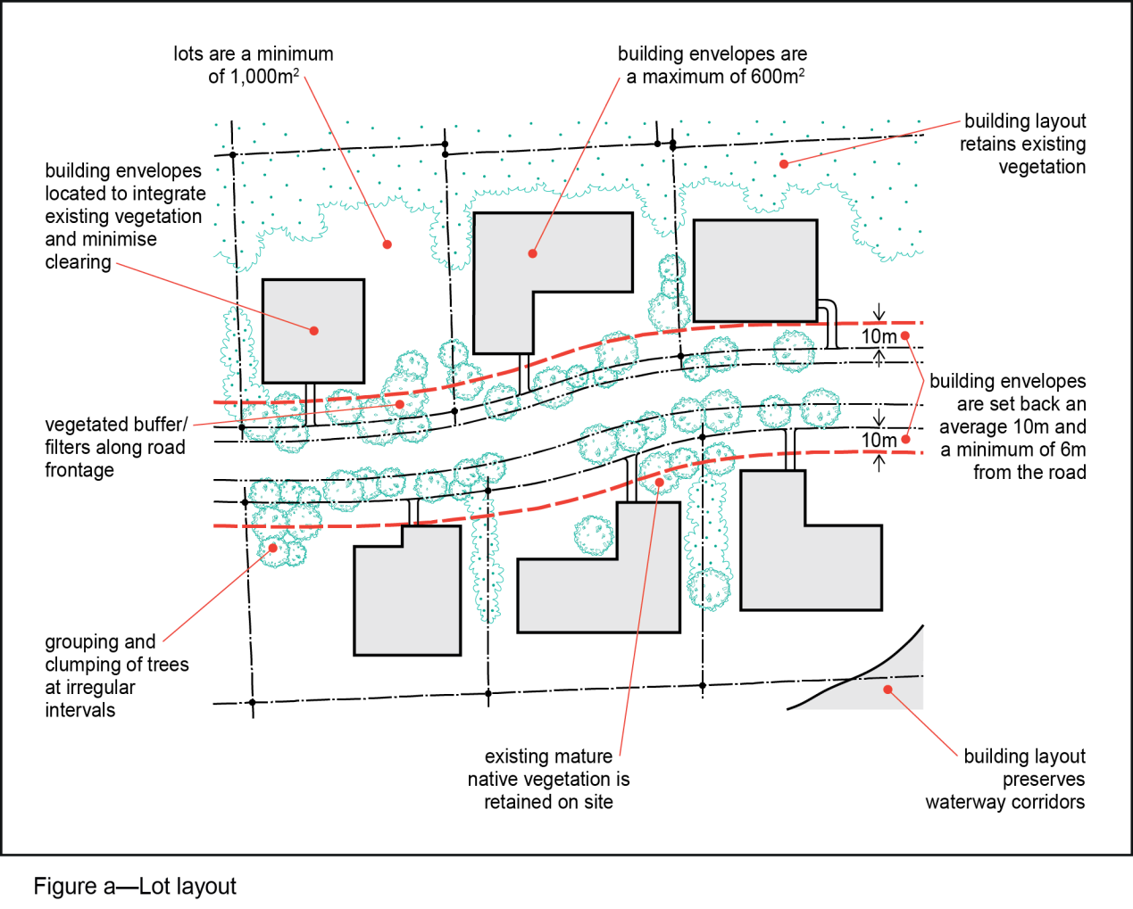
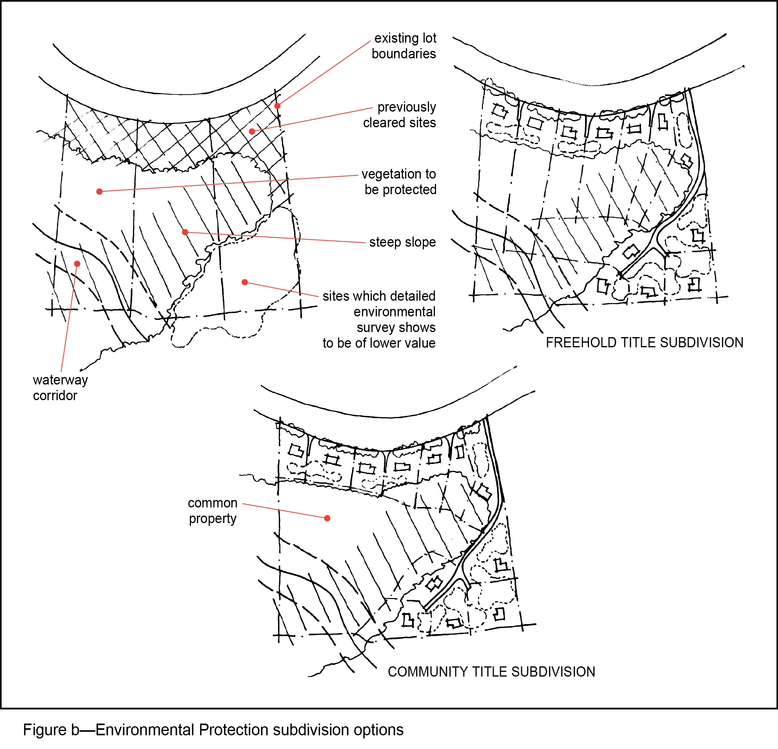

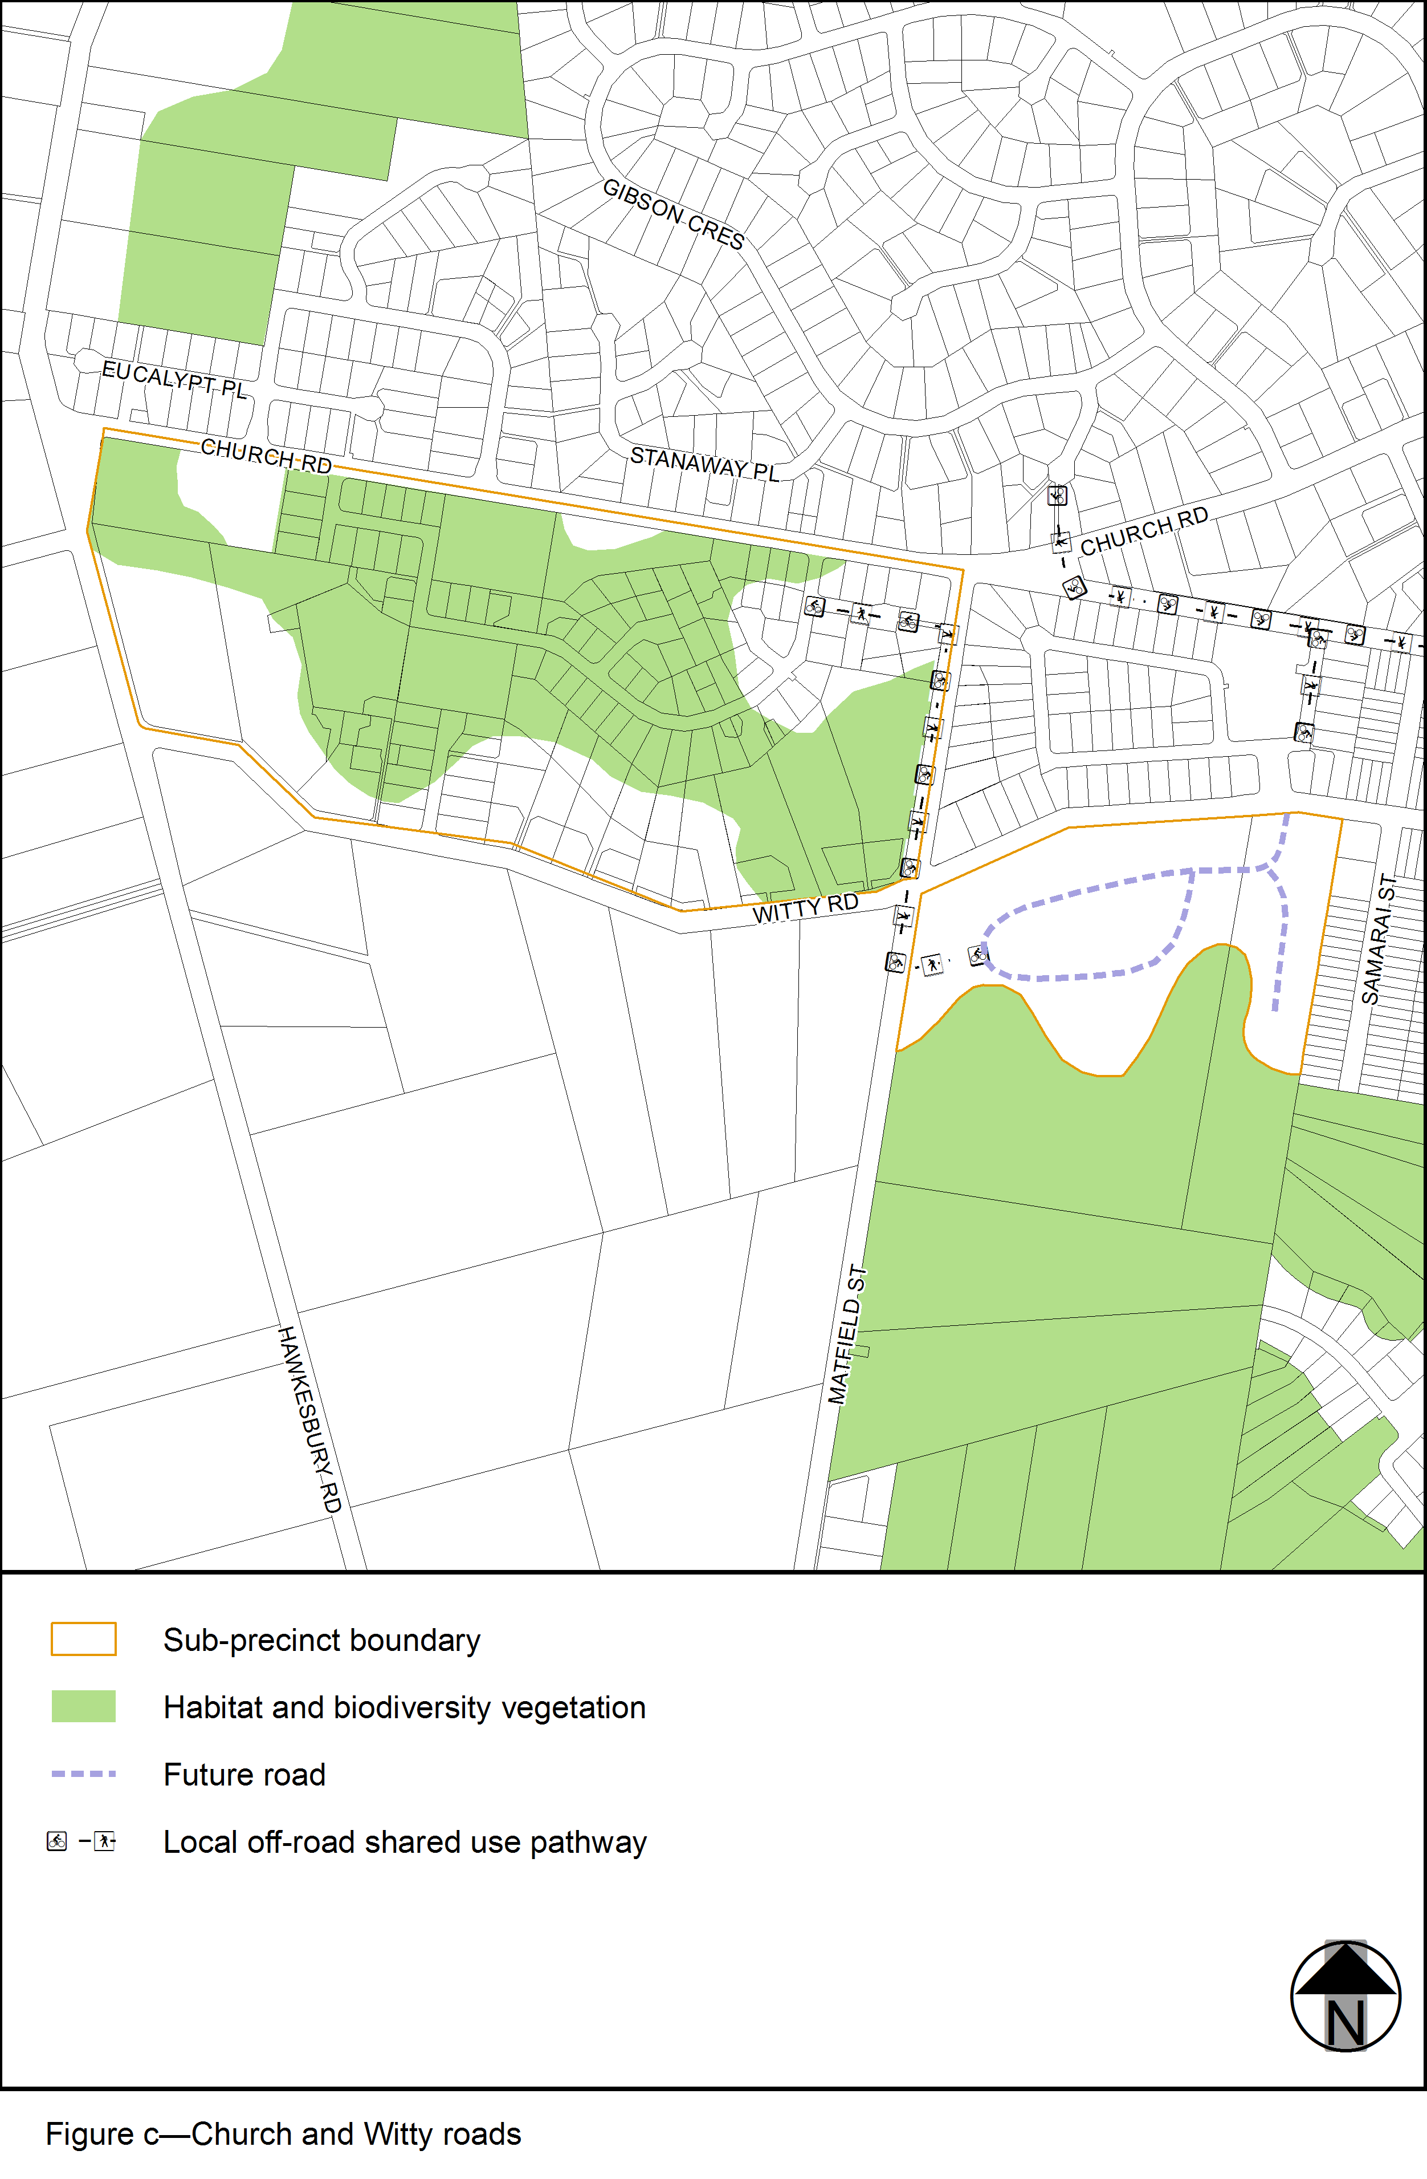
View the high resolution of Figure c–Church and Witty roads (PDF file size is 325Kb)
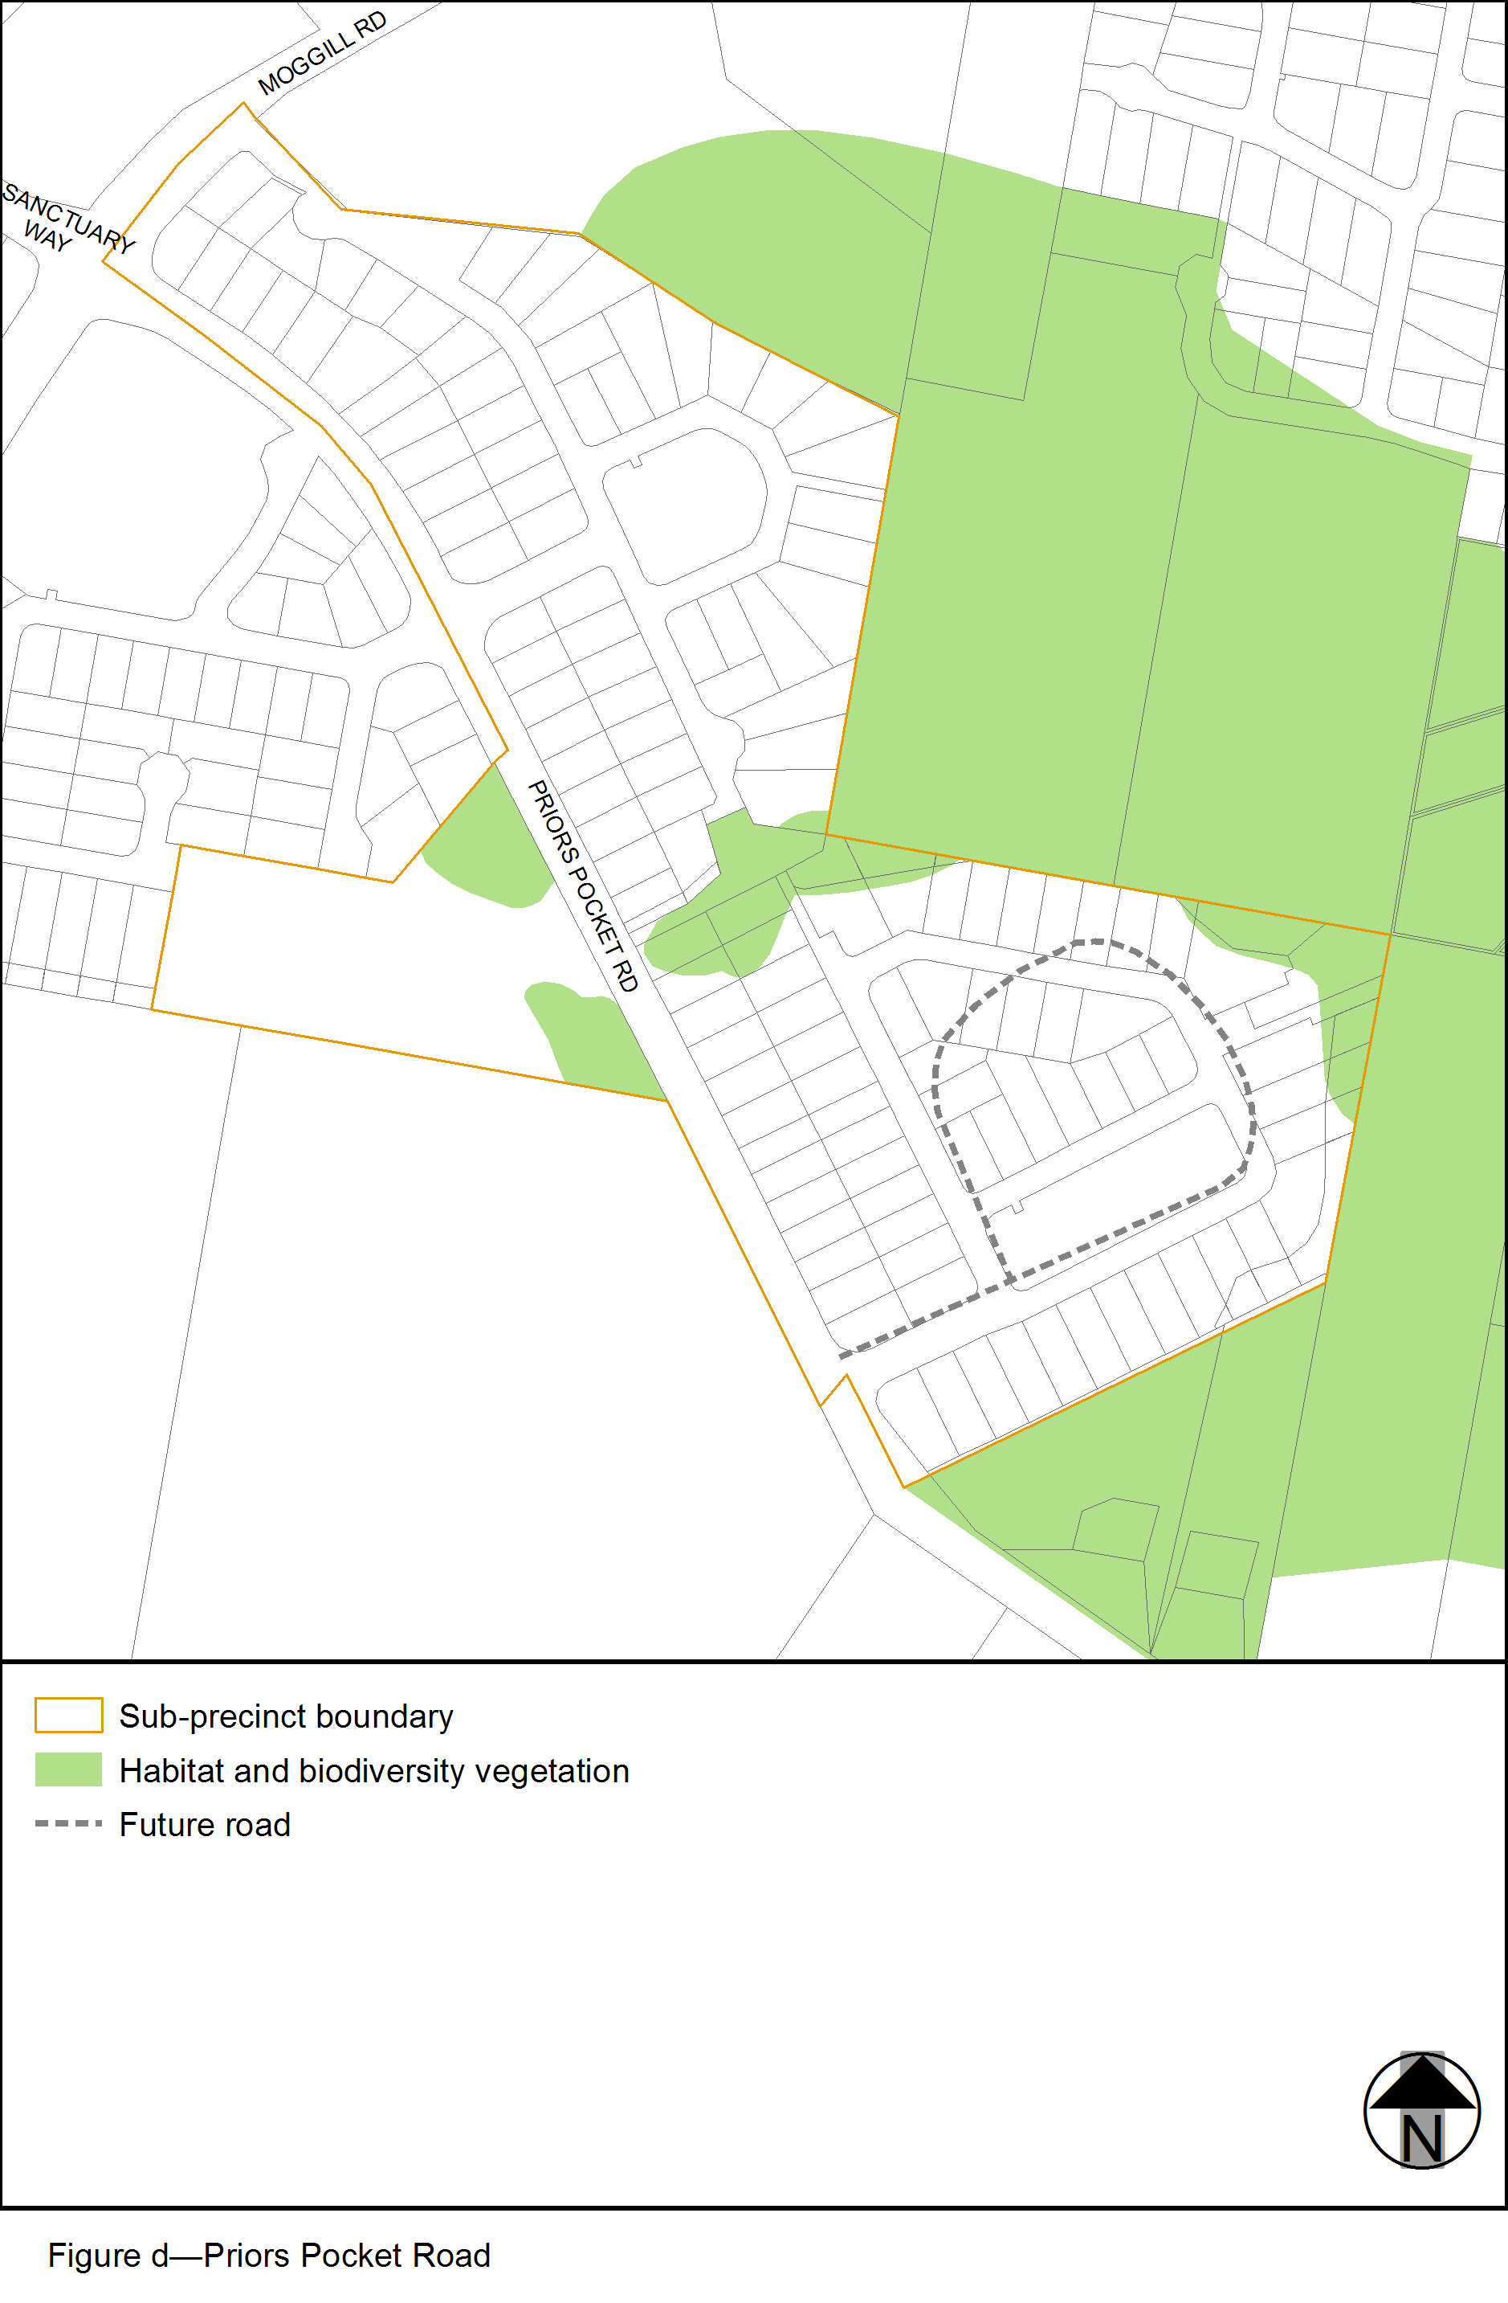
View the high resolution of Figure d–Priors Pocket Road (PDF file size is 108Kb)
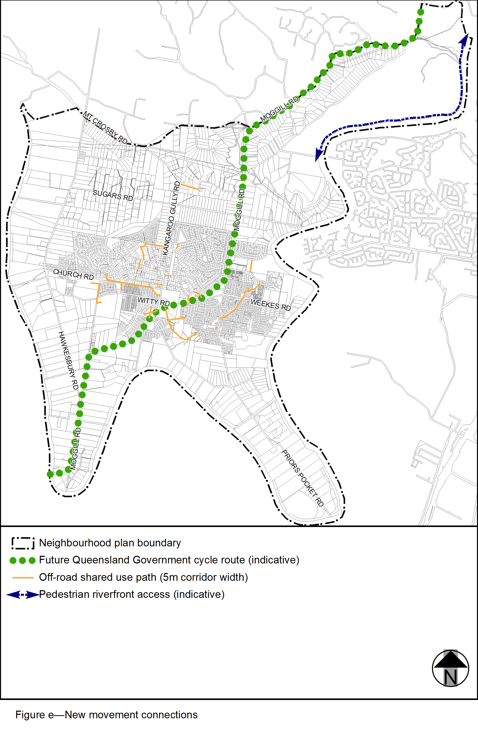
View the high resolution of Figure e–New movement connections (PDF file size is 16,381Kb)

