7.2.13.9 Mt Coot-tha neighbourhood plan code

7.2.13.9.1 Application
- This code applies to assessing a material change of use, reconfiguring a lot, operational work or building work in the Mt Coot-tha neighbourhood plan area if:
- assessable development where this code is an applicable code identified in the assessment benchmarks column of a table of assessment for a neighbourhood plan (section 5.9); or
- impact assessable development.
- Land in the Mt Coot-tha neighbourhood plan area is identified on the NPM-013.9 Mt Coot-tha neighbourhood plan map and includes the following precincts:
- Bushland living precinct (Mt Coot-tha neighbourhood plan/NPP-001);
- Natural area and recreation precinct (Mt Coot-tha neighbourhood plan/NPP-002);
- Metropolitan tourist and visitor destination precinct (Mt Coot-tha neighbourhood plan/NPP-003);
- Telecommunications facility precinct (Mt Coot-tha neighbourhood plan/NPP-004);
- Institutional uses precinct (Mt Coot-tha neighbourhood plan/NPP-005).
- When using this code, reference should be made to section 1.5, section 5.3.2 and section 5.3.3.
Note—The following purpose, overall outcomes, performance outcomes and acceptable outcomes comprise the assessment benchmarks of this code.
Note—This neighbourhood plan includes a table of assessment with variations to categories of development and assessment. Refer to Table 5.9.48.A, Table 5.9.48.B, Table 5.9.48.C and Table 5.9.48.D.

7.2.13.9.2 Purpose
- The purpose of the Mt Coot-tha neighbourhood plan code is to provide finer grained planning at a local level for the Mt Coot-tha neighbourhood plan area.
- The purpose of the Mt Coot-tha neighbourhood plan code will be achieved through overall outcomes including overall outcomes for each precinct of the neighbourhood plan area.
- The overall outcomes for the neighbourhood plan area are:
- Mt Coot-tha is of one of Brisbane’s major natural and scenic landmarks and any development ensures that the landscape and environment is preserved.
- The Mt Coot-tha area’s appeal as a major tourist and visitor destination is maintained and enhanced and contributes to Brisbane’s sustained prosperity.
- Mt Coot-tha provides an important visual icon and contrast to the built-up areas of the city, with visual protection from intrusive developments.
- The planning, design and construction of any new infrastructure and public utilities has a minimal impact on the area’s values.
- Opportunities for the co-location of facilities to reduce or minimise the development footprint, including communication towers, is consistent with the outcomes sought for the neighbourhood plan area.
- Any tourism and visitor-related facilities are located, sensitively designed and serviced to promote and sustain the significance of the built and natural environment.
- Development within the Natural area and recreation precinct (Mt Coot-tha neighbourhood plan/NPP-002) and the Metropolitan tourist and visitor destination precinct (Mt Coot-tha neighbourhood plan/NPP-003) implements the Mt Coot-tha 2030 Vision focusing on the 5 main themes of the vision, namely:
- a Brisbane icon;
- a sustainable retreat and refuge;
- a learning environment;
- a place for recreation;
- a place that is connected and accessible.
- Recreation opportunities and facilities:
- are developed to a high quality and encourage active, appreciative and healthy lifestyles in users;
- are planned and managed to conserve and promote the environmental and landscape values of Mt Coot-tha;
- enable a high level of sustainable public access to publicly owned recreation lands at Mt Coot-tha.
- Mt Coot-tha’s Aboriginal cultural and environmental heritage is respected, conserved and promoted sensitively.
- Development conserves and enhances biodiversity areas by preserving and restoring areas of high botanical and zoological significance.
- Development of a special area identified in Figure a:
- if in a view significance area, protects the visual significance of the area, such as through colour and height of buildings and landscape treatments;
- if in a landscape improvement area, establishes higher landscape values through landscape works.
- Bushland living precinct (Mt Coot-tha neighbourhood plan/NPP-001) overall outcomes are:
- Development in this precinct primarily acts as a visual transition between the surrounding low density residential development and the natural and recreation areas found elsewhere in the neighbourhood plan area.
- Development is planned and designed to sensitively respond to the values and risks of landslip, biodiversity areas, scenic amenity and bushfire hazards, as required by the relevant overlay maps and code requirements.
- Development for a dwelling house is limited primarily to low impact residential use and large lot living activities in a bushland setting.
- Impact assessable uses that may be consistent with the outcomes sought for this precinct, where small-scale and low impact development and it is able to be clearly demonstrated that the use will not impact on the rural living amenity and will contribute positively to the outcomes of the Mt Coot-tha neighbourhood plan, include:
- home-based business;
- short-term accommodation;
- outdoor sport and recreation;
- community use;
- Opportunities are encouraged to enhance the bushland living setting by acting as offset sites for environmental offsets.
- Natural area and recreation precinct (Mt Coot-tha neighbourhood plan/NPP-002) overall outcomes are:
- Development recognises the Mt Coot-tha Reserves listing as a heritage item and conserves and protects it as a place of diverse flora and fauna by incorporating sustainable design principles and management practices.
- Any new development or redevelopment of facilities for a park, environment facility, nature-based tourism, function facility or food and drink outlet, where ancillary to these uses, revitalises and re-uses existing infrastructure subject to economic viability and is generally contained within existing development footprints.
- Any new development or redevelopment of facilities for outdoor recreation, such as mountain biking, geocaching, orienteering, high ropes or flying fox facility, generally revitalises and re-uses existing infrastructure.
- Development within the area leased to Broadcast Australia Pty Ltd being the former National Transmission Agency and Australian Broadcasting Commission station continues to permit access and use of the existing telecommunications tower. Subject to the existing buildings being economically viable for conversion, they will be redeveloped for community and recreation purposes, such as an environment facility, nature-based tourism, theatre or outdoor sport and recreation facility. This redevelopment will be generally contained within the existing development footprints.
- Development respects, celebrates and interprets the important cultural heritage values of the forest.
- New facilities are developed to provide accessible and diverse views and vistas.
- Any new transport system and facilities, including the opening of a new road, are required to improve the safety and movement systems for people and wildlife while conserving and enhancing the scenic, landscape, cultural heritage and biodiversity values of the precinct.
- Mt Coot-tha Reserve provides significant regional connections to the D’Aguilar National Park, regional trails and outdoor recreation opportunities.
- Metropolitan tourist and visitor destination precinct (Mt Coot-tha neighbourhood plan/NPP-003) overall outcomes are:
- Brisbane Botanic Gardens area:
- This area provides visitor services and facilities that contribute to Brisbane’s sustained prosperity and provide options for learning and leisure.
- Impact assessable uses that may be consistent with the outcomes sought, where small-scale and low-impact development, include:
- tourist attraction;
- community use;
- function facility;
- market;
- food and drink outlet;
- educational establishment (such as an outdoor education centre or environmental education experience centre);
- shop;
- theatre;
- short-term accommodation;
- renewable energy facility.
- Outdoor recreation activities may also be accommodated where small scale and low impact (such as a natural-form swimming facility, diving, canoeing, park, rock climbing or abseiling). Development is designed to be accessible, inspiring, engaging and responsive to Brisbane’s subtropical climate and lifestyle.
- Interpretive and visitor facilities are provided to actively engage visitors in educational and learning experiences, including sustainable living exhibitions and programs.
- Development of visitor facilities improves the quality of the visitor's experience through sustainable re-use and recycling practices, and technological solutions.
- Expansion of the metropolitan tourist and visitor destination facilities is expected to occur with the closure of the Brisbane City Council quarry and should focus on exploring natural environment, recreation, sustainability, astronomy, history and cultural heritage topics.
- Brisbane City Council quarry:
- Expansion of the extractive industry is inconsistent with the outcomes sought.
- Any rehabilitation and restoration measures are consistent with the post-quarry use as an extension of, and incorporation into, the Brisbane Botanic Gardens.
Editor’s note—The quarry is a major source of crushed rock for Brisbane City Council operations. Under current extraction operations, Council estimates the remaining life of the facility until around 2025. Council intends to commence planning for post-quarry use around 2015. Detailed planning will seek to implement the Mt Coot-tha 2030 Vision for the Brisbane City Council quarry site.
- Mt Coot-tha summit lookout:
- Mt Coot-tha summit lookout continues to function as a tourist destination providing a unique lookout experience. Existing uses such as food and drink outlet, where not a drive-through facility, services visitors to the locality.
- Impact assessable uses that may be consistent with the outcomes sought, where small-scale and low-impact development, include:
- tourist attraction;
- community use;
- function facility;
- food and drink outlet, where not a drive through facility;
- shop.
- Any development and design is responsive to scenic landscape values and views afforded from this site.
- Development reflects the subtropical climate of Brisbane and respects the unique and iconic status of the lookout.
- Development of visitor facilities improves the quality of visitor experiences through universal design, sustainable re-use and recycling practices, and technological solutions.
- Telecommunications facility precinct (Mt Coot-tha neighbourhood plan/NPP-004) overall outcomes are:
- This precinct contains sites that continue to operate television and radio production, broadcasting and telecommunication purposes.
- Co-location, co-use and rationalisation of existing infrastructure and buildings are encouraged. Opportunities for co-masting and rationalisation of telecommunications facilities on Mt Coot-tha are considered in any redevelopment.
- Existing mast structures continue to play a role as iconic structures of the Brisbane city landscape.
- Any redevelopment is consistent with existing uses and intensification is limited to manage impacts on visual amenity, servicing requirements, traffic, parking and access, light and noise impacts, natural recreational values, flora and fauna or potential harm from electromagnetic radiation.
- There is no net increase in development footprints.
- Car parking provision is limited.
- Building heights that may impede public views or vistas are limited.
- Design and construction reflects and responds to the bushland setting.
- Institutional uses precinct (Mt Coot-tha neighbourhood plan/NPP-005) overall outcomes are:
- This precinct contains existing educational establishments and will continue to operate as such uses, including the Stuartholme school and convent and the Sisters of Mercy Novitiate.
- Development for an educational establishment or rooming accommodation is limited to existing development footprints.
- Design and construction reflects and responds to the scenic amenity values and bushland setting. Design, siting, height and colour of proposed structures respect views from public viewing locations.

7.2.13.9.3 Performance outcomes and acceptable outcomes

Table 7.2.13.9.3—Performance outcomes and acceptable outcomes
Performance outcomes | Acceptable outcomes
If a non-residential development in the Bushland living precinct (Mt Coot-tha neighbourhood plan/NPP-001)
PO1  Development for a non-residential purpose is designed, sited and constructed to be sympathetic with the habitat and landscape values of the precinct. | AO1  Development for a non-residential purpose:  - is not proposed in a view significance area or landscape improvement area where appropriate design measures are not included;  - does not involve the intensive utilisation of greater than 2,500m2 or 25% of the site, whichever is the lesser;  - does not necessitate clearing more existing vegetation than would be required for a dwelling house on the site;  - is not located within a view significance area or landscape improvement area where appropriate design measures are not included.  Note—Compliance with PO2, PO3 and PO4 is also required for sites within a view significance area or landscape improvement area.
If located within a view significance area or within a landscape improvement area
PO2  Development comprising building work is located and sited to prevent detraction from the natural landscape and visual areas of significance. | AO2.1  Development is sited, designed and constructed to minimise adverse impacts on the visual catchment, particularly where the development will be visible from an extensive visual catchment or a localised visual catchment.  Note—Development impacts on the metropolitan or local visual catchment can be demonstrated by the lodgement of a vista analysis report.
AO2.2
Development ensures that a building is sited, designed and constructed to minimise disruption to the natural landscape by:
- locating buildings below ridgelines and skylines;
- minimising clearing and other disturbance to natural patterns of vegetation on hillsides;
- ensuring that the design of any proposal integrates with the environment.
PO3  Development ensures that a building or structure is of a scale, form and material that are compatible with the landscape values of each special area. | AO3.1  Development ensures that a building is sited and designed to be sympathetic to the form and line of the surrounding landscape.
AO3.2
Development of a building or structure is screened from view when visible from public spaces such as roads or parks.
AO3.3
Development minimises the mass of buildings by:
- moderating the height, size and bulk of buildings and other structures by articulating facades, variations in wall or roof lines, or using modular structures, such as pavilions;
- separating vehicle storage areas, such as garages or carports, from the dwelling house where this will assist in reducing the building’s mass.
AO3.4
Development uses external materials that are:
- subdued natural colours, such as grey, brown or green, and have low light reflectivity;
- non-reflective and either colour bonded or painted in subdued natural colours that integrate with the existing colours and patterns of the Mt Coot-tha landscape.
PO4  Development maximises the natural habitat landscape values of the site to minimise visual intrusion and wider visual impacts. | AO4.1  Development is located and sited to maximise the retention of existing vegetation and revegetation uses locally occurring native vegetation species.
AO4.2
Development uses a vegetative screen to primarily screen:
- built structures;
- areas cleared as a result of excavation;
- from public view on a road alignment;
- from public viewing areas.

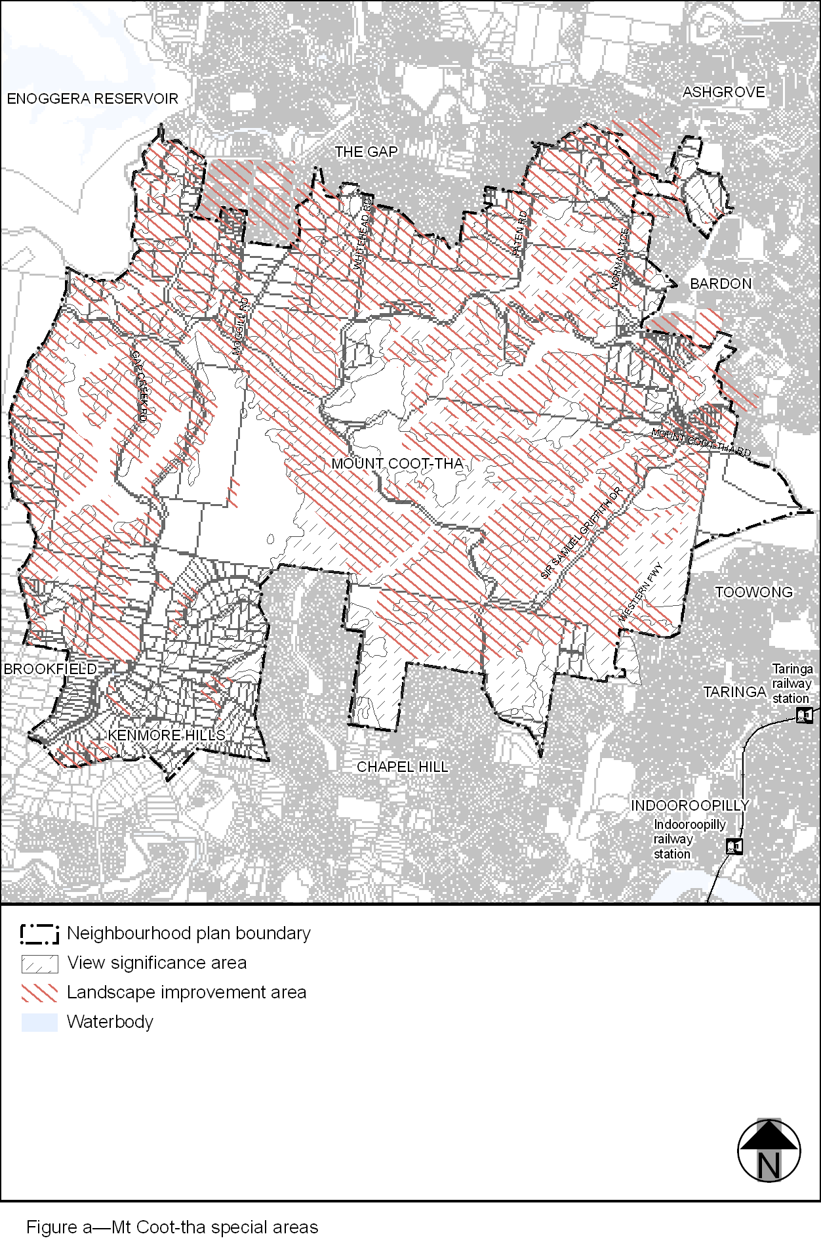
View the high resolution of Figure a–Mt Coot-tha special areas (PDF file size is 502Kb)
