7.2.14.1 New Farm and Teneriffe Hill neighbourhood plan code

7.2.14.1.1 Application
- This code applies to assessing a material change of use, reconfiguring a lot, operational work or building work in the New Farm and Teneriffe Hill neighbourhood plan area if:
- assessable development where this code is an applicable code identified in the assessment benchmarks column of a table of assessment for a neighbourhood plan (section 5.9); or
- impact assessable development.
- Land in the New Farm and Teneriffe Hill neighbourhood plan area is identified on the NPM-014.1 New Farm and Teneriffe Hill neighbourhood plan map and includes the following precincts:
- Low density living precinct (New Farm and Teneriffe Hill neighbourhood plan/NPP-001);
- Low–medium density living precinct (New Farm and Teneriffe Hill neighbourhood plan/NPP-002);
- Medium density living precinct (New Farm and Teneriffe Hill neighbourhood plan/NPP-003);
- Mixed use centre precinct (New Farm and Teneriffe Hill neighbourhood plan/NPP-004):
- Brunswick Street sub-precinct (New Farm and Teneriffe Hill neighbourhood plan/NPP-004a);
- Brunswick Street and Merthyr Road sub-precinct (New Farm and Teneriffe Hill neighbourhood plan/NPP-004b);
- Merthyr Road and Moray Street sub-precinct (New Farm and Teneriffe Hill neighbourhood plan/NPP-004c);
- James and Arthur streets sub-precinct (New Farm and Teneriffe Hill neighbourhood plan/NPP-004d);
- Merthyr Road and James Street sub-precinct (New Farm and Teneriffe Hill neighbourhood plan/NPP-004e).
- Parks precinct (New Farm and Teneriffe Hill neighbourhood plan/NPP-005)
- When using this code, reference should be made to section 1.5, section 5.3.2 and section 5.3.3.
Note—The following purpose, overall outcomes, performance outcomes and acceptable outcomes comprise the assessment benchmarks of this code.
Note—This neighbourhood plan includes a table of assessment with variations to categories of development and assessment. Refer to Table 5.9.50.A, Table 5.9.50.B, Table 5.9.50.C and Table 5.9.50.D.

7.2.14.1.2 Purpose
- The purpose of the New Farm and Teneriffe Hill neighbourhood plan code is to provide finer grained planning at a local level for the New Farm and Teneriffe Hill neighbourhood plan area.
- The purpose of the New Farm and Teneriffe Hill neighbourhood plan code will be achieved through overall outcomes including overall outcomes for each precinct of the neighbourhood plan area.
- The overall outcomes for the neighbourhood plan area are:
- New Farm’s characteristic diversity of built form and village feel is retained.
- Infill development and redevelopment reflect New Farm’s established character and style.
- A mix of housing choices including affordable housing is retained and provided.
- Safe, comfortable and convenient accesses within, to and from New Farm and Teneriffe Hill is provided for pedestrians, cyclists and people with disabilities, including along major traffic routes such as Brunswick Street.
- A clear, formalised and highly interconnected street system including rear lanes is provided through the area.
- Development complements existing urban and landscape characteristics and cultural associations and contributes to the distinctive and identifiable character and sense of place of New Farm as a whole and of its distinctive neighbourhoods.
- Buildings are located and designed to form strong and attractive vistas and memorable landmarks.
- Important places, landmarks and cultural elements are recognisable and form a focus for development, orientation and travel throughout the area.
- New Farm and Teneriffe Hill provide a wide range of public space including:
- linear parks along the riverfront;
- local pocket parks within residential areas;
- sites for both casual and organised recreation;
- squares, plazas and courtyards within commercial activity nodes;
- conservation parks for environmental and landscape elements.
- These public spaces are improved by pedestrian links and defined by development that maximises casual surveillance.
- Amalgamation of sites benefits the community by providing increased open space, improved pedestrian linkages or useable public spaces.
- Mixed use development close to transport nodes provides after-hours uses to enhance activity, surveillance and security.
- Development is of a height, scale and form which is consistent with the amenity and character, community expectations and infrastructure assumptions intended for the relevant precinct, sub-precinct or site and is only developed at a greater height, scale and form where there is both a community need and an economic need for the development.
- Low density living precinct (New Farm and Teneriffe Hill neighbourhood plan/NPP-001) overall outcomes are:
- Teneriffe Hill provides high-quality and coherent housing.
- Proposals incorporate existing buildings through infill development.
- Extensions under or at the rear of existing buildings, or in the form of separate buildings, are appropriate on larger sites where they do not compromise the character of the area.
- Multiple dwellings are either contained in existing buildings, complement the character of existing houses, or provide affordable housing.
- Non-residential uses serve the local community and are only located in existing non-residential buildings.
- Low–medium density living precinct (New Farm and Teneriffe Hill neighbourhood plan/NPP-002) overall outcomes are:
- Proposals retain existing houses and are of a scale and character compatible with detached housing.
- Non-residential uses serve the local community and are located in existing non-residential buildings.
- Medium density living precinct (New Farm and Teneriffe Hill neighbourhood plan/NPP-003) overall outcomes are:
- This precinct is predominantly medium density, taking advantage of the benefits of high levels of accessibility and visual amenity that characterise this area.
- Development provides visual and physical links to the river.
- New developments north of Merthyr Road retain areas along the river frontage for public access.
- Car parking is located in basement or semi-basement areas in order to reduce the visual impact of cars on the streetscape.
- Non-residential uses serving the local community are compatible with the surrounding residential neighbourhood.
- New non-residential uses are incorporated within a mixed use development where residential uses dominate.
- Mixed use centre precinct (New Farm and Teneriffe Hill neighbourhood plan/NPP-004) overall outcomes are:
- Centres in the precinct develop as discrete nodes and contain a range of commercial and residential uses.
- Proposals include small-scale uses with limited tenancy sizes while providing a variety of tenancy types.
- Larger tenancy sizes are appropriate where involving a new community facility to service the needs of local residents.
- Development in the Brunswick Street sub-precinct (New Farm and Teneriffe Hill neighbourhood plan/NPP-004a):
- provides a wide range of retailing, entertainment and commercial uses that service the needs of New Farm residents and the wider community.
- Development in the Brunswick Street and Merthyr Road sub-precinct (New Farm and Teneriffe Hill neighbourhood plan/NPP-004b):
- ensures that it remains the primary neighbourhood centre providing a range of retailing, commercial and community services and facilities for the residents of New Farm and the surrounding area.
- Development in the Merthyr Road and Moray Street sub-precinct (New Farm and Teneriffe Hill neighbourhood plan/NPP-004c):
- ensures that it remains a secondary neighbourhood centre providing local services for New Farm residents. This centre has a limited commercial function.
- Development in the James and Arthur streets sub-precinct (New Farm and Teneriffe Hill neighbourhood plan/NPP-004d):
- ensures that it remains a secondary neighbourhood centre providing a similar function to the Merthyr Road and Moray Street sub-precinct (New Farm and Teneriffe Hill neighbourhood plan/NPP-004c);
- due to its proximity to Fortitude Valley, facilities including the existing hotel and cafes in this centre also service a wider area.
- Development in the Merthyr Road and James Street sub-precinct (New Farm and Teneriffe Hill neighbourhood plan/NPP-004e):
- ensures that it remains a smaller secondary neighbourhood centre providing local services for New Farm residents.
- Parks precinct (New Farm and Teneriffe Hill neighbourhood plan/NPP-005) overall outcomes are:
- Parks in this precinct, being New Farm Park, Teneriffe Park, Merthyr Park and Wilson Outlook Reserve, are enhanced as important public open space facilities for both active and passive recreation.
- The Merthyr Bowls Club and the New Farm Bowls Club are preserved as fundamental elements of the local open space system serving the needs of the local community.
- Development proposals demonstrate compatibility with existing open space and recreational uses, servicing local needs and public function.

7.2.14.1.3 Performance outcomes and acceptable outcomes

Table 7.2.14.1.3.A—Performance outcomes and acceptable outcomes
Performance outcomes | Acceptable outcomes
General
PO1  Development is of a height, scale and form that achieves the intended outcome for the precinct, improves the amenity of the neighbourhood plan area, contributes to a cohesive streetscape and built form character and is:  - consistent with the anticipated density and assumed infrastructure demand;  - aligned with community expectations about the number of storeys to be built;  - proportionate to and commensurate with the utility of the site area and frontage width;  - designed to avoid a significant and undue adverse amenity impact to adjoining development;  - sited to enable existing and future buildings to be well separated from each other and avoids affecting the potential development of an adjoining site.  Note—Development that exceeds the intended number of storeys or building height can place disproportionate pressure on the transport network, public space or community facilities in particular.  Note—Development that is over-scaled for its site can result in an undesirable dominance of vehicle access, parking and manoeuvring areas that significantly reduce streetscape character and amenity. | AO1  Development complies with the number of storeys and building height set out in Table 7.2.14.1.3.B.  Note—Neighbourhood plans will mostly specify a maximum number of storeys where zone outcomes have been varied in relation to building height. Some neighbourhood plans may also specify height in metres. Development must comply with both parameters where maximum number of storeys and height in metres are specified.
PO2  Development provides open space that:  - is designed and located for the recreational, service and storage needs of residents;  - is exposed to sunlight and integrates with the living area of a dwelling. | AO2  Development in the Low density living precinct (New Farm and Teneriffe Hill neighbourhood plan/NPP-001), Low–medium density living precinct (New Farm and Teneriffe Hill neighbourhood plan/NPP-002) or Medium density living precinct (New Farm and Teneriffe Hill neighbourhood plan/NPP-003) allocates a minimum of 30% of the site to landscaped open space, with multiple dwellings being provided with minimum private open space comprising:  - in the Low density living precinct (New Farm and Teneriffe Hill neighbourhood plan/NPP-001), ground level area totalling 40m² for each ground level dwelling unit, including an area of at least 23m² with a minimum dimension of 4m;  - in the Low–medium density living precinct (New Farm and Teneriffe Hill neighbourhood plan/NPP-002), ground level area totalling 35m² for each ground level dwelling unit, including an area of at least 16m² with a minimum width of 4m, in each case, conveniently accessible from a living room;  Note—Any undercover area included in this calculation has a minimum head height of 2.4m.  - for above ground dwelling units in the Low–medium density living precinct (New Farm and Teneriffe Hill neighbourhood plan/NPP-002) or Medium density living precinct (New Farm and Teneriffe Hill neighbourhood plan/NPP-003), a balcony with a minimum area of 8m² and width of 2m conveniently accessible from a living room, or a rooftop area with a minimum area of 10m2 and width of 2m directly connected to the dwelling.
If in the Low density living precinct (New Farm and Teneriffe Hill neighbourhood plan/NPP-001)
PO3  Development and buildings are located to protect the amenity of residents, having regard to breezes, vegetation, sunlight, privacy and building separation. | AO3  Development is set back a minimum of 6m from the rear boundary.
If in the Low–medium density living precinct (New Farm and Teneriffe Hill neighbourhood plan/NPP-002)
PO4  Development ensures that building size and bulk is compatible with the existing detached housing and the scale and character of the street. | AO4  Development has a maximum gross floor area of:  - 60% of the site area if:  - the premises is used for a retirement facility; or  - the proposal includes a minimum of 30% of dwelling units as affordable housing;  - 55% of the site area if:  - the site at the appointed day is larger than 1,000m2 and has a frontage greater than 20m; or  - the site has a frontage of at least 20m and is adjoined by multiple dwellings or premises approved for multiple dwellings on 2 boundaries;  - the site is a corner site and the new development is located a minimum of 10m from any existing dwelling house on an adjoining lots;  - 50% of the site area in all other circumstances.
PO5  Development ensures building size and bulk is consistent with the existing high-quality housing character of the locality. | AO5  Development has a maximum site cover of 50%.
PO6  Development ensures buildings are situated on site to protect the amenity of residents having regard to breezes, vegetation, sunlight, privacy and building separation. | AO6  Development has a minimum setback of 6m from the rear boundary.
If in the Medium density living precinct (New Farm and Teneriffe Hill neighbourhood plan/NPP-003)
PO7  Development ensures new buildings maintain views to and from the river and other landmark sites identified in Figure a, and a visual relationship with other buildings in the vicinity. | AO7  Development is in accordance with the maximum number of storeys and building height set out in Table 7.2.14.1.3.B.
PO8  Development ensures building size and bulk is consistent with the medium density nature of the locality and retains an appropriate residential scale and relationship with other precincts in the neighbourhood plan area. | AO8  Development has a maximum gross floor area equal to the area of the site.
PO9  Development on larger sites comprises 2 or more individual structures, rather than 1 large structure. | AO9.1  Development has a minimum separation distance between buildings of 5m within the site.
AO9.2
Development has a maximum building wall length of 10m.
PO10  Development includes street setbacks which are compatible with existing setbacks in the area. | AO10  Development is set back a minimum of 6m from any road alignment.
PO11  Development includes visual and physical links to and along the river and ferry terminals and in particular, between Merthyr Park and Oxlade Drive. | AO11  Development provides:  - public access along the river north of Merthyr Road, as indicated in Figure a;  - improved pedestrian access to ferry terminals.
If in the Mixed use centre precinct (New Farm and Teneriffe Hill neighbourhood plan/NPP-004)
PO12  Development reflects the pedestrian nature and scale of the locality and retains an appropriate visual relationship with adjoining residential precincts. | AO12  Development is in accordance with the maximum number of storeys and building height set out in Table 7.2.14.1.3.B
PO13  Development and building size and bulk is consistent with existing small-scale development, sensitive to the surrounding residential environment and exhibits a positive relationship with the street. | AO13.1  Development has a maximum gross floor area of:  - 80% of the site area, or the gross floor area of the existing building, whichever is the greater; or  - the area of the site where the additional gross floor area is for affordable housing.
AO13.2
Development provides no less than 30% of the gross floor area of the first 3 storeys for residential use.
Note—This requirement does not apply to:
(a) the re-use of an existing non-residential building; or
(b) extensions to existing buildings that add less than 100m2 to the floor area of the building.
PO14  Development does not include blank walls and provides active street frontages at pedestrian levels to the street frontage. | AO14  Development includes non-residential uses in ground-storey tenancies addressing the street level.
PO15  Development provides for pedestrian protection and comfort. | AO15  Development and buildings provide awnings of at least 3m width on any side which fronts a public street.
PO16  Development including alterations and additions does not destroy important aspects of an existing building. | AO16.1  Development including alterations:  - is sympathetic to the existing building elements and is distinguishable from the original;  - repairs damaged building elements rather than replaces them, if possible.
AO16.2
Development including alterations and additions to buildings reinstates or reconstructs verandahs or awnings.
PO17  Development and building setbacks are consistent with the setbacks prevailing in the precinct. | AO17  Development and buildings are located on the front boundary.
PO18  Development is of a small scale and provides a diverse range of services.  Note—Alternative tenancy sizes to that prescribed are appropriate where a new facility serving local community needs requires a larger space. | AO18  Development with single tenancies are a maximum of:  - 80m2 for offices and shops at ground level;  - 150m2 for offices above ground level;  - 150m2 for food and drink outlets where a restaurant.

Table 7.2.14.1.3.B—Maximum building height
Development | Building height  (number of storeys) | Building height (m)
If in the Low density living precinct (New Farm and Teneriffe Hill neighbourhood plan/NPP-001)
Any development in this precinct | 2 | 9.5
If in the Low–medium density living precinct (New Farm and Teneriffe Hill neighbourhood plan/NPP-002)
Any development in this precinct | 2 | 9.5
If in the Medium density living precinct (New Farm and Teneriffe Hill neighbourhood plan/NPP-003)
Any development in this precinct | 5 | 15
If in the Mixed use centre precinct (New Farm and Teneriffe Hill neighbourhood plan/NPP-004)
Any development in this precinct | 3 | 10.5
If in the Mixed use centre precinct (New Farm and Teneriffe hill neighbourhood plan/NPP-004), where in the Brunswick Street sub-precinct (New Farm and Teneriffe Hill neighbourhood plan/NPP-004a)
Any development in this precinct | 4 | 14
If in the Mixed use centre precinct (New Farm and Teneriffe hill neighbourhood plan/NPP-004), where in the Merthyr Road and James Street sub-precinct (New Farm and Teneriffe Hill neighbourhood plan/NPP-004e)
Any development in this precinct | 2 | 9.5
If within 10m of the boundary of any land included in the Low density living precinct (New Farm and Teneriffe Hill neighbourhood plan/NPP-001) or the Low–medium density living precinct (New Farm and Teneriffe Hill neighbourhood plan/NPP-002)
Any development in this precinct | 2 | 9.5
Note—For buildings in the Low density living precinct (New Farm and Teneriffe Hill neighbourhood plan/NPP-001), if there is an existing building on the site which exceeds 2 storeys, new buildings are to be the same height as the existing building.
Note—For buildings in the Low–medium density living precinct (New Farm and Teneriffe Hill neighbourhood plan/NPP-002), an existing building where retained as part of development may exceed 2 storeys.
Note—Buildings in the Low–medium density living precinct (New Farm and Teneriffe Hill neighbourhood plan/NPP-002) are permitted to be 3 storeys and 9.5m to the underside of the ceiling of any habitable room if:
- the site at the appointed day is larger than 1,000m2 and has a frontage greater than 20m;
- or the site has a frontage of at least 20m and is adjoined by multiple dwellings or premises approved for multiple dwellings on two boundaries;
- or the site is a corner site and the new developed is located a minimum of 10m from any existing detached house or adjoining lot;
- or the proposal includes a minimum of 30% of dwelling units as affordable housing.
Note—Buildings in the Mixed use centre precinct (New Farm and Teneriffe Hill neighbourhood plan/NPP-004) are permitted to be greater than 3 storeys and 10.5m where the height of the existing buildings which are retained on site as part of the development is greater than 3 storeys or 10.5m.
Note—The maximum of 4 storeys and 14m in the Brunswick Street sub-precinct (New Farm and Teneriffe Hill neighbourhood plan/NPP-004a) is only permitted where development is adjacent to the Medium density living precinct and the additional storey is for affordable housing.
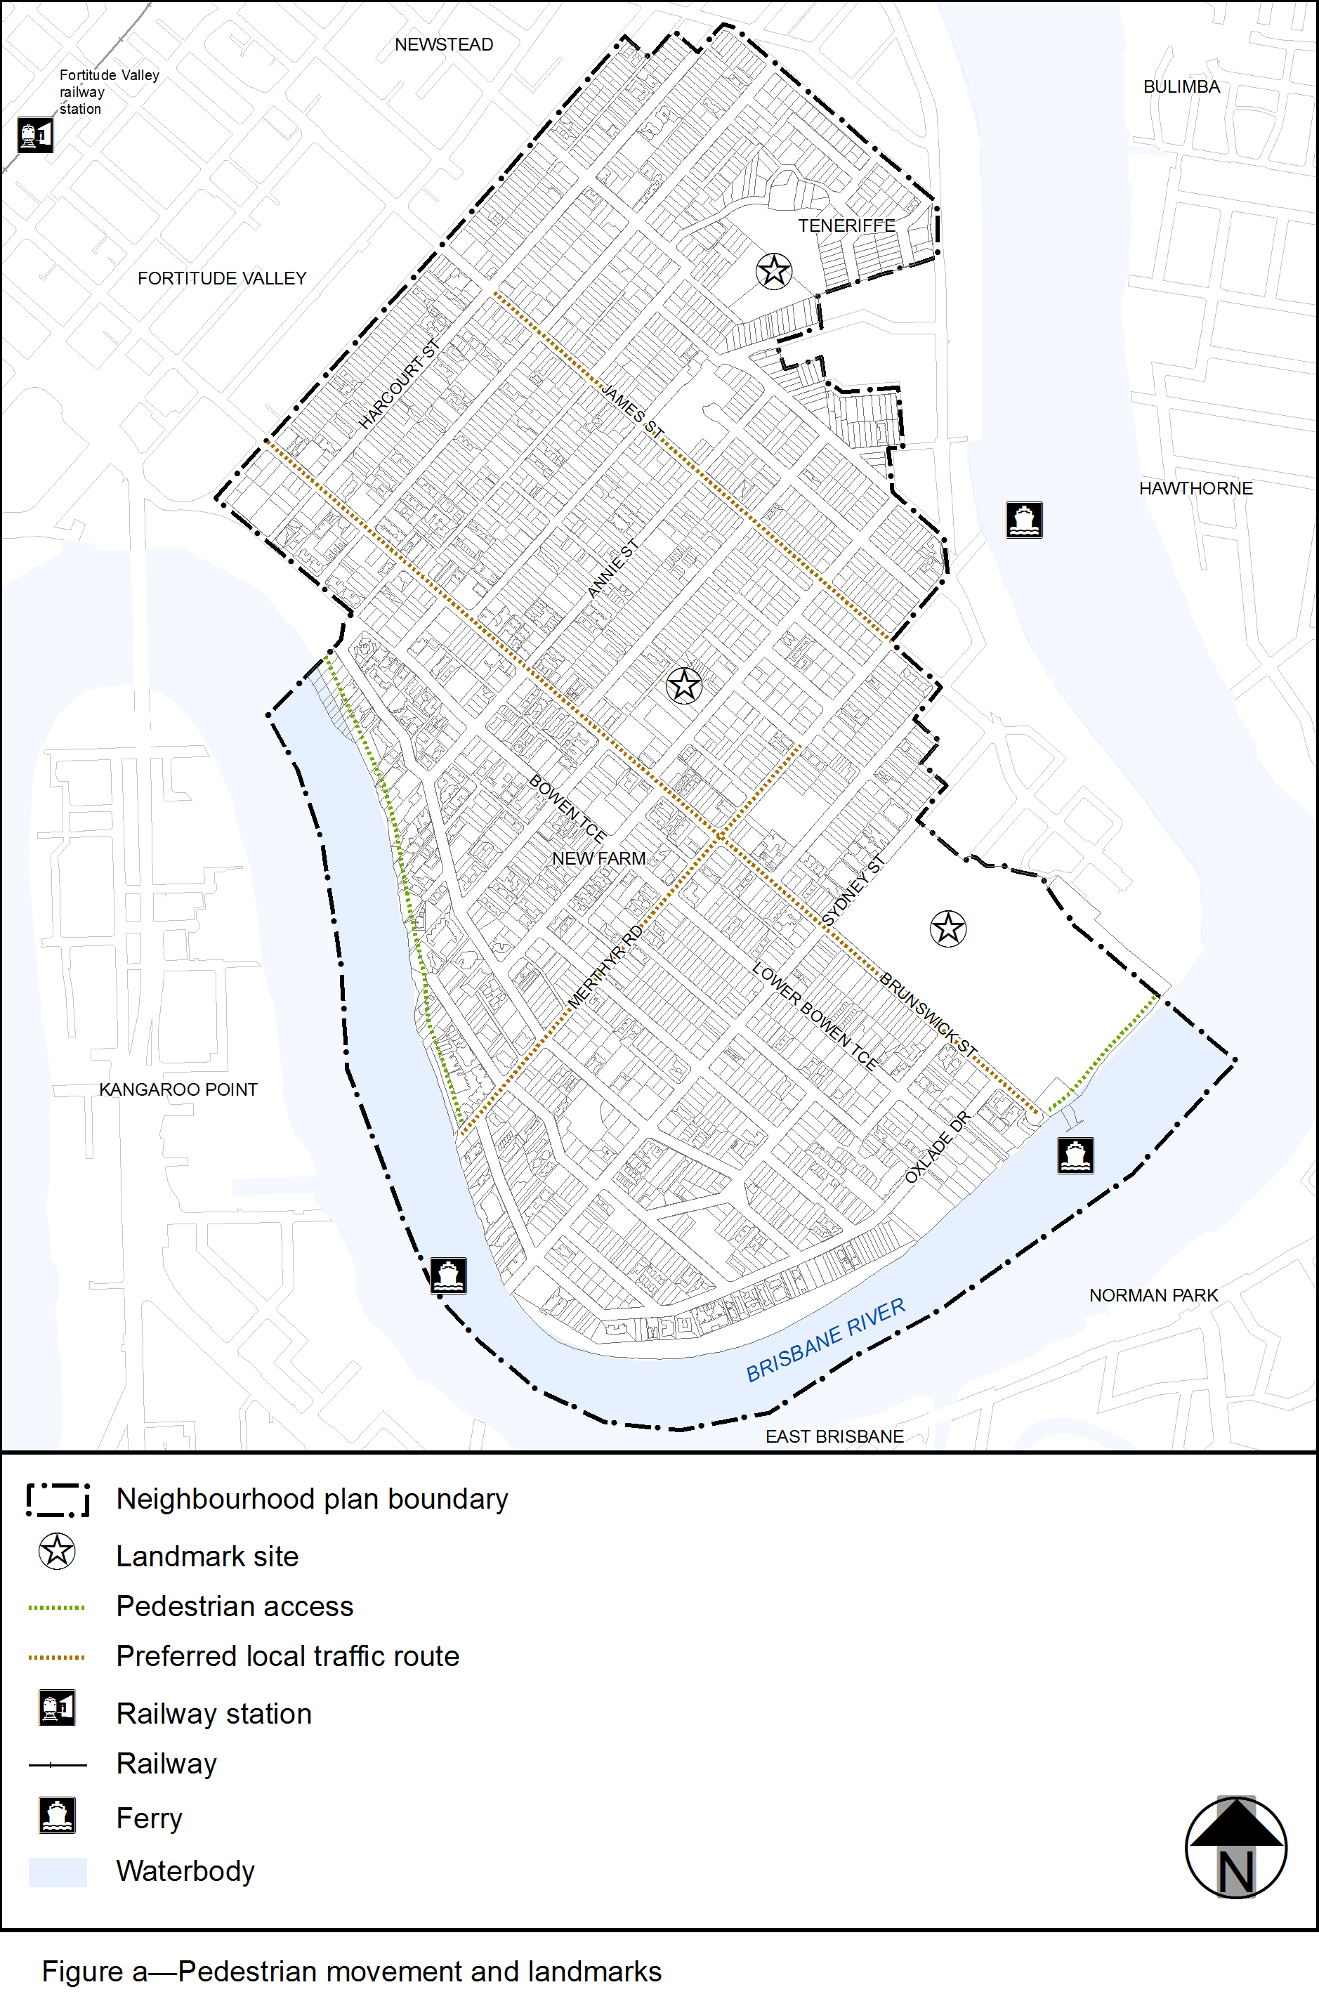
View the high resolution of Figure a–Pedestrian movement and landmarks (PDF file size is 430Kb)

