7.2.16.2 Pinkenba—Eagle Farm neighbourhood plan code

7.2.16.2.1 Application
- This code applies to assessing a material change of use, reconfiguring a lot, operational work or building work in Pinkenba—Eagle Farm neighbourhood plan area if:
- assessable development where this code is an applicable code identified in the assessment benchmarks column of a table of assessment for a neighbourhood plan (section 5.9); or
- impact assessable development.
- Land within the Pinkenba—Eagle Farm neighbourhood plan area is identified on the NPM-016.2 Pinkenba—Eagle Farm neighbourhood plan map and includes the following precincts:
- Eagle Farm precinct (Pinkenba—Eagle Farm neighbourhood plan/NPP-001);
- Pinkenba village precinct (Pinkenba—Eagle Farm neighbourhood plan/NPP-002);
- Pinkenba north precinct (Pinkenba—Eagle Farm neighbourhood plan/NPP-003);
- Bulwer Island precinct (Pinkenba—Eagle Farm neighbourhood plan/NPP-004);
- Gateway precinct (Pinkenba—Eagle Farm neighbourhood plan/NPP-005);
- Myrtletown precinct (Pinkenba—Eagle Farm neighbourhood plan/NPP-006).
- When using this code, reference should be made to section 1.5, section 5.3.2 and section 5.3.3.
Note—The following purpose, overall outcomes, performance outcomes and acceptable outcomes comprise the assessment benchmarks of this code.
Note—This neighbourhood plan includes a table of assessment with variations to categories of development and assessment. Refer to Table 5.9.55.A, Table 5.9.55.B, Table 5.9.55.C and Table 5.9.55.D.

7.2.16.2.2 Purpose
- The purpose of the Pinkenba—Eagle Farm neighbourhood plan code is to provide finer grained planning at a local level for the Pinkenba—Eagle Farm neighbourhood plan area.
- The purpose of the Pinkenba—Eagle Farm neighbourhood plan code will be achieved through overall outcomes including overall outcomes for each precinct of the neighbourhood plan area.
- The overall outcomes for the neighbourhood plan area are:
- Development will support and promote the Australia TradeCoast’s competitive advantage and role as an economic and employment area of city-wide and regional significance.
- The intensification and diversification of industrial development and supporting infrastructure networks balances the area’s strategic economic importance with the need to protect significant environmental features.
- Development provides for high impact industry that is difficult to locate in other areas of the city as it is potentially hazardous, and where it meets separation distances or can be demonstrated it will not significantly impact on sensitive land uses or the Brisbane Airport. The encroachment of lower order industrial activities into precincts identified for high impact or special industry uses is not supported.
- Development achieves separation distances and physical buffers to the Low density residential zone, especially Pinkenba Village, to ensure the residential character and amenity of such areas is protected.
- The scale and density of existing residential uses in the Pinkenba village precinct is maintained at current levels of development to minimise reverse amenity impacts on nearby industrial uses and the Brisbane Airport.
- Development achieves a high level of environmental performance and design with visually appealing development and complementary landscaping.
- Access to the Brisbane River will be maintained and enhanced in specific places to balance the needs of waterfront industry and public recreation.
- The natural environmental qualities of the Brisbane River, Boggy Creek and Entrance Creek are maintained. Areas of high ecological significance in coastal management districts and corridors are protected including significant vegetation in the catchments of these waterways. Development will protect ecological corridors and establish connections with significant environmental features throughout the area, in particular the mangroves, salt marshes, wetlands and Moreton Bay.
- Development along Boggy Creek contributes to improved water quality and estuarine ecosystem health of Boggy Creek, and minimises the risks to buildings or structures in areas affected by coastal erosion.
- The transport network is progressively upgraded to meet the needs of business and industry in the neighbourhood plan area, and to provide better connectivity between key employment nodes such as the Brisbane Airport, Myrtletown and the petrochemical industries on Bulwer Island. Development does not compromise the future provision, function and operation of Kingsford Smith Drive, Eagle Farm Road and Main Myrtletown Road. Any future road upgrades along these roads ensure safe and convenient access for Pinkenba Village.
- Pedestrians and cyclists are provided with continuous safe and convenient access to open space networks, workplaces and the riverfront.
- Development in the Myrtletown precinct (Pinkenba—Eagle Farm neighbourhood plan/NPP-006) supports and complements the future land use intent of the precinct and does not conflict with or hinder the establishment of the highest and best industrial land uses for the area. Interim development is limited to storage yards to ensure high impact and special industries are developed in the long term. Development of high impact and special industries is dependent upon infrastructure service provision and implementation of a structure plan for the precinct.
- Non-residential development occurs above the defined storm-tide flood level adopted for the area in response to the risk of higher storm tide inundation levels and associated coastal erosion affecting property and human life. Development incorporates stormwater drainage systems which mitigate flooding impacts on surrounding land. Habitable floor areas for residential development are located above the defined storm-tide level for the plan area.
- Development incorporates water-efficiency measures and innovative, integrated water management strategies including water sensitive design to protect downstream environments from stormwater quantity and quality impacts and to ensure a more sustainable use of water resources.
- Development is located and designed to minimise the impact of aircraft noise and ensure the safety and efficiency of the current and future operating capacity of the Brisbane Airport. Nevertheless, the proximity to the airport means that noise levels will be greater than other parts of the city.
- Essential commercial and retail services are consistent with the outcomes sought where co-located with an existing commercial or retail use and do not adversely impact on existing arterial, suburban or district road networks.
- Eagle Farm precinct (Pinkenba—Eagle Farm neighbourhood plan/NPP-001) overall outcomes are:
- The precinct is intended to accommodate low impact and medium impact industries with low traffic and amenity impacts. Industrial activities may include high-tech manufacturing, incubator industries, small-scale export-orientated logistics and business support services. High impact industries will only be supported in the precinct where located more than 500m away from any sensitive use.
- Established industry and residential areas are closely located in some areas. Where proximate to residential areas, industrial buildings are of a nature and scale that is compatible with surrounding residential uses and minimises adverse impacts on visual amenity and streetscape character.
- Larger lots in the precinct are suitable for large buildings accommodating uses such as air freight and logistics services for time-sensitive goods.
- Development should present high-quality landscaped business settings at locations with high visibility or where fronting Kingsford Smith Drive or Eagle Farm Road. Truck lay-over areas on Eagle Farm Road will not compromise accessibility and pedestrian or cycle safety.
- Development of a limited number of shops and food and drink outlets is supported at the Holt Street Tangalooma Flyer terminal, with terminal parking and associated landscaped areas developed to present an appealing visual transition from surrounding industrial uses. Development will include a dedicated public transport pick-up and set-down area to facilitate visitor and commuter access to the terminal.
- Pinkenba village precinct (Pinkenba—Eagle Farm neighbourhood plan/NPP-002) overall outcomes are:
- The precinct includes the Low density residential zone with a predominance of detached houses on large allotments. The precinct will remain in the Low density residential zone within a broader industrial locality.
- Development involving reconfiguring a lot avoids reverse amenity impacts with nearby industrial activities, and from road and rail transport infrastructure, and minimises risk of property damage resulting from frequent tidal and flood inundation especially associated with rising sea levels.
- Existing social, cultural and recreational facilities will be maintained and the heritage, cultural and character values of existing places, buildings and other structures protected.
- Development of a small shop or office use adjoins the existing post office or the Pinkenba Hotel to directly service the local residential and working communities.
- Development on land described as Lot 28 on SP100526 supports recreation activities and provides a visual buffer between the village and airport activities north of Lomandra Drive.
- Other impact assessable uses are not considered consistent with the outcomes sought, including multiple dwellings.
- Pinkenba north precinct (Pinkenba—Eagle Farm neighbourhood plan/NPP-003) overall outcomes are:
- Development will comprise predominantly medium impact industrial uses.
- Development capitalises upon its proximity to the Brisbane Airport, the Port of Brisbane, the Gateway Arterial and the regional road network.
- Development amalgamates land to create larger sites for high quality, integrated developments.
- Development contributes to improved water quality and estuarine ecosystem health of Boggy Creek, and, minimise the risks to buildings/structures in areas affected by coastal erosion.
- Development adjacent to the Pinkenba recreation reserve is compatible and integrated with the recreational uses of these areas and does not detract from the residential amenity of Pinkenba Village.
- Bulwer Island precinct (Pinkenba—Eagle Farm neighbourhood plan/NPP-004) overall outcomes are:
- Development will predominantly consist of high impact and special industry activities which require port access, such as dry and wet bulk processing, storage and handling facilities, chemical manufacturing and petroleum product refining. Land uses allied with existing and port-related activities will also be encouraged and preferably located closer to Tingira Street frontages.
- Development of the existing refinery, gas, transport and storage activities is supported subject to the cumulative risks and traffic impacts associated with such uses being mitigated to meet legislated standards.
- Development will preserve access to wharves, jetties and pontoons along the waterfront to support ongoing maritime uses.
- Areas identified as Core Port Land are subject to the relevant land use plan for the Port of Brisbane.
- Access to existing public recreation areas along the Brisbane River is maintained. Public access along the northern riverbank of the Lytton Reach, east of Kirra Street, is restricted due to risks to public safety.
- Gateway precinct (Pinkenba—Eagle Farm neighbourhood plan/NPP-005) overall outcomes are:
- Development comprises medium impact industry uses that do not compromise nearby environmental values.
- Development capitalises on its proximity to the Brisbane Airport, the Port of Brisbane, the Gateway Arterial and the regional road network.
- Development must be compatible with the safety, security and operational requirements of the Brisbane Airport.
- Myrtletown precinct (Pinkenba—Eagle Farm neighbourhood plan/NPP-006) overall outcomes are:
- The precinct provides the main location for high impact industry uses in the north of the Australia TradeCoast area. The location is appropriate for high impact industry uses and special industry uses that require separation from sensitive uses due to gas, dust, odour, vibration or noise emissions, or involve storing hazardous or offensive substances.
- Development between Brownlee Street, Piped Road and the Brisbane River occurs in accordance with an approved structure plan that demonstrates an integrated strategy for stormwater drainage, filling and excavation and roads. Subdivision is not consistent with the outcomes sought unless it is required to facilitate or catalyse particular development which accords with the precinct intent.
- Development must be compatible with the safety, security and operational requirements of the Brisbane Airport.
- This precinct provides the location of a potential port services facility (cruise ship terminal) to cater for mega cruise ships unable to access the Brisbane River reaches west of the Sir Leo Hielscher Bridge. Refer to Figure b.
- Development extends riparian open space along Boggy Creek to allow greater public access and enjoyment of the Brisbane River and its tributaries.
- Development along Boggy Creek contributes to improved water quality and estuarine ecosystem health of Boggy Creek and minimises the risks to buildings or structures in areas affected by coastal erosion by maintaining a building setback of at least 50m from the coastline and on sites adjacent to the creek.
- Development obtains principal access from either Main Beach Road or Sandmere Road where sites have frontage to either of these roads.
- Activities that are not high impact industry or special industry uses, and other impact assessable uses, are not consistent with the outcomes sought.

7.2.16.2.3 Performance outcomes and acceptable outcomes

Table 7.2.16.2.3.A—Performance outcomes and acceptable outcomes
Performance outcomes | Acceptable outcomes
PO1  Development ensures:  - lot size, dimensions and levels allow a range of uses;  - lot size is sufficient to enable storm surge and river flooding risks to be mitigated. | AO1.1  Development has a minimum lot size that complies with Table 7.2.16.2.3.B.
AO1.2
Development contains a minimum square or rectangular area and minimum frontage in accordance with Table 7.2.16.2.3.B.
If in the Eagle Farm precinct (Pinkenba—Eagle Farm neighbourhood plan/NPP-001)
PO2  Development provides an attractive and coherent streetscape along major roads. | AO2.1  Development provides a landscaped buffer with a minimum width of 3m along the full site frontage to Kingsford Smith Drive and Eagle Farm Road excluding vehicle access points.
AO2.2
Development orientates office components to address Kingsford Smith Drive and Eagle Farm Road.
AO2.3
Development ensures vehicle parking and loading areas are located behind buildings fronting Kingsford Smith Drive and Eagle Farm Road.
PO3  Development provides high-quality landscaping along site boundaries shared with the Royal Queensland Golf Course to effectively screen the use including buildings, parking, vehicle manoeuvring, outdoor storage, hard-stands and outdoor fabrication areas. | AO3  Development provides a densely planted landscaped buffer with a minimum width of 3m along the whole shared boundary of the property with the Royal Queensland Golf Course.
PO4  Development ensures commercial offices, if conducted in association with an industrial use on the site, are ancillary to the industrial use. | AO4  Development of commercial offices where conducted in association with an industrial use on the site do not exceed the lesser of:  - 30% of the gross floor area; or  - 100m2.
PO5  Development provides for safe rail crossings. | AO5  Development accommodates a controlled rail crossing near the intersection of Eagle Farm Road and Farrer Street. Refer to Figure a.
If in the Pinkenba village precinct (Pinkenba—Eagle Farm neighbourhood plan/NPP-002)
PO6  Development does not:  - significantly obstruct the outlook from adjoining land in the Low density residential zone;  - result in significant overshadowing of adjoining land in the Low density residential zone. | AO6  Development for a house, where raised to avoid flood inundation, has a maximum building height of 11m.
PO7  Development is clustered near existing shop and office uses and does not adversely impact on the existing road networks of the locality. | AO7.1  Non-residential development has a maximum gross floor area of 250m2.
AO7.2
Non-residential development adjoins an existing food and drink outlet, medical centre or shop.
AO7.3
Non-residential development for a vehicular access is not provided from an arterial, suburban or district road.
If in the Myrtletown precinct (Pinkenba—Eagle Farm neighbourhood plan/NPP-006)
PO8  Development achieves an integrated long-term vision for the area and:  - successfully integrates heavy industry activities, trunk infrastructure and essential services with sensitive environmental features to capitalise on the area’s locational and competitive advantage;  - caters for high impact industry and special industry uses that require separation from sensitive uses;  - avoids adverse effects on the values of areas of high ecological significance in a coastal management district and other significant environmental features to protect the area’s biodiversity, physical coastal processes and coastal landforms;  - occurs in accordance with a sequencing plan to ensure the precinct is properly drained and provides adequate flood immunity and coordinates infrastructure provision in a timely and cost-efficient manner;  - provides a minimum buffer width of 50m along the Brisbane River measured from the mean high water spring tide mark;  - principally caters for high impact industry and special industry uses;  - is adequately serviced and provides for appropriate road connections and access to public transport services and bicycle paths;  - maintains Bancroft Road, north of Brownlee Street, as a limited access road with ingress and egress being primarily obtained from either Main Beach Road or Sandmere Road;  - encompasses all lots within the precinct in a structure plan, if prepared;  - facilitates the development of the cruise- ship terminal.  Note—This can be demonstrated through a structure plan.  Note—Guidance for preparing a structure plan is provided in the Structure planning planning scheme policy. | AO8  No acceptable outcome is prescribed.
PO9  Development does not result in the alienation of land from its potential long-term use. | AO9  Development ensures lot sizes cater for high impact industry and special industry uses.
PO10  Development fronting the Brisbane River enhances this waterway. | AO10  Development with an interface to the Brisbane River or adjoining open space along the Brisbane River provides:  - an articulated building facade to the river;  - a landscaped buffer with a minimum width of 50m where land directly adjoins the Brisbane River;  - high-quality building finishes which incorporate a variety of materials such as brick, painted concrete or masonry and glass. Refer to Figure b.
PO11  Development provides access from an all-weather access road. | AO11  Development ensures vehicular access is provided from Main Beach Road or Sandmere Road.

Table 7.2.16.2.3.B—Minimum lot size and dimension
Development | Minimum lot size | Minimum square or rectangle (m)⁽¹⁾ | Minimum frontage (m)
If in the Pinkenba village precinct (Pinkenba—Eagle Farm neighbourhood plan/NPP-002)
Development of a site in the Low density residential zone | 800m2 | 20 x 40 | 20
If in the Bulwer Island precinct (Pinkenba—Eagle Farm neighbourhood plan/NPP-004)
Development of a site in the Low impact industry zone or General industry A zone precinct of the Industry zone | 1,000m2 | 20 x 30 | 25
Development of a site in the General industry C zone precinct of the Industry zone | 4ha | 150 x 250 | 150
If in the Myrtletown precinct (Pinkenba—Eagle Farm neighbourhood plan/NPP-006)
Development in the Special industry zone | 4ha⁽²⁾/10ha⁽³⁾ | 80 x 100⁽⁴⁾ | 80(4)
Notes—
(1) Applies to both regular- and irregular-shaped lots but excludes rear lots.
(2) Where in accordance with an approved structure plan for the Myrtletown precinct (Pinkenba—Eagle Farm neighbourhood plan/NPP-006).
(3) In the absence of an approved structure plan for the Myrtletown precinct (Pinkenba—Eagle Farm neighbourhood plan/NPP-006).
(4) Where a minimum lot size of 10ha applies.
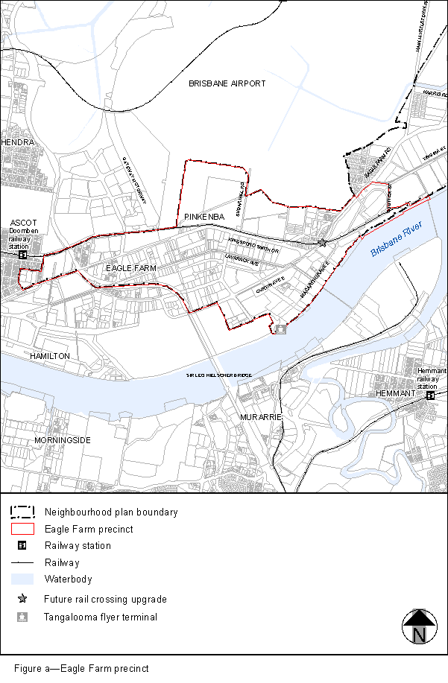
View the high resolution of Figure a–Eagle Farm precinct (PDF file size is 193Kb)
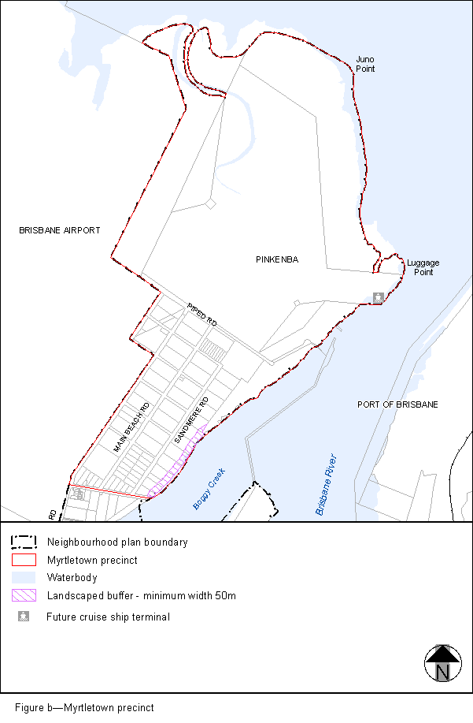
View the high resolution of Figure b–Myrtletown precinct (PDF file size is 144Kb)
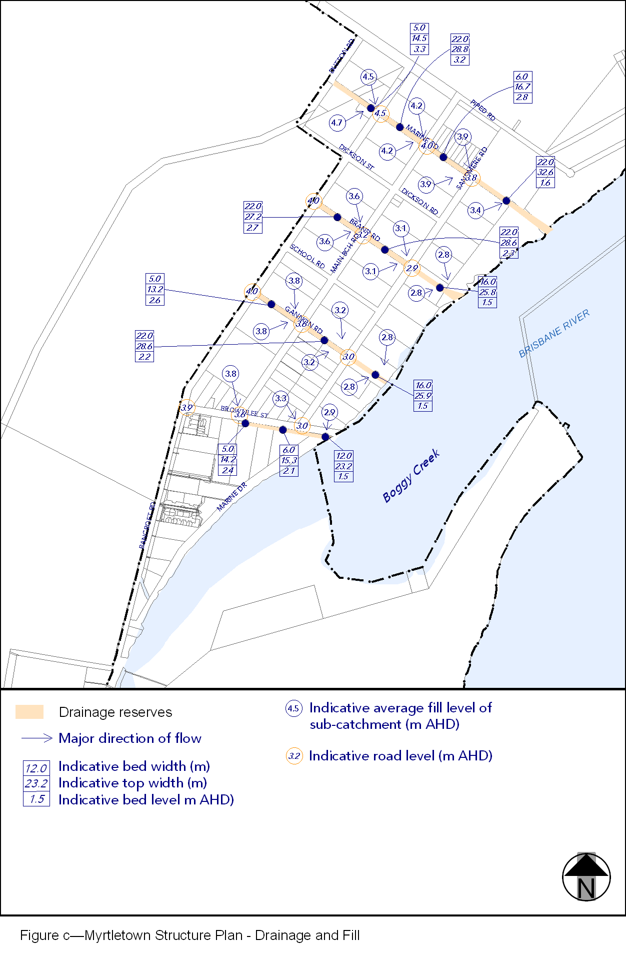
View the high resolution of Figure c–Myrtletown Structure Plan – Drainage and Fill (PDF file size is 136Kb)

