7.2.19.3 Sherwood—Graceville district neighbourhood plan code

7.2.19.3.1 Application
- This code applies to assessing a material change of use, reconfiguring a lot, operational work or building work in the Sherwood—Graceville district neighbourhood plan area if:
- assessable development where this code is an applicable code identified in the assessment benchmarks column of a table of assessment for a neighbourhood plan (section 5.9); or
- impact assessable development.
- Land in the Sherwood—Graceville district neighbourhood plan area is identified on the NPM-019.3 Sherwood—Graceville district neighbourhood plan map and includes the following precincts:
- Westside character precinct (Sherwood—Graceville district neighbourhood plan/ NPP-001);
- Corinda centre precinct (Sherwood—Graceville district neighbourhood plan/NPP-002);
- Sherwood centre precinct (Sherwood—Graceville district neighbourhood plan /NPP-003);
- Honour Avenue centre precinct (Sherwood—Graceville district neighbourhood plan/NPP-004);
- Community hub precinct (Sherwood—Graceville district neighbourhood plan/NPP-005);
- St Aidan’s school precinct (Sherwood—Graceville district neighbourhood plan/NPP-006);
- Light industry and employment precinct (Sherwood—Graceville district neighbourhood plan/NPP-007);
- Alan Fletcher Research Station/Montrose Access precinct (Sherwood—Graceville district neighbourhood plan/NPP-008);
- Sport and recreation precinct (Sherwood—Graceville district neighbourhood plan/NPP-009).
- When using this code, reference should be made to section 1.5, section 5.3.2 and section 5.3.3.
Note—The following purpose, overall outcomes, performance outcomes and acceptable outcomes comprise the assessment benchmarks of this code.
Note—This neighbourhood plan includes a table of assessment with variations to categories of development and assessment. Refer to Table 5.9.62.A, Table 5.9.62.B, Table 5.9.62.C and Table 5.9.62.D.

7.2.19.3.2 Purpose
- The purpose of the Sherwood—Graceville district neighbourhood plan code is to provide finer grained planning at a local level for the Sherwood—Graceville district neighbourhood plan area.
- The purpose of the Sherwood—Graceville district neighbourhood plan code will be achieved through overall outcomes including overall outcomes for each precinct of the neighbourhood plan area.
- The overall outcomes for the Sherwood—Graceville district neighbourhood plan area are:
- Development in the district reflects its unique character and the area’s relationship to the Brisbane River. This is characterised by predominantly low-density housing comprising a large proportion of traditional character houses, complemented by established vegetation in both private and public open spaces.
- A mix of housing densities, types and sizes exist within walking catchment of services and public transport at the Corinda and Sherwood centres, to accommodate the community’s housing needs at various stages of their lives and in particular to provide housing for the ageing population in the area.
- The continuation of community uses throughout the area, particularly within the Community hub precinct (Sherwood—Graceville district neighbourhood plan/NPP-005) to take advantage of the accessibility to the Sherwood and Corinda centres, public transport and adjacent parkland.
- The Brisbane riverfront parks, Cliveden Avenue bushland and parks along Oxley Creek are significant natural assets and are protected and rehabilitated where appropriate.
- Privately owned sport and recreation land is protected from intrusion from other land uses.
- Growth of local educational establishments is supported where consistent with local residential amenity and traffic movement.
- Development is of a height, scale and form which is consistent with the amenity and character, community expectations and infrastructure assumptions intended for the relevant precinct, sub-precinct or site and is only developed at a greater height, scale and form where there is both a community need and an economic need for the development.
- While making efficient use of land, development is consistent with community expectations and infrastructure assumptions.
Note—Where this code includes performance outcomes or acceptable outcomes that relate to noise assessments, guidance is provided in the Noise impact assessment planning scheme policy.
- Westside character precinct (Sherwood—Graceville district neighbourhood plan/NPP-001) overall outcomes are:
- The precinct is an area of Brisbane with outstanding features that contribute to the identity of the neighbourhood. A collection of distinctive and intact character houses built in 1946 or before predominate in the area, while newer buildings, sympathetic to the character of the precinct, do not detract from it.
- Character houses in this precinct, are predominantly larger in scale and form compared to other houses of their era and are generally intact and well maintained. The character houses are generally set low with wide proportions, and feature traditional elements such as verandahs and external timber staircases. A general consistency in roof form and height contributes to the precinct’s special character with typically hipped roofs or with low, wide gables. Garages are located and designed so as not to dominate or detract from the streetscape.
- In addition to the predominance of houses built in 1946 or before, the precinct is characterised by wide property frontages with large spacing between buildings, landscaping of open lawns with mature specimen trees, tennis courts, low timber and wire style fencing and hedges. Streets are often wide with mature street tree plantings, including significant stands of camphor laurels that should be retained or replaced where possible.
- The scale, form and proportion of development within the precinct reflect the distinctive qualities that create a sense of visual cohesion within the nearby streetscape. New buildings and other works in terms of the scale, form and mass, sit comfortably within the streetscape and do not dominate adjacent or nearby character places.
- Corinda centre precinct (Sherwood—Graceville district neighbourhood plan/NPP-002) overall outcomes are:
- This is a vibrant, mixed use centre, accommodating a range of centre activities, including multiple dwellings, offices, shops and community uses. A wide choice of housing types is located within walkable proximity to the services provided at Corinda centre and to the Corinda railway station.
- Existing large car parking areas are redeveloped for centre activities.
- To support a compact centre core, centre activities only occur in the District centre zone.
- Residents living within the precinct will have residential amenity consistent with the levels in a vibrant, mixed use centre.
- Sherwood centre precinct (Sherwood—Graceville district neighbourhood plan/NPP-003) overall outcomes are:
- This is a vibrant, mixed use centre, accommodating a range of centre activities, including multiple dwellings, offices, shops and community activities. A wide choice of housing types is located within walkable proximity to the services provided at Sherwood centre and to the Sherwood railway station.
- To support a compact centre core, centre activities are only supported in the District centre zone.
- Residents living within the precinct will have residential amenity consistent with the levels in a vibrant, mixed use centre.
- Honour Avenue centre precinct (Sherwood—Graceville district neighbourhood plan/NPP-004) overall outcome is:
- This precinct allows for centre activities while encouraging the retention and re-use of heritage and character buildings in the centre. New developments and extensions to existing buildings respect the existing character through appropriate scale, siting and form of new development.
- Community hub precinct (Sherwood—Graceville district neighbourhood plan/NPP-005) overall outcome is:
- This precinct provides a community focus for the Sherwood—Graceville district neighbourhood plan area with the co-location of a range of community uses that are well located close to the Sherwood and Corinda centres, and with good access to public transport.
- St Aidan’s school precinct (Sherwood—Graceville district neighbourhood plan/NPP-006) overall outcome is:
- St Aidan’s school continues to operate in its current location with any expansion or redevelopment ensuring the location, height and massing of new buildings retains the amenity of surrounding residential areas.
- Light industry and employment precinct (Sherwood—Graceville district neighbourhood plan/NPP-007) overall outcome is:
- This precinct provides a local industry and employment node within the Sherwood—Graceville district neighbourhood plan area. New industry uses or expansion of existing lawful industry uses can only occur where they are consistent with low impact industry intent.
- Alan Fletcher Research Station/Montrose Access precinct (Sherwood—Graceville district neighbourhood plan/NPP-008) overall outcomes are:
- Both sites comprising this precinct are located adjacent to low density residential areas and gain vehicular access through residential streets. Each site has a frontage to the Brisbane River and contains significant native vegetation forming part of a corridor of riparian vegetation along the river’s edge.
- Any future re-use of the site will be as another community use that is consistent with the low density residential character of surrounding areas.
- Any residential component of a redevelopment is of a height, scale and intensity that reflect the predominantly two-storey character residential surroundings.
- Redevelopment of the site includes open space along the riverfront and rehabilitation of native vegetation.
- Redevelopment of the site includes a public space that commemorates and provides public education of the site’s historically significant use.
- Redevelopment of the site is in accordance with a structure plan.
- Sport and recreation precinct (Sherwood—Graceville district neighbourhood plan/NPP-009) overall outcomes are:
- Privately owned outdoor sport and recreation areas are protected from redevelopment for other uses to ensure adequate space for a range of sport and recreation uses is retained to meet current and future needs.
- Reconfiguring a lot if not associated with an existing or approved building is inconsistent with the outcomes sought for this precinct.

7.2.19.3.3 Performance outcomes and acceptable outcomes

Table 7.2.19.3.3.A—Performance outcomes and acceptable outcomes
Performance outcomes | Acceptable outcomes
For accepted development subject to compliance with identified requirements (acceptable outcomes only) or assessable development
If for a dwelling house:
PO1  Development:  - maintains the traditional backyard pattern and character of the area, with a proportion of the site set aside for open space rather than built structures;  - enhances the subtropical nature of the area, with building bulk limited to allow for the flow of breezes and for sunlight to penetrate into open space and living areas;  - includes private open space of a suitable size and proportion to cater for the active recreation needs of residents of all age groups, as well as providing space for service functions such as clothes drying;  - has a rear boundary setback that provides sufficient clearance to enable useable private open space;  - retains existing trees within the front setback;  - retains large trees and provides substantial areas for landscaping consistent with the established traditional landscape character of the area. | AO1.1  Development has:  - a maximum building footprint of 50% of the site area;  - a minimum area of private open space of 100m2, or 30% of the site, whichever is the greater, and has a minimum dimension of 3m.
AO1.2
Development has a minimum rear boundary setback of 6m.
AO1.3
Development retains mature trees in backyard areas and provides a minimum of 1 tree for every 7m of the average lot width, capable of growing to a height of over 4m.
For assessable development
General
PO2  Development is of a height, scale and form that achieves the intended outcome for the precinct, improves the amenity of the neighbourhood plan area, contributes to a cohesive streetscape and built form character and is:  - consistent with anticipated density and assumed infrastructure demand;  - aligned with community expectations about the number of storeys to be built;  - proportionate to and commensurate with the utility of the site area and frontage width;  - designed to avoid significant and undue adverse amenity impact to adjoining development;  - sited to enable existing and future buildings to be well separated from each other and to avoid affecting the potential development of adjoining sites.  Note—Development that exceeds the intended number of storeys or building height can place disproportionate pressure on the transport network, public space or community facilities in particular.  Note—Development that is over-scaled for its site can result in an undesirable dominance of vehicle access, parking and manoeuvring areas that significantly reduce streetscape character and amenity. | AO2  Development complies with the number of storeys and building height in Table 7.2.19.3.3.B.  Note—Neighbourhood plans will mostly specify a maximum number of storeys where zone outcomes have been varied in relation to building height. Some neighbourhood plans may also specify the height in metres. Development must comply with both parameters where the maximum number of storeys and height in metres are specified.
If in the Westside character precinct (Sherwood—Graceville district neighbourhood plan/NPP-001)
PO3  Development:  - has a scale, form, mass, rhythm and setting that reflects those of nearby buildings in the street built in 1946 or before;  - preserves characteristic streetscape attributes of the area, including large backyards, generous building setbacks, mature large trees, and a high proportion of open space and landscaping relative to built form;  - is in accordance with Figure d, Figure e and Figure f.  - Note—To demonstrate compliance with this provision, a detailed streetscape analysis is to be submitted. This analysis will consider the subject site, along with at least 2 properties on either side of the subject site and will include plans, elevations and perspective views to identify for each of the properties: front and side boundary setbacks; height to first floor; height to front gutter; height to ridge of roof; and views of the site and adjacent properties along the street in 2 directions. | AO3.1  Development has a maximum building footprint of 40% of the site area.
AO3.2
Development complies with the number of storeys and building height in Table 7.2.19.3.3.B.
Note—Neighbourhood plans will mostly specify a maximum number of storeys where zone outcomes have been varied in relation to building height. Some neighbourhood plans may also specify the height in metres. Development must comply with both parameters where the maximum number of storeys and height in metres is specified.
AO3.3
Development is set back from any road alignment to a distance within 20% of the average front setback of the nearest buildings built in 1946 or before that front the same street, in accordance with Figure d.
AO3.4
Development has a minimum rear boundary setback of 10m or 25% of the depth of the lot, whichever is less, in accordance with Figure d.
AO3.5
Development is either:
- set back from side boundaries to a distance within 20% of the average of other houses in the street that were built in 1946 or before; or
- set back a minimum distance described by the Queensland Development Code for buildings where not on a small lot.
PO4  Development:  - does not allow car parking structures and areas to dominate the appearance and settings of the house when viewed from the street;  - is designed to minimise the visual impact of garage doors and uses materials such as timber battens. | AO4.1  Development is designed so that car parking structures are not located between the front facade of the building and the street.
AO4.2
Development is designed to locate garages or carports at the rear, under or to the side of the building in accordance with Figure c and is either:
- set back for the full depth of all open or enclosed verandahs on the upper level above in line with the original external wall; or
- set back 1m from the upper level of the front exterior wall where there is no verandah.
AO4.3
Development is designed so that car parking structures have a maximum total width of 6m.
AO4.4
Development is designed so that garages or carports have a maximum roof pitch of 30º degrees.
AO4.5
Development:
- is designed so that driveways and parking areas:
- comprise a minimum of 50% permeable surfaces such as car tracks, sleepers, pavers and gravel interspersed with soft landscaping;
- are not large expanses of bitumen and concrete;
- ensures driveway areas between the kerb and the property line are completed in accordance with the Infrastructure design planning scheme policy.
AO4.6
Development has a maximum driveway crossover width of 3.5m.
PO5  Development with fencing that is visible from the street is designed so that the fencing:  - is low and transparent;  - complements the traditional fencing styles in the area. | AO5  Development is designed so that front fences and return side fences forward of the main building are:  - a maximum height of 1.2m;  - of a timber paling and/or wire construction that complements the traditional character of the streetscape;  - at least 20% transparent.
PO6  Development:  - incorporates landscaping that:  - is consistent with the established landscape character of the area;  - accommodates the retention of existing vegetation;  - ensures that site design integrates the retention of existing trees into the development, with new buildings, car parks and driveways located to allow for retention and long-term viability of significant on-site vegetation;  - ensures that established significant vegetation removed or damaged is replaced with mature vegetation elsewhere on the site. | AO6  No acceptable outcome is prescribed.
If the site does not contain a house built in 1946 or before
PO7  Development ensures that the design of new buildings complements the character of houses in the street built in 1946 or before, in accordance with Figure e and Figure f. | AO7.1  Development is designed so that roof forms are hips, pyramids or gables with a pitch of between 20º and 30º or within 10% of the pitch of houses in the street built in 1946 or before.
AO7.2
Development ensures a building contains a verandah facing the street of a similar configuration to those of houses in the street built in 1946 or before.
PO8  Development provides new buildings that use traditional lightweight materials and architectural elements that are sympathetic to the buildings in the street built in 1946 or before. | AO8  No acceptable outcome is prescribed.
If the site contains a house built in 1946 or before
PO9  Development has elements that contribute to the character of buildings built in 1946 or before if they can be seen from the street.  Note—Elements include: roof form, external walls, building core, verandahs, external openings, and decorative detailing. | AO9.1  Development is designed so that a building retains its original form, materials, proportions and external components, including:  - the front wall, the roof form and side walls beyond, at least as far back as the ridge of the rear-most gable in a gable roof house or the primary ridge for a hipped house roof;  - buildings on a corner lot maintain the entirety of the existing roof form, and extensions are in the form of a pavilion;  - external openings including any original window or door frames that are visible from the street;  - side and front verandahs (including balustrading and decorative details).
AO9.2
Development ensures the original location and proportion of the front door to the house is retained as the main entrance.
AO9.3
Development ensures new windows and doors contained in any external wall visible from the main street frontage are:
- of vertical proportions;
- include a higher ratio of wall area to window or door;
- of a style and construction and incorporate materials sympathetic with the era of the house built in 1946 or before.
Note—The extent of any partial demolition needs to be identified in plan and elevation drawings. The proposed partial demolition must not affect the appearance of the original structure from the street.
PO10  Development ensures:  - restumping, raising, lowering or building underneath a house built in 1946 or before is consistent with either:  - the scale, form and height of adjacent houses built in 1946 or before; or  - the predominant scale, form, height and rhythm of houses in the street built in 1946 or before;  - new ground level enclosures are recessed in line with the main building core as seen from the street.  Note—The building core is the main body of the building excluding any closed or open verandahs. | AO10  Development:  - does not raise or lower houses by more than 750mm;  - if involving closing in underneath a house built in 1946 or before:  - is set back for the full depth of all open or enclosed verandahs on the upper level above in line with the original external wall;  - is set back 1m from the upper level of the front exterior wall where there is no verandah;  - is screened with a vertical timber batten frieze to minimise the visual impact of new built-in areas underneath;  - ensures timber or concrete stumps are used around the exterior of houses built in 1946 or before.
If in the Corinda centre precinct (Sherwood—Graceville district neighbourhood plan/NPP-002) or the Sherwood centre precinct (Sherwood—Graceville district neighbourhood plan/NPP-003)
PO11  Development protects the amenity of adjoining areas outside of the precinct by stepping down in height and scale to provide an appropriate interface. | AO11  Development has a maximum building height that complies with Table 7.2.19.3.3.B.
PO12  Development provides clear and safe pedestrian access to the Corinda railway station. | AO12  Pedestrian connections are provided in accordance with Figure a.
PO13  Development provides:  - vehicle access from Browne Street to the Corinda library;  - sufficient off-street parking for the Corinda library;  - clear pedestrian access through the site from the Corinda railway station to the library. | AO13.1  Development of Lot 3 on RP29567 provides vehicle access to the Corinda library from Browne Street.
AO13.2
Development dedicates to Council a pedestrian pathway with a minimum width of 3.5m which provides access through the site from the Corinda railway station to the Corinda library, in the location indicated in Figure a.
If in the District centre zone
PO14  Development:  - ensures coordinated and efficient development of the centre;  - provides a safe and comfortable pedestrian environment and an attractive streetscape;  - ensures vehicular access and parking does not dominate the streetscape. | AO14  Development is located on a site with a minimum area of 1,200m2 and a minimum frontage of 30m.
PO15  Development ensures the size and bulk of a building has a medium density form that promotes a compact centre and maximises its proximity to public transport. | AO15  Development has a maximum gross floor area that is 150% of the site area.
PO16  Development with a frontage to a street or public space encourages pedestrian activity through the provision of intensive or interactive uses along the frontage. | AO16  Development:  - has a minimum of 20% of the gross floor area for non-residential centre activities;  - is designed so that the ground storey facing the street is occupied by active commercial centre activities with a high level of pedestrian activity such as restaurants, shops or community activities;  - ensures that the ground storey facade is set back no more than 3m except for vehicle access or deep planting;  - has a ground storey with a minimum floor-to-ceiling height of 4m;  - provides awnings over the footpath in accordance with the Infrastructure design planning scheme policy.
PO17  Development involving centre activities adjoining land in the Medium density residential zone minimises visual impacts from servicing and car parking. | AO17  No acceptable outcome is prescribed.
If in the Honour Avenue centre precinct (Sherwood—Graceville district neighbourhood plan/NPP-004)
PO18  Development is designed so that the Honour Avenue facade has a uniform alignment with all new development reflecting the dominant pattern of existing development. | AO18  Development is built to the front boundary along Honour Avenue.
PO19  Development:  - minimises vehicular access points to properties fronting Honour Avenue;  - uses opportunities to combine driveway access with that of existing development. | AO19  No acceptable outcome is prescribed.
PO20  Development is consistent with the form and height of existing buildings in the centre built in 1946 or before. | AO20.1  Development ensures a building includes a front parapet above an awning along Honour Avenue.
AO20.2
Development with a third storey is set back a minimum of 4m from the front boundary.
PO21  Development provides pedestrian amenity along the footpaths. | AO21  Development provides continuous awning cover along Honour Avenue.
If in the Community hub precinct (Sherwood—Graceville district neighbourhood plan/NPP-005)
PO22  Development locates car parking to avoid dominating the streetscape. | AO22.1  Development locates parking at the rear of properties or underground.
AO22.2
Development ensures vehicle access points are minimised, with provision of combined driveway access for properties where possible.
If in the St Aidan’s school precinct (Sherwood—Graceville district neighbourhood plan/NPP-006)
PO23  Development:  - does not impact adversely on the safety or operation of local roads, including the free flow of traffic;  - encourages safe, convenient access by a range of transport modes by provision of adequate:  - car parking, including overspill parking for special events;  - passenger pick-up and set-down areas for vehicles;  - bicycle parking, lockers and changing facilities. | AO23  No acceptable outcome is prescribed.
PO24  Development is of a scale that is consistent with the area and protects the amenity of nearby landowners. | AO24  Development ensures the height and location of buildings is in accordance with Figure g.
PO25  Development ensures:  - unreasonable adverse impacts on adjoining residential development are avoided;  - fenestration and landscaping, including fencing, is designed to protect the privacy of adjoining residents. | AO25.1  Development does not result in noise levels generated from the use that exceed the levels in the Noise impact assessment planning scheme policy.
AO25.2
Development provides a landscape buffer 2m in width to any vehicle movement and parking areas along any residential boundaries.
AO25.3
Development locates active outdoor activities away from adjoining residential development.
AO25.4
Development provides screen fencing to a minimum height of 1.8m, and landscaping screening is provided to boundaries of adjoining residential land use.
AO25.5
Development provides vehicle movement areas that are located a minimum of 3m from any adjoining residential development, or provides acoustic screening.
AO25.6
Development provides a landscaped buffer zone along all street frontages, including 1.5m depth of landscaping along all boundaries with residential properties.
PO26  Development incorporates subtropical design elements through the following measures:  - high-quality subtropical design that maximises amenity, street activity and pedestrian connectivity;  - ventilation in and around buildings using appropriate building forms, breezeways, open courtyards and landscaped areas;  - landscaping to promote Brisbane’s subtropical climate and atmosphere. | AO26  No acceptable outcome is prescribed.
PO27  Development of buildings is finished with high-quality materials selected for their durability and the contribution made to the character of the school. | AO27  No acceptable outcome is prescribed.
PO28  Development of buildings avoids incorporating any type of glass or other surface likely to reflect specular rays that could create undue nuisance, discomfort or hazard to any part of the locality. | AO28  No acceptable outcome is prescribed.
If in the Alan Fletcher Research Station/Montrose Access precinct (Sherwood—Graceville district neighbourhood plan/NPP-008)
PO29  Development:  - retains building footprints for existing structures;  - is of a height and scale that is consistent with the predominantly low density residential character of surrounding areas;  - does not have development footprints for proposed structures, car parking and servicing areas with a total site utilisation greater than 45%;  - provides adequate on-site parking;  - provides a satisfactory buffer to the Brisbane River and waterways to protect and enhance their ecological values;  - provides dedicated, public parkland along the Brisbane River frontage of the site;  - provides pedestrian and bikeway connections or linkages within and to streets external to the site and to and within parkland;  - provides adequate landscaping, particularly the provision of a landscaped buffer zone to the park and along the street frontages, including sufficient depth of landscaping along all boundaries with residential properties;  - incorporates public open space that commemorates and provides public education of the site’s historically significant use.  Note—A structure plan prepared in accordance with the Structure planning planning scheme policy may demonstrate compliance with these outcomes. | AO29  No acceptable outcome is prescribed.

Table 7.2.19.3.3.B—Maximum building height
Development | Building height  (number of storeys) | Eaves height (m) | Building height (m)
If in the Westside character precinct (Sherwood—Graceville district neighbourhood plan/NPP-001)
Development of a site within the street frontage zone (refer to Figure e) | 2 | Within 20% of the eaves height of adjacent dwellings | Not specified
Development elsewhere on the site, where it does not dominate the original roof form as viewed from the street | 2 | Not specified | Not specified
Development of a site that does not contain a house built in 1946 or before | 2 | Within 20% of the eaves height of buildings on adjoining properties | Not specified
If in the District centre zone
Any development in this zone | 5 | Not specified | 17 from ground level to the underside of the ceiling of any habitable room
If in the Sherwood centre precinct (Sherwood—Graceville district neighbourhood plan /NPP-003)
Development of a site fronting Jerold Street on sites indicated as Medium density residential 3 storey maximum in Figure b | 3 | Not specified | 10.5
Note—Buildings built in 1946 or before in the Westside character precinct (Sherwood-Graceville district neighbourhood plan/NPP-001) are raised or lowered no more than 750mm in accordance with AO10.
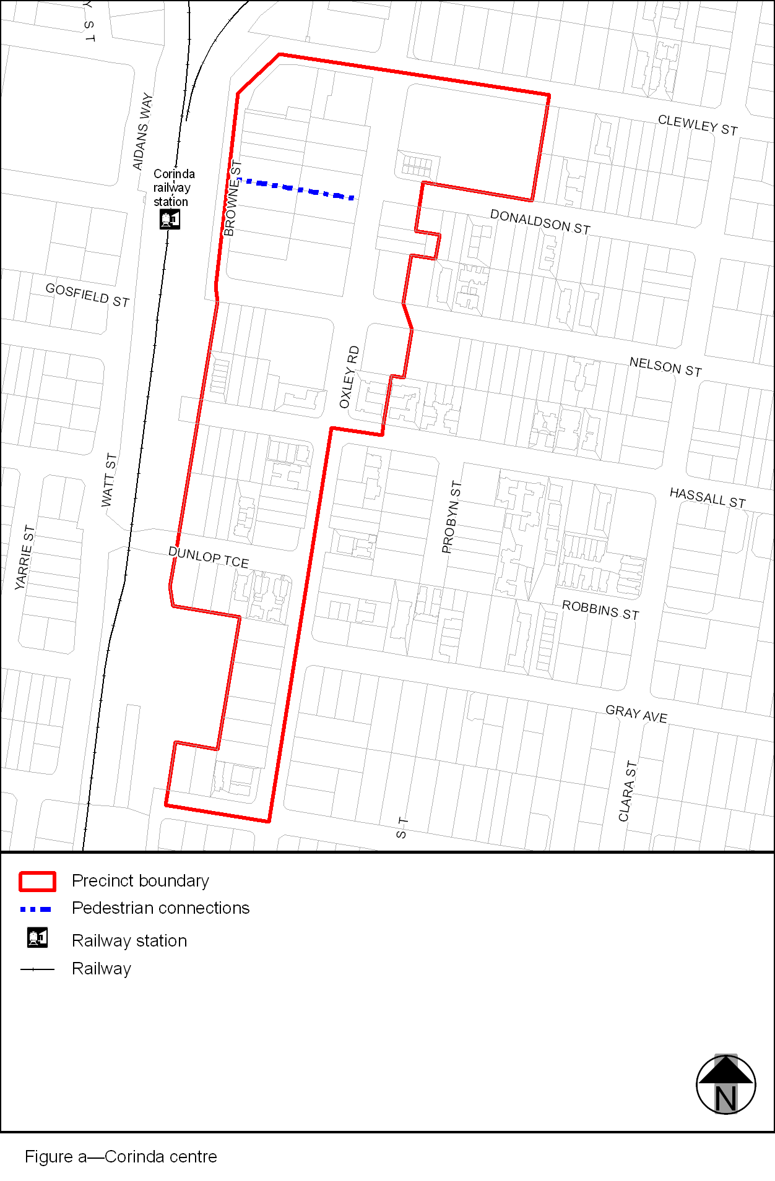
View the high resolution of Figure a–Corinda centre (PDF file size is 122Kb)
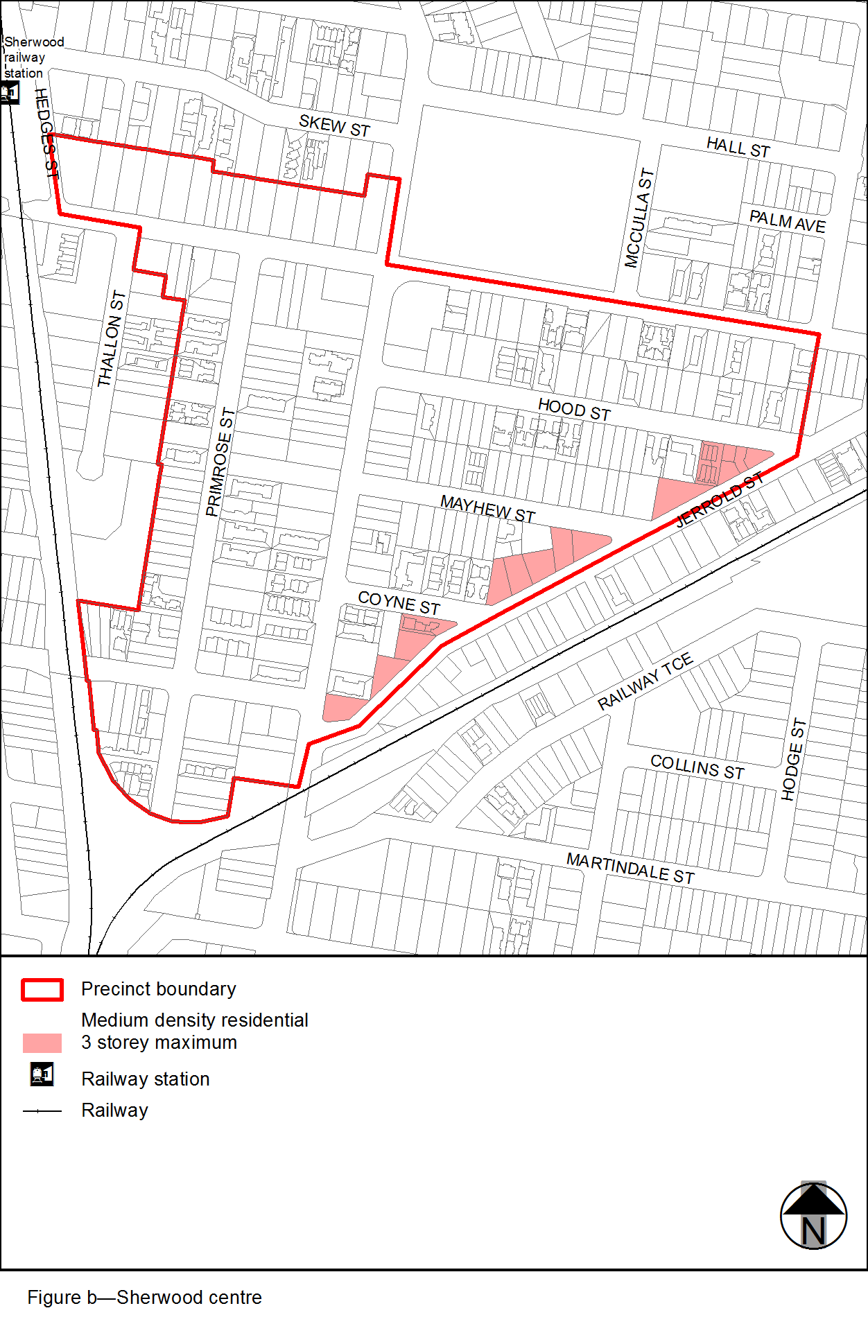
View the high resolution of Figure b–Sherwood centre (PDF file size is 122Kb)
