7.2.19.4 South Brisbane riverside neighbourhood plan code

7.2.19.4.1 Application
- This code applies to assessing a material change of use, reconfiguring a lot, operational work or building work in the South Brisbane riverside neighbourhood plan map area if:
- assessable development where this code is an applicable code identified in the assessment benchmarks column of a table of assessment for a neighbourhood plan (section 5.9); or
- impact assessable development.
- Land in the South Brisbane riverside neighbourhood plan area is identified on the NPM-019.4 South Brisbane riverside neighbourhood plan map and includes the following precincts:
- South Brisbane reach precinct (South Brisbane riverside neighbourhood plan/NPP-001);
- Musgrave precinct (South Brisbane riverside neighbourhood plan/NPP-002);
- Boundary and Vulture precinct (South Brisbane riverside neighbourhood plan/NPP-003):
- Village heart sub-precinct (South Brisbane riverside neighbourhood plan/NPP-003a).
- Kurilpa precinct (South Brisbane riverside neighbourhood plan/NPP-004):
- Kurilpa south sub-precinct (South Brisbane riverside neighbourhood plan/NPP-004a);
- Kurilpa north sub-precinct (South Brisbane riverside neighbourhood plan/NPP-004b).
- Riverside north precinct (South Brisbane riverside neighbourhood plan/NPP-005);
- Buchanan and Davies parks precinct (South Brisbane riverside neighbourhood plan/NPP-006):
- Hockings Street sub-precinct (South Brisbane riverside neighbourhood plan/NPP-006a).
- Riverside south precinct (South Brisbane riverside neighbourhood plan/NPP-007).
Editor's note—Part of the neighbourhood plan area is covered by the South Bank Corporation area which South Bank Corporation is responsible for planning under the South Bank Corporation Act 1989.
- When using this code, reference should be made to section 1.5, section 5.3.2 and section 5.3.3.
Note—The following purpose, overall outcomes, performance outcomes and acceptable outcomes comprise the assessment benchmarks of this code.
Note—This neighbourhood plan includes a table of assessment with variations to categories of development and assessment. Refer to Table 5.9.63.A, Table 5.9.63.B, Table 5.9.63.C and Table 5.9.63.D.

7.2.19.4.2 Purpose
- The purpose of the South Brisbane riverside neighbourhood plan code is to provide finer grained planning at a local level for the South Brisbane riverside neighbourhood plan area.
- The purpose of the South Brisbane riverside neighbourhood plan code will be achieved through overall outcomes including overall outcomes for each precinct of the neighbourhood plan area.
- The overall outcomes for the neighbourhood plan area are:
- South Brisbane riverside is an eclectic, inner-city riverside community, supporting an established, diverse and growing local population situated within a key emerging employment locality and cultural district of international reputation.
- The community’s creative focus and relaxed way of life will be reflected through high-quality buildings and public realm, incorporating subtropical design excellence and innovation.
- Development is of a height, scale and form which is consistent with the amenity and character, community expectations and infrastructure assumptions intended for the relevant precinct, sub-precinct or site and is only developed at a greater height, scale and form where there is both a community need and an economic need for the development.
- Development makes a positive contribution to the public realm through on-site amenity such as deep planting, well-connected and publicly accessible spaces, protection of existing vegetation, landscaping and public art.
- Development along the river’s edge enhances the Kurilpa Point Park, South Brisbane Riverside Lands Park and the West End Riverside Lands Park, by providing improved access, appropriate building setback, bulk and separation, materials, design and landscaping.
- New social facilities and infrastructure are provided to support the needs created by increased residential and employment densities.
- Structure planning of key development sites achieves integration with their surrounds, creation of attractive public realm and retention and re-use of on-site heritage structures.
- Important character values are retained and enhanced by maintaining key views and vistas to the Brisbane River and Taylor Ranges.
- South Brisbane reach precinct (South Brisbane riverside neighbourhood plan/NPP-001) overall outcomes are:
- This precinct is a gateway to the South Brisbane riverside area and contains some of Brisbane's key destinations, such as the ‘cultural precinct’, the South Bank ‘entertainment precinct’ and ‘educational precinct’.
- A further focus of this precinct is its public realm, with buildings set along boulevards and in parkland. New and enhanced public spaces serve a variety of purposes suited to their location, including river boardwalk access or views, informal gathering and meeting places or formal plazas. Public realm improvements also occur through upgrades along Tribune Street, Ernest Street, Glenelg Street and parts of Melbourne Street.
- Connectivity with the Brisbane River is enhanced through improvements to the link under the Brisbane Convention and Exhibition Centre, connecting the heart of West End with South Bank. The future development of the South Bank rail and busway stations delivers high-quality intermodal public transport facilities, integrating new public spaces with excellent urban amenity and improved pedestrian links.
- Musgrave precinct (South Brisbane riverside neighbourhood plan/NPP-002) overall outcomes are:
- This precinct provides for a mix of activities and uses, including high-density residential and offices with ground-storey retail. Key worker and student accommodation is encouraged.
- Options to upgrade Russell Street will be explored to improve pedestrian and cyclist safety and movement from Boundary Street to South Bank. On-site landscaping will increase the visual greenery and amenity of the area.
- Active elements of new mixed use development along Russell Street, Cordelia Street and Edmondstone Street will overlook the streets and park to improve pedestrian safety.
- Boundary and Vulture precinct (South Brisbane riverside neighbourhood plan/NPP-003) overall outcomes are:
- This precinct is the heart of South Brisbane riverside. Boundary Street has retail, food and drink outlet, entertainment and community focus and maintains a human scale built form at the street level.
- Development between Russell Street, Vulture Street, O’Connell Street and Edmondstone Street accommodates a broad range of medium-density residential units, small-scale ground storey retail and small-scale commercial uses. Residential accommodation provides opportunities for a diverse population including families, students, and key workers. Compatible community and educational uses, such as a childcare centre and retirement facility, are interspersed amidst medium-density residential units.
- Mixed use development along Boundary, Russell and Vulture streets creates a pleasant pedestrian experience through active frontages, awnings and streetscape improvements. Particular attention is given to increasing landscaping, greenery and shade along Vulture Street. Dwelling units are located above ground-storey retail and commercial uses to maximise day/night casual surveillance of these key pedestrian and bicycle routes.
- Redevelopment of the Absoe site (111 Boundary Street – Lot 2 on RP151557) contributes to the vibrant village atmosphere of Boundary Street. A new urban plaza or public space on Boundary Street links activity from Boundary Street through the site to Mollison Street where the proposed CityGlider station is located. Retaining and re-using heritage buildings on the Absoe site gives new life to old buildings. Mixed use development integrates active ground-storey uses and community spaces with residential and commercial uses. New roads and pedestrian links allow people to move between Mollison, Little Jane and Wilson streets. Pressure on local parking is relieved by inclusion of an underground commercial car park forming part of the integrated redevelopment of the Absoe site.
- Development in the Village heart sub-precinct (South Brisbane riverside neighbourhood plan/NPP-003a):
- supports low- to mid-rise development.
- Kurilpa precinct (South Brisbane riverside neighbourhood plan/NPP-004) overall outcomes are:
- This precinct provides for high-density mixed-use development, supporting the core function of the CBD. A high-quality public realm consisting of open spaces and enhanced streets contributes to South Brisbane riverside becoming a ‘world class cultural district’ with day and night-time activity.
- Permanent and short-term accommodation is provided where residential amenity is highest or within mixed use buildings.
- Streetscape improvements and pedestrian links increase pedestrian and cyclist movement through the precinct and to the surrounding river crossings.
- Fish Lane is a vibrant active laneway with small retail tenancies.
- Hope Street is a destination for dining, entertainment and retail in combination with public space under the rail viaduct and will link Melbourne Street to the redevelopment on the Parmalat site between Montague Road and the river.
- The Parmalat site is redeveloped into a mixed use landmark for Brisbane with high-quality public space and enhanced connections to the river.
- Development in the Kurilpa south sub-precinct (South Brisbane riverside neighbourhood plan/NPP-004a):
- supports medium- to high-density development.
- Development in the Kurilpa north sub-precinct (South Brisbane riverside neighbourhood plan/NPP-004b):
- supports high-density development.
- Riverside north precinct (South Brisbane riverside neighbourhood plan/NPP-005) overall outcomes are:
- This precinct is a transition zone between the high-density development of the Kurilpa precinct to the north, and lower density buildings to the south. Residential apartments take advantage of parkland and riverfront amenity, set amongst landscaping and new public spaces.
- Redevelopment of the Australian Consolidated Industries and Hanson sites creates a new vibrant destination with significant community benefit. Brereton Street will be extended to the river and contain residential, commercial, retail, cultural and community uses. New public spaces will be created together with new connections to the river and its parklands. Heritage buildings will be retained and adapted for new uses. Until redevelopment occurs, the continued and viable operation of the Australian Consolidated Industries and Hanson industries is enabled and residential uses are not located adjacent to industrial development that generates noise or with long operating hours. Commercial uses that are designed to allow for long-term adaptation into residential uses are appropriate.
- Along Montague Road, predominantly commercial and retail development, street upgrades, landscaping and building design provides an attractive and comfortable environment for pedestrians.
- Mollison Street and Hocking Street are upgraded to create attractive and comfortable pedestrian environments between the riverside and the heart of West End.
- Buchanan and Davies parks precinct (South Brisbane riverside neighbourhood plan/NPP-006) overall outcomes are:
- This precinct is a vibrant mixed use area, with residential uses predominantly focused towards the river and Bank Street.
- A wide variety of recreational activities and community facilities will be provided at Davies Park, catering for residents and employees in the precinct, and the wider South Brisbane riverside area.
- Along Hocking Street, Mollison Street, Jane Street and Montague Road, commercial and retail uses activate the area during the day, and may form part of mixed use developments with residential development above ground level. The current pattern of small lots and tenancies along Montague Road and Jane Street is maintained, with pedestrian amenity provided through awnings and landscaping.
- Development along Jane Street is mixed use to ensure casual surveillance over Davies Park is maintained day and night. Ground level uses tend towards arts and craft, cultural uses or health and wellbeing services.
- Development along Montague Road ranges in height, with taller buildings achievable on larger sites north of Vulture Street, consistent with built form along Montague Road to the north in the Kurilpa precinct (South Brisbane riverside neighbourhood plan/NPP-004) and the Riverside north precinct (South Brisbane riverside neighbourhood plan/NPP-005). Development frames the street, creating a continuous edge along Montague Road, softened by landscaping zones along the frontage.
- Laneways to the west and service lanes east of Montague Road access new development from internal streets. Increased building height is achieved on amalgamated lots, with access points to Montague Road reduced to improve the function of the road for the CityGlider, and pedestrian and cyclist movement. An additional vehicle connection between Hocking and Donkin streets accesses new buildings near the river, while allowing more internal movement away from Montague Road. A new connection to the South Brisbane Riverside Lands Park in the vicinity of Donkin Street increases access to the river. Until the Australian Consolidated Industries and Hanson sites are redeveloped, residential uses are not located on the opposite side of Hockings Street.
- On internal streets, buildings provide landscaping along the street frontage in a zone designed to deliver privacy to residences, while maintaining casual surveillance of the street and supplementing streetscaping. Existing trees are retained throughout the precinct, particularly in proximity to the South Brisbane Riverside Lands Park and on or adjacent to internal streets.
- Riverside south precinct (South Brisbane riverside neighbourhood plan/NPP-007) overall outcomes are:
- This precinct provides a transition between the ‘timber and tin’ housing of West End and Highgate Hill and new development in the South Brisbane riverside area. The precinct accommodates predominantly medium- to high-density residential development, which replaces obsolete industrial and warehouse uses. Small-scale retail and commercial uses integrated within new residential developments, servicing the local community, are consistent with the outcomes sought. This precinct allows for a retail component with a maximum gross floor area of 4,000m2 and primary frontage to Montague Road to be located between Ferry Road and Davies Park.
- A new ferry terminal is located at Victoria Street and associated land uses are supported to activate the terminal.
- Wide industrial streets are transformed into residential streets with narrower carriageways and room for pedestrians and cyclists. Parks and pedestrian connections provide additional open space and pedestrian and cycle only access to West End Riverside Lands Park. Redevelopment adjacent to Davies Park enhances the park interface and improves casual surveillance.
- Redevelopment of sites at the end of Duncan Street and Bailey Street will provide a new connection from Montague Road to West End Riverside Lands Park as an extension of Rogers Street. Other connections parallel to Montague Road through old industrial sites complete the road network so that local traffic can move internally rather than on Montague Road and people can move more easily around the area.
- Development provides a range of dwelling sizes and types. Buildings are located on large sites with taller towers located towards the centre of the site to minimise off-site impacts such as overlooking and overshadowing.
- Mixed use development along Montague Road activates the street during the day with small retail or commercial tenancies, and residential uses above. Where possible, these premises are accessed by vehicles from rear lanes such as Tondara Lane or Wolfe Street.
- Development along the eastern side of Montague Road and the northern side of Forbes Street is sensitive to adjoining residences outside of the South Brisbane riverside area, by using layout and architectural treatments to minimise impacts.

7.2.19.4.3 Performance outcomes and acceptable outcomes

Table 7.2.19.4.3.A—Performance outcomes and acceptable outcomes
Performance outcomes | Acceptable outcomes
Built form
PO1  Development is of a height, scale and form that achieves the intended outcome for the precinct, improves the amenity of the neighbourhood plan area, contributes to a cohesive streetscape and built form character and is:  - consistent with anticipated density and assumed infrastructure demand;  - aligned to community expectations about the number of storeys to be built;  - proportionate to and commensurate with the utility of the site area and frontage width;  - designed to avoid a significant and undue adverse amenity impact to adjoining development;  - sited to enable existing and future buildings to be well separated from each other and to avoid affecting the potential development of an adjoining site.  Note—Development that exceeds the intended number of storeys or building height can place disproportionate pressure on the transport network, public space or community facilities in particular.  Note—Development that is over-scaled for its site can result in an undesirable dominance of vehicle access, parking and manoeuvring areas that significantly reduce streetscape character and amenity. | AO1.1  Development complies with the number of storeys and building height in Table 7.2.19.4.3.B.  Note—Neighbourhood plans will mostly specify a maximum number of storeys where zone outcomes have been varied in relation to the building height. Some neighbourhood plans may also specify height in metres. Development must comply with both parameters where maximum number of storeys and the height in metres are specified.
AO1.2
Development, except where located in the Kurilpa precinct (South Brisbane riverside neighbourhood plan/NPP-004) and Riverside south precinct (South Brisbane riverside neighbourhood plan/NPP-007), can have buildings on corner sites identified in Figure b with an additional 2 storeys of height than that shown in Table 7.2.19.4.3.B, provided additional storeys are restricted in scale to a maximum horizontal dimension of 30m.
AO1.3
Development has a maximum site cover in accordance with Table 7.2.19.4.3.C.
PO2  Development ensures that building placement and bulk maintains significant views and vistas towards the ridgeline of the Taylor Ranges as obtained from the locations identified in Figure a.  Note—A view analysis is to be prepared that demonstrates compliance with this performance outcome and a 3D model of the proposal is to be provided to assist in the Council’s assessment of an application. | AO2  No acceptable outcome is prescribed.
PO3  Development of buildings over 8 storeys are made up of a podium and clearly defined slender tower to reduce visual bulk and scale. Spacing between multiple towers provides for solar access, cross ventilation and privacy. | AO3.1  Development ensures that the tower elements of new buildings extend no more than 75% of the width of the podium.
AO3.2
Development has a maximum horizontal dimension for a tower of 40m on any side.
AO3.3
Development on a site greater than 3,000m2 provides more than 1 tower and a minimum separation distance of 10m between the towers.
PO4  Development provides building setbacks that are sufficient to ensure that the building:  - protects important views and vistas identified in Figure a;  - does not dominate the street or other pedestrian spaces;  - does not prejudice the development of adjoining sites;  - enables existing and future buildings to be well separated from each other to allow light penetration, air circulation, privacy and ensure windows are not built out by adjoining buildings;  - facilitates the creation of attractive, vibrant and accessible laneways. | AO4.1  Development provides buildings that are set back from the front property boundary as specified in Figure b.
AO4.2
Development provides buildings in the High density residential zone or Mixed use zone with a minimum setback from the side property boundary of 3m, or 5m where windows of habitable rooms face the side boundary.
AO4.3
Development of buildings where in a zone in the centre zones category that do not include a residential use:
- are built to the side boundary up to 4 storeys;
- where buildings are 8 storeys or less, upper storeys are set back from the side boundary by a minimum of 3m.
AO4.4
Development of a building including habitable rooms facing the side boundary where in a zone in the centre zones category has a building setback that is a minimum of 5m.
AO4.5
Development is set back from the rear property boundary of a minimum of 6m and uses the area for deep planting.
AO4.6
Development of a building on a site adjoining a laneway identified in Figure b does not require a building setback.
AO4.7
Development of a building that adjoins the West End Riverside Lands and South Brisbane Riverside Lands parks is set back a minimum of 6m from the property boundary.
AO4.8
Development of a building with tower elements is set back a minimum of 6m from the front of the podium and 5m from the side of the podium in the High density residential zone and the Medium density residential zone.
AO4.9
Development of a building with tower elements is set back a minimum of 4m from the front of the podium, 3m from the side of the podium and 4m from the rear of the podium or laneway where in a zone in the centre zones category.
Note—In a zone in the residential zones category, the setbacks within the relevant use code apply where alternatives are not specified in the neighbourhood plan.
Note—All front setbacks in a zone in the residential zones category are used for deep planting in accordance with Figure b.
PO5  Development provides podiums that are designed to provide a human-scale street environment and are consistent with the prevailing podium heights in the adjoining streetscape. | AO5.1  Development provides podiums that are built to the front property boundary and have a maximum height of 3 storeys, where located in the District zone precinct of the District centre zone.
AO5.2
Development provides podiums in all areas other than in the District zone precinct of the District centre zone, that are at least 2 storeys and no more than 4 storeys in height.
PO6  Development on a significant corner site provides a prominent visual reference and contribution to the neighbourhood’s public realm by:  - accommodating high levels of pedestrian movement at the corner and enhancing the pedestrian experience;  - emphasising the corner setting through building form, expression, silhouette, scale, materials and landscaping;  - reinforcing a sense of arrival to the neighbourhood plan area, precinct or sub-precinct through marking a node, an intersection or connection point in the neighbourhood;  - respecting the prominence of any adjoining or nearby heritage places, traditional character buildings or local landmarks;  - where a land dedication is required:  - accommodating a deep-planted large feature tree within the dedication area;  - providing a building envelope that acknowledges and respects the presence of the large feature tree canopy. | AO6.1  Development, except where located in the Kurilpa precinct (South Brisbane riverside neighbourhood plan/NPP-004) and Riverside south precinct (South Brisbane riverside neighbourhood plan/NPP-007), can have buildings on significant corners in Figure b with an additional 2 storeys in addition to the number shown in Table 7.2.19.4.3.B, provided additional storeys are restricted in scale to a maximum horizontal dimension of 30m.
AO6.2
Development is designed to emphasise the corner setting and:
- provides building entries on both street frontages; or
- provides a single main entry at the corner.
AO6.3
Development provides an inverted corner land dedication in the corner land dedication sites indicated in the Streetscape hierarchy overlay.
Note—Refer to the Infrastructure design planning scheme policy.
AO6.4
Any part of the building including the basement but excluding awnings is kept outside the corner land dedication area.
PO7  Development provides buildings on riverfront sites that are designed to:  - maximise views and river breezes through the site from the river to the remainder of the precinct and surrounding residential areas;  - have a slender form when viewed from the river if a taller building;  - create a varied skyline using a range of building heights. | AO7.1  Development on a site fronting the South Brisbane Riverside Lands Park or West End Riverside Lands Park has a maximum building length of 30m in any direction.
AO7.2
Development that provides buildings that are located on a site fronting the South Brisbane Riverside Lands Park or West End Riverside Lands Park are orientated perpendicular to the river and are longer than they are wide.
AO7.3
Development, where more than 1 building is provided on a site fronting the South Brisbane Riverside Lands Park or West End Riverside Lands Park, provides a minimum separation distance of 10m between buildings.
PO8  Development:  - is closely integrated with the street environment by providing built form and uses that activate the frontage and generate pedestrian traffic;  - for ground and podium levels abutting footpaths suits the nature and character of the street and provides:  - a gradual transition between public street and semi-public or private outdoor or building spaces;  - a permeable edge to the street, which creates both a visual widening of the street section and amenable edge to pedestrian movement;  - useable outdoor/semi-outdoor spaces that support outdoor lifestyles and engage with the public realm. | AO8.1  Development provides buildings of a built form that activate the ground and podium levels with windows and doors that allow for an active, visual connection and surveillance of streets, plazas and public spaces.
AO8.2
Development provides a building form that includes pedestrian entrances at least every 15–20m along the street frontages.
AO8.3
Development implements a transition at the street frontages as follows:
- subtropical boulevard, in accordance with Figure c;
- city streets, in accordance with Figure c, Figure d, Figure e or Figure f;
- neighbourhood streets, in accordance with Figure g.
Note—An outdoor room – soft landscape (Figure e) or a landscape transition (Figure c) are not suitable in the Village heart sub-precinct (South Brisbane riverside neighbourhood plan/NPP-003a).
AO8.4
Development ensures that the ground storey of buildings is occupied by uses that have visible presence on and interaction with the street such as shops, cafes, restaurants and offices at the following locations:
- Vulture Street;
- Boundary Street;
- Cordelia Street;
- Glenelg Street;
- Victoria Street;
- Montague Road;
- Russell Street;
- Melbourne Street;
- Mollison Street;
- all buildings in the Kurilpa precinct (South Brisbane riverside neighbourhood plan/NPP-004).
Public realm
PO9  Development on a key development site makes a significant contribution to the public domain of South Brisbane riverside by supplementing existing public spaces. | AO9.1  Development provides new public open space as indicated in Figure a, with plazas providing 24 hour public access.
AO9.2
Development on a site where the area is equal to or greater than 10,000m2 has a minimum of 20% of the site that is publicly accessible.
AO9.3
Development includes new open spaces or enhancement of existing open spaces which incorporates acceptable solutions identified in the Infrastructure design planning scheme policy.
PO9A  Development provides long term infrastructure for the land for community facilities network to meet the recreational needs of residents and workers. | AO9A  Development protects land for community facilities in the general location specified in Figure a and in accordance with the Long term infrastructure plans.
PO10  Development:  - creates an integrated and continuous through-block pedestrian network that facilitates logical and direct access to centres of activity, public transport facilities and small-scale spaces;  - creates new and enhances existing arcades, laneways and associated small-scale spaces;  - supports patronage of informal crossings and the safe movement of pedestrians across streets at ground level;  - maintains arcades for public use during hours of operation. | AO10.1  Development provides an arcade within an indicative location for an arcade identified in Figure a.
AO10.2
Development ensures that the design of new, or enhancement of existing, laneways, and arcades:
- is in accordance with the specifications and acceptable outcomes identified in the Infrastructure design planning scheme policy;
- has a minimum corridor width as shown in Figure a:
- has a minimum unobstructed pedestrian path width of:
- 1.8m for arcades where in a zone in the residential zones category indicated to have a 5m width in Figure a;
- 2m for arcades where in a zone in the residential zones category indicated to have a 6m width in Figure a;
- 1.8m for arcades where in a zone in the centre zones category indicated to have a 3m width in Figure a;
- 2.4m for arcades where in a zone in the centre zones category indicated to have a 5m width in Figure a;
- 2.4m for arcades where in a zone in the centre zones category indicated to have a 6m width in Figure a;
- implements a transition at the arcade frontage as follows:
- where in a zone in the centre zones category – Figure d and Figure e;
- where in a zone in the residential zones category – Figure g.
Car parking, access and servicing
PO11  Development:  - provides buildings that are designed to accommodate useable floor space (not car parking) that genuinely activates and surveys the streetscape;  - designs and locates vehicle entrances, servicing and car parking to minimise disruption to building frontages and the pedestrian environment, and to reduce the visual impact on the street environment;  - maximises pedestrian movement, comfort and safety in areas of high pedestrian usage by reducing pedestrian and vehicular conflict;  - has driveway crossovers that maintain the integrity, quality and primacy of footpaths;  - may incorporate above-ground parking only where sleeved by active facades. | AO11.1  Development provides car parking areas that are located underground.
AO11.2
Development provides vehicular access from a laneway or secondary frontages or where new service lanes can be created.
AO11.3
Development provides only 1 vehicle access point to each site.
If in the Boundary and Vulture precinct (South Brisbane riverside neighbourhood plan/NPP-003), the Riverside south precinct (South Brisbane riverside neighbourhood plan/NPP-007) or the Riverside north precinct (South Brisbane riverside neighbourhood/plan NPP-005)
PO12  Development on a site greater than 10,000m2 provides towers that are designed and sited to ensure human-scale development at the street level and ameliorate amenity impacts on adjacent development. | AO12  Development provides buildings with a 10m setback between the tower and any street alignment.
If in the Kurilpa precinct (South Brisbane riverside neighbourhood plan/NPP-004)
PO13  Development of buildings adjacent to the Kurilpa Point Park and the South Brisbane Riverside Lands Park is:  - set in soft landscape or plaza areas and has a building layout to allow for maximum permeability and view windows to the Brisbane River;  - designed to reduce the impacts of solar access, wind and aspect on adjoining public spaces. | AO13  Development of buildings adjacent to Kurilpa Point Park or the South Brisbane Riverside Lands Park comprises a tower in a plaza setting.
PO14  Development is designed with podiums that are set back from the rear property boundary to ensure the development does not prejudice the development of adjoining sites and enables existing and future buildings to be separated to allow light penetration, air circulation, privacy and ensure windows are not built out by adjoining buildings. | AO14  Development is designed with podiums that are set back from the rear property boundary by a minimum of 4m for non-residential uses and 6m for residential uses.
PO15  Development:  - is closely integrated with the public space underneath the railway viaduct with built form and uses that activate the frontage, generate pedestrian traffic and provide a sense of human scale;  - incorporates building setbacks that create open, inviting and publicly accessible pedestrian spaces along the railway viaduct with open/plaza spaces linking the local street network to the railway viaduct public space;  - provides ground and podium levels adjacent to the railway viaduct public space that suit its nature and character and provide:  - activities that enliven and allow surveillance of the public space;  - strong visual and physical connections between internal and external publicly accessible spaces;  - a subtropical urban design and built form which will enhance the existing urban industrial infrastructure character of the railway viaduct;  - a permeable edge between the public railway viaduct space and Merivale Street, Montague Road, Peel Street and Hope Street;  - useable outdoor/semi-outdoor spaces that support outdoor lifestyles and engage with the public realm;  - located below the railway viaduct is to be used for temporary activities only and is clear of permanent structures or any other activity that may impede construction and maintenance of railway infrastructure and emergency access. | AO15.1  Development designs the railway viaduct public space shown in Figure a and the buildings adjacent to the railway viaduct public space in accordance with the Infrastructure design planning scheme policy.
AO15.2
Development provides pedestrian entrances at least every 20m along the railway viaduct frontage.
AO15.3
Development provides buildings that are set back a minimum of 6m from the railway viaduct public space.
If in the Buchanan and Davies parks precinct (South Brisbane riverside neighbourhood plan/NPP-006), where in the High density residential zone
PO16  Development is designed with a tower that is sufficiently set back to ensure that the building does not dominate the street or other pedestrian spaces. | AO16.1  Development is designed with a podium fronting the street in accordance with Figure h.
AO16.2
Development is designed with podiums of at least 2 storeys and no greater than 4 storeys.
If in the Buchanan and Davies parks precinct (South Brisbane riverside neighbourhood plan/NPP-006), the Riverside north precinct (South Brisbane riverside neighbourhood plan/NPP-005) or the Riverside south precinct (South Brisbane riverside neighbourhood plan/NPP-007)
PO17  Development of buildings adjacent to the South Brisbane Riverside Lands Park or West End Riverside Lands Park does not provide private access to the parks. | AO17  Development on a site that adjoins the South Brisbane Riverside Lands Park or West End Riverside Lands Park provides access to the parks via a communal path network within the property boundary to connect existing public accessways to the parks.
If in the Riverside north precinct (South Brisbane riverside neighbourhood plan/NPP-005) or the Riverside south precinct (South Brisbane riverside neighbourhood plan/NPP-007)
PO18  Development of buildings adjacent to the South Brisbane Riverside Lands and West End Riverside Lands parks is set back to ensure that new development does not dominate the parks or other pedestrian spaces. | AO18  Development on a site that adjoins the South Brisbane Riverside Lands Park or West End Riverside Lands Park or new public open spaces has a maximum building height of 2 storeys for a distance of 20m from the common property boundary.
If in the Riverside South precinct (South Brisbane riverside neighbourhood plan/NPP-007)
PO19  Development provides corridor parks that:  - are pedestrian friendly, accessible green open spaces that link to the West End Riverside Lands Park;  - enhance views down to the river, provide shade trees and seating, act as communal meeting spaces, are safe and accessible and incorporate public art works;  - complement the West End Riverside Lands Park open space network. | AO19.1  Development provides corridor parks and pedestrian connections in the locations identified in Figure a.
AO19.2
Development provides parks that:
- are designed in accordance with the Infrastructure design planning scheme policy and the West End Riverside Lands Park master plan;
- have a minimum corridor width of 12m where not within a road reserve (Beesley Street);
- are dedicated to the Council;
- may have a maximum of 1 communal pedestrian access point directly onto the corridor park;
- have no new driveways or vehicular access from development within corridor parks;
- provide for universal pedestrian access to West End Riverside Lands Park with integrated seating opportunities in ramp design.
If in the Boundary and Vulture precinct (South Brisbane riverside neighbourhood plan/NPP-003)
PO20  Development of a commercial car parking station on the Absoe site (‘car park site’ shown in Figure b) services the local business needs of surrounding retail uses. | AO20  Development of a commercial car parking station is provided in basement format and has capacity for approximately 450 car parks.

Table 7.2.19.4.3.B—Maximum building height
Development | Building height (number of storeys)
If in the South Brisbane Reach precinct (South Brisbane riverside neighbourhood plan/NPP-001)
Not specified
If in the Musgrave precinct (South Brisbane riverside neighbourhood plan/NPP-002)
Development of a site less than 1,200m2 | 5
Development of a site 1,200m2 or greater but less than 2,500m2 | 8
Development of a site 2,500m2 or greater2 | 12
If in the Boundary and Vulture precinct (South Brisbane riverside neighbourhood plan/NPP-003)
Development of a site less than 1,000m2 | 3
Development of a site 1,000m2 or greater but less than 2,500m2 | 5
Development of a site 2,500m2 or greater but less than 10,000m2 | 8
Development of a site 10,000m2 or greater | 15
If in the Boundary and Vulture precinct (South Brisbane riverside neighbourhood plan/NPP-003) and in the area bound by Edmondstone, Vulture, O’Connell and Russell streets
Development of a site 1,000m2 or greater | 6
Development of a site in the High density residential zone | 6
If in the Boundary and Vulture precinct (South Brisbane riverside neighbourhood plan/NPP-003), where in the Village heart sub-precinct (South Brisbane riverside neighbourhood plan/NPP-003a)
Any development in this sub-precinct | 3
If in the Kurilpa precinct (South Brisbane riverside neighbourhood plan/NPP-004)
Development of a site less than 1,000m2 | 10
Development of a site 1,000m2 or greater or less than 1,800m2 | 20
Development of a site 1,800m2 or greater | 30
If in the Kurilpa precinct (South Brisbane riverside neighbourhood plan/NPP-004), where in the Kurilpa south sub-precinct (South Brisbane riverside neighbourhood plan/NPP-004a)
Development of a site less than 1,800m2 | 8
Development of a site 1,800m2 or greater | 12
If in the Kurilpa precinct (South Brisbane riverside neighbourhood plan/NPP-004), where in the Kurilpa north sub-precinct (South Brisbane riverside neighbourhood plan/NPP-004b)
Development of a site less than 5,000m2 | 15
Development of a site 5,000m2 or greater | 30
If in the Riverside north precinct (South Brisbane riverside neighbourhood plan/NPP-005)
Development of a site less than 1,800m2 | 12 except where fronting Montague Road where height is 5
Development of a site 1,800m2 or greater | 15 except where fronting Montague Road where height is 8
If in the Buchanan and Davies parks precinct (South Brisbane riverside neighbourhood plan/NPP-006)
Development of a site less than 1,800m2 | 8 where in the High density residential zone or 5 where in the Mixed use zone
Development of a site 1,800m2 or greater | 12 where in the High density residential zone or 8 where in the Mixed use zone  12 where in the Hockings Street sub-precinct (South Brisbane riverside neighbourhood plan/NPP-006a)
If in the Riverside south precinct (South Brisbane riverside neighbourhood plan/NPP-007) excluding land in the Low-medium density residential zone
Development of a site less than 500m2 | 4
Development of a site 500m2 or greater but less than 10,000m² | 7 where in a zone in the Residential zones category or 4 where in the Mixed use zone
Development of a site 10,000m2 or greater | 12 where in a zone in the Residential zones category or 6 where in the Mixed use zone
Note—Table 7.2.19.4.3.B does not apply to land in the Open space zone, Sport and recreation zone, or Character residential zone and in these areas heights are in accordance with the relevant city-wide codes.
Note—Significant corner sites identified in Figure b are allowed 2 storeys in addition to the heights specified in Table 7.2.19.4.3.B provided that the development complies with performance outcome PO6.

Table 7.2.19.4.3.C—Maximum site cover
Development | Maximum site cover
If in the South Brisbane reach precinct (South Brisbane riverside neighbourhood plan/NPP-001) | Not specified
If in the Musgrave precinct (South Brisbane riverside neighbourhood plan/NPP-002) | 70%
If in the Boundary and Vulture precinct (South Brisbane riverside neighbourhood plan/NPP-003), except where in the Character residential zone | 80%
If in the Kurilpa precinct (South Brisbane riverside neighbourhood plan/NPP-004) | 80%  Note—On-site planning outcomes on key development sites are dependent on site planning outcomes subject to master planning (Parmalat).
If in the Riverside north precinct (South Brisbane riverside neighbourhood plan/NPP-005) | 80% where in the Mixed use zone  Note—Dependent on site planning outcomes subject to master planning (Australian Consolidated Industries/Hanson).
If in the Buchanan and Davies parks precinct (South Brisbane riverside neighbourhood plan/NPP-006) | 70% where in the Mixed use zone  60% where in the High density residential zone
If in the Riverside south precinct (South Brisbane riverside neighbourhood plan/NPP-007) | 70% where in a zone in the Residential zones category  80% where in the Mixed use zone
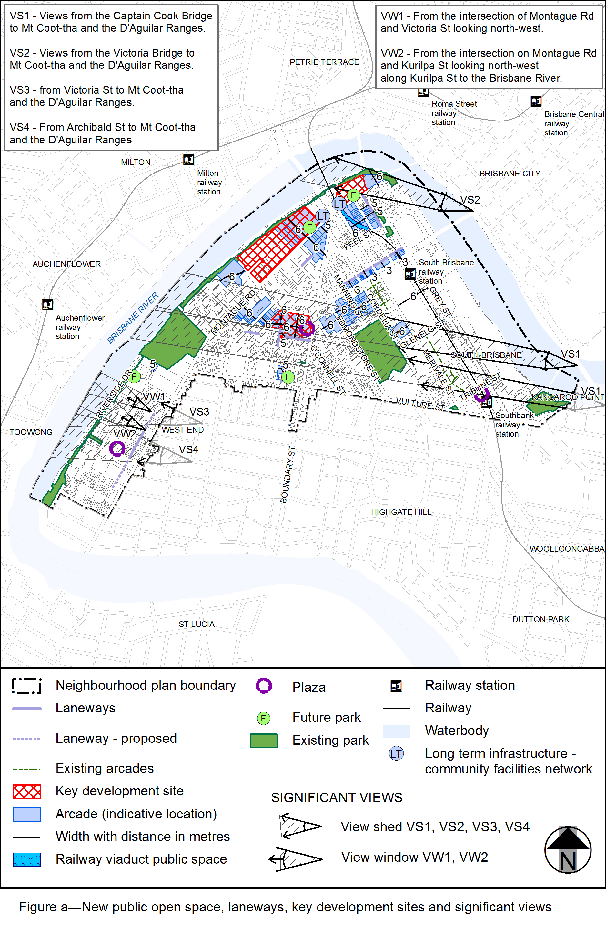

View the high resolution of Figure a–New public open space, laneways, key development sites and significant views (PDF file size is 321Kb)
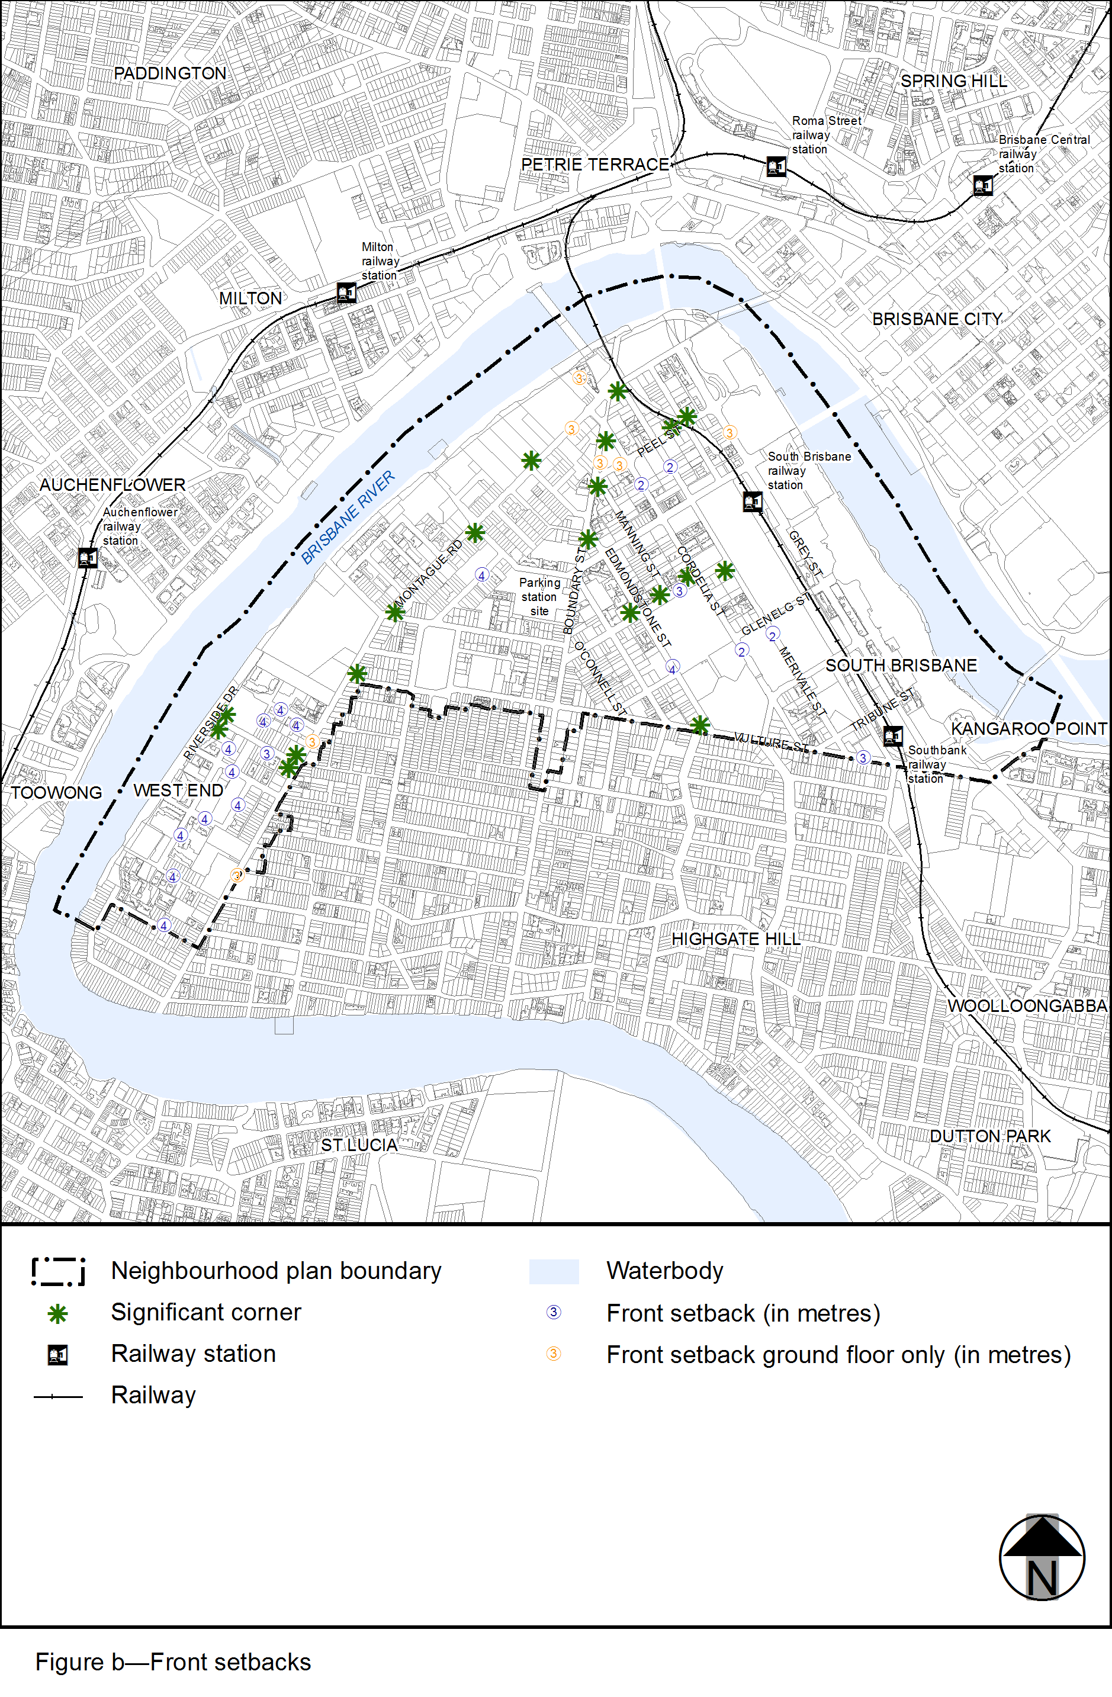
View the high resolution of Figure b–Front setbacks (PDF file size is 508Kb)
