7.2.23.2 West End—Woolloongabba district neighbourhood plan code

7.2.23.2.1 Application
- This code applies to assessing a material change of use, reconfiguring a lot, operational work or building work in the West End—Woolloongabba district neighbourhood plan area if:
- assessable development where this code is an applicable code identified in the assessment benchmarks column of a table of assessment for a neighbourhood plan (section 5.9); or
- impact assessable development.
- Land in the West End—Woolloongabba district neighbourhood plan area is identified on the NPM-023.2 West End—Woolloongabba district neighbourhood plan map and includes the following precincts:
- West End estate precinct (West End—Woolloongabba district neighbourhood plan/NPP-001).
Editor's note—Part of the neighbourhood plan area is covered by the Woolloongabba priority development areas which Economic Development Queensland is responsible for planning under the Economic Development Act 2012.
- When using this code, reference should be made to section 1.5, section 5.3.2 and section 5.3.3.
Note—The following purpose, overall outcomes, performance outcomes and acceptable outcomes comprise the assessment benchmarks of this code.
Note—This neighbourhood plan includes a table of assessment with variations to categories of development and assessment. Refer to Table 5.9.68.A, Table 5.9.68.B, Table 5.9.68.C and Table 5.9.68.D.

7.2.23.2.2 Purpose
- The purpose of the West End—Woolloongabba district neighbourhood plan code is to provide finer grained planning at a local level for the West End—Woolloongabba district neighbourhood plan area.
- The purpose of the West End—Woolloongabba district neighbourhood plan code will be achieved through overall outcomes including overall outcomes for each precinct of the neighbourhood plan area.
- The overall outcomes for the neighbourhood plan area are the following:
- Views of significance to the City Centre and locality from the public realm are maintained and enhanced, including:
- across the West End peninsula to the City Centre and the ridgeline of the Taylor Ranges;
- to significant landmarks within the locality;
- to the Brisbane River.
- Development is of a height, scale and form which is consistent with the amenity and character, community expectations and infrastructure assumptions intended for the relevant precinct, sub-precinct or site and is only developed at a greater height, scale and form where there is both a community need and an economic need for the development.
- West End estate precinct (West End—Woolloongabba district neighbourhood NPP-001) overall outcomes are the following:
- Dwelling houses are preserved in their current form, scale and setting, so the original historical character and pattern of development in this precinct of relatively intact, historically significant grouping of small 19th century and early 20th century workers cottages, characterised by 1-storey timber and tin detached dwelling houses on small narrow lots, is retained.

7.2.23.2.3 Performance outcomes and acceptable outcomes

Table 7.2.23.2.3.A—Performance outcomes and acceptable outcomes
Performance outcomes | Acceptable outcomes
General
PO1  Development is of a height, scale and form that achieves the intended outcome for the precinct, improves the amenity of the neighbourhood plan area, contributes to a cohesive streetscape and built form character and is:  - consistent with the anticipated density and assumed infrastructure demand;  - aligned to community expectations about the number of storeys to be built;  - proportionate to and commensurate with the utility of the site area and frontage width;  - designed so as not to cause a significant and undue adverse amenity impact to adjoining development;  - sited to enable existing and future buildings to be well separated from each other and to not prejudice the development of an adjoining site.  Note—Development that exceeds the intended number of storeys or building height can place disproportionate pressure on the transport network, public space or community facilities in particular.  Note—Development that is over-scaled for its site can result in an undesirable dominance of vehicle access, parking and manoeuvring areas that significantly reduce streetscape character and amenity. | AO1  Development complies with the number of storeys and building height in Table 7.2.23.2.3.B.  Note—Neighbourhood plans will mostly specify maximum number of storeys where zone outcomes have been varied in relation to building height. Some neighbourhood plans may also specify height in metres. Development must comply with both parameters where maximum number of storeys and height in metres are specified.
PO2  Development minimises visual impacts to view corridor of local significance and enhances opportunities for observation of key vistas and views from identified view points. | AO2.1  Development minimises impacts on views, as shown in Figure c.
AO2.2
Development enhances opportunities for views and vistas from the view point.
If in the West End estate precinct (West End—Woolloongabba district neighbourhood plan/NPP-001)
PO3  Development retains the original historic character and pattern of development. | AO3.1  Development retains buildings built in 1946 or before.
AO3.2
Development ensures that buildings built in 1946 or before are sited at the front of the site facing the street frontage.
PO4  Development presents as small lots with narrow street frontages. | AO4.1  Development does not straddle existing lot boundaries.
AO4.2
Development results in 1 dwelling house and no secondary dwelling house on each lot.
PO5  Development:  - retains the original historic character and pattern of development;  - is consistent with the form, mass, scale and rhythm of other dwelling houses built in 1946 or before in the street and precinct. | AO5.1  Development has a maximum site cover of 50% of the site area.
AO5.2
Development of a dwelling house is set back from the front alignment within 20% of the average setback of adjoining buildings fronting the same street.
AO5.3
Development, where there are two street frontages, has a primary street frontage that the majority of houses in the street front. The secondary street frontage complies with the rear boundary requirements.
AO5.4
Development, if new building work on corner sites, has a minimum setback along the longer frontage of 1.5m.
AO5.5
Development has a minimum rear boundary setback of 6m.
AO5.6
Development on corner sites for new building works has a minimum setback along the longer frontage for new of 1.5m.
AO5.7
Development has no built to boundary walls.
PO6  Development provides for building heights and alterations to the front elevation that are sympathetic to adjacent and existing dwelling houses and does not detract from the character streetscape. | AO6.1  Development results in a front elevation that is a maximum of 4.8m above ground for a minimum of 65% of the front elevation.
AO6.2
Development results in any new ground storey having a ceiling height a minimum of 2.4m to the street, as shown in Figure a.
Note—Traditional verandah roofing was approximately 2.1m at the edge. Excavating under a dwelling house or a combination of raising and excavating is preferred to achieve compatible scale and height.
PO7  Development provides for new ground-storey enclosures that are recessed in line with the main building core, as seen from the street. | AO7  Development results in any ground storey being recessed a minimum of 2m from the front building line of the level above.  Note—Refer to Figure a.
PO8  Development for dwelling houses and new buildings must retain or use traditional pitched roof forms and architectural elements that:  - are sympathetic to the existing and adjacent buildings built in 1946 or before in the street;  - do not detract from the streetscape. | AO8.1  Development has roof forms that are pyramidal with side front gable or reverse gable only.  Note—Mono pitch and skillion roofs to the street are not consistent with the outcomes sought.
AO8.2
Development has a minimum roof pitch of 26.5°.
PO9  Development for:  - new buildings complement the form, scale and traditional character of dwelling houses built in 1946 or before in the street;  - new building work is the same form and scale as surrounding character houses and is not pseudo-historic replication. | AO9  Development is in accordance with Figure b , and the composition of entries and verandahs, car accommodation and roof shape conform to the overall street pattern.  Note—Contemporary detailing is restricted to the rear of the dwelling.
PO10  Development has a street elevation with a verandah similar to other dwelling houses in the street built in 1946 or before. | AO10.1  Development results in street elevations composed of full-length verandahs or a combination of projecting gabled rooms with verandahs.  Note—Verandahs may be enclosed if they retain a lightweight transparent appearance and are capable of being reversed. Refer to Figure b.
AO10.2
Development has external stairs on the front elevation to access the first floor.
PO11  Development has fences visible from the street that are low and transparent and complement traditional fencing styles in the precinct. | AO11  Development has a maximum front fence height of 1.2m with timber paling or wire.
PO12  Development of new buildings use lightweight materials that are sympathetic to other dwelling houses in the street built in 1946 or before. | AO12  Development of new buildings use lightweight materials that are sympathetic to other dwelling houses in the street built in 1946 or before.  Note—Traditional materials are painted timber walls and corrugated metal roof sheeting.
PO13  Development has parking that does not dominate the appearance and setting of the dwelling house when viewed from the street. | AO13.1  Development on a site that does not have existing car parking does not require any new on-site car parking.
AO13.2
Development has garages or carports that are not located between the front elevation and the front boundary, and are:
- located a minimum of 2m behind the building line;
- a maximum width of 3m.
AO13.3
Development has other car parking that is single width only and is recessed 2m behind the building line.
Note—Refer to Figure a.
AO13.4
Development has a maximum driveway crossover width of 3m.

Table 7.2.23.2.3.B—Maximum building height
Development | Building height  (number of storeys) | Building height (m) | Building height to rear and side eaves (m)
If in the West End estate precinct (West End—Woolloongabba district neighbourhood plan/NPP-001)
Any development in this precinct | 2 | 9.5 | 6.2

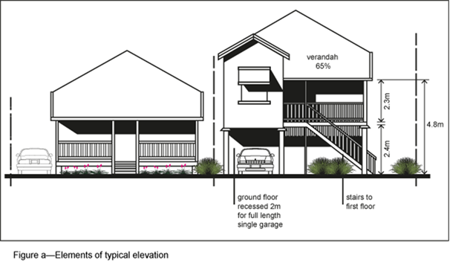

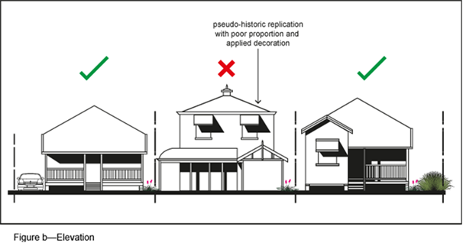

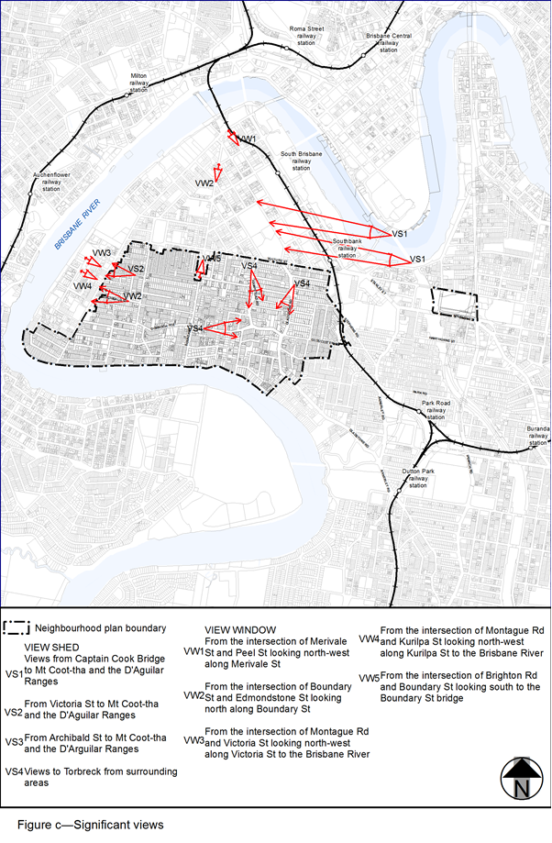

View the high resolution of Figure c–Significant views (PDF file size is 450Kb)

