Chapter 3 Road corridor design

Contents
3.1 Introduction
3.2 Major roads
3.3 Minor roads
3.4 Freight routes
3.5 Pavement design
3.6 Bicycle routes
3.7 Streetscape hierarchy
3.8 Heritage kerb
3.9 Wildlife movement solutions
3.10 Traffic management and direction
3.11 Fences and barriers

3.1 Introduction

3.1.1 General
- This chapter outlines the following for road and transport infrastructure:
- design and construction standards;
- advice about satisfying assessment benchmarks in the planning scheme;
- the information that the Council may request to be supplied for a development application.
- The purpose of the design standards and specifications identified in this chapter is to ensure that roads and transport infrastructure are designed and constructed to adequately provide for, where appropriate:
- safe and convenient travel for pedestrians, cyclists, public transport, freight and private vehicles;
- parking for vehicles;
- access to properties;
- stormwater drainage;
- installation of utility services;
- accommodation of the largest service vehicle likely to access the site;
- aesthetics, improved liveability and economic growth;
- amelioration of noise and other pollution;
- a low maintenance asset for Council.
- This chapter provides the acceptable outcome for development within the road reserve.
- Deviations from or modifications to the design standards set out in this chapter may be acceptable, however it is the responsibility of the applicant to demonstrate that the proposal meets the performance outcomes of the applicable code.
- All work within the road reserve requires a Council permit.
- Some existing parts of the freight network might not comply with all of the current specified design standards.

3.1.2 Application
- The design standards stated in this chapter apply to development that requires:
- new roads and transport infrastructure;
- upgrades to existing roads and infrastructure that are reasonable and relevant to the plans for upgrades and the expected impact of the proposed development.
- The design standards identified by the road hierarchy may be modified or augmented by the design requirements of the freight, public transport, bicycle or streetscape networks.
- In addition to this planning scheme policy, road corridors are planned, designed and constructed in accordance with the current edition of the following:
- Council’s standard drawings;
- Road planning and design manual (Queensland Department of Transport and Main Roads);
- Manual of uniform traffic control devices (Queensland Department of Transport and Main Roads);
- Austroads Guide to road design;
- Translink public transport infrastructure design manual;
- Australian standards (as specifically referenced in each section).
- Queensland Traffic and Road Use Management Manual (TRUM);
- Queensland Department of Transport and Main Roads traffic control drawings.
Note—Where there is a conflict in the design standards between these references, the document listed first prevails over the others in descending order.

3.2 Major roads

3.2.1 Design principles
- Major roads are designed to allow the movement of through-traffic vehicles, including freight and buses, pedestrians and cyclists.
- Major roads form part of the public domain and are designed to accommodate a balance of social and economic functions, especially in centres.
- The design of each major road will depend upon their modal priority which may vary for:
- each road;
- individual sections of a road;
- at different times of the day, such as clearway for morning peak and parking during the remainder of the day.
- Corner truncations, comprising minimum 6m long by 3 equal chord truncations. For freight-dependent development roads the minimum size corner truncation is to be 10m long by 5 equal chords.
Note—Truncations may be modified by the Streetscape hierarchy overlay.

3.2.2 Standard drawings
Table 3.2.2.A identifies the standard drawings which apply for the design of major roads.

Table 3.2.2.A—Standard drawings for major roads
Drawing number | Drawing title
BSD-1022 | Road types and road widths (major roads)
BSD-8301 | Roadside swale types and typical sections
BSD-2001 | Kerb and channel profiles
BSD-5231 | Kerb ramp
BSD-2101 | Bus bay slab (standard crossfall)
BSD-2102 | Bus bay slab (adverse crossfall)
BSD-3162 | Passenger loading zone
BSD-2103 | Premium bus stop
BSD-2104 | Intermediate bus stop
BSD-2105 | Regular bus stop
BSD-2107 | Adshel ‘mini’ bus shelter
BSD-2108 | Adshel ‘boulevard’ bus shelter
BSD-2109 | Translink standard bus shelter typical layout
BSD-3003 | Typical passing lane treatments
BSD-3006 | Turning template Volvo 10B bus
BSD-3164 | Typical pavement markings – signalised pedestrian crossing
BSD-3165 | Typical pavement markings – signalised intersection crossing
BSD-3156 | Raised pavement markers, standard install painted islands/medians
BSD-5101 | Bike lane pavement markings (on road bike lanes)
BSD-5102 | Bike lane widths on carriageway
BSD-5103 | Bike lanes - markings at bus stops
BSD-5104 | Bike lanes at signalised intersection, through and right turn movement
BSD-5105 | Bike lanes - commencement and termination details
BSD-5106 | Bike lanes, roundabouts, lanes on all approaches
BSD-5260 | Pedestrian refuge general design criteria
BSD-5257 | Pedestrian refuge with kerb buildouts
BSD-5259 | Pedestrian refuge supplementary details
BSD-2061 | Precast traffic island codes and details (sheet 1 of 2)
BSD-2061 | Precast traffic island codes and details (sheet 2 of 2)

3.2.3 Design standards
- Table 3.2.3.A provides a summary of the design standards for major roads. Pavement design requirements for major roads are detailed in section 3.5.
- Parts of the existing road network might not comply with all of the current specified design standards.
Note—The majority of motorways and some arterial roads in the local government area are owned and managed by the Queensland Government and are not covered by these road design requirements. Refer to Chapter 2 of this planning scheme policy.

Table 3.2.3.A—Design standards for major roads
Design standards | Motorway | Arterial road | Suburban road | District road
General requirements
Traffic volume (vpd) – guideline | Refer to Queensland DTMR Road Planning and Design Manual | >30,000 | 15,000–30,000 | 6,000–15,000
Design speed |  | 90km/h minimum | 80km/h minimum | 60km/h minimum
Typical sign posted speed (maximum) |  | 80km/h | 70km/h | 60km/h
Design vehicle ⁽¹⁾ |  | Standard vehicle | Standard vehicle | Standard vehicle
Direct lot access |  | No | No | No
Cross section ⁽²⁾
Reserve width (minimum) | Refer to Queensland DTMR Road Planning and Design Manual | 33m–40m | 33m-–-40m | 19.5m
Minimum carriageway width
— number of traffic lanes |  | 6 ⁽³⁾ | 4 ⁽⁴⁾ | 2–4
— minimum width of through traffic lanes ⁽⁵⁾ |  | 3.5m | 3.5m | 3.5m ⁽⁵⁾
— number of parking lanes |  | None | None | None
Road crossfall |  | 2.5% | 2.5% | 2.5%
Minimum bicycle lane width |  | 2m | 1.8m | 1.8m
Bus facilities |  | Design for indented bus bay | Design for indented bus bay | On road bus stops within parking lane if already provided  OR  Design for indented bus bays where no parking lane
Verge width (minimum) ⁽⁶⁾ |  | 4.25m | 4.25m | 4.25m
Geometric requirements for roads
Longitudinal grade | Refer to Queensland DTMR Road Planning and Design Manual
— maximum |  | 5% | 6% | 6%
— minimum |  | 1% | 1% | 1%
Length between tangent points (minimum) |  | 80m | 50m | 50m
Vertical curve length for grade change >1% (minimum) |  | 90m | 60m | 60m
Horizontal curve radius (minimum) |  | 300m | 300m | 130m
Vertical curve radius (minimum) |  | 2900m | 2900m | 2900m
Super-elevation |  | Full | Full | Full
Notes—
(1) If the road is also identified by the freight network overlay, the design vehicle may be larger.
(2) Refer to BSD-1022 for typical cross sections.
(3) As an interim, an arterial route may have 4 traffic lanes, depending on expected traffic volumes.
(4) As an interim, a suburban route may have 2 traffic lanes, depending on expected traffic volume.
(5) The minimum kerbside lane width is 4.5m if parking is provided.
(6) Unless varied by the Streetscape hierarchy overlay or Bicycle network overlay.
(7) Fixed objects include median barriers and vegetation.

3.2.4 Cross-section for major roads standards

3.2.4.1 General
- This section outlines additional design standards for instances where modification of the design standards in Table 3.2.3.A may be appropriate.
- The cross-section elements include:
- traffic lanes;
- verges;
- roadside drainage;
- medians;
- bicycle lanes;
- bus provision;
- on-street parking;
- bus stops;
- auxiliary lanes;
- pavement taper.
- When, as an outcome of development, only part of the ultimate design is constructed (such as one carriageway of a future dual carriageway, or an upgrading of a section of existing road), the interim cross-section provides for all road users. Bicycle, pedestrian and public transport facilities are incorporated into the partial design.

3.2.4.2 Traffic lanes
- Minimum traffic lane widths for both vehicles are provided in accordance with Table 3.2.3.A. Additional width may be required to achieve lateral clearances specified in either the Manual of Uniform Traffic Control Devices (Queensland) or Austroads.
- Sealed shoulders of 1.5m are required where no kerb exists.
- Sealed shoulders are constructed with a smooth surface flush with the vehicular lanes.

3.2.4.3 Roadside drainage
- Opportunities for including water sensitive urban design principles into the design of the road network must be maximised.
- Water sensitive urban design sections that incorporate swales are shown on BSD-8301.
- In already-developed built-up urban areas, kerb and channel, Standard Type E (BSD-2001) is the normal edge treatment for major roads.
- Mountable type kerb (BSD-2001) is used in medians and traffic islands.
- The existing ultimate alignment of the kerb and channel may not be known until a road survey is undertaken, which should extend a minimum of 50m along the road beyond the frontage of the development site and a minimum of 5m onto the adjacent land to determine the alignment for kerb and channel and the extent of cut and fill batters.
- The longitudinal grade of kerb and channel should not be less than 1V: 250H. To reduce the length of possible pondage in the channel, the vertical radii should be limited to a maximum of 3000m for crest curves and 1250m for sag curves.
- Underbed edges, which are preferred in non-urban environments, usually require table drains and wider verges than in kerbed/underground drainage situations.

3.2.4.4 Medians
Features of the 2 standard median widths as provided in BSD-1022 are shown in Table 3.2.4.4.A.

Table 3.2.4.4.A—Medians for major roads
Feature | Median width
 | 4.8m | 6m
Residual median width at signalised intersections ⁽¹⁾ | 1.8m | 3m
Allows for shelter of vehicles within median opening undertaking staged movement at un-signalised intersections | No | Yes
Allows sufficient refuge for staged movement of pedestrians at signalised intersections ⁽²⁾⁽³⁾ | No | Yes
Allows for installation of street lighting within median ⁽⁴⁾ | Yes | Yes
Intersection types | Signalisation only | Signalisation  priority controlled (non-signalised)
Notes—
(1) Given turn lane width of 3m. A residual median width of 1.8m is the minimum to accommodate a traffic signal.
(2) Medians are very important for the refuge of pedestrians that may otherwise become stranded when attempting to cross a multi-lane road.
(3) Subject to road design, the median may be reduced to 1.2m in areas not located near intersections.
(4) The median width to accommodate street lighting is 2m minimum (source: Energex).
In general, coloured surface, exposed aggregate, broomed concrete, or stencilled concrete treatments are preferred to paver bricks, due to maintenance considerations. Refer to Reference Specification for Civil Engineering Works S155 Road Pavement Markings for approved surface colours. Turfed and landscaped medians should have side drains installed under the median kerb (i.e. on both sides of the median). An outlet should be provided for these side drains to an existing maintenance hole, gully or other functional side drain.

3.2.4.5 Bicycle lanes
On-carriageway bicycle lanes are required on all major roads. Further information is provided in section 3.5 of this planning scheme policy.

3.2.4.6 Bus provision
- The major road network is designed to accommodate buses, which may include indented bus bays, transit lanes, dedicated bus lanes and priority treatment at intersections.
- Bus turn-path templates are provided in BSD-3006.

3.2.4.7 Bus stops
- Bus stops on arterial and suburban roads are located in indented bays designed to accommodate a 14.5m bus in all circumstances. The design of indented bus bays is provided in BSD-2101 and BSD-2102.
- Bus stops on district roads that are located within the kerbside parking lane and are to accommodate a 14.5m bus in all circumstances. The design of the bus stop is provided in BSD-2104.
- At locations where a parking lane is not provided, the bus stop is to be indented as per BSD-2101 and BSD-2102.
- Bus stops are located in the vicinity of intersections (preferably on the departure side) to enable pedestrians to cross major roads at signalised intersections.
- Bus shelters are to be provided in accordance with TransLink drawing no. Tl-4B (Bus shelter design –Type 4B). Design requirements are provided in BSD-2109 and Queensland Department of Transport and Main Roads Public Transport Infrastructure Design Manual.

3.2.4.8 On-street parking
- Vehicle parking is not acceptable on major roads.
- Consideration may be given to permitting parking in the kerbside lane of a four-lane road or a six-lane road at time periods deemed appropriate by Council.
- At locations where parking is permitted out of clearway restriction times, the width of the kerb lane is 4.5m to accommodate parallel parked vehicles and cyclists.

3.2.4.9 Auxiliary lanes
- On two-lane roads, typically district roads, turn lanes or passing lanes are required at all intersections except if with minor roads and driveways.
- A typical passing lane treatment at an intersection with a neighbourhood road is shown in BSD-3003. This requirement also applies in situations where access is being obtained from an existing two-lane road and the warrants as specified by the Road planning and design manual (Queensland Government’s Department of Transport and Main Roads) for dedicated turn lanes are not met.

3.2.4.10 Pavement taper
- If pavement widening is required on the road frontage of a development site and the road is not constructed to the ultimate width, a pavement taper is required.
- The pavement taper is to be a minimum of 1V:10H as a transition between the new and existing pavements of differing width.
- The pavement taper is to start at the lot boundary and extend away from the lot.
- A tapering of pavement is not permitted in tight curves.
- A longer taper is required at locations such as intersections and merge lanes to facilitate traffic operations.

3.2.5 Road alignment for major roads

3.2.5.1 Horizontal alignment
- In urban areas, constraints may dictate the adoption of adverse crossfall, which would require larger radius curves to compensate.
- At intersections, through lane alignments should be straight. If a curve is unavoidable, it must not start within an intersection.
- The speed value of a curve, as suggested by its geometry, may not be achieved because of the restriction of stopping sightlines by lateral obstructions. Where the angle of deflection is small, significantly larger radius must be used to achieve an adequate curve length and avoid kinks. It is the radii achieved for the through lanes, not for the design centre-line, which is important.
- In reverse curve situations:
- a length of the tangent between the curves is used to improve driveability and aesthetics;
- curves must be of a similar radius;
- broken back or compound curves, the radius of the second curve must not be less than that of the first;
- these or higher standards are applied to deviations of through lanes which result from the introduction of turn lanes.
- Where a reduction in the number of lanes is proposed:
- tapers appropriate for the design speed are to be provided for the terminating lane;
- tapers are located to provide merging vehicles with good visibility of the traffic stream that is being entered and facilitate safe and effective merging;
- the preferred location for terminating the lane is the outside of a curve;
- in a multi-lane situation, the dropping of the right hand lane is not acceptable.

3.2.5.2 Vertical alignment
- Sag vertical curves have smaller radii, based on comfort and aesthetic criteria.
- It is desirable, if possible, to coordinate vertical curves with horizontal.
- Intersection locations are dictated by vertical sightline considerations.
- The consideration of intersection-specific sight distance requirements influence the vertical alignment adopted for the major road carriageway.

3.2.6 Intersections for major roads

3.2.6.1 General
- To match mid-block capacity, intersection flaring (i.e. by the addition of left and right turn lanes and in some cases, through lanes) is to be used on major roads.
- Right turn lanes are offset from through lanes, where possible.
- On the major road network, all turning movements are available.
- Intersections on bus routes are designed to accommodate bus turning path templates.

3.2.6.2 Signalised intersections
- Separate lanes are provided for left turn movements on major roads (i.e. slip lanes).
- In the vicinity of uses generating high pedestrian volumes (e.g. shopping centres and schools), slip lanes are not preferred and signalisation of pedestrian movement should be considered.
- Single stage pedestrian crosswalks are provided across all legs of a signalised intersection.
- Detailed design requirements for signals are provided in the BSD-4000 series.
- Further information regarding electrical and communications associated with signalised intersections is provided in Chapter 9 of this planning scheme policy.

3.2.6.3 Priority controlled intersections
- T-intersections are preferred instead of cross-junctions or multi-leg treatments.
- Roundabouts are only used on roads no more than 1 level apart in the road hierarchy with reasonably balanced traffic flows.
- Traffic on major roads approaches should not be unreasonably impeded by minor road approach traffic.
- On major roads, roundabouts are only used at the lowest end of the traffic volume range, where single lane operation can suffice. This could be as a staged treatment with single lane approaches before widening to multi-lane standard is required, at which time traffic signals may be installed.
- Multi-lane roundabouts (i.e. 2 or more circulating lanes) are not acceptable.

3.2.6.4 Intersection location
- Intersections on curves are avoided.
- If a T-intersection is located on a curve, the outside of the curve situation is preferred because of better sightlines.
- To ensure adequate visibility, intersections are located on a constant grade or in a sag vertical curve.
- Intersections near hill crests are avoided.
- Major road intersections are not located where longitudinal grades exceed 3%.

3.2.6.5 Intersection spacing
Spacing of intersections on major roads provides for signal coordination between intersections that are planned for signalisation (400–500m), as well as reasonable time intervals between driver decisions for other intersections with lesser roads (150m).

3.2.6.6 Intersection stagger
T-intersections are preferably staggered right–left. This is required to prevent back-to-back turn right lanes and associated sight distance restraints and results in a safer outcome for vehicle operation.

3.3 Minor roads

3.3.1 Design principles
- Minor roads are designed to be a priority pedestrian and bicycle environment with low-speed traffic and provide:
- property access;
- circulation within a local area;
- a connection to major roads.
- The layout of minor roads should incorporate the following principles:
- good pedestrian and cyclist connectivity;
- connections to the surrounding public transport, pedestrian and bicycle hierarchies;
- circulation between surrounding neighbourhoods promotes travel on minor roads rather than major roads;
- no more than 3 minor roads are traversed from any 1 lot to access the nearest accessible district road;
- travel time for a vehicle in a low-speed residential environment from an individual lot to connect to a major road is no greater than 90 seconds;
- the temporary storage and collection of refuse and recyclables from each lot is considered when planning the layout of the development and subdivision;
- turn lanes and special provisions for passing vehicles are not required on minor roads.
- For the design of new subdivisions, traffic catchments for minor roads are:
- 300 lots for neighbourhood roads;
- 100 lots for local roads (excluding laneways).
- If an area is accessed by only 1 road that is likely to carry more than 100 vehicles per day, alternative emergency access is provided.
- Development proposals for new urban areas must show the proposed local road layout in a traffic impact report. For more information on the traffic impact report see the Transport access parking and servicing planning scheme policy.
Note—Special passing provision is not required in residential minor roads provided that design conforms to BSD-1021.

3.3.2 Standard drawings
Table 3.3.2.A identifies the standard drawings, which apply for the design of minor roads.

Table 3.3.2.A—Standard drawings for minor roads
Drawing number | Drawing title
BSD-1021 | Road types and road widths (minor and freight-dependent development roads)
BSD-8301 | Roadside swale types and typical sections
BSD-2001 | Kerb and channel profiles
BSD-2002 | Precast kerb blocks
BSD-2104 | Intermediate bus stop
BSD-2105 | Regular bus stop
BSD-2109 | Translink standard bus shelter typical layout
BSD-3001 | Typical manoeuvring areas – residential streets
BSD-3002 | Turning provisions for industrial areas
BSD-3003 | Typical passing lane treatments
BSD-3219 | Local traffic area - Angled slow way 1 lane - 1 way - General design criteria
BSD-3004 | Turning template Acco 2350 side loading refuse vehicle
BSD-3005 | Turning template Scania L94UB CR22L bus
BSD-3006 | Turning template Volvo 10B bus
BSD-3164 | Typical pavement markings – signalised pedestrian crossing
BSD-3165 | Typical pavement markings – signalised intersection crossing
BSD-3166 | Raised pavement markers, standard install painted island/medians
BSD-5101 | Bike lane pavement markings (on road bike lanes)
BSD-5102 | Bike lane widths on carriageway
BSD-5103 | Bike lanes - markings at bus stops
BSD-5104 | Bike lanes at signalised intersection, through and right turn movement
BSD-5105 | Bike lanes - commencement and termination details
BSD-5106 | Bike lanes, roundabouts, lanes on all approaches
BSD-3201 | Local traffic area - Brisbane City - General design criteria
BSD-3166 | Coloured pavement threshold treatment general design and specification
BSD-3211 | Local traffic area - Roundabout – Central island with concrete apron
BSD-3212 | Local traffic area roundabout – fully mountable A.C plateau
BSD-5260 | Pedestrian refuge general design criteria
BSD-5257 | Pedestrian refuge with kerb buildouts
BSD-5259 | Pedestrian refuge supplementary details
BSD-3213 | Local traffic area - Intersection priority change - General design criteria
BSD-3214 | Local traffic area - Modified T junction - General design criteria
BSD-3216 | Local traffic area - Speed platform - Mid block - General design criteria
BSD-3217 | Local traffic area - Speed platform - Intersection - General design criteria
BSD-3219 | Local traffic area - Angled slow way 1 lane - 1 way - General design criteria
BSD-3220 | Local traffic area - Angled slow way 2 lane - 2 way - General design criteria
BSD-3221 | Local traffic area - Perimeter gateway - General design criteria
BSD-2061 | Precast traffic island codes and details (sheet 1 of 2)

3.3.3 Design standards
- Table 3.3.3.A provides a summary of the design standards for minor roads. Pavement design requirements for minor roads are detailed in section 3.5.
- Parts of the existing road network might not comply with all the current specified design standards.

Table 3.3.3.A—Design standards for minor roads
Design standards | Neighbourhood roads |  | Local
 |  |  | Streets | Laneways
General requirements
Traffic volume (vpd) – guideline | 1,000–3,000vpd | 3,000–6,000vpd | 1,000vpd maximum | <750
Design speed | 40km/h maximum | 50km/h maximum | 40km/h maximum | 40km/h maximum
Design vehicle ⁽¹⁾ | Domestic refuse collection vehicle | Domestic refuse collection vehicle | Domestic refuse collection vehicle | Domestic refuse collection vehicle
Direct lot access | Yes | Yes⁽⁷⁾ | Yes | Yes
Cross-section⁽¹²⁾
Reserve width  (minimum) ⁽²⁾ | Bus route: 20m | 24m | 14m | N/A
 | Non-bus route: 16m
Road carriageway⁽¹¹⁾⁽¹²⁾
— Kerb-to-kerb widths ⁽³⁾ | Non-bus route 7.5m | 15.5m | 5.5m | N/A
 | Bus route 11m
— Number of moving lanes | 1–2 ⁽⁸⁾ | 2 | 1 ⁽⁸⁾ | 1-2
— Number of parking lanes | 1–2 | 2 | 1 | N/A
Road crossfall | 2.5% | 2.5% | 2.5% | 2.5%
Verge crossfall | 2% | 2% | 2% | 2%
Cyclist facilities | N/A | Bicycle lane | N/A | N/A
Bus facilities | Kerbside stops on bus routes | Kerbside stops on bus routes | Not permitted | Not permitted
Verge width (minimum) ⁽⁴⁾ | 4.25m | 4.25m | 4.25m | N/A
Longitudinal grade
— Maximum | Bus route: 10% | 10% | 16.7% | N/A
 | Non-bus route: 16.7%
— Minimum | 1% | 1% | 1% | 1%
Length between tangent points (minimum) | 30m | 50m | Cul-de-sac: 15m ⁽⁵⁾ | N/A
 |  |  | 20m ⁽⁵⁾
Vertical curve length for grade change >1% (minimum) | 35m | 60m | Cul-de-sac: 20m ⁽⁵⁾ | N/A
 |  |  | 30m ⁽⁵⁾
Horizontal curve radius -  minimum centrelines ⁽⁶⁾ | 13.75m | 80m | 12.75m | N/A
Kerb and channel profile ⁽⁹⁾ | Bus route: standard type E | Standard type E | Layback type D ⁽¹⁰⁾ | N/A
 | Non-bus route: layback type D
Notes—
(1) If the road is also identified as part of the freight network on the Road hierarchy overlay map, the design vehicle may be larger.
(2) Refer to BSD-1021.
(3) Kerb-to-kerb width measured from nominal face of kerb, except for kerb type ‘D’ (BSD-2001) measured from kerb invert.
(4) Unless varied by the Streetscape hierarchy overlay code or Bicycle network overlay code.
(5) Where the geometry would allow a higher speed, a higher standard is required.
(6) Tight curves are a preferred speed control feature. Any design needs to ensure that the design vehicle will not cross the centre-line of the road on a horizontal curve.
(7) For neighbourhood roads with design traffic volumes over 3,000 vehicles per day, direct property access is only provided where the carriageway width is 15.5m or wider to provide 2 moving lanes, bicycle lanes and kerbside parking lanes.
(8) Special passing provision is not required (i.e. residential minor road).
(9) Refer to BSD-2001. 200 Type E kerb and channel is required along a park frontage unless an alternative is approved for water sensitive design.
(10) For water sensitive design, refer to BSD-8301. Alternative kerb and channel types may be acceptable to achieve water sensitive design intent in localised areas.
(11) Where a neighbourhood or local road is identified as either a primary freight route or primary freight access road, the pavement design standards relating to freight identified in section 3.5 will be applicable. Similarly, where a minor road is located within an industrial area or provides access to an industrial use (i.e. low impact industry, medium impact industry, high impact industry, or special industry) the pavement design standards relating to freight identified in section 3.5 will also be applicable.
(12) Cross-sections for minor roads within the Centre zone category require increased corridor widths to accommodate indented on-street car parking.

3.3.4 On-street parking
- The availability of on-street parking relates to the width of road pavement, the width of the frontage of the allotments and the size of the traffic catchment to the street.
- The standard carriageway cross-section is usually adequate in the provision of parallel parking for visitors.
- Additional parking bays are required in the vicinity of cul-de-sac heads where sufficient kerb space is not available.
- On local roads with a cul-de-sac head, the limited road frontage, measured from the first approach tangent point, is excluded when assessing on-street parking requirements. Instead, a special parking provision, such as indented bays or central island parking, is provided.
- If provided, parking lanes of 2.5m wide are indented excluding adjacent bicycle and through traffic lanes.
- A separation of 0.25m is required between parking bays and the bicycle lane to mitigate effects of door opening.

3.3.5 Lot access
For neighbourhood roads with design traffic volumes of over 3,000 vehicles per day, direct lot access is only provided if the carriageway width provides for separation of parking, bicycle and traffic lanes.

3.3.6 Intersections for minor roads

3.3.6.1 General
- Intersections on minor roads are generally priority controlled.
- Design of intersections should include a kerb return radius of 6m at street intersections. For freight-dependent development roads, minimum kerb return radius is to be 14m at intersection.

3.3.6.2 Priority-controlled intersections
- Priority to the through road is provided at T-intersections while traffic on the terminating road must give way.
- Types of treatments for T-intersections are shown on BSD-3213 and BSD-3214.
- Roundabouts in local and neighbourhood roads are designed with a minimum radius of 9m with a 1.5m wide concrete backing strip.
- Stop signage is appropriate for four-way cross street intersections on minor roads where traffic volumes in both roads is less than 3,000 vehicles per day.
- Traffic lights or other controls are required for minor road to major road connections or where traffic flows exceed 3,000 vehicles per day in any road.
- Pavement surface treatment is provided on the 50km/h minor road at the 60km/h major road interface. Threshold treatment may be provided on the minor road at intersections where the minor road is intersecting with a higher sign posted speed. The treatment is to be as per BSD-3166.

3.3.6.3 Intersection spacing
- Intersections within the minor road network are located sufficiently far apart to separate the traffic movements at each intersection and to provide a reasonable time interval between driver decisions.
- The desirable minimum intersection spacing’s (centre-line to centre-line distance) are for:
- local roads:
- 60m if intersections are located on the same side of through street;
- 40m if intersections are located on opposite sides of through street.
- neighbourhood roads:
- 100m if intersections are located on the same side of through street;
- 60m if intersections are located on opposite sides of through street.
- roundabouts, 80m, and maximum spacing of 120m.

3.3.6.4 Signalised intersections
- Separate lanes are provided for left turn movements on major roads (i.e. slip lanes).
- In the vicinity of uses generating high pedestrian volumes (e.g. shopping centres and schools), slip lanes are not preferred and signalisation of pedestrian movement should be considered.
- Single stage pedestrian crosswalks are provided across all legs of a signalised intersection.
- Detailed design requirements for signals are provided in the BSD-4000 series.
- Further information regarding electrical and communications associated with signalised intersections is provided in Chapter 9 of this planning scheme policy.

3.3.7 Speed control

3.3.7.1 Geometric design
- Control of vehicle speed in residential streets should be achieved through:
- horizontal curves spaced at a minimum of 80m and a maximum of 120m;
- speed control devices (e.g. one-way slow or roundabouts at intersections) spaced at a minimum of 80m and a maximum of 120m.
- Night-time legibility of speed control devices is enhanced by appropriate means including street lighting, raised retro-reflective pavement markers and white reflective road markings including white painted kerb faces.

3.3.7.2 Cul-de-sac design
- In residential areas, the length of a cul-de-sac is to be a maximum of 180m.
- In residential areas, cul-de-sac head and/or turning areas are to be designed in compliance with BSD-3001.
- In industrial areas, the cul-de-sac head is to be designed in compliance with BSD-3002.

3.3.7.3 Signage
- Signage should be kept to a minimum and only used for safety purposes.
- Locations of signage must comply with the Manual of Uniform Traffic Control Devices.

3.3.7.4 Mountable kerbs
- The standard mountable kerbs (finished height of 150mm above the adjoining road surface) are generally used in conjunction with speed control devices on minor roads.
- Where traffic is intended to regularly mount islands (e.g. apron of speed control devices), the standard mountable kerb should be lowered such that the finished height is 75mm above the adjoining road surface.

3.4 Freight routes

3.4.1 Design principles
- Roads that are identified in the freight network are designed for larger design vehicles such as B-doubles and Higher Mass Limit (HML) vehicles. The design and construction of these roads for the freight network must align with the:
- structural performance standards for roads that are identified to carry freight vehicles (pavement and structures) and requirements of section 5.3.5;
- bridge heights;
- lane widths.
- This section outlines the standards for the design and construction of all freight routes intended to be owned or maintained by Council including:
- primary freight routes;
- primary freight access.

3.4.2 Design standards
Table 3.4.2.A lists a summary of the design standards that are applicable for the freight network.

Pavement design requirements for major roads are detailed in section 3.5.

Where a neighbourhood or local road is identified as either a primary freight route or primary freight access road, the pavement design standards relating to freight identified in section 3.5 will be applicable. Similarly, where a minor road is located within an industrial area or provides access to an industrial use (i.e. low impact industry, medium impact industry, high Impact industry, or special industry) the pavement design standards relating to freight identified in section 3.5 will also be applicable.

Table 3.4.2.A—Design standards for freight network
Design criteria | Primary freight routes | Primary freight access
General requirements
Design vehicles | 25m B-double combination vehicle  HML vehicles  Vehicle carrying commercial quantities of dangerous goods ⁽¹⁾ | 25m B-double combination vehicle  HML vehicles  Vehicle carrying commercial quantities of dangerous goods ⁽¹⁾
Individual lot access | No | Yes
Cross-section
Reserve width (minimum) | N/A | If on minor road:  22.5m
Road carriageway
— kerb-to-kerb width | N/A | 14m
— number of traffic lanes | N/A | 2
— width of kerbside traffic lanes on multi-lane roads | 3.5m | 3.5m
— width of traffic lanes of two-lane roads | 4m | 4m
— number of parking lanes | N/A | 2
Cyclists facilities  — minimum width of bicycle lane | 2m | N/A
Verge width (minimum) | 4.25m | 4.25m
Geometric requirements
Longitudinal grade
— maximum | 5% | 5%
— minimum | 1% | 1%
Length between tangent points (minimum) | N/A | If on minor road:  30m
Vertical curve length for grade change >1% (minimum) | N/A | If on minor road:  35m
Horizontal curve radius (minimum) | N/A | If on minor road:  40m
Superelevation | N/A | If on minor road:  full
Note—(1) Under the provisions of the Transport Operations (Road Use Management—Dangerous Goods) Regulation 2008 dangerous good routes may exclude tunnels.

3.4.3 Cross-section for roads in freight network

3.4.3.1 General
- This section outlines additional design standards for modifying the design standards set out in Table 3.4.2.A.
- The cross-section elements include:
- traffic lanes;
- roadside drainage;
- on-street parking;
- bicycle lanes.

3.4.3.2 Traffic lanes
Widths for:
- kerbside traffic lanes on multi-lane roads are 3.5m;
- traffic lanes on two-way roads are 4m.

3.4.3.3 Roadside drainage
Vertical profile kerb and channel, (Standard Type E, as per BSD-2001), is used on freight routes unless otherwise approved.

3.4.3.4 On-street parking
Parking lanes are provided on primary freight routes.

3.4.3.5 Bicycle lanes
The minimum width of bicycle lanes on primary freight routes is 2m.

3.4.4 Intersections

3.4.4.1 Intersection spacing
Intersection spacing on primary freight routes are:
- 100m if intersections are located on the same side of through street;
- 60m if intersections are located on opposite sides of through street;
- 70m for roundabouts.

3.4.4.2 Intersection design
The design of intersections located on the primary freight network includes:
- corner truncations, comprising a minimum 10m long by 5 equal chord truncations;
- a kerb return radius of 15m at intersections.

3.5 Pavement design

3.5.1 Design principles
The underlying principle of pavement design is to achieve a pavement that is functional, structurally sound, has good ride quality, adequate skid resistance, and requires minimal maintenance under the anticipated traffic loading adopted for the design period. The selection process involves adoption of material types, thicknesses and configurations of the pavement layers to meet the design objectives. The design criteria specified in this section are based on the following publications:
- Guide to Pavement Technology – Part 2: Pavement Structural Design (Austroads, 2012);
- Reference Specifications for Civil Engineering Work (Brisbane City Council), in particular:
- S140 Earthworks;
- S150 Roadworks;
- S180 Unit Paving;
- S300 Quarry Products;
- S310 Supply of Dense Graded Asphalt;
- S320 Laying of Asphalt;
- S330 Sprayed Bituminous Surfacing.
- Pavement Rehabilitation Design Manual (Brisbane City Council);
- Pavement Design Manual – Supplement to Part 2: Pavement Structural Design of the Austroads’ Guide to Pavement Technology (Department of Transport and Main Roads, 2013);
- Guide to Pavement Technology – Part 4D: Stabilised Materials (Austroads, 2006);
- Guide to Pavement Technology – Part 4L: Stabilising Binders (Austroads, 2009);
- Guide to Industrial Floors and Pavements – Design, Construction and Specification (Cement, Concrete and Aggregates Australia, 2009);
- Guide to Residential Streets and Paths (Cement & Concrete Association of Australia, C&CAA T51, February 2004;
- Pavement Recycling and Stabilisation Guide (Auststab Ltd, 2015).

3.5.2 Design life
- The design life for flexible pavements is 20 years.
- When the 20-year design traffic loading (TL₂₀) for flexible pavements exceeds 1 x 10⁷ ESAs, a 40-year design life is required. Council approval may be granted for a shorter design life, where considered appropriate. In these circumstances, the design should include intervention strategies to extend the pavement life to 40 years.
- The design life for rigid pavements is 40 years.

3.5.3 Design traffic
- The appropriate assessment of the design traffic loading is essential in the production of an acceptable pavement design to cater for the existing traffic and remain serviceable under projected increases in traffic loading throughout the design life of the pavement.
- Design traffic shall be calculated in equivalent standard axles (ESAs) for the applicable design life of the pavement.
- In addition to published/predicted traffic generation as per the Traffic Impact Assessment Report, actual traffic counts should be used for all roads, so that traffic loading (ESAs) can be calculated and used in the pavement design. The designer should consider present and predicted heavy vehicle traffic volumes, axle loadings and configurations, heavy vehicle growth and street capacity based on the Traffic Impact Assessment Report, or Council information to determine the Design Traffic Loading. The design traffic shall take account of:
- the construction traffic associated with the development;
- the in-service traffic including any potential industries in the development;
- any future developments linked to that development;
- the projected loading from external catchments.
- The method used to calculate design traffic depends on the type of traffic data available. The selection of the appropriate level of traffic data which are to be obtained should be based on a combination of factors such as:
- availability of historical data;
- accuracy required;
- presence in the traffic spectrum of specialised loadings;
- typical axle group or loading distribution.
- Where historical data is limited, the designer will need to give consideration to the following design variables:
- present traffic volumes;
- percentage of heavy vehicles;
- road function class;
- number of ESAs per heavy vehicle;
- growth rate;
- design period.
- In industrial areas, where specific future uses are known. (e.g. a freight-dependent development such as a particular large manufacturing plant or distribution centre), appropriate generation rates for that future use or uses should be used. However, in cases where the future industrial uses will not be known, and given the potentially wide variation in traffic generation, depending on location, industry type, number of employees, amount of retailing etc. generation rates assumed for pavement design must necessarily be conservative.
- For preparing traffic studies, evidence indicates that heavy vehicles avoid peak periods where possible, therefore 6-hour peak period counts may not give an accurate indication of pavement loading caused by heavy vehicles. For upgrading and widening of existing roads and/or extensions of the existing network, 7-day classified counts are to be used where vehicles are separated into Austroads vehicle classifications. Twelve-hour traffic counts may be used to interpret historical trends and growth rates.
- The pavement design report shall include all traffic data and/or assumptions made in the calculation of the design traffic.
- Where reliable traffic data is not available, presumptive traffic loading is allowed for local and neighbourhood roads without bus services as detailed in Table 3.5.3.A.

Table 3.5.3.A—Minimum design traffic loadings by functional road class
Class of road | Minimum traffic loading (TL₂₀) (ESA)
Local road (cul-de-sac) | 4.0 x 10⁴
Local road | 1.5 x 10⁵
Neighbourhood road  (without bus services) | 9.0 x 10⁵

3.5.3.1 Traffic counts
Manual and automated intersection counts have been regularly performed throughout Brisbane. The older counts provide a historical record and may be used to predict trends in growth rates.

3.5.3.1.1 12-hour intersection counts
- Typically, the 12-hour counts represent approximately 80% of the daily traffic. The 12-hour count is multiplied by 1.25 to calculate daily traffic.
- Twelve-hour intersection counts provide the number of heavy vehicles without the Austroads classifications. The ESA per heavy vehicle can be ascertained using Table 3.5.3.1.1.A.
- The annual traffic can be estimated by multiplying the weekday traffic by the number of days/year taken as 310 days/year. However, on some roads, such as those adjoining major retail centres and sporting venues, a factor of 365 is appropriate.

Table 3.5.3.1.1.A—ESA/HV equivalencies according to road classification (not used for automated classified counts)
Road classification | ESA/HV
 | Range | Typical
Local | N/A | 0.9
Local | 0.9–1.8 | 1.2
Neighbourhood road | 1.2–2.3 | 1.5
District road | 0.8–2.0 | 1.4
Suburban road | 0.8–2.0 | 1.4
Freight network – freight-dependent development | 1.0–2.6 | 1.6
Arterial road | 1.2–2.1 | 1.7

3.5.3.1.2 Automated classified counts
- Automated traffic count reports identify the axle configuration, vehicle speeds, and vehicle classification according to Austroads classifications. Automated counts should be undertaken for at least 7 continuous days. Table 3.5.3.1.2.A shows typical ESA/HV equivalencies for automated counts for Brisbane.

Table 3.5.3.1.2.A—Typical ESA/HV equivalencies - Austroads vehicle classifications
Austroads class | Description | ESA/HV
1 | Short vehicle | 0.0
2 | Short vehicle towing | 0.0
3 | Two-axle truck or bus | 0.8
4 | Three-axle truck or bus | 2.0
5 | Four-axle truck | 3.0
6 | Three-axle articulated vehicle | 1.5
7 | Four-axle articulated vehicle | 3.0
8 | Five-axle articulated vehicle | 2.5
9 | Six-axle articulated vehicle | 3.0
10 | B-double | 4.1
11 | Double road train | 6.5
12 | Triple road train | n/a
- This data is based on the typical traffic spectrum containing a mixture of loaded and unloaded vehicles. Where the traffic spectrum is not typical e.g. haul routes with all loaded vehicles in the same direction and bus routes, higher ESA/HV equivalencies should be derived and used. If site-specific design traffic standards for ESA/HV are available, these should be used in place of the representative data shown in Table 3.5.3.1.2.A.

3.5.3.2 Traffic loading calculation
- Selecting the appropriate traffic loading is essential for achieving the desired service life. There are 2 main classes considered for pavement design:
- light-traffic roads are all roads with estimated traffic TL₂₀ ≤ 1 x 10⁶ ESAs over a 20-year period;
- heavy-traffic roads are all roads with estimated traffic TL₂₀ > 1 x 10⁶ ESAs over a 20-year period. They also include freight-dependent development roads.
- Design traffic loadings are adjusted to cater for the introduction of new generation heavy vehicles (HV) (including buses) and higher mass limits (HML) vehicles.
- The traffic loading (TL_{DES}), in cumulative ESAs, traversing the design lane during the specified period is:
 |  | 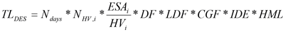 | (1)
where:
TL_{DES} | = | number of ESAs over the design period
N_{days} | = | number of days in every year over the design period – according to Table 3.5.3.2.A.
N_{HV,i} | = | number of heavy vehicles, type i, per day derived from traffic counts or  weigh-in-motion (WIM) counts
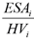 | = | number of ESAs per heavy vehicles, type i – according to Table 3.5.3.2.A.
DF⁽¹⁾ | = | direction factor – the proportion of two-way heavy vehicles travelling in the direction of the design lane
LDF | = | lane distribution factor – proportion of heavy vehicles in design lane
CGF | = | cumulative growth factor
IDE | = | increased damaging effect – according to Table 3.5.3.3.A
HML | = | higher mass limit – according to Table 3.5.3.4.A
Note—(1) Where the actual traffic count is for 1 direction only, DF = 1.0. Where AADT is used and no other information on the directional split of traffic is available, use DF = 0.5.

Table 3.5.3.2.A—Design standards for traffic loading
Measure | 12-hour intersection counts | Automated classified counts | WIM counts (if applicable)
N_{days} | Minimum value 310⁽¹⁾ | 365 | 365
 | According to Table 3.5.3.1.1.A | According to Table 3.5.3.1.2.A | According to Appendix H of Austroads (2012)
Note—(1) The annual traffic can be estimated by multiplying the weekday count by the number of days/year. The minimum value is 310 days/year. However, on some roads, such as those adjoining major retail centres and sporting venues, a factor of 365 is appropriate.
- Part of the task of estimating the cumulative traffic loading (in the design lane) over the design period is to estimate the likely changes in daily traffic loading during this period. The compound growth of traffic is usually defined as a percentage increase in annual traffic volume – a typical statement being ‘the annual growth rate is R%’. The cumulative growth factor over the design period is calculated as follows (Austroads 2010):
 |  | 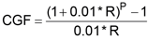 | for R>0 | (2)
 |  |  | for R=0
where:
CGF | = | cumulative growth factor (-)
R | = | annual growth rate (%)
P | = | design period (years)
- A range of annual growth rates are presented in Table 3.5.3.2.B for design periods of 20, 25 and 40 years. For other design periods, Equation (2) can be used to calculate the cumulative growth factor (CGF).

Table 3.5.3.2.B—Cumulative growth factor (CGF) values
Design period (P) (years) | Annual growth rate (R) (%)
 | 0 | 1 | 2 | 3 | 4 | 6 | 8 | 10
20 | 20 | 22 | 24.3 | 26.9 | 29.8 | 36.8 | 45.8 | 57.3
25 | 25 | 28.2 | 32 | 36.5 | 41.6 | 54.9 | 73.1 | 98.3
40 | 40 | 48.9 | 60.4 | 75.4 | 95 | 154.8 | 259.1 | 442.6
- The cumulative growth factor (CGF) values in Table 3.5.3.2.B assume that the traffic volumes are below the saturation capacity for the entire design period. The designer should check whether the saturation capacity is likely to be exceeded during the design period and whether any upgrading of road capacity is planned.

3.5.3.3 Increased damage effect (IDE) on steep grades, intersections and roundabouts
Increased pavement damage occurs when vehicles are turning at intersections and roundabouts. Uneven load distribution causes higher loads on one wheel path compared to the other and load transfer induces horizontal shear forces which can increase pavement damage significantly. Additional stresses are also generated on long, steep grades (greater than 10%) and at intersections (e.g. due to braking). At these locations, the load-induced damage may be compounded by the slowly moving load, which has a detrimental effect on the visco-elastic performance of asphalts. To allow for these effects, the traffic loading (ESA) must be increased by a factor of 1.3 in these locations. The designer need not adjust the asphalt modulus in the Mechanistic Design Procedure for low-speed environments, since this effect is considered by the increased damage effect (IDE) factor.

Table 3.5.3.3.A—Increased damage effect (IDE) values
Location | IDE value
On grades >10%, intersections, roundabouts and bus stops | 1.3
Any other road section | 1.0

3.5.3.4 Higher mass limit (HML) vehicles and B-double routes
- Higher mass limits (HML) allow for increased mass limits (axle loads) on approved routes for specific vehicles fitted with road-friendly suspension systems and operated in accordance with the Intelligent Access Program (IAP). Due to the low operating speeds of much of the Council road network, when assessing the implications of HML vehicles in pavement designs, no road wear reduction factors are to be applied to the design loads when using road-friendly suspensions.
- The Department of Transport and Main Roads (DTMR) is the regulating authority for higher mass limit (HML) and multi-combination (B-doubles) vehicles in Queensland and maintains the maps of approved routes for these classes of vehicles. Where a pavement forms part of an approved or proposed route, the calculated design traffic shall be multiplied by a factor of 2 to allow for the effects on the pavement caused by rapid loading of subsequent axle groups and reduced slow speed of travel. On roads within 200m of approved B-double and/or HML routes (except local residential access streets), on designated or proposed freight routes, in all industrial areas and freight-dependent development, this factor must be applied.

Table 3.5.3.4.A—Higher mass limit (HML) values
Location | HML value
On routes designated for specific vehicles HML vehicles and B-double vehicles)  Roads within 200m of designated HML and B-double routes other than local roads  Designated or proposed freight routes  All freight-dependent development access roads | 2
Any other road section | 1
- Where a freight-dependent development is proposed to have access available to HML and/or B-double vehicles, the route from the development to an existing 'approved' HML and/or B-double route shall be assessed and, where there is inadequate pavement strength, be upgraded to the standard suitable for HML and/or B-double vehicles.

3.5.3.5 Design traffic at intersections
Design traffic at an intersection must be calculated by adding the design traffic applicable to one road to the design traffic applicable to the crossroad. Selection of the pavement structure should be based on minimum maintenance requirements.

3.5.3.6 Deemed to comply design traffic loading for small areas
For road widening and extensions to roads subject to heavy traffic loading, the design traffic loading should be based on the results of the traffic study using actual traffic counts. However, for small areas of pavement construction (typically less than 200m2), the nominal/minimum traffic loadings for the various road classifications given in Table 3.5.3.6.A can be used. Allowances for increased damage effect (IDE) and HML values are incorporated in the nominal design traffic in Table 3.5.3.6.A.

Table 3.5.3.6.A—Design traffic by road type for flexible pavements
Road classification | Design Life | Nominal design traffic (ESA)
District | 20 years | Minimum 6.0 x 10⁶
Suburban | 20 years | Minimum 6.0 x 10⁶
Freight-dependent development | 20 years | Minimum 1.0 x 10⁷
Arterial | 40 years | Minimum 3.8 x 10⁷

3.5.4 Subgrade evaluation

3.5.4.1 General
- The design parameter for the subgrade is the California Bearing Ratio (CBR). The pavement design must be based on the soaked CBR tests being representative of the subgrade over the various lengths of road at the box depth.
- A design CBR must be determined for each unique section of road defined on the basis of topographic, geological and drainage conditions at the site. In determining the design CBR, account should also be taken of the variation of the subgrade strength with depth below subgrade level. The critical layer of material should be established to ensure each layer has adequate cover.

3.5.4.2 Sampling frequency
- Subgrade must be evaluated at the following frequencies:
- road length ≤ 120m: not less than 2 tests for each subgrade type.
- road length > 120m: 1 test for every 60m or part thereof, but not less than 3 tests for each subgrade type.
- Spacing of test sites must be selected to suit subgrade, topographic and drainage characteristics.

3.5.4.3 Laboratory determination of design Californian Bearing Ratio
- The design CBR must be based on the soaked condition in the subgrade at a compaction of 100% standard, that is, the design CBR is the four-day soaked CBR as determined by testing in accordance with AS 1289.6.1.1 (single point test).
- When the subgrade CBR is particularly sensitive to changes in moisture content, adequate testing of the CBR over a range of moisture contents and densities must be provided and CBR interpolated at the design moisture content and density conditions, that is, 4-point test using DTMR Test Method Q113A.

3.5.4.4 Maximum design CBR
A maximum subgrade CBR of 10 is to be used for design purposes. Granular subgrade with CBR values greater than 10 and which have a known in-situ service life may be accepted if accompanied by a certified geotechnical report.

3.5.4.5 Soft subgrades
- If the CBR determined for the subgrade is less than CBR 3 for flexible (granular, full depth asphalt or stabilised) pavement and CBR 5 for concrete pavement, then one of the following subgrade treatment options is required:
- remove unsuitable subgrade material and replace with Class 3 gravel or select material that meets the requirements for select fill as specified in Reference Specifications for Civil Engineering Work S140 Earthworks. The minimum depth of subgrade replacement is shown in Table 3.5.4.5.A;
- carry out lime stabilisation treatment in accordance with the methodologies set out in section 3.5.6.4;
- use other techniques such as rock spalls on geotextile, geogrids together with correctly sized gravel blanket course etc.

Table 3.5.4.5.A—Minimum depth of subgrade replacement
In-situ subgrade design CBR | Minimum depth of subgrade replacement (mm)
2.5% | 150
2.0% | 200
1.5% | 300
1.0% | 400
<1.0% | Specific assessment required
- The proposal for subgrade treatment needs to be submitted to Council for approval. After subgrade improvement, the pavement design should be based on subgrade CBR 3 for flexible pavement and CBR 5 for concrete pavement.

3.5.5 Design procedure
There is a distinction between the design principles that are applied to roads subject to light-traffic and heavy-traffic loadings. Light-traffic loading is considered to be a 20-year design traffic loading of up to and including 1 x 10⁶ ESA with heavy traffic loading being greater than 1 x 10⁶ ESA.

3.5.5.1 Roads subject to light traffic loadings – TL₂₀ ≤ 1 x 10⁶ ESAs
Roads subject to light traffic loadings have design traffic up to TL₂₀ of 1 x 10⁶ ESA. It is expected that cul-de-sacs, local roads and neighbourhood roads without bus services fall within this classification.

3.5.5.1.1 Granular pavement
- Granular pavements with thin asphalt surfaces are likely to be suitable for these roads. Above TL₂₀ of 1 x 10⁶ ESA, for granular pavements with relatively thin asphalt surfacing, the fatigue life of the asphalt is likely to be significantly less than the design life of the granular pavement. In such cases, the asphalt has to be regularly replaced, rejuvenated and/or overlaid, which is unacceptable to Council.
- The granular pavement comprises the majority of Council’s lightly trafficked road network. Council prefers this pavement type as it provides the lowest whole-of-life costs, enables ready access for installing and maintaining utilities, the best opportunities for rehabilitation in urban residential situations and acceptable ride quality. This pavement is also the most cost-effective pavement to construct.
- All granular pavements must be sealed with a prime coat or a primer seal prior to surfacing with asphalt.
- Designs must be based on Figure 3.5.5.1.1a. The thickness of the unbound layers in Figure 3.5.5.1.1a includes the allowance for the construction and design tolerances.
- Using Figure 12.2 of Guide to Pavement Technology – Part 2: Pavement Structural Design (Austroads, 2012) is not acceptable.
- Notwithstanding that Figure 3.5.5.1.1a may indicate a lesser pavement depth, the minimum pavement and individual course thicknesses for roads subject to light traffic loading are given in Figure 3.5.5.1.1a.
- Continue pavement at least 75mm past the back of the concrete kerb and channel (CKC) to ensure stability of the pavement edge. Provide minimum 75mm crushed rock bedding under the concrete kerb and channel as shown on BSD-2041.

Table 3.5.5.1.1.A—Minimum thickness for roads subject to light traffic
Traffic load – TL₂₀ (ESA) | Up to 1.5 x 10⁵ ESA | Up to 5.0 x 10⁵ ESA | Up to 1.0 x 10⁶ ESA
Composition | Minimum course thickness (mm)
Asphalt ⁽¹⁾ ⁽²⁾ | 30 C170 AC | 50 C320 / MG AC | 50 MG AC
Prime coat/seal ⁽³⁾ | Yes | Yes | Yes
Base Class 1 ⁽⁴⁾ | 100 | 100 | 100
Sub-base Class 2 ⁽⁴⁾ | 100 | 100 | 100
Sub-base Class 3 ⁽⁴⁾ | As required to obtain the minimum design thickness
Minimum total pavement thickness including AC | 230 | 250 | 250
Notes—
(1) Refer Reference Specification S310 Supply of Dense Graded Asphalt for material properties.
(2) Refer Reference Specification S320 Laying of Asphalt for layer thickness requirements.
(3) Refer Reference Specification S330 Sprayed Bituminous Surfacing for material properties.
(4) Refer Reference Specification S300 Quarry Products for material properties.
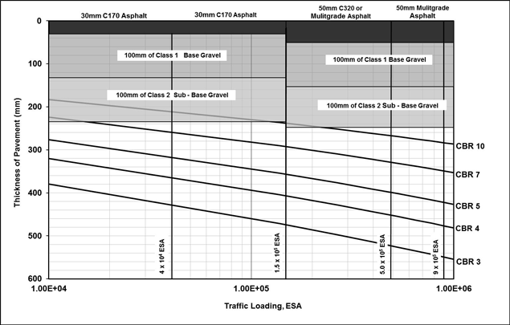
Figure 3.5.5.1.1a—Design chart for roads subject to light traffic

3.5.5.1.2 Full depth asphalt pavement
- This pavement is not generally used for local roads. However, it is may be used in areas where the speed of construction is critical or for narrow pavement widening. The full depth asphalt pavement shall be designed in accordance with section 3.5.5.2.2.
- Where full-depth asphalt pavements are to be constructed alongside existing granular pavements, the design must consider the possible effect on subsoil drainage of the pavement, and the need for additional subsoil drainage to prevent ‘tanking’.

3.5.5.1.3 Concrete pavement
- Full-depth concrete roads are generally used only for roads subject to heavy traffic loading (i.e. all roads with 20 year design traffic > 1.0 x 10⁶ ESA). However, a full-depth concrete road can be designed for roads subject to light traffic loadings, subject to the following requirements:
- the design life is 40 years;
- the pavement must have a minimum 100mm thick unbound granular sub-base consisting of Class 1 granular material;
- the concrete shall have a 28-day compressive strength of not less than 40MPa;
- the flexural strength of the concrete must be a minimum 4.0MPa;
- the load safety factor (LSF) must be 1.3;
- integral or structural concrete shoulders are not required;
- special attention should be paid to the jointing details in regard to ride quality and the provision of additional conduits for future services;
- the design, detailing and construction of concrete pavements for residential streets should be in accordance with the publication Guide to Residential Streets and Paths (Cement & Concrete Association of Australia, C&CAA T51, February 2004).
- The minimum thickness for roads subject to light traffic loadings are given in Table 3.5.5.1.3.A.

Table 3.5.5.1.3.A—Pavement design – Minimum concrete thickness
Minimum concrete thickness ⁽²⁾⁽³⁾ (mm)
Class of road |  | Local access  (cul-de-sac) | Local access | Neighbourhood access (without bus services)
Traffic load – TL₄₀ (ESA) ⁽¹⁾ |  | Up to 1 x 10⁵ | Up to 3.7 x 10⁵ | Up to 2.5 x 10⁶
SUB-GRADE CBR ⁽⁴⁾ | 10 | 200 | 210 | 230
 | 5 | 210 | 220 | 240
 | 4 | Subgrade replacement or treatment where required.  Then treat as CBR 5.
 | 3
 | 2
 | 1
Notes—
(1) Calculated from TL₂₀ for class of road from Table 3.5.3.A assuming 2% p.a. growth.
(2) Based on 28-day design characteristic flexural strength of 4.0MPa, concrete grade N₄₀.
(3) Provide minimum 75mm crushed rock bedding under the concrete kerb and channel. Extend pavement edge 75mm past the back of the CKC to ensure stability of the pavement edge.
(4) Based on the four-day soaked values.

3.5.5.2 Roads subject to heavy traffic loadings – TL₂₀ > 1.0 x 10⁶ ESAs
- Roads subject to heavy traffic loading are all roads with estimated traffic TL₂₀ of greater than 1.0 x 10⁶ ESAs over a 20-year period. They also include freight-dependent development roads as a subset. The design traffic loadings are adjusted to account for the effects on the pavement of the introduction of new generation heavy vehicles (HV) (including buses) and Higher Mass Limits (HML).
- It is expected that neighbourhood roads with bus services, district, suburban, freight-dependent development, and arterial roads will fall within this category.

3.5.5.2.1 Granular pavement
Granular pavements with thin asphalt surfacing are NOT acceptable for roads with TL₂₀ greater than 1.0 x 10⁶ ESAs.

3.5.5.2.2 Full-depth asphalt
- Designs for full-depth asphalt pavements may be based on Figure 3.5.5.2.2a for asphalt containing Class M1000 multigrade bitumen. The thickness of the asphalt layers in this figure includes the allowance for the construction and design tolerances.
- Full-depth asphalt shall be placed on a minimum of 150mm thick granular working platform except for roads where TL₂₀ > 1.0 x 10⁷ ESAs over a 20-year period where a minimum of 300-mm thick granular working platform is required. However, the actual thickness required is a function of the subgrade strength and working platform over 300mm thick may be required for low strength subgrade. The granular working platform should comprise the following layers in accordance with Reference Specifications for Civil Engineering Work S300 Quarry Products:
- minimum 150mm-thick top layer of Class 1 material;
- for arterial roads, an additional 150mm thick sub-base courses of Class 2 material (or alternatively Class 1 material);
- subsequent sub-base courses of Class 3 material (or alternatively Class 1 or 2 material) as required for subgrade improvement.
- The granular working platform shall not be considered as a structural layer.
- Notwithstanding that Figure 3.5.5.2.2a or the mechanistic pavement design method may indicate a lesser pavement depth, the minimum pavement and individual course thicknesses for roads subject to heavy traffic loading are given in Table 3.5.5.2.2.A.
- Where full-depth asphalt pavements are to be constructed alongside existing granular pavements, the design must consider the possible effect on subsoil drainage of the pavement, and the need for additional subsoil drainage to prevent ‘tanking’.

Table 3.5.5.2.2.A—Minimum thickness for roads subject to heavy traffic
Design traffic | TL_{DES} ≤ 1.0 x 10⁷ ESA⁽¹⁾ | TL_{DES} > 1.0 x 10⁷ ESA⁽¹⁾
Composition | Minimum course thickness (mm)
Asphalt ⁽¹⁾ ⁽²⁾ ⁽³⁾ | 100 | 150
Prime coat/seal | Yes | Yes
Base Class 1 ⁽⁴⁾ | 150 | 150
Sub-base Class 2 ⁽⁴⁾ ⁽⁵⁾ | - | 150
Sub-base Class 3 ⁽⁴⁾ ⁽⁶⁾ | If required, for subgrade improvement.
Minimum total pavement thickness | 250 | 450
Notes—
(1) TL_{DES} = number of ESAs over the design period
(2) Refer to Reference Specification S310 Supply of Dense Graded Asphalt for material properties.
(3) Refer to Reference Specification S320 Laying of Asphalt for individual layer thickness requirements.
(4) Refer to Reference Specification S300 Quarry Products for material properties.
(5) Class 2 sub-base may be replaced by the same depth of class 1 base.
(6) Class 3 sub-base may be replaced by class 2 sub-base or class 1 base.
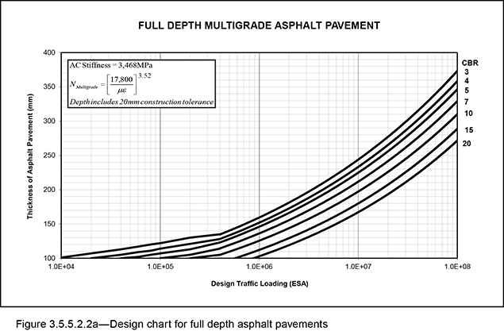
- Alternatively, the pavement may be designed by a mechanistic approach based on a mathematical model of the response of the pavement to traffic loads. This is described in detail in the Guide to Pavement Technology – Part 2: Pavement Structural Design (Austroads 2012). The salient features are:
- Damage functions are of the form:
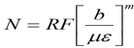
where N = traffic load repetitions
RF = reliability factor
με = microstrains i.e. 10⁻⁶m
b, m = empirically derived constants for each response type
Note—Reliability factors (RF) are applied to cemented material fatigue and asphalt fatigue. The required project reliability is set at 95% and, therefore, the RF is 1.
- Wheel loadings are to be full standard axle load, which is a dual-wheel single axle, applying a load of 80kN, with tyre pressures set at 750kPa
- Designs must be carried out using the CIRCLY5 (or subsequent versions) computer program.
- Asphalt modulus is a function of temperature, speed, binder type, and mix design. Refer to figures 6.6, 6.7, and 6.8 in the Guide to Pavement Technology – Part 2: Pavement Structural Design (Austroads 2012). As a guide, the following typical design values are applicable for the Brisbane region:
- Asphalt Modulus 1000–1500MPa for Class 170 bitumen binder;
- Asphalt Modulus 1900–2200MPa for Class 320 bitumen binder;
- Asphalt Modulus 3468MPa for multigrade (Class M1000) bitumen binder.
Note—Modulus is also a function of the way it is measured (i.e. the specific laboratory procedure used to measure the stiffness of a sample of material). Hence, caution should be used when quoting a modulus value from a reference source. A detailed discussion is outside the scope of this guideline.

3.5.5.2.2.1 Pavement damage in terms of standard axle repetitions (SAR)
- The design traffic loading is calculated in terms of the number of Standard Axle Repetitions (SAR) as described in section 7 of Guide to Pavement Technology – Part 2: Pavement Structural Design (Austroads 2012).
- The difficulties with this approach is its complexity and the lack of available data on the actual traffic spectra. Presumptive traffic load distribution (TLD) values in Table 3.5.5.2.2.1.A may be used to simplify the design process by converting SAR back to ESA.

Table 3.5.5.2.2.1.A—Load damage exponents and traffic load distribution
Damage type | k | m | Damage index | Presumptive urban traffic load distribution (SAR_{m}/ESA)
Granular (with thin bituminous surface) | e | 4 | ESA/HVAG | 0.7
 |  |  | ESA/HV | 1.8
Asphalt – normal bitumen | a | 5 | SAR_{an}/ESA | 1.1
Asphalt – multigrade bitumen | a | 3.52 | SAR_{am}/ESA | 1.1
Subgrade | s | 7 | SAR_{s}/ESA | 1.6
Cemented materials | c | 12 | SAR_{c}/ESA | 12
Note—For urban areas the presumptive value of HVAG per heavy vehicle is 2.5 HVAG/HV.
Note—SAR: standard axle repetitions

3.5.5.2.2.2 Damage function for subgrade and granular layers
- The non-linear behaviour of granular materials is modelled by sub-layering. Sub-layering of the select subgrade and granular materials must be in accordance with sections 8.2.2 and 8.2.3 of Guide to Pavement Technology – Part 2: Pavement Structural Design (Austroads 2012).
- The maximum modulus of the granular base material shall be in accordance with tables 6.4 and 6.5 of Guide to Pavement Technology – Part 2: Pavement Structural Design (Austroads 2012).
- The subgrade performance is based on the Austroads (2012) compressive strain relationship.

3.5.5.2.2.3 Damage functions for conventional asphalt fatigue:
The fatigue performance for asphalt containing conventional bitumen is based on the Shell relationship:
 |  | 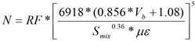
where:
N | = | allowable number of repetitions of the load for asphalt produced using conventional bitumen
 | = | tensile strain produced by the load (microstrain)
Vb | = | percentage by volume of bitumen in the asphalt (%)
Smix | = | Asphalt modulus (MPa)
RF | = | reliability factor for asphalt fatigue  (on Council projects RF = 1)

3.5.5.2.2.4 Damage functions for multigrade asphalt fatigue:
The fatigue performance for asphalt containing multigrade bitumen is based on Council research:
Where:
NMultigrade | = | allowable number of repetitions of the load for asphalt produced using multigrade bitumen
 | = | tensile strain produced by the load (microstrain)
RF | = | reliability factor for asphalt fatigue (on Council projects RF = 1)
Note—Asphalt modulus = 3468MPa

3.5.5.2.2.5 Construction and design tolerances in pavement design
- Construction and design tolerances are taken into account in the pavement design process by increasing the thickness of the critical structural asphalt layer and the critical unbound layer:
- for rehabilitation projects which are likely to be constructed under traffic with limited survey control, increase the thickness of the structural asphalt layer by 20mm;
- for new construction with good survey control, increase the thickness of the structural asphalt layer by 10mm and the thickness of the upper most unbound layer by 20mm.
- The added tolerances reflect the uncertainty and variability of the materials and technology. If the CIRCLY design, plus the added tolerance, is less than the minimum layer thickness specified by Council, then the minimum requirement must be adopted. The layer thickness limits for individual asphalt layers are outlined in Reference Specifications for Civil Engineering Work S320 Laying of Asphalt.

3.5.5.2.3 Concrete pavement
Full-depth concrete roads must be designed in accordance with the Guide to Pavement Technology – Part 2: Pavement Structural Design (Austroads 2012) considering the 2 distress types: fatigue of the base and erosion of the sub-base/subgrade. The concrete shall have a 28-day compressive strength of not less than 40MPa. A bond breaker such as bituminous seal, wax or other approved material must be included between the lean mix sub-base and concrete base. The proposed design must be submitted to Council for approval.

3.5.6 Treated pavements

3.5.6.1 General
- ‘Upside down’ pavements (i.e. pavements which have an unstabilised upper granular base layer placed over a stabilised granular sub-base layer) will not be approved. The stabilised granular layer must extend to the underside of the asphalt layer.
- The selection of stabilising agents and mix design for stabilised pavements is to be undertaken in accordance with Auststab Ltd’s Pavement Recycling and Stabilisation Guide (2015). The structural design must be undertaken in accordance with the Guide to Pavement Technology – Part 2: Pavement Structural Design (Austroads, 2012). The fatigue performance for cemented materials shall be based on the Austroads (2012) tensile strain relationship.
- The proposed design, together with the results of tests undertaken to determine the design and to prove the adequacy of the material to satisfy design requirements, must be submitted to Council at least 2 weeks prior to commencement of the work. A NATA-registered laboratory shall undertake all the required testing.
- Treated pavements that may be acceptable to Council include:
- in-situ cementitious blend stabilisation of base material in existing roads;
- cementitious blend stabilisation of imported base course material for new roads;
- foamed bitumen stabilisation of imported base course material for new roads;
- lime stabilisation of subgrades.

3.5.6.2 Cementitious blend treated materials
- Council will permit cementitious blend stabilisation of granular pavement with thin asphalt surfacing on lightly trafficked roads, where the 20 year design traffic loading is below 1.5 x 10⁶ ESA. Cemented materials will inevitably crack due to thermal and shrinkage stresses, resulting in reflective cracking of the asphalt surface. While this may be tolerable on lightly trafficked roads, it is not acceptable on heavily trafficked roads and the Guide to Pavement Technology – Part 2: Pavement Structural Design (Austroads, 2012) indicates that 175mm of asphalt is required to inhibit this reflective cracking. This renders such pavements uneconomic. However, cracking due to thermal and shrinkage stresses can be limited by good design and construction methods.
Note—Although not mandatory, the maximum cement content should be limited to 4.5% by weight to limit reflective cracking of shrinkage cracks in the treated layer and asphalt surfacing.
- After construction, the cement treated pavement must be immediately sealed with a primer seal for a minimum 4-week curing period prior to surfacing with asphalt. The pavement must be tested using a falling weight deflectometer (FWD) after the minimum curing period and prior to placing of the asphalt. Test results must be submitted to Council for approval.

3.5.6.3 Bitumen stabilisation
Any proposal for foamed bitumen or bitumen emulsion stabilisation of granular pavement material will require the design to be prepared by experienced personnel according to Queensland Department of Transport and Main Roads specifications. The proposed design must be submitted to Council for approval.

3.5.6.4 Lime stabilisation
- Lime stabilisation of the base or sub-base is generally not acceptable as a pavement treatment. Lime stabilisation of the subgrade may be acceptable.
- Testing will need to be carried out in accordance with Pavement Recycling and Stabilisation Guide (2015). Specifically, lime demand tests and UCS testing of prepared samples must be carried out to determine the amount of lime required and the strength gains achieved.

3.5.7 Subsoil drainage
Refer to Standard Drawing BSD-2041 for details. Sub-surface drains should be used to protect the road structure from moisture ingress. Typical cross-section pavement details should show side drains. Unless otherwise approved by Council, side drains should be provided at the following locations:
- both sides of all streets and roads under the kerb and channel, except where Council determines that such drains are unnecessary or disadvantageous;
- under the kerb around all landscaping areas, depending on location. Landscaping in footpaths should not be placed immediately behind the kerb. Landscaping adjacent to pavements must not have irrigation systems;
- across the end of the road at the stage boundary. This must be removed when the next stage is built;
- along the line of fill when subsoil water is affected by the compaction of the fill;
- where springs are located;
- where moisture can ingress;
- under the invert of flat grassed overland flow paths in areas that are usually subject to pedestrian or vehicle traffic;
- at the toe of cuttings greater than 2m high;
- blanket courses should be limited to areas with grades <5% and should not be used where they may affect the structural integrity of the pavement.

3.5.7.1 Other special purpose drainage systems
- Other locations/situations that should be considered for sub-surface drainage include:
- bridge abutments and approach slabs or other impermeable barriers which require transverse drains;
- soft areas, whether excavated and backfilled or not, provided a drainage outlet can be obtained;
- large pipe trenches, underground water courses, service conduits, water supply pipes and existing or abandoned utility trenches backfilled with permeable material;
- along the high side of a pavement where seepage is evident, or where water may enter from batters, full-width pavement, service trenches, permeable medians or abutting properties;
- along both sides of the pavement where the cross-slope is flatter than 2% (e.g. in transitions to superelevation).
- There is no exact method of preventing the harmful effects of water. Often the problems could require several of the typical drain types being combined with the use of mitre drains for a satisfactory solution.

3.5.7.2 Widening of existing pavements
- A common problem associated with the widening of an old gravel pavement is the accumulation of moisture at the join between the new and old pavement resulting from the use of materials of different permeability (and boxed-out construction).
- For patches and new pavement construction where the new pavement material is likely to trap water within the adjacent existing materials, sub-surface drainage should be installed on the high side of the new pavement. If the bottom of the new pavement is located within the subgrade such that it creates a sump, sub-surface drainage should also be installed on the low side of the pavement. If the drain pipe or prefabricated geo-composite strip drain is located within a fine silt or clay subgrade, then filter sand should be placed around the drain prior to backfilling with no-fines concrete (NFC) to prevent fine silty particles from entering and blocking the drains. For significant works, drainage design should be undertaken.

3.5.8 Road surfacing

3.5.8.1 Performance requirements
- Selection of the pavement surfacing must be based on the performance criteria, the 2 most important being deformation resistance and skid resistance. Rutting and shoving problems should be catered for by the selection of appropriate material types and properties. Consistent with achieving these requirements, the surfacing should provide minimum maintenance requirements.
- The absolute minimum skid resistance to be provided by the pavement surfacing shall be BPN of 45 when measured using the portable pendulum tester. However, individual locations may require higher skid resistance as defined in the Reference Specifications for Civil Engineering Work – S150 Roadworks.
- Edge restraints must be provided along the perimeter of all paved areas. They should be able to support traffic loads and to prevent the escape of the pavement material, where required, from beneath the paved surface. An edge restraint may be in the form of a kerb, combined kerb and channel, established structure or rigid flush abutment.

3.5.8.2 Asphalt
- Asphalt is the preferred surfacing material for all roads within the road hierarchy. For coloured treatments on asphalt surfaces, refer to section 3.5.8.4 for specific requirements. The following asphalt types may be used in Brisbane:
- dense-graded asphalt (DG);
- stone mastic asphalt (SMA) may be used subject to Council approval;
- proprietary products such as micro-surfacing, SAMI Fricseal etc. need to be submitted for approval.
- The following asphalt types will generally not be approved for use:
- open-graded asphalt (OGA);
- asphalts containing polymer-modified binders.
- Asphalt surfacing shall comply with Reference Specifications for Civil Engineering Work:
- S120 Quality;
- S310 Supply of Dense Graded Asphalt;
- S320 Laying of Asphalt.

3.5.8.3 Concrete
- A wide variety of surface finishes are available for concrete pavements. There is no restriction on the use of tyned- or broomed-surface finish. The concrete shall have a 28-day compressive strength of not less than 40MPa. For coloured treatments on concrete surfaces, refer to section 3.5.8.4 and Reference Specifications for S155 Road Pavement Markings for specific requirements.
- Exposed aggregate surface is permitted in local traffic area threshold treatments provided that the crushed aggregate finish:
- achieves a minimum polished aggregate friction value (PAFV) of 45;
- complies with the skid resistance requirements of Reference Specifications for Civil Engineering Work – S150 Roadworks.
- Stamped concrete is not permitted as the surface texture can cause a potential hazard for cyclists.

3.5.8.4 Coloured surface treatments
Coloured surface treatment must serve a traffic management function such as thresholds at local traffic areas and to visually enhance school zones. The use of coloured surface treatment as an aesthetic enhancement to the streetscape is not permitted.

3.5.8.5 Segmental pavers

3.5.8.5.1 General
Segmental pavers may be used, although future maintenance considerations should be taken into account when approval is sought for their use on road pavements. Pavers must be laid to the herringbone or stretcher bond pattern and are only permitted on roads subject to light traffic loadings (TL₂₀ ≤ 1.0 x 10⁶ ESA).

3.5.8.5.2 Limitation of use
Pavers should be restricted for use in local traffic area threshold treatments, landscaping features in speed control devices, traffic medians and traffic islands. As a guide, the areas of pavers should not make up more than 10% of the total road pavement area. Types of paver, colour, manufacturer, product number etc. should be shown on the engineering drawings. Slip and skid resistance values and permitted colours should comply with Reference Specifications for Civil Engineering Work – S150 Roadworks.

3.5.8.5.3 Treatment around obstructions
The preferred method for treatment of pavers around gullies, maintenance holes, service pits and similar obstacles is to use specifically manufactured pavers, designed to be placed around these obstructions. Pavers adjacent to these obstructions or the lip of the kerb and channel should have the arris reduced to a 5mm radius to narrow the gap between the pavers and the adjacent structures.

3.5.8.5.4 Pavement design
The pavers should not be considered as contributing to the structural strength of the pavement. The detail of the pavement design should be shown on the engineering drawings. A typical entrance threshold treatment is shown on Standard Drawing BSD-2041. The acceptable standard of pavement composition for residential streets should comprise a minimum 60-mm thick pavers laid on 25-mm thick cement mortar bed, and founded on a reinforced concrete base not less than 210mm thick.

3.5.8.5.5 Drainage
Particular attention needs to be paid to the design and construction of road drainage for paved roads, in particular sub-surface drainage. Refer to Standard Drawing BSD-2041. No-fines concrete blocks or PVC tubes placed over side drains to drain the pavement are not an acceptable design. Full details of the sub-surface drainage should be shown on the engineering drawings.

3.5.8.5.6 Edge treatment
Edge restraints should be provided along the perimeter of all paved areas. The minimum standard for edge restraint is 230mm x 230mm with one Y12 reinforcing bar (refer Standard Drawing BSD-2001). An isolation joint is required at the junction of the channel. A header course (full size pavers laid side by side) should be used along the edge of the road pavement abutting a kerb or channel or any footpath or median edge or edge restraint.

3.5.8.5.7 Transverse restraints
Cross beams and/or restraints are required for inclined areas and roadways, and also for surfaces where heavy vehicular braking may cause shoving of pavers. Details should be included in the engineering drawings.

3.6 Bicycle routes

3.6.1 Design principles
- The bicycle network provides safe, convenient and continuous cycle routes that encourage cyclists of all ages and abilities to ride for transport and recreation.
- The on-road bicycle routes of the bicycle network provide:
- bicycle lanes;
- priority intersections and road crossings;
- regulatory and way-finding signage;
- bicycle facilities such as bicycle parking.
- The on-road bicycle routes of the bicycle network intended to be owned or maintained by Council include:
- primary bicycle routes;
- secondary bicycle routes;
- local bicycle routes.
- The design standards for off-road bicycle routes are stated in Chapter 4 of this planning scheme policy.
- The design standards for Riverwalk are stated in Chapter 12 of this planning scheme policy.

3.6.2 Design standards and standards for bicycle routes on roads
- A summary of the design standards that are applicable to the bicycle network that is located in the road reserve, are as follows.
- some parts of the bicycle network might not comply with all the current specified standards;
- bicycle lanes are provided on all major roads.

- Guidance on provision for cyclists on the carriageway is provided in BSD-5102.

3.6.3 Cross-section

3.6.3.1 General
- This section outlines additional design standards for bicycle works on roads in addition to those outlined in section 3.6.2.
- The cross-section elements include:
- bicycle lanes;
- verges;
- on-street parking;
- intersections.

3.6.3.2 Bicycle lanes
- The width of a bicycle lane is dependent on the speed of the traffic and is shown in Table 3.6.3.2.A. The width of a bicycle lane is measured from the nominal face of kerb. The minimum width of a bicycle lane is 1.5m.
- Bicycle lanes are constructed with full depth pavement and a smooth surface flush with the vehicular lanes and gutters.
- Wide kerb lanes of 4.5m are required to accommodate a bicycle lane where off-peak kerbside parking is permitted, or as part of a parking lane.
- A minimum sealed carriageway width of 5.5m is required on all one lane major roads identified as part of the bicycle network.
- The minimum sealed carriageway width cannot be relaxed if the lane is adjacent to a median.
- It is recommended that car parking is prohibited adjacent to bicycle lanes by using yellow edge line and/or regulatory signage.
- Neighbourhood roads identified as primary or secondary routes in the bicycle network, and carrying over 3,000 vehicles per day provide:
- bicycle lanes; or
- 4.5m wide kerbside lanes, where kerbside parking is required.
- Where an on-road bicycle route is also a freight route, bicycle lanes must be 2m wide.

Table 3.6.3.2.A—Width of bicycle lane
Sign-posted speed | Bicycle lane width
60km/h | 1.8m
80km/h | 2.0m

3.6.3.3 Verges
- Where the bicycle network proposes to provide off-road paths on the verge, the verge width should be increased accordingly.
- Verge widths to be increased to a minimum 6m where an off-road path greater than or equal to 3m is identified by the bicycle network.
- On-verge bicycle paths of 3m to 3.5m width in addition to the on-road bicycle lanes and crossings are typically provided in the vicinity of schools for use by children, where it is preferred that they not ride on the carriageway.
- Bicycle, shared or separated paths along roads that front Council managed natural assets and parkland should be aligned to protect significant vegetation in accordance with the Natural Assets Local Law.

3.6.3.4 On-street parking
- Wide kerb lanes of 4.5m are required where off peak kerbside parking is permitted on roads that are identified by the bicycle network.
- Where a bicycle lane is provided adjacent to a parking lane, the potential conflicts and safety issues for cyclists need to be resolved.
- In some instances, parking may not be appropriate adjacent to a primary route.

3.6.3.5 Intersections
- Bicycle lanes are required on the approach and departure of all legs of signalised intersections on all major roads, as well as minor roads identified as bicycle routes in the bicycle network.
- Signalised bike crossings are provided where an off-road pathway on the verge crosses a road or in locations where separation of high volumes of pedestrians and cyclists is required at a signalised intersection.
- For guidance on bicycle lanes at four-way intersections, T-intersections and roundabouts, refer to BSD-5102, BSD-5103, BSD-5105, BSD-5106.

3.7 Streetscape hierarchy

3.7.1 Design principles
- This section outlines the design standards for the design and construction of all verges to be owned or maintained by Council.
- All verge dimensions are measured from the nominal face of kerb.
- Verges:
- reflect the adjacent land use and the anticipated pedestrian traffic, whether it be local or providing a connection between destinations or access to public transport;
- provide trees for shade and landscape treatment that contribute to the city’s subtropical image;
- provide appropriate infrastructure (such as street furniture) to support anticipated pedestrian needs;
- are constructed to a consistent standard to enable efficient maintenance.
- The land in the verge may accommodate:
- pedestrian routes and footpaths;
- access to public transport;
- streetscape elements such as street furniture including seating, bins, and bus shelters;
- street trees;
- significant vegetation;
- signage;
- drainage;
- utility services;
- bus stops on minor roads;
- road safety infrastructure such as guardrails.
- Commercial activities such as footpath dining may be permitted in the verge subject to Council’s local laws. Refer to the database for further guidance in this regard.
- The following additional standards also apply for streetscape design:
- AS 1428 (Set)-2010 Design for access and mobility;
- AS/NZS 3661.2:1994 Slip resistance of pedestrian surfaces - Guide to the reduction of slip hazards;
- AS 3996-2006 Access covers and grates;
- AS/NZS 4586:2004 Slip resistance classification of new pedestrian surface materials;
- AS/NZS 4663:2004 Slip resistance measurement of existing pedestrian surfaces.

3.7.2 Design specifications and standard drawings
- Table 3.7.2.A lists the standard specifications for the streetscape hierarchy.
- Table 3.7.2.B lists the standard drawings for the streetscape hierarchy.

Table 3.7.2.A—Standard specifications for the streetscape hierarchy
Speciation number | Specification title
S110 | General
S120 | Quality
S140 | Earthworks
S150 | Roadworks
S160 | Drainage
S180 | Unit paving
S190 | Landscaping
S200 | Concrete work
S205 | Centres honed concrete path
S320 | Laying of asphalt

Table 3.7.2.B—Standard drawings for the streetscape hierarchy
BSD Drawing series | BSD Drawing series title
BSD 1000 series | General
BSD 2000 series | Road corridor
BSD 3000 series | Traffic management
BSD 4000 series | Traffic signals and intelligent transport systems
BSD 5000 series | Pedestrian and cyclist facilities
BSD 7000 series | Fences, barriers and public furniture
BSD 8000 series | Stormwater drainage and water quality
BSD 9000 series | Streetscape and landscape

3.7.3 General design standards
This section provides a summary of the general design standards for streetscapes.

3.7.3.1 Verge layout
- The verge layout must be designed in accordance with the relevant streetscape hierarchy designation.
- The typical verge layouts allow for planting and elements to be laid out to suit the kerbside allocation, adjacent building layout and verge constraints.

3.7.3.2 Minimum verge width
- The minimum standard width for verges when constructing a new road is 4.25m.
- The minimum standard verge width for existing established areas is 3.75m.
- The standard verge widths may be varied by the public transport, bicycle or streetscape hierarchies.
- The standard verge width is maintained where indented bus bays are located.
- The minimum standard width of a verge may be relaxed to no less than 2.5m in the following circumstances:
- where the existing verge width is consistently narrower than the standard width for the length of the street block, or to accommodate constrained pinch points for a short distance only;
- where the streetscape type is not a subtropical boulevard in a centre (SB1), city street (CS1 or CS2) or neighbourhood street major (NS1).
- In such exceptional circumstances it must be demonstrated that pedestrian facilities and service utilities can be accommodated within the reduced width. Each case will be assessed on its merits.

3.7.3.3 Verges – bikeway
- Where the bicycle network is proposed to provide paths on the verge, the verge width should be increased accordingly.
- The standard verge width is to be increased where on-verge bicycle and pedestrian separated or shared path is greater than or equal to 3m as identified by the bicycle network.
- If on-verge bikeways of 3m to 3.5m width in addition to the on-road bicycle lanes are provided, crossings are typically provided in the vicinity of schools for use by children.

3.7.3.4 Existing significant vegetation
Verge design avoids the clearing or disturbance of significant vegetation in the verge where identified by the Natural Assets Local Law and where roads front existing or proposed Council-managed natural areas and parkland. In these situations, walkways, bikeways and drainage features should be aligned to protect significant vegetation.

3.7.3.5 Verge crossfall
- Council will not allow the resolution of levels for access to buildings or flood mitigation in the verge.
- The verge is to be free of steps, ramps and trip hazards.
- A crossfall of 1V:50H is to be provided on the verge.
- If constraints limit the formation of the verge to the correct profile across the full width, a section of verge with a minimum width of 2.5m at the ultimate level with maximum 1V:40H crossfall may be appropriate.
- The crossfall of the verge may be varied where significant trees are to be retained.
- A 0.3m offset is required from the property boundary to the commencement of a batter on private land that adjoins a road reserve where the batter is steeper than 1V:6H.
- All cut and fill batters are located outside the road reserve or access restriction strip.

3.7.3.6 Verge longitudinal grade
- Verge design achieves a uniform longitudinal gradient along the full length of the verge and ties in with the existing line and level of adjacent verges and kerb.
- The maximum longitudinal grade on any verge corresponds to the maximum grade of the road.
- The preferred option is to accommodate people using mobile devices such as wheelchairs and prams, in compliance with AS 1428 Design for Access and Mobility.

3.7.3.7 Scope of paving works
All verge works provide new pavement finishes, new or reinstated kerb and channel, driveways, pedestrian kerb crossings, tactile paving, roof-water drainage line connections and service pit lids.

3.7.3.8 Corners—intersection of verges
Where 2 streets with different streetscape hierarchy classifications meet, the higher order street type will take precedence and its layout will wrap around the corner into the minor order street. The extent and detail of the treatment wrapping around the corner will vary.

3.7.3.9 Tactile ground surface indicators (TGSI)
- Tactile ground surface indicators (TGSIs) are installed to provide guidance and/or warning of an obstruction or hazard in any location where insufficient alternative or ‘natural’ tactile cues exist.
- TGSIs must not be proliferated unnecessarily.
- TGSIs must be used where the obstruction, hazard or change of direction of travel is less likely to be expected or anticipated and could be encountered, perhaps injuriously, in the absence of a suitably placed TGSI.
- Where required, TGSIs are installed as per the requirements of AS 1428.4 Design for access and mobility - Means to assist the orientation of people with vision impairment – Tactile ground surface indicators, and:
- Tactile Ground Surface Indicator detail: BSD-5218;
- kerb ramps: BSD-5231 and BSD-5233;
- medians and traffic islands: BSD-5232;
- bus stops – BSD-2103 to BSD-2108;
- permanent clearances and temporary diversions: BSD-5217.
- Tactile markers are inlay pavers or approved equivalent, depending on the streetscape type or locality. Section 3.7.4 or Chapter 5 of this planning scheme policy provides material specifications.

3.7.3.10 Kerb ramps
- Kerb ramps are required:
- where a concrete footpath leads to a street intersection;
- at a pedestrian crossing.
- In order to maximise visibility, kerb ramps are constructed of plain broom-finished concrete.
- Kerb ramps are to:
- face the direction of travel;
- be located to suit the line of pedestrian flow and position of the signal button (where existing).
- Kerb ramps must be avoided at median islands, as the island must be modified to ensure that pedestrians and cyclists can pass through at road pavement level.
- The back of the kerb ramp must be perpendicular (90º) to the direction of travel of a pedestrian.
- Tactile pavers are installed at the back of kerb ramps at all signalised intersections.
- Kerb ramps should be clear of obstacles such as stormwater gullies, street signs, posts and trees.
- Kerb ramps, including the installation of TGSIs if required, are constructed as per BSD-5231, BSD-5233, and BSD-5234

3.7.3.11 Vehicular property access (driveways)
- Maintenance of vehicle crossovers (driveways) is the responsibility of the property owner.
- In order to reflect pedestrian priority over vehicles, the adjoining verge paving must extend across the driveway/vehicle crossover.
- The only exception to sub-section (2) is where the verge surfacing is asphalt, in which case the driveway and vehicle crossover must be constructed of plain broom-finished concrete.

3.7.3.12 Service pit lids
- If service pit lids are located in the verge, they are of black cast iron construction, manufactured to AS 3996-2006 Access covers and grates ‘Class B’ specifications (suitable for occasional vehicle use), with slip resistance qualities as specified in AS/NZS 4586-2004 Slip resistance classification of new pedestrian surface materials and AS/NZS 4663-2004 Slip resistance measurement of existing pedestrian surfaces.
- In relation to load rating, pit lids are manufactured to AS 3996-2006 Access covers and grates, Class C (suitable for driveways and roadway use).

3.7.3.13 Water sensitive urban design measures
- Kerb inlets are to comply with the requirements of the Healthy Water’s water sensitive urban design policy.
- Rain gardens may be appropriate in verges with low pedestrian traffic volumes where it can be demonstrated that the rain garden will not impact on pedestrian movement, kerbside allocation, access to public transport, services location or access, or provision of street trees.
- Applications for proposed rain gardens will be assessed case by case.
- Swales are as per Chapter 7 of this planning scheme policy.

3.7.3.14 Entrance features to new subdivisions
Sales marketing features such as walls, waterfalls, fountains, flagpoles, ornate entrance structures, non-standard landscaping and the like must not protrude onto the verge (road reserve) or any access restriction strip.

3.7.3.15 Landscaping to speed control devices
- Refer to BSD-9005, BSD-9006, BSD-3216, BSD-3218, BSD-3219, and BSD-3220
- The general treatment of traffic islands should comprise a mixture of landscaping and hard surface infill.
- The selection of plants must take into account the following traffic design criteria:
- sightlines and distances at intersections and speed control devices;
- tree form, shape and location within the road reserve must not encroach into the space required for a vehicle to pass through a speed control device.
- Plant species should be selected on hardiness, suitability of soil type, micro-environment and landscape character, and are to be selected from the general species tables for the relevant street type.

3.7.3.16 Landscaping to medians
- Refer to BSD-9005 and BSD-9006.
- For medians less than 1.5m in width, landscaping or turf is not provided. In these areas a concrete infill, usually stencilled or exposed aggregate concrete or concrete pavers, is necessary.
- Where surfaces are steeper than 1V:4H, hard surface treatment is provided.
- Medians and islands that are planted rather than concrete infilled are designed to accommodate landscape works by providing:
- a median kerb keyed 135mm into the pavement;
- a 300mm concrete backing strip behind the kerb;
- adequate site preparation and soil depths;
- root barriers where needed;
- conduit for future tap connection;
- subsoil drainage discharging to an enclosed pipe system.

3.7.3.17 Structures
Non-standard elements and structures such as planters, walls, shade structures and decks are not permitted in the verge.

3.7.3.18 Roof drainage connections
- Outlet for roof water drains on the high side of one-way crossfall paved streets are not permitted in the kerb. Roof water reticulation is required in this situation with the outlet into the main underground drainage stormwater system.
- More technical details are included in the Reference Specification S150 Roadworks and standard drawings BSD-8114 and.BSD-8115.

3.7.4 Design standards for specific street types

3.7.4.1 General
- The Streetscape hierarchy overlay map identifies the streetscape hierarchy for each street/type.
- The following provides details of the design detail for each street type.
- Additional detail for locality streets can also be found in Chapter 5 of this planning scheme policy and in neighbourhood plans.

3.7.4.2 Subtropical boulevards

3.7.4.2.1 Typical layout–in centres (SB1)
The principles in Table 3.7.4.2.1.A must be applied when designing a subtropical boulevard in centre verge layout. Refer to Figure 3.7.4.2.1a.

Table 3.7.4.2.1.A—Subtropical boulevards – in centre
Design requirement
Verge width | 6m | 5m | 3.75m (4.25m for new roads)
Description | Full width pavement | Full width pavement | Full width pavement
Unobstructed pavement width | 3.05m | 2.05m | 2.4m
Street trees | All trees are a minimum of 950mm from the nominal face of kerb and 600mm from edges of pavement.  1.6m x 1.6m tree grates are used where adjacent to the kerb. | All trees are a minimum of 950mm from the nominal face of kerb and 600mm from edges of pavement.  1.6m x 1.6m tree grates are used where adjacent to the kerb. | All trees are a minimum of 750mm from the nominal face of kerb and 600mm from edges of pavement.  1.2m x 1.6m tree grates are used where adjacent to the kerb.
A mix of tree species is laid out in an informal manner with clusters of trees
Medium- and small-crown trees are to be planted at 2m to 6m centres
Large-crown feature trees are to be planted at minimum 10m centres
Second row of trees – in tree grate at minimum 6m centres | 1.2m x 1.6m tree grate | 1.2m x 1.6m tree grate | N/A
Garden beds – located adjacent to kerb | 1.5m minimum spacing between garden beds  Maximum 10m long  Layout and length of garden beds to accommodate car parking and other kerbside allocation
Garden beds –minimum widths | 1.6m | 1.6m | 1.2m
Furniture | All furniture to be located outside of the unobstructed pavement area

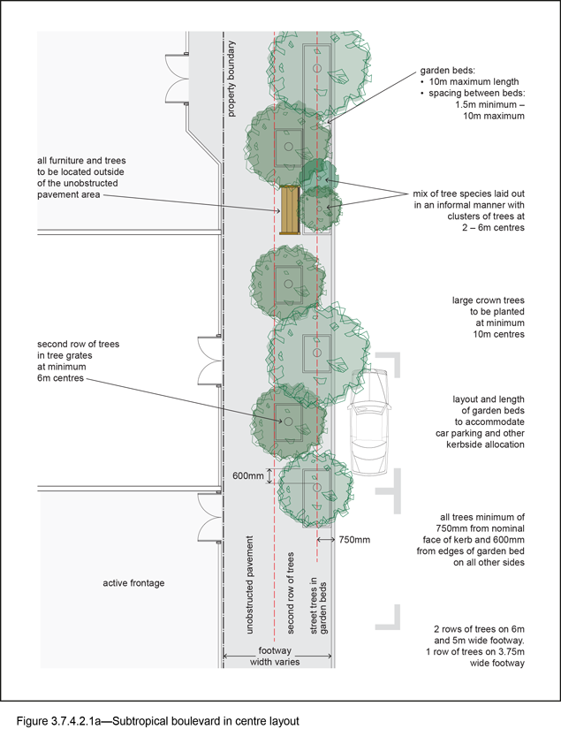

3.7.4.2.2 Typical layout – out of centres (SB2)
The principles in Table 3.7.4.2.2.A must be applied when designing a subtropical boulevard out of centre verge layout as shown in Figure 3.7.4.2.2a.

Table 3.7.4.2.2.A—Subtropical boulevards – out of centre
Design requirement
Verge width | 6m | 5m | 3.75m (4.25m new roads)
Description | Concrete footpath in turf | Concrete footpath in turf | Concrete footpath in turf
Footpath width | 1.8m | 1.8m | 1.8m
Street trees | All trees are a minimum of 950mm from the nominal face of the kerb and 600mm from the edges of the pavement. | All trees are a minimum of 950mm from the nominal face of the kerb and 600mm from the edges of the pavement. | All trees are a minimum of 750mm from the nominal face of the kerb and 600mm from the edges of the pavement.
Mix of tree species laid out in an informal manner with clusters of trees
Medium- and small-crown trees to be planted at 2m to 6m centres
Large-crown feature trees to be planted at minimum 10m centres
Turf strip adjacent kerb – minimum width | 3.3m | 2.3m | 1.3m
Turf strip at rear of verge – minimum width | 0.75m | 0.75m | 0.5m  (1m for new roads)
Furniture | No furniture
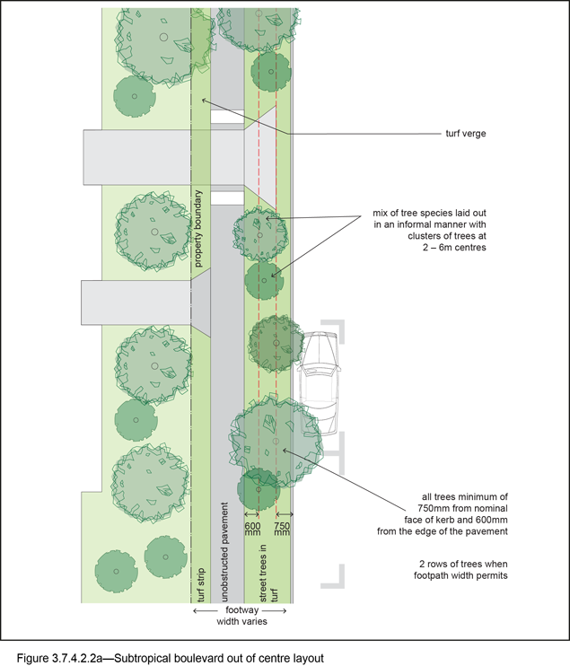

3.7.4.2.3 Standard palette
The standard palette in Table 3.7.4.2.3.A is applied in the design and construction of all subtropical boulevards.

Table 3.7.4.2.3.A—Standard palette
Design requirement
Subtropical boulevard | In centres (SB1) | Out of centre (SB2)
Pavement materials
Footpath | Exposed aggregate is:  - finish: standard Portland Grey concrete;  - colour: Victoria Falls (90% Blue Heeler and 10% Winter Brown);  - supplier: Hanson Code 10014463, Boral or approved equivalent. | Broom finished: Standard Portland Grey concrete.
Driveways | Exposed aggregate to match footpath. | Broom finished is Portland Grey concrete.
Tactile paving  (consistent with BSD-5218) | Concrete tactile paver:  - supplier: Chelmstone, Urbanstone or approved equivalent;  - colour: CCS 'Voodoo.' | Concrete tactile uses:  - supplier: Chelmstone, Urbanstone or approved equivalent;  - colour: CCS 'Voodoo.'
Street trees
Layout | Mix of species, laid out in an informal manner with clusters of trees, closely spaced in some locations and with a second row where verge width permits. | Mix of species, laid out in an informal manner with clusters of trees, closely spaced in some locations and with a second row where verge width permits.
Trees planted in: | Garden beds or tree grates, with the second row of trees always in tree grates | Mulched tree planting area in turf
Street furniture | Yes | None

3.7.4.2.4 Street tree selection
Where not identified in Chapter 5 of this planning scheme policy, trees and groundcovers are to be selected from the list in Table 3.7.4.2.4.A and Table 3.7.4.2.4.B for subtropical boulevard planting.

Table 3.7.4.2.4.A—Street trees
Scientific name | Common name
Subtropical boulevard street trees – medium and small crown
Backhousia citriodora | Lemon scented myrtle
Buckinghamia celsissima ⁽¹⁾ | Ivory curl flower
Cupaniopsis anacardioides | Tuckeroo
Flindersia australis | Crows ash
Flindersia bennettiana | Bennett’s ash
Harpullia pendula ⁽¹⁾ | Tulipwood
Livistona decipiens | Weeping cabbage palm
Lophostemon confertus | Brush box
Melaleuca viridiflora | Broad leaved paperbark
Peltophorum pterocarpum | Yellow poinciana
Syzygium francisii | Francis water gum
Waterhousea floribunda | Weeping lilly pilly
Subtropical boulevard – large-crown feature trees
Delonix regia ⁽¹⁾ | Poinciana
Ficus microcarpa var. Hillii | Hill’s fig
Ficus obliqua | Small-leaved fig
Cassia javanica x fistula | Cassia rainbow showers
Flindersia schottiana | Bumpy ash
Subtropical boulevard – upright feature trees
Agathis robusta | Kauri pine
Alloxylon flammeum | Tree waratah
Araucaria cunninghamii | Hoop pine
Brachychiton acerifolius | Illawarra flame tree
Grevillea robusta | Silky oak
Rhodosphaera rhodanthema | Deep yellowwood
Hymenosporum flavum | Native frangipani
Eleocarpus eumundii | Eumundi quandong
Flindersia brayleana | Queensland maple
Flindersia australis | Crows ash
Note—(1) Trees suitable to be planted under powerlines.

Table 3.7.4.2.4.B—Shrubs and groundcovers for garden beds
Scientific name | Common name
Shrubs and groundcovers
Dianella spp. | Flax lily
Liriope ‘Evergreen Giant’ | Liriope
Liriope ‘Stripey White’ | Variegated liriope
Myoporum parvifolium | Creeping boobialla
Philodendron ‘Xanadu’ | Xanadu
Strelitzia reginae | Bird of paradise
Trachelospermum ‘Variegated’ | Star jasmine

3.7.4.3 City streets

3.7.4.3.1 Typical layout
The principles in Table 3.7.4.3.1.A must be applied when designing a city street verge layout, as shown in Figure 3.7.4.3.1a.

Table 3.7.4.3.1.A—City street
Design requirement
 | City street major—CS1 | City street minor—CS2
Verge width | 5m | 3.75m (4.25m new roads)
Description | Full width pavement | Full width pavement
Unobstructed pavement width | 3.25m | 2.4m
Street trees | All tree centre-lines are 950mm from the nominal face of the kerb and a minimum of 600mm from the edges of the pavement. | All tree centre-lines are 750mm from the nominal face of the kerb and a minimum of 600mm from the edges of the pavement.
A city street has:
- a mix of tree species laid out in an informal manner with clusters of trees;
- medium- and small-crown trees to be planted at minimum 2m spacing, if within garden beds, or minimum 6m spacing outside of garden beds;
- large-crown feature trees to be planted at minimum 10m centres.
Garden beds – located adjacent kerb | A garden bed located adjacent to the kerb has a:  - 1.5m minimum spacing between garden beds;  - maximum length of 10m;  - layout and length to accommodate car parking and other kerbside allocation.
Garden beds – minimum widths | 1.6m | 1.2m
Tree grates | 1.6m x 1.6m | 1.6m x 1.2m
Furniture | All furniture is to be located outside of the unobstructed pavement area.
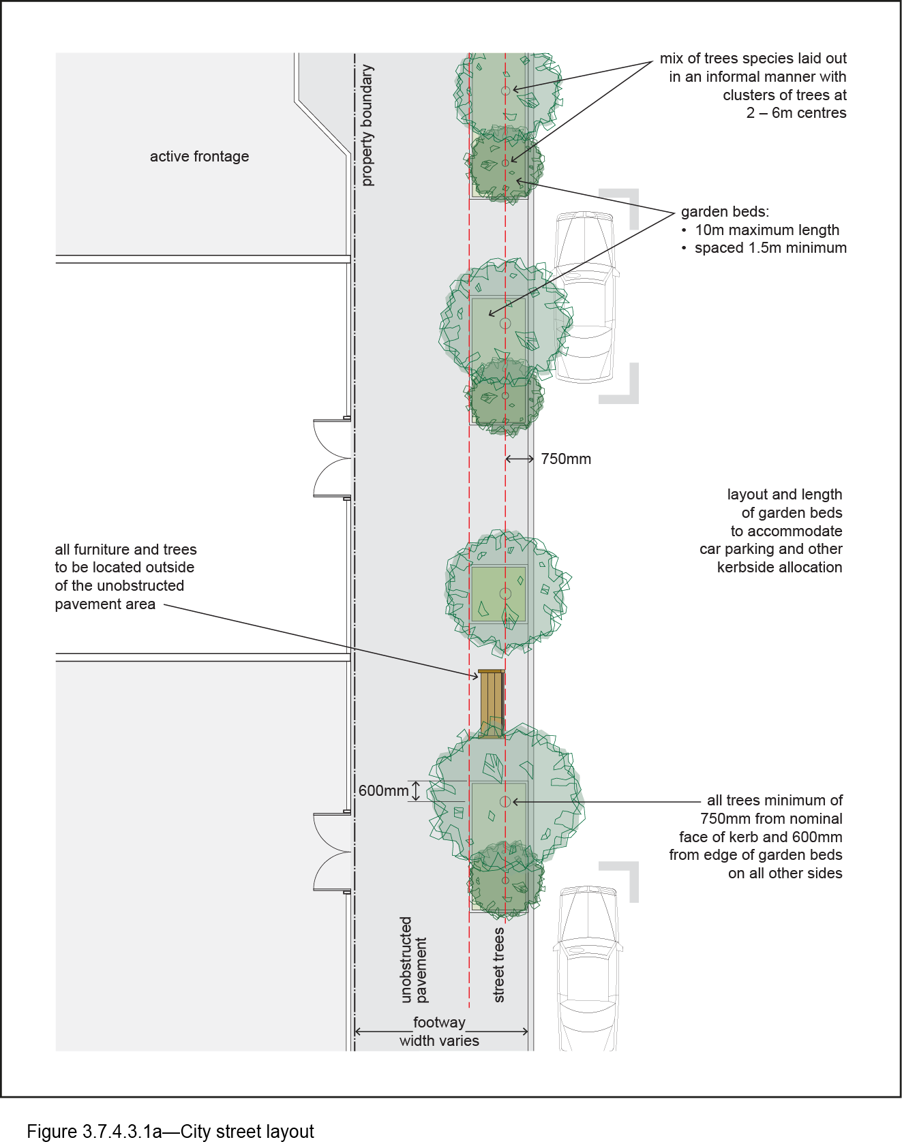

3.7.4.3.2 Standard palette
The standard palette in Table 3.7.4.3.2.A is to be applied in the design and construction of all city streets.

Table 3.7.4.3.2.A—Standard palette
Design requirement
 | City street major – CS1 | City street minor – CS2
Pavement materials
Footpath within 5km radius of the City Centre (excluding the City centre) | Exposed aggregate uses:  - type: Standard Portland Grey concrete;  - supplier: Hanson Code 10014463, Boral or approved equivalent;  - colour: Victoria Falls (90% 'Blue Heeler' and 10% 'Winter Brown').  Tactile paving uses (consistent with BSD-5218):  - type: concrete tactile paver;  - supplier: Chelmstone, Urbanstone or approved equivalent;  - colour: CCS 'Voodoo'.
Footpath outside 5km radius of the City Centre | Exposed aggregate uses:  - type: Standard Portland Grey concrete;  - supplier: Boral or approved equivalent;  - colour: Hanson 100% 'Exposemasta Blue Gold' 10032911.  Tactile paving uses (consistent with BSD-5218):  - type: concrete tactile paver;  - supplier: Chelmstone, Urbanstone or approved equivalent;  - colour: CCS 'Voodoo'.
Driveways | Exposed aggregate to match footpath
Street trees
Layout | Street trees are:  - a mix of species, in a single row at the rear of kerb;  - to be planted as singles and in pairs or clusters.
Planting | Trees are planted in garden beds or tree grates.
Street furniture | Yes

3.7.4.3.3 Street tree selection
Where not identified in Chapter 5 of this planning scheme policy, street tree species are to be chosen from those listed in section 3.7.5.

3.7.4.4 Neighbourhood streets

3.7.4.4.1 Typical layout
- The principles in Table 3.7.4.4.1.A must be applied when designing a neighbourhood street verge layout. Refer to Figure 3.7.4.4.1a.
- Note that for neighbourhood streets minor (NS2), a concrete footpath is only constructed in instances where pedestrian traffic volumes require it. Such instances will be determined on a site-by-site basis.

Table 3.7.4.4.1.A—Neighbourhood streets
Design requirement
 | Neighbourhood street major—NS1 | Neighbourhood street minor—NS2
Verge width | 3.75m (4.25m new roads)
Description | Concrete footpath in turf
Unobstructed pavement width | 1.8m | 1.2 m(1)
Street trees | Street trees:  - all trees minimum of 750mm from nominal face of kerb and 600mm from edges of pavement;  - mix of tree species laid out in an informal manner with clusters of trees;  - medium- and small-crown trees to be planted at minimum 2m spacing, if within garden beds, or minimum 6m spacing outside of garden beds;  - large-crown feature trees to be planted at minimum 10m centres.
Turf strip adjacent kerb – minimum width | 1.3m minimum | 1.3m minimum
Turf strip at rear of verge | 0.5m  (1m for new roads) (2) | 1.1m  (1.6m for new roads) (2)
Tree planting beds – minimum widths | 1.2m
Furniture | No furniture
Notes—
(1) Where required.
(2) Where concrete footpath is required.
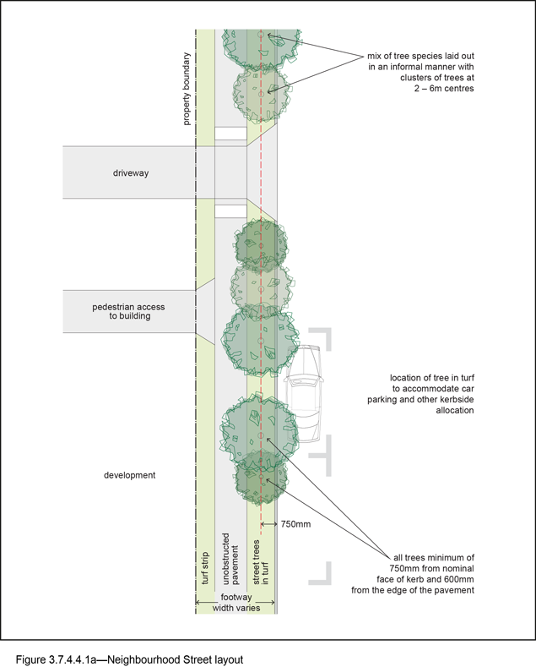

3.7.4.4.2 Standard palette
The standard palette in Table 3.7.4.4.2.A is to be applied in the design and construction of all neighbourhood streets.

Table 3.7.4.4.2.A—Standard palette
Design requirements
 | Neighbourhood street major—NS1 | Neighbourhood street minor—NS2
Pavement materials
Footpath | Broom finished: Standard Portland Grey concrete
Driveways | Broom finished: Standard Portland Grey concrete
Tactile paving  (consistent with BSD-5218) | Type: concrete tactile paver  Supplier: Chelmstone, Urbanstone or approved equivalent  Colour: CCS 'Voodoo'
Street trees
Layout | Street trees are a mix of species, in a single row at the rear of kerb. Trees to be planted as singles and in pairs or clusters.
Trees planted in | Mulched tree planting area in turf

3.7.4.4.3 Street tree selection
Where not identified in Chapter 5 of this planning scheme policy, street tree species are to be chosen from those listed in the general species tables in section 3.7.5.

3.7.4.5 Industrial streets

3.7.4.5.1 Typical layout
The principles in Table 3.7.4.5.1.A must be applied when designing an industrial street verge layout. Refer to Figure 3.7.4.5.1a.

Table 3.7.4.5.1.A—Industrial streets
Design requirement
 | Specification
Verge width | 3.75m (4.25m new roads)
Description | Concrete footpath in turf
Footpath width | 1.2m
Street trees | Street trees:  - all trees minimum of 1.45m from nominal face of kerb and 600mm from edges of pavement;  - mix of tree species laid out in an informal manner with clusters of trees;  - medium- and small-crown trees to be planted at minimum 2m spacing, if within garden beds, or minimum 6m spacing outside of garden beds;  - large-crown feature trees to be planted at minimum 10m centres.
Turf strip adjacent kerb – minimum width | 1.9m
Turf strip at rear of verge | 0.5m (1m for new roads)
Tree planting beds – minimum widths | 1.2m
Furniture | No furniture
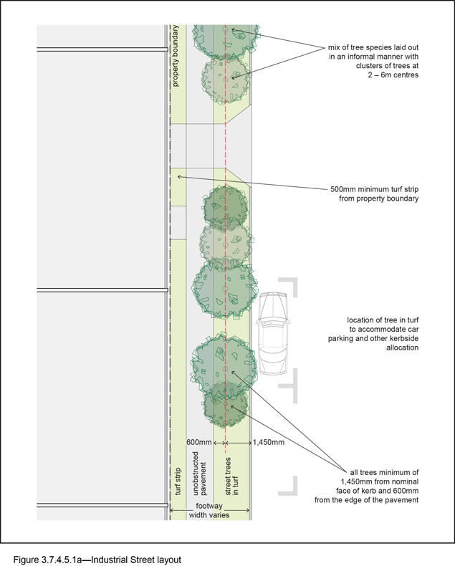

3.7.4.5.2 Standard palette
The standard palette in Table 3.6.4.5.2.A is to be applied in the design and construction of all industrial streets.

Table 3.7.4.5.2.A—Standard palette
Design requirement
Pavement materials | Specification
Footpath | Broom finished: Standard Portland Grey concrete
Driveways | Broom finished: Portland Grey concrete
Tactile paving  (consistent with BSD-5218) | Type: concrete tactile paver  Supplier: Chelmstone, Urbanstone or approved equivalent  Colour: CCS 'Voodoo'
Street trees
Layout | Street trees are a mix of species, in a single row at the rear of kerb. Trees to be planted as singles and in pairs or clusters.
Trees planted in: | Mulched tree planting area in turf

3.7.4.5.3 Street tree selection
Where not identified in Chapter 5 of this planning scheme policy, street tree species are to be chosen from those listed in the general species tables in section 3.7.5.

3.7.4.6 Locality streets
- Locality streets are only required where identified in the Streetscape hierarchy overlay map.
- Additional advice for certain locations can be found in neighbourhood plans or in Chapter 5 of this planning scheme policy.

3.7.4.7 Corner land dedications

3.7.4.7.1 General
- Corner land dedications are only required where identified in the Streetscape hierarchy overlay map.
- Additional advice for some locations can be found in neighbourhood plans or in Chapter 5 of this planning scheme policy.

3.7.4.7.2 Typical layout
- A corner land dedication is either truncated or inverted.
- A typical layout of the paving, furniture, pedestrian lighting, large feature tree planting and garden beds is shown for each option in Figure 3.7.4.7.4a and Figure 3.7.4.7.4b.

3.7.4.7.3 Typical size
Dimensions of corner land dedications are as shown in Figure 3.7.4.7.4c and Figure 3.7.4.7.4d, except where specified in Chapter 5 of this planning scheme policy or a neighbourhood plan.

3.7.4.7.4 Palette
- Acceptable paving materials, furniture, lighting and planting for corner land dedications are to match the adjoining streetscape type.
- Tree species are as specified in the relevant locality within Chapter 5 of this planning scheme policy.

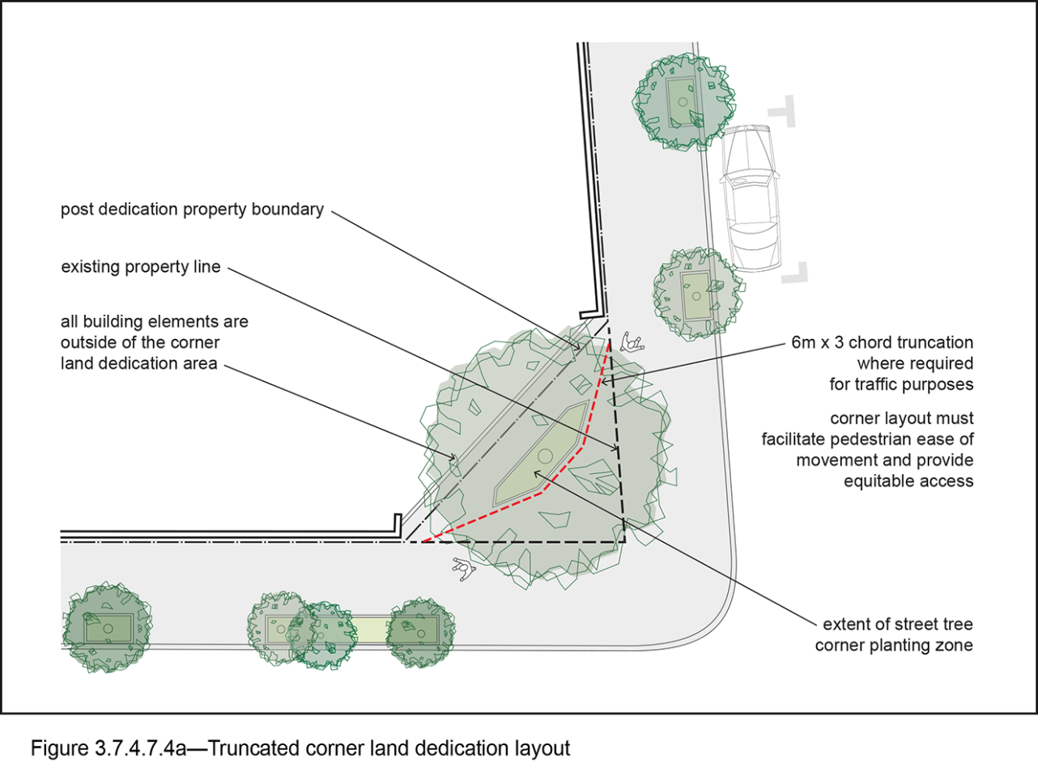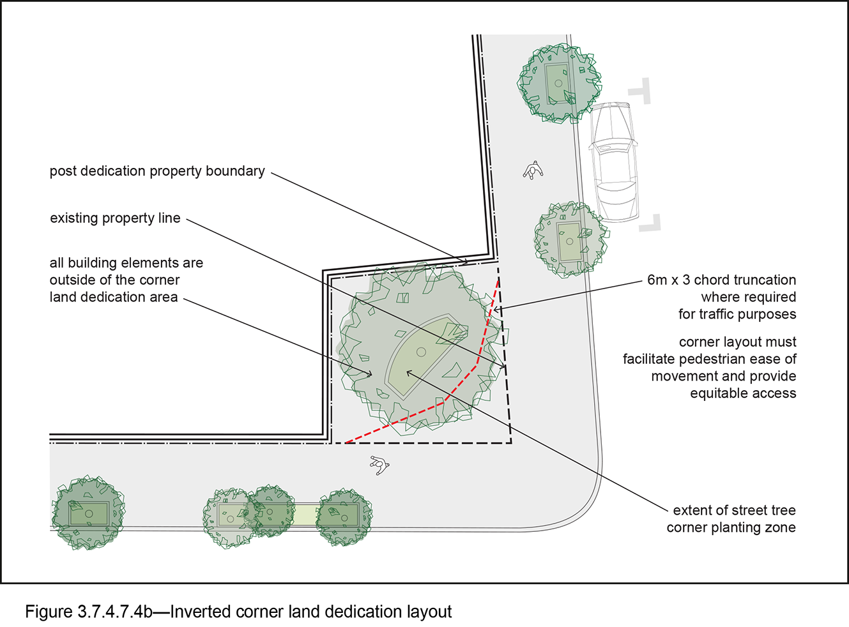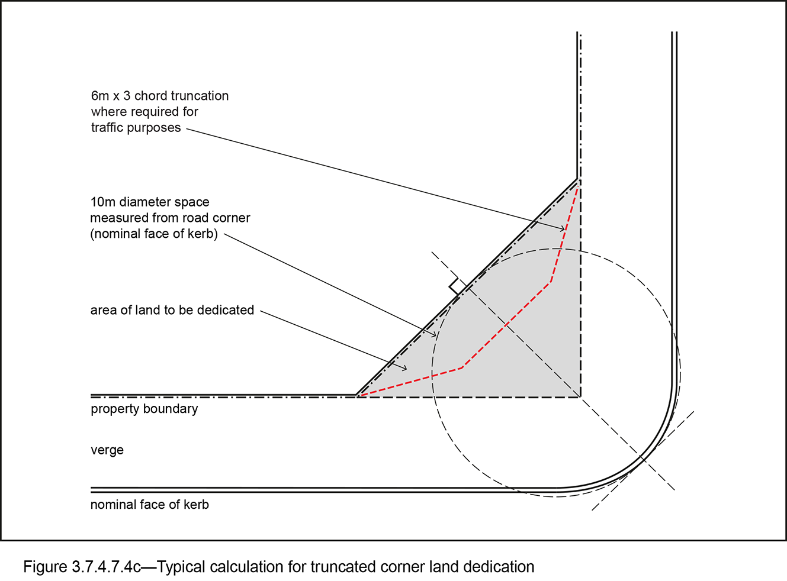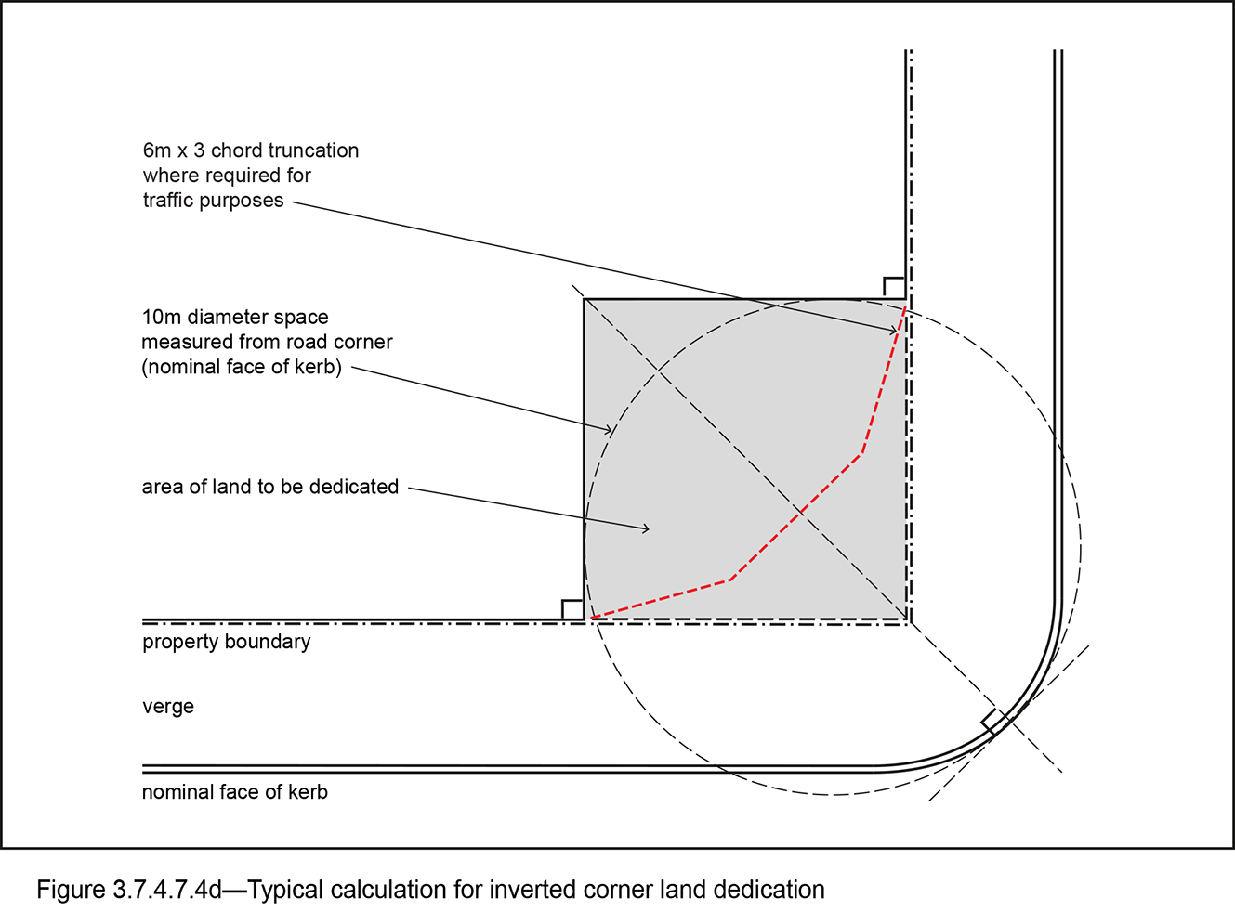

3.7.4.8 Laneways

3.7.4.8.1 General
- Lanes are only required in locations where specified in the Streetscape hierarchy overlay map.
- Additional advice can be found for specific locations in a neighbourhood plan or Chapter 5 of this planning scheme policy.

3.7.4.8.2 Typical layout
- Lanes provide for shared zones in their design through integrating or reconfiguring any required service, access function and transport modes of the space to maximise pedestrian amenity.
- A minimum of 1 pedestrian strip is included to allow pedestrians to step back when in conflict with other transport modes.
- The design and embellishment of lanes must include a pedestrian clearance zone, which must be kept clear of any obstruction to traffic.
- Refer to the typical layout diagrams for laneways in and out of centres, as shown in Figure 3.7.4.8.2a and Figure 3.7.4.8.2b.

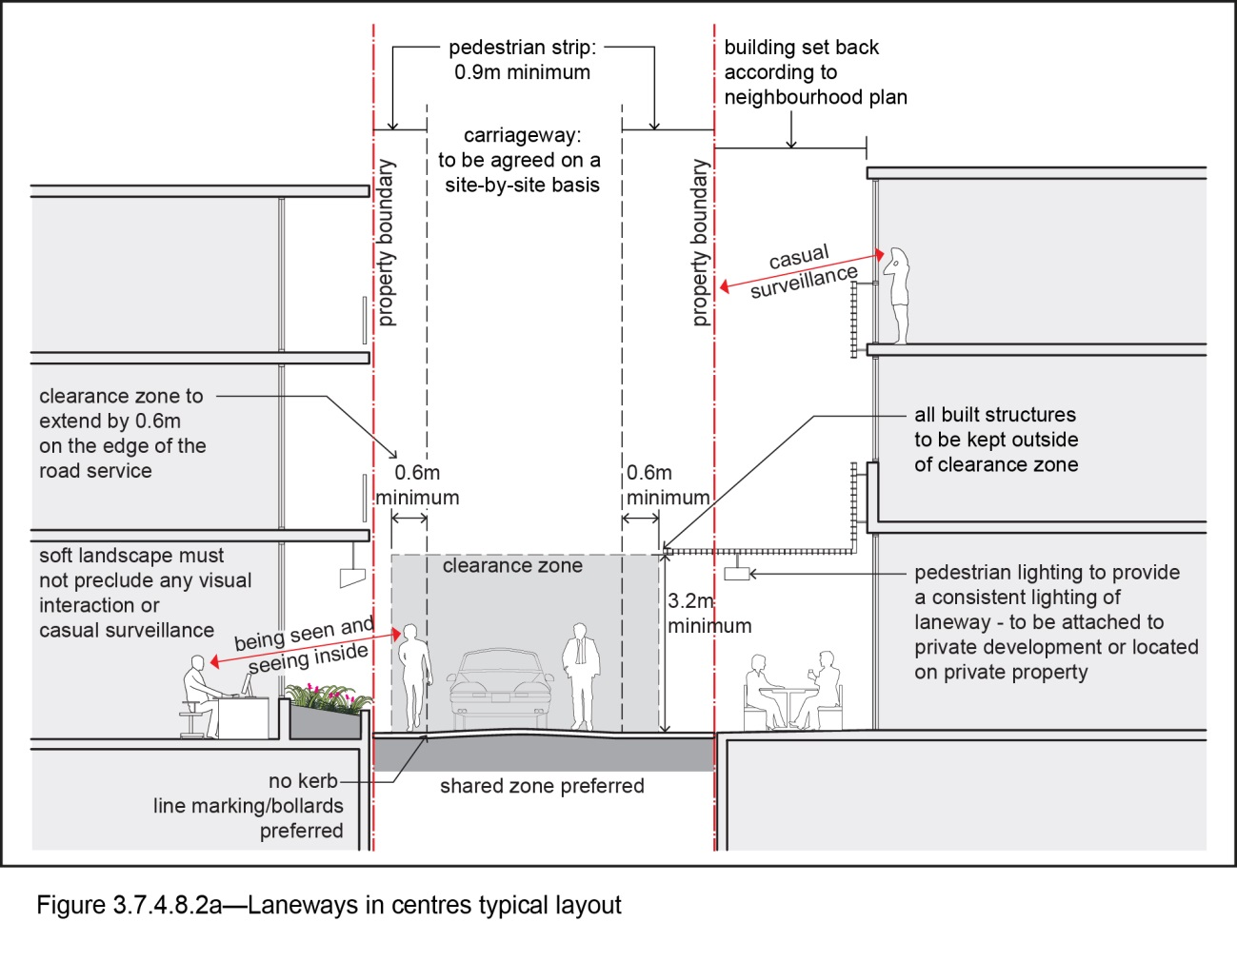
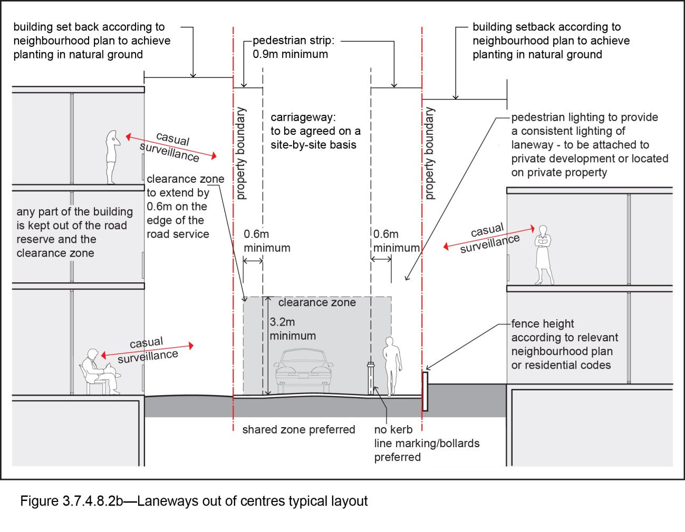

3.7.5 Design standards for street tree planting

3.7.5.1 Set out from kerb
- Street trees are planted 750mm from nominal face of kerb for verges up to 4.25m wide, and 950mm from nominal face of kerb for verges greater than 4.25m wide in accordance with BSD-1013, BSD-1014, BSD-1015 and BSD-1016.
- Street tree setback from kerb is greater for industrial streets, to accommodate the prevalence of larger vehicles along the kerbside.
- The location must accommodate the ultimate size and shape of the tree.

3.7.5.2 Existing and replacement street trees
- Existing street trees are to be retained and protected unless removal is negotiated and approved by Council.
- Replacement street tree planting achieves Council’s policy of no net canopy areas loss.
- Applicants must make arrangements with Council to accommodate hoardings, gantries and any other construction works proposed around existing street trees.

3.7.5.3 Planting locations
- Planting techniques incorporate containment of root growth where necessary.
- Consideration must be given to the location of underground services, street lights, and traffic signs. BSD-9001, BSD-9002, BSD-9003, BSD-9004, BSD-9005 and BSD-9006 provide details for tree planting under different conditions.
- Single street trees are planted at a spacing no less than one for every 6m of allotment frontage. Clusters and pairs of trees are at minimum 2m centres.
- Large-crown feature trees are planted in areas no smaller than 7m x 6m, at minimum 10m spacing.
- Where planted in corner land dedications, large-crown feature trees have a minimum setback from kerb of 3.75m, and minimum branch height clearance of 4.5m within 1.5m of the kerb, to ensure sightlines at intersections are maintained for motorists.
- Upright feature trees are planted in areas no smaller than 5m x 5m.
- Individual trees are planted at minimum 10m centres.
- Where space permits, trees may be planted in feature groups at minimum 5m centres.
- Tree planting must be avoided within:
- un-signalised intersection sightlines, unless using semi-advanced stock sizes that provide visual clearance under tree canopies;
- 3m of a power pole (<110 kV), pad mounted transformer, driveway, invert crossing, inspection boxes, fire hydrants or water valves;
- 15m of the approach side of a pedestrian crossing and within 5m from the departure side of a pedestrian crossing;
- 7m of a street light or traffic signals or 110kV concrete power pole (contact Energex to locate earth cable or for appropriate planting clearance distances from substations);
- 20m from the approach to a bus stop and 6m from the departure side – excluding at the bus stop itself, or on alignments that do not inhibit sightlines from the bus stop;
- the verge where adjoining parkland;
- 1.5m of a property service connection (i.e. such as roof water, gas, sewer, water, telecommunications or electricity);
- narrow verges and medians less than 2.5m wide.

3.7.5.4 Deep planting
- All tree planting must be in natural or improved soil profiles containing subsoil layers.
- Trees must have adequate soil quality and quantity to grow to their optimum within the particular location.
- Adequate soil volumes also help restrict root growth elsewhere.
Note—Planting on the verge does not contribute to the calculation of deep planting required on private property.

3.7.5.5 Irrigation
Reticulated irrigation is discouraged unless provided for the tree establishment period only, and sourced from non-potable water.

3.7.5.6 Root barriers
- Root barriers are not used as a response to bad species choice or inadequate root zone space.
- Root barriers deflect roots, and do not work unless the top side of the deflective is above the surface.
- Where root barriers are required, they are to be installed in accordance with BSD-9082.

3.7.5.7 Tree trenches
- Tree trenches may be required for some full-width pavement verges.
- Where required, tree trenches are designed and constructed in accordance with, BSD-9010, BSD-9011 and BSD-9012.

3.7.5.8 Tree planting surrounds
The streetscape type determines whether trees are to be planted in mulch, garden beds, tree grates, or permeable and porous paving.

3.7.5.9 Species
Where not identified in Chapter 5 of this planning scheme policy, plantings within entire streets may include a mix of species allowing for some consistency of individual feature trees at focal points such as roundabouts, ends of local access streets, and medians of main collector roads. Street tree species for these streets are listed in the general species tables.

3.7.5.10 Plant stock
- The selection and quality of plant stock must conform to Council’s ‘Nursery Stock Quality for Landscape Trees’; or ‘NATSPEC Specifying Trees – Ross Clark’.
- For new street tree planting in subtropical boulevards in centre (SB1), city streets (CS1 and CS2) and locality streets, all trees are to be advanced stock material, with:
- street trees a minimum stock size of 200L and a minimum height of 3.5m;
- feature trees a minimum stock size of 200L and a minimum height of 5m when planted.
- All trees to have a minimum clear trunk of 1.8m measured from the top of the tree grate, porous paving or finished soil level where planted in garden beds or turf, to the lowest branch.
- For new street tree planting to all other streetscape types, the minimum stock size is 25L.

3.7.5.11 Implementation
- For all streetscape works tree planting other than tree planting for new roads, developers must undertake planting and maintenance.
- Where for new street tree planting on newly constructed roads, developers can either:
- contribute to the cost of planting and establishing street trees, with the amount calculated by a rate per 6m of allotment frontage that provides for 1 tree per allotment, planted by Council when the development is substantially built; or
- undertake their own tree planting and a 12-month maintenance period for stock sizes less than 45L, and 24-month maintenance period for stock sizes greater than 45L.
- A road reserve landscaping plan for newly constructed roads showing existing and proposed trees, location of street lights, driveways, services etc., should be submitted and approved (prior to planting) by Council. The minimum stock size, quality of plants, planting and after care should conform to Council requirements. Trees damaged or declined during the maintenance period or the duration of development, whichever is the longer, must be replaced.
- The following tables are a guide to species of trees, shrubs and ground covers that generally perform well and require minimal maintenance in roadside landscaping. These lists are deliberately not comprehensive as final species choices should be based on professional site condition analysis and advice from a suitably qualified landscape architect or horticulturist.
- Street tree species are generally small–medium crowned, upright or feature tree species from these tables.
- Outside of Locality Advice areas, street tree species must comply with the most up-to-date lists of Types of street trees on Council’s website.

3.7.5.12 Large-crown trees
- Large-crown width, spreading canopy trees (centrally planted) are suitable for verges and medians exceeding 7m in width.
- The minimum unpaved area should be 6m² (this area can be grated or companion planted) and the available root zone should not be less than 10m.
- The tree species in Table 3.7.5.12.A are acceptable.

Table 3.7.5.12.A—General species table for large-crown trees
Scientific name | Common name
Ficus macrocarpa var. hillii | Hill’s fig
Ficus obliqua | Small-leaved fig
Ficus benjamina | Weeping fig
Delonix regia | Poinciana
Jacaranda mimosaefolia | Jacaranda

3.7.5.13 Medium crown trees
- Medium crown width spreading canopy trees are suitable for 2.5m–7m wide verges.
- The minimum unpaved area should be 1.5m2 (this area can be grated or companion planted) and the available root zone should not be less than 5m3.
- The tree species in Table 3.7.5.13.A are acceptable.

Table 3.7.5.13.A—General species table for medium-crown trees
Scientific name | Common name
Caesalpinea ferrea ⁽¹⁾ | Leopard tree
Waterhousea floribunda | Weeping lilly pilly
Harpullia pendula | Tulipwood
Cassia siamea | Cassod tree
Peltophorum pterocarpum | Yellow poinciana
Tamarindus indica | Tamarind
Schotia brachypetala | Kaffir bean
Flindersia schottiana | Bumpy ash
Note—(1) Leopard trees can only be planted as new and replacement plantings in specified streets within the City Centre and Fortitude Valley, as per Chapter 5 in this planning scheme policy.

3.7.5.14 Upright/columnar/elliptical trees
- Upright/columnar/elliptical trees with small crown width are suitable for planting within median strips, and verges where spreading tree canopies are inappropriate.
- The tree species in Table 3.7.5.14.A are acceptable.

Table 3.7.5.14.A—General species table for upright columnar elliptical trees
Scientific name | Common name
Lophostemon confertus | Brush box
Eleocarpus eumundii | Eumundi quandong
Melaleuca quinquenervia | Paperbark tea tree
Melaleuca viridiflora | Broad leafed paperback
Grevillea baileyana | White oak
Flindersia australis | Crow’s ash
Casuarina cunninghamiana ⁽¹⁾ | River sheoak
Casuarina glauca ⁽¹⁾ | Swamp sheoak
Mellicope elleryana | Butterfly tree
Pittosporum rhombifolium | Queensland pittosporum
Syzygium luehmannii | Lilly pilly
Syzygium francissii | Water gum
Backhousia citriodora | Lemon scented ironwood
Note—(1) Acceptable for median strips only, not verges.

3.7.5.15 Small–medium crown trees
- Small–medium crown trees with rounded canopies are suitable for planting within traffic islands and speed control devices, and on verges with overhead power lines.
- The tree species in Table 3.7.5.15.A are acceptable.

Table 3.7.5.15.A—General species table for small–medium crown trees
Scientific name | Common name
Buckinghamia celsissima | Ivory curl flower
Callistemon salignus | White bottle brush
Callistemon eureka | Pink bottle brush
Cupaniopsis anacardioides | Tuckeroo
Handroanthus impetignosis | Pink trumpet tree
Tabebuia argentea | Silver trumpet tree
Tabebuia pallida | Cuban pink trumpet tree
Xanthostermon chrysanthus | Golden penda

3.7.5.16 Upright feature trees
- Feature trees (centrally planted) are suitable for planting inside roundabouts.
- The minimum planting space should not be less than 5m wide.
- The tree species in Table 3.7.5.16.A are acceptable.

Table 3.7.5.16.A—General species table for upright feature trees
Scientific name | Common name
Araucaria cunninghamii | Hoop pine
Araucaria heterophylla | Norfolk Island pine
Grevillia robusta | Silky oak
Brachychiton acerifolius | Flame tree
Agathis robusta | Kauri pine
Flindersia brailyeana | Queensland maple

3.7.5.17 Small trees or large shrubs
Small trees and large shrubs listed in Table 3.7.5.17.A are suitable for planting inside roundabouts and roadside build outs outside of the sightline-constrained parts of those sites.

Table 3.7.5.17.A—General species table for small trees and large shrubs
Scientific name | Common name
Syzygium “Aussie Compact” | Aussie compact
Syzygium “Aussie boomer” | Aussie boomer
Syzygium “Elite” | Elite
Melaleuca tamariscina var. irbyana | Broombrush
Callistemon sp. | Bottlebrush
Tristaniopsis laurina | Water gum

3.7.5.18 Low shrubs and other plants with sculptural forms
Low shrubs and other plants with sculptural forms listed in Table 3.7.5.18.A are suitable for planting as understorey plantings within garden areas of verges, roundabouts, medians or roadside build outs outside of sightline-constrained parts of those sites.

Table 3.7.5.18.A—General species table for low shrubs and other plants with sculptured form
Scientific name | Common name
Syzygium “Tiny Trev” | Tiny Trev
Doryanthes excelsa | Spear lily (setbacks required for flower spear maintenance)
Crinum pedunculatum | Swamp lily
Agave attenuatum | Agave
Dietes grandiflora | Wild iris
Strelitzia reginae | Bird of paradise
Agapanthus africanus | African lily
Cordyline rubra | Red palm lily

3.7.5.19 Small–medium shrubs
Small–medium shrubs listed in Table 3.7.5.19.A are suitable for planting as understorey in gardens within verges, inside roundabouts and roadside build outs outside of the sightline-constrained parts of all of those sites.

Table 3.7.5.19.A—General species table for small-medium shrubs
Scientific name | Common name
Baeckea virgata | Baekea
Callistemon pachyphyllus | Swamp bottle brush/red, green bottlebrush
Callistemon “Wildfire” | Wildfire bottlebrush
Abelia grandiflora | Glossy abelia
Melaleuca “Claret Tops” | Claret tops
Schefflera arboricola | Dwarf umbrella plant

3.7.5.20 Groundcovers
Groundcovers listed in Table 3.7.5.20.A are suitable as understorey plantings within garden areas of verges, roundabouts, medians or roadside build outs within sightline-constrained parts of those sites.

Table 3.7.5.20.A—General species table for ground covers
Scientific name | Common name
Cissus antarctica | Native grape
Myoporum ellipticum | Myoporum
Lomandra sp. | Lomandra (small growing species preferred)
Dianella sp. | Blue flax lily (use in mix with other tufting ground covers for longevity)
Gazania rigens | Gazania
Nandina domestica “Nana” | Scarlet bamboo
Juniperus confertus | Juniper or blue pine
Liriope “muscari” “Evergreen Giant” | Liriope
Liriope “Stripey White” | Liriope stripey white
Grevillea sp. (prostrate forms) | Prostrate grevillea

3.7.6 Design standards for street furniture

3.7.6.1 General
- Council’s furniture suite is to be used in all instances where street furniture is required in the verge.
- Council’s furniture suite is to be used to ensure that all furniture installed in the verge meets all relevant standards for accessibility and safety, is easy to clean and maintain, and is able to be sourced for replacement.

3.7.6.2 Locations
- Where required, furniture is located to minimise clutter and provided in locations that are conducive to use.
- Furniture is located in the zone at the rear of kerb, allowing for clear pedestrian flow.
- To avoid conflict with traffic, all furniture must be located a minimum of 750mm from the nominal face of the kerb. Additionally, adjacent items must be appropriately spaced, to allow for ease of movement between them, as shown in Figure 3.7.6.2a.
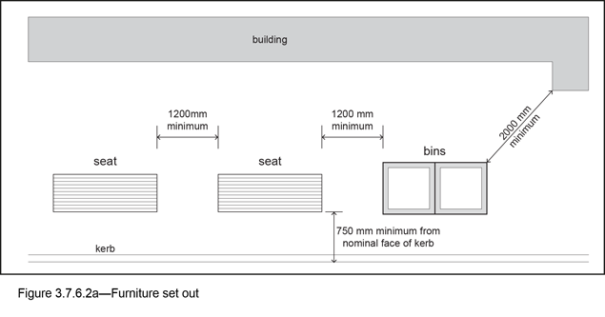

3.7.6.3 Colour and finish
- All non-stainless steel metal furniture or furniture components must be powder-coated in Dulux ‘Metropolis Storm Pearl’ (Code 84684) Satin or approved alternative, except for tree grates, which are texture powder-coated in Interpon D1000 Sable Bass Texture GN297A or approved alternative.
- Exceptions also include those localities within the streetscape locality advice section of this planning scheme policy, where furniture colour is already established. In these locations new furniture is required to match the existing.
- All stainless steel furniture is manufactured in 316 grade stainless steel, and finished with a No.4 finish, with surface roughness (Ra) to be less than 0.5 µm.

3.7.6.4 Fixing
- All items must be surface-mounted to allow for flexibility in the locations of furniture, ease of replacement and installation after completion of other civil works.
- Surface mounting bolts must penetrate directly through the concrete slab or through the unit paving and mortar bed (where relevant) into the concrete slab.

3.7.6.5 Furniture elements
Table 3.7.6.5.A lists furniture elements.

Table 3.7.6.5.A—Furniture elements
Design requirement | Specifications
Seat
As per BSD-7201
Design | The seat:  - is a robust, familiar and physically comfortable item with a contoured timber surface;  - includes a flexible leg detail that allows for a moderate height adjustment to cater for uneven surfaces (125mm maximum);  - foot location is laterally adjustable to suit different paving modules or subsurface conditions;  - is located parallel with the kerb, facing away from traffic and adjacent to street trees.
Materials and finishes | A seat has:  - a galvanised and powder-coated mild steel frame;  - hardwood timber slats sourced from plantation or sustainably harvested sources;  - timber finished in ‘Bunnings Jarrah’ stain or approved alternative.
Fixing | Surface mounted – fixed with 10mm diameter x 150mm long expansion bolts and acorn nuts
Bench
As per BSD-7203
Design | The bench:  - is an alternative to the seat, suitable for situations where supplementary seating to the standard seat is desired;  - includes a flexible leg detail that allows for a moderate height adjustment to cater for uneven surfaces (125mm max.);  - foot location is laterally adjustable to suit different paving modules or subsurface conditions.
Materials and finishes | A bench has:  - a galvanised and powder-coated mild steel frame;  - hardwood timber slats sourced from plantation or sustainably harvested sources;  - timber finished in ‘Bunnings Jarrah’ stain or approved alternative.
Fixing | Surface mounted – fixed with 10mm diameter x 150mm long expansion bolts and acorn nuts
Urban stool
As per BSD-7204
Design | An urban stool is:  - a small precast concrete stool suitable for installation in a number of configurations on the pavement;  - suitable for installation in centres, and is typically installed in small groups of 2 to 4.
Materials and finishes | An urban stool uses precast concrete, and its finish is Kolormasts ‘Raven’ honed or approved alternative.
Fixing | 20mm diameter galvanised threaded rod fixed into stool and chemset into concrete pavement
Tree grate
As per BSD-9071
Design | Tree grates:  - are designed to allow the penetration of air and water to the soil, while minimising trip and slip hazards and rubbish trapping properties;  - require a metal support frame to be installed in the verge at the time of construction, and include laser cut ‘T’ sections to accommodate tree guards;  - must be tailored to cater for existing ‘off centre’ tree trunks as required.
Materials and finishes | Tree grates are:  - laser cut and have powder-coated galvanised steel;  - tree grates are available in two sizes: 1.615m x 1.615m and 1.615m x 1.21m. Preference is given to the 1.615m x 1.615m tree grate where space permits.
Fixing | Tree grates are fixed into the verge surface and are fixed to the frame by camlocks in all corners.
Tree guard
As per BSD-9072
Design | Tree guards are:  - designed for compatibility with tree grates;  - an adjustable foot fixing allows the guard to be set vertically on sloping terrain;  - only required in association with tree grates, and normally in locations where there are high pedestrian traffic flows.
Materials and finishes | Galvanised and powder-coated mild steel frame, with stainless steel logo panel
Fixing | Tree guards are fixed to tree grates with stainless steel bolts, lock nuts and screws.
Rubbish bin – 240L dual bin
Design | The 240L dual bin is:  - designed to provide large capacity rubbish disposal and recycling facilities in a single unit;  - provided with 2 butt-bin attachments to create an all-purpose public waste disposal facility;  - is required in locations that cater for larger pedestrian traffic volumes, and is to be located parallel with the kerb, facing away from vehicular traffic;  - installed in new developments within the City Centre;  - is located within 25m of intersections on all street frontages.
Materials and finishes | The 240L dual bin has a powder-coated aluminium body, an aluminium butt-bin, and metal bin liner.
Fixing | Surface mounted – fixed with 4mm x 10mm diameter x 150mm long expansion bolts and acorn nuts
Drinking fountain
As per BSD-7331
Design | A drinking fountain:  - is placed at convenient locations throughout Brisbane, typically in centres and along major pedestrian and cyclists routes in the verge;  - has a simple, robust and accessible design to match the other components of the furniture range.
Materials and finishes | A drinking fountain is:  - 316 stainless steel natural colour;  - 600 grit polish/garnet blasted; or  - highly polished as specified.
Fixing | Surface mounted to rag bolt cage cast into concrete pavement
Bollard
As per BSD-7331
Design | A bollard:  - is of simple cylindrical form with flat top to 1m high;  - has a maximum spacing between another bollard of 1.4m;  - can be either fixed or removable.
Materials and finishes | A bollard is natural colour 316 grade stainless steel, and its finish is 600 grit polish/garnet blasted.
Fixing | Fixed bollard – surface mounted to rag bolt cage cast into concrete pavement  Removable bollard – surface mounted to removable bollard case set in concrete pavement
Bike rack
As per BSD-5051, BSD-5052
Design | A bike rack:  - can be either a single or a multi-bike rack, depending on site specific requirements;  - is typically mounted parallel to the kerb.
Materials and finishes | A bike rack is natural colour 316 grade stainless steel, and its finish is to be 600 grit polish/garnet blasted.
Fixing | Surface mounted – stainless steel base plate fixed with 4mm x 10mm diameter x 150mm long expansion bolts and acorn nuts
Public transport seat
As per BSD-7202
Design | The Public Transport Seat:  - is an alternative to the seat for public transport stops where compliance with AS1428.2:1992, clause 27.2 is required;  - includes a flexible leg detail that allows for a moderate height adjustment to cater for uneven surfaces (125mm max);  - foot location is laterally adjustable to suit different paving modules or subsurface conditions.
Materials and finishes | - a galvanised and powder-coated mild steel frame;  - hardwood timber slats sourced from plantation or sustainably harvested sources;  - timber finished in 'Bunnings Jarrah' stain or approved alternative.
Fixing | Surface mounted - fixed with 10mm diameter x 150mm long expansion bolts and acorn nuts
Light pole
As per BSD-11004
Design | The light pole is:  - galvanised and powder-coated mild steel tapered pole and luminaire;  - designed for use in centres where an awning and associated under awning lighting is not provided;  - to be installed city wide as part of new developments, typically in centres.
Materials and finishes | The light pole has a powder-coated galvanised mild steel pole and luminaire and a stainless steel logo badge.
Fixing | M16 rag-bolt cage and hex nut assembly in a concrete slab

3.7.7 Design standards for lighting

3.7.7.1 Pedestrian lighting
- Preference is given to under awning lighting.
- Where there are no awnings, pole top pedestrian lights are provided.
- Refer to BSD-11001, BSD-11002 and BSD-11003.

3.7.7.2 Up-lighting in verge
Up-lighting will not be permitted in the verge, except where it is required to illuminate public art located in the verge.

3.8 Heritage kerb
- Heritage kerb in Brisbane includes kerbs, crossovers, channel stones, margin stones or other stone features that are made from either Brisbane Tuff or granite.
- Where heritage kerbs exist they are to be retained as follows:
- retained in situ as part of any redevelopment;
- a conservation management plan is to be prepared and submitted to Council's City Architecture and Heritage Team;
- where works are being undertaken in close proximity to heritage stone kerbs, care is to be taken to ensure that new asphalt road surfaces are neatly finished beside adjoining stone surfaces;
- where they cannot be retained in their existing location due to changes through redevelopment proposals, they are to be removed, stored during construction and reinstated to the new kerb alignment.
- On the rare occasion where Council approves the permanent removal of heritage kerb, the heritage material is to be surrendered to Council for stockpiling for future use in key locations.
- Infill stone kerb may be required as follows:
- where a frontage has gaps in the stone kerbing, consult with Council's City Architecture and Heritage Team to agree if infill stone kerbs or pre-cast concrete kerbs are required;
- where infill stone kerbs are required, they are to match as closely as possible with the existing kerbs, in terms of colour, finish and proportions.
- For stone kerb joints:
- plain concrete mortar or concrete is to be used for repairs or infill work to stone kerbs;
- do not allow mortar or other adjoining materials to cover exposed faces of stone kerb;
- kerbstones are to be a minimum of 150mm above the adjoining channel.
- The supply of Brisbane Tuff is scarce and can be sourced as follows:
- the developer is to locate their own source of kerbs;
- in special circumstances, Council has very limited supplies, which may be made available for particular development;
- this infill work and supply of Brisbane Tuff is to be undertaken in consultation with Council's City Architecture and Heritage Team and the relevant regional Field Services Group;
- the cost of supply and installation will be the responsibility of the developer.
- New kerbs are as follows:
- all new works adjacent to stone kerbs are to be pre-cast concrete kerb units, 'vertical' 300mmx150mmx450mm unit lengths;
- Council does not require the use of concrete imitation stone kerb blocks.
- Stone kerbs are not to be used where they have not previously existed.

3.9 Wildlife movement solutions
Wildlife movement solutions are provided where identified in the Streetscape hierarchy overlay map. Table 3.9.4.A lists options for delivering wildlife movement solutions. These are applicable for minor and major roads as identified in the table.

3.9.1 Wildlife movement solutions infrastructure
- Wildlife movement solutions will be required to facilitate safe wildlife movement of terrestrial and aquatic species in the following circumstances:
- where development includes opening a new road within a Biodiversity area sub-category as shown on the Biodiversity areas overlay map; or
- where development requires road widening to an existing road and the site is adjacent to a location requiring wildlife solution infrastructure.
- To be effective, the types of wildlife movement solutions infrastructure provided is to be based on a solid, evidence-based understanding of the ecological connectivity requirements for native fauna occurring, or likely to occur, in that part of the Biodiversity areas overlay. This is to be achieved through a comprehensive ecological assessment and a whole-of-development approach to the planning, design and implementation of wildlife movement solutions. Guidance on undertaking an ecological assessment is provided in the Biodiversity areas planning scheme policy.

3.9.2 Locating wildlife movement solutions
- Wildlife movement solutions are to be located at sites that directly connect or re-connect components of the Biodiversity areas overlay.
- Where specific locations are not shown on the Streetscape hierarchy overlay map, any opening of a new road on land in the High ecological significance sub-category of the Biodiversity areas overlay map, the selection of suitable types of wildlife movement solutions infrastructure will be required to:
- be the most direct point of connection between lands included in the High ecological significance sub-category;
- enable the physical separation of wildlife and the road/transport corridor;
- deliver unimpeded physical and visual access for wildlife.

3.9.3 Selecting wildlife movement solutions
The types of wildlife movement solutions infrastructure selected for particular locations will achieve effective, safe wildlife movement when adequate consideration is given to:
- the daily and seasonal movement needs of native wildlife (e.g. for foraging, breeding, escaping predators or natural disaster avoidance);
- achieving physical separation of native wildlife and the road;
- adopting designs known to be used by native fauna groups or particular fauna species, especially significant fauna species.

3.9.3.1 Major roads
Wildlife movement solution infrastructure for a major road will generally include a range of measures provided within a clustered location. It is expected that a major road in a biodiversity area will also incorporate a broad suite of wildlife movement infrastructure to cater for a range of fauna groups or species, as this maximises the effectiveness of the infrastructure provision in a cost-effective manner.

3.9.3.2 Minor roads
- A wildlife movement solution for a minor road will be designed for specific fauna species. It is not expected that a minor road would incorporate large-scale wildlife movement solutions infrastructure such as land bridges. A minor road requires smaller scale wildlife movement solutions such as culverts and maintaining canopy connectivity.
- Table 3.9.4.A provides a list of potential wildlife movement solutions including a description and illustration of the measure. This table also provides guidance on which options are suited to use on a major road, a minor road, or both. Further guidance on wildlife movement solution options can be sourced from the Queensland Government's two-volume manual 'Fauna sensitive road design' on the Department of Transport and Main Roads website.
- For road exclusion fencing and other safe movement solutions for the koala, guidance should be sought in the first instance from the Queensland Government's Koala-sensitive Design Guideline: A guide to koala-sensitive design measures for planning and development activities, available under Koala legislation and policy.
- A number of wildlife movement infrastructure solutions within Brisbane have been subject to monitoring by independent research bodies from Australian universities. The findings of these studies are being progressively published and provide an invaluable insight into the effectiveness of a range of measures for local native wildlife and should be considered, where available.
- In addition, the science of safe fauna movement using wildlife movement solutions infrastructure is an evolving field of study. A literature review to identify contemporary findings on newly trialled and effective wildlife movement solutions infrastructure could also prove worthwhile.

3.9.4 Identifying target species
- The Queensland Government and Brisbane City Council hold wildlife records and these should be accessed to identify fauna known to occur, or likely to occur in a particular locality. The significant fauna species listed in Table 8.2.4.3.D of the Biodiversity areas overlay code should also be reviewed to identify or 'shortlist' the possible species to inform the nature and location of wildlife movement solutions infrastructure. Significant fauna species that move predominantly along the ground, glide or swim should be considered important target species.
- A roadkill survey conducted as part of the ecological assessment may also assist in identifying target species.

Table 3.9.4.A—Wildlife movement solutions
Title | Description | Indicative suitability for road type:
Overpass
Land bridge | A land bridge is:  - a bridge extending over a road;  - covered in soil, planted with locally occurring native vegetation and enhanced with other habitat features (e.g. logs, rocks);  - also known as a wildlife bridge;  - may also support poles and other wildlife movement solutions.  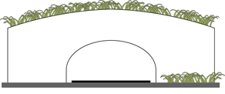 | Major roads
Cut- and-cover tunnel | A cut-and-cover tunnel occurs where the road passes below ground level through a tunnel with the area above available for revegetation and other wildlife movement solutions such as those adapted on land bridges.  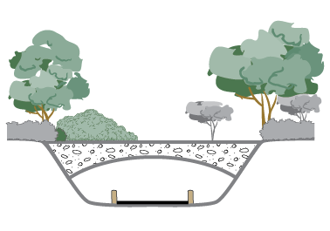 | Major roads
Canopy bridge | A canopy bridge is:  - a single rope crossing, rope tunnel, rope ladder or pole suspended above the traffic either from vertical poles or from trees;  - used by arboreal and climbing fauna species such as gliders and possums.  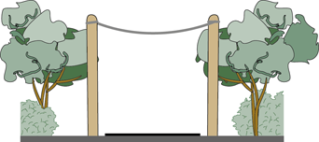 | Major and minor roads
Pole | A pole is vertical and may be placed in the centre median, on the road verge or on a land bridge to provide species that glide with intermediate landing and multiple launch opportunities.  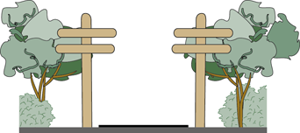 | Major and minor roads
Underpass
Culvert | A culvert:  - is a square, rectangular or half circle shape and may be purpose built for fauna passage or water drainage, or a combination of both;  - is typically pre-cast concrete cells or arches made of steel;  - varies in size depending on the target species;  - where water conveyance is involved, it includes bridges and furniture such as logs, rocks, shelving, ledges, ramps and railings that remain dry.  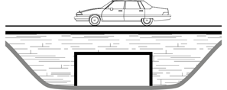 | Major and minor roads
Tunnel | A dry tunnel is a typically round pipe of relatively small diameter (e.g. less than 1.5m in diameter)  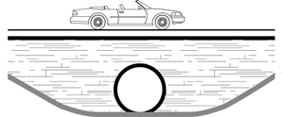 | Major and minor roads
Passage below bridge | A passage below bridge:  - is a structure that maintains the grade of the road or elevates the traffic above the surrounding land, allowing fauna to pass under the road; facilitates water drainage or movement of local human traffic and secondarily facilitates fauna passage;  - has minimal vegetation clearing (clearing only required for bridge piers or pylons) and allows natural vegetation to grow under infrastructure.  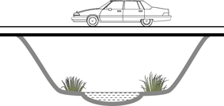 | Major and minor roads
Non-structural mitigation
Canopy connectivity | Canopy connectivity is achieved by the linear clearing being kept sufficiently narrow to allow the tree canopy to remain continuous above the road, or sufficiently narrow where discontinuous to allow fauna species such as gliders to safely traverse.  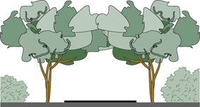 | Minor roads
Local traffic management | Local traffic management involves devices to reduce the speed or volume of traffic or increase driver awareness of fauna (e.g. road closures, chicanes, crosswalks and signage).  Note—The red arrow in the illustration below indicates fauna movement.  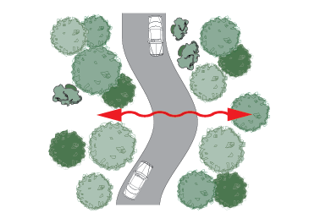 | Minor roads
Barriers
Exclusion fencing | Exclusion fencing stops fauna crossing the road surface, and is used as an integral component in encouraging fauna towards safe crossing passage (such as an overpass or culvert).  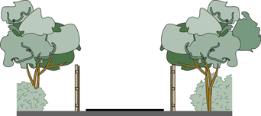 | Major and minor roads
Fauna-friendly fencing | Fauna-friendly fencing allows fauna (e.g. kangaroos, wallabies, koalas) to easily move through or under a fence, and may be appropriate in some cases to allow fauna movement at key locations on low volume traffic roads. It can be used in conjunction with exclusion fencing to direct fauna through the landscape.  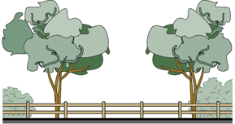 | Minor roads
Habitat enhancement
Frog pond | Frog ponds are aimed at re-creating frog breeding and refugia opportunities.  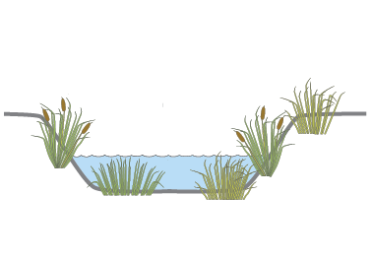 | Major and minor roads
Nest box | Nest boxes provide replacement refugia, nesting and roosting opportunities for fauna when tree hollows are removed. The type of nest box design selected is dependent on the fauna species being catered for.  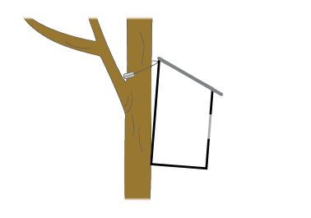 | Major and minor roads
Shelter site | Shelter sites have natural or non-natural materials placed within the road corridor or adjacent areas to restore or replace lost habitat (e.g. logs, local rocks or recycled terracotta roof tiles).  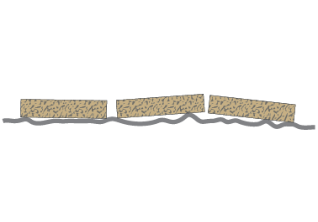 | Major and minor roads

3.10 Traffic management and direction

3.10.1 General

3.10.1.1 Pavement marking
- Pavement marking designs should be prepared in accordance with the Queensland Manual of Uniform Traffic Control Devices (MUTCD, Queensland Department of Transport and Main Roads) and the specific requirements of Brisbane City Council Standard Drawings and Reference Specification for Civil Engineering Works S155 Road Pavement Markings. This specification details the acceptable materials and defines the requirements for the installation of longitudinal and transverse pavement markings including retroreflective glass beads and anti-skid material.
- Council’s requirements for pavement marking dimensions and placement are detailed in BSD-3151, BSD-3152, BSD-3153, BSD-3154, BSD-3155, BSD-3157, BSD-3158, BSD-3161, BSD-3162, BSD-3163.

3.10.1.2 Traffic signs
- Traffic signs should be provided in accordance with the Queensland Manual of Uniform Traffic Control Devices (MUTCD, Queensland Department of Transport and Main Roads) and the specific requirements of Reference Specification for Civil Engineering Works S154 Traffic Signs and Roadside Furniture.
- Specific requirements are detailed on BSD-7122, BSD-5251, BSD-3102, BSD-3103, BSD-3104, BSD-3105, BSD-3106, BSD-3107, BSD-3108, BSD-3109, BSD-3110, BSD-3111, BSD-3112, BSD-3113.

3.10.1.3 Guide posts
Guide posts should be installed in accordance with BSD-7121 and Reference Specification for Civil Engineering Works S154 Traffic Signs and Roadside Furniture.

3.10.2 Pathway signage and pavement marking
- Regulatory signage and pavement marking designs are to be prepared in accordance with the Queensland Manual of Uniform Traffic Control Devices (MUTCD, Queensland Department of Transport and Main Roads) and the specific requirements of Standard Drawings and Reference Specifications for Civil Engineering Works S154 Traffic Signs and Roadside Furniture and S155 Road Pavement Markings.
- Requirements for pavement marking dimensions and placement for bicycle facilities are detailed in BSD-5002, BSD-5003, BSD-5004, BSD-5005, BSD-5006, and BSD-5102 to BSD-5115.
Editor’s note—Guidance on directional and way-finding signage and pavement marking design can be found in Brisbane City Council Bikeway & Greenway Signage Manual.
Editor’s note—Guidance on directional and way-finding signage and pavement marking designs for pathways associated with the Moreton Bay Cycleway can be found in the Moreton Bay Cycleway Signage Manual.

3.10.3 Coloured pavement treatment

3.10.3.1 General
- Coloured or decorative pavement surface treatments and markings are used to alert road users to a different or modified driving environment or the presence of other traffic control measures requiring extra caution.
- These treatments and markings are normally a screeded or sprayed surface treatment applied over the existing road surface, stencilled/patterned or coloured concrete or pavers/bricks.
- There are many uses for these treatments or markings, including:
- entry thresholds on areas with Local Area Traffic Management Schemes (traffic calmed area);
- guidance/delineation through traffic-calming devices within areas with Local Area Traffic Management Schemes;
- bicycle lanes;
- bus and transit lanes;
- contrasting/highlighting other pavement markings – e.g. speed limit legends and pedestrian crossings;
- high ‘anti-skid’ treatments (not a coloured treatment, but often appears very similar).

3.10.3.2 Specifications
- These coloured pavement surface treatments are covered in Reference Specification for Civil Engineering Works S155 Road Pavement Markings. Coloured surface treatments are broken into 2 types as described below:
- Type 1: Coating systems generally for traffic delineation and guidance, typically in a light traffic environment (e.g. threshold treatments in residential areas or bicycle and bus lanes);
- Type 2: Specialised (resin) bonded aggregate systems for locations where a high skid resistance surfacing is required (e.g. locations of wet weather skidding, accident black spots).
Note—Aggregates used in coloured treatments are to be clean, dry, hard, tough, durable, moderately sharp grains of either natural stone or calcined bauxite. Other aggregate materials (e.g. crushed glass) are not included in the material specification for use by Council and are not to be used on Council-controlled roads or infrastructure.

3.10.3.3 Local area traffic management (LATM) schemes (traffic calming)
- The correct usage of threshold treatments is to designate a changed road environment where arterial or sub-arterial roads (typically 60km/h or greater) intersect neighbourhood or local access roads (50km/h or less). The intent is to highlight a change of speed limit or road function, that is, movement vs. access. The treatment for the entrance to a LATM consists of a threshold treatment (typically full width of road) of red with a yellow border.
- Coloured pavement treatments are also used to delineate the path through a traffic management or calming device. These treatments are the same as used for a threshold treatment, namely red with a yellow border.

3.10.3.4 Bus lanes and transit lanes
There are special requirements for the installation of bus and transit lanes which use/require a coloured pavement surface marking and normal longitudinal markings. For the installation of bus lanes, refer to Queensland Department of Transport and Main Roads drawings TC1427.

3.10.3.5 Bicycle lanes
- Coloured bicycle lanes are typically used to delineate specialist bicycle facilities and lanes on the road pavement. They serve to restrict access where there are high levels of interaction between bicycles and other road users, typically at intersections. Coloured bicycle lanes are green.
- Associated longitudinal and transverse pavement marking types and dimensions are shown in the Queensland Manual of Uniform Traffic Control Devices (MUTCD, Queensland Department of Transport and Main Roads) and the specific requirements of Council’s Standard Drawings
- For typical longitudinal traffic markings, waterborne paint is preferred if the thickness tolerance for long-life material cannot be achieved.
- A long-life material (other than hot applied thermoplastic) may be used on high volume roads where excessive wear may occur. Any markings in a long-life material are not to exceed 3mm in thickness. Hot applied thermoplastic markings are to be avoided in areas with high bicycle use, particularly when used for bicycle lanes.
- Testing has shown that hot applied thermoplastic can be hazardous to bicycles (and motorcycles) due to the potential for water build-up or ponding behind the line which has the potential to contribute to aquaplaning and lower skid-resistance on the surface of the material if an anti-skid material is not applied at installation.
- Refer to Reference Specification for Civil Engineering Works S155 Road Pavement Markings for material details.

3.10.3.6 School zone enhancements
School Zone Enhancements (SEZ) markings are installed to alert motorist that they are entering a specialist traffic zone. The SEZ consists of a threshold treatment (either part or full width of road) of red with a yellow border with the legend ‘SCHOOL ZONE’ written in white across the red section of the threshold.

3.10.3.7 Pedestrian facilities
- A coloured pavement surface marking maybe used at pedestrian facilities to show a clear path or delineation for users. These facilities include pedestrian refuges and pedestrian buildouts at crossings.
- Coloured pavement markings may also be installed to highlight or provide a contrast for pedestrian facilities, for example, a zebra crossing.

3.10.3.8 High friction surface treatments
This treatment is applied to areas or sections of a road that has a history of accidents and/or considered to have a surface with an unacceptable skid level.
While not technically a coloured pavement treatment and not performing a traffic function, these treatments are normally a different colour to the existing road surface and are often very noticeable. They are covered by the same specification as coloured pavement treatments and are often applied by the same suppliers using very similar techniques.
Care has to be taken when considering work on or near these treatments as their installation is considered a safety issue. When maintenance is required on these treatments, they must be replaced with a high fiction surface treatment that has a minimum skid resistance value of 65 BPN. Refer to Reference Specification for Civil Engineering Works S155 Road Pavement Markings for material details.

3.11 Fences and barriers

3.11.1 General
- Fences and roadside and safety barriers systems are planned, designed and constructed in accordance with the current edition of the following standards:
- Australian Standard AS/NZS 3845:1999 Road Safety Barrier Systems;
- Austroads Design Guide to Road Design – Part 6: Roadside Design, Safety and Barriers;
- Queensland Department of Transport and Main Road Planning and Design Manual (2nd edition) – Volume 3;
- Queensland Department of Transport and Main Roads Manual of Uniform Traffic Control Devices (MUTCD);
- Queensland Department of Transport and Main Roads Standard Drawings;
- Queensland Department of Transport and Main Roads – Road Safety Barrier Systems, End Treatments and Other Related Road Safety Devices (Assessed as Accepted For Use on State-Controlled Roads in Queensland);
- Brisbane City Council Standard Drawings.
- Fences and roadside and safety barriers are provided for:
- Protection of vehicles and occupants from roadside hazards such as embankments, rigid objects, etc.;
- Traffic delineation and demarcation – an alerting element to provide warning for drivers travelling along split level roadways and substandard corners etc.;
- Pedestrian protection and delineation from static hazards (embankments, cliffs, waterway crossings etc.);
- Pedestrian protection from vehicular traffic by:
- Constraining pedestrian movement to defined pathways intended for such use;
- Providing a physical barrier to errant vehicles which might otherwise enter pedestrian areas (low speed environments only);
- Demarcation of areas not to be accessed by vehicle traffic (e.g. parklands).

3.11.2 Design principles
- Roadside barriers or fences are provided as a treatment for hazards as per Part 6: Roadside Design, Safety and Barriers of the QTMR Road Planning and Design Manual
- In choosing the type of fences and barriers for each location consideration should be given to:
- Nature of the hazard;
- Probability of accident/incident occurring;
- Traffic volume and speed;
- Road geometry, surface and alignment;
- Consequences of an accident/incident occurring (e.g. physical injury and/or property damage);
- Accidents/incident history of site.
Editor's note—For additional information on design, planning and installation of fences and barriers refer to the Infrastructure Installation and Construction Requirements Manual.

3.11.2.1 Fences
- Fences are lightweight structures whose primary purpose is to confine or guide pedestrians to safe areas or alert pedestrians and vehicle traffic to potential hazards.
- Fences may also be used to define a boundary, for example, along the frontage of a park to discourage vehicle access.
- Fences, if properly installed and positioned, may be used in a traffic delineation mode with an example being a pedestrian safety or welded mesh fence along an embankment.

3.11.2.2 Acoustic barriers
- Landscaped acoustic fences are generally required along all suburban and arterial roads.
- The proposed noise attenuation measures should comply with the Noise Impact Assessment Planning Scheme Policy.

3.11.2.3 Road safety barriers
- Structures designed to withstand or absorb the impact of vehicles.
- These barriers prevent the deviation of errant vehicles from the carriageway where such deviation has the potential to cause:
- damage/injury to the vehicle and/or it’s occupants;
- injury to pedestrians and other roadside users (e.g. street dining);
- significant damage to roadside property or infrastructure.
- These barriers provide traffic delineation and guidance, particularly where adverse road conditions exist (adverse cambers, tight corners etc.).
- Road Safety Barriers work on one of two principles – they will either deflect or redirect vehicles away from the hazard or will stop the vehicle outright. Where a system is designed to stop a vehicle outright, energy absorption capability characteristics should be included in the design to minimise or reduce the potential injury that maybe suffered by the occupants of the vehicle.

3.11.2.4 Other barriers
- These barrier systems are generally used for vehicle and pedestrian hazard identification and delineation and are utilised as a visual barrier, rather than a physical barrier.
- These outcomes maybe provided utilising alternative solutions such as landscaping or signage and road pavement marking.
- These systems may restrain or stop vehicle and/or pedestrian movement, but not both.
- Systems are typically installed as a low-impact solution and will often minimise the visual impact at a location.

3.11.2.5 Temporary barrier systems
Temporary barrier systems are used to provide positive protection for workers and the public. These barrier systems are installed on a site by site basis and are designed to comply with the requirements in the MUTCD for work sites.

3.11.3 Design standards

3.11.3.1 Fences
- The minimum standard of pedestrian safety fence is the galvanised tubular handrail as shown on Standard Drawing BSD-7001
- The preferred barrier installation at traffic islands, signalised crossing, and refuge islands is powder coated galvanised steel or aluminium pool fencing as per AS 1926 of minimum 1.2 m height.
- A galvanised tubular handrail with chainwire (Standard Drawing BSD-7001) or a galvanised weld mesh fencing (Standard Drawing BSD-7002) should be provided where there is a danger of children gaining access to high risk areas or where the drop height exceeds 1 m.
- A powder coated steel fence (hunter rod top or approved equivalent, capable of sustaining the imposed actions specified in AS 1170) should be installed. where the drop height exceeds 1.5 m.
- Where required, a log barrier fence including a lock rail for access should be provided in accordance with Standard Drawings BSD-7012, BSD-7051 and BSD-7054.
- The fencing should not hinder general maintenance, otherwise the fencing should incorporate vehicular access gates or the fencing panels are designed for easy removal. Pedestrian gates should be provided along road frontages.
- A concrete (extruded or cast in situ) mowing strip should be provided under all fences (including acoustic barriers) which interface with lawn and landscaped areas. A minimum 140 mm wide x 100 mm deep strip, flush with the surrounding ground, will need to be installed under timber fences/walls or galvanised steel fences. Mowing strips are generally not required under masonry or concrete fences/walls as the footings are usually sufficient for this purpose.

3.11.3.1.1 Hydraulic constraints
- It is desirable that fencing is not erected inside any drainage easement or overland flow path or flood regulation line or waterway corridor. Council recommends against the construction of debris retaining or solid fences, as these structures will inhibit the conveyance of floodwaters. However in instances where the overland flow between private allotments is shallow, generally less than 200 mm deep, solid fences can be constructed provided that openings are installed at ground level to accommodate overland flows.
- Council approval is required where fencing is proposed inside any drainage easement or overland flow path or flood regulation line or waterway corridor. Some suggested fencing styles include:
- Open post and rail, where no panels of fencing are incorporated between the post and rail structure to provide minimum resistance to flood flows. Examples include log barrier fencing and galvanised tubular handrail;
- Collapsible fencing are designed to collapse under flood loading so not to increase flood levels, but are also anchored to avoid being washed away. Low strength ties may be used to hold the fence in place during non-flood times;
- Swing fencing are designed to yield under the pressure of flood flows so as not to increase flood levels, but are also anchored to avoid being washed away. Usually fence panels are fitted with hinges or pivot points to allow opening during floods. Low strength ties may be used to hold the fence in place during non-flood times;
- Lifting fencing are designed to be temporarily raised to not to obstruct flood flows.

3.11.3.1.2 Fence types and typical applications

Table 3.11.3.1.2.A—Fence types and typical applications
Fence Type | Application | Benefits | Design considerations
Two Rail, Post and Rail Fence | Pedestrian Protection from slopes etc. | - Highly visible (with appropriate delineators);  - Low visual impact | - Hazard to users if installed too close to roadway.  - Easily climbed.
 | Traffic delineation along split level roadways – not preferred use. | - Highly visible;  - Cost effective to construct. | - End treatment is spear hazard to vehicles  - Will not restrain errant vehicle
Galvanised Tubular Handrail | Pedestrian protection / guidance on footpaths etc. | - Strong fence, not easily damaged;  - Good use for function, especially fences with mesh. | - Hazard to users if installed too close to roadway.  - Can be climbed over/through (no mesh).
 | Traffic delineation along split level roadways | - None | - End treatment is spear hazard to vehicles  - Low visibility
Welded Mesh Fencing | Pedestrian protection / guidance on footpaths, traffic islands etc. | - Good use for function. | - Can have low visibility – requires appropriate colour and delineators;  - Easily damaged by vehicle strike.
Pedestrian Safety Fencing | Pedestrian protection / guidance on footpaths, traffic islands etc. | - Strong fence, not easily damaged by pedestrian activity;  - Good use for function. | - Risk of spear hazard from top rail;  - Can have low visibility – requires appropriate colour and delineators  - Easily damaged by vehicle strike.

3.11.3.2 Acoustic fences
- The construction standards of typical 2 m high timber acoustic fence are shown on Standard Drawings BSD-7021 and BSD-7021. These drawings do not represent suitable noise attenuation solutions for all developments.
- A site specific attenuation solution for each development should be determined in accordance with the attenuation criteria and methodologies set out in the Noise Impact Assessment Planning Scheme Policy.

3.11.3.3 Road safety barriers
- Road Safety Barriers solutions or products must have sufficient technical/safety approvals demonstrating that the product has been tested to appropriate levels/standards (e.g. American NCHRP Test Level 2 or Test Level 3) or the product conforms to QTMR or Australian Standards.

Table 3.11.3.3.A—Road safety barrier types and applications
Barrier Type | Application | Benefits | Design considerations
Concrete Barrier# | Typically highway and high-speed areas, where total vehicle restraint is required | - Very effective in stopping errant vehicles | - Expensive to construct;  - Visually unappealing.
Guardrail | As for concrete barriers, especially in unkerbed areas where angle of impact is likely to be acute (<10⁰) | - Very effective in stopping errant vehicles;  - Lower cost than concrete barrier;  - Can be used back to back. | - Requires large clear space behind barrier;  - Inappropriate terminal ends pose spearing hazards;  - Ineffective if used in short lengths (<30m).
Bridge Barrier | As per concrete barrier | - Very effective in stopping errant vehicles;  - Often only solution in locations with limited space or on bridges and other structures. | - Expensive to install and maintain;  - Inappropriate terminal ends pose severe crash hazard
Wire Rope Barriers | As per guardrail | - Very effective in stopping errant vehicles;  - Lower maintenance cost than guardrail;  - Low visual impact;  - Suitable for use on embankments as ramping does not occur. | - Requires large clear space behind barrier;  - Requires a minimum radius to be effective (i.e. not suitable on small radii);  - Ineffective on narrow medians;  - May be ineffective restraining motorcycles
Energy Absorbing Bollards | Low speed urban environments, typically to protect dining or pedestrian areas. | - Effective at stopping errant vehicles at speeds ≤60kph;  - Visually appealing. | - Expensive to install and maintain.
Non-energy Absorbing Bollards | Low speed urban environments, typically to protect dining or pedestrian areas.  Security | - Can be effective at stopping errant vehicles at speeds ≤60kph;  - Visually appealing. | - Expensive to install and maintain;  - Provide severe crash risk to users;  - Installed outside of clear zone
#Type-F concrete barriers are only acceptable for use on roads with speed limits of 80 km/h or less

3.11.3.3.1 Flexible guardrail – general requirements
- Flexible guardrails are not generally suited to urban situations.
- Flexible guardrails should be designed as per Reference Specification for Civil Engineering S154 Traffic Signs and Roadside Furniture and QTMR Standard Drawings
- Flexible guardrails should be provided at locations where the consequences of a vehicle leaving the road pavement would be worse than the vehicle hitting the guardrail. These locations would generally include:
- At steep (>1:4) road embankments.
- At roadside obstacles.
- At structures, i.e. bridges and culverts.
- At sudden narrowing of road pavement in addition to the use of hazard markers.
- Where pedestrians are vulnerable.
- Median barriers.
- Adjacent to water features.

3.11.3.3.2 Road safety barrier end terminal solutions for urban locations
- Road Safety Barrier End Terminals are required to conform to the requirements as set out in the QTMR Standard Drawings and Road Planning and Design Manual.
- Generally the guardrail section will be installed to the appropriate QTMR standard, with appropriate end terminal treatments used.
- End terminals must be used on the approach and departure end of the guardrail system and are dependent upon factors such road speed, geometry, road function and environment space.
- Under no circumstances are ‘fishtail’ terminals to be installed.

Table 3.11.3.3.2.A—Road safety barrier end terminal types and applications
Barrier Type | Application | Benefits | Design considerations
QTMR MELT | Approach end terminal on guardrail. | - Effective at preventing egress through the guardrail end.  - Standard non-proprietary end terminal. | - A flared gating terminal that may requires large clear space;  - Generally will not fit in an urban environment
QTMR Standard Departure Terminal | Used on the departure end of the guardrail with minimal flare from the straight and is ‘tied down’ using a tensioned steel cable. | - Effective at preventing egress through the guardrail end.  - Standard end terminal type | - Requires large clear space;  - Only a departure terminal.
Gating Re-directive Guardrail End Terminals | Approach and departure end terminal on guardrail. | - Tangential guardrail end treatment where there is insufficient space for a flared terminal;  - Designed for installation on a straight alignment;  - Available in TL-2 (<70kph) and TL-3 (<100kph) design speeds. | - Proprietary products;  - Gating terminal that may require large clear space;  - Expensive when compared to MELT
Non-gating end terminals | Approach and departure end terminal on guardrail. | - A non-gating guardrail end terminal in an urban environment,  - Suitable for short lengths of guardrail;  - May be used back-to-back in medians;  - Suited to sites where available space for conventional barriers is limited. | - Proprietary products;  - Only suitable for roads with a maximum 60kph speed limit
Crash Attenuation Terminals | Approach and departure end terminal on rigid barriers such as concrete barriers. | - Are a fully re-directive, non-gating bi-directional end terminal;  - Systems are tested to both either TL-2 (<70km/h) or TL-3 (100km/h) design speeds | - Proprietary products;  - Expensive to install and maintain;  - Require large amount of space.
Thrie-beam Bullnose | A wide arc type terminal made from Thrie-beam barrier | - Suitable for high speed environments | - Require a large amount of space

3.11.3.4 Other barriers

Table 3.11.3.4.A—Other barriers types and applications
Barrier Type | Application | Benefits | Design considerations
Frangible Timber Bollards | Typically in LATM and WSUD schemes, delineation of landscaped areas | - Decorative  - Can provide good delineation | - Will not restrain errant vehicle;  - Can become hazard itself if struck.
Removable and Fixed Steel Post Bollards | As for Timber Bollards, Removable Bollard used for access point restriction. | - Removable bollard useful a access point in place of gate;  - Can be decorative | - Will not restrain errant vehicle
Concrete Bollards | Typically in LATM and WSUD schemes, delineation of landscaped areas | - Decorative;  - Can provide good delineation. | - Will not restrain errant vehicle;  - Can become hazard itself if struck.
Log Barrier Fence | Park boundary delineation | - Decorative;  - Provides good delineation | - Will not restrain errant vehicle;  - Easily damaged
Guide Posts | Road edge or hazard delineation | - Low cost solution;  - Easily replaced;  - Low impact on visual amenity. | - Will not restrain errant vehicle;  - Requires regular maintenance.

