5.3.11.1 Kelvin Grove Urban Village

5.3.11.1.1 Location and extent
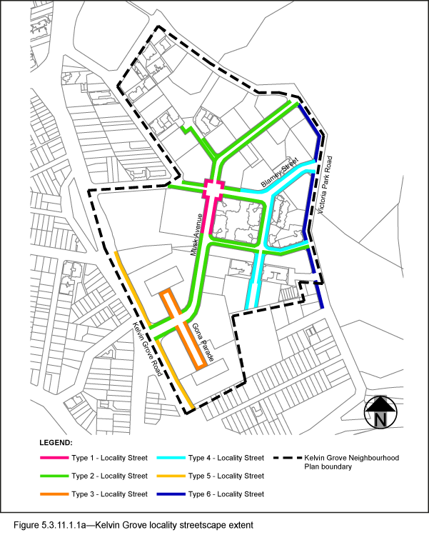
- The Locality Streets in the Kelvin Grove Urban Village Neighbourhood Plan area are indicated on the Streetscape hierarchy overlay map and on Figure 5.3.11.1.1a.
- All streetscape works occurring within the Locality Streets indicated in Figure 5.3.11.1.1a, must comply with the character specified in this document.
- Streetscapes outside these areas may be developed in keeping with this character, at the discretion of the developer and subject to Council approval.

5.3.11.1.2 Standard footway elements and materials
- These locality guidelines are to be read in conjunction with Chapter 3 – Road corridor design of the Infrastructure design planning scheme policy.
- Footway upgrades are to include new surfacing, new or reinstated kerb and channel, driveways, pedestrian kerb crossings, tactile markers, roof water drainage line connections, service pit lids, street trees, garden beds, furniture and pedestrian lighting applicable to the streetscape type.
- The scope, layout and detail of the footway upgrades are to be agreed on a site by site basis through the development assessment process.

5.3.11.1.3 Streetscape hierarchy

5.3.11.1.3.1 Streetscape types overview
- The locality streets within the Kelvin Grove Urban Village Neighbourhood Plan area are exceptions to the standard streetscape hierarchy.
- The streetscape type and specifications for locality streets in this area are outlined in Table 5.3.11.1.3.1A and shown in Figure 5.3.11.1.1a.
- Refer to Figure 5.3.11.1.3.1a for the typical streetscape set out detail.

Table 5.3.11.1.3.1A Streetscape types and specifications
Type | Description | Verge Width | Unobstructed Pavement Width | Paving Body | Band | Driveways and Kerb Ramps | Turf | Furniture
Type 1 | Full width pavement | As existing | As existing | Type: Honed coloured concrete with sawcut pattern.  Supplier: Hanson Racona (code 10040798), Boral or approved equivalent.  Colour: CCS ‘Liquorice’ 90% ‘Blue Heeler’ + 10% ‘Winter Brown’ | Supplier: Fabrok  Material: Porphyry  Style: Random crazy pave  Colour: 70% Brown, 30% Blue Grey  Size: Face size 300-400mm,  20-40mm thick  Finish: Laid in crazy pave pattern | Standard Portland Grey plain broom finished concrete | No | Provide standard and bespoke furniture in accordance with section 5.3.11.1.4.
Type 2 | Full width pavement | As existing | As existing | Supplier: Hanson or approved equivalent  Type: Exposed aggregate concrete  Colour: 'Victoria Falls' (90% ‘Blue Heeler’/ 10% ‘Winter Brown’) | Type: Honed coloured concrete with sawcut pattern.  Supplier: Hanson Racona (code 10040798), Boral or approved equivalent.  Colour: CCS ‘Liquorice’ 90% ‘Blue Heeler’ + 10% ‘Winter Brown’ | Standard Portland Grey plain broom finished concrete | No | Provide standard and bespoke furniture in accordance with section 5.3.11.1.4.
Type 3 | Full width pavement | As existing | As existing | Supplier: Hanson or approved equivalent  Type: Exposed aggregate concrete  Colour: 'Victoria Falls' (90% ‘Blue Heeler’/ 10% ‘Winter Brown’) | Supplier: Fabrok  Material: Porphyry  Style: Random crazy pave  Colour: 70% Brown, 30% Blue Grey  Size: Face size 300-400mm,  20-40mm thick  Finish: Laid in crazy pave pattern  Feature Band:  Supplier: Fabrok  Material: Granite  Finish: Exfoliated finish | Standard Portland Grey plain broom finished concrete | No | Provide standard and bespoke furniture in accordance with section 5.3.11.1.4.
Type 4 | Concrete footpath in turf | As existing | 2m wide path | Standard Portland Grey concrete, broom finish, saw cut pattern | Type: Honed coloured concrete with sawcut pattern.  Supplier: Hanson Racona (code 10040798), Boral or approved equivalent.  Colour: CCS ‘Liquorice’ 90% ‘Blue Heeler’ + 10% ‘Winter Brown’ | Standard Portland Grey plain broom finished concrete | Yes | None unless already existing
Type 5 | Concrete footpath in turf | As existing | 2m wide path | Standard Portland Grey concrete, broom finish. | Supplier: Hanson or approved equivalent  Type: Exposed aggregate concrete  Colour: 'Victoria Falls' (90% ‘Blue Heeler’/ 10% ‘Winter Brown’) | Standard Portland Grey plain broom finished concrete | Yes | None unless already existing
Type 6 | Concrete footpath in turf | As existing | 2m wide path | Standard Portland Grey concrete, broom finish | None. | Standard Portland Grey plain broom finished concrete | Yes | None unless already existing

5.3.11.1.3.2 Tactile Indicators
- All tactile indicators for streets within the Kelvin Grove Urban Village Neighbourhood Plan area are to be applied consistent with BSD-5218 - Tactile Ground Surface Indicator Detail and the following specifications:
- Supplier: Chelmstone, Urbanstone or approved equivalent;
- Material: Concrete paver;
- Colour: CCS ‘Voodoo’.
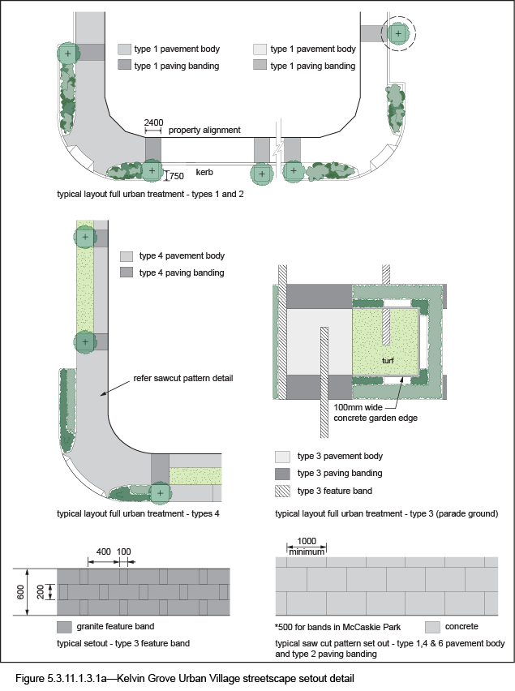

5.3.11.1.4 Furniture
- Provide furniture in accordance with Table 5.3.11.1.3.1A.
- All furniture to be located outside of the unobstructed pavement area.
- For standard furniture elements including seats and drinking fountains, refer to 3.7.6 Design standards for street furniture.
- For bespoke furniture elements for the Kelvin Grove Urban Village Neighbourhood Plan area provide the following:
- Bike racks:
- Type: C1302;
- Supplier: Street + Garden Furniture or approved equivalent;
- Colour: Stainless Steel.
- Rubbish bins:
- Type: WBE–140 Q;
- Supplier: Street Furniture Australia;
- Colour: Dulux Acrathane “Precious Silver” (Bin Grille to be Dulux “Black”) or approved equivalent.
- Recycle bins:
- Type: WBE–140 Q;
- Supplier: Street Furniture Australia;
- Colour: Dulux Acrathane ‘Precious Silver’ (Bin Grille to be Dulux ‘Exploding Star’) or approved equivalent.
- Bollards:
- Type: Bol1;
- Supplier: Street Furniture Australia;
- Colour: Dulux Acrathane ‘Precious Silver’ or approved equivalent.

5.3.11.1.5 Planting

5.3.11.1.5.1 Street trees
- Street trees are permitted in all streets within the Kelvin Grove Urban Village Neighbourhood Plan area and shall be decided on a site-by-site basis.
- Table 5.3.11.1.5A sets out the approved street tree species for use on the various streets within the Kelvin Grove Urban Village Neighbourhood Plan area.
- All tree centrelines are 750mm from the nominal face of the kerb.
- Street trees are to be:
- Located behind the kerb or within isolated tree build-outs at approximately 14.5m centres;
- Proposed species should be ex-ground and at least 3.5m high (installed) and have a clear trunk of at least 1.8m from the ground to the lowest branch;
- The use of advanced to mature trees is encouraged.
- Street trees are to be planted at regular spacing.
- Trees are to be planted in tree trenches.

5.3.11.1.5.2 Garden beds
- Garden beds are permitted in all streets within the Kelvin Grove Urban Village Neighbourhood Plan area and shall be decided on a site-by-site basis.
- Shrub and groundcover species are to be selected from Table 5.3.11.1.5B.

Table 5.3.11.1.5A —Street trees
Street | Trees
Blamey Street | Araucaria cunninghamii  Eucalyptus microcorys  Ficus hillii¹  Flindersia schottiana
Carraway Street | Melicope elleryana
Gona Parade | Roystonea regia
Kelvin Grove Road | Waterhousia floribunda
Maidstone Street | Harpullia pendula
Musk Avenue | Araucaria cunninghamii  Roystonea regia²
Ramsgate Street | Buckinghamia celsissima
School Street | Harpullia pendula
Tank Street | Harpullia pendula
Victoria Park Road | Lophostemon confertus
1 Suitable for intersection at Blamey and Musk Avenue only
2 Suitable for median planting

Table 5.3.11.1.5B —Shrub and groundcover species
Ground covers |  | Shrubs
Cissus antarctica  Crinum pedunculatum  Dianella caerulea  Hymenocallis littoralis  Liriope ‘Evergreen Giant’  Liriope muscari  Liriope muscari ‘Variegata’ | Lomandra longifolia ‘Katrinus’  Pandorea jasminoides  Pennisetum alopecuroides ‘Nafray’  Rhoeo ‘Hawaiian Dwarf’  Themeda australis  Trachelospermum jasminoides ‘Tricolour’  Xanthorrhoea johnsonii | Callistemon pachyphyllus  Philodendron ‘Xanadu’  Strelitzia reginae  Syzygium ‘Bush Christmas’  Westringia fruiticosa ‘Zena’

