3.2 Strategic intent

3.2.1 Australia’s new world city
Brisbane's City Plan plays an important role in implementing Brisbane City Council's future vision. Brisbane's future as Australia's new world city is achieved by Council's twenty-year plan for the city, set out in the Brisbane Vision.

Council’s vision is that Brisbane will be a vibrant and prosperous city, valued by residents and visitors for its friendly, optimistic character. It will be respected for its strong international ties, particularly with our Asian neighbours, and for its economic prosperity. Our communities will be active and healthy and our environment will be clean and green. All residents and visitors, of all ages and abilities, will be included in the life of Brisbane. The city will build on its cultural and creative resources to provide an enduring legacy of liveability for future generations.

Growth and the CityShape
This strategic framework has a planning horizon of 2031. By this time Brisbane has taken advantage of a unique window of opportunity to double its economic value, leveraging off world-class infrastructure and facilities while maintaining and enhancing the enviable Brisbane lifestyle. The city's growth prosperity has required it to accommodate an additional 290,000 jobs (443,000 jobs for metropolitan Brisbane) and importantly has provided capacity to meet the targets set by the SEQ Regional Plan 2009-2031 of an additional 156,000 dwellings, of which 138,000 dwellings will be provided by infill development.

The growth capacity of Brisbane has been incrementally increased through the Council's neighbourhood planning process which began in 2006. Through this process, the Council has worked in consultation and partnership with local communities to plan for their local areas within the context of the broader needs of the city. This has ensured that new development opportunities along selected transport corridors have been progressively facilitated through Council planning processes that provide for the appropriate provision of services, facilities and infrastructure.

Growth has occurred in an efficient and timely manner under the strategic framework provided by CityShape which was determined by working with the Brisbane community in 2006. CityShape, built upon a series of nodes and corridors radiating from the City Centre, has provided for an efficient urban form and has meant that large-scale urban change has been contained to less than 7 per cent of Brisbane. This has resulted in many of the Suburban Living Areas experiencing minimal change throughout the life of this planning scheme.

By planning proactively in a city-wide and regional context that also respects local values, Brisbane has embraced the prosperity that growth provides while maintaining the values that have provided a highly attractive lifestyle.

The economy
Brisbane’s economy has experienced some of the strongest growth of mature world cities. This has been in part due to its role within Queensland but also within the Asia–Pacific region. Brisbane offers a diverse range of accessible employment opportunities in the City Centre and other well-located growth areas that provide access to jobs and support the economic growth of Brisbane, the South East Queensland region and Queensland.

A network of well-connected centres and community services provides choice to consumers and caters to the service, social, entertainment and leisure needs of residents. Major Industry Areas have grown around the Brisbane Airport and Port of Brisbane as part of the Australia TradeCoast as well as in the south-west industrial gateway. Major Industry Areas and Strategic Inner City Industrial areas support business growth. By planning for economic growth and building upon the strengths of Brisbane's economy, business in Brisbane has proactively adapted and changed.

Moving Brisbane
Much of the new growth in Brisbane has built upon the principles of transit oriented development and leveraged off public transport. This has made moving around the city to work and play an easier task. Brisbane balances growth with the transport network and has a coordinated strategy to effectively connect residential communities, employment areas and centres. It enables the efficient movement of people and goods and ensures integration to maximise choices to use public transport, including Brisbane's buses and CityCats, and for active travel such as walking and cycling. Active transport features heavily in meeting future transport demand. The mode share targets in the Transport Plan for Brisbane 2008-2026 show for all weekday trips by 2026. By 2026, 1 in 5 transport trips will be made by walking and cycling and 13 per cent by public transport. The transport system has also been augmented to deal with increased traffic flows and the freight task created by Brisbane’s vibrant economy.

Housing for all
Brisbane has provided for the most significant additional residential growth predominantly within Growth Nodes on Selected Transport Corridors while keeping other residential growth relevant to the various local contexts of building and landscape character of Suburban Living Areas. A wide range of housing styles and choices has been provided that caters for residents’ housing needs and purchasing ability at all life stages. Housing choices and styles have adapted to the changing needs of the city over time. Residential growth in Brisbane has been designed to protect the health, safety and wellbeing of residents in Brisbane.

Design, character and heritage
Brisbane is a well-designed and efficiently arranged city that reflects its capital city function. The city has a regional focus and responds to its subtropical context and setting of the river, waterways, bay and surrounding mountains.

The unique traditional building character of Brisbane continues to be recognised and many older suburbs contain intact character housing. Newer development in proximity to character housing has been delivered in a manner which respects this character. The contribution of natural heritage, and Aboriginal and other cultural heritage to Brisbane has continued to be recognised and protected across the city.

Clean, green and resilient
Brisbane remains a clean and green, subtropical city with a Greenspace System that reinforces the ecological, lifestyle and scenic amenity values of the city. Brisbane is still characterised by forested hilltops and hillsides, the Brisbane River, waterways and Moreton Bay. The Greenspace System has also ensured that 40 per cent of mainland Brisbane has been set aside as natural habitat. Evolving best-practice standards for the operation of businesses and industry have meant that Brisbane maintains a reputation for protection of the environment and protection of the Brisbane lifestyle.

High environmental performance and compatibility of land uses across Brisbane has been achieved through design, appropriate land use location and land uses continually adapting to best-practice operations.

By recognising, planning and adapting to the impacts of natural forces, such as flooding, landslide, bushfire and coastal hazards, Brisbane has also remained highly resilient.

World-class infrastructure
Brisbane hosts a series of soft infrastructure networks such as social and volunteering networks and hard infrastructure networks such as public and active transport networks and community facilities. This supports the economic growth of the city and is aligned with land use intent. Areas of more intense growth have been provided with an improved level of infrastructure and facilities upgraded to meet increased demands and to assist in maintaining lifestyle. This includes health, social and community services, which have also grown commensurately to offset the impacts of increased population.

Outstanding lifestyle
By 2031, all of the characteristics that made Brisbane an outstanding lifestyle city in 2006 are still strongly evident. While Brisbane is firmly on the stage as a world city, suburbs of Brisbane still have an identifiable sense of place, and the city is accessible and inclusive to all, and is a tolerant and culturally vibrant place. The outstanding lifestyle associated with living in Brisbane continues to be a key attractor for economic, intellectual and social capital.

The strategic framework structure
Council's vision for Brisbane is outlined in five themes which set the policy direction in this strategic framework, namely its:
- globally competitive economy;
- outstanding lifestyle;
- clean and green leading environmental performance;
- highly effective transport and infrastructure underpinning these outcomes;
- CityShape as the physical expression of the other four themes and their interrelationships.
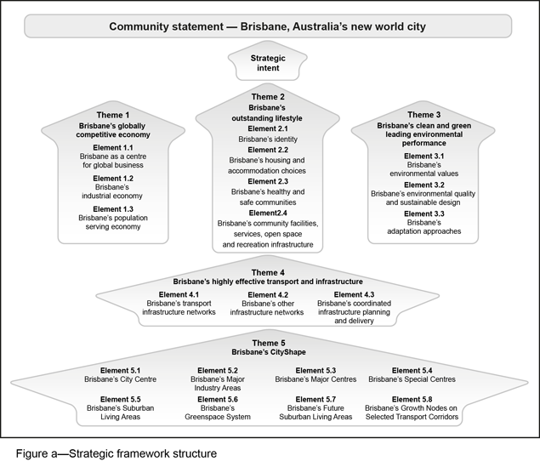
These themes are interconnected and mutually supporting. No one theme overrides the other and the key points of integration are arrived at through the Highly effective transport and infrastructure and CityShape themes. The City Plan plays an important role in achieving the theme outcomes by:
- reinforcing and enhancing the role of Brisbane as the State capital city and one of Australia's most important cities;
- continuing focus on Brisbane's well-established Greenspace System, strong integration between its centres of economic activity and city life, and its major transport networks;
- providing for the outcomes of the Queensland Government's SEQ Regional Plan 2009-2031;
- setting out strategic outcomes across these five themes, supported by more detailed provisions in the balance of the planning scheme;
- establishing an urban structure that provides policy direction for the balance of the planning scheme in facilitating development that supports the city we want;
- providing a framework that encourages innovation;
- providing for strong alignment between infrastructure investment, development and economic needs in a logical sequence for the achievement of these outcomes.

Brisbane is evolving into a city that plans strategically for its economic development and optimises, protects and maintains the characteristics that its residents value highly. Brisbane is known for its unique subtropical lifestyle and capacity for its residents to actively contribute to its future and enjoying its lifestyle.

The City Plan complements other important initiatives by Brisbane City Council to ensure Brisbane takes advantage of future economic opportunities on the horizon and delivers the goals of the Brisbane Vision.

The five themes below explain how the planning scheme will do this and how we will monitor our progress.

