7.2.2.4 Bulimba district neighbourhood plan code

7.2.2.4.1 Application
- This code applies to assessing a material change of use, reconfiguring a lot, operational work or building work in the Bulimba district neighbourhood plan area if:
- assessable development where this code is an applicable code identified in the assessment benchmarks column of a table of assessment for neighbourhood plan (section 5.9); or
- impact assessable development.
- Land in the Bulimba district neighbourhood plan area is identified on the NPM-002.4 Bulimba district neighbourhood plan map and includes the following precincts:
- Bulimba north precinct (Bulimba district neighbourhood plan/NPP-001);
- Oxford Street precinct (Bulimba district neighbourhood plan/NPP-002):
- Oxford Street B1 sub-precinct (Bulimba district neighbourhood plan/NPP-002a);
- Oxford Street B2 sub-precinct (Bulimba district neighbourhood plan/NPP-002b);
- Oxford Street B3 sub-precinct (Bulimba district neighbourhood plan/NPP-002c).
- Hawthorne centre precinct (Bulimba district neighbourhood plan/NPP-003);
- Bulimba Barracks precinct (Bulimba district neighbourhood plan/NPP-004):
- Riverfront recreation sub-precinct (Bulimba district neighbourhood plan/NPP-004a);
- Community heart sub-precinct (Bulimba district neighbourhood plan/NPP-004b);
- Residential interface sub-precinct (Bulimba district neighbourhood plan/NPP-004c);
- Residential core sub-precinct (Bulimba district neighbourhood plan/NPP-004d);
- Royal Australian Navy sub-precinct (Bulimba district neighbourhood plan/NPP-004e).
- Godwin Street precinct (Bulimba district neighbourhood plan/NPP-005).
- When using this code, reference should be made to section 1.5, section 5.3.2 and section 5.3.3.
Note—The following purpose, overall outcomes, performance outcomes and acceptable outcomes comprise the assessment benchmarks of this code.
Note—This neighbourhood plan includes a table of assessment with variations to categories of development and assessment. Refer to Table 5.9.10.A, Table 5.9.10.B, Table 5.9.10.C and Table 5.9.10.D.

7.2.2.4.2 Purpose
- The purpose of the Bulimba district neighbourhood plan code is to provide finer grained planning at a local level for the Bulimba district neighbourhood plan area.
- The purpose of the Bulimba district neighbourhood plan code will be achieved through overall outcomes including overall outcomes for each precinct of the neighbourhood plan area.
- The overall outcomes for the neighbourhood plan area are:
- The district’s primary role as a low to low–medium density residential area is retained.
- Development in the Bulimba district neighbourhood plan area provides for low-rise detached dwelling houses predominantly in the Low density residential zone.
- Streets and areas present a strong traditional built character by retaining pre-1911 houses and houses built in 1946 or before and conserving mature plantings.
- New houses, extensions to houses and multiple dwellings are built to a design which is in keeping with the local pre-1911 and built in 1946 or before traditional building character, where located within the Traditional building character overlay or Pre-1911 building overlay.
- The history and commercial character of the neighbourhood plan area is protected, in particular:
- places of cultural heritage significance are conserved to preserve the area's identity;
- the area's traditional commercial buildings built in 1946 or before are protected with extensions to these buildings built to a design that is in keeping with the existing building’s architectural character;
- views of heritage places from the public realm are maintained as a priority.
- The Oxford Street frontage will continue to be the focus for retail, food and drink outlet and entertainment related uses such that the development of these activities beyond the boundaries of a zone in the centre zones category or the Mixed use zone is not consistent with the outcomes sought.
- Redevelopment or refurbishment of existing development incorporates high-quality building and landscape design themes.
- The local servicing and employment opportunities offered by existing industrial activities along Taylor Street are maintained, with any new development on these sites not to involve a residential use and to be consistent with low impact industrial uses.
- Development at the intersection of Hawthorne Road and Lindsay Road is consolidated to form a local convenience centre where:
- existing character commercial and character non-residential buildings in the centre will be protected and adaptively re-used for retail and commercial uses;
- character residential buildings in the Hawthorne centre precinct (Bulimba district neighbourhood plan/NPP-003) may be demolished where this is required for the expansion of the cinema complex.
- The Byron Street/McConnell Street riverfront area will transition from its existing boat building and light industrial focus to become a low-rise residential precinct comprising a mixture of dwelling houses and multiple dwelling developments that provide public access along the riverfront, and provide views from the street to the Brisbane River through breaks in buildings.
- An integrated network of shaded, landscaped streets and pedestrian and cycle routes enhance connections to Bulimba’s residential areas, the Oxford Street and Hawthorne commercial areas, the ferry terminals and parks.
- Multiple dwelling developments in Banya Street, Johnson Street and Bulimba Street in the Bulimba north precinct (Bulimba district neighbourhood plan/NPP-001) is low rise and respects the scale and character of the area through varied building heights and articulated built form.
- Development is of a height, scale and form which is consistent with the amenity and character, community expectations and infrastructure assumptions intended for the relevant precinct, sub-precinct or site and is only developed at a greater height, scale and form where there is both a community need and economic need for the development.
- Bulimba north precinct (Bulimba district neighbourhood plan/NPP-001) overall outcomes are:
- This precinct encompasses established low impact industry and warehouse activities which may cease operation or relocate over the life of this neighbourhood plan.
- Multiple dwellings are the preferred future land use in the precinct and lot amalgamation is encouraged to facilitate this outcome.
- Development provides public access to and along the Brisbane River in order to improve access to the Apollo Road ferry terminal and the riverfront generally and has a built form which includes separation and breaks to allow views from the street to the Brisbane River.
- This precinct also supports a mix of existing residential, low impact industry and warehouse uses, in 2 distinct blocks separated by Banya Street where:
- in this part of the precinct, building heights will vary across both blocks.
- Oxford Street precinct (Bulimba district neighbourhood plan/NPP-002) overall outcomes are:
- The Oxford Street precinct remains the focus of the business activity and community life in the neighbourhood plan area with the role of the precinct consolidated as the primary commercial/retail, entertainment and leisure centre in the neighbourhood plan area.
- Development in the Oxford Street precinct provides for the expansion and improvement of retail, business, leisure and community functions.
- Development where in the District centre zone is designed as a pedestrian place, where development maintains a human scale to the street and provides for an active frontage at the ground storey to encourage movement and interaction between private development and adjacent public spaces.
- Development in the Oxford Street B1 sub-precinct (Bulimba district neighbourhood plan/NPP-002a):
- creates a cohesive, well-designed centre connecting the established village with key local destinations such as Bulimba Memorial Park, the ferry terminal and the Brisbane River;
- is consistent with the low-rise village scale of Oxford Street and incorporates design elements that reflect the established streetscape character;
- is of a continuous and fine-grain built form with active frontages that creates visual interest and improves connectivity to the riverfront;
- at ground level contains a mix of active uses such as shops, restaurants and other services contributing to a vibrant pedestrian realm and multiple dwellings above ground are supported, provided that the primary role of the precinct as a commercial and retail centre is not compromised and issues of building scale, noise and privacy are addressed;
- gives priority to pedestrian and cyclist movement along Oxford Street such that driveway crossovers to Oxford Street are limited to achieve a safe and continuous pedestrian spine and access for car parking and servicing is via side streets and shared where possible;
- manages impacts on adjoining low density residential and low–medium density residential areas through appropriate building siting and design and landscape treatments;
- enhances the landscape character of Oxford Street by planting mature vegetation as part of new development;
- ensures that the Bulimba ferry terminal functions as a gateway to Oxford Street for those arriving by CityCat or ferry and becomes a destination in its own right, building on the landmark qualities of the heritage ferry terminal building and riverfront location;
- increases the vitality of the Oxford Street precinct west of the Bulimba Memorial Park and strengthens connections between the Brisbane River and the established village centre to the east;
- does not support expansion of the centre along the northern side of Oxford Street due to the quality of heritage, character, commercial character buildings and the positive contribution they make to the streetscape and character of the area.
- Development in the Oxford Street B2 sub-precinct (Bulimba district neighbourhood plan/NPP-002b):
- provides a riverfront park north of the Bulimba ferry terminal to further strengthen these connections to the Brisbane River;
- ensures that the park provides continuation of the existing riverside park south of Oxford Street.
- Development in the Oxford Street B3 sub-precinct (Bulimba district neighbourhood plan/NPP-002c):
- fronting Lytton Road maintains the low-rise village scale of Oxford Street and sensitively responds to the slope characteristics of the site;
- maintains views of the heritage listed Bulimba Uniting Church from Riding Road, Oxford Street and from the lower section of Lytton Road.
- Hawthorne centre precinct (Bulimba district neighbourhood plan/NPP-003) overall outcomes are:
- The Hawthorne centre precinct will develop into a consolidated centre with a low- rise village feel which serves the local needs of Hawthorne residents and supports the facilities and services provided in the Oxford Street precinct.
- The retention of existing commercial and residential character buildings maintains the village aesthetics of the precinct.
- Key corner sites provide important local landmarks and new development retains traditional commercial character building forms and active commercial and retail frontages at these locations.
- Development accommodates overland flow from the Pashen Creek overland flow path and is designed and located to minimise risk from high water conditions.
- Development respects and integrates with character buildings, particularly the cinema, using traditional design elements, whilst establishing a cohesive built form identity for the precinct.
- Shared access and servicing arrangements avoid a net increase in driveway crossovers to Hawthorne Road, retaining the fine-grain commercial character of the precinct and improving the function and safety of the pedestrian realm.
- Development which is retail focused provides active frontages to Hawthorne Road and its corner with Lindsay and Orchard streets and the park.
- Park Street should not be activated given the impact this would have on residential premises. Above ground level, offices, home-businesses and multiple unit dwellings are considered generally appropriate.
- Development retains and enhances the character and functional elements of the neighbourhood plan area, in particular:
- character residential housing is retained and adaptively re-used for commercial and retail or home-based business uses;
- development maintains the established built form along Hawthorne Road provided by the existing character housing;
- where a site is not improved by a commercial character building or character dwelling, multiple dwellings may be consistent with the outcomes sought provided that proposals respond to the adjoining streetscape character and complement the dominant retail function of the village.
- The existing mechanical workshop site north of Orchard Street provides opportunities for redevelopment which will accommodate:
- a mix of uses that support the dominant retail function of the precinct;
- offices that activate Hawthorne Road and incorporate multiple dwellings above ground level are consistent with the outcomes sought.
- The Cineplex building is a character non-residential building considered to have significant value as a local landmark which:
- provides an anchor for the precinct;
- may be subject to sensitive adaptation where the proposal is supported on economic grounds, makes a positive contribution to achieving the planning scheme’s intent for the precinct and where the characteristic features of the iconic Cineplex buildings are retained or sympathetically treated.
- Commercial character buildings adjacent to the Cineplex building, such as the barber shop, also add significant character to the village and are likewise retained.
- Bulimba Barracks precinct (Bulimba district neighbourhood plan/NPP-004) overall outcomes are:
- Development in the Bulimba Barracks precinct provides for an integrated, vibrant and sustainable community comprising residential and non-residential activities that is supported by public infrastructure upgrades, amenities and generous riverfront public open space.
- Development identifies and conserves heritage buildings and features of intrinsic historic value that reflect the history of the Bulimba Barracks precinct.
- A permeable grid of roads, pedestrian and cycle links is created that prioritises pedestrians and cyclists in a low-speed traffic environment, connects to the surrounding road network and provides increased pedestrian and cycle connectivity between the Apollo Road Ferry Terminal, Riverfront recreation and Community heart sub-precincts and residential areas within and surrounding the precinct. A comfortable pedestrian environment encourages walking as the primary mode of transport to access local destinations.
- Roads and public open space are configured to facilitate the movement of stormwater, accommodate significant water, sewer and high voltage powerline infrastructure, and preserve significant view corridors to the Brisbane River along the Baldwin and Bolan Streets alignments and from Tugulawa Park.
- Development for sensitive land uses along with future occupants and visitors to the Bulimba Barracks precinct considers the site’s close proximity to the Brisbane Airport and amenity impacts associated with location under existing and future flight paths.
- Development facilitates the provision of a potential future park and ride facility located in proximity to the Apollo Road CityCat Terminal as indicated on Figure e. Development results in no net loss of riverside park and allows for further investigation of the need for future public transport infrastructure as the area undergoes renewal.
Editor's note—The Queensland Government has identified an opportunity to provide a future Park and Ride facility and further consultation should be undertaken with the Queensland Government as part of the implementation of any future development.
- Development in the Riverfront recreation sub-precinct (Bulimba district neighbourhood plan/NPP-004a):
- is in accordance with the overall outcomes for the Open space (metropolitan) zone where identified as future park on Figure e or Figure f and for the Sport and recreation (district) zone where identified as Sport and recreation (district) potential development area on Figure f;
- protects and optimises public access to and along the river frontage by providing public open space and land for sport and recreation uses along the entirety of the Bulimba Barracks precinct’s river frontage;
- accommodates a range of active and passive recreation activities including a land-based Riverwalk along the foreshore, along with an oval of sufficient size for Australian Rules Football;
- retains and adaptively reuses the heritage boat ramp and revetment wall to provide river access for non-motorised watercraft;
- incorporates the adaptive reuse of the historic fabrication workshop forecourt as a pedestrian public realm that provides a flexible outdoor community meeting place for outdoor dining, events and gatherings and that provides a link between the Apollo Road Ferry Terminal and the Community heart sub-precinct (NPP-004b);
- ensures a minimum 250m buffer is maintained between sensitive uses in the Bulimba Barracks precinct and the Australia TradeCoast Major Industry Area to the east and provides an appropriate interface with the operations of the Royal Australian Navy sub-precinct.
- Development in the Community heart sub-precinct (Bulimba district neighbourhood plan/NPP-004b):
- is in accordance with the overall outcomes for the Neighbourhood centre zone;
- creates a cohesive and well-designed community focal point for the Bulimba Barracks precinct, providing the range of non-residential and residential uses expected of a new neighbourhood centre;
- retains and repurposes the historic fabrication workshop by adapting its robust and distinctive built form for a range of non-residential uses;
- provides for residential, and other non-residential uses not suited to a refurbished historic industrial building, to be located opposite the historic fabrication workshop in a new up to 5 storey building, featuring an activated 3 storey non-residential frontage to North-South Avenue and the Riverfront recreation sub-precinct;
- is provided with ample site area and gross floor area to support the adaptive reuse of the historic fabrication workshop, provides for adequate off-street car parking and encourages privately-delivered community services and uses with a community benefit such as childcare centres, health care services and residential care facilities.
- Development in the Residential interface sub-precinct (Bulimba district neighbourhood plan/NPP-004c):
- is in accordance with the overall outcomes for the Low density residential zone;
- provides for a transition of building height and scale between the lower density residential development adjoining the Bulimba Barracks precinct and larger residential buildings in the Residential core sub-precinct;
- accommodates dwelling houses of up to two storeys including conventional and small lot housing, on lots with a minimum size of 300m2;
- retains the existing Tugulawa Park or alternatively provides sufficient land of suitable area (minimum of 3,000m2 unconstrained by easement) and dimensions to provide a local park in the vicinity of the existing Tugulawa Park;
- provides all the land within the high voltage powerline easement for public open space, extending Tugulawa Park to link with Hood and Baldwin streets.
- Development in the Residential core sub-precinct (Bulimba district neighbourhood plan/NPP-004d):
- is in accordance with the overall outcomes for the Low-medium density residential zone where identified as Low-medium density residential potential development area and Medium density residential zone where identified as Medium density residential potential development area on Figure f;
- provides for a diverse range of dwelling types from semi-detached and terraced housing to apartment buildings of mostly 3 storeys, that cater for a range of households;
- provides a graduated transition in height to the low density residential development in the Residential interface sub-precinct and the lower density residential development adjoining the Bulimba Barracks precinct;
- locates the largest residential buildings of up to 5 storeys and commensurate with the height of the historic fabrication workshop, in the centre of the Bulimba Barracks precinct to limit impacts on the low density residential detached housing character of the surrounding Suburban Living Area, to take advantage of the topography, amenity of the river and to support the Community heart sub-precinct and provision of generous riverfront public open space in the Riverfront recreation sub-precinct;
- accommodates small-scale ground floor business and commercial uses compatible with residential development overlooking and activating public open space within the Riverfront recreation sub-precinct.
- Development in the Royal Australian Navy sub-precinct (Bulimba district neighbourhood plan/NPP-004e) is in accordance with the overall outcomes for the Special purpose zone (Defence zone precinct).
- Godwin Street precinct (Bulimba district neighbourhood plan/NPP-005) overall outcomes are:
- Development in the Godwin Street precinct contributes to the creation of a vibrant, revitalised business and industry area and incorporates a range of low impact industrial uses and complementary business and commercial uses.
- The existing low impact industry located to the west of Bulimba Memorial Park is replaced by a mix of commercial and residential land uses.
- Residential uses, in particular multiple dwellings and short-term accommodation, offices and a range of employment uses are appropriate where they can successfully integrate with surrounding residential uses.
- Retail and restaurant activities are not located in the precinct to ensure that Oxford Street remains the area’s dominant retail and entertainment precinct.
- No expansion to the Godwin Street precinct’s external boundaries or significant increases in the scale or intensity of activity occurs to maintain the amenity of surrounding residential areas.

7.2.2.4.3 Performance outcomes and acceptable outcomes

Table 7.2.2.4.3.A—Performance outcomes and acceptable outcomes
Performance outcomes | Acceptable outcomes
General
PO1  Development is of a height, scale and form that achieves the intended outcome for the precinct, improves the amenity of the neighbourhood plan area, contributes to a cohesive streetscape and built form character and is:  - consistent with the anticipated density and assumed infrastructure demand;  - aligned to community expectations about the number of storeys to be built;  - proportionate to and commensurate with the utility of the site area and frontage width;  - designed to avoid a significant and undue adverse amenity impact to adjoining development;  - sited to enable existing and future buildings to be well separated from each other and avoid affecting the potential development of an adjoining site.  Note—Development that exceeds the intended number of storeys or building height can place disproportionate pressure on the transport network, public space or community facilities in particular.  Note—Development that is over-scaled for its site can result in an undesirable dominance of vehicle access, parking and manoeuvring areas that significantly reduce streetscape character and amenity. | AO1  Development complies with the number of storeys and building height in Table 7.2.2.4.3.B.  Note—Neighbourhood plans will mostly specify a maximum number of storeys where zone outcomes have been varied in relation to building height. Some neighbourhood plans may also specify height in metres. Development must comply with both parameters where a maximum number of storeys and height in metres are specified.
PO2  Development ensures the provision, dedication and design of public open space provides for the needs of residents. | AO2.1  Development maximises recreational opportunities along Norman Creek by providing areas and facilities to enable public access.
AO2.2
Development for community uses in Balmoral Park are co-located wherever practicable to allow for greater recreational use of the park.
If in the Bulimba north precinct (Bulimba district neighbourhood plan/NPP-001)
PO3  Development sensitively integrates with older existing uses and open space areas. | AO3.1  Development has a gross floor area which is no more than 80% of the site area if:  - the site has frontage to a road with a reserve width of 15.5m or more;  - a minimum site area of 2,500m2.
AO3.2
Development of new premises for a residential use fronting Johnston Park is orientated to address the park and street by:
- orientating windows and balconies towards the park and street frontages;
- avoiding fences and blank walls along the park frontage.
PO4  Development ensures public access is provided along the Brisbane River as a key recreation facility which also improves access to the Apollo Road ferry terminal. | AO4  Development along the Brisbane River frontage dedicates park for future public use, in accordance with Figure c, which:  - is designed and constructed in accordance with the Infrastructure design planning scheme policy;  - is in accordance with Figure d.
If in the Oxford Street precinct (Bulimba district neighbourhood plan/NPP-002), where in the Oxford Street B1 sub-precinct (Bulimba district neighbourhood plan/NPP-002a)
PO5  Development:  - reinforces the traditional ‘suburban village character’ of Oxford Street;  - complements the layout, scale including height and setback, built form and character of existing buildings;  - delivers a vibrant pedestrian realm along the street by maximising street activity and retaining the characteristic fine-grain urban form of the centre;  - incorporates elements of traditional shopping street design including exposed gables, timber joinery and well-defined shopfront and entry doors. | AO5  Development:  - has building openings overlooking the street;  - provides active street frontages built to the boundary;  - provides a non-residential ground storey in mixed use developments;  - ensures commercial/retail uses are provided at ground storey;  - provides ground-storey pedestrian entries at a minimum of every 10m;  - ensures second and third floor residential uses provide balconies overlooking Oxford Street.
PO6  Development ensures that:  - building design sensitively integrates with the streetscape of Oxford Street and provides continuous pedestrian shelter to maximise pedestrian comfort and accessibility;  - original shopfronts are retained or refurbished using materials which complement the period of the building. | AO6.1  Development retains and adaptively re-uses commercial character buildings by:  - maintaining the height relationship of existing floor areas to street levels;  - locating extensions at the rear of the premises.
AO6.2
Development incorporates the following design elements:
- articulated frontages and roof lines;
- parapets;
- footpath awnings that extend over the adjoining footpath.
AO6.3
Development provides a minimum 20m and a maximum 30m continuous building frontage to Oxford Street.
PO7  Development ensures a building is located in relation to site boundaries to:  - promote an attractive streetscape;  - support the suburban centre function of the Oxford Street precinct;  - maintain privacy for residents. | AO7  Development has a building setback from boundaries in accordance with Table 7.2.2.4.3.C.
If in the Oxford Street precinct (Bulimba district neighbourhood plan/NPP-002), where in the Oxford Street B2 sub precinct (Bulimba district neighbourhood plan/NPP-002b)
PO8  Development:  - demonstrates outstanding architectural and landscape design;  - responds to the site’s particular importance as an entrance statement to the Oxford Street precinct;  - reflects and optimises opportunities provided by the site’s prominent location and attributes;  - occurs across all properties, collectively and is not piecemeal;  - does not detract from the cultural heritage significance of the Bulimba ferry terminal;  - promotes an attractive and active streetscape along Oxford Street. | AO8  Development provides a signature building which assists in defining the western entry of the Oxford Street precinct and accentuates visual and physical linkages to the Brisbane River through:  - achieving a minimum site area of 2,340m2;  - an articulated built form and varied roof line;  - cantilevered awnings along the full length of Oxford Street frontage;  - active street frontages as built to boundary on both the Oxford Street and Quay Street frontages;  - generous fenestration of building facades with window and door openings which address the street and no blank walls to Oxford Street;  - the part of a building above ground level being set back from boundaries in accordance with Table 7.2.2.4.3.C.
PO9  Development of a lot fronting the Brisbane River provides a publicly accessible park along the Brisbane River as a key recreation facility which improves public access along the riverfront. | AO9  Development of new premises along the Brisbane River frontage dedicates park for future public use along the entire frontage to the river, which:  - is designed and constructed in accordance with the Infrastructure design planning scheme policy;  - is in accordance with Figure a.
If in the Oxford Street precinct (Bulimba district neighbourhood plan/NPP-002), where in the Oxford Street B3 sub-precinct (Bulimba district neighbourhood plan/NPP-002c)
PO10  Development:  - demonstrates outstanding architectural and landscape design;  - responds to the site’s particular importance as an entrance statement to the Oxford Street precinct;  - reflects and optimises opportunities provided by the site’s prominent location and attributes;  - does not detract from the cultural heritage significance of the Bulimba Uniting Church;  - presents an attractive and active streetscape appearance on Lytton Road;  - maintains views to the Bulimba Uniting Church from Lytton Road, Oxford Street and Riding Road. | AO10  Development assists in defining the eastern entry of the Oxford Street precinct through:  - building design that sensitively responds to the steeply sloping site and does not create large, blank retaining walls or facades that are visible from Lytton Road;  - generous fenestration of building facades with window and door openings which address the street and no blank walls to Lytton Road.
If in the Hawthorne centre precinct (Bulimba district neighbourhood plan/NPP-003)
PO11  Development:  - ensures that this area functions as an attractive local centre serving the convenience needs of the local resident population;  - creates active frontages on Hawthorne Road and maintains residential amenities on nearby local streets;  - is consistent with the built form character and amenity of the area. | AO11  Development is compatible with the form, design and scale of commercial character buildings such that:  - existing commercial character buildings or character non-residential buildings are retained, refurbished and used for small-scale retail and commercial uses;  Note—The precinct contains an iconic local character non-residential building in the form of Hawthorne Cineplex building.  - where a new building is proposed on a corner site, the building:  - is built to the street frontage on both sides;  - contains uses which activate the street;  - is indicative of architectural style of commercial character buildings in the area;  - has awnings which extend over the adjoining footpath;  - if fronting Hawthorne Road, is built to the street frontage and provides an awning over the adjoining footpath;  - if it has an active frontage, is limited to a street within the precinct boundary.
PO12  Development ensures that pedestrian movement along Hawthorne Road is safe and convenient and takes priority over vehicle access. | AO12.1  Development results in no net increase in driveway crossovers provided to Hawthorne Road.
AO12.2
Development on a corner site is accessed via Orchard Street or Lindsay Street.
If in the Bulimba Barracks precinct (Bulimba district neighbourhood plan/NPP-004)
PO13  Development occurs in an orderly manner and provides for an integrated, safe and functional community that:  - is configured, scaled and sited to seamlessly integrate within the surrounding neighbourhood and road network;  - is supported by appropriate infrastructure, facilities and amenities including riverfront land for public open space and sport and recreation;  - provides a mix of residential and non-residential uses;  - steps building heights to allow for views to the river and an appropriate interface with adjoining lower density residential areas and open space;  - clusters larger buildings commensurate with the height of the historic fabrication workshop within specific centralised pockets to take advantage of the topography, amenity of the river and to identify the Community heart sub-precinct (NPP-004b);  - provides for housing choice in a form and at densities appropriate to the locality and the supporting road network infrastructure and consistent with the outcomes of the Suburban Living Area;  - provides a new neighbourhood centre within the Community heart sub-precinct (NPP-004b) that:  - directly supports the immediate community;  - incorporates the historic fabrication workshop;  - comprises a mix of small-scale commercial and convenience retail uses along with residential and Community facilities—community purposes activity group uses;  - restricts total gross floor area and individual tenancy sizes for offices, shops, restaurants and cafes to limit commercial development to small-scale convenience uses serving the day to day needs of the local community;  - retains, reuses and complements places of heritage significance;  - is protected from the adverse impacts of noise, air, industrial and high voltage electrical hazards;  - does not adversely affect the ongoing operations of the Australia TradeCoast Major Industry Area, the Royal Australian Navy and the functioning and maintenance of high voltage electrical infrastructure.  Editor’s note—Structures of valued local heritage significance identified in the Bulimba Barracks Master Plan include the historic fabrication workshop, heritage boat ramp and revetment wall identified on Figure e. Other structures of potential local heritage significance may also exist as the site is identified in the Heritage overlay. A Heritage impact assessment report will be required to also consider the local heritage significance of these structures. Development may also expose examples of marine or underwater cultural heritage. Part 9 of the Queensland Heritage Act 1992 establishes obligations where dealing with discovered archaeological artefacts. | AO13.1  Building height and land uses are in accordance with Table 7.2.2.4.3.B and Figure e and Figure f.
AO13.2
Development within the Community heart sub-precinct (NPP-004b) ensures that:
- non-residential development is limited to 3 storeys height;
- food and drink outlet, office, shop and shopping centre uses have a maximum:
- cumulative gross floor area of 3,300m2;
- individual tenancy size of 1,500m2 gross floor area;
- the historic fabrication workshop is retained and reused in any redevelopment, with any modifications undertaken in accordance with a Heritage impact assessment report;
- an active frontage–secondary is provided in the locations identified on Figure e;
- vehicle and service access is not provided on a frontage to North-South Avenue or to the Riverfront recreation sub-precinct (NPP-004a);
- buildings and land uses are integrated with and oriented to the historic fabrication workshop forecourt area identified on Figure e and Figure f.
AO13.3
Development ensures that buildings are not located within 20m of the centreline of high voltage powerlines and development is consistent with the outcomes of the Major electricity infrastructure high voltage powerline easement sub-category of the Regional infrastructure corridors and substations overlay.
Note—An easement in favour of Energex is to be provided over any land within 20m of the centreline of high voltage powerlines. This land will also be included within the Major electricity infrastructure high voltage powerline easement sub-category of the Regional infrastructure corridors and substations overlay.
AO13.4
Development within the Residential core sub-precinct (NPP-004d) ensures that:
- a human-scale low-rise 3 storey facade is provided on North-South Avenue, East-West Avenue and the Riverfront recreation sub-precinct(NPP-004a);
- residential buildings of up to 5 storeys are:
- only located within the centre of the Bulimba Barracks precinct (NPP-004);
- adjacent the Community heart sub-precinct (NPP004b) or overlooking the Riverfront recreation sub-precinct (NPP-004a);
- set back a minimum 10m as illustrated in Figure f;
- non-residential uses are:
- only in locations identified as active frontage - residential on Figure e;
- provided in accordance with the Active frontages in residential zones overlay code;
- the existing large fig tree is retained within the plaza identified on Figure e where the tree can be sustainably retained following necessary site filling and shaping.
Note—A plaza is not required in the event that the fig tree identified on Figure e cannot be sustainably retained.
AO13.5
Development within the Community heart sub-precinct (NPP-004b) and the Residential core sub-precinct (NPP-004d) provides buildings that incorporate:
- facades aligned parallel to and overlooking the public realm;
- subtropical design elements for weather protection and sun shading;
- visible and expressive roof forms;
- outdoor/semi-outdoor living spaces and indoor to outdoor integration;
- frontages built to the alignment combined with pedestrian awnings where identified as an active frontage–secondary on Figure e.
Note—The provision and design of any pedestrian awning provided on the site of the historic fabrication workshop identified on Figure e and Figure f will be subject to consideration in a Heritage impact assessment report.
PO14  Development provides sport and recreation facilities and land for sport and recreation uses and public open space, that is:  - sufficient in cumulative area to adequately cater for the recreation needs of development within the precinct and the wider community;  - configured to retain the existing Tugulawa Park or alternatively provides sufficient land of suitable area (minimum of 3,000m2 unconstrained by easement) and dimensions to provide a local park in the vicinity of the existing Tugulawa Park;  - sufficient in area and dimensions to cater for a broad range of passive and active recreation activities;  - distributed to be within a comfortable walking distance of the majority of dwellings;  - configured to maximise ease of pedestrian and cyclist access throughout the precinct, to key destinations such as the Community heart sub-precinct (NPP-004b), Apollo Road Ferry Terminal and bus stops and along the entirety of the Riverfront recreation sub-precinct’s (NPP-004a) Brisbane River frontage;  - located to protect and optimise river fronted public open space and access along the river frontage, valuable landscape features, view corridors to the Brisbane River, industry buffer areas and high voltage powerline easement areas;  - fronted by public road for a majority of its length and overlooked by development designed to maximise casual surveillance;  - designed to provide for private recreation use of the river. | AO14.1  Development provides public open space for metropolitan park at a minimum depth of 40m along the full length of the Riverfront recreation sub-precinct’s (NPP-004a) river frontage in accordance with Figure e and Figure f and incorporates:  - a continuous shared or separated pedestrian and cycle path along the foreshore (Riverwalk);  - shade structures, playground and BBQ areas;  - heritage, cultural and natural elements to enrich user awareness and education including embellishments such as artwork and landscape features that reflect the precinct’s industrial, maritime and military heritage;  - the retention of any significant existing vegetation including the existing Poinciana tree located in the future park and to the west of the heritage boat ramp.
AO14.2
Development provides sport and recreation uses in the Riverfront recreation sub-precinct (NPP-004a) in accordance with Figure e and Figure f and ensures that:
- uses comprise community use, indoor sport and recreation and outdoor sport and recreation;
- land is sized and configured to provide for an oval with minimum dimensions of 155m wide and 185m long.
AO14.3
Development provides public open space for local park within the Residential interface sub-precinct (NPP-004c) in accordance with Figure e and Figure f and ensures:
- all land within Easement A on RP118251 is included within public open space;
- pedestrian access to Tugulawa Park is provided from Hood and Baldwin streets;
- where road access is required from Apollo Road through Tugulawa Park:
- replacement land in addition to land within Easement A on RP118251 is provided to offset impacts to public open space;
- local park with a minimum area of 3,000m2 and unconstrained by easement is provided within the investigation area, as indicated on Figure e and Figure f, to offset impacts to public open space;
- visual and acoustic impacts on adjoining residential premises resulting from road access changes are mitigated through landscaping and fencing.
Note—Easement A on RP118251 is reflected in the configuration of the Major electricity infrastructure high voltage powerline easement sub-category of the Regional infrastructure corridors and substations overlay.
AO14.4
Development provides public road along a minimum of:
- 75% of the land frontage to the Riverfront recreation precinct (NPP-004a) in accordance with Figure e;
- 50% of the frontage to any local park.
AO14.5
Development proposing moorings ensures:
- continuous public riverfront access along the full length of the Riverfront recreation sub-precinct’s (NPP-004a) river frontage is maintained;
- river and land-based infrastructure protects significant view corridors identified on Figure e;
- impacts to river operations are minimised.
PO15  Development provides a transport network that:  - is of sufficient capacity to cater for anticipated travel demand;  - is highly interconnected;  - maintains the integrity of and extends the established permeable street grid through connections to Apollo Road, Baldwin Street, Bolan Street and Carbeen Street;  - respects local landscape features and attributes such as significant view corridors, topography, overland flow paths and stormwater conveyance;  - includes road reserves of sufficient width to maximise space for on-road car parking on both sides of the street (including through rationalised vehicle access), incorporate pedestrian paths, on-road cycling, street tree planting and water sensitive design where indicated on Figure e;  - caters for and integrates pedestrian and cyclist facilities;  - encourages the majority of vehicular traffic to directly access Apollo Road at the two Apollo Road intersection points identified on Figure e;  - facilitates active streetscapes and casual surveillance of open space;  - provides pedestrian connections to public transport such as bus stops and the Apollo Road Ferry Terminal for future residents and employees of the Bulimba Barracks precinct (NPP-004);  - accommodates trunk infrastructure including sewer, water and stormwater within the road network. | AO15.1  Development provides a permeable street grid that extends the established road pattern adjoining the Bulimba Barracks precinct (NPP-004) and incorporates:  - future road connections to the surrounding road network and in particular to Apollo Road and Baldwin, Bolan and Carbeen Streets in accordance with Figure e;  - east-west pedestrian connections through to Apollo Road in the area between the Community heart sub-precinct (NPP-004b) and Tugulawa Park in accordance with Figure e.
AO15.2
Development provides on-site car parking spaces in compliance with the standards in the Transport, access, parking and servicing planning scheme policy.
Note—For the purposes of calculating on-site car parking requirements, the Apollo Road Ferry Terminal is not considered a major public transport interchange, and parking is provided in accordance with Table 14 of the Transport, access, parking and servicing planning scheme policy.
AO15.3
Development provides roads that prioritise pedestrians and cyclists within a low-speed traffic environment and that accommodate:
- pedestrian footpaths on either side;
- on-street cycling;
- on-street car parking on both sides of the street;
- generous street tree planting;
- natural channel design for the road identified as North-South Avenue on Figure e and Figure f.
Note—Roads located between Apollo Road and the Community heart sub-precinct (NPP-004b) may be designed as laneways.
AO15.4
Development provides a passenger drop-off and pick-up area at the head of Apollo Road adjacent to the Apollo Road Ferry Terminal.
AO15.5
Development aligns roads to provide long views to the Brisbane River in the locations identified as a significant view corridor on Figure e.
AO15.6
Development incorporates trunk sewer, water and stormwater infrastructure into the road network to ensure access for maintenance and upgrade purposes.
AO15.7
Development fronting Apollo Road:
- provides direct pedestrian access from Apollo Road to each dwelling containing a primary living area within 1m above or below the ground level of the Apollo Road footpath;
- does not provide vehicle or service access from Apollo Road.
AO15.8
Development of proposed new roads within the investigation area, indicated on Figure e and Figure f, are at least 20m from any existing residential property.
PO16  Development ensures a no net change to the effectiveness of the present stormwater management system as a result of filling and shaping to achieve flood immunity levels and provides gradients to achieve appropriate overland flow. | AO16  Development provides a stormwater management system in accordance with the outcomes of the Stormwater code and accommodates stormwater conveyance through a combined piped solution and natural channel design for the road identified as North-South Avenue on Figure e and Figure f.  Note—Overland flow paths and stormwater conveyance will be altered as a result of significant site filling and shaping and as a result of development within the Residential interface sub-precinct (NPP-004c) in particular. A piped solution may be insufficient to offset changes to overland flow paths.
If in the Godwin street precinct (Bulimba district neighbourhood plan/NPP-005)
PO17  Development ensures that building siting and design:  - respects the layout, scale including height and setback and character of existing buildings;  - provides a continuous active street frontage;  - provides continuous pedestrian shelter to maximise pedestrian comfort and accessibility and maintains the tree-lined streetscape;  - maintains privacy for adjoining residential properties including by vegetated buffers. | AO17.1  Development provides building setbacks in accordance with Table 7.2.2.4.3.C.
AO17.2
Development provides balconies and openings overlooking the street.
AO17.3
Development provides awnings to the Godwin Street and Love Street frontages and does not result in the loss of street trees.
PO18  Development carefully manages impacts on the amenity of an adjoining Low density residential zone, Low–medium density residential zone or Character residential zone. | AO18  Development provides building setbacks in accordance with Table 7.2.2.4.3.C.

Table 7.2.2.4.3.B—Maximum building height
Development | Building height  (number of storeys) | Building height (m)
If in the Bulimba north precinct (Bulimba district neighbourhood plan/NPP-001), where fronting Bulimba Street, Banya Street or Johnston Street
Development of a residential use | 2 | 9.5
Development of a residential use located behind 2 storeys | 3 | 12
If in the Oxford Street precinct (Bulimba district neighbourhood plan/NPP-002)
Development of a site in the Oxford Street B1 sub-precinct (Bulimba district neighbourhood plan/NPP-002a) | 3 | 10.5
If in the Bulimba Barracks precinct (Bulimba district neighbourhood plan/NPP-004)
Development where in the locations identified as 2 storey on Figure f and in the:  - Residential interface sub-precinct (Bulimba district neighbourhood plan/NPP-004c); or  - Residential core sub-precinct (Bulimba district neighbourhood plan/NPP-004d) | 2 | Not specified
Development where in the locations identified as 3 storey on Figure f and in the:  - Community heart sub-precinct (Bulimba district neighbourhood plan/NPP-004b); or  - Residential core sub-precinct (Bulimba district neighbourhood plan/NPP-004d) | 3 | Not specified
Development where set back a minimum 10 metres as illustrated and where in the locations identified as 5 storey on Figure f and in the:  - Community heart sub-precinct (Bulimba district neighbourhood plan/NPP-004b); or  - Residential core sub-precinct (Bulimba district neighbourhood plan/NPP-004d) | 5 | Not specified
If in the Godwin Street precinct (Bulimba district neighbourhood plan/NPP-005)
Any development in this precinct | 3 | 10.5
Note—
- Development of ground floor non-residential uses consistent with the intent and outcomes of the Active frontages in residential zones overlay code in the locations identified on Figure e as Active frontage – residential does not alter the maximum building height potential for residential development in the Residential core sub-precinct (Bulimba district neighbourhood plan/NPP-004d).
- Non-residential development does not exceed 3 storeys in building height where mixed residential and non-residential development is proposed in the 5 storey portion of the Community heart sub-precinct (Bulimba district neighbourhood plan/NPP-004b).
- Number of storeys is calculated from the lawfully changed ground level necessary to achieve appropriate overland flow and flood immunity in the Bulimba Barracks precinct (Bulimba district neighbourhood plan/NPP-004).

Table 7.2.2.4.3.C—Oxford Street and Godwin Street precinct building setbacks
Storey | Front setback | Side setback | Rear setback
If in the Oxford Street precinct (Bulimba district neighbourhood plan/NPP-002) or the Godwin Street precinct (Bulimba district neighbourhood plan/NPP-005)
Ground storey | Not specified | 0m where adjoining the District zone precinct of the District centre zone, the Inner city zone precinct of the Mixed use zone, or a road frontage | 3m
 |  | 3m where adjoining the Low density residential zone, the 2 or 3 storey mix zone precinct of the Low-medium density residential zone, or the Character zone precinct of the Character residential zone
First storey | Not specified | 0m where adjoining the District zone precinct of the District centre zone, the Inner city zone precinct of the Mixed use zone, or a road frontage | 3m to balcony and 6m to the building wall
 |  | 3m where adjoining the Low density residential zone, the 2 or 3 storey mix zone precinct of the Low-medium density residential zone, or the Character zone precinct of the Character residential zone
Second storey | 3m to the balcony and 6m to the building wall | 3m to the balcony and/or building where adjoining road frontage | 3m to balcony and 6m to the building wall
 |  | 4m to the balcony and/or building where adjoining the District zone precinct of the District centre zone or the Inner city zone precinct of the Mixed use zone
If in the Oxford Street precinct (Bulimba district neighbourhood plan/NPP-002)
Ground storey | 0m | Not specified | Not specified
First storey | 0m to the balcony and 3m to the building wall | Not specified | Not specified
If in the Godwin Street precinct (Bulimba district neighbourhood plan/NPP-005)
Ground storey | 3m | Not specified | Not specified
First storey | 3m to the balcony and 6m to the building wall | Not specified | Not specified

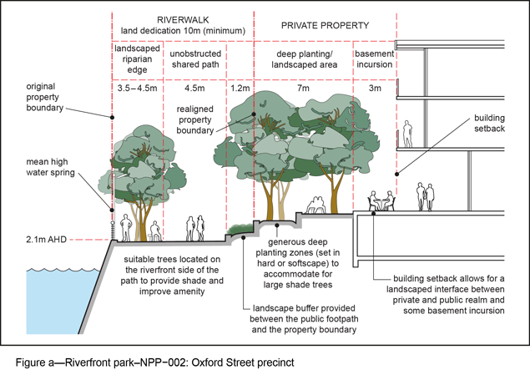
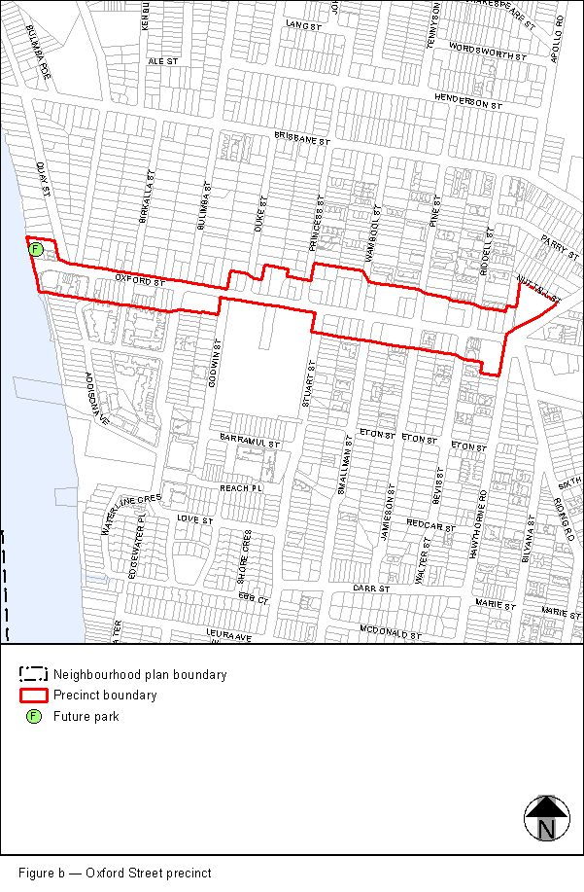
View the high resolution of Figure b—Oxford Street precinct (PDF file size is 268Kb)
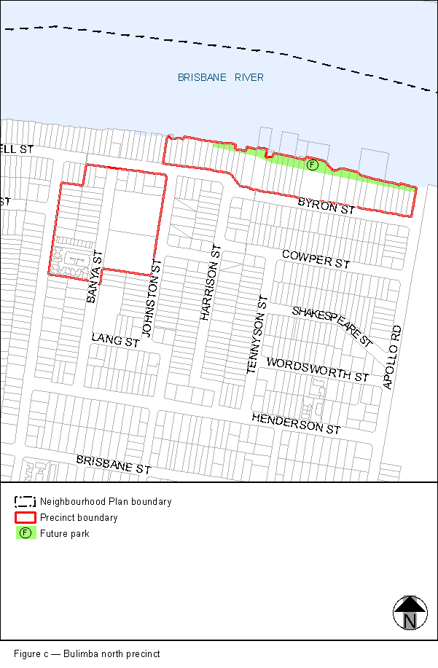
View the high resolution of Figure c—Bulimba north precinct (PDF file size is 125Kb)
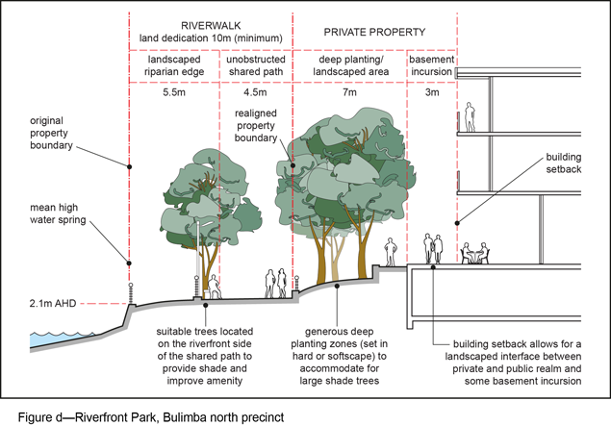
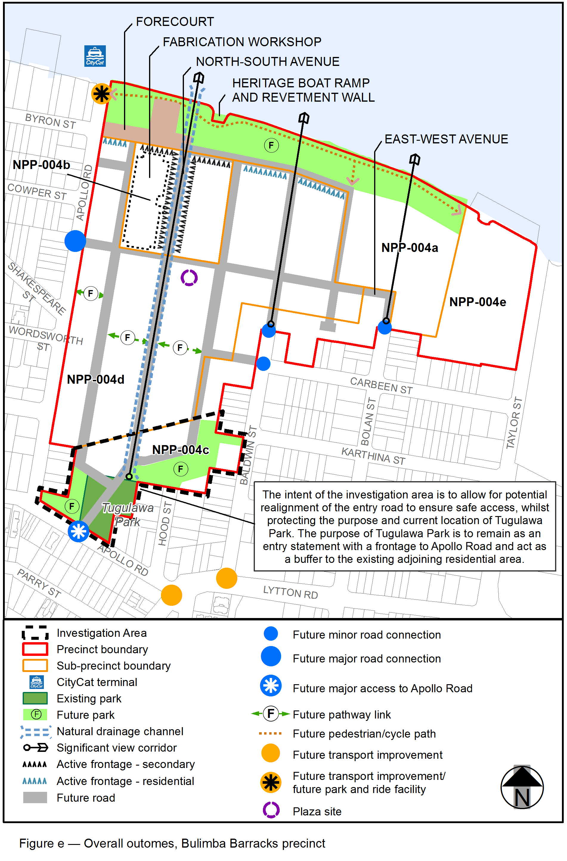
View the high resolution of Figure e—Overall outcomes, Bulimba Barracks precinct (PDF file size is 125Kb)
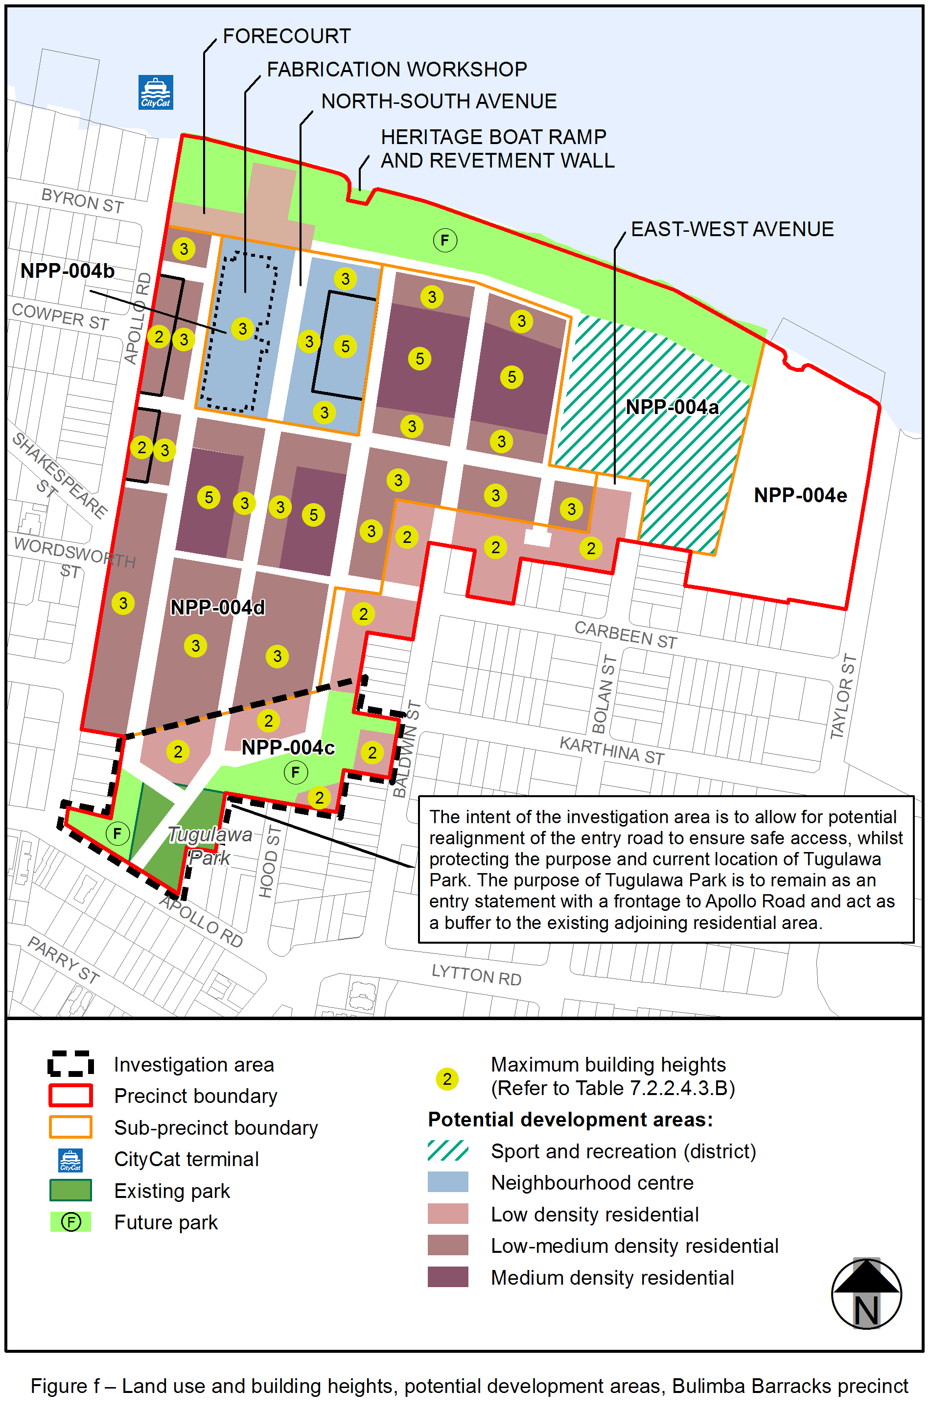
View the high resolution of Figure f—Land use and building heights, potential development areas, Bulimba Barracks precinct (PDF file size is 125Kb)

