7.2.3.9 City west neighbourhood plan code

7.2.3.9.1 Application
- This code applies to assessing a material change of use, reconfiguring a lot, operational work or building work in the City west neighbourhood plan area if:
- assessable development where this code is an applicable code identified in the assessment benchmarks column of a table of assessment for the neighbourhood plan (section 5.9); or
- impact assessable development.
- Land in the City west neighbourhood plan area is identified on the NPM-003.9 City west neighbourhood plan map and includes the following precincts:
- Victoria Barracks renewal precinct (City west neighbourhood plan/NPP-001)
- Caxton Street precinct (City west neighbourhood plan/NPP-002)
- Normanby renewal precinct (City west neighbourhood plan/NPP-003).
- When using this code, reference should be made to section 1.5, section 5.3.2 and section 5.3.3.
Note—The following purpose, overall outcomes, performance outcomes and acceptable outcomes comprise the assessment benchmarks of this code.
Note—This neighbourhood plan includes a table of assessment with variations to categories of development and assessment. Refer to Table 5.9.78.A, Table 5.9.78.B, Table 5.9.78.C and Table 5.9.78.D.
Note—The preparation of an urban context report in accordance with Table 7.2.3.9.3.B will assist in demonstrating achievement of performance outcomes in this neighbourhood plan.
Editor’s note—Council’s New World City Design Guide - Buildings that Breathe document sets out the vision, design elements and best practice case studies to guide new development. Development is actively encouraged to incorporate these design elements and embrace the city’s subtropical climate.

7.2.3.9.2 Purpose
- The purpose of the City west neighbourhood plan code is to provide finer grained planning at a local level for the City west neighbourhood plan area.
- The purpose of the City west neighbourhood plan code will be achieved through overall outcomes including overall outcomes for each precinct of the neighbourhood plan area.
- The overall outcomes for the neighbourhood plan area are:
- City west is a diverse inner-city neighbourhood with low-rise traditional character housing supported by key activity streets, high amenity public spaces, major entertainment destinations and historic renewal precincts.
- Development in City west reflects and complements the area’s unique historical and architectural character, cultural heritage values and importance as one of the earliest suburbs settled in Brisbane. The area is characterised by the 1867 Victoria Barracks and large areas comprising buildings constructed in 1946 or earlier, federation era or earlier buildings and heritage places on small allotments within a network of narrow streets and laneways. These buildings, places and areas make a significant contribution to Brisbane’s heritage and character and are retained.
- Development protects and reinforces City west’s extensive heritage and traditional character through the retention, conservation and reuse of heritage places, commercial character buildings, pre-1911 buildings and buildings constructed in 1946 or earlier. As one of the city’s oldest residential suburbs, Petrie Terrace retains a high concentration of pre-1911 buildings as well as character houses. These historic buildings are protected from demolition or removal, except where they are not capable of structural repair. New development is sensitively integrated in character areas or adjoining heritage places and federation era or earlier buildings.
- Development is of a height, scale and form which is consistent with the existing amenity, character and community expectations and is commensurate with infrastructure expectations.
- Development supports an inclusive and diverse community and provides a range of meeting and gathering places for locals and visitors.
- Development enhances the public realm and pedestrian and cycle connections.
- The Victoria Barracks renewal precinct (City west neighbourhood plan/NPP-001) overall outcomes are:
- Victoria Barracks is a precinct of high cultural heritage significance that will be revitalised as a vibrant, mixed use destination for locals and visitors, which will provide continued public access throughout the precinct, including within and around heritage buildings and open spaces.
- The precinct’s unique history will be celebrated and promoted through the retention, conservation and adaptive reuse of heritage buildings for a mix of community, commercial, retail and residential uses that facilitate public access and enjoyment of these buildings.
- Development accords with a master plan to ensure the cohesive and strategic renewal of the precinct.
- Development sensitively integrates with heritage buildings and landscapes through a predominately low-rise building height and sensitive building form that maintains the prominence of existing heritage buildings, spaces and site elements. Limited mid-rise development is permissible in discrete locations in the precinct.
- Development contributes to the amenity and legibility of the overall pedestrian and cycle network by providing publicly accessible landscaped connections through the site and to surrounding destinations including The Barracks, Roma Street Parkland and Hardgrave Park. These opportunities will be investigated and delivered through a joint stakeholder and government partnership.
- Development protects and enhances culturally significant open spaces including the Parade Grounds, 19th Century Grass Tennis Court, Petrie Terrace Wall, significant retaining walls and mature trees throughout the precinct, and provides public access to these features.
- Development optimises public access through and around the precinct and ensures that spaces between buildings and along street frontages are embellished with high quality landscaping.
- Development is designed to minimise the impact of car parking areas and vehicle access points within the public realm.
- The Caxton Street precinct (City west neighbourhood plan/NPP-002) overall outcomes are:
- The Caxton Street precinct is a key entertainment destination adjacent to Suncorp Stadium that is characterised by small-scale, ground level, active frontage uses including hotels, bars and food and drink outlet uses such as cafes and restaurants.
- The Caxton Street precinct also supports a mix of office, shop and short-term accommodation uses.
- Development maintains the traditional low-rise character of the streetscape and provides fine grain active frontages to the street.
- Development retains, conserves and adaptively reuses heritage buildings, commercial character buildings and pre-1911 buildings for non-residential uses that contribute to the vibrancy of the streetscape.
- Development height and building form sensitively transitions to adjoining and nearby lower intensity residential uses.
- Development provides streetscape improvements that enhance pedestrian amenity and the quality and vibrancy of the public realm.
- Development activates existing laneways and provides casual surveillance of these spaces.
- The Normanby renewal precinct (City west neighbourhood plan/NPP-003) overall outcomes are:
- This precinct is a mixed use hub with cross-site pedestrian connections, activated streetscapes and publicly accessible spaces.
- Development protects and integrates with the historic Normanby Hotel site by providing a permeable public realm and adequate separation between buildings to protect views and privacy.
- Development is designed at a scale and form that minimises building bulk and considers the topographical feature of the site.
- Development provides a significant publicly accessible space that is activated by ground floor uses to create a safe and comfortable public environment.

7.2.3.9.3 Performance outcomes and acceptable outcomes

Table 7.2.3.9.3.A—Performance outcomes and acceptable outcomes
Performance outcomes | Acceptable outcomes
General
PO1  Development is designed to respond to its site context and setting and exhibits outstanding architectural merit.  Development is of a height, scale and form that achieves the intended outcome for the precinct, improves the amenity of the neighbourhood plan area, contributes to a cohesive streetscape and built form character and is:  - consistent with anticipated density and assumed infrastructure demand;  - aligned to community expectations about the number of storeys to be built;  - proportionate and commensurate with the utility of the site area and frontage width;  - designed to avoid significant adverse amenity impact to adjoining development and public spaces;  - sited to enable existing and future buildings to be well separated from each other and to avoid affecting the potential development of an adjoining site.  Note—Development that exceeds the intended number of storeys or building height can place disproportionate pressure on the transport network, public space or community facilities in particular.  Note—Development that is over-scaled for its site can result in an undesirable dominance of vehicle access, parking and manoeuvring areas that significantly reduce streetscape character and amenity. | AO1  Development complies with the number of storeys in Table 7.2.3.9.3.C.  Note—Neighbourhood plans will mostly specify the maximum number of storeys where zone outcomes have been varied in relation to building height. Some neighbourhood plans may also specify the height in metres. Development must comply with both parameters where maximum number of storeys and height in metres are specified.  Note—The preparation of an urban context report in accordance with Table 7.2.3.9.3.B will assist in demonstrating achievement of performance outcomes in this neighbourhood plan code.  Note—Council’s Independent Design Advisory Panel may be invited to provide advice on development, to facilitate high quality development, in accordance with the provisions of the Independent design advisory panel planning scheme policy.  Editor’s note—Council’s New World City Design Guide - Buildings that Breathe document sets out the vision, design elements and best practice case studies to provide guidance on how to achieve subtropical design outcomes in the Caxton Street precinct, Victoria Barracks renewal precinct and Normanby renewal precinct.
PO2  Development on a site that requires a building height transition as shown on Figure a is set back from the front, side and rear boundaries so as to not create an overbearing appearance on adjoining properties, surrounding residential areas and heritage places or significantly impact occupant privacy and amenity. | AO2  Development on a site that requires a building height transition as shown on Figure a, and where above the second storey, is:  - set back a minimum of 3m from the front and side boundaries;  - set back a minimum of 6m from the rear boundary.
If in the Mixed use zone
PO3  Development:  - retains and adaptively reuses commercial character buildings and pre-1911 buildings for non-residential activities;  - ensures new buildings or additions to existing buildings are compatible and in character with the built form, architecture and scale of the area. | AO3  Development involving non-residential activities on the site of commercial character buildings and pre-1911 buildings maintains the traditional building form by:  - retaining the commercial character building or pre-1911 building;  - siting infill development to the rear of the existing building;  - providing external elements such as verandahs, eaves, overhangs and balustrades that reflect those elements of the commercial character building or pre-1911 building;  - using traditional materials, including roof materials, similar to the materials used in the commercial character building or pre-1911 building;  - preserving the scale, grain and spacing between buildings when viewed from the street;  - retaining or providing subtropical plantings within the front setback area.
If in the Victoria Barracks renewal precinct (NPP-001)
PO4  Development has, and is undertaken in accordance with, a master plan that:  - retains and conserves heritage buildings and historically and culturally significant spaces and site elements, including spaces and elements such as the Parade Ground, the Petrie Terrace Wall, retaining walls, the 19th Century Grass Tennis Court and the many mature trees throughout the precinct;  - facilitates adaptive reuse of heritage buildings for appropriate uses that promote public access and enjoyment;  - adheres to best practice heritage conservation consistent with the Burra Charter 2013 that conserves, respects and retains the built, landscape and archaeological significance of the place;  - limits the maximum total site cover of new buildings to 16% of the precinct’s site area;  - restricts new buildings of up to 6 storeys to the southern corner of the precinct adjoining the railway line, and locates only low-rise buildings in other parts of the precinct of a scale and height commensurate with the existing heritage buildings;  - provides a minimum 35% of the precinct’s site area as publicly accessible space, including, but not limited to, the plazas indicated on Figure a and Blackall Street;  - contributes to a high quality public realm with a strong pedestrian focus through subtropical landscaping, streetscape improvements and passive surveillance within and adjoining the precinct;  - provides a mix of community, commercial, retail and residential uses that creates a vibrant precinct that generates activity throughout the day and evening;  - includes predominantly active uses on the ground storeys of buildings, along pedestrian connections and fronting open spaces to ensure passive surveillance;  - provides pedestrian and cyclist access within and through the site that connects with arcades, plazas and other public spaces, and that provides access between the precinct and Petrie Terrace, The Barracks, Hardgrave Park and Roma Street Parkland;  - provides vehicular access and circulation that supports the precinct’s revitalisation, while prioritising pedestrian and cyclist access and connections.  Note—For the purposes of this performance outcome, the total site cover of all non-heritage buildings in the precinct is no more than 16%. | AO4  No acceptable outcome is prescribed.
If in the Normanby renewal precinct (NPP-003)
PO5  Development provides useable, publicly accessible open spaces that have generous subtropical plantings and are supported by active uses and passive surveillance. | AO5  Development:  - provides a minimum of 30% of the site area as publicly accessible open space;  - ensures that a minimum of 10% of publicly accessible open space contains subtropical plantings;  - is oriented to overlook public spaces, with doors, windows and balconies that allow activity, visual connection and surveillance opportunities.
PO6  Development is of a scale and design that minimises building bulk and minimises overshadowing of the Normanby Hotel. | AO6  Development above the podium is set back a minimum of 8m from the Normanby Hotel.
PO7  Development:  - provides adequate separation between buildings to allow for light penetration, air circulation, views, vistas and privacy;  - exhibits human scale and does not dominate the site. | AO7  Development above the podium:  - has a minimum building separation of 12m between towers;  - occupies less than 30% of the site area.  Note—For the purposes of this acceptable outcome, 30% site area above the podium applies to the cumulative total of all towers on the site.

Table 7.2.3.9.3.B—Urban context report
Content | Scope (and format)
Site characteristics | Demonstrate how the site’s constraints and attributes have been considered in the design of the development.
Cityscape and built form | Demonstrate how the development:  - provides a site-responsive built form taking into account site characteristics and form of surrounding development, including relationship with other buildings in terms of setbacks, privacy, light and air;  - provides a contextually responsive built form taking into account site location within City west;  - impacts on broader views across the cityscape and of the city skyline;  - exhibits outstanding architectural merit.
Streetscape | Demonstrate how the development impacts on and contributes to the streetscape and street functioning, in terms of:  - street building height, setbacks and design;  - ground level activation, including proportion of glazing and openings;  - awning heights and continuity;  - footpath width, continuity and design.
Heritage, landmarks, natural assets, views and vistas | Demonstrate how the development:  - respects the streetscape and public realm context and setting of nearby heritage buildings and places, landmarks and natural assets;  - maintains or creates views and vistas from public vantage points, including heritage places, landmarks and natural assets, and across public realm.
Public realm, connections, attractors and movement network | Demonstrate how the development:  - respects, enhances, expands and/or connects to adjoining and nearby public realm;  - maintains and enhances pedestrian permeability, including to major attractors and the wider movement network.
Subtropical climate | Demonstrate how the development design incorporates orientation, shading, outdoor spaces, natural ventilation, landscaping and articulation to reduce heat loading, protect from weather, optimise natural light and support outdoor lifestyles.

Editor’s note––The Urban context report provides a formal means for developers, architects and designers to clearly articulate how the development successfully responds to the site, its context and climate. This report should comprise of plans, diagrams, perspectives, 3D modelling (including use of the Virtual Brisbane 3D model to test development options) and supporting design rationales to demonstrate how the proposal achieves the outcomes of the Neighbourhood plan code.
Editor’s note––Council’s New World City Design Guide - Buildings that Breathe document sets out the vision, design elements and best practice case studies to guide new development. Development is actively encouraged to incorporate these design elements and embrace the city’s subtropical climate.

Table 7.2.3.9.3.C—–Maximum building height in storeys
 | Development of a site less than 500m² | Development of a site 500m² or greater but less than 1000m² | Development of a site 1000m² or greater but less than 5000m² | Development of a site 5000m² or greater
If in the Victoria Barracks renewal precinct (City west neighbourhood plan/NPP-001)
Where in the Mixed use zone | 3 |  | 6
If in the Caxton Street precinct (City west neighbourhood plan/NPP-002)
Where in the District centre zone | 3 |  | 5
If in the Normanby renewal precinct (City west neighbourhood plan/NPP-003)
Where in the Mixed use zone | 3 |  | 8 | 12
If on a site that is not in the Victoria Barracks renewal precinct, Caxton Street precinct or Normanby renewal precinct
Where in the Mixed use zone | 2 | 3

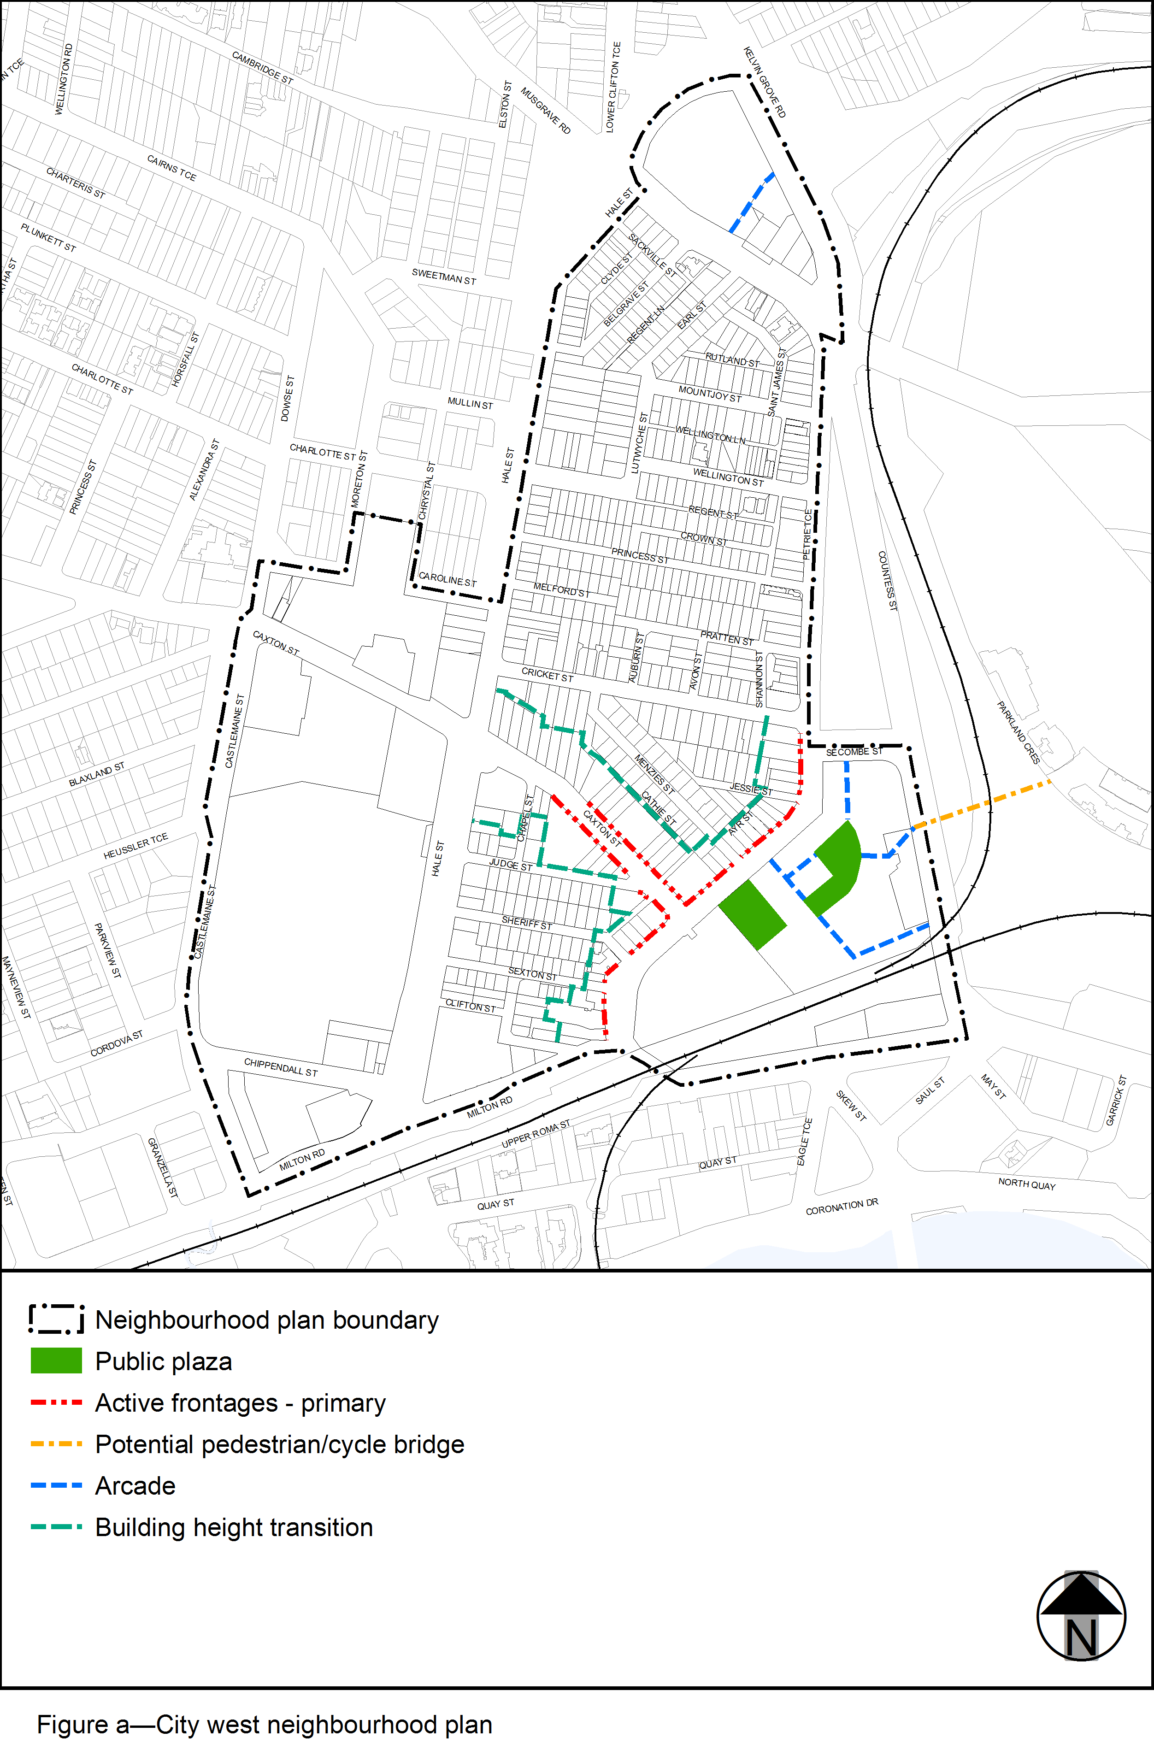
View the high resolution of Figure a–City west neighbourhood plan (PDF file size is 509Kb)

