7.2.3.10 Coorparoo and districts neighbourhood plan code

7.2.3.10.1 Application
- This code applies to assessing a material change of use, reconfiguring a lot, operational work or building work in the Coorparoo and districts neighbourhood plan area if:
- Assessable development where this code is an applicable code identified in the assessment benchmarks column of a table of assessment for a neighbourhood plan (section 5.9); or
- Impact assessable development.
- Land in the Coorparoo and districts neighbourhood plan area is identified on the NPM-003.10 Coorparoo and districts neighbourhood plan map and includes the following precincts:
- Logan Road precinct (Coorparoo and districts neighbourhood plan/NPP-001):
- Logan Road 5-6 storey sub-precinct (Coorparoo and districts neighbourhood plan/NPP 001a);
- Logan Road 3 storey sub-precinct (Coorparoo and districts neighbourhood plan/NPP 001b).
- Greenslopes Private Hospital precinct (Coorparoo and districts neighbourhood plan/NPP-002);
- Stephens Mountain precinct (Coorparoo and districts neighbourhood plan/NPP-003):
- Stephens Mountain reserve sub-precinct (Coorparoo and districts neighbourhood plan/NPP-003a);
- Stephens Mountain west sub-precinct (Coorparoo and districts neighbourhood plan/NPP 003b).
- Earl Street precinct (Coorparoo and districts neighbourhood plan/NPP-004).
- When using this code, reference should be made to section 1.5, section 5.3.2 and section 5.3.3.
Note—The following purpose, overall outcomes, performance outcomes and acceptable outcomes comprise the assessment benchmarks of this code.
Note—This neighbourhood plan includes a table of assessment with variations to categories of development and assessment. Refer to Table 5.9.82.A, Table 5.9.82.B, Table 5.9.82.C and Table 5.9.82.D.
Note—Significant vegetation is defined in the Vegetation planning scheme policy.

7.2.3.10.2 Purpose
- The purpose of the Coorparoo and districts neighbourhood plan code is to provide finer grained planning at a local level for the Coorparoo and districts neighbourhood plan area.
- The purpose of the Coorparoo and districts neighbourhood plan code will be achieved through overall outcomes including overall outcomes for each precinct of the neighbourhood plan area.
- The overall outcomes for the neighbourhood plan area are:
- A mix of housing densities and types serves the needs of the community, including the neighbourhood plan area’s young adult and elderly populations, as well as key workers, particularly in proximity to major employment nodes, centres and major public transport nodes and corridors.
- Identified character housing and traditional character streetscapes are retained and protected.
- Development reinforces the development of discrete centres along the Logan Road corridor with a diverse mix of land uses.
- Higher-intensity residential uses cluster in and around each centre, contributing to their vitality and viability.
- Development demonstrates high-quality built form and public realm outcomes that contribute to a strong sense of place and the creation of high quality streetscapes.
- The ecological, landscape and visual values of Stephens Mountain are retained.
- Remnant vegetation on Stephens Mountain is protected.
- Development of the Greenslopes Private Hospital respects the setting of a predominantly residential locality and maximises accessibility between the hospital and the Greenslopes Busway station.
- Development on Newdegate Street between Denman Street and Headfort Street provides a mix of centre and community activities that is complementary to the Greenslopes Private Hospital.
- Development is of a height, scale and form which is consistent with the amenity, character and infrastructure assumptions intended for the relevant precinct, sub-precinct or site.
- Development adjacent to public spaces is designed to increase casual surveillance and activation of the public space.
- Logan Road precinct (Coorparoo and district neighbourhood plan/NPP-001) overall outcomes are:
- The Logan Road precinct accommodates residential and commercial growth along Logan Road.
- Development within the District centre zone has a focus on centre activities that promote active street frontages while also accommodating complementary residential uses.
- Development within the Mixed use zone incorporates centre activities or residential uses that support the growth in the District centre zone and maintain an active street frontage.
- The Medium density residential zone provides for a mix of dwelling types.
- Development reinforces the built form character of Logan Road as a commercial main street, and transitions sensitively to adjoining uses within lower density residential zones.
- Greenslopes Private Hospital precinct (Coorparoo and district neighbourhood plan/NPP-002) overall outcomes are:
- Development in the Greenslopes Private Hospital precinct allows for the continued operation and intensification of the hospital within its current site area.
- The expansion of the hospital and associated medical activities into the surrounding residential area is not supported.
- Development minimises adverse impacts to the surrounding residential environment.
- Building bulk, scale and height around the perimeter of the site incorporates a sensitive transition to the surrounding residential area.
- Residential activities such as short-term accommodation and other uses that support the functions of the hospital are appropriate in this precinct.
- Development does not include car parking adjacent to Denman Street and Newdegate Street frontages, and car parking is sleeved by office or other uses that activate the street frontage and contribute to passive surveillance.
- Development provides for:
- high-quality urban design, particularly for those buildings that are highly visible from surrounding suburbs and major transport thoroughfares such as the Pacific Motorway and the South East Busway;
- active street frontages, particularly to Newdegate and Denman Streets, such as associated medical activities and where possible, hospital functions that are accessible for pedestrians and address the street frontage;
- a range of design techniques and other measures encouraging surveillance of public streets and spaces to improve pedestrian and cyclist safety;
- active and public transport integration between the site and the nearby cycle links and the Greenslopes Busway station.
- Stephens Mountain precinct (Coorparoo and districts neighbourhood plan/NPP-003) overall outcomes are:
- Development is designed to retain the landscape, habitat and ecological values of Stephens Mountain.
- Development is sensitive to the natural topography and complements the natural values of Stephens Mountain.
- Stephens Mountain reserve sub-precinct (Coorparoo and districts neighbourhood plan/NPP-003a) overall outcomes are:
- development is designed to complement the scenic landscape and contributes to passive recreation values.
- Stephens Mountain west sub-precinct (Coorparoo and districts neighbourhood plan/NPP-003b) overall outcomes are:
- any future development must be in accordance with an approved structure plan which considers the entire area zoned Emerging community;
- development located on the area zoned Emerging community, has consideration of the development constraints and does not adversely affect the character or environmental value of the land;
- development provides for land uses that provide an active frontage to the Greenslopes Busway station and plaza.
- Earl Street precinct (Coorparoo and districts neighbourhood plan/NPP-004) overall outcomes are:
- The precinct accommodates primarily multiple dwelling uses.
- Development facilitates all-abilities access to public transport infrastructure, including Greenslopes Busway station, by creating comfortable and safe active transport and streetscape networks.
- Development increases casual surveillance, activation and access to sporting fields and open space at Thompson Estate Reserve.
- Development respects and enhances the visual prominence of the expansive sporting fields and open space at Thompson Estate Reserve.
- Development incorporates subtropical architecture with high-quality design.
- Development maintains a human-scale streetscape and promotes activation of the street through the location of parking, servicing and vehicle entrances.

7.2.3.10.3 Performance outcomes and acceptable outcomes

Table 7.2.3.10.3.A—Performance outcomes and acceptable outcomes
Performance outcomes | Acceptable outcomes
PO1  Development is of a height, scale and form that achieves the intended outcome for the precinct, improves the amenity of the neighbourhood plan area, contributes to a cohesive streetscape and built form character and is:  - consistent with the anticipated density and assumed infrastructure demand;  - aligned to community expectations about the number of storeys to be built;  - proportionate to and commensurate with the utility of the site area and frontage width;  - designed so as not to cause a significant and undue adverse amenity impact to adjoining development. | AO1  Development complies with the number of storeys in Table 7.2.3.10.3.B.  Note—Neighbourhood plans will mostly specify a maximum number of storeys where zone outcomes have been varied in relation to building height. Some neighbourhood plans may also specify height in metres. Development must comply with both parameters where maximum number of storeys and height in metres are specified.  Note—Council’s Independent Design Advisory Panel may be invited to provide advice on development, to facilitate high quality development, in accordance with the provisions of the Independent design advisory panel planning scheme policy.
PO2  Development minimises impacts on existing significant vegetation and provides replacement vegetation on the site of an advanced size and maturity where significant vegetation is removed. | AO2.1  Development of buildings, structures, driveways, vehicle cross-overs and hard stand areas are designed and sited to maximise the retention of vegetation on the site and adjacent street trees.
AO2.2
Significant vegetation removed as a result of the development is replaced with vegetation of advanced size and maturity.
PO3  Development provides a high level of amenity for adjoining residential buildings and incorporates subtropical design principles to support healthy, energy efficient living. | AO3.1  Development incorporates the following subtropical design principles:  - cross-ventilation in and around buildings by use of building forms, breezeways, open courtyards and landscaped areas;  - sun shading of openings;  - suitable building orientation;  - building form that maximises amenity, street activity and pedestrian connectivity;  - deep planting within setbacks along common boundaries and frontages.
AO3.2
Development is designed to ensure that adjoining residential buildings:
- retain access to natural light, sunlight and breeze;
- maintain privacy through the positioning of balconies or habitable rooms.
If in the Logan Road precinct (Coorparoo and districts neighbourhood plan/NPP-001)
PO4  Development accommodates buildings that are sited to:  - contribute to a cohesive streetscape and built form character;  - address the street and reinforce the built form character of Logan Road as a commercial main street;  - provide a high-quality streetscape with a strong pedestrian focus through landscape and footpath works that are consistent with the desired role and function of each street indicated in the streetscape hierarchy;  - avoid significant and undue adverse amenity impact to adjoining lower density residential development;  - enable existing and future buildings to be well separated from each other to allow for light penetration, air circulation, views, vistas and privacy;  - maintain and enhance the established vegetation and deep planting in the locality. | AO4.1  Development provides rear boundary setbacks in accordance with the planning scheme where identified on Figure a.
AO4.2
Development is orientated towards the Logan Road frontage and designed to enhance a main street character.
AO4.3
Development locates car parking areas underground or in areas behind the building and not discernible from the Logan Road frontage.
AO4.4
Development incorporates a vegetation buffer a minimum of 5m wide along rear and side boundaries where adjoining a residential site.
AO4.5
Development provides a landscape screen, that is not occupied by refuse bins or other back of house activities, that is capable of achieving a height of 10m to 12m at maturity to maintain visual privacy to residences.
PO5  Development:  - has an activated, pedestrian-friendly and human-scale façade;  - incorporates active ground floor uses;  - promotes public realm safety and provides ample casual surveillance opportunities. | AO5.1  Development ensures non-residential uses are located on the ground storey directly adjoining and accessible to streets, pathways, or open space.
AO5.2
Development includes balconies, living areas, entries and windows that overlook the street, pathways or open space.
If in the Greenslopes Private Hospital precinct (Coorparoo and districts neighbourhood plan/NPP-002)
PO6  Development is designed to provide a transition from larger buildings in the interior of the site to a height, scale and form around the periphery of the site that is compatible with future development envisaged in surrounding residential areas as indicated in Figure b. | AO6  No acceptable outcome is prescribed.
PO7  Development positively contributes to the setting of the Greenslopes Private Hospital in its residential locality by:  - addressing the street with an engaging building form incorporating uses with an active frontage, and the use of windows and doors that allow for activity, visual connection and surveillance of the street in the locations identified in Figure b;  - siting and designing carparks to minimise the impact on the quality of the streetscape and the amenity of nearby residents in terms of location, bulk, form and amenity impacts including noise, light and odour. | AO7  No acceptable outcome is prescribed.
PO8  Development complements and enhances the landscape and visual character of the locality. | AO8  Development provides a landscaped 6m setback to all road frontages that:  - incorporates existing vegetation;  - does not include structures such as car parking, servicing areas, mechanical exhausts and plant, balconies and patios;  - includes covered walkways and other pedestrian shelters required for the functioning of the pedestrian network throughout the site.
PO9  Development on the site achieves a high level of integration with public and active transport. | AO9  Development on the site supports active and public transport through:  - provision of onsite facilities for public transport integration and connections with the Greenslopes Busway station to the Greenslopes Private Hospital;  - location of a secure pedestrian and cyclist entrance at the south western corner of the site to connect with existing pedestrian and cyclist networks;  - provision of end-of-trip facilities with secure parking, showers and lockers in accordance with Austroads standards and the Transport, access, parking and servicing code.
If in the Stephens Mountain precinct (Coorparoo and districts neighbourhood plan/NPP-003)
PO10  Development minimises impacts on existing vegetation and provides replacement vegetation on the site of advanced size and maturity where similar vegetation is removed. | AO10.1  Development is designed and sited to maximise retention of existing vegetation on-site.
AO10.2
Vegetation removed as a result of development is replaced with vegetation of advanced size and maturity that contributes to the ecological character of the area.
If in the Stephens Mountain reserve sub-precinct (Coorparoo and districts neighbourhood plan/NPP-003a)
PO11  Development provides for passive recreation and the retention of significant landscape features and ecological values. | AO11  No acceptable outcome is prescribed.
If in the Stephens Mountain west sub-precinct (Coorparoo and districts neighbourhood plan/NPP-003b)
PO12  Development is undertaken in accordance with a structure plan that is prepared for the entire developable land area and in accordance with the Structure planning planning scheme policy.  Note—A structure plan prepared in accordance with the Structure planning planning scheme policy can assist in demonstrating achievement of this outcome and is a useful tool to integrate development layout with all relevant spatial attributes as addressed in overlays and neighbourhood plans. | AO12  Development is consistent with a structure plan prepared in accordance with the Structure planning planning scheme policy and which addresses site context and setting by responding to:  - important view corridors and the visual values of Stephens Mountain;  - the proximity of Stephens Mountain to the site, maximising scenic amenity through building separation and view corridors from both the Greenslopes Busway station, any internal road connection and within the development site generally;  - natural hazards including bushfire and flooding;  - flora and fauna;  - vegetation management;  - services and infrastructure;  - soil and topography;  - stormwater and water quality management;  - housing density;  - transport network;  - active transport connections, particularly to the Greenslopes Private Hospital, Greenslopes Busway station and nearby open space.
PO13  Development has building height, scale and form that:  - is responsive to and below the peak of Stephens Mountain to maintain Stephens Mountain as a prominent landmark in the locality;  - allows for a visual connection between public and privately-owned spaces, to enhance casual surveillance and activate the public space;  - provides active uses overlooking Barnsdale Place, the Greenslopes Busway station, plaza, parks and open space;  - provides for a varying level of intensity and scale across the site to respond to site constraints and activate internal and external public spaces. | AO13  Development:  - is of a height and scale determined following a visual assessment and is to a maximum height of RL 40m;  - maximises casual surveillance of the walking/cycle path, Greenslopes Busway Station, parks and open space through measures including the orientation of living areas to these areas.
PO14  Development considers public access and movement through the site by:  - providing for a plaza of useable areas and dimensions;  - the design and siting of the plaza that promotes pedestrian and cycle movement through the public space and options for flexible use of the space. | AO14  Development includes a plaza of a minimum size of 1,200m² accessible to the Greenslopes Busway Station which is publicly accessible any time of the day.
PO15  Development enhances and capitalises on the landscape, ecological and visual values of the precinct by:  - retaining significant vegetation and providing sufficient space between buildings for trees and landscaping;  - protecting key environmental areas on Stephens Mountain. | AO15  No acceptable outcome is prescribed.
If in the Earl Street precinct (Coorparoo and districts neighbourhood plan/NPP-004)
PO16  Development respects and enhances the amenity, visual appearance and uses of the sporting fields, parks and open space at Thompson Estate Reserve by:  - increasing casual surveillance to parks and open space;  - providing access to parks and open space;  - being sited and designed to avoid undue adverse impact or overshadowing to parks and open space. | AO16  Development:  - incorporates expansive decks, balconies and verandahs which:  - have a minimum dimension of 3m;  - are directly accessible from living spaces;  - are orientated to directly overlook public spaces;  - provides safe access to parks and open space using crime prevention through environmental design strategies;  - does not cause adverse overshadowing to parks and open space.  Note—For guidance in achieving the key elements of crime prevention through environmental design refer to the Crime prevention through environmental design planning scheme policy.
PO17  Development is designed to promote integration with the footpath and provide a safe, enjoyable and continuous pedestrian environment with minimal obstruction or interruption from vehicular crossovers and manoeuvring. | AO17.1  Development has clearly identifiable pedestrian entries from the adjoining streets.
AO17.2
Development includes individual pedestrian entries for each ground storey dwelling facing a public street.
AO17.3
Development provides convenient access for pedestrians and cyclists to local transport networks, key destinations and public transport facilities.
AO17.4
Development minimises:
- vehicular crossovers or driveways;
- at-grade or otherwise visible car parking;
- service vehicle access across the footpath.

Table 7.2.3.10.3.B—Maximum building height
Development | Number of storeys
Where in the NPP-001 Logan Road precinct, sub-precinct 1a
If within the District centre zone | 6
If within the Mixed use zone | 5
Where in the NPP-001 Logan Road precinct, sub-precinct 1b
If within the Mixed use zone | 3
Where in the NPP-002 Greenslopes Private Hospital precinct
Any development within 20m of a road boundary | 3
All other development | 5
Where in the NPP-004 Earl Street precinct and in the Medium density residential zone
Development of a site area less than 800m² | 3
Development of a site area that is larger than 800m² and smaller than 1,200m² | 4
Development of a site area 1,200m² or greater | 5

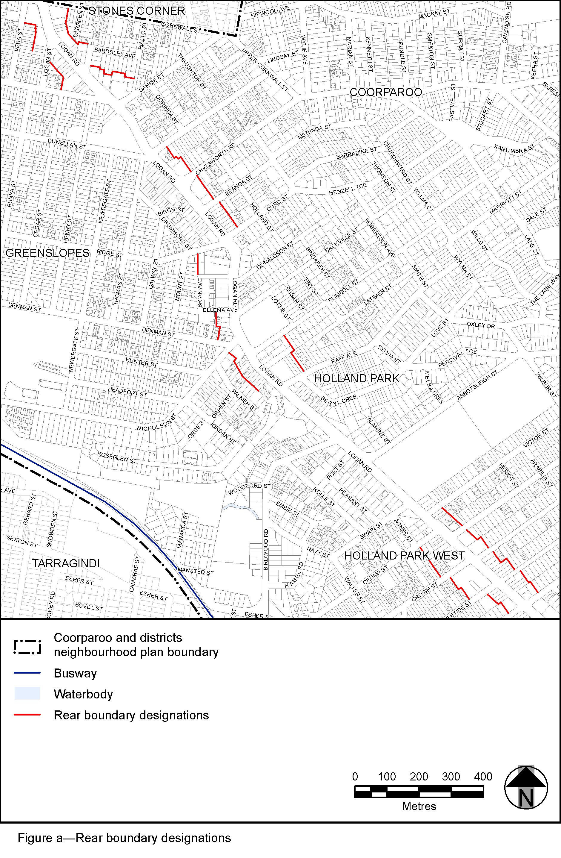
View the high resolution of Figure a–Rear boundary designations (PDF file size is 616Kb)
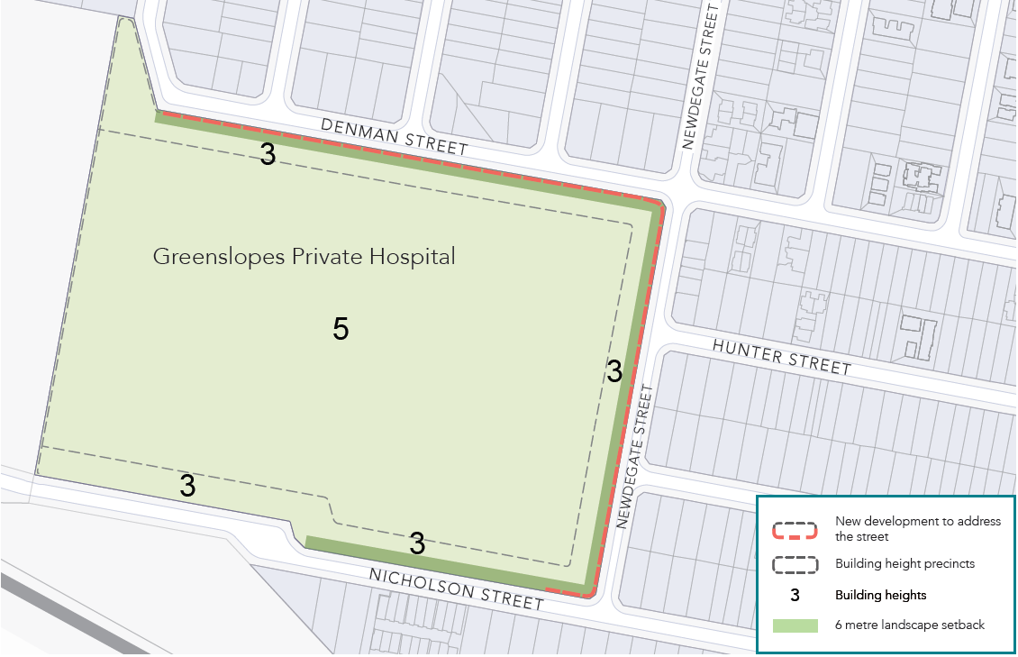
Figure b–Greenslopes Private Hospital precinct
View the high resolution of Figure b–Greenslopes Private Hospital precinct (PDF file size is 294Kb)

