7.2.12.5 Lower Oxley Creek north neighbourhood plan code

7.2.12.5.1 Application
- This code applies to assessing a material change of use, reconfiguring a lot, operational work or building work in the Lower Oxley Creek north neighbourhood plan area if:
- assessable development where this code is an applicable code identified in the assessment benchmarks column of a table of assessment for a neighbourhood plan (section 5.9); or
- impact assessable development.
- Land in the Lower Oxley Creek north neighbourhood plan area is identified on the NPM-012.5 Lower Oxley Creek north neighbourhood plan map and includes the following precincts:
- Willawong renewable energy precinct (Lower Oxley Creek north neighbourhood plan/NPP-001);
- Limited development precinct (Lower Oxley Creek north neighbourhood plan/NPP-002).
- When using this code, reference should be made to section 1.5, section 5.3.2 and section 5.3.3.
Note—The following purpose, overall outcomes, performance outcomes and acceptable outcomes comprise the assessment benchmarks of this code.
Note—This neighbourhood plan includes a table of assessment with variations to categories of development and assessment. Refer to Table 5.9.75.A, Table 5.9.75.B, Table 5.9.75.C and Table 5.9.75.D.

7.2.12.5.2 Purpose
- The purpose of the Lower Oxley Creek north neighbourhood plan code is to provide finer grained planning at a local level for the Lower Oxley Creek north neighbourhood plan area.
- The purpose of the Lower Oxley Creek north neighbourhood plan code will be achieved through overall outcomes including overall outcomes for each precinct of the neighbourhood plan area.
- The overall outcomes for the neighbourhood plan area are:
- Implement the policy direction set in the Strategic framework in order to achieve the desired vision for Lower Oxley Creek north, in particular:
- Theme 1: Brisbane’s globally competitive economy, Element 1.2 – Brisbane’s industrial economy and Element 1.3 – Brisbane’s population-serving economy;
- Theme 2: Brisbane's outstanding lifestyle, Element 2.3 – Brisbane's healthy and safe communities;
- Theme 3: Brisbane's clean and green leading environmental performance,
Element 3.1 – Brisbane's environmental values;
Element 3.2 – Brisbane's environmental quality and sustainable design, and
- Theme 4: Brisbane's highly effective transport and infrastructure, Element 4.1 –Brisbane’s transport infrastructure networks, Element 4.2 – Brisbane's other infrastructure networks and Element 4.3 – Brisbane's coordinated infrastructure planning and delivery;
- Theme 5: Brisbane’s CityShape, Element 5.2 – Brisbane’s Major Industry Areas and Element 5.6 Brisbane's Greenspace System.
- Lower Oxley Creek north forms an extension to the south-west industrial gateway predominantly for Low impact industry and Medium impact industry uses, in particular transport, logistics and distribution, and manufacturing.
- A new neighbourhood centre is developed in accordance with the Centre or mixed use code on one of the four corners at the junction of Sherbrooke Road and Learoyd Road/King Avenue to support local businesses and employees. The centre includes a supermarket and small-scale retail and commercial tenancies and is co-located with a local park. Sensitive uses, such as residential uses, childcare centre and educational establishment are not accommodated in the centre as such uses are incompatible with the preferred industry activities in the surrounding area.
- Lower Oxley Creek north may include other non-industrial business uses such as animal keeping or a retail plant nursery in the short-medium term, where they do not compromise the long term use of the land for industrial purposes.
- Development protects the safety of people and property and the environment from the impacts of sub-surface landfill emissions, including landfill gas, contaminated groundwater or leachate.
Editor’s note—Where filling or excavation is conducted on land previously occupied by a notifiable activity or on land listed on the Environmental Management Register or the Contaminated Land Register, the relevant Queensland Government department should be contacted for advice and guidelines.
- Development does not compromise any remediation activities associated with the former Willawong landfill and hazardous waste facility or operation of an existing gas extraction facility.
- Natural assets are protected and enhanced to contribute to the improved health of the Oxley Creek catchment, in particular Oxley Creek, Blunder Creek and Archerfield Wetlands.
- Development that includes land with environmental values as identified in Figure b protects, restores and transfers Habitat areas and ecological corridors (public) to the Council for public ownership.
- Cultural heritage values associated with the Oxley Creek catchment, in particular Oxley Creek, Blunder Creek and Archerfield Wetlands, are protected and enhanced.
Note—Assessment of cultural heritage significance related to potentially significant or identified Aboriginal places, sites or landscapes should be referred to the relevant State agency responsible for the administration of the Aboriginal Cultural Heritage Act 2003 for further advice.
- An accessible network of green spaces focused on environment and waterway corridors, in particular Oxley Creek, Blunder Creek and Archerfield Wetlands, is provided throughout the area. These green spaces contain valuable bushland areas and public parks, offer a wide range of recreational opportunities and are accessible via pedestrian and cycle routes in sensitively designed locations.
- Development maintains and improves the efficiency, safety and capacity of the transport network, including Beatty Road, Inala Avenue, King Avenue, Bowhill Road, Burman Road, Ritchie Road, Camden Road, Gooderham Road, Learoyd Road and Sherbrooke Road.
- Development protects and preserves the future transport network and does not prejudice or inhibit the delivery of transport network upgrades.
- Higher frequency public transport is accommodated through an improved transport network along Learoyd Road and King Avenue, and Sherbrooke Road and Gooderham Road.
- Willawong renewable energy precinct (Lower Oxley Creek north neighbourhood plan/NPP-001) overall outcomes are:
- Development for renewable energy facilities, such as a gas extraction facility and solar farm, is accommodated.
- Development addresses constraints associated with the former Willawong landfill and hazardous waste facility including ground instability and contamination.
- Limited development precinct (Lower Oxley Creek north neighbourhood plan/NPP-002) overall outcomes are:
- Further development does not occur due to the hazardous nature of the site and contamination associated with the former Willawong hazardous waste facility.
- Land disturbing works do not occur due to risk from exposure to contaminated material or potential landfill gas migration risk.
- The precinct remains inaccessible to the public.

7.2.12.5.3 Performance outcomes and acceptable outcomes

Table 7.2.12.5.3—Performance outcomes and acceptable outcomes
Performance outcomes | Acceptable outcomes
PO1  Development:  - does not expose people to unacceptable levels of risk to health, safety and wellbeing from sub-surface landfill emissions, including landfill gas, contaminated groundwater or leachate;  - is designed and constructed to minimise and mitigate risks to health, safety and wellbeing from sub-surface landfill emissions, including landfill gas, contaminated groundwater or leachate.  Note—Compliance with this performance outcome can be demonstrated by the submission of the following reports prepared by qualified experts and certified by a Registered Professional Engineer of Queensland: Hazard Analysis Assessment Report and Geotechnical Assessment Report.  Editor's note—Third party advice may be sought from Queensland Government agencies regarding Queensland Government registers and the assessment of any hazard analysis report. | AO1  No acceptable outcome is prescribed.
Access to Burman Road and Gooderham Road
PO2  Development gains access from roads that form part of the future transport network.  Note—The future transport network is identified in the Road hierarchy overlay map (OM-018.2). | AO2  Development does not provide access to sections of Burman Road and Gooderham Road identified in Figure a as not forming part of the future transport network.
If in the Habitat areas and ecological corridors (public) on Figure b
PO3  Development must protect and enhance biodiversity and landscape values as mapped in Figure b and provide public access along the public corridor that is safe from hazards and achieves Council's asset standards. | AO3  Habitat areas and ecological corridors (public) identified in Figure b are:  - transferred to the Council for public ownership;  - rehabilitated and stabilised in accordance with an approved rehabilitation plan.  Note— A rehabilitation plan will demonstrate achievement of this outcome. Rehabilitation is to be:  - completed within 1 year of the operational works approval being granted;  - maintained for a minimum of 3 years, removing rubbish and weeds, replacing damaged and dead vegetation and managing erosion.
Where Centre activities in an area identified as a neighbourhood centre in Figure b
PO4  Development is only for one single, consolidated neighbourhood centre at the junction of Sherbrooke Road and King Avenue/Learoyd Road, and is arranged and designed in accordance with a structure plan that:  - provides active frontages to streets and the co-located park;  - provides safe and efficient access and parking located to the rear of centre activities;  - addresses internal circulation of heavy vehicles within the site and the impacts of heavy vehicle ingress and egress on the surrounding road network;  - includes a significant corner site. | AO4.1  Development provides a single, consolidated neighbourhood centre, located on one of the corners at the junction of Sherbrooke Road and King Avenue/Learoyd Road identified in Figure b.
AO4.2
Development is in accordance with the design principles in Figure c.
Note— A structure plan prepared in accordance with the Structure planning planning scheme policy can assist in demonstrating achievement of this acceptable outcome.
PO5  Development includes the mix of centre activities necessary to create a fully functioning centre, while ensuring the mix of uses is balanced so as to:  - provide commercial services and shops in small-scale tenancies that support local businesses and employees;  - not adversely impact on the continued operation of surrounding industrial uses;  - ensure a scale and intensity that reflects the intended function and character of the neighbourhood centre. | AO5.1  The neighbourhood centre has a maximum combined gross floor area of 6,000m², does not include any sensitive uses and does not exceed:  - for a food and drink outlet and shopping centre - 2,500m²;  - for an office - 3,500m².
AO5.2
Development within the neighbourhood centre for a shop (supermarket) has a maximum tenancy size of 800m² gross floor area.
PO6  The single consolidated centre is co-located with a local informal use park that:  - is of sufficient size to support the recreational needs of the future workforce in the neighbourhood plan area;  - is integrated with the centre and hardstand areas to provide a cohesive and legible development outcome;  - is designed and located to ensure direct surveillance from the centre and public street;  - includes a range of embellishments to meet the needs of the future workforce in the neighbourhood plan area. | AO6  The neighbourhood centre co-locates a local informal use park on the site that:  - is in accordance with the design principles in Figure c;  - is a minimum size of 5,000m²;  - has a minimum street frontage of 50m to either Sherbrooke Road or King Avenue/Learoyd Road;  - is suitably located to provide convenient user parking, including adequate parking for trucks along the adjacent kerb space;  - is embellished with picnic shelters, taps/bubblers, bins, seating and lighting.
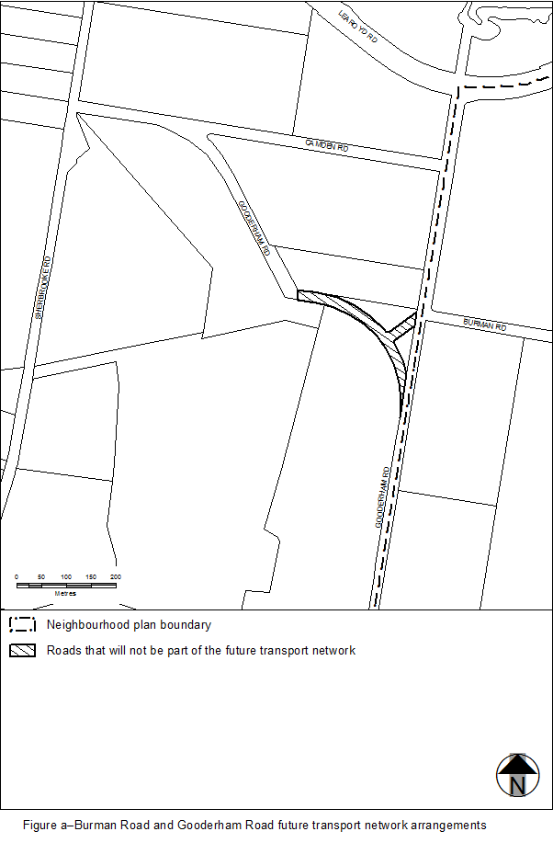
View the high resolution of Figure a–Burman Road and Gooderham Road future transport network arrangements (PDF file size is 84Kb)
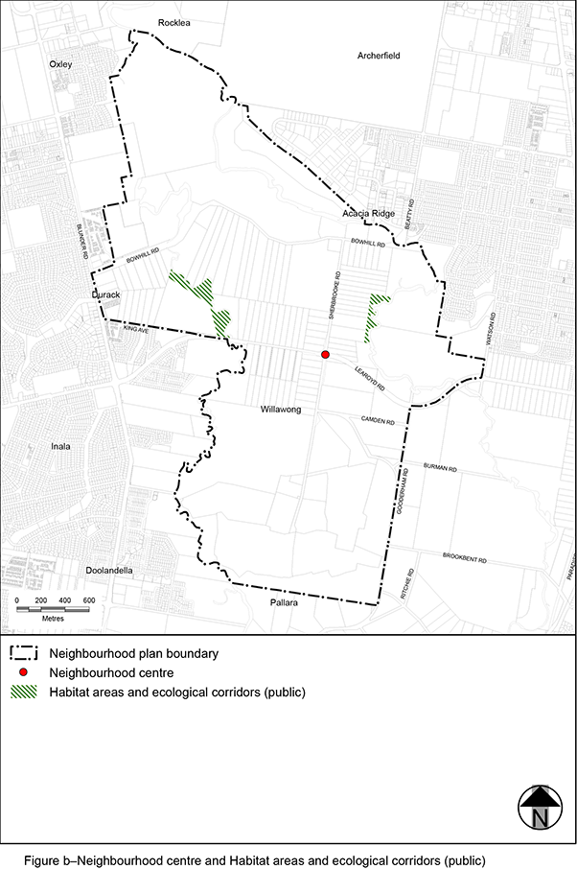
View the high resolution of Figure b–Neighbourhood centre and Habitat areas and ecological corridors (public) (PDF file size is 405Kb)

