7.2.12.4 Lutwyche Road corridor neighbourhood plan code

7.2.12.4.1 Application
- This code applies to assessing a material change of use, reconfiguring a lot, operational work or building work in the Lutwyche Road corridor neighbourhood plan area if:
- assessable development where this code is an applicable code identified in the assessment benchmarks column of a table of assessment for a neighbourhood plan (section 5.9); or
- impact assessable development.
- Land in the Lutwyche Road corridor neighbourhood plan area is identified on the NPM-012.4 Lutwyche Road corridor neighbourhood plan map and includes the following precincts:
- Lutwyche centre precinct (Lutwyche Road corridor neighbourhood plan/NPP-001);
- Lutwyche centre mixed use corridor sub-precinct (Lutwyche Road corridor neighbourhood plan/NPP-001a);
- Lutwyche centre residential corridor sub-precinct (Lutwyche Road corridor neighbourhood plan/NPP-001b).
- Windsor east precinct (Lutwyche Road corridor neighbourhood plan/NPP-002);
- Windsor east mixed use corridor sub-precinct (Lutwyche Road corridor neighbourhood plan/NPP-002a);
- Windsor east residential corridor sub-precinct (Lutwyche Road corridor neighbourhood plan/NPP-002b).
- Stafford depot precinct (Lutwyche Road corridor neighbourhood plan/NPP-003);
- Albion and Wooloowin railway stations precinct (Lutwyche Road corridor neighbourhood plan/NPP-004);
- Sisters of Mercy precinct (Lutwyche Road corridor neighbourhood plan/NPP-005);
- Industrial precinct (Lutwyche Road corridor neighbourhood plan/NPP-006).
- When using this code, reference should be made to section 1.5, section 5.3.2 and section 5.3.3.
Note—The following purpose, overall outcomes, performance outcomes and acceptable outcomes comprise the assessment benchmarks of this code.
Note—This neighbourhood plan includes a table of assessment with variations to categories of development and assessment. Refer to Table 5.9.39.A, Table 5.9.39.B, Table 5.9.39.C and Table 5.9.39.D.

7.2.12.4.2 Purpose
- The purpose of the Lutwyche Road corridor neighbourhood plan code is to provide finer grained planning at a local level for the Lutwyche Road Corridor neighbourhood plan area.
- The purpose of the Lutwyche Road corridor neighbourhood plan code will be achieved through overall outcomes including overall outcomes for each precinct of the neighbourhood plan area.
- The overall outcomes for the Lutwyche Road corridor neighbourhood plan area are:
- Intensive redevelopment is focused in the Lutwyche centre precinct and Windsor east precinct to reflect their role as established activity centres and their high level of accessibility to high-quality public transport nodes.
- Less-intensive redevelopment occurs in other locations along Lutwyche Road that are well-serviced by public transport as shown on the NPM-012.4 Lutwyche Road corridor neighbourhood plan map.
- In the balance of the neighbourhood plan area, established residential areas such as Gordon Park, Kedron and Wooloowin are primarily for low density residential uses with character housing retained.
- Intensive mixed use and residential development is focused on and takes advantage of high-quality public transport facilities that serve the Lutwyche Road Corridor neighbourhood plan area, with a concentration of employment opportunities and medium to high density residential areas within easy walking distance of public transport nodes.
- New development exhibits high-quality built form and landscaping that enhances the image of the Lutwyche Road corridor neighbourhood plan area and achieves a strong subtropical character.
- Pedestrian-focused laneways within the Lutwyche centre precincts provide a high-amenity corridor for commercial and community activities and enhance connectivity within the Lutwyche centre precincts.
- Lutwyche Road is a vibrant and attractive, tree-lined subtropical boulevard, with streetscape enhancements that encourage walking and cycling to major destinations within the Lutwyche Road corridor neighbourhood plan area and improve permeability.
- Conon and its gardens (Lot 2 on RP86282) are listed on the Queensland Heritage Register and consequently, Conon is protected and any adjoining development respects the heritage context of Conon, including its gardens.
- New public domain areas, community facilities, parks and improvements to existing parks, support the renewal of urban nodes and meet the needs of existing and future residents.
- Development is of a height, scale and form which is consistent with the amenity and character, community expectations and infrastructure assumptions intended for the relevant precinct, sub-precinct or site and is only developed at a greater height, scale and form where there is both a community need and an economic need for the development.
- Lutwyche centre precinct (Lutwyche Road corridor neighbourhood plan/NPP-001) overall outcomes are:
- Development occurs in accordance with Figure a.
- The precinct is revitalised and expanded to allow additional office activity, commercial activity, shops, restaurants and multiple dwellings, functioning as an integrated centre.
- The centre includes a district community space that is integrated with the adjoining busway station and Kedron Brook parklands. A signature mixed use building that reflects contemporary architectural and sustainability best practice is supported in this location to create a visual and functional landmark.
- Development adjoining the busway station incorporates active ground storey frontages.
- Development activates the ground level where it adjoins Lutwyche Road and laneways.
- Laneways focus pedestrian and cyclist movement and provide an intimate, high-quality open space corridor and a distinct opportunity for the location of active commercial uses that require a high level of amenity, such as cafes and restaurants.
- Any redevelopment of the Fancutt Tennis Centre enhances pedestrian connectivity between Laura, East and Conon streets.
- New development in the Lutwyche centre precinct (Lutwyche Road Corridor neighbourhood plan/NPP-001) takes into consideration constraints posed by proposed transport infrastructure.
- Lutwyche centre mixed use corridor sub-precinct (Lutwyche Road corridor neighbourhood plan/NPP-001a) has a mix of uses that provides the appeal and level of activity essential to create a vibrant place with the attributes to attract business and residents. Development in this sub-precinct:
- will achieve a mix of land uses and provide opportunities for employment, shopping and commercial activity, inner-city living, community facilities, entertainment, leisure and supporting services;
- ensures a refocusing from the current strip mall, big box type activities along Lutwyche Road towards a more human-scale retail, leisure and entertainment and community arrangement, large-scale retail uses are to be limited to ‘retail hubs’ identified in Figure a, which are sited to the north and south of the busway station and provide an anchor to a revitalised Lutwyche centre precinct (Lutwyche Road Corridor neighbourhood plan/NPP-001);
- amalgamates sites to achieve high density residential development with a mix of commercial, retail and restaurant uses;
- ensures that ground-storey areas of buildings have an active frontage to Lutwyche Road and laneways that encourage pedestrian activity through the location of intensive and interactive uses such as shops, showrooms, cafes, restaurants and extended hours services including medical centres and fitness facilities along the frontage;
- ensures that buildings are designed to create a human scale with a seamless transition between indoor and outdoor spaces;
- has a mix of office and residential uses on upper storeys;
- focuses business and commercial activities on Lutwyche Road and laneways;
- recognises the high level of accessibility, and locates mix of business uses on the lower floors, with the balance of the building used for residential uses;
- supports the renewal of properties by forming a high-quality subtropical boulevard along Lutwyche Road with distinctive finishes, street furniture and landscape elements including large shade trees;
- designs and sites residential uses to minimise air and noise impacts but is not expected to enjoy the peace and quiet or privacy of suburban living as this sub-precinct is located close to major transport infrastructure and contains centre activities with a high level of activity both day and night.
- Development in the Lutwyche centre residential corridor sub-precinct (Lutwyche Road corridor neighbourhood plan/NPP-001b):
- accommodates high density residential uses that take advantage of the superior accessibility to public transport and the high level of amenity afforded in this area;
- ensures that buildings are designed to have a strong interface with the street and clearly defined and identifiable entrances;
- encourages the redevelopment of properties in the sub-precinct and pedestrian and cyclist activity, streetscape enhancements including wider footpaths, improved paving surfaces, the extensive use of shade trees and a coordinated palette of street furniture are implemented;
- designs and sites residential uses to minimise air and noise impacts but is not expected to enjoy the peace and quiet or privacy of suburban living as this sub-precinct is located close to major transport infrastructure and centre activities with a high level of activity both day and night.
- Windsor east precinct (Lutwyche Road corridor neighbourhood plan/NPP-002) overall outcomes are:
- Development occurs in accordance with Figure b.
- The precinct is revitalised to capitalise on its proximity to the Federation Street busway station.
- Development will incorporate a mix of high density residential, commercial and office uses.
- An urban plaza and community facility are located close to the Federation Street busway station at the corner of Federation Street and Morris Street, as shown in Figure b and the urban plaza is integrated with the surrounding uses and with the community facility.
- A signature mixed use building that reflects contemporary architectural and sustainability best practice creates a visual and functional landmark in close proximity to the Federation Street busway station.
- Sites fronting Lutwyche Road in the southern part of the precinct, marked as 'Commercial hub' in Figure b, support activities such as medical research and development industries in conjunction with the Royal Brisbane Hospital.
- A public and active transport connection between the Windsor east precinct and the future redevelopment of the Mayne rail yards ensures provision for an appropriate level of connectivity between these 2 key redevelopment areas.
- New development in the precinct takes into consideration constraints posed by proposed transport infrastructure.
- Development in the Windsor east mixed use corridor sub-precinct (Lutwyche Road corridor neighbourhood plan/NPP-002a):
- achieves a mix of land uses and provides opportunities for employment, shopping and commercial activity, inner-city living, community facilities, entertainment, leisure and supporting services;
- ensures that the mix of uses in the sub-precinct provides the appeal and level of activity essential to create a vibrant place with the attributes to attract business and residents;
- ensures a refocusing from the current strip mall, big box type activities along Lutwyche Road towards a more human-scale retail, leisure, entertainment and community arrangement, large-scale retail uses are to be limited to ‘retail hubs’ identified in Figure b which are sited to the north and south of the busway station and provide an anchor to a revitalised Lutwyche centre precinct (Lutwyche Road Corridor neighbourhood plan/NPP-001);
- amalgamates sites to achieve high density residential development with a mix of commercial, retail and restaurant uses;
- ensures that ground-storey areas of buildings have an active frontage to Lutwyche Road and laneways that encourage pedestrian activity through the location of intensive and interactive uses such as shops, showrooms, food and drink outlets and extended hours services including health care service and fitness facilities along the frontage;
- ensures that the design of buildings creates a human scale with a seamless transition between indoor and outdoor spaces;
- ensures a mix of office and residential uses on upper storeys;
- focuses business and commercial activities on Lutwyche Road and laneways;
- in recognition of the high level of accessibility of the sub-precinct, locates a mix of business uses on the lower floors, with the balance of the building being for residential uses;
- supports the renewal of properties in this sub-precinct by forming a high-quality subtropical boulevard along Lutwyche Road with distinctive finishes, street furniture and landscape elements including large shade trees.
- Development in the Windsor east residential corridor sub-precinct (Lutwyche Road corridor neighbourhood plan/NPP-002b):
- accommodates high density residential uses that take advantage of the superior accessibility to public transport and the high level of amenity afforded in this area;
- designs buildings to have a strong interface with the street and clearly defined and identifiable entrances;
- implements streetscape enhancements including wider footpaths, improved paving surfaces, the extensive use of shade trees and a coordinated palette of street furniture to encourage the redevelopment of properties in the precinct and pedestrian and cyclist activity;
- designs and sites residential uses to minimise air and noise impacts but are not expected to enjoy the peace and quiet or privacy of suburban living as this sub-precinct is located close to major transport infrastructure and centre activities with a high level of activity both day and night.
- Stafford depot precinct (Lutwyche Road corridor neighbourhood plan/NPP-003) overall outcomes are:
- Should the depot facilities at the Brisbane City Council Stafford depot between Lennon Street and Bradley Street relocate, higher density residential development is considered appropriate, with strong pedestrian links provided to nearby retail and commercial activities and public transport.
- Redevelopment in this precinct includes a portion of public open space, has regard for views from surrounding properties to the City Centre, achieves a high level of urban and pedestrian amenity and provides for a new vehicle connection to Broughton Road or Wayland Street from the precinct and incorporates a high level of community input.
Note—A structure plan prepared in accordance with the Structure planning planning scheme policy can assist in demonstrating achieving this outcome and is a useful tool to integrate subdivision layout with all relevant spatial attributes as addressed in overlays and neighbourhood plans.
- Albion and Wooloowin railway stations precinct (Lutwyche Road corridor neighbourhood plan/NPP-004) overall outcomes are:
- State-owned land that is not required for transport purposes is considered suitable for medium density residential development due to its proximity to the railway stations.
- Where adjoining established low density residential areas, new development complements the bulk and scale of those areas.
- Sisters of Mercy precinct (Lutwyche Road corridor neighbourhood plan/NPP-005) overall outcomes are:
- Medium density residential development may be appropriate on this site subject to the following:
- provision of public parkland with a minimum area of 4,000m² to be located along the Chalk Street frontage;
- continuation of community services;
- managing impacts on the amenity of surrounding residents.
- Industrial precinct (Lutwyche Road Corridor neighbourhood plan/NPP-006) overall outcomes are:
- Low impact industry uses are supported in this precinct to service the needs of business and the residential population.
- This precinct accommodates existing concrete batching plants that take advantage of proximity to development sites in the City Centre and growth corridors. Their ongoing operation and the establishment of new plants in this location is supported.

7.2.12.4.3 Performance outcomes and acceptable outcomes

Table 7.2.12.4.3.A—Performance outcomes and acceptable outcomes
Performance outcomes | Acceptable outcomes
General
PO1  Development is of a height, scale and form that achieves the intended outcome for the precinct, improves the amenity of the neighbourhood plan area, contributes to a cohesive streetscape and built form character and is:  - consistent with the anticipated density and assumed infrastructure demand;  - aligned with community expectations about the number of storeys to be built;  - proportionate to and commensurate with the utility of the site area and frontage width;  - designed to avoid a significant and undue adverse amenity impact to adjoining development;  - sited to enable existing and future buildings to be well separated from each other and avoid affecting the potential development of an adjoining site.  Note—Development that exceeds the intended number of storeys or building height can place disproportionate pressure on the transport network, public space or community facilities in particular.  Note—Development that is over-scaled for its site can result in an undesirable dominance of vehicle access, parking and manoeuvring areas that significantly reduce streetscape character and amenity. | AO1  Development complies with the number of storeys and building heights in Table 7.2.12.4.3.B.  Note—Neighbourhood plans will mostly specify a maximum number of storeys where zone outcomes have been varied in relation to building height. Some neighbourhood plans may also specify height in metres. Development must comply with both parameters where maximum number of storeys and height in metres are specified.
Heritage
PO2  Development on or adjoining Conon (Lot 2 on RP86282) is of a suitable height and scale and is set back from common boundaries to ensure that new development does not overshadow Conon and its gardens.  Note—To demonstrate compliance with the performance outcome, a Heritage impact assessment report is to be submitted demonstrating to Council’s satisfaction that the proposed development will not detract from or diminish the cultural heritage significance of the heritage place. | AO2  No acceptable outcome is prescribed.
Infrastructure improvements
PO3  Development provides public realm treatments as indicated in Figure c. | AO3  Development provides public realm treatments consistent with Figure c and in compliance with the Infrastructure design planning scheme policy.
If in the Lutwyche centre precinct (Lutwyche Road corridor neighbourhood plan/NPP-001) or Windsor east precinct (Lutwyche Road corridor neighbourhood plan/NPP-002)
Building siting and design
PO4  Development is of a height and scale that contributes to the creation of a vibrant and active urban place, is congruent with the expectations of the community and is appropriate to the role of the Lutwyche Road corridor. | AO4.1  Development has a maximum gross floor area in accordance with Table 7.2.12.4.3.C.
AO4.2
Development has a maximum building height in accordance with Table 7.2.12.4.3.B.
PO5  Development protects the amenity of adjoining areas outside of the growth precincts by stepping down in height and scale to provide an appropriate interface. | AO5.1  Development on a site adjoining land in the Low density residential zone does not have a structure exceeding 25m in length within 20m of the boundary to the Low density residential zone, in accordance with Figure d.
AO5.2
Development that includes a property in the Lutwyche centre precinct (Lutwyche Road Corridor neighbourhood plan/NPP-001) adjoining land in the Low density residential zone or the Character residential zone between Felix Street and Norman Street has:
- a building setback that is a minimum of 5m from land in the Low density residential zone;
- a continuous landscape buffer within the setback with a minimum dimension of 1.5m along the full length of the property boundary with land in the Low density residential zone;
- a publicly accessible pedestrian and cyclist pathway connecting Felix Street, Isedale Street and Norman Street;
- a setback that is designed and constructed in accordance with crime prevention through environmental design principles and includes lighting that does not create a nuisance to adjoining residential uses.
Note—For guidance on assessing the incorporation of crime prevention through environmental design principles refer to the Crime prevention through environmental design planning scheme policy.
PO6  Development promotes activation of laneways through building design and site layout, as demonstrated in Figure k and Figure l. | AO6.1  Development for ground storey residential uses or centre activities is located directly adjoining laneways.
AO6.2
Development ensures if a building faces a laneway, awnings are provided in accordance with the Infrastructure design planning scheme policy.
AO6.3
Development includes balconies that overlook laneways.
AO6.4
Development ensures buildings are built to the boundary of the laneway for a minimum of 75% of the boundary.
AO6.5
Development provides a maximum building setback other than to deep-planting areas of 3m.
Parking, access and servicing
PO7  Development adjoining a site less than 1,000m² provides for access and servicing to the adjoining site if the site is capable of being redeveloped in the future. | AO7  Development on a site that adjoins lots located in the Lutwyche centre mixed use corridor sub–precinct (Lutwyche Road corridor neighbourhood plan/NPP-001a) or the Windsor east mixed use corridor sub-precinct (Lutwyche Road corridor neighbourhood plan/NPP-002a), and those adjoining lots have not been redeveloped:  - has vehicular access provided from the main vehicular entry of the site to the adjoining site;  - provides for manoeuvring and access for service vehicles to the adjoining site.
PO8  Development ensures:  - parking and vehicular entries do not dominate the streetscape or laneway;  - vehicular entry points are kept to a minimum and ensure pedestrian safety. | AO8.1  Development provides a maximum of 2 vehicle access points on each side of a laneway section.  Note—A laneway section is the part of the laneway located between existing streets, such as between Lowerson Street and East Street.
AO8.2
Development ensures car parking areas are concealed within or behind buildings or basements.
AO8.3
Development ensures car parking areas located within a podium are located behind active uses and are not discernible from street frontages.
PO9  Development allows for the provision of a new road connecting Cartwright and Gallway streets to improve visual and physical access to Flynn Oval and improve vehicular, pedestrian and cycling connectivity in the Windsor east precinct (Lutwyche Road corridor neighbourhood plan/NPP-002). | AO9  Development makes provision for new roads in accordance with Figure e and Table 7.2.12.4.3.D.
PO10  Development improves pedestrian and cycle connectivity between Laura Street, East Street and Conon Street. | AO10  Development provides safe, publicly accessible pedestrian and cycle pathways to connect Laura Street, East Street and Conon Street.
Landscape and amenity elements
PO11  Development:  - ensures a plaza of useable area and dimensions in the Windsor east precinct (Lutwyche Road Corridor neighbourhood plan/NPP-002) is provided in accordance with Figure b;  - through the design and siting of the plaza, promotes pedestrian and cycle movement through the public space and options for the flexible use of the space. | AO11  Development makes provision for a public plaza as indicated in Figure b that is:  - a minimum of 1,000m2;  - a minimum dimension of 10m;  - a maximum 50% hard paved;  - located at the level of surrounding roads  - suitable for pedestrian and cyclist access
Community facilities
PO12  Development ensures a district community centre is provided adjoining the Lutwyche busway station, with a layout that is adaptable and flexible allowing for a range of activities to cater for the needs of the community now and in the future. | AO12  Development provides:  - a minimum 1,000m2 as a district community use (centre) at Lots 0, 1 on GTP102414 and Lots 5, 6, 7, 8, 9 on GTP105634, and as shown in Figure c;  - for the layout of the centre to include meeting rooms and large rooms that cater for a range of activities including community hall, a neighbourhood activity centre and community hub.
PO13  Development provides a local community space in close proximity to the Federation Street busway station. | AO13  Development provides a minimum 250m2 in the location shown in Figure c for use as a local community use (space).
If in the Lutwyche centre precinct (Lutwyche Road corridor neighbourhood plan/NPP-001), where in the Lutwyche centre mixed use corridor sub-precinct (Lutwyche Road corridor neighbourhood plan/NPP-001a), or if in the Windsor east precinct (Lutwyche Road corridor neighbourhood plan/NPP-002), where in the Windsor east mixed use corridor precinct (Lutwyche Road corridor neighbourhood plan/NPP-002a)
Active uses
PO14  Development provides for a mix of business  and residential uses whereby:  - business uses maximise the level of activity both day and night along the streets;  - residential dwellings are provided in areas with a high level of amenity to accommodate South East Queensland’s growing population. | AO14.1  Development other than on sites marked ‘Commercial hub’ in Figure b:  - provides a maximum of 80% of the gross floor area of the development for residential uses;  - provides a maximum of 40% of the gross floor area of the development for non-residential centre activities.
AO14.2
Development sites shown as ‘Commercial hub’ in Figure b may use up to 90% of the gross floor area of the development for non-residential centre activities.
AO14.3
Development does not include residential dwellings on sites indicated in Figure b as ‘Non-residential uses only’.
AO14.4
Development ensures non-residential uses are located on the ground and lower floors of a building.
PO15  Development ensures a frontage to a street, laneway or public space including a busway station encourages pedestrian activity through the provision of intensive or interactive uses along the frontage and building design features that create a human scale and blur the distinction between indoor and outdoor spaces. | AO15.1  Development of the ground storey facing a street, laneway or public space is occupied by non-residential centre activities with a high level of pedestrian activity including but not limited to shops, showrooms, food and drink outlet, and extended hours uses such as health care service and indoor sport and recreation being a gymnasium.
AO15.2
Development has a ground storey facade located on the street front property boundary for a minimum of 75% of the length of that boundary.
AO15.3
Development ensures transparent materials comprise a minimum of 50% of the external wall materials up to a height of 2.5m above footpath level.
AO15.4
Development provides at least 1 pedestrian entrance for every 15m of building frontage.
AO15.5
Development ensures the ground storey has a minimum floor to ceiling height of 4m.
Note—Where development is located in a street that is subject to a road widening requirement, the alignment of the proposed widening is regarded as the street-front property boundary.
PO16  Development in the Lutwyche centre precinct (Lutwyche Road Corridor neighbourhood plan/NPP-001) provides for a series of laneways that create an attractive, safe and convenient pedestrian environment away from Lutwyche Road in accordance with Figure a. | AO16.1  Development dedicates a 10m width of land to the Council for laneways in accordance with Figure a.  Note—Development will be required to dedicate land for laneways. The laneway segment between Lowerson Street and High Street will be provided in accordance with the alignment shown in Figure a. The alignment of other laneways is to be generally in accordance with Figure a.
AO16.2
Development ensures servicing, vehicle manoeuvring and refuse bin storage and collection areas are not located adjacent to laneways.
AO16.3
Development provides laneways that are finished in accordance with the Infrastructure design planning scheme policy.
AO16.4
Development does not provide car parking areas adjoining laneways.
PO17  Development that occurs on the Centro site located on the corner of Chalk Street and Lutwyche Road (Lot 1, 302 on SP242892 and Lot 5 on RP842880) provides a publicly accessible pedestrian and cycle link with a 5m width through the site in accordance with Figure a connecting the end of the proposed laneway on Lowerson Street through to Chalk Street. | AO17  No acceptable outcome is prescribed.
Building siting and design
PO18  Development:  - avoids the creation of a canyon of buildings along streets, through variation in building form, height and materials, articulation of facades and the provision of space for deep planting of trees in the front setback;  - ensures siting and design of buildings encourages air flow around buildings;  - ensures the design of buildings above podium allows sufficient space between buildings for breezes and views through the site. | AO18.1  Development ensures podium heights are a minimum of 2 storeys as shown in Figure g.
AO18.2
Development ensures podiums fronting Lutwyche Road are built to the side boundary for a minimum distance of 10m from the front property boundary, except if:
- there is a requirement for the provision of an overland flow path;
- the development is on a property adjoining land outside the Lutwyche centre mixed use corridor sub-precinct (Lutwyche Road corridor neighbourhood plan/NPP-001a) in which case no part of the development is less than 2m from the boundary with the adjoining land.
AO18.3
Development ensures podiums include a front boundary setback of a minimum of 5m x 5m for every 20m of street frontage to allow deep planting large shade trees.
AO18.4
Development ensures:
- where buildings are above podium height, buildings are set back from the front property boundary by an average of 4m and no less than 2m including balconies;
- if located on a corner site on Lutwyche Road:
- all buildings are built to the street;
- all buildings have a boundary above podium level for a distance of up to 15m from the corner in accordance with Figure h.
AO18.5
Development ensures buildings above podium height, including balconies, extend for no more than 75% of the width of the property and are a maximum of 30m in any direction with a minimum setback from a side boundary of 2m in accordance with Figure g.
AO18.6
Development ensures the facade of the podium is occupied by uses such as commercial or residential units with balconies and openings to the street.
AO18.7
Development ensures that where there is more than 1 tower above the podium, the towers are separated by at least 12m.
PO19  Development maintains adequate levels of natural ventilation and light penetration to neighbouring habitable rooms, balconies and private open space. | AO19  Development (including a balcony or car parking structure) is not located within 4m of the rear property boundary.
PO20  Development fronting Victoria Street:  - complements the existing low density residential environment on the western side of Victoria Street;  - ensures the lower levels of a building are occupied by residential units overlooking the street in accordance with Figure i;  - provides vehicle access to buildings which is visually unobtrusive;  - provides necessary flood immunity for basement parking achieved in a way that is visually in accordance with Figure j. | AO20  Development fronting Victoria Street:  - complies with the number of storeys in Table 7.2.12.4.3.B;  - is in accordance with Figure j.
PO21  Development fronting Rosemount Terrace:  - complements the existing low to medium density residential environment on the western side of Rosemount Terrace;  - provides an articulated facade or a substantial landscape buffer that addresses Rosemount Terrace;  - provides vehicle access to buildings which is visually unobtrusive. | AO21  Development fronting Rosemount Terrace complies with the number of storeys in Table 7.2.12.4.3.B.
Landscape and amenity elements
PO22  Development ensures recreation areas are provided with shade and are directly accessible from building tenancies or the street frontage. | AO22  No acceptable outcome is prescribed.
If in the Sisters of Mercy precinct (Lutwyche Road corridor neighbourhood plan NPP-005)
Building siting and design
PO23  Development:  - provides a transition in building form and scale to the adjacent low density residential environment;  - does not significantly reduce daylight to open space and habitable rooms in adjacent development. | AO23.1  Development provides a front boundary setback that is a minimum of 3m.
AO23.2
Development adjoining land outside the Sisters of Mercy precinct (Lutwyche Road Corridor neighbourhood plan/NPP-005) ensures the side boundary setback from adjoining sites is a minimum of 6m.
PO24  Development provides adequate parkland for local open space and recreation. | AO24.1  Development provides parkland which is a minimum of 4,000m2 and has a minimum width of 50m.
AO24.2
Development locates the parkland on Chalk Street to allow high visibility from the street and passive surveillance.
PO25  Development ensures design and orientation of buildings adjacent to the park provides an appropriate interface to the parkland. | AO25.1  Development is set back a minimum of 6m from the parkland.
AO25.2
Development, where fencing is proposed between the development and parkland, has fencing a maximum of 1.2m in height or 1.5m in height where it has 50% transparency.
PO26  Development provides vehicular access only from main roads. | AO26  Development provides vehicular access to the site from Chalk Street or Bridge Street or both as appropriate.
PO27  Development provides consistent pedestrian/cycle connections through the site to the parkland from surrounding areas. | AO27  No acceptable outcome is prescribed.

Table 7.2.12.4.3.B—Maximum building height
Development | Building height (number of storeys) | Building height (m)
If in the Lutwyche centre precinct (Lutwyche Road Corridor neighbourhood plan/NPP-001), where in the Lutwyche centre mixed use corridor sub-precinct (Lutwyche Road corridor neighbourhood plan/NPP-001a), or if in the Windsor east precinct (Lutwyche Road Corridor neighbourhood plan/NPP-002) where in the Windsor east mixed use corridor sub-precinct (Lutwyche Road corridor neighbourhood plan/NPP-002a)
Development on a site with a frontage to Victoria Street or Rosemount Terrace | 3 | Not specified
Where not fronting either Victoria Street or Rosemount Terrace
Development on a site less than 2,000m² | 5 | Not specified
Development on a site of 2,000m² or greater but less than 3,000m² | 6 | Not specified
Development on a site of 3,000m² or greater but less than 6,000m² | 9 | Not specified
Development on a site of 6,000m² or greater | 12 | Not specified
If in the Lutwyche centre precinct (Lutwyche Road corridor neighbourhood plan/NPP-001), where in the Lutwyche centre residential corridor sub-precinct (Lutwyche Road corridor neighbourhood plan/NPP-001b), or if in the Windsor east precinct (Lutwyche Road corridor neighbourhood plan/NPP-002), where in the Windsor east residential corridor sub-precinct (Lutwyche Road corridor neighbourhood plan/NPP-002b)
Development on a site of less than 2,000m² | 5 | Not specified
Development on a site of 2,000m² or greater but less than 3,500m² | 6 | Not specified
Development on a site of 3,500m² or greater but less than 6,000m² | 8 | Not specified
Development on a site of 6,000m² or greater | 8 | Not specified
If in the Sisters of Mercy precinct (Lutwyche Road corridor neighbourhood plan/NPP-005)
Development adjoining land outside the precinct | 3 | Not specified
All other development | 8 | Not specified
Note—On a site located around or above sub-surface transport infrastructure, building height may be further limited by engineering constraints.
Note—For buildings in the a Mixed use corridor sub-precinct fronting Rosemount Street, the number of storeys stated is the number of storeys above street level.

Table 7.2.12.4.3.C—Maximum gross floor area
Development | Maximum gross floor area
If in the Lutwyche centre precinct (Lutwyche Road corridor neighbourhood plan/NPP-001), where in the Lutwyche centre mixed use corridor sub-precinct (Lutwyche Road corridor neighbourhood plan/NPP-001a), or if in the Windsor east precinct (Lutwyche Road corridor neighbourhood plan/NPP-002), where in the Windsor east mixed use corridor sub-precinct (Lutwyche Road corridor neighbourhood plan/NPP-002a)
Development on a site less than 800m2 | 100% of site area
Development on a site of 800m2 to 1,999m2 | 175% of site area
Development on a site of 2,000m2 to 2,999m2 | 250% of site area
Development on a site of 3,000m2 to 5,999m2 | 325% of site area
Development on a site of 6,000m2 or greater | 400% of site area
If in the Lutwyche centre precinct (Lutwyche Road corridor neighbourhood plan/NPP-001, where in the Lutwyche centre residential corridor sub-precinct (Lutwyche Road corridor neighbourhood plan/NPP-001b), or if in the Windsor east precinct (Lutwyche Road corridor neighbourhood plan/NPP-002), where in the Windsor east residential corridor sub-precinct (Lutwyche Road corridor neighbourhood plan/NPP-002b)
Development on a site less than 800m2 | 75% of site area
Development on a site of 800m2 to 1,999m2 | 150% of site area
Development on a site of 2,000m2 to 3,499m2 | 200% of site area
Development on a site of 3,500m2 to 5,999m2 | 250% of site area
Development on a site of 6,000m2 or greater | 300% of site area

Table 7.2.12.4.3.D—Road widening
Road/Street | Street width to be achieved by widening (m)
Lutwyche Road | 36
Isedale Street | 20
Lowerson Street | 20
East Street | 20
High Street | 20
Algar Street | 20
Cartwright Street | 20
New road between Cartwright Street and Gallway Street | 20
Note—In the vicinity of a heritage place, street widths may vary to accord with the requirements applicable to the heritage place.
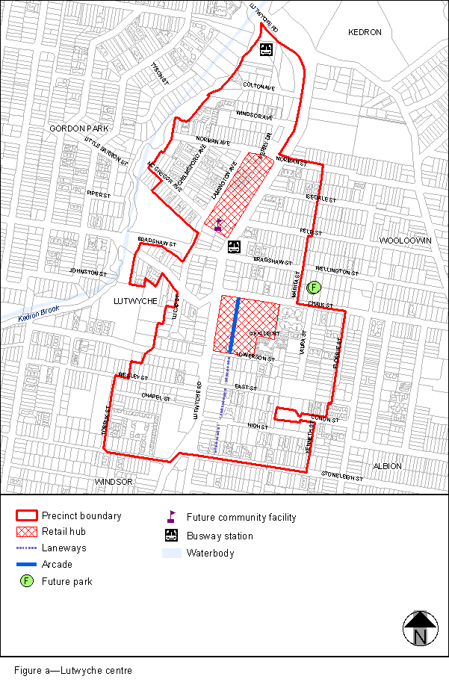
View the high resolution of Figure a–Lutwyche centre (PDF file size is 231Kb)
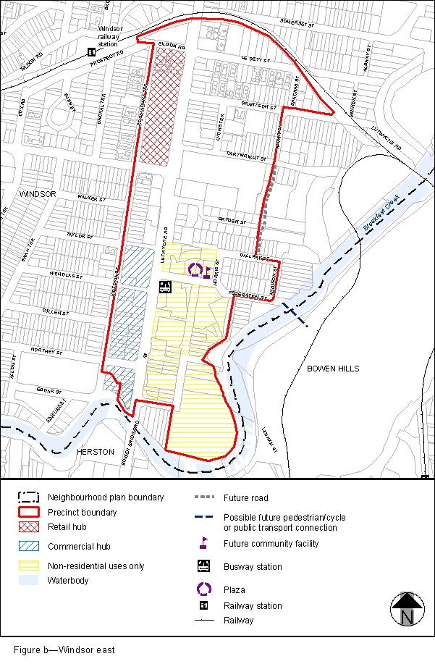
View the high resolution of Figure b–Windsor east (PDF file size is 159Kb)
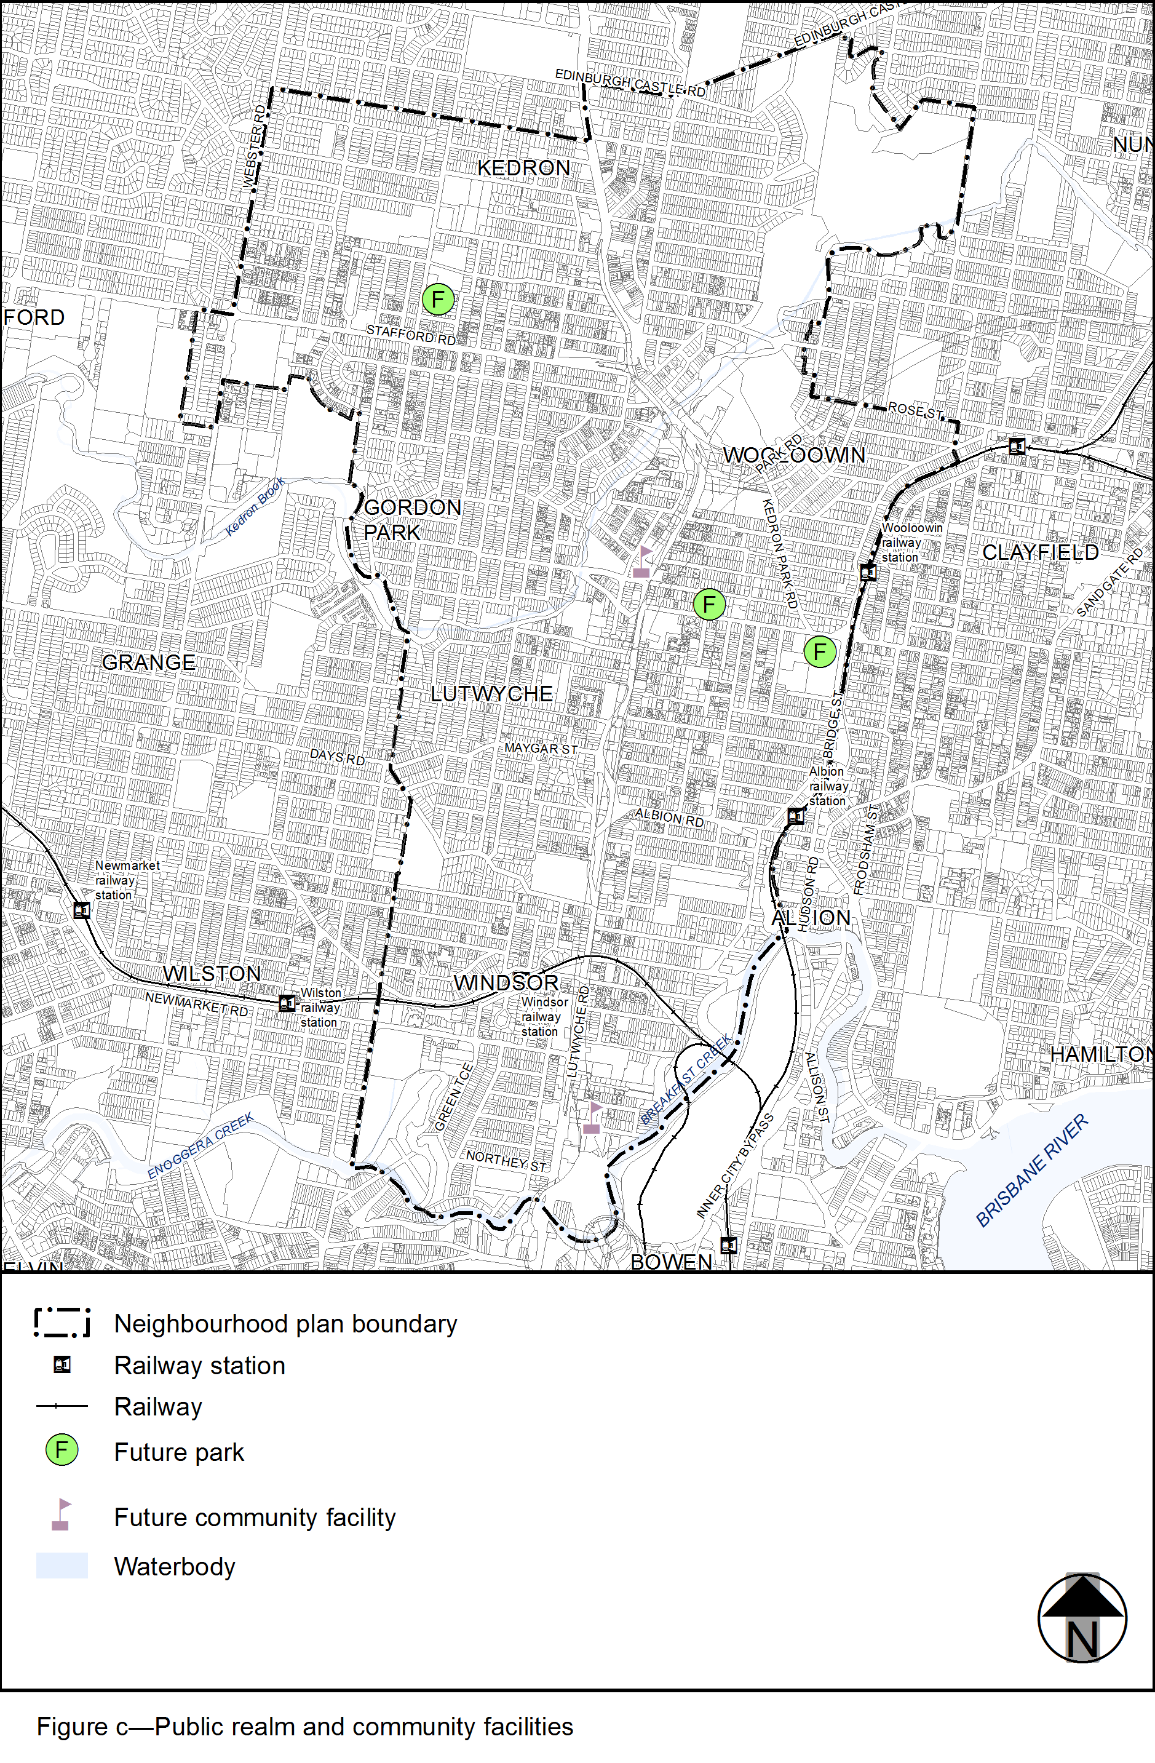
View the high resolution of Figure c–Public realm and community facilities (PDF file size is 536Kb)
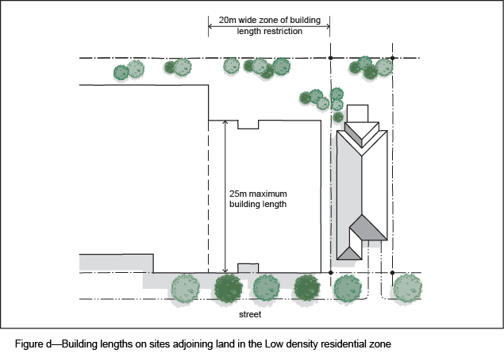
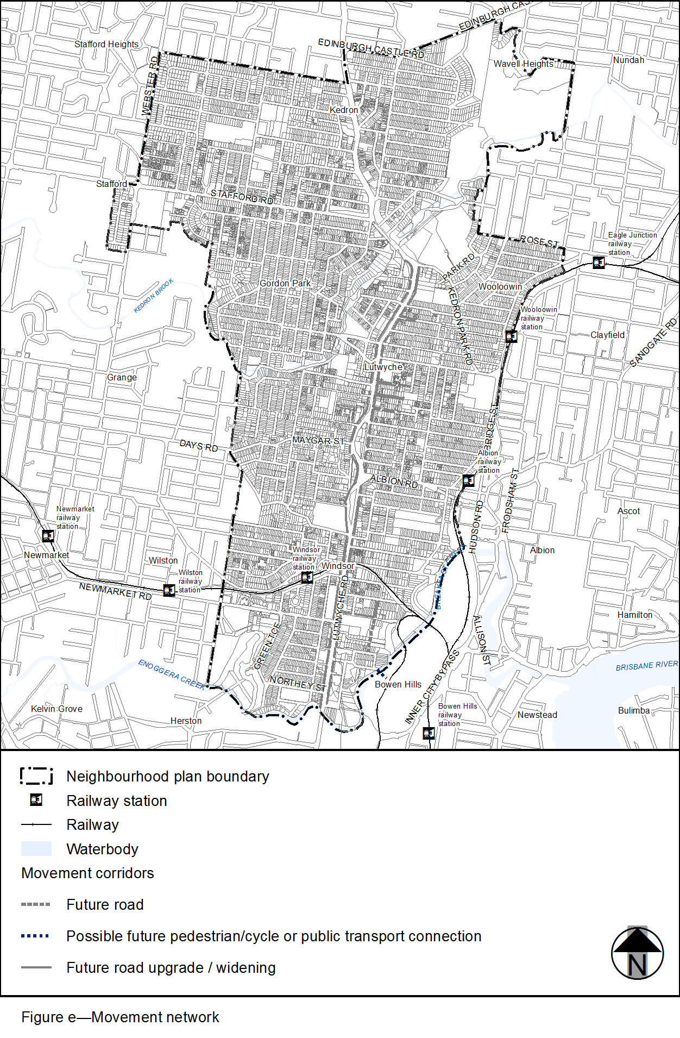
View the high resolution of Figure e–Movement network (PDF file size is 545Kb)
