7.2.19.2 Sandgate Road neighbourhood plan code

7.2.19.2.1 Application
- This code applies to assessing a material change of use, reconfiguring a lot, operational work or building work in the Sandgate Road neighbourhood plan area if:
- assessable development where this code is an applicable code identified in the assessment benchmarks column of a table of assessment for a neighbourhood plan (section 5.9); or
- impact assessable development.
- Land in the Sandgate Road neighbourhood plan area is identified on the NPM-019.2 Sandgate Road neighbourhood plan map.
- When using this code, reference should be made to section 1.5, section 5.3.2 and section 5.3.3.
Note—The following purpose, overall outcomes, performance outcomes and acceptable outcomes comprise the assessment benchmarks of this code.
Note—This neighbourhood plan includes a table of assessment. Refer to Table 5.9.61.A, Table 5.9.61.B, Table 5.9.61.C and Table 5.9.61.D.

7.2.19.2.2 Purpose
- The purpose of the Sandgate Road neighbourhood plan code is to provide finer grained planning at a local level for the Sandgate Road neighbourhood plan area.
- The purpose of the Sandgate Road neighbourhood plan code will be achieved through the following overall outcomes:
- Development does not exacerbate flooding or detrimentally impact on the environmental values of Zillman Waterholes, Downfall Creek and Nundah Creek.
- Open space, parks and recreational facilities meet the needs of the community and are located in accessible locations that are well connected within the neighbourhood plan area.
- Where on a site fronting Sandgate Road:
- showroom development requiring large floor space is accommodated;
- development does not involve the expansion of showroom activities into adjoining medium impact industry and low impact industry areas;
- no further business or centre activities (other than showrooms) are accommodated;
- no further industrial development is accommodated other than the ongoing use of existing industrial buildings for low impact industry.
- Development is of a height, scale and form which is consistent with the amenity and character, community expectations and infrastructure assumptions intended for the relevant precinct, sub-precinct or site and is only developed at a greater height, scale and form where there is both a community need and an economic need for the development.
- While making efficient use of land, development is consistent with community expectations and infrastructure assumptions.

7.2.19.2.3 Performance outcomes and acceptable outcomes

Table 7.2.19.2.3.A—Performance outcomes and acceptable outcomes
Performance outcomes |  | Acceptable outcomes
Building height
PO1  Development is of a height, scale and form that achieves the intended outcome for the precinct, improves the amenity of the neighbourhood plan area, contributes to a cohesive streetscape and built form character and is:  - consistent with anticipated density and assumed infrastructure demand;  - aligned to community expectations about the number of storeys to be built;  - proportionate to and commensurate with the utility of the site area and frontage width;  - designed to avoid significant and undue adverse amenity impact to adjoining development;  - sited to enable existing and future buildings to be well separated from each other and to avoid affecting the potential development of adjoining sites.  Note—Development that exceeds the intended number of storeys or building height can place disproportionate pressure on the transport network, public space or community facilities in particular.  Note—Development that is over-scaled for its site can result in an undesirable dominance of vehicle access, parking and manoeuvring areas that significantly reduce streetscape character and amenity. | AO1  Development complies with the building height in Table 7.2.19.2.3.B.  Note—Neighbourhood plans will mostly specify a maximum number of storeys where zone outcomes have been varied in relation to building height. Some neighbourhood plans may also specify the height in metres. Development must comply with both parameters where maximum number of storeys and the height in metres are specified.
If on a site fronting Sandgate Road
PO2  Development is of a scale and location that must be appropriate for the display and sale of bulky goods on an arterial road setting. |  | AO2.1  Development for a shop has a minimum tenancy size of 350m².
AO2.2
Development has a maximum site cover of 70%.
AO2.3
Development has a minimum building setback of 15m to the Sandgate Road frontage.
PO3  Development has building facades that avoid large blank walls, allow for signage and address Sandgate Road. |  | AO3.1  Development provides facade articulation that incorporates:  - freestanding wall panels;  - pedestrian awnings to the front and side elevations;  - articulated wall panels;  - textural and material variation.  Note—Refer to Figure a and Figure b
AO3.2
Development provides a building facade that allows for large-scale signage.
Note—Refer to Figure a and Figure b.
AO3.3
Development can incorporate a single-level showroom within the 15m front setback, provided that the showroom:
- is a maximum of 50m²;
- is physically interconnected to and part of a minimum tenancy;
- has external walls made of a minimum of 80% clear glass;
- allows for car access into adjoining sites.
Note—Refer to Figure a and Figure b.
AO3.4
Development of a building has wall and glass surfaces visible from Sandgate Road with a maximum of 20% reflectivity.
PO4  Development is located and designed to create an internal integrated vehicle circulation system between individual sites and minimise vehicle access points to Sandgate Road. |  | AO4.1  Development integrates vehicular parking and access between sites, as shown in Figure a and Figure b, through the creation of internal easements.  Note—Creation of easements will require an application for reconfiguring a lot.
AO4.2
Development locates car parks at the front of the site where they do not impede access to adjoining sites
PO5  Development has a well-connected street system that facilitates safe vehicular movement. |  | AO5.1  Development of a road connection between Lathe Street and Hadley Street is provided in accordance with Figure c.
AO5.2
Development of a service road running parallel to Sandgate Road between Radley Street and Telford Street is provided in accordance with Figure c.
PO6  Development provides landscaping and shade structures to contribute to the visual amenity of the area, provide solar shading to car parks, and is outside signage sightlines from Sandgate Road. |  | AO6.1  Development provides for a landscape strip with low-level dense planting along the Sandgate Road frontage with a minimum width of 3m.  Refer to Figure a and Figure b.
AO6.2
Development provides for groupings of large trees and spreading groundcovers in all landscaped areas outside of signage sightlines.
AO6.3
Development provides shade trees with a minimum of 1.5m clear trunk in car parking areas at a ratio of 1 tree for every 6 car-parking spaces and shade structures to shade at least 30% of the car parking spaces.
Refer to Figure a and Figure b.
AO6.4
Street trees are provided in accordance with Figure c.

Table 7.2.19.2.3.B—Maximum building height
Development | Building height (m)
Development on a site fronting Sandgate Road | 10

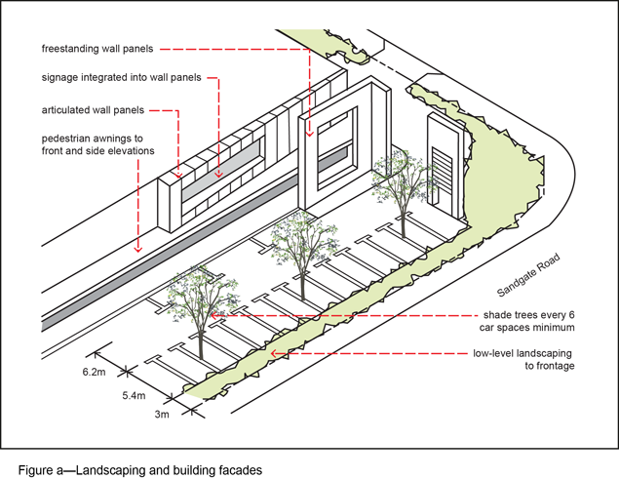
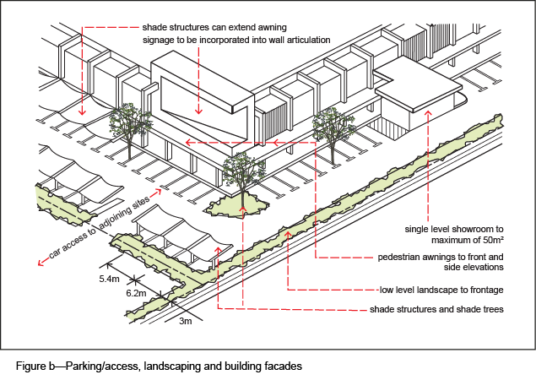
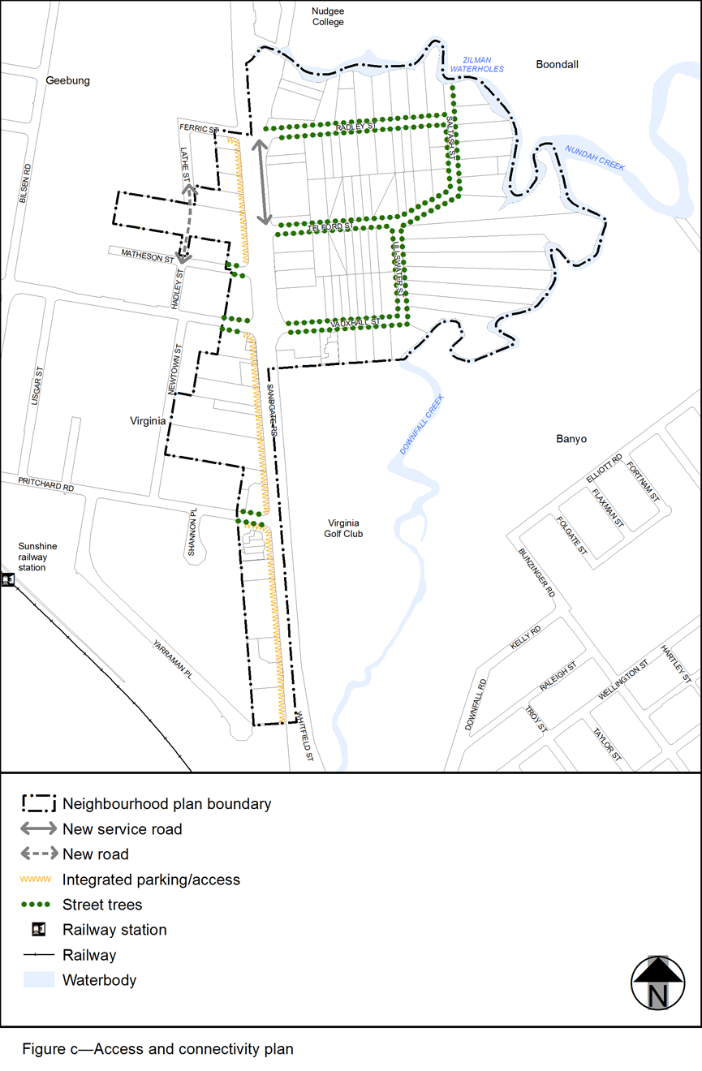
View the high resolution of Figure c–Access and connectivity plan (PDF file size is 141Kb)

