7.2.20.1 Taringa neighbourhood plan code

7.2.20.1.1 Application
- This code applies to assessing a material change of use, reconfiguring a lot, operational work or building work in the Taringa neighbourhood plan area if:
- assessable development where this code is an applicable code identified in the assessment benchmarks column of a table of assessment for a neighbourhood plan (section 5.9); or
- impact assessable development.
- Land in the Taringa neighbourhood plan area is identified on the NPM-020.1 Taringa neighbourhood plan map and includes the following precincts.
- Taringa core precinct (Taringa neighbourhood plan/NPP-001).
- Taringa gateway precinct (Taringa neighbourhood plan/NPP-002).
- Harrys Road east precinct (Taringa neighbourhood plan/NPP-003).
- When using this code, reference should be made to section 1.5, section 5.3.2 and section 5.3.3.
Note—The following purpose, overall outcomes, performance outcomes and acceptable outcomes comprise the assessment benchmarks of this code.
Note—This neighbourhood plan includes a table of assessment. Refer to Table 5.9.74.A, Table 5.9.74.B, Table 5.9.74.C and Table 5.9.74.D.

7.2.20.1.2 Purpose
- The purpose of the Taringa neighbourhood plan code is to provide finer grained planning at a local level for the Taringa neighbourhood plan area.
- The purpose of the Taringa neighbourhood plan code will be achieved through overall outcomes including overall outcomes for each precinct of the neighbourhood plan area.
- The overall outcomes for the neighbourhood plan area are:
- development is of a height, scale and form consistent with the intent for the relevant precinct or zone
- development supports a high level of accessibility and amenity for pedestrians and cyclists through an enhanced public realm including footpath widening, street tree planting, landscaping and improved walking, cycling and public transport connections, particularly to Taringa Railway Station
- development is concentrated in the mixed use centre of Taringa Village, in close proximity to Taringa Railway Station and high frequency bus services along Moggill Road and Morrow Street, to reinforce Taringa Village as a district centre and support greater use of public transport services
- development within Taringa Village promotes a vibrant, high quality public realm and streetscape with active non-residential uses at the ground storey that support an active streetscape, including pedestrian routes that directly connect to the Taringa Railway Station
- the form and scale of development in Taringa Village is subservient to the nearby major centres of Toowong and Indooroopilly and provides a human scale pedestrian experience at the street level.
- Taringa core precinct (Taringa neighbourhood plan/NPP-001) overall outcome is:
- development reinforces the precinct’s role as the recognisable social and retail heart of Taringa through the provision of the highest concentration and greatest mix of uses including shops, cafes, restaurants, commercial, residential and community uses.
- Taringa gateway precinct (Taringa neighbourhood plan/NPP-002) overall outcomes are:
- high density mixed use development capitalises on the precinct’s location adjoining the Taringa Railway Station and the Taringa Village centre
- development ensures a high level of amenity, safety and accessibility for pedestrians and cyclists through deep tree planting along the boundary to the Taringa Railway Station, orientating balconies to increase surveillance of the station and improvements to the streetscape.
- Harrys Road east precinct (Taringa neighbourhood plan/NPP-003) overall outcomes are:
- mixed use development is provided that focuses on the delivery of high density residential development with active ground storey uses
- built form is sensitive to topography and proximity to the adjoining residential area, through application of the building height transition requirements of the Centre or mixed use code and presentation of a human scale to Moggill Road
- development contributes to the public realm through the provision of a plaza activated by cafes, restaurants and shops at the ground storey.

7.2.20.1.3 Performance outcomes and acceptable outcomes

Table 7.2.20.1.3.A–Performance outcomes and acceptable outcomes
Performance outcomes | Acceptable outcomes
PO1  Development does not prejudice the future alignment of the Moggill Road infrastructure corridor and preserves the opportunity for future upgrades and widening. | AO1  Development provides a setback from the future boundary alignment of the Moggill Road infrastructure corridor in Figure a, in accordance with the relevant development code.
Where in the Corridor zone precinct of the District centre zone
PO2  Development is of a height, scale and form that achieves the intended outcome for the applicable precinct, improves the amenity of the neighbourhood plan area, contributes to a cohesive streetscape and built form character and is:  - consistent with the anticipated density and assumed infrastructure demand;  - commensurate with the utility of the site area and frontage width;  - designed to avoid significant and undue adverse amenity impact on the streetscape and neighbouring development;  - sited to enable existing and future buildings to be well separated from each other and to avoid affecting the development of an adjoining site. | AO2  Development complies with the minimum site area and maximum number of storeys in Table 7.2.20.1.3.B.
PO3  Development has:  - a continuous built form to the street;  - a strong visual and physical connection between internal and external spaces;  - useable outdoor or semi-outdoor spaces that support outdoor lifestyles and engage with the public realm and provide a transition between public and private spaces. | AO3.1  Development ensures the ground storey of a building is built to the side boundaries for a minimum distance of 10 metres from the front property boundary.  Note—Except in a locations subject to requirements for provision of an overland flow path or public realm.
AO3.2
Development includes balconies, living areas, entries and windows that overlook the public realm.
PO4  Development fronting the Moggill Road/Morrow Street corridor identified in Figure b:  - includes a building transition that steps back from the street boundary to provide a lower scale interface with the street and pedestrian spaces;  - provides a concentration and variety of active uses that contribute to the creation of a vibrant mixed use environment and safe streetscape;  - creates an interactive edge to the street. | AO4.1  Development of the first 3 storeys fronting the Moggill Road/Morrow Street corridor identified in Figure b:  - contains active uses on the ground storey;  - includes a mix of residential, employment, retail, commercial and community uses;  - provides a facade that includes:  - a high level of articulation;  - modulation of form;  - variation of materials.
AO4.2
Development of a foyer fronting the Moggill Road/Morrow Street corridor identified in Figure b occupies a maximum of 25% of the site frontage, is open to the public realm and contains activities and spaces that attract people such as seating areas, cafes, shopfront galleries and display spaces.
PO5  Development on a landmark site identified in Figure b enhances the character of the precinct and reinforces the sense of arrival to Taringa Village. | AO5  Development provides a landmark site, where shown in Figure b, at:  - the corner of Beatrice Street and Moggill Road;  - the corner of Swann and Moggill Roads, with a corner land dedication.  Note—Development on landmark sites is designed in accordance with the landmark site requirements of the Centre or mixed use code.
PO6  Development on the ground storey fronting the Moggill Road/Walker Street corridor identified in Figure b, may include active and/or non-active uses. | AO6  No acceptable outcome is prescribed.
If in the Taringa gateway precinct (Taringa neighbourhood plan/NPP-002)
PO7  Development improves pedestrian safety and visual amenity for users of the Taringa Railway Station including platforms, entry points and pedestrian routes. | AO7  Development:  - provides direct public access through the site to the Taringa Railway Station;  - provides views from balconies, living and working areas to the public realm and to the passenger waiting areas of the Taringa Railway Station (including platforms, entry points and pedestrian routes);  - screens parking, servicing, infrastructure and utility areas from view of the passenger waiting areas of the Taringa Railway Station.  Note—Fencing and landscaping is to be designed in accordance with the Crime prevention through environmental design (CPTED) planning scheme policy.
PO8  Development provides a high level of visual amenity for residents of development adjacent to the Taringa Railway Station. | AO8  Development provides a six metre wide deep-planted area within the building setback directly adjoining the rail corridor including large trees spaced to enable passive surveillance.  Note—Fencing and landscaping is to be designed in accordance with the Crime prevention through environmental design planning scheme policy.
If in the Harrys Road east precinct (Taringa neighbourhood plan/NPP-003)
PO9  Development fronting Moggill Road includes a building transition that steps back from the future boundary alignment to provide a lower scale interface between the public realm and built form. | AO9  Development fronting Moggill Road has a maximum building height of three storeys within five metres of the future boundary alignment shown in Figure a.
PO10  Development contributes to the public realm through the provision of a convenient and comfortable gathering place for local residents in the form of a plaza located in accordance with Figure b. | AO10  The plaza is located as identified in Figure b, and includes:  - safe (e.g. fenced to the road) pedestrian and cyclist access that is located to facilitate a direct connection with any future pedestrian and cyclist crossing points across Moggill Road;  - landscaping sited to provide a visual buffer to Moggill Road without compromising CPTED principles.  Note – Development incorporates a plaza that is designed in accordance with the requirements of the Centre or mixed use code.

Table 7.2.20.1.3.B – Maximum building height
Development | Building height in storeys
If in the Taringa core precinct (Taringa neighbourhood plan/NPP-001)
Development of a site less than 800 square metres (m2) | 3
Development of a site 800m2 or greater but less than 1,200m2 | 5
Development of a site 1,200m2 or greater | 8
If in the Taringa gateway precinct (Taringa neighbourhood plan/NPP-002)
Development of a site less than 800m2 | 3
Development of a site 800m2 or greater but less than 1,200m2 | 5
Development of a site 1,200m2 or greater but less than 2,500m2 | 8
Development of a site 2,500m2 or greater | 12
If in the Harrys Road east precinct (Taringa neighbourhood plan/NPP-003)
Development of a site less than 800m2 | 3
Development of a site 800m2 or greater but less than 1,200m2 | 5
Development of a site 1,200m2 or greater but less than 2,500m2 | 8
Development of a site 2,500m2 or greater | 10

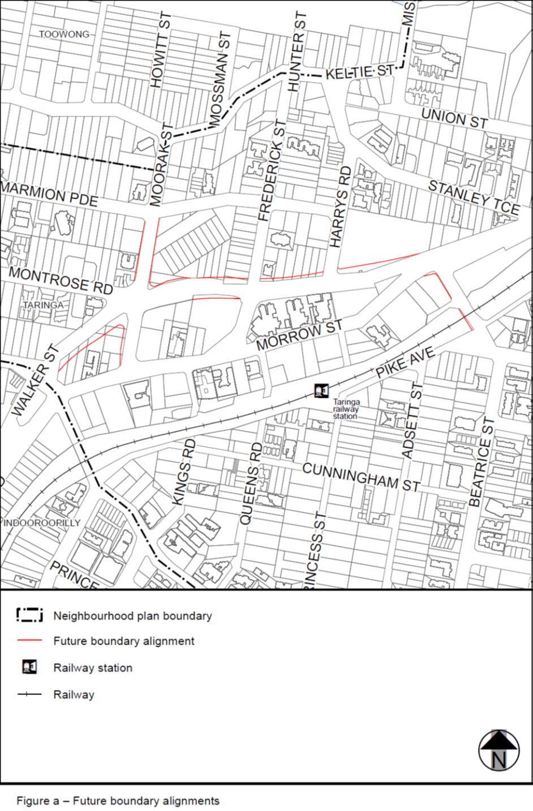

View the high resolution of Figure a–Future boundary alignments (PDF file size is 202Kb)
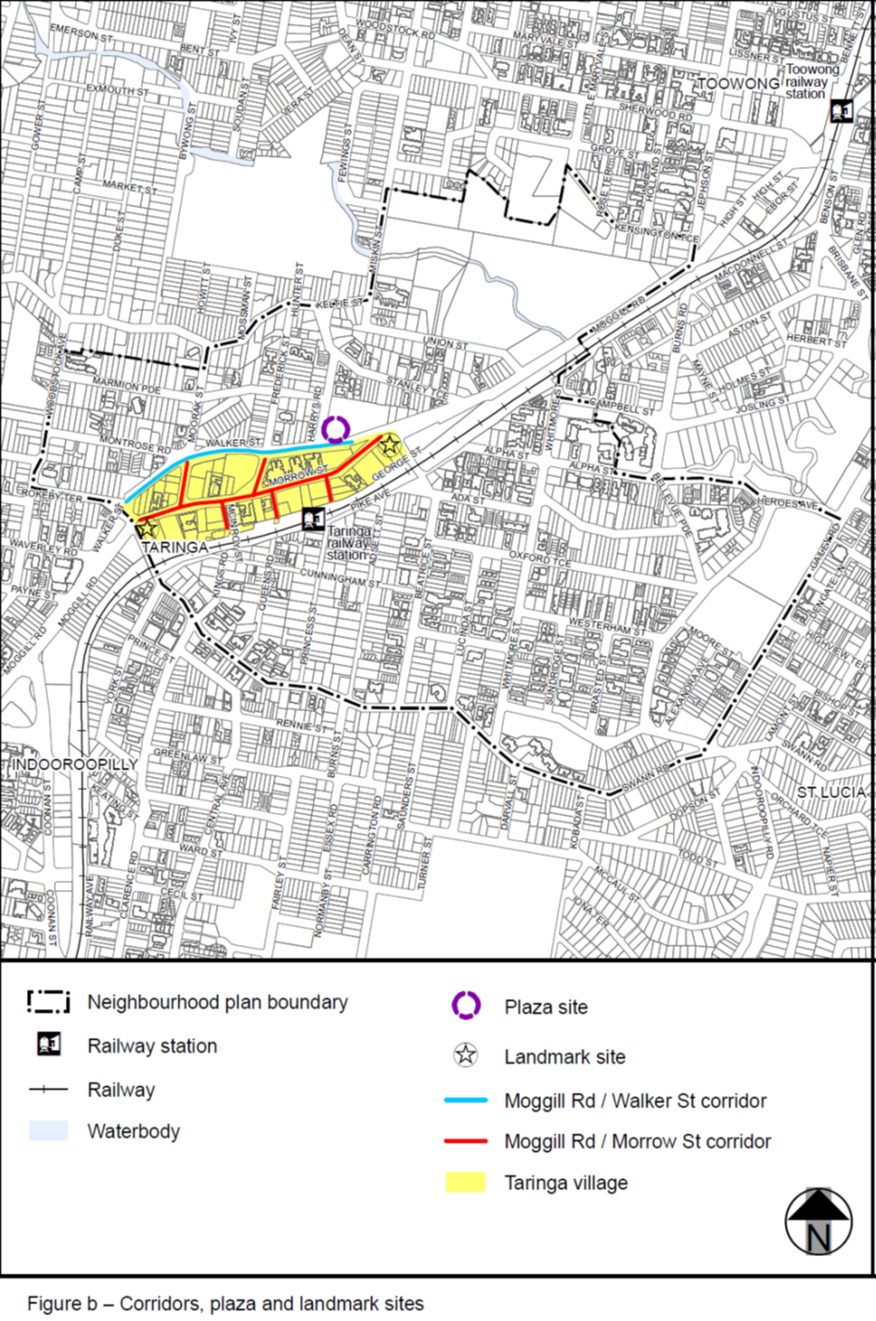

View the high resolution of Figure b–Corridors, plaza and landmark sites (PDF file size is 677Kb)

