7.2.1.3 Algester—Parkinson—Stretton neighbourhood plan code

7.2.1.3.1 Application
- This code applies to assessing a material change of use, reconfiguring a lot, operational work or building work in the Algester—Parkinson—Stretton neighbourhood plan area if:
- assessable development where this code is an applicable code identified in the assessment benchmarks column of a table of assessment for a neighbourhood plan (section 5.9); or
- impact assessable development.
- Land in the Algester—Parkinson—Stretton neighbourhood plan area is identified on the NPM-001.3 Algester—Parkinson—Stretton neighbourhood plan map.
- When using this code, reference should be made to section 1.5, section 5.3.2 and section 5.3.3.
Note—The following purpose, overall outcomes, performance outcomes and acceptable outcomes comprise the assessment benchmarks of this code.
Note—This neighbourhood plan includes a table of assessment. Refer to Table 5.9.3.A, Table 5.9.3.B, Table 5.9.3.C and Table 5.6.3.D

7.2.1.3.2 Purpose
- The purpose of the Algester—Parkinson—Stretton neighbourhood plan code is to provide finer grained planning at a local level for the Algester—Parkinson—Stretton neighbourhood plan area.
- The purpose of the Algester—Parkinson—Stretton neighbourhood plan code will be achieved through the overall outcomes.
- The overall outcomes for the neighbourhood plan area are:
- Development creates functional and integrated communities.
- Land subject to development constraints or character or environmental values specified in Figure a, Figure b or Figure c in this neighbourhood plan code or shown on an overlay map is protected from inappropriate development in order to maintain its character, natural and ecological significance.
- Any development in the southern parts of the neighbourhood plan area provides for the protection and continued function of the wildlife corridor linking Karawatha Forest, Parkinson Bushlands and the Greenbank Army Reserve.
- Open space, parks and recreational facilities meet the needs of the community and are located in accessible locations that are well connected within the neighbourhood plan area.
- Development in a potential development area specified in Figure a, Figure b or Figure c addresses the location of the land, availability of services, environmental constraints, amenity, and existing patterns of development, to ensure an integrated development outcome.
- Residential development provides for a mix of housing types, styles and densities.
Note—Densities and yields are to be calculated excluding parts of the site that are not within a potential development area. These include areas with development constraints or character or environmental values identified in overlay maps. Yields and maximum gross floor area for multiple dwellings and dual occupancy are to be calculated across the potential development area including all access ways and roads respectively.
- Neighbourhood centres identified in Figure b serve the retail, commercial, community and service needs of the local community. Centre activities do not expand outside of these identified sites and other land already included in the Neighbourhood centre zone.

7.2.1.3.3 Performance outcomes and acceptable outcomes

Table 7.2.1.3.3—Performance outcomes and acceptable outcomes
Performance outcomes | Acceptable outcomes
No performance outcomes are prescribed. | No acceptable outcomes are prescribed.

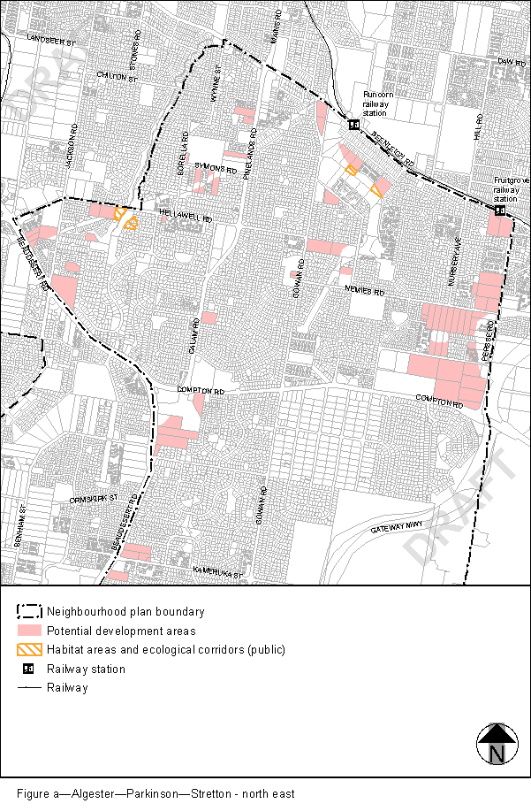
View the high resolution of Figure a–Algester-Parkinson-Stretton – north east (PDF file size is 466Kb)
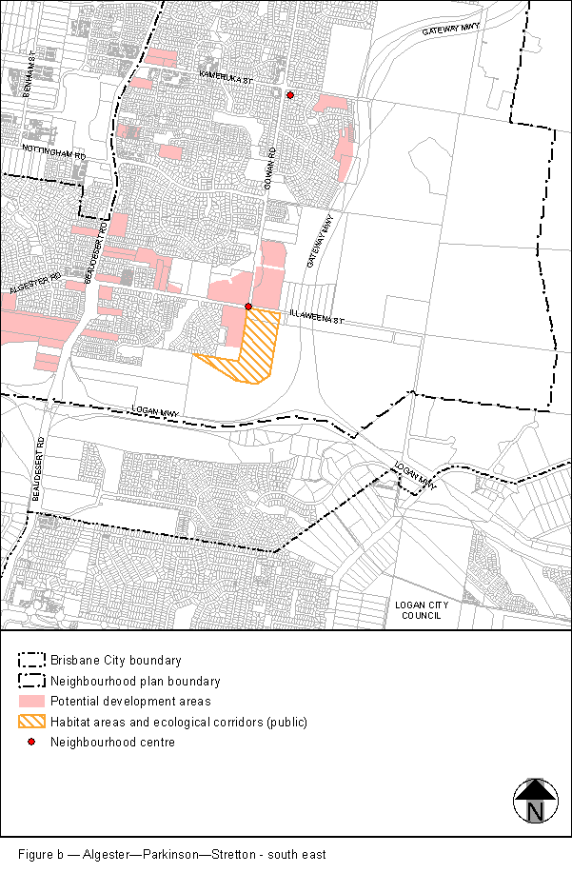
View the high resolution of Figure b–Algester-Parkinson-Stretton – south east (PDF file size is 500Kb)
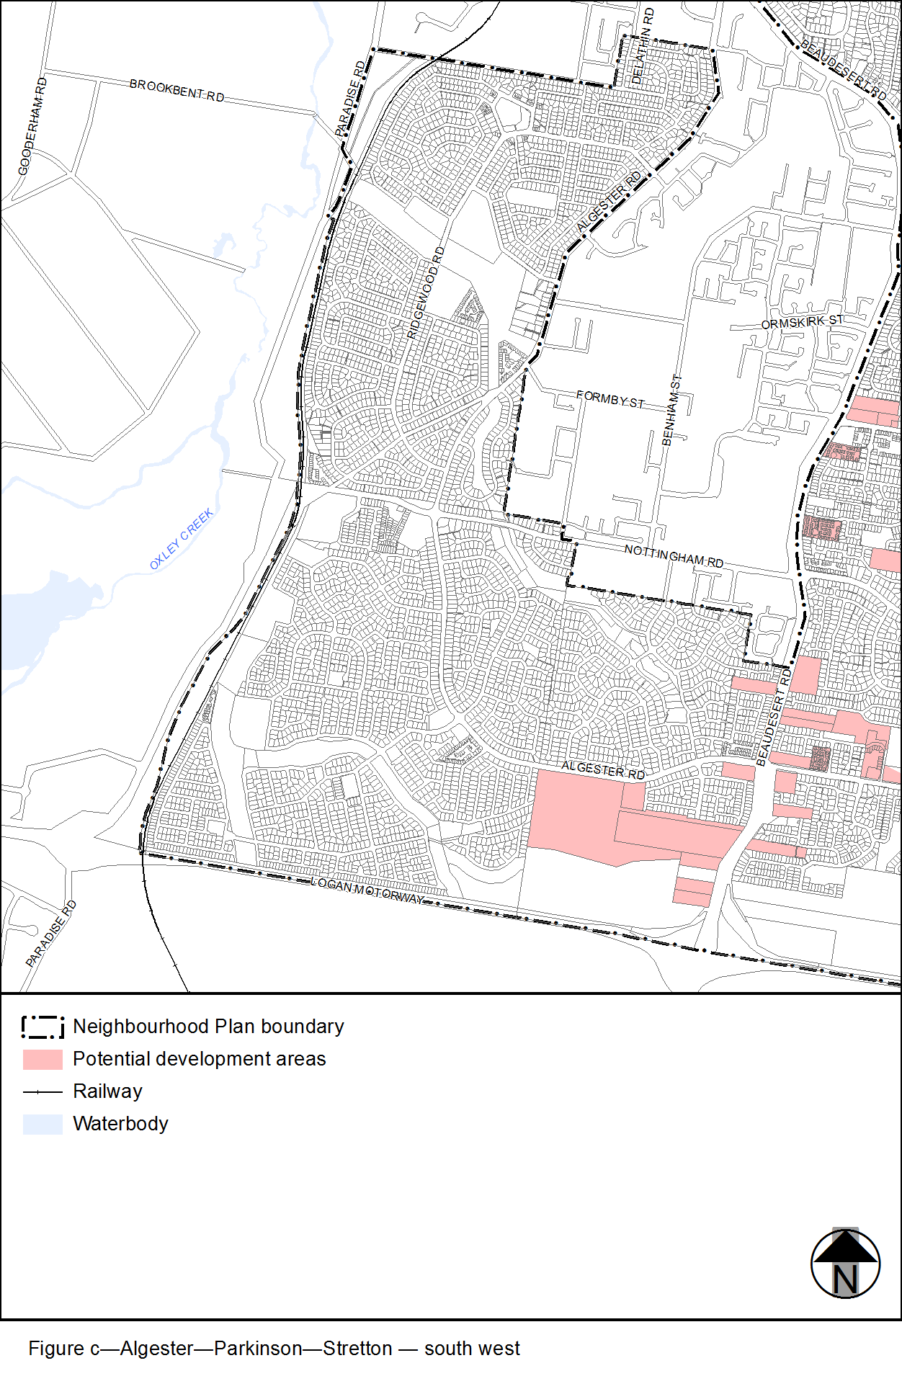
View the high resolution of Figure c–Algester-Parkinson-Stretton – south west (PDF file size is 382Kb)

