7.2.2.1 Banyo—Nudgee neighbourhood plan code

7.2.2.1.1 Application
- This code applies to assessing a material change of use, reconfiguring a lot, operational work or building work in the Banyo—Nudgee neighbourhood plan area if:
- assessable development where this code is an applicable code identified in the assessment benchmarks column of a table of assessment for a neighbourhood plan (section 5.9); or
- impact assessable development.
- Land in the Banyo—Nudgee neighbourhood plan area is identified in the NPM-002.1 Banyo—Nudgee neighbourhood plan map and includes the following precincts:
- Nudgee north precinct (Banyo—Nudgee neighbourhood plan/NPP-001):
- Nudgee north a sub-precinct (Banyo—Nudgee neighbourhood plan/NPP-001a).
- Elliott Road north precinct (Banyo—Nudgee neighbourhood plan/NPP-002):
- Elliott Road north a sub-precinct (Banyo—Nudgee neighbourhood plan/NPP-002a);
- Elliott Road north b sub-precinct (Banyo—Nudgee neighbourhood plan/NPP-002b);
- Elliott Road north c sub-precinct (Banyo—Nudgee neighbourhood plan/NPP-002c).
- Blinzinger Road precinct (Banyo—Nudgee neighbourhood plan/NPP-003);
- Banyo centre precinct (Banyo—Nudgee neighbourhood plan/NPP-004):
- Banyo centre a sub-precinct (Banyo—Nudgee neighbourhood plan/NPP-004a).
- Banyo centre residential precinct (Banyo—Nudgee neighbourhood plan/NPP-005);
- Tufnell Road south precinct (Banyo—Nudgee neighbourhood plan/NPP-006):
- Tufnell Road south a sub-precinct (Banyo—Nudgee neighbourhood plan/NPP-006a).
- St Vincents Road south precinct (Banyo—Nudgee neighbourhood plan/NPP-007).
- When using this code, reference should be made to section 1.5, section 5.3.2 and section 5.3.3.
Note—The following purpose, overall outcomes, performance outcomes and acceptable outcomes comprise the assessment benchmarks of this code.
Note—This neighbourhood plan includes a table of assessment with variations to categories of development and assessment. Refer to Table 5.9.7.A, Table 5.9.7.B, Table 5.9.7.C and Table 5.9.7.D.

7.2.2.1.2 Purpose
- The purpose of the Banyo—Nudgee neighbourhood plan code is to provide finer grained planning at a local level for the Banyo—Nudgee neighbourhood plan area.
- The purpose of the Banyo—Nudgee neighbourhood plan code will be achieved through overall outcomes including overall outcomes for each precinct of the neighbourhood plan area.
- The overall outcomes for the Banyo—Nudgee neighbourhood plan area are:
- The residential area of Banyo and Nudgee is currently predominantly low density detached dwelling houses and alternative housing choices for the area’s ageing population and students attending the Australian Catholic University are limited. As such, townhouses and units are encouraged to cater for the changing needs of existing and future residents. Appropriate locations include large parcels of under-utilised industrial land close to the Banyo shopping centre and close to the Banyo and Nudgee railway stations.
- Industry continues to play an important role in the local economy of the Banyo—Nudgee area. New industrial activity is encouraged where impacts can be successfully buffered from residential areas. Residential redevelopment of isolated industrial pockets in predominantly residential areas is encouraged.
- Nundah Creek, Nudgee Waterhole and the corridor linking the waterhole to the Boondall Wetlands are major natural features of the area which are retained and enhanced. These natural features have a range of environmental values including habitat, ecological, cultural and waterway values.
- Development is of a height, scale and form which is consistent with the amenity and character, community expectations and infrastructure assumptions intended for the relevant precinct, sub-precinct or site and is only developed at a greater height, scale and form where there is both a community need and economic need for the development.
- Nudgee north precinct (Banyo—Nudgee neighbourhood plan/NPP-001) overall outcomes are:
- Development protects the 2 important habitat and ecological corridors that pass through this precinct being Nundah Creek and the Nudgee Waterhole to Boondall Wetlands corridor.
- Expansion of the retirement facility and complementary facilities is supported on the Mercy Centre site and in the Nudgee north a sub-precinct (Banyo—Nudgee neighbourhood plan/NPP-001a)
- Elliott Road north precinct (Banyo—Nudgee neighbourhood plan/NPP-002) overall outcomes are:
- Medium density residential development is supported given proximity to the Nudgee railway station and nearby open space.
- Development of any residential uses is adequately buffered from existing industry.
- Existing buildings continue to be used for industrial and warehouse purposes until a transition to residential use occurs.
- Development in the Elliott Road north b sub-precinct (Banyo—Nudgee neighbourhood plan/NPP-002b):
- ensures that low impact industry uses provide a transition use from a medium impact industry use and high impact industry use to a residential use.
- Blinzinger Road precinct (Banyo—Nudgee neighbourhood plan/NPP-003) overall outcomes are:
- If this site is no longer required by Energex, it is redeveloped as low density residential.
- Banyo centre precinct (Banyo—Nudgee neighbourhood plan/NPP-004) overall outcomes are:
- The centre is developed to create an attractive environment for surrounding uses and contains a legible network of public spaces, paths, roads and parking.
- Development in the Banyo centre a sub-precinct (Banyo—Nudgee neighbourhood plan/NPP-004a):
- ensures that residential development is adequately buffered from surrounding industrial uses and the railway.
- Banyo centre residential precinct (Banyo—Nudgee neighbourhood plan/NPP-005) overall outcomes are:
- Residential development is consistent with the low density of surrounding development and is buffered from the Queensland Rail welding facility.
- Tufnell Road south precinct (Banyo—Nudgee neighbourhood plan/NPP-006) overall outcomes are:
- Redevelopment is for low impact uses such as offices, warehousing and low impact industry. A significant component of residential development occurs in the precinct.
- Retail uses are not consistent with the outcomes sought.
- Low–medium density residential development is consistent with the overall outcomes, given the proximity to the Banyo centre, railway station, Earnshaw College and other community facilities.
- A small area of high density residential development may be supported at the northern end of the Queensland Rail site, on the lots adjoining the Banyo centre residential precinct, subject to adequate buffering from existing and future industrial activities being provided.
- Development in the Tufnell Road south a sub-precinct (Banyo—Nudgee neighbourhood plan/NPP-006a):
- acts as a buffer between the industrial and residential areas, providing a physical separation between these 2 incompatible uses to reduce the risk of industrial impacts affecting future residents and existing residents nearby. The buffer accommodates only low impact uses such as parks, community and recreational facilities. Very low impact components of industrial uses, such as small-scale car park areas and landscaping where there is no building work are acceptable within the buffer. Roads may be included within the buffer to separate land uses and provide opportunities for surveillance of the buffer to ensure it is a useable and safe space. Some acoustic and drainage devices may be acceptable within the buffer. The preferred location for a park is within this precinct. However, using the buffer for a park will depend on the useability and quality of the space and the extent of acoustic and drainage facilities proposed.
- St Vincents Road south precinct (Banyo—Nudgee neighbourhood plan/NPP-007) overall outcomes are:
- This low impact industry precinct buffers between the medium impact industry and high impact industry area to the east and the nearby low density residential area and it is currently unsuitable for residential development because of the impacts of nearby industries, particularly odour and noise.
- To assist in the facilitation of future residential development, subdivision of these sites for non-residential development is not consistent with the outcomes sought.
- Low–medium density residential development may be located in the precinct in the future given the site's location near Bindha railway station, when the impacts of the industry are minimised to acceptable levels.

7.2.2.1.3 Performance outcomes and acceptable outcomes

Table 7.2.2.1.3.A—Performance outcomes and acceptable outcomes
Performance outcomes | Acceptable outcomes
General
PO1  Development is of a height, scale and form that achieves the intended outcome for the precinct, improves the amenity of the neighbourhood plan area, contributes to a cohesive streetscape and built form character and is:  - consistent with the anticipated density and assumed infrastructure demand;  - aligned to community expectations about the number of storeys to be built;  - proportionate to and commensurate with the utility of the site area and frontage width;  - designed to avoid a significant and undue adverse amenity impact to adjoining development;  - sited to enable existing and future buildings to be well separated from each other and avoid affecting the potential development of an adjoining site.  Note—Development that exceeds the intended number of storeys or building height can place disproportionate pressure on the transport network, public space or community facilities in particular.  Note—Development that is over-scaled for its site can result in an undesirable dominance of vehicle access, parking and manoeuvring areas that significantly reduce streetscape character and amenity. | AO1  Development complies with the number of storeys and building height in Table 7.2.2.1.3.B.  Note—Neighbourhood plans will mostly specify a maximum number of storeys where zone outcomes have been varied in relation to building height. Some neighbourhood plans may also specify height in metres. Development must comply with both parameters where maximum number of storeys and height in metres are specified.
PO2  Development provides safe public access for pedestrians along Nundah Creek. | AO2  Development provides a path as indicated in Figure a.
PO3  Development retains the ‘leafy’ feel of the treed avenues. | AO3  Development maintains a continuous canopy of well-matured trees as shown in Figure a.
PO4  Development preserves the benefits provided by the landmark and shade trees. | AO4  Development maintains the groupings of trees shown in Figure a.
If in the Nudgee north precinct (Banyo—Nudgee neighbourhood plan/NPP-001), where in the Nudgee north a sub-precinct (Banyo—Nudgee neighbourhood plan/NPP-001a)
PO5  Development has a building size and bulk which is consistent with the low density of the locality. | AO5  Development complies with the number of storeys, gross floor area and building height in Table 7.2.2.1.3.B.
If in the Elliott Road north precinct (Banyo—Nudgee neighbourhood plan/NPP-002)
PO6  Development of a residential use provides safe and convenient pedestrian access to Nudgee station and local parks. | AO6  Development provides paths through the precinct to link Nudgee station and Nudgee Reserve with existing residential areas to the south.
PO7  Development of residential uses is low to medium density and complements the scale and design of the area. | AO7  Development complies with the number of storeys, gross floor area and building height in Table 7.2.2.1.3.B.
PO8  Development of a residential building provides high-quality visual amenity for residents both internal and external to the site. | AO8.1  Development has a building length which is a maximum of 20m.
AO8.2
Development provides for variation in colour and materials for roof and wall areas.
PO9  Development of a residential use is adequately buffered from the noise and lighting impacts of existing industry and the railway. | AO9.1  Development of a building adjoining an industrial use and the railway incorporates:  - internalised landscape and amenity areas in accordance with Figure b;  - acoustic measures such as sunrooms, sealed windows and landscaped buffers in accordance with Figure c;  - useable private outdoor space with a maximum of 70% enclosed walls in accordance with Figure d.  Note—For gross floor area calculations, enclosed balcony or courtyard areas are not included if exposed to a noise source and have a minimum of 70% of the wall area provided as floor-to-ceiling openable glass windows.
AO9.2
Development ensures bedroom windows are located to avoid lighting impacts from industry.
PO10  Development where adjacent to a green-space area provides:  - high-quality, visually interesting building facades;  - casual surveillance of the public domain. | AO10  Development of habitable rooms, balconies and patio areas overlook and address adjoining green-space areas as shown in Figure e.
PO11  Development on a site that has frontage to Elliott Road, includes landscaping and footpath treatment that provides a high-quality and consistent visual outcome leading to the entrance to the Nudgee Reserve. | AO11.1  Development provides 1 street tree for every 8m of street frontage.
AO11.2
Development provides a concrete footpath a minimum of 1.5m wide.
AO11.3
Development provides a landscaped front boundary setback which is a minimum of 6m to the outermost projection of the building and does not incorporate a visitor parking area.
If in the Elliott Road north precinct (Banyo—Nudgee neighbourhood plan/NPP-002), where in the Elliott Road north b sub-precinct (Banyo—Nudgee neighbourhood plan/NPP-002b)
PO12  Development with a frontage to Ivedon Street ensures buildings are compatible in scale and design with a residential building on the other side of the street and contribute positively to the amenity and character of the local area, especially as seen from the street. | AO12  Development of buildings within 30m of Ivedon Street are of a scale and bulk consistent with the detached houses in the locality, in accordance with Figure f.
PO13  Development ensures the transition of the precinct from industry to residential in an orderly manner. | AO13.1  Development for the first residential redevelopment proposal in the sub-precinct is a minimum of 3ha, developed in accordance with an approved structure plan. Subsequent residential development can occur where the site adjoins industry on no more than 2 sides.  Note—Compliance can be demonstrated by a structure plan prepared in accordance with the Structure planning planning scheme policy.
AO13.2
Development of any single residential redevelopment proposal ensures that no isolated area of less than 1,200m2 remains in the sub-precinct.
If in the Elliot Road north precinct (Banyo—Nudgee neighbourhood plan/NPP-002), where in the Elliott Road north c sub-precinct (Banyo—Nudgee neighbourhood plan/NPP-002c)
PO14  Development improves pedestrian and cycle access to the railway station for residents to the south of the sub-precinct. | AO14  Development provides a public path from Railway Parade through the sub-precinct to link with existing pedestrian access to the railway station.
PO15  Development ensures the park fronting St Achs Street is safe and continuous. | AO15  Development ensures land fronting St Achs Street is dedicated as park.
If in the Banyo centre precinct (Banyo—Nudgee neighbourhood plan/NPP-004)
PO16  Development makes a positive contribution towards the legibility of the centre by defining the centre, its network of public spaces, paths, roads, parking and is generally consistent with Figure g. | AO16  No acceptable outcome is prescribed.
If in the Banyo centre precinct (Banyo—Nudgee neighbourhood plan/NPP-004), where in the Banyo centre a sub-precinct (Banyo—Nudgee neighbourhood plan/NPP-004a)
PO17  Development of residential uses is adequately buffered from railway or industrial uses in the Tufnell Road south a sub-precinct (Banyo—Nudgee neighbourhood plan/NPP-006a). | AO17  Development of residential uses is limited to the lots fronting Tufnell Road.
PO18  Development fronting Tufnell Road respects the residential area opposite. | AO18  Development is consistent with Figure h.
PO19  Development fronting Tufnell Road provides an attractive environment for the development to its rear. | AO19.1  Development ensures rear building elevations provide visual interest through building articulation, variations of materials and colours and placement of windows and awnings.
AO19.2
Development of service and storage areas is screened from view to the rear through landscaping and fencing.
If in the Banyo centre residential precinct (Banyo—Nudgee neighbourhood plan/NPP-005)
PO20  Development facilitates the ongoing operation of the Queensland Rail welding facility. | AO20  Development of a new residential use does not occur within 100m of the Queensland Rail welding facility until operation of the welding facility ceases permanently.
If in the Tufnell Road south precinct (Banyo—Nudgee neighbourhood plan/NPP-006)
PO21  Development is designed to minimise impacts such as noise, odour, particulate and other air emissions and visual pollution on existing and future nearby residents, and provides a convenient and safe network of links to nearby facilities and services. | AO21.1  Development is in accordance with Figure i, including provision of a landscape buffer 100m wide.
AO21.2
Development ensures that if the buffer is less than 100m wide, building bulk and height is reduced accordingly so the same visual outcome and air-quality levels appropriate to a residential area are achieved.
AO21.3
Development provides densely landscaped mounds as the primary method of minimising noise from industrial areas to residential areas.
AO21.4
Development provides a new service road which:
- terminates at the rear of the Banyo centre;
- is generally in accordance with Figure i;
- does not provide access to residential uses.
PO22  Development ensures that non-residential traffic does not access Tufnell Road from this precinct. | AO22.1  Development requires all non-residential traffic to access this precinct via Earnshaw Road and other industrial roads south of Tufnell Road.
AO22.2
Development of the Queensland Rail site is not for non-residential purposes until access can be provided from Earnshaw Road, generally in accordance with Figure i.
PO23  Development deters non-residential traffic from using residential streets. | AO23.1  Development requires all non-residential traffic to be directed south along Earnshaw Road.
AO23.2
Development of access roads to non-residential and residential areas from Earnshaw Road is physically separated.
PO24  Development does not exacerbate flooding of Cannery Creek. | AO24  Development does not increase the stormwater discharge from the precinct.
PO25  Development acknowledges the history of the former army land. | AO25  Development reflects the site’s history through:  - street names;  - historical information plaques in public areas;  - retention of the former guardhouse shown in Figure i.
PO26  Development provides parkland for the needs of workers and residents. | AO26  Development provides parkland in the Tufnell Road south a sub-precinct (Banyo—Nudgee neighbourhood plan/NPP-006a) which ensures:  - the useability and quality of the space is not significantly impacted by acoustic and drainage facilities;  - the site of the park is not located in the area identified as ‘unsuitable as park’ in Figure i.

Table 7.2.2.1.3.B—Maximum building height and gross floor area
Development | Building height (number of storeys) | Building height (m) | Gross floor area  (percent of site area)
If in the Nudgee north precinct (Banyo—Nudgee neighbourhood plan/NPP-001)
Development of a site in the Nudgee north a sub-precinct (Banyo—Nudgee neighbourhood plan/NPP-001a) | 2 | Not specified | 30% or 50% if a retirement village
If in the Elliott Road north precinct (Banyo—Nudgee neighbourhood plan/NPP-002)
Development of a site other than in the Elliott Road north b sub-precinct (Banyo—Nudgee neighbourhood plan/NPP-002b) within 30m of Ivedon Street | 4 | Not specified | 80%
Development of a site in the Elliott Road north b sub-precinct (Banyo—Nudgee neighbourhood plan/NPP-002b) within 30m of Ivedon Street | 2 | Not specified | Not specified
If in the Banyo centre residential precinct (Banyo—Nudgee neighbourhood plan/NPP-005)
Any development in this precinct | 3 | Not specified | Not specified

P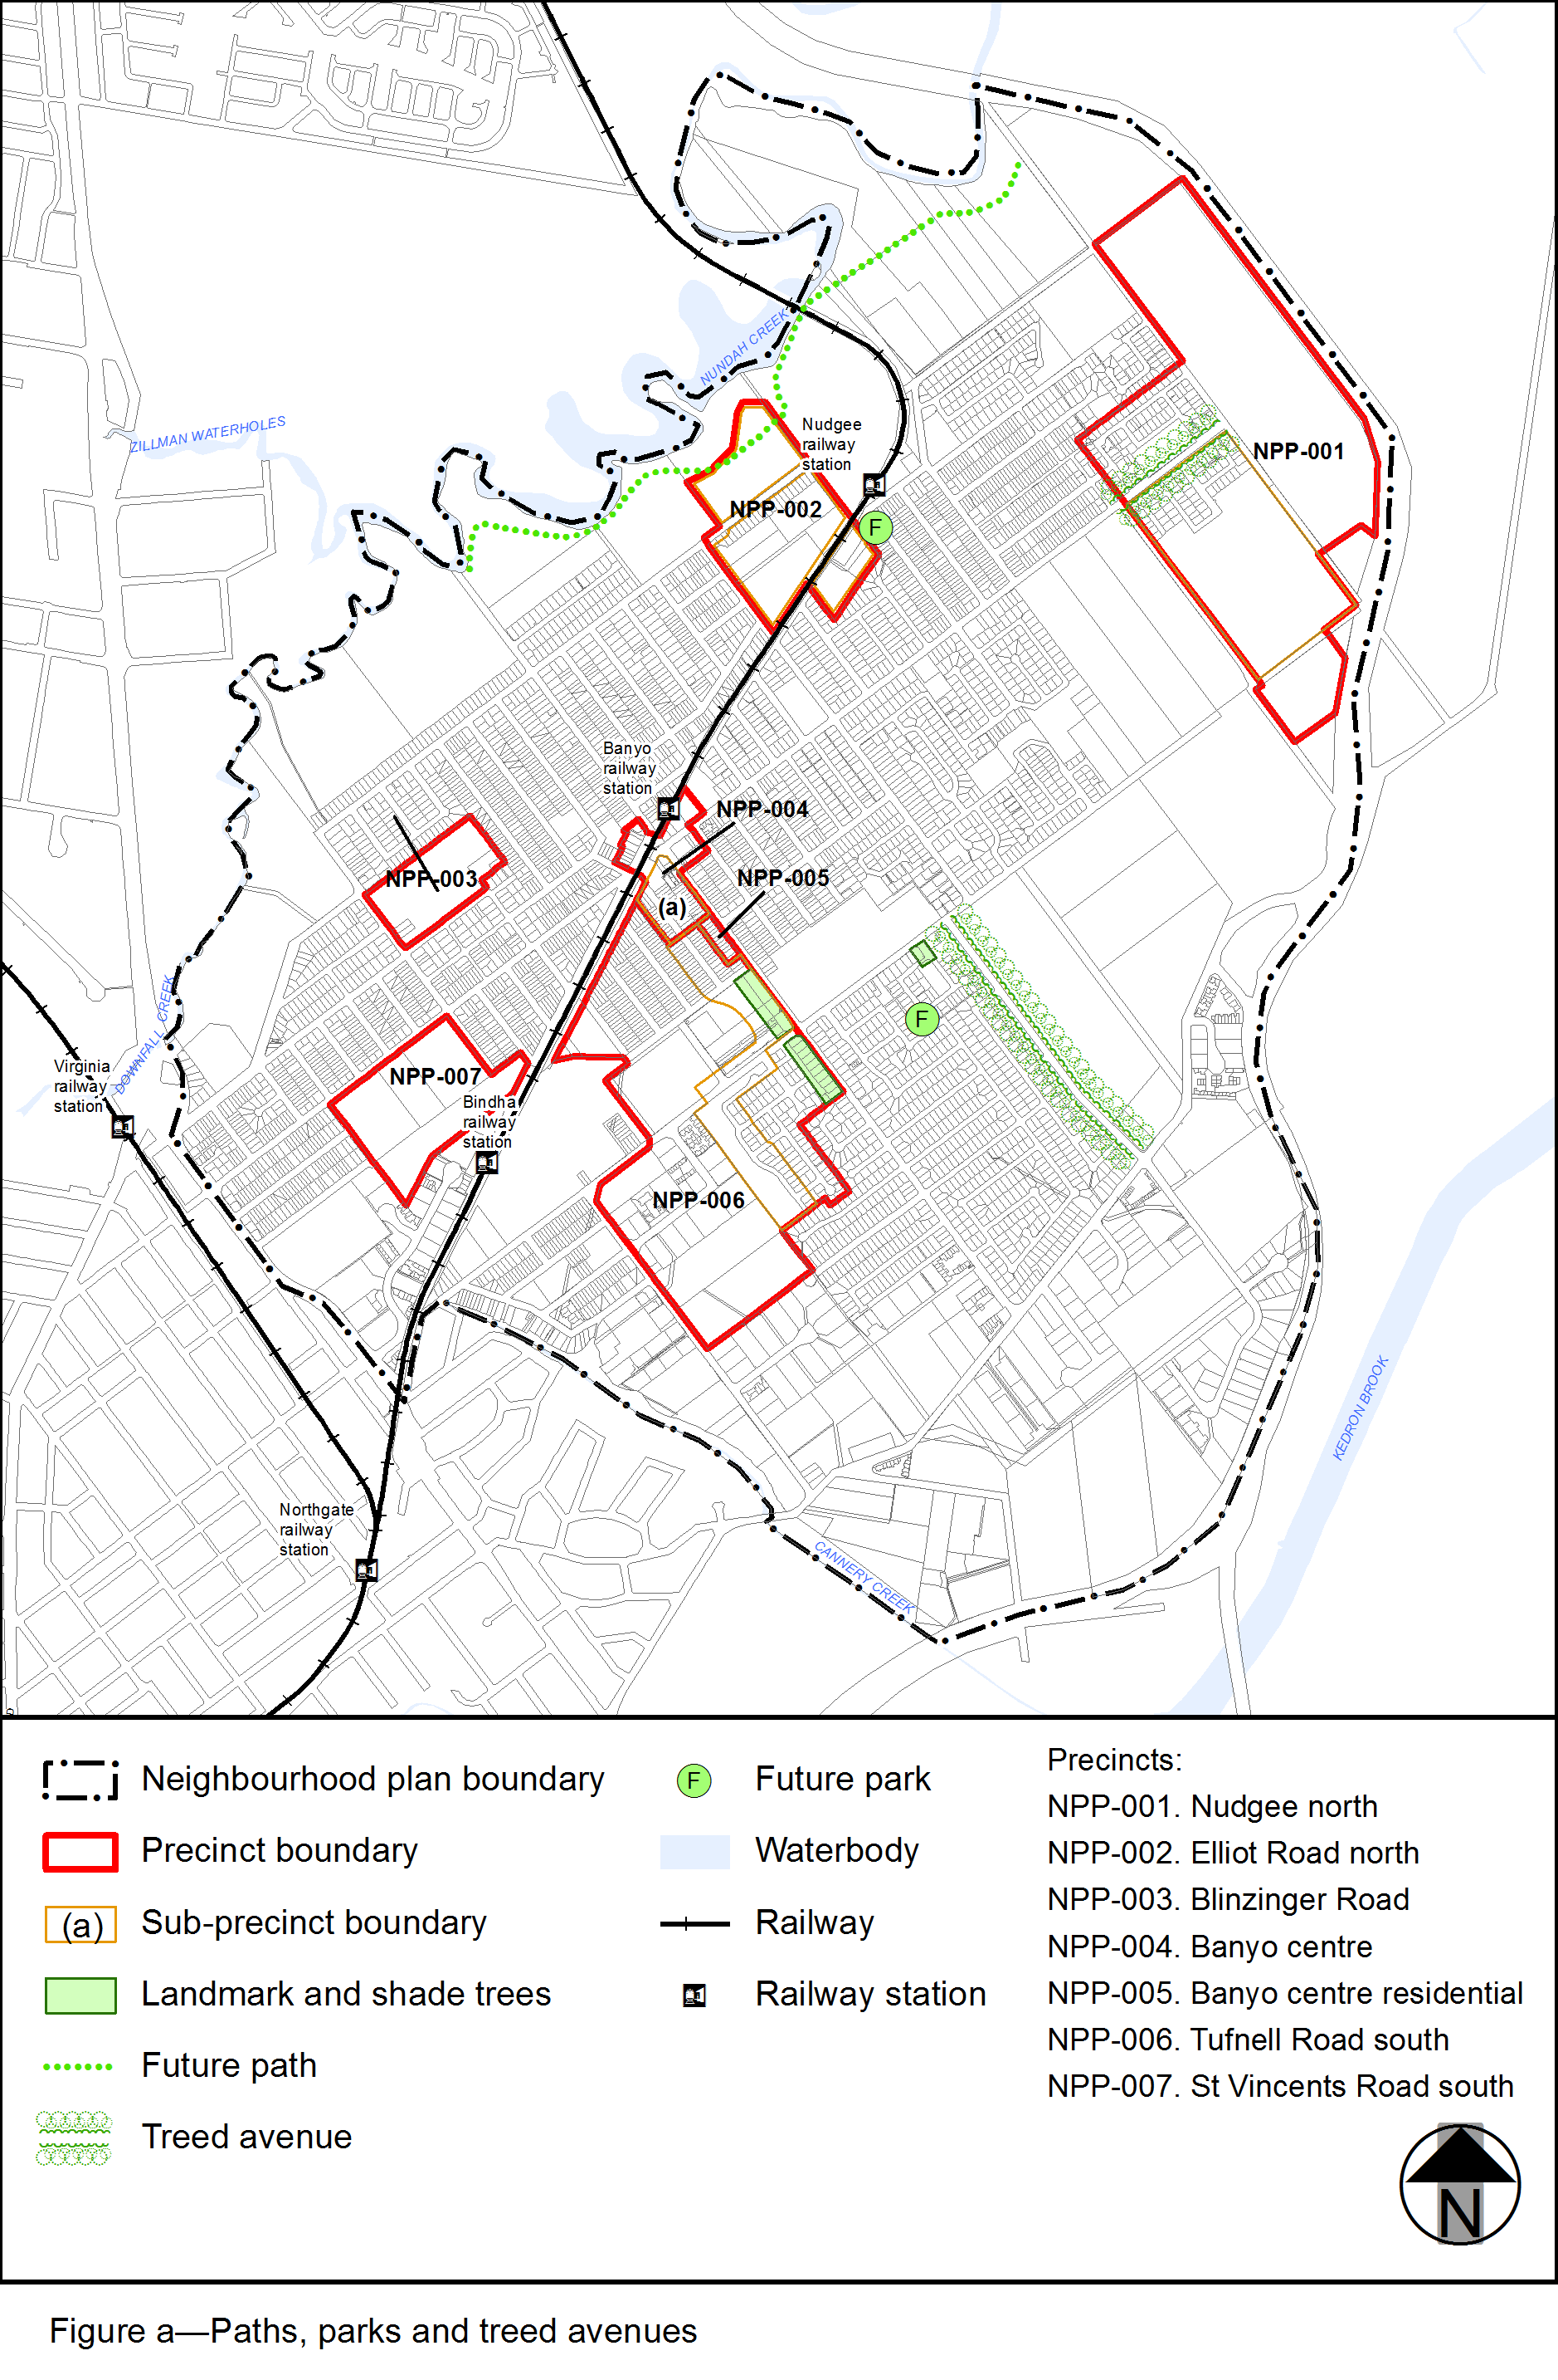
View the high resolution of Figure a–Paths, parks and treed avenues (PDF file size is 540Kb)
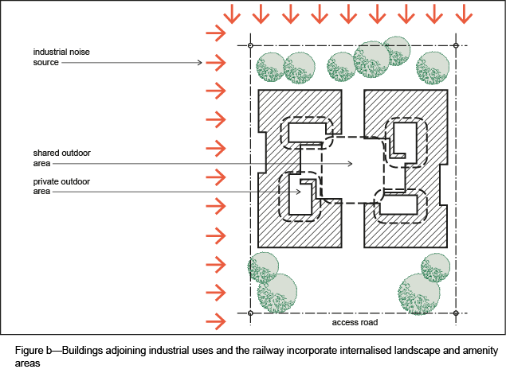
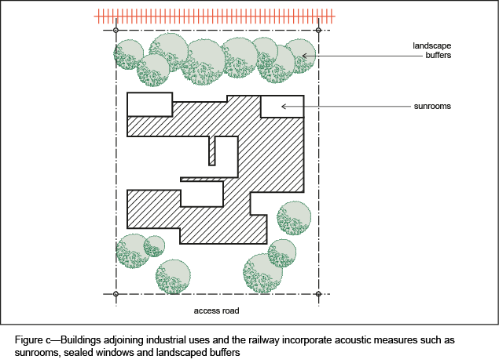
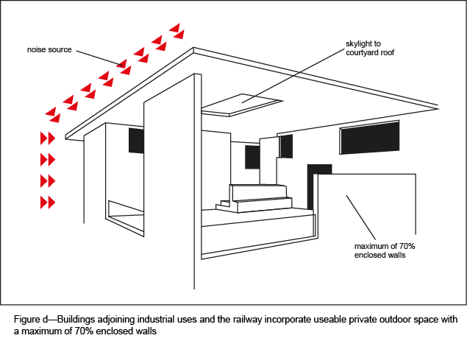
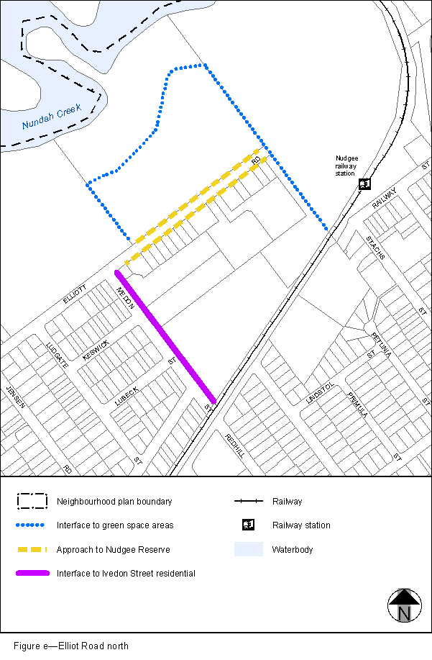
View the high resolution of Figure e–Elliot Road north (PDF file size is 126Kb)
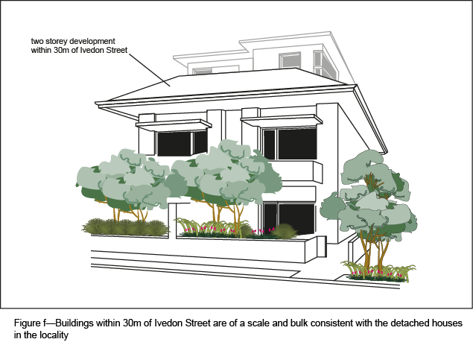
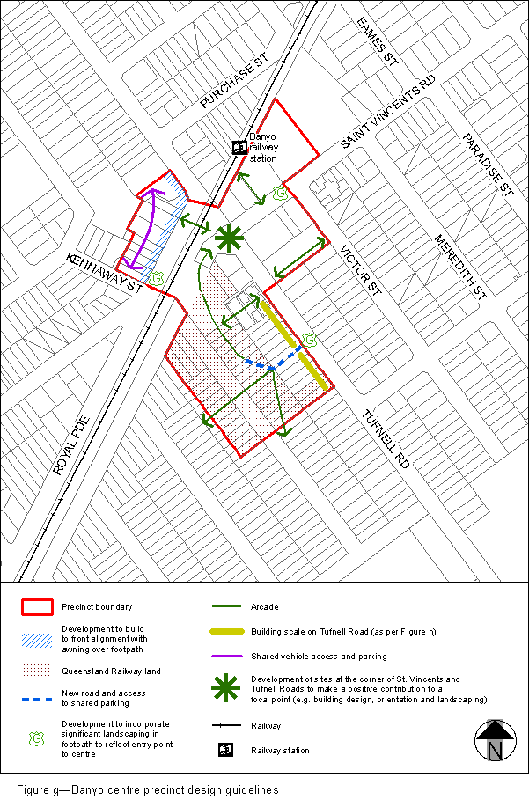
View the high resolution of Figure g–Banyo centre precinct design guidelines (PDF file size is 181Kb)
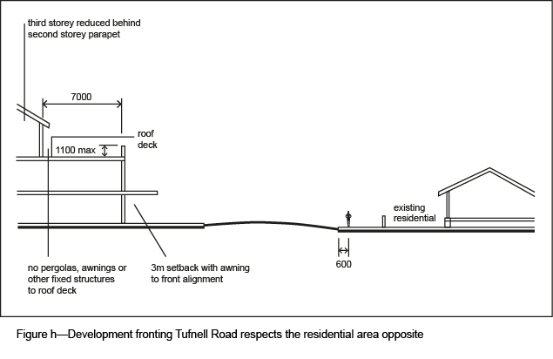
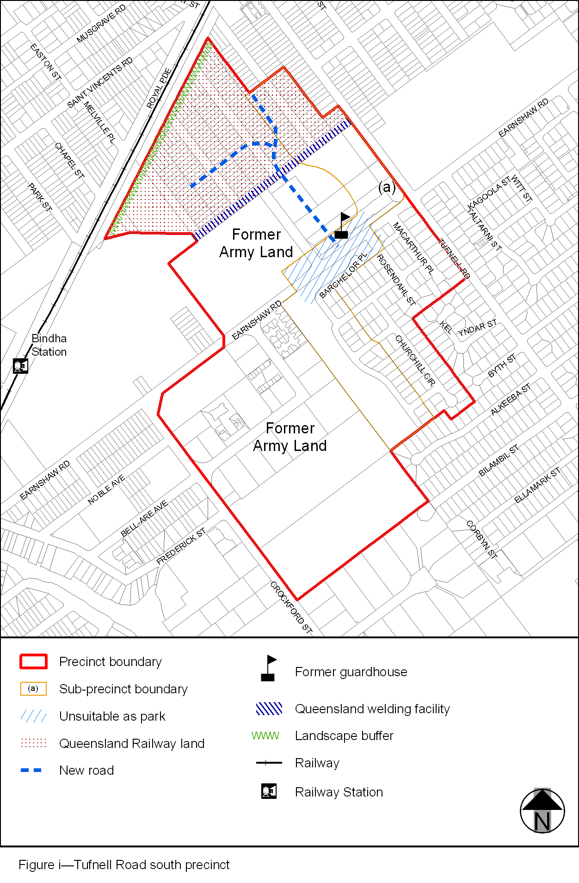
View the high resolution of Figure i–Tufnell Road south precinct (PDF file size is 219Kb)

