9.4.11 Transport, access, parking and servicing code

9.4.11.1 Application
- This code applies to assessing:
- operational work which is assessable development if this code is identified as a prescribed secondary code in the assessment benchmarks column of a table of assessment for operational work (section 5.8); or
- a material change of use or reconfiguring a lot if:
- assessable development where this code is identified as a prescribed secondary code in the assessment benchmarks column of a table of assessment for a material change of use (section 5.5) reconfiguring a lot (section 5.6), or an overlay (section 5.10); or
- impact assessable development, to the extent relevant.
- When using this code, reference should be made to section 1.5 and section 5.3.3.
Note—The following purpose, overall outcomes, performance outcomes and acceptable outcomes comprise the assessment benchmarks of this code.
Note—Where this code contains performance outcomes or acceptable outcomes that relate to:
- crime prevention through environmental design principles, guidance is included in the Crime prevention through environmental design planning scheme policy;
- design for the reduction of graffiti, guidance is provided and the Graffiti prevention planning scheme policy;
- infrastructure design and construction works, guidance is provided in the Infrastructure design planning scheme policy;
- refuse and recycling, guidance is provided in the Refuse planning scheme policy;
- transport, access, parking and servicing standards and guidelines are contained in the Transport, access, parking and servicing planning scheme policy and the Infrastructure design planning scheme policy.
Note—If involving a standard format lot with common property such as requiring a community management scheme under the Body Corporate and Community Management Act 1997, the development contains a reconfiguring a lot aspect of development and the Subdivision code will apply.

9.4.11.2 Purpose
- The purpose of the Transport, access, parking and servicing code is to assess the suitability of the transport, access, parking and servicing aspects of development.
- The purpose of the code will be achieved through the following overall outcomes:
- Development provides for access, circulation, parking and vehicle-based services for all relevant transport modes, including walking, cycling and public transport relevant to the nature of the proposed development and its location in relation to the transport network and surrounding existing and future land uses.
- Development enhances the potential for trip making other than by private vehicle.
- Development provides safe access for all transport modes that does not impact adversely on the efficiency and safety of the transport network or diminish the amenity of nearby land uses.
- Development ensures that impacts on amenity caused by traffic generation is consistent with the community’s reasonable expectations for the intended use.
- Development provides site access arrangements to ensure that any adverse impacts on other development, the transport network and those who use it, are minimised to maintain amenity of the area and the safety and efficiency of the transport system.
- Development ensures that access, parking and servicing arrangements and impacts such as noise, are consistent with the community’s reasonable expectations and avoid risk of damage to people, property and vehicles.
- Development maximises safety in the use of the transport network, particularly for the most vulnerable users (children, pedestrians, persons with disabilities and cyclists) so that all transport modes are safe and convenient.
- Development provides for walking and cycling routes and end-of-trip facilities for pedestrians and cyclists, designed and located to make walking and cycling attractive and viable transport options.
- Development envisaged by the planning scheme, which will potentially have an adverse impact on the operation of the transport network, is designed and of a scale that maintains the safety and efficiency of the transport network.
- Development provides for on-site parking and manoeuvring areas for cars, motorcycles, bicycles and service vehicles which:
- are safe and convenient to use;
- if outside the City core and the City frame identified in Figure a are adequate to meet the design peak-parking demands without significant overflow to adjacent premises or the generation of excessive on-street car parking demand, taking into account the requirements of other road users.
- Development provides for on-site servicing that is safe, convenient to use, but discrete, and adequate to meet the reasonably expected demands generated by the development, without significant adverse impacts on the external road system or adjacent premises.
- Development accommodates future road upgrades and widenings ensuring the ongoing capacity, efficiency and safety of the transport network.

9.4.11.3 Performance outcomes and acceptable outcomes

Table 9.4.11.3—Performance outcomes and acceptable outcomes
Performance outcomes | Acceptable outcomes
PO1  Development is designed:  - to include a technically competent and accurate response to the transport and traffic elements of the development;  - in accordance with the standards in the Transport, access, parking and servicing planning scheme policy;  - to ensure the efficient operation and safety of the development and its surrounds.  Note—The acceptable outcome and performance outcome can be demonstrated through a development application that:  - is accompanied by sufficient information, including computer modelling input and output data, to allow the proposed development to be properly assessed against the requirements of this code and the standards and guidelines of the Transport, access, parking and servicing planning scheme policy;  - is certified by a Registered Professional Engineer Queensland that all plans, documents and dimensioned drawings comply with the requirements of this code and the standards and guidelines of the Transport, access, parking and servicing planning scheme policy;  - ensures that any computer modelling input and output data are accurate, reasonable and carried out in accordance with sound traffic engineering practices. | AO1  Development complies with the standards in the Transport, access, parking and servicing planning scheme policy.
PO2  Development of a major size incorporates on-site provision for integration with the public transport network and the management of vehicles, public transport, pedestrians and cyclists, including providing appropriate pedestrian and cyclist linkages to adjoining uses, public areas and the transport network consistent with the planning by the Queensland Government and Council. | AO2  No acceptable outcome is prescribed.
PO3  Development provides vehicle access that is located and designed so as to have no significant impact on the safety, efficiency, function, convenience of use or capacity of the road network. | AO3.1  Development provides site access that is located and designed in compliance with the standards in the Transport, access, parking and servicing planning scheme policy.
AO3.2
Development provides an easement for a vehicular access benefiting all adjoining landowners and the Council if the vehicular access services more than an individual development or premises.
PO4  Development provides walking and cycle routes through the site which:  - link to the external network and pedestrian and cyclist destinations such as schools, shopping centres, open space, public transport stations, shops and local activity centres along the safest, most direct and convenient routes;  - encourage walking and cycling;  - ensure pedestrian and cyclist safety;  - provide a direct and legible network.  Note—The Infrastructure design planning scheme policy provides additional guidance on how to comply with this performance outcome. | AO4.1  Development provides walking and cycle routes which are constructed on the carriageway or through the site to:  - create a walking or cycle route along the full frontage of the site;  - connect to public transport and existing cycle and walking routes at the frontage or boundary of the site.
AO4.2
Development provides walking and cycle routes that are constructed in compliance with the standards in the Transport, access, parking and servicing planning scheme policy and the Infrastructure design planning scheme policy.
AO4.3
Development provides walking and cycle routes which do not include a potential entrapment area, blind corner or sudden change in level that restrict sightlines.
PO5  Development provides secure and convenient bicycle parking which:  - for visitors is obvious and located close to the building’s main entrance;  - for employees is conveniently located to provide secure and convenient access between the bicycle storage area, end-of-trip facilities and the main area of the building;  - is easily and safely accessible from outside the site;  - does not impact adversely on visual amenity;  - does not impede the movement of pedestrians or other vehicles;  - is designed to comply with a recognised standard for the construction of bicycle facilities.  Note—For a performance outcome relating to the number of bicycle parking spaces provided, the application must demonstrate how the needs of the intended users of the site differ from the standard rates in the Transport, access, parking and servicing planning scheme policy. | AO5.1  Development provides on-site bicycle parking spaces in compliance with the standards in the Transport, access, parking and servicing planning scheme policy.
AO5.2
Development provides bicycle parking spaces for employees which are co-located with end-of-trip facilities (shower cubicles and lockers) in compliance with the Transport, access, parking and servicing planning scheme policy and AS 2890.3-1993 Bicycle parking facilities.
AO5.3
Development ensures that the location of visitor bicycle parking is discernible either by direct view or using signs from the street.
AO5.4
Development provides visitor bicycle parking which does not impede pedestrian movement.
AO5.5
Development provides bicycle parking which is constructed in compliance with the standards in the Transport, access, parking and servicing planning scheme policy.
PO6  Development provides shower cubicles and lockers in sufficient numbers to meet the needs and volume of predicted pedestrian and cyclist users.  Note—For a performance outcome the application must demonstrate how the needs of the intended users of the site differ from the standard rates in the Transport, access, parking and servicing planning scheme policy. | AO6  Development provides shower cubicles and lockers for pedestrians and cyclists in compliance with the standards in the Transport, access, parking and servicing planning scheme policy.
PO7  Development provides pedestrian and cyclist access to the site which is designed to provide safe movement and avoid unnecessary conflict between pedestrians, cyclists and motor vehicles. | AO7  Development provides pedestrian and cycle access that is designed and constructed in compliance with the site access design guidelines, pedestrian facilities standards and cyclist facilities standards in the Transport, access, parking and servicing planning scheme policy.
PO8  Development provides pedestrian and cyclist access to and from the site which is located to take advantage of safe crossing points of the adjacent road system, key destinations and public transport facilities. | AO8  No acceptable outcome is prescribed.
PO9  Development provides access driveways in the road area that are located, designed and controlled to:  - minimise adverse impacts on the safety and operation of the transport network, including the movement of pedestrians and cyclists;  - ensure the amenity of adjacent premises, from impacts such as noise and light. | AO9.1  No acceptable outcome for access is prescribed, for a major development (as described in the Transport, access, parking and servicing planning scheme policy).
AO9.2
Development which is not a major development (as described in the Transport, access, parking and servicing planning scheme policy) provides a single site access driveway in the road area to the lowest order road to which the site has frontage.
AO9.3
Development ensures that sight distances to and from all proposed access driveways in the road area and intersections are in compliance with the standards in the Transport, access, parking and servicing planning scheme policy.
AO9.4
Development provides access driveways in the road area which:
- are located, designed and controlled in compliance with the standards in the Transport, access, parking and servicing planning scheme policy;
- are not provided through a bus stop, taxi rank or pedestrian crossing or refuge.
AO9.5
Development makes provision for shared access arrangements particularly where it is necessary to limit access points to a major road.
PO10  Redevelopment provides for:  - the closure of all access driveways in the road area that no longer comply with the standards in the Transport, access, parking and servicing planning scheme policy;  - the reinstatement of adjacent footpaths. | AO10  No acceptable outcome is prescribed.
PO11  Development provides that an internal approach to an access driveway in the road area is designed and located to provide for the safety of pedestrians and cyclists using paths adjacent to the frontage of the site, and motorists. | AO11.1  Development provides sight distances to and from all proposed access driveways in the road area and intersections which are in compliance with the standards in the Transport, access, parking and servicing planning scheme policy.
AO11.2
Development ensures that convex mirrors are only used in a site:
- as a secondary support at access driveways;
- in addition to acceptable sight splays that comply with the sight distances standards in the Transport, access, parking and servicing planning scheme policy.
PO12  Development in the City core and City frame as identified in Figure a provides car parking spaces at rates to discourage private car use and encourage walking, cycling and the use of public transport. | AO12  Development in the City core and City frame as identified in Figure a provides maximum car-parking rates in compliance with the standards in the Transport, access, parking and servicing planning scheme policy.  Note—For accepted development subject to compliance with identified requirements including an existing premises, no reduction to existing car parking is required to comply with a maximum car-parking rate in the Transport, access, parking and servicing planning scheme policy.
PO13  Development outside of the City core and City frame as identified in Figure a provides on-site car parking spaces to accommodate the design peak parking demand without any overflow of car parking to an adjacent premises or adjacent street. | AO13  Development outside of the City core and City frame as identified in Figure a:  - provides on-site car parking spaces in compliance with the standards in the Transport, access, parking and servicing planning scheme policy; or  - for accepted development subject to compliance with identified requirements, does not result in on-street car parking if no parking standard is identified in the Transport, access, parking and servicing planning scheme policy.  Note—For accepted development subject to compliance with identified requirements including an existing premises, no reduction to existing car parking is required to comply with a maximum car-parking rate in the Transport, access, parking and servicing planning scheme policy.
PO14  Development ensures that the number of car parking spaces and design of the car parking area:  - meet the combined design peak parking demand for residential, visitor and business parking;  - allow for the temporal sharing of car-parking spaces for uses with different peak parking demands.  Note—In order to demonstrate that adequate car parking is provided, a traffic impact assessment prepared in compliance with the Transport, access, parking and servicing planning scheme policy is to identify the appropriate number of car parking spaces to be provided. | AO14.1  Development provides a number of car parking spaces on site equalling the sum of the maximum design peak parking demand for the individual uses at any point in time.
AO14.2
Development involving mixed use provides a non-residential car parking area with shared parking for all the businesses in the development.
PO15  Development provides a car park layout which allows for on-site vehicle parking that:  - is clearly defined, safe and easily accessible;  - is designed to contain potential adverse impacts within the site;  - does not detract from the aesthetics or amenity of an area;  - discourages on-street parking if parking has an adverse traffic management safety or amenity impact;  - is consistent with safe and convenient pedestrian and cyclist movement. | AO15  Development provides parking bays, queue areas and manoeuvring areas which are designed for the design service vehicle to the standards in the Transport, access, parking and servicing planning scheme policy.
PO16  Development creates a safe environment by incorporating the key elements of crime prevention through environmental design. | AO16  Development incorporates the key elements of crime prevention through environmental design in its layout, building and structure design and landscaping by:  - facilitating casual surveillance opportunities and including good sightlines to publicly accessible areas such as car parks, pathways, public toilets and communal areas;  - defining different uses and ownerships through design and restricting access from non-residential uses into private residential dwellings;  - promoting safety and minimising opportunities for graffiti and vandalism through exterior building design and orientation of buildings and use of active frontages;  - ensuring publicly accessible areas such as car parks, pathways, public toilets and communal areas are well lit;  - including way-finding cues;  - minimising predictable routes and entrapment locations near public spaces such as car parks, public toilets, ATMs and communal areas.  Note—For guidance in achieving the key elements of crime prevention through environmental design, refer to the Crime prevention through environmental design planning scheme policy.
PO17  Development minimises the potential for graffiti and vandalism through access control, canvas reduction and easy maintenance selection. | AO17  Development incorporates graffiti and vandalism prevention techniques in its layout, building and structure design and landscaping, by:  - denying access to potential canvases through access control techniques;  - reducing potential canvases through canvas reduction techniques;  - ensuring graffiti can be readily and quickly removed through easy maintenance selection techniques.  Note—For guidance on graffiti and vandalism prevention techniques, refer to the Graffiti prevention planning scheme policy.
PO18  Development is serviced by an adequate number and size of service vehicles. | AO18  Development ensures that the number and size of design service vehicles selected for the site is in compliance with the standards in the Transport, access, parking and servicing planning scheme policy.
PO19  Development layout provides for services which:  - are wholly within the site, other than service vehicle manoeuvring areas which may overhang the verge on a minor road where use of the footpath is not adversely affected;  - are clearly defined, safe and easily accessible;  - are designed to contain potential adverse impacts of servicing within the site;  - do not detract from the aesthetics or amenity of the surrounding area. | AO19.1  Development ensures that a service bay provided on site:  - is provided and designed to comply with the design vehicle table and service area design standards in the Transport, access, parking and servicing planning scheme policy;  - is located away from street frontages and screened from adjoining premises.
AO19.2
Development provides on-site servicing facilities and associated on-site vehicle manoeuvring areas which are designed in compliance with the service area design standards in the Transport, access, parking and servicing planning scheme policy.
AO19.3
Development provides service areas for refuse collection in compliance with the standards in the Refuse planning scheme policy, Transport, access, parking and servicing planning scheme policy and the Infrastructure design planning scheme policy.
PO20  Development provides service vehicle access routes to and from the site which minimise the impact on:  - amenity and safety in residential areas;  - streets not constructed to a standard that accommodate increased heavy vehicle movements. | AO20  Development ensures that service vehicles use the shortest and most direct route to the major road network in compliance with the heavy vehicle standards in the Transport, access, parking and servicing planning scheme policy.
If for development which is required to be serviced by a b-double (Austroad class 10 vehicle), multi-combination vehicle, over-dimensioned vehicle or any other vehicle identified by the Queensland Government as requiring a permit to operate on the road (freight-dependent development)
PO21  Development which is freight-dependent development ensures that the traffic generated by the development does not impact on:  - the operation of the transport network;  - the safety and amenity of a residential area;  - a road not constructed to accommodate a non-standard vehicle such as a road only constructed to accommodate a vehicle that has a legal right of access to all roads including Austroads vehicles classes 1–9. | AO21.1  Development which is freight-dependent development is located on a site which:  - has frontage to or direct access to the freight network in the Road hierarchy overlay via roads in a zone in the Industry zones category; or  - can be serviced by a route that can act as a primary freight access route and connect to an existing primary freight route without impacting on the safe operation of the road network in compliance with the heavy vehicle standards in the Transport, access, parking and servicing planning scheme policy.
AO21.2
Development which is freight-dependent development provides any necessary upgrade to a road used as an access route in compliance with the Infrastructure design planning scheme policy.
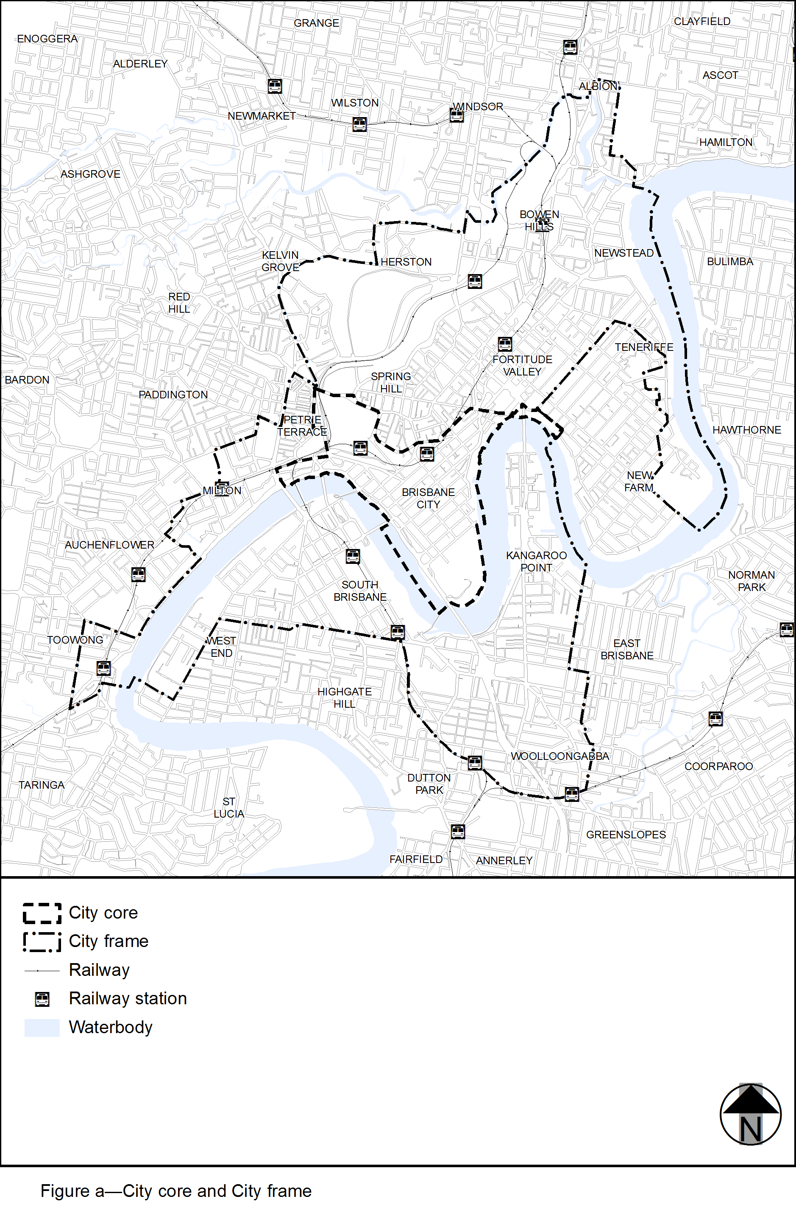
View the high resolution of Figure A–City core and City frame (PDF file size is 545Kb)

