SC6.12 Graffiti prevention planning scheme policy

Contents
1 Introduction
1.1 Relationship to planning scheme
1.2 Purpose

2 Graffiti vandalism and prevention

3 Access control
3.1 Formal measures of access control
3.2 Passive measures of access control

4 Canvas reduction

5 Maintenance solutions

1 Introduction

1.1 Relationship to planning scheme
This planning scheme policy provides guidance or advice about satisfying an assessment benchmark which identifies this planning scheme policy as providing that guidance or advice.

1.2 Purpose
This planning scheme policy provides guidance or advice on the following:
- the role of design in graffiti prevention and management to support Council’s Graffiti reduction policy;
- the techniques to reduce the likelihood and impact of graffiti vandalism.

2 Graffiti vandalism and prevention
- Graffiti vandalism can be significantly reduced and possibly prevented through anticipation of risks to property, life-cycle asset management considerations, limiting access to sites and buildings and avoiding elements that constitute a graffiti-friendly structure, including:
- large blank surface areas which are easy to access;
- areas of light colouring;
- smooth surfaces;
- high visibility;
- access to higher levels of the structure;
- high risk access (risk involved in accessing);
- poor lighting.
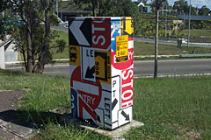
Example of graffiti prevention applied to Council's traffic signal control
- Graffiti prevention strategies are in order of preference:
- access control;
- canvas reduction;
- easy maintenance selection.
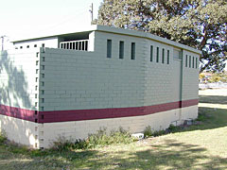
Example of where Council has used colour banding on a brick wall to diminish its graffiti-friendly status

3 Access control
- Access control denies, where possible, access to a potential canvas.
- Formal measures of access control provide physical barriers and restrict access to a potential canvas.
- Passive measures of access control cannot be wholly relied on and are recommended in conjunction with formal measures or with canvas reduction and easy maintenance selection strategies.

3.1 Formal measures of access control
- Formal measures of access control include use of vegetation, reducing screen visibility, making access uncomfortable and use of fencing.
- Vegetation can be planted to reduce or impede access to potential canvas if:
- planted out slightly from the wall;
- fixed to the vertical surface, such as vines, or against lattice;
- sited in planter boxes above walls to grow down towards the ground, such as vines.
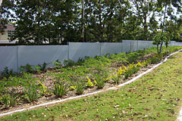
Example of vegetation planted a distance from a structure
- Screen visibility can be reduced if vegetation is planted a distance from a structure for example along the property line. This may not prevent graffiti, but the graffiti can be made less obvious. This method could be applied in circumstances where it is not possible to apply other forms of graffiti prevention, or when members of the public do not normally access the structure, such as water reservoirs.
- Vegetation which is uncomfortable to contact can reduce access. Coarse or serrated foliage is better than spiky. Banksia and grevillea, for example, can be as effective as bougainvillea or rose bushes. Landscaping which is uncomfortable to move across can be built out from a vertical surface including the use of timber, water or rocks.
- Fencing can deny or reduce access and set rules for access and use. The fence is to be designed and constructed so that it does not provide a canvas. Dark-coloured, non-continuous materials are preferred over light-coloured, continuous surfaces. Non-continuous materials provide an additional security benefit, as the fencing will be see-through.
- Fencing can demark and define areas, such as a single chain that does not physically restrict access, but is a form of implicit access control. High continuous fences are more likely to effectively control access.
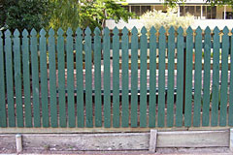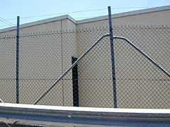
Effective fencing examples

3.2 Passive measures of access control
- Common forms of passive measures of access control are creating noise with texture or use of sprinklers. Other forms of passive control that set rules in a space are:
- pathways away from potential canvas;
- changes in ground texture, generally alongside pathways;
- simple one chain fences;
- signage indicating times of use;
- limiting access to other areas of structure through limiting potential climbing access points.
- Ground surfaces that create noise, such as rocks and gravel present a means of identifying the presence of someone, especially at night. The ground material should be of relatively fine grade and is not recommended for relatively remote areas, or in locations where there is already a great deal of noise, or where there is no natural surveillance or community guardianship. This technique should be used in conjunction with another access control measure.
- In public areas, such as parks, the location and after hours use of sprinklers can deter graffiti. If the surface is able to endure long periods of damp, sprinklers can be slightly trained on the vertical surface. This technique may only be required for early evening hours.

4 Canvas reduction
- Canvas reduction techniques are the next alternative if access cannot be restricted or denied. Canvas reduction includes minimal design, minimising vertical surface area and surface treatments.
- Where functional, a structure can be designed to ensure large walls or vertical surfaces are not exposed to potential graffiti attacks.
- Vertical surface area can be minimised through the use of grills, bars, mesh, other perforated metal or cavity brick. These materials can still be graffiti targets. It is important that maintenance is considered. Generally a surface colour or finish should be selected that is easy to maintain such as a dark colour.
- Surface treatments that deter graffiti can be applied if access cannot be restricted and non-solid surfaces cannot be selected. The application of legal art on surfaces that are otherwise continuous and blank is effective if the style is dense and colourful, does not resemble the graffiti form or denote any specific ownership and leaves no blank areas.
- Varieties of inventive legal art and styles include:
- interpretive (draws upon the themes of the immediate environment or is in keeping with the asset’s use);
- camouflaged (seeks to make the asset ‘disappear’. This can be effective for small assets such as traffic signal control boxes, but is difficult to apply on larger structures. Note that if the background colour/s are light, and/or blank, a canvas could be presented);
- tromploy (a form whereby artistic realism is employed to ‘trick’ the eye. Tromploy can be used to create the impression of structural features. Some features can even present the impression that there is surveillance, for example painting of windows);
- independent (a design is determined independent of surrounds. There are some generic forms such as wildlife and vegetation scenes).
- Canvas disruption of a line of otherwise blank canvas can be achieved through the use of false columns, different material selections including very rough and textured vertical surfaces, use of multiple colours on the same wall (sectioned) and use of vegetation and landscaping.
- Canvas disruption should be combined with other techniques such as dark or use of several colours, use of vegetation or art. However, if a textured surface is continuous, the same colour and effectively a blank surface; then it is a likely canvas. In the case of textured surfaces, it can be difficult to remove or mask the graffiti.
- Blank canvas can be reduced through the application of directional signage, advertising or information.
- Rapid removal (24–48 hours) is most effective in deterring future graffiti.

5 Maintenance solutions
- Materials and surfaces can be selected on the basis of maintenance and management of graffiti. Common forms of easy maintenance solutions include use of dark paint colours and a limited range of standard colours, specific building materials and finishes and protective coatings or sacrificial coatings.
- Most graffiti is applied within a height of 1–4m from the ground which means maintenance selections should be applied to a minimum height of 3m from the ground.
- Selecting a dark base colour is an effective graffiti management strategy and masking graffiti is far easier when the base paint coat is a darker colour.
- Establishing a standard and limited colour scheme for external surfaces is an effective way to reduce time and resources spent on graffiti removal by enabling an easy match of colours when required (in the case of masking graffiti). The Council has a standard paint colour palate of 27 standard colours for use on public structure. The standard Council paint colours list is available from Council’s Graffiti reduction policy.
- Materials and finishes can be selected that allow for straightforward and quick graffiti removal. The following materials can be selected on the basis that they are not popular with graffitists, and/or graffiti is able to be easily cleaned:
- ceramic and vitrified tiles;
- metal, such as stainless steel;
- stone (must be igneous or metamorphic, such as granite or marble);
- glass.
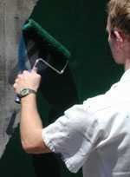
Standard Brisbane City Council colour being applied to a surface
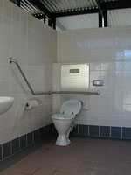
Tiles are a material that is easy to remove graffiti from
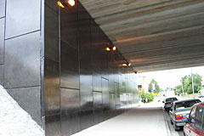
A surface where a protective coating has been applied
- Protective coatings are designed to provide a barrier between the base coat or material and any graffiti that may be applied and are useful in protecting unpainted brick and masonry surfaces, and surfaces painted unusual colours that are difficult to match. It is not recommended that protective coatings are applied without prior liaison with Graffiti Reduction Coordinator or Graffiti Reduction Liaison officers, as any removal attempt from a surface with a protective coating needs to be specific.
- Sacrificial coatings are a form of protective coating designed to provide a barrier between the base material or coat, and any subsequent graffiti vandalism. These coatings are somewhat ‘waxy’ in appearance. Sacrificial coatings are designed to be retained until graffiti damage builds up to a certain level. The coating (containing the graffiti) is then water blasted off. The sacrificial coating may then be re-applied.
- Some sacrificial coating products can be unreliable and most are expensive. Therefore coatings should be trialled and assessed against the following criteria:
- durability of the product;
- ease of paint and marker pen removal;
- toxicity of product (risk to tradesperson during application);
- toxicity of removal agent;
- cost of application and removal agent;
- proven record and referees/references.
- Surfaces to avoid include natural brick or concrete, unless painted in a dark colour. Graffiti is very difficult to remove from these materials, as paint is able to seep into the surface. It is recommended that brick and concrete facing public space be rendered and painted. Paint should be a dark or standard colour and applied to a minimum of 3m in height.
- Plastic-based compounds such as polycarbonates and perspex should also be avoided. They become permanently marked and unsightly after paint and/or removal chemicals are applied. Graffiti is very difficult to effectively remove from perspex. In addition, plastic-based compounds can be easily scratched and melted. To maintain appearance the material will need to be replaced.

