5.3.3.2 City west

5.3.3.2.1 Location and extent
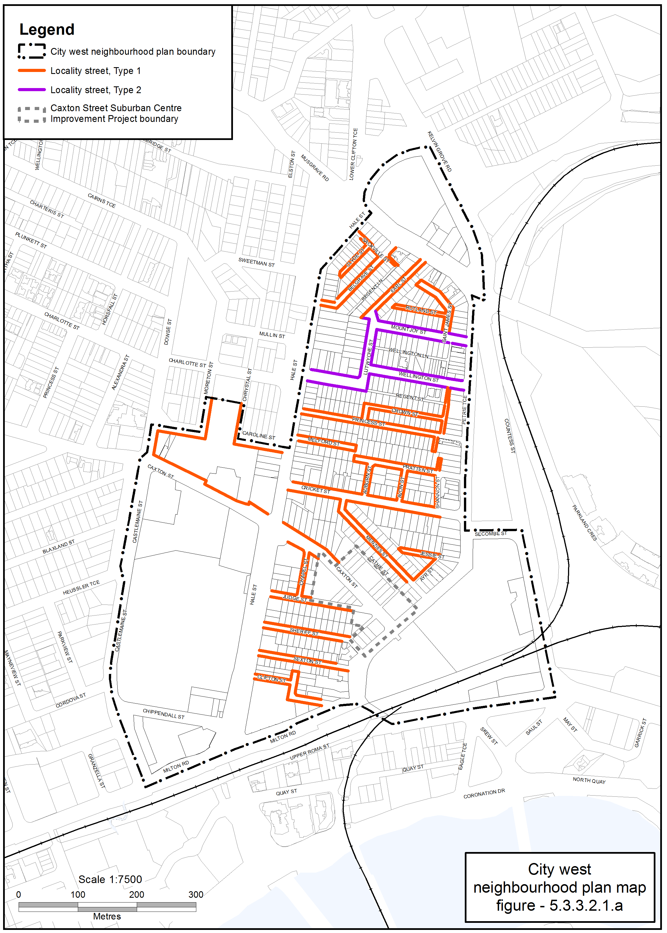
Figure 5.3.3.2.1.a—–City west locality streetscape extent
- The Locality Streets in the City west neighbourhood plan area are indicated on the City west Locality Streetscape Extent map in Figure 5.3.3.2.1.a.
- All streetscape works occurring within the Locality Streets indicated in Figure 5.3.3.2.1.a, must comply with the character specified in this document.
- Streetscapes outside these areas may be developed in keeping with this character, at the discretion of the developer and subject to Council approval.

5.3.3.2.2 Standard footway elements and materials
- These locality guidelines are to be read in conjunction with Chapter 3 – Road corridor design of the Infrastructure design planning scheme policy.
- Footway upgrades are to include new surfacing, new or reinstated kerb and channel, driveways, pedestrian kerb crossings, tactile markers, roof water drainage line connections, service pit lids, street trees, garden beds, furniture and pedestrian lighting applicable to the streetscape type.
- The scope, layout and detail of the footway upgrades are to be agreed on a site by site basis through the development assessment process.

5.3.3.2.3 Streetscape hierarchy

5.3.3.2.3.1 Streetscape types overview
- The locality streets within the City west neighbourhood plan area are exceptions to the standard streetscape hierarchy.
- The streetscape type and specifications for locality streets in this area are outlined in Table 5.3.3.2.3.1A and shown in Figure 5.3.3.2.1.a.

Table 5.3.3.2.3.1A—Streetscape type and specifications
Component | Locality Streets Type 1 in City west neighbourhood plan area
Verge width | Retain existing width
Description | Full width pavement
Unobstructed pavement | Refer to Table 5.3.3.2.3.1B
Paving materials | Full width asphalt  - Type: BCC Type 1 asphalt  - Width: 25mm thick.
Tactile markers | Type: Concrete tactile paver  Supplier: Chelmstone, Urbanstone or approved equivalent  Colour: CCS ‘Pewter’
Driveways | Broom finished concrete
Furniture | No furniture
Trees | Street trees planted in asphalt footpaths are to be planted in garden beds or tree grates and are permitted in accordance with the footway width requirements set out in Table 5.3.3.2.3.1B.  Streets trees include:  - a mix of tree species laid out in an informal manner with clusters of trees  - medium and small crown trees to be planted at minimum 2m spacing, if within garden beds, or minimum 6m spacing outside of garden beds  - large crown feature trees to be planted at minimum 10m centres.  Distance:  - all tree centrelines are 750mm from the nominal face of the kerb and a minimum of 600mm from the edges of the pavement.  Layout:  - a mix of species, in a single row at the rear of kerb  - to be planted as singles and in pairs or clusters.
Garden beds | Garden beds are permitted subject to the footway width requirements set out in Table 5.3.3.2.3.1B.  A garden bed located adjacent to the kerb has a:  - 1.5m minimum spacing between garden beds  - maximum length of 10m  - layout and length to accommodate car parking and other kerbside allocation.
Component | Locality Streets Type 2 in the City west neighbourhood plan area
Verge width | As existing verge width
As existing verge width | 1.2 m wide concrete footpath in turf
Unobstructed pavement | Refer to Table 5.3.3.2.3.2B
Paving materials | Broom finished concrete
Tactile markers | Type: Concrete tactile paver  Supplier: Chelmstone, Urbanstone or approved equivalent  Colour: CCS ‘Voodoo’
Driveways | Broom finished concrete
Furniture | No furniture
Trees | Street trees are permitted in accordance with the footway width requirements set out in Table 5.3.3.2.3.1B.  Streets trees include:  - a mix of tree species laid out in an informal manner with clusters of trees  - medium and small crown trees to be planted at minimum 2m spacing,  if within garden beds, or minimum 6m spacing outside of garden beds  - large crown feature trees to be planted at minimum 10m centres.  Distance:  - all tree centrelines are 750mm from the nominal face of the kerb and a minimum of 600mm from the edges of the pavement.  Layout:  - a mix of species, in a single row at the rear of kerb  to be planted as singles and in pairs or clusters.
Garden beds | Garden beds are permitted subject to the footway width requirements set out in Table 5.3.3.2.3.1B.  A garden bed located adjacent to the kerb has a:  - 1.5m minimum spacing between garden beds  - maximum length of 10m  layout and length to accommodate car parking and other kerbside allocation.

Table 5.3.3.2.3.1B—Footway width exceptions
Existing verge widths (from nominal face of kerb) | Existing verge widths (from nominal face of kerb) | Street trees | Unobstructed pavement width
Less than 2.1m | No garden beds | No | Full width
2.1m - 2.49m | 750mm - 1.15m | No | 1.2m
2.5m - 3.14m | 1.15m | Yes | 1.2m - 1.8m
3.15m - 3.74m | 1.2m | Yes | 1.8m - 2.4m
3.75m | 1.2m | Yes | 2.4m

5.3.3.2.4 Planting

5.3.3.2.4.1 Street trees
- Street trees are permitted and SC6.24 Planting species planning scheme policy in Schedule 6 Planning scheme policies sets out the approved street tree species for use on the various streets within the City west area.
- Each street has a minimum of two approved street tree species to encourage variety and diversity within the precinct.
- Where two or more street trees are required on the same development frontage, a mixture of the appropriate species as listed in SC6.24 is required.

5.3.3.2.4.2 Garden beds
- Garden beds are permitted as identified in Table 5.3.3.2.3.1B.
- Shrub and groundcover species are to be selected from SC6.24 Planting species planning scheme policy in Schedule 6 Planning scheme policies.

