5.3.3.3 Coorparoo and districts

5.3.3.3.1 Location and extent
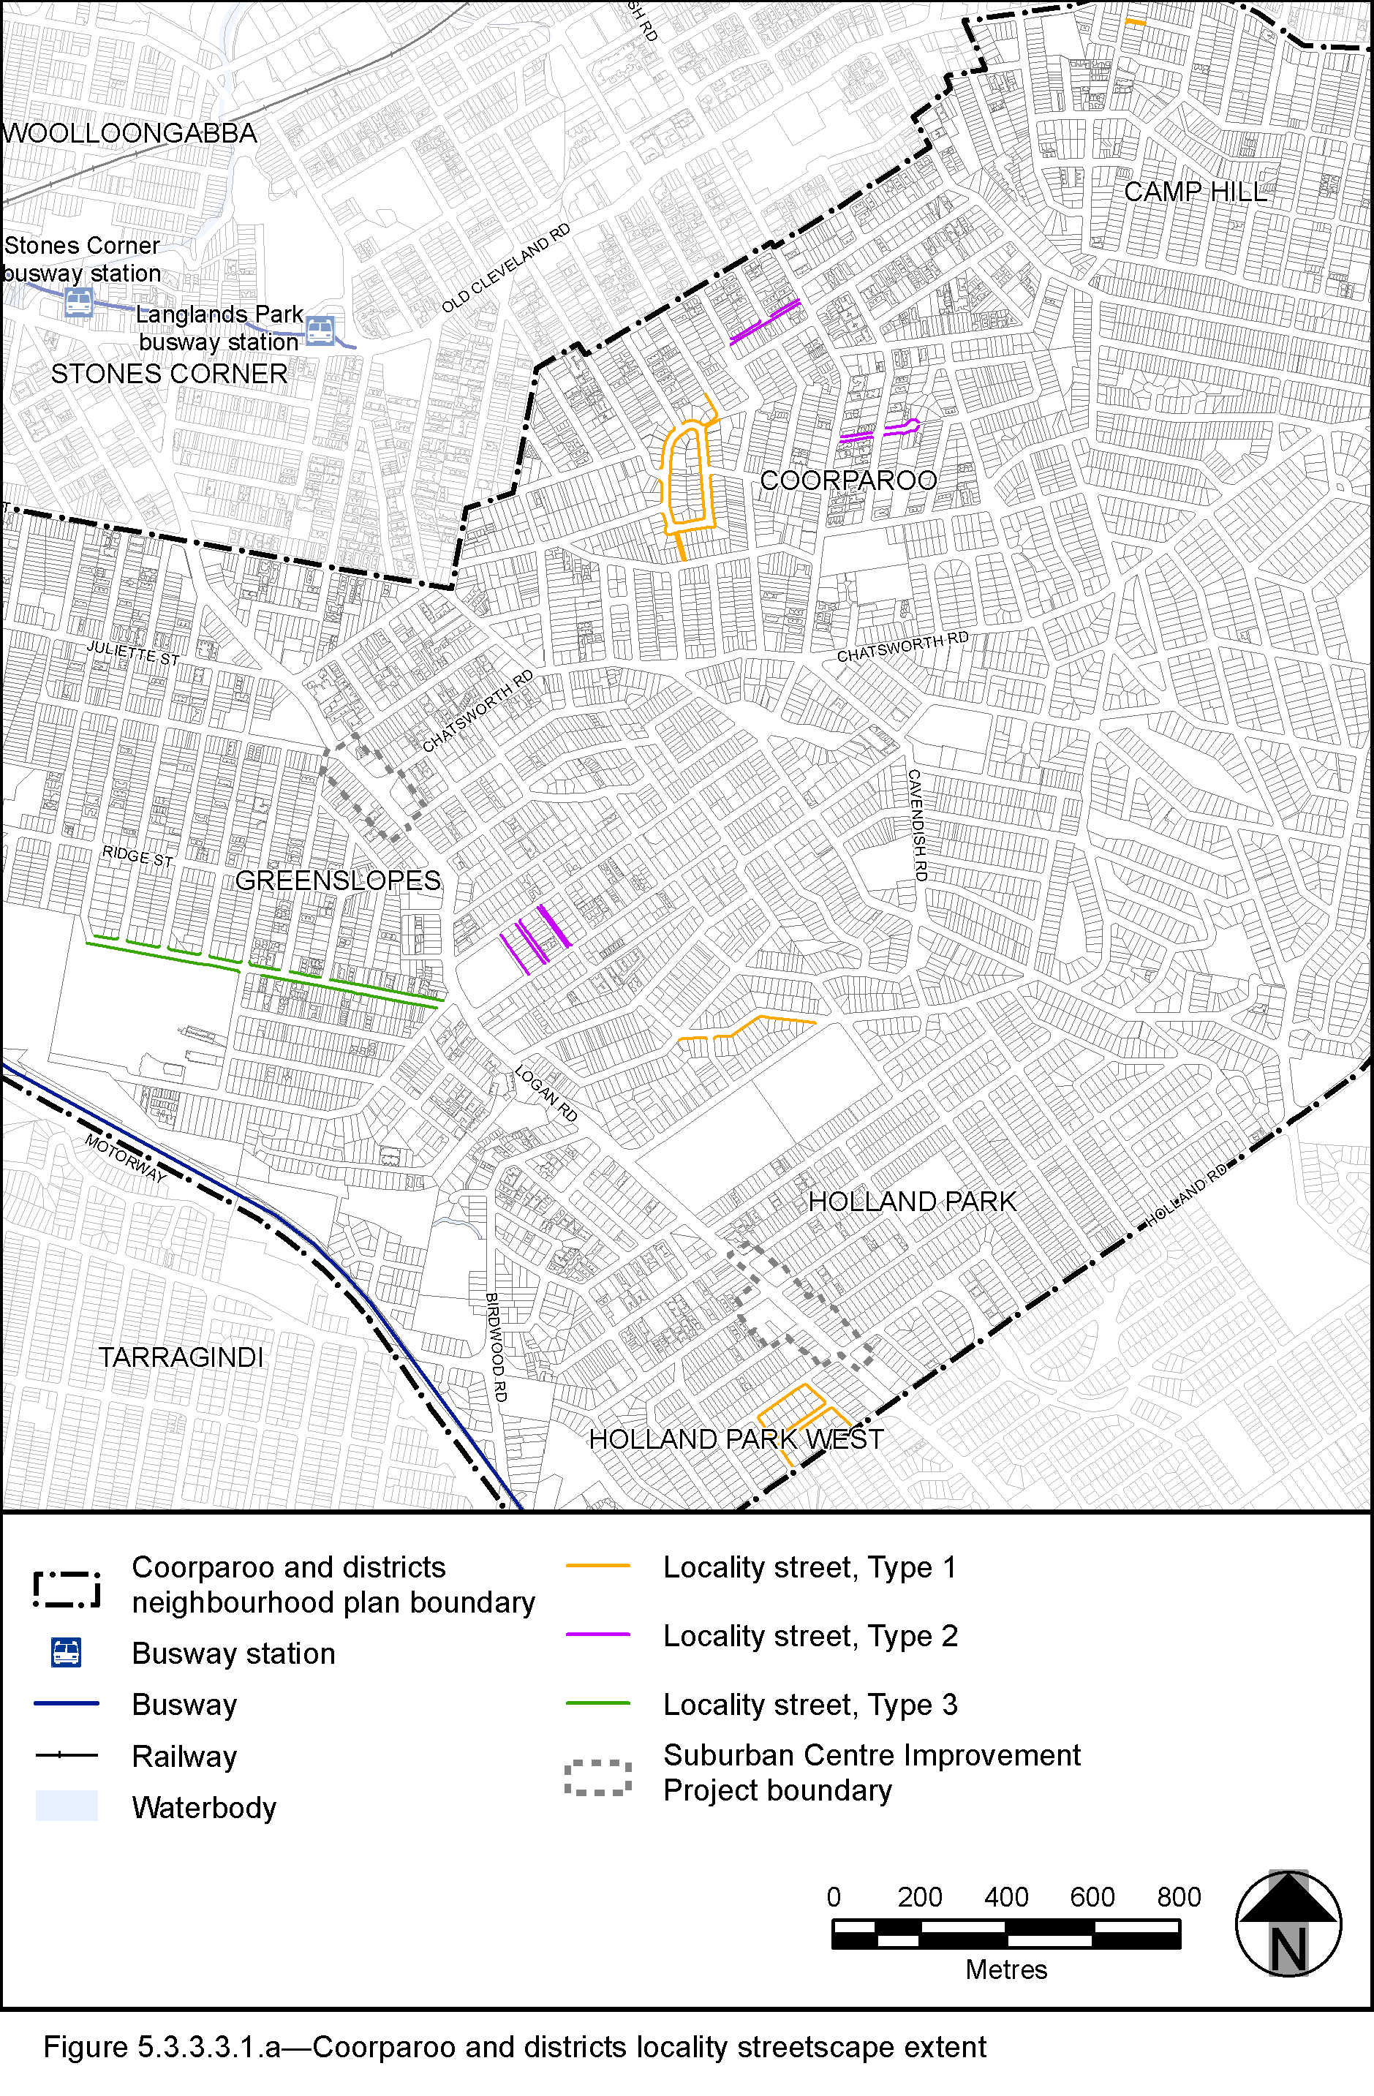
View the high resolution of Figure 5.3.3.3.1.a—Coorparoo and districts locality streetscape extent (PDF file size is 2038Kb)

- The locality streets in the Coorparoo and districts neighbourhood plan area are indicated on the Coorparoo and districts locality streetscape extent map in Figure 5.3.3.3.1.a.
- All streetscape works occurring within the locality streets indicated in Figure 5.3.3.3.1.a must comply with the character specified in this document.
- Streetscapes outside these areas may be developed in keeping with this character, at the discretion of the developer and subject to Council approval.

5.3.3.3.2 Standard footway elements and materials
- These locality guidelines are to be read in conjunction with Chapter 3 Road corridor design of the Infrastructure design planning scheme policy.
- Footway upgrades are to include new surfacing, new or reinstated kerb and channel, driveways, pedestrian kerb crossings, tactile markers, roof water drainage line connections, service pit lids, street trees, garden beds, furniture and pedestrian lighting applicable to the streetscape type.
- The scope, layout and detail of the footway upgrades are to be agreed on a site by site basis through the development assessment process.

5.3.3.3.3 Streetscape hierarchy

5.3.3.3.3.1 Streetscape types overview
- The locality streets within the Coorparoo and districts neighbourhood plan area are exceptions to the standard streetscape hierarchy.
- The streetscape type and specifications for locality streets in this area are outlined in Table 5.3.3.3.3.1A and shown in Figure 5.3.3.3.1.a.

Table 5.3.3.3.3.1A—Streetscape type and specifications
Component | Locality Streets Type 1 in Coorparoo and districts neighbourhood plan area
Verge width | As existing verge width
Description | Full width turf
Driveways | Broom finished concrete
Furniture | No furniture
Trees | Street trees are permitted in accordance with the footway width requirements set out in Table 5.3.3.3.3.1B.  Streets trees include:  - medium and small crown trees to be planted at minimum 2m spacing, if within garden beds, or minimum 6m spacing outside of garden beds;  - large crown feature trees to be planted at minimum 10m centres.  Distance:  - all tree centrelines are 750mm from the nominal face of the kerb.  Layout:  - trees planted in a single row at the rear of kerb;  - to be planted as singles and in pairs or clusters.

Component | Locality Streets Type 2 in Coorparoo and districts neighbourhood plan area
Verge width | As existing verge width
Description | 1.2m wide(1) concrete footpath in turf
Unobstructed pavement width | Refer to Table 5.3.3.3.3.1B, as applicable
Pavement Materials | Broom finished concrete
Tactile markers  (consistent with BSD-5218) | Type: Concrete tactile paver  Supplier: Chelmstone, Urbanstone or approved equivalent  Colour: CCS ‘Voodoo’
Driveways | Broom finished concrete
Furniture | No furniture
Trees | Street trees are permitted in accordance with the footway width requirements set out in Table 5.3.3.3.3.1B.  Streets trees include:  - a mix of tree species laid out in an informal manner with clusters of trees;  - medium and small crown trees to be planted at minimum 2m spacing, if within garden beds, or minimum 6m spacing outside of garden beds;  - large crown feature trees to be planted at minimum 10m centres.  Distance:  - all tree centrelines are 750mm from the nominal face of the kerb and a minimum of 600mm from the edges of the pavement.  Layout:  - a mix of species, in a single row at the rear of kerb;  - to be planted as singles and in pairs or clusters.
Notes: (1) Where existing verge width allows.
Component | Locality Streets Type 3 in Coorparoo and districts neighbourhood plan area
Verge width | As existing verge width
Description | 1.8m wide⁽¹⁾ concrete footpath in turf  Concrete footpath abuts the property boundary
Unobstructed pavement width | Refer to Table 5.3.3.3.3.1B, as applicable
Pavement Materials | Broom finished concrete
Tactile markers  (consistent with BSD-5218) | Type: Concrete tactile paver  Supplier: Chelmstone, Urbanstone or approved equivalent  Colour: CCS ‘Voodoo’
Driveways | Broom finished concrete
Furniture | No furniture
Trees | Street trees are permitted in accordance with the footway width requirements set out in Table 5.3.3.3.3.1B.  Streets trees include:  - a mix of tree species laid out in an informal manner with clusters of trees;  - medium and small crown trees to be planted at minimum 2m spacing, if within garden beds, or minimum 6m spacing outside of garden beds;  - large crown feature trees to be planted at minimum 10m centres.  Distance:  - all tree centrelines are 1350mm from the nominal face of the kerb and a minimum of 600mm from the edges of the pavement.  Layout:  - a mix of species, in a single row at the rear of kerb;  - to be planted as singles and in pairs or clusters.
Turf strip adjacent kerb – minimum width | 1.8m – varying width
Turf strip at rear of verge | 0m
Tree planting beds – minimum widths | 1.2m
Notes: (1) Where existing verge width allows.

Table 5.3.3.3.3.1B—Footway width exceptions
Existing verge widths (from nominal face of kerb) | Garden beds | Street trees | Pathway width Locality Street Type 1 | Pathway width Locality Street Type 2 | Pathway width Locality Street Type 3
Less than 1.65m | No garden beds | No | No path | Full width | Full width
1.65m - 2.49m | No garden beds | No | No path | 1.2m | 1.2m
2.5m and wider | No garden beds | Yes | No path | 1.2m | 1.8m

5.3.3.3.4 Planting–Locality Street Types 1 and 2

5.3.3.3.4.1 Street trees
- Street trees are permitted as identified in Table 5.3.3.3.4.1A and each street has an approved street tree species to fit with the character within the precinct.
- Street trees are to be:
- laid out in an informal manner;
- medium and small crown trees to be planted at minimum 2m spacing, if within garden beds, or minimum 6m spacing outside of garden beds;
- large crown feature trees to be planted at minimum 10m centres.
- Trees are to be planted in garden beds.
- Table 5.3.3.3.4.1A sets out the approved street tree species for use on the various streets within the Coorparoo and districts neighbourhood plan area.

Table 5.3.3.3.4.1A—Street trees
Street | Street Trees
Lamrock Street (north side) | Buckinghamia celsissima
Doughty Avenue (south side) | Buckinghamia celsissima Delonix regia
Curlewis Street (south side) | Xanthostemon chrysanthus  Jacaranda mimosifolia
Ontario Street | Syzygium australe  Delonix regia
Percival Terrace | Delonix regia  Bauhinia purpurea
Letchworth Road | Delonix regia  Buckinghamia celsissima
Regal Street (in the crescent between Letchworth Road and Welwyn Crescent) | Delonix regia  Buckinghamia celsissima
Howard Street | Delonix regia  Buckinghamia celsissima
Welwyn Crescent | Delonix regia  Buckinghamia celsissima
Welwyn Crescent (off MacKay Street) | No trees
Regal Street (off Letchworth Road and Macaulay Street) | No trees

5.3.3.3.5 Planting–Locality Street Type 3

5.3.3.3.5.1 Street trees
- Street trees are permitted and section 3.7.5 Design standards for street tree planting sets out the approved street tree species for use on the various streets within the Coorparoo and districts area.
- Each street has a minimum of two approved street tree species to encourage variety and diversity within the precinct.
- Where two or more street trees are required on the same development frontage, a mixture of the appropriate species as listed in section 3.7.5 Design standards for street tree planting is required.

