5.3.4.1 Dutton Park—Fairfield

5.3.4.1.1 Location and extent

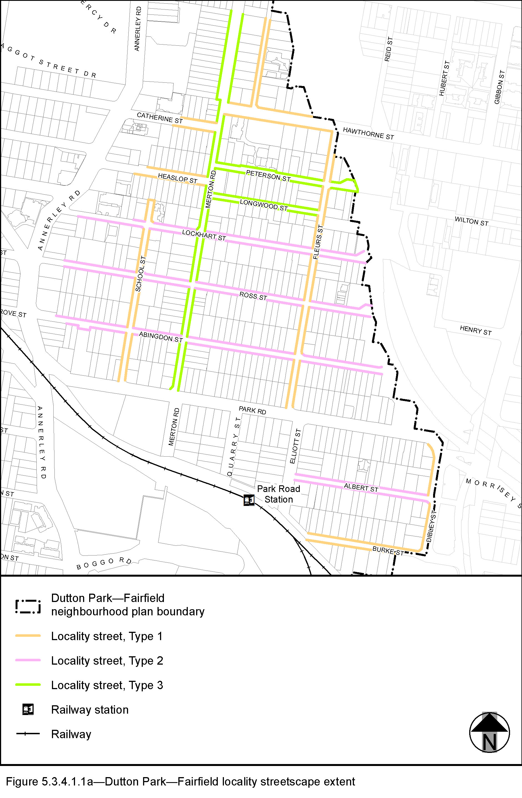
View the high resolution of Figure 5.3.4.1.1a–Dutton Park—Fairfield locality streetscape extent (PDF file size is 334Kb)

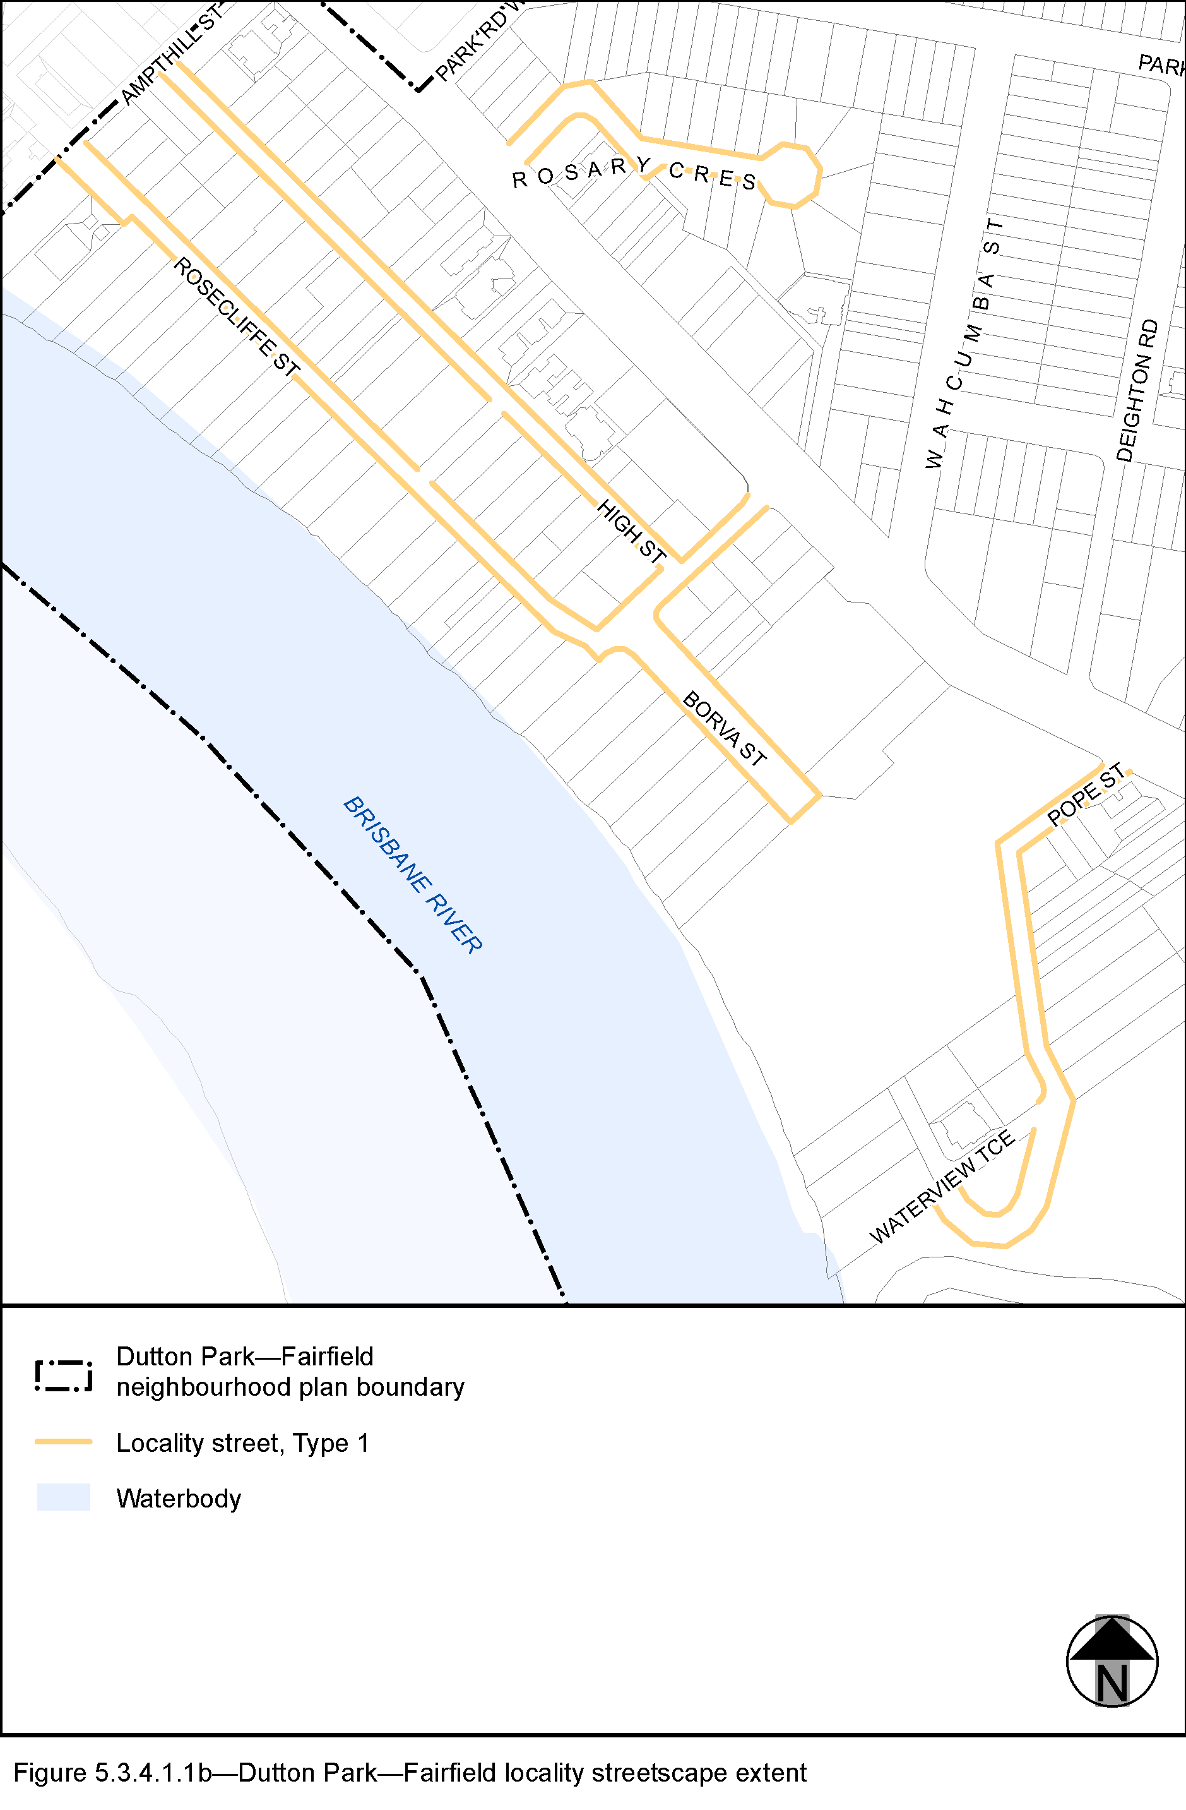
View the high resolution of Figure 5.3.4.1.1b–Dutton Park—Fairfield locality streetscape extent (PDF file size is 277Kb)

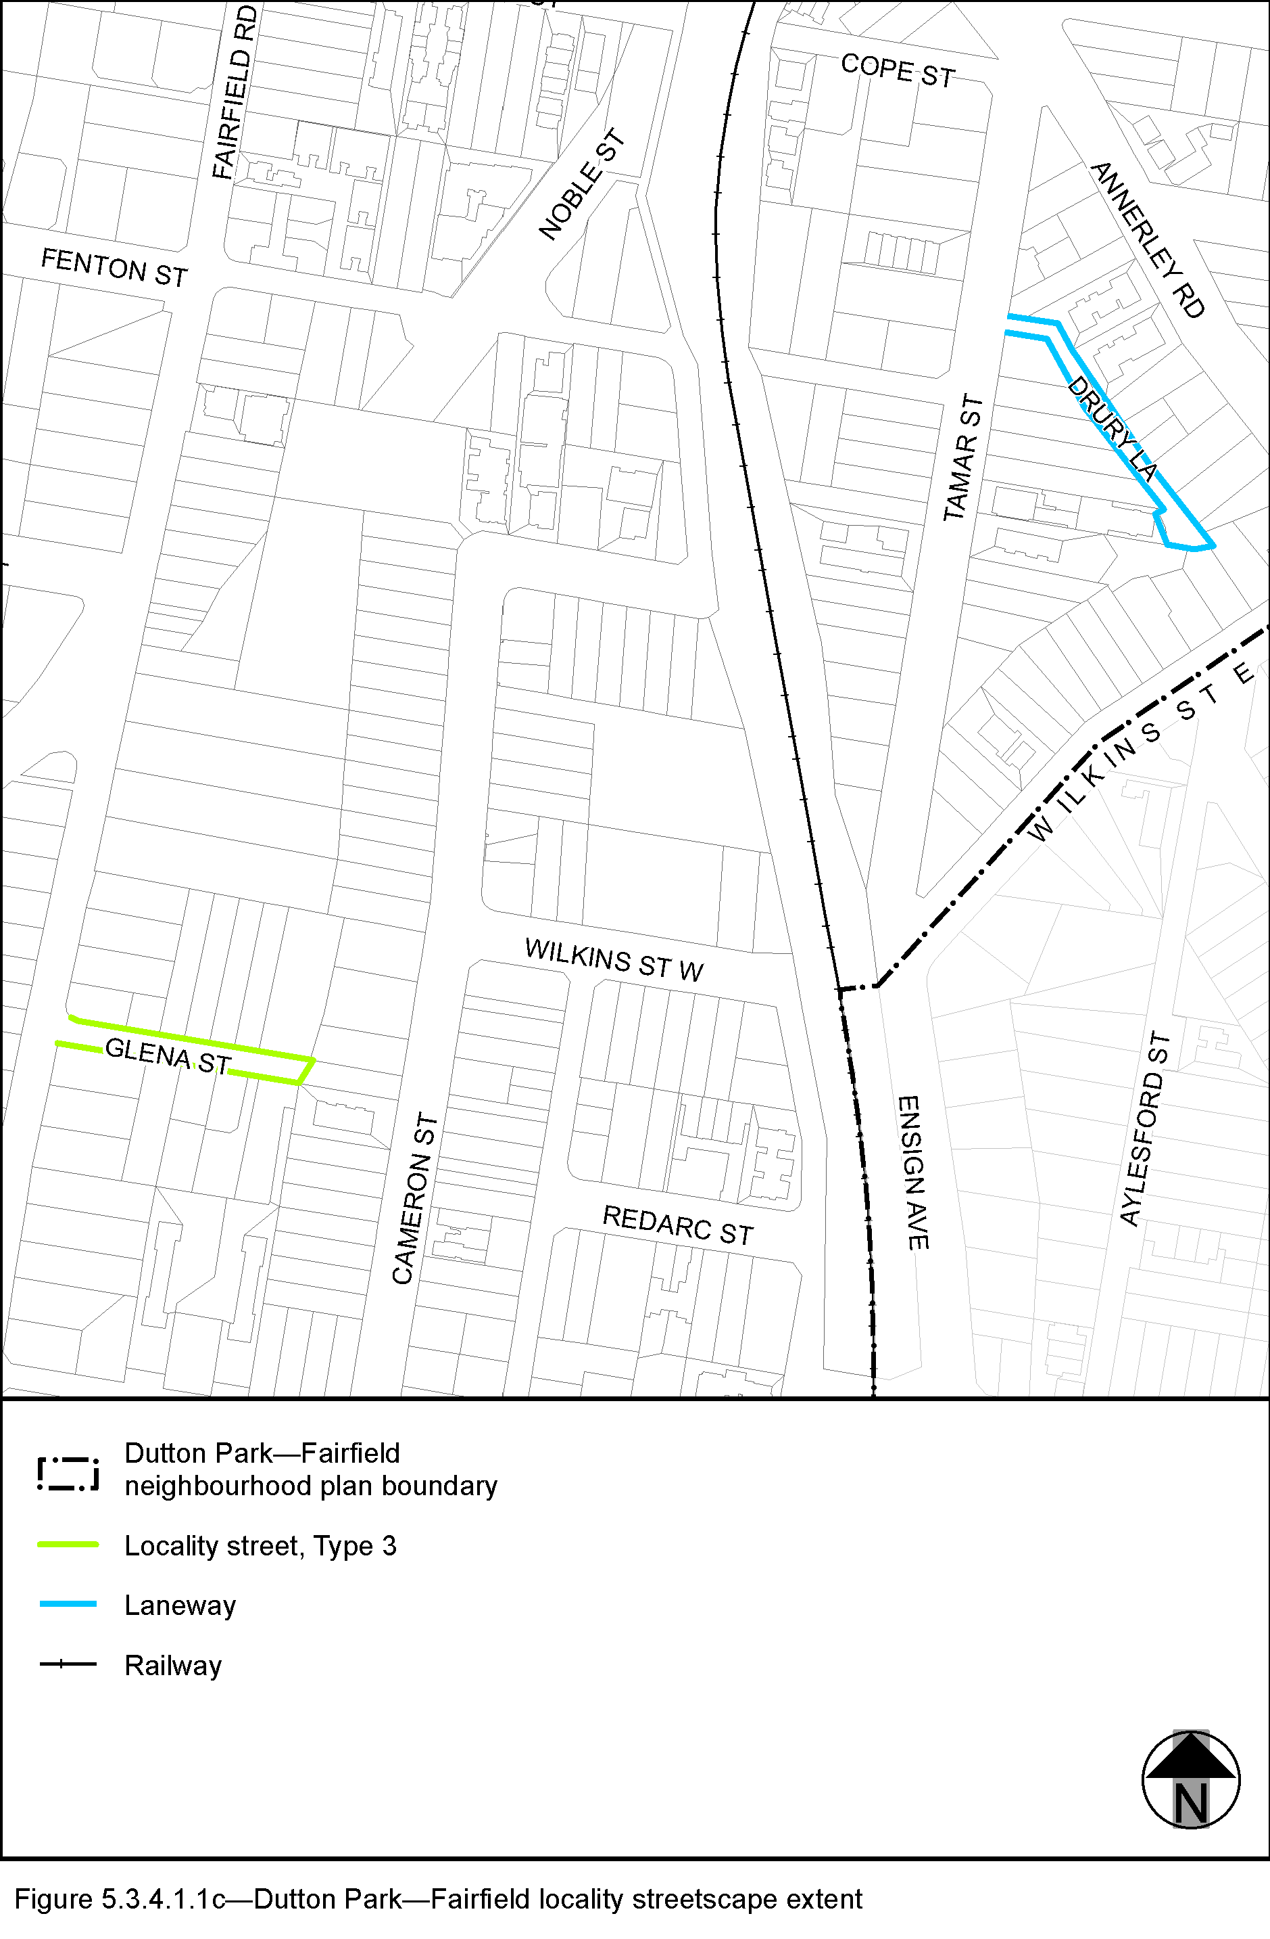
View the high resolution of Figure 5.3.4.1.1b–Dutton Park—Fairfiled locality streetscape (PDF file size is 293Kb)
- The Locality Streets in the Dutton Park—Fairfield neighbourhood plan area are indicated on the Dutton Park—Fairfield Locality Streetscape Extent map in Figure 5.3.4.1.1a, Figure 5.3.4.1.1b and Figure 5.3.4.1.1c.
- All streetscape works occurring within the Locality Streets indicated in Figure 5.3.4.1.1a, Figure 5.3.4.1.1b and Figure 5.3.4.1.1c must comply with the character specified in this document.
- Streetscapes outside these areas may be developed in keeping with this character, at the discretion of the developer and subject to Council approval.

5.3.4.1.2 Standard footway elements and materials
- These locality guidelines are to be read in conjunction with Chapter 3 – Road corridor design of the Infrastructure design planning scheme policy.
- Footway upgrades are to include new surfacing, new or reinstated kerb and channel, driveways, pedestrian kerb crossings, tactile markers, roof water drainage line connections, service pit lids, street trees, garden beds, furniture and pedestrian lighting applicable to the streetscape type.
- The scope, layout and detail of the footway upgrades are to be agreed on a site by site basis through the development assessment process.

5.3.4.1.3 Streetscape hierarchy

5.3.4.1.3.1 Streetscape types overview
- The locality streets within the Dutton Park—Fairfield neighbourhood plan area are exceptions to the standard streetscape hierarchy
- The streetscape type and specifications for locality streets in this area are outlined in
Table 5.3.4.3.1.1A and shown in Figure 5.3.4.1.1a, Figure 5.3.4.1.1b and Figure 5.3.4.1.1c.

Table 5.3.4.1.3.1A—Streetscape type and specifications
Component | Locality Streets Type 1 in the Dutton Park—Fairfield neighbourhood plan area
Verge width | Retain existing width
Description | Full width pavement
Unobstructed pavement | Refer to Table 5.3.4.1.3.1B
Paving materials | Full width asphalt  - Type: BCC Type 1 asphalt;  Width: 25mm thick.
Tactile markers | Type: Concrete tactile paver  Supplier: Chelmstone, Urbanstone or approved equivalent  Colour: CCS ‘Pewter’
Driveways | Broom finished concrete
Furniture | No furniture
Trees | Street trees planted in asphalt footpaths are to be planted in garden beds or tree grates and are permitted in accordance with the footway width requirements set out in Table 5.3.4.3.1.1B.  Streets trees include:  - a mix of tree species laid out in an informal manner with clusters of trees;  - medium and small crown trees to be planted at minimum 2m spacing, if within garden beds, or minimum 6m spacing outside of garden beds;  - large crown feature trees to be planted at minimum 10m centres.  Distance:  - all tree centrelines are 750mm from the nominal face of the kerb and a minimum of 600mm from the edges of the pavement.  Layout:  - a mix of species, in a single row at the rear of kerb;  - to be planted as singles and in pairs or clusters.
Component | Locality Streets Type 2 in the Dutton Park—Fairfield neighbourhood plan area.
Verge width | As existing verge width
Description | 1.2m wide(1) concrete footpath in turf
Unobstructed pavement | Refer to Table 5.3.4.3.1.1B.
Paving materials | Broom finished concrete
Tactile markers | Type: Concrete tactile paver  Supplier: Chelmstone, Urbanstone or approved equivalent  Colour: CCS ‘Voodoo’
Driveways | Broom finished concrete
Furniture | No furniture
Trees | Street trees planted in asphalt footpaths are permitted in accordance with the footway width requirements set out in Table 5.3.4.3.1.1B.  Streets trees include:  - a mix of tree species laid out in an informal manner with clusters of trees;  - medium and small crown trees to be planted at minimum 2m spacing, if within garden beds, or minimum 6m spacing outside of garden beds;  - large crown feature trees to be planted at minimum 10m centres.  Distance:  - all tree centrelines are 750mm from the nominal face of the kerb and a minimum of 600mm from the edges of the pavement.  Layout:  - a mix of species, in a single row at the rear of kerb;  - to be planted as singles and in pairs or clusters.
Component | Locality Streets Type 3 in the Dutton Park—Fairfield neighbourhood plan area
Verge width | An existing verge width
Description | 1.2m wide(1) concrete footpath or full width turf
Unobstructed pavement | Refer to Table 5.3.4.3.1.1B as applicable
Paving materials | Broom finished concrete(2)
Tactile markers | Type: Concrete tactile paver  Supplier: Chelmstone, Urbanstone or approved equivalent  Colour: CCS ‘Voodoo’
Driveways | Broom finished concrete
Furniture | No furniture
Trees | Street trees are permitted in accordance with the footway width requirements set out in Table 5.3.4.1.1B.  Streets trees include:  - a mix of tree species laid out in an informal manner with clusters of trees;  - medium and small crown trees to be planted at minimum 2m spacing, if within garden beds, or minimum 6m spacing outside of garden beds;  - large crown feature trees to be planted at minimum 10m centres.  Distance:  - all tree centrelines are 750mm from the nominal face of the kerb and a minimum of 600mm from the edges of the pavement.  Layout:  - a mix of species, in a single row at the rear of kerb;  - to be planted as singles and in pairs or clusters.
Notes: (1) Where existing verge width allows.
(2) Where concrete footpath is required.

Table 5.3.4.3.1.1B—Footway width exceptions
Verge widths (from nominal face of kerb) | Garden bed width | Street trees | Unobstructed pavement width
Less than 1.65m | No garden beds | No | Full width
1.65m-2.49m | No garden beds | No | 1.2m
2.5m and wider | No garden beds | Yes | 1.2m

5.3.4.4 Planting

5.3.4.4.1 Street trees
- Street trees are permitted and Section 3.7.5 Design standards for street tree planting sets out the approved street tree species for use on the various streets within the Dutton Park—Fairfield area.
- Each street has a minimum or two approved street tree species to encourage variety and diversity within the precinct.
- Where two or more street trees are required on the same development frontage, a mixture of the appropriate species as listed in Section 3.7.5 Design standards for street tree planting is required.

