5.3.14.1 Newstead and Teneriffe waterfront

5.3.14.1.1 Location and extent
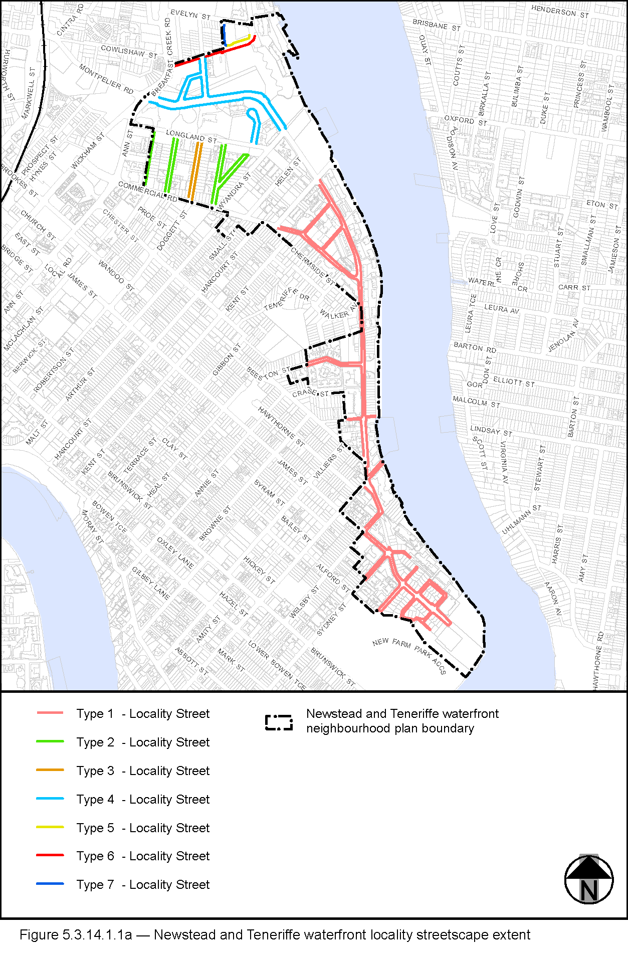
View the high resolution of Figure 5.3.14.1.1a–Newstead and Teneriffe waterfront locality streetscape extent (PDF file size is 1286Kb)
- The Locality Streets in the Newstead and Teneriffe waterfront neighbourhood plan area are indicated on the Streetscape hierarchy overlay map and on Figure 5.3.14.1.1a.
- All streetscape works occurring within the Locality Streets indicated in Figure 5.3.14.1.1a, must comply with the character specified in this document.
- Streetscapes outside these areas may be developed in keeping with this character, at the discretion of the developer and subject to Council approval.
- For RiverWalk layout and treatment specifications refer to the Newstead and Teneriffe waterfront neighbourhood plan Code and Chapter 12 – Public riverside facilities of this planning scheme policy.

5.3.14.1.2 Standard footway elements and materials
- These locality guidelines are to be read in conjunction with Chapter 3 – Road corridor design of the Infrastructure design planning scheme policy.
- Footway upgrades are to include new surfacing, new or reinstated kerb and channel, driveways, pedestrian kerb crossings, tactile markers, roof water drainage line connections, service pit lids, street trees, garden beds, furniture and pedestrian lighting applicable to the streetscape type.
- The scope, layout and detail of the footway upgrades are to be agreed on a site by site basis through the development assessment process.

5.3.14.1.3 Streetscape hierarchy

5.3.14.1.3.1 Streetscape types overview
- The locality streets within the Newstead and Teneriffe waterfront neighbourhood plan area are exceptions to the standard streetscape hierarchy.
- The streetscape type and specifications for locality streets in this area are outlined in Table 5.3.14.1.3.1A and shown in Figure 5.3.14.1.1a.

Table 5.3.14.1.3.1A – Streetscape types and specifications
Type | Verge Width | Description | Unobstructed Pavement Width | Paving Material | Tactile  (consistent with BSD-5218) | Driveways | Kerb and channel | Street Trees | Garden Beds | Furniture
Type 1 | Match existing width | Match existing | Match existing | Type: Exposed aggregate concrete  Supplier: Hanson or approved equivalent  Colour: 'Honey Red' | Type: Concrete paver  Supplier: Chelmstone, Urbanstone or approved equivalent  Colour: CCS 'Voodoo' | To match adjacent footpath finish. | - | Existing trees to be retained. New street trees are permitted where the footway width allows (refer to Table 5.3.14.1.3.1B) | - | -
Type 2 | Match existing width | Full width | Match existing width as per Table 5.3.14.1.3.1B | Exposed Aggregate:  Standard Portland Grey Concrete  'Victoria Falls' (90% Blue Heeler  10% Winter Brown)  Hanson Code ‘IE251AF61’, Boral or approved equivalent | Type: Concrete tactile paver  Supplier: Chelmstone, Urbanstone or approved equivalent  Colour: CCS ‘Voodoo’ | Exposed Aggregate to match footway | Porphyry or granite where existing. Elsewhere pre-cast portland grey concrete kerbs units | Layout: Mix of species, laid out in an informal manner with clusters of trees, closely spaced in some locations.  Trees planted in: Garden beds - See detail in Figure 5.3.14.1.3a. No street trees where footway width is less than 2.5 metres (refer to Table 5.3.14.1.3.1B) | Refer to Table 5.3.14.1.3.1B for garden bed width.  Garden bed length: 3m (or 1.5m if not possible to achieve 3m length) | None
Type 3 | Match existing width | Full width | Match existing width as per Table 5.3.14.1.3.1B | Exposed Aggregate:  Standard Portland Grey Concrete  'Victoria Falls' 90% Blue Heeler  10% Winter Brown  Hanson Code ‘IE251AF61’, Boral or approved equivalent | Type: Concrete tactile paver  Supplier: Chelmstone, Urbanstone or approved equivalent  Colour: CCS ‘Voodoo’ | Exposed Aggregate to match footway | Porphyry or granite where existing. Elsewhere pre-cast portland grey concrete kerbs units. | Layout: Mix of species, laid out in an informal manner with clusters of trees, closely spaced in some locations  Trees planted in: Garden beds - See detail in Figure 5.3.14.1.3a. No street trees where footway width is less than 2.5 metres (refer to Table 5.3.14.1.3.1B). | Refer to Table 5.3.14.1.3.1B for garden bed width.  Garden bed length: 3m (or 1.5m if not possible to achieve 3m length). | Seats – Yes  Bins – Yes  Pole top pedestrian lighting – Yes (required for both sides of the street)  Note – seats and bins will not be required adjacent to purely residential development.
Type 4 | Minimum 3.75 metres | Full width | - | Exposed aggregate:  CCS Oxide: Paperbark with Charcoal aggregate by Hanson, Boral or approved equivalent | Type: Concrete tactile paver  Supplier: Chelmstone, Urbanstone or approved equivalent  Colour: CCS ‘Voodoo’ | To match footway | Pre-cast portland grey concrete kerb units | Layout: Mix of species, laid out in an informal manner with clusters of trees, closely spaced in some locations and with a second row where footway width permits.  Trees planted in: Garden beds. | - | Seats: HUB - Newstead S3 Seat with armrests.  Bins: BCC 240L dual bin.  Bollards: HUB - Newstead Bollards 900 & Newstead Bollards 1800.  Drinking Fountain: Commercial Systems - DF 5001 (with custom square bowl).  Pedestrian Lighting:  Bega pole top luminaire.  Balustrade: To be determined on a site-by-site basis.
Type 5 | 3.75m | Full width | Match existing width as per Table 5.3.14.1.3.1B. | Exposed Aggregate:  CCS Oxide: Paperbark with Charcoal aggregate by Hanson, Boral or approved equivalent. | Type: Concrete tactile paver  Supplier: Chelmstone, Urbanstone or approved equivalent  Colour: CCS ‘Voodoo’ | Exposed Aggregate to match footway | Porphyry or granite where existing.  Elsewhere pre-cast portland grey concrete kerbs units. | Layout: Mix of species, laid out in an informal manner with clusters of trees, closely spaced in some locations.  Trees planted in: Garden beds - See detail in Figure 5.3.14.1.3a.  No street trees where footway width is less than 2.5 metres (refer to Table 5.3.14.1.4.1B). | Refer to Table 5.3.14.1.3.1B for garden bed width.  Garden bed length: 3m (or 1.5m if not possible to achieve 3m length) | None
Type 6 | 3.75m | Full width | - | Exposed Aggregate:  CCS Oxide: Paperbark with Charcoal aggregate by Hanson, Boral or approved equivalent. | Type: Concrete tactile paver  Supplier: Chelmstone, Urbanstone or approved equivalent  Colour: CCS ‘Voodoo’ | To match footway | Pre-cast portland grey concrete kerbs units. | Layout: Mix of species, laid out in an informal manner with clusters of trees, closely spaced in some locations and with a second row where footway width permits.  Trees planted in: Garden beds. | - | Seats: HUB - Newstead S3 Seat with armrests.  Bins: BCC 240L dual bin.  Bollards: HUB - Newstead Bollards 900 & Newstead Bollards 1800.  Drinking Fountain: Commercial Systems - DF 5001 (with custom square bowl).  Pedestrian Lighting:  Bega pole top luminaire.  Balustrade: To be determined on a site-by-site basis.
Type 7 | Match existing width | Full width | Match existing width as per Table 5.3.14.1.3.1B | Exposed Aggregate:  CCS Oxide: Paperbark with Charcoal aggregate by Hanson, Boral or approved equivalent. | Type: Concrete tactile paver  Supplier: Chelmstone, Urbanstone or approved equivalent  Colour: CCS ‘Voodoo’ | Exposed Aggregate to match footway | Porphyry or granite where existing. Elsewhere pre-cast portland grey concrete kerbs units. | Layout: Mix of species, laid out in an informal manner with clusters of trees, closely spaced in some locations.  Trees planted in: Garden beds - See detail in Figure 5.3.14.1.3a. No street trees where footway width is less than 2.5 metres (refer to Table 5.3.14.1.3.1B). | Refer to Table 5.3.14.1.3.1B for garden bed width.  Garden bed length: 3m (or 1.5m if not possible to achieve 3m length) | None

Table 5.3.14.1.3.1B – Footway width exceptions
Verge widths (from nominal face of kerb) | Garden bed width | Street trees | Unobstructed pavement width
Less than 2.1m | No garden beds | No | Full width
2.1m – 2.49m | 750mm – 1.15m | No | 1.2m
2.50m – 3.14m | 1.15m | Yes | 1.2m – 1.8m
3.15m – 3.74m | 1.2m | Yes | 1.8m – 2.4m
3.75m | 1.2m | Yes | 2.4m

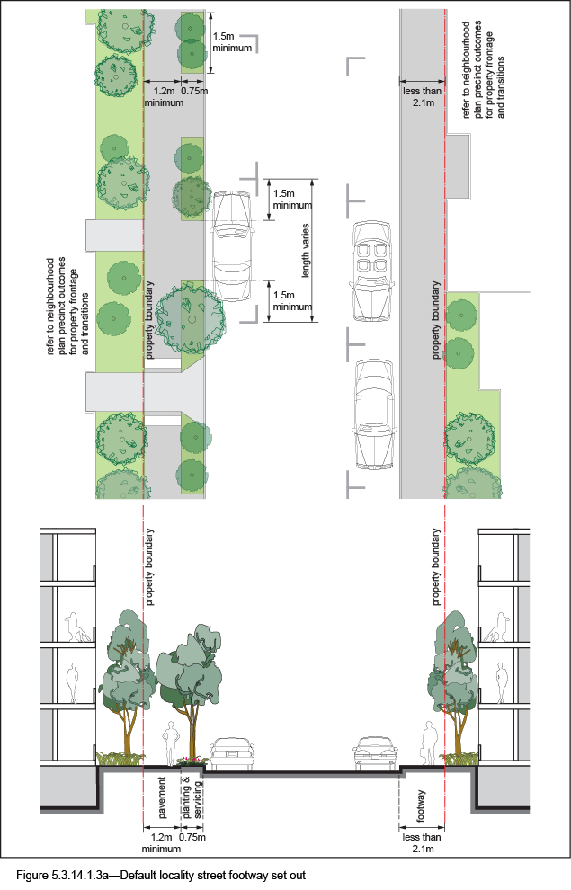

5.3.14.1.4 Planting

5.3.14.1.4.1 Street trees
- Street trees are permitted as identified in Table 5.3.14.1.3.1A.
- Table 5.3.14.1.4A sets out the approved street tree species for use on the various streets within the Newstead and Teneriffe Waterfront neighbourhood plan area.
- Each street has a minimum of two approved street tree species to encourage variety and diversity within the precinct.
- Where two or more street trees are required on the same development frontage, a mixture of the appropriate species as listed in Table 5.3.14.1.4A is required.

5.3.14.1.4.2 Garden beds
- Garden beds are permitted in accordance with Table 5.3.14.1.3.1A.
- Species are to be selected from Table 5.3.14.1.4B.

Table 5.3.14.1.4A – Street Trees
Street | Tree species
Beeston Street | Waterhousia floribunda  Delonix regia
Binkenba Court | Harpullia pendula  Delonix regia
Commercial Road | Harpullia pendula  Flindersia schottiana  Waterhousia floribunda  Agathis robusta  Delonix regia
Dath Street | Harpullia pendula  Flindersia schottiana
Dixon Street | Harpullia pendula  Xanthostemon chrysanthus  Delonix regia
Doggett Street | Flindersia schottiana  Cupaniopsis anacardioides  Lophostemon confertus
Florence Street | Harpullia pendula  Waterhousia floribunda
Gray Street | Harpullia pendula  Peltophorum pterocarpum
Helen Street | Buckinghamia celsissima  Flindersia schottiana  Plumeria rubra
Hollins Crescent | Harpullia pendula  Delonix regia
Hopetoun Way | Harpullia pendula  Delonix regia
Kyabra Street | Flindersia schottiana  Cupaniopsis anacardioides  Waterhousia floribunda
Lamington Street | Harpullia pendula  Peltophorum pterocarpum  Ficus benjamina
Longland Street | Cupaniopsis anacardioides  Waterhousia floribunda  Melaleuca quinquenervia
Macquarie Street | Harpullia pendula  Delonix regia  Waterhousia floribunda
Market Street | Lophostemon confertus  Flindersia schottiana  Ficus rubiginosa
Masters Street | Cupaniopsis anacardioides  Flindersia schottiana  Grevillea baileyana
Merthyr Road | Harpullia pendula  Ficus microcarpa var. Hillii
Refinery Parade | Harpullia pendula  Peltophorum pterocarpum
RiverWalk | Delonix regia  Ficus rubiginosa  Araucaria cunninghamii
Skyring Terrace | Lophostemon confertus  Flindersia australis  Ficus rubiginosa
Stratton Street | Harpullia pendula  Melaleuca quinquenervia  Grevillea baileyana
Sydney Street | Harpullia pendula  Peltophorum pterocarpum
Vernon Terrace | Harpullia pendula  Ficus microcarpa var. Hillii
Waterloo Street | Lophostemon confertus  Flindersia australis  Ficus rubiginosa  Cupaniopsis anacardioides
Welsby Street | Peltophorum pterocarpum  Jacaranda mimosifolia
Wyatt Street | Cupaniopsis anacardiodes  Flindersia schottiana  Melaleuca quinquenervia
Wyandra Street | Handroanthus chrysanthus

Table 5.3.14.1.4B – Shrubs and groundcover species
Shrub and groundcover species
Dianella spp.
Dietes bicolour
Liriope ‘Evergreen Giant’
Myoporum ellipticum
Themeda ‘Mingo’
Trachelospermum spp.

